Trends and Patterns in Work–Life Integration: A Bibliometric Study

Abstract: The increasing demands of modern workplaces and evolving social structures have brought work-life integration (WLI) into sharper focus. Unlike traditional work-life balance, WLI emphasizes the seamless coexistence of work and personal responsibilities. The study aims to examine a bibliometric analysis of work-life integration papers that are indexed in the Web of Science database. A bibliometric study based on secondary data from the Web of Science database is used in this research work. 51 papers were chosen for in-depth review after screening 489 papers using a systematic literature review and the PRISMA methodology. To display publishing metrics, citation trends, word cloud insights, and co-authorship networks, bibliometric analysis was conducted using Biblioshiny and Vosviewer software. The publication shows that research is more focused on work-life integration rather than work-life balance. The paper suggests that organizations should set digital boundaries and show cultural sensitivity. The paper concludes that organisations can better support their workforce in achieving effective work-life integration, ultimately fostering greater employee satisfaction, productivity, and well-being. It is recommended that organisational policy improvements should be made, and future research should be conducted.
Keywords: Work-Life Integration (WLI), Work-Life Balance (WLB), Systematic Literature Review (SLR), Organizational Policies, Remote Work, Family Conflict, Employee Well-being.

- Introduction
Work-Life integration (WLI) has emerged as a critical research topic as more professionals navigate the complex interdependence between their work and personal lives. It is a component of employee well-being that refers to the employee's ability to balance personal and professional responsibilities while also making time for rest and social activities (Malasig & Jr., 2025). Work-life integration, unlike the more structured notion of balance, seeks to blend the boundaries between various life domains—work, family, community, and personal life allowing individuals to seamlessly navigate between them (Yadav et al., 2022; Nor Sham et al., 2025).
Work-life balance programs are now widely implemented globally, reflecting a cultural shift that emphasises flexibility and autonomy in both personal and professional spheres (Udin et al., 2023; ‌Mushtaq et al., 2025). Unlike work-life balance (WLB), which implies a clear division between work and life, WLI emphasises the integration of the two domains. The factors influencing this integration are multifaceted, spanning technological advancements, organisational policies, cultural influences, and individual traits.
Instead of viewing work-life integration as a static end state, modern thought views it as a dynamic, context-dependent process. Flexible work arrangements are highlighted by Kumar et al. (2021) as key integrating techniques, but they caution that in the absence of supporting environments, these arrangements may only transfer stress. While Jones & Jones (2013) and Major et al. (2013) emphasize corporate responsibility for creating settings that match individual capacities with organisational goals, Harrington & Ladge (2009) contend that integration must be ingrained in organisational strategy rather than bolted on as a benefit.

- Literature Summary
The evolution of work-life integration can be traced through multiple distinct periods, from ‘separation’ and ‘balance’ to a more nuanced, contextual knowledge of power, preferences, and blurred boundaries. Success in early thought was characterized by minimizing interference between work and home, which were tacitly viewed as distinct domains. Reviews of integration volumes by Beauregard (2006), Blair-Loy (2005), Raddon (2008), Tomlinson (2007), Lobene (2019) and Major et al. (2013) handbook demonstrate how ‘work-life balance’ became a dominating frame, highlighting childcare, flexible scheduling, and parental leave.
These works depict balance as a normative ideal, but they also show how early policy discussions frequently treated women's numerous tasks as the main issue that needed to be resolved and presumed a male ‘ideal worker’. Broader institutional and economic research also show this initial stage. Tang & Cousins (2005) compare working time, gender, and family in East-West Europe, while Bussmann (2009) demonstrates how trade openness impacts women's employment and welfare. Both studies demonstrate that gender regimes and labor market structures, rather than just personal preference, shape balance.
Matilla-Santander et al. (2017) later add that many European workers remain dissatisfied with working hours and work–life balance, indicating that the ‘balance’ model did not deliver equally across social groups. Ilies et al. (2009) show that daily job satisfaction spills over into employees’ family lives, suggesting that integration can be resource-enhancing when work is experienced positively. Cruz & Meisenbach (2017) and Astakhova et al. (2024) remind us that meaningful roles outside paid work—volunteering, multiple passions, entrepreneurship—are integral parts of the integration story rather than distractions from it.
In a similar vein, Lee et al. (2011) challenge the notion that home is always a barrier to career by showing how family life can improve work outcomes in Korea. Going a step further, Jones & Jones (2013) use evolutionary theory to support their claim that people are suited to a variety of interconnected tasks and that organizations should share accountability for creating environments that promote healthier integration. Spieler et al. (2018) and Weiss & Ortlieb (2024) highlight life-course and identity dynamics, suggesting that the ‘right’ level of integration changes over time and across biographies.
Micro practices humans employ to control these fluxes are also shown by boundary work studies. To balance ‘bridges’ (connections) and ‘buffers’ (separations) between work and home, employees create and modify physical, temporal, and psychological borders (Kreiner & Hollensbe, 2009). Golden (2009) views families and organizations as mutually enacted contexts that jointly form work-life experiences, whereas Golden & Geisler (2007) investigate how personal digital assistants (early cellphones) strengthen connectedness and make these strategies more challenging. Polk (2008) shows that relational beliefs and communication patterns in close relationships significantly shape work–family integration, indicating that boundaries are co-constructed, not just individually chosen.
Kinman and Jones (2008) extend this line with a stress-based model, showing how effort–reward imbalance and over-commitment fuel work–life conflict, whereas Grady & McCarthy (2008) reveal how mid-career professional mothers attempt integration in ways that are experienced as both empowering and exhausting. Von Borell De Araujo et al. (2015) similarly portray women’s negotiations at the work–home interface as acts of resilience that challenge dominant narratives of ‘breakdown’ when conflicts arise.
A third phase shifts the lens from individuals to organizational systems, asking why some environments facilitate sustainable integration while others undermine it. Attridge et al. (2005) argue for integrating employee assistance, work/life, and wellness services, suggesting that siloed programs cannot address the systemic nature of strain. Ryan & Kossek (2008) show that work–life policies can either break down or reinforce barriers to inclusion, depending on how managers implement them and whom they are seen to benefit. Harrington & Ladge (2009) explicitly frame ‘work-life integration’ as a new organizational paradigm that must move beyond programmatic fixes toward cultural change.
Foucreault et al. (2016) document how organizational cultures can block employees’ access to respite, even when formal policies exist, while Peters & Blomme (2019) argue that clinging to the ‘ideal worker’ undermines attempts to use flexible workplace designs to reduce conflict and support gender equality. Foucreault and colleagues show that norms about availability and performance can trap employees in overwork, whereas Peters & Blomme theories show how redesigning jobs around autonomy and output rather than presence might unlock more genuine integration.
Several studies emphasize cross-national and regulatory contexts. De Cieri & Bardoel (2010) analyze global work–life management in multinational enterprises and argue that vertical integration of HR strategy with global operations is essential but hard to achieve. Sanséau & Smith (2012) examine regulatory change and work-life integration in France and the UK, showing how national policy frameworks create very different opportunity structures for employees.
Pedersen & Lewis (2012) explore how flexible working time arrangements blur work–life boundaries and reshape friendships, revealing unexpected psychosocial consequences of flexibility. Tang & Cousins (2005) and Bussmann (2009) remind us that the capacity to integrate work and life is filtered through gendered labour markets and welfare states, not just through organisational design.
Spatial and cultural mobility complicate matters further. Kraeh et al. (2016) describe German expatriates’ boundary adjustments in South Korea as a ‘clash of cultures,’ where previously taken-for-granted norms about hours, availability, and personal time no longer hold. Lee & Steele (2009) show, in South Africa, that boundary management of non-work lives influences organizational commitment, indicating that global South contexts are also key sites for theorizing integration.
Padhi & Patnaik (2017) study insurance employees in India, finding that integration–segmentation preferences shape the work–family interface in ways that are tightly bound to local organizational cultures and sectoral norms. Tahir (2024) offers an interpretive account of women entrepreneurs in the UAE, showing that for self-employed women, integration of roles is often both a necessity and an opportunity, negotiated against a backdrop of gendered expectations and family obligations.
More recent work emphasizes that integration is not inherently good or bad; its impact depends on preferences, identity constructions, and power relations. Leslie et al. (2018) introduce the idea of work–life ideologies—shared beliefs about how work and non-work should relate—and show that these ideologies shape judgments, policy support, and perceptions of what counts as legitimate boundary management. Powell et al. (2018) call for advancing work–life theory from multiple perspectives, stressing that future frameworks must explicitly incorporate intersectionality, changing career patterns, and the multiplicity of life domains beyond family (such as volunteering or passion projects).
Basile & Beauregard (2021) make a particularly important contribution by arguing that an oversupply of segmentation can itself be problematic. Their study shows that when work–life boundaries are too rigid, individuals may experience lost opportunities for positive spillover, constrained identity expression, or feelings of isolation, challenging earlier assumptions that more separation is always better.
Spieler et al. (2018) examine age-related differences in managing the work–nonwork interface and find that older and younger workers may prefer and practice boundary management differently, indicating that age is a key moderator of integration outcomes. Unger et al. (2022) show that work–home integration interacts with perceived supervisor expectations to affect career success, suggesting that integration can be career-enhancing or career-limiting depending on how supervisors interpret and reward boundary choices.
Althammer et al. (2021) test a mindfulness-based intervention aimed at improving work–life balance and find that employees’ segmentation preferences moderate changes in detachment, well-being, and perceived balance; integration-oriented employees respond differently than segmentation-oriented ones. Wepfer et al. (2018) ask whether work-life integration can impair well-being through lack of recovery, showing that high integration can undermine health when it erodes opportunities for psychological detachment from work. Weiss & Ortlieb (2024) frame this tension as ‘professional–personal boundary work,’ describing individuals as torn between integration and segmentation as they navigate conflicting demands, norms, and aspirations.
Cruz & Meisenbach (2017) expand role boundary management theory by studying volunteering, demonstrating that people shift strategies across contexts and that work–life boundaries can collapse when additional meaningful roles are added. Astakhova et al. (2024) use a person-centered approach to examine multi-passion profiles during the pandemic, showing that when people hold strong passions across domains, crises can destabilize their integration strategies but also lead to new configurations of commitment and identity.
Several of the sources sit slightly aside from mainstream work–life research but enrich the narrative by bringing in systems and critical perspectives on ‘integration’ more broadly. Hammond & Wilby (2006) recount the life and work of James Grier Miller, whose Living Systems Theory proposed that integration across levels—from cells to organisations and societies—is fundamental to survival and adaptation. Stonebraker & Liao (2004, 2006), writing about supply chain integration under environmental turbulence, illustrate how tightly coupled systems can be both resilient and fragile, a dynamic that parallels highly integrated work–life arrangements that are efficient yet vulnerable to shocks.
Brianson’s (2016) ‘Europa and Gaia’ takes an ecofeminist approach to integration theory in the context of European integration, arguing for a relational, non-hierarchical understanding of interconnectedness. Placed alongside gendered work–life studies (e.g. Grady & McCarthy 2008; Von Borell De Araujo et al., 2015; Tahir 2024), this ecofeminist lens suggests that sustainable work–life integration requires more than individual coping; it demands structural transformations in how economic, political, and ecological systems value care, reproduction, and vulnerability. Grote & Guest (2016), calling for a reinvigoration of quality-of-working-life research, echo this systemic stance by arguing that job quality, identity, and health must be addressed together rather than in isolation.
Therefore, the main aim of this study is to examine a bibliometric analysis of work-life integration papers that are indexed in the Web of Science database. To accomplish this following research objectives are formulated:
RO1: To identify the publication pattern in the field of work-life integration.
RO2: To explore the current and future trends in the field of work-life integration.

- Research Methodology
This study's research methodology uses a systematic literature review technique with the goal of synthesizing and critically analyzing the body of knowledge regarding work and family life. For this paper, the authors utilized structured review methods to search relevant publications similar to studies conducted by Kumar et al. (2021), Leslie et al. (2018), Beauregard et al. (2006) and Blair-Loy et al. (2005). Through the use of the PRISMA methodology, the article guarantees an open and systematic selection of pertinent research (Figure 1).
A comprehensive search employing a range of scholarly materials between 1997 and 2024 from the Web of Science database was carried out to comprehend WLI. The keywords related to work- life, family -life and work-life integration, namely ‘work-life integration,’ work-life balance,’ ‘organizational policies’ greeting,’ remote work,’ and ‘employee well-being’ were searched within the existing article title, abstract and keyword headings in the Web of Science database. Initially, the total search resulted in 489 relevant research papers that focused on work-life integration.
Further analysis was carried out, and 438 papers that did not fall under the topic areas of Business/Management/Accounting, Economics/Finance Econometrics, and Social Sciences were screened out of the current study. The remaining 51 publications in the language English were finally selected for the review. The analysis of these papers was executed through Vosviewer and Biblioshiny software of R studios.

Figure 1: Systematic Literature Review Framework

Initial records identified from the
Web of Science Database (n = 489)
Identification

Articles not in the domain of Business/Management/Accounting, Economic/Finance Econometrics, and Social Sciences were excluded (n = 438)
Screening

All the articles included were in
English language. Articles included
in review (n =51)
Included

Source: (Authors’ adaptation from Page et al., 2021)

- Results and Discussion

  - Year-wise Publication
From the early 1990s to 2024 (Figure 2), the average number of citations for work-life integration research shows a varying but steadily improving scholarly trajectory. Regarding the most recent time frame, citations increase significantly starting around 2015 and peak close to 2020, suggesting increased scholarly interest fueled by growing flexible work arrangements, digital change, and shifting work-home borders. After 2021, there is a noticeable slowdown that lasted until 2024, which may indicate that citation patterns have become more common or that research is shifting toward more relevant modern topics like employee health, hybrid work, and AI-enabled workplaces.
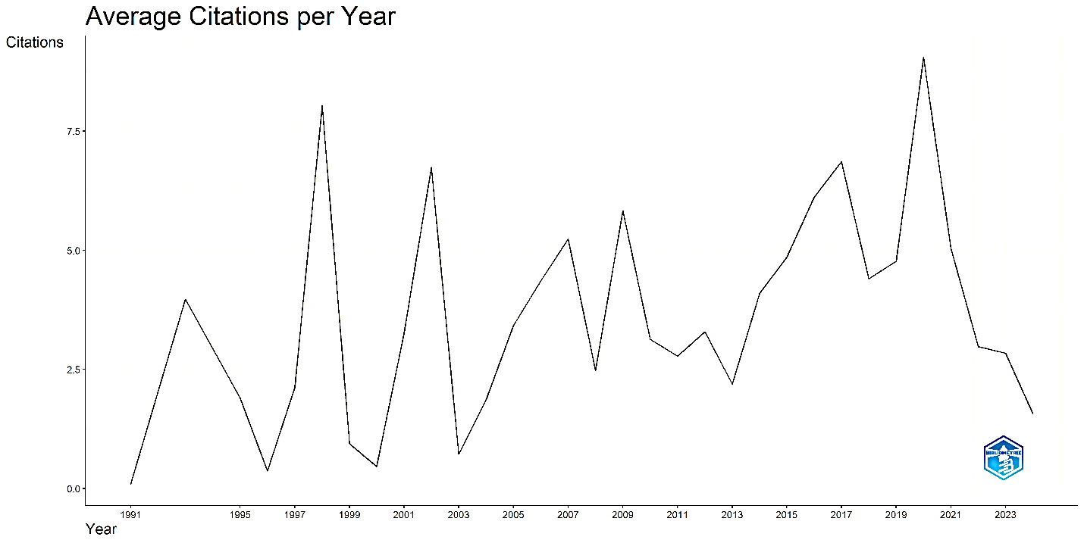
Figure 2: Year-Wise Publication
Source: Authors’ Compilation

  - Country-wise Publication
Country-wise publication analysis shows the contribution of various countries in the development of WIL. In the context of country-wise publication, the analysis shows that the USA emerged as the biggest country with the highest number of publications all over the world. After the USA, the UK emerged as the second country that is continuously working on the concept of work-life integration. Germany is at the 3rd place as it is contributing 8 publications. Netherland and Switzerland are other countries that are working on the concept of work-life integration. The rest of the countries also contributed to the growth of WIL, but relatively less in comparison to the USA and UK (Table 1).

 | Table 1: Country-wise Publications
Serial No | Country | Number of Publication
1 | USA | 36
2 | United Kingdom | 13
3 | Germany | 8
4 | Netherland | 4
5 | Switzerland | 4
6 | Australia | 3
7 | Brazil | 3
8 | Canada | 3
9 | France | 2
10 | Ireland | 2
Source: Authors’ Compilation

Figure 3: Map showing the Country-wise Publication
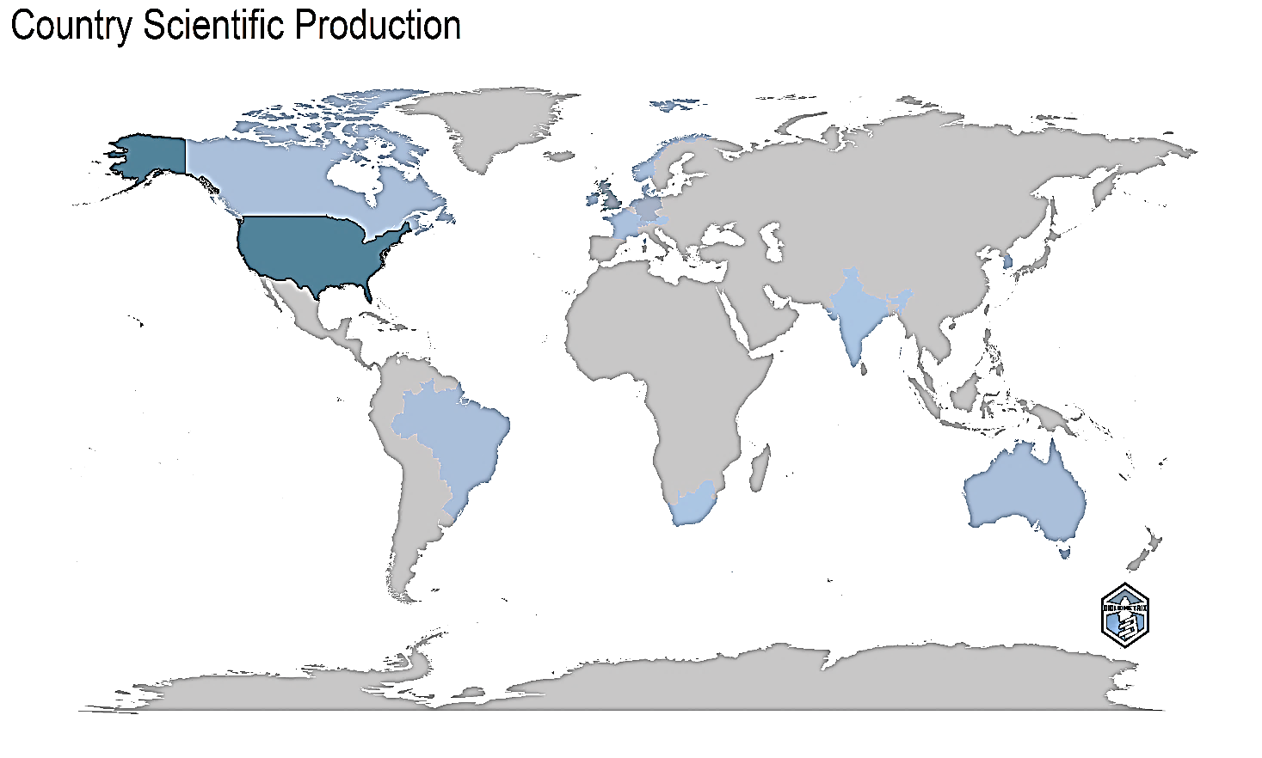
Source: Authors’ compilation

  - Source-wise Publication
Biblioshiny software has been used to extract journal classifications to find the most contributing journals. Table 2 shows the journals that contributed at least 8 articles in this domain. The journals International Journal of Human Resource Management, Journal of Managerial Psychology, International Journal of Manpower and Journal of Business Ethics have contributed 11 or more papers. Details of sources having multiple articles are given in Table 2 & Figure 4.
Table 2: Source-wise Publications
Serial No | Journal | No. of Articles
1 | International Journal of Human Resource Management | 14
2 | Journal of Managerial Psychology | 13
3 | International Journal of Manpower | 11
4 | Journal of Business Ethics | 11
5 | Engineering Construction and Architectural Management | 10
6 | Journal of Nursing Management | 10
7 | Personnel Psychology | 9
8 | Gender Work and Organization | 8
9 | IEEE Transactions on Engineering Management | 8
10 | Management Sciences | 8
Source: Authors’ compilation
Figure 4: Graph showing the Source-wise Publication
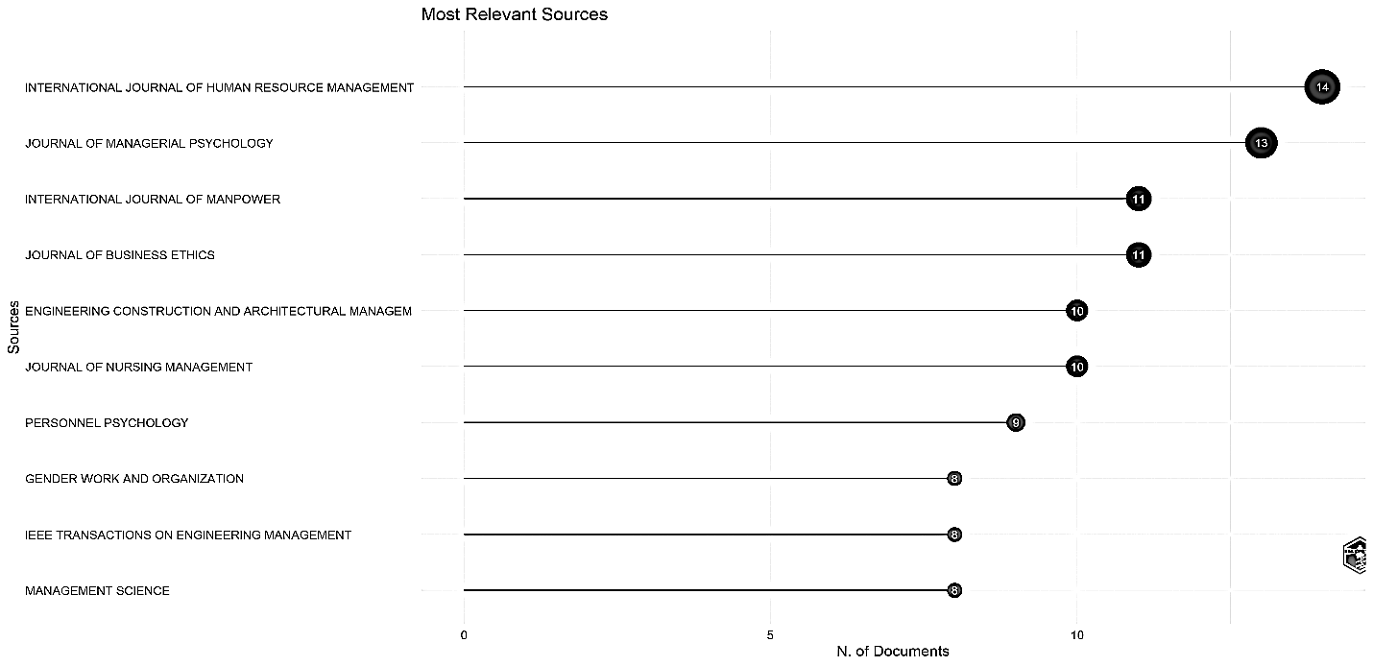
Source: Authors’ compilation
  - Author-wise Publication
From analyzing figure 5, researchers found the contribution of various authors in the field of work-life integration. The highest research work is done by KOSEEK EE from 2000 to 2024. Beauregard has also contributed to the evolution of work-life integration from the year 2008 to 2022. Hammond M has also done work in the development of work-life integration from the year 2014 to 2024. Various other authors have contributed in development of work-life integration. Figure 5 shows the author’s contribution and their respective years.
Figure 5: Author-wise Publication
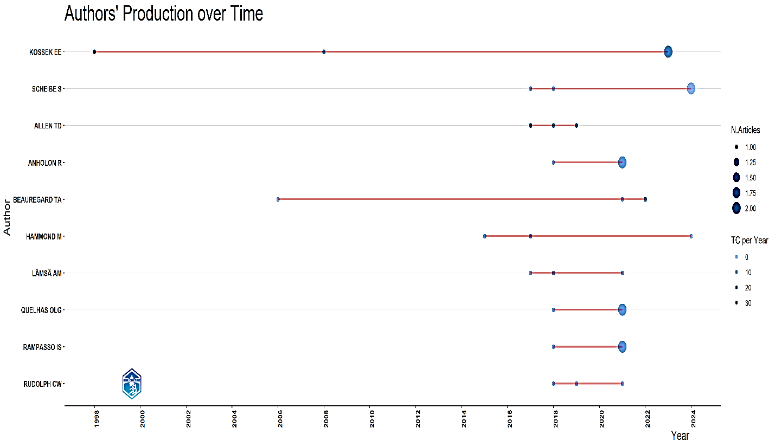
Source: Authors’ Compilation

  - Keywords and Word Cloud Analysis
Keywords are used to identify the themes and the most used words in the papers. In the selected papers, commonly used keywords are identified with the help of Biblioshiny. Table 3 and Figure 6, highlight the major keywords in the field of WLI. It is observed that many keywords are identical in meaning; they have the same meaning but are used in different patterns. The most common keywords used are integration (75), management (75), performance (50), work life (50), family conflict (50), work-life (50), innovation (50), and information (50).
Figure 7 shows word cloud occurrence. The word cloud generated using the Biblioshiny package in R highlights the core keywords— work-life integration intelligence, management framework and impact. Surrounding these central terms, prominent themes include technology consequences, validation framework mode, work-life conflict and family conflict, underscoring their significance in this domain.
 | Table 3: Word Frequency
Serial No | Country | Number of Publication
1 | Integration | 75
2 | Management | 75
3 | Performance | 50
4 | Job satisfaction | 50
5 | Work life | 50
6 | Innovation | 50
7 | Information | 50
8 | Family conflict | 50
Source: Authors’ Compilation

Figure 6: Trending topics

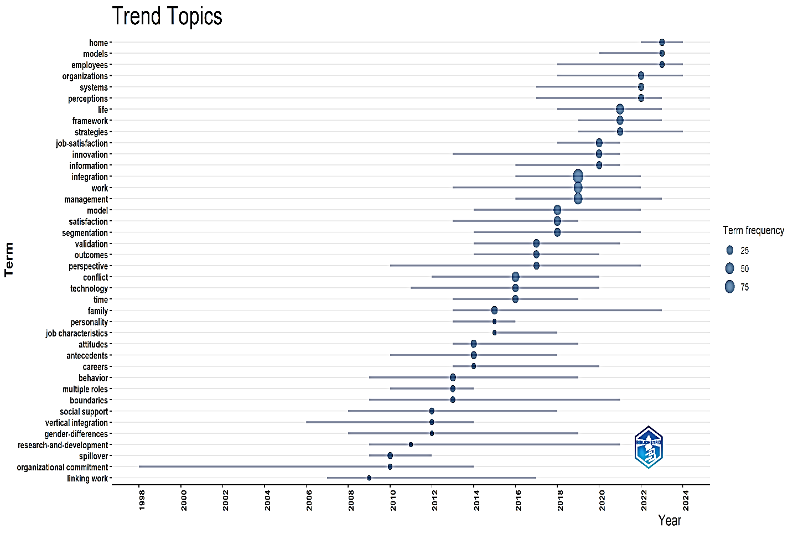
Source: Authors’ Compilation

Figure 7: Word Cloud
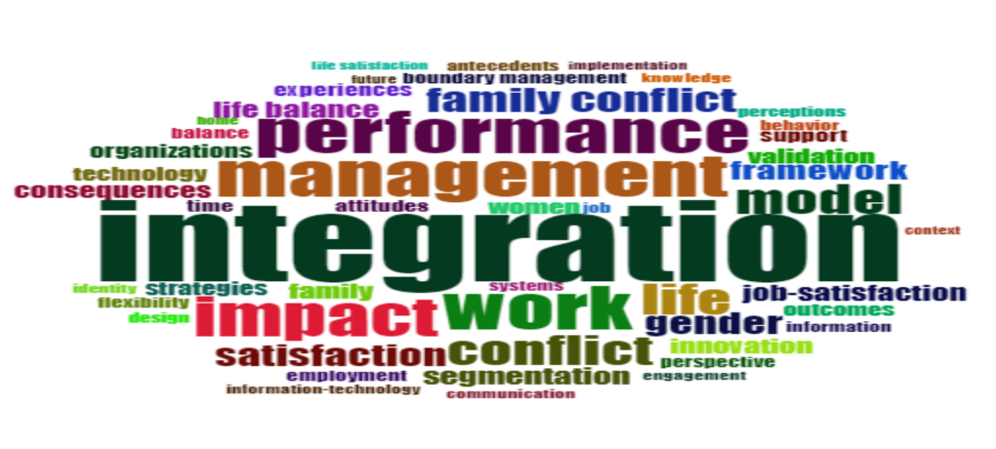
Source: Authors’ Compilation

Figure 8: Keywords Network
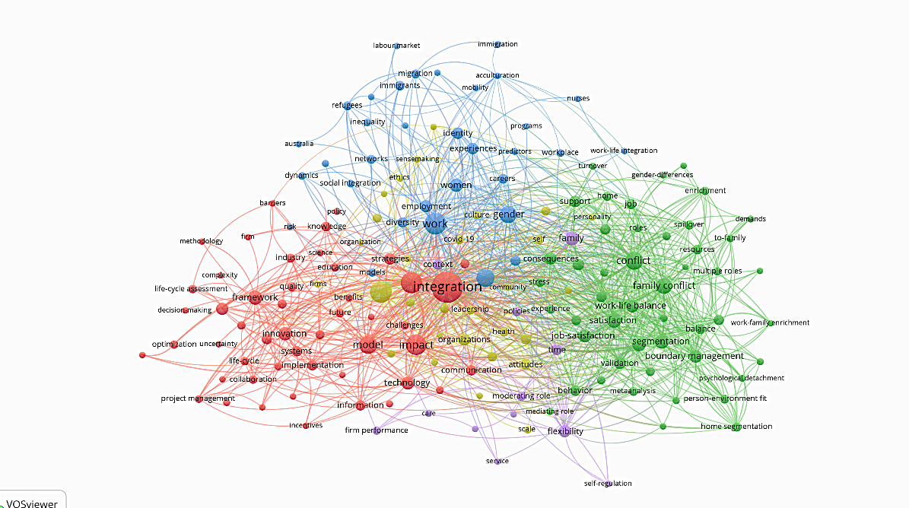
Source: Authors’ Compilation

Key word mapping in Figure 8 displays the keywords used together. ‘Work-life integration’, ‘family conflict’ and ‘work diversity’ have a maximum association with the other keywords. The network mapping shows that work diversity and subsets (organization model, culture, work time) are strongly linked with the terms of WLI and job satisfaction.

- Recent trends in Work-Life Integration

5.1 Factors influencing Work-Life Integration
- Individual factors
An individual’s personal traits and habits influence their work-life integration. Factors such as ‘self-efficacy’ and ‘personal control’ over scheduling and role transitions facilitate more effective integration and reduce strain (Chauhan & Rai, 2024). Moreover, demographic factors such as gender, age, income, education, marital status and whether a person has children influence expectations, role demands, and typical boundary strategies. Additionally, career stage (early, mid, late career) changes both workload and flexibility needs, altering how people can and want to integrate roles.
- Organizational factors
Factors which correspond to the working environment and conditions are organisational factors. The availability and design of ‘flexible work arrangements’ (e.g., telework, flexible hours) are repeatedly identified as core enablers of work–life integration. Similarly, ‘inclusive cultures’ and ‘supervisor’s support’ increase the positive effects of flexibility on both work–life outcomes and productivity (Sirgy & Lee, 2017). The level of workload, performance expectations, and characteristics of being an ideal worker can undermine integration, even in the presence of formal work–life policies.
- Technological factors
Technological changes are inevitable. The changing dynamics through digital technologies (e.g., smartphones, remote access, AI) make integration easier (Allen et al., 2015) but also intensify permeability of boundaries and after-hours work (Como et al., 2021). The extent to which organizations and individuals regulate connectivity (e.g., norms about after-hours email) affects recovery, stress, and sense of control. Technostress, a phenomenon that surfaced as a noteworthy subject in several investigations. Research indicated that although digital tools might improve flexibility and productivity, they also increase technostress among employees (Tarafdar et al., 2007; Salo et al., 2022).
- Socio-cultural factors
An individual is by nature a social animal. Therefore, socio-cultural factors influence individuals at both work-level and personal life settings. Factors like ‘regional disparities’, ‘labor regulations’, and ‘societal norms’ about working time, gender roles, and caregiving, shape what forms of work–life integration are available and acceptable. Social factors such as ‘partners support’, ‘extended family help’, ‘peer influence’ and ‘social networks’ can buffer strain and make complex role combinations more sustainable (Chauhan & Rai, 2024). Additional non-work roles, such as volunteering or community leadership, add demands but can also provide resources (meaning, skills), making the net effect on integration context-dependent.
- Boundary and recovery dynamics
Boundary preferences and tactics (integration vs segmentation) strongly shape how people manage work–nonwork interfaces and their well-being. Alignment between a person’s boundary preference and actual boundary enactment is a central determinant of well-being, neither integration nor segmentation is universally better (Wepfer et al., 2017). Excessive integration without adequate recovery time is associated with fatigue, reduced well-being, and impaired work–life outcomes. The ability to alternate and combine integration and segmentation tactics (e.g., focused office time plus occasional flexible ‘freestyle’ work at home) supports sustainable careers.​ Recovery needs, health concerns, and desire for psychological detachment influence when people choose stricter boundaries versus greater blending of roles.

  - Strategies for improving Work-Life Integration
Based on the reviewed literature, the following suggestions are offered to improve work-life integration:
- Establish Digital Boundaries: Organizations should create policies that limit after-hours communication and support employees in disconnecting from digital tools. Companies can implement flexible/hybrid work policies that specify core hours, meeting windows, and response-time norms so flexibility does not become “always on.” The companies should focus on performance management in terms of outcomes rather than hours, giving employees autonomy to choose when and where they work within clear deliverables.​ Periodically review flexible arrangements (e.g., quarterly check-ins) to adjust workloads, clarify expectations, and can also help to accomplish it and ensure they are helping rather than harming integration.
- Inclusive Organizational Policies: Companies should offer flexible work arrangements, parental leave, and wellness programs that cater to diverse employee needs. It can offer short trainings on psychological detachment (mentally switching off), recovery planning, and self-regulation (planning breaks, shutdown rituals, micro-recovery during the day).​ Use mindfulness-based micro-interventions (brief daily practices) can help employees to notice and let go of work thoughts after hours. These improve detachment and satisfaction with work–life integration.
- Cultural Sensitivity: Employers should consider the cultural context when designing WLI programs, ensuring they align with the social norms of their global workforce. It can be done by designing WLI according to the national culture, labor regulations, and societal norms about working time, gender roles, and caregiving. In multicultural workplaces, employees' preferences for flexible scheduling, remote work, and corporate support systems can be greatly influenced by their views regarding gender roles, family duties, collectivism versus individualism, and time orientation.
- Employee Support Programs: Companies should invest in training programs that help employees develop emotional intelligence, stress management techniques, and time management skills. This can be achieved by training managers to talk explicitly about boundaries (e.g., asking team members about preferred contact times and respecting them) and to model healthy integration themselves (no routine late-night emails). It is also achieved by equipping managers with coaching skills to help employees prioritize tasks, negotiate deadlines, and use existing work–life policies without stigma and include work–life support behaviors (respecting time off, flexible scheduling, fair workload allocation) in leadership evaluations and feedback.
- Health and Well-being Initiatives: Health and well-being initiatives are essential for achieving effective work–life integration, as they directly support employees’ physical, mental, and emotional resilience in balancing professional and personal responsibilities Comprehensive wellness programs that offer preventive healthcare support, stress management workshops, mental health counselling, flexible work schedules, and chances for physical activity both within and outside of the workplace are advised for organisations. To further improve general well-being, it might be helpful to promote digital detox practices, encourage regular breaks, and cultivate a supportive workplace culture that places a high priority on psychological safety.

- Conclusion
This systematic literature review, conducted using the PRISMA framework, provides a comprehensive understanding of the factors influencing work-life integration (WLI). The review identified five critical factors- ‘Individual factors’, ‘Organizational factors’, ‘Technological factors’, ‘Socio-cultural factors’, ‘Boundary and recovery dynamics’—as key contributors to WLI. Each factor plays a nuanced role, either enabling or challenging the integration of work and personal life, depending on how it is managed and contextualized. The study also explores ways to cope up with issues in work-life integration and suggested strategies for improving work-life integration via establishing digital boundaries, developing inclusive organisational policies, organizing employee support programs, managing cultural sensitivity and health & well-being initiatives.
The findings highlight the dual impact of technology: while it offers flexibility and connectivity that facilitate WLI, it also poses challenges like constant connectivity and potential burnout. Organizational policies, when inclusive and well-implemented, emerged as essential enablers of WLI, particularly during periods of heightened remote work adoption. Cultural and social norms were found to significantly influence WLI, underscoring the importance of contextualizing strategies to local socio-cultural settings. Individual traits such as emotional intelligence and resilience proved crucial for effectively managing WLI, while the reciprocal relationship between health and well-being underscored their foundational role in achieving sustainable integration.
The study identified several significant research gaps, such as the need for cross-cultural analyses to comprehend regional and global variations, longitudinal studies to evaluate the evolution of WLI over time, and analyzing the responses of various workforce demographics, such as age and gender, to various WLI interventions and a more thorough examination of how emerging technologies like automation and artificial intelligence (AI) will influence future WLI dynamics. These gaps underline the need to take a multidisciplinary approach to enhance knowledge and progress WLI and suggest important areas for more scholarly investigation.
In conclusion, this study not only synthesizes existing knowledge on WLI but also provides actionable insights for organizations and policymakers. By addressing the challenges and leveraging the opportunities identified in this review, organizations can better support their workforce in achieving effective work-life integration, ultimately fostering greater employee satisfaction, productivity, and well-being.

Disclaimer (Artificial intelligence)

Author(s) hereby declare that NO generative AI technologies such as Large Language Models (ChatGPT, COPILOT, etc.) and text-to-image generators have been used during the writing or editing of this manuscript.

References
- Alex Brianson, 2016. ‘Europa and Gaia: Towards an Ecofeminist Perspective in Integration Theory,’ Journal of Common Market Studies, Wiley Blackwell, vol. 54(1), pages 121-135, January.
- Allen, T. D., Golden, T. D., & Shockley, K. M. (2015). How effective is telecommuting? Assessing the status of our scientific findings. Psychological Science in the Public Interest, 16(2), 40–68. https://doi.org/10.1177/1529100615593273
- Althammer, S. E., Reis, D., Van Der Beek, S., Beck, L., & Michel, A. (2021). A mindfulness intervention promoting work–life balance: How segmentation preference affects changes in detachment, well‐being, and work–life balance. Journal of Occupational and Organizational Psychology, 94(2), 282–308. https://doi.org/10.1111/joop.12346
- Astakhova, M. N., Ho, V. T., & McKay, A. S. (2023). Passion Amid the Pandemic: Applying a Person‐Centered Approach to Examine Cross‐Domain Multi‐Passion Profiles during a Crisis. Journal of Management Studies, 61(4), 1457–1497. https://doi.org/10.1111/joms.12929
- Attridge, M., Herlihy, P.A., & Maiden, R.P. (Eds.). (2005). The Integration of Employee Assistance, Work/Life, and Wellness Services (1st ed.). Routledge. https://doi.org/10.4324/9780203820674
- Basile, K., & Beauregard, T. A. (2018). Oceans apart: work-life boundaries and the effects of an oversupply of segmentation. The International Journal of Human Resource Management, 32(5), 1139–1170. https://doi.org/10.1080/09585192.2018.1512513
- Beauregard, T. A. (2006). Book review: ‘Work and Life Integration: Organizational, Cultural, and Individual Perspectives’. Edited by Ellen Ernst Kossek and Susan J. Lambert. British Journal of Industrial Relations. https://doi.org/10.1111/j.1467-8543.2006.00501_8.x.
- Blair-Loy, Mary. (2005). Review of Ellen Ernst Kosek and Susan J. Lambert, eds., Work and Life Integration: Organizational, Cultural, and Individual Perspectives. Administrative Science Quarterly. 50. 642-644.
- Bussmann, M. (2009). The effect of trade openness on women’s welfare and work life. World Development, 37(6), 1027–1038. https://doi.org/10.1016/j.worlddev.2008.10.007
- Chauhan, P., & Rai, S. (2024). Conceptualizing work-life integration: A review and research agenda. Asia Pacific Management Review, 29(4), 415–426. https://doi.org/10.1016/j.apmrv.2024.10.002
- Como, R., Hambley, L., & Domene, J. (2021). An exploration of work-life wellness and remote work during and beyond COVID-19. Canadian Journal of Career Development, 20(1), 46-56.
- Cruz, D., & Meisenbach, R. (2017). Expanding role boundary management theory: How volunteering highlights contextually shifting strategies and collapsing work–life role boundaries. Human Relations, 71(2), 182–205. https://doi.org/10.1177/0018726717718917
- De Cieri, Helen & Bardoel, E. (2010). Global work-life management in multinational enterprises: A challenge for vertical integration. Universia Business Review. 27. 44-57.
- Foucreault, A., Ollier-Malaterre, A., & Ménard, J. (2016). Organizational culture and work–life integration: A barrier to employees’ respite? The International Journal of Human Resource Management, 29(16), 2378–2398. https://doi.org/10.1080/09585192.2016.1262890
- Golden, A. G. (2009). Employee families and organizations as mutually enacted environments. Management Communication Quarterly, 22(3), 385–415. https://doi.org/10.1177/0893318908327160
- Golden, A. G., & Geisler, C. (2007). Work–life boundary management and the personal digital assistant. Human Relations, 60(3), 519–551. https://doi.org/10.1177/0018726707076698
- Grady, G., & McCarthy, A. M. (2008). Work‐life integration: experiences of mid‐career professional working mothers. Journal of Managerial Psychology, 23(5), 599–622. https://doi.org/10.1108/02683940810884559
- Grote, G., & Guest, D. (2016). The case for reinvigorating quality of working life research. Human Relations, 70(2), 149–167. https://doi.org/10.1177/0018726716654746
- Hammond, D., & Wilby, J. (2006). The life and work of James Grier Miller. Systems Research and Behavioral Science, 23(3), 429–435. https://doi.org/10.1002/sres.738
- Harrington, B., & Ladge, J. J. (2009). Work–Life Integration: Organizational Dynamics, 38(2), 148–157. https://doi.org/10.1016/j.orgdyn.2009.02.003
- Ilies, R., Wilson, K. S., & Wagner, D. T. (2009). The spillover of daily job satisfaction onto employees’ family lives: The facilitating role of Work-Family Integration. Academy of Management Journal, 52(1), 87–102. https://doi.org/10.5465/amj.2009.36461938
- Jones, J., & Jones, A. M. (2013). Managing the gap: Evolutionary science, work/life integration, and corporate responsibility. Organizational Dynamics, 42(4), 262-269.
- Kinman, G., & Jones, F. (2008). Effort‐reward imbalance, over‐commitment and work‐life conflict: testing an expanded model. Journal of Managerial Psychology, 23(3), 236–251. https://doi.org/10.1108/02683940810861365
- Kraeh, A., Bader, K., & Froese, F. J. (2016). Clash of cultures? German Expatriates’ Work-Life Boundary Adjustment in South Korea. Academy of Management Proceedings, 2016(1), 15777. https://doi.org/10.5465/ambpp.2016.15777abstract
- Kreiner, G. E., Hollensbe, E. C., & Sheep, M. L. (2009). Balancing borders and bridges: Negotiating the Work-Home interface via boundary work tactics. Academy of Management Journal, 52(4), 704–730. https://doi.org/10.5465/amj.2009.43669916
- Kumar, S., Sarkar, S., & Chahar, B. (2021). A systematic review of work-life integration and role of flexible work arrangements. International Journal of Organizational Analysis, 31(3), 710–736. https://doi.org/10.1108/ijoa-07-2021-2855
- Lee, E., Chang, J. Y., & Kim, H. (2011). The work–family interface in Korea: can family life enrich work life? The International Journal of Human Resource Management, 22(9), 2032–2053. https://doi.org/10.1080/09585192.2011.573976
- Lee, G. J., & Steele, C. L. (2011). Boundary management of employees’ non-work lives: effects on South African workers’ commitment. South African Journal of Economic and Management Sciences, 12(1), 63–81. https://doi.org/10.4102/sajems.v12i1.261
- Leslie, L. M., King, E. B., & Clair, J. A. (2018). Work-Life Ideologies: The contextual basis and consequences of beliefs about work and life. Academy of Management Review, 44(1), 72–98. https://doi.org/10.5465/amr.2016.0410
- Lobene, E. (2019). Women in management: A framework for sustainable work‐life integration. Alan T. Belasen. New York: Routledge, 2017, 334 pages, $72.95 softcover. Personnel Psychology, 72(3), 479–480. https://doi.org/10.1111/peps.12348
- Major, D. A., Burke, R., & Fiksenbaum, L. M. (2013). Work and family life: revitalizing research and practice. In Edward Elgar Publishing eBooks. https://doi.org/10.4337/9781781009291.00009
- Matilla-Santander, N., Lidón-Moyano, C., González-Marrón, A., Bunch, K., Martín-Sánchez, J. C., & Martínez-Sánchez, J. M. (2017). Attitudes toward working conditions: are European Union workers satisfied with their working hours and work-life balance? Gaceta Sanitaria, 33(2), 162–168. https://doi.org/10.1016/j.gaceta.2017.10.006
- Padhi, M., & Pattnaik, S. (2017). Role of integration-segmentation on work-family interface of insurance sector employees in India. International Journal of Manpower, 38(8), 1114–1129. https://doi.org/10.1108/ijm-02-2014-0051
- Page, M. J., McKenzie, J. E., Bossuyt, P. M., Boutron, I., Hoffmann, T. C., Mulrow, C. D., Shamseer, L., Tetzlaff, J. M., Akl, E. A., Brennan, S. E., Chou, R., Glanville, J., Grimshaw, J. M., Hróbjartsson, A., Lalu, M. M., Li, T., Loder, E. W., Mayo-Wilson, E., McDonald, S., . . . Moher, D. (2021). The PRISMA 2020 statement: an updated guideline for reporting systematic reviews. BMJ, 372, n71. https://doi.org/10.1136/bmj.n71
- Pedersen, V. B., & Lewis, S. (2012). Flexible friends? Flexible working time arrangements, blurred work-life boundaries and friendship. Work Employment and Society, 26(3), 464–480. https://doi.org/10.1177/0950017012438571
- Peters, P., & Blomme, R. J. (2019). Forget about ‘the ideal worker’: A theoretical contribution to the debate on flexible workplace designs, work/life conflict, and opportunities for gender equality. Business Horizons, 62(5), 603–613. https://doi.org/10.1016/j.bushor.2019.04.003
- Polk, D. M. (2008). Intersecting work and family: The influence of relational beliefs and behaviors on work–family integration. Journal of Management & Organization, 14(4), 345–366. https://doi.org/10.1017/s1833367200003138
- Powell, G. N., Greenhaus, J. H., Allen, T. D., & Johnson, R. E. (2018). Introduction to Special Topic Forum: Advancing and Expanding Work-Life Theory from Multiple Perspectives. Academy of Management Review, 44(1), 54–71. https://doi.org/10.5465/amr.2018.0310
- Raddon, A. (2008). Work–Life Integration: International Perspectives on the Balancing of Multiple Roles – Edited by Paul Blyton, Betsy Blunsdon, Ken Reed and Ali Dastmalchian. Gender Work and Organization, 15(6), 677–679. https://doi.org/10.1111/j.1468-0432.2008.00421_3.x
- Ryan, A. M., & Kossek, E. E. (2008). Work‐life policy implementation: Breaking down or creating barriers to inclusiveness? Human Resource Management, 47(2), 295–310. https://doi.org/10.1002/hrm.20213
- Salo, M., Pirkkalainen, H., Chua, C. E. H., & Koskelainen, T. (2022). Formation and mitigation of technostress in the personal use of Information and Technology. MIS Quarterly, 46(2), 1073–1108. https://doi.org/10.25300/misq/2022/14950
- Sanséau, P., & Smith, M. (2012). Regulatory change and work‐life integration in France and the UK. Personnel Review, 41(4), 470–486. https://doi.org/10.1108/00483481211229384
- Sirgy, M. J., & Lee, D. (2017). Work-Life Balance: An Integrative Review. Applied Research in Quality of Life, 13(1), 229–254. https://doi.org/10.1007/s11482-017-9509-8
- Spieler, I., Scheibe, S., & Roßnagel, C. S. (2018). Keeping work and private life apart: Age‐related differences in managing the work–nonwork interface. Journal of Organizational Behavior, 39(10), 1233–1251. https://doi.org/10.1002/job.2283
- Stonebraker, P. W., & Liao, J. (2004). Environmental turbulence, strategic orientation. International Journal of Operations & Production Management, 24(10), 1037–1054. https://doi.org/10.1108/01443570410558067
- Stonebraker, P. W., & Liao, J. (2006). Supply chain integration: exploring product and environmental contingencies. Supply Chain Management an International Journal, 11(1), 34–43. https://doi.org/10.1108/13598540610642457
- Tahir, R. (2024). Integration of work and life roles: an interpretive study of women entrepreneurs in the United Arab Emirates. Cross Cultural & Strategic Management, 31(2), 309–334. https://doi.org/10.1108/ccsm-06-2023-0104
- Tang, N., & Cousins, C. (2005). Working Time, Gender and Family: An East‐West European comparison. Gender Work and Organization, 12(6), 527–550. https://doi.org/10.1111/j.1468-0432.2005.00287.x
- Tarafdar, M., Tu, Q., Ragu-Nathan, B. S., & Ragu-Nathan, T. S. (2007). The impact of technostress on role stress and productivity. Journal of Management Information Systems, 24(1), 301–328. https://doi.org/10.2753/mis0742-1222240109
- Tomlinson, J. (2007). Book review: Flexible working and Organizational Change. Work Employment and Society, 21(1), 165–167. https://doi.org/10.1177/095001700702100115
- Unger, D., Kornblum, A., Grote, G., & Hirschi, A. (2022). Boundaries for career success? How work–home integration and perceived supervisor expectation affect careers. Journal of Occupational and Organizational Psychology, 96(1), 144–164. https://doi.org/10.1111/joop.12416
- Von Borell De Araujo, B. F., Tureta, C. A., & Von Borell De Araujo, D. A. (2015). How do working mothers negotiate the work-home interface? Journal of Managerial Psychology, 30(5), 565–581. https://doi.org/10.1108/jmp-11-2013-0375
- Weiss, S., & Ortlieb, R. (2024). Professional–personal boundary work: Individuals torn between integration and segmentation. German Journal of Human Resource Management, 39(2), 121–147. https://doi.org/10.1177/23970022241291503
- Wepfer, A. G., Allen, T. D., Brauchli, R., Jenny, G. J., & Bauer, G. F. (2017). Work-Life Boundaries and Well-Being: Does Work-to-Life Integration Impair Well-Being through Lack of Recovery? Journal of Business and Psychology, 33(6), 727–740. https://doi.org/10.1007/s10869-017-9520-y
- Nor Sham, N. I. S., Salleh, R., Sheikh, S. S. S., & Saleem, M. S. (2025). Work-life balance and work-life integration: A comparative analysis through conceptual distinction. Business Management and Strategy, 16(1), 39–52. https://doi.org/10.5296/bms.v16i1.22332
- Malasig, G. A., & Jr., L. C. (2025). The Effect of Work-life Integration on Productivity and Job Satisfaction of Private and Government Bank Employees in Metro Manila: A Multigroup Analysis. Journal of Economics, Management and Trade, 31(2), 31–49. https://doi.org/10.9734/jemt/2025/v31i21272
- Yadav, A., Pandita, D., & Singh, S. (2022). Work-life integration, job contentment, employee engagement and its impact on organizational effectiveness: a systematic literature review. Industrial and Commercial Training, 54(3), 509–527. https://doi.org/10.1108/ict-12-2021-0083
- ‌Mushtaq, Seerat, Ishret Fayaz, and Ajaz Akbar Mir. 2025. “Work-Life Balance and Employee Performance: The Mediating Role of Self-Efficacy”. Asian Journal of Economics, Business and Accounting 25 (9):454-66. https://doi.org/10.9734/ajeba/2025/v25i91986.
- Udin, U. (2023). The Impact of Work-Life Balance on Employee Performance: Mediating Role of Affective Commitment and Job Satisfaction. International Journal of Sustainable Development & Planning, 18(11).https://doi.org/10.18280/ijsdp.181131

