Knowledge, Perception, and Attitude Towards Pulp
Revascularisation Among Dental Students and Private Practitioners: A Questionnaire-Based Study
ABSTRACT:
Aims: To assess awareness, clinical understanding, and attitudes toward pulp revascularisation among dental students and private practitioners.
Study design: Original study
Methodology: A cross-sectional questionnaire survey was conducted among 196 respondents. The questionnaire included demographic details and items assessing familiarity with pulp revascularisation, indications, clinical protocol, materials used, perceived reliability, barriers to practice, and educational needs. Data were analysed using descriptive statistics and expressed as frequencies and percentages.
Results: Most participants were younger than 24 years (76.5%) and female (61.7%). Although 70.9% were somewhat or very familiar with pulp revascularisation, only 27.0% had actually performed the procedure. Immature permanent teeth with necrotic pulp were correctly identified as the most suitable indication by 41.0% of respondents. Limited clinical exposure (44.4%) and lack of knowledge (25.5%) were the most frequently reported barriers.
Conclusion: The findings reveal moderate theoretical awareness but limited clinical exposure to pulp revascularisation. Incorporation of hands-on workshops and clinical postings into undergraduate and postgraduate training could improve competence and acceptance of regenerative endodontic procedures.

Keywords:Pulp revascularisation, regenerative endodontics, knowledge attitude perception, dental students, survey

1.INTRODUCTION
Regenerative endodontics has emerged as a biologically driven alternative to traditional root canal therapy, especially for treating necrotic immature permanent teeth. Among regenerative methods, pulp revascularization, also known as revitalization or regenerative endodontic procedure (REP), aims to restore a functional pulp–dentin complex. It promotes continued root development and improves long-term tooth survival instead of just disinfecting and filling the canal space[1,2].This shift from replacement to regeneration reflects progress in stem-cell biology, tissue engineering, and our understanding of apical papilla–derived progenitor cells that can repopulate the canal when the right biological conditions are created[3].
Clinically, pulp revascularization usually involves little or no mechanical instrumentation, extensive irrigation, and the use of intracanal medications like calcium hydroxide or antibiotic pastes. It also requires inducing apical bleeding to create a scaffold and sealing the coronal part with biocompatible materials like mineral trioxide aggregate or bioceramics[4,5]. Favorable outcomes reported in the literature include resolution of periapical issues, increased root length, thicker dentinal walls, and, in some cases, recovery of sensitivity responses[6]. Since immature teeth with necrotic pulps are structurally weak and prone to fracture, these regenerative results may provide a significant advantage over conventional apexification procedures that only create an apical barrier without strengthening the root[7].
Over the last twenty years, organizations such as the American Association of Endodontists (AAE) and the European Society of Endodontology (ESE) have published clinical guidelines and position statements to standardize indications, case selection, and steps for regenerative endodontic therapy[8,9] Still, despite growing research and inclusion in undergraduate and postgraduate programs, routine clinical practice varies. There are differences in clinicians’ choices of irrigants, intracanal medications, scaffold induction
methods, and criteria for success. These variations reflect both evolving evidence and different levels of familiarity with the protocols.[10]
Knowledge, perception, and attitude play key roles in whether an evidence-based procedure is adopted in daily practice. Dental students, as future practitioners, have their undergraduate experiences shape their long-term clinical behavior. At the same time, private practitioners must balance scientific recommendations with patient expectations, costs, and practical considerations. Limited awareness or misconceptions about the indications, biological reasons, or possible complications—like crown discoloration, canal calcification, or uncertain pulp vitality—can hinder the acceptance of pulp revascularization, even when guidelines exist.[11]Conversely, positive views on its regenerative potential and confidence in the procedures may encourage clinicians to opt for it over more traditional methods.
Questionnaire-based surveys have become useful for evaluating cognitive and behavioral aspects among dental populations. Previous studies in various regions have shown moderate to varied awareness of regenerative endodontics, gaps in understanding current protocols, and differences between students, general dentists, and specialists regarding their willingness to perform pulp revascularization[12-14]. However, these findings are influenced by educational exposure, the availability of continuing professional development programs, and local clinical practice trends, highlighting the need for region-specific data.
It is essential to assess knowledge, perception, and attitudes toward pulp revascularization among dental students and private practitioners. This evaluation can help identify educational gaps, inform curriculum design, and guide targeted training efforts. Understanding these factors may also assist policymakers and professional organizations in promoting standardized, evidence-based adoption of regenerative endodontic procedures. This questionnaire-based study aims to assess awareness of biological principles and clinical protocols, measure perceptions of efficacy and limitations, and explore attitudes toward including pulp revascularization in everyday practice among these two key professional groups.
2.MATERIALS AND METHODS:
2.1 STUDY DESIGN AND POPULATION:
A cross-sectional questionnaire-based study was conducted among dental students and private dental practitioners. The study population included compulsory rotatory interns (CRIs), postgraduate students, dental specialists, and private practitioners from various clinical backgrounds.
2.2 SAMPLE SIZE:
A total of 196 participants voluntarily participated in the study. Both male and female respondents belonging to different age groups and professional qualifications were included.
2.3 QUESTIONAIRE DESIGN:
A self-administered, close-ended questionnaire was developed after reviewing relevant literature on regenerative endodontics. The questionnaire consisted of four sections assessing:
  - Demographic details (age, gender, qualification)
  - Knowledge related to pulp revascularisation
  - Perception regarding indications, materials, and outcomes
  - Attitude toward clinical practice, training, and perceived barrier
  - The questionnaire included multiple-choice questions and statements assessed using a Likert scale.
2.4 DATA COLLECTION:
The questionnaire was distributed electronically. Informed consent was obtained prior to participation. Confidentiality and anonymity of responses were strictly maintained throughout the study.
2.5 STATISTICAL ANALYSIS:
Collected data were entered into Microsoft Excel and analyzed using the Statistical Package for the Social Sciences (SPSS) software Descriptive statistics were used to summarize the data. Frequencies and percentages were calculated for categorical variables. Results were presented in tables and figures for better interpretation. A p-value of p<.05 was considered statistically significant wherever applicable.

3.RESULTS AND DISCUSSION:
A total of 196 participants responded to the questionnaire assessing knowledge, perception, and attitude toward pulp revascularisation among dental students and private practitioners. The demographic analysis revealed that the majority of participants were below 24 years of age (76.5%), followed by those aged 25–30 years (19.4%). Female respondents constituted 61.7% of the study population, while males accounted for 38.3%.
With regard to professional qualification, Compulsory Rotatory Interns (CRIs) represented the largest group (66.8%), followed by postgraduate students (17.3%), pedodontists (7.7%), and private practitioners (3.6%). Other dental specialists formed a smaller proportion of the respondents.
A clinically relevant pattern between subgroups was observed: dental students exhibited greater theoretical awareness of pulp revascularisation, whereas private practitioners reported lower familiarity with current protocols but expressed more concerns regarding clinical predictability and procedural complexity.
In terms of awareness, 70.9% of participants reported being either somewhat familiar (35.7%) or very familiar (35.2%) with pulp revascularisation. About 18.4% had only heard of the procedure, while 10.7% were not familiar with it. Most respondents correctly identified immature permanent teeth with necrotic pulp as the most suitable indication for pulp revascularisation (40.99%).
Most participants demonstrated a positive attitude towards pulp revascularization with a majority considering it a reliable treatment option for immature permanent teeth despite limited clinical experience.
Knowledge regarding procedural steps showed variation, with 53.6% of participants selecting the correct clinical sequence involving access opening, pulp extirpation, intracanal medicament placement, over-instrumentation, and coronal sealing. Sodium hypochlorite (34.66%) and EDTA (33.21%) were the most commonly preferred irrigants. Triple antibiotic paste (42.97%) and calcium hydroxide (36.55%) were the most frequently selected intracanal medicaments.
Regarding tissue regeneration, 49.0% of respondents believed that multiple tissue types could regenerate following pulp revascularisation. A majority of participants agreed or strongly agreed that pulp revascularisation is a reliable treatment option for immature permanent teeth (78.6%). However, opinions were divided regarding its use in mature permanent teeth, with 46.4% agreeing or strongly agreeing.
Most respondents perceived pulp revascularisation as more technique-sensitive than conventional root canal therapy (76.5%) and believed it offers better long-term outcomes compared to apexification (65.8%). Despite these positive perceptions, 65.8% of participants had never performed a pulp revascularisation procedure.
The most commonly reported barriers to clinical implementation were limited clinical exposure (44.4%), lack of knowledge (25.5%), and unpredictable outcomes (25.0%). Participants indicated that hands-on workshops (30.46%) and case demonstrations (26.72%) would be the most effective methods to improve understanding and clinical application of pulp revascularisation

Figure 1. Indications for Pulp Revascularisation
This figure depicts participants’ responses regarding the most suitable teeth for pulp revascularisation. Most respondents correctly identified immature permanent teeth with necrotic pulp as the primary indication.

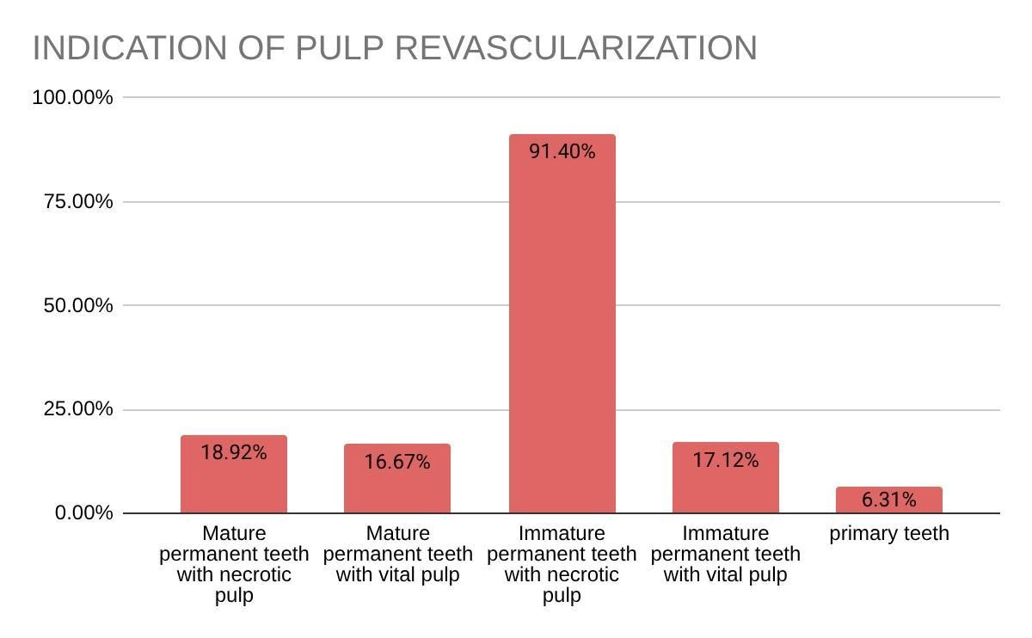

Figure 2:Perceived Reliability of Pulp Revascularisation for Immature Permanent Teeth This figure represents respondents’ attitudes toward the reliability of pulp revascularisation in immature permanent teeth. A large proportion agreed or strongly agreed that it is a reliable treatment option.

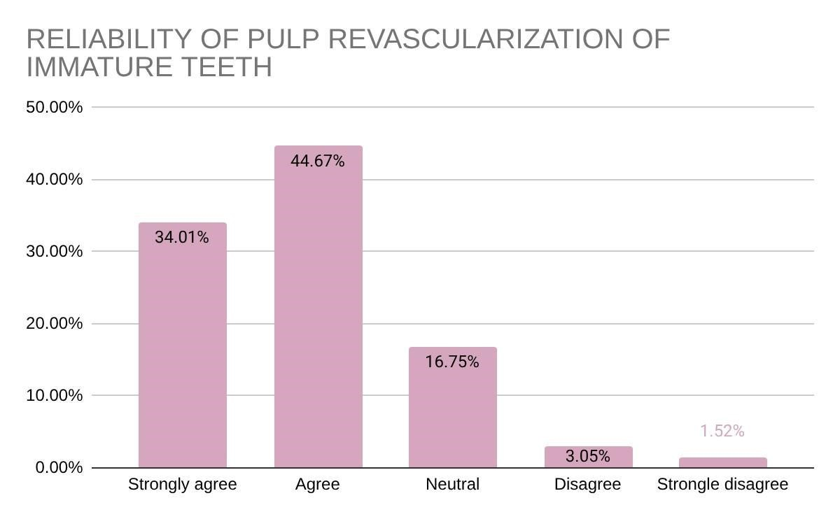

Figure 3. Barriers to Clinical Use of Pulp Revascularisation
This figure presents the perceived barriers to clinical implementation of pulp revascularisation. Limited clinical exposure was identified as the most significant barrier, followed by lack of knowledge and unpredictable outcomes.

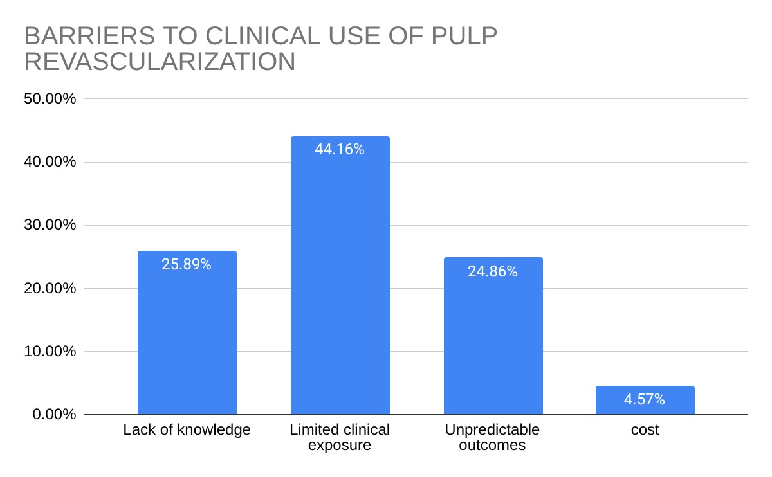

Figure4.Preferred Methods to Improve Knowledge of Pulp Revascularisation This figure highlights respondents’ preferences for improving knowledge and skills related to pulp revascularisation. Hands-on workshops and case demonstrations were the most favored methods
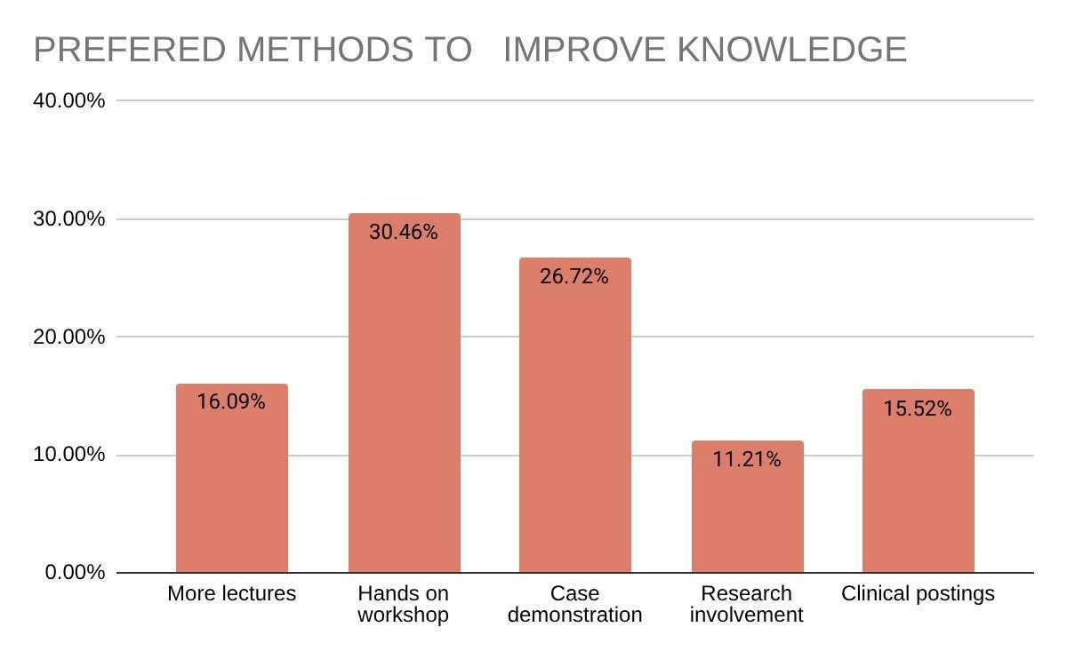

DISCUSSION:
This questionnaire-based survey assessed knowledge, perception, and attitudes toward pulp revascularization among dental students and private practitioners. It highlights how well regenerative endodontic concepts have entered current clinical education and practice. As regenerative endodontics becomes more recognized as a biologically focused alternative to traditional apexification, it is crucial to understand professional awareness and acceptance to improve patient outcomes[2,15,16]
The findings show that while most respondents had heard of pulp revascularization or regenerative endodontic therapy, their depth of knowledge, confidence in performing the procedure, and willingness to adopt it varied. These trends align with earlier surveys that showed moderate theoretical understanding but limited hands-on experience and uncertainty about protocols and outcomes[17-19].This gap between awareness and practical readiness reveals the ongoing disconnect between new research and clinical application.
In this study, dental students generally showed greater awareness of the biological principles behind pulp revascularization. They understood the role of stem cells from the apical papilla, the formation of scaffolds through induced bleeding, and the importance of growth factors released from dentin after EDTA irrigation. These findings likely reflect an increase in the inclusion of regenerative concepts into undergraduate and postgraduate programs, textbooks, and continuing education over the last decade[9,16].However, even among students, confusion about case selection, irrigation regimens, and intracanal medications indicates that teaching may still be largely theoretical, with limited practical exposure to actual regenerative cases.[29,30]
Private practitioners, in contrast, often displayed less familiarity with current guidelines and expressed hesitance to adopt pulp revascularization as a routine practice. Previous surveys reported similar concerns, where clinicians mentioned a lack of training, unpredictable outcomes, procedural complexity, and legal considerations as key barriers[17,20]. Such worries are understandable since regenerative endodontic therapy is technique-sensitive and its outcomes can vary, particularly regarding the characteristics of newly formed intracanal tissue and long-term pulp vitality[21,22].The findings point to the need for structured continuing education programs that provide both theoretical instruction and supervised clinical experience.
Both groups viewed pulp revascularization positively in terms of its clinical usefulness. Many respondents acknowledged its potential benefits over traditional apexification, such as continued root maturation, thickening of dentin walls, and lower risk of cervical fractures. These perceived advantages are supported by clinical and radiographic studies comparing revascularization with calcium hydroxide or MTA apexification[23,24]For instance, Jeeruphan et al. found significantly greater increases in root length and dentin wall thickness after revascularization, reinforcing its biological benefits for immature necrotic teeth[23] This evidence likely contributes to the favorable views expressed by respondents, even if real clinical use remains limited.
Despite this optimism, respondents commonly raised concerns about complications, particularly tooth discoloration, reinfection, and difficulties in achieving adequate intracanal bleeding. Tooth discoloration is often linked to the use of minocycline-containing triple antibiotic paste or the placement of mineral trioxide aggregate in the upper part of the canal[25].The persistence of this issue in respondents' views suggests that awareness of newer strategies, like replacing minocycline with alternative antibiotics, limiting medicament placement, or using other calcium silicate materials, may not yet be widespread[25,26].Updating teaching materials to address these practical concerns could boost clinicians' confidence in providing regenerative treatments.
Another key finding was uncertainty about the predictability and long-term success of pulp revascularization. This skepticism mirrors what exists in the literature, where studies indicate that the tissue formed inside the canal may often resemble periodontal ligament-like tissue, cementum, or bone rather than genuine pulp tissue[21,27].Although clinical success, defined by symptom resolution and radiographic healing, is high, the biological difference between regeneration and repair remains debated, which may affect practitioners' willingness to recommend the procedure to patients[22,27]. Highlighting realistic outcome expectations and current evidence during training could help reduce these doubts.
The comparison between dental students and private practitioners sheds light on important educational implications. Students' greater familiarity with guidelines from professional organizations, such as the American Association of Endodontists and the European Society of Endodontology, suggests that academic settings promote exposure to consensus statements and updated protocols[9,28].On the other hand, practitioners who finished their formal education before regenerative endodontics gained recognition may primarily depend on continuing education courses or journal articles for updates, which are not always accessible. These findings stress the importance of lifelong learning and making evidence-based training available to ensure that established clinicians stay up to date with new developments.
Assessment of attitudes in this study revealed that willingness to perform pulp revascularization was strongly influenced by perceived training quality and institutional support. Respondents who attended workshops or clinical demonstrations were more likely to consider performing the procedure independently. This aligns with earlier surveys that connected educational exposure to positive attitudes and intentions to adopt new practices[18,19].This relationship underscores the vital role of hands-on learning in bridging the gap between knowledge and practice, suggesting that incorporating regenerative cases into clinical training and specialty programs could speed up acceptance.
From a broader perspective, these results have implications for curriculum development and policy-making. Regulatory bodies and dental councils increasingly emphasize competency-based education. Therefore, including regenerative endodontics in undergraduate and postgraduate competencies may be justified, given its growing evidence base and clinical importance. Standardized teaching on case selection, disinfection protocols, choice of medications, sealing methods, and follow-up assessments could ensure a consistent baseline of knowledge across different institutions. Additionally, cooperation among endodontists, pediatric dentists, and dental educators could help integrate regenerative concepts into trauma management and pediatric endodontic training, where immature necrotic teeth are commonly encountered[2,23].
The questionnaire design of this study provides useful insights into current trends in awareness and attitudes. Nevertheless, some limitations should be acknowledged.
Self-reported responses may reflect social desirability bias, leading participants to exaggerate their knowledge or positive perceptions of pulp revascularization. Additionally, knowledge scores from multiple-choice questions might not accurately reflect true clinical skills. The sample distribution, geographic concentration, and voluntary participation could also affect the generalizability of the findings to the wider dental community. Future studies across multiple centers, with larger and more diverse groups and objective evaluations, such as case-based assessments, could provide deeper insights into readiness for regenerative procedures.
Long-term research assessing changes in knowledge and attitudes after targeted educational interventions would also be beneficial. Examining the effects of workshops, online modules, and hands-on training programs could guide strategies for improving clinical adoption. Furthermore, linking survey responses to actual case numbers performed by practitioners could clarify how perception relates to real-world application.
CONCLUSION:
This study shows that while awareness and perceived value of pulp revascularization among dental students and private practitioners are generally positive, there are significant gaps in detailed knowledge, procedural confidence, and routine application. Dental students seem more familiar with current concepts and guidelines, while private practitioners often show more hesitancy, mainly due to limited training and concerns about predictability and complications. By addressing these gaps through curriculum improvements, structured continuing education, and updates to clinical protocols, we can encourage broader, evidence-based adoption of regenerative endodontic therapy. These efforts are crucial to ensure that the biological benefits of pulp revascularization are consistently realized in everyday dental practice
ACKNOWLEDGEMENTS:
No funding sponsors were involved.
DISCLAIMER:
Author(s) hereby declare that no generative AI technologies such as large languages.models(chatGPT,COPILOT etc.)and test to image generators have been used during the writing or editing of this manuscript.
CONSENT AND ETHICAL APPROVAL:
It is not applicable
COMPETING INTEREST:
Authors have declared that competing interests exist.
REFERENCES:
1.Hargreaves KM, Diogenes A, Teixeira FB. Treatment options: biological basis of regenerative endodontic procedures. Pediatr Dent. 2013;35(2):129-40.
2.Murray PE, Garcia-Godoy F, Hargreaves KM. Regenerative endodontics: a review of current status and a call for action. J Endod. 2007;33(4):377-90.
3.Sonoyama W, Liu Y, Fang D, Yamaza T, Seo BM, Zhang C, et al. Mesenchymal stem cell– mediated functional tooth regeneration in swine. PLoS One. 2006;1:e79.
4.Banchs F, Trope M. Revascularization of immature permanent teeth with apical periodontitis: new treatment protocol? J Endod. 2004;30(4):196-200.
5.Lovelace TW, Henry MA, Hargreaves KM, Diogenes A. Evaluation of the delivery of mesenchymal stem cells into the root canal space of necrotic immature teeth after clinical regenerative endodontic procedure. J Endod. 2011;37(2):133-8.
6.Alobaid AS, Cortes LM, Lo J, Nguyen TT, Albert J, Abu-Melha AS, et al. Radiographic and clinical outcomes of regenerative endodontic procedures: a systematic review. J Endod. 2014;40(11):1733-41.
7.Rafter M. Apexification: a review. Dent Traumatol. 2005;21(1):1-8.
8.American Association of Endodontists. Clinical considerations for regenerative procedures. Chicago: AAE; 2018.
9.European Society of Endodontology. Position statement: revitalization procedures. Int Endod J. 2016;49(8):717-23.
10.Kontakiotis EG, Filippatos CG, Agrafioti A. Regenerative endodontic therapy: a data analysis of clinical protocols. J Endod. 2015;41(2):146-54.
11.Nagata JY, Gomes BPFA, Rocha Lima TF, Murakami LS, de Faria DE, Campos GR, et al. Traumatized immature teeth treated with regenerative endodontic procedures: clinical and radiographic outcomes. J Endod. 2014;40(7):957-64.
12.Manguno C, Murray PE, Howard C, Mungara J, Namerow K. A survey of dental residents’ awareness and knowledge of regenerative endodontics. J Endod. 2012;38(3):304-10.
13.Al-Zubaydi AH, Al-Huwaizi AF. Knowledge and attitude of dental students toward regenerative endodontics. Mustansiria Dent J. 2019;16(1):45-52.
14.Saoud TMA, Sigurdsson A, Rosenberg PA, Lin LM, Ricucci D, Kahler B. Treatment of a large cyst-like inflammatory periapical lesion associated with mature necrotic teeth using regenerative endodontic therapy. J Endod. 2014;40(12):2081-6.
15.Frank AL. Therapy for the divergent pulpless tooth by continued apical formation. J Am Dent Assoc. 1966;72(1):87-93.
16.Hargreaves KM, Geisler T, Henry M, Wang Y. Regeneration potential of the young permanent tooth. Pediatr Dent. 2008;30(3):253-60.
17.Epelman I, Murray PE, Garcia-Godoy F, Kuttler S, Namerow KN. Practitioner survey toward regenerative endodontics. J Endod. 2009;35(9):1204-10.
18.Manguno C, Murray PE, Howard C, Madras J, Mangan S, Namerow K. Dental residents’ expectations for regenerative endodontics. J Endod. 2012;38(2):137-43.
19.Alrahabi M, Younes HB. Knowledge and attitudes of dentists regarding regenerative endodontics. Saudi Endod J. 2016;6(2):69-75.
20.Kim SG, Malek M, Sigurdsson A, Lin LM, Kahler B. Regenerative endodontics: a comprehensive review. Int Endod J. 2018;51(12):1367-88.
21.Lin LM, Rosenberg PA. Repair and regeneration in endodontics. Int Endod J. 2011;44(10):889906.
22.Torabinejad M, Faras H, Corr R, Wright K, Shabahang S. Histologic examinations of teeth treated with regenerative techniques. J Endod. 2014;40(10):1536-41.
23.Jeeruphan T, Jantarat J, Yanpiset K, Suwannapan L, Khewsawai P, Hargreaves KM. Radiographic outcomes of apexification versus revascularization. J Endod.
2012;38(10):1330-6.
24.Andreasen JO, Farik B, Munksgaard EC. Long-term calcium hydroxide dressing and root fracture risk. Dent Traumatol. 2002;18(3):134-7.
25.Kahler B, Rossi-Fedele G. Tooth discoloration after regenerative endodontic therapy. J Endod. 2016;42(4):563-9.
26.Akcay M, Arslan H, Yasa B, Kavrik F, Yasa E. Spectrophotometric analysis of discoloration after regenerative procedures. J Endod. 2014;40(7):845-8.
27.Wang X, Thibodeau B, Trope M, Lin LM, Huang GTJ. Histologic characterization of regenerated tissues. J Endod. 2010;36(1):56-63.
28. American Association of Endodontists. Clinical considerations for regenerative procedures. Chicago: AAE; 2016.
29.Sabeti, M., Ghobrial, D., Zanjir, M., da Costa, B.R., Young, Y. & Azarpazhooh, A. (2024) Treatment outcomes of regenerative endodontic therapy in immature permanent teeth with pulpal necrosis: A systematic review and network meta-analysis. International Endodontic Journal, 57, 238–255.
30. Mayya A, Naik R, Paul MP, Amin S, Mayya SS. Knowledge, Attitude, and Perception Among Endodontists Toward Regenerative Endodontics: A Cross-sectional Survey of Four Indian Universities. J Int Soc Prev Community Dent. 2021 Jan 30;11(1):68-76. doi:
10.4103/jispcd.JISPCD_366_20. PMID: 33688475; PMCID: PMC7934828

