Assessment of Knowledge, Attitude, and Practice Toward Oral Cancer Screening Among Dental Practitioners in
Chengalpattu, Tamil Nadu :A cross
sectional study

Abstract
Background: Oral cancer is a significant public health issue in India, especially in areas with high tobacco use. Early detection through routine oral screening significantly improves survival outcomes. Dental professionals are essential for diagnosing the disease early.
Aim: To evaluate the knowledge, attitude, and practice toward oral cancer screening among dental practitioners in the Chengalpattu population.

Materials and Methods: A cross-sectional questionnaire-based study was conducted among 105 dental practitioners practicing in and around Chengalpattu. Data were analyzed using descriptive statistics, Chi-square test, one-way ANOVA, and Pearson correlation.
Results: Most dental practitioners in the Chengalpattu population showed good knowledge of the risk factors and early signs of oral cancer. They had a Positive attitude toward screening, but their routine screening practices were inconsistent.
Conclusion: Knowledge levels among dental practitioners in the Chengalpattu population were satisfactory; however, training programs are needed to improve clinical practice.
Keywords: Oral cancer, screening, knowledge, attitude, practice,chengalpattu, dental practitioners.

Introduction

Oral cancer is one of the most common types of cancer in the head and neck area, and it continues to be a major public health challenge worldwide. According to recent global cancer estimates, lip and oral cavity cancers remain highly prevalent in South and Southeast Asia.India accounts for a significant proportion of global oral cancer burden due to high prevalence of tobacco chewing, smoking, alcohol consumption, and betel quid usage. Despite improvements in diagnostic and therapeutic modalities, the overall five-year survival rate for oral cancer remains approximately 50–60%, largely because many cases are diagnosed at advanced stages.Early detection of oral cancer is crucial because survival rates drastically decrease when the disease is diagnosed at advanced stages[1].

Oral cancer often develops from oral potentially malignant disorders such like leukoplakia, erythroplakia, oral submucous fibrosis, and lichen planus. These lesions are usually asymptomatic in early stages, which contributes to delayed diagnosis[7].Routine oral screening by dental practitioners plays a vital role in early detection and prevention of disease progression[6].Dental practitioners are usually the first healthcare professionals to examine the oral cavity regularly. Therefore, they are in a unique position to identify suspicious lesions, counsel patients regarding risk factor modification, and ensure early referral for biopsy and histopathological examination. Effective screening requires adequate knowledge, positive professional attitude, and consistent clinical practice[4,5].
Routine opportunistic oral cancer screening by dental practitioners plays a pivotal role in early detection and prevention of disease progression[17]. Visual examination combined with palpation remains the primary screening method, while biopsy and histopathological assessment continue to be the gold standard for definitive diagnosis[22].

Dental practitioners are typically the first healthcare professionals to examine the oral cavity on a regular basis, positioning them uniquely for early identification of suspicious lesions, counseling on risk factor modification, and timely referral for further investigation. Emerging evidence also suggests that structured screening protocols and continuing professional education significantly enhance diagnostic confidence and screening frequency among dental practitioners[16,20] However, several studies continue to report inconsistencies between knowledge and actual clinical screening behaviors, particularly in resource-limited and semi- urban settings[11].

The Chengalpattu population represents a semi-urban and developing healthcare setting where tobacco and smokeless tobacco usage remains common. Lack of awareness, delayed healthcare seeking behaviour, and socioeconomic factors may contribute to late diagnosis of oral cancer in this region. Hence, dental practitioners in Chengalpattu play an essential role in early identification and prevention strategies. Previous studies conducted in various regions of India and other developing countries have demonstrated that although dental practitioners generally possess adequate theoretical knowledge regarding oral cancer, routine opportunistic screening practices are not consistently performed in daily clinical settings [10–13]. Reported barriers include time constraints, lack of structured screening protocols, insufficient hands-on training, limited referral pathways, and patient-related compliance issues [12–15].

Assessment of knowledge, attitude, and practice (KAP) helps in identifying gaps between theoretical knowledge and clinical implementation. Understanding these gaps among dental practitioners in the Chengalpattu population will help in designing targeted training programs, continuing dental education, and public health awareness initiatives.
Therefore, this study aimed to assess the knowledge, attitude, and practice toward oral cancer screening among dental practitioners in the Chengalpattu population.

Materials and Methods:
Study design and Setting: This study was designed as a cross-sectional analytical questionnaire-based study conducted among dental practitioners in the Chengalpattu population. The study used convenience sampling, where eligible dental practitioners practicing were invited to participate. The study was conducted among dental practitioners working in private dental clinics, dental hospitals, academic institutions, Government dental centers in Chengalpattu and nearby regions.
Study Population: Registered dental practitioners (BDS and MDS) practicing in Chengalpattu population during the study period.

Inclusion Criteria: Dental practitioners currently practicing in Chengalpattu, Willing to participate and provide consent has completed the questionnaire fully.

Exclusion Criteria: Incomplete questionnaire responses and Practitioners who are not currently practicing in Chengalpattu.

Sample Size: A total of 105 dental practitioners from Chengalpattu population were included in the study.

Data Collection Procedure: Data were collected using a pre-validated structured questionnaire distributed physically and/or digitally to dental practitioners in Chengalpattu. The questionnaire consisted of three sections:
- Demographic details
- Knowledge regarding oral cancer risk factors, signs, and diagnosis
- Attitude and practice toward oral cancer screening

Statistical Analysis: Data were entered into Microsoft Excel and analysed. Descriptive statistics were used to summarise the data, with categorical variables presented as frequencies and percentages, and continuous variables such as knowledge, attitude, and practice (KAP) scores expressed as mean and standard deviation. The association between categorical variables, such as knowledge level and qualification, was assessed using the Chi-square test. Differences in mean knowledge scores across years of clinical experience were evaluated using one-way ANOVA. Correlations between knowledge, attitude, and practice scores were examined using Pearson’s correlation coefficient. Potential confounding by demographic variables such as age, gender, qualification, and years of experience was considered during analysis through subgroup comparisons.
Subgroup analyses were performed based on demographic variables including gender, qualification, and years of clinical experience to explore variations in KAP scores. Interaction effects between variables were not specifically modeled as the primary objective was to assess overall KAP levels. The dataset was checked for completeness prior to analysis, and responses with missing data were minimal; incomplete responses were excluded from relevant analyses using list-wise deletion. This cross-sectional study employed convenience sampling of dental practitioners, and no weighting adjustments were applied.
Results:
Participants: A total of 105 dental practitioners participated in this cross-sectional study. All practitioners who were approached and met the eligibility criteria consented to participate and completed the questionnaire. Therefore, 105 participants were included in the final analysis. As this was a questionnaire-based cross-sectional survey, there was no follow-up period. Non-participation was minimal and primarily due to time constraints or lack of interest.
Descriptive data: The study participants included dental practitioners with varying demographic and professional characteristics in terms of gender, qualification, and years of clinical experience. The majority were MDS graduates and had diverse clinical experience levels. There were no substantial missing data for the primary variables, and all completed responses were included in the analysis.
Regarding knowledge items, nearly all participants recognised oral cancer as a major public health concern and correctly identified major risk factors and early signs. Biopsy and histopathology were the most commonly identified diagnostic methods. Attitude responses indicated that most practitioners agreed that early detection improves survival and that oral cancer screening is a professional responsibility. Willingness to attend additional training programs was comparatively lower. Practice responses showed that many practitioners screened patients and recorded tobacco/alcohol history, although routine screening was not consistently performed. Patient cooperation and referral limitations were the most commonly reported barriers.
Outcome data: The mean knowledge score was 4.70 ± 0.57 (range 3–5), indicating generally good knowledge levels. Chi-square analysis showed no significant

association between knowledge level and qualification (p > 0.05). One-way ANOVA revealed no statistically significant difference in knowledge scores across years of clinical experience (p > 0.05). Pearson correlation analysis demonstrated a mild positive correlation between knowledge and attitude, a weak positive correlation between knowledge and practice, and a moderate positive correlation between attitude and practice. The strongest association was observed between attitude and practice, indicating that a more positive attitude toward oral cancer screening was associated with better clinical practices.

Table 1: Participant Characteristics

 | Category | n (%)
Gender | Female | 58 (55.2%)
Gender | Male | 47 (44.8%)
Qualification | MDS | 85 (81.0%)
Qualification | BDS | 20 (19.0%)
Years of Experience | <5 years | 63 (60.0%)
Years of Experience | 5–10 years | 18 (17.1%)
 | >10 years | 24 (22.9%)
Type of Practice | Private | 62 (59.0%)
Type of Practice | Academic | 38 (36.2%)
Type of Practice | Government | 5 (4.8%)

Table 2: Knowledge Responses

Question | Response | n (%)
Early detection improves survival | Agree | 68 (64.8%)
Strongly agree | 37 (35.2%)
Responsibility to screen | Agree | 59 (56.2%)
Strongly agree | 43 (41.0%)
Neutral | 3 (2.9%)
Training willingness | Yes | 46 (43.8%)
No | 47 (44.8%)
Maybe | 12 (11.4%)
Routine screening needed | Yes | 95 (90.5%)
Not sure | 10 (9.5%)

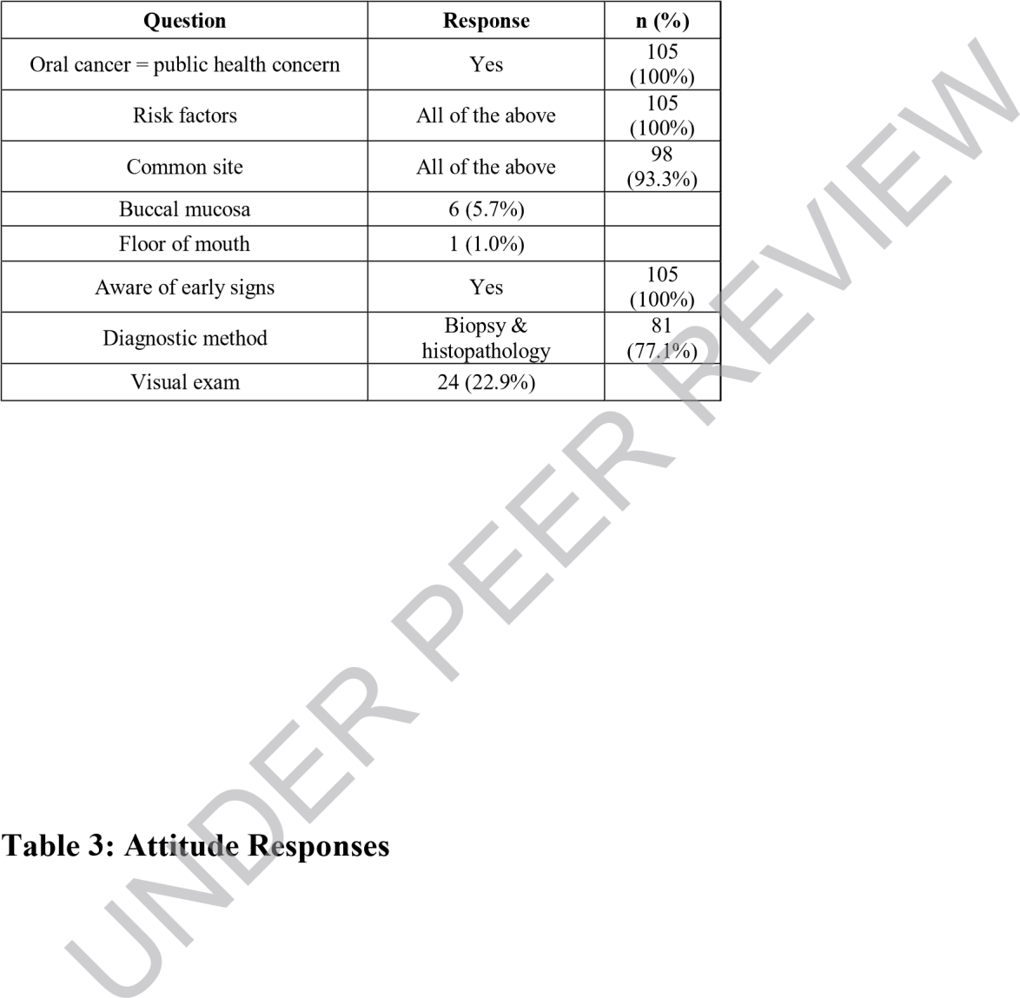

Table 4: Practice Responses

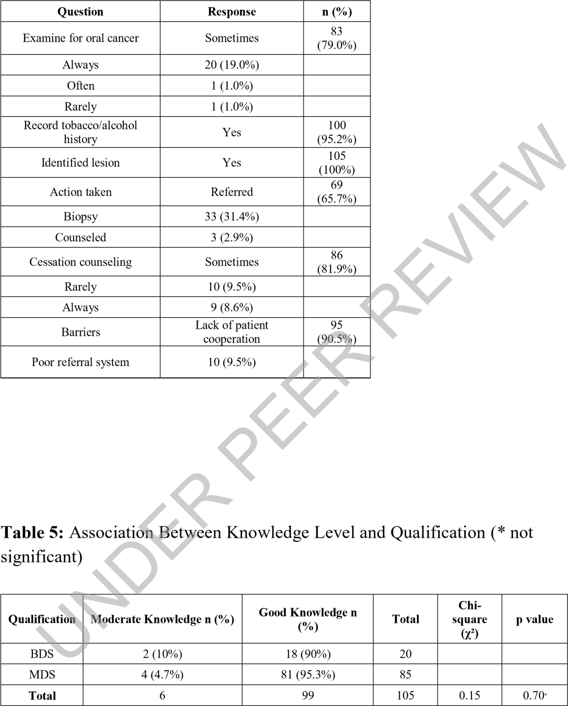

Table 6: Comparison of Knowledge Score by Years of Experience (* not significant)

Years of Experience | Mean ± SD Significant
<5 years | 4.65 ± 0.60
5–10 years | 4.72 ± 0.55 | p = 0.29*

Discussion: The present study assessed the knowledge, attitude, and practice toward oral cancer screening among dental practitioners in the Chengalpattu population. Oral cancer remains a significant public health problem worldwide and is particularly prevalent in developing countries like India due to widespread tobacco use and related habits [1,8].

In the present study, dental practitioners from the Chengalpattu population demonstrated good overall knowledge regarding oral cancer risk factors, early signs, and diagnostic procedures. Most participants recognised oral cancer as a major public health concern and were aware of common risk factors such as tobacco and alcohol consumption. Similar findings have been reported in recent studies among Indian dental practitioners, where adequate knowledge of oral cancer risk factors and early detection methods was observed, but gaps in clinical implementation persisted [10–12].

The majority of practitioners correctly identified common anatomical sites and biopsy as the confirmatory diagnostic method. Early diagnosis through biopsy and histopathological examination remains the gold standard for oral cancer detection and improves treatment outcomes when performed at early stages [6]. Early detection of oral cancer significantly improves survival rate and reduces disease-related morbidity [3].
Despite good knowledge levels, the present study showed inconsistency in routine screening practices among dental practitioners in the Chengalpattu population. Only a limited proportion of practitioners reported performing routine oral cancer screening consistently.
Similar discrepancies between knowledge and actual clinical screening practices have been highlighted in contemporary KAP studies conducted among dental professionals in South Asia [12–14].This gap may be attributed to clinical workload, lack of structured screening protocols, and limited training opportunities.
Attitude assessment in the present study showed that most practitioners believed that early detection improves survival and that oral cancer screening is part of their professional responsibility. These findings are consistent with recent studies reporting positive professional attitudes toward oral cancer screening among dental practitioners, despite variability in routine performance [13–15].

However, willingness to attend additional training programs was comparatively lower. Continuing dental education programs and structured training interventions have been shown to significantly improve practitioner confidence and screening frequency in recent interventional studies [16–17].
The practice assessment revealed that most practitioners recorded tobacco and alcohol history and were able to identify suspicious lesions. Recording habit history is essential because tobacco and alcohol remain the major modifiable risk factors associated with oral cancer

development [8]. However, referral practices varied among practitioners. Efficient referral systems and multidisciplinary coordination remain critical components of early diagnosis and management, as emphasized in recent clinical consensus guidelines [18].
Patient cooperation was identified as the major barrier to oral cancer screening among dental practitioners in the Chengalpattu population. Similar barriers related to patient awareness, fear of diagnosis, and socioeconomic constraints have been reported in recent population- based oral cancer screening studies [19].

Recent regional studies have also demonstrated no statistically significant association between qualification level and knowledge scores, suggesting comparable theoretical exposure during undergraduate and postgraduate training [14].
The positive correlation between attitude and practice observed in the present study aligns with recent behavioral research indicating that motivational reinforcement and skill-based training significantly enhance screening adherence among dental practitioners [20].
From a public health perspective, opportunistic screening during routine dental visits is considered a simple, cost-effective, and non-invasive method for early detection of oral cancer. Community-based screening programs and professional training can significantly improve early detection rates and reduce oral cancer burden [2].
In regions like Chengalpattu, where tobacco usage and associated risk factors remain prevalent, strengthening routine screening protocols in dental practice can play a major role in early diagnosis and improved patient outcomes.

Limitations:
- The cross-sectional design prevents establishment of causal relationships between knowledge, attitude, and practice.
- Convenience sampling limits the generalizability of findings beyond dental practitioners in Chengalpattu.
- The study focused on one specific region, so it may not reflect other practice settings.
- Data were self-reported and subject to response and social desirability bias.
- Clinical practices were not observed directly. This may lead reporting bias.
- Certain subgroups had smaller sample sizes.This could affect statistical power.

Conclusion: This study evaluated the knowledge, attitude, and practices related to oral cancer screening among dental practitioners in the Chengalpattu. It offers important regional evidence. The findings indicate that dental practitioners possess adequate knowledge regarding risk factors, early clinical signs, and diagnostic procedures related to oral cancer. Professional attitudes toward screening were also largely positive, with most participants recognizing early detection as a key factor in improving survival outcomes and acknowledging screening as part of their clinical

responsibility. Strengthening structured referral pathways, improving patient education about early signs of oral cancer, and integrating standardized screening protocols into routinedental exams are essential steps to boost early detection.Continuing dental education programs, hands-on clinical
training workshops, and adding tobacco cessation counsellingto routine practice may improve preventive efforts.

Consent
As per international standards or university standards, Participants’ written consent has been collected and preserved by the author(s).

Disclaimer (Artificial intelligence)
Author(s) hereby declare that NO generative AI technologies such as Large Language Models (ChatGPT, COPILOT, etc.) and text-to-image generators have been used during the writing or editing of this manuscript.

References:
- Warnakulasuriya S. Global epidemiology of oral and oropharyngeal cancer. Oral Oncol.[cite_start]2009;45(4-5):309-316.
- Sankaranarayanan R, Ramadas K, Thomas G, et al. A cluster-randomised controlled trial of visual screening for oral cancer in Kerala, India. Lancet. 2005;365(9475):1927-1933.
- Petersen PE. Oral cancer prevention and control – The approach of the World Health Organization. Oral Oncol. 2009;45(4-5):454-460.
- Neville BW, Damm DD, Allen CM, Chi AC. Oral & Maxillofacial Pathology. 4th ed. St.Louis: Elsevier; 2015.
- Greenberg MS, Glick M, Ship JA. Burket’s Oral Medicine. 12th ed. PMPH USA; 2015.
- Lingen MW, Kalmar JR, Karrison T, Speight PM. Critical Evaluation of Diagnostic Aids for the Detection of Oral Cancer. Oral Oncol. 2008;44(1):10-22.
- Speight PM, Khurram SA, Kujan O. Oral potentially malignant disorders: risk of progression to malignancy. Oral Surg Oral Med Oral Pathol Oral Radiol. 2018;125(6):612- 627.
- Gupta B, Johnson NW, Kumar N. Global epidemiology of head and neck cancers: a continuing challenge. Oncology. 2016;91(1):13-23.
- Indian Council of Medical Research. National Cancer Registry Programme. Clinico- pathological profile of cancers in India: A report of the Hospital Based Cancer Registries 2021. Bengaluru: ICMR–National Centre for Disease Informatics and Research; 2021.
- Riba H, Ghosh A, et al. Knowledge, attitudes, and practices towards oral cancer among dental practitioners in the northeastern region of India: An online cross-sectional survey. Cureus. 2024;16(1):e60894. doi:10.7759/cureus.60894.
- Alshammari F, Alqahtani M, Alenezi A, Almutairi R, Alsharari S. Knowledge, attitude and practice of oral cancer screening among dental practitioners: a multicenter cross-sectional study. BMC Oral Health. 2023;23:412.
- Prakash R, Nair S, Thomas J, Kumar V. Oral cancer screening practices among dental professionals in India: a cross-sectional study. J Oral Biol Craniofac Res. 2022;12(6):742- 748.
- Alrashdan MS, Al-Khateeb TH, Al-Zoubi F. Barriers and facilitators to oral cancer screening among dentists: a systematic review. Int Dent J. 2023;73(4):451-459.
- Sharma P, Gupta S, Reddy K, Menon I. Knowledge and awareness of oral cancer among dental practitioners in South India: a survey. J Indian Assoc Public Health Dent.2022;20(3):215-221.

- Rahman B, Al-Maweri SA, Halboub E, Alhadainy H. Attitudes toward oral cancer screening among dental professionals: a cross-sectional analytical study. Healthcare (Basel).2023;11(2):198.
- Carter LM, Ogden GR. Impact of continuing professional education on oral cancer detection rates among dentists. Br Dent J. 2022;233(5):381-386.
- Villa A, Woo SB. Oral cancer screening and prevention: an evidence-based update for dental practitioners. Dent Clin North Am. 2023;67(1):17-32.
- Kujan O, Glenny AM, Duxbury J, Thakker N, Sloan P. Early detection of oral cancer:updated clinical recommendations. Oral Oncol. 2022;129:105869.
- Singh A, Purohit BM, Bhambal A, Saxena S. Patient awareness and participation in oral cancer screening programs: a community-based study. BMC Oral Health. 2023;23:118.
- Mehrotra R, Singh M, Thomas S, Nair D. Strengthening opportunistic oral cancer screening in dental settings: a training-based interventional study. J Oral Pathol Med.2024;53(2):145-152.
- Sung H, Ferlay J, Siegel RL, et al. Global cancer statistics 2023. CA Cancer J Clin. 2023;73(4):e2023002.

- Kim HAJ, Dahlstrom K, Sturgis EM. Head and neck cancer screening: current status. Otolaryngol Clin North Am. 2026;59(1):17-32.

