Original Research Article
Comparative evaluation of Ofloxacin incorporated T-PRF vs metronidazole incorporated T-PRF as an adjunct to Non surgical periodontal therapy – A Randomized Controlled Clinical Trial

.
ABSTRACT

Introduction:
Non-surgical periodontal therapy (NSPT) remains the cornerstone in the management of periodontitis; however, complete elimination of subgingival pathogens through mechanical debridement alone is often limited. Local drug delivery systems combined with biologically active scaffolds may enhance therapeutic outcomes. Titanium-prepared platelet-rich fibrin (T-PRF), owing to its dense fibrin architecture and sustained release of growth factors, has emerged as a promising autologous biomaterial. Incorporation of antimicrobial agents such as ofloxacin and metronidazole into T-PRF may provide combined antimicrobial and regenerative benefits.
Aim:
To evaluate and compare the clinical efficacy of ofloxacin-incorporated T-PRF and metronidazole-incorporated T-PRF as adjuncts to scaling and root planing (SRP) in the treatment of periodontitis.
Methodology:
This randomized controlled clinical trial included thirty systemically healthy patients diagnosed with periodontitis were randomly allocated into three groups (n=10): Group I—SRP alone; Group II—SRP with ofloxacin-loaded T-PRF; and Group III—SRP with metronidazole-loaded T-PRF. Antimicrobial-loaded T-PRF membranes were placed sub-gingivally following SRP. Clinical parameters including plaque index, bleeding index, probing depth, and clinical attachment level were recorded at baseline, one month, and three months.
Results:
All groups demonstrated significant improvement in clinical parameters over time with no adverse events reported. Both antimicrobial-loaded T-PRF groups showed greater reductions in probing depth and gains in clinical attachment compared to SRP alone. Ofloxacin-incorporated T-PRF demonstrated marginally superior outcomes compared to metronidazole-incorporated T-PRF at three months.
Conclusion:
Antimicrobial-loaded T-PRF serves as an effective adjunct to NSPT, with ofloxacin-incorporated T-PRF showing enhanced clinical benefits in managing periodontitis.

Keywords: Local drug delivery, Metronidazole , Non-surgical periodontal therapy, Ofloxacin, Periodontitis,
T-PRF

1. INTRODUCTION
Periodontitis is an inflammatory disease of the supporting tissues of the teeth caused by specific pathogens or groups of specific microorganisms, leading to progressive destruction of the periodontal ligament and alveolar bone with recession, pocket formation, or both.¹ Periodontal therapy should ideally reduce inflammation, stop the progression of periodontal disease, enhance appearance, and establish an environment that promotes health maintenance.¹

Nonsurgical periodontal therapy (NSPT) serves as the fundamental basis for periodontal treatment and is the primary suggested method for managing periodontal infections. While NSPT has progressed over time, it remains regarded as the “gold standard” against which other treatment options are measured.² Nevertheless, traditional mechanical debridement techniques do not eliminate all periodontopathic bacteria from the subgingival area, particularly in difficult-to-access areas such as furcations, grooves, concavities, and deep pockets.¹,⁴

Antibiotics, whether used systemically or locally, have been utilized for a long time as supplementary treatments in managing periodontal disease.⁵ However, frequent and prolonged use of systemic antibiotics can lead to adverse effects such as low patient adherence, the emergence of antibiotic-resistant infections, and secondary infections.⁶ Therefore, local therapy is now considered the preferred option since it mitigates issues associated with systemic administration.⁷ The success of periodontal treatment largely hinges on selecting the right antimicrobial agent and the delivery method used. Local drug delivery (LDD) offers several benefits over systemic therapy, including fewer side effects and improved patient compliance.² Research indicates that when LDD is administered directly to the site, periodontal tissues achieve higher therapeutic concentrations of antibiotics compared to systemic delivery.²

Endogenous regenerative technology (ERT) has garnered attention in the field of regeneration due to its capability to activate the body's dormant self-healing processes and enhance its innate regenerative abilities. Among the various types of ERT, platelet-rich fibrin (PRF) is one of the most frequently utilized. The regenerative effectiveness of platelet concentrates is attributed to the release of various growth factors from platelets, which play a crucial role in wound healing and tissue regeneration.⁹

Titanium-prepared platelet-rich fibrin (T-PRF), developed using titanium tubes, provides a thicker fibrin matrix and gradual release of autologous growth factors that promote angiogenesis, fibroblast proliferation, and soft tissue regeneration.⁸ T-PRF possesses a more compact fibrin composition compared to conventional PRF and demonstrates a longer resorption period, making it a promising biomaterial for sustained drug delivery and controlled release.⁹

Ofloxacin is a broad-spectrum antibiotic belonging to the second generation of fluoroquinolones and is effective against both gram-positive and gram-negative organisms. It acts by inhibiting two type II topoisomerases in bacteria, namely DNA gyrase and topoisomerase IV.¹⁴ Ofloxacin exhibits good absorption, higher peak serum concentrations, and a longer elimination half-life of approximately 5–7 hours. Studies have demonstrated that ofloxacin shows potent antibacterial activity against several microorganisms associated with periodontal infections.¹³,¹⁴

Metronidazole is a commonly used antimicrobial agent belonging to the nitroimidazole class of antibiotics and is highly effective against anaerobic bacteria and protozoa. It acts by interacting with bacterial DNA, leading to inhibition of DNA synthesis and eventual bacterial cell death.¹⁵ It is well absorbed following administration and reaches peak plasma concentrations within 1–2 hours, with an average elimination half-life of approximately 8 hours.¹⁵ Previous studies have demonstrated the effectiveness of metronidazole in periodontal therapy when used as a local antimicrobial agent.³
Various studies have demonstrated promising results in improving clinical attachment gain and reducing probing pocket depth when platelet-rich fibrin and antimicrobial agents are used as adjuncts to nonsurgical periodontal therapy.¹²,¹⁶ The purpose of the present study was to assess the impact of T-PRF incorporated with ofloxacin and metronidazole as an antibiotic local drug delivery system adjunctive to scaling and root planing in the nonsurgical management of moderate periodontitis.

2. material and methods
Study design:
This randomized controlled clinical trial has been carried out, from December 2025 to January 2026, the study was conducted at the Department of Periodontology, K.V.G Dental College and Hospital, Sullia.

Selection Criteria:
Inclusion criteria
- Moderate periodontitis with attachment loss of 3–4 mm, probing depth ≤ 6, and bleeding on probing.
- Systemically healthy patients
- Patients age from twenty-five to fifty.
- No history of periodontal therapy, either surgical or non-surgical, in the previous six months.
- Patient who have agreed to participate in the study

Exclusion criteria
- Smokers
- Pregnancy and lactating women
- Systemic and debilitating diseases
- Use of antibiotics during the last six months.
- A previous unfavorable response to the study’s products.
- Patients with bleeding disorders
- Patients taking antiplatelet therapy and anticoagulant therapy
- Patients with severe hepatic impairment or renal disease
- Subjects having a total platelet count lower than 150,000/mm3.
- Subjects having medical conditions that compromised tissue healing (osteoporosis, anemia, etc.)

Randomization:
In this single blinded (Participants) study, the participants were divided into three groups, Group1, Group 2 and Group 3 through randomization. The randomization was carried out by lottery method (Participants pick sealed envelopes).
Group 1 – SRP Alone
Group 2 – SRP+ Ofloxacin incorporated T-PRF membrane
Group 3 –SRP + Metronidazole incorporated T-PRF membrane

PRF preparation method:
Features of titanium tubes used
Composition of the material: commercially pure titanium (Grade IV) or titanium alloy (Ti-6Al-4V) of medical grade,
biocompatible, and resistant to corrosion.
The tube capacity used in this study is 5mL
Dimensions: Internal diameter: 5mm; approximate length: 50–70 mm.
Sterilization: Autoclave sterilized.
Chemical characteristics: Devoid of clot activators, silica, additives, and anticoagulants.
Mechanical strength: Able to withstand centrifugal forces without deforming up to 2700–3500 rpm
Reusability: Reusable with appropriate cleaning and sterilization

Before starting the procedure, 10ml of blood was drawn from the antecubital vein and 5ml of blood was transferred to
two medical-grade titanium tubes (5ml in 1st tube and 5ml in the 2nd tube) and before the tubes was centrifuged(Fig 1)

1st tube- T-PRF preparation loaded with Ofloxacin incorporation
A sterile syringe was then used to add 0.5ml of Ofloxacin infusion to 5ml of blood sample and then subjected to
centrifugation at 3500rpm for 15min (Fig 1b & 2).

2nd tube-T-PRF preparation loaded with Metronidazole incorporation
A sterile syringe was then used to add 0.5ml of Metronidazole to 5ml of blood sample and then subjected to
centrifugation at 3500rpm for 15min (Fig 1b &2).
Then, the T-PRF clots was retrieved using sterile tweezers and compressed between 2 sterile glass slabs for the
preparation of the T-PRF membrane(Fig 3).

Clinical procedure:
It is an in-vivo study containing 10 patients in each group. All the procedures was performed by the same clinician. Full
mouth Scaling was performed followed by root planning under Local anaesthesia using lidocaine 2% epinephrine
1:800000 was performed.
Based on the randomization, Subjects will be divided into Group1, Group 2 and Group 3
Group 1 – Scaling and root planing alone was performed.
Group 2– After Scaling and root planing, T-PRF-loaded Ofloxacin membrane was placed sub-gingivally into the pockets
using tissue forceps and periodontal probe and then perio-pack was placed to stabilize the membrane in the pocket
site(Fig 4).
Group 3- After Scaling and root planing, T-PRF-loaded metronidazole membrane was placed sub-gingivally into the
pockets using tissue forceps and periodontal probe and then perio-pack was placed to stabilize the membrane in the
pocket site( Fig 4). Postoperative instructions will be explained and given in written format to the subjects.

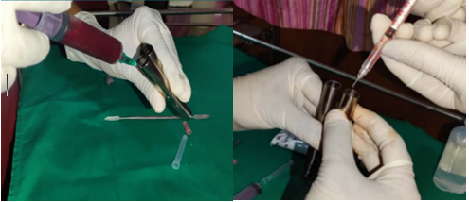

Fig 1: a)5ml of blood transfered to each titanium tube followed by b)infusion of 0.5ml of ofloxacin and metronidazole

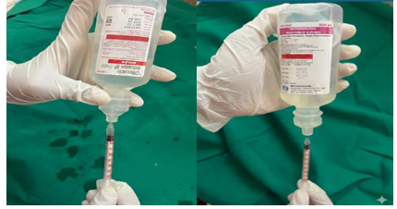

Fig 2: 0.5ml of Ofloxacin and metronidazole withdrawn using insulin syringes

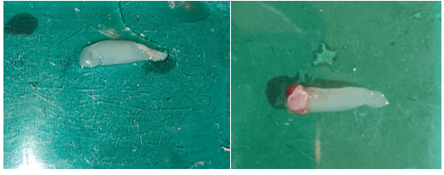

B
A

Fig 3: Ofloxacin(A) and Metronidazole(B) incorporated T-PRF membranes

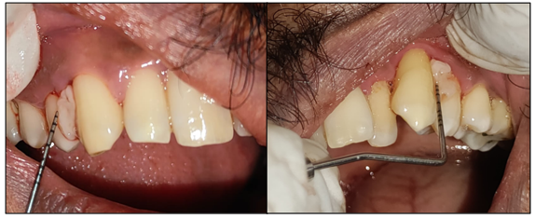

Fig 4: Placement of ofloxacin and metronidazole incorporated T-PRF membranes

Outcome measurements:
Probing depth (PD), Bleeding index (BI) -Ainamo & Bay, 1975, Plaque index (PI) by Silness and Loe, 1964,
Modified gingival index (MGI) by Lobene et al.1986 was measured in all patients at baseline and at 6 weeks
(Fig 7 and 8). The follow up duration that is initial assessment (baseline) and a formal re-evaluation 4 to 6 weeks after
NSPT therapy is based on the American Academy of Periodontology (AAP) guidelines

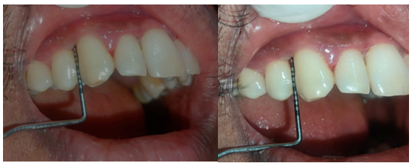

Fig 5: Pre-operative and post-operative of Ofloxacin group at baseline and 6weeks

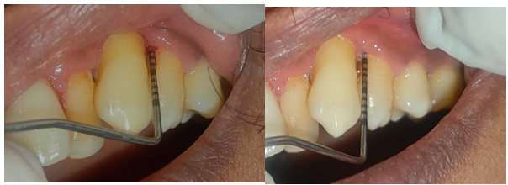

Fig 6: Pre-operative and post-operative of Metronidazole group at baseline and 6 weeks

Sample size estimation
Using the formula,
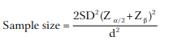

Where,
SD – σ is the Standard deviation (1)
Z_{α/2} = 1.96, at 95% Confidence interval
Z_{β} = 0.842, at 80% power
d = effect size is the Mean difference (0.90)
Substituting the values, we get
n=9.6

By adding 10% attrition rate.
The sample size is n = 10.56
This can be rounded off to 10
Therefore the total sample size is 10 per group

Statistical analysis:
All Statistical Analysis was performed using the SPSS version 27software.
Analysis of the data carried out by various tests of significance.
Descriptives was expressed in terms of mean and standard deviation.
An ANOVA test with Post hoc was used to compare the mean between the groups.
P value <0.05 was considered statistically significant for all comparison.

3. results and discussion

RESULTS
Thirty patients with moderate periodontitis were randomly allocated into three groups: Group 1 (SRP alone), Group 2
(SRP + ofloxacin-incorporated T-PRF), and Group 3 (SRP + metronidazole-incorporated T-PRF) (n=10 each). Clinical
parameters (PD, MGI, BI, and PI) were recorded at baseline and 6 weeks. All participants completed the study with no
adverse events. Baseline comparisons showed no statistically significant differences among the three groups for any
parameter (p>0.05), confirming group comparability. (Table 1). At 6 weeks, significant intergroup differences were
observed for all clinical parameters (p<0.001). Mean probing depth was 4.70 ± 0.48 mm in Group 1, 3.40 ± 0.52 mm in
Group 2, and 3.90 ± 0.57 mm in Group 3 (p<0.001). The mean PD reduction was significantly greater in Groups 2 (2.40
± 0.70 mm) and 3 (1.80 ± 0.63 mm) compared to Group 1 (1.00 ± 0.00 mm) (p<0.001). Post-hoc analysis showed
significant differences between Groups 1 and 2 (p<0.001) and Groups 1 and 3 (p=0.010), with no significant difference
between Groups 2 and 3 (p=0.118). MGI scores at 6 weeks were 1.65 ± 0.39 (Group 1), 1.05 ± 0.26 (Group 2), and
1.25 ± 0.29 (Group 3) (p<0.001). Both antibiotic-incorporated T-PRF groups showed significantly greater reductions
compared to SRP alone (p<0.01), while no significant difference was found between Groups 2 and 3. Bleeding index
showed marked improvement in Groups 2 and 3 (12.50 ± 13.18% and 17.50 ± 16.87%, respectively) compared to
Group 1 (50.00 ± 23.57%) at 6 weeks (p<0.001).
Plaque index also demonstrated significantly greater reduction in Groups 2 and 3 compared to Group 1 (p<0.001), with
no significant intergroup difference between the two antibiotic groups. Within-group analysis revealed statistically
significant improvement in all parameters from baseline to 6 weeks in all three groups (p<0.05). The parameters
described in table 1 are further illustrated using double bar charts and line diagrams to enhance visual comparison and
intergroup differences in (Fig 7 and 8)
The overall treatment efficacy analysis revealed that adjunctive use of antibiotic- incorporated T-PRF membranes
significantly enhanced clinical outcomes compared to SRP alone. Group 2 (ofloxacin-incorporated T-PRF)
demonstrated the highest mean reductions across all parameters. Statistical comparison between
the two antibiotic formulations revealed no significant differences for any parameter, suggesting both ofloxacin and
metronidazole are equally effective when incorporated into T-PRF matrices for adjunctive periodontal therapy.
In summary, all three treatment modalities resulted in significant improvements in periodontal clinical parameters from
baseline to 6 weeks. However, the magnitude of improvement was substantially greater in groups receiving antibiotic-
incorporated T-PRF membranes as adjuncts to mechanical debridement. The comparable efficacy of ofloxacin and
metronidazole formulations suggests that clinicians may select either antibiotic based on availability, patient-specific
factors, or bacterial susceptibility patterns without compromising treatment outcome
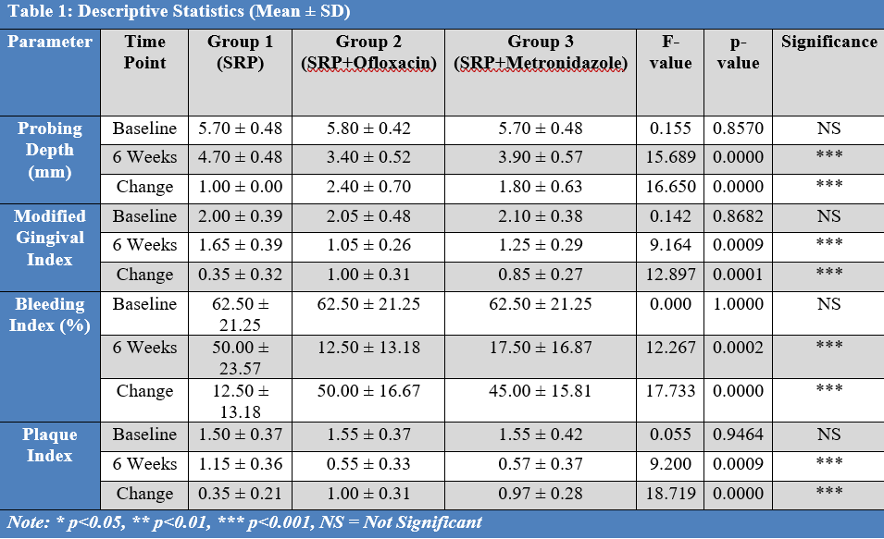

Table 1: Comparison of clinical parameters in all three groups at baseline and 6 weeks

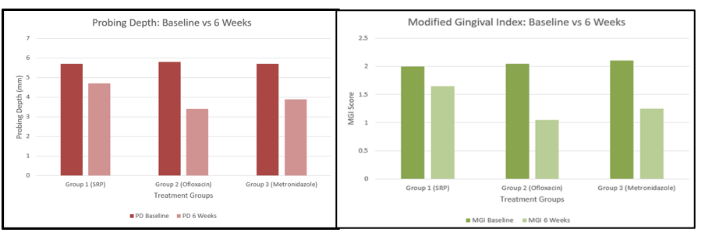

Fig 7: probing depth and Modified gingival index at baseline and 6 weeks

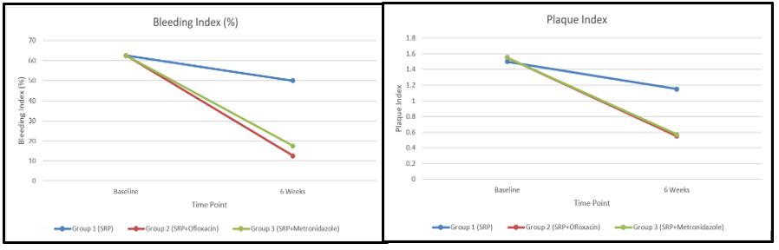

Fig 8: Bleeding index and plaque index at baseline and 6 weeks

DISCUSSION
The present randomized controlled clinical trial evaluated the adjunctive efficacy of ofloxacin- and metronidazole-incorporated titanium-prepared platelet-rich fibrin (T-PRF) in non-surgical periodontal therapy. The results demonstrated that although all three groups showed significant clinical improvement from baseline to 6 weeks, the groups treated with antibiotic-incorporated T-PRF exhibited significantly greater reductions in probing depth, gingival inflammation, bleeding, and plaque accumulation compared to SRP alone. These findings support the role of local drug delivery systems combined with biologically active platelet concentrates in enhancing periodontal healing.

Scaling and root planing remains the gold standard for initial periodontal therapy; however, it has been well documented that mechanical debridement alone cannot completely eliminate periodontopathic bacteria from deep periodontal pockets and tissue-invading microorganisms.¹ Local drug delivery systems provide higher concentrations of antimicrobial agents at the target site with minimal systemic side effects and improved patient compliance.²

Titanium-prepared PRF (T-PRF), introduced by Tunali et al., differs from conventional PRF by forming a denser fibrin network and providing sustained release of growth factors that promote angiogenesis, fibroblast proliferation, and tissue regeneration.⁸ Gummaluri et al. reported that T-PRF exhibits superior biocompatibility and regenerative potential compared to conventional platelet concentrates.⁹ The enhanced clinical outcomes observed in Groups 2 and 3 in the present study can be attributed to the combined antimicrobial and regenerative effects of antibiotic-loaded T-PRF membranes.

Ercan et al. demonstrated that T-PRF can act as a high-capacity drug delivery system for doxycycline, providing controlled and sustained antibiotic release.¹⁰ Similarly, Indurkar and Purohit reported that T-PRF effectively serves as a carrier for doxycycline with significant antibacterial activity.¹¹ These findings support the concept that T-PRF can function as a biological scaffold as well as a slow-release antimicrobial system, which explains the superior reductions in bleeding index and plaque index observed in the present study.

Ofloxacin, a second-generation fluoroquinolone, exhibits potent bactericidal activity against gram-negative anaerobes commonly implicated in periodontitis by inhibiting DNA gyrase.¹⁴ Chermmal et al. reported that adjunctive use of ofloxacin with SRP resulted in significant improvements in probing depth and gingival inflammation compared to SRP alone.¹³ The present study similarly showed that the ofloxacin-incorporated T-PRF group achieved the greatest mean reductions across all clinical parameters, indicating its strong antimicrobial efficacy when delivered locally through a fibrin matrix.

Metronidazole remains one of the most widely used antimicrobials in periodontal therapy due to its selective action against obligate anaerobic bacteria such as Porphyromonas gingivalis and Prevotella intermedia.¹⁵ Previous studies have demonstrated the effectiveness of locally delivered metronidazole in improving periodontal clinical parameters.³ Omar et al. demonstrated that leukocyte-PRF loaded with antibiotics significantly improved clinical outcomes in moderate periodontitis, supporting the present findings where metronidazole-incorporated T-PRF produced marked reductions in bleeding and gingival inflammation.¹²

The absence of statistically significant differences between ofloxacin- and metronidazole-incorporated T-PRF groups suggests that both antibiotics are equally effective when incorporated into a T-PRF matrix. This may be attributed to the sustained local release of the drugs combined with the biologic activity of platelet-derived growth factors, which together enhance wound healing and microbial control. Similar conclusions were drawn by Omar et al., who reported comparable efficacy of antibiotic-loaded PRF membranes in periodontal therapy.¹²

The pronounced reduction in bleeding index observed in the antibiotic-incorporated groups highlights the strong anti-inflammatory and antibacterial effect of this approach. This finding is consistent with studies by Ercan et al.¹⁰ and Chermmal et al.¹³ who reported significant reductions in gingival bleeding and pocket depth with local antibiotic delivery systems.

The use of films and membranes loaded with drugs with antimicrobial and regenerative potential appears an appealing alternative to the classical approach to treating periodontal disease.

Overall, the present study confirms that adjunctive placement of antibiotic-incorporated T-PRF membranes provides synergistic benefits by combining mechanical debridement, antimicrobial action, and clinical improvement. The comparable effectiveness of ofloxacin and metronidazole suggests that clinicians may choose either agent based on bacterial profile, availability, and patient-specific considerations without compromising clinical outcomes.

Limitations of the study:
Despite promising results, the present study has certain limitations. The sample size was relatively small, which may limit the statistical power and generalizability of the findings. The follow-up period of 6 weeks was short and does not provide information regarding the long-term stability of clinical outcomes. Microbiological analysis was not performed, preventing
direct assessment of bacterial reduction and changes in periodontal pathogens. Radiographic evaluation was also not included, limiting the ability to determine true periodontal regeneration or bone fill. Additionally, the study was conducted at a single center, which may introduce selection bias. Further multicenter studies with larger sample sizes, longer follow-up periods, and inclusion of microbiological and radiographic parameters are necessary to validate these findings and establish standardized clinical protocols.

4. CONCLUSION
Within the limitations of this RCT, all treatment modalities produced significant improvements from baseline to 6 weeks. The adjunctive use of antibiotic-incorporated T-PRF membranes resulted in significantly greater reductions in clinical parameters compared to SRP alone.
Both ofloxacin and metronidazole incorporated T-PRF demonstrated superior clinical efficacy, Ofloxacin being slightly superior with no much significant difference between the two formulations, indicating comparable therapeutic potential. This approach combines sustained local antimicrobial delivery with the regenerative properties of platelet concentrates, thereby enhancing periodontal healing.

CONSENT
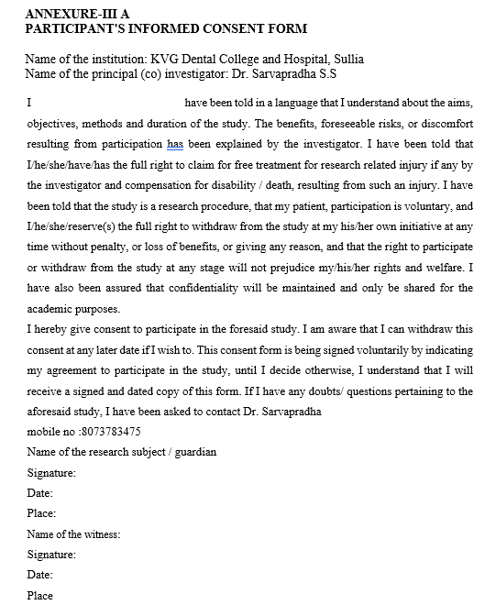

Ethical approval
The study was reviewed and approved by the Institutional Ethics committee (IECKVGDCH/PGSS23/2025-26) and registered under Clinical Trials Registry India (CTRI)- CTRI/2025/11/098023. Before any interventions, the nature and purpose of the study were explained to the participants, who then provided their written, informed consent.

AcknowledgEments
Nil

AUTHORS CONTRIBUTIONS
The first author contributed to the study design, guidance, and critical revision of the manuscript. The second author provided overall supervision, conceptual input, and final approval of the manuscript. The third and fourth author made the contribution to data collection, analysis, and manuscript drafting

COMPETING INTERESTS DISCLAIMER:
Authors have declared that they have no known competing financial interests OR non-financial interests OR personal relationships that could have appeared to influence the work reported in this paper.

Disclaimer (Artificial intelligence)
Author(s) hereby declare that NO generative AI technologies such as Large Language Models (ChatGPT, COPILOT, etc.) and text-to-image generators have been used during the writing or editing of this manuscript.

References

1.Slots J, Rams TE. Antibiotics in periodontal therapy: advantages and disadvantages. J Clin Periodontol. 1990;17(7):479–493.
2.Goodson JM, Haffajee AD, Socransky SS. Periodontal therapy by local delivery of tetracycline. J Clin Periodontol. 1979;6(2):83–92.
3.Magnusson I. The use of locally‐delivered metronidazole in the treatment of periodontitis. Clinical results. Journal of clinical Periodontology. 1998 Nov;25(11):959-63.
4.Rams TE, Slots J. Local delivery of antimicrobial agents in the periodontal pocket. Periodontology 2000. 1996 Feb;10(1):139-59.
5.van Winkelhoff AJ, Rodenburg JP, Goené RJ, Abbas F, Winkel EG, de Graaff J. Metronidazole plus amoxicillin in the treatment of Actinobacillus actinomycetemcomitans–associated periodontitis. J Clin Periodontol. 1989;16(2):128–131.
6.Bosshardt DD, Chappuis V. Local antibiotic therapy for periodontitis: clinical and microbiological effects. Periodontol 2000. 2010;53:216–243.
7.Goodson JM, Gunsolley JC. Local drug delivery in periodontal therapy. Compend Contin Educ Dent. 2002;23(9 Suppl):23–29.
8.Tunali M, Ozdemir H, Arabaci T, Gurbuzer B, Pikdoken L, Firatli E. Clinical evaluation of autologous titanium-prepared platelet-rich fibrin (T-PRF) in the treatment of multiple adjacent gingival recession defects: a 12-month study. J Periodontol. 2013;84(3):315–323.
9.Gummaluri SS, Gurumoorthy K, Kancharla AK, Boyapati R. Evaluating the predictability and regenerative capacity of titanium platelet-rich fibrin (T-PRF) in dentistry: a narrative review. Cumhuriyet Dent J. 2023;26(3):332–339.
10.Ercan E, Suner SS, Silan C, Yilmaz S, Siddikoglu D, Sahiner N, et al. Titanium platelet-rich fibrin (T-PRF) as high-capacity doxycycline delivery system. Clin Oral Investig. 2022;26(8):5429–5438.
11.Indurkar MS, Purohit JN. Titanium platelet-rich fibrin as doxycycline delivery system: an in vitro study. Int J Oral Health Sci. 2024;14(2):67–71.
12.Omar YK, Rashidy MA, Ahmed GB, Aboulela AG. Evaluation of leukocyte-platelet rich fibrin as an antibiotic slow-release biological device in the treatment of moderate periodontitis: a randomized controlled clinical trial. BMC Oral Health. 2024;24(1):1530.
13.Chermmal AK, Babu HM, Vivekananda MR. Evaluation of ofloxacin and ornidazole as an adjunct to scaling and root planing in the treatment of generalized chronic periodontitis: a randomized clinical study. World J Dent. 2021;12(6):485–491.
14.Higashi K, Seike M, Mitani Y, Morisaki K, Hayashi SI, Kitamura M, et al. Concentration of ofloxacin in human gingival crevicular fluid after oral administration of Tarivid®. J Periodontal Res. 1989;24(6):393–397.
15.Leitsch D. A review on metronidazole: an old warhorse in antimicrobial chemotherapy. Parasitology. 2019;146(9):1167–1182.
16.Rengaswami BV, Sudhakar U, Dhanasekaran M, Muthuvijayan G. Comparative Evaluation of L-PRF and Ofloxacin Incorporated L-PRF as an Adjunctive to SRP-A Split-Mouth Randomized Clinical Trial. Journal of Pharmacy and Bioallied Sciences. 2024 Apr 1;16(Suppl 2):S1369-72.
17.Petrescu N, Crisan B, Aghiorghiesei O, Sarosi C, Mirica IC, Lucaciu O, Iușan SA, Dirzu N, Apostu D. Gradual drug release membranes and films used for the treatment of periodontal disease. Membranes. 2022 Sep 17;12(9):895.
18.Bosshardt DD, Lang NP. The junctional epithelium: from health to disease. J Dent Res. 2005;84(1):9–20.
19.Kondreddy K, Mohanty A, Desai V, Surekha GL, Khader AA, Mathur S, Shetty S. The effect of adjunctive antimicrobial therapy on the clinical outcomes of non-surgical periodontal treatment: a systematic review. Journal of Pharmacy and Bioallied Sciences. 2025 May 1;17(Suppl 1):S463-6.
20.Jain N, Jain GK, Javed S, Iqbal Z, Talegaonkar S, Ahmad FJ, et al. Recent approaches for the treatment of periodontitis. Drug Discov Today. 2008;13(21-22):932–943.
21.Slots J. Selection of antimicrobial agents in periodontal therapy. J Periodontal Res. 2002;37(5):389–398.

Abbrevations
NSPT- Non surgical periodontal therapy
T-PRF- Titanium platelet rich fibrin
SRP- Scaling and root planning
LDD- Local drug delivery
ERT- Endogenous regenerative technology
PD- Probing depth
BI- Bleeding index
PI- Plaque index
MGI- Modified gingival index
RCT- Randomized controlled trial

