Original Research Article
Oral manifestations associated with hypertensive patients: A clinical observational study

ABSTRACT:

Background: Hypertension is a major chronic systemic disease affecting a large population worldwide. It has numerous oral implications either due to the disease process itself or as adverse effects of antihypertensive medications.Early identification of oral manifestations can improve diagnosis, quality of life, and comprehensive management.

Aim: To evaluate the prevalence and types of oral manifestations in hypertensive patients.

Materials and Methods: A clinical observational study was conducted on 100 hypertensive patients visiting the outpatient department of Oral Medicine and Radiology in a private dental institute located in Melmaruvathur over a period of six months. Detailed case histories were recorded, including demographic data, duration and hypertension, and antihypertensive medications. Comprehensive intraoral examinations were performed to assess oral soft tissue and hard tissue changes. The collected data were analyzed statistically to determine the frequency of various oral findings.

Result: Periodontal disease was the most frequently observed oral condition, with periodontitis affecting 70% of the study population. Gingivitis was identified in 29% of patients, while acute necrotizing ulcerative gingivitis was noted in 1%. The highest prevalence of periodontal disease was observed in individuals aged between 60 and 79 years. Various oral mucosal lesions, including gingival hyperplasia, leukoplakia, lichen planus, and hyposalivation, were also documented.

Conclusion:

Oral manifestations were commonly observed among hypertensive patients, with periodontal disease being the predominant finding.Regular oral screening and interdisciplinary collaboration are essential for optimal management of hypertensive individuals.

INTRODUCTION:

Hypertension is one of the most common chronic cardiovascular disorders and a major global health burden. Hypertension is the most prevalent non communicable disease and remains the leading cause of morbidity and mortality.It affects approximately 30–40% of the adult population and is a leading risk factor for stroke, myocardial infarction, renal failure, and premature death[1].While the systemic consequences of hypertension are well recognised,its impact on oral health has gained attention only in recent years. Persistent elevation of systemic arterial pressure can lead to progressive damage to multiple systems of the body, including the oral cavity.

The oral cavity frequently reflects systemic conditions and may exhibit changes due to underlying disease or pharmacological therapy[2]. Changes in oral tissue may occur due to altered blood flow,immune dysfunction,metabolic disturbances or pharmacological therapy.Hypertensive patients frequently present with findings affecting both hard and soft tissues. In hypertensive patients, oral alterations such as xerostomia, gingival enlargement, mucosal petechiae, lichenoid reactions, burning sensation, impaired wound healing, and altered taste perception are frequently reported[3]. Many antihypertensive medications, particularly calcium channel blockers, diuretics, and beta blockers, can induce oral side effects including gingival hyperplasia, dryness, or oral
ulcerations[4]

Hypertension is often described as a “silent killer” because it remains asymptomatic in many individuals until significant target organ damage has occurred. From a pathophysiological perspective, hypertension leads to endothelial dysfunction, vascular remodeling, and increased arterial stiffness[5]. These vascular changes extend to the microcirculation of the oral cavity,
particularly affecting the periodontium, which is highly vascularized[6]

However, recent studies have focused on the mutual relationship between periodontal disease and systemic conditions like cardiovascular disease and hypertension[7]. Hypertension shares common inflammatory pathways with periodontal disease, including increased levels of C-reactive protein, interleukin-6, and tumor necrosis factor-alpha[8]. These factors play a major role in endothelial dysfunction and periodontal destruction[9].

Calcium channel blockers have been shown to cause gingival overgrowth[10], while antihypertensive medications have also been linked to xerostomia and decreased salivary flow[11]. Thus, oral health examination may also offer supplementary information regarding systemic inflammatory load and disease progression. Although various studies have established a link between hypertension and changes in oral health, the available literature regarding the prevalence and distribution of oral manifestations among hypertensive patients is still scarce. Hence, awareness of these relationships is essential for early diagnosis and better patient management. The current study was conducted to assess and analyze the oral manifestations among hypertensive patients.

MATERIALS AND METHODS:

The study sample consisted of 100 known hypertensive patients visiting the outpatient department of oral medicine and radiology in private dental institute located at melmaruvathur.The study consist of patient between the age group of 20-80 years of which 42 patients were males and 58 were females(Table 1), all patients were from different socio-economic status.
Inclusion Criteria
- Patients with a confirmed diagnosis of hypertension
- Patients aged 20–80 years
- Patients who were currently receiving antihypertensive medication
- Patients who provided informed consent to participate in the study
Exclusion Criteria
- Patients with other systemic diseases that could influence oral manifestations
- Patients undergoing radiotherapy or chemotherapy
- Patients with incomplete medical history
- Patients who were unwilling to participate
Patients were examined clinically using a mouth mirror, probe, Williams’s periodontal probe to check the periodontal pockets, Russell’s periodontal index was used to estimate the gingival and periodontal health and further histopathological examination for mucosal changes was also carried out. All the Patients included in the study were known hypertensive patients and who were under the medication of the antihypertensive drugs.Gingivitis and periodontitis were confirmed from patients Russell’s periodontal index, and hypo salivation was noted by asking questions to the patients regarding symptoms.All the data were collected and analysed statistically.

Questions asked to the patients to evaluate hypo salivation:

An affirmative response to at least two of these questions were considered as hypo salivation;

1) Does your mouth usually feel dry?

2) Does your mouth feel dry while eating a meal?

3) Do you have difficulty swallowing dry food?

4) Do you often sip water while swallowing dry foods?

5) Is the amount of saliva in your mouth too little, or don’t you notice it?[1]

ETHICAL CLEARANCE:
Ethical approval for this study was obtained from the appropriate ethics committee, and all procedures complied with ethical research standards.

STATISTICAL ANALYSIS
All collected data were compiled and analyzed using appropriate statistical methods to determine the frequency and distribution of oral manifestations among hypertensive patients.

RESULT:

A total of 100 patients were included in the study. The age of the study population ranged from
25 to 87 years, with a predominance of middle-aged and elderly individuals.Female patients constituted the majority of the study population (58%), while males accounted for 42% of the cases.[Fig 1]
Among the study participants, periodontitis was the most prevalent periodontal condition, observed in 70% of patients[Fig 2].Gingivitis was diagnosed in 29% of cases[Fig 3] who exhibited gingival inflammation without clinical evidence of periodontal attachment loss or periodontal pocket formation and acute necrotizing ulcerative gingivitis (ANUG) was observed in 1% of the study population.
The highest prevalence of periodontal disease was seen in patients aged 60–79
years (46%), followed by those aged 40–59 years (34%). Patients aged 20–39 years and those
80 years and above constituted 10% each of the study population.

Associated oral mucosal lesions include gingival hyperplasia(6%)[Fig 4,Fig 8],lichen planus
(3%)[Fig 9],lichenoid reactions (1%)[Fig 5], leukoplakia (4%), leukoedema (2%)[Fig
6],ulcerations (3%), and hyposalivation(7%)[Fig 7]. The remaining 74% of patients did not exhibit any associated oral lesions.The study showed a significant prevalence of oral manifestations among hypertensive subjects, the most common findings being xerostomia, gingival enlargement. Medication-related effects were also observed in patients taking calcium channel blockers and beta blockers.

DISCUSSION:

Hypertension is a chronic systemic disease with well-established multisystem involvement, including the oral cavity. The current study was undertaken to assess the prevalence and pattern of oral manifestations in hypertensive patients and to correlate these observations with the history of the disease.

In the current study, a preponderance of middle-aged and older patients was noted, with the maximum prevalence of periodontal disease observed in patients aged 60-79 years. This observation is in accordance with previous studies that have demonstrated an increased prevalence and severity of periodontal disease with advancing age, possibly due to increased susceptibility to systemic risk factors for an extended period, impaired immune function, and accumulated plaque[12]. Female patients comprised a relatively larger proportion of the study population, which may be attributed to greater health-seeking behavior among women, a phenomenon that has been noted in earlier epidemiological studies.
The high prevalence of periodontal disease among hypertensive patients supports evidence suggesting a bidirectional association between hypertension and

periodontal inflammation[6]7]. Long-standing periodontal infections may release inflammatory mediators into the systemic circulation, potentially contributing to endothelial dysfunction and increasing the risk of vascular complications. Chronic periodontal infection may contribute to systemic inflammation and endothelial dysfunction[8][9]. Endothelial dysfunction results in impaired nitric oxide bioavailability, increased oxidative stress, and heightened expression of adhesion molecules, all of which promote vascular inflammation and remodeling [5]. These vascular alterations may compromise gingival microcirculation, reducing oxygen and nutrient delivery to periodontal tissues [6]. Conversely, hypertension may impair microcirculation within periodontal tissues, increasing susceptibility to periodontal breakdown.The finding that 70% of hypertensive patients exhibit periodontitis suggests that high blood pressure is a significant systemic modifier of periodontal health. Hypertension induces a state of chronic systemic oxidative stress, which leads to micro-angiopathy—a thickening of the basement membrane in small capillaries. In the oral cavity, the gingiva relies on a dense network of micro-vessels for immune surveillance and nutrient delivery. When these vessels are compromised, the tissue experiences localized hypoxia.Hypoxia induces the expression of Hypoxia-Inducible Factor 1-alpha which promotes the release of pro- inflammatory cytokines such as IL-1β and TNF-α. This localized inflammatory environment accelerates the breakdown of the periodontal ligament and alveolar bone. Furthermore, reduced blood flow limits the delivery of systemic immune cells to the periodontal pocket, allowing anaerobic bacteria to proliferate
unchecked[6].

The present study also demonstrated a notable prevalence of oral mucosal lesions among hypertensive patients. Gingival hyperplasia was the most frequently observed lesion, particularly among patients receiving calcium channel blockers. This finding is in agreement with earlier reports that attribute drug-induced gingival enlargement to altered fibroblast activity and increased extracellular matrix production caused by calcium channel blockade[10][13].This condition creates challenge in maintaining oral hygiene and may lead to functional and esthetic concern.

Lichen planus and lichenoid reactions were also observed, which may be attributed to immunologically mediated mechanisms or drug-induced hypersensitivity reactions associate
with antihypertensive therapy.Lichen planus and lichenoid reactions were observed in a combined

4% of our cohort. While idiopathic lichen planus is an autoimmune condition, lichenoid drug reactions are a delayed hypersensitivity response to medications like ACE[Angiotensin converting enzyme] inhibitors and ARBs[Angiotensin receptor blocker]. These lesions often manifest as bilateral white striae on the buccal mucosa [14][15].Such lesions are clinically important because they may resemble idiopathic lichen planus and, in rare instances, carry a risk of malignant transformation. Accurate diagnosis, careful evaluation of medication history, and periodic follow-up are therefore essential components of patient management.

Leukoplakia and leukoedema were observed in a subset of patients, particularly among elderly individuals. These lesions may be influenced by long-standing systemic disease, compromised oral hygiene, and associated risk factors such as tobacco use. Ulcerations and angular cheilitis, though less frequent, were observed and may be related to xerostomia, nutritional deficiencies, or impaired wound healing commonly seen in hypertensive patients.

In the study conducted by Lucia Ramirez et al, xerostomia was one of the most common reported symptoms .Xerostomia was one of the most commonly reported symptoms in the present study. This finding is consistent with previous studies that have identified diuretics and beta blockers as major contributors to reduced salivary flow. Salivary hypofunction not only compromises oral comfort but also increases the risk of dental caries, mucosal infections, and periodontal disease.The 7% prevalence of hyposalivation recorded in our study is a critical clinical finding. Saliva provides buffering capacity and antimicrobial proteins like IgA. Antihypertensive drugs, particularly diuretics, cause a reduction in intravascular volume, which leads to secondary dehydration of the salivary acinar cells. Beta-blockers further complicate this by interfering with the sympathetic nervous system's control over salivary protein secretion, resulting in thick,viscous saliva that provides less protection[11]

The results of the present investigation emphasize that hypertension should be regarded as a systemic disorder with implications extending beyond the cardiovascular system, including notable effects on oral health. The substantial occurrence of periodontal disease among hypertensive participants in this study is consistent with existing evidence suggesting a relationship between elevated blood pressure and periodontal inflammation[17]. Chronic inflammatory processes appear to serve as a biological bridge connecting these conditions. Long-standing periodontal infections may release inflammatory mediators into the systemic
circulation, potentially contributing to endothelial dysfunction and increasing the risk of vascular complications.

The observed higher prevalence of periodontal disease in older participants in this study is consistent with the widely acknowledged evidence that older age served as a cumulative risk factor. Older hypertensive patients tend to have a longer duration of disease, longer exposure to pharmacological treatment, and co-existing systemic conditions like diabetes mellitus, which can contribute cumulatively to the worsening of periodontal disease. Moreover, the age-related changes in the immune system may impair the effectiveness of inflammatory regulation, thus predisposing to chronic periodontal injury.[19]

It is also important to note that behavioral and lifestyle variables like smoking, alcohol, dietary habits, and psychological stress may affect blood pressure control and oral health status[18]. Although the current study focused on clinical variables, future studies that include lifestyle variables and inflammatory markers may help to shed more light on the mechanisms underlying this association.

The role of dental professionals in the comprehensive care of hypertensive patients is particularly significant. Routine dental consultations offer opportunities for early detection of oral changes, monitoring of medication-related side effects, and even preliminary blood pressure screening. Close collaboration between dentists and physicians can facilitate timely adjustments in therapy
when adverse oral reactions are identified, ultimately enhancing patient out comes[7][17]

Patient education is equally essential. Hypertensive individuals should be counseled regarding meticulous oral hygiene practices and the need for regular dental visits to detect medication- related side effects at an early stage. Preventive strategies such as professional scaling, plaque control measures, and management of xerostomia can significantly enhance oral comfort and
quality of life [11][16]

Oral signs can also be used as warning signs for the progression of systemic diseases or drug reactions. Frequent dental evaluations, patient education, and a good working relationship between dental practitioners and physicians are vital for the early detection and management of hypertensive patients.
The results also strengthen the emerging awareness of the link between oral and systemic health. Early detection of oral signs in hypertensive patients can contribute to better patient monitoring, improved quality of life, and more coordinated healthcare delivery.

CONCLUSION:
Oral manifestations are common among hypertensive individuals and can serve as an important diagnostic indicator. Regular oral screening and interdisciplinary management are essential for improved patient care.The present study revealed a high prevalence of oral manifestations among hypertensive patients, demonstrating a strong association between hypertension, its pharmacological management, and oral health.

LIMITATIONS:
1.Cross-sectional study design: The observational study design of this research makes it impossible to establish any causal relationship between hypertension and oral manifestations. Although certain associations were found, it is impossible to establish whether hypertension or medications were the direct cause of the noted oral manifestations.

2.Sample size and generalizability: The research included 100 patients from a private dental institute in Melmaruvathur, which makes it impossible to generalize the results to other populations.

3.Lifestyle and behavioral considerations: The research did not consider variables such as smoking, alcohol intake, diet, oral hygiene habits, and stress levels, which are known to affect both hypertension and oral health.

4.Variability in medications: Patients took different antihypertensive medications, both alone and in combination, but the study did not consider the oral manifestations in relation to different classes of medications and dosages, which could affect the prevalence of oral side effects.

5.Self-reported salivary symptoms: The study measured hyposalivation through patient questionnaires, which may be prone to reporting bias, as it did not measure salivary flow.
6.Lack of longitudinal follow-up: Without longitudinal follow-up, it was not possible to assess the progression or resolution of the oral manifestations over time, especially in relation to changes in the control of hypertension or changes in medications.

Disclaimer (Artificial intelligence)
Author(s) hereby declare that NO generative AI technologies such as Large Language Models (ChatGPT, COPILOT, etc.) and text-to-image generators have been used during the writing or editing of this manuscript.

REFERENCE:

1. Kumar P, Mastan KMK, Chowdhary R, Shanmugam K. Oral manifestations in hypertensive patients: a clinical study. J Oral Maxillofac Pathol. 2012;16(2):215-221.

2. Krishna Veni Sankar, Jayakarthik SS, Mathumala Subramanian, Arunchallam M, Sathish Kumar M. Oral manifestation of systemic disease: A review. Int J Creat Res Thoughts. 2025 Feb;13(2):c259.

3. Elmi Rankohi Z, Shabanian M, Maleki D. Oral manifestations of patients taking anti- hypertensive medications. J Islam Dent Assoc Iran. 2020;32(3-4):83-88.

4. Langari SF, Hosseini SR, Bijani A, et al. Association between antihypertensive drugs and elderly's oral health-related quality of life. Caspian J Intern Med. 2022;13(3):582-
588.

5. Graziani F, Gennai S, Solini A, Petrini M. A systematic review and meta-analysis of epidemiologic observational evidence on the effect of periodontitis on diabetes. J Clin Periodontol. 2018;45(7):700-712

6.Leong XF, Ng CY, Badiah B, Das S. Association between hypertension and periodontitis: possible mechanisms. ScientificWorldJournal. 2014;2014:768237. .
7. Sanz M, Herrera D, Kebschull M, et al. Scientific evidence on the links between periodontal diseases and systemic diseases. J Clin Periodontol. 2020;47(3):268–288.

8. Zhao MJ, Qiao YX, Wu L, Huang Q, Li BH, Zeng XT. Periodontal disease is associated with increased risk of hypertension: a cross-sectional study. Front Physiol. 2019;10:440.

9. Tonetti MS, Jepsen S, Jin L, Otomo-Corgel J. Impact of the global burden of periodontal diseases on health, nutrition and wellbeing of mankind: a call for global action. J Clin Periodontol. 2017 May;44(5):456-462.

10. Ellis JS, Seymour RA, Steele JG, Robertson P, Butler TJ, Thomason JM. Prevalence of gingival overgrowth induced by calcium channel blockers: a community-based study. J Periodontol. 1999;70(1):63-67.

11. Ramírez Martínez-Acitores L, Hernández Ruiz de Azcárate F, Casañas E, Serrano J, Hernández G, López-Pintor RM. Xerostomia and salivary flow in patients taking antihypertensive drugs. Int J Environ Res Public Health. 2020 Apr 5;17(7):2478

12. Huang Q, Dong X. Prevalence of periodontal disease in middle-aged and elderly patients and its influencing factors. Am J Transl Res. 2022;14(8):5677-5684.

13. Gopal S, Joseph R, Santhosh VC, Kumar VV, Joseph S, Shete AR. Prevalence of gingival overgrowth induced by antihypertensive drugs: a hospital-based study. J Indian Soc Periodontol. 2015 May-Jun;19(3):308-311.

14. Kaomongkolgit R. Oral lichenoid drug reaction associated with antihypertensive and hypoglycemic drugs. J Drugs Dermatol. 2010 Jan;9(1):73-75

15. Sarafan N, Alipour A, Shariati A. Drug-induced oral lichenoid reactions in patients consuming antihypertensive drugs. Cardiovasc Biomed J. 2022;2(2):3-10.

16.Villa A, Connell CL, Abati S. Diagnosis and management of xerostomia and hyposalivation. Ther Clin Risk Manag. 2015;11:45-51.

17.Luo Y, Ye H, Liu W, Lv Z, Jia Y, Li C, Zhang Y. Effect of periodontal treatments on blood pressure. Cochrane Database Syst Rev. 2021 Dec 12;12(12):CD009409.

18.Gao N, Liu T, Wang Y, Chen M, Yu L, Fu C, Xu K. Assessing the association between smoking and hypertension: Smoking status, type of tobacco products, and interaction with alcohol consumption. Front Cardiovasc Med. 2023;10:1027988.

19.Topor G, Salcianu IA, Calin AM, Sarbu N, Campanu (Banu) M, Dumitriu‑Buzia O, Sorina S, Stefanescu V, Forna NC, Bratu IC. Risks and considerations in oral rehabilitation of elderly hypertensive patients. Romanian Journal of Oral Rehabilitation. 2024;16(2):658–670.

LEGENDS:

Table 1: Demographic Characteristics of the Study Population (n = 100)

Age Group (Years) | Male (n) | Female (n) | Total (n) | Percentage (%)
20–39 | 4 | 6 | 10 | 10%
40–59 | 14 | 20 | 34 | 34%
60–79 | 20 | 26 | 46 | 46%
≥80 | 4 | 6 | 10 | 10%
Total | 42 | 58 | 100 | 100%

FIGURE 1-SHOWING GENDER DISTRIBUTION

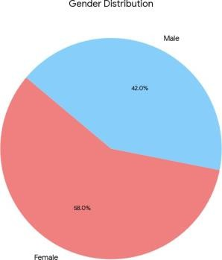

FIGURE 2-SHOWING PERCENTAGE OF PERIODONTITIS
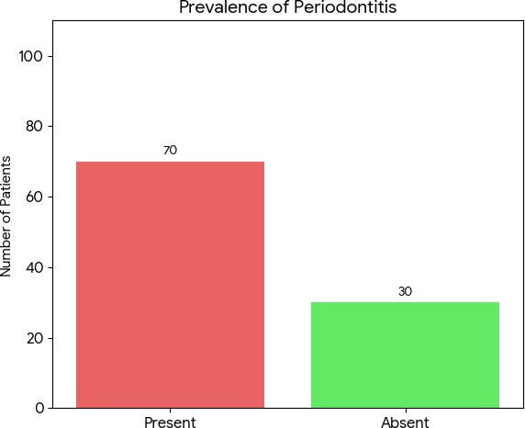

FIGURE 3-SHOWING PERCENTAGE OF GINGIVITIS

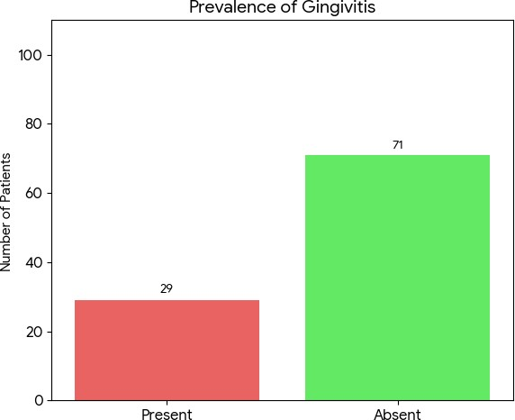

FIGURE 4-SHOWING PERCENTAGE OF GINGIVAL HYPERPLASIA
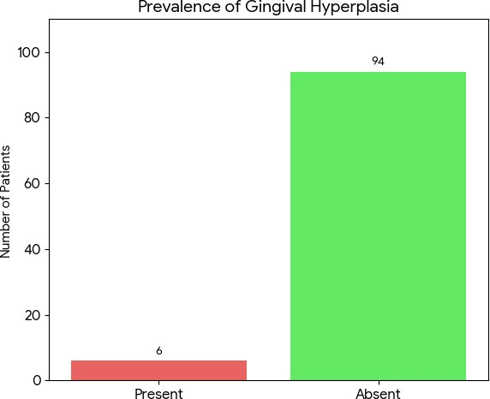

FIGURE5-SHOWING OVERALL CLINICAL FINDINGS

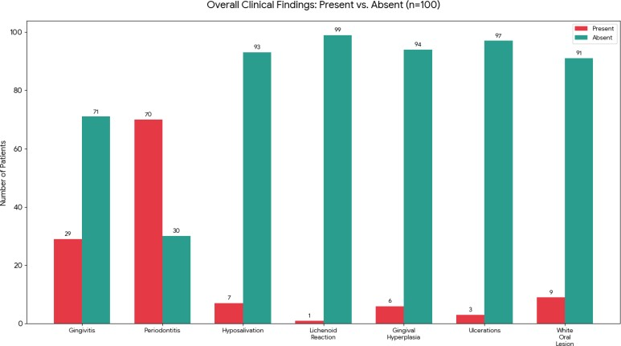

FIGURE 6-SHOWING PERCENTAGE OF WHITE ORAL LESION
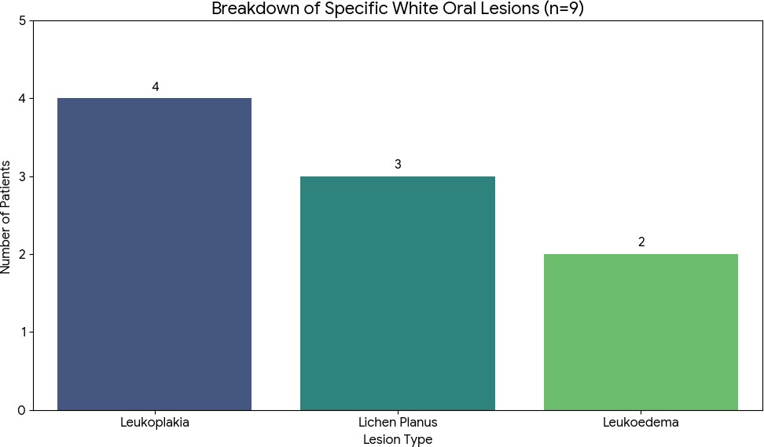

FIGURE 7-SHOWING PERCENTAGE OF HYPOSALIVATION

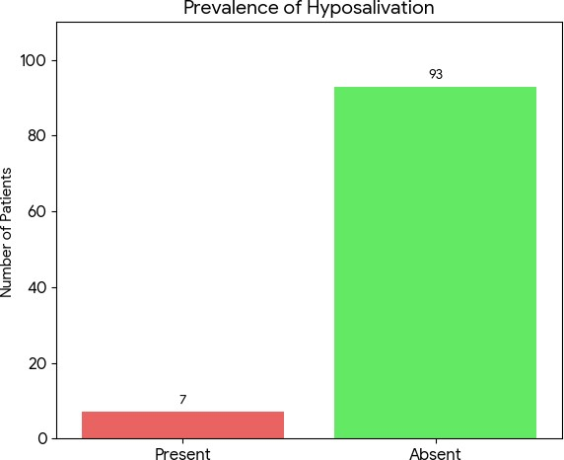

FIGURE 8 -SHOWING GINGIVAL HYPERPLASIA

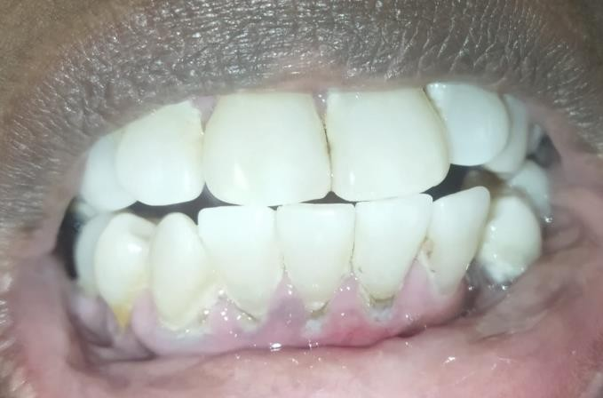
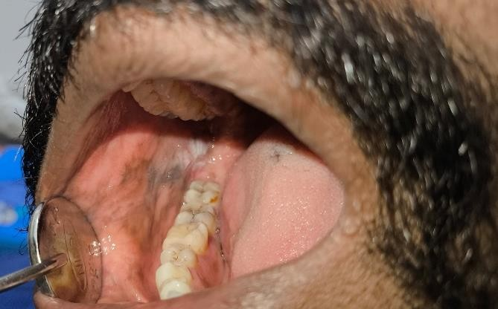

FIGURE 9-SHOWING LICHEN PLANUS

