Original Research Article
A Comparative Evaluation of flexural strength, microhardness and fracture toughness of a polymer-infiltrated ceramic and a lithium disilicate glass matrix ceramic: An in vitro study

.
ABSTRACT

Introduction: The study aims to compare the flexural strength, hardness, and fracture toughness of polymer-infiltrated ceramics to lithium disilicate to assess clinical suitability.
The past two decades have witnessed an evolution in the use of all ceramic restorations, opted for by both clinicians as well as patients. The increasing use of dental CAD/CAM systems has ushered in the development of novel CAD/CAM machinable ceramics with superior physical properties needed for permanent dental restorations.
Material and Methods: 20 specimens each of polymer-infiltrated ceramic and lithium disilicate glass matrix ceramic were prepared per ISO standards, on which mechanical and thermal tests (using Universal Testing Machine and Vickers Microhardness Tester) were conducted in metallurgical labs according to ISO reference standards.
Result: On testing the specimen, it was observed that IPS e.max CAD had statistically highly significant (p<0.001) greater flexural strength (343.78 MPa), microhardness (22.0 VHN) and fracture toughness (2.32 MPa√m) as compared to VITA Enamic (145.91 MPa, 7.7 VHN, 1.34 MPa√m respectively).
Conclusion: The presence of weaker polymer infiltration in VITA Enamic attributes towards its lower microhardness and flexural strength. It can also be deduced that the infiltration of a polymer phase into the ceramic structure does not improve its mechanical properties when compared to glass-matrix ceramics. It can be inferred that clinically IPS e.max CAD can tolerate higher values of mechanical load until fracture.

Keywords: Flexural strength, Hardness test, Ceramics, Polymer-infiltrated Ceramics, Glass-matrix Ceramics

1. INTRODUCTION

The past two decades have witnessed an evolution in the use of all ceramic restorations, opted for by both clinicians as well as patients.¹ High demands for aesthetic dentistry and biocompatible materials have paved the way for the development of newer ceramic materials. Some of the major goals of modern ceramic systems are an improvement of the mechanical properties as well as the manufacturing quality of the ceramic, and one of the ways of making that happen is the use of new technologies such as CAD/CAM (computer-aided design/computer-aided manufacturing).²
Ceramic restorative materials are presently categorised into three primary groups: glass-matrix ceramics, polycrystalline ceramics, and resin-matrix ceramics. The glass-matrix ceramics are further divided into three subcategories: naturally occurring feldspathic ceramics, synthetic ceramics, and glass-infiltrated ceramics. Polycrystalline ceramics are classified into four subgroups: alumina, stabilized zirconia, zirconia-toughened alumina, and alumina-toughened zirconia, the latter of which is currently under development. The third category, resin-matrix ceramics, encompasses multiple subgroups that are defined according to their specific composition³
Lithium disilicate dental ceramics were first introduced in 1988 for use as heat-pressed core materials. Their unique microstructure, consisting of numerous small, interlocking, randomly oriented plate-like crystals, produces a highly homogenous material with markedly enhanced mechanical properties compared to feldspathic and leucite-reinforced glass-matrix ceramics. Lithium disilicate ceramics are widely indicated for clinical applications such as crowns, veneers, occlusal veneers, inlays, onlays, and three-unit fixed prostheses due to their biocompatibility, wear resistance, and low thermal conductivity. However, they exhibit relatively low tensile strength and high brittleness, which limits their suitability for certain structural applications.
In 2013, a novel interpenetrating network material, VITA Enamic, was developed. This material consists of a porous ceramic infiltrated with a polymer to form a dual-network structure. The primary ceramic network, a lattice-like feldspar matrix, is reinforced through capillary action by a methacrylate polymer network, resulting in full integration of both networks. This interpenetrating architecture aims to combine the favourable mechanical and aesthetic properties of ceramics with the resilience of polymers.
While factors such as technique sensitivity, cost, and aesthetic appeal often influence a dentist’s selection of ceramic material, these considerations alone are insufficient for predicting clinical success. A dental ceramic must withstand the biomechanical forces encountered during normal function and parafunction within the oral environment. Consequently, a critical assessment of mechanical properties—such as flexural strength, hardness, and fracture toughness—is essential for understanding the intraoral performance of any ceramic material. In this context, in vitro evaluations of newly developed resin-matrix ceramics and their comparison with established glass-matrix ceramics, which are known for superior mechanical performance, are of paramount importance.

2. material and methods
The study was conducted by preparing the specimens according to the ISO standardization for the study of ceramic materials. The study was carried out in metallurgical laboratories where the mechanical and thermal testing of the materials was done.⁷

Sample Size and Source-
20 specimens of each material were utilized for the study. The formula used for determining the sample size was
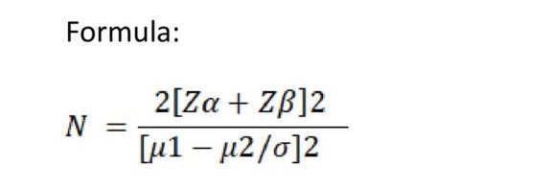
μ1-μ2/ δ is defined as Effect size (Es).
Where μ1 and μ2 are the means of two groups and δ is the standard deviation of the samples being studied.
The probability of falsely rejecting the true null hypothesis is α=0.05 and Zα=1.96. The probability of failing to reject a false null hypothesis is β=0.80 and Zβ=0.84.
Thus, N= 2[1.96+0.84]2 / (Es)2
≈ 16/(Es)2
For Effect size (Es) = 0.9 N= 16/ (0.9)2 = 19.753
i.e., ≈ 20 samples
Sample size per group of 20 units was considered for this study.
So, the total sample size required for this study was
20*2=40
Sample size (n) = 40
20 specimens of each material were utilized for the study.
List 1 : The distribution of the sample size was as follows

 | VITA Enamic | IPS e.max CAD
12 x 14 x 2 mm | 10 | 10
2 x 4 x 18 mm | 10 | 10
Total | 20 | 20

Materials-
- VITA Enamic multiColor blocks for CEREC/inLab (VITA Zahnfabrik, Bad Säckingen, Germany) (Fig.1)
- IPS e.max CAD blocks for inLab (Ivoclar Vivadent, Schaan, Liechtenstein) (Fig.2)
- Wet Mouth Liquid (ICPA Health Products Ltd.) (Fig.3)

Armamentarium- (Fig.4)
- Steel file
- Diamond file
- Digital Vernier Caliper (Baker ED20)

Equipment-
- OMAX 80X JetMachine (OMAX, Washington, USA) (Fig.5)
- Temperature cycling chamber (Comet Environs) (Fig.6)
- UNITEST-10 Universal Testing Machine (ACME Engineers, India) (Fig.7)
- Vickers Microhardness Tester, Reichert Austria Make, Sr. No. 363798 (Fig.8)
- Vision Inspection System Model No. AVI-IMG-3D (Sipcon Measuring Systems, India) (Fig.9)
Plan of Study-
The VITA Enamic and IPS e.max CAD blocks of size 12 mm x 14 mm x 18 mm were obtained from their respective manufacturers. The ceramic specimens, batch numbers and manufacturers are listed in Table 1. The ceramic materials were used as supplied.
10 samples of each ceramic material were obtained in two different measurement specifications as follows:
- 10 samples of VITA Enamic (2 mm x 4 mm x 18 mm) for flexural strength testing
- 10 samples of IPS e.max CAD (2 mm x 4 mm x 18 mm) for flexural strength testing
- 10 samples of VITA Enamic (2 mm x 12 mm x 14 mm) for hardness and fracture toughness testing
- 10 samples of IPS e.max CAD (2 mm x 12 mm x 14 mm) for hardness and fracture toughness testing
Sample Preparation (Fig. 10):
Ceramic samples measuring 2 mm × 4 mm × 18 mm and 2 mm × 12 mm × 14 mm were sectioned from larger blocks using a waterjet machine (OMAX 80X, USA) at 4572 mm/min. The blocks were secured on a wooden platform in the machine’s catch tank using nails. Required dimensions were programmed into the machine controller, and high-speed water mixed with abrasives cut the ceramics without thermal damage, preserving structural integrity.⁸ Samples were filed with diamond and steel files for uniformity. Dimensions were verified using a digital vernier caliper (Baker E20, min reading 0.01 mm). Samples outside ±0.2 mm tolerance or with chipping were discarded as they could significantly influence the test results. All samples met ISO standards for material testing.⁷
Specimen Randomization:
Since the specimens were dimension-specific to each test, random allocation between testing categories was not applicable. However, within each test group, specimens were assigned identification numbers and tested in a randomized sequence using a computer-generated randomization table to eliminate procedural bias.
Thermocycling:
Specimens underwent 500 thermal cycles in a 5°C/55°C bath using Comet Environs chambers. Each cycle involved 30 sec at 5°C, a 5-sec transfer, 10 sec at 55°C, and a 5-sec return. This regimen, based on Gale MS et al., was performed in artificial saliva (Wet Mouth Liquid, ICPA Health Products Ltd.).⁹
Three-Point Bend Test (Fig. 11):
Conducted with a UNITEST-10 universal testing machine (Acme Engineers, India) per ISO 6872:2015, samples (2 mm × 4 mm × 18 mm) were placed on a metal jig with 15 mm support spans.⁷ Dimensions were input into the software, and a central force was applied at 0.5 mm/min until failure. Fracture stress (σf) was calculated using:
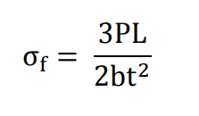
Where P = fracture load (N), L = support span (mm), b = width (mm), and d = thickness (mm).
Hardness Test (Fig. 12)
Microhardness was measured on samples (2 mm × 12 mm × 14 mm) using a Vickers Microhardness Tester (Reichert, Austria) with a 50 g load as per ISO 6507. Diagonals of the indentations were measured under a microscope (AVI-IMG-3D, Sipcon Measuring Systems, India). Microhardness was calculated with:
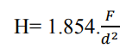
where F = load (g) and d = diagonal length of the indentation.
Fracture Toughness (Fig. 13)
Samples used for hardness testing were also tested for fracture toughness. They were loaded in tension at a crosshead speed of 0.5 mm/min. The load and displacement were constantly monitored and recorded until crack propagation or crack failure. The length of the crack was observed under an optical microscope. Fracture toughness (K_{IC}) was calculated using:
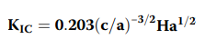
where c = half diagonal of the indentation, a = crack length, and H = Vickers hardness number.
Data Management & Analysis
Test results were classified and coded for analysis. Statistical analysis was performed using SPSS v21. Descriptive statistics (mean, SD) were used for quantitative data. A significance level of α = 0.05 was set, with p ≤ 0.05 considered significant. Data normality was assessed via the Shapiro-Wilk test, and unpaired t-tests compared Groups A and B across study parameters.

3. results and discussion

The data obtained was compiled and subjected to statistical analysis.
The arithmetic mean, standard deviation and standard error were calculated for each group.
On further conducting an unpaired t test for each group, it was observed that IPS e.max CAD had statistically highly significant (p<0.001) greater flexural strength, microhardness and fracture toughness as compared to VITA Enamic.

Table 1: Descriptive statistics like mean, standard deviation and standard error of flexural strength for VITA Enamic and IPS e.max CAD. (SD = Standard Deviation, amount of variation within a set of values) (SE = Standard Error, indicates the precision of the estimate of the parameter)
(in Mpa) | Mean | SD | SE | Minimum | Maximum
VITA Enamic | 145.91 | 32.3 | 10.21 | 107.13 | 186.49
IPS e.max CAD | 343.78 | 30.96 | 9.79 | 256.75 | 359.87

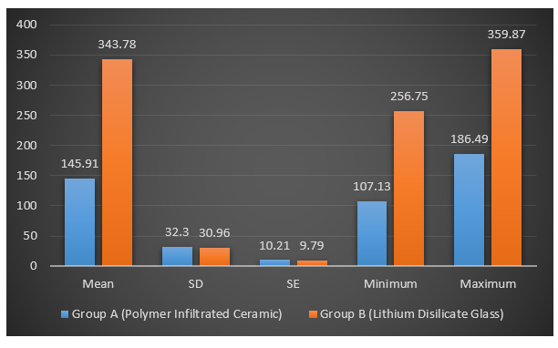

Graph 1: Mean, standard deviation and standard error of flexural strength for VITA Enamic and IPS e.max CAD

In Mpa | Mean | SD | Mean Difference ± SE | Unpaired t test | p value, Significance
Vita Enamic | 145.91 | 32.3 | 197.86 ± 14.15 | t = -13.982 | p<0.001**
IPS e.max CAD | 343.78 | 30.96 | 197.86 ± 14.15 | t = -13.982 | p<0.001**
Table 2: Comparative statistics of flexural strength of VITA Enamic and IPS e.max CAD after unpaired t test (SD = Standard Deviation, amount of variation within a set of values) (SE = Standard Error, indicates the precision of the estimate of the parameter)

Table 3: Descriptive statistics like mean, standard deviation and standard error of microhardness for VITA Enamic and IPS e.max CAD (SD = Standard Deviation, amount of variation within a set of values) (SE = Standard Error, indicates the precision of the estimate of the parameter)

In HV (Vickers Hardness Number) | Mean | SD | SE | Minimum | Maximum
VITA Enamic | 7.7 | 1.05 | 0.33 | 6.0 | 9.0
IPS e.max CAD | 22.0 | 5.96 | 1.88 | 15.0 | 32.0

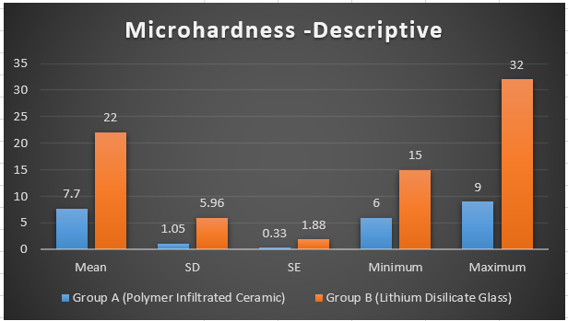

Graph 2: Mean, standard deviation and standard error of microhardness for VITA Enamic and IPS e.max CAD

Table 4: Comparative statistics of microhardness of VITA Enamic and IPS e.max CAD after unpaired t test (SD = Standard Deviation, amount of variation within a set of values) (SE = Standard Error, indicates the precision of the estimate of the parameter)
In HV (Vickers Hardness Number) | Mean | SD | Mean Difference ± SE | Unpaired t test | p value, Significance
VITA Enamic | 7.7 | 1.05 | 14.3 ± 1.91 | t =7.467 | p<0.001**
IPS e.max CAD | 22.0 | 5.96 | 14.3 ± 1.91 | t =7.467 | p<0.001**

Table 5: Descriptive statistics like mean, standard deviation and standard error of fracture toughness for VITA Enamic and IPS e.max CAD (SD = Standard Deviation, amount of variation within a set of values) (SE = Standard Error, indicates the precision of the estimate of the parameter)

MPa√m | Mean | SD | SE | Minimum | Maximum
VITA Enamic | 1.34 | 0.37 | 0.11 | 1.01 | 1.89
IPS e.max CAD | 2.32 | 0.03 | 0.01 | 2.27 | 2.37

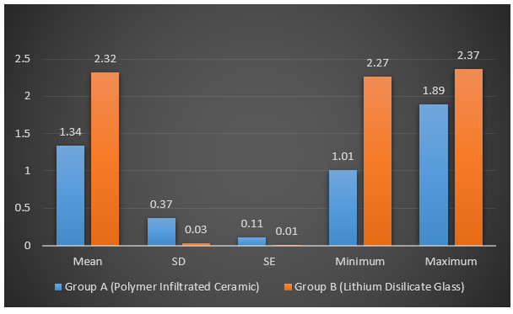

Graph 3: Mean, standard deviation and standard error of fracture toughness for VITA Enamic and IPS e.max CAD

Table 6: Comparative statistics of fracture toughness of VITA Enamic and IPS e.max CAD after unpaired t test (SD = Standard Deviation, amount of variation within a set of values) (SE = Standard Error, indicates the precision of the estimate of the parameter)
MPa√m | Mean | SD | Mean Difference ± SE | Unpaired t test | p value, Significance
VITA Enamic | 1.34 | 0.37 | 0.97 ± 0.11 | t = -8.269 | p<0.001**
IPS e.max CAD | 2.32 | 0.03 | 0.97 ± 0.11 | t = -8.269 | p<0.001**

Discussion:
The rise of in-office milling machines and in-lab digital design has accelerated the development of new dental materials. CAD/CAM technology has improved the fit and precision of crowns and fixed dental prostheses, with newer materials enhancing both efficiency and predictability.¹⁰ As minimally invasive dentistry advances, the mechanical properties of restorative materials are continually tested, expanding options for aesthetic restorations.¹¹ CAD/CAM resin composite blocks have introduced new applications for ceramics, broadening material choices.
CAD/CAM materials are broadly classified into two categories: glass ceramics and resin composites. Glass ceramics consist of a glassy matrix reinforced with ceramic fillers, offering superior mechanical properties due to their crystalline structure. Resin composites, on the other hand, feature a polymeric matrix with ceramic fillers, offering advantages in machinability and mechanical properties akin to enamel and dentin.¹² Their standardized industrial production results in dense, reliable structures.¹³
To verify manufacturers' claims, mechanical testing of dental materials is essential. Tests predict how materials respond intraorally, focusing on their ability to withstand biomechanical forces during function and parafunction.^{14, 15} It is integral to understand these properties before electing to use the material in a clinical setting. Mechanical properties are evaluated through in vitro tests, standardized by organizations like the ADA and ISO 6872:2015 for ceramic materials.
Types of In Vitro Tests
In vitro tests fall into two categories:
- Physical Property Measurements: Include flexural strength, microhardness, and fracture toughness tests.
- Simulations of Clinical Behavior: Replicate intraoral conditions, such as thermocycling, to assess material durability under temperature changes.¹⁵
According to the fundamentals of machine design, it is essential that every component of any machine be able to withstand the forces applied to it for it to perform maximally. Dental materials face various stresses: tensile (elongation), compressive (shortening), and shear (twisting). Flexural stress, a combination of these forces, is critical in prosthetic applications.¹⁶ The three-point bend test is the ISO standard for measuring flexural strength, involving a supported specimen subjected to a central load.⁷
Hardness is one of the basic mechanical indices used to describe and compare materials. Hardness indicates resistance to surface indentation and affects finishing, polishing, and wear resistance. It dictates a material's resistance to surface penetration, abrasion, and wear. The Vickers hardness test, using a diamond indenter, measures surface indentation diagonals to calculate hardness values. High hardness can improve wear resistance but may increase enamel wear in opposing teeth.¹⁷
In 1913, Inglis realized that the stress-concentration factor around a crack tip, is directly related to the geometry (length and width) of the crack itself. When this stress-concentration factor increases, the maximum stress-strain level the material can tolerate before fracture decreases. However, the crack tip is surrounded by a zone of plastic deformation which absorbs some of the stress that is magnified at the crack tip and prevents the further propagation of the crack.³⁵ Evaluation of fracture toughness of any new material is imperative before use in the oral environment as this property is material specific and not environment specific. Fracture toughness is critical to ensuring the longevity of indirect restorations, especially in regions subjected to high occlusal forces.²⁷ Fracture toughness measures a material’s ability to resist crack propagation. Higher fracture toughness reduces the incidence of catastrophic, irreparable fractures in posterior teeth. The indentation fracture technique, using a Vickers indenter, introduces microcracks to assess toughness.¹⁸ This property is crucial for materials exposed to mechanical stresses in the oral environment.
In vitro tests often overlook fatigue effects, which are critical for predicting clinical performance. Hence the results obtained after testing can be considered unrealistically optimistic to a certain extent. Carrying out mechanical fatigue tests in a wet environment can help better speculate the clinical behavior of different materials.²⁵ Thermocycling simulates the temperature fluctuations in the mouth, creating stress at the material interfaces.^{19, 20} Testing in artificial saliva enhances the replication of intraoral conditions.
Each of the above-mentioned tests are important, within their own right, yet it is important to analyze their results collectively to obtain an accurate inference.
Study Findings and Material Comparison
In this study, IPS e.max CAD and VITA Enamic were compared:
- Flexural Strength: IPS e.max CAD exhibited a mean strength of 343.78 MPa, significantly higher than VITA Enamic’s 145.91 MPa. This amounts to a substantial difference. This suggests IPS e.max CAD can withstand greater loads before failure. This property plays an important role, especially for thin restorations.²⁹ Crystal orientation, grain-size distribution and shape, the ratio of the glass matrix to the crystalline phase, and homogeneity control the flexural strength and fracture toughness of glass-ceramics. The high flexural strength of these glass-ceramics is due to the interlocked microstructure and the shape of the crystals.³⁴ It can be concluded that as compared to IPS e.max CAD, VITA Enamic has a lower damage tolerance and any flaws introduced by chewing or grinding adjustments will have a greater impact on its resultant strength.
- Hardness: IPS e.max CAD had a mean Vickers hardness of 22.0 VHN, compared to 7.7 VHN for VITA Enamic. The reason for this might be the lower inorganic content of the ceramic-polymer composite material of VITA Enamic.³⁰ The lower hardness of VITA Enamic may reduce opposing enamel wear. The lower hardness value of VITA Enamic could be advantageous in terms of protecting the opposing tooth from clinical wear.⁵ In 2013, Mörmann et al³³ reported that less opposite enamel wear occurred against ceramic-polymer composite materials as compared to glass matrix ceramics, however these materials show higher excessive material wear as compared to glass-matrix ceramics. Hence, it can be speculated that the lower hardness value of VITA Enamic might actually be considered as an advantage in protecting the opposite tooth from enamel wear. Also, hardness affects the polishability and ease of milling of ceramics.³⁶ Assuming a linear relationship between the material removed during milling and its hardness, materials with lower hardness should be milled faster.³⁷
- Fracture Toughness: IPS e.max CAD showed higher toughness (2.32 MPa√m) than VITA Enamic (1.34 MPa√m), indicating better resistance to crack propagation. Platelet-like crystals are uniformly distributed within an interlocking microstructural network, a characteristic feature of lithium disilicate glass ceramics. This densely arranged crystalline framework acts as a barrier to crack advancement. Should cracks initiate, their progression becomes deflected and confined within the crystal structure along a more tortuous path, which may restrict further propagation and contribute to improved fracture toughness. The lower inorganic content of VITA Enamic might be the reason for its lower fracture toughness in relation to IPS e.max CAD.³⁰ It can be speculated, according to Sen D et al³¹, that in ceramic-polymer composite materials, thermocycling induces stresses at the network interfaces of the glass ceramic and polymer parts of the material due to differences in their coefficient of thermal expansion. Also, VITA Enamic is constrained by the relatively low elastic modulus of the resin component; consequently, it’s fracture toughness is primarily determined by the properties of the resin matrix. This might be a reason for the reduced fracture toughness of VITA Enamic.
The results of the present study closely corresponded with the manufacturer’s reported data. These outcomes can be attributed to the inherent structural differences between the materials. IPS e.max CAD features interlocking lithium disilicate crystals, which confer both strength and fracture toughness. In contrast, VITA Enamic possesses a dual-network architecture, in which a porous ceramic framework is infiltrated with a polymer. This configuration increases material flexibility but results in comparatively lower hardness and fracture resistance⁴
IPS e.max CAD exhibits a high crystalline content, with up to 70 vol% of its structure comprising a glassy matrix. Crystallisation occurs upon heating under vacuum, resulting in a highly interlocked microstructure of lithium disilicate crystals. Tangential compressive stresses arise around these crystals due to the thermal expansion mismatch between the crystalline and glassy phases. These stresses are thought to contribute to the material’s enhanced fracture toughness by mechanisms such as crack bridging and deflection [22].
In contrast, VITA Enamic is composed of a dual-network structure, consisting of a porous sintered ceramic framework whose pores are infiltrated with a polymer matrix via capillary action following the application of a coupling agent under high pressure. This high-pressure polymer infiltration generally improves fracture toughness relative to other ceramic–resin composites [23,24]. However, compared with glass-matrix ceramics such as IPS e.max CAD, the incorporation of a polymer phase into the ceramic network does not appear to enhance mechanical properties to the same extent.
Another finding that was identified during the conduction of the present study was related to the edge chipping of the ceramic materials. During specimen preparation from the ceramic blocks, the specimens of IPS e.max CAD tended more towards edge chipping. This can be attributed to its microstructure and composition. Because of its lack of resin content and higher surface hardness, it may be more prone to edge chipping. These findings are in accordance with the study conducted by Awada A et al²⁸ in 2014. These findings suggest a higher likelihood of obtaining milling fidelity of polymer-based ceramic materials in areas of possibly reduced restorative material thickness such as crown margins.³⁸
Clinical Implications
While IPS e.max CAD offers superior mechanical properties, VITA Enamic’s lower hardness may protect opposing teeth from wear. Its less abrasive nature is advantageous for certain clinical scenarios, particularly in patients with parafunctional habits or in cases involving extensive occlusal contact. Additionally, VITA Enamic is generally easier to mill, resulting in reduced bur wear and potentially shorter fabrication times, which can be advantageous in chairside CAD/CAM workflows. However, VITA Enamic is more prone to edge chipping due to its microstructure. In contrast, the higher hardness and strength of IPS e.max CAD provide better resistance to functional loads, although this increased brittleness may predispose it to chipping at sharp internal angles or stress points if not properly designed.
It can be deduced that in a direct comparison between properties, glass ceramics are superior as compared to ceramic-polymer composite materials. Lithium disilicate glass ceramics exhibit sufficiently high strength to be suitable for full-coverage crowns in posterior regions. However, ease of fabrication and the possibility of an easier and less visible intra-oral repair of minor defects induced by function are the advantages of ceramic-polymer materials.
Limitations of the Study
- Specimen Size: The small size of ceramic blocks limited specimen dimensions, slightly deviating from ISO 6872 standards.
- In Vitro vs. Clinical Conditions: This study is limited by several factors inherent in the oral environment, such as saliva composition, pH fluctuations, enzymatic activity, occlusion, no simulation of masticatory fatigue or cyclic loading and operator technique which can affect clinical outcomes.²⁶ In addition to this, indications like crowns, partial crowns, inlays et cetera as well as the selection of luting material are decisive for clinical success.
- Lack of Long-Term Clinical Data: While in vitro tests are important for providing initial predictors for the success of a material, they are by no means a replacement for clinical tests in patients.²³ Future long-term clinical trials are required to compare the properties of both ceramic materials.
Utilizing in vitro studies as a benchmark for clinical trials will provide a definitive conclusion on the success and survivability of these materials. Based on such in vitro testing and clinical trials, a new manufacturing process may be formed for the development of commercially available CAD/CAM materials which will maintain desirable properties of both high crystal ceramics and ceramic-polymer materials such as high tolerance to mechanical load and also reduced abrasiveness to opposing teeth and milling usability.
Before generalized clinical use of any new material, the advantages and disadvantages of the material have to be considered on a case-by-case basis before making decisions regarding patient treatment.
Future Directions
Further research should include additional properties like wear resistance, biocompatibility, fatigue testing, and color stability. Long-term clinical studies will help establish the real-world performance of these materials. Combining the strengths of glass ceramics and ceramic-polymer composites could lead to advanced materials with high mechanical tolerance and reduced enamel wear.

4. Conclusion

- IPS e.max CAD demonstrated superior flexural strength, hardness, and fracture toughness compared to VITA Enamic.
- However, VITA Enamic’s lower hardness may benefit opposing enamel, and its easier milling offers practical advantages.
- Clinicians should consider these properties alongside individual patient needs and clinical situations when selecting materials. Ultimately, in vitro studies, supplemented by clinical trials, are essential for guiding the future of CAD/CAM dental materials.

COMPETING INTERESTS DISCLAIMER:
Authors have declared that they have no known competing financial interests OR non-financial interests OR personal relationships that could have appeared to influence the work reported in this paper.
Disclaimer (Artificial intelligence)
Author(s) hereby declare that NO generative AI technologies such as Large Language Models (ChatGPT, COPILOT, etc.) and text-to-image generators have been used during the writing or editing of this manuscript.

References

1. Chai J, Takahashi Y, Sulaiman F, Chong K, Lautenschlager EP. Probability of fracture of all-ceramic crowns. Int J Prosthodont. 2000 Sep-Oct;13(5):420-4.
2. Lohbauer U, Petschelt A, Greil P. Lifetime prediction of CAD/CAM dental ceramics. J Biomed Mater Res. 2002;63(6):780-5.
3. Gracis S, Thompson VP, Ferencz JL, Silva NR, Bonfante EA. A new classification system for all-ceramic and ceramic-like restorative materials. Int J Prosthodont. 2015 May-Jun;28(3):227-35.
4. Willard A, Gabriel Chu TM. The science and application of IPS e.max dental ceramic. Kaohsiung J Med Sci. 2018 Apr;34(4):238-242.
5. He LH, Swain M. A novel polymer infiltrated ceramic dental material. Dent Mater. 2011 Jun;27(6):527-34.
6. VITA North America [Internet]. www.vitanorthamerica.com. [cited 2023 Feb 18]. Available from: https://www.vitanorthamerica.com/en-US/Download-centre-275
7. International Organization for Standardization. ISO 6872:2015(E). _ Dentistry — Ceramic materials_. Geneva: ISO; 2015.
8. Belli R, Geinzer E, Muschweck A, Petschelt A, Lohbauer U. Mechanical fatigue degradation of ceramics versus resin composites for dental restorations. Dent Mater. 2014 Apr;30(4):424-32.
9. Gale MS, Darvell BW. Thermal cycling procedures for laboratory testing of dental restorations. J Dent. 1999 Feb;27(2):89-99.
10. Miyazaki T, Hotta Y, Kunii J, Kuriyama S, Tamaki Y. A review of dental CAD/CAM: current status and future perspectives from 20 years of experience. Dent Mater J. 2009 Jan;28(1):44-56.
11. Conrad HJ, Seong WJ, Pesun IJ. Current ceramic materials and systems with clinical recommendations: a systematic review. J Prosthet Dent. 2007 Nov;98(5):389-404.
12. Ruse ND, Sadoun MJ. Resin-composite blocks for dental CAD/CAM applications. J Dent Res. 2014 Dec;93(12):1232-4.
13. Giordano R. Materials for chairside CAD/CAM-produced restorations. J Am Dent Assoc. 2006 Sep;137 Suppl:14S-21S.
14. Guazzato M, Albakry M, Ringer SP, Swain MV. Strength, fracture toughness and microstructure of a selection of all-ceramic materials. Part I. Pressable and alumina glass-infiltrated ceramics. Dent Mater. 2004 Jun;20(5):441-8.
15. Kelly JR, Benetti P, Rungruanganunt P, Bona AD. The slippery slope: critical perspectives on in vitro research methodologies. Dent Mater. 2012 Jan;28(1):41-51.
16. Anusavice KJ, Shen C, Rawls HR. Phillip's science of Dental materials Kenneth. 12th ed. St. Louis, MO: Elsevier; 2012.
17. Sakaguchi RL, Powers JM. Craig's restorative dental materials. 13th ed. St. Louis, MO: Elsevier; 2012.
18. Scherrer SS, Denry IL, Wiskott HW. Comparison of three fracture toughness testing techniques using a dental glass and a dental ceramic. Dent Mater. 1998 Jul;14(4):246-55.
19. Vásquez V, Ozcan M, Nishioka R, Souza R, Mesquita A, Pavanelli C. Mechanical and thermal cycling effects on the flexural strength of glass ceramics fused to titanium. Dent Mater J. 2008 Jan;27(1):7-15.
20. Egilmez F, Ergun G, Cekic-Nagas I, Vallittu PK, Lassila LVJ. Does artificial aging affect mechanical properties of CAD/CAM composite materials. J Prosthodont Res. 2018 Jan;62(1):65-74.
21. Höland W, Apel E, van ‘t Hoen C, Rheinberger V. Studies of crystal phase formations in high-strength lithium disilicate glass–Ceramics. J Non Cryst Solids. 2006 Sep14;352(38-39):4041–50.
22. Guess PC, Schultheis S, Bonfante EA, Coelho PG, Ferencz JL, Silva NR. All-ceramic systems: laboratory and clinical performance. Dent Clin North Am. 2011 Apr;55(2):333-52, ix.
23. Heintze SD, Zimmerli B. Relevance of in vitro tests of adhesive and composite dental materials, a review in 3 parts. Part 1: Approval requirements and standardized testing of composite materials according to ISO specifications. Schweiz Monatsschr Zahnmed. 2011;121(9):804-16. Dutch, English.
24. Della Bona A, Corazza PH, Zhang Y. Characterization of a polymer-infiltrated ceramic-network material. Dent Mater. 2014 May;30(5):564-9.
25. Al-Harbi FA, Ayad NM, ArRejaie AS, Bahgat HA, Baba NZ. Effect of Aging Regimens on Resin Nanoceramic Chairside CAD/CAM Material. J Prosthodont. 2017 Jul;26(5):432-439.
26. Çağlayan E, Sasany R, Bolat BN, Hartavi D, Batgerel OE, Ucar SM, Umurca DG. Optical properties of repaired additively manufactured resin composites and zirconia and subtractively manufactured ceramics: a comparative study of composite resins. BMC Oral Health. 2025 Jan 27;25(1):144.
27. Sasany R, Ucar SM, Mosaddad SA, Rodríguez Alonso V. Effect of polydopamine surface treatment on the mechanical properties of zirconia and resin occlusal veneers fabricated using additive and subtractive manufacturing: An in vitro study. J Dent. 2025 Aug;159:105805.
28. Awada A, Nathanson D. Mechanical properties of resin-ceramic CAD/CAM restorative materials. J Prosthet Dent. 2015 Oct;114(4):587-93.
29. Stawarczyk B, Liebermann A, Eichberger M, Güth JF. Evaluation of mechanical and optical behavior of current esthetic dental restorative CAD/CAM composites. J Mech Behav Biomed Mater. 2015 Mar;55:1-11.
30. Albero A, Pascual A, Camps I, Grau-Benitez M. Comparative characterization of a novel cad-cam polymer-infiltrated-ceramic-network. J Clin Exp Dent. 2015 Oct 1;7(4):e495-500.
31. Sen D, Sonmez Ceren N, Turp V. Microstructural characterization and mechanical evaluation of five different CAD/CAM Materials. Dent Mat. 2015;31.
32. Hampe R, Theelke B, Lümkemann N, Eichberger M, Stawarczyk B. Fracture Toughness Analysis of Ceramic and Resin Composite CAD/CAM Material. Oper Dent. 2019 Jul/Aug;44(4):E190-E201.
33. Mörmann WH, Stawarczyk B, Ender A, Sener B, Attin T, Mehl A. Wear characteristics of current aesthetic dental restorative CAD/CAM materials: two-body wear, gloss retention, roughness and Martens hardness. J Mech Behav Biomed Mater. 2013 Apr;20:113-25.
34. Hallmann L, Ulmer P, Kern M. Effect of microstructure on the mechanical properties of lithium disilicate glass-ceramics. J Mech Behav Biomed Mater. 2018 Jun;82:355-370. doi: 10.1016/j.jmbbm.2018.02.032. Epub 2018 Mar 3.
35. Hertzberg RW, Vinci RP, Hertzberg JL. Deformation and fracture mechanics of Engineering Materials. 5th ed. Chichester: John Wiley & Sons Ltd; 2012.
36. Leung BT, Tsoi JK, Matinlinna JP, Pow EH. Comparison of mechanical properties of three machinable ceramics with an experimental fluorophlogopite glass ceramic. J Prosthet Dent. 2015 Sep;114(3):440-6.
37. Chavali R, Nejat AH, Lawson NC. Machinability of CAD-CAM materials. J Prosthet Dent. 2017 Aug;118(2):194-199.
38. Batson ER, Cooper LF, Duqum I, Mendonça G. Clinical outcomes of three different crown systems with CAD/CAM technology. J Prosthet Dent. 2014 Oct;112(4):770-7.

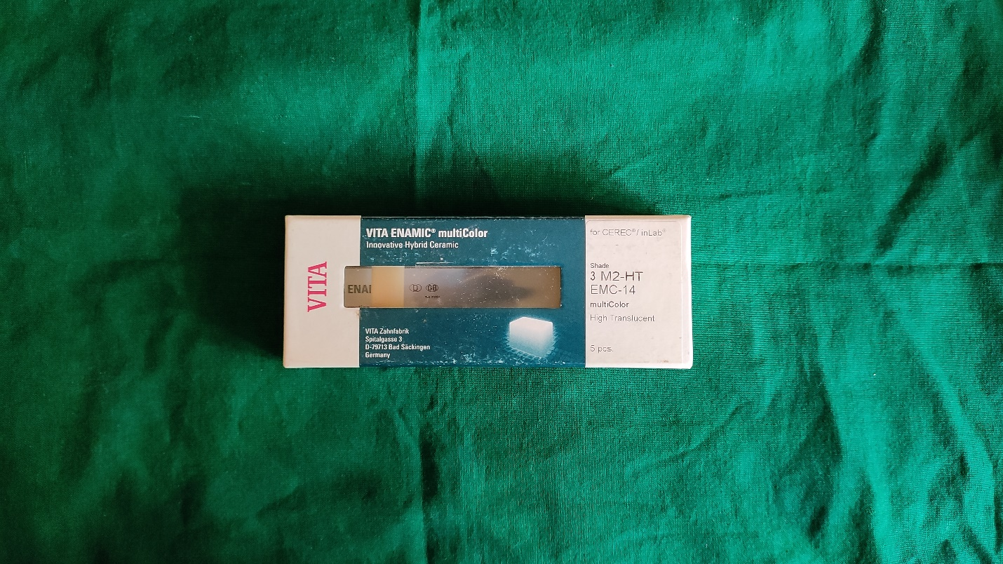

(a)

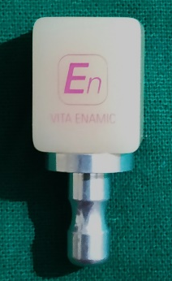

(b)

Fig. 1: VITA Enamic multiColor blocks for CEREC/inLab (VITA Zahnfabrik, Bad Säckingen, Germany)

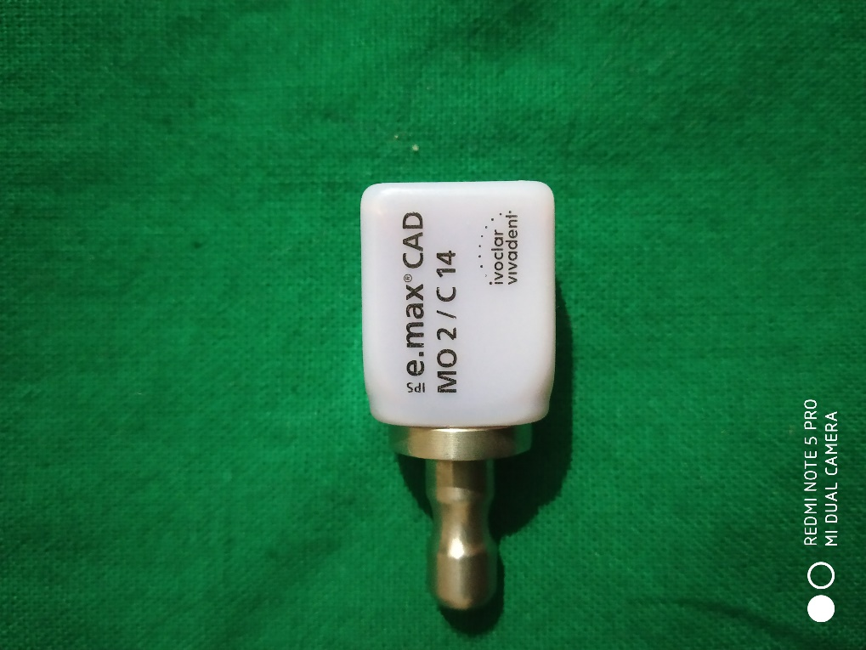
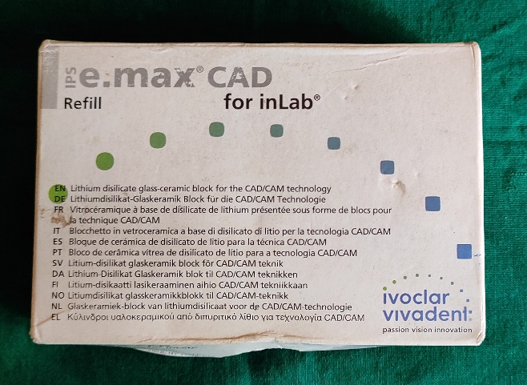

Fig. 2: IPS e.max CAD blocks for inLab (Ivoclar Vivadent, Schaan, Liechtenstein)

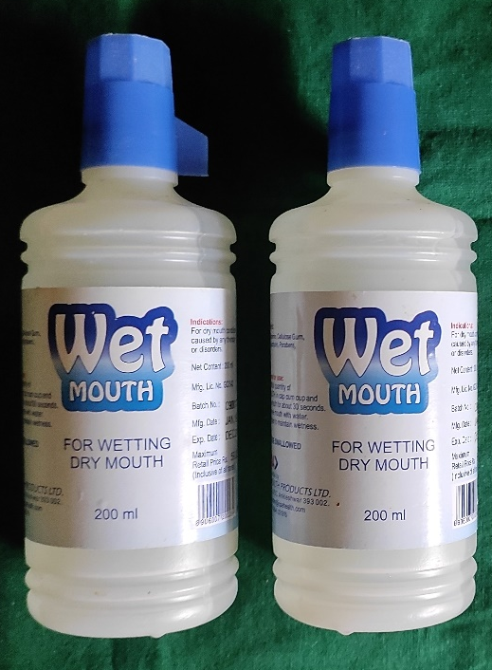

Fig. 3: Wet Mouth Liquid (ICPA Health Products Ltd.)
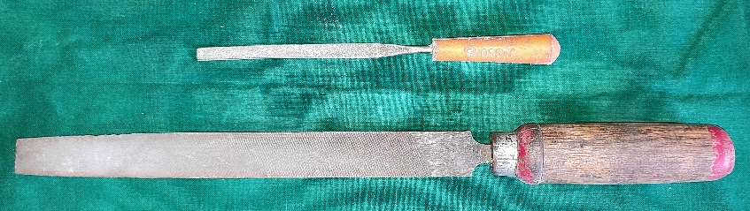

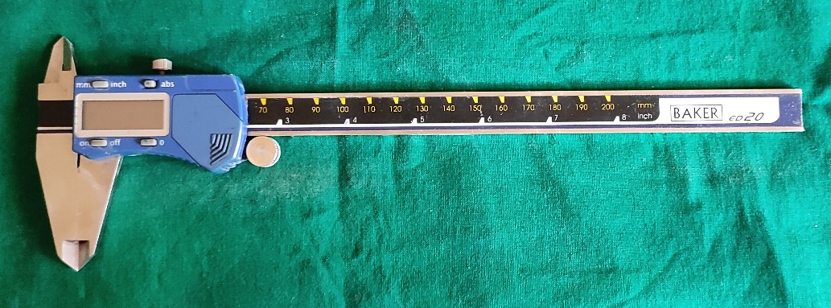

Fig. 4: Armamentarium

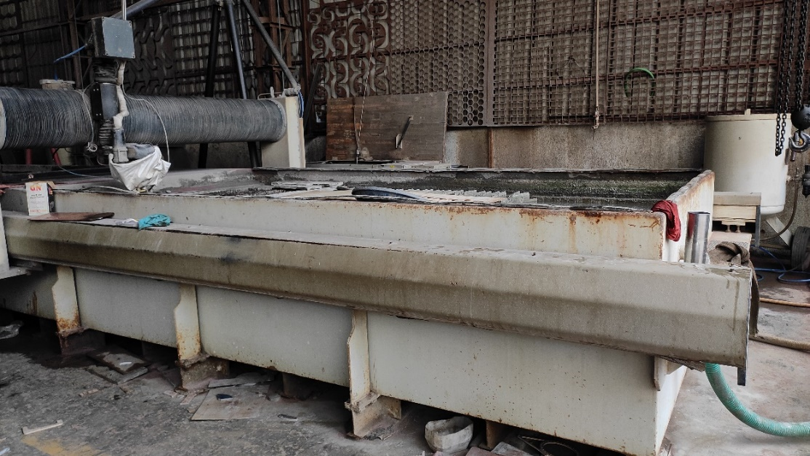

Fig. 5: OMAX 80X JetMachine (OMAX, Washington, USA)

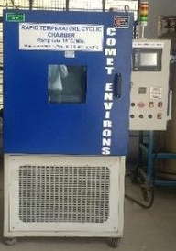

Fig. 6: Temperature cycling chamber (Comet Environs)

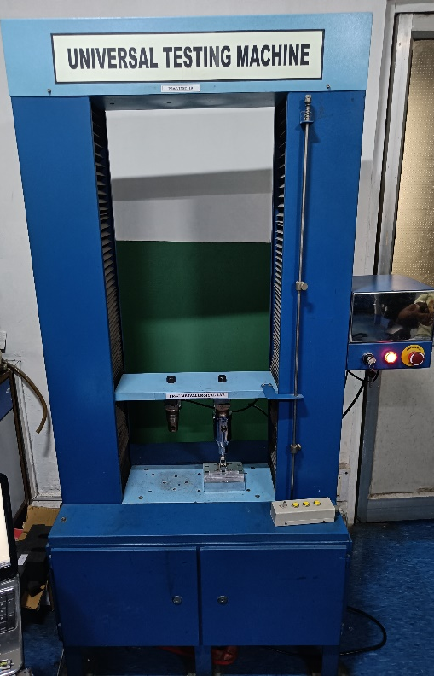

Fig. 7: UNITEST-10 Universal Testing Machine (ACME Engineers, India)

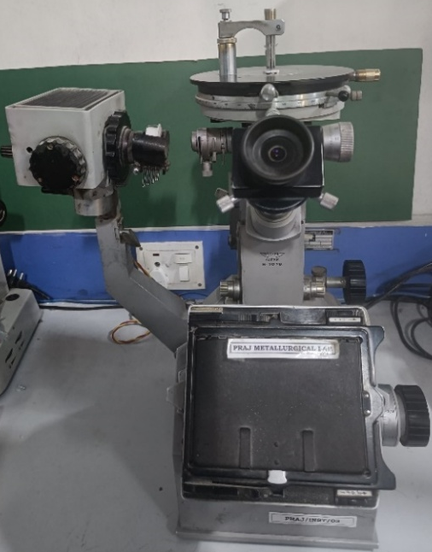

Fig. 8: Vickers Microhardness Tester, Reichert Austria Make, Sr. No. 363798

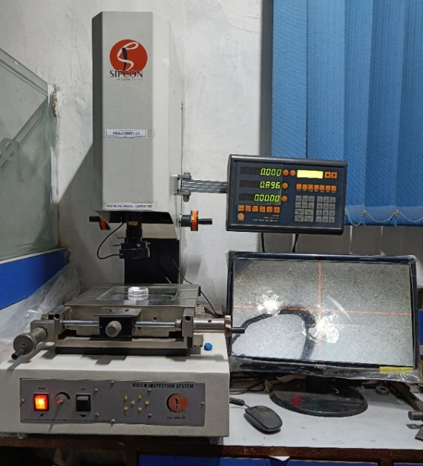

Fig. 9: Vision Inspection System Model No. AVI-IMG-3D (Sipcon Measuring Systems, India)

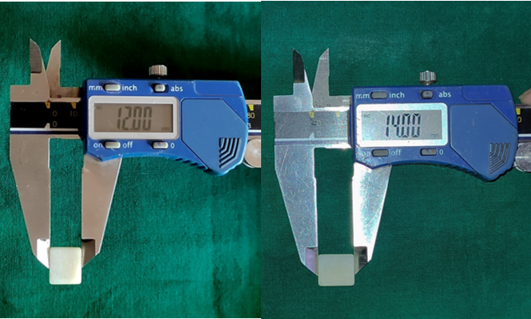
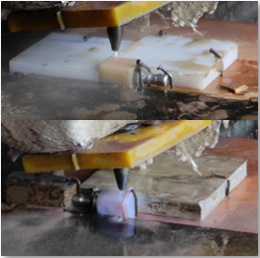

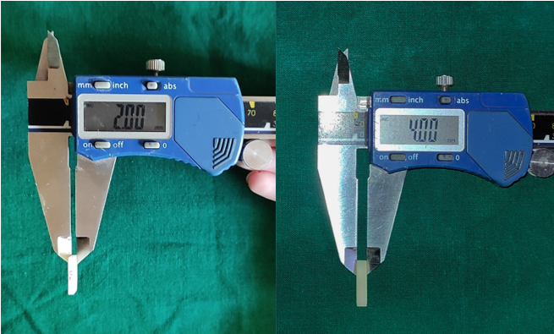

Fig. 10: Sample preparation
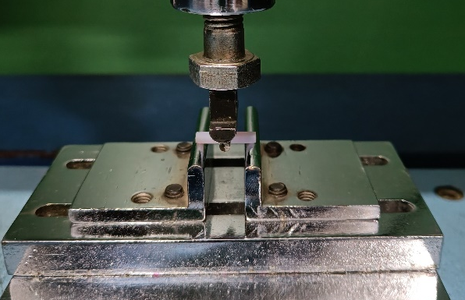

Fig. 11 Three-point bend test on Universal Testing Machine

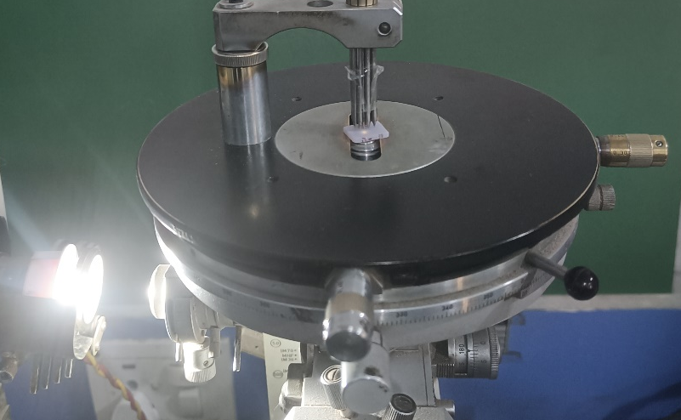

Fig. 12: Hardness test on Vickers Microhardness Tester

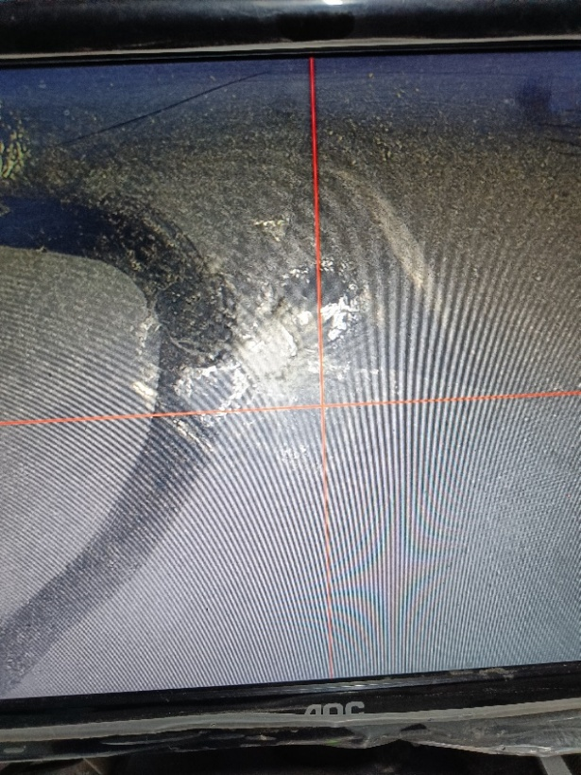

Fig. 13: Crack length evaluation using the Vision Inspection System

