An Ischemic Stroke Revealing an Aneurysmal Dilation of the Ascending Aorta and Atheromatous Ectasia of the Descending Thoracic Aorta
Abstract
We report the case of an acute embolic-appearing ischemic stroke that led to the diagnosis of a complex aortic pathology combining an ascending aortic aneurysm, defined as a permanent pathological dilation of the proximal aorta conferring a major risk of dissection or rupture, and an atheromatous ectasia of the descending thoracic aorta, characterized by the accumulation of fibrolipidic deposits within the aortic wall and constituting a potential embolic source, as illustrated in the present case. Identification of this atypical emboligenic substrate prompted a multidisciplinary management strategy.
Key words : ischemic stroke, aortic aneurysm, atherosclerosis .

1 — Introduction
Abdominal aortic aneurysm (AAA) is a frequent clinical entity, with an estimated prevalence of 4–7% in men over 65 years of age. Its predominant predisposing factors : smoking, hypertension, male sex, and aging, substantially overlap with those of atherosclerosis (1).
In contrast, aneurysms of the ascending thoracic aorta (ATAA) and descending thoracic aorta (DTAA) constitute distinct pathophysiological entities, differing in their genetic, embryologic, anatomic, histologic, and biochemical characteristics, both in physiological and pathological states.
We herein describe the case of a patient admitted for an acute neurovascular syndrome, in whom further evaluation uncovered an ascending aortic aneurysm associated with an atheromatous plaque within an ectatic descending thoracic aorta.

2 — Case Presentation
A 60-year-old woman with no cardiovascular risk factors, previously followed for urothelial carcinoma surgically treated four years earlier, was admitted for acute confusion that had begun 12 hours prior to admission, associated with right-sided hemiparesis and aphasia. On clinical examination, the Glasgow Coma Scale score was 14/15, and both hemodynamic and respiratory parameters were stable. Blood pressure was 137/78 mmHg, and heart rate was 80 beats per minute.
Brain computed tomography (CT) revealed findings suggestive of a right parieto-occipital hemorrhagic infarction, along with recent left parietal ischemia. A brain magnetic resonance imaging (MRI) study was subsequently performed and confirmed the abnormalities previously identified on the CT scan.
The electrocardiogram showed left ventricular hypertrophy without repolarization abnormalities. Transthoracic echocardiography demonstrated an aneurysmal dilation of the ascending aorta measuring 48 mm (Figure 1), moderate degenerative changes of a tricuspid aortic valve resulting in moderate aortic regurgitation, and preserved biventricular function without additional abnormalities.

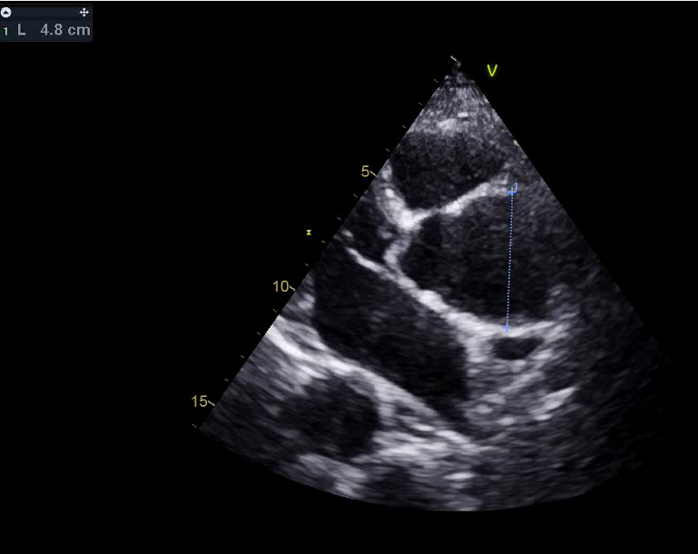
Figure 1 : Transthoracic echocardiography in a parasternal long-axis view demonstrates aneurysmal dilation of the ascending aorta measuring 48 mm.
Contrast-enhanced thoracic CT confirmed a 48 mm ascending aortic aneurysm extending to a 42 mm ectatic descending aorta. The latter harbored a large, irregular-surfaced, hemicircumferential mural thrombus considered potentially emboligenic (Figure 2). Laboratory investigations were unremarkable. Ultrasound of the supra-aortic trunks revealed atherosclerotic changes without significant stenosing plaques.
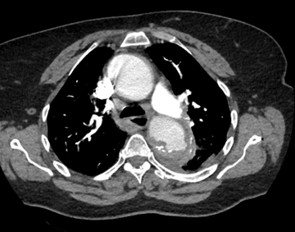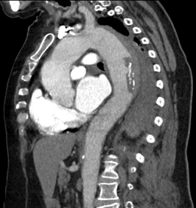
Figure 2 : Contrast-enhanced thoracic CT in axial (a) and sagittal (b) views demonstrates an ascending thoracic aortic aneurysm measuring 48 mm at its maximal diameter, extending into a 42 mm ectatic descending aorta, which harbors a hemicircumferential mural thrombus with an irregular surface, consistent with a potentially emboligenic component.
The patient was started on high-dose statin therapy, along with prophylaxis for deep vein thrombosis using prophylactic low-molecular-weight heparin (LMWH) and strict blood pressure control. Regular neurological monitoring and a follow-up CT scan were performed. In addition, beta-blocker therapy was initiated to maintain the heart rate within normal limits, together with antihypertensive treatment to prevent progression toward aortic dissection. As the hemorrhage was recent, there was no indication for initiating antiplatelet or anticoagulant therapy at that stage.
After clinical stabilization and confirmation of the absence of hemorrhage on the follow-up CT scan, the patient was started on anticoagulant therapy, in association with a beta-blocker and an angiotensin-converting enzyme inhibitor. Close neurological monitoring was maintained, along with strict surveillance of blood pressure and heart rate, and management of all cardiovascular risk factors.
Neurological function had recovered 6 months after the initial onset of symptoms.
Subsequent follow-up showed no progression of the aneurysmal dilation of the aorta, and a conservative management strategy was therefore adopted.

3 — Discussion
The pathophysiology of AAA is closely linked to atherosclerotic risk factors and plaque development (2,3). In contrast, numerous studies suggest that ascending aortic aneurysms are predominantly of genetic or familial origin (4,5). In patients without identifiable genetic mutations, inflammation or infection constitutes a recognized non-atherosclerotic trigger (6,7).
Emerging evidence supports the concept of the aorta as two distinct functional entities:
(A) the ascending aorta, and (B) the thoraco-abdominal aorta (descending thoracic and abdominal segments), separated by the ligamentum arteriosum (8,9).
These differences stem from divergent embryologic origins (10). ATAA displays a pro-aneurysmal yet paradoxically anti-atherosclerotic phenotype, whereas the thoraco-abdominal aorta is particularly susceptible to atherosclerotic aneurysm formation. Vascular smooth muscle cells (VSMCs), the primary cellular component of the aortic media, differ in embryologic origin and migratory pathways depending on the aortic segment (11). In the ascending aorta, they arise from neural crest cells, whereas in the descending thoracic and abdominal aorta they derive from paraxial mesoderm (10).
These distinctions determine divergent molecular and mechanical responses, including impaired cellular differentiation, aberrant extracellular matrix remodeling, and variable susceptibility to inflammatory or mechanical stimuli (12). Thus, the biological mechanisms underlying aneurysm development depend fundamentally on anatomical location, supporting the notion of genetically and physiologically distinct aortic territories.
The present case illustrates the unusual coexistence of an ascending aortic aneurysm and an atheromatous dilation of the descending thoracic aorta, revealed by an acute embolic ischemic stroke.

4 — Conclusion
A refined understanding of the physiopathological disparities between the ascending aorta—relatively protected from atherosclerosis—and the thoraco-abdominal aorta—particularly vulnerable to atheromatous degeneration—is essential for the development of targeted therapeutic strategies.
A deeper comprehension of the segment-specific biological mechanisms governing aortic disease represents a major challenge, with the potential to enable earlier intervention and prevent life-threatening complications.
Authors’ contributions : This work was carried out in collaboration among all authors. All authors read and approved the final manuscript.
ETHICAL APPROVAL : As per international standards or university standards written ethical approval has been collected and preserved by the author(s).
CONSENT : As per international standards or university standards, patient(s) written consent has been collected and preserved by the author(s).
Disclaimer (Artificial intelligence)

Author(s) hereby declare that NO generative AI technologies such as Large Language Models (ChatGPT, COPILOT, etc.) and text-to-image generators have been used during the writing or editing of this manuscript.

COMPETING INTERESTS : Authors have declared that no competing interests exist.

5 — References
- Cornuz J, Sidoti Pinto C, Tevaearai H, Egger M. Risk factors for asymptomatic abdominal aortic aneurysm: systematic review and meta-analysis of population-based screening studies. Eur J Public Health 2004;14(04):343–349
- Zarins, C.K.; Xu, C.; Glagov, S. Atherosclerotic enlargement of the human abdominal aorta. Atherosclerosis 2001, 155, 157–164. [CrossRef]
- Kuhlencordt, P.J.; Gyurko, R.; Han, F.; Scherrer-Crosbie, M.; Aretz, T.H.; Hajjar, R.; Picard, M.H.; Huang, P.L. Accelerated atherosclerosis, aortic aneurysm formation, and ischemic heart disease in apolipoprotein E/endothelial nitric oxide synthase double-knockout mice. Circulation 2001, 104, 448–454. [CrossRef] [PubMed]
- Biddinger, A.; Rocklin, M.; Coselli, J.; Milewicz, D.M. Familial thoracic aortic dilatations and dissections: A case control study. J. Vasc. Surg. 1997, 25, 506–511. [CrossRef]
- Ostberg, N.P.; Zafar, M.A.; Ziganshin, B.A.; Elefteriades, J.A. The Genetics of Thoracic Aortic Aneurysms and Dissection: A Clinical Perspective. Biomolecules 2020, 10, 182. [CrossRef]
- Schmidt, J.; Sunesen, K.; Kornum, J.B.; Duhaut, P.; Thomsen, R.W. Predictors for pathologically confirmed aortitis after resection of the ascending aorta: A 12-year Danish nationwide population-based cross-sectional study. Arthritis Res. Ther. 2011, 13, R87. [CrossRef]
- Elefteriades, J.A.; Ziganshin, B.A.; Halperin, J.L. Diseases of the Aorta. In Fuster and Hurst’s the Heart, 15e; Fuster, V., Narula, J., Vaishnava, P., Leon, M.B., Callans, D.J., Rumsfeld, J., Poppas, A., Eds.; McGraw-Hill Education: New York, NY, USA, 2022.
- Ruddy, J.M.; Jones, J.A.; Spinale, F.G.; Ikonomidis, J.S. Regional heterogeneity within the aorta: Relevance to aneurysm disease. J. Thorac. Cardiovasc. Surg. 2008, 136, 1123–1130. [CrossRef]
- Elefteriades, J.A.; Farkas, E.A. Thoracic aortic aneurysm clinically pertinent controversies and uncertainties. J. Am. Coll. Cardiol. 2010, 55, 841–857. [CrossRef] [PubMed]
- Ruddy, J.M.; Jones, J.A.; Ikonomidis, J.S. Pathophysiology of thoracic aortic aneurysm (TAA): Is it not one uniform aorta? Role of embryologic origin. Prog. Cardiovasc. Dis. 2013, 56, 68–73. [CrossRef] [PubMed]
- Grewal, N.; Gittenberger-de Groot, A.C.; Lindeman, J.H.; Klautz, A.; Driessen, A.; Klautz, R.J.M.; Poelmann, R.E. Normal and abnormal development of the aortic valve and ascending aortic wall: A comprehensive overview of the embryology and pathology of the bicuspid aortic valve. Ann. Cardiothorac. Surg. 2022, 11, 380–388. [CrossRef] [PubMed]
- Halloran, B.G.; Davis, V.A.; McManus, B.M.; Lynch, T.G.; Baxter, B.T. Localization of aortic disease is associated with intrinsic differences in aortic structure. J. Surg. Res. 1995, 59, 17–22. [CrossRef]

