Case report
PERMEABLE OVAL FORAMEN AND CEREBRAL VASCULAR ACCIDENT IN A YOUNG PERSON: A CASE STUDY IN CHAD
Abstract :
Stroke is a real public health problem with a significant socio-economic impact and a high mortality risk. Its frequency in young people is between 10 and15% of all strokes. The persistence of a patent foramen ovale is one of the causes of cerebral ischaemia in young people, most commonly through paradoxical embolism. We report the case of a 17-year-old girl who presented with cerebral ischaemia with hemorrhagic transformation, revealing an 11 mm PFO with right-to-left shunting. In light of this clinical case, two hypotheses emerge: either our young girl has a right-to-left shunt responsible for cerebral ischaemia that has reached the stage of haemorrhagic infarction, or she has a cerebral haemorrhage following vascular ischaemic softening secondary to an inflammatory flare-up, which would explain why our patient had flu-like symptoms one week before her admission.
Keywords: paradoxical embolism, cerebral ischaemia, cerebrovascular disease, serology
Introduction
Stroke is one of the leading causes of emergency room admissions and constitutes a major public health problem (1). It is estimated that there are approximately 150,000 new cases per year in Europe, representing one stroke every four minutes, a quarter of which are recurrent strokes in patients with a history of cerebrovascular disease. When it occurs between the ages of 15 and 45, it is referred to as a young stroke. Its frequency is low: between 10 and 15% of strokes (1). Its socio-economic impact is very significant and the risk of mortality is high. The incidence of stroke in young people varies according to the studies due to the age limit taken into account (45 or 55 years). It is estimated at between 3 and 10/100,000 in the United States and between 13 and 24/100,000 in Europe (2). The aetiologies in young people are largely dominated by cryptogenic, cardioembolic and venous origins, which, according to the literature, make diagnostic evaluation a challenge in this age group. Certain anomalies, such as patent foramen ovale (PFO) or atrial septal aneurysm (ASIA), have an uncertain emboligenic role. PFO is significantly more common in young adults with AIC than in the general population (2). Its role is suggested by the mechanism of paradoxical embolism, i.e. the passage of a venous clot into the systemic circulation (3).
We report here the case of a 17-year-old girl admitted for sudden onset of left-sided hemiplegia, in whom investigations concluded a haemorrhagic stroke in the left semioval centre without vascular abnormality. Upon further investigation into the cause, we found a 9 mm PFO
Case presentation:
This is a 17-year-old female patient with no significant medical history apart from an episode of flu-like symptoms a week ago. The interview revealed no particular predisposing factors, no consanguinity among her ancestors and no family history of disease. She presented to the emergency department with left-sided hemiplegia rated at 4/5 in the lower limb and 3/5 in the upper limb, with sensory disturbance and loss of deep tendon reflexes. Her Glasgow Coma Scale score was 15/15 and her NIHSS score was 8. Laboratory tests revealed no significant abnormalities, with negative serology results. A brain CT scan supplemented by an MRI angiogram showed a parenchymal haematoma in the left semi-oval centre with perilesional oedema, but no vascular lesions were visualised.
Echocardiography: Good biventricular function with no valvular lesions.
Trans-Oesophagy echocardiography: 9 mm patent foramen ovale, right-to-left shunt and positive bubble test over 3 cycles.
Treatment received: Aspirin 75 mg/day, motor physiotherapy and a proposal to close the PFO with a prosthesis. The patient's condition improved and the motor deficit regressed.

Discussion:
Ischemic stroke (IS) in young people accounts for 10% of all strokes across all age groups (2). Unlike in older people, the annual incidence is increasing, but the prognosis in terms of survival and functional outcome is better. The aetiology of IS in young people is dominated by arterial dissections, embolic heart disease and atherosclerosis. In 30 to 40% of cases, no cause is found (3). Emergency management is based on monitoring vital functions and screening for acute complications.
The foramen ovale, formerly known as Botal's foramen, is a normal feature of the foetal heart. Connecting the two atria, it allows blood returning from the placenta to the right atrium to fill the left heart, thus bypassing the pulmonary circulation, which is unnecessary for foetal haemostasis. After birth, the decrease in venous return due to the exclusion of the placenta and the increase in pulmonary venous return close the valve. Within a few weeks or months, the Vieussens valve fuses with the interatrial septum, closing the foramen ovale in nearly three-quarters of people. In others, closure of the foramen ovale is absent, incomplete or delayed, leaving a short channel in the interatrial septum and the possibility of a right-to-left (R-L) shunt. This is referred to as a patent or permeable foramen ovale (PFO).
The prevalence of PFO in the general population is usually estimated at 25% overall (3). It decreases with age; it is estimated to be 30% between the ages of 1 and 29, as in our 17-year-old patient, 25% between the ages of 30 and 79, and 20% from the age of 80 onwards. The diagnosis of PFO is based on the detection of a D-G shunt by contrast echocardiography or bubble test during a transthoracic echocardiogram (TTE), transoesophageal echocardiogram (TEE) or transcranial Doppler ultrasound (TCD). TEE is usually considered the gold standard diagnostic method for PFO (4). In accordance with the literature, we performed an echocardiogram supplemented by a TEE, which is available in our facility, on our patient and observed a right-to-left shunt with a 9 mm septal defect and a positive bubble test. Imaging allows for early detection of cerebral ischaemia. This involves attenuation of the density of the basal ganglia or insular cortex, absence of white-grey differentiation and smoothing of the sulci. MRI measures the extent of the ischaemic penumbra and the severity of existing ischaemic lesions, which is a key factor in the risk of haemorrhage during thrombolysis (5). In our patient, we performed a brain CT scan supplemented by an MRI angiogram, which showed a parenchymal haematoma in the left semi-oval centre with perilesional oedema and no visualised vascular lesions. Although cerebral ischaemia is the most obvious form of paradoxical embolism in young stroke patients, haemorrhagic events may occur either in connection with haemorrhagic infarction of cerebral ischaemia or Decompression sickness (DCS) is linked to nitrogen bubbles released during ascent, causing tissue ischaemia and endothelial dysfunction. Cutaneous ADD is classified as benign. Its pathophysiology is poorly understood: formation of bubbles in situ or arterial embolism due to the passage of bubbles via a right-to-left shunt. A strong association between a history of cutaneous ADD and the presence of a shunt has been demonstrated, as reported by E. Schwob et al (6) in Mont Pellier (France), where cerebral haemorrhage revealed a PFO.
In light of this clinical case, two hypotheses emerge: either our young girl has a right-to-left shunt responsible for cerebral ischaemia that has reached the stage of haemorrhagic infarction, or she has a cerebral haemorrhage following vascular ischaemic softening secondary to an inflammatory flare-up, which would explain why our patient had flu-like symptoms one week before her admission.
Conclusion
As with all cases of AIC, AIC in young people is a therapeutic emergency with significant disability. The search for embolic heart disease is a priority, but the origin remains undetermined in more than a third of cases. Knowledge of the role played by persistent patent foramen ovale in the pathogenesis of ischaemic strokes has led to the recommendation that it be closed in order to prevent recurrence, especially since the development of interventional catheterisation techniques has made this closure relatively easy.
Image 1: ETO cross-section along the minor axis showing bubble passage Image 2: Apical 4-chamber ETT showing the diameter of the septal defect at 12 mm
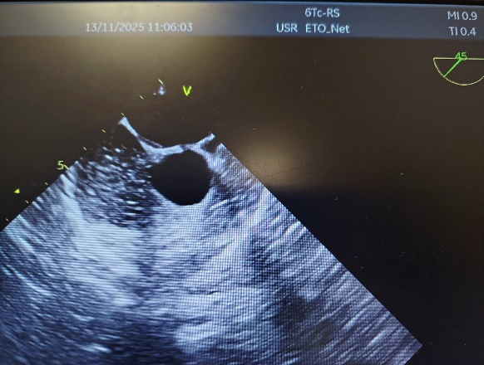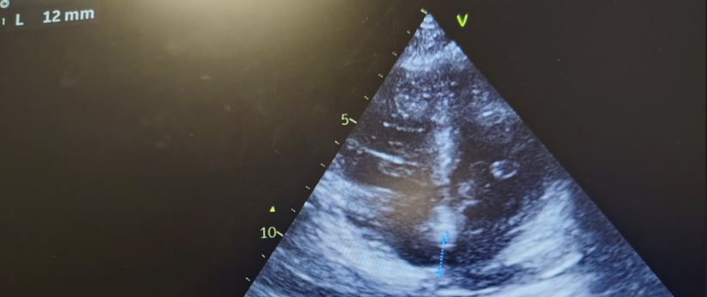
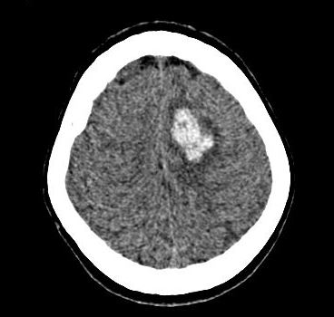
Image 3: brain scan: hypodense brain lesion
All authors declare that they have no conflicts of interest, and this work has been carried out in strict compliance with patient anonymity and in the interests of science.

Disclaimer (Artificial intelligence)

Author(s) hereby declare that NO generative AI technologies such as Large Language Models (ChatGPT, COPILOT, etc.) and text-to-image generators have been used during the writing or editing of this manuscript.

References

1. Mojadidi MK, Zaman MO, Elgendy IY, et al. Cryptogenic stroke and patent foramen ovale. J Am Coll Cardiol 2018;71: 1035–43.
2. De Bray JM, Maugin D, Alecu C, Dubas F. Ischemic strokes in young adults (< 45 years). Clinical and etiological aspects. Angéiologie 1999; 51: 61-4.
3. Neau JP, Bailbe M, Gil R. Ischemic strokes in young adults. Press Med 1998; 27: 1589-603.
4. Koutroulou I, Tsivgoulis G, Tsalikalis D, Karacostas D, Grogo-riadis N, Karapanaiotides T. Epidemiology of patent foramen ovale in the general population and in stroke patients: a narrative review. Front Neurol 2020; 11:1–14.
5. Tobe J, Bogiatzi C, Munoz C, Tamayo A, Spence JD. Trans-cranial Doppler is complementary to echocardiography for detection and risk stratification of patent foramen ovale. Can J Cardiol 2016;32:986.e9–986.e16.
6. E. Schwob, N. Marmion et al.: A cutaneous decompression accident revealing a patent foramen ovale and a cerebellar hemorrhage. 0.1016/j.annder.2018.09.185
7. Saiki, H., Sugimoto, M., Kuwata, S., Kurishima, C., Iwamoto, Y., Ishido, H., ... & Senzaki, H. (2016). Novel mechanisms for cerebral blood flow regulation in patients with congenital heart disease. American heart journal, 172, 152-159.

