Identification Profile of Aortic Endocarditis with Complications of a Coronal-Aortic Triangle Abscess in a Stemi Patient

Abstract:
We report the case of a 44-year-old man, a chronic smoker with a 28 pack-year history, regular consumer of alcohol, cannabis, and hashish, followed for coronary artery disease and having undergone two angioplasties, who was admitted for typical chest pain with ST-segment elevation, suggestive of an acute ST-elevation myocardial infarction (STEMI). Coronary angiography performed during hospitalization revealed severe stenosis of the ostium of the proximal left anterior descending artery and the first marginal branch, severe stenosis of the mid-left anterior descending artery and distal right coronary artery, as well as a proximal occlusion of the circumflex artery.
Given the atypical clinical course, notably persistent inflammatory syndrome, fever, and the appearance of a new murmur, transthoracic and then transesophageal echocardiography were performed. These examinations revealed heterogeneous, hypoechoic thickening at the mitro-aortic trigone compatible with a partially ruptured abscess, as well as a mobile image on the aortic annulus. Overall, the findings suggested aortic infective endocarditis complicated by a partially ruptured mitro-aortic trigone abscess, occurring in the context of rheumatic mitral and aortic heart disease. Initially unnoticed, it was first revealed by a STEMI presentation.
The patient received comprehensive treatment for his ischemic heart disease, including dual antiplatelet therapy, anticoagulation, statins, an ACE inhibitor, and a beta-blocker, in addition to empirical penicillin-based antibiotic therapy, later adjusted according to the antibiogram. A surgical bypass was planned, but the patient’s prognosis rapidly worsened with the onset of septic shock and hemodynamic failure, leading to death.
This case highlights the importance of considering an infectious or structural cause in young patients presenting with STEMI and normal coronaries, and underscores the critical diagnostic value of transesophageal echocardiography in detecting perivalvular complications.

Key words: Aortic Endocarditis, Mitro-Aortic, Trigone Abscess, STEMI

1. Introduction
Three generations ago, the diagnosis of endocarditis almost inevitably carried a fatal prognosis. Over the years, successive studies, clinical observations, and hypotheses—whether accurate or not—have refined the complex and evolving clinical definition of infective endocarditis (IE). It was only relatively recently that effective therapeutic management was established, with the advent of the antibiotic era. Moreover, the development of contemporary surgical techniques has played a crucial role in improving outcomes and the prospects of recovery for this condition.
Cardiac abscesses represent a severe complication of infective endocarditis, often indicative of delayed diagnosis and the virulence of the infection, thus compromising the chances of cure with antibiotics alone. Nevertheless, detection of such complications is now facilitated by transesophageal echocardiography (TEE).
Acute ST-elevation myocardial infarction (STEMI) and cardiogenic shock are major cardiovascular emergencies associated with high mortality. While the primary etiologies of STEMI—such as plaque rupture or erosion and thrombosis—are well established, rare cases exist where emboli from vegetations related to infective endocarditis precipitate these events. IE, an infection of the cardiac endocardial surface primarily affecting the valves, leads to vegetation formation, which may embolize and obstruct coronary arteries, resulting in STEMI.
We present here a recent case of STEMI induced by infective endocarditis, characterized by a mitro-aortic trigone abscess, observed in our institution.

2. Case Report
The patient is a 44-year-old man, a chronic smoker with a 28 pack-year history, regular consumer of alcohol, cannabis, and hashish, with a history of coronary artery disease and two prior angioplasties. Initial examination revealed pleuritic chest pain associated with exertional dyspnea progressing to orthopnea, persistent fever up to 40°C refractory to prior antibiotic therapy, and signs of general deterioration, including asthenia, anorexia, and a weight loss of 20 kg over one month.
Vital signs were initially stable, with blood pressure at 110/80 mmHg and heart rate at 83 bpm. Cardiac auscultation revealed a 4/6 “rolling” diastolic murmur at the mitral focus. Abdominal examination was unremarkable, with no hepatomegaly or splenomegaly. Cutaneous and mucosal examination revealed petechiae and an Osler’s node. Electrocardiogram (ECG) showed circumferential ST-segment elevation without reciprocal changes.
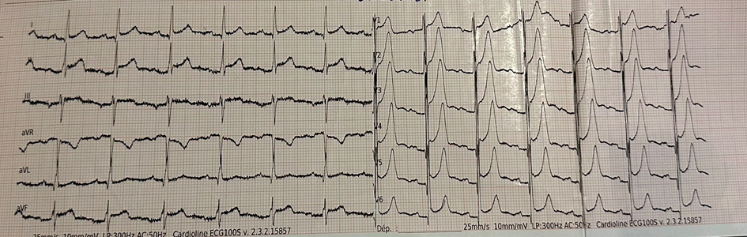
Figure 1: ECG showing circumferential ST-segment elevation corresponding to the ischemic event
Transthoracic Echocardiography
TTE revealed:
- thickened, rigid mitral valve
- severe mitral stenosis (mean gradient 10 mmHg, valve area 1.1 cm², inter-leaflet separation 6 mm)
- calcified and remodeled aortic valve with moderate stenosis (valve area 1.6 cm², mean gradient 17 mmHg, Vmax 2.7 m/s)
- a hyper-echogenic cavity between the aortic annulus and the roof of the left atrium, suggestive of a mitro-aortic trigone abscess
- LV not dilated, moderate concentric LVH, preserved global and segmental kinetics, ejection fraction ≈50%
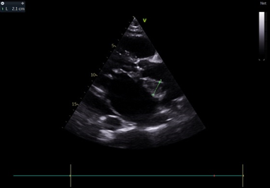
Figure 2: Long-axis view showing mitro-aortic trigone abscess, 21 mm thick
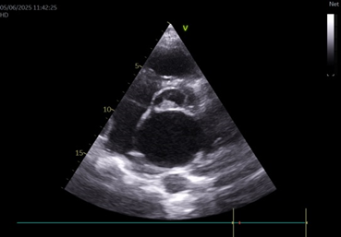
Figure 3: Short-axis view confirming mitro-aortic trigone abscess
Coronary Angiography
Coronary angiography revealed:
- critical stenosis of the ostium of the proximal LAD and first marginal artery
- severe stenosis of the mid-LAD and distal RCA
- proximal occlusion of the circumflex artery
Transesophageal Echocardiography
TEE demonstrated:
- thickened, remodeled mitral valve with severe stenosis, without superimposed vegetation
- thickened tricuspid aortic valve with calcified moderate stenosis
- heterogeneous, hypoechoic thickening at the mitro-aortic trigone consistent with a partially debrided abscess
- a vibratile mass on the aortic annulus
These findings supported a diagnosis of aortic infective endocarditis complicated by a partially debrided mitro-aortic trigone abscess, in the setting of underlying rheumatic mitral and aortic valve disease.
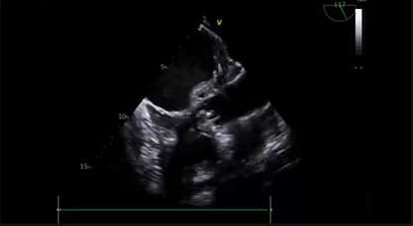
Figure 4: Long-axis mitral–aortic view showing the trigone abscess
Additional Work-up
- Supra-aortic trunk ultrasound: normal
- Brain CT & thoracic angio-CT: no abnormalities
- Thoraco-abdominopelvic CT: no pulmonary septic emboli
Laboratory Findings
- Elevated troponin Ic: 0.38 ng/mL (normal <0.031)
- Normochromic, normocytic, aregenerative anemia (Hb 9 g/dL; reticulocytes 47,400/mm³)
- Marked inflammatory syndrome: leukocytosis 223,150/mm³ (neutrophils 19,400/mm³); CRP 315 mg/L; PCT 2.99 ng/mL
- Blood cultures: Campylobacter fetus ssp. fetus
Clinical Course
The patient received dual antiplatelet therapy, anticoagulation, statins, an ACE inhibitor, and a beta-blocker, in addition to empirical penicillin-based antibiotic therapy, later adjusted according to the antibiogram. Coronary bypass surgery was planned. However, the clinical status deteriorated abruptly, with the onset of septic shock and hemodynamic collapse, leading to death.

3. Discussion
The reported frequency of abscess formation in infective endocarditis ranges from 20–30%, rising to 60% in prosthetic valve endocarditis according to pathological studies (5,6). A male predominance has been documented in large series of abscess-complicated IE (7,8). Clinically, these patients frequently present with advanced heart failure (NYHA III–IV). Abscesses are associated with heart failure in more than 60% of cases, particularly in aortic native valve IE, where diagnosis and surgical intervention are often delayed [5,8,9]. In contrast, abscesses on prosthetic valves—if not accompanied by prosthetic dehiscence—tend to produce less heart failure at diagnosis, which is usually earlier.
Embolic complications occur in nearly one-third of patients, mainly in native valve IE. Larger series confirm this frequency, with neurologic and peripheral emboli occurring in prosthetic valve abscesses as well (7,10). Staphylococci and streptococci are the most commonly isolated pathogens; however, 20–30% of cases yield negative cultures (5,6,11).
TEE remains the gold standard for diagnosing abscesses, with sensitivity >80% and diagnostic accuracy approaching 100%. Limitations arise when lesions are located on the anterior annulus or obscured by calcification or prosthetic materials. Aortic abscesses are typical, representing >80% of cases (12). Extension into the aortic root, fibrous trigone, interventricular septum, or formation of multiple fistulas reflects advanced disease (13).
Coronary embolism is a rare but severe complication of IE, and STEMI due to septic emboli is exceptional (14). When present, the valves most frequently involved are the tricuspid (50%), followed by aortic (20%) and mitral valves (20%) (15) . Embolization risk is influenced by vegetation size and the microbiological pathogen, with Staphylococcus aureus being highly emboligenic (16,17).
Reported cases show varied coronary territories affected (18,19): anterior (20,21), anterolateral (19,22), inferior (19,23,24), lateral (25), as well as multiterritorial infarctions. Currently, no validated therapeutic strategy exists for STEMI caused by IE, as guidelines address each condition separately. Therefore, management must be individualized.

4. Conclusion
Advances in the management of severe infective endocarditis complicated by coronary embolism highlight the cumulative progress of medical knowledge—no single breakthrough has transformed diagnosis or treatment. Despite significant developments in both medical and surgical management, IE remains associated with high morbidity and mortality.
This case underscores the necessity of early diagnosis and the importance of considering structural or infectious causes in young patients presenting with STEMI, as well as the pivotal role of TEE in identifying perivalvular complications

ETHICAL APPROVAL : As per international standards or university standards written ethical approval has been collected and preserved by the author(s).
CONSENT : As per international standards or university standards, patient(s) written consent has been collected and preserved by the author(s).
Disclaimer (Artificial intelligence)

Author(s) hereby declare that NO generative AI technologies such as Large Language Models (ChatGPT, COPILOT, etc.) and text-to-image generators have been used during the writing or editing of this manuscript.

5. References
[1] MeineTJ, Neetles RF,Anderson DJ, Cabell CH, Corey R, Sexton DJ, et al. Cardiac conduction abnormalities in endocarditis defined by the Duke criteria. Am Heart J 2001;142:280–5.
[2] Samsky MD, Morrow DA, Proudfoot AG, Thacker LR, van Diepen S, Tu J, et al. Cardiogenic shock after acute myocardial infarction: a review. JAMA 2021;326:1840–1850.
[3] Baaten CCFMJ, Nagy M, Bergmeier W, Schulz C, Kehrel BE, Massberg S, et al. Platelet biology and function: plaque erosion vs. rupture. Eur Heart J 2024;45:18–31.
[4] Fabri J, Issa VS, Pomerantzeff PMA, Grinberg M, Barros CM, Mansur AJ, et al. Time-related distribution, risk factors, and prognostic influence of embolism in patients with left-sided infective endocarditis. Int J Cardiol 2006;110:334–339.
[5] Rodrigues Borges AG, Suresh K, Mirza H, Katz JP, Simandl SL, Bil f inger T, et al. False aneurysm of the mitral-aortic intervalvular fibrosa after uncomplicated aortic valve replacement. J Am Soc Echocardiogr 2002;15(7):743–5.
[6] Matthews RV, French WJ, Criley JM. Chest trauma and subvalvular left ventricular aneurysms. Chest 1989;95(2):474–6.
[7] Economopoulos G. Delayed pseudoaneurysm of the mitral-aortic interval vular fibrosa. Ann Thorac Surg 2007;83(6):2233.
[8] Afridi I, Apostolidou MA, Saad RM,ZoghbiWA.Pseudoaneurysmsofthe mitral-aortic intervalvular fibrosa: dynamic characterization using transe sophageal echocardiographic and Doppler techniques. J Am Coll Cardiol 1995;25(1):137–45.
[9] Ghersin E, Litmanovich D, Agmon Y, Milo S. Pseudoaneurysm of the mitral-aortic intervalvular fibrosa following aortic valve replacement–diagnosis and dynamic evaluation with multidetector CT and transesophageal echocardiography. Interact Cardiovasc Thorac Surg 2005;4(6):502–4.
[10] Yokoyama Y, Tamaki S, Kato N, Yokote J, Mutsuga M. Pseudoaneurysm from the mitral-aortic intervalvular fibrosa following endocarditis. Jpn J Thorac Cardiovasc Surg 2003;51(8):374–7.
[11] Karalis DG,BansalRC,HauckAJ,RossJJ,ApplegatePM,JutzyKR,etal. Transesophagealechocardiographicrecognitionofsubaorticcomplications in aortic valve endocarditis. Clinical and surgical implications. Circulation 1992;86(2):353–62.
[12] Bier AJ, Lamphere JA, Daily PO. Coronary artery compression caused by a large pseudoaneurysmofthemitral-aortic intervalvular fibrosa. J Am Soc Echocardiogr 1995;8(5Pt 1):753–6.
[13] Koch R, Kapoor A, Spencer KT. Stroke in patient with an intervalvular f ibrosa pseudoaneurysm and aortic pseudoaneurysm. J Am Soc Echocar diogr 2003;16(8):894–6
[14] E. Mylonakis and S. B. Calderwood, “Infective endocarditis in adults,” New England Journal of Medicine, vol. 345, no. 18, pp. 1318–1330, 2001.
[15] E. A. Ashley and J. Niebauer, Cardiology Explained, Remedica, London, 2004, Chapter 10, Infective endocarditis.
[16] S. Hubert, F. Thuny, N. Resseguier et al., “Prediction of symp tomatic embolism in infective endocarditis: construction and validation of a risk calculator in a multicenter cohort,” Journal of the AmericanCollege of Cardiology, vol. 62, no. 15, pp. 1384 1392, 2013.
[17] D. Mohananey, A. Mohadjer, G. Pettersson et al., “Association of vegetation size with embolic risk in patients with infective endocarditis: a systematic review and meta-analysis,” JAMA Internal Medicine, vol. 178, no. 4, pp. 502–510, 2011
[18] D.L.Connolly, P. S. Dardas, J. J. Crowley, A. Kenny, and M. C. Petch, “Acute coronary embolism complicating aortic valve endocarditis treated with streptokinase and aspirin. A case report.,” The Journal of Heart Valve Disease, vol. 3, no. 3, pp. 245-246, 1994.
[19] F. Casazza, F. Faorista, F. Donatelli, and A. Grossi, “Acute myocardial infarction in bacterial endocarditis,” Giornale Ita liano di Cardiologia, vol. 26, no. 2, pp. 207–211, 1996.
[20] E. Ural, U. Bildirici, G. Kahraman, and B. Komsuoğlu, “Coro nary embolism complicating aortic valve endocarditis: treat ment with successful coronary angioplasty,” International Journal of Cardiology, vol. 119, no. 3, pp. 377–379, 2007.
[21] B. Hibbert, M. Kazmi, J. P. Veinot, E. R. O'Brien, and C. Glover, “Infective endocarditis presenting as ST-elevation myocardial infarction: an angiographic diagnosis,” Canadian Journal of Cardiology, vol. 28, no. 4, pp. 515.e15–515.e17, 2012.
[22] G. Murtaza, Z. U. Rahman, P. Sitwala et al., “Case of acute ST segment elevation myocardial infarction in infective endocar ditismanagement with intra coronary stenting,” Clinics and Practice, vol. 7, no. 3, 2017.
[23] M.Singh,A.Mishra,andE.Kaluski,“AcuteST-elevation myo cardial infarction due to septic embolism: a case report and review of management options,” Catheterization and Cardio vascular Interventions, vol. 85, no. 6, pp. E166–E171, 2015.
[24] J. Jose, K. Narayanan, S. T. Chacko, and O. K. George, “Infec tive endocarditis presenting with ST segment elevation,” Jour nal of Heart Valve Disease, vol. 20, no. 4, pp. 468–470, 2011.
[25] C. J. Roxas and A. J. Weekes, “Acute myocardial infarction caused by coronary embolism from infective endocarditis,” The Journal of Emergency Medicine, vol. 40, no. 5, pp. 509 514, 2011.

