Case report
ADULT ADENOID HYPERTROPHY MIMICKING A NASOPHARYNGEAL MASS: A DIAGNOSTIC CHALLENGE
ABSTRACT
The adenoids, also known as the nasopharyngeal tonsils, come from lymphoid tissue in the pharyngeal mucosa. They are part of Waldeyer’s ring, which is a circular arrangement of lymphoid tissue. This ring includes the pharyngeal (adenoid), palatine, lingual, and tubal tonsils. These tonsils are located at the entrance of the aerodigestive tract.
They play an important role in mucosal immunity during early life by trapping inhaled pathogens and helping with antigen presentation. This contributes to both humoral and cell-mediated immune responses.
Adenoid hypertrophy is predominantly a pediatric condition and rarely persists into adulthood due to physiological involution after puberty. When present in adults, it may clinically and radiologically mimic various nasopharyngeal pathologies, including malignancy.
We report a case of a 51-year-old woman presenting with long-standing left-sided nasal obstruction. She also presented with snoring, mouth breathing and headache. Clinical examination revealed a deviated nasal septum and a suspected nasopharyngeal mass. Radiological evaluation demonstrated a soft tissue lesion in the nasopharynx, raising suspicion of a neoplasm, for which a biopsy was performed.

Histopathological examination revealed respiratory epithelium overlying dense lymphoid tissue with well-formed follicles and prominent germinal centers, consistent with reactive lymphoid hyperplasia, without evidence of atypia or malignancy.
This case highlights the importance of considering adenoid hypertrophy in adult nasopharyngeal masses and underscores the essential role of histopathology in ensuring accurate diagnosis and appropriate management.

Keywords: Adult, Adenoid Hypertrophy Mimicking, Nasopharyngeal Mass, Diagnostic
Introduction
Adenoids, also called nasopharyngeal tonsils, are lymphoid tissues found in the roof and back wall of the nasopharynx, part of Waldeyer's ring.¹ The pharyngeal (adenoid), palatine, lingual, and tubal tonsils at the aerodigestive tract's entrance make up this circular configuration of lymphoid tissue. By capturing pathogens and encouraging antigen presentation, they support humoral and cell-mediated immune responses and contribute to mucosal immunity. Adenoid hypertrophy commonly presents with nasal obstruction, mouth breathing, snoring, and hyponasal speech. It may cause eustachian tube dysfunction, leading to aural fullness, conductive hearing loss, and otitis media with effusion. They are most prominent during childhood and typically shrink after puberty.² Therefore, adenoid hypertrophy is frequently seen in children and rarely continues in adults.
When adult patients present with nasopharyngeal masses, there is often concern about malignant conditions, such as nasopharyngeal carcinoma or lymphoma.³ Ongoing adenoid tissue in adults has been linked to chronic infections, allergies, environmental factors, and smoking.⁴ CT/MRI radiological evaluation reveals a soft tissue mass in the nasopharynx, where it is still challenging to distinguish between benign lymphoid hyperplasia and cancer. These results are not conclusive, even though imaging characteristics like symmetric enlargement, preserved architecture, and lack of deep tissue invasion may support benignity. Adenoidectomy with or without tonsillectomy and ventilation-tube insertion is one of the most frequently performed operations.⁵
Case Presentation
A 51-year-old woman presented with left-sided nasal obstruction for five to six years. The obstruction developed gradually and was ongoing. She also presented with snoring, mouth breathing and headache. There was no history of nosebleeds, smoking, allergy, weight loss, or other systemic symptoms.
Clinical examination revealed a deviated nasal septum toward the left side. Nasal endoscopy indicated a mass in the nasopharyngeal region. The initial clinical diagnosis was left-sided nasal septum deviation with a nasopharyngeal mass being considered. Otoscopic examination showed an intact tympanic membrane with normal appearance and mobility. On lymph node examination, there was no significant cervical lymphadenopathy, and any palpable lymph nodes.
Imaging showed homogeneous soft tissue mass in the nasopharynx with narrowing of the airway.
A biopsy was carried out and sent for histopathological examination. The sample included two small biopsy pieces, one measuring 0.5 × 0.5 cm and other measuring 0.3x0.2cm.
Histopathological Findings- The microscopic examination from the biopsy tissue revealed Respiratory epithelium lining. The underlying stroma showed prominent lymphoid tissue with well-formed lymphoid follicles and germinal centres which was consistent with lymphoid hyperplasia. There was also seen focal areas of squamous metaplasia.
No evidence of malignancy or granulomatous inflammation was identified. The final diagnosis was suggestive of adenoid hypertrophy.

Discussion
Since adenoid tissue typically experiences physiological involution after adolescence, adenoid hypertrophy is uncommon in adults but common in children.² However, a number of studies have shown that adenoid tissue may continue to exist in adults and manifest as symptoms like nasal discharge, snoring, and obstruction.⁶ It may cause eustachian tube dysfunction, leading to aural fullness, conductive hearing loss, and otitis media with effusion. Adenoid hypertrophy in adults is now more easily detected with increased use of nasal endoscopy and imaging methods.⁷ The differential diagnosis of adenoid hyperplasia in adults includes nasopharyngeal carcinoma, lymphoma, benign nasopharyngeal tumors, nasopharyngeal cysts, and granulomatous conditions such as tuberculosis. Among these, malignancy remains the most critical consideration due to overlapping clinical and radiological features. Hence, histopathological examination is essential to establish a definitive diagnosis and exclude neoplastic conditions.⁸
The prevalence of adenoid hypertrophy in adults varies among studies. Another study by Al-Juboori et al. reported a much lower prevalence of 0.18% among adults with nasal obstruction, highlighting the rarity of this condition in older individuals.⁴ Hamad et al. evaluated 140 adult patients presenting with nasal obstruction and found adenoid hypertrophy in 24 patients (17.14%), suggesting that persistent adenoid tissue can be a significant etiological factor for nasal obstruction in adults.⁷ The persistence of adenoid tissue in adulthood has been attributed to a number of etiological factors. Environmental pollution, smoking, allergic rhinitis, and chronic infections are all thought to be significant risk factors.⁴ Rout et al. observed that approximately 21% of adult nasal obstruction cases were associated with adenoid hypertrophy, with chronic infection and allergy being the most common contributing factors.⁹ Khan et al. reported that adenoid hypertrophy accounted for approximately 4.31% of adult patients presenting with nasal obstruction, indicating that although uncommon, it remains a clinically significant cause of nasal obstruction.¹⁰ Kole et al. (2023) showed that adenoid hypertrophy in adults is significantly associated with chronic nasal and middle ear pathologies, supporting its clinical relevance beyond childhood.¹¹ Kitamura et al. (2024) further demonstrated that adenoid hypertrophy contributes to nasopharyngeal airway obstruction and altered airflow dynamics.¹²
The key diagnostic challenge lies in the clinic radiological overlap between adenoid hypertrophy and nasopharyngeal malignancy, often leading to overdiagnosis in adults. Clinical and imaging findings lack specificity and may be misleading. This case highlights the importance of clinicopathological correlation, where preserved architecture and absence of atypia exclude malignancy. Hence, histopathological examination still remains the gold standard for diagnosing the condition. Histologically, adenoid hypertrophy presents as a layer of respiratory epithelium overlying lymphoid tissue with well-formed lymphoid follicles and prominent germinal centres, indicating reactive lymphoid hyperplasia.⁹ Similar histopathological findings have been described in previous studies evaluating adult adenoid tissue.⁵
In the current case, the patient has been presenting with long-standing nasal obstruction, along with snoring, mouth breathing and headache. The imaging studies showed evidence of a nasopharyngeal mass. Biopsy tissue sent for evaluation revealed evidence of reactive lymphoid hyperplasia, as seen in adenoid hypertrophy. Further patient underwent adenoidectomy and was followed up to monitor symptom progression and ensure no development of suspicious features.
This is in agreement with the findings of other studies that have emphasized the importance of biopsy in adult patients presenting with nasopharyngeal masses in order to exclude malignancy.⁷

Conclusion
While adenoid hypertrophy mainly affects children, it can rarely continue into adulthood and appear as a nasopharyngeal mass. Such instances may mimic malignant lesions both clinically and on imaging. Thus, histopathological examination is vital for accurate diagnosis and for ruling out cancer.

Figures
Figure 1- Nasal endoscopic image demonstrating a well-defined nasopharyngeal mass.

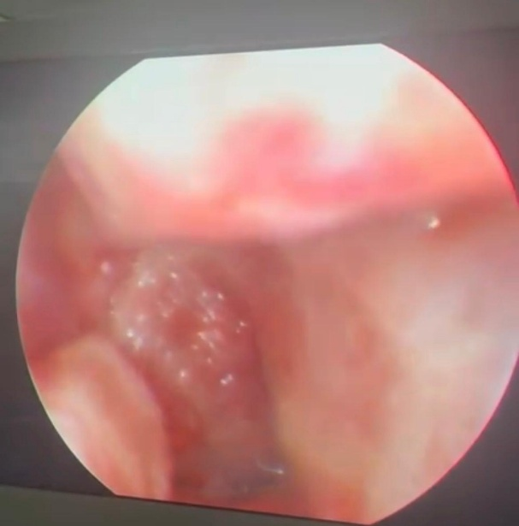

Figure 2: Gross photograph showing two tiny biopsy fragments one measuring approximately 0.5 × 0.5 cm and other measuring 0.2x0.2cm..

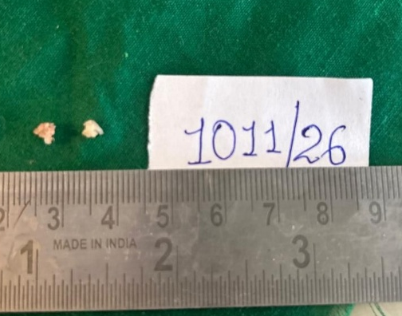

Figure 3
Photomicrograph showing pseudostratified ciliated respiratory epithelium overlying dense lymphoid tissue with well-formed lymphoid follicles and prominent germinal centers, consistent with reactive lymphoid hyperplasia (H&E stain, low power).
.
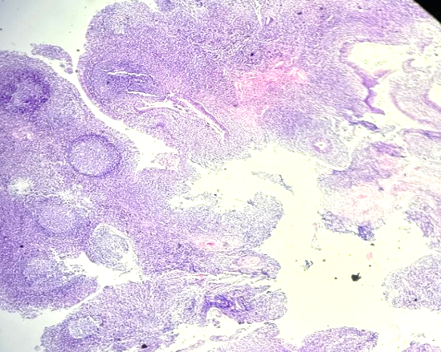

Figure 4: Photomicrograph showing prominent germinal centers consistent with adenoid hypertrophy (H&E stain, high power) and pseudostratified ciliated columnar lining epithelium.

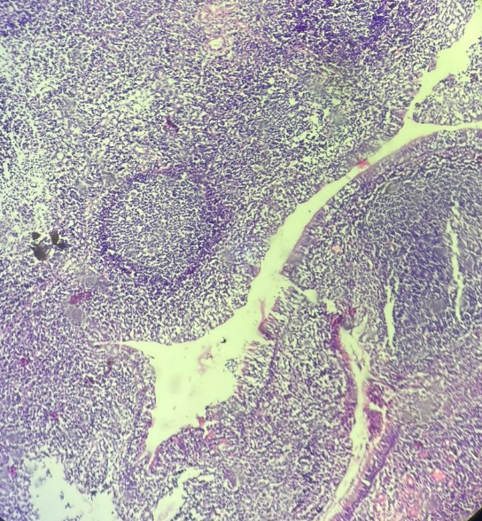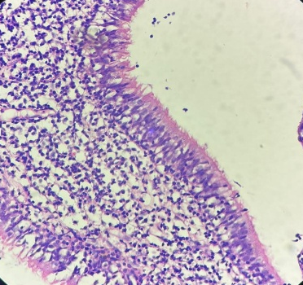

Fig 5- Epithelial lining showing squamous metaplasia at foci
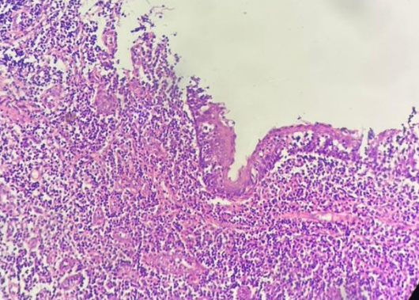

Consent
As per international standards or university standards, patient(s) written consent has been collected and preserved by the author(s).

Ethical Approval:

As per international standards or university standards written ethical approval has been collected and preserved by the author(s).
Disclaimer (Artificial intelligence)

Author(s) hereby declare that NO generative AI technologies such as Large Language Models (ChatGPT, COPILOT, etc.) and text-to-image generators have been used during the writing or editing of this manuscript.

References
- Jeans WD, Fernando DC, Maw AR, Leighton BC. A longitudinal study of the growth of the nasopharynx and its contents in normal children. Br J Radiol. 1981;54:117-121.
- Thimmappa TD, Gangadhara KS. Adenoid hypertrophy in adults. Int J Otorhinolaryngol Head Neck Surg. 2019;5:1354-1357.
- Frenkiel S, Black MJ, Small P. Persistent adenoid presenting as a nasopharyngeal mass. J Otolaryngol. 1980;9(4):357-360.
- Al-Juboori AN, Fadhil A, Sahib N. Adenoid hypertrophy in adult patients and its relation with allergy. European Scientific Journal. 2014;10(12):1857-7881.
- Yildirim N, Şahan M, Karslioğlu Y. Adenoid hypertrophy in adults: clinical and morphological characteristics. Journal of International Medical Research. 2008 Jan;36(1):157-62.
- Avseren E, Bora F, Yucel Z, Oltulu E, Ceylan S. Adenoid hypertrophy in adults. Istanbul Med J. 2010;11(4):168-170.
- Alhamad RM, Jassim AA. Adenoid hypertrophy in adults and nasal obstruction. Al-Kindy College Medical Journal. 2014;10(1):8-10
- Tonpe S, Warbhe H, Banode P, Gandham S, Nagendra V. The diagnostic value of CT scan in identifying adenoid hypertrophy in adults: A case report. Cureus. 2024;16(6):e62793.
- Rout MR, Mohanty D, Vijaylaxmi Y, Bobba K, Metta C. Adenoid hypertrophy in adults: A case series. Indian J Otolaryngol Head Neck Surg. 2013;65(3):269-274.
- Haq AU, Khan NU, Asghar A, Manzoor F, Akhtar M, Pervez S. Adenoid hypertrophy: An unusual cause of nasal obstruction in adults. Pak Armed Forces Med J.
- Sharad KA, Narayan DS, Bhagwatkumar PS. Association of adenoid hypertrophy with nasal and middle ear pathologies in adults. Indian Journal of Otolaryngology and Head & Neck Surgery. 2023 Dec;75(4):3053-6.
- Kitamura T, Uegomori-Yokura A, Oku Y, et al. Effects of adenoid hypertrophy on nasopharyngeal airway ventilation: A computational fluid dynamics study. Int J Pediatric Otorhinolaryngol. 2024;180:111961.

