Surgical Correction of Deviated Nasal Septum via Rhinoplasty and Cartilage Reduction: A Detailed Case Report

Abstract

Background: Deviated nasal septum (DNS) is a common structural abnormality causing nasal obstruction, snoring, headaches, and aesthetic deformity. Surgical intervention is indicated when conservative management fails.

Case Presentation: A 24-year-old male presented with long-standing nasal obstruction, snoring, intermittent headaches, and visible nasal deviation following childhood trauma. Clinical examination and computed tomography revealed a severe C-shaped septal deviation with dorsal nasal asymmetry. The patient underwent open septorhinoplasty with septal cartilage reduction and reconstruction.

Surgical Technique: An open septorhinoplasty approach was performed with elevation of mucoperichondrial flaps, correction of septal deviation while preserving the dorsal and caudal L-strut, cartilage reshaping and grafting, and osteotomies for nasal realignment.

Outcome: Postoperative recovery was uneventful. At one-, three-, and six-month follow-up, the patient demonstrated significant improvement in nasal breathing, resolution of snoring, and satisfactory aesthetic outcome.

Conclusion: Open septorhinoplasty with cartilage reduction is an effective and reliable technique for managing severe septal deviation with associated nasal deformity, providing both functional and aesthetic benefits.

Keywords

Deviated nasal septum; Septoplasty; Septorhinoplasty; Nasal obstruction; Rhinoplasty; Cartilage graft

Introduction

Deviated nasal septum (DNS) is one of the most common causes of chronic nasal obstruction encountered in otolaryngology and facial plastic surgery practice. The nasal septum consists of both cartilaginous and bony components, including the quadrangular cartilage, perpendicular plate of the ethmoid, vomer, and maxillary crest, which together divide the nasal cavity into two symmetrical passages and facilitate normal airflow and mucociliary clearance [1].

Septal deviation may arise from congenital maldevelopment, disproportionate growth of septal cartilage relative to surrounding bony structures, or trauma during childhood or adolescence [2]. Even minor trauma to the developing nasal skeleton can result in progressive deviation and associated external nasal deformity.

While mild septal deviation is often asymptomatic, severe deformity can significantly impair nasal airflow and lead to symptoms such as unilateral nasal obstruction, mouth breathing, snoring, headaches, and recurrent sinusitis [3]. Epidemiological studies suggest that septal deviation may be present in a large proportion of the adult population, although only a subset of individuals develop clinically significant symptoms requiring intervention [4].

Septoplasty remains the standard surgical procedure for the management of symptomatic DNS, aiming to correct deviated cartilage and bone while preserving structural integrity [5]. However, septal deviation is frequently associated with external nasal deformities, including dorsal deviation and tip asymmetry. In such cases, septorhinoplasty provides a comprehensive approach by addressing both functional and aesthetic concerns simultaneously [6].

A fundamental principle of septal surgery is the preservation of the dorsal and caudal L-strut, which provides critical structural support to the nasal dorsum and tip and helps prevent postoperative deformities such as saddle nose collapse [7]. Recent studies have demonstrated that septoplasty and septorhinoplasty significantly improve patient-reported outcomes and overall quality of life [8].

However, detailed reports describing the surgical management of severe septal deviation with simultaneous functional and aesthetic correction using cartilage reduction techniques remain limited.

This case report highlights the surgical management of a severe deviated nasal septum using open septorhinoplasty with cartilage reduction, emphasizing both functional improvement and aesthetic outcomes.

Case Presentation

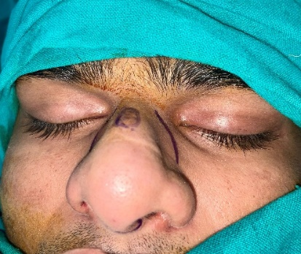
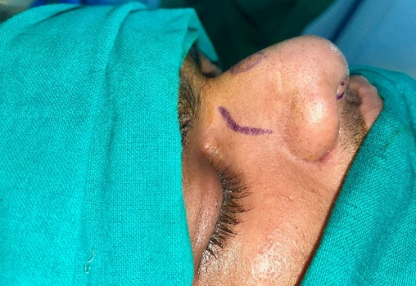
Patient Information
A 24-year-old male presented with complaints of persistent nasal obstruction predominantly affecting the left nasal cavity for approximately five years. The patient also reported habitual mouth breathing, loud snoring during sleep, and intermittent frontal headaches. In addition to functional symptoms, he expressed concern regarding the visible deviation of his nose toward the right side. The patient gave a history of minor nasal trauma during adolescence, following which he noticed a gradual worsening of symptoms.
Clinical Findings
Extraoral examination revealed deviation of the nasal dorsum toward the right side with asymmetry of the nasal tip (Fig. 1). Anterior rhinoscopy demonstrated a pronounced C-shaped septal deviation toward the left nasal cavity, resulting in significant narrowing of the internal nasal valve.
Fig : 1 Pre-operative images of the patient
Diagnostic Assessment
Computed tomography of the paranasal sinuses confirmed severe septal deviation involving both cartilaginous and bony components. The inferior turbinates appeared normal, and no associated sinus pathology was identified. Based on these findings, a diagnosis of severe deviated nasal septum with associated external nasal deformity was established.
Treatment Plan
Considering both functional impairment and aesthetic concerns, surgical correction via open septorhinoplasty with septal cartilage reduction and reconstruction was planned.
Surgical Procedure
The procedure was performed under general anaesthesia with endotracheal intubation. The patient was positioned supine with slight head elevation. Nasal cavities were packed with adrenaline-soaked pledgets to achieve mucosal vasoconstriction and minimize intraoperative bleeding.
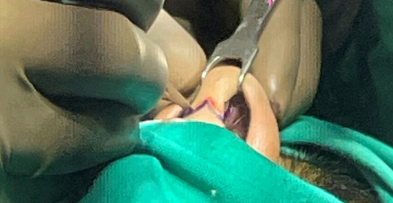
Local anaesthetic containing lidocaine with epinephrine was infiltrated into the columella, nasal dorsum, septum, and nasal tip to provide haemostasis and facilitate dissection.
An inverted V-shaped transcolumellar incision with bilateral marginal extensions was made, and the nasal skin–soft tissue envelope was carefully elevated to expose the underlying cartilaginous framework (Fig. 2).
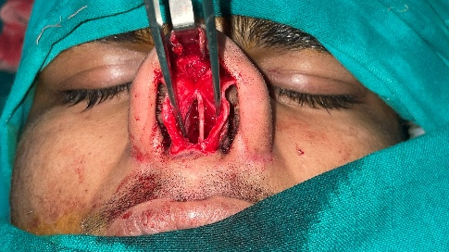
A hemitransfixion incision was performed, followed by elevation of bilateral mucoperichondrial flaps with preservation of mucosal integrity (Fig 3). The deviated septal cartilage was identified and excised while preserving a 1-cm dorsal and caudal L-strut to maintain structural support.
Cartilage scoring techniques were employed to release intrinsic tension and facilitate straightening of the septum. The excised cartilage was reshaped and utilized as graft material for septal stabilization. Lateral osteotomies were performed to correct dorsal deviation and achieve proper alignment of the nasal bones.
Fig 2 An inverted V‑shaped transcolumellar incision was made
Interdomal sutures were placed to improve nasal tip symmetry and projection. The mucoperichondrial flaps were repositioned and sutured, and the external incision was closed with fine sutures (Fig 4).
Postoperative Care and Follow-up
The postoperative period was uneventful. Nasal packing was removed after 48 hours, and the external nasal splint was removed after seven days.
Fig 3 After exposure of the septum
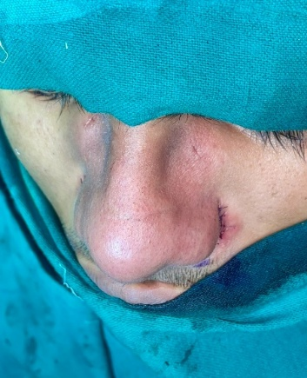
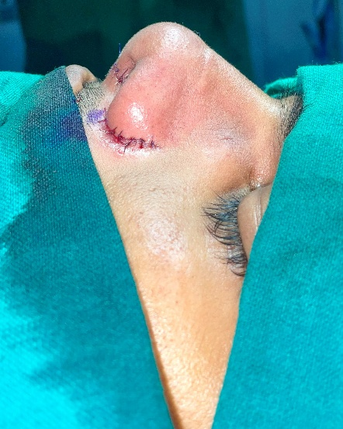
At one-month follow-up, the patient reported significant improvement in nasal breathing, with clinical examination demonstrating a straight nasal dorsum and adequate airway patency. At three months, septal alignment remained stable with complete resolution of snoring symptoms. At six-month follow-up, the patient remained asymptomatic and expressed high satisfaction with both functional and aesthetic outcomes.
Fig 4 Post operative pictures
Early surgical intervention in severe septal deviation can significantly improve both airway function and facial aesthetics.
Discussion

Deviated nasal septum (DNS) is one of the most common structural abnormalities affecting nasal airflow and is a significant contributor to chronic nasal obstruction. The nasal septum plays a crucial role in regulating airflow dynamics and supporting the external nasal framework [9]. Severe septal deviation, particularly when associated with external nasal deformity, often necessitates a combined functional and aesthetic surgical approach.

Trauma during childhood or adolescence is a well-recognized etiological factor in the development of septal deviation and associated nasal deformities [10]. In the present case, a history of nasal trauma during adolescence likely contributed to the progressive deformity and worsening of symptoms over time. Similar findings have been reported in previous studies, where untreated nasal trauma resulted in both functional impairment and cosmetic deformity requiring surgical correction.

Septoplasty remains the standard surgical procedure for symptomatic DNS; however, in cases with concomitant external nasal deformity, septorhinoplasty provides a more comprehensive solution. Carrie et al. demonstrated that septoplasty significantly improves nasal obstruction and quality of life compared to medical management alone [5]. Additionally, systematic reviews by Van Egmond et al. have confirmed the effectiveness of surgical intervention in relieving nasal obstruction and improving patient-reported outcomes [20].

Preservation of the dorsal and caudal L-strut is a fundamental principle in septal surgery, as it maintains structural support of the nasal dorsum and tip. Failure to preserve this support can lead to complications such as saddle nose deformity and nasal tip collapse. Guyuron et al. emphasized the importance of maintaining septal support while correcting deformities to achieve both functional and aesthetic success [14].

Cartilage scoring and grafting techniques play a critical role in overcoming cartilage memory and ensuring long-term stability of the corrected septum. Spreader grafts and septal extension grafts have been shown to improve internal nasal valve function and enhance airflow dynamics. Studies by Becker et al. and Toriumi have highlighted the effectiveness of grafting techniques in maintaining nasal structure and preventing postoperative deformities [15,16].

Open septorhinoplasty offers superior visualization of nasal anatomy, making it particularly advantageous in complex cases involving severe septal deviation and external deformity. Compared to closed techniques, the open approach allows precise correction, better graft placement, and improved symmetry. Most reported that functional rhinoplasty significantly improves disease-specific quality-of-life scores, supporting the use of this approach in appropriately selected patients [18].

The favorable outcome observed in the present case is consistent with previous literature demonstrating that septorhinoplasty provides significant improvement in both nasal airflow and aesthetic appearance. Sunnergren et al., in a large retrospective study, reported high success rates and patient satisfaction following septoplasty procedures [9]. Similarly, Preda et al. highlighted the safety and effectiveness of endoscopic septoplasty with low complication rates [10].

Overall, this case supports the growing body of evidence that combined functional and aesthetic correction through open septorhinoplasty is an effective and reliable treatment modality for severe deviated nasal septum, particularly in cases associated with external nasal deformity.

Conclusion

Open septorhinoplasty with cartilage reduction is a reliable and effective technique for the management of severe deviated nasal septum associated with external nasal deformity. Preservation of structural support, particularly the dorsal and caudal L-strut, along with appropriate use of cartilage grafting techniques, is essential for achieving optimal functional and aesthetic outcomes. This case highlights that a combined functional and aesthetic surgical approach can result in significant improvement in nasal airflow, symptom relief, and patient satisfaction.

Acknowledgements
The authors thank the surgical team and operating room staff.

Consent
As per international standards or university standards, patient(s) written consent has been collected and preserved by the author(s).

Ethical Approval:

As per international standards or university standards written ethical approval has been collected and preserved by the author(s).

Disclaimer (Artificial intelligence)
Author(s) hereby declare that NO generative AI technologies such as Large Language Models (ChatGPT, COPILOT, etc.) and text-to-image generators have been used during the writing or editing of this manuscript.

References
1. Alghamdi FS, Albogami D, Alsurayhi AS, Alshibely AY, Alkaabi TH, Alqurashi LM, et al. Nasal septal deviation: A comprehensive narrative review. Cureus. 2022;14(11):e31317. doi:10.7759/cureus.31317.

2. Watters C, Brar S, Yapa S. Septoplasty. StatPearls [Internet]. Treasure Island (FL): StatPearls Publishing; 2022. Available from: https://www.ncbi.nlm.nih.gov/books/NBK567718/

3. Ashwinirani SR, Suragimath G, Nimbal AV. Deviated nasal septum prevalence and associated symptoms in Maharashtra population of India. Int J Pharm Res Allied Sci. 2023;12(3):1–6. doi:10.51847/peicuqhjxg.

4. Besharah BO, Alharbi HA, Abu Suliman O, Althobaiti HK, Mogharbel AM, Muathen SH. Endoscopic septoplasty versus conventional septoplasty: A systematic review and meta-analysis. Ann Med Surg (Lond). 2023;85:4015–25. doi:10.1097/MS9.0000000000000984.

5. Carrie S, O’Hara J, Fouweather T, et al. Clinical effectiveness of septoplasty versus medical management for nasal airway obstruction. BMJ. 2023;383:e075445. doi:10.1136/bmj-2023-075445.

6. Wu Y, Yu T, Zhang Z, Wang X, Gao S. The benefits of septoplasty for patients with deviated nasal septum and allergic rhinitis: A meta-analysis. Sci Rep. 2024;14:28855. doi:10.1038/s41598-024-80377-3.

7. Di Giuli R, Mafi P, Belloni LM, Vaccari S, Klinger F, Roxo CW. Achieving a strong and straight septal extension graft: A novel four-step surgical approach in rhinoplasty. Plast Reconstr Surg Glob Open. 2024;12(10):e6272. doi:10.1097/GOX.0000000000006272.

8. Ghosh SK, Choudhary A. A comparative study of correction of caudal septal deviations. Indian J Otolaryngol Head Neck Surg. 2024;76:3972–7. doi:10.1007/s12070-024-04757-x.

9. Sunnergren O, Alexandersson C, Broström A, et al. Clinical practice and outcome of septoplasty: A retrospective study. Laryngoscope Investig Otolaryngol. 2025;10:e70199. doi:10.1002/lio2.70199.

10. Preda MA, Chaloob ZA, Preda AA, et al. Endoscopic septoplasty: Outcomes and complications. Medicina. 2026;62(1):135. doi:10.3390/medicina62010135.

11. Stewart MG, Smith TL, Weaver EM, et al. Outcomes after nasal septoplasty: Results from the Nasal Obstruction Septoplasty Effectiveness (NOSE) study. Otolaryngol Head Neck Surg. 2004;130(3):283–290. doi:10.1016/j.otohns.2003.12.004.

12. Rhee JS, Sullivan CD, Frank DO, Kimbell JS, Garcia GJ. A systematic review of patient-reported nasal obstruction scores. Otolaryngol Head Neck Surg. 2014;150(1):27–35. doi:10.1177/0194599813509782.

13. Constantian MB. The incompetent external nasal valve: Pathophysiology and treatment. Plast Reconstr Surg. 1994;93(5):919–931. doi:10.1097/00006534-199404000-00005.

14. Guyuron B, Uzzo CD, Scull H. A practical classification of septonasal deviation and effective surgical techniques. Plast Reconstr Surg. 1999;104(7):2202–2209. doi:10.1097/00006534-199912000-00040.

15. Becker SS, Dobratz EJ, Stowell N, Barker D, Park SS. Revision septoplasty: Review of sources of persistent nasal obstruction. Am J Rhinol. 2008;22(4):440–444. doi:10.2500/ajr.2008.22.3200.

16. Toriumi DM. Structure approach to primary rhinoplasty. Facial Plast Surg Clin North Am. 2016;24(3):327–332. doi:10.1016/j.fsc.2016.03.002.

17. Kim DW, Shah AR, Toriumi DM. Conchal cartilage grafting in rhinoplasty. Otolaryngol Clin North Am. 2009;42(1):113–123. doi:10.1016/j.otc.2008.09.012.

18. Most SP. Analysis of outcomes after functional rhinoplasty using a disease-specific quality-of-life instrument. Arch Facial Plast Surg. 2006;8(5):306–309. doi:10.1001/archfaci.8.5.306.

19. Spiekermann C, Rudack C, Stenner M. Computational fluid dynamics in nasal airway obstruction: A systematic review. Eur Arch Otorhinolaryngol. 2016;273(10):3119–3128. doi:10.1007/s00405-016-3995-5.

20. Van Egmond MMHT, Rovers MM, Tillema AHJ, et al. Septoplasty for nasal obstruction due to deviated nasal septum in adults: A systematic review. Rhinology. 2018;56(3):195–208. doi:10.4193/Rhin17.213.

