Traumatic Pisiform Dislocation Associated with Distal Forearm Fracture in an Adolescent: A Case Report and Literature Review
.
ABSTRACT
Aims:
To report an exceptionally rare case of traumatic pisiform dislocation in a pediatric patient, associated with a displaced forearm fracture, and to review the diagnostic and therapeutic options available in the current literature.
Presentation of Case:
A 14-year-old male presented following a fall onto his outstretched left hand. Clinical examination revealed a forearm deformity with complete functional impairment. Radiographs demonstrated a displaced fracture of both forearm bones at the distal quarter, with concomitant anterolateral dislocation of the pisiform onto the ulnar border of the triquetrum. Closed reduction of the forearm fracture achieved simultaneous spontaneous relocation of the pisiform, without additional carpal intervention. Postoperative course was uneventful. At six-week follow-up, the patient achieved full painless wrist motion with no evidence of instability or recurrence.
Discussion:
Fewer than fifty cases of traumatic pisiform dislocation have been reported in the literature since the first description by Gras in 1835[1,2,8]. Diagnosis is primarily radiological and may be missed on standard views; supplementary projections such as Garraud's 30-45 degrees supination lateral view are recommended. When associated with a displaced forearm fracture, indirect reduction through fracture management may suffice. Otherwise, open reduction with temporary K-wire fixation or pisiform excision are accepted alternatives.
Conclusion:
Pisiform dislocation is rare and easily overlooked, especially when associated with other injuries. Systematic radiographic assessment of the carpus in any distal forearm trauma is essential to ensure early diagnosis and optimal functional outcomes.

Keywords Pisiform; carpal dislocation; wrist trauma; forearm fracture; pediatric orthopaedics; closed reduction

1. INTRODUCTION

Traumatic dislocation of the pisiform is one of the rarest carpal injuries described in the orthopaedic literature. Since Gras first reported the condition in 1835, fewer than fifty cases have been documented worldwide [1,2].
The pisiform is a sesamoid bone embedded within the tendon of the flexor carpi ulnaris (FCU) muscle and articulates with the triquetrum to form the pisotriquetral joint. Its stability is ensured by several ligamentous structures, including the pisohamate and pisometacarpal ligaments as well as the tendinous expansion of the FCU [3].
Because of these strong stabilizing structures, dislocation of the pisiform is uncommon and typically occurs after significant traumatic forces [4].
Clinical signs are often subtle and nonspecific, which may delay diagnosis, especially when the injury is associated with other wrist or forearm lesions [5]. Imaging therefore plays a key role in establishing the diagnosis.
We report a case of traumatic pisiform dislocation in a 14-year-old patient associated with a displaced fracture of both forearm bones, in which closed reduction of the fracture resulted in spontaneous relocation of the pisiform. Such combined injuries remain extremely uncommon in pediatric trauma.
Because of the extreme rarity of this injury, each reported case contributes valuable information to the existing literature. Awareness of pisiform dislocation is important for clinicians managing wrist and forearm trauma, as the diagnosis can easily be missed on routine radiographs. Reporting such cases may help improve early recognition and guide appropriate management strategies in both adult and pediatric patients.

2. PRESENTATION OF CASE
A 14-year-old male with no past medical history presented to the emergency department following a fall from standing height onto his outstretched left hand in dorsiflexion. On examination, there was a visible axial deformity at the distal third of the left forearm with point tenderness over the wrist and carpus and complete functional impairment of the limb. No skin wound, neurovascular deficit, or significant ecchymosis was identified. Radial and ulnar pulses were present and symmetric; sensation in the median and ulnar nerve distributions was intact.

Standard anteroposterior and lateral radiographs of the forearm (figure 1), wrist, and hand demonstrated a displaced angulated fracture of the distal quarter of both the radius and ulna. The pisiform was noted to be displaced anteriorly, repositioned along the ulnar border of the triquetrum. This finding was confirmed on supplementary oblique wrist projections.
Careful analysis of the preoperative radiographs demonstrated disruption of the normal pisiform–triquetrum relationship, supporting the diagnosis of pisotriquetral dislocation.

(A)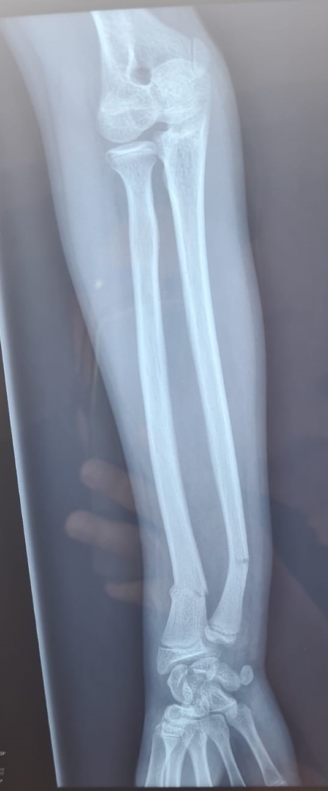 (B) 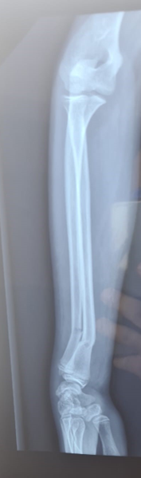

Figure 1: Preoperative radiographs of the left forearm and wrist demonstrating a displaced distal fracture of both the radius and ulna associated with an anterolateral dislocation of the pisiform relative to the triquetrum.

The patient was taken to the operating room under general anesthesia. Closed reduction of the forearm fractures was performed using standard external manipulation. Reduction of the fractures simultaneously achieved spontaneous relocation of the pisiform, without any additional direct intervention on the carpus (figure 2). A long-arm plaster cast was applied in neutral position.

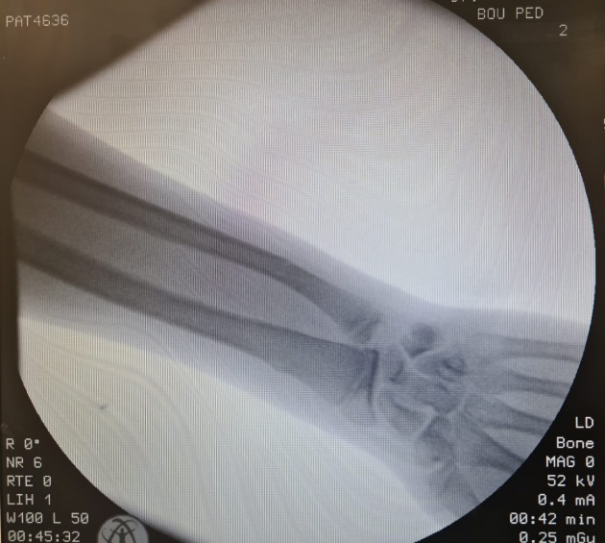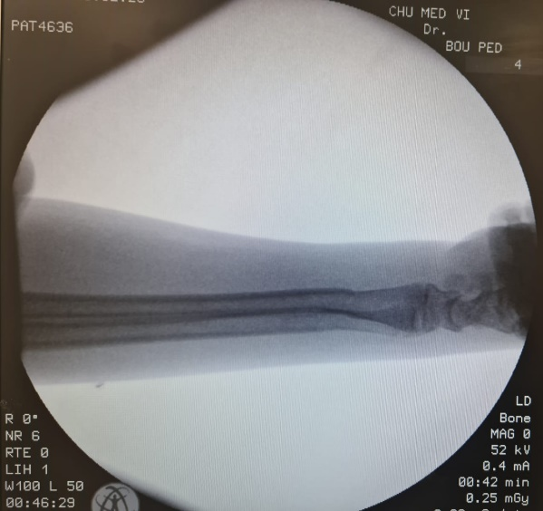
- (B)

Figure 2: Intraoperative fluoroscopic images after closed reduction of the distal forearm fracture showing restoration of forearm alignment and spontaneous reduction of the pisiform. (A) Lateral view. (B) Anteroposterior view.

Control radiographs confirmed anatomical reduction of both the forearm fractures and the carpal dislocation. The postoperative course was uneventful. At the six-week follow-up, reduction was maintained. Following cast removal, functional rehabilitation led to full, painless recovery of wrist motion with no residual instability.

3. discussion
The pisiform is the smallest bone of the proximal carpal row and the only one not directly involved in radiocarpal load transmission. Its sesamoid function within the flexor carpi ulnaris (FCU) tendon amplifies the moment arm of this muscle and contributes to stability of the pisotriquetral joint [3,10].
Biomechanically, the flexor carpi ulnaris tendon exerts a dynamic stabilizing force on the pisiform. Sudden traction or alteration of its tension during traumatic wrist hyperextension may contribute to displacement of the pisiform, particularly when associated with deformity of the forearm bones.
Because of its strong ligamentous and tendinous attachments, dislocation of the pisiform requires significant disruption of the surrounding stabilizing structures, which explains the rarity of this injury [3,4].

Two main mechanisms of injury have been described in the literature. The first is an indirect mechanism caused by sudden and forceful contraction of the flexor carpi ulnaris during resisted wrist extension. The second corresponds to direct trauma to the hypothenar region, typically occurring during a fall onto an outstretched hand [4,5]. In our patient, the mechanism corresponded to the second type.

In cases associated with forearm fractures, the angulated deformity of the radius and ulna may alter tension in the carpometacarpal and pisotriquetral stabilizing structures, facilitating displacement of the pisiform.

Clinically, pisiform dislocation produces mild and nonspecific findings including ulnar-sided wrist pain, limitation of wrist extension or adduction, and occasional hypothenar swelling [4,6]. These symptoms may easily be overlooked, particularly when associated with more obvious injuries such as fractures of the forearm, as observed in the present case.

Diagnosis is primarily radiological and requires careful evaluation of wrist radiographs, particularly in pediatric patients where carpal injuries may be subtle [3,9]. Standard wrist radiographs may be insufficient because the pisiform often overlaps the triquetrum and hamate on conventional views. The pisiform normally overlies the triquetrum on standard radiographs, and disruption of this relationship should raise suspicion of pisotriquetral dislocation [3,4].

Garraud’s oblique projection with 30–45° supination allows better visualization of the pisiform relative to the triquetrum [3]. When radiographic findings are inconclusive, computed tomography provides a more accurate three-dimensional evaluation of carpal alignment [5].

When pisiform dislocation accompanies a displaced forearm fracture, reduction of the fracture alone may restore normal carpal alignment, as demonstrated in our patient. In our case, intraoperative fluoroscopy confirmed restoration of the normal pisiform–triquetrum relationship immediately after fracture reduction, indicating indirect relocation of the pisiform without direct manipulation.
Restoration of forearm alignment may reestablish normal tension in the flexor carpi ulnaris tendon and surrounding ligamentous structures, allowing spontaneous relocation of the pisiform. This indirect reduction mechanism has been reported in pediatric cases associated with distal radial fractures [6].
The spontaneous relocation of the pisiform following reduction of the forearm fracture is clinically significant. It suggests that restoration of normal forearm alignment may reestablish physiological tension in the flexor carpi ulnaris tendon and associated ligamentous structures, allowing indirect reduction of the pisiform without the need for additional surgical intervention.
Similar cases reported in the literature describe traumatic pisiform dislocation occurring either as an isolated injury or in association with distal radius fractures. However, reports in adolescent patients remain extremely limited. Most previously reported cases required either closed reduction of the pisiform itself or open reduction with temporary fixation. In contrast, our case demonstrates that reduction of the associated forearm fracture alone may restore normal pisotriquetral alignment, highlighting the importance of addressing associated injuries before considering direct surgical treatment of the pisiform.

For isolated dislocations or cases resistant to closed reduction, open reduction with temporary pisotriquetral K-wire fixation for four to six weeks is usually recommended [4].In chronic or recurrent cases, pisiform excision has been described as an effective salvage procedure with satisfactory functional outcomes [2,5].

To our knowledge, traumatic pisiform dislocation associated with distal forearm fracture in adolescents remains extremely rare in the literature, emphasizing the importance of careful radiographic evaluation of the carpus in pediatric forearm trauma.
The main strength of this report lies in the description of a rare association between pisiform dislocation and displaced forearm fracture in an adolescent patient. However, as a single case report, the findings cannot be generalized and further studies are needed to better understand the optimal management of this rare injury.
The long-term prognosis after successful reduction of pisiform dislocation is generally favorable when early diagnosis and appropriate management are achieved. Most reported cases demonstrate restoration of normal wrist function without chronic instability or pain.

4. CONCLUSION
Traumatic dislocation of the pisiform is a rare and clinically elusive injury. It should be actively sought in any patient presenting with wrist or distal forearm trauma, particularly when standard radiographs show associated fractures. Supplementary projections or computed tomography should be used whenever doubt persists.

Early recognition of this injury is essential because appropriate management of the associated fracture may lead to indirect reduction of the pisiform, avoiding unnecessary surgical procedures and ensuring optimal functional recovery.

Ethical Approval
Ethical approval was not required for this case report according to institutional policy.
Consent
Written informed consent was obtained from the patient’s legal guardian for publication of this case report and accompanying images.

Disclaimer (Artificial intelligence)

Author(s) hereby declare that NO generative AI technologies such as Large Language Models (ChatGPT, COPILOT, etc.) and text-to-image generators have been used during the writing or editing of this manuscript.

References:
- Immermann EW. Dislocation of the pisiform. J Bone Joint Surg Am. 1948;30:489-492.
- Minami M, Yamazaki J, Ishii S. Isolated dislocation of the pisiform. J Hand Surg Am. 1984;9:125-128.
https://doi.org/10.1016/S0363-5023(84)80200-2
- Van der Lei B, Klasen HJ. Traumatic dislocation of the pisiform. J Hand Surg Br. 1990;15:86-88.
- Petrou IG, Savioz-Leissing C, Gray A. Traumatic dislocation of the pisiform bone. J Hand Microsurg. 2018;10:53-55.
https://doi.org/10.1055/s-0037-1606206
- Mahmood F, Mehta M, Kakkar R. Pisiform dislocation. BMJ Case Rep. 2021;14:e237482.
https://doi.org/10.1136/bcr-2020-237482
- Lee SK, Desai H, Silver B. Pisotriquetral joint injuries and instability. Hand Clin. 2015;31:361-370.
- Bae DS. Pediatric carpal injuries. J Pediatr Orthop. 2010;30:S77-S84.
https://doi.org/10.1097/BPO.0b013e3181d8318c
- Garcia-Elias M. Carpal instability and dislocations. In: Green's Operative Hand Surgery. Elsevier; 2017.
- Taleisnik J. The Wrist. Churchill Livingstone; 1985.
- Wolfe SW, Pederson WC, Kozin SH. Green's Operative Hand Surgery. 7th ed. Elsevier; 2017.

