Case report
Traumatic Upper Rectal Perforation Associated with Seatbelt Sign Following Motor Vehicle Collision: A Case Report

.
ABSTRACT

Background: We report a rare case of traumatic upper rectal perforation in a 35-year-old female restrained passenger after a front-impact motor vehicle collision with airbag deployment. The patient presented with abdominal and back pain and a lower abdominal seatbelt sign. Vital signs were stable.
Case Report: FAST examination was negative; however, contrast-enhanced CT of the abdomen and pelvis demonstrated pneumoperitoneum and radiologic features suspicious for hollow viscus injury; CT also identified an L2 vertebral fracture. Emergency exploratory laparotomy revealed a 0.7 × 0.7 cm anterior rectal wall perforation just below the rectosigmoid junction and small-bowel contusion 50 cm proximal to the ileocecal valve. The rectal defect was repaired primarily in two layers and a pelvic drain placed. Peritoneal fluid culture grew Escherichia coli; subsequent wound culture grew ESBL-producing E. coli. The patient recovered on ertapenem with resolution of abdominal symptoms, return of bowel function, and improvement of inflammatory markers; superficial surgical site infection was managed with local care.
Conclusion: This case highlights the need for high index of suspicion and prompt operative source control in blunt-trauma patients with seatbelt sign and CT pneumoperitoneum, and supports selective primary repair for small, non-destructive intraperitoneal rectal perforations with appropriate antimicrobial stewardship.

Keywords: Case reports; Rectal perforation; Seatbelt sign; Blunt abdominal trauma; Hollow viscus injury

1. INTRODUCTION
Trauma from motor vehicle collisions (MVCs) remains a leading global cause of morbidity; abdominal blunt trauma can produce hollow viscus injuries (HVI) that are infrequent but carry outsized morbidity if diagnosis or source control are delayed (Borgialli et al., 2014; Leoni et al., 2023; Wolmarans & Knottenbelt, 2023; Kokabi et al., 2015). The presence of an external abdominal seatbelt sign (SBS) has long been associated with increased risk of intra-abdominal injury and guides early investigation, though its positive predictive value is variable across series. Contemporary cross-sectional imaging has increased sensitivity for occult free intraperitoneal air; however, clinical correlation and early surgical consultation remain critical when CT findings and examination diverge. Here we present a case report of an upper rectal perforation associated with a seatbelt sign and pneumoperitoneum, managed by prompt laparotomy and primary repair, and complicated postoperatively by ESBL Escherichia coli wound colonization that required targeted carbapenem therapy (Leoni et al., 2023; Mahan & Esposito, 2023).

2. Case Presentation

A 35-year-old female with no past medical or surgical history was the restrained passenger in a front-impact motor vehicle collision with airbag deployment on 02 November 2025. She reported lower abdominal and back pain on presentation and was noted to have a seatbelt sign (lower abdominal ecchymosis). She denied loss of consciousness, nausea, and vomiting. Triage at 15:49 recorded BP 112/78 mmHg, pulse 78 bpm, RR 18/min, temperature 37.0 °C, and SpO₂ 99%. FAST was negative.
Examination revealed voluntary guarding, focal lower abdominal tenderness (predominantly in the right lower quadrant), and a seatbelt sign without external wound degloving. Neurologic exam, distal perfusion, and limb joint function were intact. Laboratory testing on 02/11/25 showed leukocytosis (WBC 22.47 ×10^3/µL) and hemoglobin 12.5 g/dL.
Imaging included radiographs without acute bony thoracoabdominal abnormalities, but CT lumbosacral spine demonstrated an L2 vertebral body superior endplate fracture (addendum noting T12 involvement). Contrast CT abdomen and pelvis (created 03/11/25) demonstrated pneumoperitoneum, minimal free fluid tracking along the right paracolic gutter into the pelvis, mildly prominent small bowel loops and dilated ascending colon, and subcutaneous fat stranding consistent with the seatbelt sign (Figures 1 and 2); solid organs and pelvis were otherwise unremarkable. Given CT-confirmed free intraperitoneal air and worsening abdominal pain with guarding, general surgery performed an urgent exploratory laparotomy.
Intraoperative findings included moderate serosanguinous and mucinous peritoneal fluid, small-bowel contusion located 50 cm proximal to the ileocecal junction without frank perforation, and a discrete 0.7 × 0.7 cm perforation on the anterior rectal wall just below the rectosigmoid junction (upper rectum/intraperitoneal rectum). The rectal defect was closed primarily in two layers, and a pelvic drain was placed; no proximal fecal diversion was performed. Source control was achieved, and the abdomen was closed.
Peritoneal fluid culture (obtained 03/11/25) subsequently yielded Escherichia coli. The patient’s immediate postoperative course was notable for return of bowel function and tolerance of soft diet. By 12/11/25 she was afebrile, ambulating, passing stool, and had reassuring vitals (BP 111/72 mmHg; pulse 72 bpm; SpO₂ 98%). Laboratory values demonstrated normalization of leukocytosis (WBC 10.37 × 10^3/µL) and CRP at 7.33 mg/L. On postoperative day 5, the midline laparotomy wound showed mild serous/turbid drainage and two small gaping areas without purulence; wound culture (08/11/25) grew heavy ESBL-positive Escherichia coli and gram-negative rods on Gram stain.
The patient was managed with daily wound care (irrigation, Betadine packing) and targeted intravenous ertapenem (selected in keeping with contemporary guidance for ESBL intra-abdominal infections). VTE prophylaxis, analgesia, and orthotrauma care for the L2 fracture continued. The pelvic drain output decreased and no anastomotic leak or pelvic abscess developed. The superficial surgical site infection was controlled with local care and systemic antibiotics; the patient was discharged with outpatient follow-up instructions and documented consent for case reporting.

3. discussion

This case illustrates several salient points for clinicians managing blunt abdominal trauma with external deceleration signs. First, the abdominal seatbelt sign remains a valuable external marker that should heighten clinical suspicion for HVI; multiple series have demonstrated that SBS is associated with an increased risk of intra-abdominal injury and HVI specifically, though the positive predictive value is imperfect and age and mechanism influence risk. Contemporary multicenter analyses and systematic reviews continue to emphasize that SBS should prompt early CT assessment and surgical consultation (Borgialli et al., 2014; Leoni et al., 2023).
Second, CT in hemodynamically stable blunt trauma patients is the imaging modality of choice for detecting hollow viscus injury. According to current trauma guidelines including ATLS, contrast-enhanced CT of the abdomen is the imaging modality of choice in hemodynamically stable patients with suspected blunt abdominal injury (Leoni et al., 2023; Wolmarans & Knottenbelt, 2023). Sensitivity is high although specificity can be limited, and isolated small volumes of free air may reflect transient or clinically irrelevant findings in rare cases. In our patient CT demonstrated pneumoperitoneum with minimal free fluid and localized fat stranding which is a combination that, when correlated with abdominal guarding and leukocytosis, correctly predicted the need for operative exploration. Recent literature supports CT’s central role while underscoring that radiologic interpretation must be integrated with clinical trajectory to decide on laparotomy (Wolmarans & Knottenbelt, 2023; Kokabi et al., 2015).
Third, management of intraperitoneal rectal injuries in civilian blunt trauma remains individualized but guided by principles derived from both civilian series and historical military literature. Non-destructive intraperitoneal rectal wounds (<50% circumferential involvement, viable tissue) may be safely managed with primary repair, drainage, and targeted antibiotics; fecal diversion is reserved for destructive injuries, gross contamination, or when repair integrity is doubtful. Our patient had a small, well-demarcated defect repaired primarily in two layers with pelvic drainage and experienced no anastomotic failure or pelvic sepsis, consistent with contemporary evidence supporting selective primary repair for small intraperitoneal rectal perforations (Mahan & Esposito, 2023; Clemens et al., 2017).
Fourth, microbiology and antimicrobial stewardship are critical. Intra-abdominal cultures returned Escherichia coli and later wound cultures revealed ESBL-producing strains. Current clinical guidance supports the use of carbapenems for severe ESBL-Enterobacterales intra-abdominal infections; ertapenem is an evidence-supported choice for susceptible ESBL-producing organisms in intra-abdominal and surgical site infections where Pseudomonas coverage is not required. Early culture-directed therapy, de-escalation where feasible, and adequate source control remain the pillars of management. Our institution’s selection of ertapenem aligned with these recommendations and the patient’s rapid clinical improvement corroborates appropriate antibiotic choice in this scenario (Tamma et al., 2022; Sartelli et al., 2024).
The co-occurrence of spinal injury (L2 vertebral fracture) illustrates the multisystem nature of deceleration trauma and the need for coordinated multispecialty care (orthotrauma, general surgery, radiology, infectious disease/microbiology, and physiotherapy), with attention to mobilization, bracing, and analgesia while managing abdominal source control and infection.
Limitations and learning points: this is a single case report and cannot define best practice; however, it reinforces that (1) the seatbelt sign should prompt a low threshold for CT and surgical evaluation, (2) CT evidence of free intraperitoneal air with compatible exam findings warrants early operative exploration in stable patients, (3) small intraperitoneal rectal perforations may be managed with primary repair and drainage with careful postoperative surveillance, and (4) ESBL organisms may complicate postoperative courses, requiring targeted carbapenem therapy and rigorous infection control. These lessons align with existing literature and reporting standards and support judicious, individualized decision making (Gagnier et al., 2013).

4. Conclusion

This case underscores the diagnostic importance of the abdominal seatbelt sign in patients with blunt abdominal trauma, even when hemodynamically stable. The presence of pneumoperitoneum on computed tomography, when correlated with physical examination findings, should prompt early operative exploration to prevent delayed morbidity. In selected cases of small, non-destructive intraperitoneal rectal perforations, primary repair with adequate drainage can be performed safely without fecal diversion. Additionally, culture-directed antimicrobial therapy remains essential in optimizing postoperative outcomes and limiting antimicrobial resistance. Early recognition, timely surgical intervention, and coordinated multidisciplinary care are critical to achieving favorable outcomes in rare but clinically significant hollow viscus injuries.

Consent

All authors declare that written informed consent was obtained from the patient for publication of this case report and accompanying images. A copy of the written consent is available for review by the Editorial Office, Chief Editor, or Editorial Board members of this journal upon request.

Disclaimer (Artificial intelligence)

Author(s) hereby declare that NO generative AI technologies such as Large Language Models (ChatGPT, COPILOT, etc.) and text-to-image generators have been used during the writing or editing of this manuscript.

References

- Borgialli, D. A., Ellison, A. M., Ehrlich, P., et al. (2014). Association between the seat belt sign and intra-abdominal injury in children with blunt torso trauma. Academic Emergency Medicine, 21(11), 1240–1248. https://doi.org/10.1111/acem.12506
- Leoni, J. A., Neufeld, J., Gao, J., & Kirkpatrick, A. W. (2023). Abdominal seatbelt signs: Predictive value of computed tomography. Canadian Journal of Surgery, 66(3), E261–E268. https://doi.org/10.1503/cjs.006522
- Wolmarans, A., & Knottenbelt, J. D. (2023). Accuracy of CT scan for detecting hollow viscus injury in trauma: A systematic review and meta-analysis. World Journal of Surgery, 47(5), 1216–1226. https://doi.org/10.1007/s00268-023-06922-9
- Kokabi, N., Wong-You-Cheong, J. J., Shuaib, W., et al. (2015). Specific radiological findings of traumatic hollow viscus injury: A pictorial essay. European Journal of Radiology, 84(9), 1649–1656. https://doi.org/10.1016/j.ejrad.2015.05.021
- Mahan, M. E., & Esposito, T. J. (2023). Rectal trauma. In StatPearls. StatPearls Publishing. https://www.ncbi.nlm.nih.gov/books/NBK534303/
- Clemens, M. S., Peace, K. M., & Ferguson, E. (2017). Rectal trauma: Evidence-based practices. Surgical Clinics of North America, 97(5), 1159–1171. https://doi.org/10.1016/j.suc.2017.06.004
- Tamma, P. D., Aitken, S. L., Bonomo, R. A., et al. (2022). Infectious Diseases Society of America 2022 guidance on the treatment of extended-spectrum β-lactamase producing Enterobacterales (ESBL-E), carbapenem-resistant Enterobacterales (CRE), and Pseudomonas aeruginosa with difficult-to-treat resistance. Clinical Infectious Diseases. https://doi.org/10.1093/cid/ciac268
- Sartelli, M., Coccolini, F., Kluger, Y., et al. (2024). WSES/GAIS/SIS-E/WSIS/AAST global clinical pathways for patients with intra-abdominal infections. World Journal of Emergency Surgery, 19(1), 3. https://doi.org/10.1186/s13017-023-00530-7
- Gagnier, J. J., Kienle, G., Altman, D. G., et al. (2013). The CARE guidelines: Consensus-based clinical case reporting guideline development. BMJ Case Reports, 2013, bcr2013201554. https://doi.org/10.1136/bcr-2013-201554
- El Kafsi J, Kraus R, Guy R. Rectal disruption following abdominal seatbelt trauma: A report of three cases and review of the literature. Ann R Coll Surg Engl. 2016;98(2):86–90. https://doi.org/10.1308/rcsann.2016.0050
- Al-Ozaibi L, Adnan J, Hassan B, Al-Mazroui A, Al-Badri F. Seat belt syndrome: Delayed or missed intestinal injuries, a case report and review of literature. Int J Surg Case Rep. 2016;20:74-76. https://doi.org/10.1016/j.ijscr.2016.01.015

FIGURES
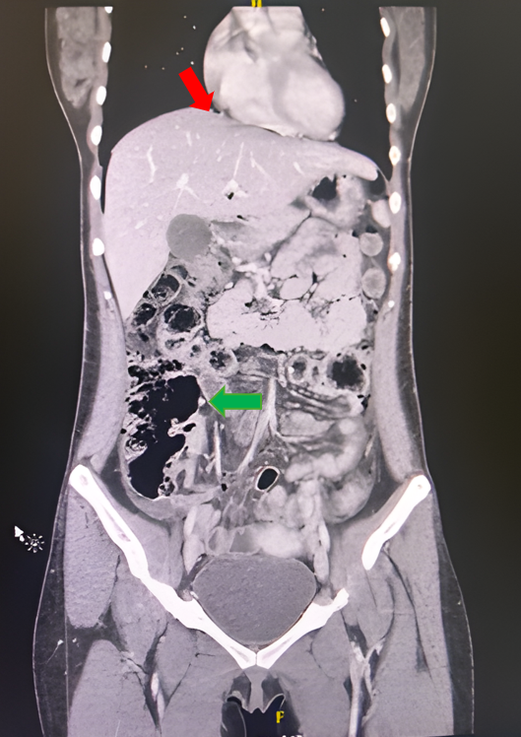
Figure 1. Coronal contrast-enhanced CT image demonstrating pneumoperitoneum beneath the right hemidiaphragm (red arrow) and abnormal intraperitoneal gas adjacent to bowel loops (green arrow), suggestive of hollow viscus injury following blunt abdominal trauma.

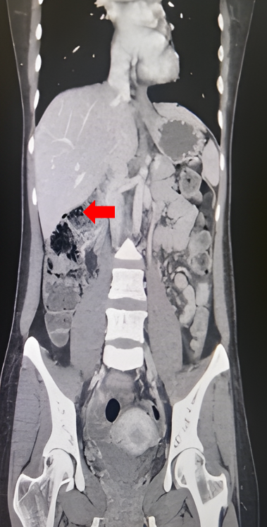
Figure 2. Coronal contrast-enhanced CT image demonstrating abnormal intraperitoneal gas adjacent to bowel loops (arrow), supporting suspicion of hollow viscus injury in the setting of blunt abdominal trauma.

