Case report
Dehydrated Amniotic Membrane as Adjunctive Therapy for Recurrent Immunological Corneal Ulcer: A Case Report

.
ABSTRACT

Introduction:
Amniotic membrane transplantation has become an established therapeutic approach for ocular surface reconstruction. It is commonly used in persistent epithelial defects, corneal ulcers, chemical burns, and after pterygium surgery. Dehydrated amniotic membrane (DAM) is a processed form of human amniotic tissue that can be stored at room temperature and easily applied in outpatient settings. DAM provides anti-inflammatory, anti-angiogenic, and epithelial regenerative properties. The aim of this report is to highlight the therapeutic role of dehydrated amniotic membrane in the management of recurrent immunological corneal ulcers.
Case Presentation:
We report the case of a 68-year-old woman with dermatomyositis treated with systemic corticosteroids, associated with Raynaud’s phenomenon and livedo. She presented with a painful red left eye and decreased visual acuity. Five months earlier, the patient had developed a corneal ulcer in the same eye that healed slowly after intensive medical therapy.
On admission, visual acuity was limited to hand motion perception. Slit-lamp examination revealed a deep marginal corneal ulcer measuring approximately 10 × 5 mm with positive fluorescein staining. Corneal sensitivity was preserved and the Schirmer test measured 20 mm, suggesting reflex tearing. The anterior chamber was well formed and a total white cataract prevented fundus visualization. The contralateral eye showed mild ocular surface disease with diffuse superficial punctate keratitis, tear break-up time of 5 seconds, and Schirmer test of 9 mm.
Initial management included preservative-free lubricating agents and antibiotic prophylaxis. Due to the absence of clinical improvement, a dehydrated amniotic membrane was applied in order to promote corneal epithelial healing.
Complete epithelial healing was observed within 10 days after membrane placement.
Conclusion
Dehydrated amniotic membrane represents a safe and effective adjunctive therapy for immunological corneal ulcers, particularly in settings where access to cryopreserved amniotic membrane is limited.

Keywords
Amniotic membrane transplantation, Dehydrated amniotic membrane, Immunological corneal ulcer, Ocular surface reconstruction, Autoimmune keratitis

1. INTRODUCTION:
Immunological corneal ulcers represent a severe form of ocular surface disease frequently associated with autoimmune or systemic inflammatory disorders. These ulcers are characterized by stromal inflammation, progressive tissue destruction, and delayed epithelial healing. If left untreated, they may lead to severe complications such as stromal thinning, corneal perforation, and permanent visual impairment.
The pathophysiology of immunological corneal ulcers involves immune-mediated inflammatory mechanisms leading to the release of cytokines and proteolytic enzymes that cause stromal degradation. Management is often challenging and requires a combination of local therapy, systemic immunosuppressive treatment, and sometimes surgical interventions when medical therapy alone is insufficient.
Amniotic membrane transplantation has been widely used in ophthalmology (1,3,8,9). It has been extensively studied for its anti-inflammatory and regenerative properties in ocular surface disorders. The amniotic membrane acts as a biological scaffold that promotes epithelial cell migration and differentiation while reducing inflammation and inhibiting corneal neovascularization. These properties make it particularly useful in the management of persistent epithelial defects and corneal ulcers.
Amniotic membrane is available in several forms including fresh, cryopreserved, and dehydrated preparations. Dehydrated amniotic membrane is an allogeneic tissue derived from human amniotic membrane that undergoes special processing allowing long-term storage at room temperature. Compared with fresh or cryopreserved membranes, dehydrated amniotic membrane offers important logistical advantages (8,10), including ease of storage, immediate availability, and simplified handling in outpatient settings.
Immunological corneal ulcers remain challenging to manage due to their recurrent nature and the high risk of corneal perforation, particularly in patients with underlying autoimmune diseases. In resource-limited settings where access to cryopreserved amniotic membrane is restricted, dehydrated amniotic membrane may represent a valuable therapeutic alternative.
The aim of this study is to report a case of recurrent immunological corneal ulcer successfully treated with dehydrated amniotic membrane and to discuss its therapeutic potential.

2. Case presentation:
A 68-year-old female patient with a history of dermatomyositis treated with systemic corticosteroids presented to the ophthalmology emergency department with a painful red left eye associated with decreased vision. The patient also had Raynaud’s phenomenon and livedo and was receiving angiotensin receptor blocker therapy.
Five months before the current consultation, the patient had developed a corneal ulcer in the same eye. At that time, the ulcer had been treated with fortified topical antibiotics, lubricating agents, and oral antibiotic therapy. Although the corneal surface eventually healed, the healing process was slow and required approximately two months.
At presentation, best-corrected visual acuity in the affected eye was limited to hand motion perception. Slit-lamp examination revealed conjunctival hyperemia and a deep marginal corneal ulcer measuring approximately 10 × 5 mm. Fluorescein staining was positive, confirming epithelial loss. Corneal sensitivity was preserved. The Schirmer test measured 20 mm, consistent with reflex tearing.
The anterior chamber was well formed and showed no inflammatory reaction. A total white cataract prevented visualization of the posterior segment.
Examination of the contralateral eye revealed corrected visual acuity of 7/10. Slit-lamp examination demonstrated diffuse superficial punctate keratitis associated with tear film instability with a tear break-up time of 5 seconds. The Schirmer test measured 9 mm, indicating moderate dry eye. The remainder of the examination was unremarkable.
The Ocular Surface Disease Index (OSDI) score was 100 in the affected eye and 28 in the fellow eye.
Initial management consisted of intensive ocular surface treatment including preservative-free lubricants, topical antibiotic prophylaxis, and close clinical monitoring. The patient was referred to the internal medicine department for reassessment of systemic disease and visceral evaluation. No additional systemic abnormalities were detected.
Because of the lack of clinical improvement, the decision was made to apply a dehydrated amniotic membrane in order to accelerate epithelial healing.
Three days after placement of the membrane, a clear reduction in inflammation and progressive epithelialization of the ulcer were observed. By day 10, the amniotic membrane had been completely resorbed and the therapeutic contact lens was removed. Complete epithelial healing was achieved.
At the three-month follow-up visit, the corneal surface remained stable with no recurrence of the ulcer and significant improvement in ocular comfort.

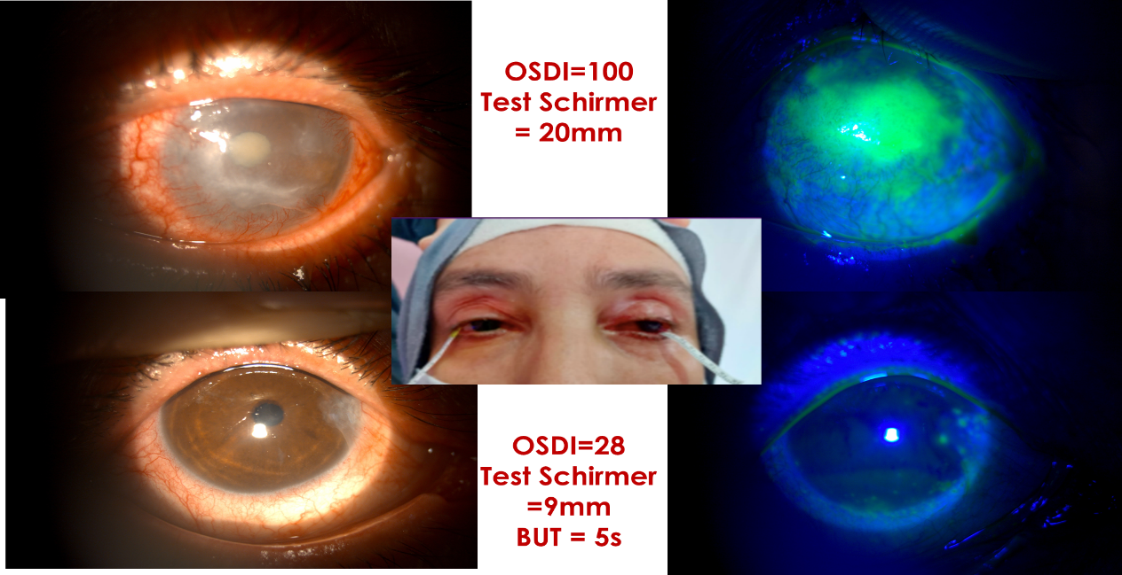
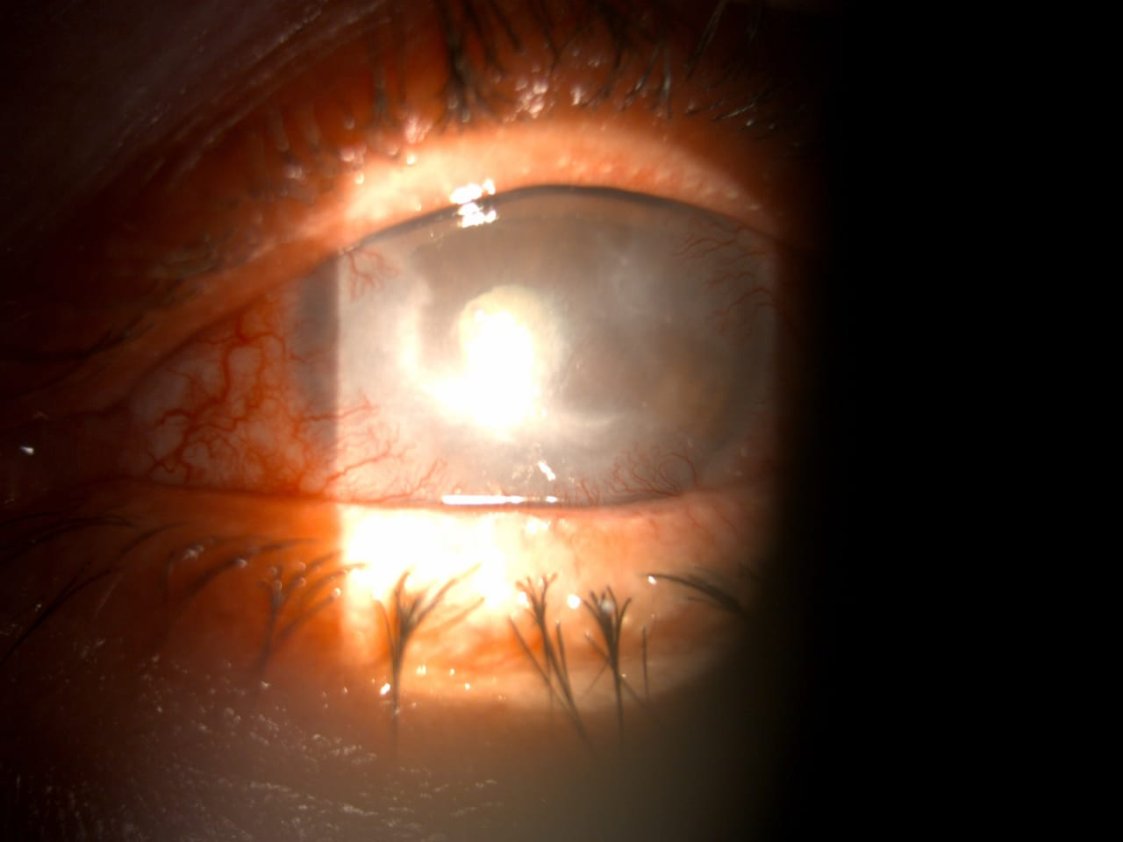
Aspect trois jours après la pose de la membrane amniotique déshydratée

Fig 1 : Appearance three days after placement of the dehydrated amniotic membrane


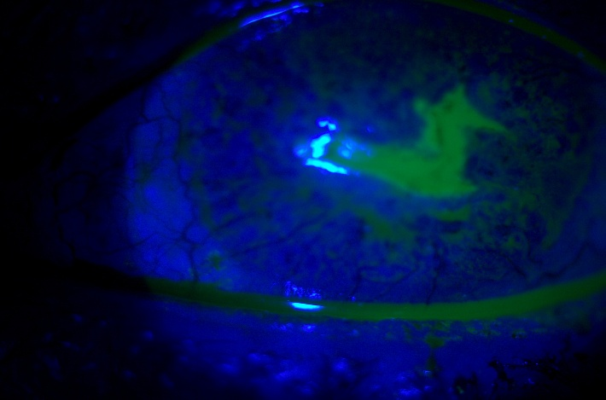

Fig 2 : Appearance on day 10 after resorption of the dehydrated amniotic membrane
and removal of the therapeutic lens

3.DISCUSSION:

Amniotic membrane transplantation has become an important therapeutic option for the treatment of ocular surface diseases. The amniotic membrane contains multiple growth factors (3,8,9), including epidermal growth factor and keratinocyte growth factor, which promote epithelial regeneration and accelerate wound healing.
In addition to stimulating epithelial cell migration, amniotic membrane exerts significant anti-inflammatory effects by suppressing pro-inflammatory cytokines and inhibiting matrix metalloproteinases responsible for stromal degradation. These properties contribute to the stabilization of the ocular surface and prevention of further tissue damage.
Another important advantage of amniotic membrane is its ability to inhibit corneal neovascularization and fibrosis, thereby preserving corneal transparency. These biological effects make amniotic membrane transplantation particularly useful in persistent epithelial defects, neurotrophic keratitis, and immunological corneal ulcers.
Traditionally, amniotic membrane transplantation is performed using fresh or cryopreserved membranes obtained from tissue banks. However, the availability of such tissues may be limited in many countries. In Morocco, for instance, the number of amniotic membrane banks remains very limited, which restricts access to cryopreserved membranes.
Dehydrated amniotic membrane offers several advantages over conventional preparations(10,11). It can be stored at room temperature, has a long shelf life, and can be easily applied in outpatient settings without the need for an operating room. These characteristics significantly simplify its use in routine clinical practice.
Several techniques can be used when applying amniotic membrane. The inlay technique involves placing the stromal side of the membrane downward so that the basement membrane acts as a scaffold for epithelial growth. In contrast, the overlay technique places the membrane over the corneal surface as a biological bandage protecting the ulcer.
Our case demonstrates the effectiveness of dehydrated amniotic membrane in promoting rapid epithelial healing in a recurrent immunological corneal ulcer associated with systemic autoimmune disease.
The main limitation of this report is the description of a single clinical case. Further studies involving larger patient populations are necessary to better evaluate the long-term efficacy of dehydrated amniotic membrane in the management of immunological corneal ulcers.
These findings are consistent with previously published studies highlighting the effectiveness of amniotic membrane in promoting corneal healing and reducing inflammation in ocular surface disorders.

4. CONCLUSION:
Dehydrated amniotic membrane represents a safe, accessible, and reproducible therapeutic option for the treatment of immunological corneal ulcers. Its ease of storage and outpatient application makes it particularly useful in settings with limited access to cryopreserved amniotic membrane. Early use of this technique may accelerate corneal healing and improve patient outcomes.

Consent

Written informed consent was obtained from all participants prior to their inclusion in the study.

Ethical approval

Ethical approval for this prospective study was obtained from the Ethics Committee of the 20 August 1953 Hospital, Ibn Rochd University Hospital Center, Casablanca, Morocco. The study was conducted in accordance with the principles of the Declaration of Helsinki.

Disclaimer (Artificial intelligence)

Author(s) hereby declare that NO generative AI technologies such as Large Language Models (ChatGPT, COPILOT, etc.) and text-to-image generators have been used during the writing or editing of this manuscript.

References

1 Tseng SCG. How does amniotic membrane work. Ocul Surf. 2004
2 Meller D et al. Amniotic membrane transplantation in chemical burns. Ophthalmology. 2000
3 Dua HS et al. The amniotic membrane in ophthalmology. Surv Ophthalmol. 2004
4 Heiligenhaus A et al. Amniotic membrane transplantation in ulcerative keratitis. Graefes Arch Clin Exp Ophthalmol. 2001
5 Singh V et al. Clinical outcomes of dehydrated amniotic membrane. Int Ophthalmol. 2019
6 Zhang T et al. Amniotic membrane transplantation in ocular surface diseases. Surv Ophthalmol. 2021
7 Said DG, Dua HS. Amniotic membrane transplantation in ophthalmology. Br J Ophthalmol. 2023

8 Ljubimov AV, Saghizadeh M. Amniotic membrane transplantation in ocular surface reconstruction.Prog Retin Eye Res. 2020;75:100777.

9 Said DG, Dua HS. Human amniotic membrane in ophthalmology. Br J Ophthalmol. 2023;107(1):1-9.

10- Zhang T, Yam GH, Riau AK, et al. The use of amniotic membrane in ocular surface diseases. Surv Ophthalmol. 2021;66(4):639-660.

11- Shen L, Sun P, Zhang C. Clinical applications of dehydrated amniotic membrane in ocular surface disorders. Cornea. 2021;40(3):356-362.

12- Meller D, Pauklin M, Thomasen H, et al. Amniotic membrane transplantation in the human eye. Dtsch Arztebl Int. 2011;108(14):243-248.

13- Suri K, Kosker M, Raber IM, et al. Sutureless amniotic membrane transplantation for ocular surface disease. Am J Ophthalmol. 2013;156(4):641-650.

