Case report
Gestational Gigantomastia in a 37-Year-Old Woman: managed successfully by multidisciplinary approach

Abstract
Gestational gigantomastia (GG) is an extremely rare condition characterized by excessive breast enlargement during pregnancy and may lead to serious maternal morbidity. Due to its rarity, standardized management guidelines are lacking, particularly in resource-limited settings. To the best of our knowledge, this is the first reported case of gestational gigantomastia from Bangladesh and contributes valuable regional evidence to guide clinical and surgical decision-making. A 37-year-old woman at 33+ weeks of gestation presented with massive bilateral breast enlargement over seven months, complicated by respiratory distress and an infected ulcer wound. Right and left breasts were weighed approximately 15kg and 13 kg respectively, with associated skin ulceration and accessory breast tissue. Imaging revealed diffuse edematous breast parenchyma without malignancy, and core biopsy for histopathology confirmed a benign proliferative lesion. After multidisciplinary consultation, pregnancy was terminated via lower-segment cesarean section. Following delivery and clinical stabilization, the patient was treated conservatively with the dopamine agonist cabergoline. Post-treatment, the patient demonstrated a significant reduction in breast size with resolution of respiratory distress. She was discharged in stable condition with a plan for delayed reduction mammoplasty, which she later declined. At follow-up, breast volume had decreased, although residual skin laxity remained. Early recognition of gestational gigantomastia is essential, particularly when rapid breast enlargement leads to systemic complications.
Keywords: Gestational gigantomastia, pregnancy, Bangladesh, breast enlargement

Introduction

Gestational gigantomastia (GG) is an extremely rare condition characterized by extreme and debilitating breast enlargement during pregnancy.¹ It affects between 1 in 28,000 and 1 in 100,000 pregnancies globally. Many authors cite gigantomastia as breast enlargement that requires reduction of over 1500 g per breast. However, the literature is inconsistent regarding weight reduction, with reported weight losses ranging from 0.8 to 2 kg.² Although the precise definition remains unclear, Lewison et al. aptly described it as "True gigantomastia develops rapidly during pregnancy, undergoes regression after delivery, and recurs with subsequent pregnancies.” ³ High gonadotropin levels during the first or early second trimester are closely correlated with gestational gigantomastia, which may indicate a possible hormonal cause. Advances in medicine, obstetrics, anaesthesia, and surgery have led to a change in the recommended care of gestational gigantomastia. This is because improved surgical procedures, research, and investigative tools have made it possible to understand the problem better. Additionally, anaesthesia has advanced, and anaesthesia providers are more comfortable and skilled in administering anaesthesia during pregnancy. Pregnancy termination was the standard of care in the past. Still, with careful planning and scheduling, surgery may be performed safely throughout pregnancy to reduce injury to both the mother and the fetus.
The non-surgical treatment of gigantomastia includes a number of strategies, such as using binders to provide appropriate breast support, keeping the skin clean, maintaining a proper diet, providing emotional support, and administering bromocriptine as part of ongoing medical care. If the patient wishes, bromocriptine can be maintained during the postpartum phase to inhibit breast development and lactation. However, the majority of patients need surgical intervention, and spontaneous cure of gigantomastia is uncommon. Bilateral mastectomy with breast reconstruction or reduction mammoplasty are the surgical alternatives.⁴ Although post-operative nursing is possible with reduction mammoplasty, there is a chance that the condition will return in subsequent pregnancies. However, for women who intend to get pregnant in the future, bilateral mastectomy with reconstruction is the recommended course of action. To our knowledge, this is the first reported case of gestational gigantomastia from Bangladesh. Reporting this case adds valuable regional evidence and may assist clinicians and surgeons in decision-making, especially in resource-limited settings where standardized management protocols are lacking.

Case Summary

A 37-year-old pregnant woman, 33⁺ weeks of gestation, presented with significant breast enlargement over 7 months and respiratory distress for 3 days (Figure 1).

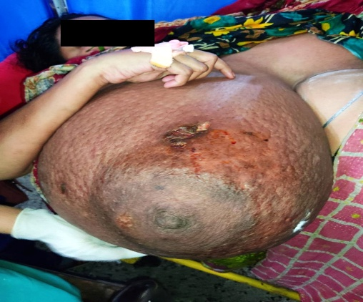
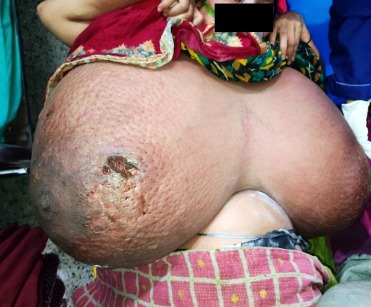

Figure 1. Gestational Gigantomastia at the time of admission
Upon examination, both breasts measured 150 cm (right) and 142 cm (left) at their widest points through the areola, weighing approximately 15 kg and 13 kg, respectively. The skin was tense with engorged veins, deviated nipple-areola complexes, and multiple infected ulcers. Accessory breast tissue was noted in the right axilla. USG of both breasts revealed bilateral massive enlargement of both breasts with diffuse oedematous parenchyma and duct ectasia with bilateral accessory breast tissue (Figure 2).

B
A
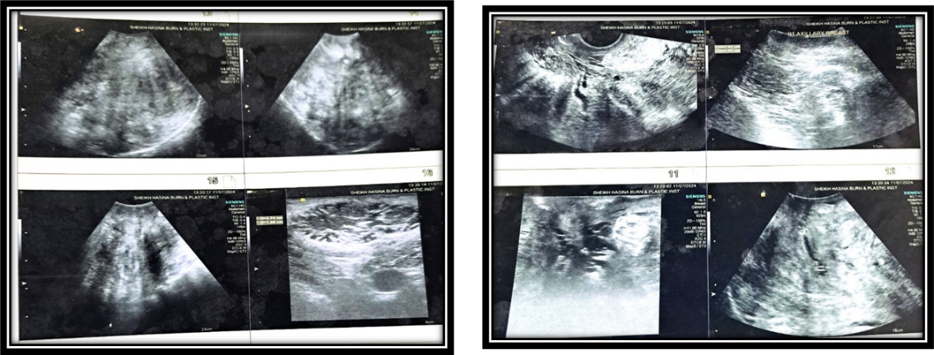

Figure 2. Ultrasonogram of both breasts A-Left B-Right
MRI of the chest and breast revealed bilateral massive enlargement of both breasts with bilateral accessory breast tissue. Histopathology report from core biopsy of both breasts suggested a proliferative breast lesion without atypia, fibrocystic change. Hormonal assay revealed hypothyroidism; otherwise normal.
After consultation with Obstetrics and Gynaecology, a successful caesarian section was performed, resulting in the delivery of a healthy baby. Then patient was transferred to the Intensive Care Unit and kept on mechanical ventilation because of respiratory distress and low oxygen saturation. After 7 days, her condition improved, and she was extubated and transferred to the surgery ward. A multidisciplinary team (General Surgery, Plastic Surgery, Obstetrics, Endocrinology) meeting was arranged and decision was made to treat with cabergoline. The patient was treated with cabergoline daily for 1 month after the delivery of the baby. Respiratory distress resolved along with the decreasing size of both breasts to 110 cm (right) and 96 cm (left) (Figure 3).

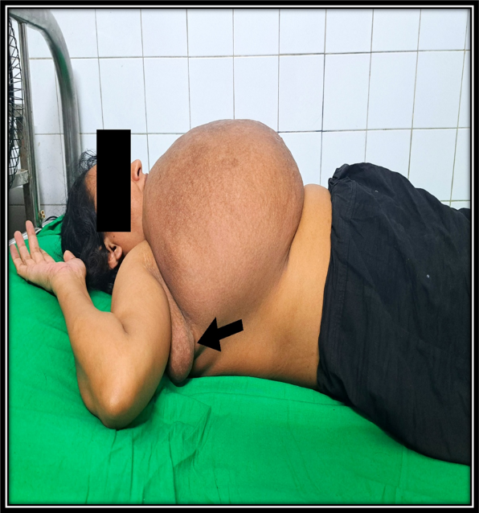
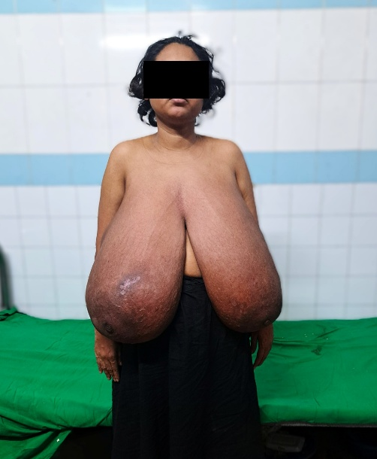
B
A

Figure 3. Gestational gigantomastia after 3 weeks of
A- Anterior view
B- Lateral view with axillary breast (arrow marked)

Patient was discharged with advice for follow-up with a plan for reduction mammoplasty. After 3 months, the patient returned for follow-up but refused surgery. On examination, the breast volume was reduced, but the skin remained loose and lax (Figure 4).


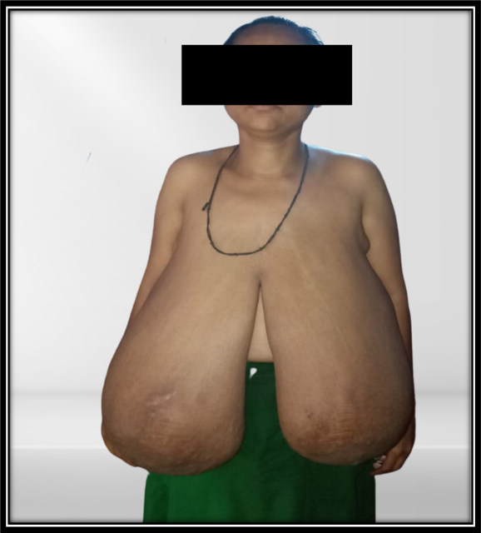
B
A

Figure 4. Gestational gigantomastia after 3 months on medication

A- Anterior view; B- Lateral view

Discussion

The etiology and pathogenesis of gestational gigantomastia (GG) are not fully understood, but it is believed to be triggered by placental hormones.⁵ Excessive breast enlargement typically occurs during the first trimester, when gonadotropin levels are at their peak. A prior history of GG increased the risk for the condition in subsequent pregnancies.⁶ There are also reported cases of penicillamine-induced breast gigantism with subsequent treatment with danazol.⁷ Cases of gigantomastia occurring despite normal hormone profiles may be attributed to heightened hormonal sensitivity at the target tissue level.⁸ Agarwal et al. (2002) reported a 24-year-old gravida 2, who presented at 19 weeks’ gestation with bilateral breast hypertrophy, with prolactin and other laboratory investigations within normal ranges.⁹ They proposed that increased estrogen receptor responsiveness to prolactin could explain the observed hypertrophy and enlargement. Enhanced receptor sensitivity has also been suggested as a mechanism for unilateral gigantomastia. Management is individualized and varies from conservative approaches to medical and surgical intervention.¹⁰
Bromocriptine is the most commonly used medical therapy and may lead to partial regression or stabilization of breast hypertrophy. However, its effects are inconsistent, typically temporary, and rarely result in a return to normal breast volume.^{11,12} Hedberg et al. reported a case in which bromocriptine effectively prevented the need for surgical intervention in a patient with normal hormone levels.¹³ Kullander¹⁴ reported mammary growth arrest with 2 Br-alpha ergocryptine, another prolactin secretion inhibitor, in a patient with nonpathological circulating prolactin levels. Hydrochlorothiazide has been reported to provide a temporary reduction in breast swelling.¹⁵ In contrast, furosemide showed no clinical benefit as well as hydrocortisone was ineffective¹⁶, whereas prednisone may have offered modest improvement in some cases.^{,17} The most used surgical options for gestational gigantomastia are reduction mammoplasty and bilateral mastectomy with delayed reconstruction. Recurrence has been reported in patients who had breast reduction and later became pregnant again.¹⁸ Mastectomy during pregnancy should be reserved for cases of massive spontaneous haemorrhage.¹⁹ El Bochdadly recommends simple mastectomy with immediate reimplantation of the nipple–areola complex as the optimal surgical approach for complicated gigantomastia.²⁰ Bilateral mastectomy with delayed reconstruction is associated with a comparatively lower recurrence risk in future pregnancies.^{21,22}
In our case, spontaneous postpartum regression of the marked breast enlargement occurred. Reduction mammoplasty was not feasible due to the extreme bilateral hypertrophy and associated life-threatening complications. Severe complication including ulceration was also present, which progressed to sepsis. As the patient was in a term pregnancy, we went for termination of pregnancy before any surgical intervention. After termination, the patient’s condition improved, and we started on a dopamine agonist such as cabergoline. In GG, medical treatment with cabergoline may be used initially as an alternative to surgery.²³

Conclusion

Gestational gigantomastia is a rare but potentially life-threatening condition that requires early recognition and timely intervention. Further studies should be conducted to identify the pathophysiology and develop a guideline regarding management of gestational gigantomastia.

Patient consent: The patient provided written informed consent to publish her case for academic purposes.

Ethical Approval:

As per international standards or university standards written ethical approval has been collected and preserved by the author(s).

COMPETING INTERESTS DISCLAIMER:
Authors have declared that they have no known competing financial interests OR non-financial interests OR personal relationships that could have appeared to influence the work reported in this paper.

Disclaimer (Artificial intelligence)

Author(s) hereby declare that NO generative AI technologies such as Large Language Models (ChatGPT, COPILOT, etc.) and text-to-image generators have been used during the writing or editing of this manuscript.

References
- Dancey A, Khan M, Dawson J, Peart F. Gigantomastia--a classification and review of the literature. J Plast Reconstr Aesthet Surg. 2008;61(5):493-502. doi: 10.1016/j.bjps.2007.10.041. Epub 2007 Nov 28. PMID: 18054304.
- Lewison EF, Jones GS, Trimble FH, da Lima LC. Gigantomastia complicating pregnancy. Surg Gynecol Obstet. 1960 Feb;110:215-23. PMID: 14416563.4. Shakya D GTALPH. Gestational gigantomastia: A rarity. nt J Adv Integr Med Sci. 2016; 1: 13-4.
- Mangla M, Singla D. Gestational Gigantomastia: A Systematic Review of Case Reports. J Midlife Health. 2017 ;8(1):840-44. doi: 10.4103/jmh.JMH_92_16. PMID: 28458479

- Ezem BU, Osuagwu CC, Opara KA. Gestational gigantomastia with complete resolution in a Nigerian woman. BMJ Case Rep. 2011 Feb 15;2011:bcr0120102632. doi: 10.1136/bcr. 01.2010.2632. PMID: 22707463; PMCID: PMC3062818
- Rooney PJ. and Cleland J., Successful treatment of D-penicillamine-induced breast gigantism with danazol, British Medical Journal. (1981) 282, no. 6276, 1627 1627, https://doi.org/10.1136/bmj.282.6276.1627-e.
- Taylor PJ., Cumming DC., and Corenblum B., Successful treatment of D-penicillamine-induced breast gigantism with danazol, The British Medical Journal. (1981) 282, no. 6261, 362–363.
- Wølner-Hanssen P., Palmer B., Sjöberg N., and Åstedt B., Gigantomastia, Acta Obstetricia et Gynecologica Scandinavica. (1981) 60, no. 5, 525–527.
- Sharma K., Nigam S., Khurana N., and Chaturvedi KU., Unilateral gestational macromastia—a rare disorder, Malaysian Journal of Pathology. (2004) 26, no. 2, 125–128.

- Agarwal N, Kriplani A, Gupta A, Bhatla N. Management of gigantomastia complicating pregnancy. A case report. J Reprod Med. 2002 Oct;47(10):871-4. PMID: 12418075.

- Rezai S., Nakagawa JT., Tedesco J., Chadee A., Gottimukkala S., Mercado R., Henderson CE., Gestational gigantomastia complicating pregnancy: a case report and review of the literature, Case Rep. Obstet. Gynecol (2015).100-104
- Cheung KL, Alagaratnam TT. Pregnancy-related gigantomastia. Case report. Archives of gynecology and obstetrics. 1997 Jan;259(2):87-9.
- Lafreniere R, Temple W, Ketcham A. Gestational macromastia. The American journal of surgery. 1984 Sep 1;148(3):413-8.
- Hedberg K, Karlsson K, Lindstedt G. Gigantomastia during pregnancy: effect of a dopamine agonist. American Journal of Obstetrics and Gynecology. 1979 Apr 15;133(8):928-31.
- Kullander S. Effect of 2 br-alpha-ergocryptin (CB 154) on serum prolactin and the clinical picture in a case of progressive gigantomastia in pregnancy. InAnnales Chirurgiae et Gynaecologiae 1976 Jan 1 (Vol. 65, No. 4, pp. 227-233).
- Moss WM. Gigantomastia with pregnancy: A case report with review of the literature. Archives of Surgery. 1968 Jan 1;96(1):27-32.
- Nolan JJ. Gigantomastia Report of a Case. Obstetrics & Gynecology. 1962 Apr 1;19(4):526-9.
- Propper DJ, Reid DM, Stankler L, Eastmond CJ. Breast vasculitis in association with breast gigantism in a pregnant patient with systemic lupus erythematosus. Annals of the rheumatic diseases. 1991 Aug 1;50(8):577-8.
- Vidaeff AC, Ross PJ, Livingston CK, Parks DH. Gigantomastia complicating mirror syndrome in pregnancy. Obstetrics & Gynecology. 2003 May 1;101(5 Part 2):1139-42.
- Wolf Y, Pauzner D, Groutz A, Walman I, David MP. Gigantomastia complicating pregnancy: case report and review of the literature. Acta obstetricia et gynecologica Scandinavica. 1995 Jan 1;74(2):159-63.
- El Boghdadly S, Pitkanen J, Hassonah M, Al Saghier M. Emergency mastectomy in gigantomastia of pregnancy: a case report and literature review. Annals of Saudi Medicine. 1997 Mar;17(2):220-2
- Swelstad MR, Swelstad BB, Rao VK, Gutowski KA. Management of gestational gigantomastia. Plast Reconstr Surg. 2006 Sep 15;118(4):840-848.
- Dellal FD, Ozdemir D, Aydin C, Kaya G, Ersoy R, Cakir B. Gigantomastia and Macroprolactinemia Responding to Cabergoline Treatment: A Case Report and Minireview of the Literature. Case Rep Endocrinol. 2016;2016:3576024. doi: 10.1155/2016/3576024. Epub 2016 Apr 18. PMID: 27195157
- Fofung SK, Malik JH, Fofung WM, Wabwire B. Gestational Gigantomastia: A Century of Evidence with a New Case. Plast Reconstr Surg Glob Open. 2025 Nov 24;13(11):e7290. doi: 10.1097/GOX.0000000000007290. PMID: 41293672.

