Endoscopic Retrieval of Impacted Ingested Cow Skin-Kpomo in an Adolescent Female: A Case Report Highlighting a Cultural Dietary Risk Factor

Abstract
Background: Oesophageal food bolus impaction is a gastrointestinal emergency requiring prompt endoscopic intervention. While meat bolus impaction is well documented in Western literature, regional dietary practices, such as ingestion of cow skin (kpomo), may predispose to impaction in adolescents.
Case Presentation: A 16-year-old female presented with sudden retrosternal chest pain, vomiting, and dyspnoea after swallowing unchewed kpomo. Initial management included intravenous proton pump inhibitor therapy and failed nasogastric tube insertion, suggesting complete oesophageal obstruction which is a red flag sign. Upper gastrointestinal endoscopy revealed distal oesophageal impaction. Initial retrieval with a basket was unsuccessful; successful extraction was achieved using a polypectomy snare following distal manipulation. Post-procedure recovery was uneventful.
Conclusion: This case highlights kpomo as a culturally specific risk factor for oesophageal impaction and underscores the importance of timely endoscopic management to prevent complications.

Keywords
Cow skin (kpomo); Oesophageal food bolus impaction; Adolescent; Endoscopy; West Africa; Foreign body removal

Background
Oesophageal foreign body impaction is a common gastrointestinal emergency in adolescents and adults, most often due to food bolus obstruction (ASGE, 2011). While Western literature frequently reports meat impaction, dietary habits are regionally specific and influence the type of foreign body encountered.
Cow skin, locally called kpomo, is a widely consumed delicacy in West Africa. Despite prolonged cooking, kpomo retains a dense, elastic, rubbery texture due to its high collagen content. Swallowing kpomo without adequate mastication increases the risk of distal oesophageal impaction, as was observed in this present case (figure 4). The distal oesophagus is particularly vulnerable due to physiological narrowing at the lower esophageal sphincter.
Delay in recognition and intervention may lead to mucosal injury, perforation, mediastinitis, aspiration, and sepsis. Despite the prevalence of kpomo consumption, there is limited documentation of its role in oesophageal impaction, making this case a valuable contribution to region-specific clinical literature.

Case Presentation
History: Miss D.F., a 16-year-old female student, presented with a 1-day history of sudden-onset chest pain. The pain was sharp, constant, mid-sternal, worsened by swallowing and talking, and scored 8/10 in severity. She reported swallowing kpomo(cow skin) without adequate chewing.
Associated symptoms included vomiting and difficulty breathing. Initial management at the school clinic involved intravenous omeprazole and a failed nasogastric tube insertion, suggesting complete oesophageal obstruction which is a red flag sign”. Persistent symptoms prompted referral to a tertiary facility.

Examination Findings: On admission and review; She was very conscious, and in painful distress and restless. She was not pale, anicteric, acyanosed, and no peripheral edema was noted. Her pulse rate was 79 bpm, Blood Pressure of 103/60 mmHg was recorded, and Respiratory rate of 24 cycles per minute recorded. Her chest was clinically clear. The abdomen was full and moves with respiration, soft, with mild epigastric and umbilical tenderness, there were no organomegaly.

Investigations: HIV: Seronegative, Hepatitis B & C: Non-reactive, VDRL: Non-reactive, haemoglobin level is 14g/dl.
Diagnosis: Suspected distal Oesophageal foreign body impaction.
Management Plan: commence resuscitation and then schedule patient for emergency endoscopic foreign body removal.

Endoscopic Procedure

Pre-Procedure Preparation: Patient assessed and declared fit by anesthesiologist. Under mild conscious sedation, Oxygen administration via nasal prongs was commenced with continuous monitoring of vital signs, a Bite guard applied in the mouth after the administration of 10% topical lidocaine sprayed to the posterior pharynx for mucosal anaesthesia.

Endoscopic Findings and Intervention
Following gentle insertion of a flexible upper GI endoscope which revealed distal oesophageal impaction, by a foreign body-kpomo. Initial retrieval using an endoscopic retrieval basket failed, which was likely due to the its’ slippery nature as it was coated with saliva and mucous as well as the size and shape of the cow skin(kpomo). The foreign body was gently manipulated distally and successfully grasped with a polypectomy snare, then extracted orally without complications (Figures 1-4). There was an instant retrieve of distress by the patient. She was subsequently observed for full recovery and later transferred to the ward for further observation.
Post-Procedure Care: she was placed on nil per os, intravenous PPI, antibiotics, analgesics and fluid. Patient resumed oral intake after 48hours without complications and later discharged in stable clinical state after counselling on proper dietary habit and to chew well before attempting to swallow.

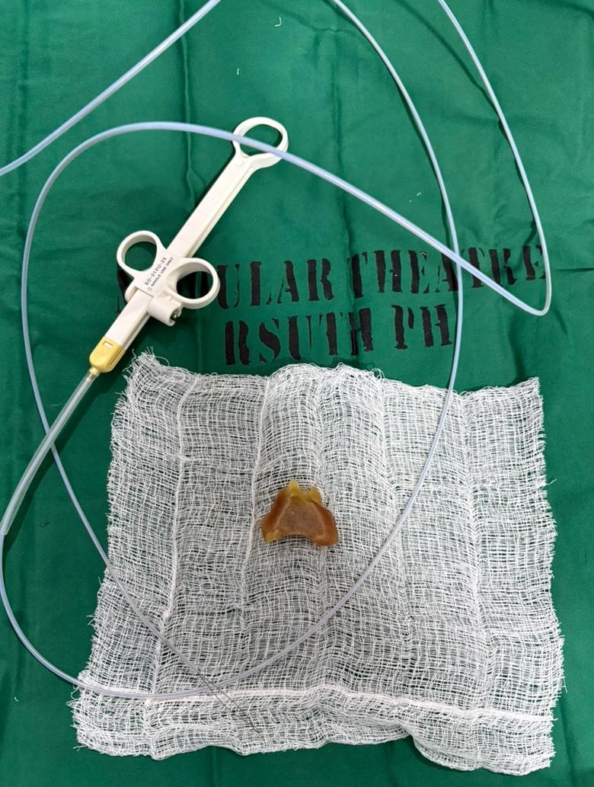
Fig 1. Retrieved Cow skin (Kpomo) and polypectomy snare.

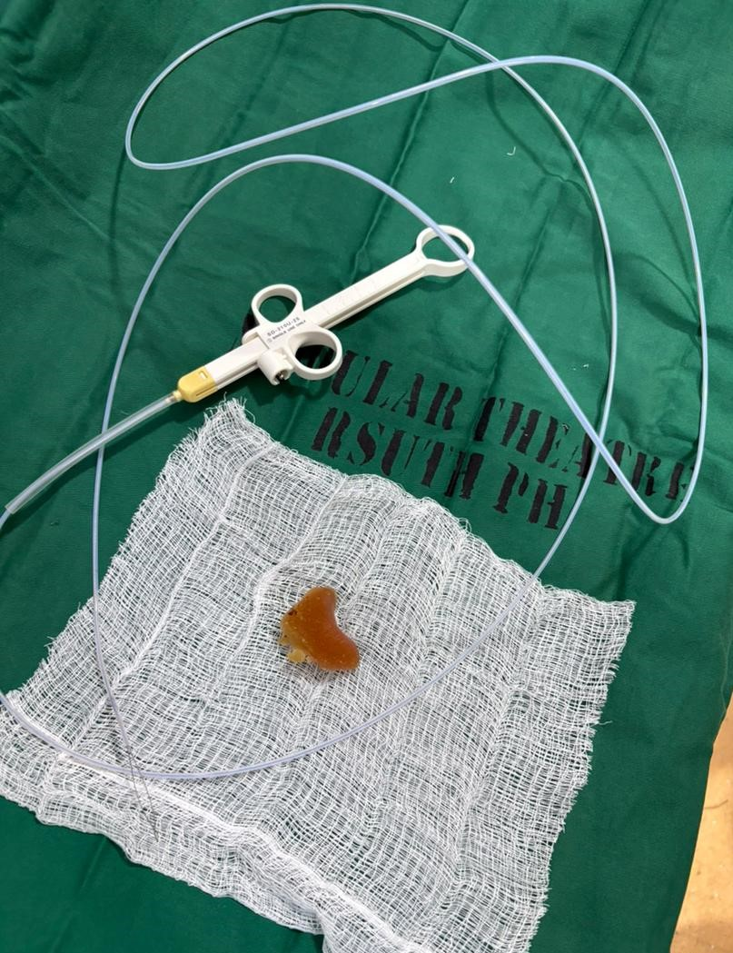
Fig 2. Retrieved Cow skin (Kpomo) and polypectomy snare.

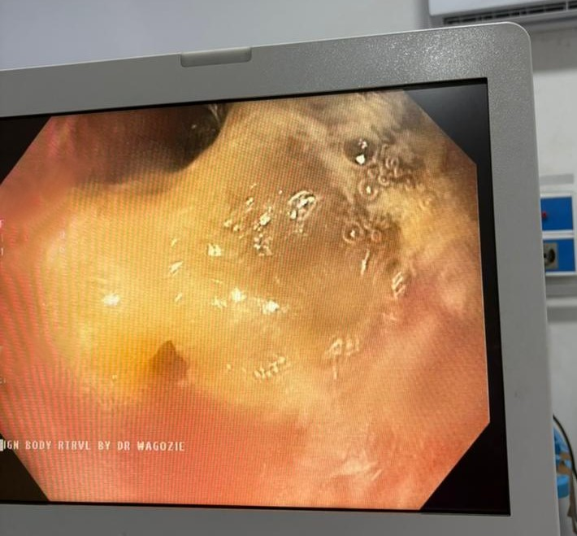
Fig 3. Impacted Cow skin(Kpomo) in the Distal Oesophagus
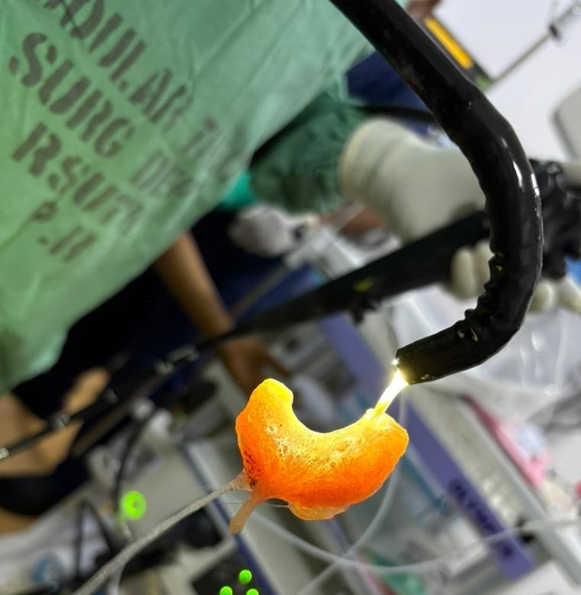
Fig 4. Retrieved Foreign body at the tip of the scope held with polypectomy snare

Discussion
Oesophageal foreign body impaction is a recognized gastrointestinal emergency requiring prompt evaluation and intervention. Food bolus impaction accounts for the majority of oesophageal foreign bodies in adolescents and adults, particularly following ingestion of poorly chewed meat products (ASGE, 2011; ESGE, 2016).
A similar case reported by Longstreth and Longstreth (2009) described a 15-year-old female who presented with sudden retrosternal chest pain and vomiting following ingestion of inadequately chewed meat. Endoscopy revealed a food bolus impacted in the distal oesophagus, which required snare retrieval after failed basket extraction. The clinical pattern closely mirrors that of the present case.
Timing and Indications for Endoscopy: According to ASGE guidelines, oesophageal food impaction without complete obstruction should undergo urgent endoscopic removal within 24 hours to reduce the risk of complications. In cases of complete obstruction or inability to handle secretions, emergent endoscopy is recommended (ASGE, 2011). Similarly, ESGE recommends endoscopic intervention within 24 hours for food bolus impaction and within 6 hours if there are signs of complete obstruction or respiratory compromise (ESGE, 2016). Early referral and timely intervention in this patient were in keeping with international best practice standards.
Technique of Retrieval: Evidence supports a stepwise approach to foreign body extraction. Retrieval baskets are often first-line instruments; however, when impaction is firm, alternative tools such as polypectomy snares or grasping forceps may be more effective (Birk et al., 2016). Distal manipulation before extraction, as performed in this case, is recommended in selected cases to reduce mucosal trauma and avoid perforation. Forceful proximal traction against a tightly embedded bolus increases the risk of oesophageal tear.
Antibiotic Use and Post-Procedural Care: Routine antibiotic prophylaxis is not universally required for uncomplicated food bolus removal. However, antibiotics may be indicated where there is concern for mucosal injury, prolonged impaction, or high risk of perforation (ASGE, 2011). In this case, intravenous ceftriaxone was administered prophylactically due to the duration of impaction, failed prior manipulation attempt (NG tube insertion), and need for mechanical manipulation during retrieval. Proton pump inhibitors post-extraction were used to promote mucosal healing and reduce acid-mediated injury.
Cultural and Regional Considerations: While Western literature frequently reports steak and meat bolus impaction, this case highlights cow skin (kpomo) as a culturally relevant risk factor in West African settings. Its dense, elastic consistency increases the risk of distal oesophageal lodging when swallowed without adequate mastication. This case therefore contributes region-specific insight into dietary risk factors for food bolus obstruction.
Complications and Prognosis: Untreated oesophageal impaction may lead to oesophageal perforation, mediastinitis, aspiration, sepsis, and stricture formation. The reported perforation rate for impacted oesophageal foreign bodies ranges between 1–4%, increasing with delayed intervention (ESGE, 2016). Prompt endoscopic retrieval in this patient resulted in an uneventful recovery, consistent with favorable outcomes reported in early-managed cases and also in line with best global practices.

Conclusion
Severe retrosternal chest pain in adolescents following ingestion of poorly chewed food should raise suspicion for Oesophageal impaction with foreign body. Timely referral, adherence to guideline-based endoscopic management, and structured post-procedure care result in excellent outcomes. Public education on safe consumption of high-risk foods such as kpomo and proper chewing of food before swallowing may reduce incidence.

Clinical learning Points
- Cultural dietary practices matter – Foods like Cow skin (kpomo), with dense and elastic textures, can cause Oesophageal impaction if swallowed without adequate chewing.
- High index of suspicion –Adolescents, Children and Adults, presenting with sudden retrosternal pain, vomiting, or dysphagia after recent ingestion of difficult-to-chew food should be evaluated promptly for oesophageal obstruction following foreign body impaction.
- Endoscopy is first-line management – Urgent upper GI endoscopy within 24 hours is recommended.
- Stepwise retrieval minimizes risk –Gentle distal manipulation prior to extraction reduces the risk of mucosal trauma and esophageal perforation.
- Post-procedure care is essential.

CONFLICT OF INTEREST
There is no conflict of interest.
This report is sorely sponsored by the authors

Disclaimer (Artificial intelligence)

Author(s) hereby declare that NO generative AI technologies such as Large Language Models (ChatGPT, COPILOT, etc.) and text-to-image generators have been used during the writing or editing of this manuscript.

References
- ASGE Standards of Practice Committee. Management of ingested foreign bodies and food impactions. Gastrointest Endosc. 2011;73:1085–1091.
- Birk M, Bauerfeind P, Deprez PH, et al. Removal of foreign bodies in the upper gastrointestinal tract. ESGE Guideline. Endoscopy. 2016;48:489–496.
- Longstreth GF, Longstreth KJ. Oesophageal food bolus impaction: epidemiology and management. Gastroenterology Review. 2009;5:12–18.

