Case report
THERAPEUTIC OUTCOMES OF UNDERWATER ULTRASOUND THERAPY FOR DE QUERVAIN’S TENOSYNOVITIS: A CASE REPORT

Abstract:
De Quervain’s tenosynovitis is a common inflammatory condition of the wrist and thumb that causes pain and functional limitation. Therapeutic ultrasound is frequently used in conservative management; however, some patients are unable to tolerate conventional contact ultrasound due to localized hypersensitivity. Underwater ultrasound therapy may offer an alternative method of ultrasound. 42-year-old male software professional with a two-month history of radial-sided thumb pain and difficulty gripping objects presented with features consistent with De Quervain’s tenosynovitis. Previous conservative treatments provided only temporary relief, and the patient was unable to tolerate contact ultrasound due to pain hypersensitivity. Underwater ultrasound therapy was administered using a 1 MHz frequency at 1.0 W/cm² in continuous mode for 10 minutes per session for a total of 10 sessions. Pain intensity measured using the Numerical Pain Rating Scale (NPRS) reduced from 6 at baseline to 3 by Day 10 and reached 0 by Day 30. Functional outcomes assessed using the Patient-Rated Wrist Evaluation (PRWE) showed marked improvement. PRWE pain scores reduced from 30 at baseline to 7 by Day 15, and 0 by Day 30. Functional scores for specific activities improved from 28 to 0, and usual activity scores improved from 21 to 0 by Day 30, with sustained recovery at follow-up. This case report indicates that underwater ultrasound therapy may be a safe and well-tolerated physiotherapy intervention for achieving significant pain relief and functional recovery in patients with De Quervain’s tenosynovitis who are hypersensitive to conventional ultrasound applications.
Keywords: De Quervain’s tenosynovitis, Underwater ultrasound, Patient rated wrist evaluation, Physiotherapy, Hand function, Case report.

- Introduction
Tenosynovitis is a common disorder of the hand and wrist, frequently affecting workers and athletes due to repetitive and forceful hand activities (Fedorczyk, 2012). Among hand and wrist tenosynovitis conditions, De Quervain’s disease, Dupuytren’s disease, and trigger finger are reported as the most prevalent (Ferrara, et al., 2020). De Quervain’s tenosynovitis is a painful inflammatory condition involving the radial side of the wrist, specifically at the base of the thumb (Awan et al., 2017).
De Quervain’s tenosynovitis primarily affects the tendons of the abductor pollicis longus (APL) and extensor pollicis brevis (EPB) within the first dorsal compartment of the wrist (Tabinda and Mahmood, 2015). The condition is commonly described as a stenosing tenosynovitis, characterized by thickening of the extensor retinaculum, which restricts normal tendon gliding and leads to pain, swelling, and functional limitation of the thumb and wrist (Rayan, 2008).
The exact etiology of De Quervain’s tenosynovitis remains unclear and is still debated in the literature. However, several contributing factors have been proposed, including repetitive wrist and thumb movements, biomechanical overload, blunt trauma, anatomical variations, overuse injuries, genetic predisposition, exposure to cold environments, and, in rare cases, infectious causes (Huang et al., 2006).
Management of De Quervain’s tenosynovitis is often challenging and must be individualized based on symptom severity and patient tolerance. Conservative management is widely accepted as the first line of treatment and includes oral non-steroidal anti-inflammatory drugs (NSAIDs), corticosteroid injections, splinting, and physiotherapy interventions (Peters-Veluthamaninal et al., 2009). Physiotherapy programs commonly incorporate therapeutic exercises, mobilization techniques, stretching, and physical modalities to reduce pain and improve function (Hartzell et al., 2012).
Therapeutic ultrasound is a commonly used physical modality in the management of musculoskeletal disorders (Hartzell et al., 2012). It utilizes high-frequency sound waves to promote tissue healing, reduce pain, and improve tissue extensibility. In the treatment of De Quervain’s tenosynovitis, non-thermal or pulsed ultrasound is typically preferred due to its proposed effects on tendon healing and tissue regeneration (Hartzell et al., 2012, Priyanka et al., 2023).
Ultrasound therapy can be delivered using different application techniques (Awan et al., 2017). While the direct contact method is most commonly employed, alternative methods are required when treating anatomically irregular areas with minimal soft tissue coverage, such as the hand and wrist (Király et al., 2017). In such cases, the underwater (water bath) method is recommended, as it allows uniform transmission of ultrasound waves and minimizes discomfort over bony prominences. Additionally, patients who are hypersensitive to pain may tolerate underwater ultrasound better than the conventional contact method (Bagcaci et al., 2023).
Compared to direct contact ultrasound, underwater ultrasound requires relatively higher intensity to achieve comparable tissue effects (Casarotto et al., 2004). Previous studies have demonstrated the effectiveness of underwater ultrasound therapy in conditions such as carpal tunnel syndrome and rheumatoid arthritis of the hand (Bagcaci et al., 2023). However, evidence regarding its application in De Quervain’s tenosynovitis is currently lacking.
To the best of our knowledge, no published studies have reported the effectiveness of underwater pulsed ultrasound therapy in the management of De Quervain’s tenosynovitis. Therefore, this case study aims to describe the clinical outcome of underwater ultrasound therapy on pain reduction and functional improvement in a patient with De Quervain’s tenosynovitis who demonstrated hypersensitivity to conventional ultrasound application.
- Presentation of Case, Discussion
In December 2025, a 42-year-old male presented to the outpatient department of Thulir Physiotherapy and Rehabilitation Centre with complaints of pain over the radial aspect of the thumb and difficulty holding objects. He was a software professional by occupation and reported playing badminton recreationally on weekends.
The patient reported that the pain had begun approximately two months prior to presentation and had gradually progressed in intensity. Initially, he consulted an orthopaedic surgeon and was prescribed oral analgesics for one week, along with advice to avoid sports activity for ten days. After temporary symptom relief, he resumed playing badminton; however, within two days, his pain worsened significantly. A repeat orthopaedic consultation was sought, and radiographic evaluation of the wrist and hand revealed no abnormalities. He was subsequently advised to continue analgesics and undergo physiotherapy.
During his initial physiotherapy sessions elsewhere, therapeutic ultrasound was attempted using the direct contact method. However, the patient experienced severe pain immediately upon probe application over the thumb region and discontinued the treatment. He was advised to have home-based hot water fomentation, which provided temporary symptomatic relief. On a subsequent visit, low-level laser therapy was administered for seven minutes daily over one week, resulting in partial pain reduction. Therapeutic exercises were also prescribed. Despite this, the patient experienced recurrence of pain within two days, leading to confusion and further consultation with another physician.
On the advice of a friend, the patient presented it to our centre for further management. A detailed subjective and objective assessment was conducted by the physiotherapy team. On examination, active and passive range of motion of the thumb was full and comparable to the contralateral side. No visible muscle wasting was observed in the thenar eminence, and muscle strength was graded as 5/5. Palpation revealed localized tenderness (Grade 3) over the radial aspect of the lower thumb, with marked hypersensitivity to touch. There was no associated warmth, swelling, or crepitus. The patient denied any numbness or tingling sensations in the fingers. Finkelstein’s test was positive, supporting a clinical diagnosis of De Quervain’s tenosynovitis.
Following assessment, the patient was provided with detailed education and counselling regarding his condition and treatment plan. He was advised to discontinue pain medications during the physiotherapy intervention period. After a multidisciplinary discussion among the senior physiotherapist and rehabilitation team, it was decided to initiate underwater ultrasound therapy, considering the patient’s hypersensitivity and existing evidence supporting its use in inflammatory hand conditions (Király et al., 2017).
2.1 Therapeutic Intervention
Informed consent was obtained from the patient prior to the beginning of the treatment. A detailed explanation about the treatment was explained well to the patient. Underwater ultrasound therapy was administered with the patient seated comfortably. A water tub containing room-temperature water was placed in front of him, and he was instructed to immerse the affected hand completely. Ultrasound was delivered using a therapeutic ultrasound unit (Electroson 700; Technomed Electronics) at a frequency of 1 MHz and an intensity of 1.0 W/cm² in continuous mode.¹¹ Thse method of application is shown in figure 1. The ultrasound transducer head was held perpendicular to the affected area at a distance of approximately 1–3 cm from the skin surface without direct contact. Each session lasted 10 minutes. A total of 10 treatment sessions were administered over a two-week period, with five sessions per week. No adverse effects were reported during or after treatment.
Figure 1: Method of Underwater Ultrasound therapy application
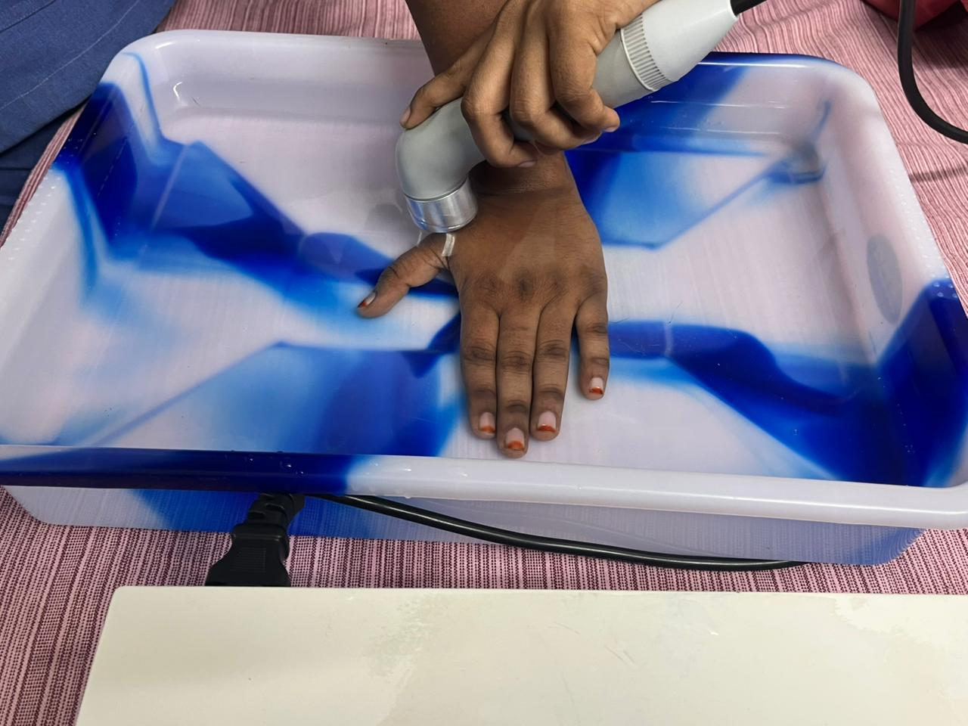
A structured exercise program was implemented alongside and following ultrasound therapy, including thenar muscle group stretching, forearm flexor and extensor stretches, eccentric unweighted and progressively loaded hammer curls, eccentric thumb abduction and extension using Theraband, eccentric wrist flexion and extension with a dumbbell, and eccentric forearm supination and pronation exercises using Theraband (Priyanka et al., 2023)
2.2 Outcomes and Follow-Up
After three treatment sessions, the patient reported approximately 50% reduction in pain and expressed high satisfaction with the intervention. Gradual strengthening and mobility exercises for the thumb and wrist were then introduced, and continuation of therapy was advised. At the completion of ten sessions, the patient reported complete resolution of pain and was able to perform thumb and wrist movements without discomfort.
In addition to clinical management, ergonomic assessment of the patient’s workstation was conducted, and appropriate modifications were recommended. His badminton racquet was evaluated, and grip modifications were made to reduce strain on the thumb. Sport-specific retraining using the modified racquet was carried out under supervision at the center.
The total duration of management was four weeks. Follow-up assessments were conducted on 0, 15, 30, 45, and 60 days of post-intervention. The patient remained asymptomatic at all follow-up visits, with no recurrence of pain or functional limitation.
2.3 Outcome Measures and Analysis
Pain intensity was assessed using the Numerical Pain Rating Scale (NPRS), and functional status was evaluated using the Patient-Rated Wrist Evaluation (PRWE). Outcome measures were recorded by a blinded physiotherapist at baseline (Week 0), 2nd week, and the follow-up. Descriptive statistics were used to summarize the findings. Continuous variables were expressed as mean as appropriate.
- Result
Pain and functional outcomes demonstrated progressive improvement following underwater ultrasound therapy. At baseline (Day 0), the Numerical Pain Rating Scale (NPRS) score was 6, which reduced to 3 by Day 10 and further decreased to 1 by Day 15. Complete pain resolution (NPRS = 0) was achieved by Day 30 and was maintained at follow-up assessments on Days 45 and 60.
The Patient-Rated Wrist Evaluation (PRWE) pain score decreased from 30 at baseline to 20 on Day 10 and 7 on Day 15, reaching 0 by Day 30 and remaining unchanged at subsequent follow-ups. Functional scores also showed consistent improvement. The PRWE functional score for specific activities improved from 28 at baseline to 20 on Day 10 and 10 on Day 15, with complete functional recovery by Day 30. Similarly, the functional score for usual activities improved from 21 at baseline to 14 on Day 10 and 5 on Day 15, reaching 0 by Day 30. All improvements were sustained through Day 60 without symptom recurrence. The improvement in PRWE score exceeded the Minimal Clinically Important Difference (MCID) of approximately 11–14 points, indicating a clinically meaningful recovery.
Table I : Outcome measures mean evaluation
Outcomes | Pretest  Day 0 | Post test 1  Day 10 | Post test 2  Day 15 | Post test 3  Day 30 | Post test 4  Day 45 | Post test 5  Day 60
Numerical Pain Rating Scale | 6 | 3 | 1 | 0 | 0 | 0
Patient Related Wrist Evaluation  Pain Score | 30 | 20 | 7 | 2 | 0 | 0
Functional Score (Specific Activity) | 28 | 20 | 10 | 3 | 0 | 0
Functional Score (Usual Activity) | 21 | 14 | 5 | 2 | 0 | 0

- Discussion
This case report described the clinical outcome of underwater ultrasound therapy in a patient with De Quervain’s tenosynovitis who demonstrated hypersensitivity to conventional contact ultrasound applications. The underwater method was selected to enable uniform transmission of acoustic energy to an anatomically irregular and sensitive region while eliminating direct mechanical pressure over the inflamed tendon sheath (Király et al., 2017). This approach was particularly suitable for the wrist and thumb region, where superficial tendons and bony prominences often limit patient tolerance to direct ultrasound application (Bagcaci et al., 2023).
The observed reduction in pain and improvement in functional ability following underwater ultrasound therapy may be attributed to the combined mechanical and thermal effects of therapeutic ultrasound (Casarotto et al., 2004) These effects are believed to enhance local blood flow, reduce inflammatory mediators, and facilitate collagen extensibility within the thickened tendon sheath, which are key pathological features in De Quervain’s tenosynovitis. Previous literature has suggested that ultrasound therapy may assist in reducing fibrosis and improving tendon gliding in chronic inflammatory conditions (Guillén-Astete et al., 2022).
In addition, ultrasound waves transmitted through a water medium may produce a gentle micromechanical or “micro-massage” effect, which has been proposed to modulate pain through neurophysiological mechanisms, including stimulation of mechanoreceptors and activation of endogenous pain inhibitory pathways (Guillén-Astete et al., 2022, Mustafa et al., 2022) While such mechanisms have been reported in other musculoskeletal conditions, their specific role in De Quervain’s tenosynovitis requires further investigation.
The use of water as a coupling medium offers several advantages over direct contact ultrasound, particularly in patients with localized hypersensitivity. Water allows effective transmission of ultrasound energy while minimizing discomfort caused by probe pressure on inflamed tissues (Bagcaci et al., 2023). This may improve patient tolerance, adherence to treatment, and overall therapeutic experience. However, it is important to note that underwater ultrasound typically requires higher intensity settings compared to contact mode to achieve comparable tissue effects, and careful monitoring is necessary to avoid excessive thermal buildup (Király et al., 2017, Bagcaci et al., 2023).
- Conclusion
Underwater ultrasound therapy was a safe and well-tolerated intervention that resulted in meaningful pain reduction and functional improvement in a patient with De Quervain’s tenosynovitis who was hypersensitive to conventional ultrasound. This modality may be considered as an alternative or adjunct physiotherapy option in selected cases.
6 Limitations
This report describes a single patient, which limits generalizability. Imaging confirmation was not performed, and long-term outcomes beyond two months were not evaluated. In addition, concurrent interventions such as exercises and ergonomic modifications may have contributed to the observed improvements, making it difficult to isolate the effects of underwater ultrasound therapy. Despite these limitations, this case highlights the potential role of underwater ultrasound therapy as a safe and well-tolerated alternative modality for patients with De Quervain’s tenosynovitis who are unable to tolerate conventional contact ultrasound. Further controlled studies with larger sample sizes are required to establish optimal treatment parameters and to determine the clinical effectiveness of underwater ultrasound in this population.

- Conflict of Interest
The authors declare that there are no conflicts of interest related to this case report.
- Ethical Approval
Ethical approval was not required for this case report as it describes the clinical management of a single patient using standard physiotherapy interventions provided as part of routine clinical care. No experimental procedures or deviations from established treatment protocols were performed. Written informed consent was obtained from the patient for participation and for publication of clinical details.
Disclaimer (Artificial intelligence)
Author(s) hereby declare that NO generative AI technologies such as Large Language Models (ChatGPT, COPILOT, etc.) and text-to-image generators have been used during the writing or editing of this manuscript.

References
- Awan, W. A., Babur, M. N., & Masood, T. (2017). Effectiveness of therapeutic ultrasound with or without thumb spica splint in the management of De Quervain's disease. Journal of Back and Musculoskeletal Rehabilitation, 30(4), 691–697. https://doi.org/10.3233/BMR-160591
- Bagcaci, S., Yilmaz, R., & Sahin, N. (2023). Efficiency of therapeutic underwater ultrasound therapy in mild-to-moderate carpal tunnel syndrome: A randomized sham-controlled study. Turkish Journal of Physical Medicine and Rehabilitation, 69(3), 366–376. https://doi.org/10.5606/tftrd.2023.12467
- Casarotto, R. A., Adamowski, J. C., Fallopa, F., & Bacanelli, F. (2004). Coupling agents in therapeutic ultrasound: Acoustic and thermal behavior. Archives of Physical Medicine and Rehabilitation, 85(1), 162–165. https://doi.org/10.1016/S0003-9993(03)00293-4
- Fedorczyk, J. M. (2012). Tendinopathies of the elbow, wrist, and hand: Histopathology and clinical considerations. Journal of Hand Therapy, 25(2), 191–200. https://doi.org/10.1016/j.jht.2011.12.001
- Ferrara, P. E., Codazza, S., Cerulli, S., Maccauro, G., Ferriero, G., & Ronconi, G. (2020). Physical modalities for the conservative treatment of wrist and hand's tenosynovitis: A systematic review. Seminars in Arthritis and Rheumatism, 50(6), 1280–1290. https://doi.org/10.1016/j.semarthrit.2020.08.006.
- Guillén-Astete, C. A., García-López, H., Zurita-Prada, P. A., Urrego-Laurín, C., Kanaffo, S., Terán-Tinedo, M. A., & García-Montes, N. (2022). Ultrasound changes following controlled mechanical stress in synovial tissue in the hands of healthy individuals. ARP Rheumatology, 1(2), 117–121.
- Hartzell, T. L., Rubinstein, R., & Herman, M. (2012). Therapeutic modalities—An updated review for the hand surgeon. The Journal of Hand Surgery, 37(3), 597–621. doi: 10.1016/j.jhsa.2011.12.042.
- Huang, T. H., Feng, C. K., Gung, Y. W., Tsai, M. W., Chen, C. S., & Liu, C. L. (2006). Optimization design of thumb spica splint using finite element method. Medical and Biological Engineering and Computing, 44(12), 1105–1111. doi: 10.1007/s11517-006-0131-4.
- Király, M., Varga, Z., Szanyó, F., Kiss, R., Hodosi, K., & Bender, T. (2017). Effects of underwater ultrasound therapy on pain, inflammation, hand function and quality of life in patients with rheumatoid arthritis: A randomized controlled trial. Brazilian Journal of Physical Therapy, 21(3), 199–205. https://doi.org/10.1016/j.bjpt.2017.04.002
- Mustafa, M., Khan, M., Hanif, M., Khan, R. R., Rehman, M., Ambreen, H., Mustafa, M., & Arshad, N. (2022). Efficacy of therapeutic ultrasound in De Quervain's tenosynovitis. Pakistan BioMedical Journal, 5, 166–169.https://doi.org/10.54393/pbmj.v5i4.377
- Peters-Veluthamaninal, C., Winters, J. C., Groenier, K. H., & Mayboom-de Jong, B. (2009). Randomized controlled trial of local corticosteroid injections for De Quervain’s tenosynovitis in general practice. BMC Musculoskeletal Disorders, 10, 131. https:// doi: 10.1186/1471-2474-10-131.
- Priyanka, N. H. M., Kavith, K., Usha Nandhini, M., & Franklin, C. V. J. (2023). Effectiveness of ultrasound, massage therapy, kinesio taping and exercises on De Quervain’s tenosynovitis. International Journal of Health Sciences and Research, 13(12), 140–144. https://doi.org/10.52403/ijhsr.20231217
- Rayan, G. M. (2008). Nonoperative treatment of Dupuytren's disease. The Journal of Hand Surgery, 33(7), 1208–1210. doi: 10.1016/j.jhsa.2008.05.027
- Tabinda, H., & Mahmood, F. (2015). De Quervain's tenosynovitis and phonophoresis: A randomized controlled trial in pregnant females. Journal of Orthopaedics, Trauma and Rehabilitation, 19(1), 2–6. https://doi.org/10.1016/j.jotr.2014.04.001

