Tubercular Liver Abscess: A Rare Manifestation of Extrapulmonary Tuberculosis
ABSTRACT
Tubercular liver abscess (TLA) is an uncommon manifestation of extrapulmonary tuberculosis, often misdiagnosed as pyogenic or amoebic abscess. We report the case of a 30-year-old male presenting with right hypochondrial pain, diagnosed with TLA confirmed by CBNAAT positivity in aspirated pus. The patient was successfully managed with percutaneous pigtail drainage and antitubercular therapy (ATT). This case underscores the importance of considering tuberculosis in the differential diagnosis of hepatic abscesses in endemic regions and highlights the role of minimally invasive drainage combined with ATT. The clinical presentation of tubercular liver abscess (TLA) is often nonspecific, with patients typically reporting fever, vague abdominal pain, malaise, and weight loss. On physical examination, hepatomegaly is a frequent finding, whereas jaundice is uncommon and, when present, usually indicates biliary involvement due to extra‑ or intrahepatic obstruction. Importantly, the severity of liver disease does not correlate with the occurrence of jaundice. By recognizing and treating such manifestations early, clinicians can ensure timely recovery and strengthen the collective understanding of this uncommon presentation. This case reminds us that in the battle against tuberculosis, even its rarest shadows must be unmasked, because forewarned is forearmed.
Keywords: Tubercular liver abscess, CBNAAT, pigtail drainage, extrapulmonary tuberculosis, antitubercular therapy
INTRODUCTION
Tuberculosis (TB) is a communicable disease caused by Mycobacterium tuberculosis. While pulmonary involvement is most common, the infection can affect nearly any organ system, manifesting as extrapulmonary TB. Transmission occurs via inhalation of airborne droplets released by individuals with active pulmonary disease during coughing, sneezing, or even speaking. Despite being both preventable and curable with appropriate chemotherapy, TB continues to pose a significant global health burden, particularly in low‑ and middle‑income countries where socioeconomic constraints and limited health system capacity hinder timely diagnosis and effective treatment [1].
Hepatic involvement in Tuberculosis is rare, and an isolated tubercular liver abscess (TLA) is an even rarer entity. Its clinical presentation often mimics pyogenic or amoebic abscess, leading to diagnostic delays [2]. Tubercular liver abscess (TLA), though rare, should be considered in endemic regions where patients present with hepatic abscesses but routine investigations fail to demonstrate amoebic or pyogenic etiology. In such settings, clinical suspicion supported by imaging findings and Microbiological confirmation is essential for accurate diagnosis. We present a case of TLA in a young male, managed successfully with percutaneous drainage and ATT. This case highlights the importance of maintaining TLA in the differential diagnosis of liver abscesses in the Indian context, underscoring both the epidemiological relevance and the need for heightened clinical awareness.
CASE PRESENTATION
Patient Profile:
A 30-year-old male ex-smoker with Occasional alcohol consumption, including wine and beer, approximately 180–200 ml per episode, one to two times per month, for the past five years, non-diabetic, non-hypertensive and no past history of TB or ATT intake, presented with right hypochondrial pain for 6 days. The patient typically experiences pain localized to the right hypochondrium, just beneath the costal margin. The onset is often gradual, developing insidiously, usually described as dull, aching, or pressure‑like sensation. This discomfort radiates to the right shoulder or scapular region sometimes. It is not associated with high fever and chills; however patient experiences malaise and anorexia. The pain tends to be persistent and continuous, occasionally fluctuating in intensity. It is exacerbated by deep inspiration, coughing, or movement, while rest and analgesics provide partial relief. The severity was increased to moderate to severe, with a Numeric Rating Scale (NRS) score of 6–8/10, significantly affecting daily activities and led to medical evaluation. There was no history of projectile vomiting, yellowish discolouration of skin or urine, abdominal swelling, cough, expectoration, chest pain, palpitation, syncope, burning micturition, flank pain, joint pain or rashes.
On clinical examination, he was afebrile, conscious oriented hemodynamic stable, with tenderness in the right hypochondrium and hepatomegaly noted. Other system is unremarkable.
Investigations:
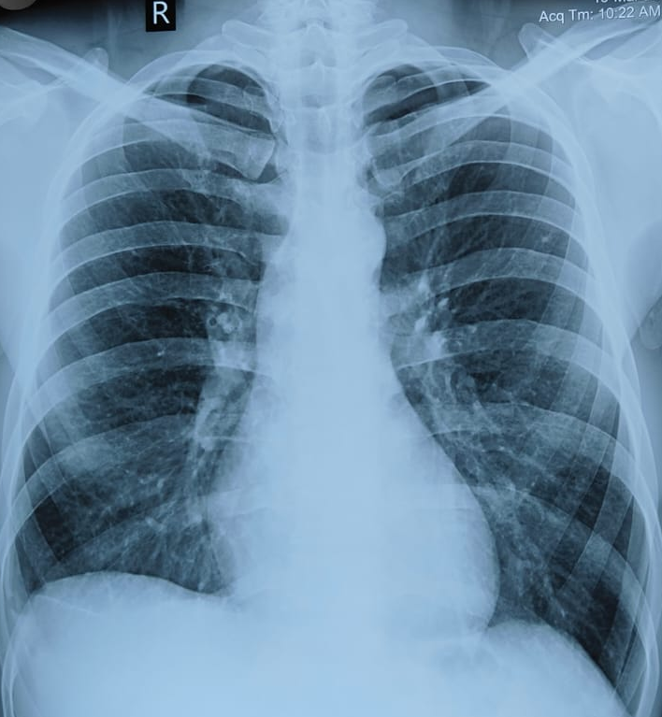
Laboratory findings: Baseline haematological and biochemical parameters were obtained at presentation as shown in Table 1, Hb 11.4 g/dL, TLC 15.1 ×10⁹/L, Na 131.7 mmol/, Normal Renal and hepatic profile. Serological testing for HIV, HBsAg, and HCV was negative. Chest radiograph reveals normal lung parenchyma with no focal area of consolidation or abnormal shadow to suggest pulmonary involvement (Figure 1). Pus aspirated from the hepatic abscess showed no evidence of pyogenic infection. Subsequent CBNAAT (Cepheid, Gene Xpert System) testing of the aspirated material confirmed the presence of Mycobacterium tuberculosis, with the strain found to be rifampicin-sensitive. These findings established the diagnosis of tubercular hepatic abscess and provided the basis for initiating appropriate anti-tubercular therapy in line with National Tuberculosis Elimination Programme (NTEP) guideline.

Figure 1; Posteroanterior chest radiograph demonstrating normal thoracic anatomy. The lungs are well expanded with clear parenchyma and no evidence of focal consolidation

Table 1; Patient Laboratory Profile on admission
Parameters | Patient Values | Reference | Units
Hb | 11.4 | 13.0-17.0 | g/dl
TLC | 15.1 | 4.00-10.00 | thou/mm³
Platelet Count | 308.9 | 150-410 | thou/mm³
RBS | 92 | 70-140 | mg/dl
Urea | 21.7 | 10-38 | mg/dl
Cr. | 0.74 | 0.3-0.7 | mg/dl
Na | 131.7 | 135-145 | mEq/L
K | 4.4 | 3.5-5.5 | mEq/L
Total Bil. | 0.5 | 0.30-1.20 | mg/dl
Direct | 0.2 | <0.3 | mg/dl
Indirect | 0.3 | <1.1 | mg/dl
SGOT | 30.25 | 13-35 | U/L
SGPT | 12.25 | 7-35 | U/L
SAP | 107.8 | 150-380 | U/L
Amylase | 17.2 | 30-118 | U/L
Lipase | 12.00 | <60 | U/L
HIV | Negative
HBsAg | Negative
HCV | Negative

Imaging: In this case, serial ultrasonography was instrumental in monitoring the evolution of a subcapsular hepatic abscess. Progressive reduction in lesion size, organization of the liquefaction cavity, was clearly documented on serial imaging as shown in Table 2.
Table 2: Serial Ultrasonography Findings showing progressive resolution of hepatic abscess
Date | Findings
27/12/2025 | Liver is enlarged in size (~17.6 cms). There is evidence of well-defined heterogenous area of size approximately 4.7 x 4.9 x 3.6 cm (volume ~44cc) devoid of internal vascularity with central area of liquefaction in segment VII of liver in subcapsular region. No dilatation of IHBR seen. Hepatic vessels are normal. Portal vein is patent. Heterogeneous lesion with central liquefaction in segment VII of liver. (Figure 2)
05/01/26 | Enlarged liver, well defined hypoechoic collection suggestive of residual liver abscess of vol ≈ 52.4 cc with multiple air foci within in Segment VII of liver in subcapsular location with drainage tube within collection. Mild right pleural effusion is seen.
12/01/2026 | Residual collection 35 cc with Pig-tail in situ.
17/01/26 | Residual abscess (≈ 34 cc)
02/03/2026 | Hepatomegaly with residual liver abscess (≈17.0 cc) shows significant interval reduction in size as compare to previous scan dated 05/01/2026. (Figure 3)
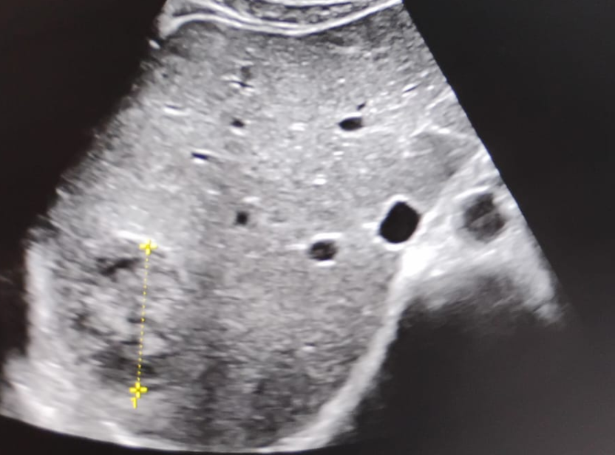
Figure 2; Ultrasonography of the liver (27/12/2025) showing a well-defined, hepatic abscess measuring approximately 4.7 × 4.9 × 3.6 cm (volume ~44 cc) in segment VII, subcapsular region.
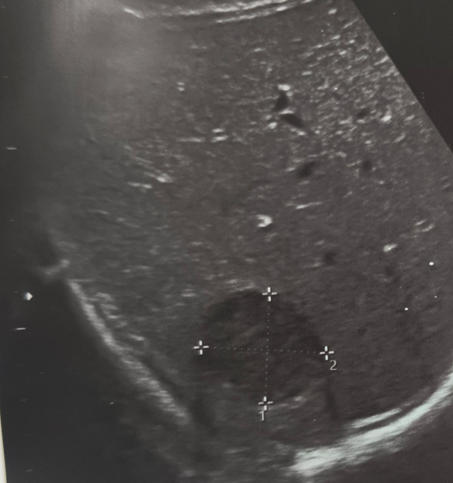
Figure 3: Ultrasound abdomen on 02/03/2026 showing hepatomegaly with a residual liver abscess ≈17.0 cc. The abscess demonstrates significant interval reduction in size compared to the previous scan dated 05/01/2026, indicating favorable response to ATT.

MANAGEMENT
The patient was initially evaluated for his presenting complaints, and the necessary diagnostic workup was undertaken. Following confirmation of the diagnosis, a pigtail catheter was inserted on 01 January 2026, resulting in the drainage of approximately 170 mL of pus. The catheter was subsequently removed on 13 January 2026 after adequate drainage. Anti-tubercular therapy (ATT) was commenced on 07 January 2026 in accordance with the NTEP protocol. In addition, supportive management included analgesics, a proton pump inhibitor, pyridoxine, and nutritional supplements, ensuring comprehensive care and facilitating recovery.
OUTCOME
The patient showed clinical improvement and was discharged on 16/01/2026 in satisfactory condition. He was advised to continue ATT, nutritional support, and follow-up on OPD basis. On follow-up, the patient demonstrated clinical improvement, and ultrasonography performed after initiation of anti-tubercular therapy (ATT) confirmed interval resolution of the abscess. A subsequent ultrasound of the abdomen on 02 March 2026 (Figure 2) revealed hepatomegaly (approximately 16.6 cm) with a well-defined hypoechoic residual collection in segment VII of the liver, located subcapsularly. The residual abscess measured 3.4 × 3.1 × 3.0 cm, with an estimated volume of 17.0 cc. Importantly, this represented a significant interval reduction in size compared to the previous scan dated 05 January 2026, indicating a favorable therapeutic response to ATT. No intrahepatic biliary radical dilatation was observed, hepatic vessels appeared normal, and the portal vein remained patent.
DISCUSSION
Tuberculosis (TB) manifests clinically in two principal forms: pulmonary TB (PTB) and extrapulmonary TB (EPTB). PTB, involving the lungs, is the most frequent presentation, whereas EPTB refers to disease affecting sites outside the lungs, such as the pleura, lymph nodes, abdomen, genitourinary tract, skin, bones and joints, or meninges [3]. Hepatic TB has been reported in 10-15% of patients having extrapulmonary TB, but tubercular liver abscess is extremely rare, with a prevalence of 0.34%[4].
The clinical presentation of tubercular liver abscess (TLA) is often nonspecific, with patients typically reporting fever, vague abdominal pain, malaise, and weight loss. On physical examination, hepatomegaly is a frequent finding, whereas jaundice is uncommon and, when present, usually indicates biliary involvement due to extra‑ or intrahepatic obstruction. Importantly, the severity of liver disease does not correlate with the occurrence of jaundice [5]. Although isolated TLA is a rare entity, it should remain an important differential diagnosis in patients presenting with liver abscesses, particularly in endemic regions such as India. Hepatic involvement can occasionally manifest in diverse forms. Tubercular liver disease may present as a solitary or multiple hepatic abscesses, as an intrahepatic mass lesion mimicking neoplasm, or as granulomatous hepatitis [6]. Because amoebic and pyogenic abscesses are far more common in this region, tubercular liver abscess (TLA) is often overlooked unless routine serological and microbiological investigations fail to identify these usual causes. In such endemic settings, maintaining a high index of suspicion for hepatic TB is essential, as timely recognition and initiation of anti‑tubercular therapy can lead to complete resolution and prevent complications. CBNAAT positivity in aspirated pus confirmed the diagnosis in this case, highlighting its diagnostic utility in extrapulmonary TB.
Treatment of tubercular liver abscess (TLA)
The Basic 7R Rule of TB Treatment: The management of TB, whether pulmonary or extrapulmonary, must adhere to standardized principles to ensure therapeutic success and prevent drug resistance. The 7R Rule of TB Treatment provides a comprehensive framework for patient-centered care. This includes [7], [8];
- Right Diagnosis; Early and accurate diagnosis of TB using tools like sputum microscopy, CBNAAT (GeneXpert), TrueNat, or culture is the foundation of appropriate treatment. Misdiagnosis leads to inappropriate therapy, drug resistance, or ongoing transmission.
- Right Drugs (as per NTEP Regimen); Use of standardized first-line ATT for drug-sensitive TB (2HRZE/4HRE) or appropriate second-line regimens for drug-resistant TB (DR-TB), in accordance with NTEP and WHO recommendations. Treatment must be guided by drug susceptibility testing (DST).
- Right Dosages (Weight-Based); Dosages must be prescribed based on the patient's weight band, using Fixed-Dose Combinations (FDCs) to reduce pill burden and ensure appropriate drug ratios. Underdosing or overdosing can result in treatment failure or toxicity.
- Right Time; All medications must be taken at the same fixed time daily, preferably on an empty stomach. Splitting doses is discouraged as it may compromise peak drug levels and efficacy.
- Regular Intake; Strict adherence to daily dosing is critical. Missed or irregular intake can lead to development of drug resistance, treatment failure, and disease relapse.
- Right Duration; Duration of treatment varies based on the type of TB: 6 months for drug-sensitive pulmonary TB, 9–12 months or longer for extra-pulmonary or drug-resistant TB (e.g., MDR/XDR-TB). Treatment should be neither prematurely stopped nor unnecessarily prolonged.
- Report All Cases to NTEP (Mandatory); Notification of all diagnosed TB cases is legally mandated under the Government of India's policy. Reporting ensures patient support, adherence monitoring, contact tracing, and data-driven control strategies.
The 7R Rule of TB treatment is not an official guideline but a simplified framework inferred from the principles outlined in the Standards of TB Care in India (STCI), the National TB Elimination Programme (NTEP), and WHO recommendations. It serves as an easy‑to‑remember tool to reinforce comprehensive care and accountability in TB management.
Applying these principles in the present case not only facilitated clinical improvement and radiological resolution but also underscored the importance of structured TB care in extrapulmonary presentations. The 7R framework thus reinforces the need for vigilance, adherence, and systematic reporting to achieve successful outcomes in rare manifestations such as TLA.
Percutaneous drainage (PD) in TLA
Percutaneous drainage (PD) is a minimally invasive, image‑guided procedure used to evacuate pus or infected fluid collections, and it serves as a safe and effective alternative to surgery in conditions such as tubercular liver abscess (TLA). Although most TLAs respond well to anti‑tubercular therapy (ATT) alone, PD becomes necessary in specific situations. Drainage is indicated for large abscesses, typically greater than 6–8 cm, for cases that fail to improve after 2–3 weeks of ATT, or when the abscess is superficial and at risk of rupture. The procedure is performed under ultrasound or CT guidance, where a needle is introduced into the abscess cavity and a catheter, often a pigtail, is placed for continuous drainage. When combined with ATT, PD provides effective symptom relief and promotes resolution of the collection. Catheter removal is considered once the drain output becomes minimal and follow‑up imaging confirms reduction in abscess size. Thus, PD plays an important adjunctive role in the management of complicated TLAs, ensuring both safety and therapeutic success [9].
Nutritional support and pyridoxine supplementation
However percutaneous drainage combined with ATT remains the cornerstone of management. Nutritional support plays a vital role in the management of tubercular liver abscess, as patients often present with weight loss, anorexia, and general debility. Adequate intake of calories, proteins, and micronutrients helps restore immune function, enhances recovery, and improves tolerance to anti‑tubercular therapy (ATT) [10], [11]. In addition, pyridoxine (vitamin B6) supplementation is routinely recommended during ATT, particularly with isoniazid‑containing regimens, to prevent drug‑induced peripheral neuropathy. This simple but essential measure ensures patient safety, supports adherence, and contributes to overall treatment success in TLA cases.
This case emphasizes the need for vigilance in atypical hepatic abscess presentations and the role of minimally invasive interventions in improving outcomes.
CONCLUSION
Tubercular liver abscess, though rare, warrants a high index of suspicion in regions where tuberculosis is endemic. Early microbiological confirmation, particularly through rapid molecular diagnostics, combined with prompt intervention-drainage alongside anti-tubercular therapy-can transform a potentially life-threatening condition into a favorable outcome. This case contributes to the limited body of literature on tubercular hepatic abscess and highlights the importance of clinical vigilance in high-burden countries like India, where tuberculosis continues to present in diverse and often unexpected forms. By recognizing and treating such manifestations early, clinicians can ensure timely recovery and strengthen the collective understanding of this uncommon presentation. This case reminds us that in the battle against tuberculosis, even its rarest shadows must be unmasked-because forewarned is forearmed.
Conflicts of Interest: None declared.
Consent
As per international standards or university standards, patient(s) written consent has been collected and preserved by the author(s).

Disclaimer (Artificial intelligence)
Author(s) hereby declare that NO generative AI technologies such as Large Language Models (ChatGPT, COPILOT, etc.) and text-to-image generators have been used during the writing or editing of this manuscript.

References
[1] WHO, “https://www.who.int/news-room/fact-sheets/detail/tuberculosis,” 2026.
[2] M. Meena, R. Dixit, L. P. Meena, and J. K. Samaria, “Primary/local hepatic tuberculosis without dissemination,” BMJ Case Rep., vol. 2015, p. bcr2014206974, Jan. 2015, doi: 10.1136/bcr-2014-206974.
[3] J. Y. Lee, “Diagnosis and treatment of extrapulmonary tuberculosis.,” Tuberc. Respir. Dis. (Seoul)., vol. 78, no. 2, pp. 47–55, Apr. 2015, doi: 10.4046/trd.2015.78.2.47.
[4] S. Dhungel and S. Mishra, “Tubercular Hepatic Abscess: An Incidental Finding.,” Cureus, vol. 15, no. 2, p. e35447, Feb. 2023, doi: 10.7759/cureus.35447.
[5] J. Dey et al., “Tuberculosis as an Etiological Factor in Liver Abscess in Adults,” Tuberc. Res. Treat., vol. 2016, pp. 1–4, 2016, doi: 10.1155/2016/8479456.
[6] S. Malewadkar, V. Shetty, S. Vyas, and N. Doctor, “Undiagnosed Hepatic Tuberculosis Presenting With Intraabdominal Rupture and Hemoperitoneum, Requiring Urgent Hepatic Resection,” J. Clin. Exp. Hepatol., vol. 11, no. 4, pp. 506–510, Jul. 2021, doi: 10.1016/J.JCEH.2020.09.004.
[7] Central Tuberculosis Division National Tuberculosis Elimination Programme. (https://dghs.mohfw.gov.in/). https://tbcindia-wp.azurewebsites.net/wp content/uploads/2023/05/publication-1.pdf.
[8] Standard Treatment Workflow (STW) Guidelines for DRUG SENSITIVE-TB TREATMENT AS PER NTEP. (2022). https://www.icmr.gov.in/icmrobject/uploads/STWs/1725964686_2_ntep_18032022.pdf.
[9] Harclerode, T. P., & Gnugnoli, D. M. (2025). Percutaneous Abscess Drainage. In StatPearls. StatPearls Publishing.
[10] A. Licata et al., “The Role of Vitamin Deficiency in Liver Disease: To Supplement or Not Supplement,” Nutrients, vol. 13, no. 11, p. 4014, Nov. 2021, doi: 10.3390/nu13114014.
[11] D. Jamioł-Milc et al., “Nutritional Support for Liver Diseases.,” Nutrients, vol. 15, no. 16, Aug. 2023, doi: 10.3390/nu15163640.

