Case report

Sjögren’s Syndrome Presenting With Multiple Cystic Lung Lesions: A Rare Pulmonary Manifestation

Abstract

Aims: This case report aims to describe a rare presentation of primary Sjögren’s syndrome (pSS) manifesting as diffuse thin-walled cystic lung disease, emphasizing the need for autoimmune evaluation in such cases to avoid misdiagnosis and enable multidisciplinary management.

Case Presentation: A 60-year-old female farmer presented with progressive dyspnoea, dry cough, fever and longstanding sicca symptoms, along with a prior history of myocardial infarction. Examination revealed pallor, respiratory distress and bilateral basal crackles. High-resolution computed tomography (HRCT) demonstrated diffuse thin-walled pulmonary cysts with associated interstitial changes and bronchiectasis. Laboratory evaluation showed normocytic anaemia with elevated ESR and CRP. Autoimmune testing revealed positive antinuclear antibodies (ANA) and anti-Ro/SSA antibodies, while Schirmer’s test confirmed ocular dryness, supporting the diagnosis of pSS with pulmonary involvement consistent with lymphocytic interstitial pneumonia.

Discussion: Cystic lung disease in pSS is thought to result from lymphocytic infiltration causing small airway obstruction and cyst formation. Radiologically, these thin-walled cysts associated with interstitial changes may mimic other cystic lung disorders such as pulmonary Langerhans cell histiocytosis and lymphangioleiomyomatosis, posing diagnostic challenges.

Conclusion: Diffuse thin-walled cystic lung disease may represent an uncommon but important pulmonary manifestation of primary Sjögren’s syndrome. Recognition of this pattern is essential to prompt autoimmune evaluation, avoid misdiagnosis and enable timely multidisciplinary management.

Keywords
Sjögren’s Syndrome; Cystic Lung Disease; Lymphocytic Interstitial Pneumonia; Autoimmune Disease; Interstitial Lung Disease

Introduction

Sjögren’s syndrome is a chronic systemic autoimmune disorder characterized by lymphocytic infiltration and progressive dysfunction of the exocrine glands, most commonly affecting the lacrimal and salivary glands. The resulting glandular hyposecretion leads to the classical symptoms of xerostomia and keratoconjunctivitis sicca. However, beyond these hallmark features, Sjögren’s syndrome is increasingly recognized as a multisystem disease with a wide range of extraglandular manifestations involving the lungs, kidneys, nervous system, skin and haematological system. (1)

Pulmonary involvement is one of the most clinically significant extraglandular manifestations and has been reported in a substantial proportion of patients with primary Sjögren’s syndrome.(2–4) The spectrum of respiratory manifestations includes airway disease, lymphocytic interstitial pneumonia (LIP), nonspecific interstitial pneumonia (NSIP), organizing pneumonia, and, less commonly, pulmonary hypertension.(5) Interstitial lung disease (ILD) remains the most frequently described pulmonary complication and is associated with increased morbidity and mortality. (6)

In contrast, cystic lung disease is an uncommon radiological finding in Sjögren’s syndrome. When present, pulmonary cysts are most often associated with lymphocytic interstitial pneumonia or other lymphoproliferative processes. (3) These cysts are typically thin-walled and diffusely distributed and may mimic other cystic lung disorders such as lymphangioleiomyomatosis, Birt–Hogg–Dubé syndrome, or pulmonary Langerhans cell histiocytosis. (2,7) Because of this overlap in radiological appearance, the diagnosis can be challenging and may lead to delayed recognition of the underlying autoimmune disease.
Recognition of cystic lung disease as a manifestation of primary Sjögren’s syndrome is clinically important, as it may represent an early or atypical presentation of the disease and can influence both diagnostic evaluation and long-term management.(6) Increased awareness of such atypical pulmonary manifestations can facilitate earlier identification of systemic autoimmune conditions and guide appropriate multidisciplinary care.
Here, we report a rare case of primary Sjögren’s syndrome presenting with multiple pulmonary cysts. This case highlights an unusual radiological presentation of the disease and aims to broaden the existing clinical spectrum of pulmonary involvement associated with Sjögren’s syndrome.

Presentation of Case
A 60-year-old woman, a farmer by occupation, presented with a one-week history of progressive dyspnoea, persistent dry cough and low-grade fever. Dyspnoea had worsened to the extent of limiting daily activities. She denied any history of tuberculosis, asthma, smoking, or previously diagnosed connective tissue disease.
She reported long-standing dryness of the mouth and eyes, increased thirst, and difficulty swallowing dry food for several years. Five years earlier, she had suffered a right ventricular myocardial infarction and had remained clinically stable thereafter. There was no significant family history of autoimmune disease.
On examination, the patient was pale, afebrile, and dyspnoeic at rest with an oxygen saturation of 88% on room air. There was no cyanosis or clubbing. Chest examination revealed bilateral coarse crackles in the infra-axillary and infrascapular regions with reduced chest expansion (2 cm).

Investigations: Laboratory evaluation revealed normocytic anaemia (MCV 82 fL), neutrophilic leucocytosis, ESR 36 mm/hr, and CRP 36 mg/L. Liver and renal function tests, calcium, and thyroid-stimulating hormone were within normal limits. Sputum for acid-fast bacilli was negative.
Chest radiography showed fibrotic changes with multiple cysts. High-resolution computed tomography (HRCT) demonstrated diffuse interstitial lung disease with multiple cystic and cavitary lesions and bronchiectasis in both lower lobes, consistent with lymphocytic interstitial pneumonia (LIP) as seen in Figure 1 and Figure 2.
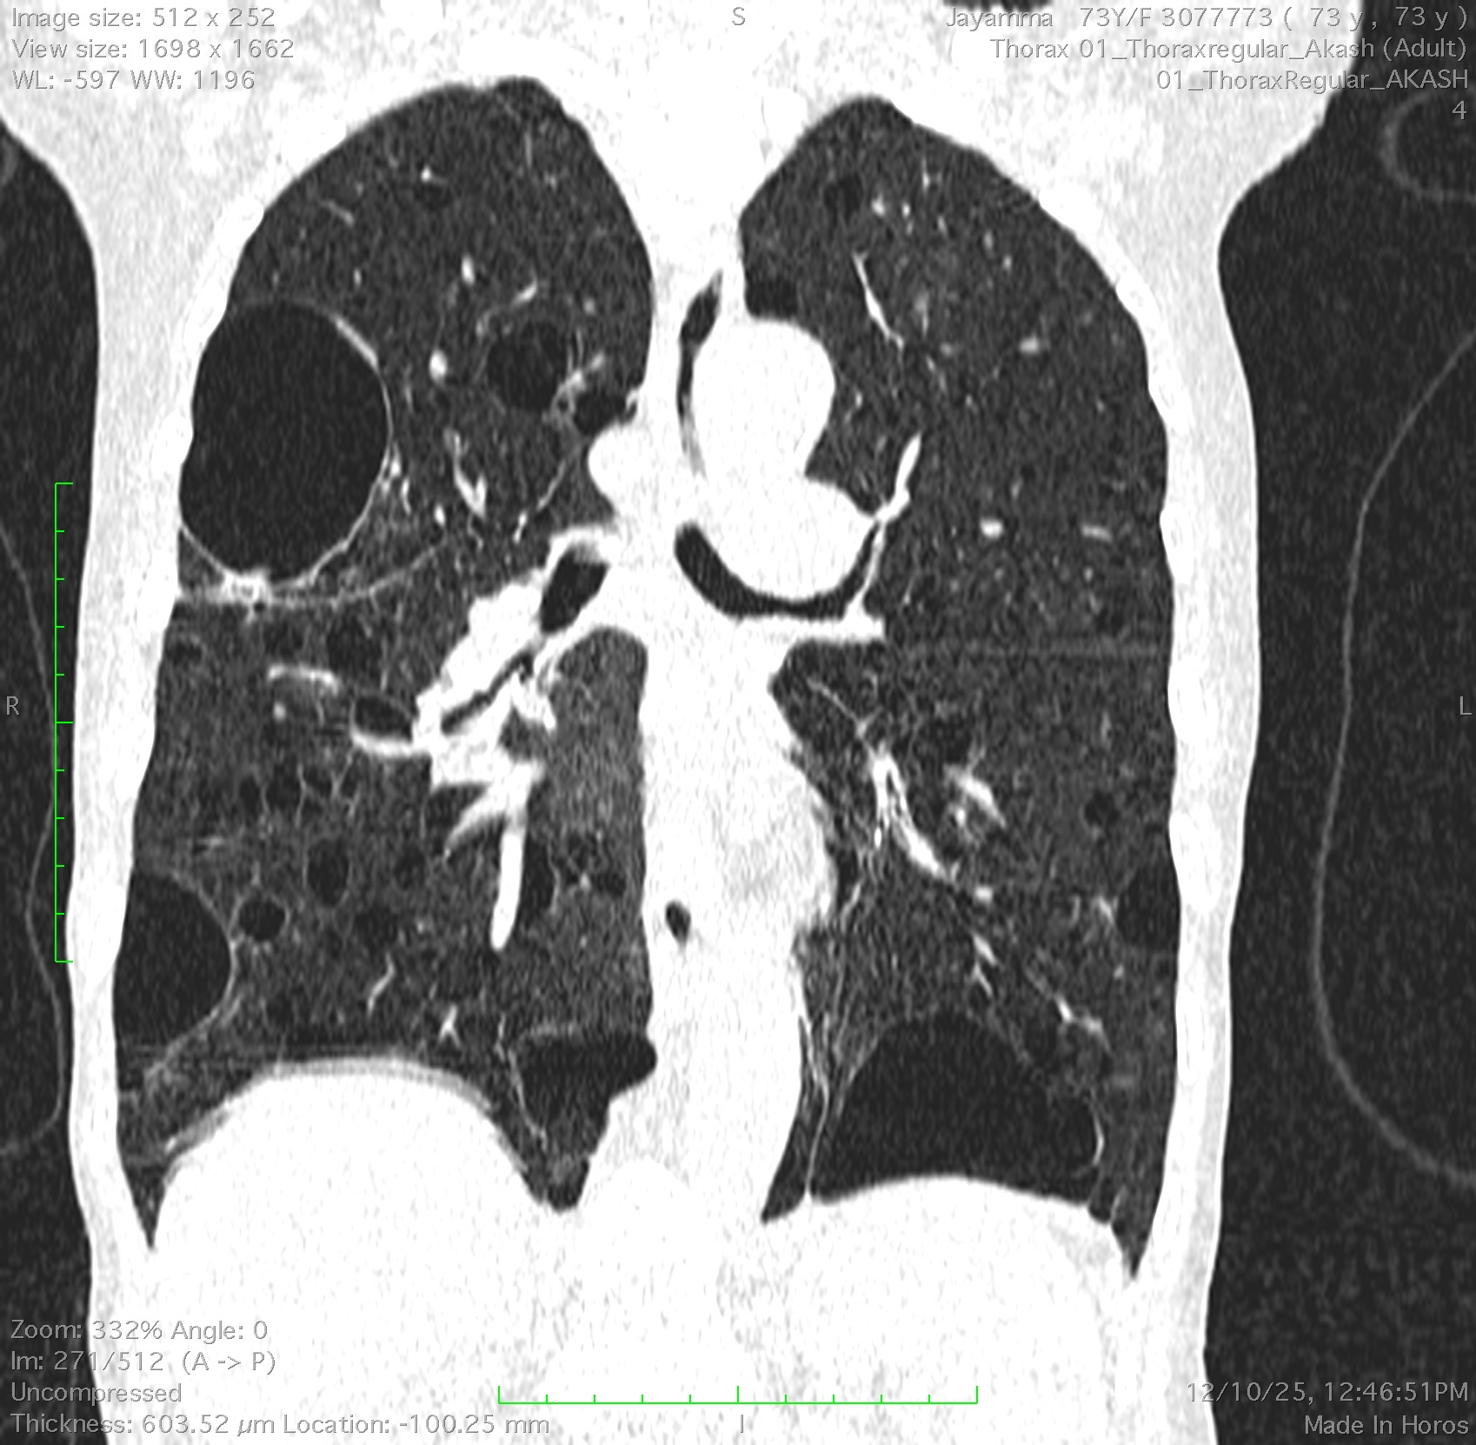  Figure 1 Coronal HRCT reconstruction demonstrating bilateral, diffuse thin-walled pulmonary cysts, predominantly in the mid and lower lung zones, consistent with cystic lung involvement in Sjögren’s syndrome. | 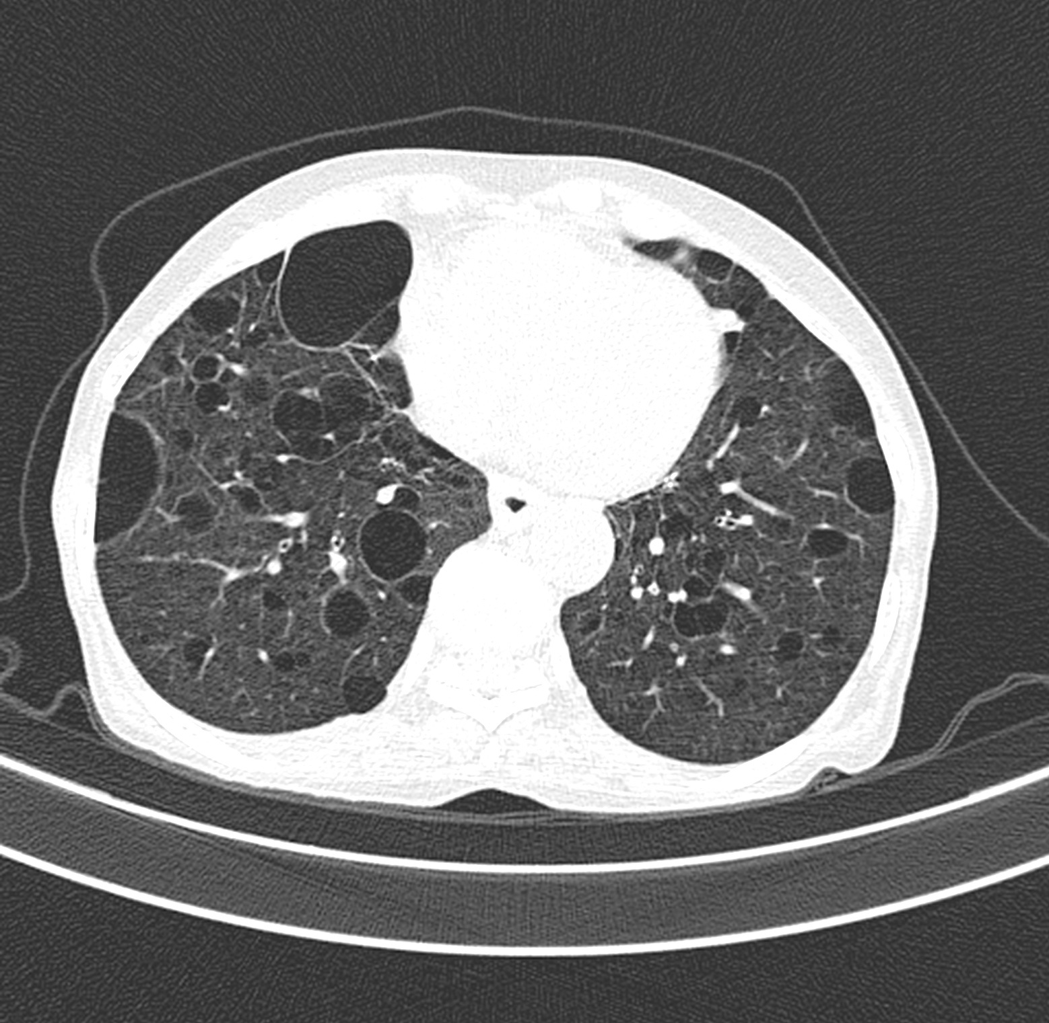  Figure 2 Axial HRCT of the thorax showing multiple, thin-walled cystic lesions of varying sizes diffusely involving both lungs.
Autoimmune screening revealed positive antinuclear antibodies and anti-Ro/SSA antibodies, confirming the diagnosis of primary Sjögren’s syndrome. Schirmer’s test was positive and salivary gland function was mildly reduced. The patient was managed with systemic corticosteroids, oxygen therapy and supportive care.
Differential diagnoses considered included pulmonary Langerhans cell histiocytosis, lymphangioleiomyomatosis, infectious cavitary lung disease and vasculitis-related pulmonary involvement. The presence of thin-walled cysts without necrosis, negative infectious workup, autoimmune seropositivity and sicca symptoms supported a diagnosis of pSS-associated LIP.

The patient was initiated on systemic corticosteroid therapy along with supplemental oxygen and supportive care. Symptomatic treatment for sicca symptoms was also provided.

Following initiation of corticosteroid therapy, the patient demonstrated symptomatic improvement with reduced dyspnoea and improved oxygen saturation. She was advised regular follow-up with pulmonary function testing and serial imaging to monitor disease progression and to detect complications such as pneumothorax or lymphomatous transformation.

Discussion
Pulmonary involvement in primary Sjögren’s syndrome (pSS) represents one of the most significant extra-glandular manifestations, contributing to morbidity and mortality. (1,6) The spectrum of pulmonary disease in pSS encompasses airway abnormalities, interstitial lung disease (ILD) and cystic lung disease. (5) Among the ILD patterns, the most frequently reported are nonspecific interstitial pneumonia (NSIP), usual interstitial pneumonia (UIP), and lymphocytic interstitial pneumonia (LIP) (8,9).
In the present case, high-resolution computed tomography (HRCT) revealed multiple thin-walled cystic lesions distributed predominantly in the lower lobes, along with interstitial thickening and bronchiectasis. These findings were consistent with LIP-related cystic lung disease, a rare but recognized manifestation of Sjögren’s syndrome.(3) Cyst formation in pSS is thought to result from peribronchiolar lymphocytic infiltration, leading to small airway obstruction, air trapping and subsequent alveolar wall rupture. (2) Another proposed mechanism involves the check-valve phenomenon, where inflammatory narrowing of bronchioles allows air inflow but restricts outflow, resulting in localized hyperinflation and cyst development.(10)
Radiologically, cystic lung disease associated with pSS typically presents with thin-walled cysts of variable size, often coexisting with ground-glass opacities, centrilobular nodules or interlobular septal thickening. The absence of thick-walled cavitations, air-fluid levels or necrosis helps differentiate cystic lesions from infectious or vasculitic cavities. (7) This distinction is clinically significant because cystic lesions in pSS reflect a non-destructive, inflammatory process, while cavitary lesions often imply infection or malignancy.(2)
Histopathological examination in such cases usually demonstrates diffuse lymphoplasmacytic infiltration of the interstitium with reactive lymphoid follicles, occasionally containing germinal centers, characteristic of LIP. The lymphoid proliferation can, however, evolve into mucosa-associated lymphoid tissue (MALT) lymphoma, emphasizing the importance of ongoing surveillance. (3,10)
Management of pSS-related cystic lung disease primarily involves systemic corticosteroid therapy, which can improve symptoms and stabilize lung function. However radiologic reversal is uncommon. In cases of progressive disease or poor response to steroids, immunosuppressants such as azathioprine, mycophenolate mofetil, or rituximab may be considered. (11,12) Regular HRCT and pulmonary function monitoring are essential for assessing disease progression and early detection of complications such as pneumothorax or lymphomatous transformation.
The overall prognosis of pSS-associated cystic lung disease is variable and largely depends on the underlying pulmonary pathology and the extent of systemic disease involvement. In many patients, the condition follows a relatively indolent course, with stable lung function over prolonged periods when appropriate immunomodulatory therapy is instituted. (6) However, a subset of patients may experience progressive respiratory impairment due to advancing interstitial lung disease or associated lymphoproliferative disorders. Early recognition and timely initiation of immunosuppressive therapy may improve clinical outcomes by reducing inflammatory activity and preventing further structural lung damage. (11,12) Long-term follow-up is therefore crucial, as patients with pSS have an increased risk of pulmonary complications and an elevated lifetime risk of developing non-Hodgkin lymphoma, particularly mucosa-associated lymphoid tissue (MALT) lymphoma. (3,10)
Recent literature emphasizes that cystic lung disease may represent an early or isolated pulmonary manifestation of Sjögren’s syndrome, sometimes preceding classical sicca symptoms or serological positivity. (2,4) Therefore, clinicians should maintain a high index of suspicion when evaluating patients with unexplained diffuse cystic lung disease.

Conclusion
This case highlights the importance of recognizing cystic lung lesions as a possible pulmonary manifestation of primary Sjögren’s syndrome. Thin-walled cysts may be an early or dominant presentation of the disease and can occur even before classical sicca symptoms are clinically significant. Clinicians should consider Sjögren’s syndrome as a differential diagnosis for patients presenting with idiopathic cystic lung disease. A multidisciplinary approach involving pulmonologists, rheumatologists and radiologists is crucial for timely diagnosis, appropriate management and vigilant monitoring for potential complications such as pneumothorax or lymphomatous transformation. Further research is needed to clarify the pathophysiological mechanisms driving cyst formation and to optimize therapeutic strategies for patients with Sjögren’s-related cystic lung disease.
Disclaimer (Artificial intelligence)
Author(s) hereby declare that NO generative AI technologies such as Large Language Models (ChatGPT, COPILOT, etc.) and text-to-image generators have been used during the writing or editing of this manuscript.

References
1. Fox RI. Extraglandular Manifestations of Sjögren’s Syndrome (SS): Dermatologic, Arthritic, Endocrine, Pulmonary, Cardiovascular, Gastroenterology, Renal, Urology, and Gynecologic Manifestations. In: Fox RI, Fox CM, editors. Sjögren’s Syndrome [Internet]. New York, NY: Springer New York; 2011 [cited 2026 Mar 16]. p. 285–316. Available from: http://link.springer.com/10.1007/978-1-60327-957-4_17 doi:10.1007/978-1-60327-957-4_17
2. Pan CH, Zhang XF, Chen C, An XB. Review of research on pulmonary cysts in sjögren’s syndrome. J Cardiothorac Surg. 2025 Jul 18;20(1):306. doi:10.1186/s13019-025-03540-5 PubMed PMID: 40682117; PubMed Central PMCID: PMC12273288.
3. Kim JY, Park SH, Kim SK, Hyun DS, Kum YS, Jung KJ, et al. Lymphocytic interstitial pneumonia in primary Sjögren’s syndrome: a case report. Korean J Intern Med. 2011 Mar;26(1):108–11. doi:10.3904/kjim.2011.26.1.108 PubMed PMID: 21437172; PubMed Central PMCID: PMC3056249.
4. Gupta N, Wikenheiser-Brokamp KA, Fischer A, McCormack FX. Diffuse Cystic Lung Disease as the Presenting Manifestation of Sjögren Syndrome. Ann Am Thorac Soc. 2016 Mar;13(3):371–5. doi:10.1513/AnnalsATS.201511-759BC PubMed PMID: 26741500; PubMed Central PMCID: PMC5461998.
5. Flament T, Bigot A, Chaigne B, Henique H, Diot E, Marchand-Adam S. Pulmonary manifestations of Sjögren’s syndrome. Eur Respir Rev Off J Eur Respir Soc. 2016 Jun;25(140):110–23. doi:10.1183/16000617.0011-2016 PubMed PMID: 27246587; PubMed Central PMCID: PMC9487244.
6. Luppi F, Sebastiani M, Silva M, Sverzellati N, Cavazza A, Salvarani C, et al. Interstitial lung disease in Sjögren’s syndrome: a clinical review. Clin Exp Rheumatol. 2020;38 Suppl 126(4):291–300. PubMed PMID: 33095142.
7. Boddu P, Parimi V, Taddonio M, Kane JR, Yeldandi A. Pathologic and Radiologic Correlation of Adult Cystic Lung Disease: A Comprehensive Review. Pathol Res Int. 2017 Feb 8;2017:1–17. doi:10.1155/2017/3502438
8. Lynch DA. Lung Disease Related to Collagen Vascular Disease. J Thorac Imaging. 2009 Nov;24(4):299–309. doi:10.1097/RTI.0b013e3181c1acec
9. Mormile I, Mormile M, Rossi FW, Williams M, Valente T, Candia C, et al. Radiological patterns and pulmonary function values of lung involvement in primary Sjögren’s syndrome: A pilot analysis. Front Med. 2022;9:998028. doi:10.3389/fmed.2022.998028 PubMed PMID: 36388884; PubMed Central PMCID: PMC9649970.
10. Avelino EB de P, Verza L, Neves T, Chojniak R, Guimarães MD. Lymphocytic interstitial pneumonia and pulmonary amyloidosis in Sjögren’s syndrome. Radiol Bras. 2019;52(6):410–1. doi:10.1590/0100-3984.2017.0212 PubMed PMID: 32047338; PubMed Central PMCID: PMC7007054.
11. Lee AS, Scofield RH, Hammitt KM, Gupta N, Thomas DE, Moua T, et al. Consensus Guidelines for Evaluation and Management of Pulmonary Disease in Sjögren’s. Chest. 2021 Feb;159(2):683–98. doi:10.1016/j.chest.2020.10.011
12. Price EJ, Rauz S, Tappuni AR, Sutcliffe N, Hackett KL, Barone F, et al. The British Society for Rheumatology guideline for the management of adults with primary Sjögren’s Syndrome. Rheumatology. 2017 Jun 28. doi:10.1093/rheumatology/kex163

