Case report

Hypersensitivity Pneumonitis Presenting with Spontaneous Pneumomediastinum and Pneumopericardium: A Case Report

ABSTRACT
Background: The severity and length of exposure determine hypersensitivity pneumonitis (HP) clinical presentation, as symptoms can vary from acute flu-like symptoms to chronic fibrotic lung disease. Inhaling organic or chemical antigens can cause HP, which is an inflammatory lung condition.
Aims
Here we present a rare case of hypersensitivity pneumonitis that presented with spontaneous pneumomediastinum and pneumopericardium.
Place and Duration of Study: This case study was carried out at Department of Internal medicine and Pulmonology in Kuwait hospital, Sharjah, United Arab Emirates
Case Presentation:
A 54-year-old man with no pre-existing illness presented with subacute worsening shortness of breath over 3 weeks, associated with cough, fever and sweating. There was history of recent occupational wood dust exposure. Clinical, radiological and bronchoscopy features were suggestive of hypersensitivity pneumonitis with spontaneous pneumomediastinum and pneumopericardium. Patient responded well with corticosteroids with complete recovery.
Discussion: Pneumomediastinum is a rare complication seen in interstitial lung disease patients alone or associated with pneumothorax. The importance of parenchymal remodeling in HP has been highlighted by recent research, which may increase the risk of barotrauma by altering lung mechanics Those with a violent cough or honeycombing are especially predisposed. Areas of air trapping and regional pressure variations that may lead to alveolar rupture may be identified with the use of sophisticated imaging techniques, such as inspiratory and expiratory CT scans.
Conclusion:
Hypersensitivity pneumonitis can be frequently mistaken for other infective condition. Emphasis needs to be given on detailed occupational history taking. Spontaneous pneumomediastinum and pneumothorax can be rare presenting symptom of hypersensitivity pneumonitis.

Keywords: pneumomediastinum, allergic alveolitis, polymorphisms, interstitial pulmonary disease

INTRODUCTION
Hypersensitivity pneumonitis (HP), also referred to as extrinsic allergic alveolitis, encompasses a complex and heterogeneous spectrum of interstitial lung diseases characterised by immune-mediated inflammation of the lung parenchyma. The condition arises in susceptible individuals who develop an exaggerated or dysregulated immune response following repeated exposure to specific inhaled antigens (1). These antigens are typically organic in origin, although certain low-molecular-weight chemical agents have also been implicated. The pathogenesis of HP involves a combination of innate and adaptive immune mechanisms, leading to alveolar and small airway inflammation that may progress to fibrosis in chronic forms of the disease. The clinical and radiological heterogeneity of HP reflects variations in antigen type, intensity and duration of exposure, as well as host susceptibility factors (Marwah et al., 2020).
There have been genetic polymorphisms, including those in major histocompatibility complex class 2 found in these individuals (2-5). Viral infections may act as a trigger to environmental antigens by increasing their antigen-presenting capacity, reducing the clearance of antigens, and causing the release of inflammatory cytokines. (6) Recognized predisposing factors for pneumomediastinum, and subsequently pneumopericardium, include smoking and underlying lung disease (chronic obstructive pulmonary disease, asthma, interstitial pulmonary disease) and cases of immense increase in intra-alveolar pressure, such as following cough, vomiting, positive-pressure ventilation, labor, or any Valsalva maneuver and cocaine abuse (Bai et al., 2020; Giannopoulou et al., 2025).

Hypersensitivity pneumonitis (HP) is an inflammatory interstitial lung disorder precipitated by the inhalation of organic or chemical antigens. The clinical presentation of HP is largely determined by both the intensity and duration of antigen exposure. Manifestations may range from acute, influenza-like symptoms to progressive, chronic fibrotic lung disease, reflecting the heterogeneity of host immune responses and patterns of exposure. Traditionally, HP was classified as acute, sub-acute or chronic, based on the Symptom duration (7), but this classification has little clinical value today as they are difficult to distinguish clearly and do not correlate well with outcomes (8). Fibrosis is a critical determinant of prognosis (9-13), accordingly HP has been categorised as non-fibrotic (purely inflammatory) HP or fibrotic HP (mixed or purely fibrotic) (14-15).
Pneumomediastinum developing spontaneously in HP is still an uncommon occurrence and has been reported in a few case studies (16-19). This case study looks at a patient who had subacute HP that initiative presented with spontaneous pneumomediastinum. Drawing on current research, we aim to explore the possible pathways that link these two illnesses, highlighting the challenges associated with diagnosis and treatment. Because of the possibility of rare complications in inflammatory lung Illnesses, this case emphasizes the importance of considering a wide range of differential diagnosis into account when patients present with respiratory symptoms.

CASE PRESENTATION
A 54-year-old male with no background cardiac or respiratory disease, presented to Emergency department, complaining of shortness of breath of 3 weeks duration that worsened for 1 day. He gave a history of cough that started 3 months ago and was associated with intermittent fever and sweating. Symptoms were progressively worsening. He reported weight loss. He was a previously healthy non-smoker and non-alcoholic living at home alone. Patient worked as a graphic designer and had started furniture work a few months back. He admitted to being exposed to wood dust without facial mask. Examination revealed patient was hypoxic, tachypnoeic and his chest examination showed bilateral crepitations. There were no signs of heart failure. Lab evaluation showed leucocytosis, but rest of the infection panel was negative. Echocardiogram was performed and showed mild pulmonary hypertension with a preserved left ventricular systolic function.
High-resolution computerized tomography (HRCT) of chest revealed evidence of pneumomediastinum and pneumopericardium seen. In addition, there were bilateral patchy ground glass opacities, patchy consolidation and scattered centrilobular nodules suggestive of Hypersensitivity pneumonitis (HP). Bronchoalveolar lavage (BAL) showed lymphocytosis with negative workup for infectious causes including bacterial, tuberculosis and fungal. He was started on oral prednisone and instructed to restrain from his current job exposure. Patient had a remarkable recovery with a near complete radiological resolution of the pulmonary opacities in the follow up HRCT chest.

DISCUSSION
Here we discuss a case of pneumomediastinum and pneumopericardium as a primary presenting feature in a case of hypersensitivity pneumonitis.
The classic HRCT findings of HP are upper and middle lobe predominant patchy ground-glass or nodular opacities in a bronchiole-centric distribution, with areas of air trapping. The appearance of ground glass / nodular opacities (high attenuation), air trapping (low attenuation) and normal parenchyma is referred to as the "head cheese sign."
The diagnosis of HP is based on exposure history of an identified antigen, typical clinical presentation and high-resolution computed tomography (HRCT) scan picture. In selected cases, bronchoalveolar lavage (BAL) lymphocytosis and histopathologic data [14,15] might be needed. As per CHEST guidelines, a confident diagnosis of HP can be made in patients who have an identified exposure and a typical pattern on HRCT scan [15]. Although as per ATS/JRS/ALAT guidelines, a confident diagnosis requires additional evidence of BAL lymphocytosis [14]. Our patient had typical high-resolution CT scan findings for HP, supported by evidence of BAL lymphocytosis.

Complete avoidance of inciting antigen and treatment with immunosuppressive agents like steroids are the mainstay of treatment [20]. With this treatment, our patient had a full clinical and radiological recovery which further confirmed the diagnosis.

Patients with interstitial lung disease have distortion of lung architecture and formation of subpleural blebs which may rupture and lead to pneumothorax [21]. Pneumomediastinum is a rare complication seen in interstitial lung disease patients alone or associated with pneumothorax [22]. Alveolar rupture in regions of damaged tissue may be facilitated by these pressure gradients. The importance of parenchymal remodeling in HP has been highlighted by recent research, which may increase the risk of barotrauma by altering lung mechanics Those with a violent cough or honeycombing are especially predisposed [23].

Pneumothorax and pneumomediastinum as a presenting feature of hypersensitivity pneumonitis is very rare and has been reported only in handful of cases [24]. This scenario emphasizes the importance of considering uncommon complications in the context of known pulmonary disorders. Even while spontaneous pneumomediastinum is usually treated conservatively, when it occurs in an HP patient, close observation and thorough evaluation of the underlying inflammatory disease are required. To improve our comprehension of the prevalence and risk factors linked to pneumomediastinum in HP patients, more study is necessary. Areas of air trapping and regional pressure variations that may lead to alveolar rupture may be identified with the use of sophisticated imaging techniques, such as inspiratory and expiratory CT scans.

CONCLUSION
This case report demonstrates a rare instance of spontaneous pneumomediastinum complicating hypersensitivity pneumonitis (HP). The possible processes most likely include HP-related inflammatory alterations that weaken alveolar walls and make them more likely to burst when intrathoracic pressure rises.

Competing interests
All authors declare that they do not have any financial and personal relationships with other people or organizations that could inappropriately influence (bias) their work.
No financial aid received or provided.

CONSENT
As per international standards or university standards, patient(s) written consent has been collected and preserved by the author(s).

ETHICAL APPROVAL
Ethical committee approval taken - Approval Reference No: MOHAP/DXB-REC /J.J.J /No.12 /2026.

Disclaimer (Artificial intelligence)
Author(s) hereby declare that NO generative AI technologies such as Large Language Models (ChatGPT, COPILOT, etc.) and text-to-image generators have been used during the writing or editing of this manuscript.

References
1. European Respiratory Review 2022 31(163): 210169; DOI: https://doi.org/10.1183/16000617.0169-2021
2. Camarena A, Juárez A, Mejía M, et al. Major histocompatibility complex and tumor necrosis factor-alpha polymorphisms in pigeon breeder's disease. Am J Respir Crit Care Med 2001; 163: 1528–1533. doi:10.1164/ajrccm.163.7.2004023
3. Newton CA, Batra K, Torrealba J, et al. Telomere-related lung fibrosis is diagnostically heterogeneous but uniformly progressive. Eur Respir J 2016; 48: 1710–1720. doi:10.1183/13993003.00308-2016
4. Ley B, Newton CA, Arnould I, et al. The MUC5B promoter polymorphism and telomere length in patients with chronic hypersensitivity pneumonitis: an observational cohort-control study. Lancet Respir Med 2017; 5: 639–647. doi:10.1016/S2213-2600(17)30216-3
5. Ley B, Torgerson DG, Oldham JM, et al. Rare protein-altering telomere-related gene variants in patients with chronic hypersensitivity pneumonitis. Am J Respir Crit Care Med 2019; 200: 1154–1163. doi:10.1164/rccm.201902-0360OC
6. Cormier Y, Israël-Assayag E. The role of viruses in the pathogenesis of hypersensitivity pneumonitis. Curr Opin Pulm Med 2000; 6: 420–423. doi:10.1097/00063198-200009000-00006
7. Richerson HB, Bernstein IL, Fink JN, et al. Guidelines for the clinical evaluation of hypersensitivity pneumonitis. Report of the subcommittee on hypersensitivity pneumonitis. J Allergy Clin Immunol 1989; 84: 839–844. doi:10.1016/0091-6749(89)90349-7
8. Lacasse Y, Selman M, Costabel U, et al. Classification of hypersensitivity pneumonitis: a hypothesis. Int Arch Allergy Immunol 2009; 149: 161–166. doi:10.1159/000189200
9. Vourlekis JS, Schwarz MI, Cherniack RM, et al. The effect of pulmonary fibrosis on survival in patients with hypersensitivity pneumonitis. Am J Med 2004; 116: 662–668. doi:10.1016/j.amjmed.2003.12.030
10. Hanak V, Golbin JM, Hartman TE, et al. High-resolution CT findings of parenchymal fibrosis correlate with prognosis in hypersensitivity pneumonitis. Chest 2008; 134: 133–138. doi:10.1378/chest.07-3005
11. Mooney JJ, Elicker BM, Urbania TH, et al. Radiographic fibrosis score predicts survival in hypersensitivity pneumonitis. Chest 2013; 144: 586–592. doi:10.1378/chest.12-2623
12. Churg A, Bilawich A, Wright JL. Pathology of chronic hypersensitivity pneumonitis. What is it? What are the diagnostic criteria? Why do we care? Arch Pathol Lab Med 2018; 142: 109–119. doi:10.5858/arpa.2017-0173-RA
13. Ojanguren I, Morell F, Ramón MA, et al. Long-term outcomes in chronic hypersensitivity pneumonitis. Allergy 2019; 74: 944–952. doi:10.1111/all.13692
14. Raghu G, Remy-Jardin M, Ryerson CJ, et al. Diagnosis of hypersensitivity pneumonitis in adults. An official ATS/JRS/ALAT clinical practice guideline. Am J Respir Crit Care Med 2020; 202: e36–e69. doi:10.1164/rccm.202005-2032ST
15. Fernández Pérez ER, Travis WD, Lynch DA, et al. Executive summary diagnosis and evaluation of hypersensitivity pneumonitis: CHEST guideline and expert panel report. Chest 2021; 160: 595–615. doi:10.1016/j.chest.2021.03.067
16. Fujiwara H, Arita K, Yoshimi T et al. A case of summer-type hypersensitivity pneumonitis with mediastinal and subcutaneous emphysema. Nihon Kyobu Shikkan Gakkai Zasshi 1988;26:1102–6
17. Ichikawa Y, Tokunaga N, Kinoshita M et al. Subcutaneous and mediastinal emphysema associated with hypersensitivity pneumonitis. Chest 1991;99:759–61.
18. Koschel D, Handzhiev S, Cardoso C et al. Pneumomediastinum as a primary manifestation of chronic hypersensitivity pneumonitis. Med Sci Monit 2011;17:CS152–5.
19. Grecian R , Faccenda J, Ferrando L et al. Pneumomediastinum: a rare manifestation of hypersensitivity pneumonitis in a patient presenting with unexplained breathlessness at the Borders General Hospital. BMJ Case Rep. 2015 Oct 7;2015:bcr2015211593.
20. Costabel U, Miyazaki Y, Pardo A, et al. Hypersensitivity pneumonitis. Nat Rev Dis Primers. 2020 Aug 6;6(1):65. doi: 10.1038/s41572-020-0191-z. PMID: 32764620.
21. Le Goff B, Chérin P, Cantagrel A, et al. Pneumomediastinum in interstitial lung disease associated with dermatomyositis and polymyositis. Arthritis Rheum. 2009;61:108–18. doi: 10.1002/art.24372.
22. Franquet T, Giménez A, Torrubia S, et al. Spontaneous pneumothorax and pneumomediastinum in IPF. Eur Radiol. 2000;10:108–13. doi: 10.1007/s003300050014.
23. Fujiwara T. Pneumomediastinum in pulmonary fibrosis. Chest. 1993;104:44–46. doi:10.1378/chest.104.1.44.
24. Dirk Koschel , Sabin Handzhiev et al., Pneumomediastinum as a primary manifestation of chronic hypersensitivity pneumonitis. Med Sci Monit. 2011 Dec 1;17(12):CS152–CS155. doi:10.12659/MSM.882115
25. Giannopoulou, E., Tsilivarakis, D., Kosmopoulou, S., & Lazaros, G. (2025). A Rare Case of Spontaneous Pneumomediastinum and Pneumopericardium in a 21-Year-Old Male. Cureus, 17(5).

26. Bai, M., Dwivedi, D. P., Vishnukanth, G., & Ramasubramaniam, K. (2020). Spontaneous pneumomediastinum, pneumopericardium and subcutaneous emphysema in a case of interstitial pneumonia with autoimmune features. Indian Journal of Tuberculosis, 67(4), 567-570.

27. Marwah, V., Katoch, C. D. S., Choudhary, R., & Bhati, G. (2020). An unusual case of spontaneous pneumomediastinum secondary to tracheal tear in a trumpeter. Lung India, 37(6), 547-549.

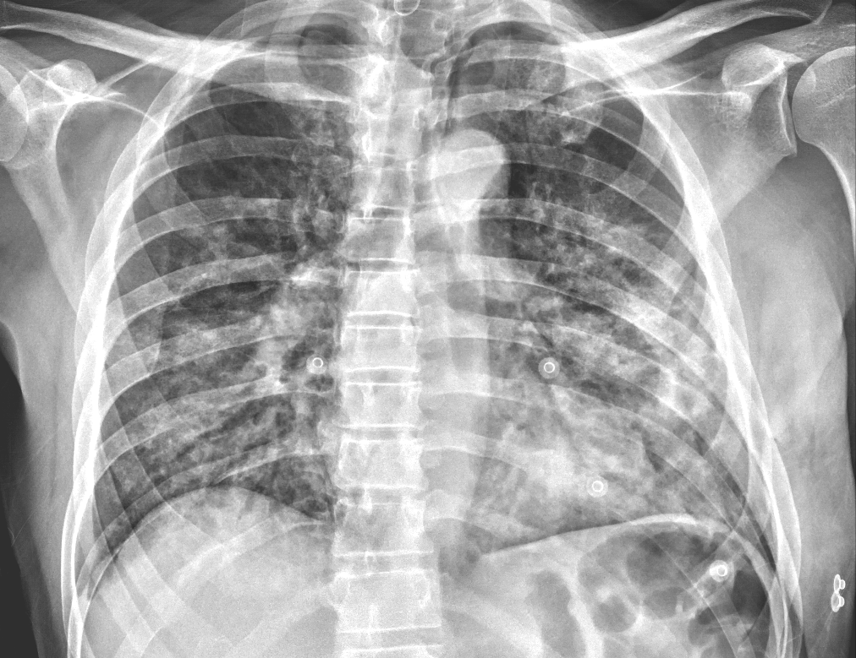

Image – 1 Initial chest X-ray

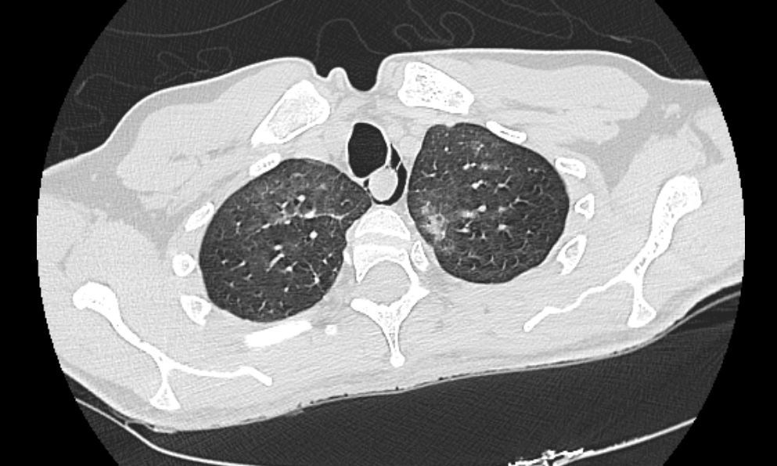

Image – 2 HRCT showing Pneumomediastinum
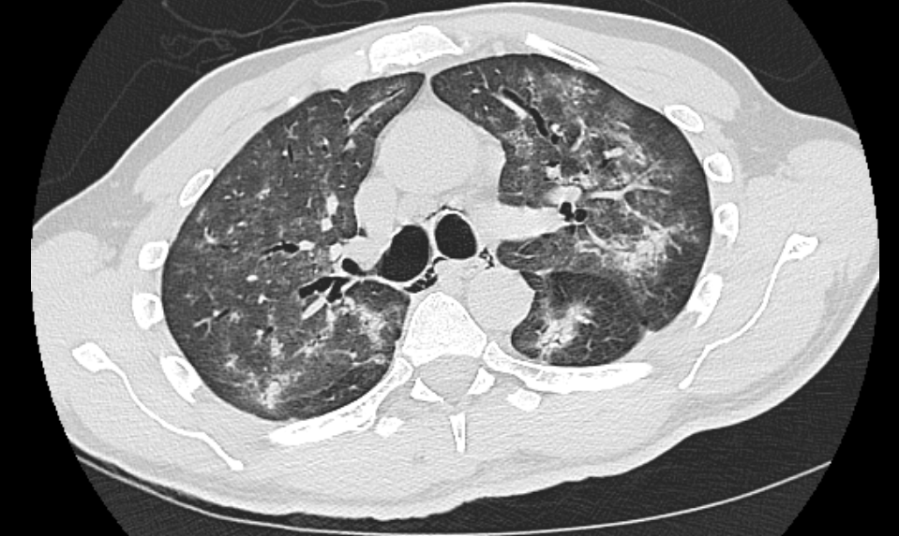
Image - 3HRCT showing pneumomediastinum, bilateral ground glass haziness, patchy consolidation, bronchiolectasis
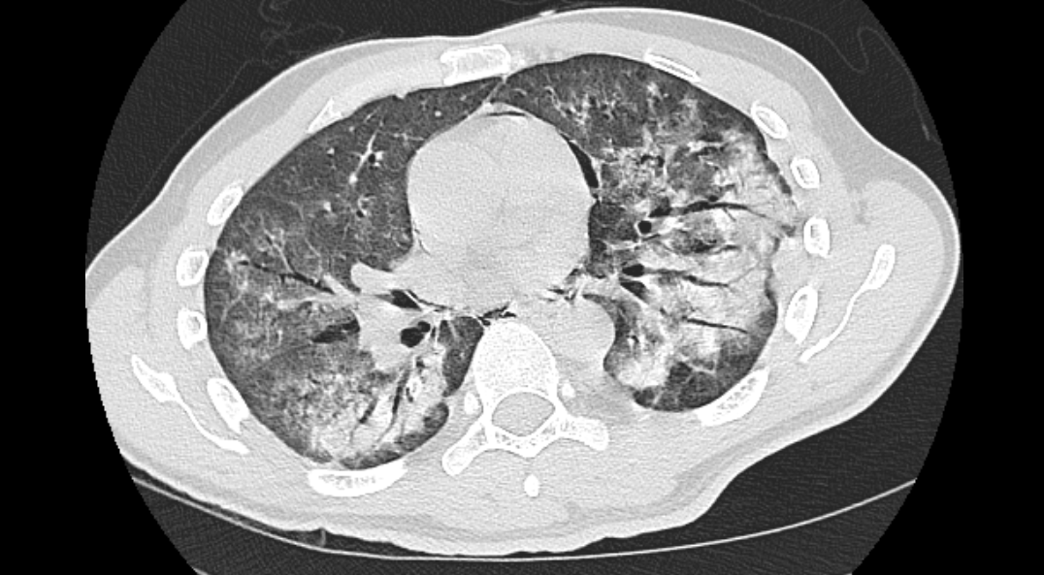

Image - 4HRCT showing pneumopericardium, bilateral ground glass haziness, patchy consolidation
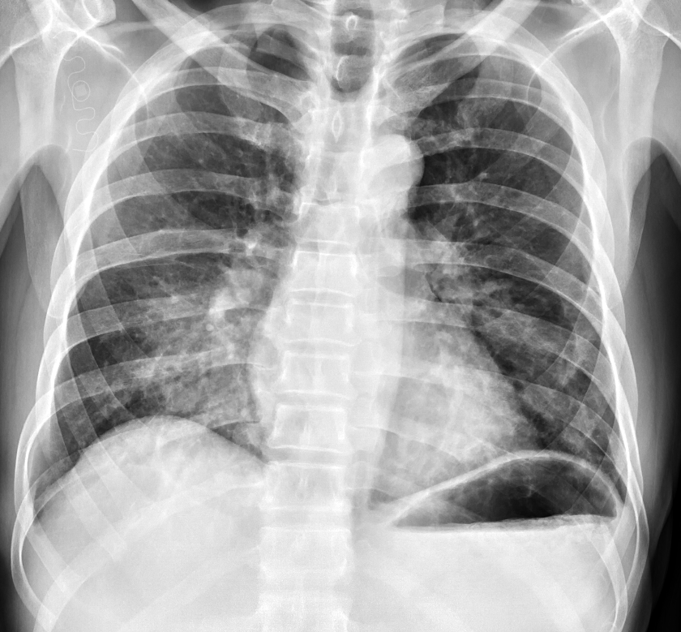

Image - 5Repeat chest X-ray showing improvement
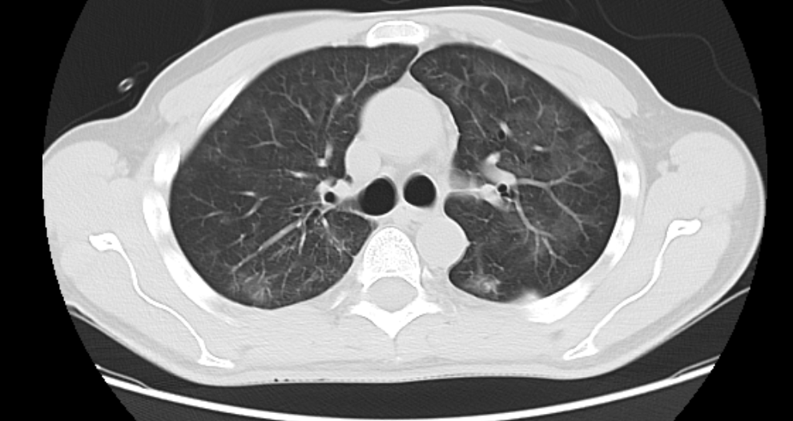
Image – 6Repeat HRCT scan showing significant improvement

