Case report
Primary Cutaneous Leiomyosarcoma of the Gluteal Region : A Case Report on a Rare Entity

Abstract:

Primary Cutaneous Leiomyosarcoma is an infrequent malignant neoplasm of dermal or subcutaneous smooth muscle origin. This report highlights an unusual presentation of the disease as a painful, progressive gluteal swelling in a fifty-year-old male, initially mismanaged as a benign lesion. The mass was excised twice, with histology reported as a spindle cell neoplasm and treated as benign entity. Recurrence at the same site with progressive enlargement prompted referral to our centre, where our surgeons proceeded with wide local excision. Histopathology with immunohistochemistry confirmed the diagnosis of leiomyosarcoma. The unusual anatomical site, repeated recurrence and diagnostic delay highlight the complexity of this entity.

This case highlights the importance of maintaining a high index of suspicion for uncommon presentations and emphasizes the critical role of prudent histopathological assessment for accurate diagnosis. A multidisciplinary approach is needed in guiding an effective management & improving patient outcomes.

Keywords :
Cutaneous leiomyosarcoma, gluteal mass, immunohistochemistry, histopathology, recurrence

Introduction:
Leiomyosarcoma is a rare aggressive malignant smooth muscle neoplasm, representing 5% of all soft tissue sarcomas. Primary cutaneous leiomyosarcoma (PCL) is an infrequent malignant sarcoma which accounts for about 2-3% of all superficial soft tissue sarcomas.¹ The incidence rates have been estimated to be about 0.2 per 1,00,000 per year.² The peak incidence is in the 5th-6th decade of life with a predilection for male population. However, it may be seen in any age and gender.³
Primary Cutaneous Leiomyosarcoma (PCL) tends to occur in lower limbs with a greater propensity for extensor surfaces. Physical trauma, radiation, sun exposure and lupus vulgaris are most commonly associated risk factors, but the exact cause is unknown. Clinically it may manifest as an ulcerated wound or a lump. Histologically, it is of two types depending upon site of origin – superficial dermal type (more common) and deep subcutaneous type. The former arises from arrector pili muscle while the latter arises from vascular smooth muscle layer.¹ Treatment options are largely non standardised owing to the paucity of data on this entity and include surgery, radiotherapy and chemotherapy. We report a rare and an interesting case of PCL of the gluteal region.
Case Presentation :
A 50 year old gentleman with no known comorbidities presented to the Surgery OPD with chief complaint of swelling over the right gluteal region for 6 months. There was no history of trauma/fever. The patient had similar complaints in 2022 and 2023 for which he underwent local excision of the swelling at a rural hospital with histopathology suggestive of a spindle cell neoplasm on both instances. The recurrence interval abbreviated while the lesion size increased with each recurrence. Physical examination revealed a firm, tender, indurated swelling of 6 x 6 cm in the upper inner quadrant of right gluteal region over a hypertrophic scar of 10 cm (at the previously operated site). Ultrasonography of the local site was suggestive of heterogenous hypoechoic collection of ~ 5 x 4 x 3 cm with internal necrosis. Tru-cut biopsy from the lesion favoured spindle cell neoplasm. As a part of metastatic workup Xray chest and Ultrasound abdomen were done, which revealed no evidence of metastatic disease. The patient underwent wide local excision of the lesion which revealed an abnormal yellow-white area measuring 6.3 x 4.5 x 2.7 cm with extensive haemorrhage and necrosis. Histological examination with haematoxylin and eosin revealed spindle cells with distinct borders, eosinophilic cytoplasm and blunted cigar shaped nuclei. The cells were arranged in fascicles in the subcutaneous tissue and dermis. 4-5 mitotic figures per 10 high-power fields were noted with moderate pleomorphism and myxoid changes (Figure 1 - 6). All the resected margins were less than 1 cm with the closest being 0.2 cm. On Immunohistochemistry, cells were found to be positive for SMA (Figure 5) and Desmin and negative for CD34, S-100, Cytokeratin and EMA. A working diagnosis of Intermediate Grade (as per FNCLCC scoring) Cutaneous Leiomyosarcoma with extensive subcutaneous extension was established. Patient underwent loco-regional and metastatic work up in the form of MRI pelvis and gluteal region along with a CT chest. MRI showed only post-operative changes, while CT chest did not reveal any definite evidence of metastatic disease. In view of multiple high risk features such as extensive subcutaneous extension, loco-regional recurrent nature, primary tumor size > 5 cm, intermediate grade and close margins, a multidisciplinary tumor board was formulated following which patient was planned for 6 cycles of Adriamycin and Ifosfamide based adjuvant chemotherapy and a consolidative external beam radiotherapy on a telecobalt unit, using a conventional two-dimensional technique, to a dose of 60 Gy in 30 fractions, delivered five fractions per week, followed by a scar boost of 10 Gy. Currently the patient is 18 months post treatment completion and on regular follow up, with no evidence of disease at local site (Figure 7) or distant metastasis.

Discussion:
PCL is an exceptionally uncommon malignant soft tissue sarcoma which accounts for about 2-3% of all superficial soft tissue sarcomas.¹ It most frequently affects Caucasian men with a peak incidence in 5th-6th decade of life, a finding concordant with our case.
PCL commonly arises in the lower extremities and head and neck region, particularly hair bearing surfaces, though any site on the body can be involved.³ It usually presents as solitary, erythematous or brownish well circumscribed nodule with or without ulceration of the overlying skin, tenderness or paraesthesias.¹ Our patient presented with a tender swelling of 5 x 5 cm in the upper inner quadrant of right gluteal region with no overlying skin changes. Predisposing factors include lupus vulgaris, physical trauma, sun and radiation exposure. However, most cutaneous LMS originate with no prior triggering factors, as in our case.⁴
PCL is of two sub-types based upon origin of the tumour ; more common superficial dermal type arises from the arrector pili muscle, while the deep subcutaneous type is thought to originate from the vascular wall smooth muscle. In our case, as discussed with the pathologist, it was difficult to characterise the origin of PCL since tumour cells were seen both in the dermis and the subcutaneous adipose tissue though extensive subcutaneous involvement was noted. Features of malignancy include mitosis of two or more per 10 high-power fields, high cellularity, nuclear atypia, bizarre myomatous cells and fascicles of spindle shaped cells with ‘cigar-shaped’ nuclei.⁴ On the molecular level, tyrosine kinase receptor overexpression ( PDGFR and IGFR ) has been demonstrated.⁵
Differential diagnoses include schwannomas, plexiform neurofibromas, desmoplastic malignant melanomas and malignant peripheral nerve sheath tumours. Immunohistochemistry is mandatory for a definitive diagnosis.⁶ Majority of cases stain positive for Vimentin, Desmin, SMA and Caldesmon. However, none of these markers are absolutely specific, hence, positivity for two such markers is needed to support the diagnosis of leiomyosarcoma.¹ Focal keratin, HHF-35, EMA, CD34 or S-100 immunostaining may also be occasionally encountered.¹
Certain poor prognostic factors such as tumour size ≥ 5 cm, acral location, subcutaneous spread, intermediate-high histological grade have been documented in literature.⁴ Other variables such as high Ki67 proliferative index, DNA ploidy and mitotic figures have also been identified as surrogate markers of unfavourable outcomes.⁷ Massi et al.⁸ reported 6% recurrence for dermal cutaneous LMS as opposed to 18.1% for cutaneous LMS with subcutaneous extension. Angeloni M et al.⁹ in their study demonstrated local recurrence to be 40-60% in subcutaneous variety vs 30-50% in dermal variety. They also concluded that former variant metastasizes earlier (20-60%) as opposed to latter (0-10%). Wong et al.¹⁰ in their study found that 4 out of 19 subcutaneous LMS patients developed distant metastasis (lungs > adrenal glands & cerebrum) while no metastasis were noted in pure dermal LMS patients. Similarly, a series of 225 patients from Scandinavian Sarcoma Group Register showed that none of the patients with strictly dermal or Grade 1 LMS tumors had no metastases in contrast to deeper or less differentiated LMS where metastasis occurred in 25% patients with 2/3rd occurring within the 1st year.¹¹ Ullah et al.¹² in their study showed age more than 60 years, head and neck subsites and tumor size more than four centimetre as pertinent drivers of mortality in patients with leiomyosarcoma of skin. Our case had multiple poor prognostic features such as size > 5 cm, FNCLCC intermediate grade, close margins, dermal involvement with extensive subcutaneous extension and recurrent nature with progressive shorter DFS - posing a greater risk of loco-regional recurrence as well as distant metastasis.
The most effective treatment is wide local excision, with a depth of resection that includes subcutaneous tissue and fascia. Classical recommendations suggest a clear margins of 3-5 cm while the recent studies endorse a more conservative resection margin of 1cm.¹³ The role of adjuvant therapy has largely remained non standardized and anecdotal. Post-op radiotherapy has demonstrated favourable outcomes in patients with large tumor size (>5cm), persistently positive margins following multiple resections and those with extensive subcutaneous extension.¹ Curative intent requires a total dose of 50-60 Gy to be administered with conventional fractionation as in our case where the patient received 60 Gy in 30 fractions, followed by a scar boost, due to recurrent nature. Hypo-fractionated dosage schedules of 36-45 Gy with 2.5–3 Gy per fraction are used in palliative settings.^{1,7} Systemic treatment has been found to delay progression in patients with disseminated disease.^{7,14} Doxorubicin based chemotherapy is commonly used in the first-line setting.⁷ Our patient received a combination of Doxorubicin and Ifosfamide in the adjuvant setting prior to radiotherapy. In our patient, the sequence of chemotherapy followed by consolidative radiotherapy was chosen after multidisciplinary tumor board discussion. The decision was guided by the need to address potential micro-metastatic disease at the earliest opportunity, given the recurrent nature of the tumor, presence of multiple high-risk features and close surgical margins. Pre-operative workup had been limited to ultrasonography of the local site and chest X-ray, and staging CT and MRI could only be obtained after surgery due to logistical delays. In order to avoid further postponement of adjuvant therapy, systemic treatment was initiated first.This sequential approach also minimized the risk of overlapping toxicities, thereby allowing the optimal and uninterrupted delivery of both chemotherapy and radiotherapy
In terms of follow up, no standard guidelines are available. Nonetheless, 4 monthly follow up is advised during the first two years. Thereafter, biannually until the fifth year post treatment and subsequently once a year until 20 years.

Conclusion:
PCL is a rare entity and a high index of suspicion must be borne in mind when dealing with a malignant spindle cell neoplasm of the skin. A panel of immunohistochemical markers is paramount for diagnosis and to distinguish it from other cutaneous malignancies with spindle cell morphology. Surgical excision with adequate margins is the treatment modality of choice. Majority literature published till date highlighting the characteristics, prognostic factors and treatment options is either based on small case series or sporadic reports, thereby warranting further studies, so that definitive management options for such cases can be explored.
Consent
As per international standards or university standards, patient(s) written consent has been collected and preserved by the author(s).

Ethical Approval:

As per international standards or university standards written ethical approval has been collected and preserved by the author(s).
Disclaimer (Artificial intelligence)

Author(s) hereby declare that NO generative AI technologies such as Large Language Models (ChatGPT, COPILOT, etc.) and text-to-image generators have been used during the writing or editing of this manuscript.

References:

- Soares Queirós C, Filipe P, Soares de Almeida L. Cutaneous leiomyosarcoma: a 20-year retrospective study and review of the literature. An Bras Dermatol. 2021;26(96)278-83. doi: 10.1016/j.abd.2020.10.003.

- Tinguria M. Cutaneous leiomyosarcoma: A rare cutaneous soft tissue neoplasm. Clinicopathologic Features and Review of Literature. Medical Research Archives. 2025 Apr 30;13(4)

- Ahluwalia VV, Singh PK, Singh H, Samanta S. Advanced Magnetic Resonance Imaging in the Evaluation of a Chronic Non-healing ulcer - A Case Report of Rare Primary Cutaneous Leiomyosarcoma. J Orthop Case Rep. 2018;8(4):7-10. doi: 10.13107/jocr.2250-0685.1134.

- Agale SV, Grover S, Zode R, Hande S. Primary cutaneous leiomysarcoma. Indian J Dermatol. 2011;56(6):728-30. doi: 10.4103/0019-5154.91839.

- Kohlmeyer J, Steimle-Grauer SA, Hein R. Cutaneous sarcomas. J Dtsch Dermatol Ges. 2017;15(6):630-648. doi: 10.1111/ddg.13249.

- Bali A, Kangle R, Roy M, Hungund B. Primary cutaneous leiomyosarcoma: A rare malignant neoplasm. Indian Dermatol Online J. 2013;4(3):188-90. doi: 10.4103/2229-5178.115513.

- Helbig D, Dippel E, Erdmann M, Frisman A, Kage P, Leiter U, et al. S1-guideline cutaneous and subcutaneous leiomyosarcoma. J Dtsch Dermatol Ges. 2023;21(5):555-563. doi: 10.1111/ddg.14989.

- Massi D, Franchi A, Alos L, Cook M, Di Palma S, Enguita AB, et al. Primary cutaneous leiomyosarcoma: clinicopathological analysis of 36 cases. Histopathology. 2010;56(2):251-62. doi: 10.1111/j.1365-2559.2009.03471.x.

- Angeloni M, Muratori F, Magarelli N, Chalidis BE, Ricci R, Rossi B, et al. Exophytic growth of a neglected giant subcutaneous Leiomyosarcoma of the lower extremity. A case report. Int Semin Surg Oncol. 2008;21;5:11. doi: 10.1186/1477-7800-5-11.

- Wong GN, Webb A, Gyorki D, McCormack C, Tran P, Ngan SY et al. Cutaneous leiomyosarcoma: dermal and subcutaneous. Australas J Dermatol. 2020 Aug;61(3):243-249. doi: 10.1111/ajd.13307.

- Svarvar C, Böhling T, Berlin O, Gustafson P, Follerås G, Bjerkehagen B et al. Scandinavian Sarcoma Group Leiomyosarcoma Working Group. Clinical course of nonvisceral soft tissue leiomyosarcoma in 225 patients from the Scandinavian Sarcoma Group. Cancer. 2007 Jan 15;109(2):282-91. doi: 10.1002/cncr.22395.

- Ullah A, Khan Yasinzai AQ, Chaudhury H, Chandasir A, Nguyen T, Tracy K et al. Primary cutaneous leiomyosarcoma: demographics and survival benefit of surgical management in a US population. Proc (Bayl Univ Med Cent). 2025 Apr 28;38(4):399-406. doi: 10.1080/08998280.2025.2491895.

- Deneve JL, Messina JL, Bui MM, Marzban SS, Letson GD, Cheong D et al. Cutaneous leiomyosarcoma: treatment and outcomes with a standardized margin of resection. Cancer Control. 2013 Oct;20(4):307-12. doi: 10.1177/107327481302000408.

- Young RJ, Litière S, Lia M, Hogendoorn PCW, Fisher C, Mechtersheimer G, et al. Predictive and prognostic factors associated with soft tissue sarcoma response to chemotherapy: a subgroup analysis of the European Organisation for Research and Treatment of Cancer 62012 study. Acta Oncol. 2017;56(7):1013-1020. doi: 10.1080/0284186X.2017.1315173.

Figure 1 : Micrograph of a Hematoxylin & Eosin stained 40X slide showing presence of tumor cells in dermis with unremarkable epidermis.

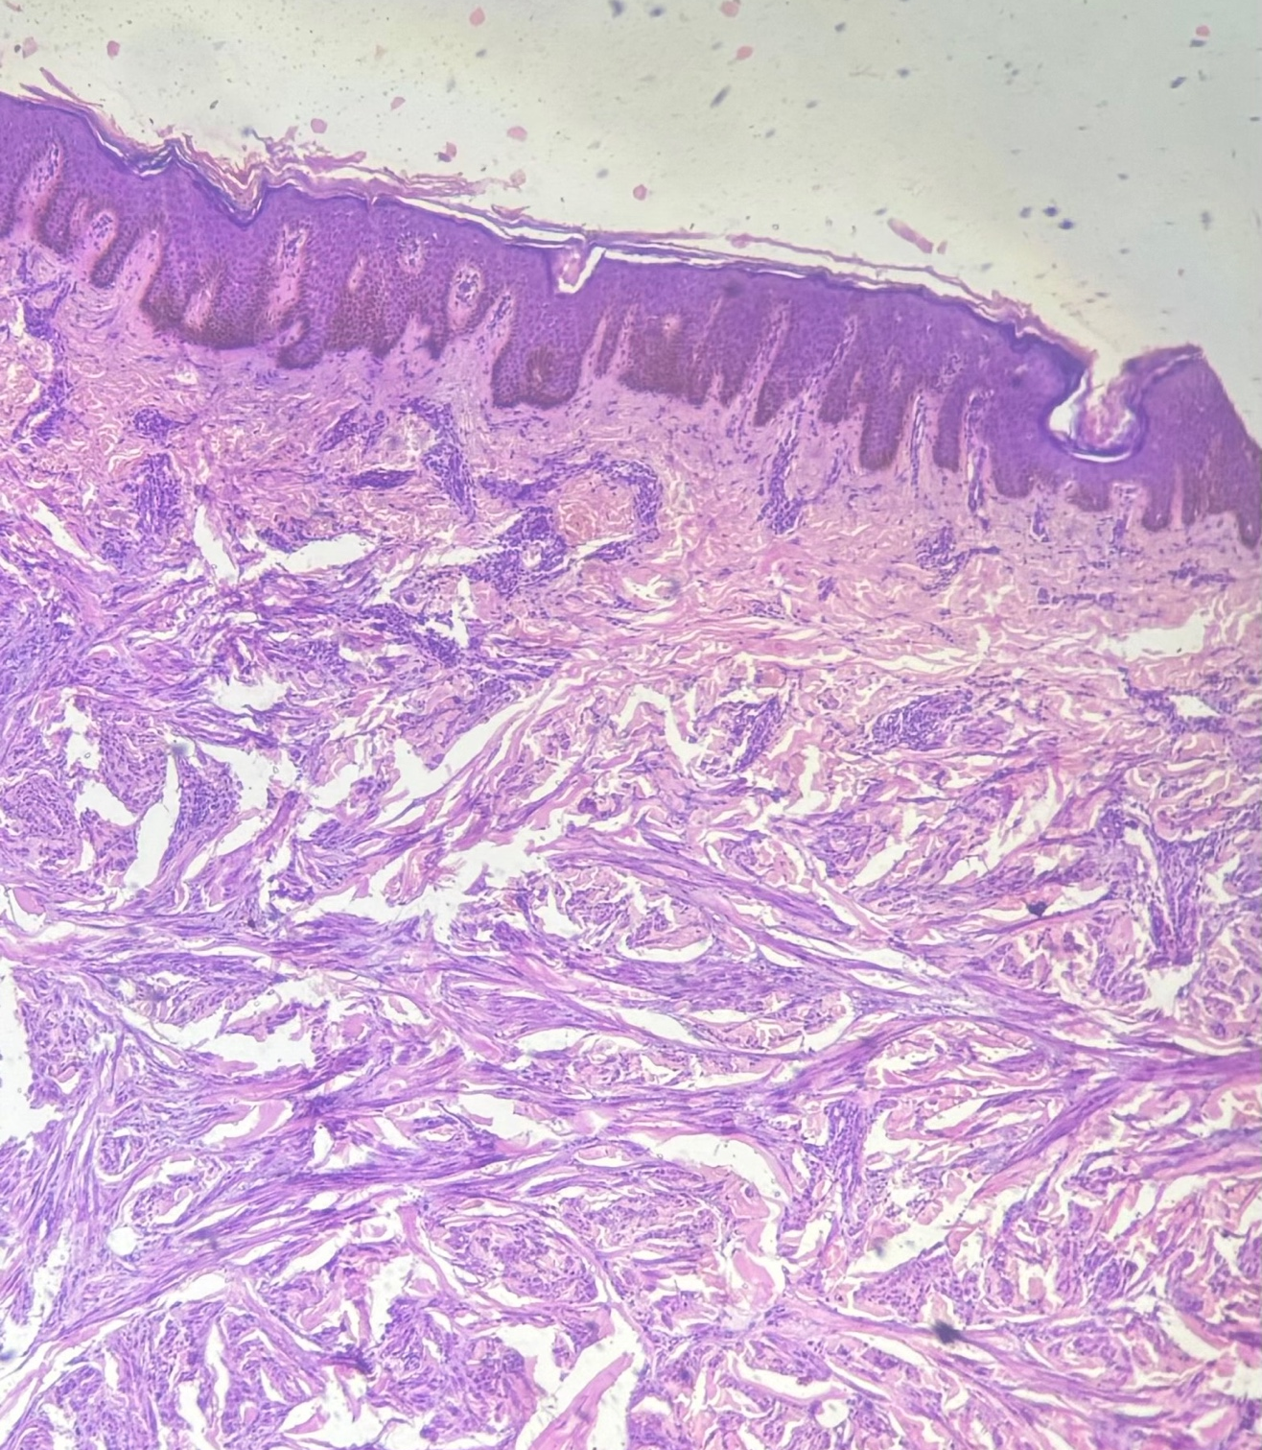

Figure 2 : Micrograph of a Hematoxylin & Eosin stained 100X slide showing tumor cells arranged in fascicles.

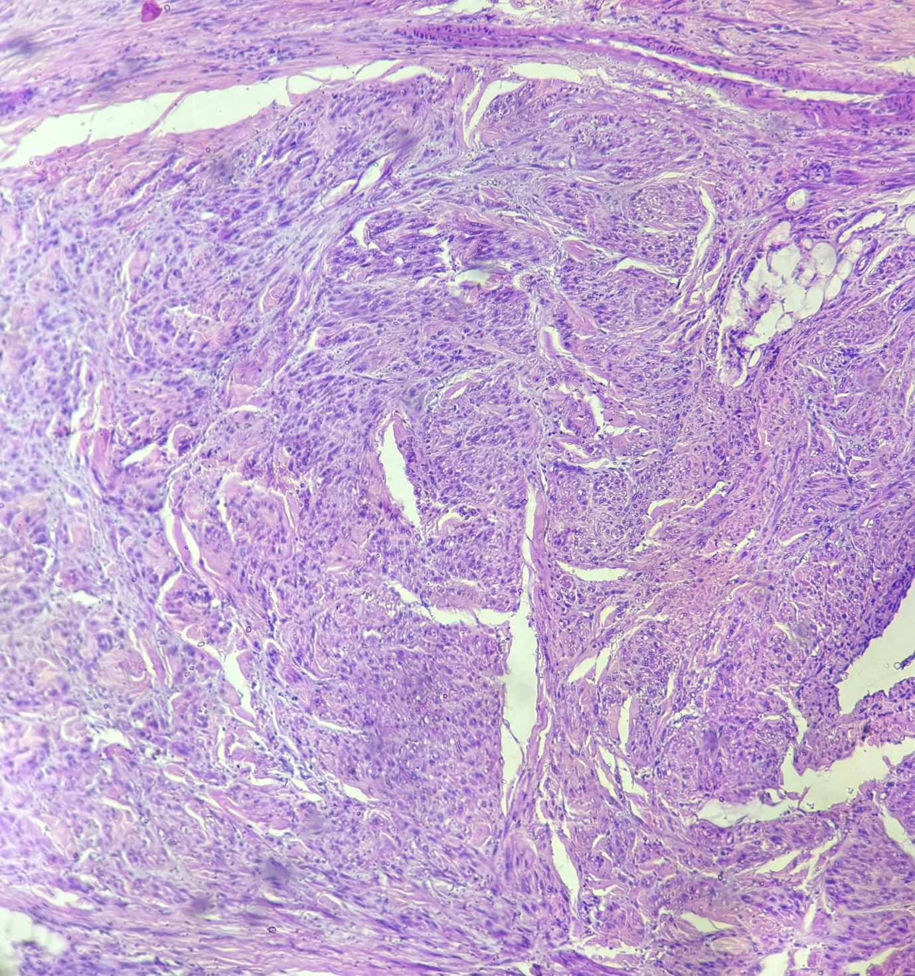

Figure 3 : Micrograph of a Hematoxylin & Eosin stained 200X slide showing extensive sub-epithelial fat extension

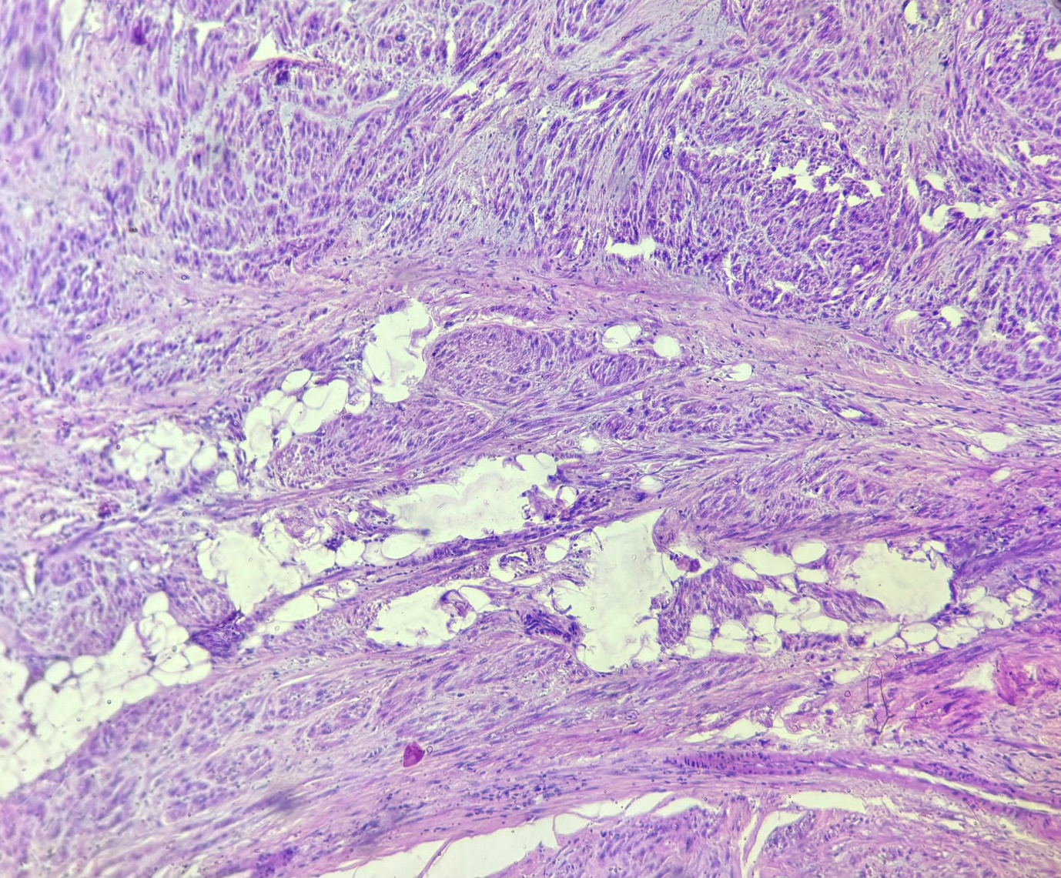

Figure 4 : Micrograph of a Hematoxylin & Eosin stained 400 X slide 4-5 mitotic figures per 10 high-power fields were noted with moderate pleomorphism and myxoid changes

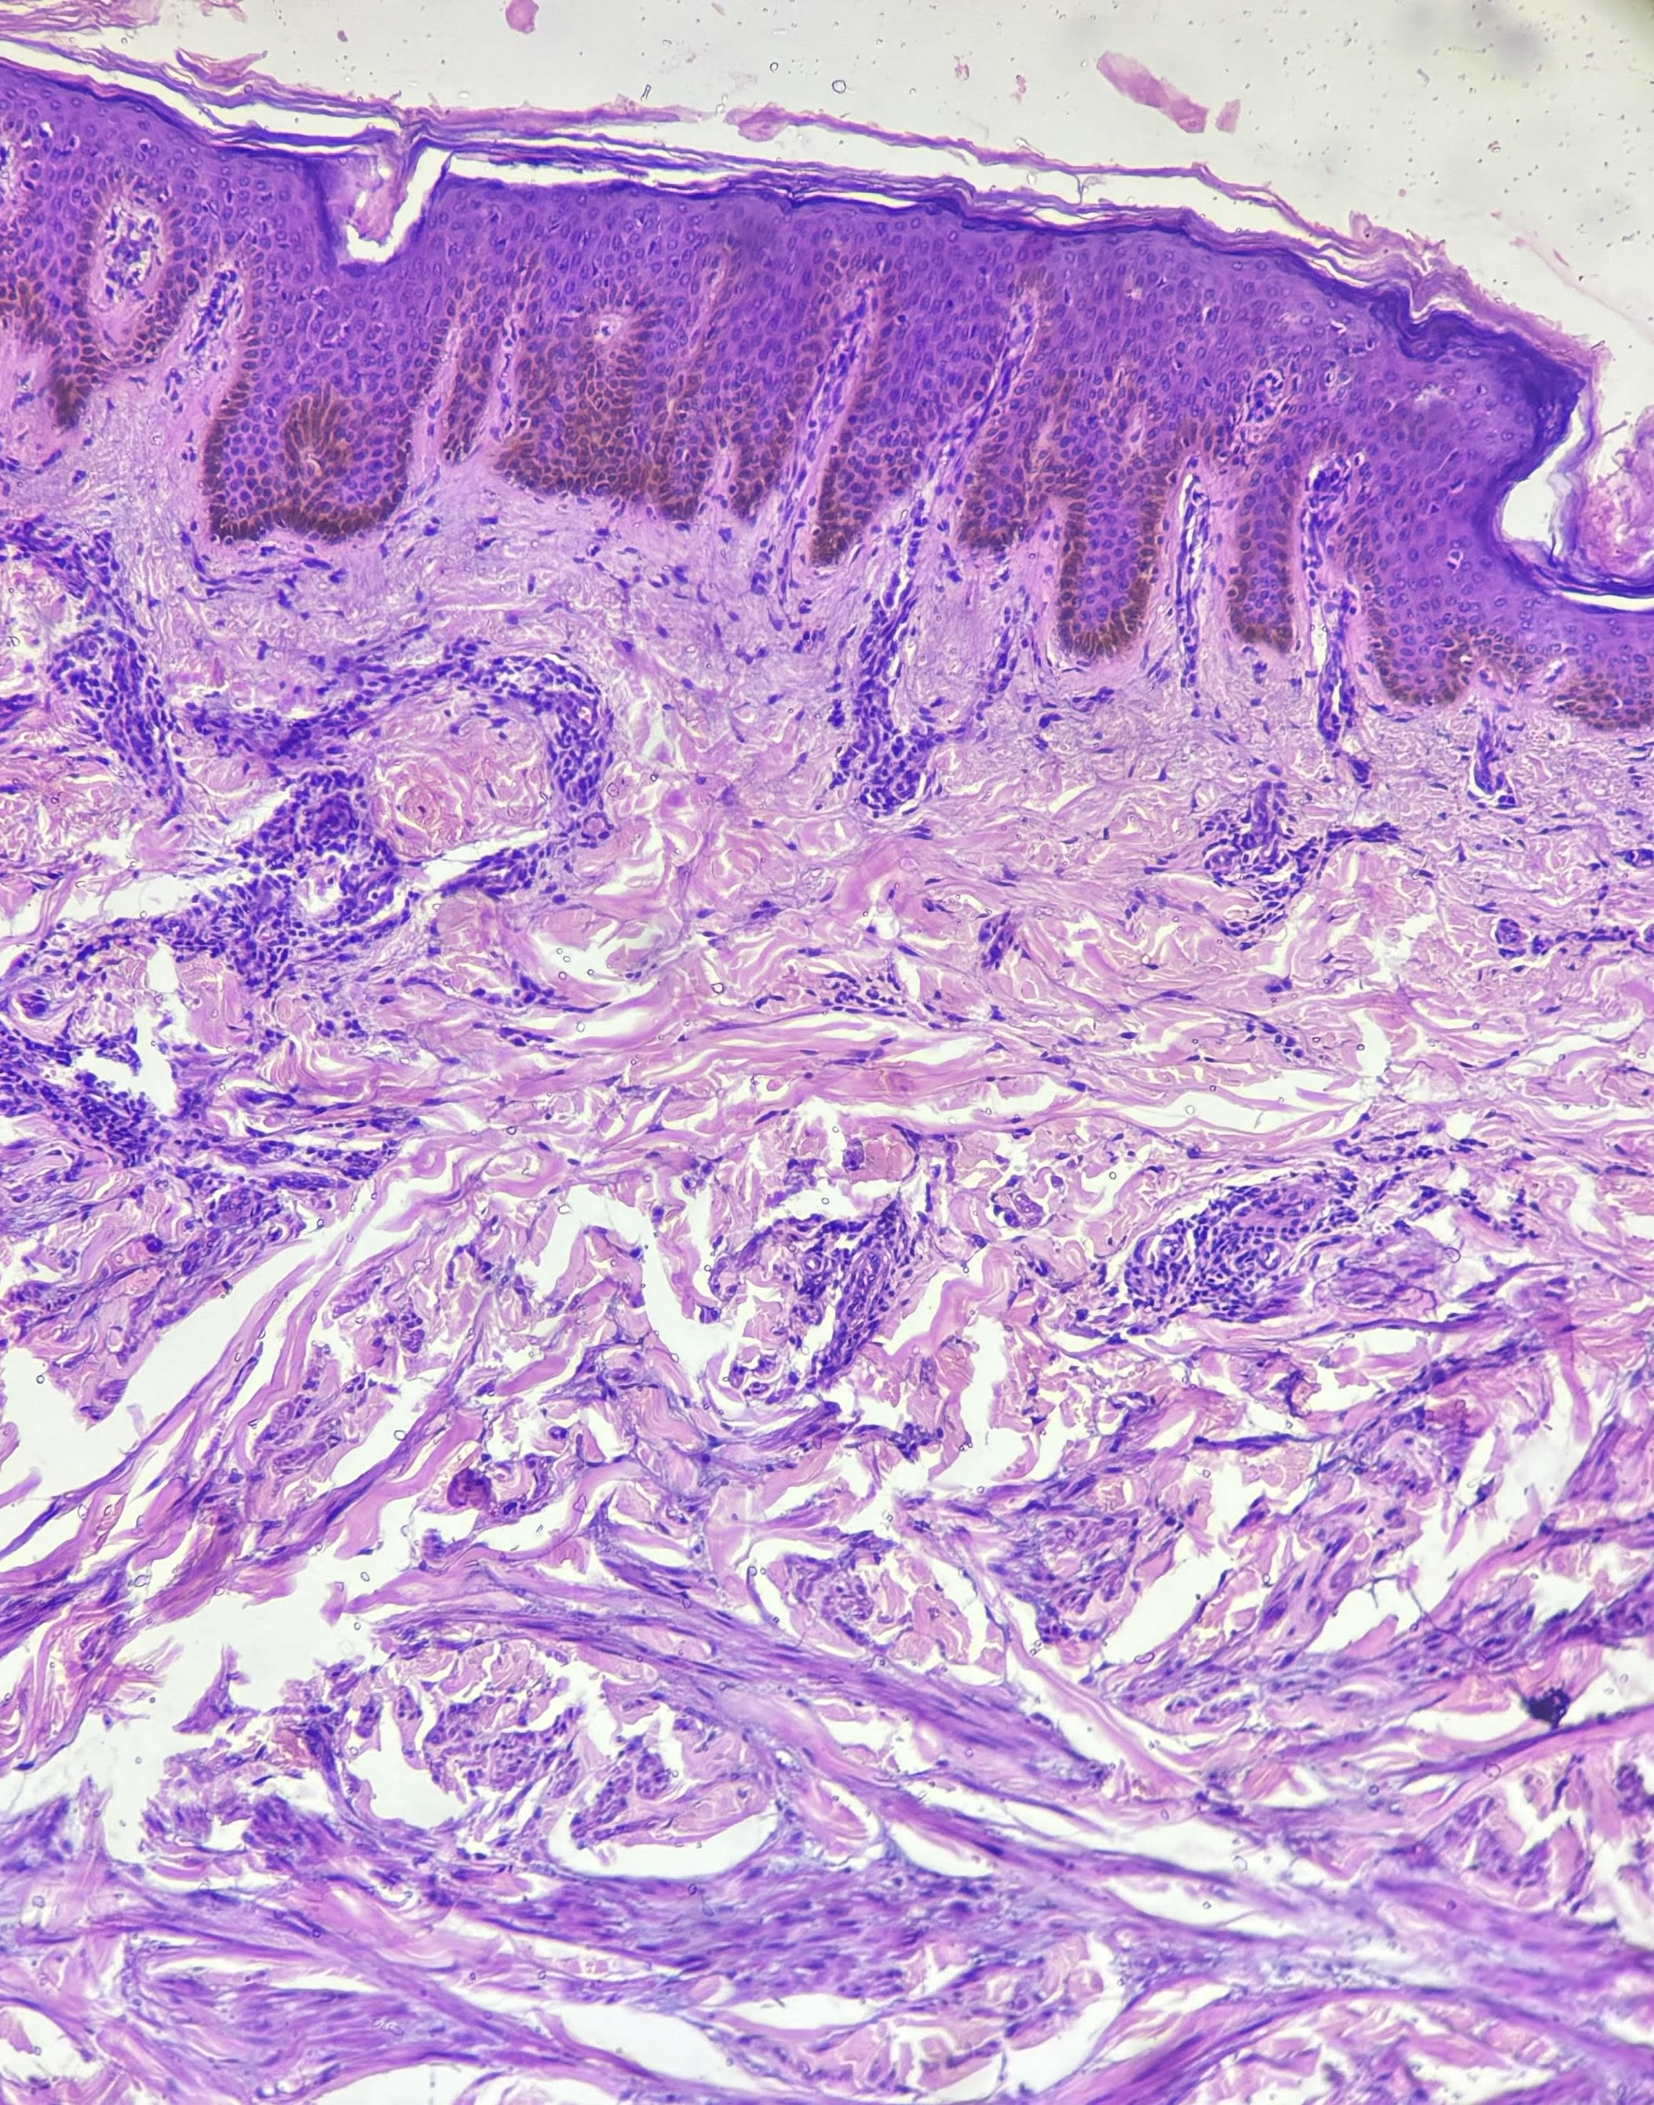

Figure 5 : IHC X200 : Tumor cells showing SMA positivity

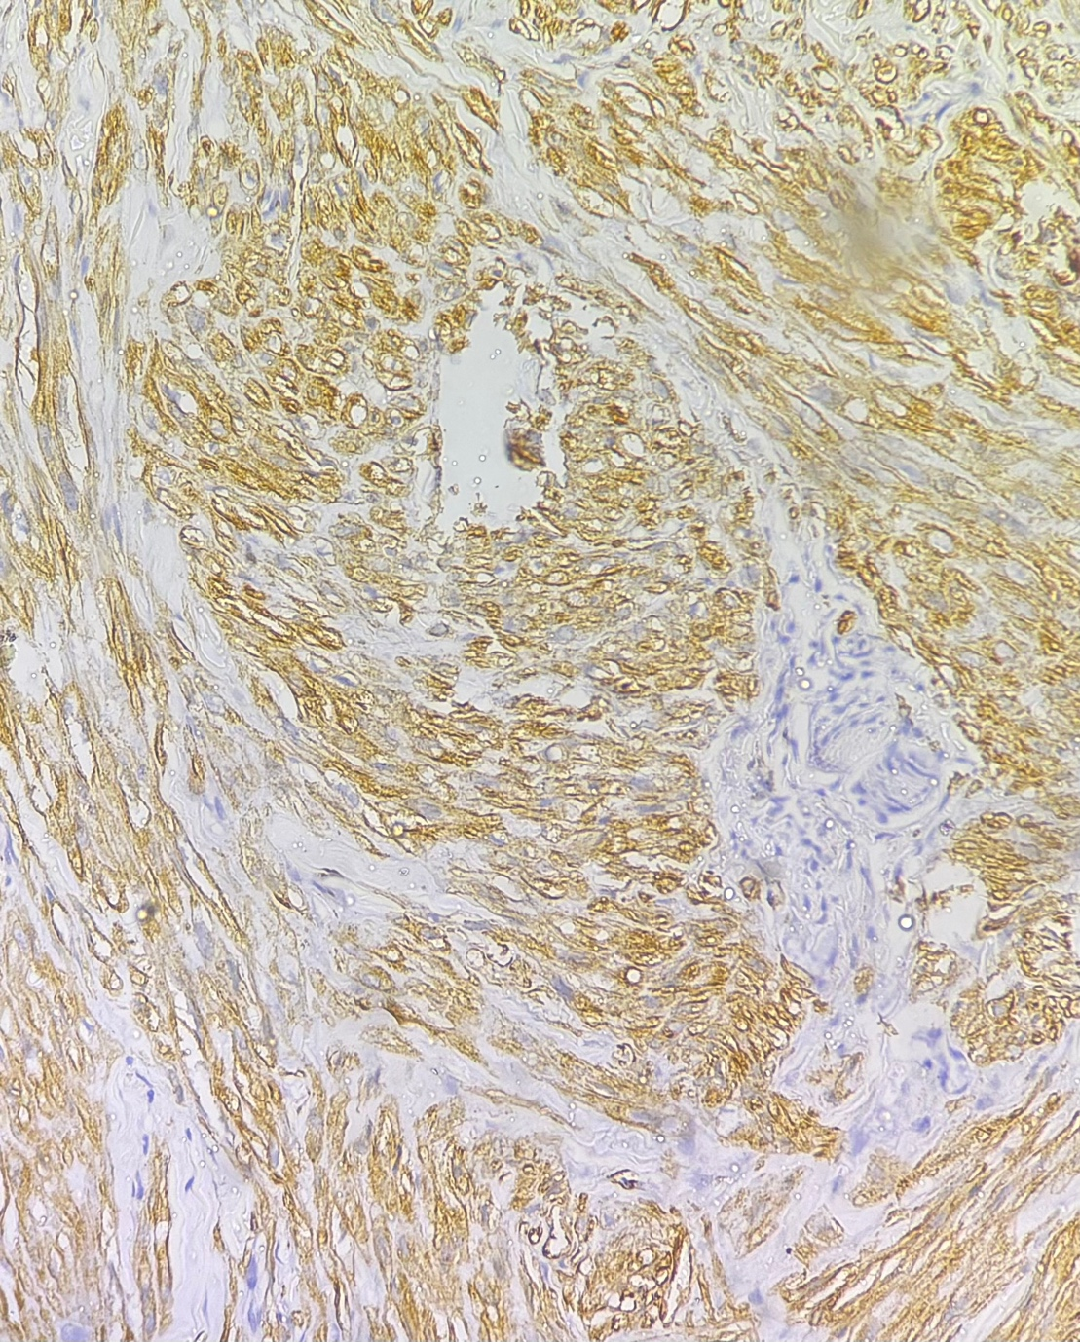

Figure 6 : Micrograph of a Hematoxylin & Eosin stained slide at 400 X showing spindle shaped tumor cells with cigar shaped nuclei, moderate to abundant eosinophilic cytoplasm with atypical mitosis (centre)

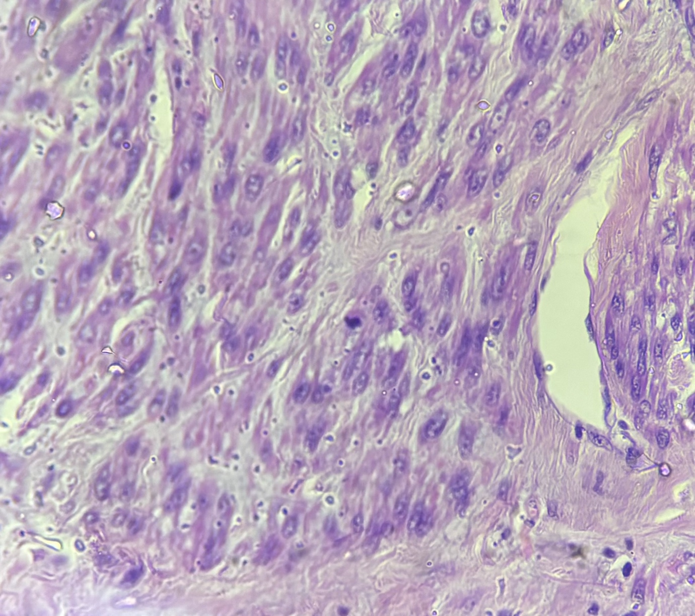

Figure 7 : 10 cm linear scar is seen on the right gluteal region post at follow up visit post radiotherapy.

