Comparative Analysis of Haematological and Biochemical Profiles in Asymptomatic and Symptomatic Malaria in Relation to Parasite Density
Original Research Article

Abstract
Malaria in endemic areas can be symptomatic or asymptomatic, affecting regular laboratory results. University students are relevant because parasitaemia can be identified accidentally, but haematological and biochemical alterations are difficult to interpret without local comparative evidence. This study examined asymptomatic and symptomatic malaria laboratory profiles in Takoradi Technical University students in Nzimah Mensah Hall and Prof. Duncan Hall. The study employed cross-sectional comparative design. 100 asymptomatic and 50 symptomatic malaria-positive students were recruited. Microscopy, Sysmex XN-350 haematological testing, and Humastar 100 biochemical testing were performed on venous blood for malaria confirmation. Data were analysed using R-studio. Group differences were analysed using t-tests or Mann–Whitney U tests with effect size calculation, and Spearman correlation examined parasite density relationships in asymptomatic cases. In symptomatic patients, parasite density was greater (2556.26 ± 2117.73 parasites/µL) than in asymptomatic instances (758.37 ± 1216.94 parasites/µL). Symptomatic students had lower haemoglobin (10.77 ± 2.36 vs 12.94 ± 2.01 g/dL), lower platelet counts (176.46 ± 76.13 vs 293.99 ± 76.25 ×10⁹/L), and higher ALT, AST, and creatinine levels. In asymptomatic cases, parasite density ranged from 21 to 9458 parasites/µL and had a slight connection with platelet count (ρ = 0.224, p = 0.025). Asymptomatic malaria in TTU students is stable in the lab despite changing parasite loads, while symptomatic malaria causes heavier parasitaemia and haematological and biochemical abnormalities.
Keywords: Hepatic dysfunction markers, Thrombocytopenia, Cohen’s d effect size, Campus health screening

1. Introduction
Malaria has a significant effect on routine lab tests, and in endemic countries, there are different manifestations. Full blood counts and blood chemistries reveal anaemia, thrombocytopenia, and changes in leucocytes, liver, and renal function, emphasizing the importance of lab medicine in the management of malaria. In various studies, Sakzabre et al. (2020) reported low haemoglobin and platelet counts among adult populations with malaria parasitaemia presenting to Volta Regional Hospital, Ghana. Similarly, Mutala et al. (2020) reported hematological abnormalities among urban, peri-urban, and rural populations of the Ashanti Region of Ghana. Similar findings were reported from endemic countries like Senegal, where Sylla et al. (2022) reported anaemia and thrombocytopenia among uncomplicated P. falciparum infections during antimalarial efficacy studies. Other studies across endemic regions have also reported comparable haematological disturbances in malaria, including alterations in erythrocyte indices and inflammatory markers associated with parasite invasion and host immune response (Cowman et al., 2016; Pang et al., 2025). Recent studies from Africa and Asia have further confirmed that malaria infection can significantly alter haematological and biochemical parameters across different populations and clinical settings (Maheswari et al., 2025; Jolinom et al., 2025).
Malaria may present as asymptomatic. Asymptomatic parasitaemia is now recognized for its epidemiological and clinical significance. Almeida et al. (2021) reported that asymptomatic P. vivax infections, including submicroscopic infections, were infectious to vectors. This finding highlights the epidemiological importance of asymptomatic malaria infections as potential reservoirs for continued malaria transmission. In Europe, Corbacho-Loarte et al. (2022) showed asymptomatic and low-density infections among migrants from sub-Saharan Africa, underscoring the limitations of clinical presentation in the diagnosis of the disease. In fact, Aninagyei et al. (2021) showed that asymptomatic P. falciparum parasitaemia among blood donors in Ghana was associated with changes in platelet thrombogenicity. Similar observations have been reported in other endemic settings where asymptomatic malaria infections were associated with oxidative stress responses and subtle haematological changes despite the absence of overt clinical symptoms (Babalola et al., 2020; Eledo et al., 2020). Epidemiological investigations in school-aged children and rural communities have also shown that asymptomatic malaria can influence haemoglobin levels, red blood cell indices, and immune responses, emphasizing its clinical and public health relevance (Sumbele et al., 2021; Orish et al., 2024).
The intensity of parasitaemia also appears to have a role to play. Antwi-Baffour et al. (2023) found correlations between the intensity of parasitaemia and some haematological parameters among outpatient attendees in Ghana, while Shukla et al. (2023) found correlations between parasite density and haematological and biochemical indices in patients with P. falciparum malaria. Ehiem et al. (2021) found that parasitaemia correlated with liver enzyme abnormalities and hepatocellular dysfunction in Ghanaian children with malaria, highlighting the role of biochemical abnormalities in the context of parasite infection and inflammation-induced damage to red blood cells. This further underlines the value of parasite density and its role in disease expression alongside other laboratory indices. Other clinical investigations have similarly demonstrated that increasing parasite density is associated with progressive changes in haematological markers and inflammatory mediators, supporting the importance of parasite burden in determining disease severity (Kachhawa, 2025; Bohli et al., 2025). Studies conducted in both endemic and non-endemic regions have also highlighted the relationship between parasite density and alterations in haematological profiles, including platelet indices and red cell parameters (Akpan et al., 2025; Okon et al., 2022).
However, there are three important areas that have not been addressed or have been insufficiently addressed by previous studies. The first area relates to the fact that while many studies have been done on malaria and parasite density, most have been done on symptomatic malaria and a few on pediatric populations. There have been no sufficient studies done on asymptomatic carriers among university students. In addition, several investigations have focused on specific sub-groups such as pregnant women, children, or individuals with co-infections, leaving young adult populations in university environments relatively under-studied (Okafor et al., 2024; Kamau et al., 2021).
The second area relates to the fact that while some comparative studies have been done on asymptomatic and symptomatic carriers, there have been few comparative studies done on asymptomatic and symptomatic carriers using haematological, biochemical, and parasitological indices. The third area relates to the fact that while some studies have been done on the differences between asymptomatic and symptomatic carriers, few have been done on the effect size analysis and the relationship between parasite density and some laboratory indices within each group. This analysis is important to help understand whether the differences between asymptomatic and symptomatic carriers are statistically significant and whether they are clinically significant, and whether they are similar to each other.
University students are an important subject group for such an investigation. They share living quarters with others, often travel between communities, and may be parasitaemic without showing clinical symptoms. In these groups, laboratory investigations may incidentally identify parasitaemia; however, the laboratory results of these malaria-infected individuals may be difficult to interpret in the absence of reference data. An understanding of whether asymptomatic malaria in these groups is accompanied by subtle but identifiable laboratory abnormalities, and whether these differ from those with malaria symptoms, is important for the management of malaria in university students.
The current study recruited students of the Takoradi Technical University residing in Nzimah Mensah Hall and Prof. Duncan Hall to investigate the differences in haematological and biochemical abnormalities in asymptomatic malaria cases compared with those with malaria symptoms. In addition to comparing laboratory results between groups, the current study also investigated the relationship between parasite density and laboratory results in asymptomatic malaria cases. By using parasitological measurement in combination with standardized laboratory investigations and effect size analysis, the current study provides methodologically rigorous results that are highly relevant for laboratory investigations of malaria in young adults in Ghana.

2. Materials and Methods
2.1 Study Design and Setting
A cross-sectional study design was done with a comparative approach between students of Takoradi Technical University (TTU), Western Region, Ghana. The two university residential halls (Nzimah Mensah Hall and Prof. Duncan Hall) were used to recruit the participants. The research involved comparison of haematological, biochemical and parasitological parameters between asymptomatic and symptomatic malaria infected students in the same campus set up.
2.2 Study Population and Sample Size
One hundred and fifty students were recruited with 100 being asymptomatic and 50 symptomatic malaria-positive students. The sample size has been chosen according to the requirements of sufficient statistic power to find the clinically significant differences in the main parameters of the laboratory results between the groups. Having the ratio of allocation 2:1 (100 vs. 50), the study has around 80% power at the 5% level of significance to identify moderate effect sizes in independent group comparison. The use of intentional oversampling of the participants who have not shown any symptoms was done to enable stabilization of subgroup analysis of the distribution of parasite density and correlation testing in this group.
The participants were categorized according to the clinical presentation at the moment of laboratory confirmation. Clinical assessment was performed at the point of blood sampling. The definition of asymptomatic included those students whose parasitaemia of malaria was confirmed through microscopy and did not have a fever or other symptoms of malaria at the time of sampling. For clarity, asymptomatic malaria was defined as microscopy-confirmed parasitaemia in a student with no measured fever (axillary temperature < 37.5°C), no malaria-consistent symptoms such as headache, chills, malaise, myalgia, or nausea, and no self-reported history of fever within the preceding 48–72 hours. This time window was applied in consideration of the erythrocytic lifecycle of the parasite to reduce the likelihood of enrolling individuals in the early phase of symptomatic infection.
Symptomatic patients were those who had microscopy-established malaria parasitaemia and matching clinical conditions. Symptomatic malaria therefore included students with measured fever (≥ 37.5°C) and/or malaria-consistent symptoms present at the time of evaluation. Informed consent was signed by all the participants before enrolment and collection of blood samples.
2.3 Blood Sample Collection
Standard phlebotomy procedures were used to collect a total of five milliliters of venous blood aseptically at the median cubital vein of each participant. Three milliliters of the dispensed DNA were transferred to K3EDTA anticoagulant tubes that were properly labeled to do haematological analysis and prepare thick and thin blood films. The rest of the two milliliters were moved to plain tubes where the serum was separated and subjected to biochemical analysis. All samples were carried under conditions of controlled environment and analyzed on the same day of collection in order to reduce pre-analytical variability and maintain analytical integrity.

Figure 1: Images Captured during the Sample Data Collection for the Study
2.4 Malaria Diagnosis and Parasite Quantification
Rapid diagnostic test kits were used to screen malaria infection and microscopy was used to confirm their infection. Thin and thick blood films were made through normal procedures. The thin films were adhesed in absolute methanol. Giemsa (10 per cent) was used in staining the slides (10 minutes) and the stains were observed under x100 oil immersion microscopy. Both thick and thin blood films were examined systematically, with thick films primarily used for parasite detection and density quantification, and thin films used to support morphological identification of the parasite. Quantitative buffy coat (QBC) analysis was not used in this study.
The parasite density was reported as parasites per microliter (parasites/uL) through conventional methods of counting. Parasite density estimation was performed using thick blood films by counting the number of parasites against a defined number of white blood cells and converting to parasites per microliter using standard calculation methods. Where appropriate, group comparison and correlation analysis were done on the data of parasite density in the asymptomatic subgroup.
On microscopic examination, the predominant forms observed in peripheral blood were ring-stage (early trophozoite) parasites, which are commonly seen in uncomplicated malaria infections. Species-level confirmation was based on microscopy within the epidemiological context of the study area, where Plasmodium falciparum is the predominant species. Molecular species confirmation was not performed.

2.5 Haematological Analysis
Haematological parameters were analyzed using a Sysmex XN-350 automated haematology analyzer in accordance with the manufacturer’s operational procedures. The evaluated indices included haemoglobin concentration, red blood cell count, mean corpuscular volume, mean corpuscular haemoglobin, mean corpuscular haemoglobin concentration, white blood cell count, and platelet count. Routine internal quality control procedures were performed prior to sample analysis to ensure analytical accuracy, precision, and instrument reliability in line with established laboratory standards.
2.6 Biochemical Analysis
Serum biochemical parameters were measured using a Humastar 100 automated chemistry analyzer following the manufacturer’s instructions. The assessed parameters included alanine aminotransferase, aspartate aminotransferase, total bilirubin, direct bilirubin, indirect bilirubin, urea, and creatinine. Internal quality control procedures were conducted prior to analysis to verify assay performance and ensure accuracy and reliability of results in accordance with standard laboratory practice.

2.7 Statistical Analysis
Data were analyzed with R-studio using parametric or non-parametric statistical tests according to the distribution characteristics of each variable. Independent t-tests were applied to variables that met assumptions of normality, while Mann–Whitney U tests were used for variables that were not normally distributed. Effect sizes were calculated to quantify the magnitude of differences between asymptomatic and symptomatic groups. Within the asymptomatic group, Spearman’s rank correlation analysis was performed to evaluate associations between parasite density and laboratory parameters. Statistical significance was defined at a threshold of p < 0.05.

3. Results & Discussion
A total of 150 students were evaluated, comprising 100 asymptomatic and 50 symptomatic malaria cases. The overall distribution of biochemical, haematological, and parasitological parameters is presented in Table 1. The reference ranges presented in the table are based on standard adult clinical laboratory intervals and are supported by World Health Organization (2024) guidance on haemoglobin thresholds and interpretation of haematological parameters. Clear differences were observed between groups, with symptomatic participants demonstrating more pronounced laboratory abnormalities.
Biochemical indices showed consistent elevations in the symptomatic group. As shown in Table 1, alanine aminotransferase (ALT) was higher among symptomatic participants (35.98 ± 16.74 U/L) compared with asymptomatic individuals (24.85 ± 9.67 U/L). A similar pattern was observed for aspartate aminotransferase (AST), which increased from 28.27 ± 12.11 U/L in asymptomatic cases to 46.80 ± 17.12 U/L in symptomatic cases, with median values in the symptomatic group exceeding the upper reference range. Renal markers followed the same direction, with creatinine rising from 0.89 ± 0.19 mg/dL in asymptomatic participants to 1.16 ± 0.30 mg/dL in symptomatic participants, and urea increasing from 13.65 ± 3.99 mg/dL to 18.10 ± 6.39 mg/dL. Bilirubin fractions demonstrated parallel elevations, as symptomatic individuals recorded higher total, direct, and indirect bilirubin concentrations, frequently approaching or exceeding reference limits.
Haematological findings also differed substantially. As presented in Table 1, haemoglobin levels were lower in symptomatic participants (10.77 ± 2.36 g/dL) than in asymptomatic participants (12.94 ± 2.01 g/dL). Red blood cell (RBC) counts decreased from 4.85 ± 0.56 × 10¹²/L in asymptomatic cases to 4.08 ± 0.69 × 10¹²/L in symptomatic cases. Mean corpuscular volume (MCV) and mean corpuscular haemoglobin concentration (MCHC) were likewise reduced in symptomatic individuals. Platelet counts showed one of the most marked differences, declining from 293.99 ± 76.25 × 10⁹/L in asymptomatic cases to 176.46 ± 76.13 × 10⁹/L in symptomatic cases. In contrast, white blood cell (WBC) counts were higher in symptomatic participants (7.57 ± 2.81 × 10⁹/L) compared with asymptomatic participants (6.11 ± 1.85 × 10⁹/L), suggesting a heightened inflammatory response.
Parasitological assessment revealed substantial disparities in parasite burden. As indicated in Table 1, mean parasite density was 758.37 ± 1216.94 parasites/μL in asymptomatic participants and 2556.26 ± 2117.73 parasites/μL in symptomatic participants. Median values further illustrated this difference, with symptomatic cases demonstrating approximately sixfold higher parasite loads.

Table 1: Participant Characteristics and Laboratory Parameters
Parameter | Asymptomatic (n=100) | Symptomatic (n=50) | Median (IQR)_Asymptomatic | Median (IQR)_Symptomatic | Reference Range | Units
Biochemical Parameters
ALT | 24.85 ± 9.67 | 35.98 ± 16.74 | 24.5 (17-32.25) | 36.5 (23.75-46.75) | 7-56 | U/L
AST | 28.27 ± 12.11 | 46.8 ± 17.12 | 28 (18-37) | 47.5 (36.75-58.75) | 10-40 | U/L
Creatinine | 0.89 ± 0.19 | 1.16 ± 0.3 | 0.87 (0.75-1.02) | 1.15 (0.95-1.37) | 0.6-1.3 | mg/dL
Direct_Bilirubin | 0.13 ± 0.06 | 0.25 ± 0.1 | 0.13 (0.08-0.18) | 0.25 (0.18-0.33) | 0.0-0.3 | mg/dL
Indirect_Bilirubin | 0.66 ± 0.28 | 1.2 ± 0.58 | 0.62 (0.46-0.86) | 1.13 (0.76-1.46) | 0.2-1.0 | mg/dL
Total_Bilirubin | 0.79 ± 0.29 | 1.45 ± 0.6 | 0.77 (0.59-1.02) | 1.41 (0.99-1.79) | 0.3-1.2 | mg/dL
Urea | 13.65 ± 3.99 | 18.1 ± 6.39 | 13.7 (11.2-16.15) | 18.55 (14.45-21.77) | 7-20 | mg/dL
Hematological Parameters
Hemoglobin | 12.94 ± 2.01 | 10.77 ± 2.36 | 13.37 (11.44-14.12) | 10.76 (8.46-12.48) | 12.0-16.0 | g/dL
MCH | 28.8 ± 3.14 | 27.39 ± 3.67 | 28.65 (27.2-30.7) | 27.4 (24.95-29.9) | 27-32 | pg
MCHC | 33.99 ± 2.08 | 32.29 ± 2.62 | 34.1 (32.68-35.45) | 31.9 (30.7-33.5) | 32-36 | g/dL
MCV | 89.72 ± 7.77 | 85.96 ± 9.06 | 90.8 (85.47-93.6) | 86.9 (77.75-91.3) | 80-100 | fL
Platelets | 293.99 ± 76.25 | 176.46 ± 76.13 | 306 (234.75-348.25) | 186 (120.25-226) | 150-450 | ×10⁹/L
RBC | 4.85 ± 0.56 | 4.08 ± 0.69 | 4.84 (4.52-5.2) | 4.06 (3.63-4.58) | 4.1-5.9 | ×10¹²/L
WBC | 6.11 ± 1.85 | 7.57 ± 2.81 | 5.96 (4.96-7.32) | 7.66 (5.46-9.52) | 4.0-11.0 | ×10⁹/L
Parasitological Parameters
Parasite_Count | 758.37 ± 1216.94 | 2556.26 ± 2117.73 | 371.5 (162.5-982.5) | 2218 (953-3662.75) | Variable | parasites/μL
Parasite_Density | 758.37 ± 1216.94 | 2556.26 ± 2117.73 | 371.5 (162.5-982.5) | 2218 (953-3662.75) | Variable | parasites/μL

Statistical comparison confirmed that many of these differences were significant (Table 2). Haemoglobin and RBC counts were significantly lower in symptomatic participants (p < 0.001), both demonstrating large effect sizes. MCV and MCH were also significantly reduced (p = 0.014 and p = 0.022, respectively), though with smaller effect sizes. MCHC showed a significant reduction using the Mann–Whitney U test (p < 0.001) with a large effect size. Platelet counts exhibited a highly significant decrease in symptomatic participants (p < 0.001) with a large effect size, while WBC counts were significantly higher (p = 0.001) with a medium effect size.
Biochemical parameters demonstrated similarly strong statistical differences. AST and ALT were significantly elevated in symptomatic cases (p < 0.001), both with large effect sizes. Total, direct, and indirect bilirubin concentrations were also significantly higher (all p < 0.001), each with large effect sizes. Renal markers, including urea and creatinine, showed significant increases in symptomatic participants (p < 0.001), again with large effect sizes. Overall, Table 2 demonstrates that most laboratory differences between groups were not only statistically significant but also of considerable magnitude.

Table 2: Statistical Comparison of Parameters between Groups
Parameter | Statistical Test | Asymptomatic mean ± SD | Symptomatic Mean ± SD | Test Statistic | p-value | Effect Size1 | Significant2
Hemoglobin | Independent t-test | 12.94 ± 2.01 | 10.77 ± 2.36 | 5.563 | 0.000 | Large | Yes*
RBC | Independent t-test | 4.85 ± 0.56 | 4.08 ± 0.69 | 6.804 | 0.000 | Large | Yes*
MCV | Independent t-test | 89.72 ± 7.77 | 85.96 ± 9.06 | 2.510 | 0.014 | Small | Yes*
MCH | Independent t-test | 28.8 ± 3.14 | 27.39 ± 3.67 | 2.325 | 0.022 | Small | Yes*
MCHC | Mann-Whitney U | 33.99 ± 2.08 | 32.29 ± 2.62 | 3577.000 | 0.000 | Large | Yes*
Platelets | Independent t-test | 293.99 ± 76.25 | 176.46 ± 76.13 | 8.908 | 0.000 | Large | Yes*
WBC | Independent t-test | 6.11 ± 1.85 | 7.57 ± 2.81 | −3.326 | 0.001 | Medium | Yes*
AST | Mann-Whitney U | 28.27 ± 12.11 | 46.8 ± 17.12 | 954.000 | 0.000 | Large | Yes*
ALT | Independent t-test | 24.85 ± 9.67 | 35.98 ± 16.74 | −4.352 | 0.000 | Large | Yes*
Total_Bilirubin | Independent t-test | 0.79 ± 0.29 | 1.45 ± 0.6 | −7.368 | 0.000 | Large | Yes*
Direct_Bilirubin | Mann-Whitney U | 0.13 ± 0.06 | 0.25 ± 0.1 | 747.500 | 0.000 | Large | Yes*
Indirect_Bilirubin | Mann-Whitney U | 0.66 ± 0.28 | 1.2 ± 0.58 | 960.000 | 0.000 | Large | Yes*
Urea | Independent t-test | 13.65 ± 3.99 | 18.1 ± 6.39 | −4.494 | 0.000 | Large | Yes*
Creatinine | Independent t-test | 0.89 ± 0.19 | 1.16 ± 0.3 | −5.915 | 0.000 | Large | Yes*
1 Effect sizes: Negligible (<0.2), Small (0.2-0.5), Medium (0.5-0.8), Large (>0.8)
2 * p < 0.05 indicates a statistically significant difference
Within the asymptomatic group, parasite density exhibited wide variability. As shown in Table 3, the mean parasite density was 758.37 parasites/μL, with a median of 371.5 parasites/μL and values ranging from 21 to 9458 parasites/μL. The interquartile range (162.5–982.5 parasites/μL) indicated a skewed distribution, with some individuals harbouring substantial parasite loads despite the absence of clinical symptoms. The categorical distribution presented in Figure 2 shows that 66% of asymptomatic participants fell within the low-density range (100–999 parasites/μL), 22% within the moderate range (1000–9999 parasites/μL), and 12% within the very low category (<100 parasites/μL).
Table 3: Parasite Density Characteristics of Asymptomatic Malaria Patients
Statistical Measure | Value (parasites/μL)
n | 100
Mean | 758.37
SD | 1216.94
Median | 371.5
Q1 | 162.5
Q3 | 982.5
Min | 21
Max | 9458

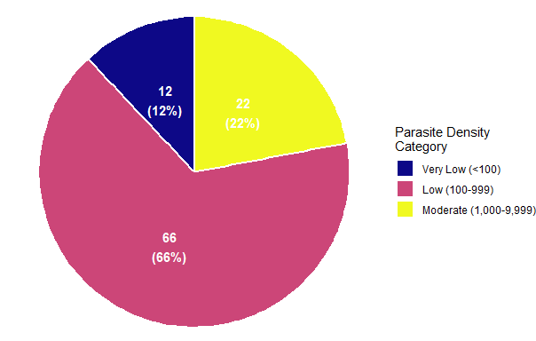
Figure 2: Parasite Density Categories (Distribution in Asymptomatic Patients)

Correlation analysis explored whether parasite density influenced laboratory parameters among asymptomatic carriers. As presented in Table 4 and illustrated in the correlation heatmap (Figure 3), most relationships were weak or negligible. Platelet count demonstrated the only statistically significant association, showing a weak positive correlation with parasite density (ρ = 0.224, p = 0.025). This relationship is visually supported by the scatter plot in Figure 4, which demonstrates a slight upward trend in platelet values with increasing parasite density on a logarithmic scale. Haemoglobin (ρ = 0.087, p = 0.391) and RBC count (ρ = 0.031, p = 0.757) showed negligible positive correlations. WBC count showed a negligible negative correlation (ρ = −0.003, p = 0.973). Liver enzymes and renal markers exhibited weak or negligible correlations, none of which reached statistical significance. Total bilirubin showed a weak positive association (ρ = 0.178, p = 0.076), approaching but not achieving statistical significance.
Table 4: Spearman Rank Correlation between Parasite Density and Laboratory Parameters of Asymptomatic Malaria Patients
Laboratory Parameter | Correlation Coefficient (ρ) | p-value | Sig.1 | Strength | Direction
Hemoglobin | 0.087 | 0.391 |  | Negligible | Positive
RBC | 0.031 | 0.757 |  | Negligible | Positive
Platelets | 0.224 | 0.025 | * | Weak | Positive
WBC | −0.003 | 0.973 |  | Negligible | Negative
AST | 0.009 | 0.933 |  | Negligible | Positive
ALT | −0.101 | 0.316 |  | Weak | Negative
Total_Bilirubin | 0.178 | 0.076 |  | Weak | Positive
Urea | −0.133 | 0.187 |  | Weak | Negative
Creatinine | −0.058 | 0.565 |  | Negligible | Negative
1 *** p < 0.001, ** p < 0.01, * p < 0.05
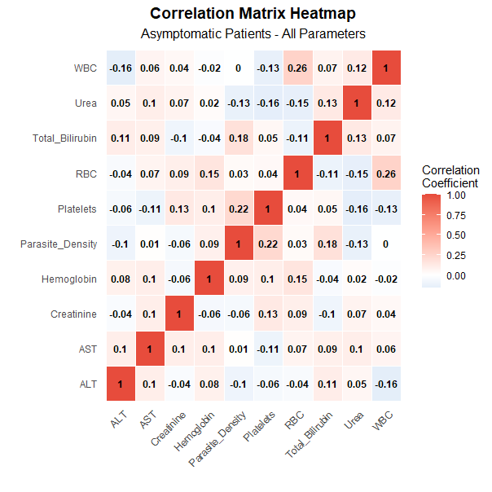
Figure 3: Spearman Rank Correlation Matrix Heatmap
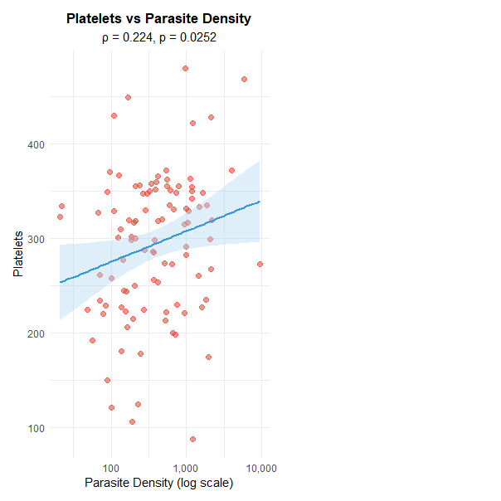
Figure 4: Scatter Plot of Platelets and Parasite Density
The overall laboratory profile comparison further clarifies these differences. The radar chart in Figure 5 demonstrates that symptomatic participants consistently displayed higher liver enzymes, bilirubin levels, renal markers, and WBC counts, while asymptomatic participants maintained comparatively higher haemoglobin, RBC counts, mean corpuscular indices, and platelet levels. Effect size analysis using Cohen’s D, shown in Figure 6, confirms that the largest between-group differences were observed for platelets, RBC count, haemoglobin, total bilirubin, creatinine, urea, ALT, and AST. WBC count demonstrated a moderate effect, while MCV and MCH showed smaller yet statistically significant differences.
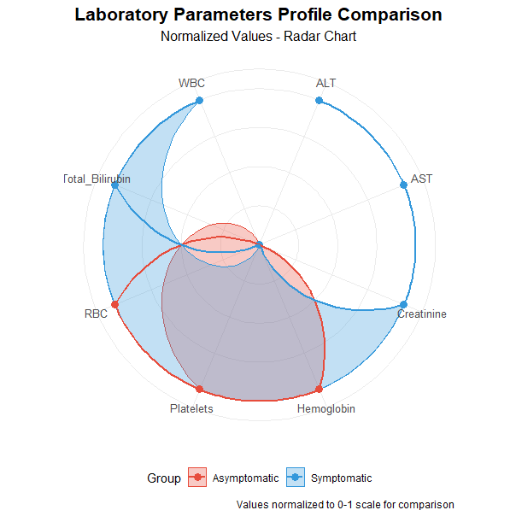
Figure 5: Radar Chart of Laboratory Parameters Profile Comparison

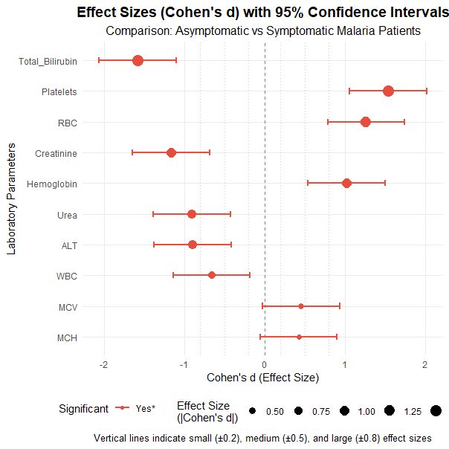
Figure 6: Effect Sizes (Cohen's D) with 95% Confidence Intervals
Taken together, these findings indicate that symptomatic malaria among Takoradi Technical University students is characterised by elevated hepatic and renal markers, reduced erythrocyte indices, and marked thrombocytopenia, accompanied by significantly higher parasite densities. In contrast, asymptomatic carriers generally maintained relatively stable haematological and biochemical profiles, with parasite density showing minimal influence on most laboratory parameters except for a modest association with platelet count.

4. Discussion
In this study of Takoradi Technical University students, symptomatic malaria was related with a much higher laboratory load across haematological, biochemical, and parasitological parameters. This population's symptoms matched increased parasite density and more severe blood cell indices and organ function markers. Ghanaian individuals with malaria parasitaemia had anaemia and thrombocytopenia as the main haematological findings (Sakzabre et al., 2020). These observations are consistent with broader investigations showing that malaria infection frequently alters red cell indices, platelet counts, and inflammatory markers due to parasite-induced haemolysis and immune activation (Pang et al., 2025; Kotepui et al., 2025).
Symptomatic students had lower haemoglobin, red blood cell count, MCHC, and MCV and MCH than asymptomatic carriers. This suggests symptomatic malaria disrupts erythrocytes more. Malaria haemolyzes and removes infected and uninfected erythrocytes, causing anaemia (Naser et al., 2024). Mutala et al. (2020) found haematological differences related with malaria in urban, peri-urban, and rural Ghana, supporting red cell indices in endemic areas. Kaboré et al. (2020) found that asymptomatic malaria can impact red blood cell homeostasis in Burkina Faso, though less so. Similar reductions in haemoglobin and erythrocyte indices have been reported among malaria-infected populations in Ethiopia and Cameroon, further supporting the role of parasite infection in disrupting red blood cell homeostasis (Abebe et al., 2024; Njewa et al., 2024). This suggests that asymptomatic parasitaemia is physiologically active, while symptomatic infection is more consistently associated with clinically significant haemoglobin and RBC-related index decreases.
One of the most clearly differed measures was platelet count, with symptomatic students having severe thrombocytopenia and larger effect sizes. This is consistent with Volta Region Ghanaian findings that adults with malaria parasitaemia have thrombocytopenia (Sakzabre et al., 2020). A thorough review by Mahittikorn et al. (2021) found that malaria often reduces platelets, especially in severe cases. Additional clinical investigations have confirmed that thrombocytopenia and platelet indices are strongly associated with parasite density and may serve as useful predictors of malaria infection in endemic settings (Tiiba et al., 2023; Akpan et al., 2025). The high platelet signal in this study supports the practical laboratory utility of platelet count as a malaria biomarker, especially when interpreted with parasite density and erythrocyte parameters.
Symptomatic students had greater white blood cell counts, indicating a stronger inflammatory response to infection. More evidence suggests that malaria stimulates inflammatory pathways, with immune responses ranging by disease severity (Wilairatana et al., 2022). Host–parasite interaction studies have further demonstrated that inflammatory cytokine responses and immune activation are key determinants of disease severity in malaria infections (Asmah et al., 2024). Aninagyei et al. (2021) found changed platelet thrombogenicity and inflammatory alterations in asymptomatic blood donors with Plasmodium falciparum parasitaemia in Ghana, showing that even clinically quiet infections can disrupt platelet pathways. This study shows that overt clinical illness is associated with higher WBC levels, indicating increased inflammation.
Symptomatic students had more biochemical abnormalities. ALT, AST, and all bilirubin fractions increased considerably with large effect sizes. In Ghanaian children, Ehiem et al. (2021) found increased liver enzymes in acute malaria before therapy and connected infection to hepatocellular stress. Biochemical and haematological abnormalities were also found in uncomplicated P. falciparum malaria in Senegal where Sylla et al. (2022) specifically reported anaemia, thrombocytopenia, and biochemical alterations in patients with uncomplicated malaria, highlighting the clinical relevance of these laboratory markers in symptomatic infections. Comparable biochemical disruptions have also been observed in other malaria-infected populations, including alterations in renal and hepatic function parameters associated with parasite-induced systemic stress (Akpulu et al., 2025; Obiorah et al., 2024).
Symptomatic students with elevated transaminases and bilirubin may have malaria-associated haemolysis and hepatic involvement, supporting the use of basic liver function tests in clinically suspected cases.
Similar patterns were seen in renal indicators. Again, symptomatic pupils had higher urea and creatinine levels with substantial effect sizes. Although no renal disease was detected, these findings suggest that symptomatic infection may cause increased systemic stress due to dehydration, inflammation, or early renal involvement. At therapy monitoring, Sylla et al. (2022) found biochemical changes in uncomplicated malaria, suggesting kidney indicators may shift even in mild malaria. New results from a young adult campus sample suggests renal function metrics can discriminate symptomatic from asymptomatic malaria.
Symptomatic students had highest median parasite density, indicating more infection than asymptomatic carriers. This supports the notion that parasitaemia causes higher clinical and laboratory abnormalities. Antwi-Baffour et al. (2023) found high parasite counts in malaria outpatients in Ghana and examined their associations with haematological markers, stressing parasite density as an interpretative factor. Recent comparative studies across endemic and non-endemic settings have similarly demonstrated that higher parasite densities are often associated with more pronounced haematological abnormalities and disease severity indicators (von Wedel et al., 2025). Mutala et al. (2020) found that parasite density varies substantially across Ghanaian populations, even within endemic locations. In this study, asymptomatic students had a wide density range, including moderate levels in a significant proportion, supporting public health concerns that asymptomatic carriers may transmit.
In the asymptomatic subgroup, parasite density correlated weakly with most laboratory markers, with platelet count being the sole statistically significant link. Sakzabre et al. (2020) found that as parasite density increased in adult hospital patients in Ghana, platelet counts decreased. Comparable patterns have been described in asymptomatic malaria populations where laboratory changes may remain subtle despite measurable parasite densities (Nundu et al., 2021; Nwaneri et al., 2020). Population features may explain the disparity. Asymptomatic university students were healthier than hospital-based populations, which may have higher inflammatory responses and splenic sequestration. According to Naser et al. (2024), malaria-related haematological alterations are influenced by host–parasite interaction and vary by age, exposure history, and clinical phenotype. This limited link shows that parasite density alone may not predict routine haematological or biochemical profiles in asymptomatic young individuals.
TTU students with symptomatic malaria had greater parasite density, thrombocytopenia, lower erythrocyte indices, and raised hepatic and renal indicators. Despite changing parasite levels, asymptomatic carriers had stable laboratory profiles. These findings support Ghanaian and African data that malaria causes full blood count and biochemical panel patterns. However, asymptomatic infection in young individuals may not show clear linear connections between parasite density and standard laboratory markers. This highlights the necessity of parasitological confirmation and complete laboratory profiling in campus health services, where symptoms alone may underestimate infection and context-specific test interpretation is necessary.

5. Conclusion
A consistent trend emerges from this study. Symptomatic malaria in Takoradi Technical University students had more parasites and laboratory abnormalities than asymptomatic infection. Symptomatic students exhibited low haemoglobin, red blood cell counts, and thrombocytopenia. They also had greater liver enzymes, bilirubin, urea, and creatinine. Despite variable parasite levels, asymptomatic carriers had more consistent haematological and biochemical profiles. Importantly, parasite density in asymptomatic students did not correlate with most laboratory markers, suggesting that parasite load alone does not predict laboratory impairment in clinically silent infection.
This research has practical applications. A comprehensive blood count and basic biochemical testing can help diagnose symptomatic malaria and determine its physiological effects. Nevertheless, asymptomatic infection should not be ignored. Moderate parasite densities in healthy students may spread campus-wide. Thus, university health services in endemic areas should use parasitological testing and targeted laboratory assessment instead of clinical presentation. The study improves laboratory-based clinical decision-making and structured malaria screening in young adults.

Limitations and Recommendations. This study examined the haematological and biochemical differences among students at Takoradi Technical University that are linked to malaria. It was not possible to evaluate the probable role of helminth infections, hemoglobinopathies, and nutritional deficits in the reported haematological alterations. These factors may independently influence red cell indices, platelet counts, and biochemical markers, and their absence from the analysis may have contributed to residual variability in the findings.
In addition, species-level confirmation of Plasmodium infection was not performed using molecular diagnostic techniques. Although microscopy was used for morphological identification and the study was conducted in a setting where Plasmodium falciparum is epidemiologically predominant, the possibility of mixed or non-falciparum infections cannot be entirely excluded. Species variation may influence the degree of haematological and biochemical alterations observed.
The study also employed a cross-sectional design, which limits causal interpretation of the observed laboratory differences between asymptomatic and symptomatic groups. Temporal changes in parasite density and laboratory parameters could not be assessed beyond the single sampling point.
To enhance attribution of reported laboratory alterations and support clinical interpretation, future research in comparable university populations should include screening for these diseases and, if feasible, analytically correct for them. Future studies may also incorporate molecular species confirmation and longitudinal follow-up to better characterize parasite dynamics and their relationship with laboratory indices over time.

Ethical Approval and Consent:
Ethical approval for this study was obtained from the Takoradi Technical University University Ethics Review Committee (Approval Ref. No. TTU/ERC/25/007). Permission was also secured to conduct participant recruitment and blood sample collection within Nzimah Mensah Hall and Prof. Duncan Hall. Participation was voluntary, and written informed consent was obtained prior to enrolment and specimen collection. Confidentiality was maintained throughout the study by using unique identifiers and restricting access to research data. The primary benefit of this work is the added evidence on how asymptomatic malaria parasitaemia influences haematological and biochemical parameters among TTU students, supporting improved screening and laboratory-based decision-making in similar populations.

DECLARATIONS
Data Availability Statement
Upon reasonable request, the corresponding author will provide the data used to support our findings.

COMPETING INTERESTS DISCLAIMER:
Authors have declared that they have no known competing financial interests OR non-financial interests OR personal relationships that could have appeared to influence the work reported in this paper.

Disclaimer (Artificial intelligence)

Author(s) hereby declare that NO generative AI technologies such as Large Language Models (ChatGPT, COPILOT, etc.) and text-to-image generators have been used during the writing or editing of this manuscript.

6. References
Abebe, W., Asmare, Z., Barasa, S., Woldesenbet, D., Lemma, W., & Derso, A. (2024). Assessment of the selected hematological profiles among malaria and Schistosoma mansoni co-infected patients, Northwest Ethiopia. Journal of Parasitic Diseases, 48(2), 308-319. https://doi.org/10.1007/s12639-024-01669-z
Akpan, P. A., Ekpo, E. E., Emechebe, C. I., & Okafor, I. M. (2025). Platelet indices and malaria parasite density of pregnant women with asymptomatic malaria parasite infection in a tertiary health facility in Calabar, Nigeria. Nigerian Journal of Parasitology, 46(2). https://doi.org/10.4314/njpar.v46i2.20
Akpulu, S. P., Armstrong, R. A., & Mairiga, A. A. (2025). Haematological and Biochemical Alterations in Diabetic Patients with Malaria Parasitaemia: Insights from Dalhatu Araf Specialist Hospital, Lafia, Nigeria. FULafia Journal of Health Sciences, 1(1), 118-126. https://fjohs.org/index.php/fujohs/article/view/20/19
Almeida, G. G., Costa, P. A. C., Araujo, M. D. S., Gomes, G. R., Carvalho, A. F., Figueiredo, M. M., ... & Gazzinelli, R. T. (2021). Asymptomatic Plasmodium vivax malaria in the Brazilian Amazon: submicroscopic parasitemic blood infects Nyssorhynchus darlingi. PLoS Neglected Tropical Diseases, 15(10), e0009077. https://doi.org/10.1371/journal.pntd.0009077
Aninagyei, E., Adu, P., Rufai, T., Ampomah, P., Kwakye-Nuako, G., Egyir-Yawson, A., & Acheampong, D. O. (2021). Effect of asymptomatic Plasmodium falciparum parasitaemia on platelets thrombogenicity in blood donors. Indian Journal of Hematology and Blood Transfusion, 37(4), 632-639. https://doi.org/10.1007/s12288-020-01390-w
Antwi-Baffour, S., Mensah, B. T., Johnson, G., Armah, D. N. O., Ali-Mustapha, S., & Annison, L. (2023). Haematological parameters and their correlation with the degree of malaria parasitaemia among outpatients attending a polyclinic. Malaria journal, 22(1), 281. https://doi.org/10.1186/s12936-023-04710-3
Asmah, R. H., Squire, D. S., Adupko, S., Adedia, D., Kyei-Baafour, E., Aidoo, E. K., & Ayeh-Kumi, P. F. (2024). Host-parasite interaction in severe and uncomplicated malaria infection in ghanaian children. European Journal of Clinical Microbiology & Infectious Diseases, 43(5), 915-926. https://doi.org/10.1007/s10096-024-04804-z
Babalola, A. S., Jonathan, J., & Michael, B. E. (2020). Oxidative stress and anti-oxidants in asymptomatic malaria-positive patients: a hospital-based cross-sectional Nigerian study. The Egyptian Journal of Internal Medicine, 32(1), 23. https://doi.org/10.1186/s43162-020-00024-x
Bohli, J. K., Ansah, P. B., Kwamena, T. E., Allotey, E., Duneeh, R. V., Yeboah, E. B., ... & Ablordey, K. (2025). Variations in haematological and inflammatory biomarkers and their association with Plasmodium falciparum malaria: a cross-sectional comparative study at a clinic in Ghana. Malaria Journal, 24(1), 220. https://doi.org/10.1186/s12936-025-05474-8
Corbacho-Loarte, M. D., Crespillo-Andújar, C., Chamorro-Tojeiro, S., Norman, F., Pérez-Molina, J. A., Martín, O., ... & Monge-Maillo, B. (2022). Screening of imported malaria infection in asymptomatic migrants from Sub-Saharan Africa: A retrospective analysis of a 2010–2019 cohort. Travel Medicine and Infectious Disease, 49, 102411. https://doi.org/10.1016/j.tmaid.2022.102411
Cowman, A. F., Healer, J., Marapana, D., & Marsh, K. (2016). Malaria: biology and disease. Cell, 167(3), 610-624. https://doi.org/10.1016/j.cell.2016.07.055
Ehiem, R. C., Nanse, F. A. K., Adu-Frimpong, M., & Mills-Robertson, F. C. (2021). Parasitaemia estimation and prediction of hepatocellular dysfunction among Ghanaian children with acute malaria using haemoglobin levels. Heliyon, 7(7). https://doi.org/10.1016/j.heliyon.2021.e07445
Eledo, B. O., Tommy, E. O., Onuoha, E. C., Dunga, K. E., & Okamgba, O. C. (2020). The effects of assymptomatic malaria on some haematological parameters among the elderly in a sub-urban community in Southern Nigeria. Int J Blood Res Disord, 7, 055. https://doi.org/10.23937/2469-5696/1410055
Jolinom, E., EDZODZOMO, G., PAMBO-PAMBO, A. B., OBIANG, C. S., MOUNDOUNGA, H. K., & ENGONGA, L. C. O. Hemato-Biochemical Profile of Malaria Patients in Sub Saharan Africa: A Case of the Urban Health Center of Franceville, Gabon. https://doi.org/10.9734/jamb/2025/v25i4924
Kaboré, B., Post, A., Berendsen, M. L., Diallo, S., Lompo, P., Derra, K., ... & van der Ven, A. J. (2020). Red blood cell homeostasis in children and adults with and without asymptomatic malaria infection in Burkina Faso. PLoS One, 15(11), e0242507. https://doi.org/10.1371/journal.pone.0242507
Kachhawa, K. (2025). Analysis of the Clinical Profile in Patients with Plasmodium falciparum Malaria and Its Association with Parasite Density. Journal of global infectious diseases. https://doi.org/10.4103/0974-777X.201626
Kamau, E., Yates, A., Maisiba, R., Singoei, V., Opot, B., Adeny, R., ... & Polyak, C. S. (2021). Epidemiological and clinical implications of asymptomatic malaria and schistosomiasis co-infections in a rural community in western Kenya. BMC Infectious Diseases, 21(1), 937. https://doi.org/10.1186/s12879-021-06626-2
Kotepui, M., Suwannatrai, A. T., Kotepui, K. U., Mahittikorn, A., Masangkay, F. R., Thinkhamrop, K., ... & Wilairatana, P. (2025). A systematic review and meta-analysis of Plasmodium infections and erythrocyte sedimentation rate in relation to disease severity. BMC Infectious Diseases, 25(1), 1306. https://doi.org/10.1186/s12879-025-11622-x
Maheswari, U., Sonti, S., & Priyadharshini, D. (2025). Unveiling Hemato-Biochemical Signatures of Malaria: A Cross-Sectional Study from a Tertiary Care Perspective. TPM–Testing, Psychometrics, Methodology in Applied Psychology, 32(S1 (2025): Posted 12 May), 1232-1237. https://tpmap.org/submission/index.php/tpm/article/view/767
Mahittikorn, A., Masangkay, F. R., Kotepui, K. U., Mala, W., Milanez, G. D. J., Wilairatana, P., & Kotepui, M. (2021). Alteration of platelet count in patients with severe non-Plasmodium falciparum malaria: a systematic review and meta-analysis. Biology, 10(12), 1275. https://doi.org/10.3390/biology10121275
Mutala, A. H., Badu, K., Owusu, C., Agordzo, S. K., Tweneboah, A., Abbas, D. A., & Addo, M. G. (2020). Impact of malaria on haematological parameters of urban, peri-urban and rural residents in the Ashanti region of Ghana: a cross-sectional study. AAS Open Research, 2, 27. https://doi.org/10.12688/aasopenres.12979.3
Naser, R. H., Rajaii, T., Farash, B. R. H., javad Seyyedtabaei, S., Hajali, V., Sadabadi, F., & Saburi, E. (2024). Hematological changes due to malaria–An update. Molecular and biochemical parasitology, 259, 111635. https://doi.org/10.1016/j.molbiopara.2024.111635
Njewa, B., Eyong, E. E. J., & Ebai, C. B. (2024). Malaria parasitaemia and its impact on biological parameters among children< 16 years old attending the Nkwen District Hospital, Cameroon. MalariaWorld Journal, 15, 3. https://doi.org/10.5281/zenodo.10731943
Nundu, S. S., Culleton, R., Simpson, S. V., Arima, H., Muyembe, J. J., Mita, T., ... & Yamamoto, T. (2021). Malaria parasite species composition of Plasmodium infections among asymptomatic and symptomatic school-age children in rural and urban areas of Kinshasa, Democratic Republic of Congo. Malaria journal, 20(1), 389. https://doi.org/10.1186/s12936-021-03919-4
Nwaneri, D., Oladipo, O., Ifebi, E., Oviawe, O., Asemota, O., Ogboghodo, B., ... & Sadoh, A. (2020). Haematological parameters and spleen rate of asymptomatic and malaria negative children in Edo south district, Nigeria. Annals of Global Health, 86(1), 62. https://doi.org/10.5334/aogh.2458
Obiorah, C. S., Elkanah, O. S., Kela, S. L., Barka, J. S., Christopher, P. N., & Onyeuku, O. C. Biochemical and Hematological Derangement in Plasmodium falciparum Infected Patients Attending Health Facilities in Northern Taraba State, Nigeria. https://doi.org/10.52403/ijrr.20240828
Okafor, I., Odey, O. J., Njar, V. E., & Emechebe, C. (2024). Serum Iron, Total Iron Binding Capacity and Malaria Parasite Density of Pregnant Women with Asymptomatic Malaria Parasite Infection Attending Ante-Natal Clinic at A Tertiary Hospital in Calabar, Nigeria. AJFMED, 3(2), 84-90. https://ajfmed.com/index.php/ajfm/article/view/74
Okon, A. U., Eze, B. I., Emmanuel, U. A., Marcus, I. W., & Adanna, U. C. (2022). Correlation of parasite density and biochemical parameters in children with malaria infection in Calabar, South-South Nigeria. Egyptian Pediatric Association Gazette, 70(1), 27. https://doi.org/10.1186/s43054-022-00122-1
Orish, V. N., Lokpo, S. Y., Kwadzokpui, P. K., Safianu, R., Marinkovic, A., Prakash, S., ... & Sanyaolu, A. (2024). Association between asymptomatic Plasmodium falciparum malaria infection, anaemia and mean corpuscular volume of school children in the Volta Region of Ghana. European Journal of Microbiology and Immunology, 14(2), 195-201. https://doi.org/10.1556/1886.2024.00007
Pang, B., Raoufi, A., Taghinejad, Z., Fakhraei, M., Esfahani, M. L., Heydari, P., ... & Samarkhazan, H. S. (2025). Parasites in the bloodstream: Unraveling hematological chaos and clinical implications. Parasitology International, 103172. https://doi.org/10.1016/j.parint.2025.103172
Sakzabre, D., Asiamah, E. A., Akorsu, E. E., Abaka-Yawson, A., Dika, N. D., Kwasie, D. A., ... & Osei, G. Y. (2020). Haematological profile of adults with malaria parasitaemia visiting the Volta Regional Hospital, Ghana. Advances in Hematology, 2020(1), 9369758. https://doi.org/10.1155/2020/9369758
Shukla, A., Thakur, S. S., Jaiswal, S. K., Patidar, H., Dubey, K., & Solanki, P. (2023). Parasitic density and its relationship with Haematological parameters, Liver function test and kidney function test in Patients of Malaria Falciparum. European Journal of Cardiovascular Medicine, 13(2). https://www.healthcare-bulletin.co.uk/article/volume-13-issue-2-pages486-490-ra/
Sumbele, I. U. N., Teh, R. N., Nkeudem, G. A., Sandie, S. M., Moyeh, M. N., Shey, R. A., ... & Kimbi, H. K. (2021). Asymptomatic and sub-microscopic Plasmodium falciparum infection in children in the Mount Cameroon area: a cross-sectional study on altitudinal influence, haematological parameters and risk factors. Malaria Journal, 20(1), 382. https://doi.org/10.1186/s12936-021-03916-7
Sylla, K., Tine, R., Sow, D., Lelo, S., Abiola, A., NDiaye, J. L., ... & Faye, B. (2022). Anemia, Thrombocytopenia, and Changes in Biochemical Parameters Occurring in Patients with Uncomplicated Plasmodium falciparum Malaria: Data Analysis from Antimalarial Efficacy‐Randomized Trials in Dakar and Kaolack Regions, Senegal. Journal of Parasitology Research, 2022(1), 1635791. https://doi.org/10.1155/2022/1635791
Tiiba, J. D. I., Ahmadu, P. U., Naamawu, A., Fuseini, M., Raymond, A., Osei-Amoah, E., ... & Eyulaku, N. J. (2023). Thrombocytopenia a predictor of malaria: how far?. Journal of Parasitic Diseases, 47(1), 1-11. https://doi.org/10.1007/s12639-022-01557-4
von Wedel, C., Matthies, L. C., Dierks, C., Tober-Lau, P., Bardtke, L., Lingscheid, T., ... & Mischlinger, J. (2025, August). Comparative Analysis of Initial Full Blood Count Parameters in Adults Infected With Plasmodium falciparum for Classification of Disease Severity and Previous Exposure Across Endemic (Gabon) and Nonendemic (Germany) Settings. In Open Forum Infectious Diseases (Vol. 12, No. 8, p. ofaf421). US: Oxford University Press. https://doi.org/10.1093/ofid/ofaf421
Wilairatana, P., Mala, W., Milanez, G. D. J., Masangkay, F. R., Kotepui, K. U., & Kotepui, M. (2022). Increased interleukin-6 levels associated with malaria infection and disease severity: a systematic review and meta-analysis. Scientific reports, 12(1), 5982. https://doi.org/10.1038/s41598-022-09848-9
World Health Organization. (2024). Guideline on haemoglobin cutoffs to define anaemia in individuals and populations. World Health Organization. https://www.who.int/publications/i/item/9789240088542

