Molecular Authentication and Phylogenetic Characterization of Curcuma aeruginosa Roxb. (Zingiberaceae) using Chloroplast rbcL Gene Sequences

Abstract
Curcuma aeruginosa Roxb. (Zingiberaceae) is a medicinally significant species frequently confused with morphologically allied taxa such as C. caesia and C. zedoaria in the herbal trade. This study authenticates C. aeruginosa collected from Assam, India, using an integrative taxonomic framework through molecular, morphological and herbarium-based approaches.
Ex-situ morphological validation revealed erect pseudostems with oblong-lanceolate leaves bearing reddish midribs, terminal inflorescences with pink bracts and bluish-violet rhizomes, which are diagnostic features consistent with C. aeruginosa. The specimen was taxonomically verified at the Botanical Survey of India, Coimbatore (Voucher No. BSI/SRC/5/23/2023/Tech–875). The rbcL gene was successfully amplified (564 bp) and sequenced (GenBank accession PQ287241). BLAST analysis showed 97% query cover and 96.15% identity with C. aeruginosa accessions (MK934697.1, KX758482.1), confirming its molecular identity. Phylogenetic analysis positioned the specimen within a distinct C. aeruginosa clade with strong bootstrap support (99%). This integrative study establishes a verified reference for C. aeruginosa within the Indian flora, reinforces its taxonomic distinctiveness, and highlights the importance of DNA barcoding for resolving identification ambiguities in Curcuma and related Zingiberaceae taxa. The study also highlights the practical importance of molecular authentication for ensuring correct identification of medicinal Curcuma species in herbal markets and pharmacognostic research.

Keywords: Curcuma aeruginosa, rbcL, DNA barcoding, Zingiberaceae, morphology, taxonomy

1. Introduction
The genus Curcuma is one of the largest genera within the Zingiberaceae family, comprising about 120 described species worldwide, as reported by Záveská et al. (2012). It is widely distributed in tropical and subtropical regions, particularly in India, Thailand, China, Malaysia, Indonesia, and northern Australia (Elhawary et al., 2024). About 40 species of Curcuma are reported from India (Pemba and Sharangi, 2017). Members of this genus are characterized by branched, aromatic rhizomes, spirally arranged bracts and a versatile anther, but exhibit extensive morphological plasticity, particularly in floral structure, bract color and rhizome pigmentation (Dung et al., 1997; Sirirugsa, 1998).
Such morphological variation frequently leads to taxonomic relations and species misidentification, especially among C. aeruginosa, C. caesia, C. zedoaria, and C. phaeocaulis, which share overlapping morphological traits (Sharma, 2012; Sirirugsa et al., 2007). The Flora of China (Vol. 24) notes that C. phaeocaulis is often mistaken for C. aeruginosa or C. caesia. At the same time, in Indian herbal markets, rhizomes sold as “black turmeric” (C. caesia) are frequently found to be C. aeruginosa or related congeners, reflecting the limitations of traditional morphology-based or phytochemistry-based taxonomy.
Curcuma aeruginosa Roxb., commonly known as pink and blue ginger, is a triploid species (2n = 63) (Joseph et al., 1999) distinguished by its pink-tipped, bluish rhizomes and leaves with reddish-brown streaks along the midrib (Sabu, 2006; Singh, 2011). It is one of the earliest described species in the genus and is widely distributed across Myanmar, Malaysia, India and Southeast Asia (Srivastava et al., 2006). Despite its distinct coloration, overlapping morphological features with allied species have led to persistent taxonomic confusion.
To resolve these challenges, DNA barcoding provides a reliable and reproducible molecular tool for species-level discrimination. The rbcL gene, a chloroplast-encoded marker (~1400 bp) that codes for the large subunit of the RuBisCO enzyme, is among the most universal plant barcodes due to its high amplification efficiency, broad taxonomic coverage, and sufficient interspecific resolution (Kress & Erickson, 2007). Although the complete rbcL gene is approximately 1400 bp in length, many DNA barcoding studies utilize partial fragments of the gene. In the present study, a 564 bp region of the rbcL gene was amplified and sequenced for species authentication. Recent integrative approaches, such as those of Tan et al. (2025), demonstrate that combining morphological, chemical and molecular data enhances the accuracy of species delimitation within Curcuma and related genera.
The present study authenticates Curcuma aeruginosa collected from Assam, India, through an integrative taxonomic framework based on rbcL gene sequencing, ex-situ morphological characterization and herbarium validation. This combined approach establishes a robust reference for species delimitation and supports the refinement of systematic and evolutionary relationships within the genus Curcuma and the tribe Zingibereae.
2. Materials and Methods
2.1 Plant Material Collection
Rhizomes of Curcuma aeruginosa were procured from a local herbal market in Assam, India and subsequently cultivated ex-situ in the Botanical Garden of the PG and Research Department of Botany, Government Arts College (Autonomous), Coimbatore, Tamil Nadu.
2.2 DNA Extraction
Genomic DNA was isolated from fresh rhizome tissue using the EXpure Plant DNA Isolation Kit (Bogar Bio Bee Stores Pvt. Ltd., India). Approximately 50 mg of finely ground tissue was homogenized in lysis buffer and processed following the manufacturer’s protocol. The extracted DNA was treated with RNase, purified, and eluted in 100 µL of elution buffer. DNA purity and concentration were evaluated using a Qubit 3.0 fluorometer.
2.3 PCR Amplification of rbcL Gene
Amplification of the rbcL gene was performed using specific primers:
Forward (rbcLAF): 5′-ATGTCACCACAAACAGAGACTAAAGC-3′
Reverse (rbcLAR): 5′-GTAAAATCAAGTCCACCRCG-3′
PCR reactions were conducted with an initial denaturation at 95°C (2 min), followed by 25 cycles of denaturation (95°C, 30 s), annealing (55°C, 30 s), and extension (72°C, 2 min), with a final extension at 72°C for 10 min.

2.4. Visualization and Sequencing
Amplified products were analyzed on a 1.2% agarose gel stained with ethidium bromide. The ~564 bp band was visualized under UV transillumination. PCR products were purified using the Montage PCR Cleanup Kit (Millipore) and sequenced using ABI BigDye Terminator v3.1 chemistry on an ABI 3730xl Genetic Analyzer (Applied Biosystems).
2.5. Bioinformatics Analysis
The resulting sequences were assembled and trimmed using BioEdit and subjected to BLASTn ( BLASTN 2.16.0+ )analysis in NCBI for similarity search. Multiple sequence alignment was performed using MUSCLE v3.7, and poorly aligned regions were removed using Gblocks 0.91b. Phylogenetic analysis was conducted using PhyML 3.0 under the HKY85 substitution model. The robustness of the phylogenetic tree was evaluated using bootstrap analysis with 1000 replicates to assess node support. Tree visualization was performed using TreeDyn 198.3.
3. Results
3.1 Morphological Validation
Ex-situ cultivated plants displayed erect pseudostems with oblong-lanceolate leaves bearing reddish midribs and produced a terminal inflorescence composed of bright pink bracts enclosing the flowers. The floral morphology, including the tubular corolla and prominent labellum, is consistent with the diagnostic features of Curcuma aeruginosa Roxb. (Fig. 1A& 1B). Rhizomes were cylindrical, with a brown external cortex and bluish-violet inner pigmentation
(Fig. 2). These diagnostic characters correspond with published monographs and the Zingiberaceae of South India key.

Fig. 1 A -Habit of C. aeruginosa Fig. 1 B-Inflorescence of C. aeruginosa Roxb
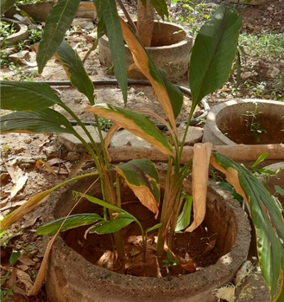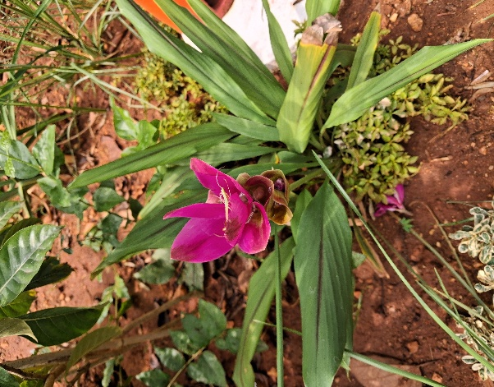

Fig. 2 Rhizome of C. aeruginosa
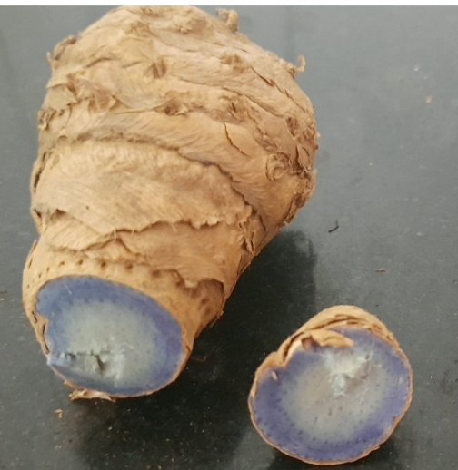

3.2 Taxonomic Confirmation
The specimen was authenticated as Curcuma aeruginosa Roxb. at the Botanical Survey of India, Southern Regional Centre, Coimbatore, using the keys provided in Zingiberaceae of South India. The specimen was assigned voucher number BSI/SRC/5/23/2023/Tech–875 and deposited in the departmental herbarium for reference. The specimen was identified and certified by
Dr. M.U. Sharief, Scientist ‘F’ and Head of Office, BSI Coimbatore.
3.3. PCR Amplification and Sequencing
The rbcL gene was successfully amplified from Curcuma aeruginosa, producing a distinct single band of approximately 564 bp (Fig. 3). The sequence was confirmed as C. aeruginosa through BLAST analysis, showing similarity with published sequences. The purified PCR product was sequenced and deposited in NCBI GenBank with Accession No. PQ287241, corresponding to a 564 bp partial chloroplast rbcL sequence of Curcuma aeruginosa.

Fig 3. Agarose gel electrophoresis of rbcL PCR amplification. Well 42- DNA Ladder and 53- Curcuma aeruginosa (Contig DQN2, 564 bp).
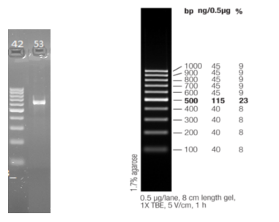

3.4. BLAST Analysis
The BLASTn search against the GenBank nucleotide database with query Id: Query_1711555, of the amplified rbcL sequence (564 bp) revealed a 97% query cover and 96.15% identity with reference sequences of Curcuma aeruginosa (MK934697.1 and KX758482.1) in the NCBI database (Table 1). The alignment also showed close similarity with other Zingiberaceae members such as C. longa, C. zedoaria, and Zingiber citriodorum, confirming the conserved nature of the rbcL region. The phylogenetic clustering distinctly placed the sample within the C. aeruginosa clade, thereby validating its molecular identity. An E-value of 0.0 indicates an extremely significant alignment, meaning the similarity is not random and confirms strong sequence homology.
Table 1. Top BLASTn hits for Curcuma aeruginosa rbcL gene (Accession No. PQ287241).
Closest Match (NCBI) | Query Cover (%) | Percent Identity (%) | E-value | Accession No.
Curcuma aeruginosa ribulose-1,5-bisphosphate carboxylase/oxygenase large subunit gene, partial cds | 97 | 96.15 | 0.0 | MK934697.1
Curcuma aeruginosa isolate Cu2 rbcL gene, partial cds | 97 | 96.15 | 0.0 | KX758482.1
Curcuma zedoaria chloroplast, complete genome | 98 | 95.67 | 0.0 | NC_048505.1
Curcuma longa chloroplast, complete genome | 98 | 95.67 | 0.0 | MN711722.1
Curcuma aromatica chloroplast, complete genome | 98 | 95.67 | 0.0 | MK621777.1

3.5. Phylogenetic Analysis
Maximum Likelihood analysis based on the rbcL sequence revealed that C. aeruginosa clustered closely with other C. aeruginosa accessions, forming a distinct monophyletic clade with high bootstrap support (99%). It was clearly separated from C. longa and C. zedoaria, confirming its independent lineage within Curcuma (Fig. 4).
Fig 4. Maximum Likelihood phylogenetic tree based on rbcL sequences of Curcuma species. The C. aeruginosa (PQ287241) sequence groups within a well-supported clade distinct from C. longa and C. zedoaria.
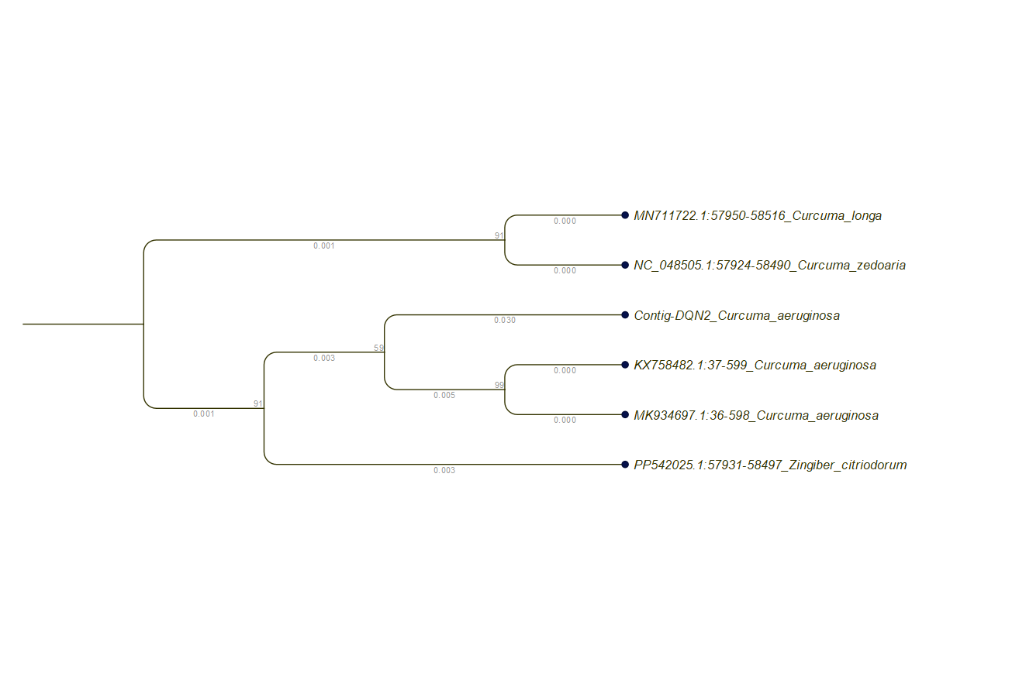

4. Discussion
The results of this study confirm that the Assam-derived specimen is correctly identified as Curcuma aeruginosa (Roxb.) by aligning morphology, herbarium voucher verification and rbcL sequence placement. Morphological verification through ex-situ cultivation also confirmed the diagnostic features bluish rhizomes, erect pseudo stems with distinctive red midrib streaks in oblong-lanceolate leaves. The molecular evidence, including strong BLAST similarity and phylogenetic clustering strong clade support and voucher documentation provides a robust authentication. This integrated confirmation strengthens the taxonomic reliability of this accession and sets a reference for future systematic and pharmacognostic work.
From a morphological-systematic perspective, the genus Curcuma is notoriously challenging due to its high morphological plasticity and overlap of diagnostic characters among its congeners such as C. caesia and C. zedoaria. Studies demonstrate that even chloroplast barcodes such as rbcL and matK provide limited species-level resolution in this group (Chen et al., 2015).
Our results with rbcL region therefore suggests that rbcL can be successful in cases where reference sequences exist and morphological characters are clear and this integration with morphology and voucher deposition increases confidence in results, addressing earlier concerns about sole reliance on barcodes. Importantly, our study aligns with recent phytochemical and biological investigations of C. aeruginosa that reinforce its distinctiveness and applied importance.
This misidentification between C. aeruginosa and C.caesia is to be addressed because
C. aeruginosa possesses a distinct sesquiterpene rich chemical profile dominated while C. caesia is camphor dominant. These differences translate into non-interchangeable medicinal roles.
C. aeruginosa is traditionally used for rheumatic disorders, cosmetic preparations, anti-androgenic activity, hepatoprotection and post-coital contraceptive formulations, whereas C. caesia is used for asthma, piles, tumors, wounds and inflammatory conditions (Jose & Thomas, 2014). Several studies such as volatile-oil profiling from Nepal documented a unique essential-oil composition in C. aeruginosa compared to C. longa and C. zedoaria (Poudel et al., 2022) and similar GC-MS work from Kerala differentiated C. aeruginosa chemotypes (Kundamveetil 2024). These biochemical distinctions support the taxonomic separation of C. aeruginosa and contribute functional evidence to species delimitation. Furthermore, recent network-pharmacology studies revealed that C. aeruginosa contains bio-active compounds targeting specific pathways such as MAPK and HIF-1 in androgenetic alopecia (Sintos, A. M. L., & Cabrera, H. S. (2024), and recent anticancer essential-oil nano-formulation work (Panyajai et al., 2024) demonstrates that its biochemical profile is both distinctive and bio-active. The present molecular authentication also supports our previous phytochemical and pharmacological findings on C. aeruginosa
(Narthanaa et al., 2025), confirming that the bioactive profiles reported earlier were derived from correctly identified plant material. Such integration of molecular taxonomy with biochemical evidence enhances the reliability of pharmacognostic studies in Zingiberaceae. Collectively, these studies demonstrate that C. aeruginosa is not only morphologically distinct but also chemically and functionally differentiated.
Environmental and ecological factors, including climate change, may influence plant distribution patterns, phenotypic plasticity, and population genetic diversity (Nazar et al., 2024). However, DNA barcoding markers such as the chloroplast rbcL gene are relatively conserved and remain reliable for species authentication regardless of environmental variation. Therefore, molecular barcoding provides a stable and reproducible tool for plant identification even under changing ecological conditions.
The positive outcome of our integrative studies suggests several broader implications such as the approach of taxonomical identity through morphology, voucher deposition and DNA barcoding can be implemented for other challenging Curcuma species, particularly where morphological overlap and trade mislabeling occurs. This approach also supports for herbal product authentication for trade by establishing a reliable molecular and morphological reference accession which enables researchers to compare unknown material against a validated standard.

5. Conclusion
This study confirms both the morphological and molecular identity of Curcuma aeruginosa Roxb. through an integrative approach. The strong agreement between molecular and morphological data establishes a reliable reference for this species and demonstrates the value of combining classical taxonomy with DNA barcoding. The findings also address a major issue of frequent misidentification and adulteration in the genus, due to overlapping morphological traits. By providing clear diagnostic and molecular evidence, this work contributes to minimizing taxonomic ambiguity, enhancing species authentication and supporting accurate identification in both systematic and commercial contexts. We also recommend that this work can be extended beyond single-locus barcoding in future.
Data Availability Statement
All rbcL gene sequence data generated in this study have been deposited in the NCBI GenBank repository. Accession numbers were provided in the manuscript.
Conflict of Interest Statement
The authors declare no known financial, commercial, or personal conflicts of interest that could have appeared to influence the work reported in this manuscript. The research was conducted independently and the funding body had no role in study design, data collection, analysis, interpretation or the decision to publish.

Funding
This research was supported by the Tamil Nadu State Council for Science and Technology (TNSCST), Chennai, under the Research Funding for Research Scholars in Colleges (RFRS) scheme.
Author Contributions
Deepa M. A. conceptualized and supervised the study. Narthanaa S. performed the experimental investigations and prepared the manuscript. Pugalenthi M. critically reviewed the manuscript and contributed to its final revision.
Disclaimer (Artificial intelligence)
The authors confirm that no generative artificial intelligence tools were used for data analysis, interpretation of results, or generation of scientific conclusions in this manuscript.
6. References
- Botanical Survey of India. (2023). Voucher specimen authentication: Curcuma aeruginosa Roxb. (Voucher No. BSI/SRC/5/23/2023/Tech–875). Southern Regional Centre, Coimbatore, Tamil Nadu.
- Chen, Q., Hu, H., & Zhang, D. (2022). DNA barcoding and phylogenomic analysis of the genus Fritillaria in China based on complete chloroplast genomes. Frontiers in Plant Science, 13, 764255. https://doi.org/10.3389/fpls.2022.764255
- Chen, M., Sun, J., Yao, H., Gong, F., Cai, L., Wang, C., Shao, Q., & Wang, Z. (2023). Analysis of genetic and chemical variability of five Curcuma species based on DNA barcoding and HPLC fingerprints. Frontiers in Plant Science, 14. https://doi.org/10.3389/fpls.2023.1229041.
- DuanZ.SongW.ChenK.QiaoX.YeM. (2017). Assessment of genetic and chemical variability in Curcumae longae rhizoma (Curcuma longa) based on DNA barcoding markers and HPLC fingerprints. Biol. Pharm. Bull.40 (10), 1638–1645. doi: 10.1248/bpb.b17-00020
- Edgar, R. C. (2004). MUSCLE: Multiple sequence alignment with high accuracy and high throughput. Nucleic Acids Research, 32(5), 1792–1797.
- Elhawary, E. A., Moussa, A. Y., & Singab, A. N. B. (2024). Genus Curcuma: Chemical and ethnopharmacological role in the aging process. BMC Complementary Medicine and Therapies, 24(1), 31. https://doi.org/10.1186/s12906-023-04317-w
- Gan, C. Y., & Wagiran, A. (2025). Amplification of rbcL DNA Barcode from Different Organs of Black Turmeric and its Herbal Medicinal Products. Proceedings of Science and Mathematics.
- Hollingsworth, M. L., Clark, A. A., Forrest, L. L., Richardson, J., Pennington, R. T., Long, D. G., Cowan, R., Chase, M. W., Gaudeul, M., & Hollingsworth, P. M. (2009). Selecting barcoding loci for plants: Evaluation of seven candidate loci with species-level sampling in three divergent groups of land plants. Molecular Ecology Resources, 9(2), 439–457. https://doi.org/10.1111/j.1755-0998.2008.02439.x
- Hooker, J. D. (1890). The Flora of British India (Vol. 6). L. Reeve & Co.
- Joseph, R., Joseph, T., & Jose, J. (1999). Karyomorphological studies in the genus Curcuma Linn. Cytologia, 64, 313–317.
- Kress, W. J., & Erickson, D. L. (2007). A two-locus global DNA barcode for land plants: rbcL and matK. PLoS ONE, 2(6), e508. https://doi.org/10.1371/journal.pone.0000508
- Kundamveetil, S. (2024). Comparative phytochemical analysis of Curcuma aromatica, C. aeruginosa, and C. angustifolia. Asian Journal of Biological and Life Sciences, 13(1), 235–240.
- Larsen, K. (2005). Distribution patterns and diversity centres of Zingiberaceae in SE Asia. Biologiske Skrifter, 55, 219–228.
- Li, J., Xie, D.-F., Guo, X.-L., Zheng, Z.-Y., He, X.-J., & Zhou, S.-D. (2020). Comparative analysis of the complete plastid genome of five Bupleurum species and new insights into DNA barcoding and phylogenetic relationships. Plants, 9(4), 543. https://doi.org/10.3390/plants9040543
- Liu, Q., Zhu, S., Hayashi, S., Iida, O., Takano, A., Miyake, K., Sukrong, S., Agil, M., Balachandran, I., Nakamura, N., Kawahara, N., & Komatsu, K. (2022). Discrimination of Curcuma species from Asia using intron length polymorphism markers in diketide-CoA synthase and curcumin synthase genes. Journal of Natural Medicines, 76(1), 69–86. https://doi.org/10.1007/s11418-021-01558-2
- Narthanaa, S., Deepa, M. A., & Pugalenthi, M. (2024). Curcuma aeruginosa ribulose-1,5-bisphosphate carboxylase/oxygenase large subunit (rbcL) gene, partial cds; chloroplast (GenBank accession PQ287241). National Center for Biotechnology Information. https://www.ncbi.nlm.nih.gov/nuccore/PQ287241
- Narthanaa, S., Pradheeba, M., Priyadharshini, G. V., Sri, J. N., Pugalenthi, M., & Deepa, M. A. (2025). Comparative phytochemical profiling and mechanistic antioxidant evaluation of Drynaria quercifolia (L.) J. Sm. and Curcuma aeruginosa Roxb. rhizomes in relation to gouty arthritis. International Journal of Advanced Research in Biological Sciences, 7(10), 126–134.
- Nazar, N., Saxena, A., Sebastian, A., Slater, A., Velusamy, S., & Sgamma, T. (2024). Integrating DNA barcoding within an orthogonal approach for herbal product authentication: A narrative review. Phytochemical Analysis, 36(1).
- Pandey, A. K., Dwivedi, M. D., & Choudhary, R. K. (2020). Molecular systematics of flowering plants in India: An overview. Journal of the Indian Botanical Society, 100(A, Special Issue), 59–75.
- Panyajai, P., Viriyaadhammaa, N., Tima, S., et al. (2024). Anticancer activity of Curcuma aeruginosa essential oil and its nano-formulations: Cytotoxicity, apoptosis and cell migration effects. BMC Complementary Medicine and Therapies, 24, 16. https://doi.org/10.1186/s12906-023-04261-9
- Pemba, H. B., & Sharangi, A. B. (2017). Promising Curcuma species suitable for hill regions towards maintaining biodiversity. Journal of Pharmacognosy and Phytochemistry, 6(6), 726–731.
- Poudel, D., Ojha, P., Rokaya, A., Satyal, R., & Satyal, P. (2022). Analysis of volatile constituents in Curcuma species (C. aeruginosa, C. zedoaria, C. longa) from Nepal. Plants, 11(15). https://doi.org/10.3390/plants11151932
- Ravindran, P. N., Nirmal Babu, K., & Sivaraman, K. (2007). Turmeric: The genus Curcuma. CRC Press.
- Roxburgh, W. (1910). Descriptions of several of the monandrous plants of India. Asiatic Researches, 11, 318–362.
- Sabu, M. (2006). Zingiberaceae and Costaceae of South India. Indian Association of Angiosperm Taxonomy, Calicut University.
- Sabu, M., & Mangaly, J. K. (1996). Taxonomic revision of South Indian Zingiberaceae. In D.-L. Wu, Q.-G. Wu, & Z.-Y. Chen (Eds.), Proceedings of the 2nd Symposium on the Family Zingiberaceae (pp. 15–22). Zhongshan University Press.
- Sari, A. P., & Supratman, U. (2022). Phytochemistry and biological activities of Curcuma aeruginosa (Roxb.). Indonesian Journal of Chemistry, 22(2), 576–598. https://doi.org/10.22146/ijc.70101
- Sasidharan, N. (2012). Zingiberaceae of South India. Botanical Survey of India, Southern Regional Centre, Coimbatore.
- Sasikumar, B. (2005). Genetic resources of Curcuma: Diversity, characterization and utilization. Plant Genetic Resources, 3, 230–251.
- Sintos, A. M. L., & Cabrera, H. S. (2024). Network pharmacology reveals Curcuma aeruginosa Roxb. regulates MAPK and HIF-1 pathways in treating androgenetic alopecia. Biology, 13(7), 497. https://doi.org/10.3390/biology13070497
- Srivastava, S., Chitranshi, N., Srivastava, S., Dan, M., Rawat, A. K. S., & Pushpangadan, P. (2006). Pharmacognostic evaluation of Curcuma aeruginosa Roxb. Natural Product Sciences, 12(3), 162–165.
- Talavera, G., & Castresana, J. (2007). Improvement of phylogenies by removing divergent and ambiguously aligned blocks from protein sequence alignments. Systematic Biology, 56(4), 564–577.
- Tan, A. L., Fauziah, A., Ummu Hani, B., Nurshahidah, M. R., et al. (2025). Unravelling the identity of black ginger and black turmeric in the Malaysian herbal market. Journal of Tropical Forest Science, 37(Special Issue), 149–161. https://doi.org/10.26525/jtfs2025.37S.SI.149
- Thomas, T. D., & Jose, S. (2014). Comparative phytochemical and anti-bacterial studies of Curcuma caesia Roxb. and Curcuma aeruginosa Roxb. International Journal of Green Pharmacy, 8, 65. https://doi.org/10.4103/0973-8258.126828
- Xu, Y. (Ed.). (2000). Flora of China (Vol. 24). Science Press & Missouri Botanical Garden.
- Záveská, E., Fér, T., Šída, O., Krak, K., Marhold, K., & Leong-Škorničková, J. (2012). Phylogeny of Curcuma (Zingiberaceae) based on plastid and nuclear sequences: Proposal of the new subgenus Ecomata. Taxon, 61(4), 747–763.

