Methane Fluxes in Seagrass Beds of Inner Ambon Bay: A Comparison of Tanjung Tiram and Halong Coast

Krisye Pasanea¹, Rahman¹, Sophia Nonamanis Margaretha Fendjalang^{2*}

(*phone +6285283968997, email *sophiafendjalang@gmail.com)
¹Departmen of Marine Science, Faculty of Marine Science and Fisheries, Pattimura Universitty, Ambon, Indonesia
²Departmen of Aquaculture, Faculty of Marine Science and Fisheries, Pattimura University, Ambon, Indonesia

.
ABSTRACT

This study evaluates the concentration and emission of methane gas (CH₄) in seagrass ecosystems in the Inner Ambon Bay, especially in the Tanjung Tiram and Halong Coast areas. Methane, as one of the greenhouse gases, plays an important role in the global carbon cycle. Gas sampling was conducted using chambers at two research locations from June to September 2023. The analysis showed that the concentration of CH₄ in Halong Coast was higher (1.6893 ± 0.2076 ppm) than in Tanjung Tiram (1.4967 ± 0.1101 ppm) (P < 0.05). The flux of CH₄ gas also showed similar results, with the flux value at Pantai Halong (0.1010 mg/m²/hour) higher than in Tanjung Tiram (0.0521 mg/m²/hour) (P < 0.05). This difference is associated with a higher variation in the physicochemical conditions of the waters, thus affecting the more intense methanogens microbial activity on Halong Coast. Although the methane flux in this seagrass ecosystem is relatively low compared to mangrove ecosystems, the results of this study provide important insights into the role of seagrass in greenhouse gas emissions and its implications for climate change. This finding is expected to support conservation efforts and sustainable management of coastal ecosystems in the Inner Ambon Bay.

Keywords: Climate change, greenhouse gases fluxes, methana, seagrass bed, coastal ecosystem

1. INTRODUCTION
Seagrass beds, as one of the main coastal ecosystems, play a crucial role in maintaining the balance of the marine and coastal environment (Alsaffar et al., 2020; Orth & Heck 2023). These ecosystems not only provide habitat for various species of marine life, but also function in biogeochemical processes, including the carbon cycle (Fourqurean et al., 2012; Johannessen, 2022). One of the important elements in the carbon cycle is methane gas (CH₄) (Tubalawony et al, 2024), which is known as a greenhouse gas with a very high global warming potential (IPCC, 2001).
Methane gas, although found in lower concentrations compared to carbon dioxide, has a much greater heating power. CH₄ emissions from coastal ecosystems, such as seagrass meadows, can affect the global greenhouse gas balance. Therefore, understanding the sources and levels of CH₄ emissions in seagrass meadows is crucial in the context of climate change.
One type of semi-closed waters in the Ambon Islands is the waters of Ambon Bay. These waters have a seagrass ecosystem that acts as a buffer for organic matter inputs from the mainland (Krisye et al., 2023). There are 42 rivers that flow into the Ambon Bay Area, 25 of which flow throughout the year (Asyiawati, 2010), so that the input of organic matter from land enters the bay and most of it will be deposited in the seagrass meadow area (Gemilang et al., 2017). Salamena et al (2023), reported that the flushing time of organic matter entering the Bay Area is 1.5 weeks for the outer part (Outer Ambon Bay - TAL), and about 2 weeks for the inner Ambon Bay (TAD) especially in the rainy season (Salamena et al., 2022). The long accumulation of organic matter in the TAD area will affect the richness of organic matter in seagrass sediments. The accumulation of organic matter in the sediments of the ecosystem will trigger a methanogens reaction that produces CH₄ gas, which causes global warming (Chauhan et al., 2015). The amount of CH₄ gas fluxes produced from the decomposition of organic matter such as anthropogenic waste and litter production seagrass will be influenced by sediment types such as sludge, sandy mud, muddy sand, or sand (Tubalawony et al., 2024; Pasanea et al., 2025). It is related to the porosity and permeability of sediments in holding organic matter and releasing gases into the atmosphere (Nurwidyanto et al., 2006).
Although there is some research on the ecological role of seagrass meadows, specific information on CH₄ fluxes in the region is limited. This raises an urgent need to explore CH₄ emissions in Ambon Bay to understand its contribution to climate change. In this context, this article aims to investigate the level of CH₄ emissions in the seagrass beds of inner Ambon Bay. By analyzing CH₄ emission data from different locations and environmental conditions, we hope to identify the factors that influence these gas emissions as well as their role in the regional and global carbon cycle.
Tanjung Tiram and Halong coast have relatively extensive seagrass ecosystems in Inner Ambon Bay. Tanjung Tiram, in addition to having a seagrass ecosystem, also has a mangrove ecosystem, whereas the Halong coast only has a seagrass ecosystem. This difference in characteristics can serve as a new area of research for examining the dynamics of methane gas concentration and emissions.Thus, the results of this study are expected to be the basis for better management strategies and efforts to conserve seagrass beds in inner Ambon Bay, as well as make an important contribution to the global discussion on greenhouse gas emissions and climate change.

2. material and methods / experimental details / methodology (Arial, Bold, 11 font, left aligned, caps)

2.1 Description of the Research Location
This research was in June to September 2023 at Tanjung Tiram and Halong Coast seagrass ecosystem areas (Figure 1). Both of these locations are under the influence of significant tidal currents, which help in the circulation of nutrients and maintain the water quality that supports seagrass life. Seagrass in the waters of Tanjung Tiram and Halong Coast has a substrate dominated by sand and mud, this condition supports the growth of various types of seagrass such as Enhalus acoroides, Thalassia hemprichii, and Cymodocea rotundata (Irawan & Nganro 2016; Taupattinaya et al., 2021). Tanjung Tiram, in addition to having a seagrass ecosystem, also has a mangrove ecosystem, whereas the Halong coast only has a seagrass ecosystem.
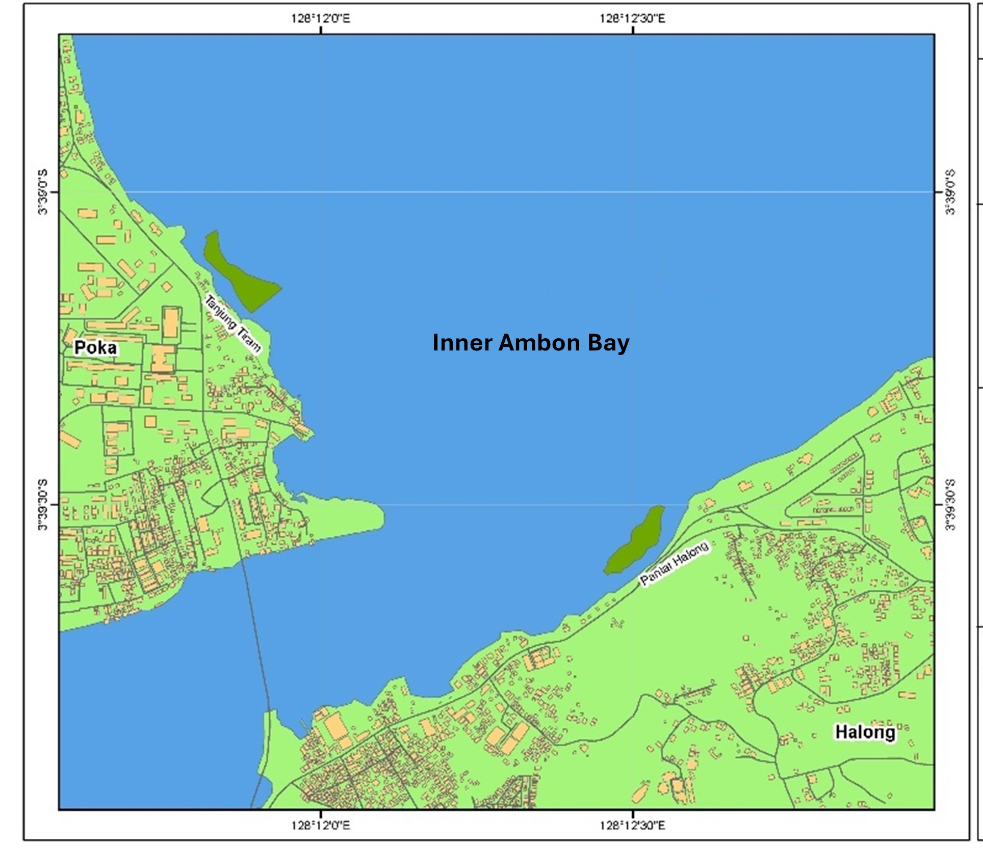
Fig 1 – Map of study sites

2.2 Procedur of Sampling
2.2.1 Physicochemical parameters

Water parameters measured in situ include temperature, salinity, and pH. Temperature and pH measurements were made using Lutron pH-222, while salinity measurements were made using a handrefractometer.

2.2.2 Gas sampling

CH₄ gas is collected by placing chambers in seagrass ecosystem areas on various seagrass species that are representations of substrate types. Each location consisted of five chamber placement points, with a distance of 20 meters between points. The chamber is made of 26 cm diameter aqua gallons made from BPA and PET. The bottom of the gallon is cut so that the volume of the remaining chamber is 17 L. Such a chamber cannot be considered to affect the incubated greenhouse gases, including CH₄. The use of this chamber has previously been carried out in studies related to CH₄ gas flux in sediments in the Goa mangrove ecosystem (Nazareth & Gonsalves 2022). This placed chamber is installed into a sediment 5 cm deep to avoid gas circulation from inside or outside the chamber. The gas is collected from the chamber using a syringe and placed in an airtight vial bottle (10 mL). The gas collection time interval for each type of sediment is 30 seconds (0s, 30s, 60s, 90s, and 120s). The same method is repeated twice on each type of substrate. The next incubation process is carried out by opening the chamber and placing it back in another sediment. All samples are stored in boxes and transported to the laboratory for further analysis.

2.3 Sample Analysis
2.3.1 CH₄ Gas Concentration

The concentration of CH₄ gas was analyzed using the Gas Chromato chart
y-Mass Spectrometry (GC-MS) method. In this method, a sample of 2-3 mL of gas was drawn from the vial using a syringe and introduced into the Thermal Conductivity Detector (TCD). The resulting gas concentration analysis is presented in parts per million (ppm).

2.3.2 CH₄ Gas Fluxes

The flux of CH₄ gas was analyzed based on the greenhouse gas flux equation developed by Rahman et al.( Rahman et al., 2022; Rahman et al., 2023). Mathematically, the greenhouse gas flux equation can be expressed as follows:
F = $⎸\frac{S* V* t* mW}{(RT* A)}$⎸
Explanation:
F = CH₄ gas flux (mg/m²/h)
S = Regression slope of CH₄ concentration measured at each 30-second interval (ppm/s)
V = Volume of the cylindrical chamber (L)
A = Surface area of the chamber (m²)
t = Time transformation factor (1 hour divided by the sampling interval = 3600s/30s or 120)
R = Ideal gas constant (0.082 L.atm/K.mol)
T = Temperature inside the chamber or air temperature (K)
mW = Molar mass of CH₄ (16 g/mol)

2.3.3 Global Warming Potential

Global Warming Potential (GWP) is a metric used to compare the extent to which a specific greenhouse gas can absorb and emit heat in the atmosphere relative to carbon dioxide (CO₂), which is used as a reference with a GWP value of 1. GWP calculates the warming effect of greenhouse gases over a specified period, typically 20, 100, or 500 years (IPPC, 2001). According to the IPCC (2001), the GWP of CH₄ gas flux over a 100-year period is equivalent to 28 times that of CO₂. Mathematically, the GWP of CH₄ can be formulated as follows:
F_{e} = Fm x GWP
Where F_{e​} represents the CO₂-equivalent flux value (mg/m²/h) as an approximation of the Global Warming Potential (GWP), Fm​ represents the carbon gas flux (mg/m²/h), and GWP represents the Global Warming Potential value of carbon gas, which is the conversion of the emission value per mole of CH₄ gas equivalent to 28 times the CO₂-e emissions over a 100-year period.
2.3.4 Statistical Analysis

All univariate data were analyzed using the Shapiro–Wilk normality test. In addition, a one-way ANOVA was carried out using XLStat to check the difference in the average concentration and flux of CH₄ (ppm), as well as physicochemical parameters between seagrass areas in Tanjung Tiram and Halong Coast.

3. results and discussion

3.1 CH₄ gas concentration
The average concentration of CH₄ gas in seagrass sediments in Tanjung Tiram waters is 1.4967 ± 0.1101 ppm, and lower than the average in Halong Coast with a value of 1.6893 ± 0.2076 ppm (Figure 2). Statistically, the average concentration of CH₄ gas in the two locations differed significantly. This can be seen in the results of the ANOVA-single factor test which shows a value of P = 0.0036 (P < 0.05). These differences indicate the presence of different inputs and decomposition of organic matter (Tubalawony et al., 2024; Pasanea et al., 2025)⁵ whose existence is also influenced by the flushing time that occurs in the waters of the Inner Ambon Bay (Salamena et al., 2022). The low flushing time allows the accumulation of organic matter and its decomposition occurs anaerobically in the methanogens process. This condition allows the formation of methane gas to reach 90% (Wallenius et al., 2021). Furthermore, organic matter entering from the land will first be filtered by the mangrove ecosystem, so that the amount reaching the seagrass ecosystem will be smaller, as is the case in the waters of Tanjung Tiram.

Fig. 2 – CH₄ concentration from different seagrass bed location (Tanjung Tiram and Halong Coast) at the Inner Ambon Bay. The mean concentration of CH₄ gas is significantly different at α = 0.05 (P < 0.05)

Apart from the input of organic matter, the difference in CH₄ gas concentration at the two locations is also caused by the physicochemical parameters of the waters. In situ measurements of parameters show that the waters of Halong Coast have higher temperature, salinity, and pH values compared to the waters of Tanjung Tiram (Table 1). Significantly, the water parameters at the two locations are very different. The study conducted by Chauhan et al (2015) shows that increasing water parameters such as temperature, salinity, and pH can significantly increase methane gas production. This is closely related to the methanogens activity that occurs in seagrass sediments. Methanogens microbes are very active in the sediments of various wetland ecosystems including seagrass beds. The findings of the study Hoehler et al (2018) showed that the methanogens activity was optimally active at 30-40 °C and some of the groups were able to tolerate low temperatures (2 °C) and high temperatures (122 °C).

Table 1. Condition of physicochemical parameters in Seagrass bed of Tanjung Tiram and Halong Coast, Inner Ambon Bay.
Water physicochemical parameters | Tanjung Tiram | Halong Coast
Temperature (°C) | 25* | 31*
Salinity (‰) | 28.3* | 28.8*
pH | 7.5** | 7.6**
Notes: * indicate significantly different at (P < 0.05), and ** indicate not significantly different (P > 0.05) α = 0.05.

3.2 CH₄ gas fluxes

The flux of methane gas (CH₄) in seagrass ecosystems in Tanjung Tiram and Halong Coast showed significant differences (P = 0.013; P < 0.05), as seen in the graph (Figure 3). In Tanjung Tiram, the average CH₄ gas flux was recorded at 0.0521 mg/m²/hour and ranged from 0.0199-0.0843 mg/m²/hour, while in Halong Coast the flux was higher, namely 0.1010 mg/m²/hour or 0.0623-0.1397 mg/m²/hour. This difference indicates that there are variations in environmental and ecosystem factors that affect the production and release of methane gas from seagrass sediments.
The seagrass beds at Halong Coast, which show higher CH₄ fluxes, are likely to have sedimentary conditions richer in organic matter, which is a major source of methane-producing microorganisms. The abundance of organic matter in Halong Coast is due to its coastal characteristics, which only have a seagrass ecosystem, so there is no filtration of organic matter. This is in contrast to the waters of Tanjung Tiram, which have a mangrove ecosystem that causes most of the organic matter to be filtered within the mangrove ecosystem, resulting in less organic matter entering the seagrass ecosystem. Environmental factors such as temperature, salinity, and nutrient availability can also play a role in these differences in methane flux (Chauhan et al., 2015).
In contrast, in Tanjung Tiram, the lower methane flux may be due to different sedimentary conditions, e.g. with lower organic content or more aerobic conditions, so that methane production by microbes is more limited (Tubalawony et al., 2024). In addition, differences in microbial communities as well as biogeochemical interactions within sediments can also affect the amount of methane produced and released into the atmosphere.
Fluctuations in CH₄ gas flux between these two locations can also be influenced by differences in seagrass density, dominant seagrass species, and other biological activities around seagrass ecosystems. For example, denser or more extensive seagrass can accelerate the biogeochemical cycle of sediments that support methane release, as may be the case at Halong Coast.
These differences are important to observe in the context of coastal ecosystem management, as the release of greenhouse gases such as methane can affect local and global climate change dynamics. Further research is needed to understand the mechanisms that control methane production and release in various seagrass ecosystems, as well as to determine how environmental changes, such as rising temperatures or eutrophication, can exacerbate or reduce methane emissions from these coastal ecosystems.

Fig. 3 – CH₄ fluxes from different seagrass bed location (Tanjung Tiram and Halong Coast) at the Inner Ambon Bay. The mean of CH₄ fluxes is significantly different at α = 0.05 (P < 0.05)

3.3 GWP of CH₄ fluxes
Methane (CH₄) is one of the most significant greenhouse gases after carbon dioxide. The GWP of methane is higher than CO₂, which means that in equal amounts, methane has a greater ability to trap heat in the atmosphere (IPCC, 2001).
The total GWP in the Tanjung Tiram seagrass meadow area is 1.4588 mgCO₂-e/m²/hour, lower than the GWP in Halong Coast which is 2.8280 mgCO₂-e/m²/hour (Table 2). The GWP at these two locations is much lower than the GWP produced by the CH₄ flux in mangrove sediments in the Ambon Bay Area. For example, reports of Tubalawony et al (2024), Kesaulya et al (2023), and Rahman et al (2024) found a CH₄ flux GWP of 3.6907 mg CO₂-e/m²/hour, 7.0015 mg CO₂-e/m²/hour, and 10.8304 mg CO₂-e/m²/hour, respectively, (Figure 4). This indicates that the input of organic matter that enters the waters of inner Ambon Bay is significantly accumulated in the mangrove sediment area.

Table 2. GWP of CH₄ gas flux in seagrass bed, Inner Ambon Bay
No | Locations | Fluxes (mg/m²/hour) | GWP (mgCO₂-e/m²/hour)
1 | Tanjung Tiram | 0.0521 | 1.4588
2 | Halong Coast | 0.1010 | 2.8280

Fig. 4 – Comparison of CH₄ gas GWP in Tanjung Tiram seagrass meadows, Halong Coast, and mangrove sediments in several locations of inner Ambon Bay. Description: A) Tanjung Tiram - this study, B) Halong Coast - this study, C) mangrove sediment of Waiheru village (Kesaulya et al., 2023), D) mangrove sediment of Poka villages (Rahman et al., 2024), and E) mangrove sediment of Tanjung Tiram coast (Tubalawony et al., (2024).

4. Conclusion

This study revealed that there was a significant variation in the concentration and flux of methane gas (CH₄) in the seagrass ecosystem of inner Ambon Bay, especially in the Tanjung Tiram and Halong Coast areas. The results of the analysis showed that the average concentration and emission of CH₄ gas in Halong Coast was higher compared to Tanjung Tiram, which was caused by differences in the physico-chemical conditions of the waters, including temperature, salinity, and pH. The ecosystem of Halong Coast which has a higher organic content and more anaerobic conditions allows for more intense methanogens microbial activity, resulting in a higher CH₄ flux.
Differences in sediment substrates, such as mud and sand, as well as inputs of organic matter from land, also affect methane emissions at both sites. The sediments at Halong Coast which are richer in organic matter support greater methane gas production, while the more aerobic conditions in Tanjung Tiram inhibit the methanogens process, resulting in lower methane emissions.
Overall, the results of this study show that the seagrass ecosystem in the inner Ambon Bay plays an important role in the local carbon cycle and has the potential to contribute to global greenhouse gas emissions, although methane emissions from this seagrass area are lower than those of mangrove ecosystems in the surrounding area. These findings are an important foundation for the management and conservation of seagrass ecosystems in the inner Ambon Bay, as well as in the development of greenhouse gas emission mitigation strategies in the context of climate change.

Authors’ Contributions

‘Author Krisye Pasanea’ designed the study, wrote the protocol, and wrote the first draft of the manuscript. ‘Author Rahman’ perform data analysis and collecting sampel and ‘Author Sophia Nonamanis Margaretha Fendjalang’ managed the tools and material, translate article and processing article for publishing.

References

Alsaffar, Z., Pearman, J. K., Curdia, J., Ellis, J., Calleja, M. L., Ruiz-Compean, P., ... & Carvalho, S. (2020). The Role Of Seagrass Vegetation And Local Environmental Conditions In Shaping Benthic Bacterial And Macroinvertebrate Communities In A Tropical Coastal Lagoon. Scientific Reports, 10(1), 13550.
Asyiawati, Y. (2010). Pengaruh Pemanfaatan Lahan Terhadap Ekosistem Pesisir di Kawasan Teluk Ambon. Jurnal Perencanaan Wilayah dan Kota, 10(2).
Chauhan, R., Datta, A., Ramanathan, A. L., & Adhya, T. K. (2015). Factors influencing spatio-temporal variation of methane and nitrous oxide emission from a tropical mangrove of eastern coast of India. Atmospheric Environment, 107, 95-106.
Gemilang, W. A., Rahmawan, G. A., & Wisha, U. J. (2017). Inner Ambon Bay water quality based physical and chemical parameters in transition season I. EnviroScientaea, 13(1), 79-90.
Hoehler, T., Losey, N. A., Gunsalus, R. P., & McInerney, M. J. (2018). Environmental constraints that limit methanogenesis. Univ. of Oklahoma, Norman, OK (United States).
Intergovernmental Panel On Climate Change (IPCC). 2001. Climate Change 2001: The Scientific Basis. Contribution Of Working Group I To The Third Assessment Report Of The Intergovernmental Panel On Climate Change. Cambridge University Press, Cambridge.
Irawan, A., & Nganro, N. R. (2016). Distribution of Seagrasses in Inner Ambon Bay. Jurnal Ilmu dan Teknologi Kelautan Tropis, 8(1), 99400.
Johannessen, S. C. (2022). How Can Blue Carbon Burial In Seagrass Meadows Increase Long-Term, Net Sequestration Of Carbon? A Critical Review. Environmental Research Letters, 17(9), 093004.
Kesaulya, I., Rahman, Haumahu, S., & Krisye. (2023, July). Global Warming Potential of Carbon dioxide and Methane Emission from Mangrove Sediment in Waiheru Coastal, Ambon Bay. In IOP Conference Series: Earth and Environmental Science (Vol. 1207, No. 1, p. 012030). IOP Publishing.
Krisye, K., Fendjalang, S. N., & Rahman, R. (2023). Concentration and CO₂ emissions in seagrass ecosystem inner Ambon Bay. Agrikan Jurnal Agribisnis Perikanan, 16(2), 57-62.
Nazareth, D. R., & Gonsalves, M. J. (2022). Influence of seasonal and environmental variables on the emission of methane from the mangrove sediments of Goa. Environmental Monitoring and Assessment, 194(4), 249.
Nurwidyanto, M. I., Yustiana, M., & Widada, S. (2006). Pengaruh ukuran butir terhadap porositas dan permeabilitas pada batupasir. Berkala Fisika, 9(4), 191-195.
Orth, R. J., & Heck Jr, K. L. (2023). The Dynamics Of Seagrass Ecosystems: History, Past Accomplishments, And Future Prospects. Estuaries And Coasts, 46(7), 1653-1676.
Pasanea, K., Supusepa, J., & Putri, A. (2025). Litter Production of Enhalus acoroides and Thalassia hemprichii in the seagrass ecosystem of Tanjung Tiram, Inner Ambon Bay. Nekton, 5(2), 186-193.
Rahman, R., Kesaulya, I., & Ikbal, L. (2024). Emisi gas rumah kaca (CO2 dan CH4) pada kawasan mangrove di Pesisir Desa Poka, Kota Ambon. Jurnal Pengelolaan Lingkungan Berkelanjutan (Journal of Environmental Sustainability Management), 38-52.
Rahman, R., Wardiatno, Y., Yulianda, F., Lokollo, F. F., & Rusmana, I. (2023). Emissions and potential of global warming of N2O gas of mangrove litter degradation on the West Muna Regency Coast. Jurnal Ilmu Kehutanan, 17(2), 127-134.
Rahman, Wardiatno, Y., Yulianda, F., & Rusmana, I. (2020). Seasonal fluxes of CO2, CH4 and N2O greenhouse gases in various mangrove species on the coast of West Muna Regency, Southeast Sulawesi, Indonesia.
Salamena, G. G., Heron, S. F., Ridd, P. V., & Whinney, J. C. (2023). A risk assessment of marine plastics in coastal waters of a small island: Lessons from Ambon Island, eastern Indonesia. Regional Studies in Marine Science, 65, 103086.
Salamena, G. G., Whinney, J. C., Heron, S. F., & Ridd, P. V. (2022). Frontogenesis and estuarine circulation at the shallow sill of a tropical fjord: Insights from Ambon Bay, eastern Indonesia. Regional Studies in Marine Science, 56, 102696.
Tuapattinaya, P. M., Kurnia, T. S., & Latupeirissa, L. N. (2021). Kondisi dan keragaman jenis lamun di perairan Pantai Pulau Ambon. BIOPENDIX: Jurnal Biologi, Pendidikan dan Terapan, 7(2), 95-101.
Tubalawony, S., Mailoa, M. N., & Pasanea, K. (2024). Fluxes Of Methane Gases (Ch 4) In Sediments Of Mangrove And Seagrass Ecosystems In Tanjung Tiram, Ambon Bay, Indonesia. Egyptian Journal Of Aquatic Biology & Fisheries, 28(4).
Wallenius, A. J., Dalcin Martins, P., Slomp, C. P., & Jetten, M. S. (2021). Anthropogenic and environmental constraints on the microbial methane cycle in coastal sediments. Frontiers in microbiology, 12, 631621.

