THE EFFECTS OF MOULD MATERIALS ON THE MECHANICAL PROPERTIES OF ALUMINIUM CASTING

ABSTRACT
In this research work, the effects of mold materials on mechanical properties of aluminium were investigated. Mould materials were prepared from sand, metal, and plaster of paris (POP). A steel rod of about 25mm in diameter was used as pattern to cast aluminium in these three mould materials. Test pieces were machined from the casting produced by each of the three mould materials for tensile, hardness and impact tests, as well as microstructure. It was observed from the tests that aluminium cast by sand has the highest value of ductility at the expense of its hardness, while those castings by metal and POP moulds have appreciable increase in hardness values but lesser values of ductility. The question as to which of the mould materials is the best depends on the engineering application requirements; sand mould would be preferred where ductility is the major requirement, while metal and POP moulds might be preferred when hardness is the priority.

Keywords: Casting, aluminium, mould, sand, plaster of paris, metal

1. Introduction
Casting is a fundamental metalworking process that involves pouring molten metal into a mould cavity, allowing it to solidify, and then removing the solidified casting [1]. It has been widely adopted across industrial sectors due to its ability to produce complex geometries at relatively low cost [2]. Critical factors influencing casting quality include heat transfer across the mould–metal interface, solidification rate, and mould material properties [3]. In green sand moulds, parameters such as strength, permeability, and hardness play crucial roles in determining final casting properties [4].
Casting techniques are broadly categorized into expendable and non-expendable mould processes [5], as shown in Figure 1. Expendable mould casting employs temporary moulds, typically sand, shell, or plaster, which are destroyed after use. Sand casting is widely applied due to its flexibility, low cost, and suitability for a wide range of alloys [6]. Studies have shown that factors such as runner size, mould temperature, and pouring conditions directly influence the mechanical strength of aluminium alloys [7]. Plaster mould casting, though costlier, enables superior surface finish and dimensional accuracy, making it suitable for intricate geometries [8]. Shell moulding casting further enhance precision and surface quality, often used in aerospace and artistic applications [9]. Lost-wax (investment) moulds can be made in a single phase where a refractory clay material is laid directly over the wax model [10]. Lost-wax process is commonly used alongside vacuum casting [11]. Evaporative-pattern methods are essential for complex parts fabrication [12], examples of which are found in lost-foam and full-mould casting, employ polystyrene patterns that vaporize during pouring, simplifying mould preparation [13].
Non-expendable mould casting methods utilize permanent metallic moulds, offering improved repeatability and dimensional accuracy [14]. These include, die casting, semi-solid metal casting, centrifugal casting, and continuous casting. In die casting method, molten metal is forced into the cavity of a reusable steel mould (die) under high pressure. Die casting is a manufacturing process specially for a near-net shape with high dimensional accuracy and good surface finish objects [15]. Semi-solid techniques, in particular, reduce porosity and enable heat treatment, yielding castings with improved strength and ductility [16]. Centrifugal casting is a technique of producing castings by pouring molten metal into a rotating mould and allow it to solidify in the same mould [17]. Centrifugal casting is a manufacturing process used to form cylindrical components with a central axis of rotation [18]. In continuous casting process, molten metal flows into the continuous casting mould, cools by cold water, and pulls out after solidification [19]. Continuous casting is employed not only because of the increased quality of the final products but also for its relatively cost effectiveness associated with standard products, validating their continuous use in steel production.

Continuous
Expendable mould casting
Non-expendable mould casting
Full mould
Lost foam
Evaporative
Centrifugal
Lost wax
Shell
Semi-solid
Plaster
Die casting
Casting Techniques
Permanent
Sand
Fig. 1. Casting Techniques
Mechanical tests represent a critical aspect of casting process, serving as a reliable means of evaluating the performance and integrity of cast materials [20]. In the context of aluminium castings, tensile, hardness, and impact tests are particularly indispensable for characterizing mechanical behavior under varying service conditions [21]. These tests do not only provide fundamental data on strength, ductility, toughness, and resistance to deformation but also reveal the influence of intrinsic and process-related factors, such as casting defects, mould materials, and cooling rates, on final material properties [22]. Mechanical tests generate valuable insights that guide the optimization of casting design and processing parameters. This, in turn, contributes to improved structural reliability, reduced defect rates, and enhanced material performance in diverse engineering applications [23].
Casting process simulation has become an indispensable tool across manufacturing industries, playing a crucial role in product design and process development to improve yield and casting quality [24]. Successful implementation of simulation relies heavily on high-quality input data, particularly thermo-physical and physical properties during solidification [25]. By employing numerical methods, casting simulations enables precise calculation of component quality through detailed analyses of mould filling, solidification, and cooling - providing quantitative predictions of mechanical properties, thermal stresses, and distortions, offering valuable insight into cast performance before production begins [26]. Consequently, simulation facilitates the design of casting techniques tailored to specific applications, thereby enhancing reliability and efficiency [27]. For instance, Nimbulkar et al. [28] in their study evaluated the existing gating and feeding system and optimized it using AutoCAST X1 casting simulation software, a sand mould was prepared and the component was cast to validate the simulation results through comparison with experimental outcomes.
Despite its ancient origins, casting remains highly relevant in modern engineering. Parameters such as pouring temperature, gating design, and mould type influence microstructure formation and mechanical behaviour. Improper process control may result in defects such as porosity, shrinkage, and cavities, which compromise performance [29]. Previous studies have compared aluminium composite castings by using sand and metal moulds [30]. However, limited research exists on the comparative performance of aluminium castings produced using sand, POP, and metal moulds. This gap motivates the present study, which seeks to examine variations in mechanical properties of aluminium castings across different mould types.

2. MATERIALS AND METHODS
2.1. Materials
Materials used for this reaserch work are; Aluminium scrap, Sand, Plaster of paris (POP), Splitable cast iron metal mould.
2.2. Preparation of POP Mould
Aluminium scrap was bought, POP powder was bought, Cylindrical hollow cast iron was fabricated, casting sand was made available at Materials Science and Engineering Department Laboratory, Obafemi Awolowo University, Ile-Ife, Nigeria.
Powder form of POP was mixed with adequate amount of water, the mixture was then mixed with talc and silica flour to control the setting time of the plaster as well as to improve its strength. The plaster was poured over the casting pattern (rod-like cast iron). The POP slurry was allowed to sit for 20 minutes before removing the pattern. The mould was baked for several hours in order to remove the moisture and make it hard enough to accommodate the molten metal.
2.3. Preparation of Metal Mould
Cylindrical hollow cast iron which could be split into two halves and clamped together was fabricated. This was meant to serve as the mould. The mould was preheated to about 150-200ºC in order to ease the flow of molten metal as well as reduce thermal damage to the casting. The mould cavity was coated with a refractory material in order to prevent the casting from sticking to the mould and to elongate the mould life.
2.4. Preparation of Sand Mould
Casting sand was put inside a system of frames or mould boxes known as a flask, pattern of desired shape (rod-like) was placed in sand to create the mould, Pattern and sand were incorporated in a gating system, pattern was removed in order to create a cavity.

2.5. Preparation of Aluminium Cast by Different Mould Techniques
Scrap aluminium was melted in the electric furnace. The molten metal was then poured into the respective mould materials prepared above. Each of them was allowed to cool for one hour. Aluminium casting was removed from sand and POP mould by breaking them, while it was removed from metal mould simply by splitting the cylindrical metal mould. Aluminium castings gotten from these three different mould materials were cleaned and machined for microstructure analysis and mechanical tests.
2.6. Characterizations
The microstructural characteristics of the three samples were examined using a metallographic microscope after a systematic preparation process involving grinding (from coarse to fine), polishing, and etching. Their tensile properties were evaluated with a tensometer, while resistance to indentation was assessed using a Brinell hardness testing machine. In addition, the impact strength of the samples, indicating their ability to withstand sudden applied loads, was determined through the Izod impact test.

3. RESULTS AND DISCUSSION
3.1 Microstructure Analysis
Figure 2 illustrates the microstructure of Sample A, produced using a metallic mould. The micrograph reveals a distinctly fine microstructure, indicative of rapid heat extraction at the metal–mould interface. The high thermal conductivity of the metallic mould promotes an elevated cooling rate, which increases nucleation density while suppressing diffusion-controlled grain growth. As a result, limited time is available for dendritic coarsening, leading to reduced secondary dendrite arm spacing (SDAS) and a refined grain structure. This observation is consistent with established solidification theory, where increased cooling rates are directly associated with microstructural refinement and enhanced nucleation kinetics, agreeing to the results of the research carried out by Wang et al. [31].
Figure 3 presents the microstructure of Sample B, cast using a sand mould. In contrast to Sample A, the microstructure appears significantly coarser, reflecting a reduced cooling rate due to the low thermal conductivity and insulating nature of sand. The prolonged solidification time allows for extensive dendritic growth and coarsening, resulting in increased SDAS and larger grain size. Such coarsening occurs because the slower rate of heat dissipation permits greater atomic diffusion and grain boundary migration. This observation aligns with prior findings, including those reported by Lin et al.[32], which demonstrate that reduced cooling rates in sand casting promote coarse microstructures and larger dendritic features.
Figure 4 shows the microstructure of Sample C, produced by using a Plaster of Paris (POP) mould. The microstructure exhibits a relatively fine morphology, though not necessarily as refined as that observed in Sample A. This suggests that the presence of talc in POP mould facilitates a moderate rate of heat extraction; greater than that of sand moulds but lower than metallic moulds. The resulting cooling conditions promote partial grain refinement while still allowing limited microstructural development. The observed refinement indicates that heat transfer at the aluminium–POP interface is sufficiently effective to restrict excessive grain growth, leading to a comparatively uniform microstructure, aligns with the results from the research conducted by Yildirim et al. [33].

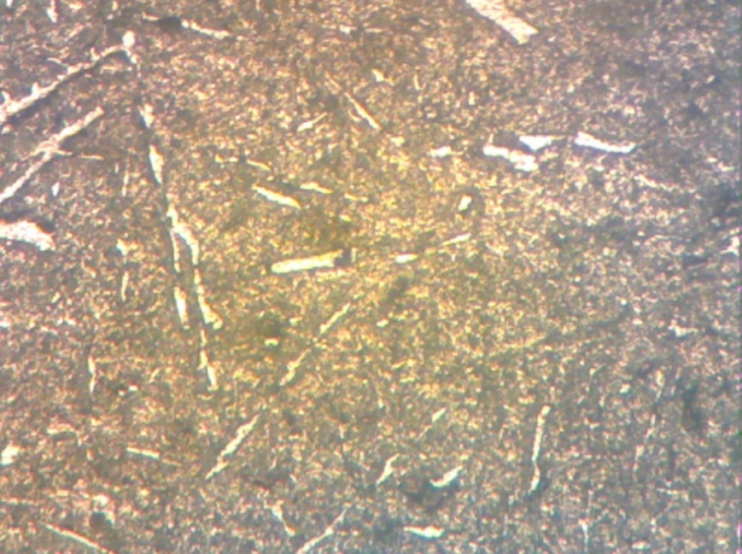
Fig. 2. Microstructure of sample ‘A’ X 200 (Mag)
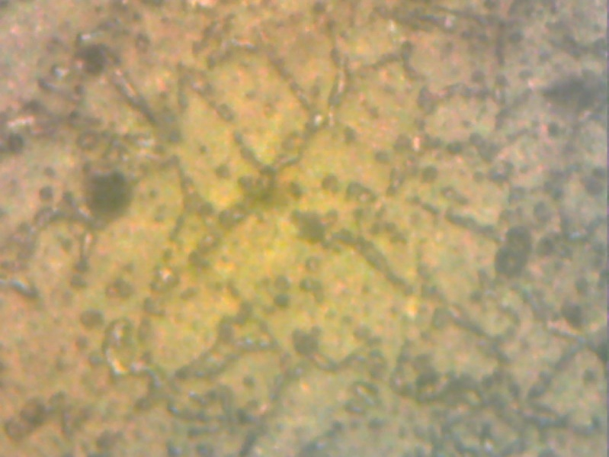
Fig. 3. Microstructure of sample ‘B’ X200 (Mag)
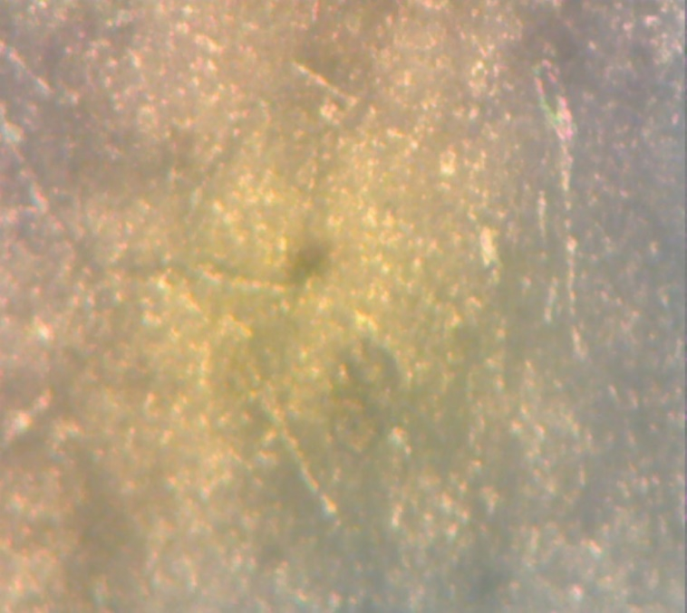
Fig. 4. Microstructure of sample ‘C’ X 200 (Mag)

  - Tensile Tests and Strain Results
Figures 5-7 show the tensile tests results of the three samples. In Figure 6, Sample B exhibited the highest fracture strength of 100 MPa, indicating superior ductility and the ability to sustain higher tensile loads before failure. This suggests that Sample B possesses a more homogeneous and refined microstructure, which allows plastic deformation to occur more uniformly and delays crack initiation and propagation. In Figure 5, sample A fractured at 90 MPa, demonstrating moderate tensile strength and ductility, likely reflecting an intermediate microstructural refinement and cooling rate during solidification [34]. In contrast, Sample C fractured at the lowest load of 72 MPa, indicating the weakest tensile performance and reduced ductility, as shown in Figure 7. This lower strength can be attributed to a coarser microstructure, larger dendritic spacing, or the presence of micro-voids and other casting defects, which act as stress concentrators and facilitate early fracture. In general, these results highlight the critical influence of cooling rate, mould material, and solidification dynamics on the tensile behavior of cast aluminium casts. Samples with finer, more uniform microstructures exhibit higher fracture loads and greater energy absorption, whereas coarser or defect-prone structures compromise tensile strength and ductility.

Fig. 5. Stress- strain curve of sample ‘A’

Figure 6. Stress-strain curve of sample ‘B’

Figure 7. Stress-strain curve of sample ‘C’

As illustrated in Figure 8, Sample B exhibits a tensile strain at fracture of 0.025, which is notably higher than that of Samples A and C (0.0175). In metallic materials, fracture strain is a key indicator of ductile behavior, reflecting the ability of the microstructure to accommodate dislocation motion and delay the onset of crack initiation. The superior ductility observed in Sample B suggests the presence of a microstructure that is more conducive to uniform plastic deformation, likely characterized by reduced internal stress concentrations and improved structural continuity, agreeing with the results obtained from the study conducted by Pedersen et al. [35].
In contrast, the lower fracture strains observed in Samples A and C indicate a more limited capacity for plastic deformation, consistent with relatively brittle or semi-brittle behavior. This reduction in ductility can be attributed to microstructural features such as refined but rigid grain structures, the presence of hard phases, or localized heterogeneities that act as stress concentrators. Such features promote early crack initiation and restrict plastic flow.

Figure 8. Bar chart showing the results of tensile strain at fracture
  - Hardness Tests Results
Figure 9 presents the Brinell hardness test results for the three samples, indicating clear differences in mechanical response: Sample A (38.00 BHN) exhibits the highest hardness, followed by Sample C (36.50 BHN), and Sample B (32.80 BHN) demonstrates the lowest hardness. These trends are directly linked to the solidification conditions imposed by the respective mould materials, which in turn controlled microstructural development and strengthening mechanisms. The superior hardness observed in Sample A (38.00 BHN) can be attributed to the pronounced chilling effect at the metal–mould interface afforded by the metallic mould. Metallic moulds typically exhibit high thermal conductivity, which enhances heat extraction during solidification and produces elevated cooling rates. High cooling rates promote a greater nucleation rate and limit the extent of diffusion-controlled growth, leading to a microstructure with reduced SDAS and smaller dendritic features. The refined microstructural scale increases the cumulative grain boundary area and reduces the mean free path for dislocation motion, thereby enhancing the material’s resistance to plastic deformation and resulting in higher hardness. Recent research on aluminium alloy solidification confirms that increasing the cooling rate significantly decreases SDAS and produces finer microstructural constituents, which correlate with increased hardness and improved mechanical properties in as-cast alloys, as supported by the results from the research conducted by Yang et al. [36]. These findings validate the interpretation that rapid cooling induced by the metallic mould in Sample A is responsible for its enhanced hardness relative to the other samples, aligns with the findings from Ceschini et al. research [37].
Although Sample C exhibits slightly lower hardness than Sample A, it still demonstrates a significant increase in hardness compared to Sample B, indicating that its intermediate cooling conditions foster a microstructural state that enhances resistance to deformation. The presence of talc and silica flour in POP mould influence its thermal behavior: characterized by moderate thermal conductivity produces cooling rates that are greater than those typical of sand moulds but lower than those associated with metallic moulds. characterized by moderate thermal conductivity and distinct interfacial heat extraction behavior produces intermediate cooling rates between sand and metallic moulds. Such intermediate rates yield partially refined microstructures with modest secondary phase distributions that can impede dislocation motion. Changes in microstructural characteristics such as more uniform grain size distribution and potential increased precipitation within the interdendritic regions contribute to increased hardness compared to slow-cooled structures. Intermediate cooling conditions can enhance hardness relative to slow cooling by producing a microstructure that balances grain refinement and phase distribution effects, validating by the findings from the research conducted by Žbontar et al. [38].
Sample B (sand mould) exhibits the lowest hardness among the cast specimens, which is consistent with its comparatively slow cooling rate during solidification. Sand moulds inherently possess low thermal conductivity; heat is extracted from the molten metal more slowly than in metallic or plaster moulds. Prolonged heat extraction extends the duration of solidification, allowing greater atomic diffusion and promoting extensive dendritic growth and coarsening of microstructural features. Coarser SDAS and larger grains reduce the cumulative grain boundary area, which in turn decreases the number of obstacles available to impede dislocation motion. This reduction in microstructural barriers results in lower resistance to plastic deformation and consequently lower hardness values. There is inverse relationships between cooling rate, microstructural coarseness, and mechanical strength, and hardness of sand-cast aluminium alloys, also confirmed from the results obtained by Agrahari et al. [39] in their research.

Figure 9. Bar chart showing hardness results
3.4 Impact Tests Results
Figure 10 presents the impact test results of the three samples. Sample B exhibits the highest impact strength (6.52 kJ/m²), followed by Sample C (6.25 kJ/m²), while Sample A records the lowest value (5.98 kJ/m²). This trend reflects the relative ability of the samples to absorb energy under sudden loading. The superior impact performance of Sample B suggests that it possesses a relatively more ductile and homogeneous microstructure, characterized by coarser grains and reduced internal stress concentrators, which enhances its ability to absorb energy under dynamic loading. In aluminium casting and other metallic systems, slower cooling rates have been shown to promote larger grain sizes and coarser intermetallic features due to extended solidification times, which can facilitate plastic deformation mechanisms and improve toughness metrics such as impact strength. This behavior arises because slower heat extraction allows for increased atomic mobility and diffusion, resulting in microstructures with fewer nucleation sites but larger grains that are less prone to brittle fracture initiation and propagation. Such relationships between cooling rate, grain morphology, and enhanced impact resistance are documented in recent studies on aluminium solidification behavior, where slow to moderate cooling conditions produce microstructural states that balance ductility and toughness more effectively than rapidly solidified structures [40].
Sample C, which exhibits moderately high impact strength, likely benefits from the presence of talc and silica flour, leading to moderate cooling rates which yield a balance between grain refinement and phase distribution. Under such conditions, solidification occurs neither so slowly as to produce coarse, defect-rich structures nor so rapidly as to suppress plasticity entirely. Studies have shown that intermediate cooling conditions can produce microstructures with sufficiently refined grains and distributed secondary phases that improve resistance to crack initiation and propagation under dynamic loading, thereby enhancing impact energy absorption relative to both very slow and very fast cooling regimes [22]. This trend reflects the interplay between cooling rate, microstructure, and impact toughness in aluminium casts, where the microstructural scale and distribution of phases significantly influence energy dissipation mechanisms during fracture.
In contrast, Sample A’s lower impact strength indicates a comparatively brittle response, consistent with its higher hardness and rapid solidification history. Rapid cooling tends to suppress microstructural development, leading to harder but less deformable structures, which reduces the material’s capacity to absorb energy under impact loading. This inverse relationship between hardness and toughness; where increased hardness often reduces impact resistance has been widely documented in cast metallic systems and is generally attributed to limited plasticity and reduced capacity for crack tip blunting under dynamic deformation [41].

Figure 10. Bar chart showing the results of impact test

4. CONCLUSIONS
4.1. Conclusions
The type of mould strongly influences solidification and, consequently, the microstructure and mechanical properties of aluminium castings. Sand moulds (Sample B) produce slower cooling, coarser grains, and higher ductility but lower hardness and strength [42]. Metal moulds (Sample A) enable rapid heat extraction, resulting in fine, high-strength microstructures with reduced ductility. POP moulds (Sample C) provide intermediate cooling and may promote precipitation hardening, yielding fine, harder microstructures with moderate ductility. Overall, these findings highlight the inherent trade-off between hardness/strength and ductility, controlled by cooling rate and mould thermal properties [43].

ACKNOWLEDGEMENT
Thanks to God Almighty for the success of this work. We sincerely appreciate everyone that has contributed positively towards the realization of this research.

COMPETING INTERESTS
The authors declare no conflicts of interest.

Disclaimer (Artificial intelligence)
Author(s) hereby declare that NO generative AI technologies such as Large Language Models (ChatGPT, COPILOT, etc.) and text-to-image generators have been used during the writing or editing of this manuscript.

REFERENCES
[1] K. Sridhar, “Casting Techniques: An Overview of Metal Shaping Methods,” vol. 14, no. 1, pp. 1–2, 2025, doi: 10.4172/2168-9806.1000456.
[2] P. Erhard et al., “Use of Sintered Bauxite Sand in Binder Jetting of Casting Cores,” Int. J. Met., no. March, 2025, doi: 10.1007/s40962-025-01691-8.
[3] C. Ahn, C. Söderhjelm, and D. Apelian, “Enabling Technologies for Thermal Management During Permanent Mold Casting: A Critical Review,” Int. J. Met., no. August, 2025, doi: 10.1007/s40962-025-01784-4.
[4] J. Keerthana, “Experimental Investigation of the Influence of Sand and Binder Composition on the Mold Properties of Alkyd Type No-Bake Chemically Bonded Sand-Casting System,” Asian Rev. Mech. Eng., vol. 11, no. 1, pp. 1–9, 2022, doi: 10.51983/arme-2022.11.1.3244.
[5] A. & Bakhtiar and E. P. Sinaga, “International Journal of Applied Science and Engineering Review,” Int. J. Appl. Sci. Eng. Rev., vol. 1, no. 6, pp. 1–5, 2020.
[6] D. Khalifa and F. Mzali, “Study of the effect of green sand properties on thermal conductivity variation of sand mould,” J. Eng. Appl. Sci., vol. 71, no. 1, pp. 1–9, 2024, doi: 10.1186/s44147-024-00493-9.
[7] Zulfadhli, A. Akhyar, N. Ali, Arhami, and M. R. Pahlevi, “Variations in casting temperatures effect of re-melted 6061 aluminum alloy on tensile strength,” Results Mater., vol. 26, no. 7, p. 100691, 2025, doi: 10.1016/j.rinma.2025.100691.
[8] M. Ioannidis, F. Oikonomopoulou, T. Bristogianni, M. Bilow, and A. M. Koniari, “Surface and finishing quality exploration of complex cast glass forms produced on disposable moulds,” Glas. Struct. Eng., vol. 9, no. 3, pp. 357–381, 2024, doi: 10.1007/s40940-024-00264-1.
[9] I. Sviridova, H. Holling, W. Tang, A. Küll, and C. M. Terán, “Production of Ceramic Investment Casting Shells Using Lithography-Based Ceramic Manufacturing and Binder Jetting Technology,” J. Manuf. Mater. Process., vol. 8, no. 4, 2024, doi: 10.3390/jmmp8040162.
[10] M. Małek, J. Kluczyński, R. Grzejda, P. Wiśniewski, A. Jenerowicz, and I. Ewiak, “Thermal and Structural Behavior of Investment Casting Molds Modified with Biodegradable Walnut Shell Chips,” Materials (Basel)., vol. 18, no. 18, pp. 1–17, 2025, doi: 10.3390/ma18184289.
[11] P. A. Ravichandran, P. Santhanamoorthy, P. Sekar, and V. Kumar, “Advance in Environmental Waste Management & Recycling A New Vacuum Pressure Casting Process for Manufacturing Complex and Thin- Walled Components,” vol. 5, no. 2, pp. 119–124, 2022.
[12] G. Sun, C. Qian, Z. Li, and Q. Wang, “Optimizing Powder-to-Liquid Ratios in Lost Foam Casting Coatings: Impacts on Viscosity, Shear Thinning Behavior, Coating Weight, and Surface Morphology,” Coatings, vol. 14, no. 9, 2024, doi: 10.3390/coatings14091089.
[13] Austin & Vincent, “We are IntechOpen , the first native scientific publisher of Open Access books TOP 1 % Nutritional Value of Soybean Meal,” Web Sci., pp. 109–127, 2017.
[14] A. Hamasaiid, M. S. Dargusch, and G. Dour, “The impact of the casting thickness on the interfacial heat transfer and solidification of the casting during permanent mold casting of an A356 alloy,” J. Manuf. Process., vol. 47, no. September, pp. 229–237, 2019, doi: 10.1016/j.jmapro.2019.09.039.
[15] M. Campanella, A. Piccininni, and G. Palumbo, “FEM based design of the die cavity to improve the quality of cast parts manufactured via high pressure die casting,” Int. J. Adv. Manuf. Technol., vol. 141, no. 9–10, pp. 5185–5201, 2025, doi: 10.1007/s00170-025-16843-7.
[16] S. K. Gautam et al., “Advancements in semi-solid metal processing of ADC12 aluminium alloy: Microstructure and mechanical properties,” Results Eng., vol. 25, no. February, p. 104453, 2025, doi: 10.1016/j.rineng.2025.104453.
[17] R. A. Pons Murguia, E. M. Villa González del Pino, Y. Bermúdez Villa, and J. Hernández del Sol, “Quality Improvement of a Casting Process Using Design of Experiments,” Prospectiva, vol. 14, no. 1, p. 47, Feb. 2016, doi: 10.15665/rp.v14i1.648.
[18] Arpita, “Simulation of vertical centrifugal casting using ANSYS,” Int. J. Sci. Res. Arch., vol. 11, no. 1, pp. 2290–2303, 2024, doi: 10.30574/ijsra.2024.11.1.0327.
[19] G. Li, T. Li, S. Zhang, W. Lin, and F. Du, “Investigation on the Flow and Solidification Characteristic of Steel During Continuous Casting,” Processes, vol. 13, no. 11, pp. 1–10, 2025, doi: 10.3390/pr13113550.
[20] A. Osman, N. A. Alsaleh, M. Ahmadein, and M. A. El-Sayed, “Quantitative evaluation of mechanical characteristics of Al-Si cast alloys: A parametric study,” China Foundry, 2026, doi: 10.1007/s41230-026-5159-5.
[21] S. Narayan and A. Rajeshkannan, “Hardness, tensile and impact behaviour of hot forged aluminium metal matrix composites,” J. Mater. Res. Technol., vol. 6, no. 3, pp. 213–219, 2017, doi: 10.1016/j.jmrt.2016.09.006.
[22] Q. Liu et al., “Influence of the solidification rate on the microstructure and mechanical properties of rapidly solidified Al-Mg-Si alloy,” J. Mater. Res. Technol., vol. 39, no. September, pp. 692–702, 2025, doi: 10.1016/j.jmrt.2025.09.151.
[23] J. Dong et al., “Research on numerical simulation and integrated die casting process of large complex thin-walled aluminum alloy automobile rear floor,” Results Eng., vol. 26, no. April, 2025, doi: 10.1016/j.rineng.2025.105399.
[24] J. Hajkowski, R. Sika, M. Rogalewicz, P. Popielarski, W. Matysiak, and S. Legutko, “Material databases and validation in modelling the structure of castings using the cellular automaton method,” Materials (Basel)., vol. 14, no. 11, pp. 1–24, 2021, doi: 10.3390/ma14113055.
[25] J. M. Maguire, N. D. Sharp, R. B. Pipes, and C. M. Ó Brádaigh, “Process simulations for manufacturing thick-section parts with low-cost fibre reinforced polymers,” SAMPE Eur. Conf., no. November, pp. 14–16, 2017.
[26] X. Niu, G. Wang, W. Liang, and H. Hou, “Numerical simulation of casting filling process based on approximate factorization method,” Zhongguo Jixie Gongcheng/China Mech. Eng., vol. 25, no. 4, pp. 546–549, 2014, doi: 10.3969/j.issn.1004-132X.2014.04.023.
[27] R. A. Hardin, K. K. Choi, N. J. Gaul, and C. Beckermann, “Reliability based casting process design optimisation,” Int. J. Cast Met. Res., vol. 28, no. 3, pp. 181–192, 2015, doi: 10.1179/1743133614Y.0000000142.
[28] S. L. Nimbulkar and R. S. Dalu, “Design optimization of gating and feeding system through simulation technique for sand casting of wear plate,” Perspect. Sci., vol. 8, pp. 39–42, 2016, doi: 10.1016/j.pisc.2016.03.001.
[29] A. A. Adeleke et al., “Recent Development in Casting Technology: A Pragmatic Review,” Rev. des Compos. des Mater. Av., vol. 32, no. 2, pp. 91–102, 2022, doi: 10.18280/rcma.320206.
[30] P. O. Babalola, A. O. Inegbenebor, C. A. Bolu, and S. I. John, “Comparison of the mechanical characteristics of aluminium SiC composites cast in sand and metal moulds,” Int. J. Mech. Eng. Technol., vol. 10, no. 2, pp. 1671–1681, 2019.
[31] Y. Wang et al., “The effect of low cooling rates on dendrite morphology during directional solidification in Mg-Gd alloys: In situ X-ray radiographic observation,” Mater. Lett., vol. 163, pp. 218–221, 2016, doi: 10.1016/j.matlet.2015.10.101.
[32] Y. Li, J. Liu, H. Zhou, and W. Huang, “Study on the Distribution Characteristics of Microstructure and Mechanical Properties Within the Cylinder Head of Low-Pressure Sand Cast Aluminum Alloy,” Int. J. Met., vol. 16, no. 3, pp. 1252–1264, 2022, doi: 10.1007/s40962-021-00678-5.
[33] M. Yildirim, D. Özyürek, and T. Tunçay, “The effects of molding materials on microstructure and wear behavior of A356 alloy,” High Temp. Mater. Process., vol. 36, no. 5, pp. 515–521, 2017, doi: 10.1515/htmp-2015-0240.
[34] N. Xu, M. Ran, Y. Xu, X. Ma, C. Zhong, and Q. Song, “Enhanced mechanical properties of rapid cooling friction-stir welded 5050 aluminum alloy joint,” Mater. Charact., vol. 230, no. PA, p. 115716, 2025, doi: 10.1016/j.matchar.2025.115716.
[35] K. O. Pedersen, I. Westermann, T. Furu, T. Børvik, and O. S. Hopperstad, “Influence of microstructure on work-hardening and ductile fracture of aluminium alloys,” Mater. Des., vol. 70, pp. 31–44, 2015, doi: 10.1016/j.matdes.2014.12.035.
[36] Q. Yang, W. Shi, M. Wang, L. Jia, W. Wang, and H. Zhang, “Influence of cooling rate on the microstructure and mechanical properties of Al–Cu–Li–Mg–Zn alloy,” J. Mater. Res. Technol., vol. 25, pp. 3151–3166, 2023, doi: 10.1016/j.jmrt.2023.06.094.
[37] L. Ceschini, A. Morri, S. Toschi, S. Seifeddine, and S. Messieri, “The influence of cooling rate on microstructure, tensile and fatigue behavior of heat-treated Al-Si-Cu-Mg alloys,” Mater. Sci. Forum, vol. 884, pp. 81–92, 2017, doi: 10.4028/www.scientific.net/MSF.884.81.
[38] M. Žbontar, M. Petrič, and P. Mrvar, “The influence of cooling rate on microstructure and mechanical properties of alsi9cu3,” Metals (Basel)., vol. 11, no. 2, pp. 1–13, 2021, doi: 10.3390/met11020186.
[39] S. Agrahari, I. Panda, F. M. Patel, M. Gupta, and C. P. Mohanty, “Effect of cooling rate on microstructures and mechanical property of Al 1230 alloy in a sand casting process,” Mater. Today Proc., vol. 26, pp. 1771–1775, 2019, doi: 10.1016/j.matpr.2020.02.372.
[40] J. B. Agboola, S. E. Anyoku, and A. M. Oladoye, “Effects of cooling rate during casting on the corrosion resistance of 6xxx aluminium alloy,” MS T 2019 - Mater. Sci. Technol. 2019, vol. 6, pp. 722–729, 2019, doi: 10.7449/2019/MST_2019_722_729.
[41] X. Li, Q. Li, H. Li, X. Gao, X. Deng, and Z. Wang, “The Effect of Cooling Rate on the Microstructure Evolution and Mechanical Properties of Ti-Microalloyed Steel Plates,” Materials (Basel)., vol. 15, no. 4, pp. 1–10, 2022, doi: 10.3390/ma15041385.
[42] B. Lu et al., “Effects of cooling rates on the solidification behavior, microstructural evolution and mechanical properties of Al–Zn–Mg–Cu alloys,” J. Mater. Res. Technol., vol. 22, pp. 2532–2548, 2023, doi: 10.1016/j.jmrt.2022.12.082.
[43] G. O. Goulart and C. A. dos Santos, “Influence of Different Cooling Rates on Grain Refinement and Tensile Strength of 38MnVS6 Microalloyed Steel after Hot Semiclosed-Die Forging,” ACS Omega, vol. 10, no. 8, pp. 8570–8578, 2025, doi: 10.1021/acsomega.4c10913.

