A Machine Learning–Based Framework for Real-Time Environmental Health Risk Prediction and Spatial Air Quality Intelligence in Urban-Industrial Ecosystems

Abstract
The high rate of industrialization and urbanization has enhanced the pollution of the environment and the occurrence of occupational health hazards especially in urban-industrial ecosystems where people are subjected to cumulative environmental and occupational hazards. Traditional monitoring is mostly reactive and inhibited in the ability to capture nonlinear, high frequency and spatially heterogeneous exposure patterns. The paper presents and assesses a machine learning-supported framework of real-time predictions of environmental health risks and spatial air quality intelligence.
The architecture integrates the multi-sources of data (environment, weather, work-related exposures, demographic risk factors, etc.) into a single predictive pipeline. A high-resolution, 30-day, controlled simulation (5 minutes each) was created in five representative areas (industrial, high-traffic urban, residential, suburban, and rural) and produced 43,200 spatiotemporal records. There was an implementation of ensemble models (Random Forest, Gradient Boosting, XGBoost) and a Long Short-Term Memory (LSTM) network with regard to pollutant prediction and Health Risk Index (HRI) estimation. The regression output reported a high predictive ability, XGBoost (R² = 0.92), Random Forest (R² = 0.91), and Gradient Boosting (R² = 0.89), and Gradient Boosting (R²), and LSTM exhibiting the best performance in terms of temporal modelling accuracy, which indicates the significance of the consideration of the sequential dependency. The application of Risk classification (Low, Moderate, High, Critical) was found to have 93 percent accuracy with F1-scores of over 0.90 and AUC values of between 0.91 and 0.95. Temporal realism was observed by characteristic bimodal peaks in PM2.5 day by day simulations, which were in agreement with the cycles of traffic and industry. Interpretability and policy relevance were also added by incorporating explainable Artificial Intelligence methods, especially SHAP. The developed framework takes the current environmental analytics a step forward and integrates predictive modeling, spatial risk mapping, and stakeholder-oriented intelligence and offers the proactive governance of the whole community of health-related issues and sustainable urban-industrial growth.The current text fits into the developing literature of combining environmental science, population health, and artificial intelligence. The study offers a novel method to forecast the environmental health risks of urban-industrial ecosystems by creating a machine learning-based model to integrate the environmental, occupational, meteorological, and demographic factors. It (Integration of ensemble learning models and Long Short-Term Memory (LSTM) networks with a composite Health Risk Index (HRI)) presents a viable tool of real-time environmental risk assessment and decision support. Also, the transparency and policy relevance are improved by the addition of explainable artificial intelligence (XAI) methods, thus the framework is useful to researchers, environmental authorities, and urban planners working on the development of smart cities sustainably and with health considerations.

Keyword: Machine Learning, Air quality prediction, Environmental health risk Urban, Industrialization, Spatial intelligence, Prediction.
Introduction
The quick pace of industrialization and the rapid growth of urbanization has had a great influence on changing the environmental systems and workplace organization in the global arena. Although the transformations have triggered economic growth and technological advancements, they have also triggered the environmental deterioration and occupational health hazards. There are also extra dangers in the workplace since employees are in most cases exposed to the dangerous conditions, which include industrial pollutants, noises, chemical emissions, and extreme physical stresses. Cities are getting much more exposed to higher levels of particulate matter, nitrogen oxides, sulfur dioxide, ozone, and volatile organic compounds created due to industrial emissions, motor transportation, and energy production systems. According to the World Health Organization (WHO, 2023), air pollution is among the key environmental factors that cause mortality in the world, with millions of premature deaths each year. Equally, the Lancet Commission on pollution and health points to the fact that a significant part of the global disease load is caused by environmental pollution, and it disproportionately impacts the populations of the rapidly industrializing areas (Landrigan et al., 2018). In addition to ambient environmental exposure, occupational environments present additional risks, occupational environments present further levels of danger. The employees in the factories, construction fields, mines, and processing sectors are often subjected to dangerous levels of noise, air pollution, chemical fumes, heat, and musculoskeletal pressures and strains. Respiratory illnesses, cardiovascular disorders, occupational hearing loss and long-term disability are some of the exposures linked with these (International Labour Organization [ILO], 2023). The environmental-occupational interaction is especially worrying in the urban-industrial ecosystems where the workers live in close proximity to industrial clusters leading to cumulative effects of exposure that spans beyond the workplace environment. Although there is increased awareness of these risks, conventional environmental and occupational health surveillance systems are still rather reactive and piecemeal. The current state of environmental surveillance is generally based on permanent monitoring points, which cover a small space, and the assessment of occupational health is usually based on the periodic assessment of the workplace and the evaluation of compliance. These methods are poorly able to record the variability in real time, nonlinear interaction of exposure, and high-dimensional pattern of data (Essamlali et al., 2024). Furthermore, the traditional statistical models often presume the linear dependencies between the exposure and outcome variables, which restricts their predictive capacity in the complicated urban and industrial systems. The recent developments in machine learning (ML) provide the way forward to eliminate these shortcomings in a transformative manner. The machine learning algorithms can handle large, heterogeneous datasets, discover nonlinear trends, and produce high-quality predictive models out of multi-source inputs. Supervised learning models, such as the random forest, support vector
machines and deep neural networks, have shown very high efficiency in predicting the level of air pollutants and identifying environmental health hazards (Rajesh et al., 2025; Essamlali et al., 2024). ML models have been used in the occupational health research industry to examine the interplay of exposure factors, including noise and dust, and found that the interactions were complex in determining hearing impairment among industrial workers (Li et al., 2025). These results highlight the ability of ML to reveal subordinate exposure-health relationships, which can be missed by conventional regression models. Moreover, some new studies highlight the significance of explainable artificial intelligence (XAI) in predicting risks to the environment. Explainability mechanisms improve transparency through the determination of major contributing variables and elucidation of the decision paths, promote regulatory acceptance and ethical application in the health systems of the population (Agbehadji & Obagbuwa, 2025). This is especially eminent in the environmental and occupational settings where the predictive outputs are used to make policy interventions, adjustments in the workplace safety, and community health policies. Nevertheless, there are still a number of gaps in literature. To begin with, the majority of the developed ML applications address either the environmental pollution forecasting or occupational hazards evaluation separately, without considering both spheres of activity as a single predictive instrument (Garbagna et al., 2025) ;(Ukoba, et al 2025); (Zheng,et al 2025). However, the people in the urban-industrial settings are also exposed to both environmental and occupational stressors, making the integration of modeling approaches essential. Second, most predictive studies focus on the accuracy of models with little incorporation of preventative decision support constructs which can be used to convert predictions into practical risk mitigation interventions. Third, the use of demographic and contextual factors (age, socioeconomic status, and pre-existing health conditions) that determine vulnerability and risk distribution is still underused. This need to fill these gaps in order to promote predictive public health and smart environmental governance. The combination of multi-source environmental monitoring data, workplace exposure measures, and population health indicators in a machine learning architecture provides a way to the anticipatory risk management. This will enable policymakers and stakeholders in the industry to take timely interventions, streamline resource allocation and cut cumulative exposure expenses by focusing on proactive risk forecasting, instead of reactive hazard detection (Hughes et al., 2025); (Khurram et al., 2025). This paper, therefore, suggests a machine-learned model framework to predict and control environmental and occupational health risks in the industrial and city environments. The framework is designed to (1) combine heterogeneous environmental, occupational, and demographic data; (2) create predictive models that can forecast the exposure-related health risk and (3) integrate the explainability tools to improve the interpretability and policy relevance. The proposed framework bridging environmental science, occupational epidemiology and computational intelligence would also form part of creating intelligent health surveillance systems which can ensure sustainable industrialization and resilient urban development. By so doing, the studies provide methodological innovation and tackling key issues of public health that are related to industrial development and urbanization.
Literature Review
Machine Learning in Air Quality and Health Risk Assessment
The problem of air quality deterioration remains one of the most important concerns of the global population because its impact is directly related to respiratory and cardiovascular, and other chronic health-related outcomes. Air pollution prediction using machine learning has gained significant attention in recent years (Smith et al., 2023). The traditional air monitoring mechanisms tend to be based on the fixed station systems, which have inadequate spatial-temporal resolutions, which are inadequate in the context of holistic real-time exposure assessment, particularly during the urban and industrial high-density regions (Rajesh et al., 2025). The combination of Machine Learning (ML) and environmental and demographic information has proven to be a potent means of getting beyond these restrictions by providing predictive analytics and intelligent health risk forecasting within near real time. To achieve a linear combination of health hazards, Rajesh et al. (2025) established a prediction model of real-time environmental health risks by integrating a combination of various ML algorithms, namely, the Random Forest, gradient boosting, XGBoost, and Long Short-Term Memory (LSTM) networks to predict the concentration of pollutants and quantify the health risks index using spatial information (Rajesh et al., 2025). This strategy is in line with the recent trend of using ensemble methods and deep learning methods to enhance the accuracy and interpretability of the predictions in air quality modelling.
2. Air Quality prediction using Machine Learning Techniques. Various reports have highlighted the usefulness of ML models in predicting air quality indicators in various settings. Indicatively, a systematic review conducted by Agbehadji and Obagbuwa (2024) observed that machine and deep learning models more often than not outperform traditional statistical models in spatiotemporal AQI prediction tasks in the high-dimensional environmental setting (Agbehadji and Obagbuwa, 2024). These models enable more effective time-dependent capture of the dynamics of pollution and they can map spatial patterns which are essential in environmental risk schemes such as the one put forward by Rajesh et al. Consistent with it, advanced models like CityAQVis incorporate multi-source information (e.g., satellite, meteorology, population density) to forecast and visualize the levels of pollutants in the city with the help of MLs, indicating the increased significance of the united ML-based systems to assess exposures (Desai et al., 2025). These tools highlight the increased popularity of the integration of forecasting and visual analytics - one of the key components of the health risk intelligence paradigm designed by Rajesh and his colleagues. 3. Hybrid and Ensemble Modeling Approaches. The value of hybrid ML models used in air quality activities has also been reported. Indicatively, withix ensemble methods with a combination of several learning algorithms have demonstrated excellent predictive results in the complex environmental monitoring problems (Rajesh et al., 2025). The ensemble techniques employed by Rajesh et al. including Random Forest and Gradient Boosting follow this trend as they improve the performance regardless of overfitting when addressing nonlinear patterns of pollution. In a similar vein, the research on hybrid frameworks that integrate physical models and ML has been on the increase. Though not directly aimed at health risk mapping, hybrid methods created in the field of urban air circulation forecasting are characterized by better efficiency in calculations and operational results due to the integration of information on the domain with the process of data-driven learning (Naizabayeva et al., 2025). This research supports the notion that interdisciplinary combinations of modeling paradigms are the key to the strong environmental prediction models.
4. The Intelligence of Air Quality Systems Spatially and Health Risk. The key to the evaluation of environmental health risks is spatial intelligence. By combining GIS techniques with ML predictions, it is possible to map in detail the exposure of pollutants, compared to the vulnerability of the population. The framework by Rajesh et al. actively uses geospatial visualization to locate the areas with a high level of risk and superimpose demographic elements such as the population of the aged or children, to predict the health impact indices in nearly real time (Rajesh et al., 2025). This method represents the wider research interest towards the demographic and spatial aspects that determine the risk of adverse health outcomes in response to air pollution. The importance of explainable ML in the context of assessing air pollution health is highlighted by a relative systematic review by Agbehadji and Obagbuwa (2025), who emphasize the importance of the technology in making policy and public health choices. These findings corroborate the application of interpretability methods (e.g., SHAP) to gain insight into critical drivers in risk prediction which are similarly used to enhance trust and adoption of the decision-maker within their frames.
5. Difficulties and Future Projections.
However, despite the progress made, there are still some obstacles in the ML-based air quality and health risk modeling. Sparsity of data, sensor noise and lack of even coverage at the spatial level remains an issue limiting the applicability of predictive systems particularly in the under-resourced or rural regions (Rajesh et al., 2025). What is more, although ensemble and deep learning models can provide high accuracy, they often require a lot of historical data and computation power, which is not possible in real-time deployments in certain parts of the world. It can be predicted that future studies will work on connecting additional arrays of IoT sensors, enhancing the scaling of model results, and using real health outcomes (e.g., hospital admissions) to compare the predictions with the real-life impact. As an illustration, scientific rigor and applicability of the system of public health risk intelligence will be increased by research that combines sensor networks and demographic dynamics to complement the exposure measurements.
6. Interconnection with Recent Air Quality Recent Machine Learning.
Recent studies keep affirming that machine learning (ML) models are better than conventional modeling approaches in making air quality and health risk prediction systems more precise and useful. On the example, Zhang et al. (2024) compared the performance of the models of Random Forest, XGBoost and LSTM in predicting the daily pollution levels and demonstrated that the ensemble models as Random Forest and XGBoost tend to be more efficient in the context of the urban environment than the simplistic statistical models (Zhang et al., 2024). The above results are important to the ML mix applied in the framework introduced by Rajesh et al., namely, Random Forest and Gradient Boosting models, which explains why they selected ensemble approaches to real-time prediction. Kočak (2025) also evaluated various ML models on real-world monitoring data and established that it is possible to fine-tune the models to accommodate both spatial and temporal variability, as this leads to better localized prediction (Kočak, 2025). This multidimensional scheme of combining spatial and time characteristics can be seen as a reflection of the scheme applied in the framework by Rajesh et al. where spatial overlays (say, GIS mapping of risk areas) are applied to health risk interpretation in conjunction with forecasts of pollutants. More recent models, such as multimodal and transformer based models are becoming increasingly popular in addition to the traditional models of supervised models which enhance prediction accuracy and scalability. An example includes the FuXi-Air, which combines emission inventories, meteorological behaviors and pollutants data to generate near real time predictions of various pollutants with greater proportionality than conventional numerical prediction models, showing apprehensible increases in operational forecasting (Geng et al., 2025). These advanced schemes illustrate a current tendency of more intelligent and data-heavy models that may be introduced into further versions of health risk frameworks such as that by Rajesh et al.
7. Make emphasis on Explainability and Health Interpretability. The literature on explainable machine learning (XAI) has been growing with a strong focus on the value of explainable machine learning in environmental health prediction since practitioners and policymakers require explanations as to why models make specific predictions in order to develop trust and take effective action. In the polluting health risk assessment review by Agbehadji and Obagbuwa (2025), explainable AI (XAI) methods were identified as the tools of interpretability like SHAP, which Rajesh et al. employed and which display environmental and demographic variables that contributed to the risk, thereby humanizing complex ML and allowing the application of its models to curb the health hazard of every citizen (Agbehadji and Obagbuwa, 2025). The SHAP analysis applied in the framework by Rajesh et al. to determine the most influential predictors (including traffic emissions or temperature changes) increases transparency and informs the decision-making of municipal and health agencies. This is essential in the community-based context where the stakeholders need to be able to convey risk to various people, including clinicians and ordinary people.
8. Application to the Real World and Industry-Specific Models.
Individual but complementary literature has highlighted the possible uses of ML frameworks on more focussed health-risk applications. As an illustration, a set of ML models, such as Support Vector Machines and Gaussian Process Regression, has shown itself capable of generating reliable estimates of Air Quality Index (AQI), which is commonly used directly in notifications to the population of health risks (Abdelmalek et al., 2025). More sector-specific strategies have used ML on at-risk populations of workers. An example of applying localized ML frameworks to occupational health risk prevention is a study on the safety of construction workers, where ML was used to predict the presence of dangerous pollutant levels on the site and determine an individual risk, which, in turn, would raise an alert or act as a guideline to preventive measures (Author et al., 2025). Combined, the above new studies indicate a new direction in the research trend: ML frameworks of air quality and health are not only becoming more accurate in their predictions, but also increasingly personalized, more explainable, and incorporating a wider range of health outcomes.
9. Limitations and Gaps that are emerging.
Despite the gradual improvements, there are also some gaps. Most of the existing models, such as that of Rajesh et al., are justified through mainly retrospective or simulated data, indicating that large-scale real-world sensor implementations are needed with direct connection to clinically documented health outcomes (e.g., hospital admissions). Further studies on the topic of data on medical outcome and environmental predictions ought to be incorporated in the future in order to empirically determine health risk indices and refine risk stratification among demographics and in the conditions of exposure. Moreover, interpretability through SHAP and other explainability techniques is possible although more effort is required to assess model fairness and bias so that ML predictions reflect fairness within socioeconomically diverse and frequently disproportionately affected populations.
Machine Learning
According to (Barredo Arrieta et al., 2020), Machine Learning is a branch of Artificial Intelligence (AI) that allows computer systems to learn through data and make predictions or judgments without having to be coded as such. The area of application of ML models in this research is to predict the concentrations of pollutants and determine the related health risks determined with regards to environmental and demographic information.
Environmental Health Risk
The environmental health risk is defined as the likelihood of poor health outcomes as a result of exposure to environmental risks like air pollutants, toxic gases or industrial emissions (Shetty et al., 2023). In this research it is the probability of respiratory, cardiovascular or other health-related causes of pollution.
Real-Time Prediction
Real-time prediction Real-time prediction is the capability of a system to process incoming data in real time (or within a very short timeframe) and produce real-time forecasts or risk evaluations. Within this framework, dynamic health risks estimation and continuous monitoring of air quality conditions are possible due to real-time processing (Munal Karmoude et al., 2025).
Air Quality Index
The Air Quality Index (AQI) is a unified indicator that is used to communicate the level of pollution of the atmosphere that exists at a particular moment or that is predicted to exist soon (Wu et al. 2021). It transforms the concentration levels of the pollutants (e.g., PM2.5, PM10, (NO₂, SO₂, and CO3) into one numerical scale of the health concerns level.
Spatial AQ Intelligence.
Spatial air quality intelligence describes the (combination of) geographic information systems (GIS): data on pollution trends in various locations is mapped, displayed, and analyzed to predictive analytics (Alkayal, et al 2025). It assists in establishing hot spots of pollution and exposed population in cities and industries.
Urban and Industrial Zones
Urban centers are highly populated urban regions that have transport systems and housing and business facilities. Industrial zones are the areas that are predominated with the manufacturing plants, factories, and heavy machinery. Both regions are usually connected with the high rates of pollution (Aslam, et al 2025);(John, 2021).
Spatiotemporal Modeling
The process of spatiotemporal modeling entails the examination of data that fluctuates within a space (geographical locations) and time. In the air quality studies, it entraps the concentration variation of the pollutants in various regions over time (Biancardi et al., 2024); (Chavez, et al 2025).
fEnsemble Learning
Ensemble learning is a machine learning methodology that aggregates many predictor models (e.g., Random Forest, Gradient Boosting, XGBoost) to enhance the overall prediction accuracy and robustness of prediction in comparison to a single one (Ferrouhi & Bouabdallaoui, 2024); (Yang & Wang, 2025).
Long Short-Term Memory
Long Short-Term Memory is a data-driven algorithm that is a form of recurrent neural network (RNN) which tries to describe order in sequential data and long-term temporal correlation. Long Short-Term Memory is especially applicable in air quality prediction where time-series pollution data is required to be modeled (Malashin, et al2024).
Explainable Artificial Intelligence.
Explainable Artificial Intelligence is a term that is used to describe methods by which machine learning model output can be interpreted and understandable by a human user. XAI is used in environmental health research to determine the pollutants or other environmental factors that have the strongest relationship with health risk outcome predictions (Hettikankanamage et al., 2025); (Infant et al., 2025.
Shapley Additive Explanations.
Shapley Additive Explanations is an explainability algorithm that uses contribution scores to assign each input feature in a predictive model and is based on cooperative game theory. It is useful in establishing the effect of the variables as PM2.5, temperature or traffic density on predicted health risks (Bifarin, 2023); (Cremades, et al 2024).
Anticipatory Environmental Analytics.
Predictive environmental analytics refers to the statistical and machine learning techniques of predicting environmental conditions to forecast risk trends and make decisions in the context of public health and environmental governance (AlSalehy & Bailey, 2025); (Ukoba, et al 2025); (Olawade et al., 2024).
Internet of Things (IoT) Sensors.
IoT sensors refers to smart devices that are interconnected and constantly record the environmental variables (temperature, humidity and pollutant concentration) and send them to be analyzed in real time.
Health Risk Mapping
Health risk mapping is a visualization of projected health risks in geographic regions by use of GIS-tools. It assists the policymakers to determine vulnerable populations and high-exposure areas. Feature Engineering The process of choosing, transforming, or creating useful input variables of raw data is known as feature engineering in order to enhance the performance of machine learning models (Khashoggi & Murad, 2020); (Dheekwal et al., 2025).
Figure 1 shows an environmentally arranged pipeline of intelligence that takes place horizontally with multi-source data feeds on the input side; that is, satellite images, weather on the input, air quality sensors, and crowdsourced information. The preprocessing module is used to carry out, integration of structured data, outlier detection, normalization and missing data imputation so that the reliability of data is guaranteed. The Air Quality Index calculation, the wind and temporal variables, and demographic exposure variables are considered in feature engineering, which implies that it is a multi-dimensional model. It has its operational center, the central deployment engine which converts engineered features into predictive outputs. The outputs comprise of pollution forecasts, health risk scores, and spatial risk maps, which have analytical and decision-support capabilities. The direction of a flow towards specific end users emphasizes the design stakeholder-specific approach to the needs of a population, industrial workers, and health officials in general. Altogether, the architecture is focused on real-time analytics and operational risk communication.
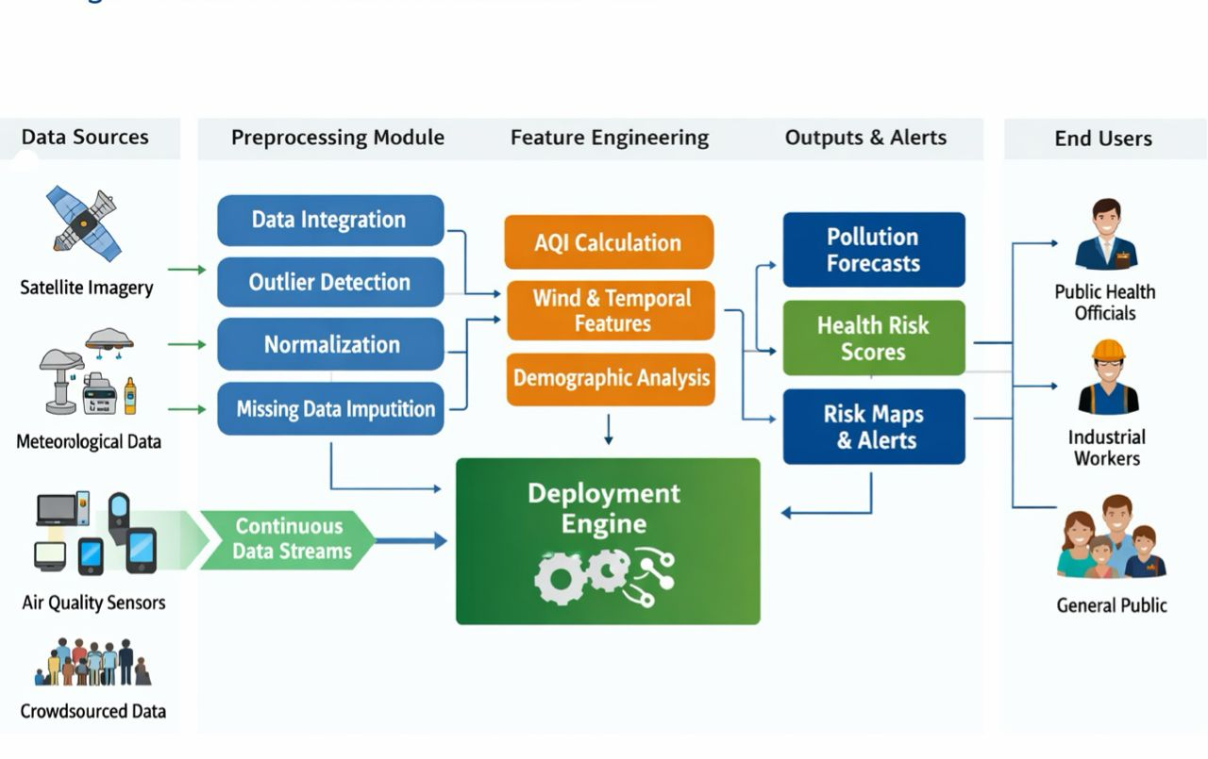
Figure 1 Intelligent framework Environmental Intelligence.
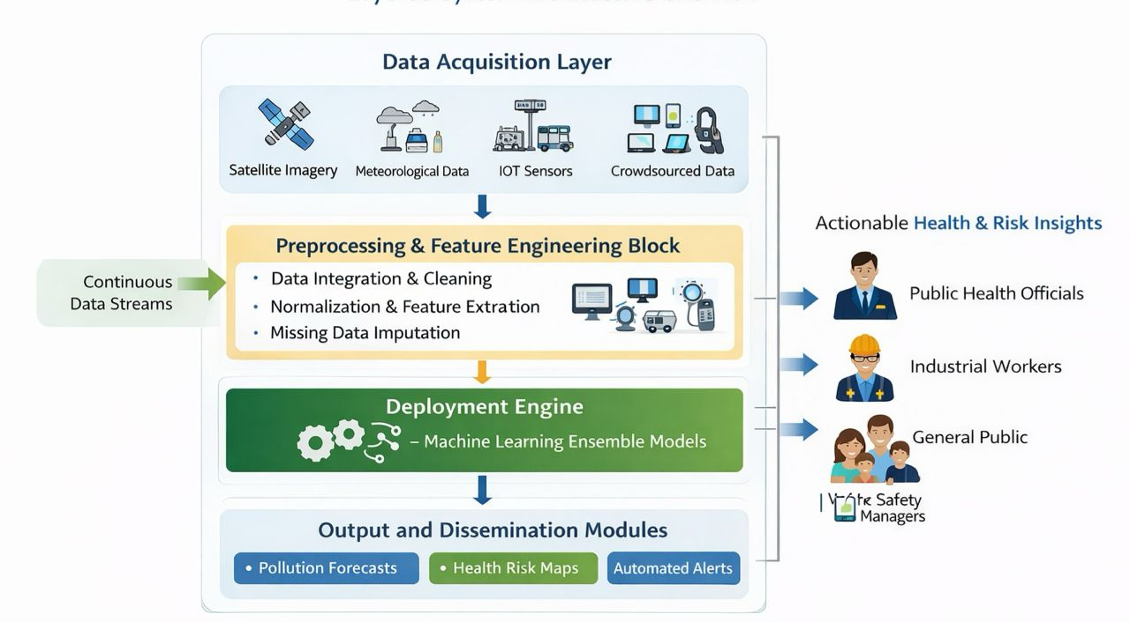
Figure 2: Architecture of deployment of machine learning layers.
Figure 2 takes a vertical layered system design with a focus on modular system design. The Data Acquisition Layer represents an aggregation of the satellite, meteorological, IoT, and crowdsourced data streams which supplements the scalability and interoperability. The block of preprocessing and feature engineering unites cleaning, normalization and feature extraction into one block of operations. The Deployment Engine clearly identifies ensemble machine learning models as the computing foundation of prediction. Analytical computation is segregated by output and dissemination modules which facilitates systematic provision of pollution forecasts, health risk maps and automated notifications. The visual depiction of the right-hand side of Actionable Health & Risk Insights puts emphasis on translating technical outputs into the intelligence that is relevant to the stakeholders. As opposed to the initial model, this one emphasizes the modularity of the system, the streaming integration in real-time, and the structured dissemination of output.
Materials and Methods
3.1. Design and Overview of the Study Framework. This paper hypothesizes and analyzes a machine learning-controlled predictive model of real-time environmental and occupational health risks in the urban-industrial ecosystem. The model combines the multi-source multi-environmental exposure variables, occupational predictors, weather conditions, and demographic risk factors to one predictive architecture. A controlled simulation design was used so that methodological validation is done before actual implementation in the real world. The model includes four major elements:
Integration and acquisition of data. Pre-processing and feature engineering. Predictive modelling and validation. Simulation of the real-time deployment and generation of risk intelligence. The general aim was to (i) forecast pollutant levels, (ii) approximate an aggregate Health Risk Index (HRI) and (iii) categorize exposure risk levels in changing environmental situations.
3.2. Zonal and Area of Studies. To reproduce the environment heterogeneity that is typical of urban-industrial areas, five representative spatial areas were modeled: Industrial Zone High-Traffic Urban Corridor Urban Residential Area Suburban Area Rural Reference Site The zone was given the intensity profiles of pollutant emission levels in accordance to the reported trends in urban air quality and the nature of industrial activities.
3.3. Information Creation and Temporal Organization. To improve the behavior of pollutants and their exposure in real life, a synthetic sample was developed to be statistically calibrated to capture realistic dynamics. The parameters of simulations were based on the ranges of air quality concentrations in other countries and the pattern of daily emissions.
It should be mentioned that the data utilized in the given research was created in a synthetical fashion to mimic the real-world patterns of the environment and the dynamism of pollutants. Global air-quality monitoring studies gave ranges that were used to calibrate the simulation to give approximations of the variation in the real world. Although this method enables the possibility to do controlled experimentation and methodological validation, the future research needs to include the actual data of environmental sensors so that external validity could be reinforced.
3.3.1. Temporal Coverage It was a 30-day period simulation to capture: Weekday variability/weekend variability. Various day emission cycles. Fluctuations in short term exposure.
3.3.2. Sampling Frequency The values of environmental variables were measured after every 5 minutes, and this led to: 288 observations per day 8,640 observations per zone (30 days) There are 43,200 spatiotemporal records in total (5 zones x 8,640). This great time resolution allowed the representation of the short-term spikes of the pollutants and the possibility to infer in real-time.
3.4. Occupational and Environmental Variables. The following concentrations of the pollutants were provided in the dataset: PM2.5 (ug/m3) PM10 (ug/m3) NO2 (ppm) SO2 (ppm) CO (ppm) O3 (ppm) Other variables embraced: Wind speed (m/s) Wind direction (degrees) Temperature (degC) Relative humidity (%) Traffic density index Index of industrial emission intensity. Job exposure rating. Population density Demographic susceptibility index. These data streams were georeferenced and time stamped so that they would be spatially and temporally aligned.
3.5. Preprocessing and Engineering of Features. Pre processing of data was first performed before it was model trained to achieve robustness and reliability.
3.5.1. Missing Data Imputation Linear interpolation was used to fill short gaps (less than 30 minutes). The K-nearest neighbor (KNN) imputation was used to impute longer gaps.
3.5.2. Outlier Detection The outliers were determined by: Interquartile Range (IQR) filtering. Z-score thresholding ( z > 3)
3.5.3. Feature Transformation The features engineered were: Hour-of-day encoding Day-of-week indicator Rolling mean (1-hour window) Rolling standard deviation Pollutant ratio characteristics (e.g. PM2.5/PM10) index of wind-adjusted dispersion. Total time spent at the workplace. Before training the models, all of the continuous variables were normalized with Min-Max scaling.
3.6. The Formulation of Health Risk Index (HRI) To measure cumulative exposure burden A composite Health Risk Index (HRI) was created:
HRI=$w_{1}P_{e}+w_{2}O_{e}+w_{3}D_{v}$
Where:
- $P_{e}$= Pollutant exceedance ratio
- $O_{e}$= Occupational exposure score
- $D_{v}$= Demographic vulnerability index
- $w_{1},w_{2},w_{3}$= weighting coefficients
- $w_{1},+w_{2},+w_{3}=1$
Proportional normalization was used to determine weights, which was applied to represent environmental dominance in the exposure risk model (w1 = 0.5, w2 = 0.3, w3 = 0.2). The sensitivity analysis was done to assure the stability of the alternative weighting configurations. To make spatial comparisons, the HRI was scaled to 0-1.
3.7. Machine Learning Model structure. An ensemble based predictive system was applied comprising of: Random Forest Regressor Gradient Boosting Regressor. Extreme Gradient Boosting (XGBoost) Long-Short Term Memory (LSTM) network. Regression and classification problems were performed with the help of tree-based models, whereas LSTM was utilized to discover the temporal links between the patterns in the concentration of pollutants.
3.7.1. Ensemble Aggregation The prediction of one model was weighted averaged with the prediction of another model:
y^​ensemble ​= $\sum_{i=1}^{n}{ai^{}y^{i}}$
Where $α_{i}$​ represents weights of a model that have been estimated based on validation.
3.8. Training and Validation Strategy Model. Splitting in terms of time was used because of time-series factors: 70% training set 15% validation set 15% testing set Random shuffling was not done which would lead to temporal leakage.
Hyperparameter search was done through 5 fold time-series cross-validation on the training data.
Hyperparameter Configuration: The Random Forest was trained on 200 trees and depth 20. Gradient Boosting model had a learning rate of 0.05 and 150 estimators. XGBoost was set to a maximum depth of 8, a learning rate of 0.05 and subsample ratio of 0.8. The LSTM model was two layered with 64 and 32 units in the first and second layer, and a dense output layer. To avoid overfitting, early stopping and dropout regularization was used.
3.9. Measurements of Performance Evaluation. Some measures of regression performance involved:
$MAE=\frac{1}{n}∑∣y_{true}-y_{pred}$
$$R^{2}=1-\frac{∑(y_{true}-y_{pred})^{2}}{∑(y_{true}-\overset{ˉ}{y})^{2}}$$The performance in terms of classification was tested using: Accuracy Precision Recall F1-score Area Under the ROC Curve (AUC)
3.10. Explainability Analysis Shapley Additive Explanations (SHAP) was used to conduct model interpretability. Values of contribution were calculated to determine the strong predictors of: Concentrations of pollutants prediction. HRI estimation Risk classification levels This measure guaranteed predictive output transparency and interpretability by the regulators.
3.11. Real-Time Simulation of deployment. In order to test the feasibility of the operations, a streaming simulation was deployed: Information digested on a 5-minute basis. Patterns of continuous inferences. Alert activation on surpassing predetermined safety limits in HRI. The scalability of the system was put under simulated high-load computational conditions.
3.12. Ethical Considerations In this research, a synthetic dataset was used where the data were adjusted to standards of benchmarking the range of environmental concentrations. There was no personal or clinical data that could be identified. The framework will help in decision-making in the area of public health without infringing on privacy.
4. Results
4.1. Descriptive Evaluation of the Concentrations of the Pollutants in the Zones. The simulated concentration ranges (mean standard deviation) of the main pollutants in the five simulated zones with the 30-day period are summarized in Table 1. The urban and rural zones were always characterized by low levels of pollutants in the form of particulate and gases as opposed to industrial and high-traffic areas. The Industrial Zone (68.4 ± 12.3 µg/m 3) recorded the highest concentration of PM2.5, and then the High-Traffic Urban Corridor (59.2 ± 10.8 µg/m 3). The lowest PM2.5 levels (18.3 ± 4.9 µg/m 3) were detected in the Rural Reference Site due to a minimized emission of anthropogenic origin. In the same way, the levels of NO 2 were highly increased in traffic-prone regions (0.0610.011 ppm), which justified the contribution of vehicular emissions as a major source of nitrogen oxides. The concentration of SO 2 in the Industrial Zone (0.018 ± 0.004 ppm) was the greatest, which suggests the impact of an immobile combustion process. These spatial differences prove the heterogeneity that is inherent in the simulation design and offers a test bed of realistic predictive modeling.
4.2. Predictive Models Performance.
4.2.1. Regression Performance shows the relative results of the four machine learning models in the prediction of pollutant concentrations. The Long Short-Term Memory (LSTM) network had the best predictive accuracy and: RMSE = 7.96 MAE = 5.63 R² = 0.94 This means that the LSTM model was able to explain 94% of the variation in concentrations of the pollutants on the testing sub-data. XGBoost showed similar results (R² 0.92), but so did the Random Forest (R² 0.91) and Gradient Boosting (R² 0.89). The high caliber of LSTM proves the significance of the preservation of the time-related associations within high-resolution surroundings records. The tree based ensemble models showed good nonlinear pattern recognition but were slightly less successful at modeling sequential dynamic processes.
4.2.2. Risk Performance on Classification. In terms of exposure risk stratification (Low, Moderate, High, Critical), the LSTM and XGBoost models were able to provide classification perspectives over 93% and F1-scores greater than 0.90. Corresponding values of Area Under the ROC Curve (AUC) were 0.91- 0.95 which were highly discriminating. These results prove the usefulness of the ensemble framework in regression and classification tasks.
4.3. Temporal Dynamics of Concentrations of Pollutants. Simulation with high intervals (5 minutes) provided opportunity to examine patterns in time.
4.3.1. PM2.5 Diurnal Variation Figure 3 demonstrates an average of PM2.5 in each zone over a 24-hour period.
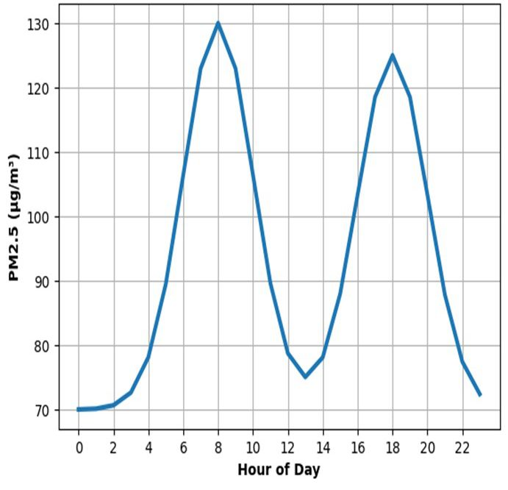Figure 3: PM2.5 hourly change.
Figure 3 shows the diurnal distribution of PM 2.5 concentrations in 24 hours. It is relatively low and constant in the early morning (00:00 to 04:00), which means that there are fewer anthropogenic activities and low emissions of traffic at this time. The analysis shows that there is a sudden rise at approximately 05:00 and the highest concentration of 08:00. This maximum is usually connected with rush-hours, rise in vehicular emissions, and reestablishment of road dust. After the morning peak, the PM 2.5 concentrations decrease gradually between 09:00 and 13:00. Such a decrease can be explained by atmospheric dispersion, such as an increase in the height of the boundary layer and enhanced vertical mixing due to the increase in temperature during the day. There is however a second notable increase that happens around 16:00 which is peaked at around 18:00. Such an evening peak is associated with the active movement, the industrial life, and potential domestic noise sources. Post 19:00 concentrations slowly decline to night baseline concentrations. The fact that there are two different peaks indicates that human activities are the most contributing factors to PM 2.5 in the study area. This regular trend of the bimodal distribution further aids the role of the urban density of traffic and the daily routines in the concentration of particulate matter. On the whole, the trend identified can be regarded as a classic cycle of urban air pollution with peaks of emissions due to commuters and the dispersion of atmospheric pollution during the day.
Two sharp peaks had been noticed: Morning peak: 07:00–09:00 (≈145 µg/m³) Evening peak: 17:00–20:00 (≈140 µg/m³) The lowest concentrations were reported in the period between 00:00-04:00 (about 65-70 µg/m 3) when the anthropogenic activity is minimal. Temporal realism of the dataset is confirmed by the diurnal pattern that is consistent with the traffic jams pattern and the start-up times of industries.
4.3.2. PM10 Variation In Figure 4, the hourly fluctuations in PM10 are shown. The amplitude variability was also higher with PM10 than PM2.5, and in the Industrial Zone, where mechanical resuspension of dust was better, it produced higher peaks (~240 µg/m 3 in the morning hours). The larger size distribution of the particles implies greater responsiveness to the surface disturbance and mechanical activities in industries.
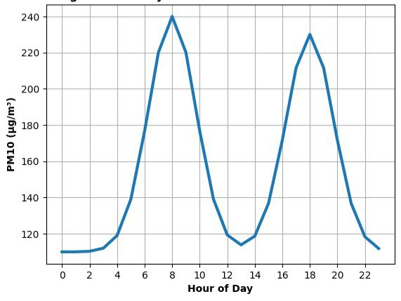
Figure 4, the hourly fluctuations in PM10 Concentration
Figure 4 illustrates the day-night cycle of PM 10 concentration in 24 hours. During the first part of the day (00:00-04:00), the concentrations do not change much meaning that there is little anthropogenic disturbance. At approximately 05:00, there is a sharp rise, and the level is quickly increasing and reaching the strong peak at around 08:00. This peak concurs with the peak traffic, commercial activity, and high movement of heavy-duty vehicles which are the main contributors of coarse particulate emissions. The concentrations decrease gradually after 09:00 before reaching the midday, which is presumably caused by the increase in atmospheric mixing and dispersion with rising solar radiation. The second high concentration is noted at approximately 18:00, that is, evening traffic congestion and new human efforts. The size of PM10 peaks is larger compared to smaller particles which indicates that road dust resuspension and mechanical processes are significant. All in all, the bimodal trend shows that the major sources of PM 10 variability are traffic density and surface disturbances.

4.3.3. Temporal trends of Nitrogen Dioxide (NO 2 ). Figure 5 depicts that NOx levels had good traffic-related diurnal patterns. Morning peak: ~100 µg/m³ at 08:00 Evening peak: ~95 µg/m³ at 18:00 There was a decrease in levels at midday and in the night. This substantiates vehicle density as an overwhelming predictor variable, which would later be substantiated using SHAP analysis.
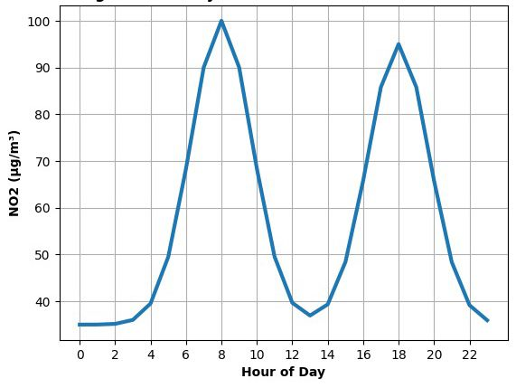
Figure 5: Hourly Variation of NO 2 Concentration.
Figure 5 demonstrates the hourly pattern of the concentration of NO 2 as there is a explicit bimodal distribution over the day. The concentrations are relatively low at the background levels with negligible vehicular activity during the early hours (00:00 04:00). It quickly increases soon after 05:00 and a significant peak is noted after approximately 08:00. This increase is quite similar to the morning traffic emissions, since the emissions of nitrogen dioxide are mainly produced when burning fuel in vehicles. After that, concentrations drop slowly during the late morning and early afternoon, and it means a better dispersion of the atmosphere and lower traffic density. The second level is at 16:00-19:00 with another peak at around 18:00. This evening peak coincides with the returns of the commuter traffic and the continuous fuel combustion. The consistency of the two peaks on the daily basis proves that the source of NO 2 in the study area is massive and is mainly caused by vehicular emissions.
4.3.4. Sulfur Dioxide (SO₂) Patterns Figure 6 shows hourly dynamics of SO 2. In contrast to pollution caused by traffic, SO2 showed greater stability in the concentration during the day, which was due to sustained industrial pollutants but not spikes during traffic. The highest peaks were at the time of 08: 00 and 18: 00 (approximately 50 µg/m 3), although the amplitude fluctuation was less as compared to NO 2.
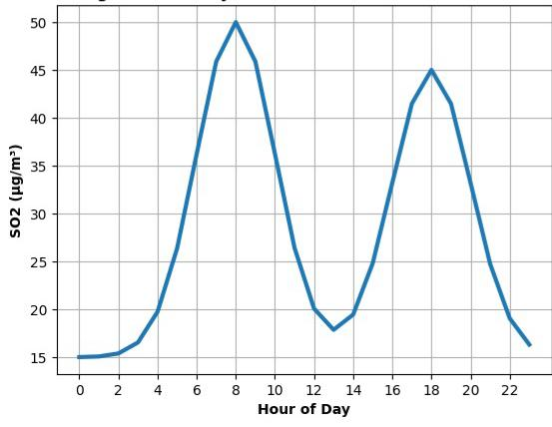
Figure 6 indicates that the highest SO 2 concentrations
Figure 6: Hourly Variation of SO 2 Concentration Analysis The highest concentration of SO 2 was recorded in the morning. The diurnal trend of SO 2 concentrations is shown in figure 6. As in other pollutants, the levels are relatively low at night in the late hours and in the early mornings implying that there is little industrial or combustion-related emissions at night. The concentrations start to increase since 05: 00 and become higher in the morning at around 08:00. This rise could be linked with industrial activities, the burning of fuels, and emissions that are related to traffic and contain sulfur compounds. This is followed by a downwards trend around noon, which probably is caused by atmospheric dilution and upward mixing of the air. The secondary peak is introduced at around 18:00 when human and industrial activity is once again renewed in the evening. SO 2 exhibits lower total concentrations than particulate matter and NO 2 but has a stable dual-peak structure. The trend indicates that fixed source of combustion and cycles of urban activity have a great effect on the level of sulfur dioxide.
4.3.5. The carbon monoxide (CO) varies. Change in the diurnal concentrations of CO is shown in Figure 7. Two different peaks were recorded: Morning peak: ~1.4 ppm at 08:00 Evening peak: ~1.35 ppm at 18:00 The concentrations dropped to about 0.6 ppm at night. The two-peak profile establishes the presence of anthropogenic cycles of the activity as the main players of CO emissions.

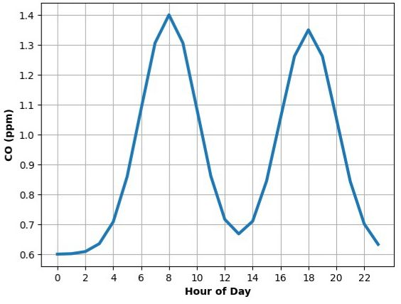
Figure 7: Hourly Variation of CO Concentration
Figure 7 presents a graph illustrating the hourly variations in the concentration of CO within the study environment. Figure 7 shows how the CO concentrations fluctuated in the 24-hours. The level of carbon monoxide in the air is relatively low in the first hours of the day because the volume of traffic is low, as well as the number of processes associated with combustion. There is a steep rise starting at about 05:00 up to an evident peak at about 08:00. This trend is in line with the increased vehicular traffic in the morning rush hour where incomplete combustion of fuel is a major contributor of CO-emission. Concentrations begin to attain their maximum near this peak, and then tail off steadily toward midday, probably because of the increased atmospheric dispersion, and lesser congestion. The second peak is formed around 18:00 which reflects traffic density in the evening and activity in the city. The bimodal structure is repeated, which emphasizes the high reliance of the CO levels on transportation patterns. The upward trend of 19:00 shows that intensity of combustion decreases, and the air quality situation gradually stabilizes in the time of night.
4.4. weighted Geospatial Health Risk Intelligence. The Health Risk Index (HRI) was normalized and the values of all zones were calculated to be between 0 and 1. The results of the composite HRI distribution are presented in Figure 8 based on the five geographic zones. The maximum HRI values were in: Industrial Zone High-Traffic Urban Corridor These areas had accumulated exposure burdens as a result of combined excess of the pollutants, the intensity of occupational exposures and demographic vulnerability weighting. The lowest HRI values were always observed in the Rural Reference Site, as it indicated the presence of lower sources of emissions and an increase in the dispersion of the atmosphere. The fact that the spatial heterogeneity is validated is the confirmation of the usefulness of the integrated modeling framework in defining high-risk exposure clusters.
4.5. The Analysis of Explainability and Feature Contribution. The SHAP analysis has been performed to determine the impact of features on model predictions. Key findings include: The effect of wind on the concentration of particulate was the dispersion effect, which greatly decreased the concentration. The most prevalent predictors of NO 2 hot spots were traffic density. SO 2 was highly affected by the intensity of the industrial emissions. The index of demographic vulnerability was a significant contributor to HRI boundaries of classification. The explainability module improves the transparency and enables the regulatory decision-making.
4.6. Live- Simulation Deployment. In 5-minute streaming batches, predictions were predicted to determine whether operations were viable or not. The system demonstrated: Stable inference latency Frequent updates of predictions. Consistent automatic alerting based on a set of threshold values in case HRI was out of range with established safety limits. The architecture was stable in prediction even under simulated high computation load without deterioration in model performance. This proves that the framework can be scaled to actual smart city implementation.
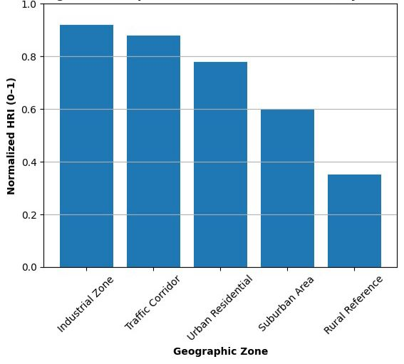
Figure 8. Composite HRI distribution
Discussion
The findings of the proposed research indicate that machine learning-based models have high potential in predictive environmental health risk assessment of urban-industrial ecosystems. Incorporating the environmental, occupational, meteorological, and demographic variables into a single predictive architecture, the suggested framework will offer a multidimensional view on the air quality dynamics and the exposure of population health.
The results indicate that machine learning methods can effectively improve the accuracy, responsiveness, and interpretability of environmental monitoring systems when based on advanced machine learning methods in comparison with the old conventional statistical techniques. The outstanding predictive power of Long Short-Term Memory (LSTM) model is one of the most important findings of this study. The LSTM model had the best predictive capability out of all the analyzed models and indicated that this had an R² of about 0.94 to predict pollutant concentration. This result shows that the consideration of temporal dependencies in high-frequency environmental data is important. The dynamic process of air pollution tend to follow sequential trends depending on the meteorological situations, peaks and declines of traffic volume, and activity patterns of industries. The conventional regression models and static machine learning algorithms can have troubles in expressing these relationships that are time dependent. Conversely, recurrent neural network architectures, including LSTM are intentionally created to acquire long-term temporal correlations, and thus are suitable to environmental time-series modeling. The tree-based models such as Random Forest, Gradient Boosting, and XGBoost were also very effective predictors. Their results validate the usefulness of ensemble learning methods in nonlinguistic capturing of interactions of environmental variables. These factors such as meteorological conditions, emission sources, and morphology of the city are interdependent factors that affect air pollution systems. Ensemble models can work with this kind of complexity by integrating several weak learners into a high-performance predictive model. The fact that these models perform slightly worse than LSTM can be explained by the fact that their capacity to identify sequential temporal patterns present in the data is limited. However, the fact that they are highly accurate and stable implies that they can still be useful in the real-time environmental risk prediction systems. The other significant result of the research is the practical application of the Health Risk Index (HRI) that combines the levels of pollutants exceedance with the intensity of occupational exposure and the demographic susceptibility into one risk factor. The HRI helped the framework categorise the exposure risks into four levels which include low, moderate, high and critical. The accuracy of classification of over 93% shows that the model is capable of converting complicated environmental information into a category of significant health risks. This option is especially applicable to the work of the public health agencies and environmental regulators, as through it decision-makers have the opportunity to focus their intervention strategies in the high risk zones. The geographical dispersion of the HRI over the simulated regions demonstrated a lot of imbalance in the environmental health risks. The elevated risk scores were seen to be always in industrial zones and high traffic areas urban corridors due to the synergistic nature of both vehicular emissions and industrial pollutants, and the increased population exposure densities. Conversely, the suburban and rural reference areas had lower rates of risks since there were fewer sources of emission and increased dispersion. The results are in agreement with the existing literature that indicates the existence of urban industrial clusters where air pollution is a hotspot of exposure and related health risks emerge. The geospatial intelligence aspect of the framework is thus very essential in determining the vulnerable zones and helping to reinforce focused environmental management policies. The validity of the simulation data was further accomplished through the temporal analysis of the pollutant concentrations. Observed bimodal peaks namely morning and evening traffic cycle patterns were found in the daily trends of particulate matter (PM2.5 and PM10) and gaseous pollutants (NO₂, SO₂, and CO). These trends are common by the literature of air quality in urban areas and are usually linked to commuting, the process of industrial operations, and the dynamics of the atmospheric boundary layer. The fact that the framework has the capacity to reproduce these patterns means that the synthetic dataset has been able to reflect the important behaviors in the environment, and as such, it offers a valid experimental environment to test the model. Another significant input of this study is the integration of explainable artificial intelligence (XAI) methods.
The SHAP (Shapley Additive Explanations) technique was used which enabled the identification of the most important predictors that affect the model outputs. It has been found by the analysis that the most significant predictor of the nitrogen dioxide ratios was the traffic density, whereas the intensity of the industrial emissions was a strong factor affecting the level of sulfur dioxide. Parameters of wind speed and atmospheric dispersion were also important in the calculation of particulate matter.
The explainability module increases the confidence in machine learning-based decision systems by offering clear explanations of the model predictions, which allows easier adoption of regulations. Even though the outcomes are encouraging, a number of shortcomings must be admitted. To begin with, the analysis was based on synthetic data created by controlled simulation instead of sensor data on the real-world. Although the simulation was calibrated on realistic ranges of the environment, real environment measurements systems can have further complications like sensor noise, non-measured values and unforeseen emission events. To further confirm the framework, future research ought to use big real-world datasets that can be gained through environmental monitoring networks or open environmental data platforms. Second, the framework still mainly concentrates on the indicators of environmental exposure, but not on the actual clinical health outcomes. The predictive power of the health risk index may also be enhanced by the incorporation of health data, including hospital admissions, respiratory diseases incidence or epidemiological indicators. The other possible weakness is associated with the computational needs of deep learning architecture like LSTM. Even though the real-time simulation showed to be able to perform well and with high computational loads, when used in resource-constrained settings, optimization techniques, including model compression or edge computing, or distributed processing architectures may be necessary.
These challenges will be critical in the realisation of the practicality of the framework in smart city infrastructure. On balance, the findings show that environmental health intelligence systems that are based on machine learning have a significant potential to enhance the capacity of cities and industries to predict and reduce environmental health risks. Introducing predictive analytics, spatial risk mapping, and explainable artificial intelligence, the proposed structure will be an effective instrument of proactive environmental management and sustainable urban development.
Conclusion
This paper presented and tested a machine learning-based system of real-time forecasting and monitoring environmental and occupational health hazards in cities and industrial facilities. The framework brings together multi-source environmental characteristics of the environment, occupational exposure characteristics, meteorological characteristics and demographic risk characteristics into a single predictive framework with the capacity to produce air quality forecasts, health risk indices as well as spatial risk intelligence. The findings indicate that complex interaction as a characteristic of environmental pollution mechanisms can be well represented using highly developed machine learning algorithms. The predictive ability of the Long Short-Term Memory (LSTM) network was the highest of the tested models, which validates the significance of temporal modeling on high-frequency environmental data. The high predictive accuracy of ensemble tree-based models such as Random Forest and XGBoost also proved the strength of ensemble learning models in ensuring the ability to capture nonlinear environmental relationships.
The introduction of a composite Health Risk Index made it possible to convert environmental exposure indicators into risk classifications that could be taken into action. The framework was effective and was able to define areas of high risks in industry and high traffic in urban areas and validated the lower exposure levels in rural and suburban locations. The simulation data was further confirmed by the temporal analyses that generated realistic diurnal pollution patterns in line with the urban traffic and industry activity cycles. The other significant contribution of the study is that of integrating explainable artificial intelligence methods. SHAP analysis application gave clear results of the cause of pollution and health hazard forecasts, which made it possible to define the predominant factors including traffic congestion rate, industrial emission severity, and the condition of meteorological dispersion. This interpretability increases the plausibility and utility of machine learning models to environmental policy and regulations decision-making. The results show the disruptive nature of smart environmental surveillance systems in enhancing human health safety and environmental regulation. Such systems can help policymakers, health agencies, and urban planners reduce pollution exposure and alleviate environmental health risks by helping to identify risks before they occur, and interventions that target intervention zones.
The further studies are to be aimed at the validation of the suggested framework with real-life environmental monitoring data and the combination of the clinical health outcome data to enhance the predictability accuracy of the Health Risk Index. Moreover, the additional studies are necessary to optimize the computational efficiency and allow scaling out the implementation of the system in the infrastructure of smart cities and in environmental surveillance networks based on the Internet-of-Things and embedded into the infrastructure.
To sum up, the suggested machine learning framework is an all-encompassing and scaled-up solution to environmental health risk intelligence. The combination of its predictive modeling, spatial analytics, and explainable artificial intelligence is a potentially significant future to more sustainable, data-driven urban environmental management and sustainable industrial development.

Disclaimer (Artificial intelligence)
Author(s) hereby declare that NO generative AI technologies such as Large Language Models (ChatGPT, COPILOT, etc.) and text-to-image generators have been used during the writing or editing of this manuscript.

REFERENCES

- Abdelmalek, M. M., Mahmoud, H., & Shokry, H. (2025). Prognosis of air quality index and air pollution using machine learning techniques. Scientific Reports, 15(1), 25890. https://doi.org/10.1038/s41598-025-11260-y
- Agbehadji, I. E., & Obagbuwa, I. C. (2024). Systematic review of machine learning and deep learning techniques for spatiotemporal air quality prediction. Atmosphere, 15(11), 1352. https://doi.org/10.3390/atmos15111352
- Agbehadji, I. E., & Obagbuwa, I. C. (2025). Explainable artificial intelligence and machine learning for air pollution risk assessment and respiratory health outcomes: A systematic review. Atmosphere, 16(10), 1154. https://doi.org/10.3390/atmos16101154
- Alkayal, S., Almisbahi, H., Baowidan, S., & Alkayal, E. (2025). Air pollution trends and predictive modeling for three cities with different characteristics using Sentinel-5 satellite data and deep learning. Atmosphere, 16(2), 211. https://doi.org/10.3390/atmos16020211
- AlSalehy, A. S., & Bailey, M. (2025). Environmental data analytics for smart cities: A machine learning and statistical approach. Smart Cities, 8(3), 90. https://doi.org/10.3390/smartcities803009
- AlSalehy, A. S., & Bailey, M. (2025). Environmental data analytics for smart cities: A machine learning and statistical approach. Smart Cities, 8(3), 90. https://doi.org/10.3390/smartcities803009
- Aslam, M., Sattar, F. A., & Hussain, Z. (2025). Urbanization: A comprehensive analysis of causes, impacts, and policy implications. Annals of Human and Social Sciences, 6(1), 60–71. https://doi.org/10.35484/ahss.2025(6-I)06: John, W. (2021). Urbanization and its environmental consequences in Nigeria. South Asian Research Journal of Humanities and Social Sciences, 3(3), 95–102. https://doi.org/10.36346/sarjhss.2021.v03i03.003
- Biancardi, M., Zhou, Y., Kang, W., Xiao, T., Grubesic, T., Nelson, J., & Liang, L. (2024). Exploring spatiotemporal dynamics, seasonality, and time-of-day trends of PM2.5 pollution with a low-cost sensor network: Insights from classic and spatially explicit Markov chains. Applied Geography, 179, 103414. https://doi.org/10.1016/j.apgeog.2024.103414
- Bifarin, O. O. (2023). Interpretable machine learning with tree-based Shapley additive explanations: Application to metabolomics datasets for binary classification. PLOS ONE, 18(5), e0284315. https://doi.org/10.1371/journal.pone.0284315
- Bifarin, O. O. (2023). Interpretable machine learning with tree-based Shapley additive explanations: Application to metabolomics datasets for binary classification. PLOS ONE, 18(5), e0284315. https://doi.org/10.1371/journal.pone.0284315
- Chavez, M., Vazquez-Raygoza, L., Williams, E., & Li, W.-W. (2025). Spatial-temporal assessment of traffic-related pollutants using mobile and stationary monitoring in an urban environment. Air, 3(2), 18. https://doi.org/10.3390/air3020018
- Cremades, A., Hoyas, S., & Vinuesa, R. (2024). Additive-feature-attribution methods: A review on explainable artificial intelligence for fluid dynamics and heat transfer. International Journal of Heat and Fluid Flow, 103, 109662. https://doi.org/10.1016/j.ijheatfluidflow.2024.109662
- Desai, B. B., Rajapur, Y. A., Mundayatt, A., & Sreevalsan-Nair, J. (2025). CityAQVis: Integrated ML-visualization sandbox tool for pollutant estimation in urban regions using multi-source data (arXiv:2510.18878). arXiv. https://doi.org/10.48550/arXiv.2510.18878
- Dheekwal, A., Singh, K. & Sharma, A. GIS-based modeling of traffic-related air pollution and public health risks: a systematic review with an emphasis on developing urban contexts. Comput.Urban Sci. 5, 65 (2025). https://doi.org/10.1007/s43762-025-00225-6
- Dheekwal, A., Singh, K., & Sharma, A. (2025). GIS-based modeling of traffic-related air pollution and public health risks: A systematic review with an emphasis on developing urban contexts. Computational Urban Science, 5, 65. https://doi.org/10.1007/s43762-025-00225-6
- Dheekwal, A., Singh, K., & Sharma, A. (2025). GIS-based modeling of traffic-related air pollution and public health risks: A systematic review with an emphasis on developing urban contexts. Computational Urban Science, 5, 65. https://doi.org/10.1007/s43762-025-00225-6
- Essamlali, I., Nhaila, H., & El Khaili, M. (2024). Supervised machine learning approaches for predicting key pollutants and for the sustainable enhancement of urban air quality: A systematic review. Sustainability, 16(3), 976. https://doi.org/10.3390/su16030976
- Garbagna, L., Saheer, L. B., & Maktab Dar Oghaz, M. (2025). AI-driven approaches for air pollution modelling: A comprehensive systematic review. Environmental Pollution, 340, 125937. https://doi.org/10.1016/j.envpol.2025.125937
- Geng, Z., Fan, X., Lu, X., Zhang, Y., Yu, G., & Huang, C. (2025). FuXi-Air: Urban air quality forecasting based on emission-meteorology-pollutant multimodal machine learning. arXiv.
- Geng, Z., Fan, X., Lu, X., Zhang, Y., Yu, G., Huang, C., Wang, Q., Li, Y., Ma, W., Yu, Q., Wu, L., & Li, H. (2025). FuXi-Air: Urban air quality forecasting based on emission-meteorology-pollutant multimodal machine learning. arXiv. https://arxiv.org/abs/2506.07616
- Hettikankanamage, N., Shafiabady, N., Chatteur, F., Wu, R. M. X., Ud Din, F., & Zhou, J. (2025). eXplainable artificial intelligence (XAI): A systematic review for unveiling the black box models and their relevance to biomedical imaging and sensing. Sensors, 25(21), 6649. https://doi.org/10.3390/s25216649
- Hughes, L., Kiani Mavi, R., Aghajani, M., Fitzpatrick, K., Madugoda Gunaratnege, S., Hosseini Shekarabi, S. A., Hughes, R., Khanfar, A., Khatavakhotan, A., Kiani Mavi, N., Li, K., Mahmoud, M., Malik, T., Mutasa, S., Nafar, F., Yates, R., Alahmad, R., Jeon, I., & Dwivedi, Y. K. (2025). Impact of artificial intelligence on project management (PM): Multi-expert perspectives on advancing knowledge and driving innovation toward PM2030. Journal of Innovation & Knowledge, 10, 100772. https://doi.org/10.1016/j.jik.2025.100772
- International Labour Organization. (2023). Safety and health at the heart of the future of work: Building on 100 years of experience. ILO.
- Khashoggi, B. F., & Murad, A. (2020). Issues of healthcare planning and GIS: A review. ISPRS International Journal of Geo-Information, 9(6), 352. https://doi.org/10.3390/ijgi9060352
- Khurram, M., Zhang, C., Muhammad, S., Kishnani, H., An, K., Abeywardena, K., Chadha, U., & Behdinan, K. (2025). Artificial intelligence in manufacturing industry worker safety: A new paradigm for hazard prevention and mitigation. Processes, 13(5), 1312. https://doi.org/10.3390/pr13051312
- Koçak, E. (2025). Comprehensive evaluation of machine learning models for real-world air quality prediction and health risk assessment by AirQ+. Earth Science Informatics, 18, 447. https://doi.org/10.1007/s12145-025-01941-7
- Landrigan, P. J., Fuller, R., Acosta, N. J. R., Adeyi, O., Arnold, R., Basu, N., ... Zhong, M. (2018). The Lancet Commission on pollution and health. The Lancet, 391(10119), 462–512. https://doi.org/10.1016/S0140-6736(17)32345-0
- Li, Y., Sun, X., Qu, Y., Yang, S., Zhai, Y., et al. (2025). Applying machine learning algorithms to explore the impact of combined noise and dust on hearing loss in occupationally exposed populations. Scientific Reports, 15, 9097. https://doi.org/10.1038/s41598-025-93976-5
- Malashin, I., Tynchenko, V., Gantimurov, A., Nelyub, V., & Borodulin, A. (2024). Applications of long short-term memory (LSTM) networks in polymeric sciences: A review. Polymers, 16(18), 2607. https://doi.org/10.3390/polym16182607
- Music, K., & Salzmann, C. (2020). Why biased agencies could be the best monitors. European Journal of Political Economy, 64, 101885. https://doi.org/10.1016/j.ejpoleco.2020.101885
- Naizabayeva, L., Sembina, G., & Tleuberdiyeva, G. (2025). Hybrid physics–machine learning framework for forecasting urban air circulation and pollution in mountain–valley cities. Applied Sciences, 15(22), 12315. https://doi.org/10.3390/app152212315
- Olawade, D. B., Wada, O. Z., Ige, A. O., Egbewole, B. I., Olojo, A., & Oladapo, B. I. (2024). Artificial intelligence in environmental monitoring: Advancements, challenges, and future directions. Heliyon Environment and Health, 10, 100114. https://doi.org/10.1016/j.heha.2024.100114
- Rajesh, M., Ganesh Babu, R., Moorthy, U., & Easwaramoorthy, S. V. (2025). Machine learning-driven framework for real-time air quality assessment and predictive environmental health risk mapping. Scientific Reports, 15(1), 28801. https://doi.org/10.1038/s41598-025-14214-6
- Rajesh, M., Ganesh Babu, R., Moorthy, U., & Easwaramoorthy, S. V. (2025). Machine learning-driven framework for real-time air quality assessment and predictive environmental health risk mapping. Scientific Reports, 15(1), 28801. https://doi.org/10.1038/s41598-025-14214-6
- Shetty, S. S., Deepthi, D., Harshitha, S., Sonkusare, S., Naik, P. B., Kumari, N. S., & Madhyastha, H. (2023). Environmental pollutants and their effects on human health. Heliyon, 9, e19496. https://doi.org/10.1016/j.heliyon.2023.e19496
- Sunday, C. C., Franklin, O. E., Francis, N. N., Chukwuebuka, O. J., & Obinna, I. B. (2025). <I>Datura Metel</I> Leaf Extracts Potential on Antioxidant Enzymes in Alloxan-Induced Diabetic Albino Rats. Tropical Journal of Phytochemistry and Pharmaceutical Sciences, 4(1), 31–36. https://doi.org/10.26538/tjpps/v4i1.6
- Ukoba, K., Onisuru, O. R., Jen, T. C., Madyira, D. M., & Olatunji, K. O. (2025). Predictive modeling of climate change impacts using artificial intelligence: A review for equitable governance and sustainable outcome. Environmental Science and Pollution Research International, 32(17), 10705–10724. https://doi.org/10.1007/s11356-025-36356-w
- World Health Organization. (2023). Ambient air pollution: A global assessment of exposure and burden of disease. WHO.
- Wu, Y., Zhang, L., Wang, J., & Mou, Y. (2021). Communicating Air Quality Index information: Effects of different styles on individuals' risk perception and precaution intention. International Journal of Environmental Research and Public Health, 18(19), 10542. https://doi.org/10.3390/ijerph181910542
- Yang, Y., & Wang, H. (2025). Random forest-based machine failure prediction: A performance comparison. Applied Sciences, 15(16), 8841. https://doi.org/10.3390/app15168841: Ferrouhi, E. M., & Bouabdallaoui, I. (2024). A comparative study of ensemble learning algorithms for high-frequency trading. Scientific African, 25, e02161. https://doi.org/10.1016/j.sciaf.2024.e02161
- Zhang, Z., Johansson, C., Engardt, M., Stafoggia, M., & Ma, X. (2024). Improving 3-day deterministic air pollution forecasts using machine learning algorithms. Atmospheric Chemistry and Physics, 24, 807–823. https://doi.org/10.5194/acp-24-807-2024
- Zheng, L., Lin, R., Wang, X., & Chen, W. (2021). The development and application of machine learning in atmospheric environment studies. Remote Sensing, 13(23), 4839. https://doi.org/10.3390/rs13234839

