Review Article

Ethosome-Based Nanocarrier Systems for Enhanced Topical Antifungal Drug Delivery: Recent Advances and Therapeutic Applications

.
ABSTRACT

Topical antifungal therapy remains the primary treatment for superficial fungal infections; however, conventional formulations often show limited therapeutic effectiveness due to poor skin penetration, low drug retention, and frequent dosing requirements. Ethosome-based nanocarrier systems have emerged as a promising strategy to enhance transdermal drug delivery due to their unique composition and improved skin permeation capabilities.

This review summarizes recent advances in ethosome-based nanocarriers for topical antifungal drug delivery, focusing on their structural characteristics, mechanisms of skin permeation, formulation strategies, and therapeutic applications. The literature for this review was collected from major scientific databases including PubMed, Scopus, and Google Scholar using relevant keywords such as ethosomes, nanocarriers, topical drug delivery, and antifungal therapy.

The findings from recent studies demonstrate that ethosomal formulations significantly improve drug permeation through the stratum corneum, enhance drug retention in deeper skin layers, and reduce systemic side effects compared with conventional topical formulations.

Overall, ethosome-based systems represent a promising strategy for improving antifungal therapy and may contribute to the development of more efficient and patient-friendly topical drug delivery systems in the future.
Graphical abstract

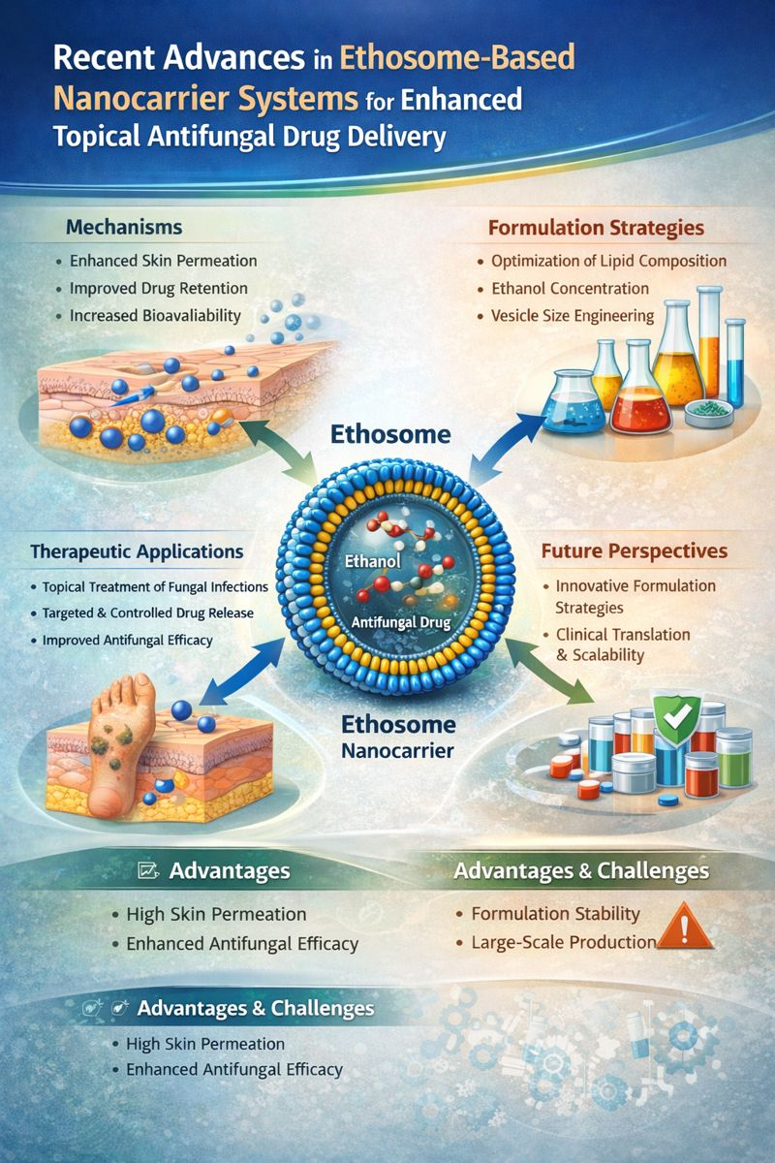

Keywords: [Ethosomes; Nanocarrier systems; Topical drug delivery; Antifungal therapy; Vesicular drug delivery; Skin permeation enhancement; Lipid-based nanoparticles; Dermatological applications)

- INTRODUCTION
Superficial fungal infections are among the most common dermatological disorders worldwide, affecting nearly one-quarter of the global population. These infections significantly contribute to morbidity, reduced quality of life, and increased healthcare costs. Topical antifungal therapy remains the primary treatment approach for most superficial mycoses because it allows localized drug delivery and minimizes systemic side effects. However, the therapeutic effectiveness of conventional topical formulations is often limited due to poor drug penetration through the stratum corneum, insufficient drug retention in deeper skin layers, frequent dosing requirements, and the emergence of antifungal resistance (Brown et al., 2012 ; Gupta et al., 2017). In recent years, nanotechnology-based drug delivery systems have attracted significant attention for improving the performance of topical formulations. Various lipid-based nanocarriers, including liposomes, niosomes, transfersomes, and ethosomes, have been investigated for their ability to enhance drug permeation across the skin barrier and improve drug bioavailability. (Akombaetwa et al., 2023). Among these vesicular systems, ethosomes—soft, ethanol-rich phospholipid vesicles—have emerged as particularly promising carriers for transdermal and topical drug delivery applications (Touitou et al., 2000; Elsayed et al., 2007). Ethosomes differ from conventional liposomes due to their high ethanol content, which increases vesicle fluidity and disrupts the lipid organization of the stratum corneum, thereby facilitating deeper drug penetration into the skin. These vesicular carriers exhibit improved flexibility, higher drug-loading capacity, and enhanced permeation efficiency compared with traditional lipid vesicles. As a result, ethosomal formulations have been widely explored for the topical delivery of antifungal agents such as clotrimazole, ketoconazole, itraconazole, and luliconazole (Verma et al., 2010; Cevc & vierl, 2010). Recent advancements in formulation strategies, including optimization of ethanol concentration, phospholipid composition, and vesicle size, have further improved the stability, controlled drug release, and therapeutic efficacy of ethosomal drug delivery systems. Several experimental studies have demonstrated superior skin deposition and improved pharmacological performance of ethosomal antifungal formulations compared with conventional topical dosage forms (Raina et al., 2023). Despite these promising developments, several challenges remain in the development of ethosome-based antifungal therapies. Issues related to formulation stability, potential skin irritation due to high ethanol content, limited large-scale manufacturing feasibility, and insufficient clinical validation continue to hinder their translation into clinical practice. Furthermore, the available literature lacks a comprehensive synthesis of recent advancements, mechanistic insights, and formulation innovations in ethosomal drug delivery systems.
Therefore, the aim of this review is to provide a comprehensive overview of recent advances in ethosome-based nanocarrier systems for enhanced topical antifungal drug delivery. The review focuses on the mechanisms of skin permeation, formulation strategies, physicochemical characterization, therapeutic applications, and current challenges associated with ethosomal antifungal formulations, while also highlighting future research directions for the development of more effective topical drug delivery systems.
- METHODOLOGY
This review was conducted through a comprehensive literature search of major scientific databases including PubMed, Scopus, Web of Science, and Google Scholar. The search strategy used relevant keywords such as “ethosomes,” “ethosome-based drug delivery,” “nanocarrier systems,” “topical antifungal drug delivery,” and “transdermal drug delivery.” Articles published in English between 2000 and 2025 were considered for inclusion in this review. Both review articles and original research studies related to ethosomal formulations and topical antifungal therapy were included. Studies that did not focus on topical or transdermal drug delivery systems were excluded.
The selection of articles followed a systematic screening process including identification, screening, eligibility assessment, and final inclusion of relevant studies. The overall selection process was organized according to the PRISMA (Preferred Reporting Items for Systematic Reviews and Meta-Analyses) guidelines to ensure transparency and methodological clarity.
2.1 PRISMA Flow Diagram and Study Selection
The literature search initially identified approximately 320 articles from the selected databases including PubMed, Scopus, Web of Science, and Google Scholar. After removing duplicate records, 250 articles remained for title and abstract screening. Following this screening process, 90 articles were considered eligible for full-text review. Finally, 45 relevant studies were included in this review for detailed analysis and discussion.
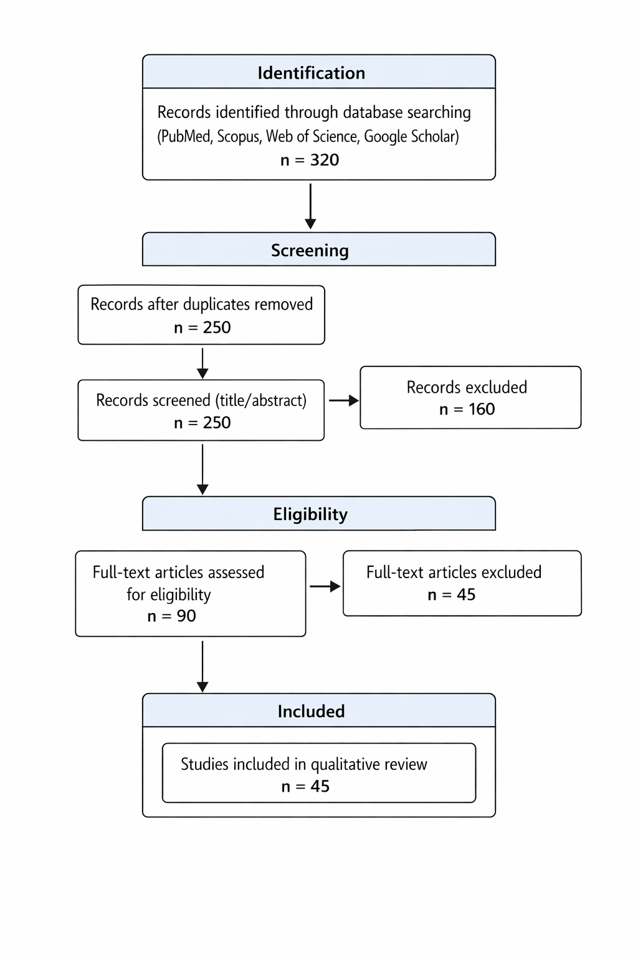
Figure 1. PRISMA flow diagram illustrating the identification, screening, eligibility, and inclusion of studies in this review.

Ethosome-Based Nanocarrier Systems: Concept, Structure, and Fundamental Principles
Ethosomes are phospholipid vesicles with added ethanol, created to address the shortcomings of traditional topical drug delivery methods. Their unique makeup, which includes a high ethanol content and flexible lipid layers, allows them to interact well with the outer layer of skin and penetrate deeply. Unlike standard liposomes, ethosomes are more flexible and can move through the skin more effectively. This quality makes them particularly useful for delivering antifungal agents that are not easily dissolved. As a result, ethosomes have become a promising option for improving how well topical drugs work and their overall effectiveness (Touitou et al., 2000; Ascenso et al., 2014).

Recent developments in nanomedicine have broadened the understanding of ethosomes by optimizing their lipid makeup, ethanol levels, and vesicle size. This has led to better stability, increased drug loading, and controlled release. Additionally, studies comparing ethosomes with other vesicular systems, such as transfersomes and niosomes, show that ethosomes have better penetration and skin retention. However, there are still challenges related to their stability and application in clinical settings (Chauhan et al., 2022).

3.1 Evolution and Conceptual Development of Ethosomes
The ethosomal system was introduced as a new version of traditional liposomes to improve transdermal drug delivery. Over the last twenty years, ethosomes have changed from basic ethanol-lipid vesicles to more complex nanocarrier systems that include hybrid vesicles and specialized lipid mixtures. This change shows a better understanding of skin barrier biology and how nanocarriers interact with skin. As a result, ethosomes are now seen as a flexible option for topical drug delivery (Touitou et al., 2000; Honeywell-Nguyen & Bouwstra, 2005).
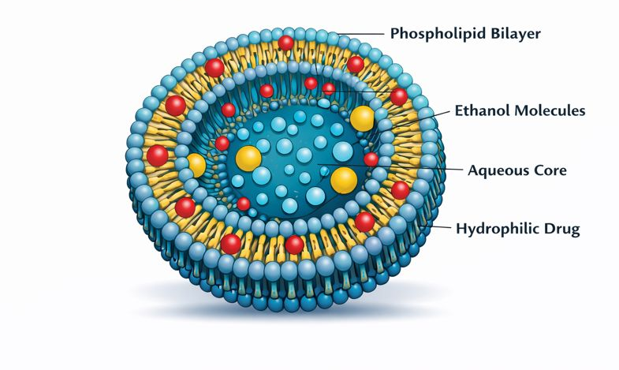
Figure 2. Structure of ethosome vesicle

Structural Composition and Physicochemical Characteristics
Ethosomes usually contain phospholipids, ethanol, water, and sometimes additives like cholesterol and surfactants. Ethanol serves two purposes by making the vesicular bilayer and the stratum corneum lipid matrix more fluid. This improves the flexibility of vesicles and how well they penetrate the skin. Important physicochemical factors, such as vesicle size, zeta potential, entrapment efficiency, and bilayer fluidity, greatly affect how well ethosomal formulations perform and how stable they are. It is crucial to optimize these factors to create consistent and effective topical delivery systems (Ascenso et al., 2014;).
Table 1. Key Characteristics of Ethosome-Based Nanocarriers
Characteristic | Description
Composition | Phospholipids, ethanol (20–45%), and water forming flexible lipid vesicles
Vesicle Flexibility | High deformability and enhanced membrane fluidity due to ethanol incorporation
Drug Encapsulation | Ability to encapsulate both hydrophilic and lipophilic drugs within aqueous core and lipid bilayer
Skin Penetration | Enhanced permeation through the stratum corneum and deeper skin layers
Therapeutic Advantage | Improved drug retention, sustained release, and localized topical delivery

3.3 Fundamental Mechanisms of Skin Penetration

The improved permeation ability of ethosomes comes from a combined process that includes ethanol breaking down lipids and the vesicles transporting drug molecules. Ethanol disrupts the structured lipids in the stratum corneum. At the same time, the flexible vesicles reach deeper skin layers, allowing for better drug deposition and controlled release. This two-part process sets ethosomes apart from other vesicular systems and explains their better performance in topical drug delivery (Fang et al., 20O8).

Comparison with Other Vesicular Nanocarriers
Compared to liposomes, transfersomes, and niosomes, ethosomes usually show better skin penetration and drug retention, especially for lipophilic drugs. However, their high ethanol content can reduce vesicle stability and raise safety issues. This suggests a trade-off between how well the drugs can permeate and the stability of the formulation. These insights emphasize the importance of thoughtful design and improvement of ethosomal systems for clinical use (Chauhan et al., 2022;).
Table 2. Comparison of Ethosomes with Other Vesicular Nanocarrier
Parameter | Ethosomes | Liposomes | Niosomes | Transfersomes
Main components | Phospholipids + ethanol + water | Phospholipids + water | Non-ionic surfactants + cholesterol | Phospholipids + edge activators
Vesicle flexibility | Very high | Low | Moderate | Very high
Ethanol content | High (20–45%) | Absent | Absent | Low
Skin penetration ability | Excellent | Limited | Moderate | Excellent
Drug entrapment efficiency | High | Moderate | Moderate | High
Stability | Good | Moderate | Good | Moderate
Suitability for topical antifungal delivery | Very high | Limited | Moderate | High

Key Advantages and Limitations
Ethosome-based systems have several advantages. They improve drug permeation and bioavailability, and they may allow for sustained topical delivery. However, there are still significant barriers to their widespread use. These include formulation instability, irritation from ethanol, challenges with scaling up production, and a lack of clinical evidence. It is important to address these issues with better formulation methods and practical research for the future development of ethosome-based topical therapies (Jafari et al., 2023).

Mechanisms of Skin Penetration and Drug Delivery by Ethosome Systems
Ethosome-based nanocarriers are a unique type of lipid vesicle created to tackle the tough barrier of the stratum corneum and improve topical drug delivery. Unlike standard liposomes, ethosomes have a high ethanol content. This changes the structure of the vesicles and the way they interact with the skin, allowing for deeper penetration and better drug availability. The way ethosomes deliver drugs is complex. It involves a combination of physical, chemical, and biological processes that work at the molecular, cellular, and tissue levels.
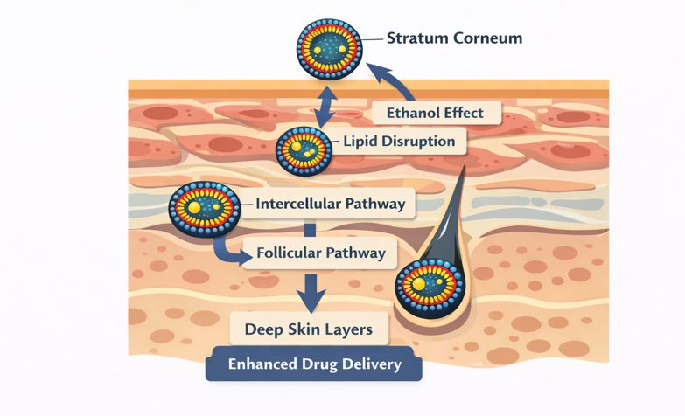
Figure 3. Mechanism of ethosomal skin penetration

4.1 Ethanol-Induced Modulation of Skin Lipid Architecture
A main mechanism behind ethosomal penetration is the disruptive effect of ethanol on the structured lipid layers of the stratum corneum. Ethanol interacts with intercellular lipids, increases lipid fluidity, and lowers the packing density of ceramides and fatty acids. This creates temporary pathways for drug molecules. This phenomenon, called the “ethanol effect,” improves skin permeability and helps with deeper distribution of vesicles and encapsulated drugs

At the molecular level, ethanol-induced lipid disorder lowers the thermodynamic barrier for skin transport and boosts vesicle flexibility. This allows ethosomes to pass through narrow intercellular spaces that rigid lipid vesicles cannot reach (Almuqbil & Aldhubiab, 2025).

Vesicle Deformability and Fusion with Skin Lipids
Beyond ethanol-mediated lipid disruption, the flexible nature of ethosomal vesicles plays a critical role in skin transport. The high ethanol concentration reduces bilayer stiffness and increases vesicle elasticity, enabling ethosomes to deform and move through complex intercellular pathways within the stratum corneum. Studies using advanced imaging techniques indicate that ethosomes mainly penetrate through intercellular lipid domains and may partially fuse with epidermal lipid membranes, enabling localized drug deposition and sustained release (Raj et al., 2023; Almuqbil & Aldhubiab, 2025). This fusion-based mechanism distinguishes ethosomes from conventional liposomes, which generally remain confined to the superficial skin layers and therefore show lower penetration efficiency (Almuqbil & Aldhubiab, 2025).

4.3 Carrier-Mediated Transport and Drug Release Dynamics

Ethosomes function both as penetration enhancers and active drug carriers. Their phospholipid-ethanol structure enables efficient encapsulation of drug molecules and protects them from enzymatic degradation and premature release. After penetrating the skin barrier, ethosomes release drugs gradually in a controlled manner, maintaining therapeutic concentrations in the epidermal and dermal layers and improving therapeutic outcomes (Gangwar et al., 2010).
Recent studies show that the combination of ethanol-induced lipid fluidization and vesicle–skin interactions enables significantly higher drug absorption compared with conventional formulations and other nanovesicular carriers such as liposomes and niosomes (Lohakare et al., 2024).

4.4 Multiscale Mechanistic Insights and Emerging Perspectives
Recent advances in molecular dynamics simulations, imaging techniques, and in vitro skin models have provided deeper insights into the complexity of ethosomal delivery. These studies indicate that ethosome-mediated penetration is governed by a combination of thermodynamic, structural, and biological factors rather than a single dominant mechanism (Esposito et al., 2024).Overall, these insights show that ethosomes are a flexible and effective nanocarrier platform. They can help bypass skin barrier challenges and improve topical drug delivery.
Table 3. Key Mechanisms of Ethosome-Mediated Skin Penetration
Mechanism | Core Function | Outcome in Antifungal Delivery
Ethanol effect | Disrupts stratum corneum lipids | Enhanced skin permeability
Vesicle flexibility | Enables passage through narrow skin pathways | Deep tissue penetration
Multiple transport routes | Intercellular and follicular pathways | Improved drug distribution
Controlled release | Gradual drug liberation in skin layers | Prolonged therapeutic effect
- Formulation Strategies and Optimization of Ethosome-Based Antifungal Systems
The effectiveness of ethosome-based nanocarriers depends heavily on careful formulation design and improvement. Good design leads to stable vesicles, effective drug encapsulation, better skin penetration, and controlled release. Recent studies show that optimized ethosomal formulations work better than traditional topical systems in terms of bioavailability, antifungal effectiveness, and patient satisfaction (Touitou et al., 2000; Elsayed et al., 2007).

5.1 Formulation Components and Their Roles
Ethosomes mainly consist of phospholipids, ethanol, and water. Cholesterol or surfactants can be added to improve stability. Phospholipids maintain structure and help with drug encapsulation. Ethanol increases membrane fluidity and aids in penetration. The properties of the drug, like lipophilicity, molecular size, and solubility, affect how the vesicles form and how well they load. Choosing and optimizing these components carefully is crucial for achieving vesicles that have the right size, deformability, and skin delivery performance (Verma et al., 2003; Ascenso et al., 2014).

Preparation Techniques and Process Optimization
Common ethosome preparation techniques include:
• Cold Method: This is the most widely used approach because it is simple and leads to the formation of nanoscale vesicles with high drug loading.
• Hot Method: This technique works well for drugs that can tolerate heat; it allows for quicker hydration of lipid components.
• Solvent Dispersion: This method produces uniform vesicles but involves extra steps to remove the solvent.

Important process factors include ethanol concentration, hydration time, stirring speed, and sonication intensity. These factors affect vesicle size, polydispersity, and stability. Adjusting these variables is crucial for creating consistent, scalable formulations that can be used in clinical settings (Godin & Touitou, 2004; Elsayed et al., 2007).
Table 4. Ethosome preparation methods, key parameters, vesicle size, and outcomes for antifungal drug delivery.
Method | Key Parameters | Vesicle Size (nm) | Outcome
Cold Method | Ethanol 20–45%, hydration 30–60 min, sonication | 80–150 | High encapsulation, deep skin penetration, sustained release
Hot Method | Lipid hydration 60–70°C, ethanol addition, stirring | 100–200 | Moderate penetration, stable vesicles
Solvent Dispersion | Lipids in ethanol, gradual aqueous addition | 90–180 | Uniform vesicles, enhanced topical delivery

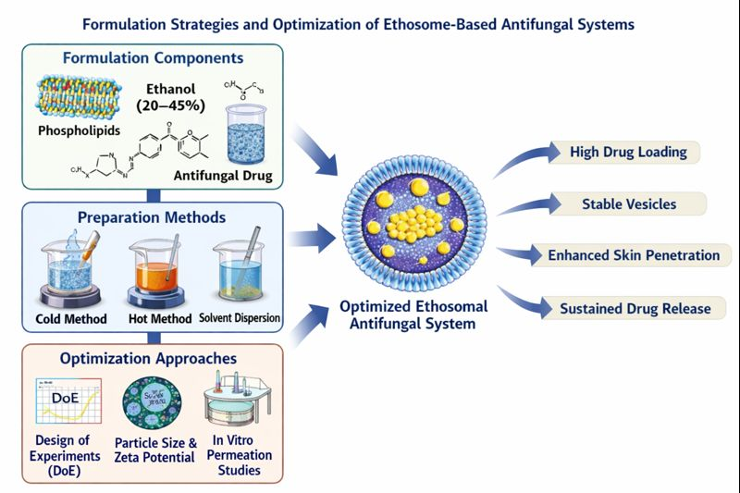
Figure 4. Schematic representation of formulation strategies and optimization of ethosome-based antifungal systems.

Advanced Optimization and Performance Evaluation
Improving optimization strategies is crucial to making sure ethosomal nanocarriers have consistent physicochemical properties and reliable therapeutic effects. Current formulation research increasingly uses organized experimental design and multi-parameter evaluation to effectively optimize ethosomal systems, instead of depending on trial-and-error methods.

Systematic Optimization Approaches
Modern studies often use statistical and computational tools to identify important formulation variables and their interactions. Key optimization strategies include:

• Design of Experiments (DoE): This method evaluates how formulation and process variables, such as ethanol concentration, lipid composition, and sonication time, affect vesicle characteristics.

• Particle Size and Polydispersity Index (PDI) Analysis: This analysis determines vesicle uniformity and stability, which are vital for consistent skin penetration.

• Zeta Potential Measurement: This measurement checks surface charge and predicts the colloidal stability of ethosomal systems.

• Drug Entrapment Efficiency and Loading Capacity: This evaluates how well ethosomes can encapsulate antifungal agents.

• In vitro and ex vivo Skin Permeation Studies: These studies look at transdermal flux, drug deposition, and permeation kinetics using skin models. (Ascenso et al., 2014; Elsayed et al., 2007)

Performance Outcomes of Optimized Ethosomal Systems
Optimized ethosomal formulations consistently show better pharmaceutical and therapeutic performance than conventional topical formulations. Recent literature highlights several key outcomes:

• Improved skin deposition: More antifungal drugs accumulate in the deeper layers of the skin.
• Sustained and controlled drug release: Drug availability at the target site lasts longer, which lowers dosing frequency.
• Better entrapment efficiency: Higher drug loading with less leakage during storage.
• Superior antifungal effectiveness: More effective at inhibiting fungal growth compared with traditional creams, gels, and ointments.
• Better formulation stability: More resistant to aggregation and breakdown over time. (Verma et al., 2003; Ascenso et al., 2014)

Translational Relevance and Clinical Implications
Systematic optimization of ethosomal systems is crucial for connecting laboratory-scale formulation with clinical application. By combining physical and chemical characterization with biological performance evaluation, optimized ethosomes become effective platforms for delivering antifungal drugs that improve efficacy and patient compliance. However, differences in experimental protocols and evaluation models among studies emphasize the need for standardized assessment frameworks. This will help with regulatory approval and clinical translation. (Elsayed et al., 2007)
Table 5. Optimization parameters and performance outcomes of ethosomal systems
Parameter | Evaluation | Key Impact
Ethanol concentration | Particle size, PDI | Controls vesicle flexibility and skin permeation
Lipid composition | Entrapment efficiency | Influences stability and drug loading
Sonication conditions | Vesicle size analysis | Improves homogeneity and delivery efficiency
Zeta potential | Surface charge measurement | Predicts colloidal stability
Skin permeation | Franz diffusion studies | Enhances drug deposition in skin layers
Release kinetics | In vitro release tests | Enables sustained drug delivery

Therapeutic Applications of Ethosome-Based Antifungal Systems
Ethosome-based nanocarriers have emerged as effective platforms for delivering topical antifungal drugs. They tackle key issues of traditional formulations, including poor skin penetration, quick drug clearance, and less effective therapy. The special vesicular structure, along with ethanol-induced lipid fluidization, allows ethosomes to pass through the stratum corneum and achieve better drug deposition in deeper skin layers. Recent studies show that ethosomal formulations greatly improve local drug availability, extend therapeutic action, and boost antifungal results. This makes them a promising option for treating superficial and persistent fungal infections(Shen et al., 2024).

6.1 Topical Delivery of Key Antifungal Agents
Ethosomal systems have been studied for various antifungal drugs. They show better permeation and greater antifungal effectiveness than traditional dosage forms.

Clotrimazole-loaded ethosomes produce significantly higher transdermal flow and antifungal activity against Candida species than regular creams and liposomal options. This highlights how vesicle flexibility helps improve drug localization (Maheshwari et al., 2012).

Luliconazole ethosomal gels have high entrapment efficiency and provide sustained drug release. They also demonstrate better antifungal activity with less skin irritation, which suggests they could be good for long-term topical treatment (Dave et al., 2020).

Voriconazole-loaded ethosomes show better skin absorption and improved antifungal effectiveness compared to hydroalcoholic solutions. This points to their potential for treating deeper fungal infections (Iizhar et al., 2016).

Ketoconazole-loaded ethosomal gel formulations have demonstrated enhanced skin permeation and improved antifungal activity, indicating the potential of ethosomal systems for effective topical treatment of fungal infections (Barde et al., 2021).

Table 6. Ethosomal Antifungal Formulations Reported in Literature
Drug | Ethosome Type | Vesicle Size (nm) | Entrapment Efficiency (%) | Key Findings
Clotrimazole | Ethosomes | ~132 | ~69 | Enhanced permeation, higher inhibition vs liposomes/cream (Maheshwari et al., 2011)
Luliconazole | Ethosomal gel | ~155 | ~87 | Sustained release, improved antifungal activity (Dave et al., 2020)
Voriconazole | Ethosomes | 420–600 | ~46 | ~6-fold higher skin deposition vs solution (Atypon et al., 2016)
Fluconazole | Ethosomal gel | ~144 | ~83 | ~2× diffusion vs liposomes (Bhalaria et al., 2009)

Preclinical and Clinical Evaluation
Preclinical studies show that ethosomal systems improve drug penetration and skin retention compared to standard topical formulations. In vitro and ex vivo research reveals significantly higher drug flow and deposits in both the epidermal and dermal layers. This supports the benefits of ethosomal carriers in topical antifungal treatment.

While clinical data is still scarce, early studies suggest better treatment results for superficial fungal infections. This highlights the need for well-structured clinical trials to confirm long-term safety and effectiveness (Bhalaria et al., 2009).

Comparative Efficacy with Conventional Formulations
Compared to traditional creams, gels, and solutions, ethosomal antifungal formulations have several performance benefits. They include better skin penetration, longer drug retention, and stronger antifungal effects. These systems also show shorter lag time and higher drug flow, leading to better treatment results.

Notably, clotrimazole-loaded ethosomes have created larger inhibition zones against fungal strains than current products on the market. This highlights how vesicular delivery improves antifungal strength (Yadav & Prasad, 2024).

Potential in Chronic and Drug-Resistant Fungal Infections
Ethosomal delivery systems provide specific benefits for managing chronic, recurring, and drug-resistant fungal infections. They release drugs steadily and keep high local drug levels while reducing systemic exposure. This ability to improve drug targeting and patient adherence makes them especially useful for long-term antifungal treatment.

Recent developments, such as adding permeation enhancers, bioactive compounds, and hybrid nanocarrier systems, further increase the therapeutic potential of ethosomes. These improvements may help in overcoming antifungal resistance (Dave et al., 2020).
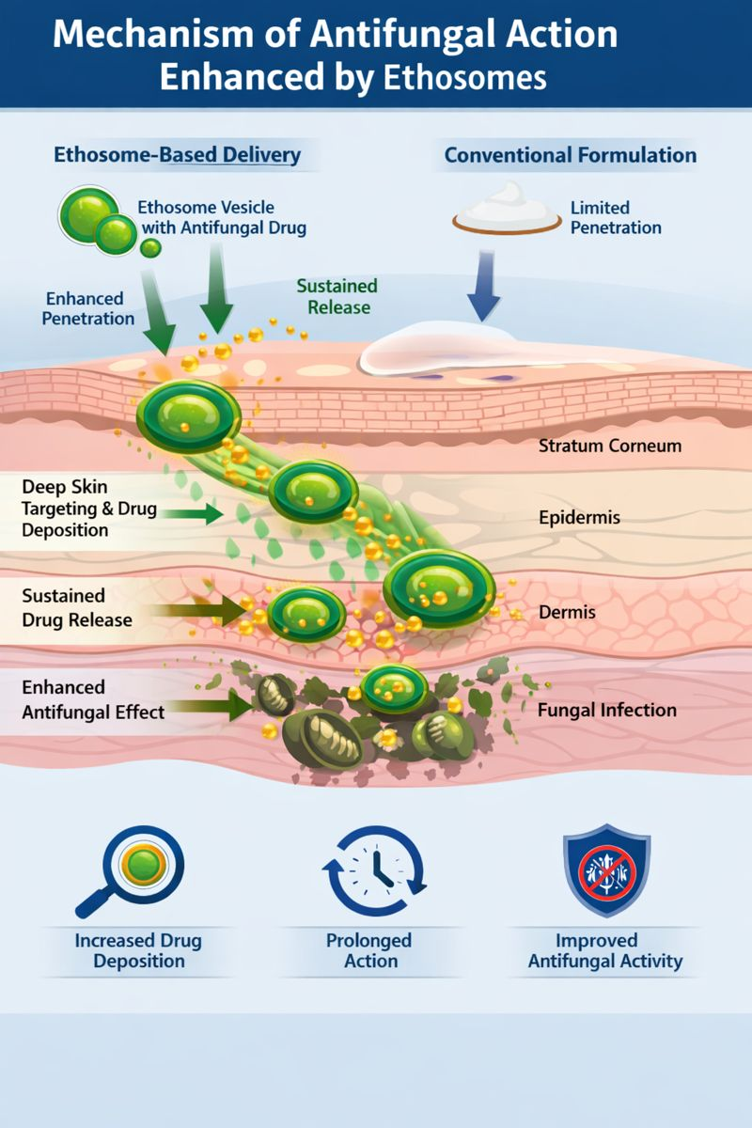
Figure 5. Mechanism of Antifungal Action Enhanced by Ethosomes

Challenges and Limitations of Ethosome-Based Antifungal Systems
Despite notable advances in ethosome-mediated topical antifungal delivery, various scientific, technological, and practical challenges still limit their wider clinical and commercial use. Recent studies highlight that although ethosomes show better skin penetration and treatment effectiveness, ongoing issues with stability, safety, scalability, and regulatory approval remain key obstacles to real-world application (Manpreet et al., 2025).

7.1 Physicochemical and Storage Stability Constraints
Ethosomal vesicles are dynamic systems. Their stability is greatly affected by ethanol concentration, lipid composition, and environmental conditions. While high ethanol content is crucial for membrane flexibility and better penetration, it can also weaken lipid bilayers. This can cause vesicle fusion, drug leakage, and changes in size distribution during storage. Recent studies show that long-term stability is one of the main challenges in ethosomal formulations, especially under accelerated stability conditions (Ascenso et al., 2023).

Additionally, differences in experimental methods between studies make it hard to set standard stability measures. This limits the reproducibility and comparison of results. It highlights the need for better stabilization methods, such as lipid engineering, cryoprotectants, and solid-state ethosomal systems.

Safety and Ethanol-Related Dermatological Concerns
Although ethosomes are generally seen as biocompatible, the high ethanol concentration needed to form the vesicles raises concerns about how the skin tolerates them. Extended exposure could lead to irritation, dryness, or damage to the skin barrier, especially in sensitive or unhealthy skin. Recent studies in dermatology indicate that finding the right balance between improving penetration and ensuring skin safety is a major design challenge for ethosomal systems (Negi et al., 2025).

In addition, the lack of standardized toxicity evaluation methods for nanoscale topical carriers makes risk assessment more difficult. Future formulations should include safety-by-design principles. They need to use biocompatible ingredients and optimized ethanol levels without affecting their therapeutic effectiveness.

Manufacturing, Scalability, and Reproducibility Issues
The shift of ethosomal formulations from lab research to industrial production comes with important technical challenges. Maintaining precise control over vesicle size, polydispersity, and drug encapsulation during scale-up is hard. This leads to variability between batches. Recent developments in lipid-based nanocarrier engineering highlight the need for scalable manufacturing methods. Continuous processing, microfluidics, and high-pressure homogenization can help ensure consistency and meet regulatory standards (Buya et al., 2024).

Moreover, the absence of standardized quality control parameters for ethosomal products limits their use in pharmaceutical production pipelines.

Regulatory and Clinical Translation Barriers
Despite promising preclinical results, the clinical use of ethosome-based antifungal systems is still limited. Uncertainty around regulations for nanocarrier-based topical formulations and a lack of adequate clinical trial data have slowed their path to market. Recent reviews show that regulatory agencies do not have consistent guidelines for assessing the safety, effectiveness, and quality of lipid-based nanocarriers. This creates confusion about approval processes (Ascenso et al., 2023).

Additionally, most studies published focus on in vitro or ex vivo models. There are relatively few well-structured clinical trials. This gap in translation is a significant barrier to the use of ethosomal systems in standard antifungal treatment.
Table 7. Challenges and Proposed Solutions for Ethosome-Based Antifungal Formulations
Challenge | Description | Proposed Solutions
Stability | Vesicle aggregation, drug leakage, size change over time | Optimization of lipid composition, lyophilization, controlled storage conditions
Ethanol-induced irritation | Skin dryness or sensitization | Reduce ethanol %, add moisturizers/emollients
Scale-up | Batch variability, process reproducibility | Standardized large-scale methods (homogenization, microfluidics)
Regulatory & translational | Lack of clinical data, undefined standards | Conduct controlled clinical studies, develop regulatory guidelines

Future Perspectives and Research Directions
Ethosome-based nanocarriers show significant promise for topical antifungal therapy; however, their full clinical potential remains to be explored. Future research should focus on the rational design of next-generation ethosomal systems with optimized vesicle size, surface charge, and membrane flexibility to enhance skin targeting while minimizing systemic exposure. In addition, the development of stimuli-responsive and ligand-functionalized ethosomes may enable targeted and controlled drug release, particularly for the treatment of chronic, recurrent, and drug-resistant fungal infections. Hybrid delivery strategies that combine ethosomes with other nanocarriers or functional excipients also warrant further investigation to address challenges such as vesicle instability, drug leakage, and limited skin retention. Moreover, co-delivery systems incorporating multiple antifungal agents or synergistic adjuvants may provide an effective approach to overcome antifungal resistance and improve therapeutic outcomes. Advances in analytical and imaging techniques, including high-resolution microscopy, quantitative skin deposition studies, and predictive in vitro–in vivo correlation models, will further improve understanding of the mechanisms governing ethosomal drug delivery. Importantly, translating laboratory-scale innovations into clinical applications will require scalable manufacturing methods, standardized quality control parameters, and long-term stability assessments. The lack of unified regulatory guidelines and comprehensive clinical data currently limits widespread adoption, highlighting the need for systematic translational and clinical research. Overall, future progress in ethosomal drug delivery will depend on the integration of advanced formulation strategies, mechanistic insights, and regulatory-oriented development approaches. These efforts are expected to accelerate the clinical translation of ethosome-based antifungal therapies and support their emergence as a promising strategy for safer and more effective topical drug delivery.
- ConclusioN
Ethosome-based nanocarrier systems represent a promising approach for improving topical antifungal drug delivery by enhancing drug penetration through the stratum corneum and increasing drug retention within deeper skin layers. The unique composition of ethosomes, particularly the presence of high ethanol content combined with phospholipid vesicles, provides greater membrane flexibility and facilitates improved permeation compared with conventional topical formulations. Recent studies have demonstrated significant advancements in the development and optimization of ethosomal formulations for antifungal therapy. Improvements in formulation strategies, vesicle characterization, and drug-loading approaches have resulted in enhanced skin deposition, sustained drug release, and improved therapeutic outcomes for several antifungal agents. These findings highlight the potential of ethosomal systems to overcome major limitations associated with traditional topical drug delivery systems. Despite these promising developments, several challenges remain before ethosomal formulations can be widely translated into clinical practice. Issues related to formulation stability, potential skin irritation associated with high ethanol content, large-scale manufacturing feasibility, and limited clinical validation must be carefully addressed.
Future research should focus on optimizing formulation parameters, conducting comprehensive in vivo and clinical studies, and developing standardized evaluation methods to ensure safety, stability, and therapeutic effectiveness. Continued advancements in nanotechnology-based drug delivery systems may facilitate the successful translation of ethosome-based antifungal therapies into clinical and commercial applications, ultimately improving treatment outcomes for patients with fungal skin infections.
Ethical Approval
This article is a review based on previously published literature and does not involve any human participants or animals. Therefore, ethical approval was not required.
Disclaimer (Artificial intelligence)
Author(s) hereby declare that NO generative AI technologies such as Large Language Models (ChatGPT, COPILOT, etc.) and text-to-image generators have been used during the writing or editing of this manuscript.

References
- Touitou, E., Dayan, N., Bergelson, L., Godin, B., & Eliaz, M. (2000). Ethosomes—novel vesicular carriers for enhanced delivery: characterization and skin penetration properties. Journal of Controlled Release, 65(3), 403–418.
- Elsayed, M. M., Abdallah, O. Y., Naggar, V. F., & Khalafallah, N. M. (2007). Lipid vesicles for skin delivery of drugs: reviewing three decades of research. International Journal of Pharmaceutics, 332(1–2), 1–16.
- Verma P, Pathak K. Therapeutic and cosmeceutical potential of ethosomes: An overview. J Adv Pharm Technol Res. 2010;1(3):274–282. https://doi.org/10.4103/0110-5558.72419
- Akombaetwa N, Ilangala AB, Thom L, Memvanga PB, Witika BA, Bapolisi AM, et al. Current advances in lipid nanosystems intended for topical and transdermal drug delivery applications. Pharmaceutics. 2023;15(2):656. https://doi.org/10.3390/pharmaceutics15020656
- Brown GD, Denning DW, Levitz SM. Tackling human fungal infections. Science. 2012;336(6082):647. https://doi.org/10.1126/science.1222236.
- Gupta AK, Foley KA, Versteeg SG. New antifungal agents and new formulations against dermatophytes. Mycopathologia. 2017;182(1-2):127-141. https://doi.org/10.1007/s11046-016-0045-0
- Cevc, G., & Vierl, U. (2010).Nanotechnology and the transdermal route: A state of the art review and critical appraisal. Journal of Controlled Release, 141(3), 277–299. https://doi.org/10.1016/j.jconrel.2009.10.016
- Almuqbil, R. M., & Aldhubiab, B. (2025). Ethosome-based transdermal drug delivery: Its structural components, preparation techniques, and therapeutic applications across metabolic, chronic, and oncological conditions. Pharmaceutics, 17(5), 583. https://doi.org/10.3390/pharmaceutics17050583
- Raj, A., Dua, K., Nair, R. S., Chandran, C. S., & Alex, A. T. (2023).Transethosome: An ultra-deformable ethanolic vesicle for enhanced transdermal drug delivery.Chemistry and Physics of Lipids, 255. 105315.https://doi.org/10.1016/j.chemphyslip.2023.105315
- Gangwar, S., Singh, S., & Garg, G. (2010). Ethosomes: A novel tool for drug delivery through the skin. Journal of Pharmacy Research, 3(4), 688–691.
- Lohakare, N. S., Bhamare, V. G., Chavan, N. D., Shelar, S. D., Mahajan, H. D., & Amrutkar, R. D. (2024).
Ethosome: An innovative perspective of drug delivery.Pharmaceutical Nanotechnology.
https://doi.org/10.2174/0122117385303596240513053014
- Ascenso, A., Raposo, S., Batista, C., Cardoso, P., Mendes, T., Praça, F. G., Bentley, M. V. L. B., & Simões, S. (2014). Development, characterization, and skin delivery studies of related ultradeformable vesicles: transfersomes, ethosomes, and transethosomes. International Journal of Nanomedicine, 9, 5837–5851.
- Esposito, E., Pecorelli, A., Ferrara, F., Lila, M. A., & Valacchi, G. (2024). Feeding the body through the skin: Ethosomes and transethosomes as a new topical delivery system for bioactive compounds.Annual Review of Food Science and Technology, 15, 53–78. https://doi.org/10.1146/annurev-food-072023-034528
- Shen, T., Tian, B., Liu, W., Yang, X., Sheng, Q., Li, M., Wang, H., Wang, X., Zhou, H., Han, Y., Ding, C., & Sai, S. (2024). Transdermal administration of farnesol-ethosomes enhances the treatment of cutaneous candidiasis induced by Candida albicans in mice. Frontiers in Microbiology, 15, 1350611. https://doi.org/10.3389/fmicb.2024.1350611
- Maheshwari, R. G., Tekade, R. K., Sharma, P. A., & Tekade, M. (2012). Ethosomes and ultradeformable liposomes for transdermal delivery of clotrimazole: A comparative assessment. Saudi Pharmaceutical Journal, 20(2), 161–170. https://doi.org/10.1016/j.jsps.2011.10.001
- Verma, D. D., Verma, S., Blume, G., & Fahr, A. (2003). Particle size of liposomes influences dermal delivery of substances into skin. International Journal of Pharmaceutics, 258(1–2), 141–151.
- Godin, B., & Touitou, E. (2004). Ethosomes: new prospects in transdermal delivery. Critical Reviews in Therapeutic Drug Carrier Systems, 21(1), 63–102.
- Dave, V., Yadav, R. B., & Sharma, S. (2020). Luliconazole-loaded ethosomal gel for improved topical antifungal therapy. Drug Development and Industrial Pharmacy, 46(9), 1474–1484.
- Iizhar, S. A., Syed, I. A., Satar, R., & Ansari, S. A. (2016).In vitro assessment of pharmaceutical potential of ethosomes entrapped with terbinafine hydrochloride.Journal of Advanced Research, 7(3), 453–461.https://doi.org/10.1016/j.jare.2016.03.003.
- Barde, S., Burande, M., Kolpe, P., Waghmare, R., & Satpute, K. (2021).
Formulation and evaluation of ketoconazole loaded ethosomal gel for antifungal activity.
International Journal of Pharmaceutical Research and Applications, 6(3), 1230–1236.
- Ascenso, A., Raposo, S., Batista, C., & Ribeiro, H. M. (2023). Stability and safety considerations in lipid-based nanocarriers for dermal delivery. International Journal of Pharmaceutics, 635, 122701.
- Akombaetwa N, Ilangala AB, Thom L, Memvanga PB, Witika BA, Buya AB, et al. Current advances in lipid nanosystems intended for topical and transdermal drug delivery applications. Pharmaceutics. 2023;15(2):656. doi:10.3390/pharmaceutics15020656.

