Synthesis of Y₂O₃ Nanoparticles in Water and Ethanol by Pulsed Laser Ablation for Y₂O₃/n-Si Heterojunction Photodetectors

Abstract
Nanoparticles (NPs), nanotubes, rods, and sheets made of rare earth metals have recently become the material of choice for many device applications. This study aims to synthesize Y₂O₃ nanoparticles using the laser ablation technique in two different liquid media (deionized water and ethanol) and investigate their structural, morphological, optical, and chemical properties, as well as to evaluate the performance of Ag/Y₂O₃/n-Si/Ag heterojunction UV photo-detectors based on the prepared nanoparticles. Studies have been conducted on the structural, morphological, optical, and chemical characteristics of Yttrium oxide . XRD results verify the production of a polycrystalline Y₂O₃ film have cubic crystalline phase with crystallite sizes of 10.52 nm for Y₂O₃ in ethanol and 42.53 nm for Y₂O₃ in water . The SEM results of Y₂O₃ in ethanol shows brittle and porous particles of different sizes ranging from 19.79 nm to 95 nm, while Y₂O₃ in water , The particles were different shape with some agglomerates with particle size range of 40.27 nm to 3 μm. In the AFM image, the Y₂O₃ film's grains measured 49.25 nm in size for case ethanol, whereas in water, particles measured 52.97 nm. The energy gap of Y₂O₃ NPs(ethanol and water respectively) was 4.9 eV and 4.8 eV . The bond Y–O stretching mode of the Y₂O₃ structure is responsible for the high intensity peaks detected by FTIR, which are concentrated around 500-696 cm−1. For Y₂O₃ in ethanol and water, the photo-detector's responsivity at the short wave length region (350-400nm) was 0.16 and 0.17 A/W, respectively. However, for Y₂O₃ in ethanol and water, the photo-detector's responsivity at 850 nm was 0.42 nm and 0.51 A/W, respectively. The Y₂O₃ /n-Si heterojunction photo-detector's specific detectivity D* was determined to be 6.0×1012 and 7.3×1012 Jones, with corresponding quantum efficiencies of 59% and 62% at 350 nm for in case ethanol and water respectively. It is recommended that the synthesis of Y₂O₃ by the method employed in this experiment would be beneficial for fabricating Y₂O₃ nanostructures with good electrical and optical properties to be used in UV optoelectronic devices.

.Keywords: Y₂O₃, Water, Ethanol, Laser ablation, Heterojunction, Silicon

1-Introducation
Nanoparticles are incredibly tiny particles with a size of less than 100 nm and can comprise carbon, metal, metal oxides, or organic substances [27]. The visual, biological, chemical, and electrical properties of nanoparticles are distinct from those of bulk materials [1]. In comparison to their bulk equivalents, nanoparticles exhibit unique properties, such as reduced electrical conductivity and resistivity, increased strength and hardness, decreased diffusivity, enhanced chemical reactivity, and enhanced biological activity [2]. Consequently, nanoparticles have great potential in several fields, such as microelectronics, gas-sensor technologies, photovoltaics, nonlinear optics, heterogeneous catalysis, and medicine [3-6]. One important use case is the photo-detector. In a typical photo-detector, a semiconductor with a specific band gap is used. This allows for the creation of a mobile electron and the opening of a hole in the valence band, which is caused by photons with sufficient energy entering the material. The generated charge-hole pairs act as conductors when biased, making the resulting current visible. For one instant, these charge-hole pairs will generate heat by recombination [3]. This detector converts photons into free current carriers in an instant. If the incident photon wants to activate valence electrons, its energy needs to be greater than or equal to the band gap energy. Rare earth metals (REMs), as the basis for rare earth materials, are critical to producing high-technology equipment and for innovative technologies, often as alloys or additives thereof, to achieve advanced material performance characteristics [24]. Nanoparticles (NPs), nanotubes, rods, and sheets made of rare earth metals have recently become the material of choice for many device applications. Different metals, magnetic materials, metal oxides, and quantum dots have all been used to create metal nanoparticles including, yttrium oxide (Y₂O₃ ) is a common rare earth metal and important for future applications because of its mechanical, chemical, and thermal stability. Y₂O₃ is a widespread rare earth metal, which is used in biomedical imaging, materials science, synthesis of inorganic compounds, optics, electricity, biology applications, and photodynamic therapy [25,26]. Because of their high refractive index, wide band gap (5.8 eV), and strong thermal and chemical durability, Y₂O₃ nanoparticles have drawn a lot of interest [1,8]. These characteristics have led to the application of Y₂O₃ nanoparticles in bio-imaging, luminescence, and sensing [9]. One of the most stable yttrium compounds with a vast array of significant uses is yttrium oxide, sometimes known as yttria. The primary governing elements for every application are the synthesis techniques, which are crucial in producing the necessary size and shape of nanoparticles. A number of techniques, including chemical precipitation, electrothermal decomposition, , sol gel ,solvothermal, hydrothermal, combustion synthesis, sonochemical methods, microwave hydrothermal, reverse micelle method, microwave solvothermal, and microwave combustion methods, have been proposed for the production of yttrium oxide nanoparticles [10, 11]. The simple one-step top-down method of PLAin liquids (PLAL) is utilized to create nanoparticles. This process offers a number of benefits over conventional approaches, including the ability to control the size and characteristics of the generated nanoparticles and guarantee their purity. It is also employed in the preparation of various nanostructure materials. Laser fluence, pulse width, repetition rate, temperature, ablation time, wavelength, the level of the liquid above the target surface, and the concentration of the stabilizing agent are some of the ablation parameters that have a significant impact on the size, shape, and morphology of the nanoparticles created by laser ablation in liquid [12,13].. In this study, preparation and characterization of Y₂O₃ NPs by laser ablation at different liquid to be applied as UV photo-detector(Y₂O₃ /Si).
2. Preparation of samples
A schematic of the laser ablation technique for creating nanoparticles is shown in Fig. 1a. The target material vaporizes when the laser beam focuses on the surface of a solid target material in the surrounding media (gas or liquid) because the irradiated spot's temperature rises quickly. The electron state is excited, light is emitted, and electrons and ions are generated as a result of collisions between the evaporating species (atoms and clusters) and the surrounding molecules, creating a laser-induced plasma plume. The target material, ambient media (gas or liquid), ambient pressure, and laser settings all affect the plasma structures (plume size and emission spectrum). The target is a solid disk of Y₂O₃ placed in deionized water or ethanol.After placing the target in solution, a Nd:YAG laser operating at 1064 nm, 8 Hz, and 300 pulses was used to ablate it. The laser was then exposed to 360 mJ of energy. The produced colloid solution was entirely transparent and stable, devoid of aggregation as seen in figure 1b. Immediately following laser ablation, the optical characteristics of the resulting colloidal solutions were assessed using a UV-Vis (SPUV26) spectrophotometer. The NEXUS-670 was used to examine the colloidal solution's Fourier transform infrared spectroscopy (FTIR) spectrum between 400 and 4000 cm-1. In order to examine morphology, topography, surface analysis, and crystal structure, thin films are deposited using the drop casting process.
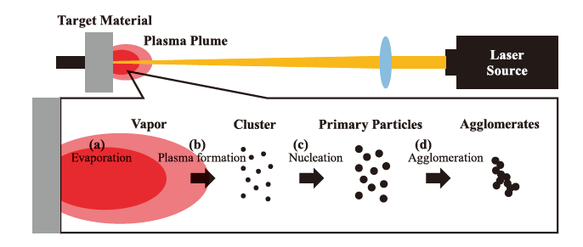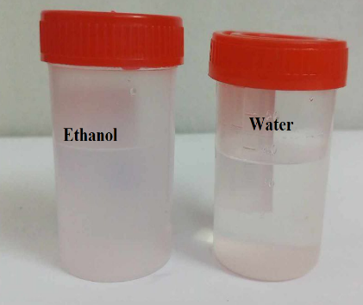
(b)
(a)
Fig.(1 A AND B ): Preparation of Y₂O₃ NPs colloidal by
laser ablation in liquid
3. Result and Dissection
The XRD results for the Y₂O₃ film produced by laser ablation in ethanol and water are shown in Figs. 2a,b. Seven distinct peaks are produced at 2̨ values of 20.49, 29.19, 33.89 o, 43.54, 48.64 o, 53.34, and 57.56 o in Figure 1a, which indicate Y₂O₃ in ethanol. These peaks correspond to diffraction at (211), (222), (400), (134), (440), (611), and (622) planes, respectively. The cubic crystalline phase of Y₂O₃ is in concordance with ICSD #160890 and 431036. The Debye Scherrer method calculated the crystallite size to be 10.52 nm. In contrast, Figure 1b displays the diffraction pattern of Y₂O₃ in water. The creation of the phase cubic crystalline of Y₂O₃ film was confirmed by the prominent peaks that were seen at 2θ = 29.19° and 48.14°, which correspond to the planes (211) and (440), respectively and 42.53 nm was the size of the crystallite .The silica glass substrate is the cause of the pattern's broad dispersed peak i. [14,15].
D = kλ β cos θ……..(1)
where λ is o.154 nm for the wavelength of the X-ray, k is a constant (0.89), θ denotes the Bragg angle, and β is the half-width of the line profile

Fig.(2): XRD analysis of Y₂O₃ films.

Table 1: summary of XRD analysis of Y₂O₃ films.

Sample | 2 Theta (deg) | FWHM (deg) | D (nm) | hkl
Y₂O₃ -Ethanol | 20.49 29.19 33.89 43.54 48.64  53.34 57.56 | 0.46  0.41  0.43  0.40  0.33  0.44  2.63 | 17.59  20.07  19.35  21.43  26.47  20.24  3.45 | (211)  (222)  (400) (134)  (440) (611) (622)
Y₂O₃ -Water | 29.19  48.14 | 0.21  0.19 | 39.18  45.89 | (222)  (440)

A SEM images of Y₂O₃ film in two cases ethanol and water are displayed in Figure 3a,b.The Y₂O₃ in ethanol image shows porous and brittle grains of different sizes, ranging from 19.79 nm to 95 nm. The SEM image of the Y₂O₃ in water are displayed in Figure 3b. It observed the grains with different shapes and some agglomerates with grains size falls between 40.27 nm and 3 μm. It is evident that the morphology, particle size, and aggregation of the particles are significantly influenced by the liquid medium difference. It is also noted that more than 70% of the Y₂O₃ in ethanol and water are nanosized, or less than 100 nm, based on their distribution analysis of size..
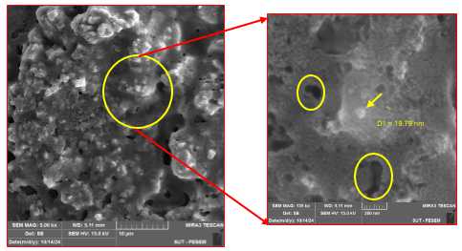
(a)
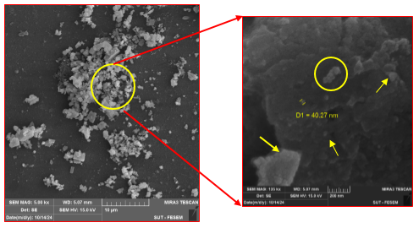
(b)
Fig.(3): SEM image of the synthesized Y₂O₃ (a) in Ethanol(b) in Water.
The AFM images of the Y₂O₃ nanoparticles ablated in ethanol and water are displayed in Figure 4a,b. The Y₂O₃ NPs particles in ethanol take the shape of sand dunes, and some of the grains are gathered into hills. The white peak is 72 nanometers high, 49.25 nm in size, and has a mean roughness of 2.22 nm. The Y₂O₃ NPs in water are spherical and dispersed particles, with some aggregating into domes that are dispersed across the surface and grow to a height of 37 nm, a size of 52.97 nm, and a mean roughness of 1.98 nm. The increased density of water causes the grain sizes of Y₂O₃ ablated in water (Fig 4b) to be larger than those ablated in ethanol.
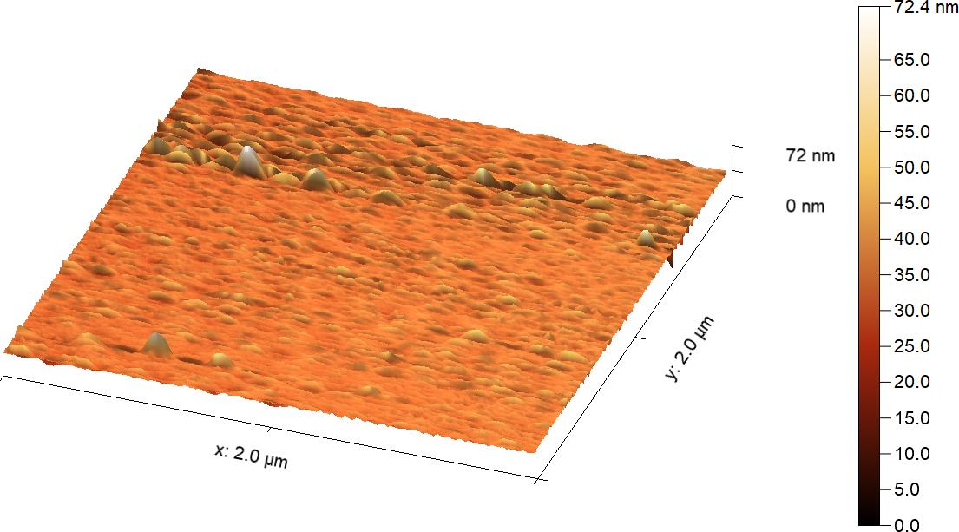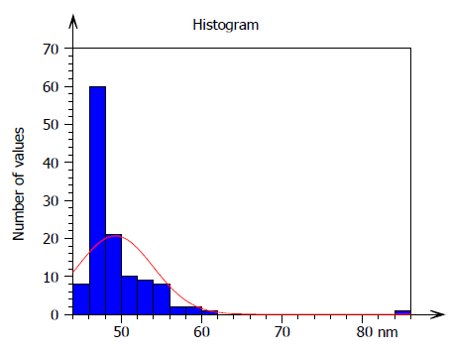
(a)
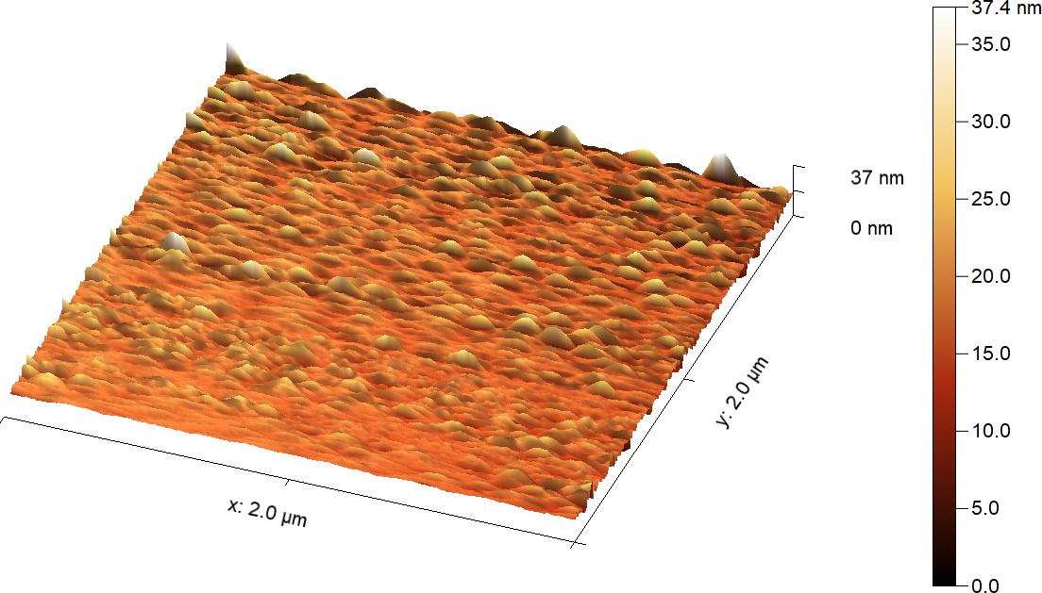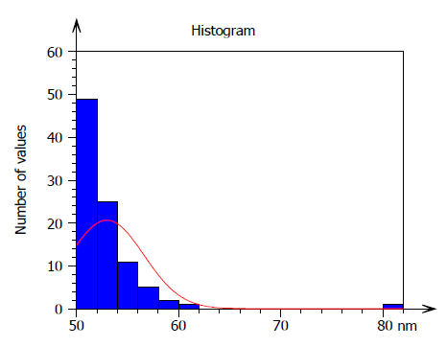
(b)
Fig.(4): AFM image of the synthesized Y₂O₃ (a) in Ethanol(b) in Water..
Figure 5 displays the optical absorption spectra of Y₂O₃ nanoparticles in water and ethanol, which are measured in the 190–1100 nm range. It is evident that the exciton/interband transitions of Y₂O₃ should be responsible for the absorption bands of Y₂O₃ nanoparticles in ethanol at around 250 nm and in water at about 218 nm [16]. The production of Y₂O₃ nanoparticles is indicated by the existence of tiny zigzag peaks in the absorption spectra, which show surface plasmon resonance. It is observed that the absorption spectra exhibit changes in peak positions and intensities with various the liquids. For instance, because of increased scattering and quantum confinement effects, smaller nanoparticles frequently exhibit stronger absorption in particular wavelength ranges. Furthermore, during synthesis, the solvent may have an impact on the kinetics of the reaction, which may further alter the final optical characteristics of the nanoparticles. Tauc's plot relation (eq.2) was used to estimate the optical band gap (Eg) of Y₂O₃ samples [17]:

[(αhv) = B(hv - Eg)^{n}]…………….(2)

The direct transition value is n, the incident photon energy is denoted by hv, and B is a constant. Figure 6a,b illustrates the plot of (αhν)² vs. hν, which was used to assess the band gap. For the Y₂O₃ nanoparticles made with ethanol and water, the band gap was determined to be 4.9 and 4.8 eV, respectively. Band gap energy has been found to show a blue shift in the samples' absorption edge [18].

Fig. (5): Absorbance spectra of Y₂O₃ colloidal.

Fig.(6): A graph displaying the energy band gap of Y₂O₃ colloidal (a) in ethanol and (b) in Water.

Figure 7 displays the FTIR spectrum of yttrium oxide in ethanol and water that was acquired using the laser ablation method. The OH stretching and bending vibration modes, which are caused by both hydroxyl groups and firmly adsorbed molecular water in the crystal lattice, are responsible for the peaks seen in the region 3447.46 cm-1. The asymmetric stretching of the C–O band, which may result from the absorption of CO2 from the environment, is responsible for the peaks at about 1640 cm-1. The presence of yttrium oxide in the crystalline phase is revealed by the high intensity peaks centered about 500–696 cm−1, which are attributed to the Y–O stretching mode of the Y₂O₃ structure [10,19]. The spectra showed no further peaks, suggesting that the material was very phase pure. This is well matched with the result of the XRD studies.

Fig.(7) : FT-IR spectra of Y₂O₃ colloidal..

Equation (3) can be used to estimate the photo-detector's spectrum responsivity Rλ, which is regarded as one of the most significant figures of merit that characterizes the photo-detector performance [20–22].

R = I_{ph}/P_{in} (A/W) ………….(3)
Where, Iph is the photocurrent of the photo-detector and P is the power of light at specific wavelength. As seen in fig. 8, the photo-detector characteristics were investigated at room temperature for Y₂O₃ in ethanol and Y₂O₃ in water at 5 V bias. Y₂O₃ has the highest responsivity at the UV area between 350 and 400 nm. This can be attributed to either Y₂O₃ or the bonding n-Si/Y₂O₃ heterojunction, which indicates the presence of a connection between the silicon substrate and the Y₂O₃ layer. The absorption edge of the Si substrate, it is indicated by the peak in the infrared region at 850 nm [23]. For Y₂O₃ in ethanol and water, the photo-detector's responsivity at the short wave length region (nm) was 0.16 and 0.17 A/W, respectively. This finding suggests that Y₂O₃ has UV activity. While, for Y₂O₃ in ethanol and water, the photo-detector's responsivity at 850 nm was 0.42 nm and 0.51 A/W, respectively. It was found that the visible-blind photo-detector's responsivity is poor in the visible range.

Fig. (8) Responsivity of AgY₂O₃ /Si/Ag photo-detector

The specific detectivity D* of the Y₂O₃ /n-Si heterojunction photo-detector (in ethanol and water a) were found from responsivity found to be 6.0×10¹² and 7.3×10¹² Jones respectively at 850 nm. The specific detectivity depends on behavior the responsivity as shown in figure9. Figure 10 shows that Y₂O₃ has a quantum efficiency of 59% in ethanol and 62% in water at 350 nm. In ethanol and water, the greatest quantum efficiency at 850 nm was 62% and 75%, respectively. Around 850 nm is when the photo-detector reaches its maximum quantum efficiency, meaning that light at that wavelength is absorbed in the carriers' diffusion length or depletion zone.

Fig. (9) of Ag/Y₂O₃ /Si/Ag photo-detector

Fig. (10) Quantum efficiency of Ag/Y₂O₃ /Si/Ag photo-detector
4. Conclusion
Y₂O₃ NPs were formed on silicon and quartz substrates at low temperatures (80 °C) using the drop casting approach. The NPs were prepared utilizing the laser ablation method in various liquids, including water and ethanol. The XRD, SEM, and AFM studies verified that the nanoscale Y₂O₃ particles increased the absorption area to volume ratio, which is useful for altering the bulk material's characteristics. Based on the data, it can be concluded that water is a more polar solvent than ethanol, which is less polar. The ablation-formed nanoparticles' solubility and stability are affected by this variation. Also it note The effect of using water and ethanol in preparing nanoparticles by laser ablation can significantly influence the absorbance spectra. Different solvents can alter the particle size, shape, and distribution of the nanoparticles, which in turn affects their optical properties. Y₂O₃ NPs synthesized in water may exhibit different absorbance peaks compared to those prepared in ethanol due to variations in surface plasmon resonance and electronic transitions. It is suggested that synthesis of Y₂O₃ by the method employed in this experiment would be beneficial for fabricating Y₂O₃ nanostructures with good electrical and optical properties to be used in UV optoelectronic devices.
Disclaimer (Artificial intelligence)
Author(s) hereby declare that NO generative AI technologies such as Large Language Models (ChatGPT, COPILOT, etc.) and text-to-image generators have been used during the writing or editing of this manuscript.

References

[1] R. Tilaki, S. Mahdavi, "Size, composition and optical properties of copper nanoparticles prepared by laser ablation in liquids". Appl. Phys. A 88(2), 415–419 (2007). https://link.springer.com/article/10.1007/s00339-007-4000-2

[2] G. Ren, D. Hu, E.W. Cheng, M.A. Vargas-Reus, P. Reip, R.P. Allaker, "Characterisation of copper oxide nanoparticles for antimicrobial applications". Int. J. Antimicrob Agents 33(6), 587–590 (2009). https://doi.org/10.1016/j.ijantimicag.2008.12.004

[3] N. Tarasenko, V. Burakov, A. Butsen, "Laser ablation plasmas in liquids for fabrication of nanosize particles". Publications del’Observatoire Astronomique de Beograd 82, 201–211 (2007). https://publications.aob.rs/82/pdf/201-211.pdf
[4] K.S. Khashan, G.M. Sulaiman, F.A. Abdulameer, "Synthesis and antibacterial activity of CuO nanoparticles suspension induced by laser ablation in liquid". Arabian J. Sci. Eng. 41(1), 301–310 (2016). https://link.springer.com/article/10.1007/s13369-015-1733-7
[5] C. Petridis, K. Savva, E. Kymakis, E. Stratakis, Laser generated nanoparticles based photovoltaics. J. Colloid Interface Sci. (2016). doi:10.1016/j.jcis.2016.09.065
[6] S. Emmanuel, E.L. Kymakis, "Nanoparticle-based plasmonic organic photovoltaic devices". Mater. Today 16(4), 133–146 (2013). https://doi.org/10.1016/j.mattod.2013.04.006
[7]. Alaie Z., Nejad S.M., Yousefi M.H., "Recent advances in ultraviolet photo-detectors" Materials Science in Semiconductor Processing, 29:16-55,( 2015 ) . https://doi.org/10.1016/j.mssp.2014.02.054
[8] A.M. Khachatourian, F. Golestani-Fard, H. Sarpoolaky, C. Vogt, M.S. Toprak,
Microwave assisted synthesis of monodispersed Y₂O₃ and Y₂O₃ :Eu3+
particles, Ceram. Int. 41 (2), 2006–2014 (2015), http://dx.doi.org/10.1016/j.ceramint.2014.09.105
[9] G. Rajakumar, L. Mao, T. Bao, W. Wen, S. Wang, T. Gomathi, N. Gnanasundaram, M. Rebezov, M.A. Shariati, I.M. Chung, M. Thiruvengadam, Yttrium oxide nanoparticle synthesis: An overview of methods of preparation and biomedical applications, Appl. Sci. 11 (5) ,2172, (2021) http://dx.doi.org/10.3390/app11052172.
[10]Ahlam J. Abdulghani and Waleed M. Al- Ogedy"Preparation and Characterization of Yttrium Oxide Nanoparticles at Different Calcination Temperatures from Yttrium Hydroxide Prepared by Hydrothermal and Hydrothermal microwave Methods" Iraqi Journal of Science, 56(.2) pp: 1572-1587,( 2015). https://ijs.uobaghdad.edu.iq/index.php/eijs/article/view/9974
[11] Wang L, Shi L, Liao N, Jia H, Du P, Xi Z, Wang L"Photoluminescence properties of Y₂O₃ :Tb³⁺ and YBO₃:Tb³⁺ green phosphors synthesized by hydrothermal method"Jin D Mater Chem Phys 119:490-494, (2010). https://doi.org/10.1016/j.matchemphys.2009.10.002
[12]Khawla S. Khashan1 · Ghassan M. Sulaiman2 · Abubaker H. Hamad3 ·Farah A. Abdulameer1 · Assel Hadi1 "Generation of NiO nanoparticles via PLAin deionised water and their antibacterial activity" Appl. Phys. A123(190) (2017) https://link.springer.com/article/10.1007/s00339-017-0826-4
[13]Myungjoon Kim , Saho Osone , Taesung Kim, Hidenori Higashi and Takafumi Seto "Synthesis of Nanoparticles by Laser Ablation: A Review" KONA Powder and Particle Journal , 34 ,80-90(2017). https://www.jstage.jst.go.jp/article/kona/34/0/34_2017009/_article
[14]Nameeta Brahme, Anuradha Gupta, D.P.Bisen and U.Kurrey
"Thermoluminescence Study of Y₂O₃ : Tb'' Recent Research in Science and Technology 4(8): 130-132.( 2012) file:///C:/Users/Al Diyar/Downloads/2012RecentresScTechAnu%20(4).pdf
[15]Talal M. Abdalkreem, H.C. Swart, R.E. Kroon ''Comparison of Y₂O₃ nanoparticles synthesized by precipitation, hydrothermal and microwave-assisted hydrothermal methods using urea'' Nano-Structures & Nano-Objects 35 ,101026, (2023). https://doi.org/10.1016/j.nanoso.2023.101026
[16]Qiang Lüa, Yingjun Wua, Lurong Ding b, Guomei Zua, Aihua Li , Yumei Zhao , Hong Cui"Visible upconversion luminescence of Tb3+ ions in Y₂O₃ nanoparticles induced by a near infrared femtosecond laser " Journal of Alloys and Compounds 496 ,488–493(2010). http://dx.doi.org/10.1016/j.jallcom.2010.02.085

[17] Muneer H.J. Alzubaidy, Firas M.D. Al-Jaafari ,Wedian K. Abad , Ahmed N. Abd ."Microbial and Chemical Synthesisof Cobalt Oxide Nanoparticles andTheir Antimicrobial Activities"IRAQI JOURNAL OF APPLIED PHYSICS ,20, ( 3B), , pp. 623-627,( 2024), https://www.iasj.net/iasj/download/8333211af8c486ba
[18]Hock Jin Quah and Kuan Yew Cheong''Effects of post-deposition annealing ambient on band alignment of RF magnetron-sputtered Y₂O₃ film on gallium nitride" Nanoscale Research Letters 2013, 8:53 Page 2 of 7 http://www.nanoscalereslett.com/content/8/1/53
[19]Muhammad Faisal† and Syed Khasim "Electrical Conductivity, Dielectric Behavior and EMI Shielding Effectiveness of Polyaniline-Yttrium Oxide Composites " Bull. Korean Chem. Soc., 34, (. 1 99) (2013) http://dx.doi.org/10.5012/bkcs.2013.34.1.99

[20]Abdulqader D. Faisal1 · Raid A. Ismail1 · Wafaa K. Khalef1 · Evan T. Salim1 "Synthesis of ZnO nanorods on a silicon substrate via hydrothermal route for optoelectronic applications" Optical and Quantum Electronics 52(212) (2020)
https://doi.org/10.1007/s11082-020-02329-1
[21]Hala R. Hassan,Mohammed J.M. Ali, Ahmed N. Abd "Preparation and Characterization of Ag/CdTeQDs/PS/c-Si/Ag Heterojunction for Photo-detector Applications "IRAQI JOURNAL OF APPLIED PHYSICS 20, (3B), ( 2024), 605-610. https://www.iasj.net/iasj/download/8e43b6733aa52856
[22] Imad H. Kadhim , Nabil. M. Abd-Alghafour "High Sensitivity Of Nanocrystalline SnO2-Y₂O₃ Thin Films Based UV-Detector Prepared Using Chemical Bath Deposition"Journal of the College of Basic Education 30 (126),. 402-115(2024) https://doi.org/10.35950/cbej.v30i126.12229
[23] Sahar Issa Saeed , Maryam Azher Ali , Wedian K. Abad and Ahmed N. Abd "Low-Cost Applications by Simple Chemical Method:Solar Cell and Photo-detector"International Journal of Nanoscience,23, ( 2),1-7 (2024s)http://dx.doi.org/10.1142/S0219581X23500631
[24] Leal Filho, W., Kotter, R., Özuyar, P. G., Abubakar, I. R., Eustachio, J. H. P. P., & Matandirotya, N. R. (2023). Understanding Rare Earth Elements as Critical Raw Materials. Sustainability, 15(3), 1919. https://doi.org/10.3390/su15031919
[25] Govindasamy, R., Govindarasu, M., Alharthi, S. S., Mani, P., Bernaurdshaw, N., Gomathi, T., Ansari, M. A., Alomary, M. N., Atwah, B., Malik, M. S., Rajeswari, V. D., Rekha, K., Ahmed, S. A., & Thiruvengadam, M. (2022). Sustainable Green Synthesis of Yttrium Oxide (Y₂O₃) Nanoparticles Using Lantana camara Leaf Extracts: Physicochemical Characterization, Photocatalytic Degradation, Antibacterial, and Anticancer Potency. Nanomaterials, 12(14), 2393. https://doi.org/10.3390/nano12142393
[26] Avcikurt, A. S., Tosun, S. G., Ozel, Y., Aydin, H., Coban, M. B., Unal, F., & Akyel, M. F. (2026). Structural, photoluminescent, and biological evaluation of Eu3+-doped Y₂O₃ nanoparticles for cancer theranostics, multimodal imaging, and antibacterial applications. Bioorganic Chemistry, 173, 109649.
[27] Khan, Y., Sadia, H., Ali Shah, S. Z., Khan, M. N., Shah, A. A., Ullah, N., Ullah, M. F., Bibi, H., Bafakeeh, O. T., Khedher, N. B., Eldin, S. M., Fadhl, B. M., & Khan, M. I. (2022). Classification, Synthetic, and Characterization Approaches to Nanoparticles, and Their Applications in Various Fields of Nanotechnology: A Review. Catalysts, 12(11), 1386. https://doi.org/10.3390/catal12111386

