Original Research Article

Statistical Characterization of Climatic Trends in Delhi NCR (1990–2022) Using Regression, Dispersion Measures, and Correlation Analysis

Abstract
Delhi NCR-Region, India, is considered one of those cities which draws nation-wide attention because of its extreme climatic dynamics. Hence, a comprehensive study of this region is required for assessing its extreme climatic trends, environmental stress, and urban degradation. The core objective of this study is to understand the climatic dispersions, inter-relationship between climatic variables, seasonal study, and quantify linear trend detection in Delhi NCR during the period 1990-2022. The data was obtained from Kaggle, comprising data variables of Daily Maximum Temperature (TX), Daily Minimum Temperature (TN), Daily Mean Temperature (T), and Daily Precipitation (PRCP), recorded at the Safdarjung Meteorological Station operated by the IMD. Daily observations spanning 1990-2022 were aggregated into annual mean values to construct a 33-year dataset for statistical analysis; standard deviation ($σ$) was calculated for dispersion analysis; seasonal analysis was performed to compare variations in temperature and rainfall; Pearson’s correlation method was conducted for inter-parameter relationships among the data variables; and linear regression model was deployed for analysing temperature trends. Results revealed that annual precipitation exhibited the highest variance (CV = 34%), whereas temperature variables showed relatively low variability (CV = 2.23–2.85%). Pearson’s correlation analysis conveyed strong positive relationships among temperature variables ($r$ = 0.76 - 0.94), whereas rainfall exhibited negligible correlation with temperature. Statistical tests indicated significant upward temperature trends (P < .05), although the regression models achieved modest explanatory power ($R^{2}$ ≤ 0.44). Despite the variability, the statistically significant P-values indicate that the upward trajectory of the temperature trends is reliable. The identified warming trends emphasize the importance of continuous climate monitoring and adaptive strategies to mitigate rising heat stress and environmental risks in the study region. Overall, the research highlights significant long-term climatic trend analysis with potential implications for climate resilience strategies and government policy optimizations.
Keywords: Delhi National Capital Region; Climatic Trends; Climatic Dispersions; Standard Deviation; Coefficient of Variance; Pearson’s Correlation Coefficient; Regression Analysis.

Introduction
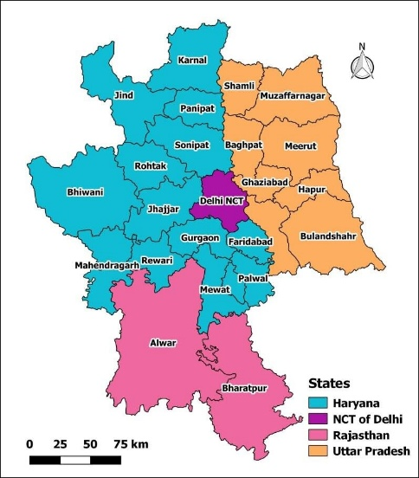
This research paper presents an in-depth analysis of three decades of climatic data from Delhi NCR, India (Fig 1). The primary objective was to examine temperature variability trends and patterns between 1990 and 2022, with a comprehensive evaluation of the entire dataset. The study is significant as it takes a holistic approach by analysing key climatic indicators such as Average Daily Maximum Temperatures (TX Mean), Average Daily Minimum Temperatures (TN Mean), Average Daily Mean Temperatures (T-Mean), and Average Daily Precipitation (PRCP Mean) trends for each year. It further explores the relationship between temperature and precipitation, conducts season-based comparisons, and develops trend detection models for temperature analysis throughout the study period. The dataset, consisting of daily maximum, minimum, and mean temperatures along with precipitation records, was analysed using tools such as Python (with libraries including Pandas, NumPy, Scikit-learn, Scipy, Matplotlib, and Seaborn), Google Collaboratory, and Microsoft Excel. The methodology included measures of central tendency for data aggregations, seasonal comparisons, and Pearson’s correlation method was exhibited to assess the relationship between temperature and rainfall, followed by a supervised model of linear regression for temperature trend analysis. The outcomes of this study might hold practical significance and can be applied in diverse areas such as understanding Delhi NCR’s climate change patterns, assessing environmental shifts, managing water resources, improving agricultural practices, supporting research and education, and informing policy-making.
Fig 1: Delhi NCR, India
Source: National Capital Region Planning Board

Study Area Description
Delhi NCR, located in northern India between 28°12′N–29°00′N and 76°50′E–77°20′E, covers a total area of 55,083 square kilometres and comprises Delhi along with adjoining districts of Haryana, Uttar Pradesh, and Rajasthan. The region, with an estimated population of 58.15 million, is among the world’s most polluted urban areas and is highly vulnerable to climatic risks. Delhi NCR experiences a composite climate characterized by hot summers, monsoon rainfall, and cool winters, making it a crucial region for assessing long-term climatic variability.

Data and Methodology
Dataset – The dataset was obtained from the Kaggle data repository (https://www.kaggle.com/). Kaggle is the world’s largest data science community for data scientists and machine learning practitioners, owned by Google LLC. The dataset represents Delhi NCR’s temperature and rainfall information, recorded at the Safdarjung Meteorological Station, operated by India Meteorological Department (IMD). Kaggle serves a secondary data hosting platform, while the primary source of observations remains IMD. The dataset includes the following components: Date (DD-MM-YYYY), Daily Maximum Temperature (°C), Daily Minimum Temperature (°C), Daily Mean Temperature (°C), and Daily Precipitation (mm) for the period 1990-2022.
Data cleaning, Data processing
Analysis of Dispersions
Supervised model – Linear Regression
Pandas, NumPy
Scikit-learn, NumPy, Matplotlib
Pandas, Matplotlib
Pandas, Seaborn, Matplotlib
Figure 2

Microsoft Excel formulas
Central tendency for yearly averages
Pearson’s Correlation
Seasonal Analysis of temperature & precipitation
Dataset
Fig 2: Methodology flowchart
The entire dataset was processed, manipulated, and cleaned using the Python libraries: Pandas and NumPy. After the data cleaning process, the following statistical methods were used in the study:
- Data preprocessing – This step involved preparing the dataset for analysis. Missing values in the PRCP column were replaced with 0 to maintain dataset consistency, as null entries in precipitation records typically indicate no rainfall (0 mm). In addition, separate columns representing the day, month, and year were created to facilitate temporal organization and enable efficient filtering of the data with respect to monthly and annual analyses.

- Measures of Central Tendency – A measure of central tendency is a single value that attempts to describe a set of data by identifying the central position within a set of data. They are also classed as summary statistics. The mean ($\overline{x}$) is one of the measures of central tendency which is used most widely for knowing the single value that describes the entire data.
${\overline{x}}_{t}$ = $\frac{Σx_{t}}{n}$

${\overline{x}}_{P}$ = $\frac{Σx_{P}}{n}$

where:
${\overline{x}}_{t}$ = Annual Average of Daily Temperatures
${\overline{x}}_{P}$ = Annual Average of Daily Precipitation values
$Σx_{t}$ = Sum of Daily Temperatures;
$Σx_{P}$ = Sum of Daily Precipitation;
$n$ = Number of days.

The above-mentioned formula was employed to compute the average of daily temperatures for each year and the average of daily precipitation values for each year, as well as to conduct a year-wise seasonal analysis. Data visualisations were generated by utilising the python libraries seaborn and matplotlib. Through the help of python grouping function, we computed the following for all 33 years:
- Annual Average of Daily Maximum Temperatures for every year (Yearly TX Mean).
- Annual Average of Daily Minimum Temperatures for every year (Yearly TN Mean).
- Annual Average of Daily Mean Temperatures for every year (Yearly T-Mean).
- Annual Average of Daily Precipitation for every year (Yearly PRCP Mean).

- Measures of Dispersion - Measures of dispersion are non-negative real numbers that help to gauge the spread of data about a central value. These measures help to determine how stretched or squeezed the given data is. There are five most used measures of dispersion: range, variance, mean deviation, quartile deviation, and standard deviation ($σ$). The dispersion method of standard deviation ($σ$) was used to understand the variability and consistency of the data. The necessary calculations were performed in an excel workbook by using the following formula:

$σ$ = $\sqrt{\frac{∑{\left(x_{i}-\overline{x}\right)}^{2}}{n}}$

where:
$σ$ = standard deviation
$\overline{x}$ = Mean of $x$ values
$x_{i}$ = $ⅈ$-th observation of variable $x$
$n$ = number of observations

- Pearson’s Correlation – Pearson’s Correlation is a statistical method that measures the similarity or correlation between two data objects by comparing their attributes and calculating a score ranging from -1 to +1. A high score indicates high correlation among the two objects, while a score near zero indicates low correlation. This method is parametric and relies on the mean parameter of the objects, making it more valid for normally distributed data.
Pearson’s Correlation Coefficient (r) | Correlation type | Implications of coefficient values
Between 0 and 1 | Positive correlation | Variables are directly proportional
Exact 0 | No correlation at all | No relationship between the variables
Between 0 and -1 | Negative correlation | Variables are inversely proportional
Table 1-: Pearson’s Correlation coefficient method

Our computed dataset comprised four variables: Yearly TX Mean, Yearly TN Mean, Yearly T-Mean, and Yearly PRCP Mean. The values of each variable were utilized in the analysis. All correlation coefficients ($r$) were computed using the in-built Python function for correlation. Data visualization was performed using a heatmap, with the python libraries seaborn and matplotlib. The Pearson’s correlation coefficient formula is as follows:

$r$ = $\frac{Σ\left(x_{i}-\overline{x}\right)\left(y_{i}-\overline{y}\right)}{σ_{x}⋅σ_{y}}$
where:
$r$ = Pearson’s correlation coefficient value
$x_{i}$ = $ⅈ$-th observation of variable $x$
$y_{i}$ = $ⅈ$-th observation of variable $y$
$\overline{x}$ = Mean of $x$ values
$\overline{y}$ = Mean of $y$ values
$σ_{x}$ = Standard deviation of $x$
$σ_{y}$ = Standard deviation of $y$

- Linear Regression – In statistics, linear regression is a type of model which is used to predict the value of another variable. The variable you want to predict is called dependent variable ($y$), the variable you are using to predict the other variable’s value is called the independent variable ($x$). This form of analysis estimates the coefficients of the linear equation, involving one or more independent variables ($x$) that best predict the value of dependent variable ($y$). Linear regression fits a straight line or surface that minimizes the discrepancies between predicted and actual output values. The linear regression model is based on the slope-intercept equation, which is expressed as follows:

$y$ = $mx+c$

where:
$x$ = $x$ coordinate
$y$ = $y$ coordinate

$m$ (slope) = $\frac{∑\left(x-\overline{x}\right)\left(y-\overline{y}\right)}{∑{\left(x-\overline{x}\right)}^{2}}$

$c$ (y-intercept) = $\overline{y}-m\overline{x}$

For our calculations, the $x$ variables were taken as years (1990, 1991, 1992 and so on), while the $y$ variable represented the Yearly TX Mean, Yearly TN Mean and Yearly T Mean, analysed separately one after another. The entire linear regression analysis was performed using the scikit-learn package.

- Regression Evaluation Metrics – The linear regression models were evaluated using the following metrics: Coefficient of Determination ($R^{2}$), Mean Absolute Error $(MAE)$, Mean Squared Error ($MSE$), and Root Mean Squared Error ($RMSE$). All metrics were computed using the scikit-learn package.

$R^{2}$ = $1-\frac{∑\left(y_{i}-{\hat{y}}_{i}\right)}{∑\left(y_{i}-\overline{y}\right)}$

$MAE$ = $\frac{1}{n}⋅∑\left|y_{i}-{\hat{y}}_{i}\right|$

$MSE$ = $\frac{1}{n}⋅∑{\left(y_{i}-{\hat{y}}_{i}\right)}^{2}$

$RMSE$ = $\sqrt{MSE}$

where:
$y_{i}$ = $ⅈ$-th observation of variable $y$
${\hat{y}}_{i}$ = predicted value of $ⅈ$-th observation of variable $y$
$\overline{y}$ = mean of all $y$ variables
$n$ = number of observations

The adopted methodology ensured a systematic data analytical approach. The results computed from these statistical methods are showcased and discussed in the subsequent section.

Results and Discussions
Yearly T-Mean Variability Analysis (Fig 3) – The analysis of Yearly T-Mean indicates an approximate increase of 6.23% between 1990 and 2022. The highest Yearly T-Mean value was seen in the year 2016 ~ 26.84 °C, whereas the lowest value occurred in 1997 ~ 23.58 °C. The SD of the yearly T-Mean series is 0.61, corresponding to an average CV ~ 2.45%. This upward trend depicts a gradual rise in warming over the studied period.
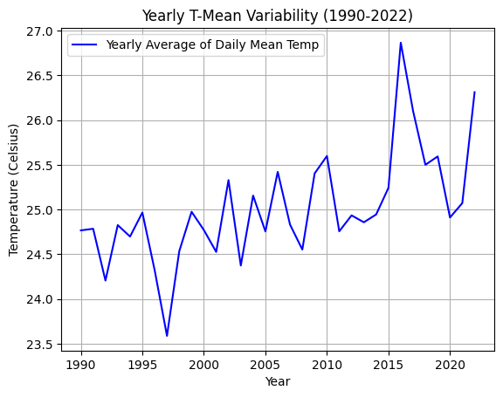
Fig 3: Line Graph visualising Yearly T-Mean Variability (1990-2022)
Yearly TX Mean Variability Analysis (Fig 4) – The change in Yearly TX Mean from 1990 to 2022 showed an overall increase of 5.95%. The highest Annual TX Mean was again in 2016 ~ 33.45 °C, while the lowest was recorded in the year 1997 ~ 29.90 °C. The Yearly TX Mean data exhibited a SD of 0.70, and a comparatively lower CV ~ 2.23%. This indicates more consistency and less variability in the Yearly TX Mean trend compared to the Yearly T-Mean trend over the studied period.
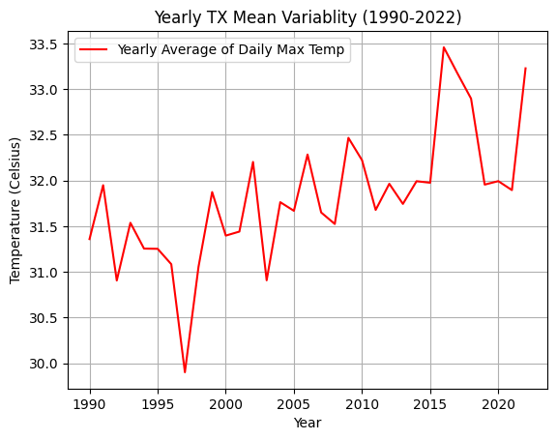
Fig 4: Line Graph visualising Yearly TX Mean Variability (1990-2022)
Yearly TN Mean Variability Analysis (Fig 5) – The Yearly TN Mean Variability change from 1990 to 2022 exhibited an overall increase of 5.30%. The highest Annual TN Mean was recorded in 2022 ~ 20.39 °C, while the lowest Annual TN Mean occurred in 1992 ~ 17.69 °C. The Yearly TN Mean data recorded a SD of 0.53, with a corresponding CV of 2.85%. These results suggest that the Yearly TN Mean shows the highest variability among the temperature variables during the study period.
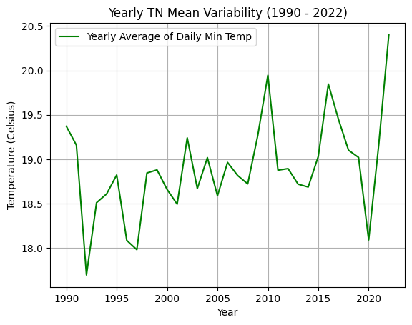
Fig 5: Line Graph visualising Yearly TN Mean Variability (1990-2022)
Yearly PRCP Mean Variability Analysis (Fig 6) – The year 2021 experienced the highest magnitude of rainfall ~ 3.43 mm, whereas the years 2014 and 1999 experienced the least rainfall ~ 0.70 mm and 0.78 mm respectively. The precipitation data show a SD of 0.61 and a CV of 34%, indicating considerable fluctuations in rainfall patterns over the study period.
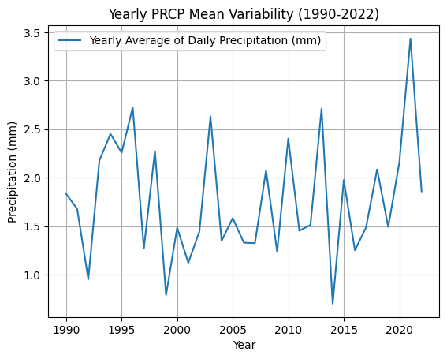
Fig 6: Line Graph visualising Yearly PRCP Mean Variability (1990-2022)

P-value Calculations (Table 2) –

Data Variables | P-values | Implications
TX Mean | 0.00002 | Statistically significant
TN Mean | 0.01 | Statistically significant
T-Mean | 0.0001 | Statistically significant
PRCP | 0.62 | Statistically insignificant

Table 2-: P-value of Data Variables

Correlation between TX Mean, TN Mean, T-Mean, PRCP Mean (Fig 7) – The following heatmap visualizes how different parameters: Yearly TX Mean, Yearly TN Mean, Yearly T-Mean and Yearly PRCP Mean are correlated with each other. The Yearly TX Mean shows a statistically insignificant correlation with the Yearly PRCP Mean ($r$ = -0.13), indicating no meaningful relationship between maximum temperature and rainfall.
In contrast, the Yearly TX Mean and Yearly T-Mean show a high correlation ($r$ = 0.94), followed by the relationship between Yearly T-Mean and Yearly TN Mean ($r$ = 0.82), and between Yearly TX Mean and Yearly TN Mean ($r$ = 0.76). All these values indicate a strong positive association among TX Mean, TN Mean, and T-Mean, suggesting that if one of these variables increase, the others also increase proportionately.
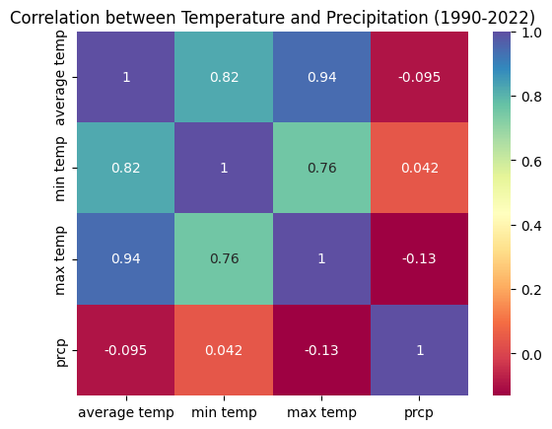
Fig 7: Heat map representing Pearson’s correlation between TX Mean, TN Mean, T-Mean, PRCP Mean
Seasonal Analysis of Temperature and Precipitation -
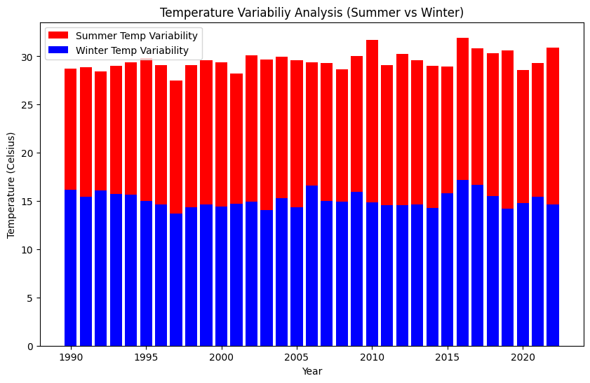
Fig 8: Stacked Bar graph representing Yearly T-Mean variability of Summer and Winter
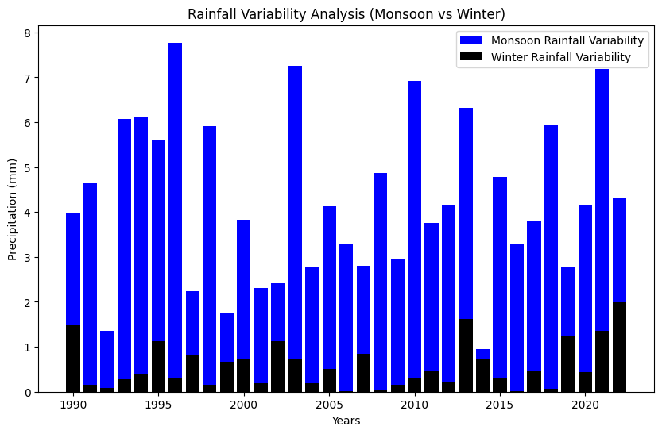
Fig 9: Stacked Bar graph representing Yearly PRCP Mean variability of Monsoon and Winter

Yearly T-Mean Variability: Summer and Winter (Fig 8) – The graph represents an overall consistent variability of Yearly T-Mean, but with a sharp contrast between summer and winter seasons. The Yearly T-Mean for the summer season (Mar, Apr, May, Jun) is considerably higher than that of the winter season (Dec, Jan, Feb) throughout the study period (1990 – 2022).
Yearly PRCP Mean Variability: Monsoon and Winter (Fig 9) – The Yearly PRCP Mean variability graph shows greater inconsistency compared to the Yearly T-Mean graph, indicating that rainfall variation exhibits more fluctuation than temperature variability. Moreover, the graph visually demonstrates that the monsoon season experienced a significantly higher amount of rainfall compared to the winter season throughout the study period (1990 – 2022).
Supervised Model: Linear Regression Analysis -
The following Regression models (Fig 10, Fig 11, Fig 12) represents the trend detections of yearly T-Mean, TX Mean, and TN Mean respectively throughout the entire study period (1990 to 2022).
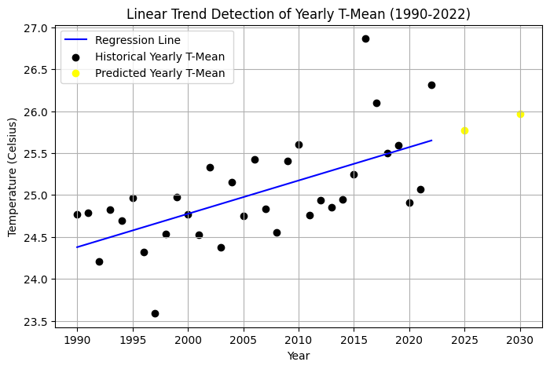
Fig 10: Linear Regression model showing yearly T-Mean trend
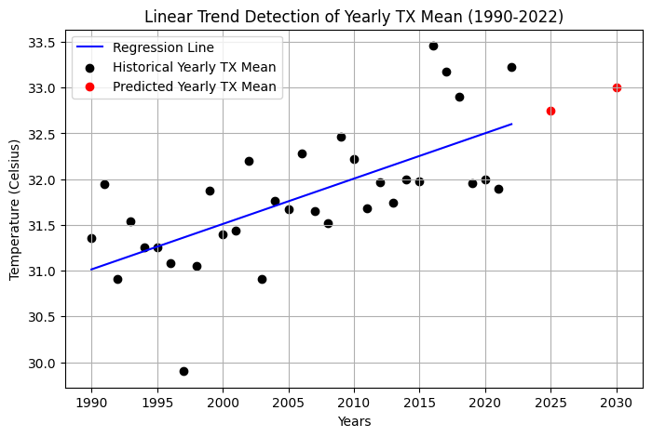
Fig 11: Linear Regression model showing yearly TX Mean trend

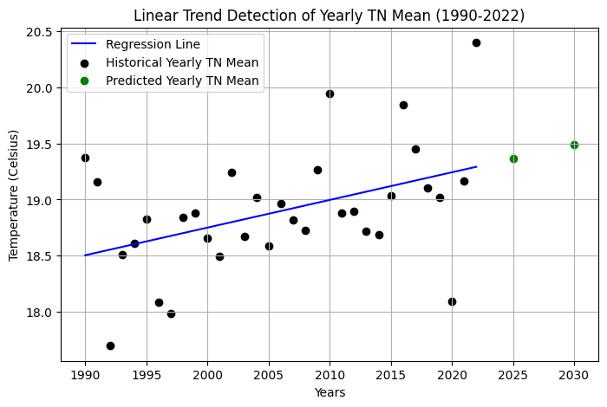
Fig 12: Linear Regression model showing yearly TN Mean trend
The following table (Table 3) shows the computed results of all three regression models. Statistical metrics such as: $R^{2}$, $MAE$, $MSE$, $RMSE$ were used to evaluate the model performance for predicting yearly T-Mean, TX Mean, and TN Mean.

MODEL | $$R^{2}$$ | MAE | MSE | RMSE
Yearly T-Mean | 0.37 | 0.39 | 0.23 | 0.48
Yearly TX Mean | 0.44 | 0.42 | 0.28 | 0.53
Yearly TN Mean | 0.18 | 0.36 | 0.23 | 0.48
Table 3-: Model Evaluations
Linear Regression was the selected modelling approach in this study because the primary objective was to quantify long-term linear trend detection. The annual aggregation reduces short-term variability and yields relatively smooth behaviour, for which linear regression is widely used in climatological trend detections. Moreover, the length of annually aggregated time series (33 years) is relatively limited for robust calibration of advanced time-series models, which typically require longer records.
Among the three models, the Yearly TX Mean model showed the highest explanatory power with an R² of 0.44, indicating that approximately 44% of the variance in yearly maximum temperature is captured by the model. This was followed by the Yearly T-Mean model with an R² of 0.37. In contrast, the Yearly TN Mean model recorded the lowest R² of 0.18, suggesting that the model explains only 18% of the variability in yearly minimum temperature. This comparatively weaker performance indicates potential challenges in modelling minimum temperatures, which are typically more sensitive to localized climatic and environmental variations.
Error metrics further highlight these differences. The MAE values ranged between 0.36 and 0.42, with the TN Mean model showing the lowest prediction error (MAE = 0.36) and the TX Mean model showing the highest (MAE = 0.42). A similar trend is observed for RMSE, where the TX Mean model produced the highest error (RMSE = 0.53), while both T-Mean and TN Mean models recorded lower errors (RMSE = 0.48). Although the TX Mean model explains the highest variance, its slightly higher error metrics suggest that extreme temperature values (TX) exhibit greater variability and are inherently more difficult to detect accurately.
Overall, the results indicate the modelling framework performs modestly for TX Mean and T-Mean data but shows limited trend detectability for TN Mean. These findings highlight the complex nature of Delhi NCR’s temperature dynamics, while more advanced modelling approaches may be explored in future studies.

Conclusion
As mentioned previously, this research paper deep dives into various statistical analysis of climatic variability from 1990 to 2022 of Delhi NCR, India. The insights suggested that TX data showed the highest variance among all the temperature variables, whereas the PRCP data recorded an even higher variance than the temperature variables depicting uncertain rainfall trends throughout the study period. Correlation among all the variables revealed that temperature variables were directly correlated which each other whereas the precipitation data revealed weak and inverse relation with temperature. The study revealed consistent warming trends across mean, maximum, and minimum temperature series. In contrast, rainfall displayed substantially higher variability and weak relevance with temperature, indicating higher uncertainty in rainfall behaviour over the study period.
Rising temperature trends can intensify urban heat in metropolitan regions supported with rapid population growth. Higher temperatures may also influence water scarcity, affect agricultural productivity, and increase cooling energy demand in urban infrastructure. Overall, this paper highlights the need for long-term adaptation strategies in sectors such as agriculture, and urban planning. The study supports evidence-based climate policy formulation especially regarding temperature fluctuations and rainfall irregularities. The findings underscored the importance of continuous climatic monitoring to better understand long-term environmental changes.

Abbreviations:
T – Daily Mean Temperature
TN – Daily Minimum Temperature
TX – Daily Maximum Temperature
PRCP – Daily Precipitation
Yearly T-Mean – Annual Average of Daily Mean Temperature
Yearly TN Mean – Annual Average of Daily Minimum Temperature
Yearly TX Mean – Annual Average of Daily Maximum Temperature
Yearly PRCP Mean – Annual Average of Daily Precipitation
CV – Coefficient of Variance
$r$ – Pearson’s Correlation Coefficient
$R^{2}$ – Coefficient of Determination
Disclaimer (Artificial intelligence)
Author(s) hereby declare that NO generative AI technologies such as Large Language Models (ChatGPT, COPILOT, etc.) and text-to-image generators have been used during the writing or editing of this manuscript.

References
- Djomou, Z. Y., Monkam, D., & Chamani, R. (2015). Characterization of climatic zones, variability, and trend in Northern Africa. Climate Dynamics, 44(11), 3481-3491.

- Jaiswal, R. K., Lohani, A. K., & Tiwari, H. L. (2015). Statistical analysis for change detection and trend assessment in climatological parameters. Environmental Processes, 2(4), 729-749.

- “Trends and periodicities of surface air temperature of Delhi” by Bhukan Lal, 1992.

- “Trend assessment of rainfall, temperature and relative humidity using non-parametric tests in the national capital region, Delhi” by Nand Lal Kushwala, D. R. Sena, D K Singh, and Indra Mani, 2023.

- “Climate variability in Delhi (1961 – 2010)” by Mr. Diwakar, 2021.

- “Trend Analysis of Decadal Change in Minimum Temperature in 20th Century: Case of Delhi, India” by Atul Saini and Subhash Anand, 2013.

- ” An Analysis of Temperature Trends of Five Metro Cities in India” by Upendra Kumar Sahoo and Tirthankar Ghosh.

- “Trend analysis of climate time series: A review of methods” by Manfred Mudelsee, 2019.

- “Exploring a minimal Convolutional Linear-Regression Model for Urban Land Surface Temperature estimation” by Matteo Piccardoa, Emanuele Massarob, Luca Caporaso, Alessandro Cescatti, and Grégory Duveiller, 2025.

- “Analysis of Climatic Trends and Variability” by Ayush Prusty, Akshita Gupta, and Vivek Ashok Bohara, 2025. (In press) https://arxiv.org/abs/2501.04578

- “Persistence of Temperature and Precipitation: From Local to Global anomalies” by Jouni J. Takalo, 2022. (In press) https://arxiv.org/abs/2201.04920

- “Global urban climatology: a meta-analysis of air temperature trends (1960–2009)” by Alvin C. G. Varquez, and Manabu Kanda, 2018. https://www.nature.com/articles/s41612-018-0042-8

- “Analysis of various climate change parameters in India using machine learning” by Rutvij Wamanse, and Tushuli Patil, 2022. (In press) https://arxiv.org/abs/2201.10123
- “Modelling and Investigating the impacts of climatic variables on Ozone concentration in Malaysia using correlation analysis with random forest, decision tree regression, linear regression, and support vector regression” by Abdul-Lateef Balogun and Abdul Waheed Tella, 2022.

- “Global Precipitation Climatology by Machine Learning; Quasi-global, Daily, and One Degree Spatial Resolution” by Hiroshi G. Takahashi, 2024.

- “Heat stress risk at an intra-urban level: A case study of Delhi, India” by Kshitij Kacker, Piyush Srivastava, and Mahua Mukherjee, 2024. https://doi.org/10.1016/j.buildenv.2024.111897

