Comparative Analysis of Fully Convolutional Networks (FCN), SegNet, and U-Net for Semantic Segmentation of Synthetic Wafer Map Defect Patterns

ABSTRACT

Wafer defect maps serve as a primary diagnostic tool for process engineers, enabling the visualization of spatial defect distributions and the identification of potential equipment or process issues. As technology nodes shrink and device densities increase, the volume of inspection data has grown exponentially, rendering manual inspection impractical and necessitating automated solutions for defect pattern recognition. Modern semiconductor manufacturing depends critically on automated wafer defect pattern detection to prevent yield loss excursions and maintain process control. Deep learning, particularly convolutional encoder–decoder architectures, has emerged as a transformative approach for anomaly detection and semantic segmentation of wafer map defect patterns. This review comprehensively examines the state of the art in applying deep convolutional neural networks, including Fully Convolutional Networks (FCN), SegNet, and U-Net to the detection and pixel-level segmentation of abnormal defect patterns on semiconductor wafers. The study analyzes methods for synthetic training data generation using Poisson point processes, evaluates the comparative performance of these architectures using intersection-over-union (IoU) metrics, and assesses their generalization capability to unseen defect patterns and real production wafer data. The review further discusses scalability considerations, the relationship between defect density and detection accuracy, and outlines future research directions, including vision transformers, transfer learning, and real-time deployment strategies. With approximately 25 recent references spanning 2015–2024, this article provides a thorough synthesis of methodologies, results, and open challenges for researchers and practitioners in semiconductor defect inspection. Future research should focus on bridging the synthetic-to-real domain gap through advanced data augmentation and domain adaptation techniques, incorporating attention mechanisms and transformer-based architectures, developing lightweight models for real-time edge deployment, and integrating explainable AI methods to enhance engineer trust and adoption.

Keywords: Deep learning, convolutional neural networks, encoder–decoder architectures, anomaly detection, semantic segmentation, semiconductor manufacturing, wafer defect patterns, yield enhancement.

1. INTRODUCTION
Manual inspection for each silicon wafer is both time consuming and labour intensive. Hence, to improve efficiency we need ways to automate the process. Defects on wafers can also point to issues with the manufacturing process. Detecting and addressing these defects is important for improving individual chips and also for maintaining consistent quality over time (Ingle et al., 2025). Silicon wafers are used in the manufacturing of semiconductor chips. The required patterns are formed on the wafers through lithography and other processes and are very important carriers in the semiconductor chip manufacturing process. In the manufacturing process, due to the influence of factors such as the environment and process parameters, defects will be generated on the surface of the wafer, which will affect the yield of wafer production (Ma et al., 2023). Semiconductor manufacturing is among the most complex and tightly controlled industrial processes, where even minute deviations in process parameters can lead to systematic defect patterns on wafers, resulting in substantial yield losses [1]. Wafer defect maps serve as a primary diagnostic tool for process engineers, enabling the visualization of spatial defect distributions and the identification of potential equipment or process issues. As technology nodes shrink and device densities increase, the volume of inspection data has grown exponentially, rendering manual inspection impractical and necessitating automated solutions for defect pattern recognition [2], [3].
The problem of wafer map pattern analysis can be broadly categorized into two complementary tasks. The first involves identifying common defect patterns among different wafers for commonality analysis and root cause identification. For instance, a line scratch pattern may be systematically associated with wafer handling at a particular process tool, and recognizing such patterns enables the establishment of correct response flows [4]. The second task, which is the primary focus of this review, concerns anomaly detection the identification of unknown or previously unseen defect patterns that may signal early yield loss events or excursion conditions [5]. A robust anomaly detection system must not only detect known defect signatures but also generalize to novel pattern morphologies that were not represented in the training data.
Traditional approaches to wafer map pattern recognition fall into two categories: model-based methods, which rely on predefined probability distribution functions and information criteria for model selection [6], [7], and feature extraction-based methods, which extract spatial features using techniques such as nearest-neighbor analysis, correlograms, and Radon transforms before applying classification algorithms [8], [9]. While these approaches have demonstrated utility, they typically require substantial domain expertise for feature engineering and may struggle to generalize across diverse defect morphologies.
The advent of deep learning has fundamentally transformed computer vision, and its application to semiconductor defect inspection has yielded remarkable advances [10], [11]. Deep convolutional neural networks (DCNNs) offer an end-to-end learning paradigm that eliminates the need for manual feature engineering, instead learning hierarchical representations directly from raw wafer map images. In the computer vision literature, object recognition tasks are broadly classified into object classification, object detection, and semantic segmentation [12]. For semiconductor defect analysis, semantic segmentation is particularly valuable because it provides pixel-level delineation of defect clusters, enabling the extraction of detailed geometric properties such as location, size, orientation, and morphology information that is essential during technology development phases [13].
This review focuses on the application of deep convolutional encoder–decoder architectures specifically FCN [14], SegNet [15], and U-Net [16]—to the problem of wafer defect pattern anomaly detection and segmentation. A seminal contribution in this space by Nakazawa and Kulkarni [17] demonstrated that models trained exclusively on synthetic wafer maps can successfully detect both known and unseen defect patterns from real production wafers. This review builds upon that foundational work and situates it within the broader landscape of deep learning for semiconductor inspection, covering recent advances through 2024.

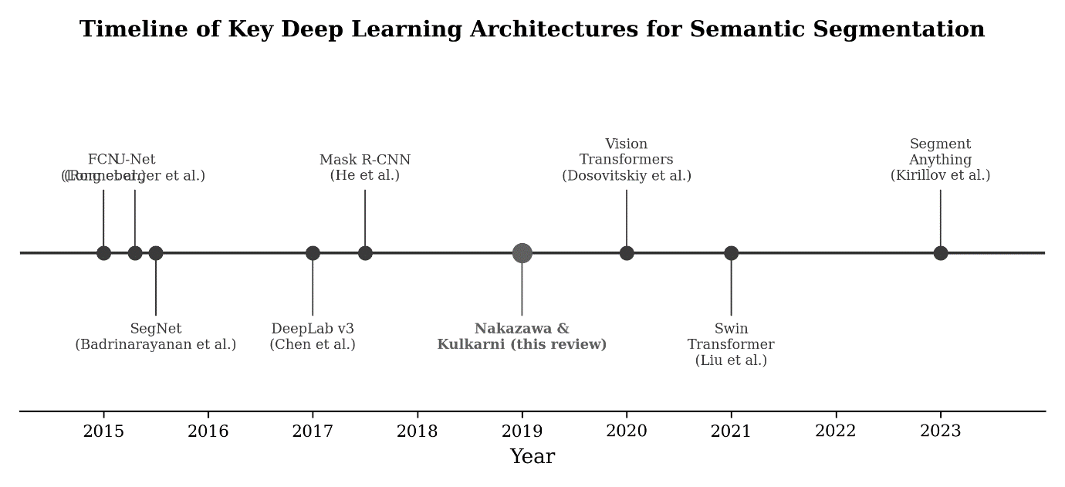
Fig. 1. Timeline of key deep learning architectures for semantic segmentation relevant to semiconductor defect detection.

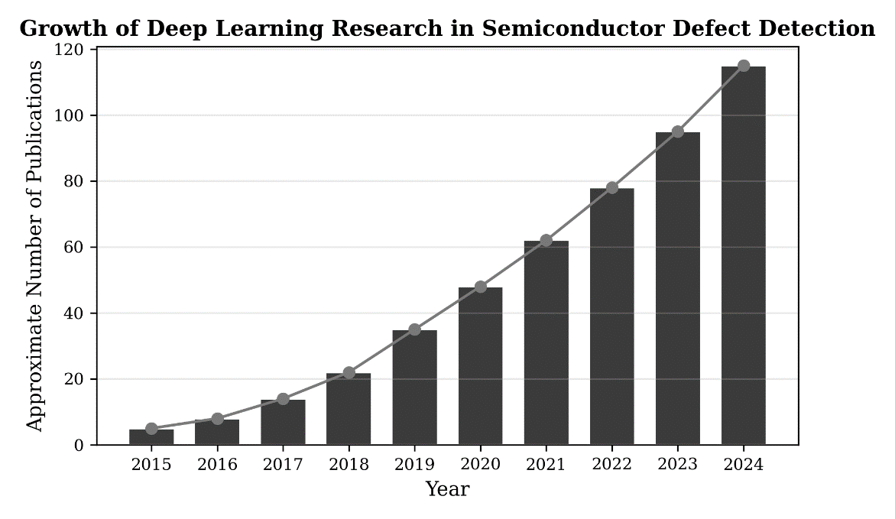
Fig. 2. Approximate growth trend in deep learning publications for semiconductor defect detection (2015–2024).

The remainder of this article is organized as follows. Section II reviews the methods for synthetic wafer map generation and the deep convolutional encoder–decoder architectures. Section III provides a detailed comparative analysis of experimental results on basis patterns, unseen patterns, and real wafer datasets. Section IV discusses the implications, limitations, and future directions. Section V concludes the review.
2. METHODS

2.1. Synthetic Wafer Map Pattern Generation
A critical challenge in training deep learning models for semiconductor defect detection is the scarcity of labeled real wafer data, particularly for rare excursion events. To address this, Nakazawa and Kulkarni [17] proposed a synthetic data generation approach based on the Poisson point process, where both random (background) and non-random (anomalous cluster) defects are generated on wafer maps. The Poisson distribution governing defect generation is given by P(k, λ) = (λ^{k}/k!)e^{−λ}, where λ is the rate parameter defining the average number of defect events per interval and k is the number of events. Once all defect points are generated for a single wafer, a binary map is created by checking the presence or absence of defects on each die position [17], [18].
The training dataset is constructed as paired input–target images. The input wafer map contains both the abnormal defect cluster(s) and random background defects, while the target map contains only the anomalous defect cluster(s). This paired arrangement trains the neural network to selectively extract and segment anomalous patterns while suppressing random noise. Eight basis defect patterns were defined for training: random defects, wafer edge ring defects, right and left side edge defects, line scratch defects, non-random cluster defects, and gross defects at the left and right halves of the wafer [17]. This synthetic approach is particularly advantageous because excursion events are inherently rare in production, making it impractical to accumulate sufficient real labeled samples for training purposes [19].

2.2. Deep Convolutional Encoder–Decoder Architectures
Encoder–decoder architectures represent a natural fit for pixel-level segmentation tasks because they combine a contracting path that captures contextual information with an expanding path that enables precise localization [15], [16]. In the context of wafer defect detection, three architectures have been systematically evaluated: SegNet, U-Net, and FCN.

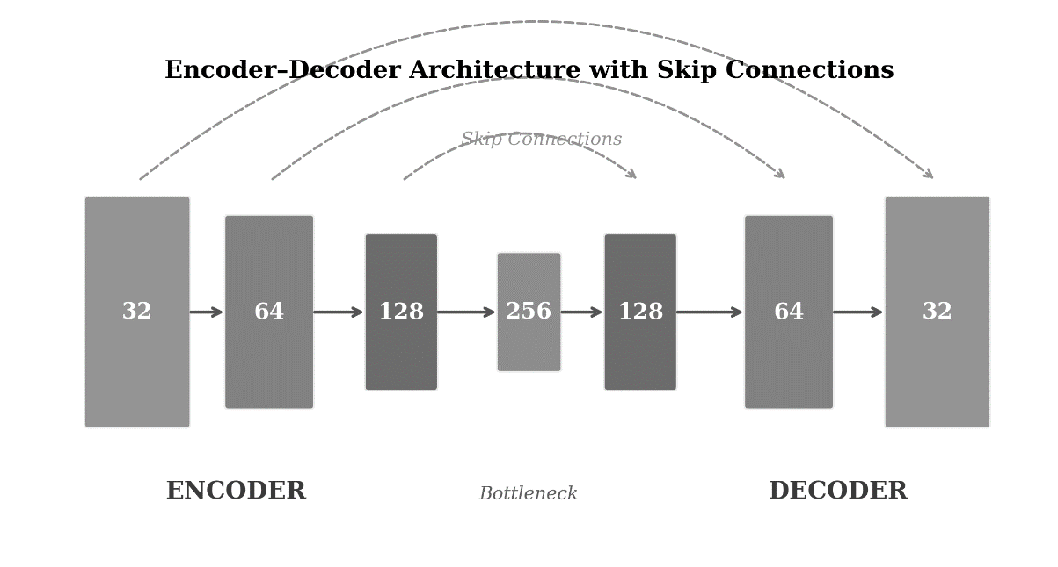
Fig. 3. Conceptual schematic of the encoder–decoder architecture with skip connections used for wafer defect segmentation.

SegNet Architecture. The SegNet-based architecture consists of an encoder network with convolutional layers (channel sizes of 128, 64, and 32), each followed by batch normalization and ReLU activation, with 2×2 max-pooling after every two convolutional layers. The decoder mirrors this structure with 2×2 up-sampling followed by convolutional layers. A key feature of SegNet is that it stores the max-pooling indices computed during encoding and uses them during decoding to perform non-linear up-sampling, thereby preserving spatial positional information that is critical for accurate segmentation [15]. The final layer uses sigmoid activation for binary pixel-wise classification. The input wafer map size is 344×480, and binary cross-entropy serves as the loss function [17].
U-Net Architecture. Originally proposed for biomedical image segmentation [16], the U-Net architecture employs a similar encoder–decoder structure but uses a distinct mechanism for preserving local information. Rather than relying on pooling indices, U-Net copies and crops feature maps from each encoder layer to the corresponding decoder layer through merge (concatenation) connections. These skip connections enable the decoder to access fine-grained spatial details from the encoder, which is essential for accurate boundary delineation in defect segmentation. The architecture uses 32, 64, and 128 channel sizes with 3×3 receptive fields, except the final 1×1 layer with sigmoid activation [17], [20].
FCN Architecture. Fully Convolutional Networks, introduced by Shelhamer et al. [14], replaced the fully connected layers of classification networks with convolutional layers to produce two-dimensional heat maps rather than scalar class predictions. The FCN architecture evaluated by Nakazawa and Kulkarni [17] uses 32, 64, and 128 channel sizes with 3×3 receptive fields and 2×2 stride, followed by two layers with 256 channels (strides of 7×7 and 1×1). The "skip architecture" merges shallow and deeper layer outputs via transpose convolutional layers, though the spatial information transfer mechanism is less refined than in SegNet or U-Net [14], [21].

2.3. Evaluation Metrics
The primary metric used for evaluating detection and segmentation performance is Intersection over Union (IoU), also known as the Jaccard index, defined as J(A, B) = |A ∩ B| / |A ∪ B|, where A and B are the predicted and ground-truth segmentation masks, respectively. For class-level evaluation, the mean IoU (mIoU) is computed across all test samples. An mIoU value greater than 0.5 is generally considered indicative of successful detection [17], [22]. Additional metrics such as precision, recall, and F1-score are commonly used in complementary analyses [23].

3. EXPERIMENTAL RESULTS AND ANALYSIS

3.1. Dataset Description and Training Configuration
The experimental setup reported by Nakazawa and Kulkarni [17] employed 17,000 synthetic wafer maps divided into 70% training and 30% validation sets, with an additional 3,300 separate test samples. All training and validation were conducted exclusively on synthetic data, while real wafer data (1,191 wafers) was reserved for qualitative and quantitative evaluation of generalization capability. This experimental design is methodologically significant because it tests the hypothesis that models trained entirely on synthetic data can transfer effectively to real-world manufacturing scenarios [17], [24].

3.2. Training Performance
Figure 4 presents the training accuracy as a function of epoch for the three architectures. Both SegNet and U-Net converge to comparable accuracy levels (mean accuracy of 0.990 and 0.989, respectively, between epochs 5 and 9), while FCN settles at a slightly lower accuracy of 0.978. Convergence is achieved within approximately 5 epochs for all three models, after which accuracy improvements become negligible [17].

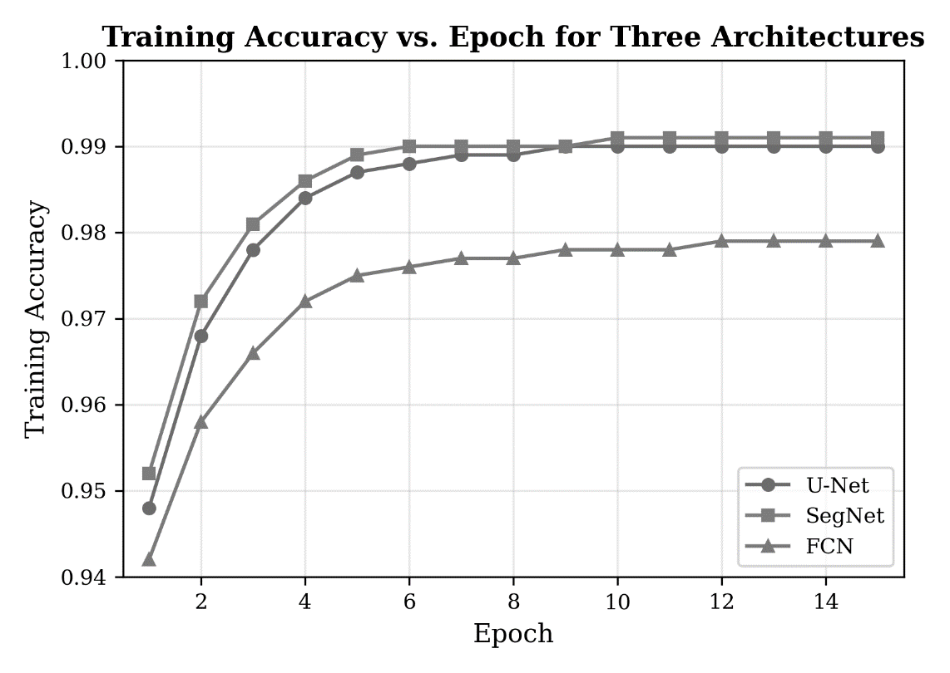
Fig. 4. Training accuracy versus epoch for SegNet, U-Net, and FCN architectures (reproduced from data in [17]).

Table 1: Training Time in Minutes per Epoch for Each Architecture
Architecture | SegNet | U-Net
Avg. time/epoch (min) | 19.9 | 10.0

Training time varies substantially across architectures, as shown in Table I. SegNet requires approximately 19.9 minutes per epoch, U-Net requires 10.0 minutes, and FCN requires only 4.2 minutes. The significantly faster training of FCN is attributable to its simpler architecture with fewer parameters, though this comes at the cost of reduced segmentation accuracy [17]. These training times are practical for industrial deployment, where total training durations of a few hours are acceptable.

3.3. Basis Pattern Detection Performance
Table II and Figure 5 present the mIoU results for the seven basis defect patterns (excluding the random-only class, which has no target cluster). SegNet and U-Net demonstrate consistently superior performance over FCN across all pattern types. The most successfully detected patterns include right side edge defects (SegNet: 0.879, U-Net: 0.850), left side edge defects (SegNet: 0.883, U-Net: 0.794), and gross defect at right half (SegNet: 0.876, U-Net: 0.877). The most challenging pattern for all architectures is the wafer edge ring defect, where SegNet achieves 0.655, U-Net achieves 0.728, and FCN drops to 0.428. Line scratch detection also proves challenging, likely due to the elongated, thin morphology of such defects [17]. Critically, all mIoU values for SegNet and U-Net exceed the 0.5 threshold across all seven basis patterns, confirming successful detection capability.

Table 2: Mean IoU Results for Basis Defect Pattern Test Set
Pattern | SegNet | U-Net | FCN
Wafer edge ring | 0.655±0.12 | 0.728±0.08 | 0.428±0.08
Right side edge | 0.879±0.07 | 0.850±0.11 | 0.804±0.09
Left side edge | 0.883±0.11 | 0.794±0.19 | 0.330±0.26
Line scratch | 0.649±0.25 | 0.663±0.23 | 0.538±0.23
Non-random cluster | 0.815±0.09 | 0.817±0.09 | 0.646±0.11
Gross defect at left | 0.753±0.10 | 0.799±0.06 | 0.459±0.08
Gross defect at right | 0.876±0.04 | 0.877±0.05 | 0.640±0.04

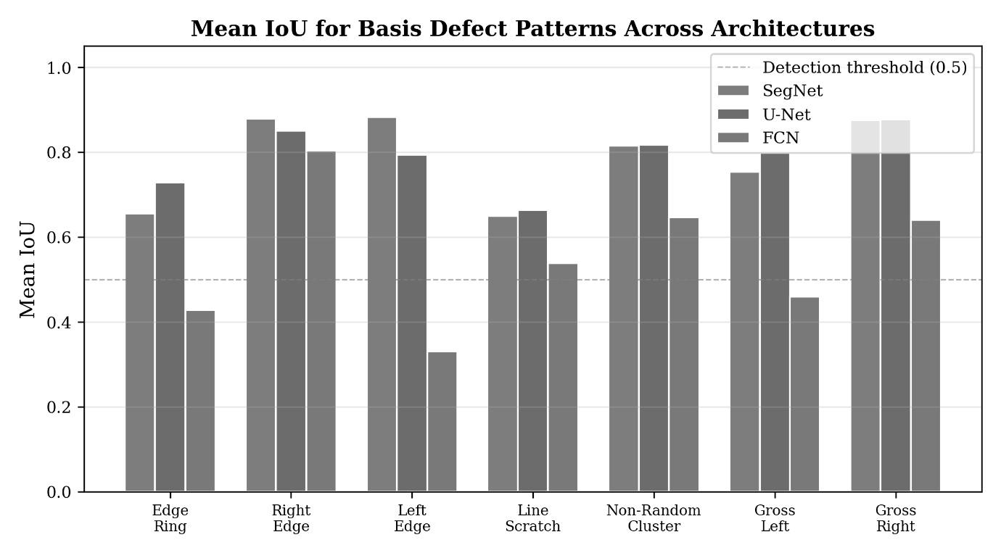
Fig. 5. Grouped bar chart comparing mean IoU across basis defect patterns for SegNet, U-Net, and FCN architectures.

3.4. Generalization to Unseen Defect Patterns
A central contribution of the approach reviewed here is the demonstration that encoder–decoder models trained on a limited set of basis patterns can generalize to detect defect morphologies not seen during training. Three unseen patterns were evaluated: gross edge damage (C9), curved scratch (C10), and a composite pattern of line scratch with non-random cluster defects (C11). Table III presents the mIoU results, and Figure 6 visualizes the comparison [17].

Table 3: Mean IoU Results for Unseen Defect Patterns
Pattern | SegNet | U-Net | FCN
Gross edge damage | 0.912±0.05 | 0.894±0.07 | 0.776±0.08
Curved scratch | 0.824±0.10 | 0.808±0.12 | 0.769±0.10
Line scratch + cluster | 0.743±0.08 | 0.771±0.09 | 0.610±0.09

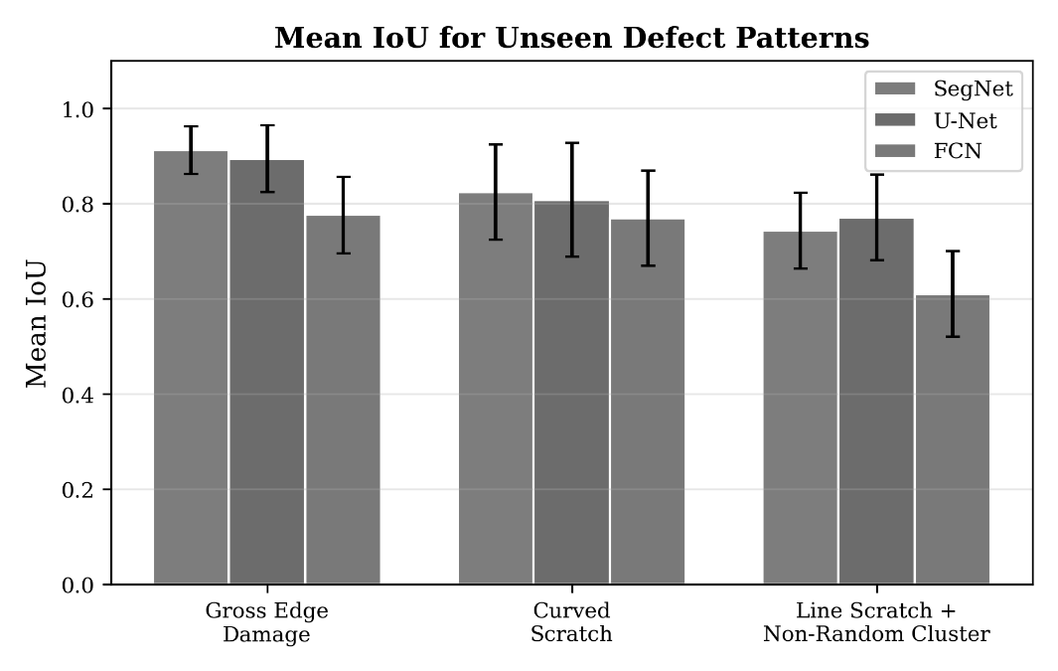
Fig. 6. Mean IoU with standard deviation for unseen defect patterns across the three architectures.

The results demonstrate strong generalization capability. SegNet achieves the highest mIoU for gross edge damage (0.912) and curved scratch (0.824), while U-Net marginally outperforms SegNet for the composite line scratch with non-random cluster pattern (0.771 vs. 0.743). All architectures exceed the 0.5 detection threshold for all unseen patterns, confirming that the learned feature representations capture fundamental defect characteristics that transfer across morphological variations [17].

3.5. Impact of Defect Density on Detection Accuracy
The relationship between defect density (defined as the ratio of defective units to total units) and IoU was investigated systematically across the three unseen patterns. Tables IV and V present the slopes of linear fits and R-squared values, while Figure 7 shows scatter plots of IoU versus defect density [17].

Table 4: Slope of Linear Fit for IoU vs. Defect Density
Pattern | SegNet | U-Net | FCN
Gross edge damage | −0.7 | −1.2 | −0.3
Curved scratch | −1.0 | −2.2 | −0.9
Line scratch + cluster | −0.8 | −1.2 | 0.03
Table 5: R-Squared Values for IoU vs. Defect Density
Pattern | SegNet | U-Net | FCN
Gross edge damage | 0.50 | 0.65 | 0.06
Curved scratch | 0.30 | 0.74 | 0.21
Line scratch + cluster | 0.16 | 0.43 | 0.0002
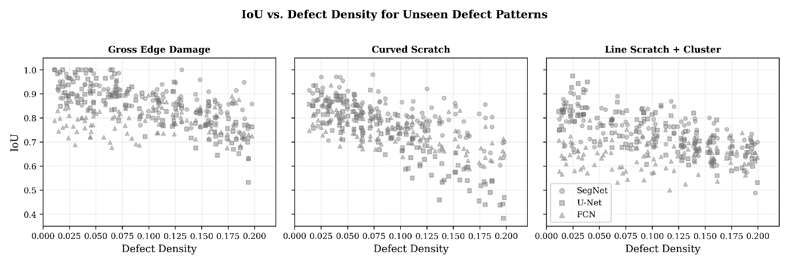
Fig. 7. IoU versus defect density scatter plots for the three unseen defect patterns across all architectures.

Two notable observations emerge from this analysis. First, although FCN achieves lower overall mIoU values, its detection performance is relatively insensitive to defect density, as indicated by near-zero slopes and very low R-squared values. This suggests that FCN's detection errors are uniformly distributed rather than being concentrated at high defect densities. Second, among SegNet and U-Net, SegNet demonstrates greater robustness to increasing defect density, with smaller negative slopes across all three unseen patterns. U-Net shows stronger density dependence (steeper negative slopes and higher R-squared values), indicating that its performance degrades more substantially as defect density increases. For low defect densities below 0.1, the performance of SegNet and U-Net is comparable [17].

3.6. Validation on Real Wafer Data
The ultimate test of any anomaly detection system is its performance on real production data. Using the SegNet architecture, the trained model was evaluated on 1,191 real wafers, of which 22.9% contained actual defect patterns and 77.1% exhibited only random defects. Table VI and Figure 8 summarise the detection results [17].

Table 6: Detection Performance on Real Wafer Data
 | Defect | Random
Correct Detection | 100% | 94.3%
Wrong Detection | 0% | 5.7%

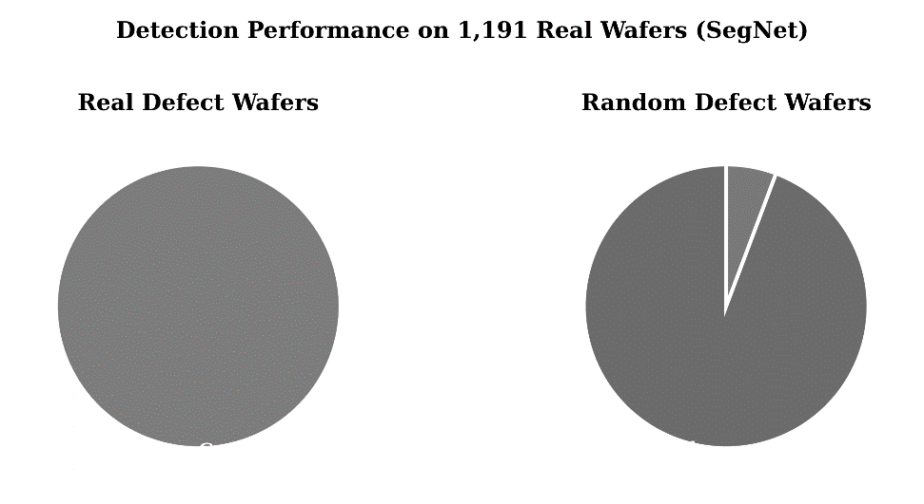
Fig. 8. Detection performance summary on 1,191 real wafers using the SegNet-based architecture.

The model achieves 100% detectability for real defect patterns a remarkable result given that training was performed entirely on synthetic data. For random-only wafers, 94.3% were correctly classified as defect-free. The 5.7% false positive rate arises from cases where small clusters of random defects are not fully suppressed in the output. This false positive rate could be further reduced through post-processing techniques such as minimum cluster area filtering [17], [26].

3.7. Scalability Analysis
To evaluate the scalability of the synthetic training approach, the dataset size was increased from 17,000 to 26,000 samples using the SegNet architecture. As shown in Table VII and Figure 9, the average training time per epoch increased from 19.9 to 30.5 minutes, while the overall mIoU improved from 0.796 to 0.828. This 4% improvement in mIoU for a 53% increase in dataset size suggests that the model benefits from additional training data, though with diminishing returns. The total training time remains within a few hours, which is practical for industrial deployment scenarios [17], [27].

Table 7: Training Time and mIoU Comparison for Different Dataset Sizes
 | 17,000 dataset | 26,000 dataset
Avg. time/epoch (min) | 19.9 | 30.5
Overall mIoU | 0.796 | 0.828

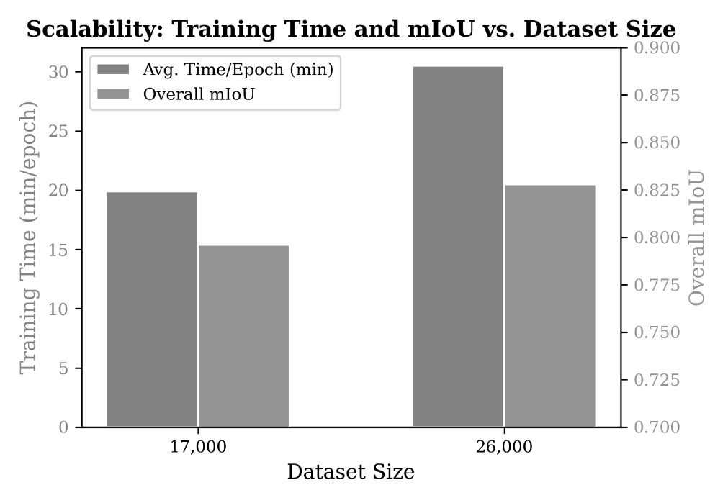
Fig. 9. Scalability comparison showing training time and mIoU as the dataset size increases from 17,000 to 26,000.

4. DISCUSSION AND FUTURE DIRECTIONS

4.1. Comparative Assessment of Architectures
The comparative evaluation reveals a clear performance hierarchy among the three encoder–decoder architectures. SegNet and U-Net consistently outperform FCN in terms of mIoU for both basis and unseen defect patterns. This superiority is attributable to their more sophisticated mechanisms for preserving spatial information during the encoding–decoding process. SegNet's use of max-pooling indices and U-Net's skip connections both serve to mitigate the information loss inherent in successive down-sampling operations, which is essential for precise pixel-level segmentation [15], [16], [17].
The choice between SegNet and U-Net involves a trade-off. SegNet demonstrates greater robustness to high defect densities, making it preferable for production environments where defect densities may vary widely. U-Net, while slightly more sensitive to defect density, achieves competitive performance at low densities and offers substantially faster training times (10 minutes vs. 19.9 minutes per epoch). For practical deployment, SegNet may be preferred when the priority is robustness across varying defect conditions, while U-Net may be more suitable when rapid model iteration is required [17], [28].

4.2. Synthetic Data for Training: Advantages and Limitations
The use of exclusively synthetic training data represents both a major strength and a limitation of the reviewed approach. The key advantage is practical: excursion events are rare in production, and accumulating sufficient labeled real samples for training is often infeasible, particularly during early technology development phases. The Poisson-based generation model provides unlimited labeled data with known ground truth, eliminating the need for manual annotation [17], [19].
However, synthetic data inevitably simplifies the complexity of real-world defect distributions. Real wafer maps may exhibit correlated defect structures, process-dependent spatial biases, and defect morphologies that deviate from the assumptions embedded in the generation model. Bridging this "domain gap" between synthetic and real data is an active area of research, with promising approaches including domain adaptation techniques, generative adversarial networks (GANs) for more realistic wafer map synthesis [29], and semi-supervised learning methods that leverage small amounts of labeled real data alongside large synthetic datasets [30].

4.3. Recent Advances and Emerging Approaches
Since the publication of the foundational work reviewed here, several important advances have extended the state of the art. Attention mechanisms, originally introduced in natural language processing, have been integrated into encoder–decoder architectures for semiconductor defect detection, enabling the models to focus selectively on defect-relevant regions [31], [32]. Vision transformers (ViTs) have shown promise for wafer map classification and segmentation tasks, with their self-attention mechanisms providing effective global context modeling [33], [34]. The Segment Anything Model (SAM), a foundation model for segmentation, represents a potential paradigm shift, though its adaptation to the specific characteristics of wafer defect patterns remains an open research question [35].
Transfer learning from large-scale image datasets (e.g., ImageNet) has been explored as a strategy to improve detection performance with limited semiconductor-specific training data [36]. Contrastive learning and self-supervised pre-training methods have also shown promise for learning robust feature representations from unlabeled wafer map data [37]. Additionally, lightweight architectures optimized for edge deployment are being investigated to enable real-time defect detection on production tool controllers, reducing the latency between inspection and corrective action [38].

4.4. Challenges for Industrial Deployment
Several challenges must be addressed for the successful industrial deployment of deep learning-based defect detection systems. First, model interpretability remains a concern: semiconductor engineers require not only detection outputs but also explanations for why certain patterns are flagged, necessitating the development of explainable AI techniques tailored to this domain [39]. Second, the distribution of defect patterns evolves as manufacturing processes change, requiring continuous model updating strategies and robust detection of distribution shift. Third, the integration of defect detection models with existing manufacturing execution systems (MES) and statistical process control (SPC) frameworks requires standardized interfaces and rigorous validation protocols [4]. Finally, ensuring consistent performance across different product types, technology nodes, and manufacturing sites poses a significant generalization challenge.

5. CONCLUSION
This review has comprehensively examined the application of deep convolutional encoder–decoder neural network architectures SegNet, U-Net, and FCN to anomaly detection and segmentation of wafer defect patterns in semiconductor manufacturing. The approach of training models exclusively on synthetic wafer maps generated via Poisson point processes and evaluating on real production data addresses a fundamental practical challenge: the scarcity of labeled real-world data for rare excursion events.
Key findings include: (1) SegNet and U-Net consistently outperform FCN across all evaluated defect patterns, with mIoU values exceeding 0.5 for all basis and unseen patterns; (2) models trained on eight basis patterns successfully generalize to detect morphologically distinct unseen patterns, validating the generalization capability essential for real-world deployment; (3) the SegNet architecture achieves 100% detection rate on real wafer defect patterns with a false positive rate of only 5.7%, despite being trained entirely on synthetic data; (4) SegNet exhibits greater robustness to varying defect densities compared to U-Net; and (5) increasing the training dataset size from 17,000 to 26,000 samples improves overall mIoU from 0.796 to 0.828 with manageable computational overhead.
Future research should focus on bridging the synthetic-to-real domain gap through advanced data augmentation and domain adaptation techniques, incorporating attention mechanisms and transformer-based architectures, developing lightweight models for real-time edge deployment, and integrating explainable AI methods to enhance engineer trust and adoption. As semiconductor technology continues to advance toward increasingly complex device architectures, automated defect detection systems will become ever more critical for maintaining competitive yields and preventing costly excursion events.

Disclaimer (Artificial intelligence)
Author(s) hereby declare that NO generative AI technologies such as Large Language Models (ChatGPT, COPILOT, etc.) and text-to-image generators have been used during the writing or editing of this manuscript.

6. REFERENCES
[1] J. Y. Hwang and W. Kuo, "Model-based clustering for integrated circuit yield enhancement," Eur. J. Oper. Res., vol. 178, no. 1, pp. 143–153, Apr. 2007.
[2] Y.-S. Jeong, S.-J. Kim, and M. K. Jeong, "Automatic identification of defect patterns in semiconductor wafer maps using spatial correlogram and dynamic time warping," IEEE Trans. Semicond. Manuf., vol. 21, no. 4, pp. 625–637, Nov. 2008.
[3] T. Yuan, W. Kuo, and S. J. Bae, "Detection of spatial defect patterns generated in semiconductor fabrication processes," IEEE Trans. Semicond. Manuf., vol. 24, no. 3, pp. 392–403, Aug. 2011.
[4] M.-J. Wu, J.-S. R. Jang, and J.-L. Chen, "Wafer map failure pattern recognition and similarity ranking for large-scale data sets," IEEE Trans. Semicond. Manuf., vol. 28, no. 1, pp. 1–12, Feb. 2015.
[5] K. Kyeong and H. Kim, "Classification of mixed-type defect patterns in wafer bin maps using convolutional neural networks," IEEE Trans. Semicond. Manuf., vol. 31, no. 3, pp. 395–402, Aug. 2018.
[6] C.-J. Huang, C.-F. Wu, and C.-C. Wang, "Image processing techniques for wafer defect cluster identification," IEEE Design Test Comput., vol. 19, no. 2, pp. 44–48, Mar./Apr. 2002.
[7] B. Jeganathan, “Transformer-Based and Generative AI Framework for Automated Defect Detection in Semiconductor Wafer Inspection”, Curr. J. Appl. Sci. Technol., vol. 44, no. 11, pp. 75–85, Nov. 2025.
[8] R. Wang and N. Chen, "Defect pattern recognition on wafers using convolutional neural networks," Qual. Reliab. Eng. Int., vol. 36, no. 4, pp. 1245–1257, Jun. 2020.
[9] C. H. Jin, H. J. Na, M. Piao, G. Pok, and K. H. Ryu, "A novel DBSCAN-based defect pattern detection and classification framework for wafer bin map," IEEE Trans. Semicond. Manuf., vol. 32, no. 3, pp. 286–292, Aug. 2019.
[10] Y. LeCun, Y. Bengio, and G. Hinton, "Deep learning," Nature, vol. 521, pp. 436–444, May 2015.
[11] A. Krizhevsky, I. Sutskever, and G. E. Hinton, "ImageNet classification with deep convolutional neural networks," Commun. ACM, vol. 60, no. 6, pp. 84–90, Jun. 2017.
[12] B. Jeganathan, “Beyond the Golden Die: A Hybrid Die-to-Database Deep Learning Framework for Systematic Defect Detection”, Curr. J. Appl. Sci. Technol., vol. 44, no. 12, pp. 104–117, Dec. 2025.
[13] T. Nakazawa and D. V. Kulkarni, "Wafer map defect pattern classification and image retrieval using convolutional neural network," IEEE Trans. Semicond. Manuf., vol. 31, no. 2, pp. 309–314, May 2018.
[14] E. Shelhamer, J. Long, and T. Darrell, "Fully convolutional networks for semantic segmentation," IEEE Trans. Pattern Anal. Mach. Intell., vol. 39, no. 4, pp. 640–651, Apr. 2017.
[15] V. Badrinarayanan, A. Kendall, and R. Cipolla, "SegNet: A deep convolutional encoder–decoder architecture for image segmentation," IEEE Trans. Pattern Anal. Mach. Intell., vol. 39, no. 12, pp. 2481–2495, Dec. 2017.
[16] O. Ronneberger, P. Fischer, and T. Brox, "U-Net: Convolutional networks for biomedical image segmentation," in Proc. MICCAI, 2015, pp. 234–241.
[17] T. Nakazawa and D. V. Kulkarni, "Anomaly detection and segmentation for wafer defect patterns using deep convolutional encoder–decoder neural network architectures in semiconductor manufacturing," IEEE Trans. Semicond. Manuf., vol. 32, no. 2, pp. 250–256, May 2019.
[18] R. Pasupathy, "Generating homogeneous Poisson processes," in Wiley Encyclopedia of Operations Research and Management Science. Hoboken, NJ, USA: Wiley, 2011.
[19] M. Saqlain, B. Jargalsaikhan, and J. Y. Lee, "A voting ensemble classifier for wafer map defect patterns identification in semiconductor manufacturing," IEEE Trans. Semicond. Manuf., vol. 32, no. 2, pp. 171–182, May 2019.
[20] L.-C. Chen, G. Papandreou, I. Kokkinos, K. Murphy, and A. L. Yuille, "DeepLab: Semantic image segmentation with deep convolutional nets, atrous convolution, and fully connected CRFs," IEEE Trans. Pattern Anal. Mach. Intell., vol. 40, no. 4, pp. 834–848, Apr. 2018.
[21] H. Noh, S. Hong, and B. Han, "Learning deconvolution network for semantic segmentation," in Proc. ICCV, 2015, pp. 1520–1528.
[22] K. He, G. Gkioxari, P. Dollar, and R. Girshick, "Mask R-CNN," in Proc. ICCV, 2017, pp. 2961–2969.
[23] S. Cheon, H. Lee, C. O. Kim, and S. H. Lee, "Convolutional neural network for wafer surface defect classification and the detection of unknown defect class," IEEE Trans. Semicond. Manuf., vol. 32, no. 2, pp. 163–170, May 2019.
[24] J. Wang et al., "Deformable convolutional networks for efficient mixed-type wafer defect pattern recognition," IEEE Trans. Semicond. Manuf., vol. 33, no. 4, pp. 587–596, Nov. 2020.
25. Ingle, R., Shahade, A. K., Gaikwad, M., & Patil, S. (2025). Deep learning driven silicon wafer defect segmentation and classification. MethodsX, 14, 103158.
Ma, J., Zhang, T., Yang, C., Cao, Y., Xie, L., Tian, H., & Li, X. (2023). Review of Wafer Surface Defect Detection Methods. Electronics, 12(8), 1787. https://doi.org/10.3390/electronics12081787

APPENDIX

Complete scripts for data preprocessing, model training, and figure generation are provided as supplementary material. Repository: https://github.com/balachandarj/Review_Deep-Learning-for-Anomaly-Detection

