Original Research Article

ASSESSMENT OF USER SATISFACTION WITH 4G/LTE NETWORK PERFORMANCE IN NORTH-CENTRAL NIGERIA

Abstract
Despite the introduction of 5G in Nigeria, its deployment still faces major challenges as it has not been fully deployed. Its availability is just centered on few major cities within the urban setting, while the majority of the population especially at the rural settings still rely on 3G and 4G for connectivity. This study investigates user satisfaction with 4G/LTE network performance in North-Central Nigeria, focusing on key performance indicators of major network operators such as speed, coverage, reliability, data bundle plan, signal strength and customer support. Through a mixed-method approach involving 384 participants, data was collected via structured questionnaires, interviews, and network performance testing. Results indicate an overall satisfaction rate of approximately 73.70% with customer support and a positive likelihood of recommendation for their network technology by approximately 74.74% of respondents. Recommendations for optimization include enhancing network coverage, reliability, and customer support. The study contributes to understanding user satisfaction factors in the telecommunications industry and provides practical insights for improving service quality and competitiveness. Limitations include regional focus and reliance on self-reported data. Future research avenues include longitudinal studies, comparative analyses, and exploration of regulatory influences on user satisfaction.
Keywords: User satisfaction, 4G/LTE network, North-Central Nigeria, Major network operators, Customer support, Service optimization.

1. Introduction
The evolution of mobile telephony, originating from radiophones in 1947, has progressed through First Generation (1G) systems to the present Fourth Generation (4G) systems like LTE and LTE-Advanced (Kumar et al., 2019; Slalmi et al., 2020). In Nigeria's North-Central region, a surge in mobile data usage, driven by the proliferation of devices like laptops and smartphones, has been observed alongside a significant increase in telephony subscribers. Long Term Evolution (LTE) technologies have played a pivotal role in meeting this demand, offering high-speed internet access across urban and rural areas (NCC, 2022; Kolackova, Svarovsky & Beranek, 2020; Fan & Huo, 2021; Okafor et al., 2023; Yusuf et al., 2024a). Despite the advancements in LTE technologies, ensuring user satisfaction remains paramount. Factors such as network speed, latency, coverage, and signal strength significantly influence user experiences. Understanding user satisfaction is crucial for mobile network service providers, impacting customer loyalty and market competitiveness. Studies highlight the multifaceted nature of user satisfaction, covering network performance, service quality, customer support, and pricing strategies (Habibi et al., 2017; Roy, Eshghi & Ganguli, 2008; Yusuf et al., 2024; Aniru & Omoavowere, 2026). Seamless connectivity and reliable service accessibility are directly linked to network coverage, significantly influencing satisfaction levels (Habibi et al., 2017; Yusuf et al., 2024a). Moreover, high-quality network performance, characterized by fast data speeds and dependable call reception, is essential for meeting user expectations (Isabona & Srivastava, 2017; Kumar et al., 2024).
Assessing user satisfaction often involves analyzing network performance metrics and user feedback to pinpoint areas for enhancement (Habibi et al., 2017; Isabona & Srivastava, 2017, Yusuf et al., 2024). Such assessments help gauge user satisfaction levels based on key performance indicators, emphasizing the need for ongoing monitoring and optimization of network performance (Isabona & Srivastava, 2017). Additionally, effective customer support strategies are crucial for enhancing user satisfaction with mobile services. Swift issue resolution and responsive assistance contribute significantly to overall satisfaction levels. Moreover, transparent pricing models and affordability play key roles in enriching user experiences (Rane, Achari & Choudhary, 2023; Bhale et al., 2026).
In the case of Nigeria, despite the introduction of 5G, its deployment still faces major challenges as it has not been fully deployed. Its availability is just centered on few major cities within the urban setting, while the majority of the population especially at the rural settings still rely on 3G and 4G for connectivity (Yusuf et al., 2024b). In the context of the North-Central region, understanding user satisfaction with LTE services requires a nuanced approach considering local demographics and usage patterns (Oje & Edeki, 2021). By evaluating user satisfaction metrics, stakeholders can identify areas for improvement and tailor network strategies to better serve the region's diverse population (NCC, 2022; Aniru & Omoavowere, 2026). Overall, continuous innovation and user-centric approaches are essential to meet the evolving needs of consumers in an increasingly connected world. In view of the above, the objective of this study is to assess the level of user satisfaction with performance of 4G/LTE networks in North Central Nigeria. The study will gather data on user perceptions and satisfaction levels and determine the level of user satisfaction based on some selected key performance indicators (KPIs); and developing recommendations for improving network performance and user satisfaction in North Central Nigeria.

2. Related Works
In recent years, the telecommunications industry has witnessed a surge in demand for high-quality mobile network services, driven by the ever-increasing expectations of users. Understanding and assessing user satisfaction have become critical aspects influencing customer loyalty and the overall success of telecommunication providers.
A study conducted in Afghanistan by Habibi et al. (2017) shed light on the importance of network coverage in determining user satisfaction. Their research focused on measuring and statistically analyzing network coverage of mobile operators, highlighting the direct impact of improved coverage on user satisfaction levels. By investigating the relationship between network coverage and user satisfaction, the study proposed feasible solutions to expand coverage to non-covered residential areas and enhance performance in existing covered areas. The study by Isabona and Srivastava (2017) delved into end-user satisfaction assessment methods for mobile telephony in urban radio networks in Nigeria. By utilizing field drive test tools and exploring mathematical models based on 3GPP KPIs, the research provided insights into network performance and its correlation with user satisfaction. The study underscored the one-to-one relationship between the quality of service provided by network operators and end-user satisfaction.
Similarly, a study conducted in India by Kar (2019) focused on identifying determinants of customer satisfaction in the telecommunication industry. By analyzing data collected from social media platforms, the research revealed a positive relationship between network quality, service interaction quality, customer support, and customer satisfaction. This highlights the significance of network quality and customer support in shaping user experiences.
Another empirical study by Balaji & Senthilkumar (2023) investigated user satisfaction with various services offered by mobile phone service providers. The study emphasized the multifaceted nature of user satisfaction, encompassing network quality, customer support, and pricing. It concluded that providers must continually enhance their services to meet evolving customer expectations and stay competitive in the industry.
Additionally, studies such as the one by Fageeri et al. (2021) in Sudan analyzed customer satisfaction with telecom companies using advanced data mining techniques. By measuring customer satisfaction through surveys and applying association rule mining, the research provided insights into user preferences and service performance.

2. Methodology
The study focused on user satisfaction with major network operators in North Central Nigeria. It covered six state capitals in the region; as well as the FCT; namely Kwara, Kogi, Niger, Plateau, Nasarawa, Benue, and Federal Capital Territory (FCT) Abuja. The study involved a combination of quantitative and qualitative research methods, primary and secondary data collection methods, including network performance testing using suitable software suites, reference to industry reports, user surveys, and interviews. The study focused on individual users of 4G/LTE networks, including both consumers and businesses. Data on network parameters, user satisfaction, and user experience were collected, and the data collection covered only urban areas in North Central Nigeria.

3.1 The Study Location
The North-Central region of Nigeria is located in the central part of Nigeria and is comprised of six states; with a growing population of mobile phone users and a significant demand for reliable and high-speed internet connectivity. The region has a diverse ethnic and cultural population and is rich in mineral resources such as tin, iron ore, coal, and limestone. It is home to several universities and research institutions, making it a hub for academic and research activities in the country (Ogundari, Akinwale & Adepoju, 2017). The region covers approximately 105,863 km² with undulating hills, plateaus, and valleys, and is characterized by a tropical savanna climate with distinct wet and dry seasons (Figure 1). The average temperature is 26°C, and the region experiences an average annual rainfall of about 1,100 mm. The Niger and Benue rivers serve as major water bodies in the region (Olanrewaju & Fayemi, 2015).

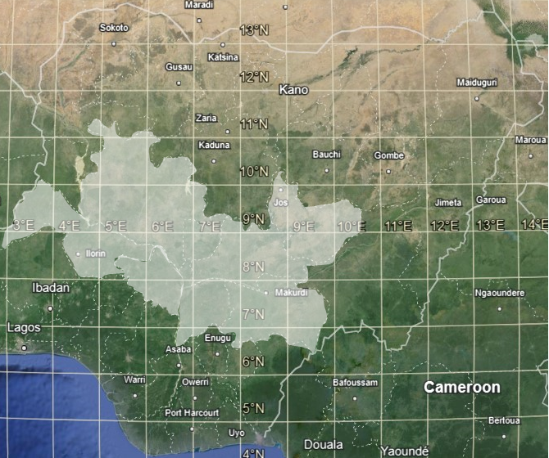
Figure 1: Map of the Study Location (Google Earth, 2024)

3.2 The Selected MNOs and Nigeria's 4G/LTE Landscape
As of March 2020, Nigeria's telecom industry boasted 189.3 million subscribers, contributing 10.88% to GDP, led by major players such as 9Mobile, Airtel, Globacom, and MTN (NCC, 2021). However, rural areas face a digital divide, with around 40 million lacking telecom access (Okocha & Edafewotu, 2022). Tower expansion, led by MTN Nigeria, Airtel, Globacom, and 9Mobile, is endorsed by the NCC, but over 80,000 towers are still needed (Okoyeuzu et al., 2023). MTN Nigeria initiated 4G LTE rollout in 2016, amid concerns over fair competition and spectrum pricing favoring larger operators. This study selected four major operators (MTN Nigeria, Airtel, Globacom, and 9Mobile) for the assessment. They currently hold 2.1GHz spectrum slots from the Nigerian Communications Commission (NCC), with MTN Nigeria recently acquiring additional spectrum in line with its Ambition 2025 strategy and government broadband goals. Despite growing 4G adoption, challenges persist in North Central Nigeria, affecting network speeds, signal quality, and coverage (Abubakar, Adamu, & Usman, 2018; Adetunmbi & Daramola, 2015; Olawale, Isafiade & Samuel, 2018; Mohammed & Kebande, 2016; Akinwale & Adetunmbi, 2019).

3.3 The Study Population, Sample Size and Technique
The study population comprises management-level employees and customers from selected MNOs in North-central Nigeria, ensuring a comprehensive examination of the research problem by considering both organizational decision-makers and customer perspectives. Determining the sample size is critical, and Cochran's formula is employed for this purpose. This formula factors in population size, desired precision level, and confidence level, enabling the calculation of a statistically significant and reliable sample size, as outlined by Cochran (1977).
$$n=\frac{Z^{2}pq}{e^{2}} (1)$$
Where:
n = sample size
Z-value is found in a Z-table (for a 95% confidence level, it is usually 1.96)
p = estimated proportion of the population which has the attribute in question (in this case, we assume p = 50%, or 0.50)
$$q = 1 - p (in this case, q = 0.50)$$
e = the desired level of precision (margin of error, which in this case is 5%)
Substituting the values we have:
$$n = \frac{{(1.96)}^{2} (0.5) (0.5)}{{(0.05)}^{2}}$$
$$n = \frac{(3.84) (0.5) (0.5)}{0.0025}$$
$$n = \frac{0.96 }{0.0025}=384$$
Therefore, the sample size required for this study is 384. A sample size of 384 is considered adequate as it ensures a reasonable representation of the population, and it also allows for statistical analysis that can provide meaningful insights.
The study utilized purposive sampling to select respondents based on predefined criteria. Purposive sampling, a non-random technique, facilitated the selection of participants according to specific attributes pertinent to the study's goals. Specifically, management staff with a minimum of three (3) years in managerial roles were chosen, ensuring their substantial experience and industry knowledge. This approach ensured the selection of respondents most suited to the study's objectives, enhancing the relevance and informative quality of the obtained results.

3.4 Data Collection and Analysis
The study employed a mixed-method approach, utilizing both primary and secondary data sources. Secondary data were obtained from the Nigerian Communication Commission (NCC) website, while primary data were collected through structured questionnaires and interviews with mobile network users. Manual distribution and motivation techniques were employed to administer the user satisfaction survey, ensuring engagement and valuable insights. Research assistants were trained to support the survey effectively, and questionnaire design included demographic information and user satisfaction responses on a 7-point Likert scale. Internal consistency reliability, assessed using Cronbach's alpha and Composite Reliability, validated the survey tools and scales. Data analysis was conducted using IBM SPSS Version 29 for data cleaning and descriptive statistics, ensuring a thorough and systematic analysis.
The survey included questions aimed at assessing various aspects of participants' satisfaction and experiences with their network service provider. These questions covered areas such as overall performance satisfaction, frequency of network performance issues, satisfaction with network speed, coverage, signal strength/power, data bundle plans, reliability, customer support, and likelihood to recommend the service.
Table 1 presents the Cronbach's alpha coefficient for each survey item/question, indicating the internal consistency reliability of the corresponding constructs.
Table 1: Individual Cronbach's Alpha Values
Survey Item/Question | Cronbach's Alpha
Satisfaction with Overall Performance | 0.780
Frequency of Network Performance Issues | 0.749
Satisfaction with Network Speed | 0.725
Satisfaction with Network Coverage | 0.704
Satisfaction with Signal Strength/Power | 0.732
Satisfaction with Data Bundle Plans | 0.751
Satisfaction with Reliability | 0.734
Satisfaction with Customer Support | 0.739
Likelihood to Recommend | 0.781

3.5 Overall Cronbach's Alpha
To assess the overall internal consistency reliability of the survey instrument, we calculated the Cronbach's alpha coefficient by averaging the individual alpha values obtained for each survey item/question. The formula used for calculating the overall Cronbach's alpha is as follows:

$$Overall {Cronbach}^{'}sAlpha (CA)=\frac{Sum of Individual Alpha Values}{Number of Survey Items/Questions}$$
Substituting the values from Table 1:
$$CA=\frac{0.780+0.749+0.725+0.704+0.732+0.751+0.734+0.739+0.781}{9}$$
$$=\frac{6.695}{9}≈0.743$$

This indicates a satisfactory level of internal consistency reliability across the survey items/questions.

4. Results and Discussion
Tables 2 through 7 present the overview of each demographic category.
In Table 2, the gender distribution of the 384 survey respondents is presented. Male respondents accounted for 150 (39.06%) of the total, while female respondents constituted the majority with 180 (46.88%). A group of 54 respondents (14.06%) chose the option "Prefer not to say." This data provides insights into the gender diversity of the survey participants.

Table 2: Gender Distribution
Gender | Count
Male | 150
Female | 180
Prefer not to say | 54

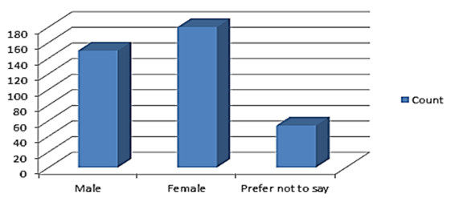
Figure 2: Gender Distribution
Table 3 displays the age distribution of the survey respondents. The age group "25-34" was the largest, with 98 respondents (25.52%), followed by "35-44" with 84 respondents (21.88%). Respondents aged "65 or older" were the least numerous, comprising 25 individuals (6.51%). This data offers insights into the age diversity of the survey participants.
Table 3: Age Range
Age Range | Count
18-24 | 73
25-34 | 98
35-44 | 84
45-54 | 73
55-64 | 31
65 or older | 25

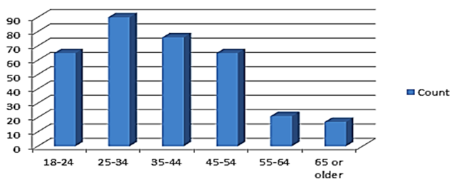
Figure 3: Age Range

From Table 4, it's observed that respondents with a "Graduate or professional degree" constituted the largest group, with 118 individuals (30.73%), followed by "Bachelor's degree" holders with 112 (29.17%). Respondents with "Primary school" education comprised the smallest group, with only 10 individuals (2.60%). These educational demographics are essential for interpreting survey results.
Table 4: Education
Education | Count
Primary school | 10
Secondary School or equivalent | 80
ND(1), HND(2), NCE(3), Other(4) | 64
Bachelor's degree | 112
Graduate or professional degree | 118

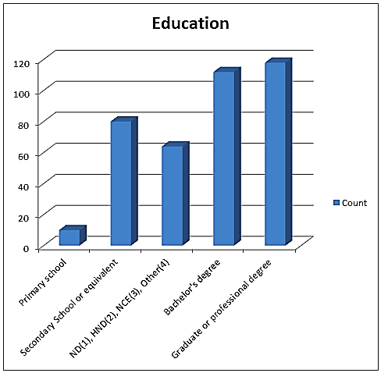
Figure 4: Education

Table 5 presents the occupational distribution of the survey respondents. "Civil Servant" emerged as the primary category, with 140 respondents (36.46%), while the category "Other (Please specify)" represented a larger portion with 244 individuals (63.54%). This data highlights the occupational diversity among the survey participants.

Table 5: Occupation
Occupation | Count
Civil Servant | 140
Other (Please specify) | 244

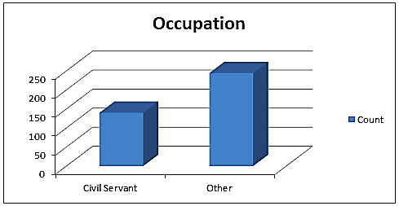
Figure 5: Occupation
In Table 6, the selection of Mobile Network Operators (MNOs) by the respondents is shown. "MTN" was the most chosen MNO, with 124 respondents (32.29%), followed by "Airtel" with 100 (26.04%). These variations in MNO selection reflect diverse preferences among users.

Table 6: MNO Selection
MNO Selection | Count
Airtel | 100
GLO | 88
9mobile | 72
MTN | 124

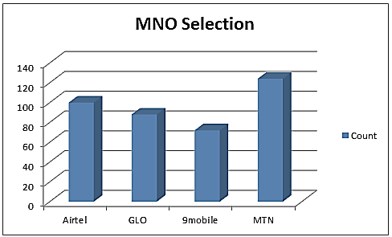
Figure 6: MNO Selection

Table 7 provides insights into the duration of LTE/4G usage among the respondents. The majority of respondents have been using LTE/4G for "1-2 years" (28.13%) and "More than 5 years" (31.25%). Understanding these usage durations is crucial for assessing user experiences and satisfaction levels.

Table 7: Duration of LTE/4G Usage
Duration of LTE/4G Usage | Count
<1 year | 62
1-2 years | 108
2-5 years | 94
>5 years | 120

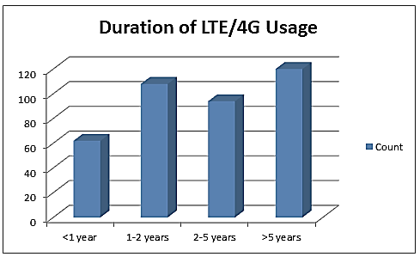
Figure 7: Duration of LTE/4G Usage

Tables 8 through 15 provide valuable insights into respondents' experiences and opinions regarding their mobile network operator's (MNO) performance in North-Central Nigeria. Bhale et al. (2026) emphasized that network performance such as call drops, data speed, congestion, and coverage remains the foundational influence that directly determines customer perceptions and provider credibility.
Table 8 reveals that a significant proportion of respondents express satisfaction with their MNO's overall performance (Figure 8), with approximately 20.83% extremely satisfied, 28.65% moderately satisfied, and 10.42% slightly satisfied. About 7.29% were just neutral in their response, while 27.08% were extremely dissatisfied.
Table 8: Satisfaction with Overall Performance
Satisfaction with Overall Performance | Count
Extremely satisfied | 80
Moderately satisfied | 110
Slightly satisfied | 40
Neither satisfied nor dissatisfied | 28
Slightly dissatisfied | 14
Moderately dissatisfied | 8
Extremely dissatisfied | 104

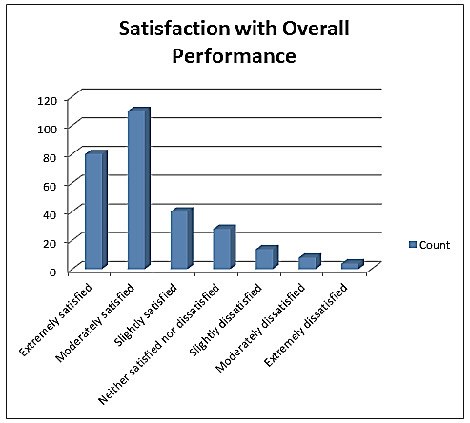
Figure 8: Satisfaction with Overall Performance

Poor network quality characterized by high latency, dropped calls, and frequent outages result in frustration, lost time, and diminished trust. It has a profoundly negative impact on customer satisfaction, often leading to reduced loyalty and increased brand switching (Bhale et al., 2026). In Table 9, most respondents 180 (46.88%) experience frequent network performance issues while 102 (26.68%) face network issues occasionally. A smaller portion rarely face network issues 100 (26.04%), while 2 (0.52%) have no problems with the network (Figure 9).

Table 9: Frequency of Network Performance Issues
Frequency of Network Performance Issues | Count
Always | 60
Very often | 10
Often | 110
Sometimes | 102
Rarely | 80
Very rarely | 20
Never | 2

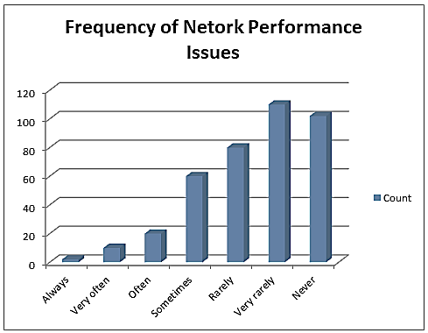
Figure 9: Frequency of Network Performance Issues

Poor network speed could lead to customer frustration and annoyance which can greatly affect their satisfaction leading to service abandonment, and brand switching (Yusuf et al., 2024; Isabona & Srivastava, 2018). Table 10 indicates that the majority of respondents (approximately 80.73%) are satisfied with the network speed, with only a small percentage expressing dissatisfaction, including 1.04% slightly dissatisfied, 1.04% moderately dissatisfied, and 0.52% extremely dissatisfied (Figure 10).

Table 10: Satisfaction with Network Speed
Satisfaction with Network Speed | Count
Extremely satisfied | 130
Moderately satisfied | 180
Slightly satisfied | 40
Neither satisfied nor dissatisfied | 24
Slightly dissatisfied | 4
Moderately dissatisfied | 4
Extremely dissatisfied | 2

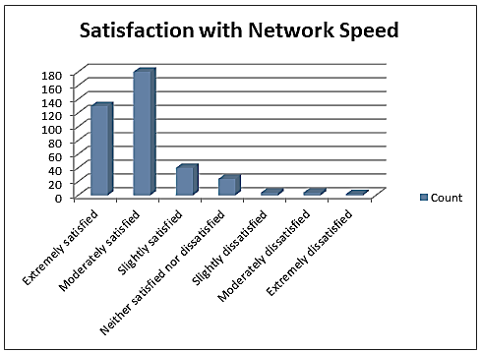
Figure 10: Satisfaction with Network Speed

Poor network coverage is a primary driver of customer dissatisfaction. It leads directly to reduce loyalty, increased complaints, and higher rates of customer churn (Switching Providers) (Aniru & Omoavowere, 2026). Similarly, Table 11 shows that a majority (around 67.71%) express satisfaction with network coverage, with relatively low levels of dissatisfaction, including 3.13% slightly dissatisfied, 3.13% moderately dissatisfied, and 4.17% extremely dissatisfied (Figure 11).

Table 11: Satisfaction with Network Coverage
Satisfaction with Network Coverage | Count
Extremely satisfied | 120
Moderately satisfied | 140
Slightly satisfied | 40
Neither satisfied nor dissatisfied | 44
Slightly dissatisfied | 12
Moderately dissatisfied | 12
Extremely dissatisfied | 16

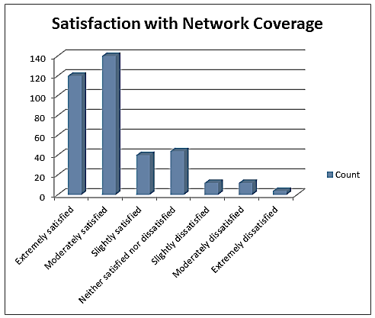
Figure 11: Satisfaction with Network Coverage

The signal strength do have an impact on the level of trust and the integrity of the connection, especially places with low signal can greatly affect customer satisfaction (Aniru & Omoavowere, 2026), Table 12 demonstrates that most respondents (around 67.71%) are satisfied with signal strength/power, with dissatisfaction levels relatively low, including 5.21% slightly dissatisfied, 1.04% moderately dissatisfied, and 1.04% extremely dissatisfied (Figure 12).
Table 12: Satisfaction with Signal Strength/Power
Satisfaction with Signal Strength/Power | Count
Extremely satisfied | 110
Moderately satisfied | 150
Slightly satisfied | 60
Neither satisfied nor dissatisfied | 36
Slightly dissatisfied | 20
Moderately dissatisfied | 4
Extremely dissatisfied | 4

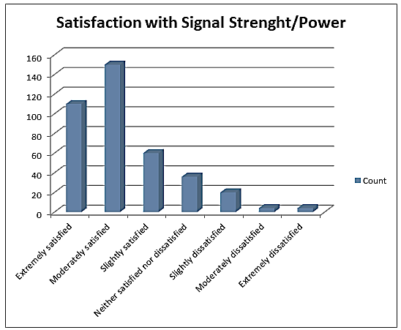
Figure 12: Satisfaction with Signal Strength/Power

When data quality falls short of expectations of the customers, it directly erodes loyalty and damages the brand's reputation. This results to diminish user experience, and often lead to high customer churn rates (Balaji & Senthilkumar, 2023). In Table 13, the majority (around 54.69%) express satisfaction with data bundle plans, with a small percentage indicating dissatisfaction, including 3.13% slightly dissatisfied, 3.13% moderately dissatisfied, and 7.81% extremely dissatisfied (Figure 13).

Table 13: Satisfaction with Data Bundle Plans
Satisfaction with Data Bundle Plans | Count
Extremely satisfied | 70
Moderately satisfied | 140
Slightly satisfied | 80
Neither satisfied nor dissatisfied | 40
Slightly dissatisfied | 12
Moderately dissatisfied | 12
Extremely dissatisfied | 30

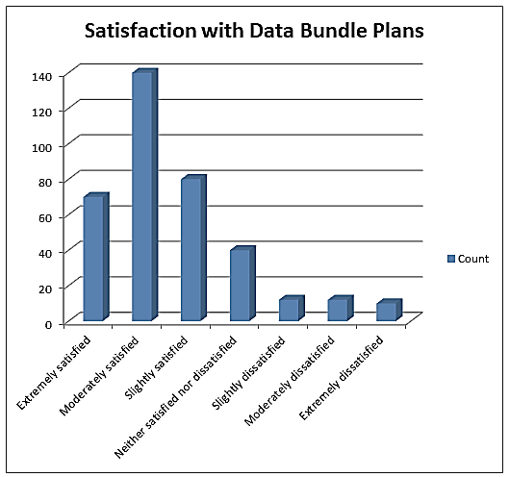
Figure 13: Satisfaction with Data Bundle Plans
In a market where high-speed, reliable connectivity is expected for video streaming, gaming, and business, limited coverage restricts usability and creates significant frustration leading to reduced satisfaction (Balaji & Senthilkumar, 2023). Table 14 reveals that most respondents (around 59.90%) express satisfaction with reliability, with relatively low levels of dissatisfaction, including 5.21% slightly dissatisfied, 2.08% moderately dissatisfied, and 4.17% extremely dissatisfied (Figure 14).

Table 14: Satisfaction with Reliability
Satisfaction with Reliability | Count
Extremely satisfied | 100
Moderately satisfied | 130
Slightly satisfied | 70
Neither satisfied nor dissatisfied | 40
Slightly dissatisfied | 20
Moderately dissatisfied | 8
Extremely dissatisfied | 16

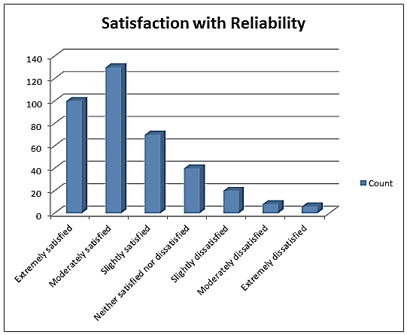
Figure 14: Satisfaction with Reliability

Poor customer support can have a negative impact on the brand's reputation, pushing away potential customers and affecting customer retention (Bhale et al., 2026). Table 15 shows that a significant portion of respondents (around 52.08%) express satisfaction with customer support, with relatively low dissatisfaction levels, including 5.73% slightly dissatisfied, 2.60% moderately dissatisfied, and 4.69% extremely dissatisfied (Figure 15).

Table 15: Satisfaction with Customer Support
Satisfaction with Customer Support | Count
Extremely satisfied | 80
Moderately satisfied | 120
Slightly satisfied | 80
Neither satisfied nor dissatisfied | 54
Slightly dissatisfied | 22
Moderately dissatisfied | 10
Extremely dissatisfied | 18

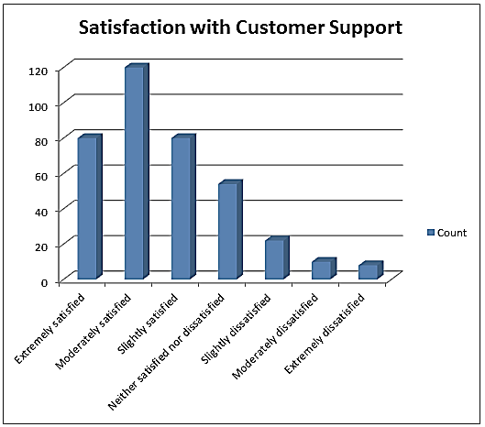
Figure 15: Satisfaction with Customer Support

Finally, Table 16 indicates that a majority of respondents (around 73.96%) express a positive likelihood of recommending their MNO's LTE/4G network technology to others, with a smaller portion expressing uncertainty or low likelihood of recommendation, including 7.81% may be; maybe not, 4.17% unlikely and very unlikely, and 9.90% most unlikely (Figure 16).

Table 16: Likelihood to Recommend
Likelihood to Recommend | Count
Most likely | 160
Very likely | 84
Likely | 40
May be; may be not | 30
Unlikely | 16
Very unlikely | 16
Most unlikely | 38

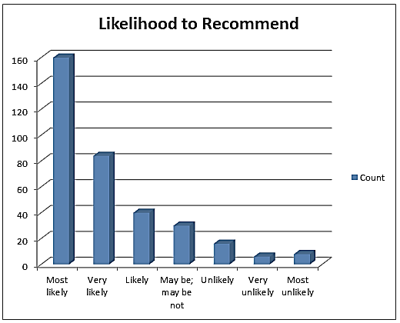
Figure 16: Likelihood to Recommend

Findings from this study on the assessment of user satisfaction with 4G/LTE network performance in North-Central Nigeria have revealed vital information that is worth discussing. On the order of selection of MNOs by the respondent, findings have revealed that the order is MTN>Airtel>GLO>9mobile. This shows high preference for MTN and low preference for 9mobile. This finding is in line with that of Yusuf et al. (2024b) on analysis of the signal strength of the key telecommunication networks in Nasarawa State, Nigeria but not in line with that of Fageeri et al. (2021) who found Aitel (Zain) as a superior network in Sudan using the Apriori Algorithm. Even though majority of the respondent 31.25% have used LTE/4G for more than 5 years and are satisfied with overall services either extremely or moderately 49.48%, a majority of the respondent have experienced serious network performance issues 46.88%, which have led to over 29.17% been dissatisfied with the overall services. Their consolation have been the fact that the MNOs have maintained good network speed 80.73%, network coverage and signal strength 67.71% which have been a major driver for their overall satisfaction in line with Yusuf et al. (2024); Isabona and Srivastava (2018) and Aniru and Omoavowere (2026).
In terms of reliability of service, majority of the respondent agreed that the MNOs are highly reliable 59.90%. This is because of the good customer support 52.08% and relationship provided by the MNOs and a variety of satisfactory data bundles available for the customers 54.69% as multiple companies offers comparable services which clients can use many providers’ services at the same time and are less loyal to brand or provider in line with Balaji and Senthilkumar (2023) and Bhale et al. (2026). As such, 73.96% of the respondent are most likely to recommend their MNOs while only 26.04% are unlikely to recommend. This finding allignes with Kar (2019) who identified that network Quality, Service interaction Quality and Customer Support play a momentous factor for the satisfaction of customers in the telecommunication industry. Also, in line with Bhale et al. (2026) who identified proactive service care, personalization, and experience-driven innovation as drivers that enhance loyalty and reduce churn.
5. Conclusion
The study examined user satisfaction with 4G/LTE network performance in North-Central Nigeria, involving 384 respondents through mixed methods. Most participants expressed satisfaction with various aspects of their MNO's performance and showed a positive likelihood of recommending their network technology. It highlights the need for ongoing optimization to improve network coverage, reliability, and customer support. Practically, it offers guidance for MNOs to enhance services and maintain competitiveness. Theoretically, it contributes to understanding factors influencing user satisfaction and underscores the importance of customer-centric approaches in telecommunications management. Limitations include regional focus and reliance on self-reported data. Future research could explore longitudinal trends, conduct comparative studies, utilize qualitative methodologies, investigate emerging technologies' impact, and explore regulatory influences on user satisfaction.
Disclaimer (Artificial intelligence)
Author(s) hereby declare that NO generative AI technologies such as Large Language Models (ChatGPT, COPILOT, etc.) and text-to-image generators have been used during the writing or editing of this manuscript.

References
Abubakar, M.S., Adamu, A.S. & Usman, A.M. (2018). An Assessment of LTE/4G Technology Performance in Nigeria: A Case Study of Abuja FCT. International Journal of Scientific and Engineering Research, 9(2), 28-32. Doi: 10.18844/ijser.2018.9.2.28-32.
Adetunmbi, A.O. & Daramola, O. T. (2015). Evaluation of 4G LTE Network Coverage in Ilorin, Nigeria. International Journal of Computer Networks and Wireless Communications, 5(3), 26-33. Doi: 10.15680/IJCNWC.2015.05.03.003.
Akinwale, A.T. & Adetunmbi, A.O. (2019). Comparative Study of 3G and 4G LTE Performance in North-Central Nigeria. International Journal of Advanced Computer Science and Applications, 10(6), 510-517. Doi: 10.14569/IJACSA.2019.10.6.324.
Aniru, M.A. & Omoavowere, E.J. (2026). Investigation and Analysis of End-User Service Integrity in LTE/5G Fixed Wireless Access Networks in Macrocellular Environments. International Journal of Informatics Information System and Computer Engineering, 7(2), 205-220. DOI: https://doi.org/10.34010/injiiscom.v7i2.15639.
Balaji, B. & Senthilkumar, V. (2023). An Empirical Study on the Users’ Satisfaction with Various Services of the Mobile Phone Service Providers. In Proceedings of the 3rd International Conference on Reinventing Business Practices, Start-ups and Sustainability (ICRBSS 2023). Retrieved from https://doi.org/10.2991/978-94-6463-374-0_24.
Bhale, U.A., Banerjee, S., Joshi, P., Kalshetti, P. & Ray, S. (2026). Customer Satisfaction Framework for Telecom Services: Multidimensional Constructs and Demographic Variations. MSW MANAGEMENT -Multidisciplinary, Scientific Work and Management Journal, 36(1), 492-509. https://mswmanagementj.com/.
Cochran, W.G. (1977). Sampling Techniques (3rd Ed.). John Wiley & Sons, Hoboken, New Jersey, United States.
Fageeri, S. O., Arockiasamy, S. & Moyaid, A. (2021). Analyzing Customer Satisfaction Over Telecom Companies in Sudan Using Apriori Algorithm. In Proceedings of the International Conference on Management, Economics, and Social Humanities (ICMeSH 2020), SHS Web of Conferences, 124, 03003. DOI: 10.1051/shsconf/202112403003.
Fan, X. & Huo, Y. (2021). An overview of low latency for wireless communications: an evolutionary perspective. arXiv preprint arXiv:2107.03484. https://doi.org/10.48550/arXiv.2107.03484.
Google Earth (2024). Google Earth (Version 9.3.15.4). Retrieved March 3, 2024, from https://www.google.com/earth/.
Goyal, K. & Kar, A. K. (2019). Determinants of Customer Satisfaction in Telecommunication. In Proceedings of the International Conference on Communication and Intelligent Systems (pp. 815-824). Springer. DOI: 10.1007/978-3-030-30577-2_67.
Habibi, M. A., Ulman, M., Baha, B. & Stočes, M. (2017). Measurement and Statistical Analysis of End User Satisfaction with Mobile Network Coverage in Afghanistan. AGRIS on-line Papers in Economics and Informatics, 9(2), 47-58. DOI: 10.22004/ag.econ.262460.
Isabona, J. & Srivastava, V. M. (2017). User-Centric Methodology for Objective Assessment of Service Quality in Established Wireless Mobile Communication Networks. International Journal on Communications Antenna and Propagation (I.Re.C.A.P.), 7(1), 26-30. DOI: 10.15866/irecap.v7i1.10475.
Kar, A. K. (2019). Determinants of Customer Satisfaction in Telecommunication. In Proceedings of the 3rd International Conference on Business and Technology Management (ICBTM 2019) (Chapter 67). DOI: 10.1007/978-3-030-30577-2_67.
Kolackova, G., Svarovsky, P. & Beranek, L. (2020). Development of Mobile Networks and Mobile Phones. In 2020 43rd IEEE International Conference on Telecommunications and Signal Processing (TSP), 337-341. https://doi.org/10.1109/TSP49392.2020.9163470.
Kumar, A., Gaur, N. & Nanthaamornphong, A. (2024). Improving the latency for 5G/B5G based smart healthcare connectivity in rural area. Scientific Reports, 14(1), 6976.
Kumar, P. P., Kumar, S. N., Thirupathi, V. & Sandeep, C. (2019). QOS and security problems in 4G networks and QOS mechanisms offered by 4G. International Journal of Advanced Science and Technology, 28(20), 600-606.
Mai, Y. T. & Yang, C. T. (2022). A Hybrid Network User Satisfaction-Based Downlink Scheduling in LTE-A Network. Mathematical Problems in Engineering, 2022, Article ID 6342802. Academic Editor: Lei Hou. https://doi.org/10.1155/2022/6342802.
Martins, C. C. (2016). Assessment of the Quality of Mobile Telecommunications Services (Master's thesis). ISCTE Business School.
Mohammed, S. & Kebande, V.R. (2016). A Comparative Analysis of 3G and 4G Wireless Networks Performance in Selected Cities of North-Central Nigeria. Journal of Computer Science and Engineering, 2(1), 1-11. Doi: 10.18488/jcse.2.1.1-11.
NCC. (2021). 2021 Subscriber/Network Data Annual Report. Nigerian Communications Commission. Retrieved from https://ncc.gov.ng/statistics-reports/reports-publications.
NCC. (2022). Industry Statistics. Nigeria Communications Commission. Retrieved from https://www.ncc.gov.ng/statistics-reports/industry-statistics.
Ogundari, I., Akinwale, Y. O. & Adepoju, A. O. (2017). Suburban Housing Development and Off-Grid Electric Power Supply Assessment for North-Central Nigeria. International Journal of Sustainable Energy Planning and Management, 12(5), 47-64. https://doi.org/10.5278/ijsepm.2017.12.5.
Oje, A.A. & Edeki, S.O. (2021). Performance Analysis of Service Users’ Perception of Mobile Network Quality in the Learning Settings. Journal of Physics: Conference Series, 6(2021), 18 - 23. https://doi.org/10.1088/17426596/1734/1/012032.
Okafor, C. S., Alagbu, E. E., Onyeyili, T. I. & Maduka, N. C. (2023). Performance analysis and evaluation of 4G network based on handoff process. Unizik Journal of Technology, Production and Mechanical Systems, 2(1), 81-88.
Okocha, D. O. & Edafewotu, E. (2022). Bridging the Digital Divide in Nigeria. The Journal of Development Communication, 33(1), 45-54. Retrieved from https://www.researchgate.net/publication/362208863_Bridging_the_Digital_Divide_in_Nigeria.
Okoyeuzu, C., Nkwor, N. N., Arize, A., Kalu, E. U. & Achu, A. C. (2023). Economic Evolution of The Nigerian Telecommunication Industry: Emne’s and Downstream Value Chain Transmission. Journal of Marketing & Supply Chain Management, 2(1), 1-6. DOI: 10.47363/JMSCM/2023(2)113.
Olanrewaju, R. M. & Fayemi, O. A. (2015). Assessment of Climate Change Scenarios in North Central Nigeria Using Rainfall as an Index. Journal of Sustainable Development in Africa, 17(6), 14 – 30.
Olawale, O.D., Isafiade, O.A. & Samuel, O.D. (2018). Evaluation of the Performance of LTE/4G Networks in the North Central Region of Nigeria. International Journal of Advanced Research in Computer Science, 9(5), 295-301. Doi: 10.14569/IJARCS.2018.9.5.313.
Rane, N., Achari, A. & Choudhary, S. P. (2023). Enhancing Customer Loyalty through Quality of Service: Effective Strategies to Improve Customer Satisfaction, Experience, Relationship, and Engagement. International Research Journal of Modernization in Engineering Technology and Science. DOI: 10.56726/IRJMETS38104.
Roy, S., Eshghi, A. & Ganguli, S. (2008). Service Quality and Customer Satisfaction: An Empirical Investigation in Indian Mobile Telecommunications Services. The Marketing Management Journal, 18, 119-144.
Slalmi, A., Chaibi, H., Chehri, A., Saadane, R., Jeon, G. & Hakem, N. (2020). On the ultra-reliable and low-latency communications for tactile internet in 5G era. Procedia Computer Science, 176, 3853-3862.
Yusuf, S.D., Isah, S.I. & Kwaha, B.J. (2024). Analysis of 4G/LTE Network Performance in North-Central Nigeria: A Comprehensive Drive Test Approach. Journal of Engineering Research and Reports, 26(9), 105-122. DOI: https://doi.org/10.9734/jerr/2024/v26i91267.
Yusuf, S.D., Mohammed, K.O. & Loko, A.Z. (2024a). Analysis and Prediction of Path Loss for Mobile Communication Lines in Nasarawa State Using Propagation Models. Journal of Engineering Research and Reports, 26(11), 129-140. https://doi.org/10.9734/jerr/2024/v26i111319.
Yusuf, S.D., Mohammed, K.O. & Loko, A.Z. (2024b). Analysis of the Signal Strength of the Key Telecommunication Networks in Nasarawa State, Nigeria. Journal of Engineering Research and Reports, 26(12), 220-230. https://doi.org/10.9734/jerr/2024/v26i121353.

