Original Research Article

In Vitro Propagation and Rooting Ability of Wild Plum Genotypes (Prunus cerasifera Ehrh.)

.
Abstract
In this study, the propagation and rooting ability of wild plum (Prunus cerasifera Ehrh.) genotypes collected through selection was tested under in vitro conditions. During the propagation phase, 4 different BAP doses (0.5, 1.0, 1.5, 2.0 mg/L⁻¹) were applied to shoots from 6 genotypes (nos. 4, 9, 33, 42, 47, 49), while 5 different IBA doses (0.5, 1.0, 1.5, 2.0, 2.5 mg/L⁻¹) were applied during the rooting phase. During the experiment, measurements were taken of the average shoot number, shoot length, leaf number, average root number, number of rooted plants, and root length for each genotype. As a result of the analyses, while the shoot length remained short at the doses with the highest shoot count, the highest shoot length was recorded at the 2 mg/L⁻¹dose, where the shoot count decreased, for genotype 47 (4.97 cm). The average shoot number was 2, and genotype 49 was found to have the lowest shoot number in the 2 mg/L⁻¹BAP medium. Genotype 47 reached the highest plant number 100, in the 1 mg/L⁻¹BAP medium at the end of the third subculture. Again, in the 2 mg/L⁻¹BAP medium, genotype 47 stood out with a shoot length of 4.97 cm and a leaf count of 16. The best rooting percentage was obtained in genotype 42 at a 2.0 mg/L⁻¹IBA dose (88.71%) and in genotype 4 at a 1.5 mg/L⁻¹ dose of 1.5 mg/L⁻¹ (84.00%). Based on the general averages, the most effective IBA dose was 1.5 mg and 2 mg/L⁻¹), with the highest rooting rate calculated at 68%. The 2.5 mg/L⁻¹ IBA dose produced the highest number of roots and root length. The study showed that tissue culture protocols cannot be uniform and that genotypes respond differently to hormone doses. The P. cerasifera type of plum is an important species due to its strong adaptability, its cultivation being more economical than other species, its high tolerance to biotic and abiotic environmental conditions, and its preference as a rootstock. Detailed examination of these genotypes is required. It is important in terms of introducing new materials to breeding studies and conserving genetic resources.

Keywords: Prunus cerasifera, Tissue culture, rootstock, IBA, subculture, micropropagation, stone fruits

1. INTRODUCTION

Prunus cerasifera Ehrh. belongs to the Rosales order, Rosaceae family, Prunoideae subfamily, and Prunus genus, P. cerasifera Ehrh. (Myrobalan plum) is a diploid (2n = 2x = 16) species and, along with some of its subspecies, belongs to the European plum group. In Turkey, P. cerasifera Ehrh., P. domestica L., P. institia L., P. spinosa L., P. salicina Lindl., and P. simonii Carr. (Davis, 1972). P. cerasifera (Ehrh.) (cherry or Myrobalan plum) is mostly preferred as rootstock or ornamental tree. They report that P. cerasifera may be one of the parents of P. domestica (Crane & Lawrence 1952; Faust & Suranyi 1999) and that P.domestica emerged as a result of hybridization between P. cerasifera and P. spinoza. Some researchers, however, have suggested that P. domestica originated from a polyploid form of P.cerasifera as its sole parent (Reynders & Salesses, 1991; Zohary, 1992). Zhebentyayeva et al. (2019), They reported that P. domestica emerged as a result of interspecific hybridization between diploid P. cerasifera and tetraploid P. spinosa, and that this species may have been formed as a result of interspecific hybridization between P. cerasifera and an unknown Eurasian plum species.

P. cerasifera Ehrh. Myrobolan plum, green plum, cherry plum, or can plum are common names for this species. Turkey is one of the genetic centers for the species P. cerasifera Ehrh., P. insititia L., P. spinosa, and P. domestica L. plum trees, especially P. cerasifera and P. domestica, are cultivated in almost all regions of Turkey. Large forests containing different wild plum genotypes are found in different parts of Turkey, especially in transitional regions. There are many economically and important varieties of P. cerasifera in Turkey. Can, Papaz, Havran, Kebap, and Aynalı are examples of these varieties. Among these varieties, Can, Papaz, and Aynalı are consumed as green plums. In our country, wild P. cerasifera seeds or the Myrobolan 29C rootstock are mostly used as rootstocks in seedling production. (Bolat et al., 2017)
P. cerasifera is one of the leading genetic bases of cultivated plum varieties. Many wild forms and local varieties have spread to Europe and Asia through trade due to their high commercial value. P. cerasifera has more genetic diversity than other plum species due to differences in average temperature, rainfall, humidity, and growing season in their locations. P. cerasifera has several defined subspecies of different varieties have emerged as a result of crossbreeding between these subspecies and varieties. This species has a very long cultivation history. Therefore, high genetic diversity is frequently observed in this species (Horvath et al., 2008). They state that the reasons for low genetic diversity include cultivation through vegetative means, while plums cultivated in ecologically different regions have high genetic diversity. Wild populations are economically valuable because many possess desirable traits for cultivation. The species is resistant to biotic and abiotic stress factors, including extreme temperatures, and is therefore used as rootstock in the cultivation of other plum species. P. cerasifera has not been subjected to inter-species hybridization and artificial selection like P. domestica, and therefore possesses higher genetic diversity (Ayanoğlu et al., 2007; Çakır et al., 2021).
The use of rootstocks increases plant vitality by enabling the plant to strongly absorb soil nutrients, avoiding soil pathogens, and increasing resistance to abiotic stresses through tolerance to low soil temperatures, salinity, and waterlogged soil conditions. In modern fruit cultivation, the use of suitable rootstocks increases yield and quality, shortens the time to fruiting, creates a suitable flowering period, and provides resistance to difficult soil conditions (Reig et al., 2018). Seedling rootstocks cannot show homogeneous development due to genetic structural differences and are slow to bear fruit. Therefore, seedling rootstocks are being replaced by clonal rootstocks. In breeding programs for the use of P. cerasifera as a rootstock for stone fruits, it has been determined that it is highly compatible with the calcareous and high pH soils typical of the Mediterranean region, where root rot and chlorosis problems are prevalent. P. cerasifera is a rootstock widely used for plum and apricot varieties due to its adaptability to various soil conditions and is used in interspecific hybridizations. It has also been used as a parent in various rootstock and edible plum breeding programs (Moreno, 2004).
In addition to traditional methods (layering, cuttings, etc.) for propagating clonal rootstocks, micropropagation methods that enable the rapid propagation of large quantities of material have gained importance. In vitro techniques, in addition to their use in breeding studies, have found an increasingly growing area of application in recent years for commercial propagation purposes. In particular, the propagation of clonal Prunus rootstocks through tissue culture has become a major commercial sector (Aka Kaçar et al., 2001).
Plant tissue culture offers significant advantages in the plant cultivation process. The primary advantage is the ability to obtain plants free from viruses and other systemic diseases that can be transmitted through vegetative propagation. On the other hand, micropropagation allows for the production of a larger number of seedlings in a shorter time compared to other propagation methods. Some disadvantages of propagation using the tissue culture method include cost, labor, and the transfer stage of in vitro propagated plants to outdoor conditions. The plants obtained are negatively affected by stressful conditions during the climate adaptation process (Ekinci et al., 2024). Micropropagation is widely used to obtain plants with good plant health quality. However, varieties and species characteristics, the origin of explants, in vitro establishment conditions, propagation, nutrient medium composition, etc., have a significant impact at various stages of micropropagation. The final and most important stage of the in vitro technique is the rooting of explants and their adaptation to external conditions (Natalchuk et al., 2024). Despite high production and demand, the cultivation, propagation, and adaptation of Prunus species to ex vitro conditions pose significant challenges. Vegetative propagation yields are low because the survival rate of shoots without well-developed adventitious roots is low. In vitro propagation offers advantages in commercial plant cultivation because it can produce large quantities of high-quality, virus-free material in a short time. However, the process of growing in vitro and then acclimatizing to external conditions can be difficult for Prunus species (Kazemia and Mohorko, 2017). The adaptation of rooted plants grown in vitro to external conditions is one of the most important factors for their subsequent survival in field conditions (Hazarika et al., 2006). This is because plants grown in vitro tend to have abnormal morphology, anatomy, and physiology and therefore need time to acclimatize in a greenhouse before being exposed to ex vitro environmental conditions (Pospíšilová et al., 1999).
With the increase in modern orchard establishments in Turkey, there has been an increase in the use of clonal rootstocks. In particular, some disadvantages may be experienced in Prunus rootstocks due to climate and soil conditions. In order to minimize these disadvantages, there is a need for extensive Prunus rootstock breeding programs in our country. Tissue culture and micropropagation, which are methods that can be used to optimize healthy seedling production, allow for the production of a large number of genetically stable clonal seedlings at any time of the year. In addition to the advantage of producing a greater number of seedlings compared to other methods, the micropropagation technique is effective in producing large-scale, uniform seedlings.
In recent years, researchers have focused on using genetic variability in fruit and rootstock breeding studies with the aim of conserving our genetic resources.
This study aims to reveal the in vitro propagation and rooting performance of genotypes belonging to the wild P. cerasifera species, which grows in its natural environment, is unvaccinated, and is found in rural areas and roadsides, and may be suitable as rootstock candidates. The study is preliminary in nature, and experimental studies on different combinations are ongoing.
2. material and methods

2.1. Plant Material
The material for the study consisted of 50 young shoots (10-15 cm long with buds) from wild plum genotypes growing in their natural environment in some districts and villages of Mersin Province. The cuttings were taken in February from trees whose coordinates were determined and recorded.

2.2. Plant Sterilization
The cuttings were brought to the laboratory in refrigerated containers. The leaves of the shoots were removed and washed under tap water. The shoots were cut into 1.5-2 cm micro-cuttings with 1-2 buds (Figure 1). The micro-cuttings were first sterilized by shaking and mixing them manually in jars containing 70% ethyl alcohol for 2 minutes. Surface sterilization was then performed by soaking them in a 5% sodium hypochlorite solution for 10 minutes. The micro cuttings were washed three times with sterile distilled water in a laminar air cabinet and prepared for planting. The glass jars, tubes, forceps, scalpels, and blotting paper used throughout the study were sterilized in an autoclave at 121°C, 1 atmosphere pressure, for 20 minutes.
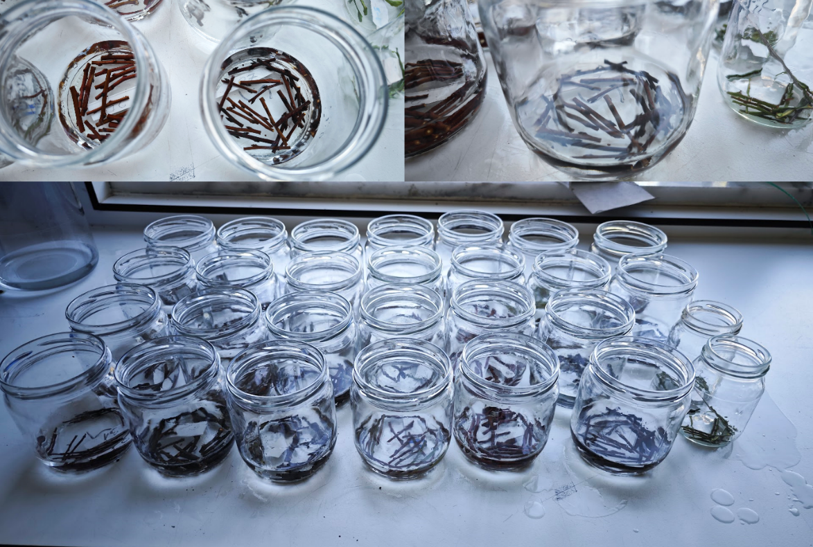
Figure 1. Micro cuttings that have been sterilized

3. METHOD
3.1. Initial Stage
The sterilized micro cuttings were cultured in a total of 1000 micro cuttings, with 50 genotypes and 20 micro cuttings from each genotype, in glass test tubes containing MS (Murashige and Skoog, 1962) medium. For 1 liter of solution, the following were added: MS medium (4.4 g), 1 ml BAP (Benzil Amino Purin), 0.1 ml IBA (Indole Butyric Acid), 1 ml PPM (Plant Protection Solution), 30 g sucrose, and 7 g agar. The prepared culture media were sterilized in an autoclave at 121 °C for 20 minutes. Micro cuttings were grown in a climate chamber at 25±1°C under conditions of 16 hours light/8 hours dark and light intensity set at 3000 lux for micro cutting development. The culture medium content was used in the initial stage for in vitro plant regeneration of genotypes and the establishment of an aseptic culture (Figure 2).
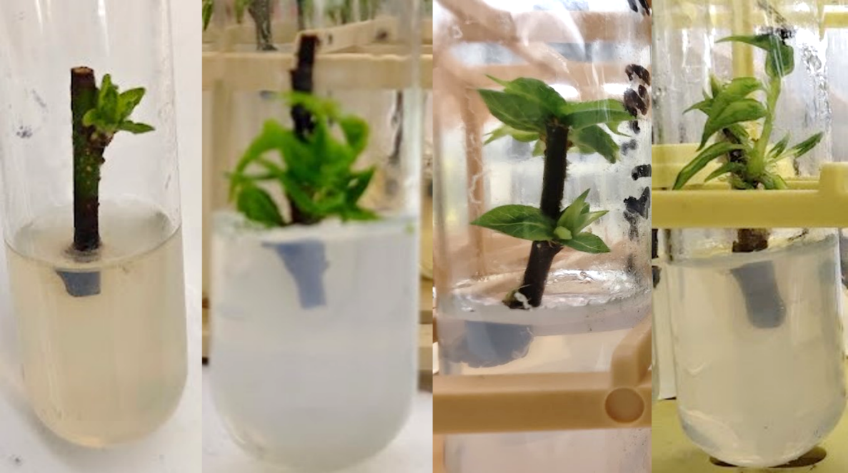
Figure 2. Micro cuttings forming shoots during the initial stage
3.2. Propagation Stage
Shoots from the surviving aseptic plants in the initial stage were cut with a scalpel and separated into individual plants. The plants were placed in MS (4.4 g) media supplemented with 4 different BAP (6-Benzilaminopurine) hormones (0.5, 1.0, 1.5, and 2.0 mg L⁻¹), 30 g L⁻¹ sucrose, and 1 ml PPM (Plant Protection Solution) were added, and the pH was adjusted to 5.8. Subsequently, 7 g of agar was added to the medium to solidify it. Subculturing was performed in a sterile cabinet, with the same procedures repeated in each subculture and subcultured every 40 days. After the initial stage, the surviving plants were transferred from glass test tubes to glass jars. Planting was carried out with 5 explants in each jar. After all planting procedures, the caps of the tubes and jars were closed and tightly wrapped with stretch film to prevent air from entering (Figure 3). The explants were grown in a climate chamber set at a temperature of 25±1ºC, 16 hours light/8 hours dark conditions, and a light intensity of 3000 lux for their development. At the end of the subculture, the surviving plants were measured individually and calculations were made based on their averages. The characteristics examined in the plants were calculated as follows, according to Özyalın et al. 2025.
Shoot length (cm): The length of the shoot was measured in centimeters using a ruler, from the lowest point of the stem to the tip of the uppermost leaf.
Number of shoots (number): The number of shoots formed per plant was determined.
Total number of leaves (number): All leaves per plant were counted and determined as a number.
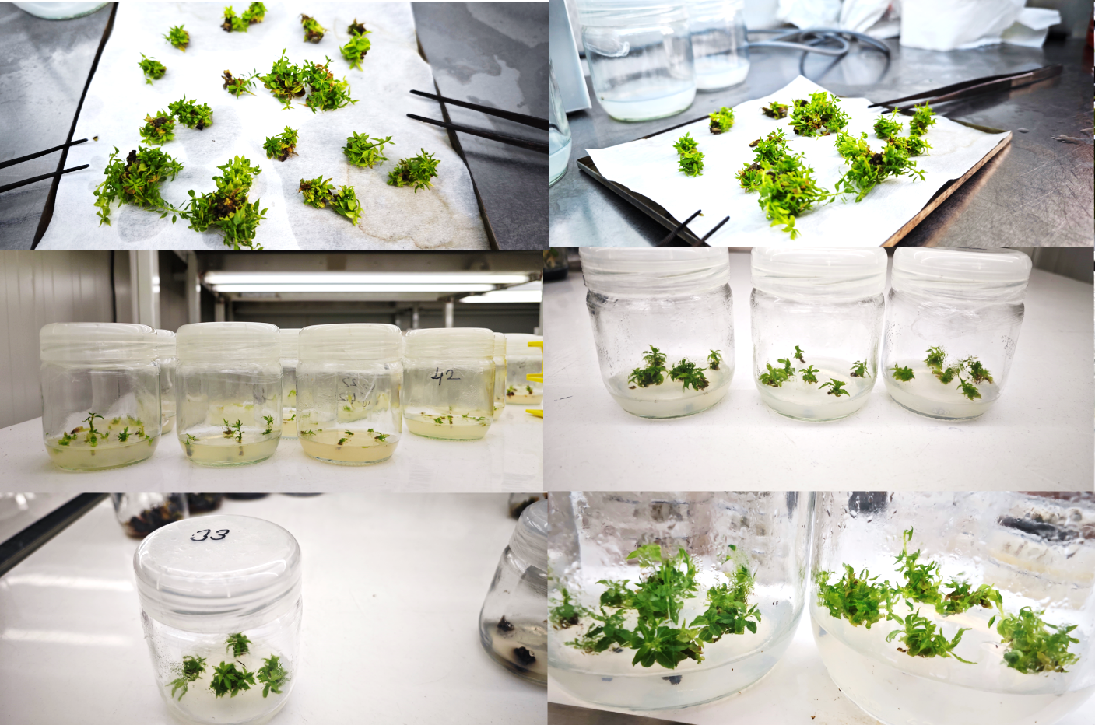
Figure 3. Images from the micropropagation stage
3.3. Rooting Stage
Shoots reaching a length of 2-3 cm were tested with 5 different concentrations of IBA (0.5, 1.0, 1.5, 2.0, and 2.5 mg L⁻¹ IBA) added to MS medium (4.4 g) to determine their rooting potential. The culture media were supplemented with 30 g L⁻¹sucrose and 1 ml PPM (Plant Protection Solution), and the pH was adjusted to 5.8. subsequently, 7 g agar was added to the medium to solidify it. The plants were left to root in a climate chamber at a temperature of 25±1ºC, under conditions of 16 hours of light/8 hours of darkness, and with a light intensity of 3000 lux (Figure 4). Measurements taken on rooted plants after 40 days:
Number of plants transferred to the rooting medium (number): Total number of plants transferred to the medium for each genotype
Number of rooted plants (number): This is the number of rooted plants that survived for each genotype.
Number of roots (number): Roots on shoots were counted individually.
Root length (mm): Determined by measuring the root lengths of rooted plants with a digital caliper and taking the average.
Rooting rate (%): This represents the ratio of the number of plants from each genotype placed in the rooting medium to the number of plants showing rooting after 40 days.
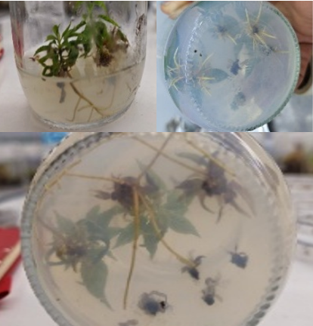
Figure 4. Images of rooted plants
3.4. Planting Stage in Trays
Plants that showed rooting success were carefully removed from the nutrient medium and cleaned with sterile water to remove residues. Very long and damaged roots were removed and cut from the plants. The planting process was carried out in trays containing a mixture of peat and vermiculite (1:1). The pots were placed in plastic boxes and covered with plastic bags to retain moisture. They were placed in a climate chamber set at 25 ºC with a photoperiod of 16 hours light/8 hours dark and a light intensity of 3000 lux. After approximately 10-15 days, the bags were removed to allow the plants to acclimate to natural conditions. The necessary sterilization of the vials and growth media was performed prior to the procedure.
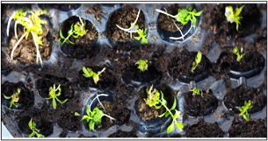
Figure 5. Plants planted in trays
3.5. Statistical Analyses
The experiment was conducted using a completely randomized plot design with three replications. Vials were used according to the number of propagated plants belonging to each genotype, with 5 plants per vial. Statistical evaluation of the obtained data was performed using the SAS software package (SAS, 2005), and differences between means were determined using the Duncan multiple comparison test at a 5% significance level. The relationships between rooting parameters were determined using Pearson correlation coefficients, and significance levels were evaluated as p<0.05 and p<0.01. Data expressed as percentages (%) were subjected to arcsin (√x) transformation. Transformed data were used in statistical analyses, and the original percentage values are shown in the tables.
4. results and discussion

4.1. Results of the Initial Stage
The initial phase was conducted to create an aseptic environment for the genotypes, resulting in significant losses in the number of micro-steel tubes belonging to the genotypes. In the initial phase, 50 genotypes x 20 micro cuttings, totaling 1000 micro cuttings, were inoculated into test tubes. The number of genotypes was later reduced from 50 to 12 (3, 4, 6, 9, 18, 26, 30, 33, 34, 42, 47, 49) due to losses. Plants belonging to 12 genotypes were transferred to the subculture medium (3, 4, 6, 9, 18, 26, 30, 33, 34, 42, 47, 49). At the end of the first subculture, only plants belonging to 6 genotypes (4, 9, 33, 42, 47, 49) survived. During the study period, plants belonging to 6 genotypes survived and studies continued on these genotypes. Micro cuttings belonging to genotypes that did not survive were removed from the experiment. (Trials will later be set up in different environments).
According to Samarfard et. al, (2025), the potential for propagation is directly related to the genotype, the type of explant used, and the in vitro culture conditions. Contaminants can cause decay in plants. Another factor is the source of the explant and the possibility of infection spreading through the air.
Many researchers have suggested that pathogenic microorganisms compete with the explant for nutrients on the culture medium. Therefore, in this competition process, slow growth of explants, necrosis in tissues, decreased tissue regeneration and rooting, or plant death occur (Nazary et al., 2012; Teixeira da Silva et al., 2016a).
Mihaljevic et al. (2013), determined that in order to solve the problems of plant losses in in vitro studies, it is important to determine an appropriate surface sterilization method that varies between species, the importance of determining the application times for different concentrations of chemicals, even within the same varieties of a single species, and that factors such as the season in which the explants were taken, the density and type of microorganisms found on the same explants but in different locations also contribute to these problems.
Explantations with undeveloped or small shoots have a lower chance of survival in ex vitro conditions, even if they are rooted (Quambusch et al., 2017).
In a study, Pakyürek and Hepaksoy (2019) tested seven different media at the initial and shoot multiplication stages and found that only S1 (MS + 1 mg L⁻¹ BAP + 0.1 mg L⁻¹ NAA) and S5 (MS + 1 mg L⁻¹ BAP + 0.5 mg L⁻¹ IBA + 0.25 mg L⁻¹ GA3) media.
Suprun et al. (2024) determined in their study that the active shoot growth period, in other words, shoots taken during the first and second weeks of May, showed the best performance in in vitro culture, with regeneration reaching 78.1-93.8% during this period.
The cuttings used in our study were taken in February, and it is thought that the cutting collection period affected the study results. It should be noted that the reasons for the rapid decline in the number of plants at the initial stage may include the inability of materials taken from natural habitats to adapt to a culture medium different from their living environment, the infection of susceptible genotypes despite careful sterilization, the amount and composition of hormones in the culture medium, and genotype specific characteristics.
4.2. Results of the Propagation Stage
The six surviving genotypes of healthy plants were transferred to four different propagation media (0.5, 1.0, 1.5, 2.0 mg/L⁻ ¹ BAP). Measurements were taken from the plants surviving at the end of the third subculture, and statistical analysis was applied to the average data. As a result of the variance analysis, the variations in the subcultures were calculated to be highly significant (p = 0.001). The results of the analyses showed that the number of shoots also varied according to the number of subcultures. The interaction between Genotype (p = 0.004) and Dose × Genotype (p = 0.009) was found to be significant, and the number of shoots also varied for each genotype in different environments, meaning that the hormone dose very sharply altered the number of shoots depending on the genotype. The interaction between Dose (p = 0.031) and Dose × Subculture (p = 0.021) was statistically significant, and both the dose alone and the Dose × Subculture interactions affected the number of shoots. The Genotype × Subculture (p = 0.013) value indicates that genotypes showed different results in each subculture. Increasing the BAP dose did not generally result in a significant increase in shoot number, and genotypes responded differently to BAP doses. This is supported by the significance level (p-value: 0.009**) for the interaction between dose and genotype. The F value (F = 21.44) for the subculture factor proves that time plays a critical role in development The adaptation of plants to the in vitro environment and their exposure to fresh nutrients in each subculture has enhanced their morphological responses. In particular, the highest number of shoots reached in the third subculture stage indicates that the proliferation capacity has stabilized over time. In plant tissue culture studies, regeneration capacity is largely dependent on the genetic background. In our study, the genotype factor was one of the most decisive elements among the sources of variation, with a high F value (F = 13.82). The SS value (Sum of Squares) of the genotype factor (4450.60) is much higher than the BAP Dose SS (Sum of Squares) value (1237.65). This proves that genetic structure is important in the shoot formation capacity of plants (Table 1).
Table 1. Interaction level of BAP doses, genotype, and subcultures on shoots
IBA Dose | 1. Variable | 2. Variable | (r) | p
0.5 mg/L⁻¹ | Subculture | Average shoot length (cm) | -0.42 | 0.402
 | Average number of shoot (number) | Average shoot length (cm) | -0.36 | 0.48
 | Average number of shoots (number) | Average number of leaves (number) | 0.41 | 0.419
 | Subculture | Average number of leaves (number) | 0.28 | 0.59
 | Average number of leaves (number) | Average shoot length (cm) | 0.71 | 0.110
 | Subculture | Average number of shoots (number) | 0.55 | 0.258
1.0 mg/L-1 | Subculture | Average number of shoots (number) | 0.65 | 0.162
 | Average number of shoots (number) | Average number of leaves (number) | 0.58 | 0.227
 | Subculture | Average number of leaves (number) | 0.45 | 0.371
 | Subculture | Average shoot length (cm) | 0.15 | 0.770
 | Average number of shoots (number) | Average shoot length (cm) | 0.11 | 0.830
 | Average number of leaves (number) | Average shoot length (cm) | 0.82 | 0.045*
1.5 mg/L⁻¹ | Subculture | Average shoot length (cm) | 0.82 | 0.045*
 | Average number of shoots | Average shoot length (cm) | 0.74 | 0.092
 | Average number of shoots (number) | Average number of leaves (number) | 0.86 | 0.028*
 | Subculture | Average number of leaves (number) | 0.89 | 0.017**
 | Subculture | Average number of shoots (number) | 0.78 | 0.067
 | Average number of leaves (number) | Average shoot length (cm) | 0.94 | 0.005**
2.0 mg/L⁻¹ | Subculture | Average shoot length (cm) | 0.61 | 0.202
 | Average number of shoots (number) | Average shoot length (cm) | -0.18 | 0.732
 | Average number of leaves (number) | Average shoot length (cm) | 0.91 | 0.011**
 | Subculture | Average number of shoots (number) | 0.52 | 0.290
 | Average number of leaves (number) | Average number of shoots (number) | 0.09 | 0.860
 | Subculture | Average number of leaves (number) | 0.43 | 0.395
Variation | (DF) | (SS) | (MS) | F | p
BAP Dose | 3.00 | 1237.65 | 412.55 | 6.41 | 0.031*
Genotype | 5.00 | 4450.60 | 890.12 | 13.82 | 0.004**
Subculture | 2.00 | 2691.20 | 1345.6 | 21.44 | 0.001***
Dose × Genotype | 15.00 | 4926.60 | 328.44 | 5.11 | 0.009**
Dose × Subculture | 6.00 | 3055.08 | 509.18 | 7.91 | 0.021*
Genotype × Subculture | 10.00 | 3897.50 | 389.75 | 6.05 | 0.013**
Error | 30.00 | 1930.50 | 64.35
Total | 71.00 | 22189.13 | - |  | 0.031*
*p <0.05; **p <0.01; ***p <0. 001.indicates D.F: Degree of freedom, S.S: Sum of squares, M.S: Mean of squares, r: Correlation coefficient
Genotype 47 showed higher shoot yield than other genotypes at all BAP doses. This may be due to differences in the internal hormone levels and sensitivity to cytokinins among genotypes. Genotypes with high regeneration capacity utilize hormones in the culture medium more effectively, leading to faster cell division within the tissue. The study observed an inverse relationship between shoot number (A.S.N) and shoot length (A.S.L). While shoot length remained short at the doses yielding the highest shoot number, the highest shoot length (Genotype 47; 4.97 cm) was recorded at the 2 mg/L⁻¹dose, where shoot number decreased. This situation is thought to be due to competition among existing shoots for nutrients and hormones when they are available, and in environments where fewer shoots are formed, the existing shoots access more nutrients and achieve growth in length. The average shoot number was 2, and genotype 49 was found to have the lowest shoot number in the 2 mg/L⁻¹ BAP medium. At the end of the third subculture, genotype 47 reached the highest number of plants (100) in a 1 mg/L⁻¹ BAP medium. In a 2 mg/L⁻¹ BAP medium, genotype 47 again stood out with a shoot length of 4.97 cm and 16 leaves. This genotype can be considered a priority genotype for in vitro propagation (Table 2).

Table 2. Parameters of shoots under different BAP doses
BAP Dose | Genotype No | At the end subculture of the 3rd | A.S.N  (number) | A.S.L (cm) | A.L.N  (number)
0.5 mg/L⁻¹ | 4 | 42 fg | 6bc | 2.00c | 12ef
 | 9 | 48ef | 4de | 1.15d | 13de
 | 33 | 35g | 5cd | 2.00c | 14cd
 | 42 | 71c | 6bc | 2.00c | 14cd
 | 47 | 95a | 7ab | 1.00d | 16a
 | 49 | 51e | 4de | 2.00c | 17a
1.0 mg/L⁻¹ | 4 | 30h | 8a | 3.00b | 12ef
 | 9 | 35g | 4de | 1.00d | 15bc
 | 33 | 50e | 6bc | 2.00c | 12ef
 | 42 | 80b | 8a | 1.50cd | 14cd
 | 47 | 100a | 7ab | 1.80 cd | 16a
 | 49 | 85b | 5cd | 2.43bc | 14cd
1.50 mg/L⁻¹ | 4 | 46ef | 6bc | 2.56bc | 11f
 | 9 | 56d | 4de | 3.18b | 13th
 | 33 | 55d | 4 | 2.95b | 11f
 | 42 | 68c | 5cd | 3.45b | 12ef
 | 47 | 86b | 7ab | 4.10a | 15bc
 | 49 | 66cd | 9a | 2.95b | 13de
2.0 mg/L⁻¹ | 4 | 35g | 5 cd | 1.68 cd | 12ef
 | 9 | 42fg | 4de | 2.49bc | 10g
 | 33 | 43fg | 3e | 4.56a | 11f
 | 42 | 70c | 5cd | 3.70a | 14cd
 | 47 | 65d | 6bc | 4.97a | 16a
 | 49 | 54d | 2f | 2.88b | 12ef
p <0.05: There is no statistically significant difference between means indicated by the same letter in the same column A.S.N: Average number of shoots, A.S.L: Average shoot length, A.L.N: Average number of leaves
The parameters related to shoot development were evaluated based on the BAP doses using general averages. The results obtained showed that BAP doses did not have a statistically significant effect on the average shoot number (A.S.N) and average leaf number (A.L.N), but had a significant effect on the average shoot length (A.S.L). The lack of a significant increase in shoot number with increasing BAP dose suggests that the hormone dose may promote shoot elongation while only slightly affecting shoot formation. Similarly, the lack of effect of BAP doses on leaf number indicates that leaf formation is largely controlled by genotypic structure or other components in the culture medium. The significant increase in average shoot length with increasing BAP doses indicates that hormones play an important role in cell division and elongation. The highest shoot length obtained at a BAP dose of. 2.0 mg L⁻¹ suggests that this dose is more effective; however, the fact that the values obtained at lower doses also fall within the intermediate groups suggests that the optimal BAP dose may vary depending on environmental conditions and genotype (Table 3).
Overall, the results obtained reveal that BAP doses play a decisive role in shoot length. Therefore, it can be said that in determining the BAP dose in in vitro propagation protocols, not only the number of shoots but also the quality and length of the shoots should be taken into account.

Table 3. Parameters related to shoot characteristics based on the general averages of different BAP doses
BAP Concentration (mg/L⁻¹) | A.S.N/(Mean ± SE) | α = 0.05 | A.S.L/(Mean±SE) | α = 0.05 | A.L.N/(Mean±SE) | α = 0.05
0.5 mg/L⁻¹ | 5.33 ± 0.33 | a | 1.69 ± 0.18 | c | 14.33 ± 0.76 | a
1.0 mg/L⁻¹ | 6.33 ± 0.61 | a | 1.96 ± 0.28 | bc | 13.83 ± 0.60 | a
1.5 mg/L⁻¹ | 5.83 ± 0.60 | a | 3.03 ± 0.24 | ab | 12.50 ± 0.56 | a
2.0 mg/L⁻¹ | 4.17 ± 0.48 | a | 3.71 ± 0.55 | a | 12.50 ± 0.96 | a
p <0.05: There is no statistically significant difference between the means indicated by the same letter in the same column. A.S.N: Average number of shoots, A.S.L: Average shoot length, A.L.N: Average number of leaves, S.E: Standard error
Erbenova et al. (2001) reported that the branching rate of dwarf Prunus rootstocks increased by 50% in MS culture medium containing 1.5 mg ^{L⁻¹} BAP.
Silveira, (2001) tested four different concentrations of BAP (0.1, 0.3, 0.5, and 0.7 mg ^{L⁻¹}) to propagate some stone fruit rootstocks in vitro. The study used GxN-22, GF-677, Mr. S 2/5, Marianna, and Myrobolan 29C plum rootstocks as plant material. They reported that the Myrobolan 29C rootstock was more successful with 0.5 mg ^{L⁻¹} BAP.
Bhojwani and Razdan, (2005); Eed et al., (2010); Teixeira da Silva et al. (2016b), stated that tissues may be damaged when shoots are cut during transfer, which may negatively affect propagation results.
Arıcı, (2008) reported that the differences observed in shoot formation in stone fruit rootstocks may be due to different hormones present in the plant itself.
Güney, (2019) conducted experiments with 1, 1.5, and 2 mg/L⁻¹BAP medium during the propagation stage of the Myrobolan 29C rootstock and found no significant difference in the average number of shoots, calculating 9.0, 7.6, and 9.0 shoots, respectively, and that the average shoot length was 1.1 cm in the medium containing 1.0 mg/L^{–1} BAP, and the shoot number ratio reached 84.4% at an average BAP concentration of 1.5 mg/L^{–1}.
Zenna, (2020a) used four different BAP concentrations (0.5, 1.0, 1.5, and 2.0) mg/L⁻¹ in an in vitro environment for P. cerasifera Ehrh. They reported that 1.5 mg/L⁻¹ BAP medium achieved 100% shoot success after three subcultures, and the longest shoots (1.92 cm) were detected at a 1.5 mg/L⁻¹ BAP dose.
Aydın and Yarılgaç, (2020), In their study titled Propagation of cherry and sour cherry genotypes using tissue culture methods, obtained the highest number of shoots from the 08 K 056 genotype at a BAP dose of 1 mg/L⁻¹ BAP dose, while the 52 K 063 and 55 K 104 genotypes produced the lowest number of shoots at a 0 mg/L⁻¹ BAP dose. They found that the shoot number increased with increasing BAP concentration.
Ak et al. (2021), investigated the in vitro development of shoot tip and nodal explants of Garnem (peach rootstock). In the study, the highest shoot number and proliferation rate were observed in nodal explants cultured in MS medium containing 2.0 mg ^{L⁻¹}BAP.
The reasons why the data obtained in the study did not reach the desired level may be due to damage occurring during the cutting stage, the hormone content of the environment, genotype-specific characteristics, and pathogens.
4.3. Results of the Rooting Stage
Six healthy plants belonging to genotypes that survived the propagation stage were transferred to a rooting medium containing 5 different IBA doses (0.5, 1.0, 1.5, 2.0, 2.5 mg/L⁻¹). At the end of 40 days, parameters related to the average number of rooted plants, number of roots, and root length (p<0.05) were examined according to their level of significance. A significant difference was found between the number of rooted plants and root length, and this difference was found to be related to genotype. At a 1 mg/L⁻¹ IBA dose, a positive correlation was calculated between Root Length and Rooting Rate (r = 0.7452; p <0.001). This proves that at this dose, as the rooting percentage increases, the roots also grow significantly longer. A negative relationship was found between Root Number and Root Length at different IBA doses (e.g., r = -0.5447 at 1 mg/L⁻¹). This result indicates that when the plant expends its energy on forming numerous roots, the roots remain shorter. The 1.5 mg/L⁻¹ IBA dose stands out as the most stable and meaningful dose in terms of its effect on root length and rooting rate (Table 4).
Table 4. Parameters of shoot traits based on overall means under different BAP doses
IBA Dose | 1. Variable | 2. Variable | (r) | (p)
0.5 mg/L⁻¹ | Root Count (number) | Rooting Rate (%) | -0.4212 | 0.3978
 | Root Length (cm) | Rooting Rate (%) | -0.5845 | 0.2231
 | Root Length (cm) | Root Count (number) | 0.7412 | 0.0421*
1 mg/L⁻¹ | Number of Roots (pieces) | Rooting Rate (%) | -0.1812 | 0.4717
 | Root Length (cm) | Rooting Rate (%) | 0.7452 | 0.0004*
 | Root Length (cm) | Root Count (number) | -0.5447 | 0.0194
1.5 mg/L⁻¹ | Root Count (number) | Rooting Rate (%) | 0.3241 | 0.531
 | Root Length (cm) | Rooting Rate (%) | 0.8122 | 0.0142*
 | Root Length (cm) | Root Count (number) | -0.1254 | 0.8128
2 mg/L⁻¹ | Number of Roots (units) | Rooting Rate (%) | -0.57 | 0.23
 | Root Length (cm) | Rooting Rate (%) | 0.64 | 0.17
 | Root Length (cm) | Number of Roots (units) | 0.39 | 0.44
2.5 mg/L⁻¹ | Number of Roots (units) | Rooting Rate (%) | -0.2145 | 0.6832
 | Root Length (cm) | Rooting Rate (%) | 0.5512 | 0.2568
 | Root Length (cm) | Root Count (number) | -0.6122 | 0.0492*
Variations | (FD) | (SS) | (MS) | F | p
IBA Dose (A) | 4 | 557.21 | 139.3 | 5.46 | 0.004**
Genotype (B) | 5 | 328.15 | 65.63 | 2.57 | 0.049*
A X B | 20 | 2544.12 | 127.21 | 4.98 | 0.001***
Total | 29 | 3429.48
*p <0.05; **p <0.01; ***p <0.001. F.D:Degrees of freedom, S.S:Sum of squares, M.S:Mean square, r:Correlation coefficient
The highest rooting percentage was obtained at an IBA dose of 2.0 mg/L⁻¹ in genotype 42 (88.71%) and at a dose of 1.5 mg/L⁻¹ in genotype 4 (84.00%). These two genotypes yielded the most statistically successful results. The highest number of roots was calculated in genotype 9 (6 roots) at an IBA dose of 2.5 mg/L⁻¹. In general, an increase in root number (from 3.00 to 6.00) was observed as the dose increased. The highest data for root length of genotypes occurred in environments containing 2.0 and 2.5 mg/L⁻¹ IBA doses. Genotypes 42 and 49 formed the longest roots, exceeding 6 cm at 2.0-2.5 mg/L⁻¹ doses It is thought that the rooting success of the genotypes used in the study may be directly attributable to the characteristics of the genotype itself. To obtain a clear idea, these genotypes need to be tested with different hormone combinations and nutrient media. Statistical analysis conducted to determine the difference between doses based on the average values covering all genotypes for each IBA dose revealed that the highest rooting rate of 68% was calculated in the medium supplemented with 1.5 mg and 2 mg/L⁻ ¹ IBA. The 2.5 mg/L⁻¹ IBA dose produced the highest number of roots and root length (Table 5).
Table 5. The effect of IBA doses on the rooting ability of genotypes
IBA Dose (mg/L⁻¹ ) | Genotype No | Rooting Rate (%) ± S. E | Root number of shoots (number)±S. E | Root Length (cm) ±S. E
0.5 mg/L⁻¹ | 4 | 65.00 cd | 3.60 ef | 4.20 gh
 | 9 | 63.00 d | 4.00 de | 4.90 ef
 | 33 | 76.00 abc | 3.70 e | 5.30 cd
 | 42 | 49.00 fg | 4.00 de | 6.00 ab
 | 47 | 52.00 ef | 4.50 cd | 4.60 fg
 | 49 | 55.00 e | 3.00 f | 5.10 de
1.0 mg/L⁻¹ | 4 | 70.00 bc | 3.20 f | 5.20 de
 | 9 | 57.14 e | 5.20 ab | 4.19 h
 | 33 | 72.22 bc | 4.19 d | 5.20 de
 | 42 | 70.00 bc | 5.19 ab | 3.19 i
 | 47 | 37.24 h | 4.20 d | 5.19 de
 | 49 | 40.61 gh | 5.20 ab | 6.20 a
1.5 mg/L⁻¹ | 4 | 84.00 a | 5.00 b | 5.40 c
 | 9 | 65.00 cd | 5.20 ab | 3.90 h
 | 33 | 51.00 ef | 5.00 b | 3.47 i
 | 42 | 68.00 bc | 5.40 a | 4.80 f
 | 47 | 75.00 abc | 4.70 c | 5.60 bc
 | 49 | 69.00 bc | 5.00 b | 4.30 gh
2.0 mg/L⁻¹ | 4 | 45.16 g | 5.00 b | 5.19 de
 | 9 | 65.52 cd | 4.00 de | 4.20 gh
 | 33 | 56.25 e | 5.00 b | 6.19 a
 | 42 | 88.71 a | 4.00 de | 5.00 de
 | 47 | 81.01 ab | 4.00 de | 6.00 ab
 | 49 | 75.00 abc | 5.00 b | 6.19 a
2.5 mg/L⁻¹ | 4 | 59.00 de | 5.50 a | 4.85 ef
 | 9 | 55.00 e | 6.00 a | 5.96 ab
 | 33 | 78.00 ab | 5.10 ab | 5.18 de
 | 42 | 69.00 bc | 4.70 c | 6.25 a
 | 47 | 75.00 abc | 5.20 ab | 6.13 a
 | 49 | 59.00 de | 3.90 e | 5.20 de
IBA Dose (mg/L⁻¹ ) | Rooting Rate (%) ± S. E | Root number of shoots (number)±S. E | Root Length (cm) ±S. E
0.5 mg/L⁻¹ | 60.00 ± 4.05b | 3.80 ± 0.21c | 5.02 ± 0.26bc
1.0 mg/L⁻¹ | 57.87 ± 6.30b | 4.53 ± 0.33b | 4.86 ±0.44c
1.5 mg/L⁻¹ | 68.67 ± 4.42a | 5.05 ± 0.09a | 4.58 ± 0.34c
2.0 mg/L⁻¹ | 68.61 ± 6.48a | 4.50 ± 0.22b | 5.46 ±0.33ab
2.5 mg/L⁻¹ | 65.83 ±3.75ab | 5.07 ± 0.28a | 5.59 ±0.24a
p <0.05: Differences between means indicated by the same letter in the same column are not statistically significant. S.E.: Standard error
Shabani et al. (2019) reported that the optimal BAP and NAA concentrations for rooting Myrobolan 29C were 2 and 1 mg/L⁻¹, respectively, and did not recommend higher concentrations of 2 mg/L⁻¹ BAP and NAA. They noted that rooting is related to the plant's own metabolism.
Zenna, (2020b), stated in their study that a 0.4 mg/L⁻¹ IBA dose achieved 100% rooting in shoots of P. cerasifera Ehrh. genotypes.
Can, (2025), used 1.0 mg L⁻¹, 2.0 mg L⁻¹, and 4.0 mg L⁻¹doses of IBA hormone in rooting media for the micropropagation of nodal explants (MS) of the Myrobolan 29C rootstock. They reported that the best rooting rate was achieved with the combination of MS + 2.0 mg L⁻¹ IBA.
Baziuk and Kobyletska, (2025) examined the rooting performance of the hybrid plum rootstock 'Wavit' (P. cerasifera × P. spinosa) under in vitro conditions in their study. Using data obtained during the rooting phase, they noted that an increase in IBA concentration (1.0, 1.25, 1.5 mg/L⁻¹) led to an increase in root number, but as the IBA dose increased, shoot length decreased.
As is well known, rooting woody plants in vitro is difficult. As evidenced by studies conducted by many researchers, each genotype has its own specific environmental requirements, and rooting is influenced by numerous factors. The species used, the source of the material, the time and season of introduction into the in vitro environment, the part of the material (shoot tip, node, root, leaf, etc.), and in vitro conditions such as humidity, light, temperature, sterilization, hormones, and dosage all significantly influence the success of the study.

5. Conclusion

It is important that genotypes suitable for use as rootstocks can be propagated under in vitro conditions. Since in vitro studies offer advantages such as the ability to obtain disease free plants and the rapid production of a large number of plants even for types where rooting success cannot be achieved via cuttings these methods have become extremely widespread. In our study investigating the in vitro propagation and rooting potential of wild plum genotypes obtained through selection;
The results obtained based on overall averages indicate that BAP doses did not have a statistically significant effect on the average number of shoots or the average number of leaves, but did have a noticeable effect on average shoot length. The fact that no significant increase in shoot number was observed with increasing BAP doses suggests that while the hormone dose may promote shoot elongation, it may only have a limited effect on shoot formation. Similarly, the lack of effect of BAP doses on leaf number indicates that leaf formation is largely controlled by genotypic factors or other components in the culture medium. The significant increase in average shoot length with increasing BAP doses demonstrates that hormones play a significant role in cell division and elongation. Overall, the results indicate that BAP doses play a decisive role in shoot length. Therefore, it can be concluded that when determining BAP doses in in vitro propagation protocols, not only the number of shoots but also shoot quality and length should be taken into account. During the propagation phase, plant growth regulators were seen to have a positive effect on the shoot formation ability of the genotypes. However, considering that different concentrations may yield better results in the production phase, trials with different concentrations should also be considered.
The rooting rate is a very important indicator for rootstock selection, but it is not the only one. Shoot formation and shoot vigor are also important indicators that must be considered. Plants with a root and shoot count below 30% and those with weak shoot formation should be excluded from the trial. Otherwise, they will offer no commercial advantage in terms of production. However, these genotypes should be examined in detail through separate trials. Better results can be achieved by applying other techniques. While rooting success is largely associated with the genotype on a large scale, it is also influenced by numerous factors, including hormones prepared for the plant’s growth environment, sterilization procedures, the plant’s size and type, light, temperature, and pH. The study has demonstrated that tissue culture protocols cannot be standardized, as genotypes respond differently to hormone doses. It should also be noted that characteristics such as the study area, population size, number of species and genotypes, and the number of parameters examined can alter correlations and variations.
The P. cerasifera species is significant because of the strong adaptability of its plums, the economic viability of its cultivation compared to other species, its high tolerance to biotic and abiotic environmental conditions, and its preference as a rootstock. Therefore, it is crucial to protect the natural habitats of these genetic resources to prevent the loss of populations. Investigating the compatibility of successfully propagated genotypes with popular varieties in the coming years is important both for obtaining new materials for breeding programs and for the conservation of genetic resources.
Disclaimer (Artificial intelligence)
Author(s) hereby declare that NO generative AI technologies such as Large Language Models (ChatGPT, COPILOT, etc.) and text-to-image generators have been used during the writing or editing of this manuscript.

References

Ak, B. E., Kıyar, P. K., Hatipoglu, I., & Dikmetaş, H. (2021). Effects of different BA and IBA concentrations on proliferation and rooting of ‘Garnem’ rootstock in vitro propagation. International Journal of Agriculture Environment and Food Sciences 5(4), p.470-476.
Aka Kaçar, Y., Yılmaz, A., Mendi, Y., Küden, A. & Çetiner, S. (2001). Effects of different solidifying agents and different pH levels used in in vitro nutrient media on the propagation of some cherry (P. avium L.) rootstocks. I. Stone Fruits Symposium. September 25-28. Yalova.
Arıcı, Ş. E. (2008). Propagation of some stone fruit rootstocks by tissue culture. Journal of the Faculty of Agriculture. 3(1).19-23.
Ayanoğlu, H., Bayazit, S., Inan, G., Bakır, M., Akpınar, A.E., Kazan, K., & Ergül, A. (2007). AFLP analysis of genetic diversity in Turkish green plum accessions (P. cerasifera Ehrh.) adapted to the Mediterranean region. Scientia Horticulturae. 114(4): 263–267.
Aydın, E. & Yarılgaç, T. (2020). Propagation of cherry and sour cherry rootstock candidates using tissue culture methods.Akademik Ziraat Dergisi. 9(2). 171-180
Baziuk, S. & Kobyletska, M. (2025). Micropropagation of Plum rootstock (P. domestica L.) of ‘Wavit’ variety. Studia Biologica. 19(1). 103–114 doi:10.30970/sbi.1901.805
Bhojwani, S. S. & Razdan, M. K. (2005). Plant tissue culture: theory and practice. Elsevier. New Delhi. India: 30-35
Bolat, I., Ak, B.E., Acar, I., & İkinci, A. (2017). Plum culture in Turkey. Acta Horticulturae. 1175. 15–18
Can, L. (2025). Investigation of the effects of different nutrition media on the in vitro micropropagation of Myrobolan 29C rootstock. (Master thesis) Selçuk University, Institute of Natural Sciences, Department of Horticulture February-2025 Konya
Crane, M. & Lawrence, W. (1952). The genetics of garden plants, Macmillan, London, UK.
Çakır, G., Taşcıoğlu, T., Çavdar, A., & Doğanlar, S. (2021). Molecular genetic characterization of the Turkish national green plum (P. cerasifera Ehrh.) collection. Anadolu Ege Agricultural Research Institute Journal. 31(1). 61-73. https://doi.org/10.18615/anadolu.950008
Davis, P.H. (1972). Flora of Turkey and East Aegean Islands, Vol:4. Edinburgh University Press. Edinburgh.
Ekinci, H., Saskin, N., Ak, B. E., & Dogan, B. D. (2024). Effects of different healing agents on acclimatization success of in vitro rooted Garnem (P. dulcis× P. persica) rootstock. In vitro cellular. Developmental Biology-Plant. 1-9.
Erbenova, M., Paprstein, F., & Seldak, J. (2001). In vitro propagation of dwarfed rootstocks for sweet cherry. Acta Horticulture 560: 477-480
Faust, M. & Suranyi, D. (1999). Origin and dissemination of plums. Horticultural Review, 23: 179–231.
Güney, M. (2019). Development of an in vitro micropropagation protocol for Myrobolan 29C rootstock. Turkish Journal of Agriculture and Forestry: Vol. 43: No. 6. Article 7.https://doi.org/10.3906/tar-1903-4
Hazarika, B. N., Teixeira da Silva, J. A., & Talukdar, A. (2006). Effective acclimatization of in vitro-cultured plants: methods, physiology, and genetics. Floriculture, Ornamental and Plant Biotechnology Volume II. 2006. Global Science Books, UK
Horvath, A., Christmann, H., & Laigret, F. (2008). Genetic diversity and relationships among P. cerasifera (cherry plum) clones. Botany. 86. 1311-1318. 10.1139/B08-097. 2008.
Kazemia, F. & Mohorko, R. (2017). Review on the roles and effects of growing media on plant performance in green roofs in world climates. Urban Forestry & Urban Greening. 23. 13–26.doi: 10.1016/j.ufug.2017.02.006
Mihaljevic, I., Dugalić, K., Tomaš, V., Viljevac, M., Pranjić, A., Čmelik, Z., Puškar, B., & Jurković, Z. (2013). In vitro sterilization procedures for micropropagation of 'Oblačinska' Sour Cherry. Journal of Agricultural Sciences 58: 117- 126.2013
Moreno, M.A. (2004). Breeding and selection of P. rootstocks at the Aula deı Experimental Station. Zaragoza, Spain. Acta Hortic. 658. 519-528 DOI: 10.17660/Actahortic.2004.658.79 https://doi.org/10.17660/ActaHortic.2004.658.79
Murashige, T. & Skoog, F. A. (1962). Revised medium for rapid growth and bioassays with tobacco tissue cultures.Physiologia Plantarum. 1962. № 15. P. 473-497.
Natalchuk, T., Medvedieva, T., Yaremko, N.O., & Udovychenko, K. (2024). Rhizogenic activity and adaptation potential of P. cerasus L. 'Ksenia' in vitro and ex vitro. S08: Genetic resources in horticulture: screening, propagation, use, and conservation. Bucharest, Romania. EHC2024, MAY 13-16
Nazary, R., Aghaye, M., & Yadollahi, A. (2012). Micropropagation of GF 677 rootstock. Journal of Agricultural Science. 4.10.5539/Jas. V4n5p131.
Özyalın, S., Yaman, C., & Balcı, G. (2025). Effect of Gibberellic Acid (GA3) on plant growth in micropropagation of raspberry (Rubus idaeus L. cv. Ruby). Journal of Agriculture Faculty of Ege University, 62(2), 259-267. https://doi.org/10.20289/zfdergi.1456285
Pakyürek, M. & Hepaksoy, S. (2019). In vitro propagation of Weiroot 158. Ejons International Journal on Mathematics Engineering & Natural Sciences 108-118.
Pospíšilová, J., Tichá, I., Kadleček, P., Haisel, D., & Plzáková, Š. (1999). Acclimatization of micropropagated plants to ex vitro conditions. Biologia Plantarum. 42(4). 481–497. doi:10.1023/a:1002688208758
Quambusch, M., Gruß, S., Pscherer, T., Winkelmann, T., & Bartsch, M. (2017). Improved in vitro rooting of Prunus avium microshoots using a dark treatment and an auxin pulse. Scientia Horticulturae. 220. 52–56. doi: 10.1016/j.scienta.2017.03.020
Reig, G., Carolina, F., Forcada, L., Mestre, J., Betrán, A., & Moreno, M. (2018). Potential of new P. cerasifera-based rootstocks for adapting under heavy and calcareous soil conditions. Scientia Horticulturae, Volume 234.2018. Pages 193–200. ISSN 0304-4238. https://doi.org/10.1016/J.Scienta.2018.02.037
Reynders, S. & Salesses, G. (1991). Study on the relationships within the subgenus Prunophora, Restriction maps of the ribosomal genes in P. cerasifera and P. spinosa. Cta Hort. 283: 27-29.10.17660/ActaHortic.1990.283.1.
Samarfard, S., Kadir, M. A., Kadzimin, S. B., Saud, H. M., Ravanfar, S. A., & Danaee, M. (2025). In vitro propagation and detection of somaclonal variation in Phalaenopsis gigantea as affected by chitosan and thidiazuron combinations. HortScience horts,49(1), 82-88. https://doi.org/10.21273/HORTSCI.49.1.82 .2025.
SAS Institute, (2005). STAT Guide for Personal Computers. Version 9.1.3. SAS Institute, North Carolina, USA
Silveira, A. C. P. (2001). In vitro multiplication of rootstocks of the genus Prunus under different BAP concentrations in two culture media. Rev. Bras. Frutic. 23(3), 488–492. 2001
Shabani, Z., Abedi, B., Ganji, M. E., & Tehranifar, A. (2019). In vitro mass propagation of ‘Myrobalan29C’ (P. cerasifera Ehrh.): a vegetative rootstock for stone fruits. Journal of Plant Production Research, 26(3), 167-177. doi: 10.22069/jopp.2019.15507.2394
Suprun, I.I., Amosova, M.A., Egorova, O.V., Lobodina, E.V., & Avakimyan, A.O. (2024). Features of clonal micropropagation of plum PK SK 1 clonal rootstock. Horticulture And Viticulture. 2024;(2):5-12. (In Russ.) https://doi.org/10.31676/0235-2591-2024-2-5-12
Teixeira da Silva, J.A., Kulus, D., Xinhua, Z., Zeng, S., Guohua, M., & Piqueras, A. (2016). Disinfection of explants for saffron (Crocus sativus L.) tissue culture. Environ Exp Biol 14(4):183–198DOI: 10.22364/eeb.14.25
Zenna, F. (2020). An efficient protocol for in vitro propagation of purple-leaf plum (P. cerasifera). Egyptian Journal of Agricultural Research. 98(3). 435-451. doi: 10.21608/ejar.2020.129814
Zohary, D. (1992). Is The European Plum, Prunus domestica L. Prunus cerasifera Ehrh. XP. spinosa L. Allo-Polyploidi. Euphytica 60, 75–77 (1992). https://Doi.Org/10.1007/BF00022260
Zhebentyayeva, T., Shankar, V., Scorza, R., Callahan, A., Ravelonandro, M., Castro, S., DeJong, T., Saski, C.A., & Dardick, C. (2019). Genetic characterization of worldwide Prunus domestica (plum) germplasm using sequence-based genotyping. Hortic Res 6, 12 (2019). https://doi.org/10.1038/s41438-018-0090-6

