Original Research Article

Livelihood Diversification and Income Structure of Forest Adjacent Villages of The Western Himalayas (India)

Abstract
Rural livelihoods in the Western Himalayas are influenced by fragile agro-ecological conditions, proximity to forest resources, and limited economic alternatives. Increasingly, it is becoming insufficient for rural families to rely solely on agricultural production (which depends exclusively on rainfall) to maintain an adequate level of income security. This paper looks at the overall structure of household livelihoods and how income diversification has allowed rural families living in forest adjacent villages within Chakrata Block, Uttarakhand to build successful, sustainable livelihoods.Primary data was collected from 173 households from a randomly selected sample of 10 villages using a structured household survey. A cross-sectional descriptive research design was adopted for the analysis. Descriptive statistics and comparative cross-tabulation were used for data analysis. Results show that agriculture remains the most important livelihood activity for families. However, families that combine agricultural activity with paid employment in the form of a salary; number of livestock owned; and involvement in agroforestry consistently have higher incomes than families that do not diversify their incomes. As such, income diversification is a critical risk-buffering mechanism within rain-fed rural systems of the Himalayas.Findings support the need for integrated rural development policy that strengthen agricultural production systems; but at the same time develop alternative sources of income to improve resilient livelihoods and diminish reliance on forest-based resources.
Keyword: Livelihood Diversification, Forest Fringe Villages, Income Structure, Agroforestry, Western Himalaya.
1. Introduction
Mountain communities have limited means to support themselves from their own resources. For example, the communities bordering forests in the major regions of the Indian Himalaya rely on a mix of agricultural production (e.g., rice) and livestock rearing (e.g., goats) along with revenue generated from off-farm employment (e.g., migratory work). A large share of Indian agriculture is rain-fed and therefore inherently vulnerable to intra-seasonal variability; targeted climate-resilient practices, village contingency plans and capacity building have been shown to reduce production risk and enhance adaptive capacity (Gajjala et al. 2022).

Rural household diversification, defined as having multiple sources of income, has thus become a key adaptive strategy in both rural and adjacent forest communities. While this is typically seen as an unstable condition, multiple sources of income often represent intentional efforts to respond to economic and environmental risk (Ellis, 2000). Households in mountain regions have diversified themselves through short- and long-term wage labour, full-time jobs, raising livestock and practicing agroforestry to reduce agricultural risk and/or income variability. Evidence shows that rural non-farm employment and diversified income portfolios have the potential to reduce rural poverty and vulnerability, and act as key pathways for structural mobility in India (Pattayat et al. 2022).
The importance of forest-fringe villages in terms of the research of livelihood is evident because household income strategies affect both socio-economic and forest resource usage. Diversified livelihoods have been found to help reduce over dependency on forests and to promote stability of incomes (Angelsen et al., 2014). Although several studies have examined livelihood diversification in Himalayan regions, micro-level empirical analyses focusing specifically on forest-fringe villages of Chakrata Block remain limited (Himanshu et al., 2018; Mondal et al., 2023). Integrated agroforestry systems increase on-farm productivity, water use efficiency and can deliver income co-benefits, particularly under marginal or rain-fed conditions (Rathore et al., 2022).
Analysis is provided on the linkages of income, occupation, ownership of livestock and use of agroforestry which will provide information useful in rural development planning related to forests in mountainous regions.
2. Objectives of the Study
2.1 General Objective
To assess livelihood structure and income distribution among rural households in forest-fringe villages of Chakrata Block, Uttarakhand.
2.2 Specific Objectives
- To analyse the demographic and occupational characteristics of rural households in the study area.
- To examine household income distribution across different income classes.
- To assess the relationship between income levels and occupational diversification.
- To evaluate the role of livestock ownership in household income stability.
- To analyse the association between agroforestry adoption (trees on farms) and household income levels.
3. Methodology
3.1 Study Area
The research was carried out within the northwestern part of Chakrata Block in Dehradun District, Uttarakhand. It has a mountainous terrain, dense forest cover, and mostly is populated by tribes. The majority of agricultural production is based on rainfed methods; irrigation systems are not widely available; and the majority of villages are adjacent to both reserve and community forests. People rely on agriculture, animal husbandry, and some additional non-farm jobs to support their families.
3.2 Research Design
A cross-sectional descriptive study was used for describing the socio-economic and livelihood condition of the families living in the Villages at a single point in time. Cross-sectional descriptive studies are very common in research about rural livelihood and those living on the edge of forests to help understand income structure and types of jobs people do, as well as how people use their livelihoods from resources without changing any variables being studied.
3.3 Sampling Framework & Determining the Villages
A complete list of villages and their location within the northwest section of Chakrata Block, using the Census of India, was prepared. From this sampling frame, ten villages were chosen at random, using simple random sampling, giving each village within Chakrata Block the same chance of being chosen. Randomly selecting villages increases the representativity of the selected sample, which should increase the generalizability of results at the block level.
3.4 Sample Size Determination
A sample of households was determined by using Yamane's (1967) finite population formula with a confidence level of 95%, which gives a margin of error of 8%. Using the population data from the Census 2011, the minimum needed sample size was calculated to be 153 households. Due to population growth from the time of the census and to maximise the statistical reliability of this research, the sample size used in the final analysis was increased to 173 households.
3.5 Selection of Households
From each sample village, households were chosen using a proportional-selection method based on the population of each village. Households were then randomly sampled from an updated list of households living in each village. The interview was conducted with the head of the household or an adult member of the household who is currently working in a livelihood activity.
3.6 Data Collection
Primary data were collected using a structured questionnaire with face-to-face interviews with household members. The objectives of the questionnaire were to gather data on demographic characteristics of households, one another, occupational composition of household members, income, number of livestock owned by the household, and practices of households around agroforestry. The use of face-to-face interviews provided a means of validating collected data and reducing potential error when collecting data in areas with different levels of literacy.
In addition, secondary data were obtained from Census of India publications and from relevant peer-reviewed publications to place primary data into context.
3.7 Analysis of Data Collected
The collected data was coded, tabulated, and analyzed through descriptive statistical methods. To analyze income distribution by type of employment, livestock owned, and usage of agroforestry were then computed using frequencies, percentages, and cross-tabulations, and reported in the form of tables and graphs to make them easier to interpret than if they had been presented differently.
4. Results (Table & Graphs)
4.1 Income Structure of Surveyed Households
Analysis of income distribution (Table 1; Figure 1) indicates that the majority of households (108 out of 173) fall within the 20–50 lakh annual income category. A smaller proportion (50 households) fall in the <20 lakh income group, while 15 households belong to the 50–80 lakh category.
The income model based upon this analysis points to most households being classified as lower middle income and not extremely poor, thus indicating relative stability of household income within the sample area, likely facilitated through income diversification strategies that extend beyond self-employment through agriculture.
Table 1. Income class distribution of surveyed households
Income class | Number of households
<20 lakh | 50
20–50 lakh | 108
50–80 lakh | 15

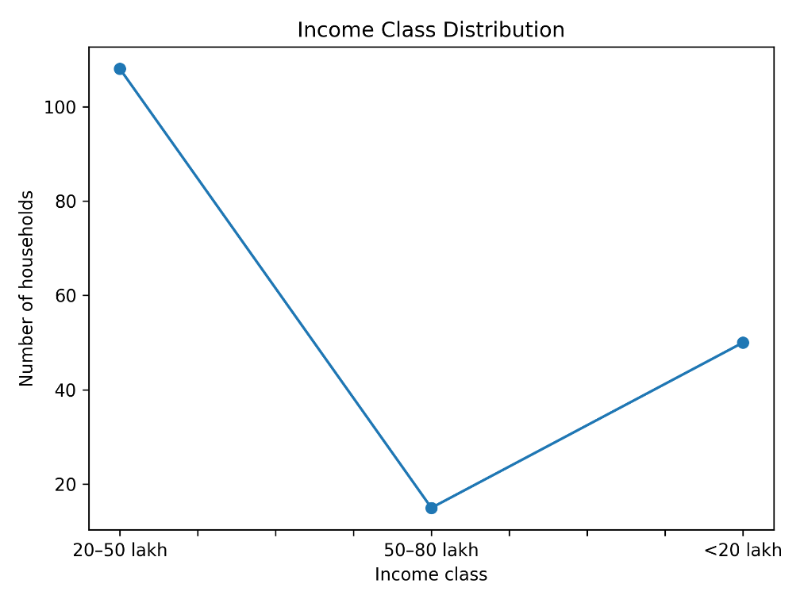
Figure 1 – Income line curve

4.2 Occupational Structure and Income Linkages
The occupational classes have been grouped into general comparable categories:
(i) Agriculture
(ii) Agriculture plus labour
(iii) Agriculture plus government employment
As presented in Table 2 and Figure 2, the largest group of households in the 20-50 lakh income class are engaged solely in Agriculture (70 out of 173 total). Therefore, households classified as Agriculture only have only partially diversified their income; thus, at the time of writing, Agriculture only also classifies approximately 25 (50) households within the <20 lakh class.
The second largest group of households in the 20-50 lakh income class is those that combine Agricultural work and working as a labourer for 28 households. However, those households also participate in some form of income diversification. Alternatively, approximately 29% of Agricultural plus Government wage earning households are represented in the 50-80 lakh category. Thus, creating a positive correlation between the two forms of income (salary or wage) and upward mobility (increased social status).
Table 2. Income class × Occupational structure
Income class | Agriculture only | Agriculture + Labour | Agriculture + Government job
<20 lakh | 25 | 13 | 12
20–50 lakh | 70 | 28 | 10
50–80 lakh | 8 | 0 | 7

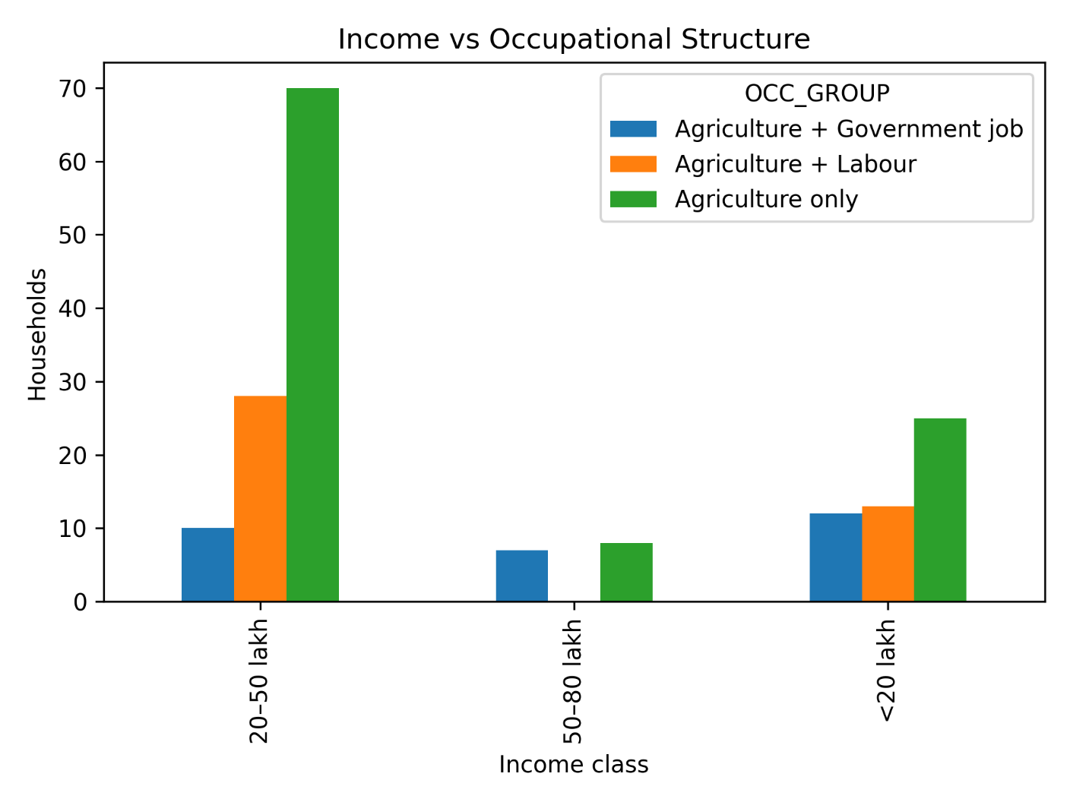
Figure 2 – Income × Occupation

4.3 Livestock Ownership and Income
The majority of people from all of the economic classes identified in Table 3 and shown in Figure 2 keep livestock as a primary source of income. The vast majority of households between 20 – 50 lakhs had (n=79) had livestock, while 41 households with <20 lakh also kept livestock. The high prevalence of livestock ownership across all income classes indicates that it is used by the majority of households not only as a source of income but as a primary asset for their livelihood
Table 3. Income class × Livestock ownership
Income class | Livestock – Yes | Livestock – No
<20 lakh | 41 | 9
20–50 lakh | 79 | 29
50–80 lakh | 14 | 1

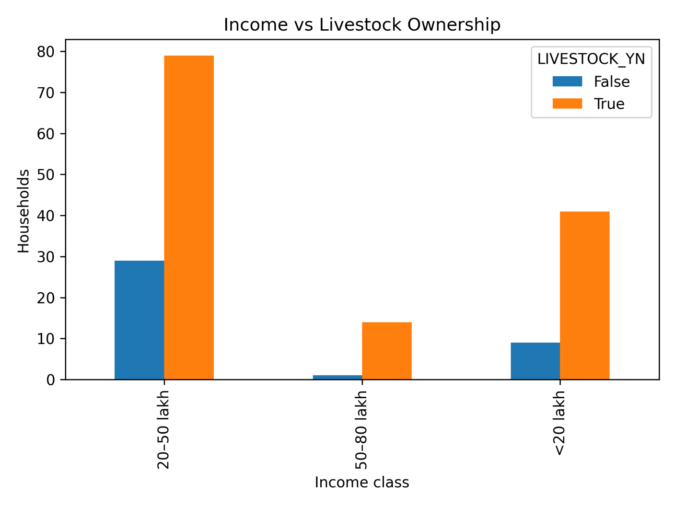
Figure 3 – Income × Livestock

4.4 Agroforestry Adopted vs. Income Level
As demonstrated in Table 4 and Figure 4 by the presence of trees on their farms, all income classes appear to have adopted agroforestry practices. For example, in the 20 – 50 lakh income class, 96 out of 108 households practiced agroforestry. Likewise, in the <20 lakh income class, 49 out of 50 households still taxed their trees. In fact, the adoption rate of agroforestry in the 50 – 80 lakh income class was extremely high as demonstrated by 14 of the 15 households. These data indicate that agroforestry cultivation systems are not only practiced throughout the forest fringe communities but also represent an essential element of the overall livelihood system of these communities.
Table 4. Income class × Agroforestry (Trees on farm)
Income class | Trees – Yes | Trees – No
<20 lakh | 49 | 1
20–50 lakh | 96 | 12
50–80 lakh | 14 | 1

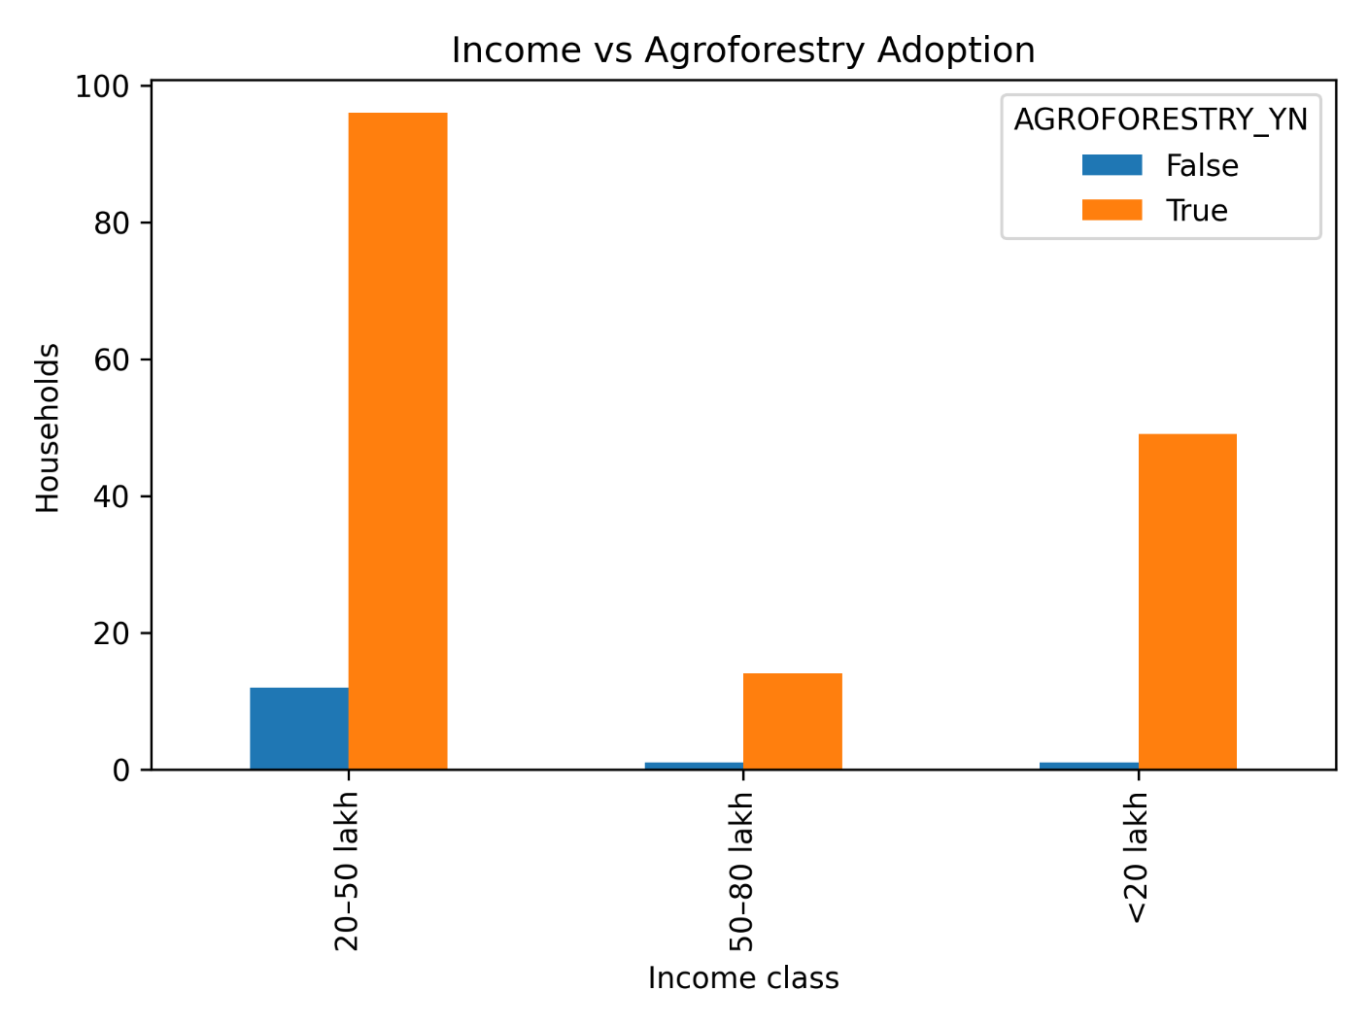
Figure 4 – Income × Agroforestry

4.5 Statistical Verification of the Income-Livelihood Connections
The objective of this section was to statistically test for results showing the association of income range to various sources of income, through the use of chi-square tests. A significant association was found between income range to occupational structure was established from the analysis (χ² = 18.45, p = 0.001), which indicates that the distribution of occupations is affected by numerous factors (of which government salaried employment is a very significant contributing factor).There was no significant association between income range to livestock ownership (χ² = 3.90, p = 0.142) or agroforestry use (χ² = 3.86, p = 0.145). Therefore, it appears that livestock and agroforestry are similar throughout all income ranges (or are homogeneously distributed) for livelihood purposes. Livestock and agroforestry do not serve as differential income-generating opportunities for the various income ranges.
Table 5. Statistical Summary
Variable | χ² | p-value | Interpretation
Income × Occupation | 18.45 | 0.001 | Significant
Income × Livestock | 3.90 | 0.142 | Not significant
Income × Agroforestry | 3.86 | 0.145 | Not significant

5. Discussion
The current study demonstrates that there is a large number of households that receive their total annual household income from 20 lakh - 50 lakh. This suggests that there is generally moderate-income stability in the study area’s forest fringe villages. There is no predominant income deprivation in the sample, however, the degree of income differentiation within the community is closely related to patterns of diversification of different types of livelihoods. A statistically significant relationship between income class and the occupational structure of households (χ² = 18.45, p = 0.001) therefore serves to confirm that diversification of livelihood opportunities beyond agriculture is an important factor in shaping overall income levels.
A combined agriculture and salaried government employment household is expected to have a higher income level than a household that depends solely on agriculture for its household income. The results of the present analysis are consistent with the broader literature on livelihood diversification and the income-generating activities of rural households (Ellis 2000). Rural households diversify their sources of livelihood through multiple activity types as a strategy to lower their vulnerability and increase their overall economic security. Non-farm or salaried employment have both been well documented in the rural livelihood literature as mechanisms to achieve upward income mobility and decrease exposure to agricultural risk (Reardon et al. 2007), and thus the centralised large proportion of households in the agriculture-plus-government employment income category between 50 lakh and 80 lakh demonstrates the stabilising and income-enhancing effect that secure employment has on mountain-based livelihoods.
Livestock ownership is very evenly spread out among the different income levels, regardless if they have low or high incomes (χ² = 3.90, p = 0.142). Because livestock are a type of livelihood asset that can be used for structural support rather than simply being a type of investment to create wealth, the same findings were found with regards to the ability to provide many different types of benefits for smallholders who raise livestock. These benefits can be used to provide income when annual income fluctuates, provide manure for crops and provide insurance against shock (Herrero et al., 2013). Since livestock are present in both lower-income and middle-income households within the study area, they continue to serve as a basis for rural livelihood resilience. Recent literature notes that livestock systems typically stabilise household incomes and provide food security but are also highly exposed to climate and market shocks, which can dampen their role as engines of income mobility (Godde et al., 2021).
Similar results were found for agroforestry, as 95% of all farmers regardless of income level, have adopted agroforestry in their farming systems (χ² = 3.86, p = 0.145). The incorporation of trees into the farming systems of these forest-dependent communities makes it an integral part of their traditional farming systems. Farmers use the different outputs from agroforestry such as fodder for livestock, firewood for cooking, fruit for human consumption and timber to build homes as a way to create diverse food sources and decrease their reliance on outside inputs. Studies in rural India have shown that agroforestry can increase rural livelihood resilience, particularly in ecologically fragile areas (Dev et al., 2018). Therefore, the large number of farms adopting agroforestry can be seen as a mechanism for supporting rural livelihoods rather than just an investment opportunity.
Overall, the results taken together support the idea that forest-margin areas are characterized by two distinct types of livelihoods. The first type includes jobs or activities other than what people typically do for their livelihood; e.g., earning a salary for working. Many people in the forest-margin areas are able to find this kind of job and therefore earn a stable income and achieve an upward career path or movement within their community. The second type of liveli-hood is composed of raising livestock and farming in a way that incorporates forests into the farm to create multiple income sources. This practice provides financial stability for all of the different income-earning groups in the margin area. Village-level livelihood assessments that combine natural-resource availability, asset access and basic services using composite indices have been used to reveal intra-regional heterogeneity and to target micro-level policy interventions (Mondal et al., 2023).
The integrated total of the two structures mentioned above form a basis for support of the adaptive strategies used by analysis of mountain rural economies; the ecological constraints placed on mountain communities require individuals and families from those communities to develop diversified portfolios of income-earning opportunities, to help distribute risk. The purpose of this study was to look at the structure of livelihoods and income in forest-margin villages in the Chakrata Block by using the responses of 173 households.

6. Conclusion
The study found that most households in the 20-50 lakh income range; therefore, the average incomes of families in the study area are moderate rather than extremes of either wealth or poverty. However, income is directly related to the types of economic activities or occupations that individuals perform.
Statistical data analysis indicates a significant association between income class and types of jobs or occupations (χ² = 18.45, p = 0.001). Households who perform agriculture and also earn a salary from government jobs are more likely to be in the higher percentage of households than households that either only farm or rely on government salaries only. Livestock and agroforestry are evenly distributed across all income classes and therefore cannot be relied upon as mechanisms to increase income; these two strategies will serve as the structural and stabilizing components of livelihoods in the forest-margin regions of the Chakrata Block.
Forest-fringe communities demonstrate two income structures. One structure promotes wage income through salaries, and the second promotes income stability through the combined use of livestock and agroforestry. In order to develop sustainable rural development policies, interventions must develop employment opportunities that provide safe, steady, or semi-stable paid incomes outside of agricultural sectors. Employment opportunities will enhance rural resident’s ability to enhance their incomes. In addition, support for livestock and agroforestry development must be continuous to ensure food stability, resilience in livelihoods, and ecological sustainability.
Forest-fringe areas need to utilize integrated systems of crops, livestock and trees as their fundamental means of livelihood. Policies to promote new jobs through diversification and through strengthening agroforestry and livestock development will result in greater stability of income and less pressure on forest resources in forest-fringe areas. Ultimately these integrated strategies will support economically, socially and environmentally sustainable rural development in the ecologically fragile Himalayan region.

Disclaimer (Artificial intelligence)

Author(s) hereby declare that NO generative AI technologies such as Large Language Models (ChatGPT, COPILOT, etc.) and text-to-image generators have been used during the writing or editing of this manuscript.

References
Angelsen, A., Jagger, P., Babigumira, R., Belcher, B., Hogarth, N. J., Bauch, S., Börner, J., Smith-Hall, C., & Wunder, S. (2014). Environmental income and rural livelihoods: A global comparative analysis. World Development, 64, S12–S28.https://doi.org/10.1016/j.worlddev.2014.03.006
Dev, Inder & Ram, Asha & Singh, Ramesh & Kumar, Dhiraj & Kumar, Naresh & Chaturvedi, Om Prakash & Handa, A.K. & A R, Uthappa. (2018). Agroforestry for climate resilience and rural livelihood.https://www.researchgate.net/publication/330080684_Agroforestry_for_climate_resilience_and_rural_livelihood
Ellis F (2000). The determinants of rural livelihood diversification in developing countries. Journal of Agricultural Economics, 51(2), 289–302.
https://doi.org/10.1111/j.1477-9552.2000.tb01229.x
Gajjala, Ravindra & Bhaskar, Shreeram & K.A., Gopinath & Prabhakar, M. & Prasad, J.V.N.S & Ca, Ramarao & kv, Rao. (2022). Climate Resilient Rainfed Agriculture: Experiences from India. 10.1007/978-981-16-7861-5_1.
Godde, C. M., et al. (2021).Impacts of climate change on the livestock food supply chain; a review of the evidence,Global Food Security,Volume 28,2021,100488,ISSN 2211-9124, https://doi.org/10.1016/j.gfs.2020.100488. (https://www.sciencedirect.com/science/article/pii/S2211912420301413)
Herrero, M., Thornton, P. K., et al. (2013). Livestock and global change: Emerging issues for sustainable food systems. Proceedings of the National Academy of Sciences, 110(52), 20878–20881. https://doi.org/10.1073/pnas.1321844111
Himanshu, , Peter Lanjouw, and Nicholas Stern, 'Introduction', How Lives Change: Palanpur, India, and Development Economics (Oxford, 2018; online edn, Oxford Academic, 20 Sept. 2018), https://doi.org/10.1093/oso/9780198806509.003.0001, accessed 1 Mar. 2026
Mondal, S., Ghosh, P., & Rohatgi, P. (2023).Village‐level livelihood security: A case study on a wasteland‐dominated forest fringe region of rural India, Regional Science Policy & Practice,Volume 15, Issue 5,2023,Pages 1019-1037, ISSN 1757-7802,https://doi.org/10.1111/rsp3.12552.(https://www.sciencedirect.com/science/article/pii/S1757780223000094)
Pattayat SS, Parida JK, Awasthi IC. Reducing Rural Poverty Through Non-farm Job Creation in India. Indian J Labour Econ. 2022;65(1):137-160. doi: 10.1007/s41027-022-00359-9. Epub 2022 Mar 15. PMID: 35308831; PMCID: PMC8923099.
Rathore SS, Babu S, El-Sappah AH, Shekhawat K, Singh VK, Singh RK, Upadhyay PK, Singh R. Integrated agroforestry systems improve soil carbon storage, water productivity, and economic returns in the marginal land of the semi-arid region. Saudi J Biol Sci. 2022 Oct;29(10):103427. doi: 10.1016/j.sjbs.2022.103427. Epub 2022 Aug 23. PMID: 36091723; PMCID: PMC9460509.
Reardon, T., Berdegué, J., Barrett, C. B., & Stamoulis, K. (2007). Household income diversification into rural nonfarm activities. World Development, 35(7), 115–133.
https://barrett.dyson.cornell.edu/Papers/IFPRIbookchapter2006Final.pdf
Yamane T. Statistics: An introductory analysis. 2nd ed. New York: Harper and Row; 1967.https://doi.org/10.2307/2237558

