Agriculture 5.0: AI-Enabled Smart Farming with Advanced Monitoring and Pest Management

.
ABSTRACT

Agriculture 5.0 is a paradigm shift whereby modern technologies (robotics, artificial intelligence (AI), and the Internet of Things (IoT) are utilised to improve productivity, sustainability, and resiliency in various agricultural domains. This is an integrated solution that not only focuses on traditional crop production but also on horticulture, livestock, fisheries, and agroforestry systems, which allows management of a farm in an integrated manner. Integration of intelligent sensors, autonomous machines, and data-oriented decision support provides the possibility to monitor the state of soil, water, and weather in real-time, which will result in increased efficiency of resource utilisation. Also, AI-based imaging and machine learning algorithms make it possible to detect insect pests and plant diseases early and precisely to support precision-based interventions and mitigate the need to use chemical inputs. Climate-smart practices also include minimising environmental effects and protecting biodiversity, as well as improving adaptive capacity to climate variability, which are also promoted by Agriculture 5.0. The integration of digital technologies and connected platforms will guarantee the availability of data integration and predictive analytics, as well as informed decision-making on farm and regional levels. In addition, automation and robotics minimise labour reliance and enhance efficient and consistent operations in farms. Agriculture 5.0 can bring transformations in the current farming sector despite the hurdles associated with it, including the cost of initial investment, complications of data management, and the use of technical expertise. It is also bringing about the possibilities of sustainable, efficient, and resilient agricultural systems by combining technological innovation with ecological principles that will address the food security challenges of the world.

Keywords: Agriculture 5.0, Artificial Intelligence, Internet of Things (IoT), Precision Agriculture, Pest and Disease Detection.

1. INTRODUCTION

The rapid growth of the global population, expected to reach 10 billion by 2050, presents unprecedented pressure on agriculture to sustainably increase production. With the added challenges of dwindling water resources, shifting climate patterns, and the loss of agricultural land, there is an urgent need for innovative solutions to boost farm productivity and efficiency (Aijaz et al., 2025; Qwaid et al., 2025). Agriculture has undergone several transformative phases, and this indicates how man has been continuously innovating and interacting with nature in the management of natural resources. Agricultural industries, as one of the primary sectors addressing these challenges, must undergo both quantitative and qualitative development. In addition to these challenges, the agricultural sector faces the migration of workers to more profitable industries, coupled with the increasing average age of farmers. Consequently, there is an urgent need for scientists and agricultural experts to develop more innovative and sustainable food production systems to address these issues and meet the growing population’s nutritional needs (Taha et al., 2025). Agriculture 1.0 largely belonged to subsistence that was based on manual labour, traditional knowledge, and natural resources. The Industrial Revolution brought about Agriculture 2.0, which brought in the use of mechanisation in the form of tractors and machines that greatly boosted productivity and minimized human labour. Agriculture 3.0, which is closely related to the Green Revolution, was a big leap and would see the use of high-yielding crop varieties, chemical fertilizers, pesticides, and irrigation technologies, which have made significant advances in food production but caused concern as to the degradation of the environment and the loss of resources. Agriculture 4.0 brought in digital platforms like the Internet of Things (IoT), sensors, geographic information systems (GIS), and big data analytics that provide the opportunity to conduct precision farming and site-specific management practices. As a continuation of these developments, Agriculture 5.0 is the most recent paradigm, with the combination of artificial intelligence (AI), robotics, machine learning, and autonomous systems to develop intelligent, data-driven, and self-optimising agricultural systems that are more productive and sustainable at the same time (Singh and Singh, 2024; Razak et al., 2024).
Agriculture 5.0 is also heavily influenced by the increased demand for smart and sustainable agriculture in response to the global challenges. Population growth is projected to bring about high food demand, and it is projected that the food demand will grow at a large rate in the next few decades. Meanwhile, in agriculture, there are limitations of decreasing arable land, water shortage, climate change, and environmental degradation. These issues have led to the need to embrace new farming methods that are capable of improving productivity without adversely affecting the environment. One of the possible solutions to fix these problems is smart agriculture, as it is based on highly developed technologies and data analytics and can effectively help optimise the resource use and minimise input wastage, as well as enhance the overall resilience of the system (Raj & Prahadeeswaran, 2025; Achury et al., 2026).
One of the key aspects of such change is sustainable agriculture, which aims at striking a balance between economic feasibility, environmental protection, and social equity. Traditional agricultural methods and especially those in high-input activities have led to the degradation of soil and water, loss of biodiversity, and emission of greenhouse gases. Whereas, smart and sustainable agriculture focuses on precision control of inputs, natural resources protection, and incorporation of ecological concepts in agricultural systems. The introduction of technologies like artificial intelligence, remote sensing, and robotics enables farmers to know the health of crops and the conditions of the soil and the environmental parameters in real time to intervene in time and specifically. This improves productivity, as well as minimizes the environmental effects and contributes to the technical sustainability of agriculture in the long run (Bergier et al., 2024; Arzoo and Singh, 2024).
Agriculture 5.0 also supplies the idea of sustainability through embracing a human-focused and resilient strategy. The Agriculture 5.0, in contrast to the past technological paradigms that largely concerned productivity, incorporates socio-economic and ecological factors, which are intended to enhance the livelihoods of farmers, food security, and inclusive development. It focuses on the interaction between humans and machines as high technologies are used to support instead of subtract from human decision-making. Other essential concerns that are discussed through this paradigm include labor shortage, resource inefficiencies, and the need to implement climate-resilient agricultural systems (Bissadu et al., 2024).
Agriculture 5.0 is an all-encompassing framework of farming due to its presence in various sectors of the agricultural system. Precision agriculture methods allow the optimization of inputs (water, fertilizers, and pesticides) in crop production by monitoring and predictive analytics in real time. In horticulture, controlled environment agriculture and automated greenhouse systems improve the quality of crops and yield with low resource consumption. Dairy and meat production can have an advantage of smart sensors and wearable devices tracking livestock health, nutrition, and behavior, which enhances livestock and animal welfare. On the same note, in fish and aquaculture, sophisticated monitoring systems and automatic feeding systems can be used to manage resources efficiently as well as control diseases. The use of remote sensing and data analytics is also useful to agroforestry systems, as it aids in maximising the interactions between trees and crops, improving carbon capture, and preserving biodiversity.
Besides that, Agriculture 5.0 encourages the combination of all these industries using the help of digital systems and data sharing, which allows treating the farm as a whole. Big data and cloud computing make it easier to analyze large datasets and give insight into the improvement of decision-making processes at the farm and policy levels. Other technologies, like blockchain, are able to increase transparency and traceability in the agricultural supply chain to enhance food safety and access to the market. Moreover, sustainable energy sources, including solar-powered irrigation systems, are in line with the sustainability objectives as they decrease the reliance on fossil fuels as well as greehouse gas emissions (Singh & Singh, 2024).
In general, the development of Agriculture 1.0 to 5.0 represents a long-standing process of the transformation of less efficient, less productive, and less sustainable farming systems to more efficient, productive, and sustainable ones. Agriculture 5.0 is a paradigm shift, a combination of progressive technologies and ecological and social factors aimed at solving the multi-level problems of modern agriculture. It provides a bright way into realizing world food security, environmental sustainability, and economic resilience by making it possible to engage intelligent, data-driven, and resource-efficient practices in the multiple sectors of the agricultural industry.
2. CONCEPT AND FRAMEWORK OF AGRICULTURE 5.0
Agriculture 5.0 is a novel, human-oriented concept in the contemporary agricultural industry that puts forth high-tech digital technologies into ecology and biology, and realizes sustainable, efficient, and resilient agricultural production. It can be easily defined as a technology-driven agricultural system that integrates artificial intelligence (AI), the Internet of Things (IoT), robotics, big data, and biotechnology to form intelligent, adaptive, and self-optimizing farming systems. As compared to the older models, which mainly focused on mechanization or digitalization, Agriculture 5.0 similarly values environmental sustainability, social welfare, and economic sustainability, thus making the agricultural development more in line with the overall sustainability targets (Barrios-Ulloa et al., 2025; Singh and Singh, 2024).
The main principles of Agriculture 5.0 are associated with precision, sustainability, resilience, and inclusivity. It is very precise in terms of data collection and analysis in real-time, which allows management of inputs to the site, including water, nutrients, and pesticides. Sustainability is instilled by the use of fewer chemicals, the use of resources efficiently, and the incorporation of renewable energy systems. Predictive analytics and climate-smart technologies that aid farmers in adapting to the uncertainties in the environment boost resilience. Also at the center of attention are inclusivity and empowerment of farmers as digital platforms and smart tools will offer access to information, decision support systems, and market connections (Razak et al., 2024; Barrios-Ulloa et al., 2025). The other related digital concepts that are being introduced in this paradigm include digital twins, cloud computing, and blockchain to maintain transparency, traceability, and effective management of the supply chain to enhance the wider agricultural ecosystem.
The culture of Agriculture 5.0 also includes the focus on the collaboration between humans and machines instead of full automation. Unlike Agriculture 4.0, which paid much attention to autonomy and the lack of human involvement, Agriculture 5.0 advocates a complementary relationship between humans and intelligent machines, as they use their respective capabilities. Most recent technologies like collaborative robots (cobots), drones, and AI-based decision support systems can help farmers in doing tedious and labour-intensive work, but humans still make strategic decisions and manage their business. This team building method increases the effectiveness, minimises the limitations of labor, and improves the quality, but does not eliminate the importance of human knowledge and judgment (Rane, 2024; Adel, 2022). Moreover, new terms like the concept of cognitive symbiosis emphasize the joint learning and interaction between human beings and machines and allow them to find adaptive and situation-specific solutions in the agricultural field (Naim and Boukhizzou, 2026).
The second dimension of Agriculture 5.0 that is relevant is that it involves the merging of digital and biological systems, which makes it unique in comparison with other previous technological paradigms. Biological innovations, backed by digital ones (sensors, remote sensing, AI-based analytics, etc.), are integrated with biological engineering (genetic engineering, synthetic biology, and microbiome management) to ensure agricultural productivity and sustainability. An example is that the real-time monitoring systems are able to measure the crop health and the soil imbalance, whereas the biotechnological interventions can help to strengthen the crops against pests, diseases, and climatic stresses. Such convergence allows a more integrated view of farming, in which the biological processes are more comprehended, tracked, and controlled with the help of digital tools (Singh and Singh, 2024).
In addition, Agriculture 5.0 promotes the creation of cyber-physical systems that would ensure a connection between the real farm setting and the online platform where decisions are made. With the help of these systems, the two-way exchange of data and feedback is continuous, which enables the dynamic changes in farm activities. As an illustration, IoT-enabled sensors can monitor the moisture level in the soil and the weather conditions, and analyze the data with AI algorithms to optimise the irrigation schedule and the application of inputs. Meanwhile, the progress of synthetic biology and precision breeding is also helping to come up with crop varieties that are adapted to certain environmental factors to further improve productivity and sustainability. This is a combination of digital and biological elements, which eventually results in smarter, more adaptive, and resource-efficient agricultural systems (Bergier et al., 2024; Ahmad and Nabi, 2021).
Simply put, the idea and model of Agriculture 5.0 is a radical change of the intelligent, interconnected, and sustainable farming systems. It offers an integrated solution to the many challenges of contemporary agriculture, such as food security, climate change, and scarcity of resources, by integrating innovative technologies in the world of digitalization with innovations in the biological field and an emphasis on human-machinery cooperation.
3. CORE TECHNOLOGIES IN AGRICULTURE 5.0
3.1 Robotics and Automation
Agriculture 5.0 is based on robotics and automation, which allow achieving precision, efficiency, and less labour reliance. Autonomous tractors, robotic harvesters, and robotic arms are currently being applied in seeding, weeding, spraying, and harvesting with little human intervention. These systems are based on sensors, GPS, and AI algorithms to carry out field work with high precision and consistency, thus enhancing productivity and cutting operational expenses. Robotization also plays an essential role in resolving the issue of labor shortage and increasing the efficiency of farm activities (Duguma & Bai, 2024; Razak et al., 2024).
Another significant aspect of automation is Unmanned Aerial Vehicles (UAVs), also referred to as drones. Drones, fitted with multispectral and thermal cameras, are applied in monitoring crops, detecting any stress, and spraying them precisely. They have the ability to produce live field maps, and they allow precise application of inputs like pesticides and fertilizers, minimising the amount of chemicals used and impact on the environment (Miller et al., 2025). All of these technologies make the process of operation efficient and facilitate the management of the site-specific behavior.
3.2 Artificial Intelligence (AI) and Machine Learning
Artificial intelligence and machine learning are the focus of decision-making in Agriculture 5.0. Such technologies allow making predictive analytics through the analysis of huge amounts of datasets on weather conditions, soil, crop growth, and past yields. Predictive models also help farmers to optimize the planting times, irrigation, and nutrient application to enhance productivity and minimize risks (Mishra, 2025; Ali, 2025). The image-based analysis of agriculture is highly prevalent using deep learning methods, especially convolutional neural networks (CNNs). Such models are able to process images, which are taken by either drones, satellites, or field cameras, to identify pests, diseases, nutrient deficiencies, and weed infestations, with high precision. This type of real-time diagnostics allows early intervention and reduces losses of crops. The use of decision support systems based on AI also incorporates various streams of data to give practical suggestions, which makes farming more accurate and data-oriented (Razak et al., 2024) (Figure 1).
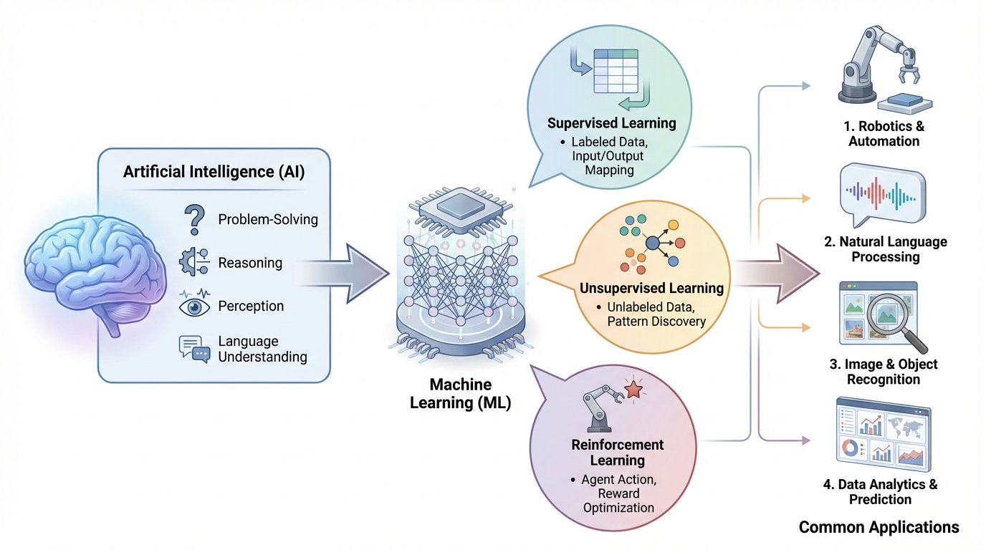
Figure 1. Overview of Artificial Intelligence (AI) and Machine Learning (ML) illustrating key learning approaches—supervised, unsupervised, and reinforcement learning—and their applications in robotics, natural language processing, image recognition, and data analytics.
3.3 Internet of Things (IoT)
IoT is a key element in relating the physical components of the farm by using smart sensors and other devices. IoT-based systems monitor soil moisture, temperature, humidity, nutrients, and the health of crops in real-time, thus offering an all-time tracking of the field condition. Such interconnected devices make the irrigation systems, fertigation systems, and climate conditions in controlled settings automated (Duguma & Bai, 2024). One of the benefits of the IoT in agriculture is real-time monitoring and data collection. Sensors provide data to centralized systems, where such data is compared to make timely decisions. This feedback mechanism is constantly active, which will increase the use of resources and crop productivity. IoT also enables the unification with AI and big data systems to create an ecosystem of smart farming (Ahmed et al., 2025).
3.4 Big Data and Cloud Computing
The data storage, integration, and processing in Agriculture 5.0 are supported by big data and cloud computing. The contemporary farms produce enormous quantities of data in the form of sensors, drones, machinery, and satellite images. The analytics of big data allow for the finding of insightful information in these datasets, which will aid in precision farming and long-term planning (Ali, 2025). Cloud computing is very important as it provides scalable storage and computing. They enable farmers and other stakeholders to be able to access data and decision-support tools remotely, making it easier to manage their farms in real-time and collaborate. An integration of various technologies like IoT, AI, and robotics to one central database on a cloud-based system can also be used to facilitate greater efficiency and transparency in agriculture (Ahmed et al., 2025) (Table 1).
Table 1: Core Technologies and Applications in Agriculture 5.0
Technology | Key Components | Major Applications in Agriculture 5.0
Robotics & Automation | Autonomous tractors, robotic arms, and drones | Precision farming, harvesting, spraying, and monitoring
AI & Machine Learning | Predictive models, deep learning, DSS | Yield prediction, pest detection, decision support
Internet of Things (IoT) | Sensors, smart devices, connectivity networks | Real-time monitoring, smart irrigation, and climate control
Big Data & Cloud Computing | Data analytics, cloud platforms, storage | Data integration, farm management, remote decision-making
4. APPLICATIONS ACROSS AGRICULTURAL SECTORS
4.1 Crop Production
The technologies of Agriculture 5.0 in crop production allow precision farming and site-specific control through the combination of AI, IoT, and remote sensing instruments. Sensors, drones, and satellite images can give farmers real-time information on soil moisture, nutrients, and crop conditions so that farmers can actively apply inputs such as water, fertilizers, and pesticides to specific areas. This enhances the efficiency of the input-use and lowers the environmental impact. Predictive analytics, which is based on AI, also provides support in predicting yield and crop modelling by comparing previous records, weather, and variability of the fields to better help with the planning and management of risks (Gupta and Pal, 2025; Sakka et al., 2025).
4.2 Horticulture
The development of smart greenhouse systems based on the technology of automated climate control has been of great benefit to horticulture. Temperature and humidity, the intensity of light, and the condition of the soil are measured by IoT-enabled sensors and manually controlled to ensure the best results in crop quality and quantity. This is further improved by automated irrigation and fertigation systems. Moreover, AI-driven image processing systems also provide quality control and grading of fruits and vegetables, which leads to consistency and minimizes losses during the post-harvest stage. The technologies assist in high-value crop production and enhance competitiveness in the market.
4.3 Livestock Farming
Agriculture 5.0 technologies are used in livestock farming to enhance livestock productivity, animal welfare, and disease control. Smart feeding takes advantage of automated ways to feed the animals the right amount with the specific needs of the animals, which lowers the amount of waste while enhancing the growth of the animals. The IoT devices and wearable sensors allow constant control over the health, behavior, and physiological rates of animals, including the temperature and activity rates. The systems are capable of identifying early disease or stress cases, which can be managed early enough to save many lives (Mohapatra, 2025; Schulthess et al., 2024).
4.4 Fisheries and Aquaculture
In the fisheries and aquaculture, the environmental parameters of water, including temperature, pH, dissolved oxygen, and salinity, are maintained at optimum levels through advanced monitoring. The sensors that are installed using IoT are capable of monitoring these variables in real-time and alerting, which ensures a healthy aquatic environment. Automated feeding methods control the distribution of feeds depending on the behavior and development of fish, enhancing the economy of food and minimizing expenditures. Disease detection and management is another area of AI-based systems, which have been applied to reduce losses as well as improve productivity within the aquaculture systems (Babar & Akan, 2024).
4.5 Agroforestry Systems
The application of remote sensing and geospatial technologies in keeping track of the health of trees, patterns of their growth, and the accumulation of biomass is beneficial to agroforestry systems due to Agriculture 5.0. Satellites and drones can be used to evaluate the forest cover, canopy, and stress levels at a large scale. The technologies facilitate sustainable land management and maximise the interactions between trees and crops. Also, agroforestry is important in carbon sequestration and ecosystem services, and digital tools can be used to measure the carbon storage and evaluate environmental benefits as a part of climate change mitigation strategies (Babar & Akan, 2024).
The following Table 2 gives a detailed report of various agricultural sectors, their main technologies employed, their main applications, and how productivity, efficiency, and sustainability of such systems have been improved through modern innovations.
Table 2: Applications of Agriculture 5.0 Across Sectors
Sector | Key Technologies Used | Major Applications | Benefits Achieved
Crop Production | AI, IoT, drones, remote sensing | Precision farming, yield prediction, crop modelling | Higher yield, reduced input use
Horticulture | IoT sensors, automation, AI imaging | Smart greenhouses, quality grading | Improved quality, resource efficiency
Livestock Farming | Wearable sensors, IoT, AI | Smart feeding, health monitoring | Better animal welfare, disease control
Fisheries & Aquaculture | IoT sensors, AI, automation | Water quality monitoring, automated feeding | Enhanced productivity, reduced losses
Agroforestry Systems | Remote sensing, GIS, AI | Tree health monitoring, carbon assessment | Climate mitigation, ecosystem services
5. SOIL HEALTH MONITORING AND MANAGEMENT
5.1 Soil Sensors (Moisture, pH, Nutrients)
The main devices of Agriculture 5.0 are soil sensors that allow tracking the main soil parameters (moisture content, pH, temperature, and nutrient levels) in real-time and precisely. New sensor technologies are usually combined with IoT systems and can provide farmers with steady streams of data, helping them comprehend the variability of soils and make informed choices. These sensors enhance the scheduling of irrigation as they monitor soil moisture content and ensure that it does not over- or underwater. Equally, sensors of pH and nutrients enable the accurate determination of the soil fertility condition, which is balanced nutrient application (Song et al., 2026; Kučera, 2025). Other recent developments are portable and wireless sensing machines, which have minimized the reliance on conventional lab-based soil testing. These systems will make it easier and assist in on-field real-time diagnostics, which will help to achieve better crop productivity and environmental sustainability (Reza et al., 2025). On the whole, precision agriculture relies on sensor-based soil monitoring since it allows managing the soil based on the data (Figure 2).
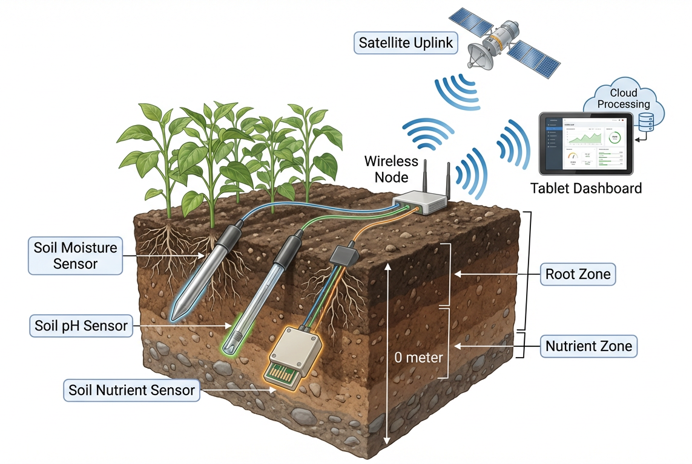
Figure 2. Smart soil monitoring system illustrating the use of moisture, pH, and nutrient sensors integrated with wireless communication, satellite uplink, and cloud-based dashboards for real-time precision agriculture management.
5.2 Soil Mapping and Digital Soil Databases
Digital soil databases and soil mapping are very important in the knowledge of spatial variations in soil characteristics within agricultural landscapes. Through remote sensing, geographic information systems (GIS), and global positioning systems (GPS), it is also possible to create detailed soil maps that give data on the type of soil, its texture, organic matter, distribution of nutrients, and its moisture. Such maps help farmers and researchers understand which constraints and opportunities of fields are possible in order to manage them in a better way. Digital soil databases combine high amounts of soil data that are obtained by sensors, field surveys, and satellite imagery into centralized systems. Such databases facilitate decision-making through the provision of real-time and historical information on soil health. They also help in coming up with predictive models of crop suitability and yield estimation. The IoT and cloud computing also make these databases more accessible and usable, allowing farmers to use the information about the soil remotely and adopt site-specific management methods (Kučera, 2025; Kalaivani et al., 2025).
5.3 Precision Nutrient Management
Another important use of soil health monitoring in Agriculture 5.0 is precision nutrient management, which aims at the efficient and site-specific use of fertilizers depending on real-time soil data. With the help of sensor-based nutrient analysis and data analytics, farmers are able to apply the appropriate amount of nutrients at the appropriate time and location, hence maximising crop yield and reducing environmental effects. Both wireless sensor networks (WSNs) and machine learning models are some of the advanced technologies being used to monitor the nutrition levels in soils and anticipate nutrient demands. Such systems may precisely calculate the NPK levels and suggest nutrient application in order to minimise nutrient loss due to leaching and runoff and increase the efficiency of nutrient usage (Senapaty et al., 2023; Sharma and Tomar, 2024). Moreover, the accuracy of the nutrient management also plays a role in sustainable agriculture, the reduction of production costs through the use of excess fertilisers, as well as the minimisation of environmental pollution. It is also long-term beneficial to the soil fertility, ensuring the balanced level of nutrients and sustaining the biological activity of soils. In such a way, the combination of soil sensors, digital mapping, and advanced analytics would establish an extensive framework of effective soil health control in the contemporary agricultural system.
6. WATER RESOURCE MONITORING AND MANAGEMENT
6.1 Smart Irrigation Systems (Drip, Sprinkler Automation)
The main technology of Agriculture 5.0 will be smart irrigation systems that can optimally use water by automation and real-time data combination. IoT-based sensors and controllers are also used together with technologies like drip and sprinkler irrigation to provide water directly based on the needs of crops. The irrigation scheduling depends on soil moisture sensors, weather, and evapotranspiration models to get the appropriate quantity of water at the appropriate time to the crop. This design helps to greatly cut down on water wastage, as compared to the traditional flood irrigation techniques (Sidik et al., 2025; A and Vadivel, 2024). The high-tech smart irrigation systems incorporate alternative renewable energy sources like solar-powered pumps and automated valves, which increase sustainability. It is possible to make AI-driven and sensor-controlled irrigation systems more dynamic and capable of adjusting water delivery in response to dynamic factors, which enhances crop yield, minimises the amount of labour needed, and lowers the costs of operation. It has been demonstrated that these systems have significant potential to enhance efficiency in water-use and sustainability in agricultural activities (Liu et al., 2025; Abdelmoneim et al., 2025).
6.2 Water Quality Assessment Using Sensors
Another important aspect of water resource management in the current agricultural practice is water quality monitoring. Parameters that are measured by sensors include pH, electrical conductivity (EC), dissolved oxygen, turbidity, and temperature, which directly affect crop growth and soil health. Constant check-up of the irrigation water would make sure that the health-threatening contaminated water, salinity problems, or imbalance of nutrients are observed early, thus causing no negative impact on crops and the soil ecosystem. Water quality sensors based on IoT allow obtaining real-time data and providing remote control to the farmer, which allows him to optimise water conditions to irrigate the fields. These systems are mostly significant in areas with water crises or dependency on other water resources like groundwater or recycled water. Cloud integration may provide the possibility to store and analyse data and alert systems, as well as to make decisions in advance (Abdelmoneim et al., 2025).
6.3 Water-Use Efficiency and Conservation Strategies
Agriculture 5.0 is largely aimed at increasing water-use efficiency, particularly in the face of growing water shortage and climate change. Combining data analytics and sensor technologies with smart irrigation systems allows for applying water accurately to crops and the environment, depending on their requirements. This minimises the losses through evaporation, deep percolation, and runoff. Other conservation techniques are deficit irrigation, harvesting of rainwater, and the application of drought-resistant varieties of crops. Besides, the GIS and remote sensing equipment assist in the determination of water stress areas and the field and regional planning of irrigation. Sensor-based irrigation schedules have been demonstrated as important to improve the productivity of water by matching irrigation with the real crop water requirement (Surve et al., 2024). Besides, AI and big data analytics can be combined and used to predict the water management of crops and weather conditions. The technologies help in managing the resources sustainably by reducing the use of water and ensuring that the crop yields remain or are increased. In sum, water resources are conserved, but agricultural resilience and long-term sustainability are also improved by the use of smart water management in general.
7. INTELLIGENT INSECT PEST AND DISEASE DETECTION
7.1 AI-Based Image Recognition Systems
Image recognition systems built on artificial intelligence (AI) are at the forefront of Agriculture 5.0 in terms of intelligent pest and disease recognition. These systems are based on machine learning and deep learning algorithms (specifically, convolutional neural networks (CNNs) and vision transformers) that are used to examine images of plant leaves, stems, and fruits to identify evidence of pest infestation or disease. Smartphones, drones, and field camera images are high-resolution images that are processed to identify the patterns, including discoloration, lesions, and abnormal growth. The AI models have proved very accurate in detecting diseases very early in their stage, which allows for intervention and saves many crops (Khan et al., 2024; Zhu et al., 2024). Automated classification and diagnosis can also be conducted by these systems, which limits the use of expert knowledge and manual scouting. Connection to mobile applications and the cloud enables farmers to get immediate recommendations and make the process of managing pests and diseases more convenient and effective (Zhu et al., 2024).
7.2 Use of Drones and Remote Sensing for Pest Surveillance
Remote sensing technologies and drones are highly important in big data pest monitoring. Unmanned aerial vehicles (UAVs) that are fitted with multispectral, hyperspectral, and thermal sensors can take accurate images of the fields, and therefore, pest infestation and its signs of disease over extensive regions are detected. Such systems are able to find subtle changes in the health of crops, including changing the color, canopy structure, or temperature, which are early warnings of stress (Agrawal and Arafat, 2024). AI, when combined with UAVs, increases real-time processing and analysis of aerial data quality and efficiency in the detection process. Monitoring via drones can cover extensive areas of the field within a short period of time and provide interventions that are more precise, eliminating the necessity to use blanket pesticides (Anam et al., 2024). The method plays a vital role in ensuring sustainability in the management of pests through the reduction of chemicals and environmental effects (Figure 3).
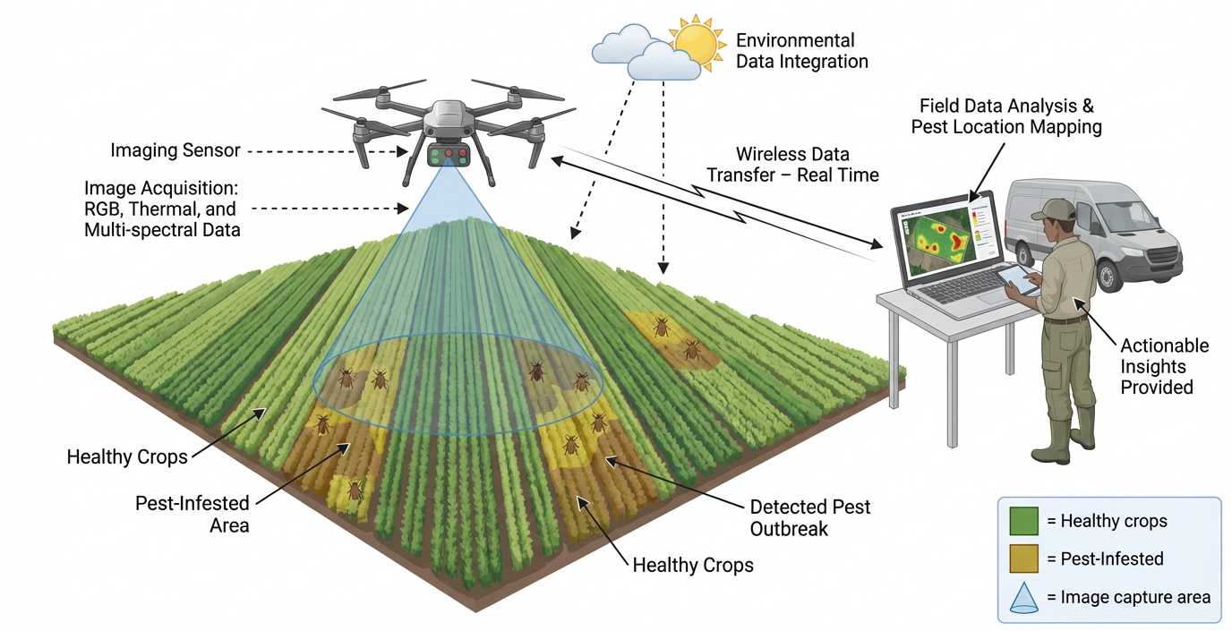
Figure 3. Use of drones and remote sensing enables rapid, real-time detection of pest infestations and crop stress across large fields, improving monitoring accuracy. These technologies support early warning systems and targeted pest management, reducing chemical use and enhancing crop protection efficiency.
7.3 Early Warning Systems and Predictive Modelling
The Agriculture 5.0 early warning systems amalgamate sensor data, weather data, and the past records of pest incidences to forecast possible outbreaks. Machine learning algorithms of predictive models are used to study environmental factors, including temperature, humidity, and rainfall, which affect the dynamics of pests and diseases. Such systems create warning signs and recommendations, which help farmers to implement preventive actions before infestation of critical levels (Ali et al., 2025). These systems are highly likely to be applied to decision support systems, where they enable real-time insights and risk evaluation. Early warning systems help reduce the loss of crops and maximise the use of pesticides, as well as enhance general farm resilience by making it possible to react to early warning signals. The use of big data analytics also contributes to the improved accuracy of prediction and scalability across the regions (Anam et al., 2024).
7.4 Integration with Integrated Pest Management (IPM)
The combination of smart detection technologies and Integrated Pest Management (IPM) control is one of the major milestones of sustainable agriculture. Detection systems based on AI and drone surveillance tools give accurate data on the presence and severity of pests and allow applying control methods based on this information: biological agents, cultural practices, and specific pesticides. This follows the principles of IPM that limit the amount of chemicals to be used while still being able to control the pests. Besides, dynamic IPM strategies have real-time monitoring and predictive analytics, and interventions are implemented depending on the threshold levels and environmental conditions instead of regular spraying. This will lower the pesticide resistance, protect valuable organisms, and improve the condition of the ecosystem. The context-aware recommendations can also be developed with the help of intelligent systems, combining pest identification with the corresponding control measures in relation to particular crops and areas (Ghosh et al., 2026). Table 3 provides all the details.
Table 3: Technologies and Functions in Intelligent Pest and Disease Detection
Technology/Approach | Key Tools/Methods | Applications | Benefits Achieved
AI Image Recognition | CNNs, deep learning, computer vision | Disease identification, pest detection | High accuracy, early diagnosis
Drones & Remote Sensing | UAVs, multispectral imaging, thermal sensors | Field surveillance, stress detection | Large-area coverage, targeted spraying
Early Warning Systems | ML models, weather data, IoT sensors | Pest outbreak prediction, alerts | Preventive action, reduced crop loss
Integration with IPM | DSS, AI analytics, biological controls | Targeted pest management strategies | Reduced pesticide use, sustainability
8. DECISION SUPPORT SYSTEMS AND ICT PLATFORMS
8.1 Farm Management Software and Mobile Applications
Farm management software and mobile applications are crucial components of the Decision Support Systems (DSS) in Agriculture 5.0, facilitating the way farmers plan, monitor, and optimize the farm operation to be efficient. Such digital devices combine information from different sources, like sensors, weather stations, satellite images, and farm equipment, to create a single place of control over the work of farmers. These applications can be used to plan crops, manage inputs, track finances, estimate yields, and help ensure that farmers can be more efficient and profitable in their operations. Smallholder farmers, especially those using mobile-based applications, have seen their accessibility improved through the introduction of easy-to-use interfaces and real-time services on weather forecasts, pest outbreaks, and market prices. Most apps have AI-powered services that provide tailored suggestions on the basis of geographic information. This democratization of information will enable farmers to make decisions and practice precision agriculture (Ajay et al., 2025; Raj and Prahadeeswaran, 2025).
8.2 Real-Time Advisory Services
Real-time advisory services are a new development in ICT-based agriculture that offers fast and location-based advice to farmers. These services are based on constant data gathering by IoT devices, remote sensing technologies, and meteorological systems in order to provide actionable insights. As an example, farmers have the opportunity of getting alerts on irrigation time, pests and disease awareness, nutrient application, and severe weather conditions via SMS, mobile applications, or the internet. AI and machine learning make these advisories more accurate and relevant because they analyze both historical and real-time data. Predictive insights can be created by decision support platforms, which will allow proactive management of crops and resources. This real-time communication helps to decrease the level of uncertainty, become more risk-absorbing, and less susceptible to climate variability (Singh et al., 2024; Wolfert et al., 2017). Also, the services enable the provision of extension support, which maintains contact between the research institutions and the farmers so that the knowledge is disseminated.
8.3 Integration of Multi-Source Data for Decision-Making
The characteristic feature of modern Decision Support Systems is the synthesis of multi-source data to help in making comprehensive and data-driven decisions. Agriculture 5.0 systems receive extensive information on different levels, such as soil sensors, weather stations, drones, satellite images, and market databases. By combining these datasets into a single platform, it is possible to have a holistic analysis and make informed decisions in various areas of farm management. Cloud computing and analytics of big data are important in processing and analyzing these huge volumes of data. Advanced algorithms are able to recognize patterns, correlations, and trends that one would not be able to detect using traditional approaches. An example is using soil moisture data with weather predictions and crop development models to optimally schedule irrigation and using pest surveillance data with climatic conditions to optimally plan pest management. Besides, data sharing and collaboration between stakeholders such as farmers, researchers, policy makers, and agribusinesses is improved by the application of interoperable platforms and standardized data formats. Another technology that is under investigation is blockchain technology, where data security, transparency, and traceability in agricultural systems are guaranteed. Multi-source data integration not only increases the accuracy of decisions but also allows for managing resources sustainably and improving the overall agricultural output (Wolfert et al., 2017; Razak et al., 2024). In general, the concept of Agriculture 5.0 is supported by the use of Agriculture-focused platforms, such as Decision Support Systems and ICT, that allow making smart, data-driven, and real-time decisions. These systems help to improve efficiency, minimize risks, and increase the sustainability of agricultural production by combining farm management technologies, an advisory service based on real-time information, and the integration of multiple sources of data (Figure 4).
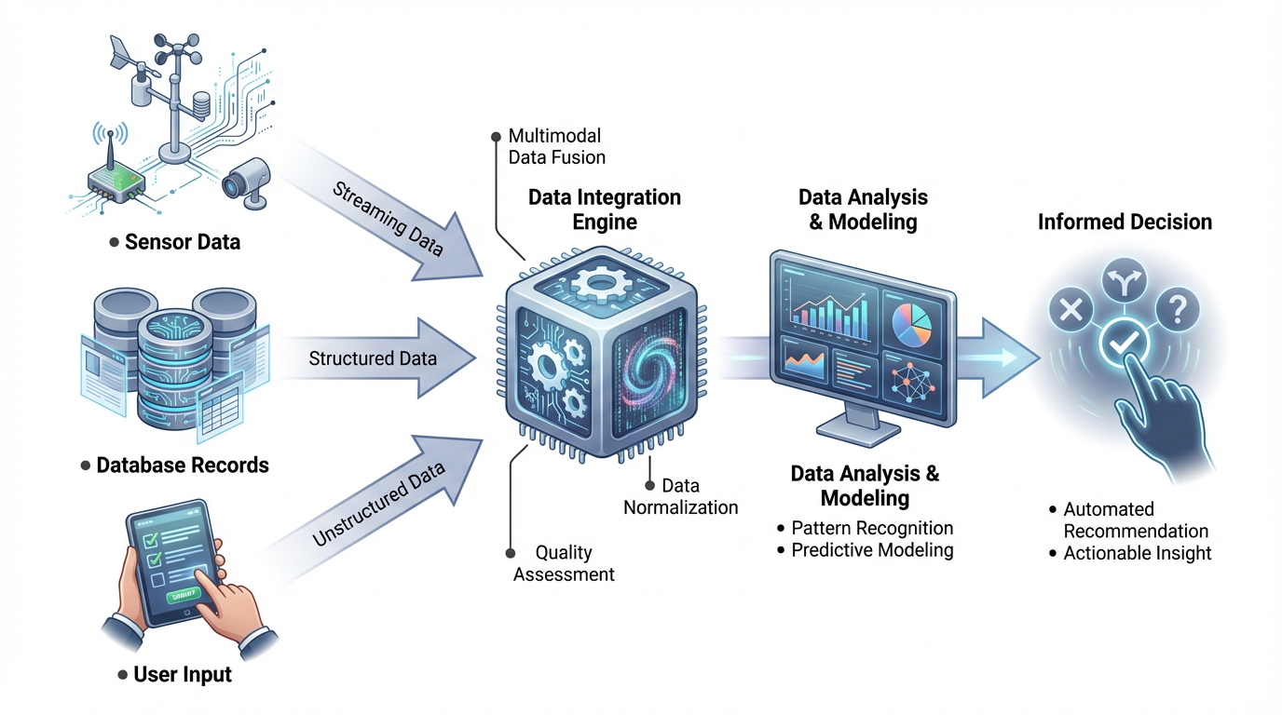
Figure 4. Integration of multi-source data combines inputs from sensors, satellites, weather data, and field observations to provide comprehensive insights for informed decision-making. It enhances precision, enabling timely and site-specific agricultural interventions for improved productivity and sustainability.
9. ENVIRONMENTAL AND ECONOMIC IMPACTS
9.1 Reduction in Chemical Inputs
Agriculture 5.0 technologies play a larger role in minimising chemical inputs by means of precision-based applications. Variable rate technology (VRT), artificial intelligence (AI)-based spraying, and sensor-based nutrient management tools are some of the tools that enable the application of fertilizers and pesticides on a site-specific basis. Research shows that digital agricultural technologies may help decrease the usage of fertilisers by 60% and 80%, and pesticides by 20% and 80%, which reduces the effects of environmental pollution and loss of inputs. Equally, the application of robotic spot-spraying systems has recorded a 65% reduction in herbicides, with a reduction in efficiency. This is a highly specific method that not only increases the cost of production but also decreases the pollution of soil and water and contributes to environmentally friendly agricultural structures (Getahun et al., 2024).
9.2 Climate Change Mitigation and Adaptation
Agriculture contributes greatly to the total greenhouse gas (GHG) emissions through its share of about 10-12%, which is very important and thus necessitates climate-smart interventions. The new technologies of Agriculture 5.0 can reduce climate change through the optimization of the usage of inputs, increased energy efficiency, and the introduction of renewable energy systems. It has been revealed that precision agriculture can cut carbon emissions by 15-25% and energy use by 10-20%. Moreover, the technologies can be used to improve climate adaptation through predictive modelling, real-time monitoring, and decision-making, which are based on data. The AI-driven systems have the capability to predict the variability of weather and optimise irrigation and nutrient control to enable farmers to deal with climate uncertainty. The second way to enhance resilience with climate-smart agricultural practices is the stabilization of yields and the minimization of risks related to extreme weather (Zheng et al., 2024).
9.3 Cost Efficiency and Profitability
Among the significant economic advantages of Agriculture 5.0, the enhanced cost-efficiency and the profitability of the farm are to be named. Farmers can greatly cut down on the cost of operations by maximizing the use of inputs, which include fertilizers, water, fuel, and labour. Digital agricultural technology has recorded significant cost savings in the inputs and has, at the same time, raised yields by up to 62% in certain instances. Other studies of meta-analyses clearly demonstrate that the use of precision agriculture technologies can raise the return on investment (ROI) by about 22% and net profit by about 18.5 percent. Moreover, agricultural practices that are climate-smart have a positive effect on household income and farm profitability due to their positive impacts on productivity and resource efficiency (Zheng et al., 2024). All these economic benefits result in the fact that Ag 5.0 is one of the strategies that will help farmers in the country to improve their lives and achieve a stable financial condition in the long run.
9.4 Sustainability and Resource Conservation
The main results of Agriculture 5.0 are sustainability and efficient conservation of resources. Precision technologies would allow us to make the best use of water, soil nutrients, and energy, minimize wastage, and conserve natural resources. As an illustration, the use of precise irrigation systems can decrease water consumption by 20-50%, whereas digital tools can spare on a total power expenditure and enhance the condition of the soil. Besides, agricultural activities like diversification, conservation agriculture, and integrated nutrient management yield sustainability in the health of an ecosystem in the long run. Studies indicate that diverse agricultural regimes would lead to an increase in biodiversity, better soil quality, and better carbon sequestration in the long run, besides causing an increase in profit. These are practices that minimize the degradation of the environment, increase resilience, and contribute to areas of environmental services, including nutrient cycling and climate regulation. Agriculture 5.0 overall develops a harmonious connection between environmental sustainability and economic feasibility. It offers an all-round approach to sustainable agricultural development in the midst of the global challenges by decreasing the input of chemicals, curbing climate change, enhancing profitability, and saving on resources.
10. CHALLENGES AND LIMITATIONS
Agriculture 5.0 has various limitations that restrain its mass adoption, especially among small farmers. The high start-up costs and the cost of the newest technologies are among the biggest obstacles since drones, sensors, robotics, and IoT-based systems are expensive. These technologies are costly to install, maintain, and train, and hence, they cannot be accessible to all farmers with low financial capabilities. The initial costs are always cited among the significant impediments, and this is particularly true in the developing world, where the income of the farms is not very high, and credit access is limited (Barnes et al., 2018). Another threat of serious concern in digital agriculture is data privacy and data security. Agriculture 5.0 will primarily rely on data collection and cloud-based analytics, which bring up concerns regarding the ownership, sharing, and protection of data. The common reason farmers do not readily embrace these technologies is the fear of abuse, a lack of transparency, and poor data governance systems. Studies point out that the fear of data sovereignty and privacy has been the most recognizable impediment to the implementation of smart farming technologies. Moreover, there is also a threat of cyberattacks and unauthorised access, which also compounds the trust in digital platforms.
The other weakness is a lack of technical knowledge and infrastructure. Agriculture 5.0 technologies need digital literacy, technical capacity, and complex data interpretation to make effective use. Several of the farmers, however, do not have proper training and extension services, hence do not make full use of the technologies at hand. It has been indicated that there is very limited awareness and a lack of technical expertise, which is a major obstacle to adoption, especially in rural and developing areas. These difficulties are even aggravated by the digital divide in rural regions. Real-time monitoring and decision-making require reliable internet connectivity, electricity, and digital infrastructure. Nevertheless, these fundamental facilities cannot be found in most rural areas, limiting the use of modern agricultural methods. In some developing nations, such as India, the lack of connectivity in rural areas and digital infrastructure persistently hinders the use of precision agriculture on a large scale. In general, such issues demonstrate that affordable technologies, better infrastructure, training of farmers, and a solid policy of data governance are the key factors to make the Agriculture 5.0 usage inclusive and sustainable.
11. POLICY FRAMEWORK AND INSTITUTIONAL SUPPORT
Agriculture 5.0 requires effective policy frameworks and well-established institutional support systems to support the effective implementation of the technology, innovation, and inclusive growth. The governments of the world, especially the developing nations such as India, are encouraging the use of digital agriculture by providing specific initiatives and policies. As an example, the Digital Agriculture Mission (2024) will develop a digital public infrastructure, including databases on farmers, geospatial infrastructure, and digital decision support tools, such as AgriStack and the Krishi Decision Support System, to make services more productive and effective (Papadopoulos et al., 2024). All these programs aim at the combination of data on soil, crops, weather, and markets, which allows evidence-based policymaking and advisory services in real-time. Also, the rural connectivity initiatives like BharatNet will play an important role in the infrastructure disparity and access to digital platforms by the farmers.
Public-private partnerships (PPP) are critical to empowering agricultural systems of innovation through a mix of public sector-based support and private sector-based efficiency and technological competence. PPP models help in the investments in agricultural infrastructure, online platforms, and the development of value chains, hence enhancing productivity and market access. Recent projects like the integrated agricultural investment portal are designed to simplify PPP-based projects and promote transparency to attract the involvement of the private sector in the development of other areas, such as agro processing, storage, and export zones. Researchers have shown that properly designed PPPs will facilitate extension delivery, advance climate-sensitive farming, and guarantee scalable and prolonged technological uptake when there is an evident administration and responsibility (Pandey et al., 2025).
The extension services and capacity building are also vital towards the successful uptake of Agriculture 5.0 technologies. To use modern tools of AI, IoT, and data analytics, farmers need training and technical expertise, as well as constant advisory services. Governments and institutions are paying more attention to digital extension systems, mobile-based advisory services, and skill development programs to improve the competencies of farmers. Training programs, farmer-producer organisations (FPOs), and digital advisory services are some of the initiatives that can be applied to overcome knowledge gaps and encourage inclusive participation. In addition, the digital platforms are integrated with the extension services, which leads to the timely distribution of information on the weather, pest outbreaks, and market prices to enhance decision-making and farm performance (Sanyaolu & Sadowski, 2024).
12. Future Prospects And Emerging Innovations
Agriculture 5.0 is the future that could be defined by the intersection of various innovative approaches in digital, biological, and engineering fields, which are intended to develop highly intelligent, autonomous, and sustainable farming systems. The combination of artificial intelligence (AI), robotics, and blockchain technologies is one of the most promising lines. The further development of AI and machine learning is likely to improve predictive analytics further and allow for accurate decisions regarding crop well-being, pest infestations, resource management, etc. Robotics will evolve to complete autonomy in farm functions such as planting, harvesting, and weeding with minimum human interference. Simultaneously, blockchain technology is becoming an important means of transparency, traceability, and security of agricultural supply chains to enable trust between stakeholders and enhance the efficiency of the market (Mohan et al., 2026; Raj and Prahadeeswaran, 2025). These technologies are set to combine to form efficient and resilient data-oriented agricultural ecosystems that are decentralized.
The other significant invention is the creation of smart farms and digital twin systems. Digital twins are virtual copies of the real farm systems that combine real-time data from sensors and IoT devices, and satellite images to emulate and optimize agricultural functions. The systems permit scenario analysis, prediction models, and risk evaluation, which help farmers to make wise decisions before taking any action in the field. Recent research indicates that the digital twin technology has the potential to have a major effect on productivity, resource-use efficiency, and sustainability since it can constantly adjust to the situation (Zhang et al., 2025). Smart farms, built on a combination of technologies, including AI, IoT, cloud computing, and edge computing, should become the foundation of the next generation of agriculture, and they will provide autonomous and self-optimizing systems that can react dynamically to environmental changes.
Other radical frontiers of Agriculture 5.0 are advancements in biosensors and nanotechnology. There is a growing development of biosensors to identify the health of plants, soil nutrients, pathogens, and environmental stress in real-time at the molecular scale. The sensors are able to deliver highly accurate data that can be used to enhance early detection of diseases and deficiencies, which will result in early interventions. Nanotechnology adds even more features to these features by allowing the delivery system of fertilisers, pesticides, and biostimulants to be targeted in order to boost the efficiency and cut on environmental impact. The new technologies like the Internet of Nano Things (IoNT) and bio-nano communication systems are projected to transform precision agriculture by offering extremely sensitive monitoring and control down to microscopic levels (Babar and Akan, 2024; Mashabela et al., 2025).
13. CASE STUDIES AND REAL-WORLD APPLICATIONS
13.1 Successful Implementation Examples Across Sectors
Agriculture 5.0 technologies have proven to have real-world effects on various industries with precision-based interventions. An example of successful implementation of precision agriculture, based on GPS and variable rate technology (VRT), in a soybean farm in the United States, showed that the method increased yield and saved water and nutrients (Zhong and Zhong, 2024). Equally, in the European wheat systems, nitrogen management through VRT enhanced energy efficiency by 13.3, and total energy input was reduced by 11.7, which shows economic benefit as well as environmental benefit. Variable rate irrigation (VRI) systems in the United States showed that the smart water management system could produce higher yields of cotton by 8% and less water by 15% (Et-taibi et al., 2024). Sensors - IoT-based animal health monitoring in livestock farming has been reported to enhance productivity and disease detection, whereas in precision crop monitoring, remote sensing by UAV and NDVI analysis have proven to be useful in yield prediction and crop health analysis. All of these developments demonstrate the transformative nature of smart farming technologies to optimize the use of resources and promote the overall output of farms, which is no longer a generalised approach to a highly localised and responsive one. In particular, smart sensors can offer important and up-to-date information about the conditions of the soil, the development of plants, and the environment, which will help make the right changes in the use of resources and identify possible problems in time (Manono et al., 2026). In combination, these case studies demonstrate the use of digital technologies to increase productivity, decrease input consumption, and facilitate sustainable agriculture within the sectors.
13.2 Comparative Analysis of Traditional vs Smart Farming
The conventional methods of farming are generally based on the use of homogeneous inputs and manual decisions, which usually result in inefficiencies and waste. An example is that the use of conventional fertilizers does not consider spatial variations in fields, leading to either excessive or reduced application of inputs. By contrast, the Agriculture 5.0 uses smart farming, where tools like the IoT sensors, artificial intelligence, and remote sensing collect and analyze data to allow site-specific management (Gire, 2025). Precision agricultural practices maximize agricultural production and quality at minimum costs and with less environmental degradation. Such technologies as yield mapping and real-time monitoring enable farmers to detect variability in the fields and modify practices to enhance efficiency and profitability. Moreover, smart farming systems minimize the consumption of water, fertilisers, and pesticides, protect or improve the yields, and increase sustainability (Danish et al., 2022). On the whole, conventional agriculture is still labour-intensive and less accurate, whereas smart farming has great benefits regarding productivity, efficiency of resource usage, and environmental sustainability, which makes it a major element of the new agricultural systems.
14. CONCLUSION
Agriculture 5.0 is a paradigm shift to highly integrated, intelligent, and sustainable farming systems by integrating robotics, artificial intelligence (AI), and the Internet of Things (IoT) in crop production, horticulture, livestock and fisheries, and agroforestry. The most important results of this review include the fact that real-time soil and water monitoring, as well as AI-based insect pest and disease detection, can increase the efficiency of resource use, minimise input costs, and make accurate and data-driven decisions. All these technologies make productivity and reducing the environmental effects more effective and contribute to the maintenance of climate-resistant agriculture. Agriculture 5.0 has a significant role to play in food security in the future because it aims to meet the rising food demand within limited natural resources, climate change, and labor crisis by guaranteeing increased crop yields, better quality, and sustainable intensification. Moreover, the ability to incorporate various agricultural sectors into a single digital ecosystem makes the farms more resilient and competitive in general. However, to successfully adopt and scale it, several actions are required, among them investment in digital infrastructure, low-cost access to technology by smallholders, capacity building via training and extension services, and enabling policy frameworks to stimulate innovation and collaboration between the public and the private. Open data platforms, localised solutions, and technologies that are user-friendly should be encouraged further to assist in adoption. Conclusively, the Agriculture 5.0 project is far-reaching in transforming the world by creating a balance between technology and the environment, which ultimately guarantees the global food and nutritional security in the long term.

Disclaimer (Artificial intelligence)

Author(s) hereby declare that NO generative AI technologies such as Large Language Models (ChatGPT, COPILOT, etc.) and text-to-image generators have been used during the writing or editing of this manuscript.

References
- A, K., and Vadivel, R. (2024). Optimized water management for precision agriculture using IoT-based smart irrigation system. World Journal of Advanced Research and Reviews, 21(3), 802–811. https://doi.org/10.30574/wjarr.2024.21.3.0682
- Abdelmoneim, A. A., Kimaita, H. N., Kalaany, C. M. A., Derardja, B., Dragonetti, G., and Khadra, R. (2025). IoT Sensing for Advanced Irrigation Management: A Systematic review of trends, challenges, and future Prospects. Sensors, 25(7), 2291. https://doi.org/10.3390/s25072291
- Achury, R., Heinen, R., Meyer, S. T., and Weisser, W. W. (2026). Future agricultural policies need to integrate biodiversity targets into smart farming. Npj Sustainable Agriculture, 4(1). https://doi.org/10.1038/s44264-026-00133-0
- Agrawal, J., and Arafat, M. Y. (2024). Transforming Farming: A Review of AI-Powered UAV Technologies in Precision Agriculture. Drones, 8(11), 664. https://doi.org/10.3390/drones8110664
- Ahmad, L., & Nabi, F. (2021). Agriculture 5.0: artificial intelligence, IoT and machine learning. CRC Press.
- Ahmed, N., and Shakoor, N. (2025). Advancing agriculture through IoT, Big Data, and AI: A review of smart technologies enabling sustainability. Smart Agricultural Technology, 10, 100848. https://doi.org/10.1016/j.atech.2025.100848
- Ajay, A., Bisht, A. S., Chauhan, S. S., Uppuluri, P., Nidjelli, D. N., Muthireddy, D. K., Erramchetty, S. K., and M, M. K. (2025). LeafVisionNet: A deep learning-based approach for the classification of black gram leaf disease using attention-driven and semi-local feature boosted SqueezeNet. Smart Agricultural Technology, 12, 101245. https://doi.org/10.1016/j.atech.2025.101245
- Ali, M. U. (2025). Smart Agriculture: Integration of IoT, AI and big data in farm management. Journal of Scientific Research and Reports, 31(12), 114–122. https://doi.org/10.9734/jsrr/2025/v31i123756
- Anam, I., Arafat, N., Hafiz, M. S., Jim, J. R., Kabir, M. M., and Mridha, M. F. (2024). A systematic review of UAV and AI integration for targeted disease detection, weed management, and pest control in precision agriculture. Smart Agricultural Technology, 9, 100647. https://doi.org/10.1016/j.atech.2024.100647
- Arzoo, and Singh, G. (2024). Advancements and challenges in sustainable agriculture: A comprehensive review. International Journal of Research in Agronomy, 7(8), 385–389. https://doi.org/10.33545/2618060x.2024.v7.i8f.1259
- Babar, A. Z., and Akan, O. B. (2024). Sustainable and Precision Agriculture with the Internet of Everything (IoE). arXiv (Cornell University). https://doi.org/10.48550/arxiv.2404.06341
- Barnes, A. P., Soto, I., Eory, V., Beck, B., Balafoutis, A., Sánchez, B., Vangeyte, J., Fountas, S., Van Der Wal, T., and Gómez-Barbero, M. (2018). Exploring the adoption of precision agricultural technologies: A cross regional study of EU farmers. Land Use Policy, 80, 163–174. https://doi.org/10.1016/j.landusepol.2018.10.004
- Barrios-Ulloa, A., Solano-Barliza, A., Arrubla-Hoyos, W., Ojeda-Beltrán, A., Cama-Pinto, D., Arrabal-Campos, F. M., and Cama-Pinto, A. (2025). Agriculture 5.0 in Colombia: Opportunities through the emerging 6G network. Sustainability, 17(15), 6664. https://doi.org/10.3390/su17156664
- Bergier, I., Barbedo, J. G. A., Bolfe, É. L., Romani, L. a. S., Inamasu, R. Y., and Massruhá, S. M. F. S. (2024). Framing Concepts of Agriculture 5.0 via bipartite analysis. Sustainability, 16(24), 10851. https://doi.org/10.3390/su162410851
- Bissadu, K. D., Sonko, S., and Hossain, G. (2024). Society 5.0 enabled agriculture: Drivers, enabling technologies, architectures, opportunities, and challenges. Information Processing in Agriculture, 12(1), 112–124. https://doi.org/10.1016/j.inpa.2024.04.003
- Danish, S., Ali, H., Datta, R., Shahbaz, P., Haq, S. ul, Boz, İ., Alexy, M., Jung, A., Molnár, B., Shankar, R., Govindakrishnan, M., Rawat, S., Sherly, J., & Govindakrishnan, P. M. (2022). Smart Farming - Integrating Conservation Agriculture, Information Technology, and Advanced Techniques for Sustainable Crop Production. In IntechOpen eBooks. IntechOpen. https://doi.org/10.5772/intechopen.102141
- Duguma, A. L., and Bai, X. (2024). How the internet of things technology improves agricultural efficiency. Artificial Intelligence Review, 58(2). https://doi.org/10.1007/s10462-024-11046-0
- Et-taibi, B., Abid, M. R., Boufounas, E., Morchid, A., Bourhnane, S., Hamed, T. A., & Benhaddou, D. (2024). Enhancing water management in smart agriculture: A cloud and IoT-Based smart irrigation system. Results in Engineering, 22, 102283. https://doi.org/10.1016/j.rineng.2024.102283
- Getahun, S., Kefale, H., and Gelaye, Y. (2024). Application of Precision Agriculture Technologies for Sustainable crop Production and Environmental Sustainability: A Systematic review. The Scientific World JOURNAL, 2024(1), 2126734. https://doi.org/10.1155/2024/2126734
- Ghosh, A., Sarkar, R., and Barman, D. (2026). Context-Aware pesticide recommendation via Few-Shot Pest Recognition for Precision Agriculture. arXiv (Cornell University). https://doi.org/10.48550/arxiv.2601.00243
- Gire, T. (2025). Human-Centered AI in Smart Farming: Toward Agriculture 5.0. International Journal for Research in Applied Science and Engineering Technology, 13(10), 1569. https://doi.org/10.22214/ijraset.2025.74813
- Gupta, G., and Pal, S. K. (2025). Applications of AI in precision agriculture. Discover Agriculture, 3(1). https://doi.org/10.1007/s44279-025-00220-9
- Kalaivani, T. S., Kamireddy, T., and Govindakumar, S. (2025). IoT-Enabled Soil and Crop Monitoring System Using Low-Cost Smart Sensors for Precision Agriculture. Engineering Proceedings, 77. https://doi.org/10.3390/ecsa-12-26537
- Khan, A., Malebary, S. J., Dang, L. M., Binzagr, F., Song, H.-K., and Moon, H. (2024). AI-Enabled Crop Management Framework for pest detection using visual sensor data. Plants, 13(5), 653. https://doi.org/10.3390/plants13050653
- Kučera, P. (2025). Advancements in Soil Health Monitoring Using Smart Sensors: A Precision Farming Approach. Europian Journal of Precision Agriculture e-ISSN 3051-0244, 1(01), 9-16.
- Liu, X., Zhao, Z., and Rezaeipanah, A. (2025). Intelligent and automatic irrigation system based on internet of things using fuzzy control technology. Scientific Reports, 15(1), 14577. https://doi.org/10.1038/s41598-025-98137-2
- Manono, B. O., Mwami, B., Mutavi, S., & Nzilu, F. M. (2026). Precision Farming with Smart Sensors: Current State, Challenges and Future Outlook. Sensors, 26(3), 882. https://doi.org/10.3390/s26030882
- Mashabela, M. D., Terefe, T., Kerchev, P., Sitole, L., and Mhlongo, M. I. (2025). Next-generation biostimulants: molecular insights, digital integration, and regulatory frameworks for sustainable agriculture. Frontiers in Plant Science, 16, 1710899. https://doi.org/10.3389/fpls.2025.1710899
- Miller, T., Mikiciuk, G., Durlik, I., Mikiciuk, M., Łobodzińska, A., and Śnieg, M. (2025). The IoT and AI in Agriculture: The Time Is Now—A Systematic Review of Smart Sensing Technologies. Sensors, 25(12), 3583. https://doi.org/10.3390/s25123583
- Mishra, H. (2025). A review on Artificial Intelligence, Machine Learning and IoT integration in Precision Agriculture. Journal of Scientific Agriculture, 101–109. https://doi.org/10.25081/jsa.2025.v9.9497
- Mohan, R. N. V. J., Rayanoothala, P. S., and Sree, R. P. (2026). Smart agriculture 5.0: blockchain and reinforcement learning synergy for multicropping optimization and traceable IoT-Enabled supply chains. Frontiers in Blockchain, 9. https://doi.org/10.3389/fbloc.2026.1766232
- Mohapatra, H. (2025). A LoRa IoT Framework with Machine Learning for Remote Livestock Monitoring in Smart Agriculture. ArXiv.Org. https://doi.org/10.48550/arxiv.2510.07322
- Naim, M., and Boukhizzou, A. (2026). Animating the transition: How agriculture 5.0 revitalises agroecological principles. Smart Agricultural Technology, 13, 101788. https://doi.org/10.1016/j.atech.2026.101788
- Pandey, M. K., Singh, M., Sulekha, Rana, P., Tripathi, S., Vishwakarma, S. K., Pandey, A., and Shastri, S. (2025). Public-Private Partnerships in Agricultural Extension: Opportunities and challenges. Journal of Experimental Agriculture International, 47(6), 597–612. https://doi.org/10.9734/jeai/2025/v47i63520
- Papadopoulos, G., Arduini, S., Uyar, H., Psiroukis, V., Kasimati, A., and Fountas, S. (2024). Economic and environmental benefits of digital agricultural technologies in crop production: A review. Smart Agricultural Technology, 8, 100441. https://doi.org/10.1016/j.atech.2024.100441
- Raj, M., and Prahadeeswaran, M. (2025). Revolutionizing agriculture: a review of smart farming technologies for a sustainable future. Discover Applied Sciences, 7(9). https://doi.org/10.1007/s42452-025-07561-6
- Rane, N. L. (Ed.). (2024). Artificial Intelligence and Industry in Society 5.0. Deep Science Publishing.
- Razak, S. F. A., Yogarayan, S., Sayeed, M. S., and Derafi, M. I. F. M. (2024). Agriculture 5.0 and Explainable AI for Smart Agriculture: A scoping review. Emerging Science Journal, 8(2), 744–760. https://doi.org/10.28991/esj-2024-08-02-024
- Reza, M. N., Lee, K.-H., Karim, M. R., Haque, M. A., Bicamumakuba, E., Dey, P. K., Jang, Y. Y., and Chung, S.-O. (2025). Trends of soil and solution nutrient sensing for open field and hydroponic cultivation in facilitated smart Agriculture. Sensors, 25(2), 453. https://doi.org/10.3390/s25020453
- Sakka, M. E., Ivanovici, M., Chaari, L., and Mothe, J. (2025). A review of CNN applications in smart agriculture using multimodal data. Sensors, 25(2), 472. https://doi.org/10.3390/s25020472
- Sanyaolu, M., and Sadowski, A. (2024). The role of precision Agriculture Technologies in enhancing Sustainable agriculture. Sustainability, 16(15), 6668. https://doi.org/10.3390/su16156668
- Schulthess, L., Longchamp, F., Vogt, C., and Magno, M. (2024). A LORA-Based and Maintenance-Free cattle monitoring system for alpine pastures and remote locations. arXiv (Cornell University). https://doi.org/10.48550/arxiv.2406.06245
- Senapaty, M. K., Ray, A., and Padhy, N. (2023). IOT-Enabled Soil Nutrient Analysis and Crop Recommendation Model for Precision agriculture. Computers, 12(3), 61. https://doi.org/10.3390/computers12030061
- Sharma, D., and Tomar, G. S. (2024). Soil nutrient analysis and automatic monitoring in precision agriculture. Communications in Soil Science and Plant Analysis, 56(2), 145–166. https://doi.org/10.1080/00103624.2024.2406478
- Sidik, A. R., Tawakal, A., Sumirat, G. S., and Narputro, P. (2025). Smart Irrigation Based on Soil Moisture Sensors with Photovoltaic Energy for Efficient Agricultural Water Management: A Systematic Literature Review. Engineering Proceedings, 17. https://doi.org/10.3390/engproc2025107017
- Singh, A. K., & Singh, D. R. (2024). Agriculture 5.0: Smart technologies for sustainable farming and farmer empowerment. Journal of AgriSearch, 11(4), 225–233. https://doi.org/10.21921/jas.v11i04.15212
- Song, W., Li, X., Zhang, J., Huang, J., Wang, J., Feng, W., Guo, Y., and Ren, L. (2026). Soil Sensors in Smart Agriculture: Multi-Type monitoring technologies and Ecological development Pathways. Agriculture, 16(3), 359. https://doi.org/10.3390/agriculture16030359
- Surve, V., Hitesh, Patel, H. H., and Payal. (2024). Sensor Based Irrigation Management in Crop Production: A review. Annual Research & Review in Biology, 39(4), 1–4. https://doi.org/10.9734/arrb/2024/v39i42068
- Wolfert, S., Ge, L., Verdouw, C., and Bogaardt, M.-J. (2017). Big Data in Smart Farming – A review. Agricultural Systems, 153, 69–80. https://doi.org/10.1016/j.agsy.2017.01.023
- Zhang, R., Zhu, H., Chang, Q., and Mao, Q. (2025). A Comprehensive review of Digital Twins Technology in agriculture. Agriculture, 15(9), 903. https://doi.org/10.3390/agriculture15090903
- Zheng, H., Ma, W., and He, Q. (2024). Climate-smart agricultural practices for enhanced farm productivity, income, resilience, and greenhouse gas mitigation: a comprehensive review. Mitigation and Adaptation Strategies for Global Change, 29(4). https://doi.org/10.1007/s11027-024-10124-6
- Zhong, Y., and Zhong, S. (2024). Development of precision agriculture techniques for soybean yield improvement. Biological Evidence. https://doi.org/10.5376/be.2024.14.0027
- Zhu, H., Lin, C., Liu, G., Wang, D., Qin, S., Li, A., Xu, J.-L., and He, Y. (2024). Intelligent agriculture: deep learning in UAV-based remote sensing imagery for crop diseases and pests detection. Frontiers in Plant Science, 15, 1435016. https://doi.org/10.3389/fpls.2024.1435016
- Aijaz, N., Lan, H., Raza, T., Yaqub, M., Iqbal, R., & Pathan, M. S. (2025). Artificial intelligence in agriculture: Advancing crop productivity and sustainability. Journal of Agriculture and Food Research, 20, 101762.

- Taha, M. F., Mao, H., Zhang, Z., Elmasry, G., Awad, M. A., Abdalla, A., Mousa, S., Elwakeel, A. E., & Elsherbiny, O. (2025). Emerging Technologies for Precision Crop Management Towards Agriculture 5.0: A Comprehensive Overview. Agriculture, 15(6), 582. https://doi.org/10.3390/agriculture15060582

- Qwaid MA, Sarker MT, Shawon SM, Zubair HT. AI-enabled smart farming framework for sustainable date palm cultivation in arid regions using machine learning and IoT integration. Sci Rep. 2026 Jan 13;16(1):5125. doi: 10.1038/s41598-026-36106-z. PMID: 41526481; PMCID: PMC12877140.

