An Agronomic Review of Finger Millet (Eleusine coracana): Adaptability, Nutritional Value and Importance for Sustainable Agriculture

ABSTRACT
In nutritional security millets play an important role due to their high nutritional value, which emphasizes the importance of encouraging their production and use. For human societies millets have been a staple meal for centuries, particularly in Asia and Africa. Millets are reliable source of dietary energy, providing around 320–370 kcal/100 g of consumption. Finger millet grows easily in high altitude areas and is cultivated in the Himalayan regions up to an altitude of about 3,000 metres above sea level. Globally food insecurity remains a major challenge due to unfavourable and changing climatic conditions that limit crop productivity in many regions. Several staple crops are highly sensitive to abiotic stresses such as drought, heat, and poor soil fertility, which further threaten sustainable food production. In this context finger millet emerges as a climate resilient and nutritionally rich crop capable of thriving under marginal and stress prone environments. Ragi is a good source of bioactive compounds, dietary fiber and essential micronutrients with particularly good amount of calcium content compared to most other cereals. This review article examines the morphology, ecological adaptability, nutrition composition, health benefits, and food security potential of finger millet.
Key words- Climate Resilient, Finger millet, Gluten Free, Nutritional Security.
Introduction
Earth's ecosystem possesses an amazing ability to maintain ecological equilibrium by providing essential conditions such as a life-supporting atmosphere, adequate water resources, and a stable temperature range. These factors enable the survival of diverse life forms and ensure the continuity of natural cycles (Greenfield Emily).
However, Changes in the environment brought about by humans often lead to habitat degradation, ecological imbalance, and the decline or extinction of numerous plant and animal species. A major cause of this problem is the narrow approach focused on a few numbers of crops for human consumption. Globally, agriculture depends primarily on a few staple crops, such as maize, rice, and wheat, because of higher yields and high nutritional value. Although these crops are important, excessive dependence on them has led to the neglect of many other edible and nutrient-rich plant species.Such neglect reduces agricultural diversity and increases vulnerability to pests, diseases and climate change. As a result, biodiversity loss happens at both the species and genetic levels, reducing ecosystem resilience and threatening long-term food security. Therefore, it is essential to conserve and enhance a wide range of plant species to maintain ecological balance and ensure a stable future for both natural systems and human societies. (Thilsted et al., 2023).
Drought is a significant abiotic factor that limits crop productivity in arid and semi-arid regions. Under drought conditions, millet grows better than most other cereals because of its climate-resilient properties, including high tolerance to environmental stresses, minimal water requirements, and good growth and yield stability (Mude et al., 2020).
Millet is a type of small-grain annual cereal crop belonging to the family Poaceae. They are known for their exceptional resilience, having the ability to thrive in marginal and low-fertility soils and adapt effectively to hot, dry, and barren environmental conditions (Patil et al., 2023).
Due to high nutritional value millets play a vital role in nutritional security, which underlines the need to promote its cultivation and consumption. Historically, especially in Asia and Africa, millet has been an important staple food for human populations. However, over the last three decades, the apparent consumption of sorghum and other millets has declined. This reduced demand has resulted in a significant decline in millet production in India. For example, sorghum production decreased from seven million tonnes in 2010-2011 to 4.2 million tonnes in 2015-2016. In the same way, over the same time period, the production of small millet fell from 0.44 million tonnes to 0.39 million tonnes, ragi fell from 2.2 million tonnes to 1.8 million tonnes, and Bajra fell from 10.4 million tonnes to 8.1 million tonnes (Rao et al.,2017).
Millets are very good source of dietary energy, providing about 320–370 kcal per 100 g of intake. They are higher in fiber and lower in starch than other staple grains, with carbohydrates comprising approximately 65–75% of their total weight. The millets dietary fiber provides several health benefits, including improved gastrointestinal function, better blood lipid profiles, and better regulation of amount of blood sugar. Due to its minimum gluten and minimum glycemic index, millet is especially suitable for people with diabetes and celiac disease (Gowda et al.,2022).
Ragi is a cereal grain of the Poaceae family that is frequently grown in semi-arid and arid environments. The name Eleusine (genus) is derived from Eleusis, a city historically associated with agriculture in Greece, while the name coracana (species) comes from the Sinhala word kurukkan, which means grain. In Sanskrit, finger millet is called as Ragi, a term derived from Rajika, meaning red (Negi et al., 2017). About 3,000 years ago, ragi was brought to India from its native highlands in Ethiopia. This crop is well adapted to high altitude environments and can be successfully grown at altitudes up to 3,000 metres above sea level in the Himalayan region (Goswami et al., 2015).
Ragi seeds are used in the preparation of different types of traditional foods, including porridge, fermented products, unleavened bread and are also used in alcohol production. Because of its high dietary fibre content and associated health benefits, the demand for Ragi has increased, especially among the urban population (Yogeesh et al., 2021).
Origin of Finger millet
Cultivated finger millet was first domesticated around 5,000 years ago in Ethiopia's highlands and western Uganda. The cultivation of finger millet later spread to India's Western Ghats approximately 3000 BC.
Domestication- Ethopian Highlands and Western Uganada in 5000 years ago
3000 BCE- Introduced in India
Taxonomy of Finger millet
Table 1. Taxonomic classification of finger millet (Eleusine coracana (L.) Gaertn.)
CLASSIFICATION
Kingdom | Plantae
Order | Poales
Family | Poaceae (Graminae)
Subfamily | Chloridoideae
Genus | Eleusine
Sub Species | E. coracana ssp. coracana)  E. coracana ssp. africana)
Finger millet species has 2 subspecies africana and coracana (L.) Gaertn. africana Subspecies has two races, africana and spontanea and subspecies coracana has four races, elongata, plana, compacta and vulgaris (Upadhyaya et al.,2008).

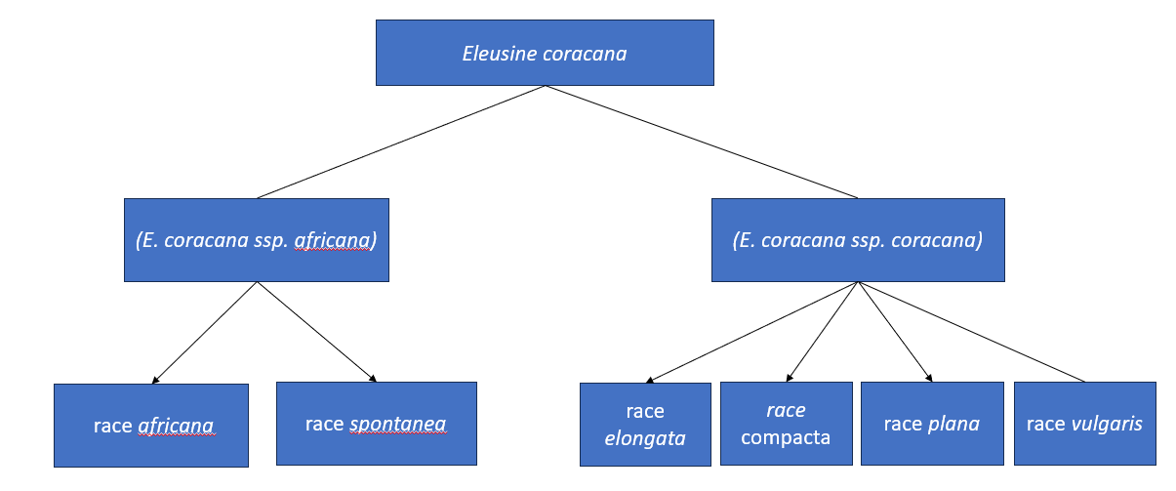
Fig 1. Sub Species and race of Finger millet

Morphology of finger millet
Morphologically, finger millet is a tufted annual grain, attaining a height of approximately 30-150 cm and complete life cycle within 75-160 days (Marakana et al.,2025).
The Ragi inflorescence is made up of a terminal whorl containing 02 to 10 spikes, usually five or six. These spikes emerge from the tip of the peduncle and spread out in a pattern that resembles a bird’s foot.
The lowermost spike is located about 2 to 5 cm away from the others, whereas the other remaining spike arises from a common point at the stem's end. The remaining spikes are known as the "fingers". whereas this basal spike is known as "thumb" because it resembles a bird's thumb or first claw. Each finger contains around 70 spikelets, and every spikelet has 5 to 7 well-developed florets. In a spikelet, the flowering process proceeds from the base upwards, while within a finger it proceeds from the highest spikelet downward. Generally, an earhead contains between 1,500 and 3,000 flowers with a flowering duration of about six to ten days, and the highest number of flowers opening on the third day following onset.
The grains are spherical and smooth, with a thin, transparent, and loosely attached pericarp. The naked grain is roughly spherical, and its colour can vary from reddish brown, black, brown, purple, orange red to white. The grain has a slightly flattened base and has a small indentation on it known as the hilum. A subtle flattening of the grain indicates the position of the embryo. The two integuments of the ovule give rise to seed coat, which stay distinct except at the base. At early developmental stages, the cells of the inner layer are nearly double the size of outer layer (Swamy K.R.M. 2023).
Stem: Slender, erect, and smooth
Ragi: Shallow, branched fibrous root system
Leaves: Narrow, grass-like appearance
Leaf sheath: Flattened, over lapping, split along the entire length
Leaf blade: a prominent midrib, ligule, a fringe of hairs. Leaf blade is linear and taper to an acute point, folded and striated and often with ciliated margins.
Ligule :1 to 2 mm long, fimbriate.
Panicle: Arises from a long peduncle
Grain: Smooth and Rounded
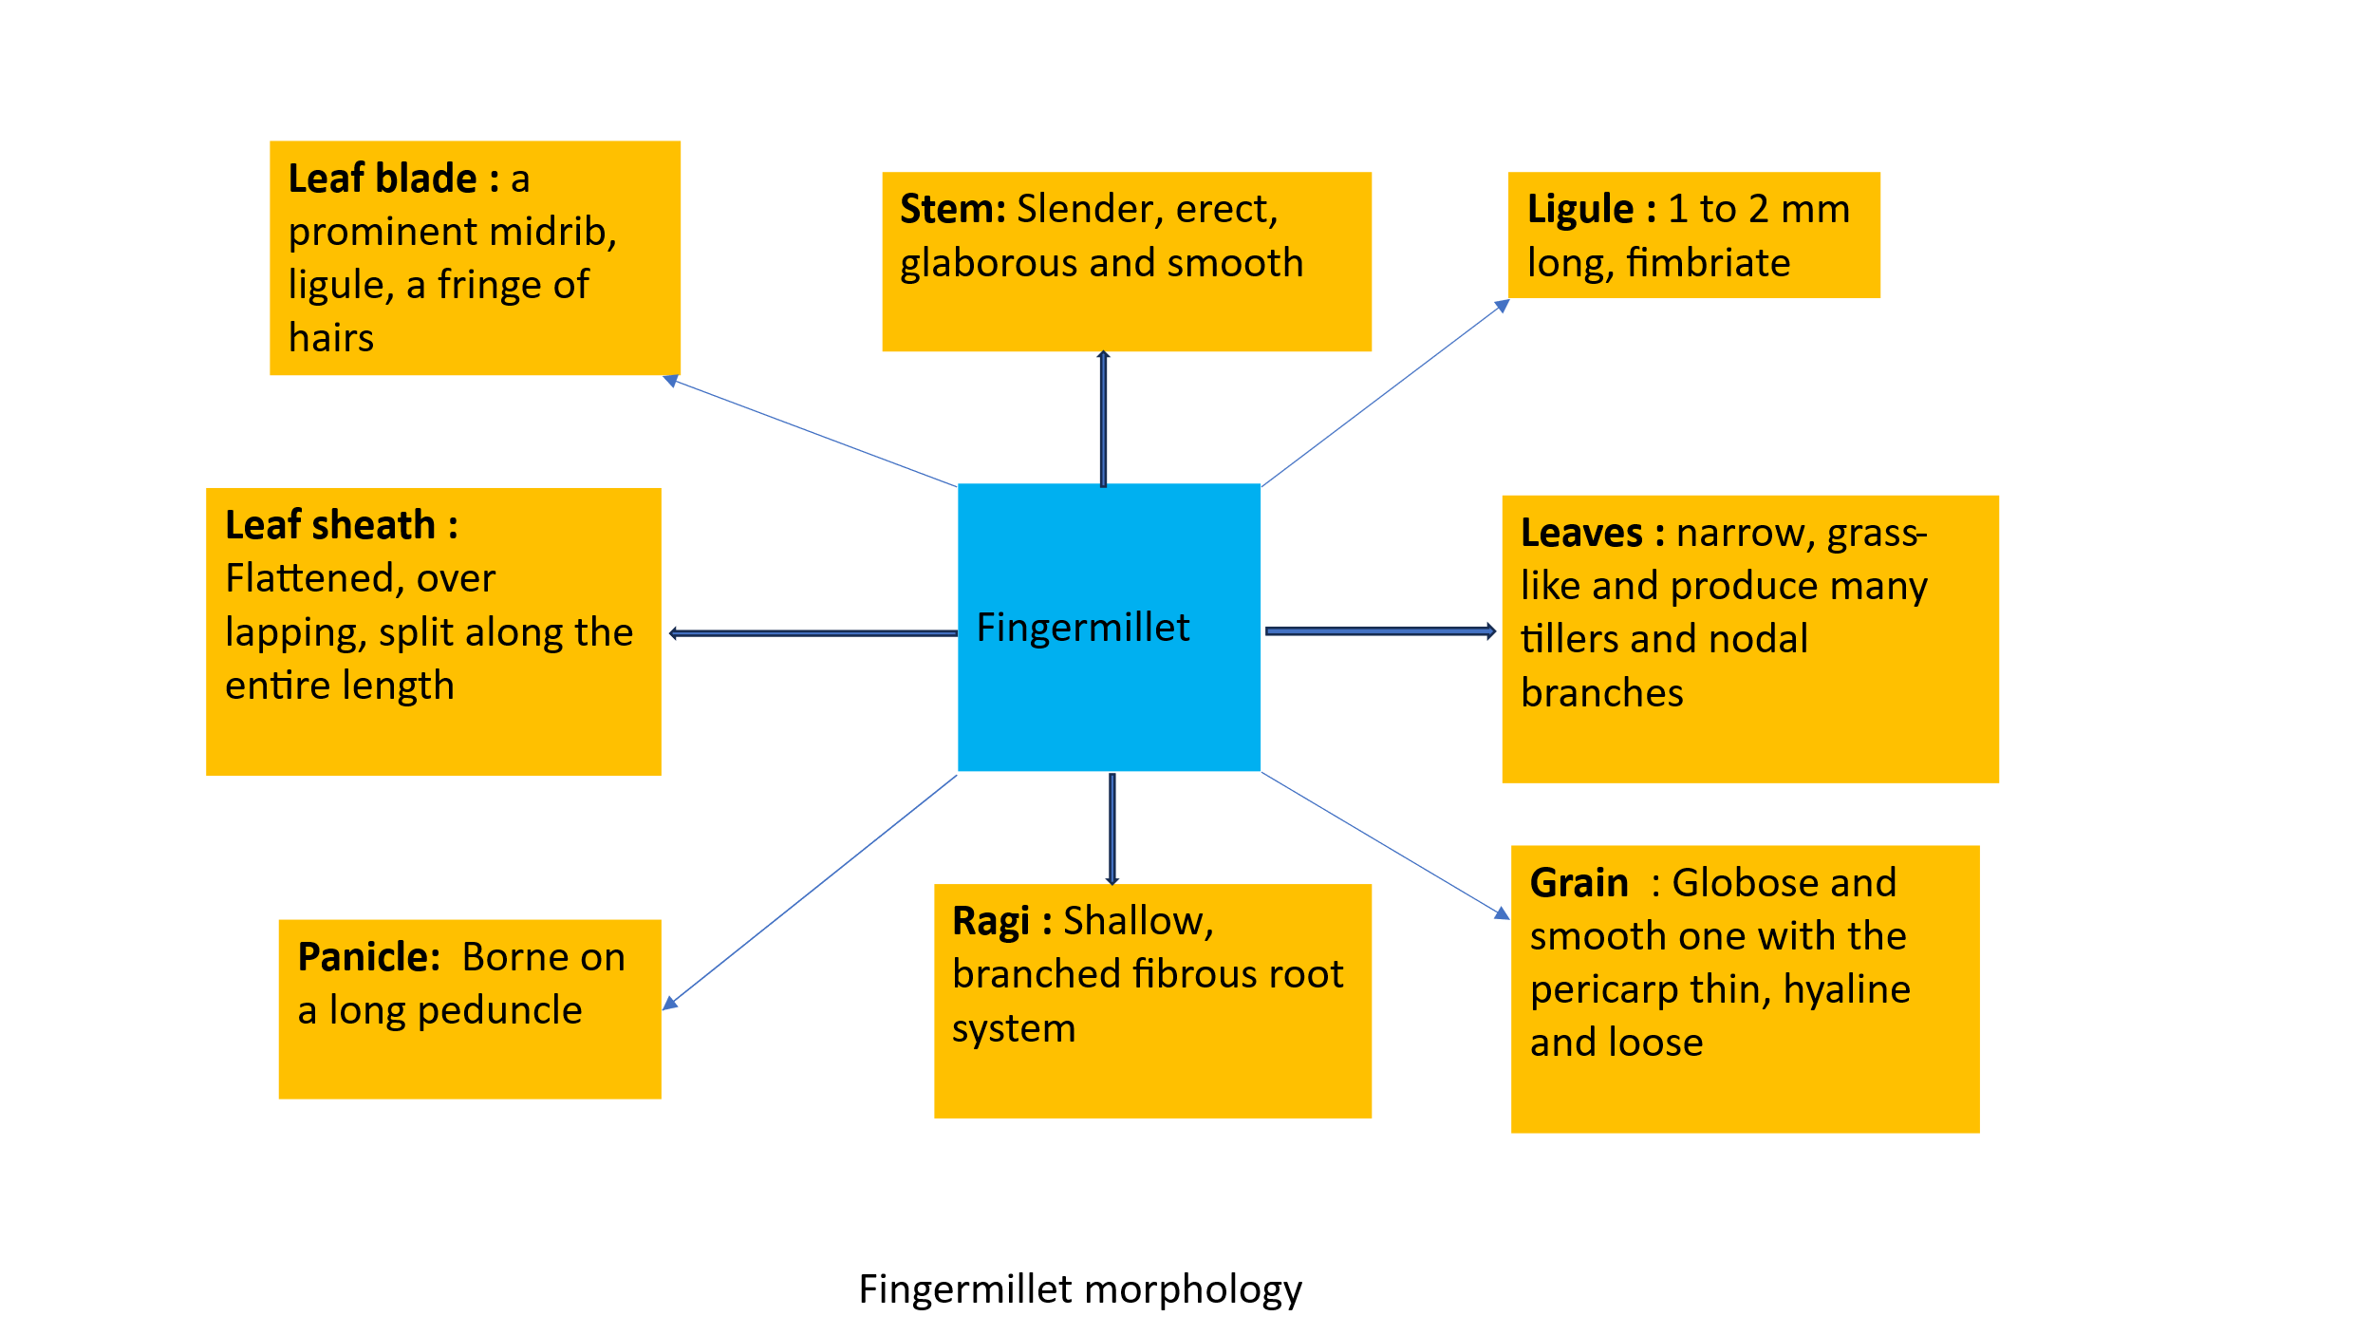
Fig 2. Morphological features of finger millet

Finger millet possesses high water use efficiency, a robust root system, and adaptable morphological traits that enhance drought resistance. Biochemical reactions such as the accumulation of proline and soluble sugars reduce osmotic stress and oxidation damage. Molecular studies have identified key drought-responsive genes (EcDehydrin7, EcNAC67, EcbZIP60) and revealed homologous relationships with Poaceae species, facilitating gene transfer for breeding (Srikant et al.,2025)

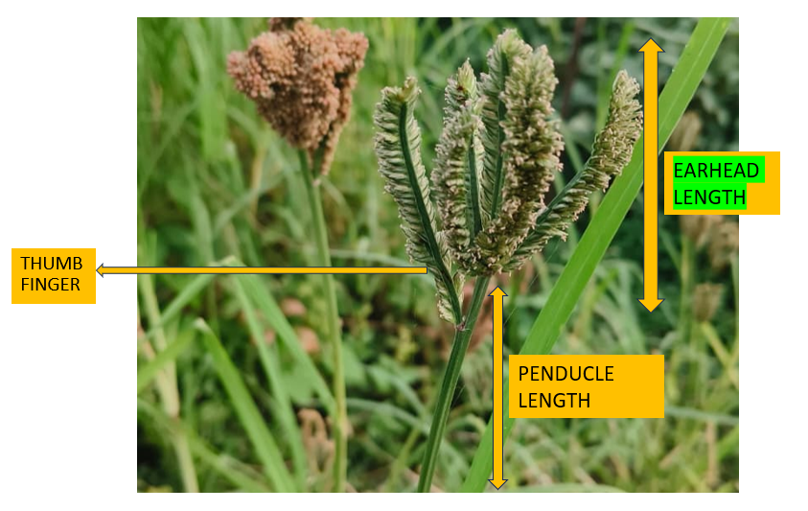
Fig 3. Panicle of Finger Millet

Agro-Ecological Adaptability of Finger Millet
Finger millet grows easily in high altitude areas and is is successfully cultivated in the Himalayas at elevations upto 3,000 meters (Bisht and Singh, 2009).
Its cultivation is mainly confined to hilly areas, marginal and dry lands and famine-prone areas, where the crop is mainly grown by tribal and small-scale farmers under rain-fed conditions. India is the world’s largest producer of ragi, with around 1.19 million hectares under cultivation and producing 1.98 million tonnes, with an average output of 1,661 kilograms per hectare (Sakamma et al., 2017; Sood et al., 2019).
Ragi can be cultivated in rainfed conditions and in areas with limited rainfall ranging from 200 mm to 500 mm. (Karki et al.,2020). Ragi crop performs best in soil with moderate rainfall, with temperatures between 11 and 27 °C, and pH between 5.0 and 8.2 (Upadhyaya et al.,2008).
Nutritional Composition of Finger Millet
Ragi is rich in nutrients that serves as an importatnt source of essential micronutrients, dietary fiber and bioactive compounds, with a particularly high calcium content compared to most other grains. The grain contains approximately 72–79.5% total carbohydrates, with starch making up about 59.4–70.2%. This starch fraction serves as the primary energy source and influences the grain’s processing qualities in food use. The finger millet grain consists of the seed coat, embryo and endosperm, in its structure. The outer covering of the seed composed of five distinct layers and is abundant in dietary fiber, polyphenols, and antioxidant compounds (Karki et al.,2020).
Finger millet shows an exceptionally high calcium concentration (approx. 344 mg/100 g), Which is about ten times more than commonly consumed grains like wheat (41 mg per 100 g), maize (26 mg per 100 g), and rice (33 mg per 100 g). The special thing is that the amount of calcium in it is almost three times more than that in milk. Due to its high calcium content, finger millet is recognised as a nutritionally superior crop.. It provides a significant source of calcium in the diets of people in developing tropical and subtropical areas, particularly where calcium-rich food options are often limited (Maharajan et al., 2021).

Table 2. Approximate Nutritional Composition (per 100 g) of Fingermillet
Approximate Composition and Dietary Fibre (per 100 g) of Fingermillet
Protein (g) |  | 07.16 ± 0.63
Ash (g) |  | 02.04 ± 0.34
Total Fat (g) |  | 01.92 ± 0.14
Dietary fibre (g) | Total | 11.18 ± 1.14
Dietary fibre (g) | Insoluble | 09.51 ± 0.65
Dietary fibre (g) | Soluble | 01.67 ± 0.55
Carbohydrates (g) |  | 66.82 ± 0.73
Energy (KJ) |  | 1342 ± 10
Source : Indian Food Composition Tables, NIN – 2017

Health Benefits of Finger Millet
• Rich Source of Calcium - Ragi is high in calcium, which helps in bone mineralization, skeletal development and prevention of osteoporosis. As a result, regular consumption of calcium-rich foods such as ragi porridge (ragi kanji) is frequently recommended as a natural dietary alternative to calcium supplements for supporting skeletal health (Vagdevi et al.,2023). Calcium (Ca) is essential for numerous important regulatory and physiological activities in the human body, including nerve impulse transmission, muscle contraction and relaxation, and blood coagulation cascade regulation. Additionally, it is essential for the activation of various enzymes and the stimulation and regulation of hormone secretion, thereby support normal metabolic and cellular functions (Pravina et al., 20 13).
• High Dietary Fiber Content-
Ragi's high fiber improves digestive health, promotes satiety, regulates blood sugar levels. Its fiber improves satiety, controls hunger, and reduces excessive energy intake, all of which help people manage their weight. Due to its beneficial effects on gastrointestinal health Ragi porridge is widely recommended a good complementary food for infants and young children. Ragi's insoluble fiber fraction promotes intestinal motility, increases stool bulk, improves digestive function, and aids in the prevention and treatment of constipation, supporting overall gut health (Swamy K.R.M. 2023).
• Low Glycemic Index and Diabetes Management- Ragi is beneficial for people with diabetes because of its complex carbohydrate and polyphenols, contribute to a low glycemic response. The antioxidant activity of millet-based foods is greatly enhanced by phytates, polyphenols, and tannins. This antioxidant capability is critical to maintaining overall health, delaying the aging process, and decreasing the risk of metabolic diseases (Bisht et.al., 2009)
•Rich in Antioxidants- Antioxidant activity of Ragi is regulated by a variety of parameters, including, oxygen radical absorbance capacity, ferrous ion chelating ability, and ferric reducing antioxidant power, total flavonoid content, total phenolic, DPPH and ABTS cation radical scavenging activities. However, the activity of the grain determines its total phenolic composition (Ashik Somarajan K and Sonia Morya.,2022). The presence of phenolic compounds helps reduce the chance of developing chronic diseases and fight oxidative stress.
• Gluten-Free and Hypoallergenic- Ragi is gluten-free by nature, thus it offers substantial benefits for people with celiac disease, who must follow a strict gluten-free diet to manage their condition (Pagano, 2006).
• Source of Essential Micronutrients-Finger millet is an essential part of the diets for women during pregnancy and breastfeeding, as well as for children and it has a significant economic value for marginal farmers. Ragi grains are nutritionally superior, being rich in dietary fiber, protein, energy, vitamins and minerals, than other cereals, making them more nutritious (Vadivoo et al.,1998).
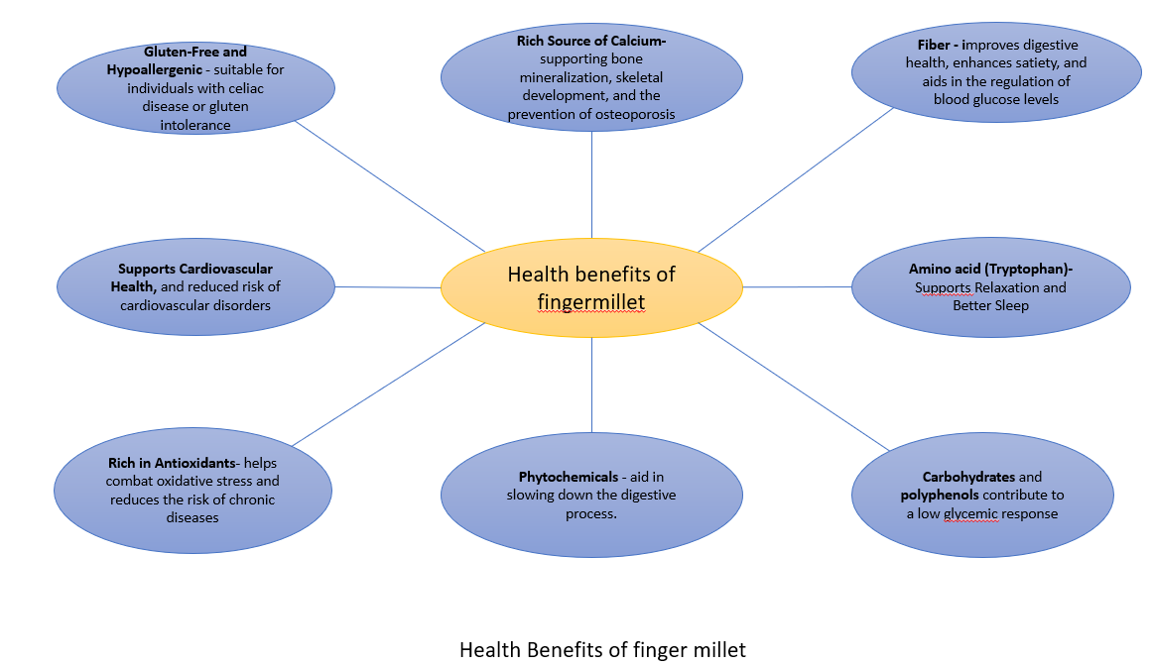
Fig 4. Health Benefits of finger millet

Role of Finger Millet in Food and Nutritional Security
Ragi plays a key role in enhancing food and nutrition security, especially in developing countries and rain-fed ecosystems. This crop exhibits remarkable adaptability in a variety of agro-ecological settings, such as high-altitude areas, desert, and rainfed settings, and frequently outperforms other tropical cereals in similar situations. It is cultivated mainly by small farmers and hence is often called "poor man's food"(Kumar et al., 2019).
In arid, nutrient-limited, and marginal areas, it is essential for sustainable agriculture and improving food security for communities with limited resources. Because of its high drought tolerance, finger millet has a significant adaptive advantage and reduced crop failure risk compared with other cereal crops under such challenging conditions. As a result, it is widely recognized as a staple cereal in numerous semi-arid and tropical regions worldwide (Nelson Wekha et al., 2017).
In drought-prone areas around the world Ragi is a staple food crop and plays a key role in food security. Ragi grains can be kept for longer periods without substantial damage from storage pests., making them an ideal food grain for regions vulnerable to famine and food scarcity (Upadhyaya et al., 2007).
Ragi-based food products are widely used as nutritional supplements for pregnant and lactating women, infants and individuals recovering from illness. The Ragi is an excellent source of dietary fiber and phytochemicals , which provide multiple health-promoting effects. Ragi has been shown in studies to have hypoglycemic, hypocholesterolemic, nephroprotective, and anticataractogenic effects, highlights its potential as a functional food, particularly in diabetic diets. Additionally, ragi is beneficial for women who have cardiovascular risk factors such as high blood pressure and high cholesterol levels. This grain also supports to the function of the nervous system and maintaining the integrity of cell membranes (Kewat et al., 2017).
Seed coat of Ragi is plentiful in polyphenolic compounds such as phenolic acids and flavonoids, phytochemicals, dietary fiber, and is also incredibly rich in minerals, with calcium being especially prominent (Devi et al., 2014).
Conclusion
Fingrer millet holds an important place in agriculture because of its rich nutritional profile and strong capacity to flourish under different environmental conditions. This crop adapts different types of agro-ecological zones, including high altitudes and both arid and rainfed areas, outperforming other tropical cereals in this regard. Nutritionally, Ragi is a vital source of minerals, dietary fiber, protein and bioactive phytochemicals such as polyphenols, with the seed coat being particularly high in calcium. These nutritional attributes make it perfect dietary supplement for pregnant and breastfeeding mothers, newborns, and those recovering from illness. Ragi has been shown in studies to have hypoglycemic, hypocholesterolemic, nephroprotective, and anticataractogenic effects, underscoring its value as a functional food, particularly in diabetic diets. Overall, Ragi distinguishes itself not only as a resilient and adaptable staple crop for resource-poor regions while also serving as a highly nutritious food with significant health advantages -promoting properties, underscoring its critical role in both agricultural sustainability and human nutrition.
Disclaimer (Artificial intelligence)
Author(s) hereby declare that NO generative AI technologies such as Large Language Models (ChatGPT, COPILOT, etc.) and text-to-image generators have been used during the writing or editing of this manuscript.

References-
- Ashik Somarajan K, Sonia Morya. A review on finger millet properties, processing, health benefits, and applications. Pharma Innovation 2022;11(7):3388-3395. DOI: 10.22271/tpi.2022.v11.i7aq.14538
- Bisht, B.S. and Singh, D.P. (2009). Agriculture and Uttarakhand hills. Directorate of Experiment Station, G.B.Pant Univer-sity of Agriculture & Technology, Pantnagar, pp.11-17.
- Devi, P. B., Vijaya bharathi, R., Sathyabama, S., Malleshi, N. G., and Priyadarisini, V. B. (2014). Health benefits of finger millet (Eleusine coracana L.) polyphenols and dietary fiber: a review. J. Food Sci. Technol. 51, 1021–1040. doi:10.1007/s13197-011-0584-9.
- Goswami, A. P., Prasad, B., & Joshi, V. C. (2015). Characterization of finger millet [Eleusine coracana (L.) Gaertn.] germplasm for morphological parameters under field conditions. Journal of Applied and Natural Science, 7(2), 836–838. https://doi.org/10.31018/jans.v7i2.692.
- Gowda, N.A.N.; Siliveru, K.; Prasad, P.V.V.; Bhatt, Y.; Netravati, B.P.; Gurikar, C. Modern Processing of Indian Millets: A Perspective on Changes in Nutritional Properties. Foods 2022, 11, 499. https://doi.org/ 10.3390/foods11040499.
- Greenfield Emily. (2023). Ecological Equilibrium: Restoring Harmony. SIGMAEARTH. https://sigmaearth.com/ecological-equilibrium-restoring-harmony/#google_vignette.
- Hilu, K. W., J. M. J. de Wet, and J. R. Harlan. “Archaeobotanical Studies of Eleusine Coracana Ssp. Coracana (Finger Millet).” American Journal of Botany 66, no. 3 (1979): 330–333. https://doi.org/10.2307/2442610.
- Karki, A., Chandra, A., Joshi, S., Rawat, P., & Sharma, S. (2020). An overview of Finger millet (Eleusine coracana L.). Journal of Pharmacognosy and Phytochemistry, 9(4), 866–869. www.phytojournal.com
- Kumar, A., Chawla, H. S., Jeena, A. S., & hit, R. (2019). Morphological Characterization of Finger Millet Germplasm Collected from Uttrakhand Hills for Qualitative Traits. International Journal of Current Microbiology and Applied Sciences, 8(09), 2105–2109. https://doi.org/10.20546/ijcmas.2019.809.243

- Swamy K.R.M., 2023. “Origin, Domestication, Taxonomy, Botanical Description, Genetics and Cytogenetics, Genetc Diversity, Breeding, of Ragi (Eleusine coracana L.)”. International Journal of Current Research, 15, (08), 25589-25610.
- Longvah, T., Anathan, R., Bhaskaracharya, K. and Venkaiah, K. (2017). Indian Food Composition Tables 2017, National Institute of Nutrition, Indian Council of Medical Research, Hyderabad, Telangana, India.
- Mude, L. N., Mondam, M., Gujjula, V., Jinka, S., Pinjari, O. B., Yellodu Adi Reddy, N., & Patan, S. S. V. K. (2020). Morpho-physiological and biochemical changes in finger millet [Eleusine coracana (L.) Gaertn.] under drought stress. Physiology and Molecular Biology of Plants, 26(11), 2151–2171. https://doi.org/10.1007/s12298-020-00909-9
- Marakana, P.R. , Ramani, HR., Suthar, HG. and Patel, PS.2025. “Analysis of agronomic traits of different quantitative morphology of finger millet genotypes”. International Journal of Advanced Biochemistry Research. SP-9(9): 1774-1777. DOI: 10.33545/26174693.2025.v9.i9Sw.5768.
- Maharajan, T., Antony Ceasar, S., Ajeesh Krishna, T. P., & Ignacimuthu, S. (2021). Finger Millet [Eleusine coracana (L.) Gaertn]: An Orphan Crop With a Potential to Alleviate the Calcium Deficiency in the Semi-arid Tropics of Asia and Africa. Frontiers in Sustainable Food Systems, 5(July), 1–8. https://doi.org/10.3389/fsufs.2021.684447
- Negi, S., Kumar, V., & Bhatt, A. (2017). Morphological Characterization and Genetic Analysis of Finger Millet (Eleusine coracana (L.) Gaertn) Germplasm. International Journal of Bio-Resource and Stress Management, 8(3), 469–472. https://doi.org/10.23910/ijbsm/2017.8.3.1732
- Nelson Wekha, W., Kibet Korir, N., Siambi, M., Ojulong, H. F., & Gweyi-Onyango, J. P. (2017). Agromorphological Performance and Character Association of Finger Millet under Varying Phosphorus Regimes. Journal of Agricultural Studies, 5(1), 90. https://doi.org/10.5296/jas.v5i1.10809.
- Pravina, P., Sayaji, D., and Avinash, M. (20 13). Calcium and its role in human body . Int. J. Res. Pharm. Bio med. Sci. 4, 65 9–668.
- Patil, P., Singh, S. P., & Patel, P. (2023). Functional properties and health benefits of finger millet (Eleusine coracana L.): A review. The Journal of Phytopharmacology, 12(3), 196–202. https://doi.org/10.31254/phyto.2023.12308.
- Pagano, A. E. (2006). “Whole grains and the gluten-free diet,” The Celiac Diet Series 2, ed. C. R. Parrish (Charlottesville, VA: University of Virginia Health System), 66–78.
- Rao, D.B.; Malleshi, N.G.; Annor, G.A.; Patil, J.V. Nutritional and health benefits of millets, Indian Institute of Millets Research (IIMR): Hyderabad, India, 2017; p. 112
- Sakamma, S., Umesh, K. B., Girish, M. R., Ravi, S. C., Satishkumar, M., & Bellundagi, V. (2017). Finger Millet (Eleusine coracana L. Gaertn.) Production System: Status, Potential, Constraints and Implications for Improving Small Farmer’s Welfare. Journal of Agricultural Science, 10(1), 162. https://doi.org/10.5539/jas.v10n1p162
- Sood, P., Singh, R. K., & Prasad, M. (2019). Millets genetic engineering: the progress made and prospects for the future. Plant Cell, Tissue and Organ Culture, 137(3), 421–439. https://doi.org/10.1007/s11240-019-01587.
- Thilsted.S.K., Elouafi.I. 2023. The world is precariously dependent on just a handful of staple food crops – we must diversify. The Telegraph. https://www.telegraph.co.uk/global-health/climate-and-people/underused-foods-could-help-end-scourge-of-malnutrition.
- Upadhyaya H.D., Gopal Reddy V. and Sastry D.V.S.S.R. 2008. Regeneration guidelines:finger millet. In: Dulloo M.E., Thormann I., Jorge M.A. and Hanson J., editors. Crop specific regeneration guidelines [CD-ROM]. CGIAR System-wide Genetic Resource Programme, Rome, Italy. 7 pp.
- Vagdevi.A., Trupthi.S., Pandey.M., Reddy.N.B., and Singh.M.(2023). Nutritional qualities, processing and health benefits of finger millet (Eleusine coracana L.). The Pharma Innovation Journal 2023; 12(1): 1291-1297
- Yogeesh, L. N., Lokesh, G. Y., Girish, G., Hiremath, U., & Unit, S. (2021). Morphological characterization of White Finger Millet [ Eleusine coracana ( L .) Gaertn ] Genotypes for Qualitative Traits. Biological Forum – An International Journal 13(4): 353-356.
- Vadivoo, A. S., Joseph, R., and Ganesan, N. M. (1998). Genetic variability and diversity for protein and calcium contents in finger millet (Eleusine coracana (L.) Gaertn) in relation to grain color. Plant Foods Hum. Nutr. 52, 353–364.

