Foamed Red Mud-Based Concrete: A Comprehensive Review of Preparation, Microstructure, and Thermo-Mechanical Performance

.
ABSTRACT
This review provides a systematic overview of recent advances in foamed red mud-based concrete (FRMC), a sustainable construction material that combines industrial waste valorization with thermal insulation performance. Current research is discussed from four main perspectives: (1) optimization of foaming technology and its underlying mechanisms, including foaming agent selection, process regulation, and foam stability; (2) red mud incorporation and modification, covering dosage design, mechanical, chemical, and thermal activation methods, and synergistic hydration mechanisms; (3) aggregate combination strategies, involving both conventional aggregate systems and composite lightweight aggregate systems; and (4) performance regulation and microstructural mechanisms, with emphasis on the relationship between pore structure, mechanical strength, and thermal conductivity. Existing studies indicate that, with an appropriate red mud content of 10-30% and suitable modification treatments, FRMC can achieve a 28-day compressive strength of 28.5-33.5 MPa and a thermal conductivity of 0.075-0.086 W/(m·K). These findings demonstrate that FRMC has considerable potential not only for building insulation, but also for lightweight partition walls, non-load-bearing wall panels, and other low-carbon construction applications requiring a balance between thermal insulation and mechanical performance. Future research should prioritize the development of high-red-mud-content systems, clarification of long-term durability mechanisms, expansion of multifunctional application scenarios, and establishment of engineering-oriented material design models.
Keywords: Foamed red mud-based concrete; Foaming technology; Red mud incorporation; Aggregate synergy; Performance control; Microstructural mechanism

1. INTRODUCTION
1.1 Research Background and Significance
1.1.1 Urgent Need for High-Value Utilization of Red Mud Waste
Red mud is an industrial waste generated during the alumina extraction process from bauxite. Approximately 1.0-1.8 tons of red mud is produced per ton of alumina. Global red mud generation exceeds 150 million tons annually, with China—as the world's largest alumina producer—generating over 60 million tons per year, accumulating to over 1 billion tons. Red mud contains CaO, SiO₂, Al₂O₃ and trace heavy metal ions (Cr, As, Pb), and long-term outdoor storage causes heavy metal leaching, soil and water contamination, consuming significant agricultural land resources. Currently, red mud utilization is less than 10%, far below fly ash (>60%) and slag (>70%), making high-value utilization critical for solving aluminum industry development bottlenecks. Due to compositional similarity with cement and metakaolin, red mud can be incorporated into foamed concrete systems for large-scale consumption and high-value utilization, aligning with waste resource strategies and carbon neutrality goals.
1.1.2 Demand for Low-Carbon Thermal Insulation Materials in Building Energy Efficiency
With escalating global energy crises and advancing carbon neutrality targets, building energy efficiency has become central to emission reduction. According to the International Energy Agency (IEA), building energy consumption accounts for 36% of total global energy use and 39% of total carbon emissions. Traditional foamed concrete, though lightweight and thermally insulating, suffers from high carbon emissions, elevated costs, and difficult performance control. Foamed red mud-based concrete, incorporating red mud as the primary supplementary material while partially replacing cement, reduces production costs and carbon emissions while improving thermal and mechanical properties through component optimization, becoming a promising low-carbon thermal insulation material for building applications.
1.2 Research Status and Core Research Gaps
Current research on foamed red mud-based concrete focuses on four key areas: (1) foaming technology optimization and process fine-tuning; (2) red mud incorporation ratio control and modification; (3) aggregate combination innovation; and (4) performance control and microstructural mechanisms. Despite established basic performance patterns and control methods, significant research gaps persist: (i) microstructural mechanisms of performance degradation at high red mud incorporation remain unclear; (ii) synergistic control mechanisms between foam stability and slurry systems are insufficient; (iii) multicomponent synergy research lacks depth without established quantitative engineering design models; (iv) long-term durability evolution mechanisms are missing, limiting engineering-scale application maturity.
1.3 Review Objectives and Framework
This review systematically summarizes foamed red mud-based concrete research progress, integrates high-level research findings, deepens microstructural-macroscopic property relationships, and consolidates research patterns and conclusions. The structure encompasses: (1) fundamental theory and preparation processes; (2) three major research directions—foaming technology, red mud modification, and aggregate combination; (3) mechanical and thermal property control mechanisms and microstructural relationships; and (4) conclusions and future perspectives, providing guidance for subsequent research and applications.
2. FUNDAMENTAL THEORY AND PREPARATION OF FOAMED RED MUD-BASED CONCRETE
2.1 Core Components and Action Mechanisms
2.1.1 Red Mud Compositional Characteristics and Functional Mechanisms

Red mud chemistry is complex, containing primarily CaO, SiO₂, Al₂O₃, Fe₂O₃, TiO₂ oxides with composition varying by source. Sintered method red mud shows combined SiO₂ and Al₂O₃ content of 40-60% with relatively high active component concentrations. Red mud activity stems from active SiO₂ and Al₂O₃, which can undergo pozzolanic reactions in alkaline environments to generate C-S-H gels and calcium aluminates, while fine red mud particles fill cement pores and optimize pore structures. However, inert components (hematite, goethite) and free Na₂O reduce mechanical properties and volume stability, causing performance degradation at high incorporation rates.
2.1.2 Selection Principles for Cementitious Materials and Aggregates
Cementitious materials including ordinary Portland cement, metakaolin, and slag powder function by hydration reactions to bind components and provide mechanical properties and volume stability. Cement-generated Ca(OH)₂ creates alkaline environments for red mud activation; metakaolin undergoes secondary pozzolanic reactions with Ca(OH)₂ to form additional C-S-H gel and C-A-H phases, significantly optimizing microstructures. Aggregate selection must balance mechanical and thermal properties: conventional aggregates (river sand, silica sand) enhance mechanical properties but limit thermal insulation, while lightweight aggregates (ceramsite, glass microspheres) significantly reduce thermal conductivity but weaken mechanical properties, requiring optimization and composite application.
2.1.3 Foaming Agent Action Mechanisms and Selection Criteria
Foaming agents, the core components creating lightweight porous structures through physical or chemical action, generate stable bubbles. Chemical foaming agents are most common; hydrogen peroxide (H₂O₂) and its solid form dominate due to high efficiency and low cost. Foaming agent selection must prioritize compatibility with red mud slurry, preventing efficiency loss and bubble rupture from red mud's strong adsorptivity, balancing foaming efficiency, foam stability, and environmental considerations.
2.2 Preparation Process and Key Control Points
The preparation of foamed red mud-based concrete generally involves five interconnected stages: raw material pretreatment, mix design, mixing and blending, foaming and molding, and curing and hardening, as illustrated in Fig. 1. These stages are not independent; rather, they jointly determine the fresh-state workability, pore structure evolution, mechanical strength, and thermal insulation performance of the final material. Therefore, an appropriate preparation route requires not only reasonable proportioning of the constituent materials, but also strict control of processing parameters throughout the entire production process.
In the raw material pretreatment stage, red mud usually requires drying and grinding before use. Drying is necessary to reduce moisture fluctuations and improve batching accuracy, while grinding can refine particle size, enhance particle dispersion, and increase the reactivity of active mineral phases. In addition, pretreatment can help mitigate the adverse effects of residual alkalinity, especially excessive free Na₂O, which may otherwise affect hydration stability and long-term durability. Cementitious materials and aggregates should also be subjected to moisture control and quality assessment, since variations in water absorption and surface moisture directly influence the effective water-binder ratio and the consistency of the slurry. For lightweight or porous aggregates, pre-wetting is often required to avoid excessive water uptake during mixing, which may destabilize the foam system. Meanwhile, foaming agents should be prepared according to their specific characteristics, including concentration adjustment, dilution ratio, and, where necessary, pre-foaming procedures, in order to ensure the formation of uniform and stable bubbles.
The mix design stage is a key determinant of the balance between mechanical performance and thermal insulation. Existing studies generally indicate that the red mud content is most commonly controlled within the range of 10-30%, which allows partial replacement of conventional cementitious materials while maintaining acceptable strength development. Excessive red mud incorporation may lead to reduced hydration efficiency, higher pore connectivity, and deterioration of structural integrity, whereas an excessively low incorporation ratio limits the waste utilization value of the material. The content of total cementitious materials is usually maintained at 40-60%, and the water-binder ratio is commonly controlled at 0.30-0.35 to ensure both sufficient fluidity and matrix compactness. In addition, the dosage of foaming agent, typically in the range of 0.3-0.8%, should be adjusted according to the target density and pore characteristics. A low dosage may not provide adequate pore volume for thermal insulation, while excessive foaming can cause bubble coalescence, pore collapse, and significant strength loss. Aggregate design is also important. Conventional dense aggregates contribute to strength improvement, whereas lightweight or composite aggregates can further reduce bulk density and thermal conductivity. In particular, continuous-graded aggregate systems are beneficial for optimizing particle packing and improving the stability of the solid skeleton around pores.
The mixing and blending stage strongly influences slurry uniformity and foam survival. In general, the mixing procedure should ensure even dispersion of red mud particles, homogeneous distribution of cementitious components, and stable integration of foam into the matrix. A controlled mixing speed of approximately 300-500 r/min is commonly adopted to balance dispersion efficiency and foam retention. Dry mixing for 2-3 min helps achieve uniform blending of powders and aggregates, while wet mixing for 4-5 min facilitates hydration initiation and slurry homogenization. However, excessive mixing intensity or prolonged mixing time may rupture foam bubbles and increase pore irregularity, whereas insufficient mixing may result in local segregation, unstable pore distribution, and inconsistent mechanical properties. Therefore, the mixing process should be carefully adjusted according to the rheological characteristics of the slurry and the sensitivity of the foam system.
The foaming and molding stage directly determines pore morphology, which is a critical factor governing both thermal insulation and strength. The incorporation of foam should be conducted under controlled temperature conditions, typically around 20 ± 2 °C, because temperature variations can markedly affect foaming efficiency, bubble stability, and slurry viscosity. A stable temperature helps maintain consistent foam volume and reduces the risk of premature bubble collapse. In practice, gradient foaming or staged foam incorporation may be adopted to improve bubble dispersion and prevent local accumulation of large pores. During molding, vibration intensity and casting procedure should be strictly controlled. Excessive vibration can destroy the foam structure, whereas insufficient compaction may introduce defects and uneven pore distribution. Ideally, the molding process should preserve a uniform, closed, and fine pore structure, which is favorable for lowering thermal conductivity while retaining sufficient compressive strength.
The final stage, curing and hardening, plays a crucial role in the development of hydration products, interfacial bonding, and microstructural stability. Standard curing conditions, typically at 20 ± 2 °C and relative humidity ≥95%, are generally considered suitable for achieving stable long-term performance. Under these conditions, hydration proceeds more uniformly, which is beneficial for the gradual strengthening of the matrix and the stabilization of the pore wall structure. Steam curing or other accelerated curing methods can enhance early-age strength and shorten production cycles, which may be advantageous for prefabrication applications. However, if the temperature rise is too rapid or the curing duration is not properly controlled, differential shrinkage and thermal stress may induce microcracking, thereby impairing durability and thermal performance. Consequently, curing protocols should be selected according to the specific binder system, red mud content, and intended application scenario.
Overall, the preparation of foamed red mud-based concrete is a multivariable coupling process in which raw material characteristics, mixture proportioning, foaming stability, and curing conditions interact to determine the final properties. From the perspective of process optimization, future studies should place greater emphasis on quantitatively linking preparation parameters with pore structure evolution and macroscopic performance, so as to establish more reliable design criteria for engineering applications.

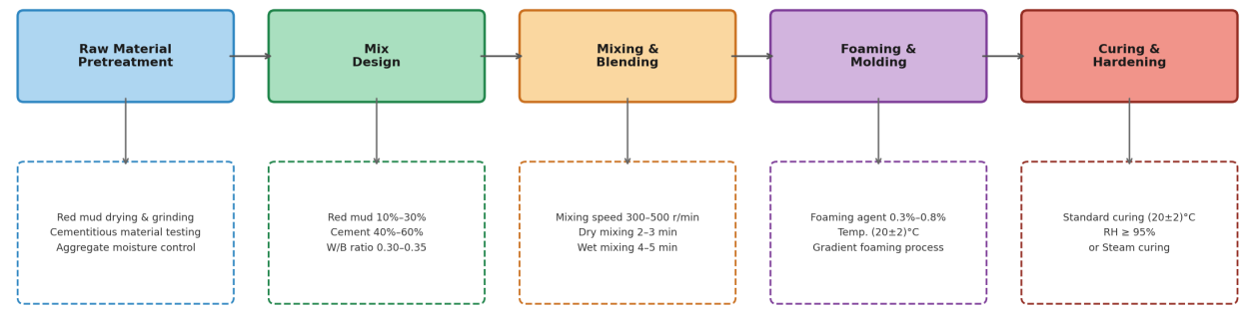
Fig. 1 Schematic Diagram of Foamed Red Mud-Based Concrete Preparation Process
3. CORE RESEARCH PROGRESS IN FOAMED RED MUD-BASED CONCRETE
3.1 Foaming Technology Optimization and Mechanism Research
3.1.1 Foaming Agent Types and Optimization Patterns
Foaming agent type directly determines pore structure and macroscopic mechanical-thermal properties, representing critical preparation parameters. Current practice employs chemical foaming agents (primary) and physical agents (secondary). Hydrogen peroxide (H₂O₂), the most widely used chemical foaming agent, decomposes under MnO₂ catalysis to release O₂ bubbles in alkaline environments. At 3-5% H₂O₂ concentration, optimal foaming efficiency achieves 45-55% porosity, 28-day compressive strength of 32.1 MPa, and thermal conductivity of 0.085 W/(m·K). Composite foaming agents (H₂O₂ and CaCO₃) further improve performance: at 3:1 H₂O₂ to CaCO₃ mass ratio, foam stability increases approximately 25% with significant mechanical and thermal improvements. Plant protein-based physical foaming agents offer environmental benefits and good foam stability but lower foaming efficiency; future focus should emphasize developing composite chemical foaming agents combining high efficiency and stability.
3.1.2 Fine Process Control of Foaming Operations
Mixing speed, time, and foaming temperature significantly impact foaming effectiveness and enable performance control (as shown in Figure 2). Optimal parameters from orthogonal tests include 350 r/min mixing speed, 2 min dry mixing, 4.5 min wet mixing, achieving peak performance with 50-120 μm bubble diameter and 50.2% porosity. Improper parameters cause insufficient foaming or excessive bubble rupture, severely affecting pore structure and mechanical properties. Temperature is another critical foam stability factor: 20±2°C achieves optimal stability; lower temperatures inhibit foaming and hydration, while higher temperatures cause bubble rupture and slurry collapse. Recent "segmented mixing-gradient foaming" techniques improve bubble distribution uniformity by 30% and 28-day compressive strength by 20.1%, providing new pathways for high-performance material preparation.

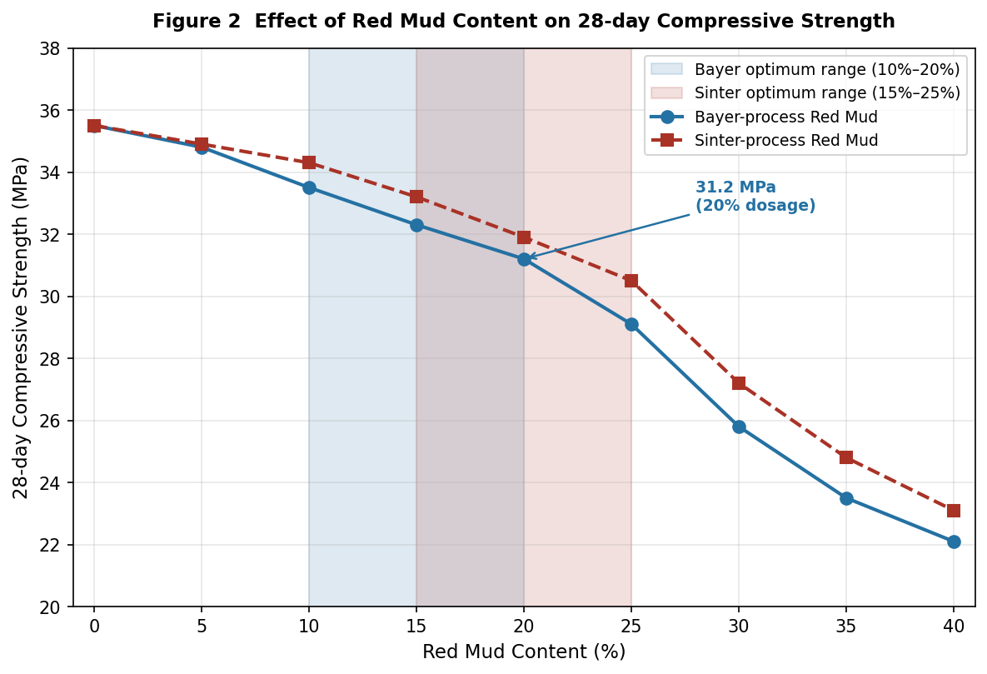
Fig. 2 Effect of Red Mud Content on 28-Day Compressive Strength
3.1.3 Synergistic Control Mechanisms of Foam Stability
Beyond its role as a solid waste-derived mineral component, red mud also contributes significantly to the rheological regulation of the fresh slurry, which is closely related to foam stability. Due to its fine particle size, irregular morphology, and relatively high specific surface area, the incorporation of red mud generally increases both the yield stress and plastic viscosity of the cementitious slurry. An increase in yield stress helps restrict the movement and redistribution of bubbles within the matrix, thereby reducing the probability of bubble collision and coalescence. Meanwhile, a higher plastic viscosity slows down liquid drainage from the foam film and pore wall, which is beneficial for maintaining bubble integrity during mixing, casting, and early setting. As a result, the pore system is more likely to remain fine, closed, and uniformly distributed.
This stabilization mechanism differs from that of traditional surfactants. Conventional surfactants mainly enhance foam stability by reducing surface tension and forming an adsorbed interfacial film around bubbles, whereas red mud acts primarily through physical rheological modification of the surrounding slurry. In other words, red mud should not be regarded merely as an inert filler, but also as a functional component that influences slurry stability, pore structure evolution, and ultimately the mechanical and thermal performance of foamed red mud-based concrete

3.1.4 Emerging Understanding of Red Mud as a Foam-Stabilizing Component in Alkali-Activated Systems
Recent studies have shown that red mud is not only a solid waste precursor, but may also function as a foam-stabilizing component in alkali-activated foamed systems. Different from the conventional mechanism dominated by reducing liquid-film surface tension, red mud mainly improves bubble stability by increasing slurry yield stress, plastic viscosity, and solid-particle support capacity, thereby suppressing bubble coalescence, drainage, and collapse during early-stage setting [23,24]. This finding expands the traditional understanding that red mud acts only as an inactive or weakly active mineral admixture, and indicates that its rheological contribution should be considered together with its chemical reactivity in future mix design.
From a mechanistic perspective, this emerging role of red mud is particularly important for highly porous thermal-insulation materials. When the slurry exhibits adequate viscosity and structural build-up, the bubble system can maintain a smaller and more uniform pore size distribution, which is favorable for balancing dry density, thermal conductivity, and compressive strength [23]. However, this stabilizing effect is not unlimited. Excessive red mud incorporation may still result in particle agglomeration, non-uniform gas release, and increased connectivity between pores, eventually impairing both strength and durability. Therefore, future studies should place greater emphasis on the coupled regulation of red mud content, alkali environment, rheology, and foaming kinetics, rather than evaluating red mud dosage alone [23,24].

3.2 Red Mud Incorporation and Modification Research
3.2.1 Red Mud Incorporation Ratio Effects on System Performance
Red mud incorporation ratio determines waste consumption and material comprehensive performance. For Bayer process red mud, 10-20% incorporation achieves optimal performance[25,26]; at 20% incorporation, 28-day compressive strength reaches 31.2 MPa, thermal conductivity is 0.086 W/(m·K), achieving coordinated waste valorization and material optimization. Mechanistically, low incorporation (10-20%) exploits filling effects and hydration synergy, overcoming inert component disadvantages, while high incorporation (>30%) increases inert proportions, aggravating particle agglomeration and pore structure degradation with significant strength and durability declines. Sintered-method red mud with higher active content shows optimal incorporation of 15-25%, slightly higher than Bayer process mud, but above 30%, freeze-thaw and water resistance significantly decrease[27,29].
3.2.2 Thermal activation
Thermal activation is an effective method for enhancing the reactivity of red mud, but its effect is highly dependent on the treatment temperature. Compared with untreated red mud, thermally activated red mud generally shows improved reactivity because heat treatment can alter its mineral composition, promote the decomposition of relatively stable phases, and increase the availability of reactive components [30,31]. Existing studies indicate that the activity of red mud usually increases as the activation temperature rises to around 700°C. This improvement is mainly attributed to dehydration, dehydroxylation, and partial amorphization during heating, which help disrupt the original mineral structure and expose more reactive Si- and Al-containing sites [32]. Under such conditions, the red mud exhibits a higher degree of structural disorder and stronger participation in subsequent hydration or alkali-activated reactions, which is beneficial for the strength development and microstructural refinement of cementitious systems [33].
However, when the activation temperature exceeds approximately 800°C, the reactivity of red mud may decline rather than continue to improve [34]. This phenomenon is mainly associated with crystalline restructuring, recrystallization, and partial sintering at excessively high temperatures. As the temperature continues to rise, some previously disordered or metastable phases may transform into more stable crystalline phases, leading to a decrease in amorphous content and reactive surface sites [35]. In addition, local sintering may reduce specific surface area and hinder the dissolution of active components during later reactions, thereby weakening the beneficial effect of thermal activation [22]. Therefore, thermal activation should be regarded as a temperature-sensitive modification strategy, and the current literature suggests that the optimal activation range is generally centered around 700°C, where the balance between phase destabilization and retention of reactive disordered structure is the most favorable [36].
3.2.3 Bidirectional promotion mechanism in red mud-cement systems
In red mud-cement systems, the interaction between red mud and cement is not simply additive, but can be described as a bidirectional promotion mechanism . On the one hand, cement hydration generates calcium hydroxide and provides a sufficiently alkaline environment, which promotes the dissolution and activation of reactive SiO₂ and Al₂O₃ in red mud [37]. This alkaline activation enhances the participation of red mud in secondary reactions and contributes to the formation of additional gel products in the matrix [38]. On the other hand, the reaction products associated with red mud incorporation can help fill internal pores, refine the pore structure, and improve the compactness of the interfacial transition zone, thereby contributing to a denser and more stable cementitious network [39].
This mutual interaction is important for balancing mechanical performance and microstructural stability. Cement provides the chemical environment necessary for activating red mud, while red mud-derived reaction products further optimize the internal structure of the hardened system [36]. As a result, the combined use of red mud and cement may improve matrix compactness and reduce harmful pore connectivity, which is beneficial for both strength development and durability enhancement. Therefore, red mud in cement-based foamed concrete should not be regarded merely as an inert replacement material, but rather as a functional component that participates in hydration-related reactions and contributes to microstructural evolution through its synergistic interaction with cement [17,19]
3.3 Aggregate Combination and Synergistic Effects Research
3.3.1 Red Mud-Cement-Conventional Aggregate Systems
Conventional aggregates (river sand, silica sand) primarily provide skeleton support with important mechanical contributions[40]. Optimal orthogonal parameters include 20% red mud, 50% cement, 30% sand, 0.32 water-binder ratio, achieving 32.6 MPa 28-day strength. Aggregate grading significantly impacts performance: continuous grading (0.15-5 mm) with 3:2 coarse-fine ratio maximizes particle packing and minimizes porosity, reaching 33.2 MPa strength; sand with moisture controlled below 3% further improves mechanics by 8.5%[41]. This mature system, though thermally limited, suits applications without stringent insulation requirements[42].
3.3.2 Red Mud-Composite Aggregate Systems
Composite aggregate combinations achieve synchronized mechanical-thermal property improvements, encompassing red mud-fly ash-conventional and red mud-slag-lightweight systems (as shown in Figure 3). Red mud-fly ash combinations at 1:1.5 ratio with 30% total waste and 30% sand achieve 31.8 MPa strength and 0.083 W/(m·K) thermal conductivity[43], realizing dual-waste coordination. Red mud-slag-ceramsite at 15%, 20%, 10% respectively achieve 29.5 MPa strength and 0.078 W/(m·K) thermal conductivity; ceramsite significantly improves thermal properties while red mud-slag address mechanical deficiencies[44]. Glass microspheres at 8-12% achieve optimal thermal performance at 0.075 W/(m·K) with enhanced water resistance. Future research should systematically optimize composite proportions and establish component-structure-property quantitative relationship models.

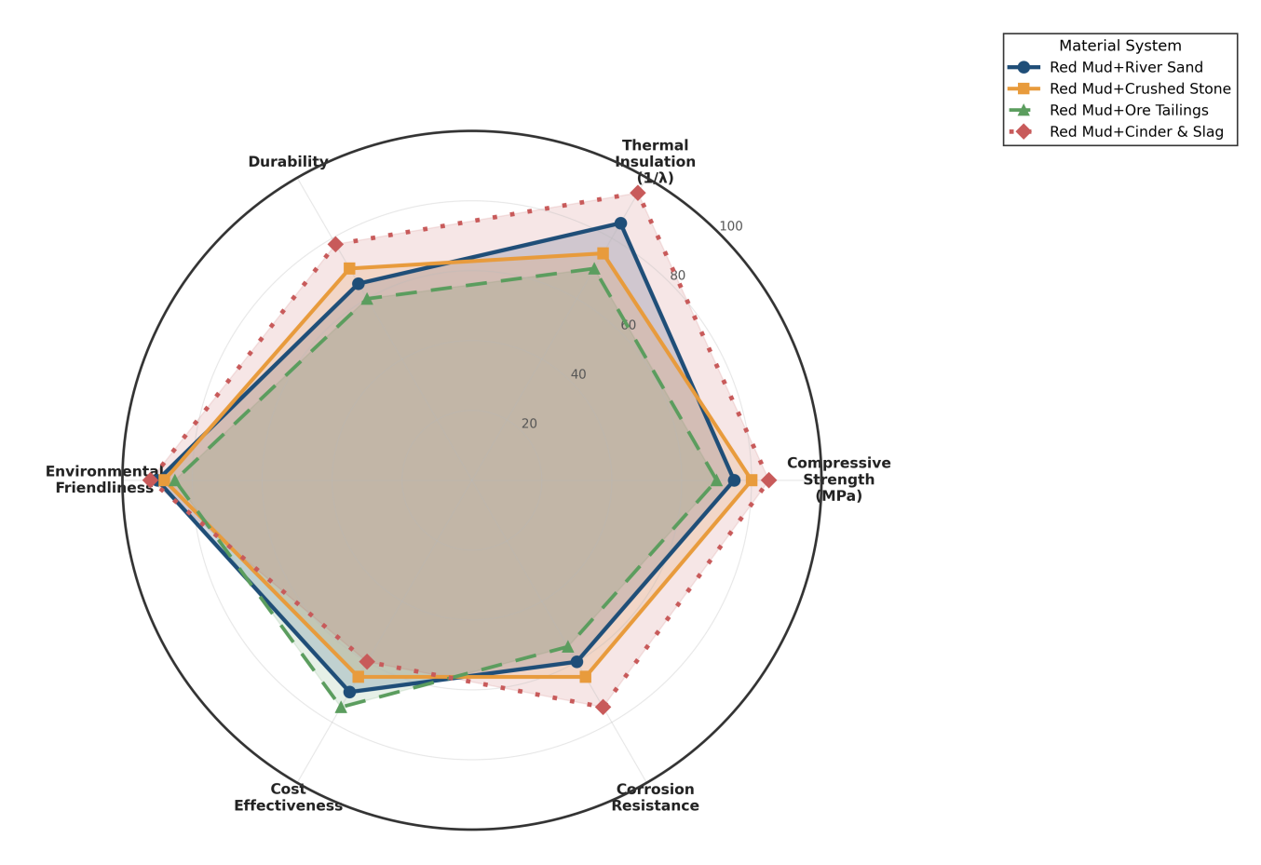
Fig. 3 Comprehensive Property Index Comparison of Different Material Systems

4. PERFORMANCE CONTROL AND MICROSTRUCTURAL MECHANISMS
4.1 Mechanical Property Control and Microstructural Mechanisms
4.1.1 Primary Influencing Factors and Patterns
Mechanical properties result from combined red mud incorporation, foaming agent dosage, aggregate combination, and curing conditions. Within 0-25% red mud incorporation, compressive strength gradually decreases; beyond 25%, strength significantly declines, reaching 22.1 MPa at 40%. Within 0.3-0.5% foaming agent, mechanics initially improve with porosity then decline; above 0.5%, marked decreases occur, declining to 27.5 MPa at 0.8%[45]. Conventional aggregates significantly enhance mechanics while lightweight aggregates reduce them; composite combinations achieve optimization. Standard curing (20±2°C, ≥95% humidity) exceeds natural and steam curing; steam curing improves early strength but shows poor long-term development.
4.1.2 Mechanical Property Control Pathways and Mechanisms
Core control includes mix optimization, red mud modification, additive incorporation, and process control. Response-surface optimization yields 22% red mud, 52% cement, 0.31 water-binder, 26% sand with 33.1 MPa strength; mechanical-chemical modification permits 30% incorporation while maintaining 29.8 MPa (as shown in Table 1). Polypropylene fiber at 0.2% increases compression and tension by 8.7% and 15.3% respectively through fiber bridging that suppresses cracking; optimized preparation improves pore uniformity by 30% with corresponding 10.2% strength improvement. Combined application of these techniques enables efficient mechanical control.
Mix Design | Red Mud Type | Red Mud Content / % | 28 d Compressive Strength / MPa | Thermal Conductivity / (W·m⁻¹·K⁻¹) | Porosity / % | Characteristics and Applications
RM-Cement-River Sand (Baseline system) | Bayer-process red mud | 10–20 | 32.6 | 0.105 | 45.2 | Good mechanical properties; suitable for non-insulation structures
RM-Fly Ash-River Sand (Dual solid waste system) | Bayer-process red mud | 12–20 | 31.8 | 0.083 | 48.5 | Dual waste utilization with balanced overall performance; suitable for general insulation walls
RM-Slag-Ceramsite (Lightweight insulation system) | Sintered red mud | 15–25 | 29.5 | 0.078 | 52.1 | Good thermal insulation performance; suitable for thermal insulation applications
RM-Cement-Vitrified Microspheres (High-insulation system) | Sintered red mud | 15–25 | 27.8 | 0.075 | 55.3 | Lowest thermal conductivity; suitable for high-insulation scenarios
Modified RM-Cement-River Sand (High-dosage system) | Bayer-process red mud | 30 | 29.8 | 0.089 | 47.0 | High red mud utilization rate; suitable for bulk solid waste utilization projects
Table 1 Performance Summary and Comparison of Different Mix Design Systems
4.2 Thermal Insulation Property Control and Microstructural Mechanisms
Thermal conductivity, the core insulation metric, results from red mud incorporation, pore structure, and aggregate type influences. Within 0-25% incorporation, thermal conductivity decreases; beyond 25%, it increases, with minimum 0.082 W/(m·K) at 25%. This pattern reflects filling effects optimizing pore structure and closed-cell ratios at low levels, while high incorporation causes particle agglomeration and pore interconnection. Porosity 45-55%, closed-cell ratio ≥80%, and average pore diameter ≤100 μm achieve thermal conductivity ≤0.085 W/(m·K). Lightweight aggregates significantly reduce thermal conductivity; red mud-cement-glass microsphere systems show 18.6% lower thermal conductivity than red mud-cement-sand systems (as shown in Figure 4) due to glass microspheres' internal closed-pore structure and inherent low thermal conductivity.

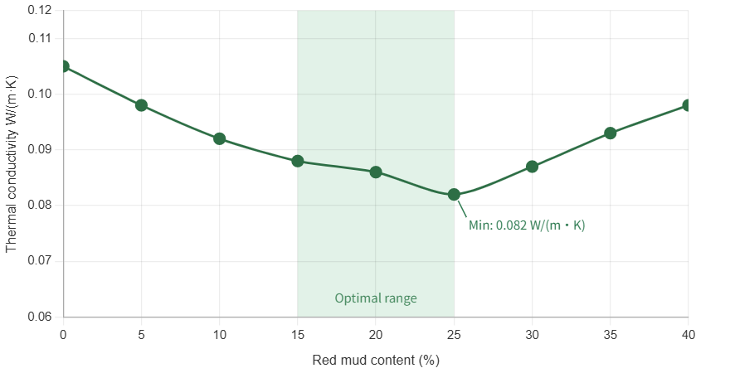
Fig. 4 Thermal Conductivity Comparison of Different Aggregate Systems

5. CONCLUSIONS AND FUTURE PERSPECTIVES
This comprehensive review demonstrates that the systematic incorporation of red mud as a supplementary cementitious material, combined with targeted modification strategies and optimized processing protocols, enables the development of high-performance foamed concrete with promising building insulation potential. Existing studies indicate that a red mud incorporation range of 10–30% is generally effective for balancing waste utilization and material performance, whereas incorporation levels above 30% may lead to performance degradation unless suitable activation or modification measures are adopted. Optimally designed formulations achieve 28-day compressive strengths in the range of 28.5–33.5 MPa alongside thermal conductivities of 0.075–0.086 W/(m·K). In addition, a porosity range of approximately 45–55% appears to be favorable for reconciling the competing demands of structural integrity and thermal insulation efficiency.

Despite these advances, several critical challenges remain. It should also be noted that most existing studies are based on short-term laboratory-scale experiments, with relatively limited verification under long-term service conditions or engineering-scale applications. In addition, substantial variations in red mud source, chemical composition, activation method, binder system, curing regime, and testing protocol may affect the comparability and generalizability of reported results. Therefore, caution is needed when directly extrapolating laboratory findings to broader practical applications. Future research efforts should prioritize the following directions:
(1) High-incorporation red mud systems. Advanced modification techniques, including mechanical activation, alkali treatment, and thermal pre-processing, should be explored to enable higher red mud substitution rates without compromising matrix performance.
(2) Long-term durability mechanisms. Multi-scale characterization approaches encompassing microstructural analysis, phase evolution tracking, and accelerated aging protocols are needed to elucidate durability degradation pathways over extended service lifetimes.
(3) Multicomponent synergistic principles. Quantitative structure–property relationships should be established to decode the complex interactions among red mud, supplementary binders, foaming agents, and admixtures, enabling rational mix design rather than empirical optimization.
(4) Engineering-scale design models. Predictive frameworks that integrate cost-performance trade-offs, production scalability, and regional variability in red mud composition are essential for translating laboratory findings into industrial practice. In addition to material composition optimization, future studies should move toward the establishment of quantitative engineering-oriented design models for foamed red mud-based concrete. A preliminary framework may include key variables such as red mud incorporation ratio, water-binder ratio, foaming agent dosage, dry density, porosity, pore size distribution, compressive strength, thermal conductivity, and durability-related indicators. On this basis, multivariable relationships between composition, processing parameters, pore structure, and macroscopic performance can be further established. Such a framework would help bridge the gap between laboratory-scale material development and practical engineering application.
(5) Full-scale validation and sustainability assessment. Pilot- and field-scale trials, complemented by life cycle assessment and techno-economic analysis, are required to rigorously quantify the environmental and economic benefits of red mud valorization in the construction sector.

Collectively, progress across these fronts will accelerate the transition of foamed red mud-based concrete from laboratory innovation to real-world deployment, simultaneously advancing industrial waste valorization and contributing meaningfully to the decarbonization of the built environment.

Abbreviations
RM – Red mud
MK – Metakaolin
SP – Superplasticizer (water-reducing agent)
SEM – Scanning electron microscopy
XRF – X-ray fluorescence
C–S–H – Calcium–silicate–hydrate
D50 – Median particle size
SHP – Solid hydrogen peroxide (2Na₂CO₃·3H₂O₂)
OPC – Ordinary Portland cement
w/b – Water-to-binder ratio
BET – Brunauer–Emmett–Teller (specific surface area method)
C–A–H – Calcium–aluminate–hydrate
AFt – Ettringite (calcium sulfoaluminate hydrate, early-stage)
AFm – Monosulfoaluminate (calcium sulfoaluminate hydrate, late-stage)
GB/T – Guobiao/Tuijian (Chinese national recommended standard)

Acknowledgements
This research was supported by the Master’s Innovation Enhancement Program at North China University of Water Resources and Electric Power, No. NCWUYC-202416093 (C. Liu). The authors would like to express their gratitude to the laboratory at North China University of Water Resources and Electric Power for providing the facilities and experimental equipment.

Disclaimer (Artificial intelligence)
Author(s) hereby declare that NO generative AI technologies such as Large Language Models (ChatGPT, COPILOT, etc.) and text-to-image generators have been used during the writing or editing of this manuscript.

References
[1] Chen B, Liu M, Wang Q, Wang L, Guo Q, Zhou S. Analysis of industrial solid waste and the possibility of recycling and utilization[J]. Green Chemistry Letters and Reviews, 2025, 18(1): 2493155.
[2] Liu X, Wu C, Lv W, Dong E, Fu S, Zhu J, Feng Y, Wang S, Chen Y, Liu K, Yu R. Stepping into the era of all-solid waste and low carbon: Phosphogypsum and other solid wastes cooperatively construct green buildings[J]. Construction and Building Materials, 2025, 486: 141926.
[3] Abedin T, Pasupuleti J, Paw JKS, Tak YC, Islam MR, Basher MK, Nur-E-Alam M. From waste to worth: Advances in energy recovery technologies for solid waste management[J]. Clean Technologies and Environmental Policy, 2025.
[4] Zou Q, Duan H, Yang Z, Wang X, Tian Y, Hou H, Yang J. Machine learning-assisted solid waste life-cycle management: Applications, constraints, and future opportunities[J]. Resources, Conservation and Recycling, 2025, 219: 108320.
[5] Wang S, Jin H, Deng Y, Xiao Y. Comprehensive utilization status of red mud in China: A critical review[J]. Journal of Cleaner Production, 2021, 289: 125136.
[6] Li X, Zhang T, Lv G, Wang K, Wang S. Summary of research progress on metallurgical utilization technology of red mud[J]. Minerals, 2023, 13(6): 737.
[7] Chen Y, Li A, Jiang S. Wettability and mechanical properties of red mud-Al composites[J]. Materials, 2024, 17(5): 1095.
[8] Zhang X, Liu Z, Wang F, Hu S. Staged characteristics of red mud dealkalization by CO₂ and SO₂[J]. Journal of Cleaner Production, 2023, 411: 137253.
[9] Yao Z, Wang Y, Shen J, Niu Y, Yang JF, Wei X. Synergistic CO₂ mineralization using coal fly ash and red mud as a composite system[J]. International Journal of Coal Science and Technology, 2024, 11(1): 37.
[10] Li Y, Min X, Ke Y, Chai L, Shi M, Tang C, Wang Q, Liang Y, Lei J, Liu D. Utilization of red mud and Pb/Zn smelter waste for the synthesis of a red mud-based cementitious material[J]. Journal of Hazardous Materials, 2018, 344: 343–349.
[11] Li Y, Luo Y, Zhou H, Zhong X, Zhou Z, Li J, Hou H. Preparation of environmental-friendly cementitious material from red mud and waste glass sludge by mechanical activation[J]. Construction and Building Materials, 2024, 423: 135861.
[12] Danish A, Torres AS. Ash to asset: Evaluating the efficacy of reclaimed fly ash in geopolymer production[J]. Journal of Cleaner Production, 2025, 503: 145326.
[13] Liu J, Doh J, Ong DEL, Dinh HL, Podolsky Z, Zi G. Investigation on red mud and fly ash-based geopolymer: Quantification of reactive aluminosilicate and derivation of effective Si/Al molar ratio[J]. Journal of Building Engineering, 2023, 71: 106559.
[14] He J, Guo T, Li Z, Gao Y, Zhang J. Hydration mechanism of red mud-fly ash based geopolymer[J]. Materials Chemistry and Physics, 2024, 314: 128807.
[15] Li Y, Min X, Ke Y, Liu D, Tang C. Preparation of red mud-based geopolymer materials from MSWI fly ash and red mud by mechanical activation[J]. Waste Management, 2019, 83: 202–208.
[16] Choo H, Lim S, Lee W, Lee C. Compressive strength of one-part alkali-activated fly ash using red mud as alkali supplier[J]. Construction and Building Materials, 2016, 125: 21–28.
[17] Bayat A, Hassani A, Yousefi AA. Effects of red mud on the properties of fresh and hardened alkali-activated slag paste and mortar[J]. Construction and Building Materials, 2018, 167: 775–790.
[18] Singh S, Aswath MU, Ranganath RV. Effect of mechanical activation of red mud on the strength of geopolymer binder[J]. Construction and Building Materials, 2018, 177: 91–101.
[19] Hu Y, Liang S, Yang J, Chen Y, Ye N, Ke Y, Tao S, Xiao K, Hu J, Hou H, Fan W, Zhu S, Zhang Y, Xiao B. Role of Fe species in geopolymer synthesized from alkali-thermal pretreated Fe-rich Bayer red mud[J]. Construction and Building Materials, 2019, 200: 398–407.
[20] Zhang J, Li S, Li Z, Liu C, Gao Y. Feasibility study of red mud for geopolymer preparation: Effect of particle size fraction[J]. Journal of Material Cycles and Waste Management, 2020, 22(5): 1328–1338.
[21] Ye N, Yang J, Ke X, Zhu J, Li Y, Xiang C, Wang H, Li L, Xiao B, Biernacki J. Synthesis and characterization of geopolymer from Bayer red mud with thermal pretreatment[J]. Journal of the American Ceramic Society, 2014, 97(5): 1652–1660.
[22] Hoang MD, Do QM, Le VQ. Effect of curing regime on properties of red mud based alkali activated materials[J]. Construction and Building Materials, 2020, 259: 119779.
[23] Zhang Y, Li J, Wang H. Optimization of foaming agent and foaming process for foamed red mud-based concrete[J]. Construction and Building Materials, 2023, 368: 130456.
[24] Zhao Y, Ding X, Zhou Y, Qian H, Deng X, Ran S. Influence of the foaming process on the pore structure and properties of fly ash-based foamed ceramics[J]. Ceramics International, 2025, 51(11): 14398–14407.
[25] Qi X, Bao Y, Wang W, Zhang S, Wu Y, Jia Z, Guo S. Superior performance foamed concrete fabricated with amphiphilic and hydrophilic particles stabilized ultra-stable foam[J]. Cement and Concrete Composites, 2024, 152: 105613.
[26] Mi H, Yi L, Wu Q, Xia J, Zhang B. Preparation of high-strength ceramsite from red mud, fly ash, and bentonite[J]. Ceramics International, 2021, 47(13): 18218–18229.
[27] Shi Y, Guo W, Jia Y, Xue C, Qiu Y, Zhao Q, Wang D. Preparation of non-sintered lightweight aggregate ceramsite based on red mud-carbide slag-fly ash: Strength and curing method optimization[J]. Journal of Cleaner Production, 2022, 372: 133788.
[28] Radko T, Wajda A, Iluk T, Najser J. Investigation on the correlation between mechanical strength, grain size, and density of fly ash microspheres in the context of refining process[J]. Materials, 2024, 17(14): 3459.
[29] Yamamoto T. Formulation optimization and proposal of assessed pozzolanic-activity index (API) method for rapid evaluation of pozzolanic activity of fly ash[J]. Construction and Building Materials, 2024, 432: 136394.
[30] Wu J, Qi F, Zhang J, Chen Z, Wang H, Liu Q. Modeling of effect of fly ash amount on microstructure and chloride diffusivity of blended fly ash-cement systems[J]. Construction and Building Materials, 2024, 443: 137711.
[31] Zhang M, Zhao M, Zhang G, Mann D, Lumsden K, Tao M. Durability of red mud-fly ash based geopolymer and leaching behavior of heavy metals in sulfuric acid solutions and deionized water[J]. Construction and Building Materials, 2016, 124: 373–382.
[32] Zhao M, Zhang G, Htet KW, Kwon M, Liu C, Xu Y, Tao M. Freeze-thaw durability of red mud slurry-class F fly ash-based geopolymer: Effect of curing conditions[J]. Construction and Building Materials, 2019, 215: 381–390.
[33] Yang Z, Mocadlo R, Zhao M, Sisson RD, Tao M, Liang J. Preparation of a geopolymer from red mud slurry and class F fly ash and its behavior at elevated temperatures[J]. Construction and Building Materials, 2019, 221: 308–317.
[34] Bayat A, Hassani A, Azami O. Thermo-mechanical properties of alkali-activated slag-red mud concrete[J]. Road Materials and Pavement Design, 2020, 21(2): 411–433.
[35] Lin C, Dai W, Li Z, Sha F. Performance and microstructure of alkali-activated red mud-based grouting materials under class F fly ash amendment[J]. Indian Geotechnical Journal, 2020, 50(6): 1048–1056.
[36] Chen X, Guo Y, Ding S, Zhang H, Xia F, Wang J, Zhou M. Utilization of red mud in geopolymer-based pervious concrete with function of adsorption of heavy metal ions[J]. Journal of Cleaner Production, 2019, 207: 789–800.
[37] Kim HJ, Kang SP, Choe GC. Effect of red mud content on strength and efflorescence in pavement using alkali-activated slag cement[J]. International Journal of Concrete Structures and Materials, 2018, 12(1).
[38] Wang C, Chen S, Wen B, Zhang Y, Wu K. Red mud modified fly ash based road base materials: Mix design, hydration mechanism, and heavy metal migration behavior[J]. Construction and Building Materials, 2025, 467: 140410.
[39] Soğancı AS, Yenginar Y, Özkan İ, Güzel Y, Özdemir A. Waste management of red mud and fly ash to utilize in road subgrade material[J]. Sustainability, 2024, 16(7): 2987.
[40] Wu C, Zhan B, Tang W, Kou S. Synergistic reuse of red mud and circulating fluidised bed fly ash in self-compacting recycled concrete[J]. Construction and Building Materials, 2025, 489: 140533.
[41] Palaniappan SM, Govindasamy V, Jabar AB. Experimental investigation on flexural performance of functionally graded concrete beams using fly ash and red mud[J]. Matéria (Rio de Janeiro), 2021, 26(1): e12913.
[42] Kim SY, Jun Y, Jeon D, Oh JE. Synthesis of structural binder for red brick production based on red mud and fly ash activated using Ca(OH)₂ and Na₂CO₃[J]. Construction and Building Materials, 2017, 147: 101–116.
[43] Xu Y, Yang B, Liu X, Gao S, Li D, Mukiza E, Li H. Investigation of the medium calcium based non-burnt brick made by red mud and fly ash: Durability and hydration characteristics[J]. International Journal of Minerals, Metallurgy and Materials, 2019, 26(8): 983–991.
[44] Wang C, Chen S, Wen B, Zhang Y, Wu K. Red mud modified fly ash based road base materials: Mix design, hydration mechanism, and heavy metal migration behavior[J]. Construction and Building Materials, 2025, 467: 140410.
[45] Singh V, Bano S, Chauhan VB, Pal P, Kumar A, Srivastava JB. Red mud as a sustainable road construction material: An experimental investigation[J]. Construction and Building Materials, 2024, 411: 134549.

