Original Research Article

In Vitro Evaluation of Anti-inflammatory and Anticoagulant Activities of Ethanolic Extract of Tridax procumbens

ABSTRACT

Background: Tridax procumbens, a medicinal plant traditionally used for various ailments, was evaluated for anti-inflammatory and anti-coagulant properties using in vitro models.
Aims: To evaluate the anti-inflammatory as well as anti-coagulant activities of Tridax procumbens by using Egg Albumin Denaturation and Blood Coagulation Assay.
Study design: Experimental study.
Place and Duration of Study: Department of Pharmacology, Rani Chennamma College of Pharmacy, Karnataka, India, between June 2025 to October 2025.
Methodology: The anti-inflammatory potential of the Tridax procumbens ethanolic extract was evaluated using the egg albumin denaturation assay. Reaction mixtures containing egg albumin, phosphate buffer (pH 7.4), and test samples (100–800 µg/mL) were incubated at 37± 2°C for 30 min, then heated at 70± 2°C for 15 min. Absorbance was measured at 280 nm using a UV spectrophotometer, and the percentage inhibition of protein denaturation was calculated relative to diclofenac sodium as the reference standard.
Anticoagulant activity was determined by assessing prothrombin time in human citrated plasma, using heparin as the reference standard. Samples were incubated at 37°C, and clotting times were recorded.
Results: With a dose-dependent rise in percentage inhibition, the extract demonstrated strong anti-inflammatory efficacy that was comparable to Diclofenac. In a similar vein, the extract showed strong anti-coagulant activity, as shown by a prolonged prothrombin time that was on compare with heparin. These results suggest the existence of bioactive substances that can alter coagulation pathways and inflammatory reactions.
Conclusion: In conclusion, the study offers scientific support for the traditional medical applications of Tridax procumbens. Its promise as a natural medicinal agent for controlling inflammatory illnesses and averting thrombotic consequences is highlighted by the ethanolic extract's anti-inflammatory and anti-coagulant properties. These results prompt more research to identify the precise mechanisms of action of the active phytoconstituents, isolate and describe them, and investigate their possible clinical uses in contemporary medicine.
Keywords: Tridax procumbens, Extract, Phytoconstituents, Anti-inflammatory activity, Anti-coagulant activity, In- vitro methodology.
1.INTRODUCTION
Since antiquity, medicinal plants have served as primary therapeutic agents, and it is estimated that more than 80% of the global population continues to rely on herbal remedies for healthcare¹. These plants represent a rich source of bioactive compounds that may be developed into standardised herbal formulations or utilised as lead molecules in the discovery of novel pharmaceuticals. Consequently, rigorous scientific validation of medicinal plants is essential to ensure their efficacy, safety, and therapeutic relevance. The Asteraceae family, one of the largest families of flowering plants, comprises numerous pharmacologically active species characterised by a high abundance of secondary metabolites, including flavonoids, terpenoids, alkaloids, and other bioactive constituents². These compounds are known to contribute to a wide range of biological activities, thereby underpinning the medicinal significance of this plant family.

Due to its several medicinal uses, Tridax procumbens L., a common creeping herb in the Asteraceae family, has drawn a lot of attention. The plant, which is native to tropical America but is now widely distributed in Asia, Africa, and Europe, has long been used in traditional medicine to treat respiratory conditions, fever, diarrhea, wounds, and skin infections. Its anti-inflammatory, anticoagulant, antioxidant, wound-healing, antibacterial, antidiabetic, hepatoprotective, and immunomodulatory properties are supported by current research^{3,4,5}.

Coagulation and inflammation are closely interconnected physiological processes that play a critical role in the pathogenesis of numerous chronic diseases, including cancer, cardiovascular disorders, and arthritis⁶. Consequently, naturally occurring compounds exhibiting both anticoagulant and anti-inflammatory properties are of considerable therapeutic interest.

Evidence from previous studies suggests that Tridax procumbens exerts modulatory effects on both the intrinsic and extrinsic pathways of blood coagulation. These effects are mediated, in part, through the inhibition of cyclooxygenase (COX) and lipoxygenase (LOX) pathways, leading to a reduction in the synthesis of pro-inflammatory mediators such as prostaglandins and leukotrienes. In addition, extracts of T. procumbens have been reported to prolong prothrombin time (PT) and activated partial thromboplastin time (aPTT), indicating a potential anticoagulant effect.

The observed pharmacological activities are largely attributed to the presence of bioactive phytochemicals, including flavonoids such as quercetin and luteolin, as well as alkaloids, coumarins, tannins, and other phenolic compounds⁷. These constituents are known to contribute to both anti-inflammatory and anticoagulant mechanisms, thereby supporting the therapeutic potential of T. procumbens in the management of inflammation-associated coagulopathies.

Tridax procumbens has become a significant plant in phytopharmacological research due to its broad therapeutic potential and solid scientific data⁸. With a focus on its anti-inflammatory and anticoagulant qualities, this chapter offers a thorough summary of its phytochemistry, pharmacological activity, plant profile, and therapeutic uses.

Morphological Description
Tridax procumbens is a creeping perennial herb with branched, hairy stems that root at the nodes and grow 30–50 cm tall. Its opposite, irregularly lobed leaves are rough due to trichomes. The plant bears small solitary flower heads with white ray florets and yellow tubular florets, typical of the Asteraceae family. Fruits are bristly achenes with a pappus for wind dispersal. It has a shallow fibrous root system aiding rapid spread, and its tissues contain secretory canals with resinous substances linked to medicinal properties.
The plant has a fibrous, shallow root system that lets it quickly spread and take over disturbed spots. Studies of its anatomy show lots of parenchymatous tissue and secretory canals filled with resinous stuff-these likely contribute to its medicinal properties⁹.

Geographical Distribution
The plant is native to tropical America but has spread widely in tropical and subtropical regions of Asia, Africa, and Europe. In India, Tridax procumbens is commonly found along roadsides, in agricultural fields, and wastelands. It thrives in poor soils, high temperatures, and areas of frequent disturbance, which makes it a highly invasive weed.

Botanical Description:
Kingdom: Plantae
Division: Magnoliophyta
Class: Magnoliopsida
Order: Asterales
Family: Asteraceae
Genus: Tridax
Species: Tridax procumbens L.

Fig no. 1: Tridax procumbens
Traditional use
Traditionally, Tridax procumbens has been used for wound healing, treatment of ulcers, cough, insect repellant activity and infectious diseases. It is commonly applied as a poultice on cuts and wounds to stop bleeding and accelerate healing. Decoctions are used to treat diarrhea and fever¹⁰.

Pharmacological Activities
- Anti-inflammatory activity
- Anti-bacterial activity
- Anti-coagulant activity
- Anti-oxidant activity
- Wound healing activity
- Anti-microbial activity
- Anti-Diabetic activity
- Anti-thrombotic activity
- Hepatoprotective activity
- Immunomodulatory activity

2. MATERIALS AND METHODS

Table 1: List of chemicals and reagents used in the study.

Sr.No | Chemical
 | Ethanol
 | Diclofenac Sodium
 | Phosphate Buffer Saline Solution
 | Ferric Chloride
 | Benedict’s reagent
 | Wagner’s reagent
 | Sodium Hydroxide solution
 | Concentrated HNO3
 | Acetic Anhydride
 | Lead Acetate solution
 | Sulfuric Acid
 | Ninhydrin reagent

- All the chemicals are collected from Rani Chennamma College of Pharmacy.

Table 2: List of Equipment

Sr.No | Equipment’s
 | Rota Evaporator
 | Soxhlet Apparatus
 | UV-Spectrophotometer
 | Centrifugation Apparatus
 | pH meter
 | Electric water bath
 | Magnetic stirrer

2.1 Collection and Authentication of Tridax procumbens

The Tidax procumbens were collected from different places such as Rani Chennamma College of Pharmacy, Belagavi, outside of college campus and from college neared places. After being verified by Dr. Harsha Hegde (ICMR-NITM). The plant Tridax procumbens was washed and shade dried for 2 weeks. After drying, the whole plant was transformed into a fine powder by using electric mixer.

2.2 Collection of Blood Sample

The Dr. Prabhakar Kore KLE Hospital Blood Bank provided the blood samples.

2.3 Extraction Process:
2.3.1 Soxhlet Extraction Method: After powdering shade-dried Tridax procumbens leaves, 50 g of the coarse material was extracted for 48 hours using 250 mL of 70% ethanol in a Soxhlet device. A rotary evaporator was used to concentrate the extract at 40–50°C, remove all of the solvent, and weigh the resulting extract residue^{11,12}.
2.3.2 Maceration Method: 70 g of powdered shade-dried Tridax procumbens leaves were macerated with 700 mL of 70% ethanol at room temperature for 48 hours, stirring occasionally. After filtering the combination, the filtrate was concentrated on a water bath to produce a solid extract that was kept in a sealed container in a dry, cool environment The extract was placed in closed container in cool and dry place to prevent any microbial growth ¹³.

2.4 Phytochemical screening

To find carbohydrates, phenolics, saponins, alkaloids, proteins, flavonoids, tannins, amino acids, and steroids, phytochemical screening of Tridax procumbens leaves was carried out using conventional techniques^{14,15,16}.
Alkaloids (Wagner's Test): When Wagner's reagent was added to the extract, a reddish-brown precipitate formed, indicating the presence of alkaloids.
Saponins (Foam Test): Saponins were detected by shaking the extract with water, which produced stable foam.

Steroids: The extract changed color from violet to blue when combined with sulfuric acid and acetic anhydride, indicating the presence of steroids.
Tannins (Lead Acetate Test): The addition of lead acetate produced a yellow precipitate, which is a sign of tannins.

Ferric chloride test: Alcoholic FeCl₃ produced a bluish-black coloring, confirming phenols (Ferric Chloride Test).

Benedict's Test for carbs: Heating the extract with Benedict's reagent produced a red precipitate, which is a sign of carbs.
Proteins (Xanthoproteic Test): Proteins were confirmed by the reaction with concentrated HNO₃, which created a yellow tint.
Flavonoids (NaOH Test): When treated with NaOH, a rich yellow color appeared, signifying the presence of flavonoids.
Ninhydrin Test for Amino Acids: Heating with the ninhydrin reagent produced a blue color, indicating the presence of amino acids.

2.5 Anti-Inflammatory Activity
The anti-inflammatory activity of Tridax procumbens crude extracts can be determined in vitro for inhibition of the denaturation of egg albumin (protein). Egg albumin denaturation inhibition was used to gauge the crude extract's anti-inflammatory properties. 0.2 mL of 1-2% egg albumin, 2 mL of extract or standard (Diclofenac sodium), and 2.8 mL of phosphate buffer (pH 7.4) were combined to create a reaction mixture (5 mL). Instead of the sample, the control had two milliliters of distilled water. After 30 minutes of incubation at 37 ± 2°C, each combination was heated for 15 minutes at 70 ± 2°C. Using distilled water as a blank, absorbance at 280 nm was measured after chilling. The usual formula was used to determine the percentage inhibition of protein denaturation.
Percentage inhibition = Absorbance of control – Absorbance of test sample × 100
Absorbance of control
2.6 Anti-Coagulant Activity
This test measures the duration of thrombin-induced clotting to assess anticoagulant activity. To obtain platelet- poor plasma (PPP), healthy volunteers' blood was drawn into trisodium citrate tubes and centrifuged for 15 minutes at 3000 rpm. CaCl₂ (25 mM), 0.2 mL plasma, and 0.1 mL crude extract (different concentrations) were combined in fusion tubes and incubated at 37°C for the test. In the control, saline was used in place of the extract, while EDTA and sodium citrate were used as reference standards. The prothrombin time was calculated by tilting the tubes every five seconds to record the clotting time.

3. RESULT AND DISCUSSIONS

3.1 Percentage yield:

An ethanol solution was used to extract 50 grams of powdered dried Tridax procumbens leaves. Following drying, the filtrate produced 6.2 grams of extract, or 12.4% of the original 50 grams of plant powder.

3.2 Preliminary phytochemical determination:

After the successful conventional extraction of the Tridax procumbens leaves, the preliminary phytochemical study revealed. The ethanolic extract contained primary metabolites such as alkaloids, saponins, tannins, steroids, phenols, flavonoids, amino acids, and proteins, according to the preliminary phytochemical qualitative analysis. These phytochemicals were identified by characteristics colour changes using standard procedures. The list is summarized in Table 3.

Table 3: Phytochemical analysis of Tridax procumbens

Sr. No | Phytochemicals | Ethanol
1 | Alkaloids | +
2 | Saponins | +
3 | Steroids | +
4 | Tannins | +
5 | Phenol | +
6 | carbohydrates | +
7 | Proteins | +
8 | Flavonoids | +
9 | Amino acids | +

Here + : Present - : Absent

3.3 Anti-inflammatory activity of Tridax procumbens:
The ethanolic extract of Tridax procumbens demonstrated a clear dose-dependent inhibition of protein denaturation, with percentage inhibition rising steadily from 19.53% at 100 µg/mL to a peak of 56.83% at 800 µg/mL. While the reference standard, diclofenac sodium, exhibited superior activity (39.45–75.78% over the same concentration range), the extract nonetheless displayed moderate anti-inflammatory potential through its consistent dose-responsive profile.

Table: 4: Anti-inflammatory activity analysis of Tridax procumbens

Concentration (ug/ml) | Absorbance (Control) | Absorbance (Extract) | % Inhibition (Extract) | Absorbance (Diclofenac Sodium) | %Inhibition (Diclofenac Sodium)
100 | 0.512 | 0.412 | 19.53% | 0.310 | 39.45%
200 | 0.512 | 0.354 | 30.85% | 0.251 | 50.97%
400 | 0.512 | 0.289 | 43.55% | 0.187 | 63.51%
800 | 0.512 | 0.221 | 56.83% | 0.124 | 75.78%

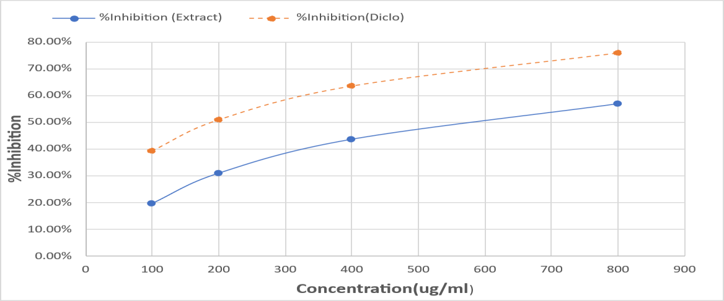
Fig no. 2 Anti-inflammatory Activities of Tridax procumbens

3.4 Anti-Coagulant activity of Tridax procumbens:

Longer clotting times in the current investigation show that Tridax procumbens has strong anti-coagulant activity. In comparison to Heparin, the effect was less noticeable but still dose dependent. Flavonoids and phenolic substances that can disrupt the coagulation cascade are found in Tridax procumbens. The anticoagulant effect is dose-dependent, increasing with higher concentrations. This anticoagulant potency can be attributed to the extract's rich profile of bioactive flavonoids and phenolic compounds, which interfere with key steps in the coagulation cascade. The clotting time for normal blood (control) was 4.47 minutes, whereas the extract-treated sample showed a prolonged clotting time of 7.08 minutes. In comparison, the standard heparin exhibited a significantly higher clotting time of 27.37 minutes.
Table: 5: Prothrombin time observed in Samples

Sample | Prothrombin time (min) | Observation
Control (Normal blood) | 4.47 mins | Normal clot formation
Standard (Heparin) | 27.37 mins | Strong anti-coagulant effect
Tridax procumbens Extract | 7.08 mins | Moderate anti-coagulant activity

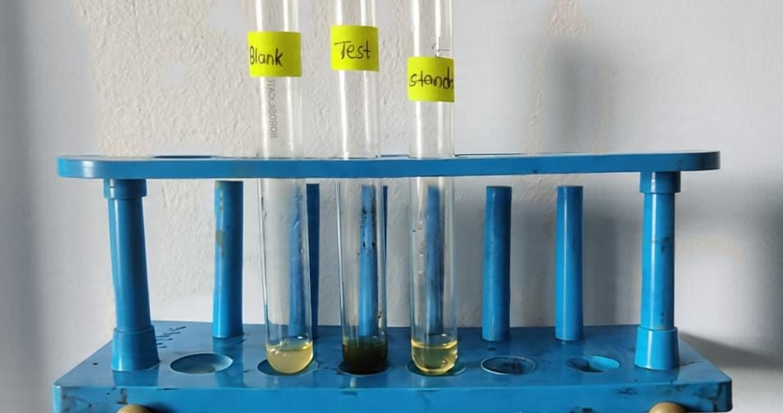

Fig no. 3 Prothrombin time test

Medicinal plants have been a part of human life for centuries, helping people treat illnesses even before modern medicine developed. Even today, many people around the world still depend on herbal remedies for their daily healthcare needs. Two important processes in the body—inflammation and blood clotting—are closely connected and essential for maintaining overall health.
Tridax procumbens is one such plant that has been traditionally used in Ayurvedic and Unani medicine for its healing properties. In this study, ethanol was used to extract the useful compounds from its leaves, and it proved to be quite effective. The extract contained several beneficial natural substances like flavonoids, alkaloids, tannins, phenols, and saponins, which are known for their medicinal value.
The results showed that the plant extract can help reduce inflammation, and its effect increased with higher doses. Although it was not as strong as the standard drug diclofenac, it still showed meaningful activity. The extract also slightly slowed down blood clotting time, indicating mild anticoagulant properties, though it was less powerful than heparin.
These effects are mainly due to the natural compounds present in the plant, especially flavonoids and phenols, which are known to support healing and protect the body. Overall, this study supports the traditional use of Tridax procumbens and suggests that it could be a useful natural option for managing inflammation and blood clotting. However, more research is needed to better understand its safety and to improve its effectiveness.

4.CONCLUSION

The current study validates the traditional usage of Tridax procumbens in folk medicine by establishing its pharmacological relevance and demonstrating its strong anti-inflammatory and anti-coagulant properties in vitro. The plant extract successfully suppressed protein denaturation, suggesting a protective role against inflammation, when the anti-inflammatory potential was evaluated using the egg albumin denaturation assay. In a similar vein, the blood coagulation test demonstrated how well it delayed the formation of clots in comparison to the control, indicating potential anticoagulant qualities. These results highlight Tridax procumbens' therapeutic value as a natural substitute for prescription medications. Tridax procumbens may prove to be a viable option for the creation of secure and efficient herbal treatments for conditions involving inflammation and coagulation. Taken together, these dual anti-inflammatory and anticoagulant effects point towards a broad-spectrum pharmacological profile that may be particularly beneficial in clinical conditions where inflammation and hypercoagulability coexist, such as cardiovascular disease, autoimmune disorders, or post-surgical states.
Similarly, the significant prolongation of clotting time in the in vitro blood coagulation assay suggests that the extract interferes with key steps in the coagulation cascade, thereby reducing the risk of pathological thrombus formation.
Tridax procumbens could emerge as a promising candidate for the development of safe, cost-effective, and accessible phytopharmaceuticals aimed at managing inflammation and coagulation-related disorders, especially in resource-limited settings.
Disclaimer (Artificial intelligence)
Authors hereby declare that NO generative AI technologies such as Large Language Models (ChatGPT, COPILOT, etc.) and text-to-image generators have been used during the writing or editing of this manuscript.

REFERENCES
- World Health Organization. Traditional Medicine Strategy 2014–2023. WHO; 2013.
- Kumar S, Pandey AK. Chemistry and biological activities of flavonoids: An overview. ScientificWorldJournal. 2013;2013: 162750. DOI: 10.1155/2013/162750
- Libby P. Inflammatory mechanisms: The molecular basis of inflammation and disease. Nutr Rev. 2007;65(12):S140–6
- Esmon CT. The interactions between inflammation and coagulation. Br J Haematol. 2005;131(4):417–30.
- R Nandita, M Jeevitha, Journal of Pharmacy and BioAllied Sciences, December 2024 27;16: S4081–S4084
- Ameena M, Rajeshkumar S, Evaluation of the Anti-inflammatory, Antimicrobial, Antioxidant, and Cytotoxic Effects of Chitosan Thiocolchicoside-Lauric Acid Nanogel, 2023 Sep 26;15(9):e46003
- Alshargabi A, Effect of Tridax procumbens extracts on coagulation time according to gender and blood groups A and O: in vitro study, Journal of Herbal Medicine, Volume 42, December 2023, DOI: 10.1016/j.hermed.2023.100806
- Pai C, Kulkarni U, Antibacterial Activity of Tridax Procumbens With Special Reference to Nosocomial Pathogens, Journal of Pharmaceutical Research International, DOI: 10.9734/BJPR/2011/763
- Kushwaha, P., Yadav, S. S., Phytochemical screening and GC-MS studies of the methanolic extract of Tridax Procumbens, International Journal of Pharmaceutical Sciences and Research, DOI: 10.13040/IJPSR.0975-8232.10(5).2492-96
- : Jhample, S. B., Gajdhane, S. B., Phytochemical screening and in vitro antimicrobial activity of Tridax procumbens L., Research Journal of Life Sciences, Bioinformatics, Pharmaceutical and Chemical Sciences, 2015, 1(1); 44-53
- Oyedemi, S. O., Bradley, G., Ethnobotanical survey of medicinal plants used for the management of diabetes mellitus in the Nkonkobe municipality of South Africa., Journal of Medicinal Plants Research, 2011;5(14):2925–33. DOI: 10.5897/JMPR.9000596
- Prakash, et al.: Assessment of anti-inflammatory activity of Tridax procumbens, MGM Journal of Medical Sciences | Volume 9 | Issue 4 | October-December 2022
- Anuja R. et. al., Development Of A Herbal Skin-Care Cream Containing Tridax Procumbens: Assessment Of Anti-Inflammatory And Antibacterial Propertie, ISSN: 2321-9939, January 2026, Volume 14, Issue 1.
- CHANDEL, M. et.al, A COMPREHENSIVE REVIEW ON TRIDAX PROCUMBENS LIN., QUANTUM JOURNAL OF MEDICAL AND HEALTH SCIENCES 4(5): 11-31. eISSN: 2785-8243 https://doi.org/10.55197/qjmhs.v4i5.180.
- Jayashri S. et.al; Evaluation of Tridax procumbens Secondary Metabolites Anti-Tuberculosis Activities by In Vitro and In Silico Methods. (2025) 82:50, https://doi.org/10.1007/s00284-024-04033-9

