Carbon Nanotubes as Anticorrosive Coatings: A Review

Abstract: Corrosion is a major cause of material degradation and economic loss across a wide range of industrial environments. Among emerging nanomaterials, carbon nanotubes (CNTs) have attracted considerable attention in anticorrosive coating systems owing to their exceptional mechanical strength, high electrical conductivity, large specific surface area, and excellent chemical stability. This review discusses the role of CNTs in anticorrosive coatings in terms of barrier enhancement, corrosion inhibition, electrochemical protection, composite reinforcement, and bio-related protective functions. Existing studies indicate that the incorporation of CNTs can significantly improve coating compactness, interfacial adhesion, mechanical durability, and overall corrosion resistance, while also imparting multifunctional protective properties. Nevertheless, their practical application remains limited by several challenges, including agglomeration, poor dispersion, insufficient interfacial compatibility, and the lack of standardized protocols for long-term performance evaluation. Overall, CNT-based anticorrosive coatings show considerable promise for advanced corrosion protection. Future research should therefore focus on controllable surface functionalization, environmentally friendly and scalable fabrication strategies, mechanism-driven material design, and systematic evaluation under realistic service conditions.
Keywords: carbon nanotubes; anticorrosive coatings; corrosion resistance; functional nanofillers; review

1 Introduction
With the rapid advancement of industrialization and modern technology, the service conditions of engineering materials and equipment have become increasingly demanding. As a result, corrosion has become an increasingly serious issue that not only shortens the service life of materials and structures, but also threatens public safety and causes substantial economic losses, and may even trigger sudden catastrophic accidents^{[1]}. It has been reported that the annual economic losses caused by corrosion account for more than 3% of the gross domestic product (GDP) in many countries worldwide^{[2]}. Therefore, corrosion protection and control have become issues of great importance in modern industry.
Conventional anticorrosion materials, such as epoxy resin coatings and perchloroethylene paints, exhibit excellent properties in many aspects, including good corrosion resistance, wear resistance, and strong adhesion. However, in specific application environments—such as aerospace, mechanical manufacturing, and marine conditions—these materials may encounter more severe challenges, particularly under extreme conditions of high temperature, high humidity, and high salinity^{[3]}. Consequently, the development of materials with superior wear resistance, high-temperature stability, and enhanced corrosion resistance has become crucial for addressing these challenges.
As an emerging nanomaterial, carbon nanotubes (CNTs) have attracted extensive attention from both the scientific community and industry since their discovery by the Japanese physicist Iijima in 1991^{[4]}. CNTs are nanoscale tubular structures composed of carbon atoms. Their unique one-dimensional nanostructure and sp² carbon–carbon bonding configuration endow them with exceptional mechanical strength, high electrical and thermal conductivity, and excellent chemical stability. These distinctive characteristics make CNTs highly promising for applications in corrosion protection. Therefore, this paper systematically reviews the application of carbon nanotubes in corrosion protection, with particular emphasis on their protective mechanisms, representative application pathways, current limitations, and future development prospects. In addition, the review highlights the differences in the roles played by CNTs across various corrosion-protection systems, thereby providing a more critical understanding of their current research status and practical potential.

2 Basic Characteristics of Carbon Nanotubes

2.1 Structure and Classification of Carbon Nanotubes
Carbon nanotubes (CNTs) are a unique class of one-dimensional nanomaterials composed of carbon atoms arranged in a hexagonal lattice and bonded through sp² hybridization to form coaxial cylindrical structures^{[5]}. CNTs are generally classified into single-walled carbon nanotubes (SWCNTs) and multi-walled carbon nanotubes (MWCNTs). Single-walled carbon nanotubes (SWCNTs) (Figure 1a) consist entirely of carbon atoms and can be structurally regarded as a single graphene sheet seamlessly rolled into a cylindrical tube, forming a hollow structure with a single graphitic layer wrapped around a common central axis. In contrast, multi-walled carbon nanotubes (MWCNTs) (Figure 1b) are composed of multiple concentric graphene layers rolled around the same central axis, with a defined interlayer spacing between adjacent layers. They can be considered as nested assemblies of several SWCNTs, where the spacing between neighboring layers is comparable to the interlayer distance in graphite.
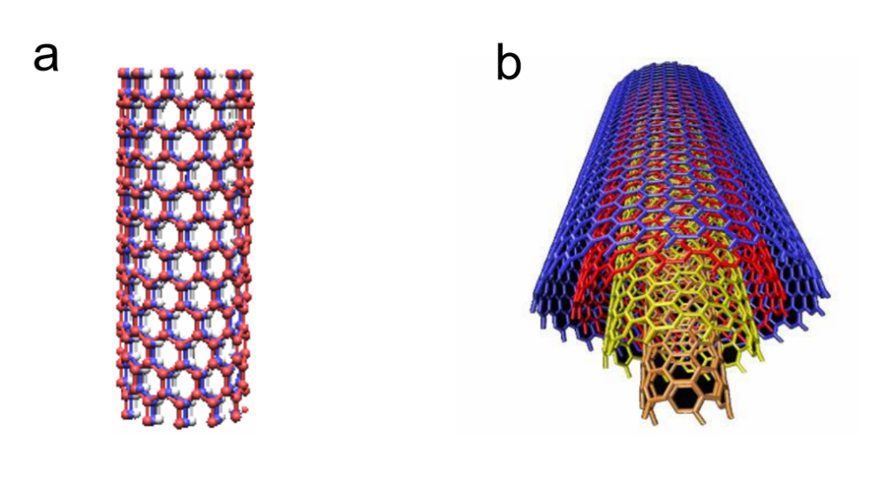
(a) Single-walled carbon nanotube (SWCNT) (b) Multi-walled carbon nanotube (MWCNT)
Figure 1 Schematic illustration of the structure of carbon nanotubes^{[3]}

2.2 Physical and Chemical Properties of Carbon Nanotubes
Carbon nanotubes (CNTs) exhibit exceptional stiffness and axial strength due to the sp² carbon-carbon bonds within their structure. These properties provide significant advantages in the field of corrosion protection. By incorporating CNTs as additives into corrosion-resistant coatings, the mechanical properties of the coatings can be significantly enhanced, improving their wear resistance and impact resistance^{[6]}. Moreover, the unique one-dimensional nanostructure of CNTs allows for efficient heat transfer along their length, making them widely regarded as excellent thermal conductors. Their outstanding thermal conductivity and thermal stability ensure that CNT-based corrosion protection materials can maintain stable performance even in high-temperature environments, demonstrating reliability and durability under extreme conditions. In addition to these advantages, CNTs also feature small diameters and large specific surface areas. Due to their smaller diameter, CNTs can densely pack on the material surface, forming a compact protective layer that effectively isolates the corrosion medium from direct contact with the substrate, thus preventing corrosion. Their large specific surface area also allows CNTs to adsorb microorganisms, impurities, and other harmful substances, further enhancing the corrosion resistance of the material^{[7]}. These properties make CNTs highly promising for applications in corrosion protection.

3 Current Status of Carbon Nanotubes in the Field of Corrosion Protection
Although CNTs have been explored in multiple corrosion-protection scenarios, the underlying mechanisms and performance-determining factors are not identical across different application systems. In coating matrices, the main contributions of CNTs are generally associated with barrier enhancement and mechanical reinforcement; in inhibitor systems, adsorption and surface functionalization play more important roles; in electrochemical protection systems, conductivity and interfacial charge-transfer behavior become dominant; in metal matrix composites, corrosion resistance is strongly coupled with microstructural strengthening; and in biomedical environments, corrosion protection must be evaluated together with antibacterial performance and biosafety. Therefore, a comparative discussion of these application pathways is essential for a more critical understanding of the current research progress.

3.1 Carbon Nanotubes as Additives in Corrosion-Resistant Coatings
Coating protection is a common method for preventing metal corrosion by applying a corrosion-resistant layer that isolates corrosive agents and slows down the corrosion process. Carbon nanotubes (CNTs), as additives in corrosion-resistant coatings, play a vital role due to their small size, excellent physicochemical properties, and high chemical stability. CNTs not only form a dense physical barrier that prevents corrosive media from reaching the substrate but also significantly enhance the coating's corrosion resistance through electrochemical protection and improved mechanical properties. Liu Henghao et al^{[8]}. successfully developed CNT-modified aqueous epoxy zinc-rich coatings by incorporating CNTs as an aqueous slurry into epoxy emulsions. The study showed that adding 0.2% CNTs to the zinc-based coating enhanced its impact resistance and corrosion protection significantly. This improvement is attributed to the unique nanostructure of CNTs, which increases the coating's density and corrosion resistance, effectively isolating corrosive agents from the substrate. Similarly, Alishahi M et al^{[9]}. prepared Ni-P-CNT coatings, demonstrating that CNT inclusion enhanced both the tribological properties and corrosion resistance of the coating. Electrochemical tests in 3.5 wt% NaCl solution revealed that the CNTs improved the coating's performance in preventing corrosion. Epoxy resin, a widely used organic coating, offers excellent thermosetting properties and strong adhesion to metal surfaces, along with good stability and flexibility. However, it suffers from inherent defects such as poor impact resistance and limited thermal stability. To address these issues, Qin Wenfeng et al^{[10]}.proposed incorporating CNTs into epoxy resin to prepare composite coatings. By controlling the CNT content, they successfully produced coatings with enhanced properties. Electrochemical testing showed that with 0.5% CNTs, the composite coating exhibited a significant increase in corrosion potential (-1.510V) and the lowest corrosion rate. Static immersion tests further confirmed its superior corrosion protection performance, highlighting the potential of CNTs in enhancing the protective capabilities of composite coatings.
Overall, the reported studies suggest that the anticorrosion effect of CNTs in coating systems is mainly achieved through three mechanisms: enhancement of barrier performance, improvement of mechanical integrity, and modulation of electrochemical protection behavior. In zinc-rich and conductive coating systems, CNTs can facilitate electron transport and improve the efficiency of protective action, whereas in polymer-based coatings their contribution is more closely associated with densification of the coating matrix and suppression of crack propagation. However, the improvement is not solely determined by CNT addition itself. The final protective performance strongly depends on dispersion quality, interfacial compatibility with the matrix, and CNT loading level. Excessive CNT content may lead to agglomeration and structural defects, thereby weakening the long-term corrosion resistance of the coating. More recent studies further confirm that the anticorrosion performance of CNT-based coatings depends strongly on CNT loading and dispersion state. For example, Huang et al.^{[11]} reported in 2024 that CNT-reinforced waterborne epoxy zinc-rich coatings exhibited the best protective performance at 0.3 wt.% CNTs, whereas excessive CNT addition led to performance deterioration. Similarly, Wang et al.^{[12]} showed that in waterborne polyurethane systems, excessive MWCNT loading promoted agglomeration and reduced both corrosion resistance and adhesion strength. In addition, recent work on phosphate coatings for high-temperature marine environments has highlighted the importance of improving CNT dispersion and coating durability under harsh service conditions^{[13]}.
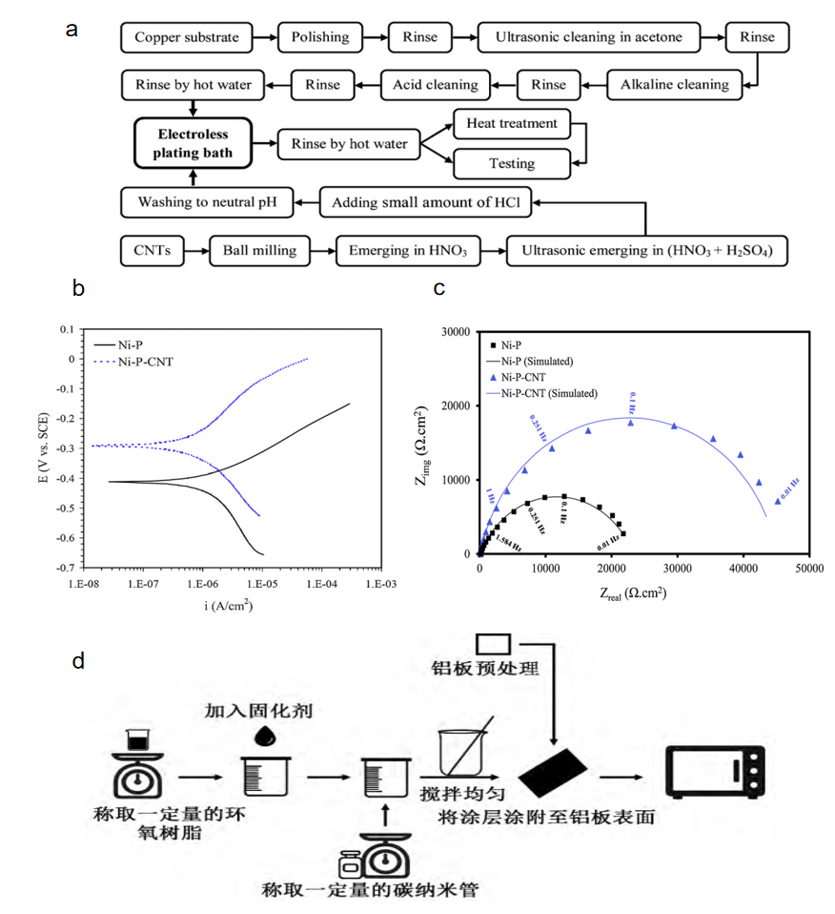
(a) Research on the preparation process of nickel-phosphorus-carbon nanotube chemical coatings^{[9]}.
(b) Polarization curves of the coating in 3.5% sodium chloride solution^{[9]}.
(c) Nyquist plot of the coating in 3.5% sodium chloride solution^{[9]}.
(d) Preparation flowchart of carbon nanotube/epoxy resin coatings^{[10]}.
Figure 2 Representative preparation procedures and electrochemical characterization of CNT-containing anticorrosive coatings

3.2 Carbon Nanotubes as Carriers for Corrosion Inhibitors
A corrosion inhibitor is a compound or complex that can prevent or retard the corrosion of materials when present in a corrosive medium at an appropriate concentration and in a suitable form. Owing to their low cost, ease of operation, strong adaptability, and good performance, corrosion inhibitors have become one of the most widely used approaches in the field of corrosion protection^{[14]}. As corrosion inhibitors, carbon nanotubes (CNTs) exhibit considerable potential, and their inhibition mechanism is illustrated in Figure 3a. Benefiting from their strong adsorption capability, CNTs can form a dense protective layer on metal surfaces, thereby effectively isolating corrosive media. In addition, CNTs are environmentally friendly and potentially sustainable, which is consistent with the growing demand for greener corrosion-protection technologies. Their surface chemistry can also be tailored through functional modification, enabling adaptation to different metals and corrosive environments and demonstrating high flexibility and broad application potential. As a result, CNTs have attracted increasing attention as promising corrosion inhibitors. Shirazi et al.^{[15]} synthesized a novel CNT-based composite inhibitor, PAA/GO/f-MWCNT, through the in situ polymerization of poly(aminobenzoic acid) (PAA), graphene oxide (GO), and functionalized multi-walled carbon nanotubes (f-MWCNTs). Electrochemical impedance spectroscopy (EIS) tests on 316 stainless steel (SS316) showed that the addition of this nanocomposite to the corrosive medium significantly improved the corrosion resistance of the substrate. This improvement was mainly attributed to the strong adsorption capacity of the nanocomposite on the metal surface and the formation of a dense and uniform protective film, which effectively hindered the penetration of corrosive species. Cen et al.^{[16]} successfully synthesized functionalized carbon nanotubes (FCNTs) by an efficient hydrothermal method, as shown in Figure 3b, and used them as corrosion inhibitors for carbon steel in a CO₂-saturated 1 wt.% NaCl solution. The results showed that FCNTs effectively suppressed the corrosion of carbon steel, achieving an inhibition efficiency of nearly 90% at a concentration of 100 mg/L. Zhang et al.^{[17]} prepared a TiO₂-coated multi-walled carbon nanotube (MWCNT)/bis(triethoxysilylpropyl) tetrasulfide (BTESPT) composite coating on AA2024 by cathodic electrophoretic deposition. Scanning electron microscopy, Fourier-transform infrared spectroscopy, and surface coverage analysis revealed that the modified MWCNTs exhibited excellent dispersion within the coating system. This improved dispersion significantly enhanced the corrosion resistance of the BTESPT system and its combination with the TiO₂ coating, thereby providing long-term and stable corrosion protection.
Compared with their direct use as coating fillers, CNTs in corrosion inhibitor systems play a more complex role as adsorption-active carriers and functional platforms. The reviewed studies indicate that pristine CNTs alone are often insufficient to provide stable and efficient inhibition, whereas functionalized CNTs or CNT-based hybrid systems can significantly enhance surface adsorption, film formation, and interfacial stability. In this respect, surface chemistry appears to be more important than the intrinsic nanotube structure alone. Nevertheless, the reported inhibition performance is still highly dependent on the corrosive medium, substrate type, and functionalization strategy. Therefore, although CNT-based inhibitors show promising efficiency, their long-term stability, environmental adaptability, and practical scalability require further systematic evaluation.
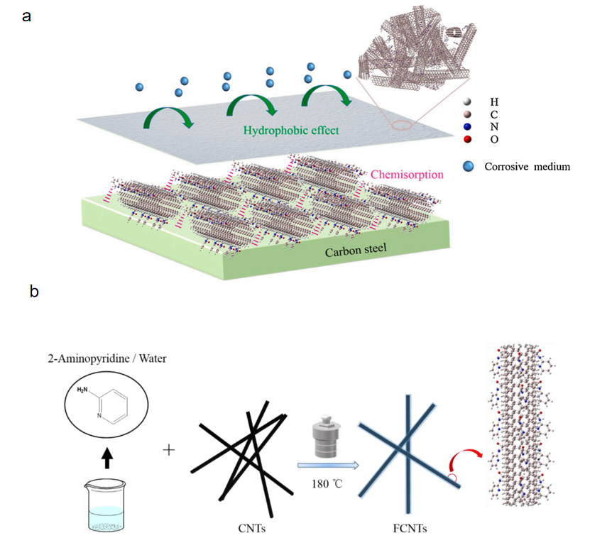
(a) Schematic diagram of the corrosion inhibition mechanism of CNTs on metal surfaces^{[16]}.
(b) Schematic diagram of the synthesis of FCNTs^{[16]}.
Figure 3 Representative corrosion-inhibition mechanism and functionalization route of CNT-based inhibitor systems

3.3 Carbon Nanotubes as Electrode Materials in Electrochemical Corrosion Protection Systems
Carbon nanotubes (CNTs) possess excellent electrical conductivity and chemical stability, which make them promising candidates for electrode materials in electrochemical corrosion protection systems. When combined with metal substrates, CNTs can form stable electrochemical protection systems that effectively inhibit metal corrosion, as illustrated by the electrochemical protection mechanism shown in Figure 4a^{[18]}. Zhou Guohua^{[19]} successfully prepared CNT/AZ31 magnesium-based composites using CNT-incubated block casting technology and investigated the effect of CNT content on the corrosion resistance of the composites by measuring electrochemical polarization curves and observing the surface morphology before and after corrosion using scanning electron microscopy (SEM). As shown in Figure 4b, the results demonstrated that the corrosion current (I_corr) of the MWCNTs/AZ31 composites decreased significantly with increasing CNT content, indicating that the CNT-containing composites exhibited better corrosion resistance than the AZ31 alloy in 3.5 wt.% NaCl solution. Moreover, the corrosion resistance of the composites improved progressively as the CNT content increased, further confirming the beneficial effect of CNT incorporation. Bogdanovskaya V. A. et al.^{[20]} synthesized multi-walled carbon nanotubes (MWCNTs) by methane catalytic pyrolysis over iron–cobalt or cobalt–molybdenum catalysts and investigated their electrochemical performance before and after corrosion treatment, as shown in Figure 4c. The results indicated that, under the same conditions, CNTs exhibited better corrosion resistance than vortex carbon, namely carbon black (CB). Ganash A. A.^{[21]} prepared MWCNT composite coatings on 304 stainless steel surfaces in sulfuric acid solution using a potentiodynamic method. The coatings were characterized by cyclic voltammetry, Fourier transform infrared spectroscopy (FTIR), and SEM, and the results showed that the MWCNT composite coatings effectively inhibited the corrosion of stainless steel in chloride-containing solutions. Li L. et al.^{[22]} investigated the operating conditions of polymer electrolyte membranes (PEM) for fuel cells at 80 °C. As shown in Figure 4d, under identical conditions, the oxidation current of functionalized CNTs and catalytic CNTs was lower than that of carbon black, suggesting that multi-walled CNTs exhibited superior corrosion resistance to carbon black even at elevated temperatures.
The studies reviewed in this section show that the value of CNTs in electrochemical corrosion protection systems lies not only in their high electrical conductivity but also in their structural stability under aggressive electrochemical conditions. Compared with conventional carbon materials, CNTs generally exhibit improved electrochemical durability and can serve as more stable conductive frameworks. However, the protective effect of CNTs in such systems is not universally positive. Their high conductivity may also alter local current distribution and interfacial electrochemical behavior, which means that protection efficiency depends strongly on system design, substrate type, and operating environment. Therefore, future studies should pay greater attention to the balance between conductive enhancement and possible galvanic side effects.
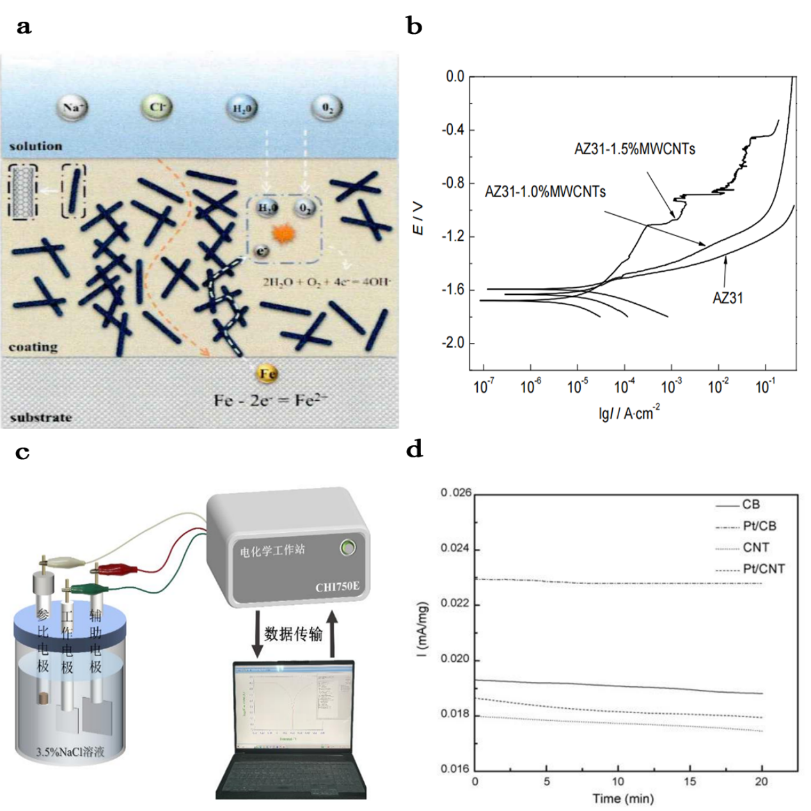
(a) Synergistic effect of CNT nanobarriers and cathodic inhibition^{[18].}
(b) Polarization curves of AZ31 alloy and composite material^{[19]}.
(c) Schematic diagram of electrochemical testing of composite coatings^{[23]}.
(d) Chronoamperometric curve of carbon after 8 hours of electrochemical oxidation at 1.2 V and 80°C^{[22]}.
Figure 4 Representative electrochemical corrosion-protection behavior of CNT-based systems

3.4 Carbon Nanotubes as Reinforcing Phases in Metal Matrix Composites
Carbon nanotube (CNT) reinforced metal matrix composites (MMCs) are excellent nanocomposites and highly attractive advanced materials. These nanocomposites can be produced using various techniques, with common methods for preparing CNT-reinforced aluminum-based composites including casting, powder metallurgy, and stir friction methods^{[24]}. Rajesh et al^{[25]}. successfully fabricated Al7075 aluminum alloy composites using multi-walled carbon nanotubes (MWCNTs) as a reinforcing material and systematically tested the differences in corrosion resistance between the composite material and the unreinforced Al7075 alloy. The results showed that the unreinforced Al7075 alloy had a higher corrosion rate compared to the prepared nanocomposites. This is because the reinforcing material helps slow down corrosion loss by forming an oxide layer. Zhang Pengxiang^{[26]} used high-energy ultrasonic-assisted casting technology to successfully prepare CNTs@Ni reinforced 2024 aluminum-based composites (2024-CNTs@Ni). To assess the electrochemical corrosion resistance of the composite material, the researchers conducted electrochemical impedance spectroscopy (EIS) analysis and compared it with the electrochemical corrosion resistance of pure 2024 aluminum alloy. The results indicated that the 2024-CNTs@Ni aluminum-based composite exhibited stronger electrochemical corrosion resistance than the 2024 aluminum alloy. This finding provides new ideas and methods for improving the corrosion resistance of aluminum-based materials. Zhang Y et al^{[27]}. used chemical vapor deposition (CVD) to successfully prepare aluminum metal matrix composite (CNT-Al MMC) coatings containing CNTs on AZ91 Mg alloy substrates, with pure aluminum coatings without CNTs as a comparison. The researchers then used scanning electron microscopy (SEM) to observe the surface morphology changes of the AZ91 Mg alloy substrate, pure aluminum coatings, and CNT-Al MMC coatings in a corrosive environment. The experimental results, shown in Figure 5, demonstrated that both the AZ91 Mg alloy substrate and pure aluminum coatings exhibited significant cracks and holes on their surfaces after corrosion, indicating poor corrosion resistance. In contrast, the CNT-Al MMC coatings showed a significant reduction in the number and size of cracks and holes under the same corrosive conditions, showing improved corrosion resistance. This important finding not only validated the effectiveness of the CVD process in preparing high-performance CNT-Al MMC coatings but also emphasized the critical role of CNTs in enhancing coating performance. Due to their high surface area and excellent mechanical properties, CNTs effectively suppress crack propagation and disperse the stress concentration generated during corrosion, significantly improving the mechanical strength and corrosion resistance of the coatings and enhancing the overall stability and durability of the coatings.
In metal matrix composites, the corrosion-protection effect of CNTs is closely coupled with their strengthening effect on the microstructure. Unlike polymeric coating systems, where the barrier function is usually dominant, CNTs in MMCs contribute through crack suppression, stress redistribution, interfacial reinforcement, and in some cases the stabilization of surface oxide films. This makes the corrosion behavior of CNT-reinforced MMCs highly dependent on fabrication route and interfacial quality. In other words, the reported improvements cannot be attributed to CNT addition alone, but rather to the combined effect of CNT dispersion, matrix compatibility, and processing-induced microstructural evolution. Accordingly, inconsistent fabrication quality remains one of the main reasons why the corrosion performance reported in different studies is difficult to compare directly.

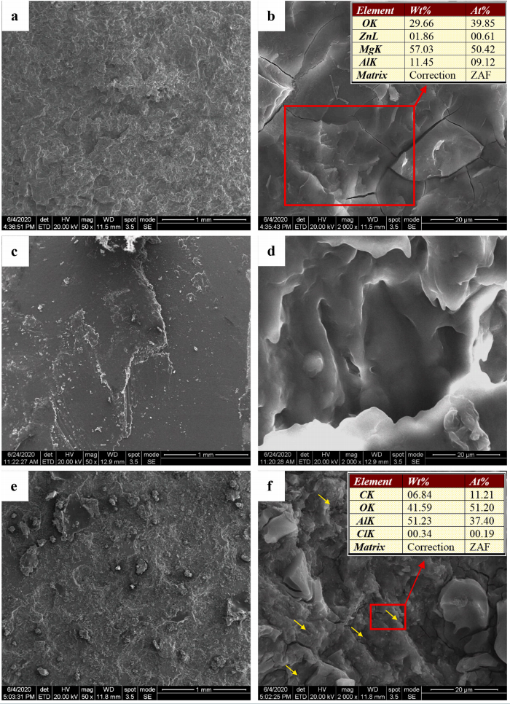
(a, b) AZ91 Mg alloy substrate; (c, d) pure aluminum coating; (e, f) CNT-Al MMC coating.
Figure 5 SEM images at different magnifications after electrochemical corrosion

3.5 Application of Carbon Nanotubes in Biocorrosion Control
Carbon nanotubes (CNTs) exhibit excellent biocompatibility and antimicrobial properties, making them promising materials for biocorrosion control. In biomedical applications such as medical devices and implants, their antimicrobial activity can effectively inhibit bacterial growth and proliferation, thereby reducing the risk of biocorrosion. Abazari S. et al.^{[28]} incorporated magnesium oxide (MgO) nanoparticles onto CNTs and used a semi-powder metallurgy route, followed by hot extrusion, to prepare ZM31/MgO-CNT composites from Mg-3Zn-1Mn alloy (ZM31), as shown in Figure 6a. Potentiodynamic polarization tests indicated that the ZM31/MgO-CNT composite exhibited not only excellent corrosion resistance but also superior cytocompatibility owing to its lower corrosion rate. These findings suggest that this composite has considerable potential for biomedical applications, particularly in implants requiring good biocompatibility. The reduced corrosion rate can help decrease the release of harmful ions in the body, thereby minimizing tissue irritation and inflammation and promoting cell adhesion, growth, and differentiation on the material surface. Jian Y. et al.^{[29]} prepared MWCNT/chitosan composite coatings by a one-step electrodeposition method, as shown in Figure 6b. Electrochemical tests showed that the MWCNT/chitosan composite coating exhibited a significantly lower corrosion current density on titanium alloy and 316L stainless steel substrates than bare metals and pure chitosan coatings. Specifically, on titanium alloy, the corrosion current density of the composite coating was only 0.047 times that of bare titanium alloy, while on 316L stainless steel it was reduced to 1/56 of that of bare stainless steel. These results indicate that the MWCNT/chitosan composite coating can markedly reduce the corrosion current density and corrosion rate of metal implants. Its hydrophobicity and dense structure provide excellent protective capability, thereby contributing to longer service life and improved safety in complex biological environments.
In the biomedical field, 316L stainless steel is widely used as an implant material because of its excellent mechanical properties and corrosion resistance. However, under complex physiological conditions, its surface may still be susceptible to bacterial adhesion and corrosion, which can lead to infection and tissue damage. To address these issues, Sivaraj D. et al.^{[30]} developed an innovative nanocomposite coating, namely silver-doped hydroxyapatite/functionalized multi-walled carbon nanotube (Ag-HA/f-MWCNT) coating, as shown in Figure 6c. To evaluate its corrosion resistance on 316L stainless steel implants, potentiodynamic polarization measurements were conducted in simulated body fluid (SBF). As shown in Figure 6d, the incorporation of CNTs into the Ag-HA nanocomposite significantly enhanced the corrosion resistance of the coating, further demonstrating the potential of Ag-HA/f-MWCNT coatings to improve the durability and safety of implant materials. Despite the substantial progress made in recent years, the widespread clinical application of CNTs still faces several obstacles. Most importantly, their potential toxicity remains a major concern. Many aspects of the pharmacokinetics, cellular internalization, and accumulation of CNTs in important human organs remain unclear. In addition, some studies have suggested that CNTs may exhibit potential genotoxicity^{[31][32][33]}. However, because systematic human-based investigations are still very limited, this issue remains controversial. It should also be noted that most existing studies on CNT toxicity have been conducted in cell or animal models. Therefore, more human-specific investigations are needed to comprehensively evaluate the potential effects of CNTs on human health, including possible genotoxic and teratogenic risks.
The application of CNTs in biocorrosion control differs fundamentally from conventional corrosion protection because the evaluation criteria are no longer limited to corrosion resistance alone. Instead, antibacterial activity, biocompatibility, and biological safety must be considered simultaneously. The reviewed studies show that CNT-containing biomedical coatings can effectively reduce corrosion current density and improve surface protection in physiological environments, while also offering antibacterial advantages. However, this multifunctionality introduces additional complexity, since improved corrosion resistance does not automatically guarantee long-term biosafety. Therefore, the major challenge in this field is to establish a more balanced assessment framework that integrates electrochemical performance, antimicrobial behavior, cytocompatibility, and toxicological risk.
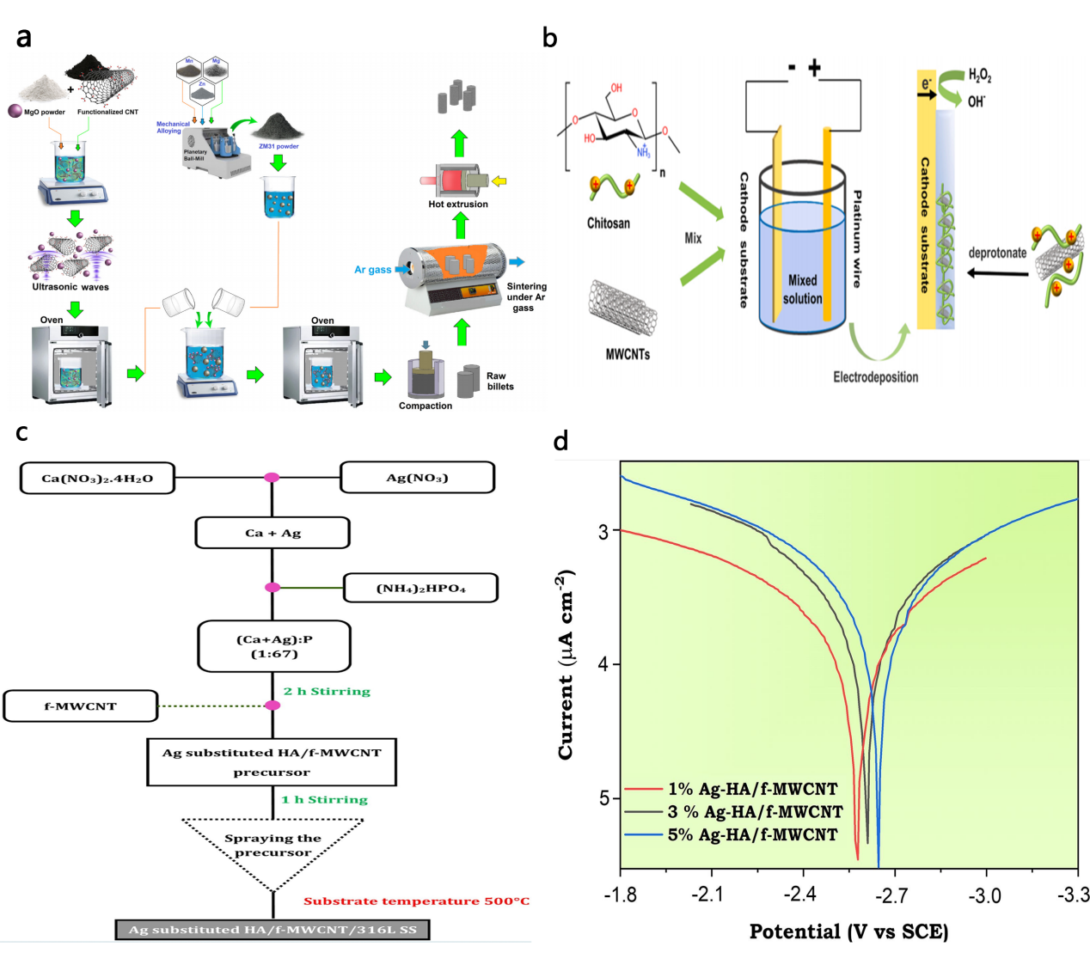
(a) Schematic diagram of the semi-powder metallurgy synthesis of MgO-CNTs/ZM31 composites^{[28]}.
(b) Schematic diagram of the electrodeposition of MWCNT/chitosan composite coatings^{[29]}.
(c) Experimental flowchart for the preparation of Ag-substituted HA/f-MWCNT nanocomposite coatings on 316L stainless steel implants^{[30]}.
(d) Polarization curves of Ag-substituted HA/f-MWCNT/316L stainless steel in SBF solution at 37°C^{[30]}.
Figure 6 Representative preparation routes and electrochemical evaluation of CNT-based biomedical protective systems

4 Conclusion
Carbon nanotubes (CNTs), as a novel corrosion protection material, have attracted widespread attention in sectors crucial to national economy and public welfare, such as the military, telecommunications, transportation, construction, power, and petrochemical industries, due to their excellent physicochemical properties, good corrosion resistance, multifunctionality, and environmental sustainability^{[34]}. However, CNTs still face several challenges in the field of corrosion control that need to be addressed:
(1) High production cost: The production cost of CNTs is relatively high, which hinders their large-scale adoption in corrosion protection coatings. Efforts should continue to reduce production costs and explore more efficient fabrication methods.
(2) Aggregation and distribution: Due to their large specific surface area, CNTs are prone to aggregation in coatings, which affects their uniform distribution and performance. Therefore, surface modification of CNTs and the use of better dispersing agents and stabilizers are key solutions to these issues^{[35]}.
(3) Complex corrosion processes in multi-factor coupled environments: The corrosion process of CNTs in complex environments is highly intricate, involving the interaction of multiple factors such as chemical media, temperature, pressure, electric fields, and magnetic fields. To better understand and control the corrosion behavior of CNTs, it is necessary to consider the combined effects of various factors. Advanced experimental techniques and theoretical models are needed for in-depth exploration and research.
(4) Unclear corrosion mechanism: The corrosion mechanism of CNTs is still not fully understood. Although some studies have attempted to explore the corrosion mechanisms of CNTs, due to experimental conditions and characterization limitations, there is still a lack of a deep understanding of the corrosion mechanisms. Further research and exploration are needed. Future research should focus on deeply understanding the interactions between the chemical properties, physical structure, and environmental factors of CNTs to better control their corrosion behavior and improve their corrosion resistance. Additionally, more advanced characterization techniques need to be developed to better study and understand the corrosion mechanisms of CNTs.
Despite these challenges in the application of CNTs in corrosion protection, with the continuous advancement of technology and in-depth research, our understanding of CNTs will deepen, and their preparation techniques and application fields will continue to develop. In the future, CNTs are expected to play a more significant role in corrosion engineering, providing more durable and environmentally friendly protection for equipment and materials.

COMPETING INTERESTS DISCLAIMER:
Authors have declared that they have no known competing financial interests OR non-financial interests OR personal relationships that could have appeared to influence the work reported in this paper.
Disclaimer (Artificial intelligence)
Author(s) hereby declare that NO generative AI technologies such as Large Language Models (ChatGPT, COPILOT, etc.) and text-to-image generators have been used during the writing or editing of this manuscript.

References
- Li Xuejin, Wang Juan, Wei Gang, et al. Application of carbon nanotubes in marine anti-corrosion coatings [J]. Chemical Engineering New Materials, 2023, 51(06): 241-244+249.
- Liu Henghao, Liu Lingli. Research progress on carbon nanotubes in anti-corrosion coatings [J]. Polymer Bulletin, 2018(08): 53-58.
- Xu Rongli. Performance and mechanism study of carbon nanotube reinforced ceramic composite coatings [D]. Jiangnan University, 2020.
- Iijima S. Helical microtubules of graphitic carbon [J]. Nature, 1991, 354(6348): 56-58.
- Li Sishi. Carbon nanocomposites and their applications in anti-corrosion coatings and flexible sensors [D]. Wuhan University, 2022.
- Xu J, Qi W, Deng W, et al. Tribo-induced evolution of nodular supporting structures providing high-performance solid lubricants in carbon nanotube coated films [J]. Carbon, 2024, 228: 119440-119440.
- Shi Xiaofan, Jia Xinlei. Research progress on the application of carbon nanotubes in anti-corrosion coatings [J]. Shandong Chemical Industry, 2021, 50(19): 111-112.
- Liu Henghao, Sun Jing, Jiang Yong. The effect of carbon nanotubes on the corrosion resistance of water-based epoxy zinc-rich coatings [J]. Coatings Industry, 2019, 49(08): 23-28+34.
- Alishahi M, Monirvaghefi S M, Saatchi A, et al. The effect of carbon nanotubes on the corrosion and tribological behavior of electroless Ni–P–CNT composite coating [J]. Applied Surface Science, 2012, 258(7): 2439-2446.
- Qin Wenfeng, Xue Yunsheng, Lin Chuanxi, et al. Preparation and corrosion resistance study of nanocarbon nanotube/epoxy resin composite coating for photothermal deicing [J]. Science and Technology and Engineering, 2023, 23(30): 12866-12873.
- Huang X, Yang C, Chen J, et al. Enhanced protective performance of carbon nanotube-reinforced waterborne epoxy zinc-rich coatings for corrosion protection of steel structures[J]. Coatings, 2024, 14(12): 1493.
- Wang F, Liu X, Cao B, et al. Influence of the dispersion of carbon nanotubes on the electrical conductivity, adhesion strength, and corrosion resistance of waterborne polyurethane composites[J]. Coatings, 2024, 14(9): 1108.
- Liu Y, Li H, Wang Z, et al. Effect of Al₂O₃-MWCNTs on anti-corrosion behavior of inorganic phosphate coating in high-temperature marine environment[J]. Surface and Coatings Technology, 2023, 473: 130039.
- Xing Xuteng. Preparation of micro-nano container-loaded corrosion inhibitors and their corrosion inhibition performance on carbon steel [D]. Tianjin University, 2021.
- Shirazi Z, Golikand A N, Keshavarz M H. A new nanocomposite based on poly(o-anthranilic acid), graphene oxide, and functionalized carbon nanotube as an efficient corrosion inhibitor for stainless steel in severe environmental corrosion [J]. Composites Communications, 2020, 22: 100467.
- Cen H, Cao J J, Chen Z. Functionalized carbon nanotubes as a novel inhibitor to enhance the anticorrosion performance of carbon steel in CO2-saturated NaCl solution [J]. Corrosion Science, 2020, 177: 109011.
- Zhang Y, Zhu H, Zhuang C, et al. TiO2 coated multi-wall carbon nanotube as a corrosion inhibitor for improving the corrosion resistance of BTESPT coatings [J]. Materials Chemistry and Physics, 2016, 179: 80-91.
- Zhang Jinge. Preparation and corrosion mechanism study of CNT-based/organic nanocomposite coatings [D]. Yangzhou University, 2022.
- Zhou Guohua. Electrochemical corrosion study of WMCNTs/AZ31 composites [J]. Journal of Corrosion and Protection, 2013, 33(05): 430-434.
- Bogdanovskaya V A, Koltsova E M, Zhutaeva G V, et al. Physico-chemical properties of carbon nanotubes as supports for cathode catalysts of fuel cells. Surface structure and corrosion resistance [J]. Protection of Metals and Physical Chemistry of Surfaces, 2016, 52: 45-54.
- Ganash A A. Electrochemical synthesis and corrosion behaviour of polypyrrole and polypyrrole/carbon nanotube nanocomposite films [J]. Journal of Composite Materials, 2014, 48(18): 2215-2225.
- Li L, Xing Y. Electrochemical durability of carbon nanotubes at 80°C [J]. Journal of Power Sources, 2008, 178(1): 75-79.
- Zhou Wen. Preparation and performance optimization of SiO2-MWCNTs enhanced organosilicon composite coatings [D]. Jiangnan University, 2023.
- Íris C, Sónia S. Strengthening mechanisms in carbon nanotubes reinforced metal matrix composites: A review [J]. Metals, 2021, 11(10): 1613-1613.
- Rajesh, M K, et al. Corrosion behavior studies of Al7075 reinforced with multiwalled carbon nanotubes metal matrix composites in acidic medium [J]. International Journal of Applied Engineering Research, 2018, 13(12 Pt.6): 10897-10904.
- Zhang Pengxiang. Preparation and performance study of CNTs@Ni enhanced 2024 aluminum matrix composites [D]. Nanchang University, 2022.
- Zhang Y, Wang Q, Chen G, et al. Mechanical, tribological and corrosion physiognomies of CNT-Al metal matrix composite (MMC) coatings deposited by cold gas dynamic spray (CGDS) process [J]. Surface and Coatings Technology, 2020, 403: 126380.
- Abazari S, Shamsipur A, Bakhsheshi-Rad H R, et al. MgO-incorporated carbon nanotubes-reinforced Mg-based composites to improve mechanical, corrosion, and biological properties targeting biomedical applications [J]. Journal of Materials Research and Technology, 2022, 20: 976-990.
- Jian Y, Zhang J, Yang C, et al. Biological MWCNT/chitosan composite coating with outstanding anti-corrosion property for implants [J]. Colloids and Surfaces B: Biointerfaces, 2023, 225: 113227.
- Sivaraj D, Vijayalakshmi K. Enhanced antibacterial and corrosion resistance properties of Ag substituted hydroxyapatite/functionalized multiwall carbon nanotube nanocomposite coating on 316L stainless steel for biomedical application [J]. Ultrasonics Sonochemistry, 2019, 59: 104730.
- Catalán J, Siivola K M, Nymark P, et al. In vitro and in vivo genotoxic effects of straight versus tangled multi-walled carbon nanotubes [J]. Nanotoxicology, 2016, 10(6): 794-806.
- Demirci O, Hasimi N, Kilinc E, Tolan V. Evaluation of genotoxic effects of C-60 fullerene-gamma-Fe2O3 and multi-wall carbon nanotubes-gamma-Fe2O3 nanoparticles [J]. Kafkas University Veterinary Faculty, 2018, 24: 799-805.
- Møller P, Jacobsen N R. Weight of evidence analysis for assessing the genotoxic potential of carbon nanotubes [J]. Critical Reviews in Toxicology, 2017, 47(10): 871-888.
- Lin Haidan, Lie Jianping, Sun Baomin. Research progress and outlook of carbon nanotube functional coatings [J]. Chemical Engineering New Materials, 2018, 46(05): 28-31.
- Shi Xiaofan, Jia Xinlei. Research progress on the application of carbon nanotubes in anti-corrosion coatings [J]. Shandong Chemical Industry, 2021, 50(19): 111-112.

