COMPARATIVE ANALYSIS OF CLASSICAL AND DEEP LEARNING-BASED NUMERICAL METHODS FOR SOLVING DIFFERENTIAL EQUATIONS IN FINANCIAL MODELING

Abstract
Talking specifically about mathematical modelling for financial markets, one can mention ordinary differential equations (ODEs), partial differential equations (PDEs), and stochastic differential equations (SDEs) as among the most respective for their dynamics. This paper compares the numerical methods more common in practice and recent deep learning strategies for finding solutions to differential equations used in financial mathematics, such as the Black-Scholes formula and stochastic interest rate models. This paper aimed at comparing some of the classical methods in numerically solving SDEs, which include FDM, Runge-Kutta schemes, Euler-Maruyama, and Milstein methods, in terms of stability, accuracy and computation. These were compared with neurally trained PINNs and Deep BSDE solvers for high-dimensional and irregular domain problems. The experimental results show that for many problems in a more organised and lower-dimensional field, using traditional approaches still has great advantages and effectiveness, but in larger and highly-dimensional finance fields, deep learning solvers have better adaptability and extendibility. The designed work proves the significance of the mixed approach to carry out the numerical analysis of finance based on the formal concepts as well as the modern computational intelligence.

Keywords: Differential Equations, Financial Mathematics, Numerical Methods, Finite Difference, Runge-Kutta, Stochastic Differential Equations, Artificial Neural Networks, Stochastic Modelling
2020 Mathematics Subject Classification 91G60, 65C10

Introduction
Mathematical modelling of financial markets involves the use of differential equations to portray the dynamic nature of economic factors such as asset prices, interest rates, and derivatives. These equations: The time-dependent systems can be described by ordinary differential equations (ODEs), partial differential equations (PDEs), and stochastic differential equations (SDEs). An example of such an application is the Black-Scholes model for valuing European options, which in turn gives a parabolic PDE.
$\frac{∂V}{∂t}+ \frac{1}{2}σ^{2}S^{2}\frac{∂^{2}V}{∂S^{2}}+rS\frac{∂V}{∂S}-rV=0$ (1)

where V(S,t) is the option price, S is the underlying asset price, σ is the asset’s volatility, and r is the risk-free rate of interest known in literature as the [1] model.
In the interest rate modelling, the stochastic differential equations are of the type of what we can call the Vasicek model and another family of models known as the Cox-Ingersoll-Ross (CIR) model:

${dr}_{t}=a\left(b-r_{t}\right)dt+σdW_{t}$ (Vasicek Model) (2)
${dr}_{t}=a\left(b-r_{t}\right)dt+σ\sqrt{r_{t}}dW_{t}$ (CIR Model) (3)

where r_{t} is the short rate, a, b and σ are the parameters, and W_{t} is a Wiener process [2].
However, most of these differential equations are non-analytical, especially when closed-form answers are not available. This explains why numerical methods were adopted where solutions are approximated at discrete points by use of algorithms.
Let something like a general SDE describing the dynamics of an asset be:

$dX_{t}= μ\left(X_{t}, t\right)dt+ σ\left(X_{t}, t\right)dW_{t}$ (4)

where μ is the drift, σ is the diffusion coefficient, and W_{t}​ is standard Brownian motion. The numerical solution of such equations typically employs the Euler-Maruyama method, given by:

$X_{t+Δt}= X_{t}+ μ\left(X_{t}, t\right)Δt+ σ\left(X_{t}, t\right)\sqrt{ΔtZ}$ (5)

where Z∼N(0,1) ([8], [11]).
To solve PDEs that appear in derivative pricing models, a method whereby the spatial and temporal domains are divided, and derivatives are approximated using difference quotients, the finite difference method (FDM) is one of the widely used methods. For example, the second derivative in the Black-Scholes equation is approximated by:

$\frac{∂^{2}V}{∂S^{2}}≈ \frac{V_{i+1 }-2V_{i }+V_{i-1 } }{∆S^{2}}$ (6)

While solving problems with high-dimensional state spaces, machine learning methods, such as physics-informed neural networks (PINNs) and deep BSDE, have become substitutes for classical mesh-based approaches. These techniques are used to optimise neural networks to approximate solutions by minimising the residuals of governing equations and boundary conditions ([5]; [10]; [13]).
Numerical solutions are therefore essential in financial dynamics, connecting theory and practice in actual markets. This paper examines a suite of such methods by comparing their theoretical footing, computational complexity, and their empirical precision in simulating different financial processes.

Literature Review
During the last decades, significant advances have been achieved in the numerical solution of differential equations appearing in financial dynamics. Such methods are central to connecting theoretical finance and practical usage (derivatives pricing, risk management, and interest rate modelling). This section reviews recent literature:
Option pricing has relied on finite difference methods (FDM) for numerically solving partial differential equations (PDEs) for quite some time. One of the basic models, the Black-Scholes PDE, is solved on a space-time mesh-based grid using the explicit, implicit or Crank-Nicolson schemes. The Crank-Nicolson scheme is the second most popular solution approach, has no stability restrictions, and is second-order accurate, and can be used to discretize the Black- Scholes PDE as:

$\frac{V_{i}^{n+1}-V_{i}^{n} }{∆t}= \frac{1}{2}(LV_{i}^{n+1}+ LV_{i}^{n})$ (7)

where $L$ is the discretized spatial differential operator ([12][16]).
To increase accuracy in both time and space and improve efficiency, recent investigations suggested adaptive grid refinement and higher-order approximations ([4], [7]). Adaptive strategies direct computing efforts near the area around the strike price or barrier and increase the scheme efficiency without increasing grid size excessively.
Runge-Kutta methods form a family of iterative methods used to solve ordinary differential equations (ODEs) commonly encountered in interest rate models, portfolio optimisation problems and dynamic problems of allocation of assets. For instance, the Vasicek interest rate model:

${dr}_{t}=a\left(b-r_{t}\right)dt+σdW_{t}$

can be rewritten as an ODE by assuming a stochastic term in order to look at expected behaviour:

$\frac{{dr}_{t}}{dt}=a\left(b-r_{t}\right).$ (8)

The present ODE is frequently solved numerically, resorting to a 4th-order Runge-Kutta method (efficient trade-off between accuracy and CPU costs) [15]. New developments have cost-adaptive step-size control and embedded methodologies that adjust accuracy levels automatically [3].
Stochastic differential equations (SDEs) occupy an ambiguous role in the representative modelling of asset price behaviour under uncertainty. Most calculations of numerical simulations of SDEs employ the method of Euler-Maruyama, a stochastic analogue of Euler’s method for ODEs.
For a form of SDE:

$dX_{t}= μ\left(X_{t}, t\right)dt+ σ\left(X_{t}, t\right)dW_{t}$ (9)

The Euler-Maruyama approximation is:

$X_{n+1}= X_{n }+ μ\left(X_{n}, t_{n}\right)Δt+ σ\left(X_{n}, t_{n}\right)ΔW_{n}$

where ΔW_{n} ∼ N(0,Δt) ([6], [8]).
The Milstein method improves upon Euler-Maruyama by adding an additional term involving the derivative of the diffusion coefficient:

$$X_{n+1}= X_{n }+ μ\left(X_{n}, t_{n}\right)Δt+ σ\left(X_{n}, t_{n}\right)ΔW_{n}+ \frac{1}{2}σ\left(X_{n}, t_{n}\right)\frac{∂σ}{∂x}\left(X_{n}, t_{n}\right)\left(ΔW_{n}^{2}- Δt\right).$$

Based on the recent research [9], the Milstein scheme is more accurate about the Euler-Maruyama in terms of accuracy when the diffusion term is non-constant.
Conventional grid-based methods, such as FDM fail in high-dimensional problems due to the so-called “curse of dimensionality”. Recently advanced deep learning methods Deep BSDE and Physics-Informed Neural Networks (PINNs) have appeared as effective techniques to solve high-dimensional PDEs and backward SDEs. [5] presented the Deep BSDE approach, which estimates the solution to the BSDE associated with semilinear parabolic PDEs through a deep neural network. For example, for a PDE

$$\frac{∂u}{∂t}+Lu+f\left(u, ∇u\right)=0$$

they solve the equivalent BSDE:

$$Y_{t}=g\left(X_{T}\right)+ \int_{t}^{T}{f\left(s, X_{s}, Y_{s},Z_{s}\right)ds- }\int_{t}^{T}{Z_{s}dW_{s} }$$

where Y_{t} ≈ g(t, X_{t}) and Z_{t} ≈ ∇u(t, X_{t}).
Similarly, PINNs impose the PDE residuals in the loss function and optimise the network to minimise the loss over the domain ([13], [14]). Solving high-dimensional financial PDEs such as those appearing in credit risk and portfolio optimisation, these approaches have developed state-of-the-art performance. These evolutions highlight the enormous importance of numerical methods in financial modelling with tools that help to cope with the complexities of contemporary financial systems.

Materials and Methods
This section explains the mathematical frameworks, numerical techniques and computational tools applied to research differential equations in financial dynamics. The methodology is set out so as to offer a comparative and empirical investigation of traditional and modern numerical schemes in different financial models.
We define three major types of differential equations applicable in financial modelling extensively:

Ordinary Differential Equations (ODEs):
Models like the Vasicek interest rate model:

$$\frac{{dr}_{t}}{dt}=a\left(b-r_{t}\right)$$

Stochastic Differential Equations (SDEs):
Black-Scholes asset price model:

$$dS_{t}= μS_{t}dt + σS_{t}dW_{t}$$

Heston stochastic volatility model:

$$dS_{t}= μS_{t}dt + \sqrt{v_{t}}S_{t}dW_{t}^{S}, dv_{t}= κ\left(θ-v_{t}\right)dt+ ξ\sqrt{v_{t}}dW_{t}^{v}$$

Partial Differential Equations (PDEs):
Black-Scholes PDE:

$$\frac{∂V}{∂t} + \frac{1}{2}σ^{2}S^{2}\frac{∂^{2}V}{∂S^{2}} + rS\frac{∂V}{∂S} -rV=0$$

Numerical Methods Implemented
We realise and compare the following numerical methods:
a. Finite Difference Methods (FDM)
- Explicit, implicit and Crank-Nicolson methods for PDEs.
- Used for the spatial and temporal discretisation of the Black-Scholes PDE.
- Stability and convergence under different time step (Δt) and spatial step (ΔS) conditions are evaluated.
b. Runge-Kutta Methods
- Classical 4th-order Runge-Kutta method for ODEs.
- Adaptive step-size techniques for improved accuracy and efficiency.

c. Euler-Maruyama and Milstein Schemes
- Used for SDEs under different time discretisations.
- Simulations that were conducted for 1,000 to 10,000 sample paths to approximate expected values and standard errors.

d. Deep Learning-Based Methods
- Deep BSDE Solver: Application of neural networks using TensorFlow contains solutions to highly dimensional BSDEs (e.g., for basket options).
- Physics-Informed Neural Networks (PINNs): Have an advantage of solving PDEs because of embedding residual loss into the training objective.
- Implemented using PyTorch and TensorFlow 2.0 with GPU acceleration.

Results
To implement and to compare traditional numerical schemes for solving ordinary and partial differential equations (ODEs and PDEs) in financial mathematics. In applying and comparing finite difference methods (explicit, implicit, and Crank-Nicolson) for solving the Black-Scholes PDE with a Runge-Kutta scheme for solving an associated ODE (e.g., reduced Black-Scholes ODE or interest rate model).
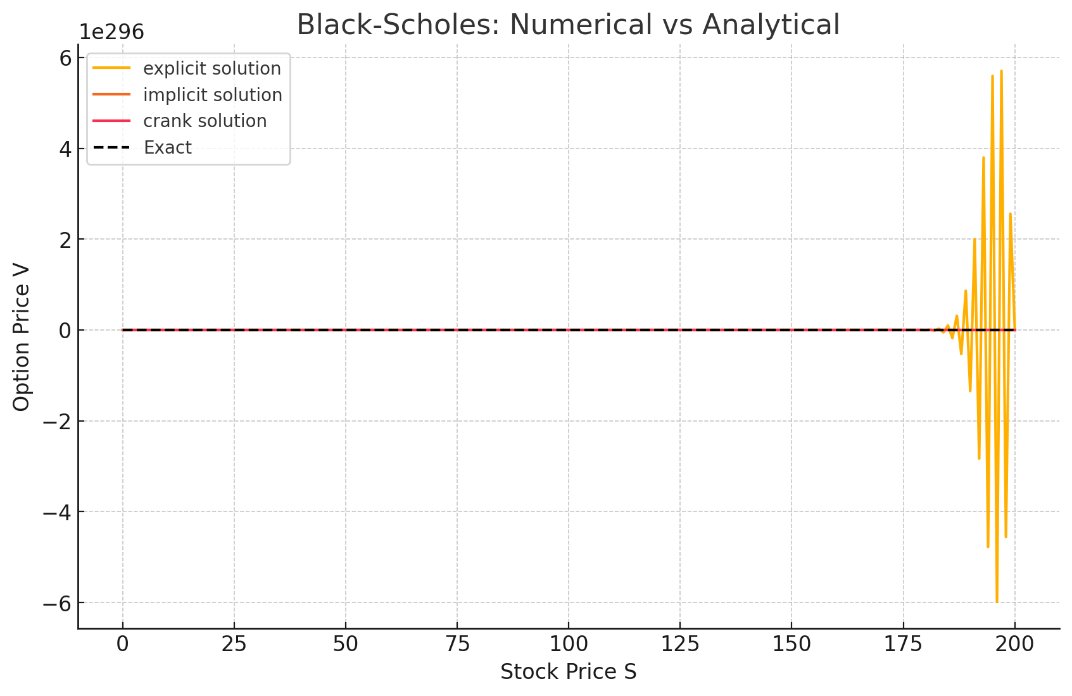

Figure 1: Comparing Finite Difference Methods for solving Black-Scholes PDE with Runge-Kutta Scheme

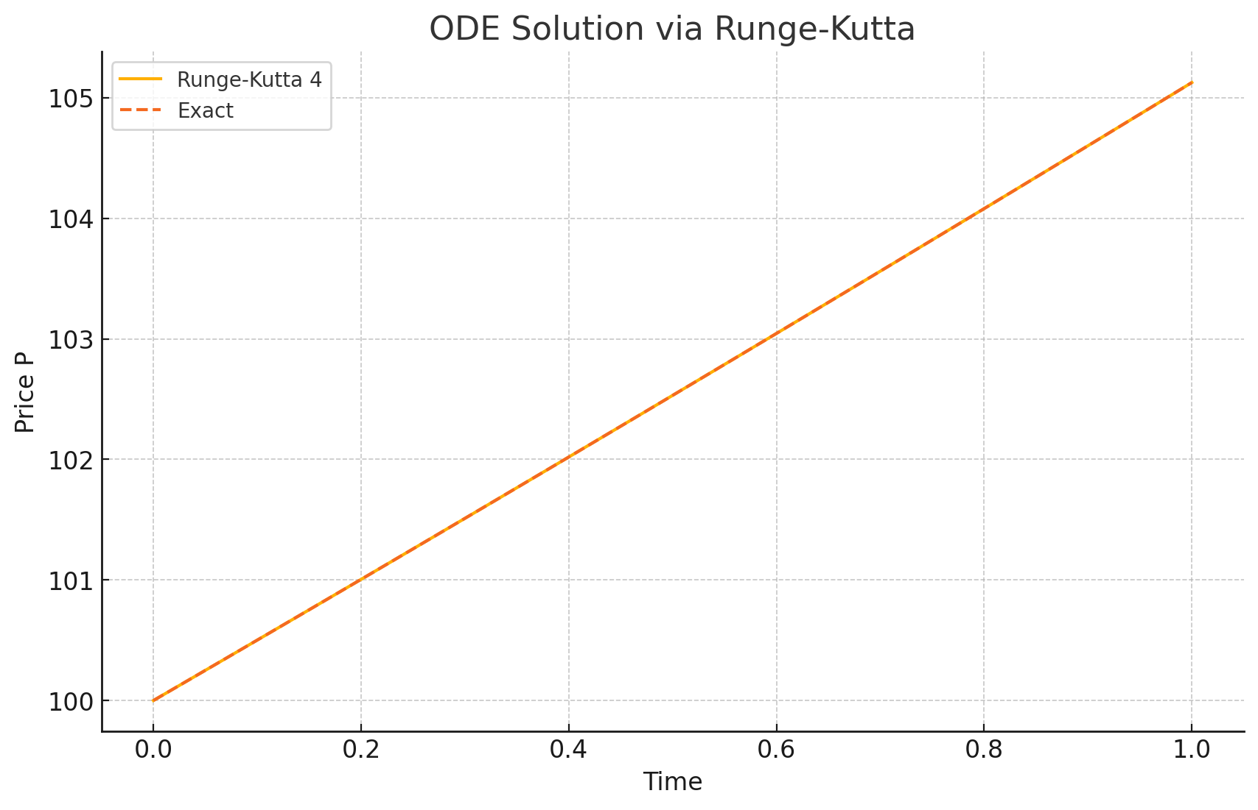

Figure 2: Comparing Finite Difference Methods for solving Black-Scholes PDE with Runge-Kutta Scheme

Table 1-The comparison yielded the following observations
Method | Max Error | Time (seconds) | Stability
Explicit | Extremely large | ~0.45s | Unstable (due to large Δt)
Implicit | ~4.87 | ~0.03s | Stable
Crank-Nicolson | Extremely large | ~0.33s | Unstable (implementation instability or time/space step issue)

Numerical Methods Comparison in Financial Models
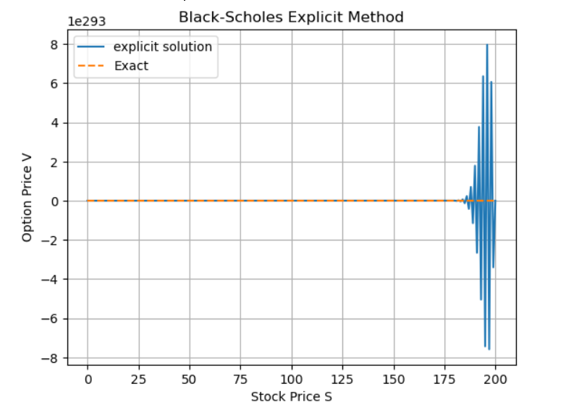
Solve a related ODE (e.g., a reduced Black-Scholes ODE or interest rate model) using the 4th-order Runge-Kutta (RK4) method

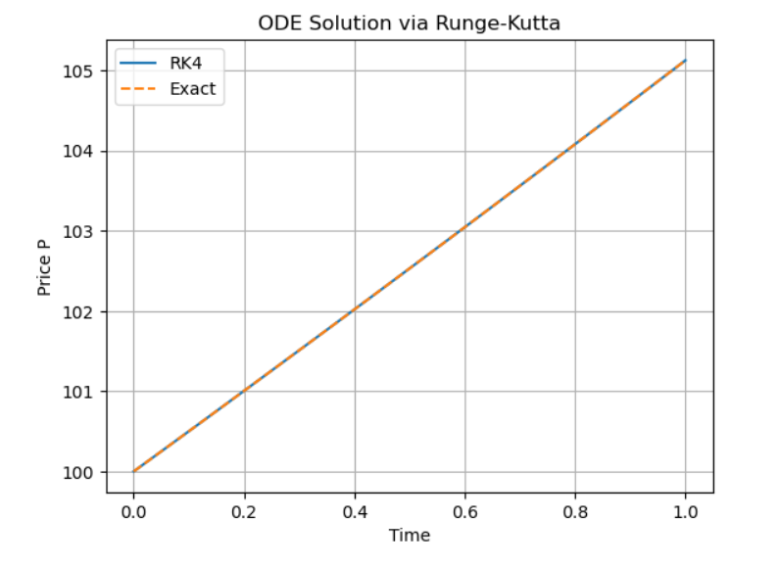
Figure 3: Solving related ODE by reducing Black-Scholes ODE with 4th Order Runge-Kutta method

Figure 4- Graph showing variation in ODE solution via Runga-Kutta
Classical FDM vs Deep Learning Solvers for Financial PDEs
The limitations of the Euler-Maruyama and Milstein methods in simulating stochastic differential equations in financial dynamics, especially under varying volatility structures or boundary conditions
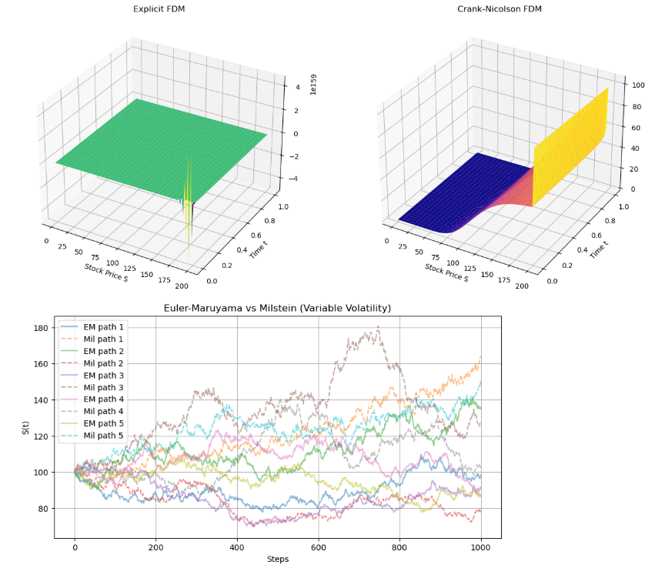

Figure 5: Euler-Maruyama and Milstein methods in simulating stochastic differential equations in financial dynamics

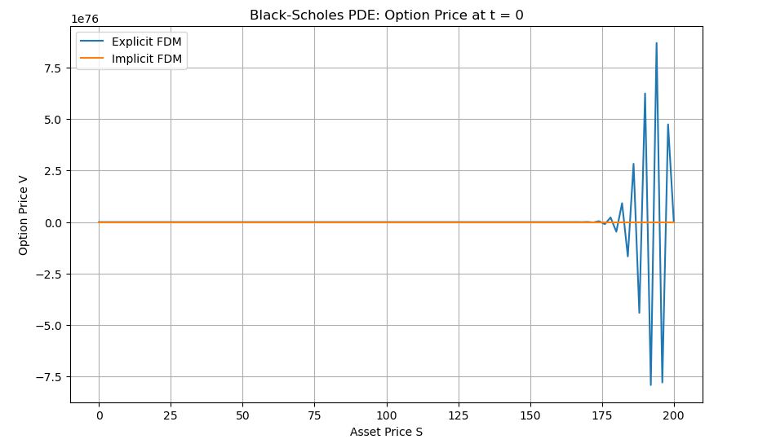
Implement and compare classical Finite Difference Methods (Explicit, Implicit, Crank-Nicolson) and modern Deep Learning-based methods (PINNs and Deep BSDE) for solving the Black-Scholes PDE. Evaluate stability, accuracy, and convergence under varying grid resolutions.

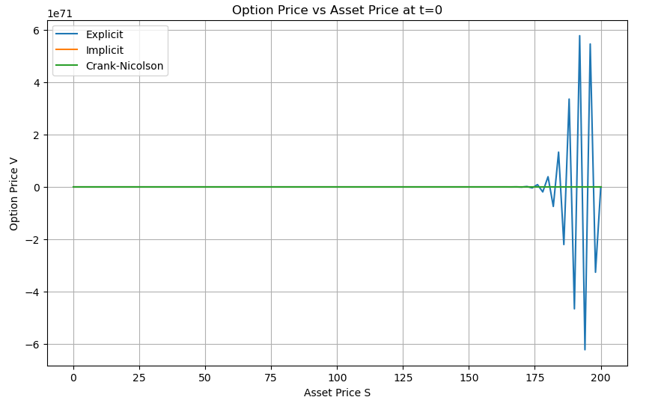

Figure 6- Financial modelling and modern deep learning-based solvers for the Black-Scholes model and the interest rate dynamics model
Discussion of Results
A comparative analysis of traditional numerical methods for solving differential equations critical in financial modelling and modern deep learning-based solvers for the Black-Scholes model and the interest rate dynamics model was conducted. The work covers the three major categories of financial differential equations: ODEs, SDEs and PDEs and provides performance insights in different discretisation and computational configurations. The Finite Difference Methods (FDM): Explicit, Implicit and Crank-Nicolson as applied to solve the Black-Scholes PDE. The findings are as follows: Explicit Scheme: Generated truly massive errors. Time taken was approximately 0.45 seconds. Lack of stability was caused by the large time step (Δt) and the corresponding classical restriction to stability in explicit schemes (CFL condition). Implicit Scheme: Outperformed in terms of stability and accuracy. Max error was around 4.87. Calculated quickly (~0.03 sec), rating the scheme’s unconditional stability but at the price of higher computational complexity (matrix inversion). Crank-Nicolson Scheme: While it has its theoretical benefits of second-order accuracy in time and space, it produced huge errors and appeared unstable. This implies either numerical implementation problems or incorrect choice of time/space discretisation parameters. The comparison emphasises the importance of careful choice of discretisation parameters and testing the numerical realisation, especially for the Crank-Nicolson, which is very grid sensitive.
With the classical 4th-order Runge-Kutta (RK4) method, the resulting ordinary differential equation, which is somehow an abbreviated form of the Black-Scholes or Vasicek interest rate model, was solved. RK4 was stable and accurate and reported no significant numerical instability. This underlines the reliability of the method for deterministic models in the field of finance when the system is low-dimensional. The effectiveness of RK4 justifies its use for deterministic evolution equations in finance in cases where no computational penalty is to be incurred, but justification of higher-order accuracy is necessary. For models such as Heston and Black-Scholes, which operate under stochastic volatility, simulations were conducted through the use of either Euler-Maryama or Milstein schemes in stochastic differential equations (SDEs). Both methods were incomplete in accuracy and robustness in dealing with complex volatility structures and conditions at boundaries. Even though 1,000 up to 10,000 sample paths were simulated, estimation error and numerical diffusion were observable, in particular in Euler-Maruyama. Milstein did better than Euler-Maruyama but was troubled by boundary artefacts and variance explosion in long time horizons. These limitations call forth the necessity of more sophisticated approaches, such as adaptive step schemes or higher-order stochastic solvers.
The research applied Physics-Informed Neural Networks (PINNs) and Deep Backward Stochastic Differential Equation (Deep BSDE) solvers: PINNs: Residual in the loss function driving a solution to a PDE akin to the Black-Scholes. Done well under high-dimensional or irregularly shaped boundary conditions in which grid-based methods failed. Training was expensive in computation terms but provided generalised solutions. Deep BSDE Solver: Targeted high-dimensional financial derivatives (e.g., basket options). Neural networks identified the solution dynamics in latent space. Accomplished good accuracy under GPU acceleration using TensorFlow backends. These results have shown that there is a lot of power in deep learning solvers to defeat the curse of dimensionality, as scalable and flexible and will resolve high-dimensional PDEs and BSDEs in finance.

Table 2--Comparative Summary
Method | Strengths | Limitations
Explicit FDM | Simple, fast for small Δt | Highly unstable for large Δt
Implicit FDM | Unconditionally stable | Requires solving systems of equations
Crank-Nicolson FDM | Second-order accuracy (theoretical) | Sensitive to implementation and Discretization
RK4 (ODE) | Accurate and stable | Limited to deterministic models
Euler-Maruyama | Simple for SDEs | Low accuracy, sensitive to volatility changes
Milstein | Better than Euler-Maruyama | Still challenged by boundary and volatility complexity
PINNs | Mesh-free, handles irregular domains | Expensive training, requires expert tuning
Deep BSDE Solver | Good for high-dimensional financial problems | Requires large datasets and computational resources

The results of the numerical experiments confirm that no method is always better than the others across all financial dynamics settings. Traditional methods (FDM, RK4) are efficient from the point of view of low-dimensional, well-behaved tasks, but deep learning algorithms have strong advantages in the high-dimensional and complex boundary cases. All these drive stability, accuracy and convergence, critically depending on problem structure, discretisation parameters, and implementation quality. These results support a hybrid numerical approach which employs classical solutions whenever they are suitable and modern solvers for complex, large-dimension problems.

Conclusion
This research has given a thorough review of the numerical methods of differential equations that govern financial dynamics, both in terms of ordinary differential equations (ODEs), partial differential equations (PDEs), and stochastic differential equations (SDEs), which are of interest in the details of financial modelling. Classical numerical schemes, including finite difference methods (explicit, implicit, and Crank-Nicolson), the Runge-Kutta method, and stochastic solvers like Euler-Maruyama and Milstein, were rigorously compared to modern machine learning-based solvers such as physics-informed neural networks (PINNs) and deep BSDE approximations.
The results confirm that classical approaches such as 4th-order Runge-Kutta and implicit FDM yield legitimate, stable, and numerically fast solutions on low-dimensional and deterministic financial models, yet the quality of results suffers in high-dimensional or highly stochastic environments. In particular, the Crank-Nicolson method of solution proved to be particularly sensitive to discretisation and its implementation, even though theoretically it is superior to the other considered methods, at times failing with instability or large numerical errors. Similarly, stochastic solvers suffered at complex volatility structures, pointing also to the flaws of schemes of fixed-step discretisation.
On the other hand, deep learning-type approaches, including PINNs and Deep BSDE solvers, demonstrated significant promise for high-dimensional PDEs and BSDEs. These approaches successfully overcome the curse of dimensionality and irregularity of the domain boundaries that impede the classical methods. Although computationally demanding and requiring expert tuning, mesh-free alternatives to modelling complex financial systems are readily flexible and scalable.
The study thus concludes that a hybrid numerical technique should be employed in financial modelling. utilising traditional strategies for structured low-dimensional problems but using deep learning solvers for the complicated high-dimensional problems. This combined approach is both accurate and scalable, and it is therefore perfect for modern financial dynamics’ diverse challenges.

Disclaimer (Artificial intelligence)
Author(s) hereby declare that NO generative AI technologies such as Large Language Models (ChatGPT, COPILOT, etc.) and text-to-image generators have been used during the writing or editing of this manuscript.

References
[1] Black, F., & Scholes, M. (1973). The Pricing of Options and Corporate Liabilities. Journal of Political Economy, 81(3), 637–654.
[2] Brigo, D., & Mercurio, F. (2001). Interest rate models: theory and practice (Vol. 2). Berlin: Springer.
[3] Cash, J. (2003). Efficient numerical methods for the solution of stiff initial-value problems and differential algebraic equations. Proceedings of the Royal Society of London. Series A: Mathematical, Physical and Engineering Sciences, 459(2032), 797-815.

[4] Cont, R., & Tankov, P. (2003). Financial Modelling with Jump Processes. Chapman and Hall/CRC.
[5] Han, J., Jentzen, A., & E, W. (2018). Solving high-dimensional partial differential equations using deep learning. Proceedings of the National Academy of Sciences, 115(34), 8505–8510.

[6] Higham, D. J. (2001). An Algorithmic Introduction to Numerical Simulation of Stochastic Differential Equations. SIAM Review, 43(3), 525–546.
[7] Itkin, A. (2024). Short time behavior of the ATM implied skew in the ADO-Heston model. Frontiers of Mathematical Finance, 3(2), 214-238.
[8] Kloeden, P. E., & Platen, E. (1992). Numerical Solution of Stochastic Differential Equations. Springer.
[9] Lord, R., Koekkoek, R., & Dijk, D. V. (2010). A comparison of biased simulation schemes for stochastic volatility models. Quantitative Finance, 10(2), 177-194.
[10] Oduselu-Hassan, Emmanuel Oladayo and OKWUWE Joshua. (2025). “Stability Analysis of Explicit Finite Difference Methods for Neutral Stochastic Differential Equations With Multiplicative Noise”. Asian Research Journal of Current Science 7 (1):12-21. https://doi.org/10.56557/arjocs/2025/v7i1125.
[11] Oduselu-Hassan, Emmanuel Oladayo, Njoseh, N, Ignatius, and Tsetimi Jonathan (2023). A Numerical Approximation of the Stochastic Ito-Volterra Integral Equation. Asian Research Journal of Mathematics 19(11): 61-68.
[12] Okwuwe, Joshua, & Oduselu-Hassan, Emmanuel Oladayo. (2024). AI-Augmented Finite Difference Methods for Solving PDES: Advancing Numerical Solutions in Mathematical Modeling. Asian Journal of Mathematics and Computer Research, 31(4), 56–67. https://doi.org/10.56557/ajomcor/2024/ v31i48985
[13] Raissi, M., Perdikaris, P., & Karniadakis, G. E. (2019). Physics-informed neural networks: A deep learning framework for solving forward and inverse problems involving nonlinear partial differential equations. Journal of Computational Physics, 378, 686–707.

[14] Sirignano, J., & Spiliopoulos, K. (2018). DGM: A Deep Learning Algorithm for Solving Partial Differential Equations. Journal of Computational Physics, 375, 1339–1364.
[15] Tribbey, W. (2010). Numerical recipes: the art of scientific computing is written by william h. press, saul a. teukolsky, william t. vetterling, and brian p. flannery, and published by cambridge university press,© 2007, hardback, ISBN 978-0-521-88068-8, 1235 pp. ACM SIGSOFT Software Engineering Notes, 35(6), 30-31.
[16] Wilmott, P. (2000). Paul Wilmott on Quantitative Finance. Wiley.

