ALLELOPATHIC EFFECT OF LEAF, STEM, AND ROOT EXTRACTS OF PARTHENIUM HYSTEROPHORUS L ON WHEAT (TRITICUM AESTIVUM L.) SEED GERMINATION AND SEEDLING GROWTH AT HARGEISA, SOMALILAND

.
ABSTRACT

(Parthenium hysterophorus L.) has a latent allelopathic effect on the germination of bread wheat seeds and the growth of its seedlings. Two experiments (Laboratory and pot experiments) were carried out during Jan-Mar 2024, at the Ministry of Agricultural Development Hargeisa, Somaliland, with the objectives of studying the leaf, stem and root extract concentrates (10%, 20% and 30%) of Parthenium hysterophorus allelopathic effect on seed germination and seedling growth of bread wheat. The concentrates were prepared from each root, stem, and leaf part of the weed. To each extract 100 ml of distilled water was added and solutions of 10%, 20%, and 30% were prepared with check (0%) which were laid out using a completely randomized design and a randomized complete block design for laboratory and pot experiment, respectively. The analysis showed that there was a highly significant effect the leaf, stem and root extract of the weed on seed germination and seedling growth of wheat. A low germination percentage of wheat seed (66%, 59%, and 26.5%) was recorded from a 30% concentration of root, stem, and leaf extracts, respectively. Similarly, in pot trials, seedling emergence decreased with a 30% concentration of root (67.71%), stem (60.95%), and leaf (42.3%) extracts. ‍ Shoot length was significantly affected by the P. hysterophorus extract parts and concentration levels, as the minimum shoot length was recorded at a 30% concentration level of leaf, stem and root parts. Root growth was also adversely affected by the leaf, stem and root extract parts and different concentrates, with the longest roots recorded at (0% concentration) and the minimum root length at 30% concentration of all the weed parts.‍ The verdicts of the study concluded that there is a direct relationship between concentration levels and effect magnitude, with higher concentrations leading to greater effects and specifically, the leaf part of P. hysterophorus exhibited a significant effect at a concentration level of 30%. Therefore, further studies are suggested to confirm the allelopathic effect of the weed under field conditions.

Keywords: Allelopathic effect, germination, concentrates, Parthenium hysterophorus, root and shoot growth, wheat

1. INTRODUCTION

Wheat (Triticum aestivum L.) is known as the king of cereal crops in the family Poaceae (Singh et al., 2023). The crop played a crucial role in the ancient civilizations of Europe, West Asia, and North Africa, serving as their primary source of food. It was one of the first nourishment crops to be domesticated, and the crop thrives best between the latitudes of 30° and 60°N and 27° and 40°S and is grown outside at elevations ranging from sea level to over 3000 msl due to its genetic potential and adaptability, it grows at temperatures ranging from 4°C to 32°C with optimal of 25°C, and precipitation ranging from 250 mm to 1750 mm (Curtis, 2019).
In terms of cereal production worldwide, wheat ranks as the second most harvested crop, following only rice and corn (maize), which highlights the significant role wheat plays in global agricultural production (Dhakane et al., 2023). Wheat is considered to be the most important crop cultivated on a large scale in terms of its value as a profitable crop, high yields per hectare, and a significant role in providing food for the population (Sandeep et al., 2021). Wheat contains a high amount of nutrients, including starch (60–90%), protein (11–16.5%), fat (1.5-2%), inorganic ions (1.2–2%), vitamins and serves as a staple source of nutrients for 40% of the world’s population as well as a popular source of animal feed (Megersa et al., 2023).
In Somaliland, wheat is one of the major primary foods for everyday living, its grain is converted into flour for making many different bakery foods, wheat flour is mostly used as a dough (local term “Laxoox”) and bread for breakfast and dinner. In 2022, the Somaliland Ministry of Agricultural Development cultivated an area of 450 ha in the region with an annual production of 1228.5 tonnes and 2.73 tons ha⁻¹ (MoAD, 2022). The Roobroon Flour Mill factories, the first and only large-scale commercial wheat farm in Somaliland, expecting to produce 25,000 tons of wheat annually with a gross revenue of $10 million from selling wheat grain and $15 million in wheat flour (Roobroon, 2022).
Ethiopia and South Africa are the prime producers in sub-Saharan Africa (USDA, 2019). In particular, Ethiopia stands out as the largest wheat producer in this region, cultivating 2.1 million hectares with a total grain yield of 6.7 million tons making it one of the main and crucial cereal crops in the country’s food security (Tesi et al., 2022). Global wheat production in 2023 was 793.3 million metric tons (FAO, 2024). The European Union is the leading producer of wheat, while China and India are the second and third leading producers respectively (USDA, 2023).
But though wheat is very pertinent for both health and the economy, Carrot grass is a severe threat to its production, as it affects this crop from emergence to maturity by discharging particular biochemicals (allelochemicals) into the nearby growing environment through their leaves, roots, and stems. Carrot weed infestation lowers crop yield and grain quality in field crops, causing significant economic losses of up to 40-90% (Hussain et al., 2024).
Parthenium hysterophorus L., a member of Asteraceae family, also known as congress grass, carrot weed, white top weed, and hunger weed (Adhikari et al., 2023). It is an annual herbaceous plant species and is one of the top 100 most invasive weeds in the world, its native to Mexico and the tropical and sub-tropical Americas but now accidentally spread to over 50 countries (Costello et al., 2022). Segmented regression studies revealed that the weed expanded more swiftly in underdeveloped countries, notably in Asia and Africa starting in the 1950s; In Somaliland P.hysterophorus (locally known as Kelidi-Noole “living alone”) due to its colonization in every habitat, has captured every place and came first from Egypt through imported wheat grain (Mao et al., 2021).
P.hysterophorus can adapt to a wide range of ecosystems, which degrades indigenous species composition, making it one of the most serious threats to biodiversity. The weed reduces crop and pasture yield significantly and serves as a secondary host for numerous crop diseases and pests. It also increases the cost of livestock production as it reduces the pasture area and decreases milk quality when animals are fed, it causes allergic metastasis issues, dermatitis, and mutagenicity in humans and animals due to the allelopathic chemicals present in the weed (Shrestha, 2023).
P.hysterophorus infest important crops such as wheat (Triticum aestivum L.) and is a fierce competitor with crop and pasture plants for soil moisture and nutrients in agroecosystems (Masum et al., 2022). P.hysterophorus spread in the southwestern and bordering field areas of Hargeisa, significantly hindering rangeland and cropland productivity in Somaliland, consequently affecting the livelihoods of thousands of agro-pastoralists (Landmann et al., 2017). Mills et al. (2015) did a thorough study and found that the invasion of exotic weeds, particularly Parthenium hysterophorus had changed the composition of grass species and large-scale agricultural activities in Somaliland, particularly Tog-Wajaale. In addition to the globalization of anthropogenic activities, climate change is a factor in the acceleration rate of invasion of noxious alien species (Al-Ruheili et al., 2022). This weed is physiologically adaptable and thus tolerant to a variety of environmental conditions such as extreme temperature, low soil moisture content, and rising atmospheric CO₂ concentrations (Thiney et al., 2019 and Masum et al., 2022).
P.hysterophorus is a potential allelopathic plant and have adverse and significant allelopathic effects on wheat, it inhibits seed germination, decreases seedling growth, biomass, and grain fill due to the allelochemicals present in its parts (Shi et al., 2021). Bashar et al. (2022) found that the methanol extract of carrot weed leaves contains a variety of compounds, including phenolic acids, carbohydrates, amino acids, terpenoids, and flavonoids; remarkably, the phenolic acids were identified as potent agents in inhibiting plant growth. In a different study, Bristone et al. (2021) investigated the presence of phytochemicals in carrot grass leaf, stem, and root extracts using different polarities of solvents (methanol, hexane, ethyl acetate, and water). The phytochemical analysis showed the presence of alkaloids, Phenols, Saponins, Tannins, Terpenoids and Glycosides of different leaf, stem and root weed parts in all solvents.
Wang et al. (2020) conducted a systematic chemical investigation of P.hysterophorus and isolated fourteen compounds, which included five plant phytosterols and their derivatives: The components include sitosterol, stigmasterol, daucosterol, stigmasterol-3-O-glucopyranoside, and stigmasteryl-3[beta]-arachidate, six terpenoids (parthenin, dihydroxyolean-12-en-28-oic acid, oleanolic acid, 3-oxo-16-hydroxyolean-12-en-28-oic acid, oleanolic acid 28-O-beta-D-glucopyranoside, and dichrocepholide), and one flavonoid, 3-O-methylquercetin, one benzene derivative, 4-methoxybenzoic acid, and (4S,6S)-4-hydroxy-6-undecyltetrahydro-2H-pyran-2-one. Another experiment conducted by Kumari and Deepalakshmi (2017) identified steroids, sugars, alkaloids, tannins, quinines, and phenols as allelochemicals in all three organs of the plant in carrot grass methanol extracts and detected the presence of 45 different compounds in the leaf part using gas chromatography-mass spectrometry (GC-MS) analysis. Therefore, the present study was designed to investigate the allelopathic effect of different parts (leaf, stem, and root) of Parthenium hysterophorus at various concentration levels (10%, 20%, and 30%) on the seed germination and seedling growth of bread wheat (Triticum aestivum L.) under laboratory and pot experiment conditions.

2. material and methods

2.1 Description of the study area
The experiment was conducted at the Ministry of Agricultural Development (MoAD), Hargeisa, Somaliland, from January to March 2024. The study area is located at an altitude of 1,271 m above sea level at 9°33′30.2″N and 44°03′06.1″E. The region has a mean annual temperature of approximately 25°C, with average minimum and maximum temperatures of 22°C and 28°C, respectively. The average relative humidity is 58%, and the mean annual rainfall is approximately 600 mm (FAOSWALIM, 2023).

2.2 Source and preparation of treatments
The experimental materials consisted of carrot grass (Parthenium hysterophorus L.) and wheat (Triticum aestivum L.) seeds.
Fresh plants of P. hysterophorus were collected from Arabsiyo, located west of Hargeisa (9°40′48.8″N, 43°45′31.0″E). The plants were separated into roots, stems, and leaves and washed thoroughly with distilled water to remove dust and debris (Plate 1). .
Plant extracts were prepared using the aqueous extraction method. Fresh plant parts were crushed separately using a pestle and mortar. From each plant part, extracts of 10 g, 20 g, and 30 g were prepared and mixed with 100 ml of distilled water to obtain 10%, 20%, and 30% (w/v) concentrations, respectively. The prepared solutions were stored in a refrigerator at 15°C (Plate 2). until use to maintain freshness.
Certified wheat seeds were obtained from the Wajaale Research and Production Center, Ministry of Agricultural Development.
Seed viability test
Seed viability was tested using the tetrazolium chloride (TTZ) test. A total of 300 wheat seeds were soaked in distilled water for 5 hours to allow hydration. The seeds were then cut longitudinally and placed in a 1% tetrazolium chloride solution (1 g TTZ in 100 ml distilled water). The samples were incubated in darkness for 24 hours at 28°C. Seeds showing bright red staining were considered viable, and the viability percentage was recorded as 95%.
Seed health test
Seed health was assessed using the potato dextrose agar (PDA) method. Surface-sterilized seeds (70% ethanol) were placed in six Petri dishes (5 seeds per dish) containing PDA medium and incubated at 27°C for 7 days. No fungal growth was observed, indicating that the seeds were free from seed-borne pathogens (Plate 3).

2.3 Treatment and experimental design

2.3.1 Laboratory experiment
The laboratory experiment consisted of three extract types (root, stem, and leaf) and three concentration levels (10%, 20%, and 30%) along with a control treatment (distilled water). A total of 10 treatments were arranged in a Completely Randomized Design (CRD) with four replications. Forty 90-mm Petri dishes were used. Each Petri dish was lined with two Whatman filter papers and ten surface-sterilized wheat seeds were placed evenly on the filter paper.
The treatments were randomly assigned to the Petri dishes. Each dish received 20 ml of the respective extract solution, while the control received distilled water. The dishes were incubated at 25°C, which is considered optimal for wheat germination. Moisture levels were maintained by adding the corresponding extract solution daily (Plate 5).
Table 1. Treatment combinations used in the laboratory experiment
Treatment | Extract type | Concentration
T1 | Control | Distilled water
T2 | Root extract | 10%
T3 | Root extract | 20%
T4 | Root extract | 30%
T5 | Stem extract | 10%
T6 | Stem extract | 20%
T7 | Stem extract | 30%
T8 | Leaf extract | 10%
T9 | Leaf extract | 20%
T10 | Leaf extract | 30%

2.3.2 Pot experiment
A pot experiment was conducted to evaluate the allelopathic effects under soil conditions. The experiment included the same ten treatments used in the laboratory study and was arranged in a Randomized Complete Block Design (RCBD) with three replications, resulting in 30 experimental pots.
Plastic pots measuring 30 cm × 25 cm were filled with 1.5 kg of field soil. Ten wheat seeds were sown in each pot in two rows, with 5 seeds per row. The spacing between rows was 20 cm, and the spacing between seeds was 5 cm. Spacing between blocks and pots was 0.5 m and 0.25 m, respectively.
The prepared extract solutions were applied by soil drenching at sowing and later sprayed on seedlings after 7 days of germination (two sprays per seedling). All pots received equal irrigation (300 ml water) to maintain uniform moisture conditions.

Table 2. Layout of pot experiment
Block 1 |  |  | 0.5m | Block 2 |  |  | 0.5m | Block 3
P1  (T3) | P2  (T7) | P3  (T1) | 0.5m | P11  (T5) | P12  (T2) | P13  (T9) | 0.5m | P21  (T1) | P22  (T4) | P23  (T7)
P4  (T10) | P5  (T4) | P6  (T9) | 0.5m | P14  (T4) | P15  (T7) | P16  (T3) | 0.5m | P24  (T2) | P25  (T9) | P26  (T10)
P7  (T2) | P8  (T5) | P9  (T8) | 0.5m | P17  (T10) | P18  (T1) | P19  (T6) | 0.5m | P27  (T8) | P28  (T6) | P29  (T3)
P10  (T6) |  |  | 0.5m | P20  (T8) |  |  | 0.5m | P30  (T5)

2.4 Data collection

2.4.1 Laboratory data collection
Following seven days of incubation, the following metrics (germination percent and seedling growth) were regarded in this investigation as specified below.
Germination percentage: The final germination percentage in each treatment was determined by adding up the number of seeds that emerged during the study following treatment.
Germination % = (number of germinated seeds/total seeds) X 100%

Measuring seedling growth
Root length: after the 7th day of seed germination, the root growth of the seedlings in the petri dish was measured with a ruler in centimetres every three days for a period of three weeks, starting at the tip of the primary root and ending at the base of the hypocotyl, the average length of the roots was then recorded.
Shoot length: later the 7th day of plumule development the seedling shoot growth was measured every three days for a period of 21 days starting from the tip of the upper leaf to the base of the point of attachment to the cotyledon using a ruler in units of centimetre and then average shoot lengths were recorded.

2.4.2 Pot data collection
After seed germination, germination percent, and shoot growth were documented in this test as detailed below.
Germination percentage: The final germination percentage in each treatment was determined by adding up the number of seeds that emerged each day following treatment.
Germination % = (number of germinated seeds/total seeds) X 100%

Shoot length: next to the sowing period the seedling shoot growth was measured every three days for a period of three weeks using a ruler in units of centimetre and then average sprout lengths were recorded.

2.5 Data analysis
The collected data were subjected to Analysis of Variance (ANOVA) using SAS software version 9.0. Treatment means were compared using the Least Significant Difference (LSD) test at a 1% probability level (p ≤ 0.01) following the procedures described by Gomez and Gomez (1984).

2.6 Ethical consideration
All laboratory procedures were conducted following standard laboratory safety guidelines. Equipment and facilities were used responsibly, and all experimental procedures were carried out in accordance with institutional research standards.

3. results and discussion

3.1 Laboratory experiment

3.1.1 Effect of leaf, stem and root of P.hysterophorus extracts and concentration ratio on wheat seed germination
The result showed that leaf, stem and root extract concentrate significantly (p<0.01) affected the germination of wheat seeds (Appendix 1). As the concentrate of the extract level increased from 0 to 30%, germination of the wheat seed decreased from 86.25% to 66, 59, 26.5% for root, stem, and leaf extracts, respectively (table3). This implies that the higher the concentrate the greater its negative impact on germination of wheat seed. This study results are in line with the findings of Naz et al., (2023), Budhathoki et al., (2020), and Tessema & Tura, (2018) who reported that aqueous extracts of carrot weed in different parts and levels had significant inhibitory effects on wheat seed germination.
Moreover, the study observed differential effects among the leaf, stem and root extract of P.hysterophorus indicating that there are varying allelochemicals within P.hysterophorus parts. For example, the potency of the inhibitory allelopathic effect of the leaf extract surpassed the root and stem parts within the level of 20% and 30% concentrates causing reduced germination percentages of 47.25% and 26.5% respectively. This indicates there is a predominant allelopathic compound within the foliage part of this weed followed by the stem and root extracts. This has implications for wheat cultivation, as the allelopathic tendencies of P.hysterophorus parts substantially impede the germination of wheat crop.
This finding in line with the investigations of Oli Sarita et al., (2024), and Tessema & Tura, (2018) who revealed that the presence of allelochemicals in this weed leaf part is responsible for affecting wheat seed germination, as these substances are leached out from carrot weed when alive or dead. Bashar et al., (2023), also observed that the carrot weed contains seven phenolic compounds predominantly present in the leaf part of carrot weed and recognized these as the primary agents of inhibition. This sheds light on its significant effect and threat to cultivated crops. The allelopathic potential of these compounds implies that the weed can disrupt the growth and development of crop plants potentially leading to reduced yields and economic losses for farmers and agro-pastoralists.

Table 3. Effect of leaf, stem and root of P.hysterophorus extracts and concentration ratio on wheat seed germination
Type of extract | Concentrate rate (%) | Germination (%)
Control  Root | T1 (0) | 86.55ª
Control  Root | T2 (10) | 69^{abc}
Control  Root | T3 (20) | 67.5^{bcd}
Control  Root | T4 (30) | 66^{bcd}
Stem
Stem | T5 (10) | 71.75^{abc}
Stem | T6 (20) | 69.5^{abc}
Stem | T7 (30) | 59^{dc}
Leaf
Leaf | T8 (10) | 72.25^{abc}
Leaf | T9 (20) | 47.25^{ed}
Leaf | T10 (30) | 26.5e
Grand mean |  | 63.2
LSD (α=0.01) |  | 17.53
CV% |  | 22.38
Means with the same letter are not significantly different at 0.01 probability level.

3.1.2 Effect of leaf, stem and root of P.hysterophorus extracts and concentration ratio on wheat shoot length
The leaf, stem and root extracts and different concentrate rates displayed a significant effect (p<0.01) on shoot length (Appendix 1). The mean shoot length (cm) ranged from 0.59cm to 12.25cm (table 4). Different types of P.hysterophorus extracts exhibited varying effects on shoot growth at different concentrations. The most severe reduction in shoot growth (0.59 cm) was observed with the 30% leaf extract, whereas the 30% stem (3.07 cm) and root (3.13 cm) extract concentrates also significantly decreased shoot length. This demonstrates that the leaf extract had a more substantial growth-limiting effect on shoot growth compared to the stem and root parts. The results also indicated that shoot length decreased as the concentration of leaf, stem, and root extracts increased from 10% to 30%. This indicates that the allelopathic effects become more severe and cause greater damage as the level of concentration increases. Similar findings were reported by Khatun et al., (2023), Khan et al., (2020), and Oli (2018) regarding the concentrates of carrot weed parts effect on wheat and reduced shoot growth at higher rates due to the toxicities of allelochemicals which disrupt essential physiological processes leading to impaired growth and development.‍

Table 4. Effect of leaf, stem and root of P.hysterophorus extracts and concentration ratio on wheat shoot length
Type of extract | Concentrate rate (%) |  | Shoot Length (cm)
Control  Root |  | T1 (0) | 12.25ª
 |  | T2 (10) | 6.73^{b}
 |  | T3 (20) | 5.17^{bc}
 |  | T4 (30) | 3.13^{cd}
Stem
 |  | T5 (10) | 6.39^{b}
 |  | T6 (20) | 4.84^{bc}
 |  | T7 (30) | 3.07^{cd}
Leaf
 |  | T8 (10) | 6.67^{b}
 |  | T9 (20) | 2.9^{d}
 |  | T10 (30) | 0.59e
Grand mean |  |  | 5.03
LSD (α=0.01) |  |  | 1.71
CV% |  |  | 27.4
Means with the same letter are not significantly different at 0.01 probability level.

3.1.3 Effect of leaf, stem and root of P.hysterophorus extracts and concentration ratio on wheat root length
The analysis of variance showed that leaf, stem, and root extract concentrations had a significant negative effect (P<0.01) on wheat root length with mean root length ranging between 0.51cm to 11.25cm (Appendix 1 and Table 5). P.hysterophorus extract sort of cuttings showed different effects at the three concentration levels of 10%, 20%, and 30%. The minimum root length was recorded at a 30% concentration of leaf extract (0.51cm) followed by stem extract (1.95cm) and root extract (2.21cm)‍‍. The peak root length was recorded in the stem control (11.25cm) representing that leaf part has a strong allelopathic effect on root length followed by stem and root extracts. In agreement with this result, Shrestha & Thapa (2018), and Hassan (2018) reported that allelochemical mainly (parthenin) from different parts of carrot grass lethal weed has a significant reduction effect on root length as these compounds can leach from living plant parts or be released during the decomposition of plant residues. The study results also demonstrate that as the concentration levels of extracts of the root, stem, and leaf increase from 10% to 30%, the allelopathic effects intensify, pointing out that the higher concentrations of carrot grass extract led to a greater decrease in root growth. This study aligns with the findings of Bristone et al. (2021) and Singh (2021), who reported that increased concentrations of P.hysterophorus extract resulted in a more pronounced reduction in root growth.

Table5. Effect of leaf, stem and root of P.hysterophorus extracts and concentration ratio on wheat root length
Type of extract | Concentrate rate (%) | Root Length (cm)
Control  Root | T1 (0) | 11.25ª
Control  Root | T2 (10) | 4.31^{bc}
Control  Root | T3 (20) | 3.95^{bcd}
Control  Root | T4 (30) | 2.21^{cdef}
Stem
Stem | T5 (10) | 4.11^{bcd}
Stem | T6 (20) | 3.48^{bcde}
Stem | T7 (30) | 1.95^{def}
Leaf
Leaf | T8 (10) | 4.53^{b}
Leaf | T9 (20) | 2.06^{ef}
Leaf | T10 (30) | 0.51^{f}
Grand mean |  | 3.78
LSD (α=0.01) |  | 1.48
CV% |  | 31.72
Means with the same letter are not significantly different at 0.01 probability level

3.2 Pot experiment
To highlight the importance and emphasize the significance of allelopathic problems of carrot weed plant extracts and how its concentration variations can influence germination and seedling growth in real-field conditions, another experiment was conducted at the Ministry of Agricultural Development using germination pots and the data collected from this experiment is presented and discussed below.

3.2.1 Physiochemical properties of pot soil
As shown in Table 6. Soil analysis report, the soil analytical results indicated that the soil particle size distribution in the pot experiment consisted of 53.3% sand, 10% silt, and 36.7% clay, which can be classified as sandy clay. The total NPK of the soil was medium to high which can support wheat seedling growth (Xu et al., 2021)

Table 6. Soil analysis report
Particulars | Value | Methods
Sand (%) | 53.3 | Soil Texture Test (HIMEDIA Soil Analysis Kit Method,)
Silt (%) | 10.0 | Soil Texture Test (HIMEDIA Soil Analysis Kit Method,)
Clay (%) | 36.7 | Soil Texture Test (HIMEDIA Soil Analysis Kit Method,)
Textural Class | Sandy Clay | Soil Texture Test (HIMEDIA Soil Analysis Kit Method,)
Available Nitrogen (kg ha⁻¹) | 73 (Medium) | Soil Texture Test (HIMEDIA Soil Analysis Kit Method,)
Available Phosphorus (kg ha⁻¹) | 56–73 (Medium High) | Soil Texture Test (HIMEDIA Soil Analysis Kit Method,)
Available Potassium (kg ha⁻¹) | 280–392 (High) | Soil Texture Test (HIMEDIA Soil Analysis Kit Method,)

N.B: Himedia soil kit reagents have 95% accuracy

3.2.2 Effect of leaf, stem and root of carrot grass extracts and concentration ratio on wheat seedling emergence
The analysis variance showed that leaf, stem and root extracts of P.hysterophorus and concentrate proportions significantly (p<0.05) affected the germination of wheat seeds (Appendix 2). The average recorded percentage of wheat seeds ranged between 42.38% to 86.67% as revealed in Table 7. Various extracts from the leaves, stems, and roots of carrot grass exhibit diverse effects. The leaf extract showed very low (42.38%) germination at a 30% concentration, suggesting that this weed’s leaf part contains the highest concentration of allelopathic compounds. The stem and root extracts also resulted in 60.95% and 65.71% germination at 30% concentration, respectively, but relatively better compared to the effect of leaf extract. So, attention should be given to this weed particularly leaf during weeding to mitigate its impact on wheat. The present finding is supported by the results of Khan (2020) and Sharma & Devkota (2014) who identified major phenolic compounds in the leaves of carrot grass and found that the leaf part caused the highest suppression of seed germination compared to the stem and root.
The results of the analysis also reveal a consistent trend of declining seedling emergence as the concentration of P.hysterophorus extracts increases from 0% to 30%. This effect was evident across all extract types studied. The overall germination rates decrease significantly at the highest concentration level, emphasizing that as the infestation level increases the potential allelopathic effect of carrot grass also increases, posing a detrimental impact on wheat crop establishment. This supports the findings of Shakya et al., (2022), Bashar et al., (2022), Khan (2020), and Hassan et al., (2018) which all consistently revealed that higher concentrations of carrot grass aqueous extract exerted a significant inhibitory effect on the germination of wheat seeds. This underscores its potent allelopathic impact and potential to hinder the successful germination process crucial for crop growth and establishment.
Table 7. Effect of leaf, stem and root of P.hysterophorus extracts and concentration ratio on wheat seedling emergence
Type of extract | Concentrate rate (%) | Germination%
Control  Root | T1 (0) | 86.67ª
Control  Root | T2 (10) | 77.62ª
Control  Root | T3 (20) | 69.05^{ab}
Control  Root | T4 (30) | 65.71^{ab}
Stem
Stem | T5 (10) | 75.71^{ab}
Stem | T6 (20) | 67.62^{ab}
Stem | T7 (30) | 60.95^{ab}
Leaf
Leaf | T8 (10) | 75.71^{ab}
Leaf | T9 (20) | 65.24^{ab}
Leaf | T10 (30) | 42.38^{b}
Grand mean |  | 68.67
LSD (α=0.01) |  | 18.95
CV% |  | 21.44
Means with the same letter are not significantly different at 0.01 probability level.

3.2.3 Effect of leaf, stem and root of P.hysterophorus extracts and concentration ratio on wheat shoot length
The result showed that the leaf, stem, and root extract of P.hysterophorus and concentrate ratio had a significant (p<0.05) effect on wheat shoot length. The mean shoot length (cm) ranged from 6.61cm to 18.3cm. The maximum wheat shoot length was recorded at stem control (18.3cm) while the minimum shoot length was recorded from the 30% concentrate of all extract parts. Among the different extracts, the leaf extract had the most pronounced inhibitory effect on wheat shoot length, especially at higher concentrations. At 30% concentration, the leaf extract resulted in the shortest shoot length of 6.61 cm, demonstrating its strong allelopathic impact. Similarly, the stem extract at 30% concentration and the root extract at the same concentration also significantly reduced shoot length, with values of 9.86 cm and 11.18 cm, respectively. This study is in line with the findings of Khatun et al., (2023) who stated that the leaf extract exhibited a stronger inhibitory allelopathic effect compared to other vegetative parts of the parthenium plant.
The results also showed that increasing the concentration of these extracts from 10% to 30% significantly impacts wheat shoot growth. At a 10% concentration, shoot lengths are moderately reduced, with the leaf extract resulting in 14 cm, the stem extract in 14.03 cm, and the root extract in 14.79 cm. This initial reduction indicates that even at lower concentrations, the allelopathic effects of carrot grass begin to hinder wheat shoot development. As the concentration increases from 20 to 30%, the effects become more pronounced as the allelopathic compounds exert greater stress on wheat, further limiting its shoot length. At the highest concentration of 30%, the impact on wheat shoot length become more severe. This significant decrease at higher concentrations underscores the potent allelopathic properties of carrot grass part extracts. Overall, these findings clearly demonstrate that as the concentration of carrot grass extracts increases, the negative impact on wheat shoot length intensifies significantly. This suggests that higher levels of carrot grass infestation could severely hinder wheat growth, highlighting the importance of managing carrot grass infestations to prevent it’s severe reductions in wheat crop growth and productivity.These results agree with the findings reported by Naz et al., (2023), Shakya et al., (2022), Singh (2021), Thakur et al., (2020), Khaliq et al., (2016) and Afridi & Khan (2015), who stated that carrot weed reduced shoot elongation of wheat, as the concentration of extract increased affecting the productivity of this crop.

Table 8. Effect of leaf, stem and root of P.hysterophorus extracts and concentration ratio on wheat shoot length
Type of extract | Concentrate rate (%) | Shoot Length (cm)
Control  Root | T1 (0) | 18.3ª
Control  Root | T2 (10) | 14.79^{ab}
Control  Root | T3 (20) | 12.24^{abc}
Control  Root | T4 (30) | 11.18^{bcd}
Stem
Stem | T5 (10) | 14.03^{abc}
Stem | T6 (20) | 11.97^{abc}
Stem | T7 (30) | 9.86^{cd}
Leaf
Leaf | T8 (10) | 14^{abc}
Leaf | T9 (20) | 11.17^{bcd}
Leaf | T10 (30) | 6.61^{d}
Grand mean |  | 12.23
LSD (α=0.01) |  | 2.52
CV% |  | 16.03
Means with the same letter are not significantly different at 0.01 probability level.

4. Conclusion

To investigate the allelopathic effects of P.hysterophorus leaf, stem and root extract concentrates on wheat seed germination and seedling, fresh carrot grass plants were separated into roots, stems, and leaves, and then processed into concentrates of 10%, 20%, and 30% solutions and stored at 15°C to maintain their efficacy throughout the study period. Due to the allelopathic effects of carrot grass extract, wheat seed germination was inhibited, and both root and shoot lengths decreased as the concentration of the extract increased. Different parts of the plant exhibited varying effects at different concentration levels. The leaf extract, in particular, was found to have the most active compounds. Leaves, being the primary site of photosynthesis, gaseous exchange, and respiration, tend to have a higher concentration of allelochemicals compared to the stem and root. Additionally, leaves are more exposed to environmental factors such as sunlight and air, which can further enhance the production and release of allelochemicals. At the maximum concentration of 30%, there is a notable reduction in wheat seeds and seedlings, highlighting the strong allelopathic properties of carrot grass extracts.
The study results revealed that P.hysterophorus extracts have significant allelopathic effects on wheat seed germination and seedlings, depending on the type and concentration of the extracts. Higher concentrations generally inhibited seed germination and seedling growth more effectively, with shoot extracts showing the most pronounced effects at higher concentrations.
It's suggested that this information is valuable for understanding the potential impact of P.hysterophorus on wheat crops. Farmers should pay special attention during the weeding process and collect this weed in designated areas to avoid its adverse effects on crops. It is strongly recommended to conduct further studies on carrot grass, its impact on crop yield, and optimal management strategies which will facilitate the development of efficient and safe weed control methods.
Disclaimer (Artificial intelligence)
Author(s) hereby declare that NO generative AI technologies such as Large Language Models (ChatGPT, COPILOT, etc.) and text-to-image generators have been used during the writing or editing of this manuscript.

References

- Singh, S., Kaur, J., Ram, H. (2023). Agronomic bio-fortification of wheat (Triticum aestivum L.) to alleviate zinc deficiency in human beings. Rev Environ Sci Biotechnol 22, 505–526. https://doi.org/10.1007/s11157-023-09653-4
- Curtis, B.C., (2019) Wheat in the World. Available online: HYPERLINK "http://www.fao.org/3/y4011e/y4011e04.htm (accessed on 28 March 2019).
- Dhakane, A. A., Ibrahim, M. M., Dahir, F., & Said, M. S. A. (2023) Evaluation of Introduced Wheat Varieties Under Tropical Agro-Ecosystem Environment of Mogadishu, Somalia. Journal of Agriculture and Veterinary Science (IOSR-JAVS) e-ISSN: 2319-2380, p-ISSN: 2319-2372. Volume 16, Issue 9 (September. 2023), PP 01-07 DOI: 10.9790/2380-1609010107
- Sandeep, K, Naresh P.S., Vaishali, Aastha, Vishakha B., Khyati L. and Neelesh K. (2021). Analysis of Genetic Diversity in Wheat (Triticum aestivum L.) Using Simple Sequence Repeats Marker. 10 (37), 94-102. doi:10.37273/chesci.cs2051101006v
- Megersa O., Fekadu Tadesse, Lalisa Ofga, Zeleke Legesse, Hussein Abro (2023). Large Scale Demonstration of Irrigated Wheat Production Technologies in Bedeno District of Eastern Hararghe Zone, Oromia National Regional State, Ethiopia, Research &Development. Volume 4, Issue 1, March 2023, pp. 6-12. http://dx.doi.org/10.11648/j.rd.20230401.12
- MoAD (2022) Ministry of Agricultural Development 2022 Wajaale Production Project.
- Roobroon (2022). Hargeisa, Somaliland available at https://www.roobroon.com
- USDA (2019) United States Department of Agriculture. World markets and Trade Report. ttps://ers.usda.gov/webdocs/outlooks/37116/31031_gfa14d_002.pdf?v=1487
- Tesi, k. M., & Mohammed, P. (2022). genotypic variability and associations of morpho agronomic and quality traits in bread wheat (Triticum aestivum L.) at Kulumsa and Bekoji South-East Ethiopia (doctoral dissertation) http://ir.haramaya.edu.et //hru/handle/123456789/5273
- FAO. (2024) Crop Prospects and Food Situation – Triannual Global Report No. 1, March 2024. Rome. https://doi.org/10.4060/cd0022en
- USDA (2023), Economic Research Service Situation and Outlook Report: available at https://www.ers.usda.gov › webdocs › outlooks
- Hussain, I., M.I.U. Qaisrani, A.A. Khakwani, Z. Hasnian, U.K. Saddozai, M. Naeem, H. Gul and M. Abbass. (2024). Response of maize (Zea mays L.) to Parthenium hysterophorus mixed soil under climatic conditions of Dera Ismail Khan, KP, Pakistan. Pakistan Journal of Weed Science Research, 30(1): 01-06. DOI | https://dx.doi.org/10.17582/journal.PJWSR/2024/30.1.01.06
- Adhikari, P., Lee, Y. H., Poudel, A., Lee, G., Hong, S. H., & Park, Y. S. (2023). Predicting the impact of climate change on the habitat distribution of Parthenium hysterophorus around the world and in South Korea. Biology, 12(1), 84. https://doi.org/10.3390/biology12010084
- Costello, B., Osunkoya, O. O., Sandino, J., Marinic, W., Trotter, P., Shi, B., & Dhileepan, K. (2022). Detection of parthenium weed (Parthenium hysterophorus L.) and its growth stages using artificial intelligence. Agriculture, 12(11), 1838. DOI:10.3390/agriculture12111838
- Mao, R., Shabbir, A., & Adkins, S. (2021). Parthenium hysterophorus: A tale of global invasion over two centuries, spread and prevention measures. Journal of Environmental Management, 279, 111751. Doi: 10.1016/j.jenvman.2020.111751.
- Shrestha, S. (2023). Status of Invasive Alien Plant Species in Dhankuta Municipality. Journal of Research and Development, 6(1): 68-75. https://doi.org/10.3126/jrdn.v6i01.55240
- Masum, S. M., Halim, A., Mandal, M. S. H., Asaduzzaman, M., & Adkins, S. (2022). Predicting current and future potential distributions of Parthenium hysterophorus in Bangladesh using maximum entropy ecological niche modelling. Agronomy, 12(7), 1592. DOI:10.3390/agronomy12071592
- Landmann, T., Dubovyk, O., Ghazaryan, G., Kimani, J., & Abdel-Rahman, E. (2017, July). Wide-area mapping of invasive species propagation and containment zones in Somaliland using phenometric trends and generalized linear modelling. In 2017 IEEE International Geoscience and Remote Sensing Symposium (IGARSS) (pp. 1103-1106). IEEE
- Al-Ruheili, A. M., Al Sariri, T., & Al Subhi, A. M. (2022). Predicting the potential habitat distribution of parthenium weed (Parthenium hysterophorus) globally and in Oman under projected climate change. Journal of the Saudi Society of Agricultural Sciences, 21(7), 469-478. https://doi.org/10.1016/j.jssas.2021.12.004
- Thiney, U., Banterng, P., Gonkhamdee, S., & Katawatin, R. (2019). Distributions of Alien Invasive Weeds under Climate Change Scenarios in Mountainous Bhutan. Agronomy, 9(8), 442. https://doi.org/10.3390/agronomy9080442
- Shi, B., Dhileepan K, Adkins S. (2021). The Impact of Parthenium Weed-Amended Substrates on the Germination and Early Growth of a Range of Pasture and Crop Species. Agronomy 11(9):1708. https://doi.org/10.3390/agronomy11091708
- Bashar, H. K., Juraimi, A. S., Saiful, M., Uddin, M. K., Asib, N., Anwar, M. P., Karim, S. R., Rahaman, F., Haque, M. A., &Hossain, A. (2022). Documentation of Phytotoxic Compounds Existing in Parthenium hysterophorus L. Leaf and Their Phytotoxicity on Eleusine indica (L.) Gaertn. and Digitaria anguinalis (L.) Scop. Toxins, 14(8), 561. https://doi.org/10.3390/toxins14080561
- Bristone, B., Zain, N. M., Muhamad, S. H. A. M. S. U. L., & Ywih, C. H. (2021). Preliminary phytochemical analysis and assessment of herbicidal activity of Parthenium hysterophorus L. extract on germination and initial development of two selected rice weeds in Malaysia. Annals of Agri Bio Research. 26 (1): 43-51
- Wang, M. H., Gan, J. J., Chen, W. H., & Guan, Y. L. (2020). Chemical constituents of Parthenium hysterophorus. Chemistry of Natural Compounds, 56, 556-558.https://doi.org/10.1007/s10600-020-03090-3
- Kumari, C., & Deepalakshmi, J. (2017). Qualitative and GC-MS Analysis of Phytoconstituents of Parthenium hysterophorus Linn. Research Journal of Pharmacognosy and Phytochemistry, 9(2), 105-110.
- FAOSWALIM. (2023) Hargeisa climate series; faoswalimorg-weather/data/aws/icpac/ Hargeisa
- Naz, S., Muhammad, Z., Zaman, A., & Ullah, S. (2023) Allelopathic effect of Parthenium hysterophorus L. on the germination and growth of Wheat. 19 (1): 2023. Journal of Xi’an Shiyou University, Natural Science Edition 1329-1335 volume 19 issue 01 January 2023 ISSN: 1673-064x http://xisdxjxsu.asia
- Budhathoki, P., Gyawali, A., Mandal, M., & Khanal, S. (2020) Quantitative Estimation of Phytochemicals Present in Selected Weeds and Their Allelopathic Effect on Wheat (Triticum aestivum L.) Seedlings at Paklihawa, Nepal January 2021, Journal of Plant Resources and Environment 19(1):142-150
- Tessema, S. S., & Tura, A. M. (2018). Allelopathic property of Parthenin on seed germination and seedling growth of wheat (Triticum aestivum) and barley (Hordeum vulgare). Int. J. Chem. Biochem. Sci. IJCBS, 14, 23-27.
- Oli Sarita, Joshi Rajeev, Bohara Bhuwan (2024). A Review on Parthenium hysterophorus L. and its application in Agriculture, Journal of Agricultural Sciences and Engineering, 2024, 6(1), 16-31. https://doi.org/10.48309/jase.2024.183986
- Bashar, H. K., Juraimi, A. S., Ahmad-Hamdani, M. S., Uddin, M. K., Asib, N., Anwar, M. P., & Hossain, A. (2023). Evaluation of allelopathic effects of (Parthenium hysterophorus L.) methanolic extracts on some selected plants and weeds. Plos one, 18(1), https://doi.org/10.1371/journal.pone.0280159
- Khatun, M. S., Biswas, P. K., Mandal, M. S. H., Yeasmin, M., Akhi, S. S., Mehraj, H., & Masum, S. M. (2023) Prevalence and allelopathic effect of parthenium hysterophorus on crops in southwest regions of Bangladesh. Ecology Journal 5(2):155-161, https: //doi.org/10.59619/ej.5.2.8
- Khan, M. I. (2020). Effect of Parthenium (Parthenium Hysterophorus l.) Water Extract against Wheat (T.aestivum l.) and their Associated Weeds. Metropolitan Journal of Science and Technology, 55. Vol. 1, No. 1, 2020
- Oli, S., Chopra, N., Tiwari, L. M., Mohan, B., Pandey, N., Bharti, M., ... & Tewari, G. (2018). Phytotoxic effect of the extracts of Parthenium hysterophorus L. on the germination, seedling growth and biomass of some agricultural crops. G-Journal of Environmental Science and Technology, 5(4), 40-45.
- Shrestha, B., & Thapa, C. B. (2018). Allelopathic effects of invasive alien species Parthenium hysterophorus L. on seed germination of paddy and wheat. Himalayan Biodiversity, 6, 1–5. https://doi.org/10.3126/hebids.v6i0.33526
- Hassan, G., Rashid, H. U., Amin, A., Khan, I. A., & Shehzad, N. (2018). Allelopathic effect of Parthenium hysterophorus on germination and growth of some important crops and weeds of economic importance. Planta Daninha, 36, e018176372. DOI:10.1590/s0100-83582018360100132
- Singh, A. K. (2021). Inhibitory Effects of Aqueous Leaf Extract of (Parthenium hysterophorus L.) on Seed Germination and Seedling Growth of Some Cultivated Crops. Indian Journal of Scientific Research, 11(2), 09-12.
- Xu, X. P., Ping, H. E., Chuan, L. M., Liu, X. Y., Liu, Y. X., Zhang, J. J., ... & Wei, Z. H. O. U. (2021). Regional distribution of wheat yield and chemical fertilizer requirements in China. Journal of Integrative Agriculture, 20(10), 2772-2780.
- Khan, R., Basit, A., Rasheed, S. M., & Shah, S. S. (2020). Allelopathic effects of plant parts of two invasive weeds on seed germination and seedling growth of open-pollinated maize varieties. DOI:10.28941/26-1(2020)-7
- Sharma S, and Devkota A (2014) Allelopathic potential and phytochemical screening of four medicinal plants of Nepal. Sci World 12:56–61 doi.org/10.3126/sw. v12i12.13598
- Shakya, B., Budhathoki, S., Maharjan, S. R., & Thapa, L. B. (2022). Effects of invasive Parthenium hysterophorus leachates on seed germination and seedling growth of wheat (Triticum aestivum). Journal of Natural History Museum, 65-76. DOI:10.3126/jnhm. v32i1.49953
- Bashar, H. M. K., Juraimi, A. S., Ahmad-Hamdani, M. S., Uddin, M. K., Asib, N., Anwar, M. P., & Rahaman, F. (2021). A Mystic Weed, Parthenium hysterophorus: Threats, Potentials and Management. Agronomy 2021, 11, 1514. https://doi.org/10.3390/agronomy11081514
- Thakur, G.S., & Kunjam, S. (2020). Allelopathic potential of Parthenium hysterophorus on wheat, Triticum aestivum, rice, Oryza sativa, soybean, Glycine max and pigeonpea, Cajanus cajan. https://doi.org/10.33451/florafauna.v26i2pp197-205
- Khaliq, A., Aslam, F., Matloob, A., Javaid, A., Tanveer, A., Hussain, S., & Ihsan, M. Z. (2016). Phytotoxic activity of parthenium against wheat and canola differ with plant parts and bioassays techniques. Planta Daninha, 34, 11-24. https://doi.org/10.1590/S0100-83582016340100002
- Afridi, R. A., & Khan, M. A. (2015). Comparative effect of water extract of Parthenium hysterophorus, Datura alba, Phragmites australis, and Oryza sativa on weeds and wheat. Sains Malaysiana, 44(5), 693-699. DOI:10.17576/jsm-2015-4405-08

APPENDICES
Appendix 1. The mean square of lab experiment measurements
Source | DF | G% | SHL | RL
Treatments | 9 | 881.75** | 33.52** | 30.45**
Rep | 3 | 245.4 | 3.72 | 0.92
Error | 27 | 200.1 | 1.9 | 1.43
Total | 39
Grand mean |  | 63.2 | 5.03 | 3.78
CV (%) |  | 22.38 | 27.4 | 31.72
N.B: This ANOVA table is four replications (Petri plates)

Appendix 2. Mean square of pot germination and shoot parameters
Source | DF | G% | SHL
Treatment | 9 | 425.23** | 23.39**
Rep | 2 | 66.19 | 8.23
Error | 18 | 216.76 | 3.85
Total | 29
Grand mean |  | 68.67 | 12.23
CV (%) |  | 21.44 | 16.03
N.B: This ANOVA table is three replications (pot trials)

LIST OF PLATES

Plate 1. Sample collection
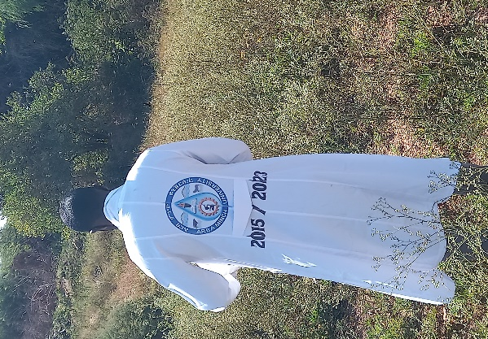

A

- carrot grass sample collection at Arabsio
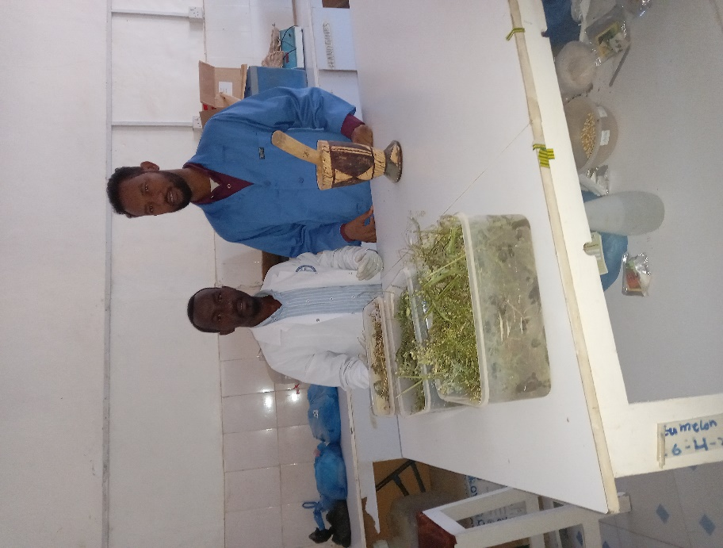

cleaning prepared (leaf, stem and root) parts of carrot grass

Plate 2. Weighing and crashing of Carrot grass
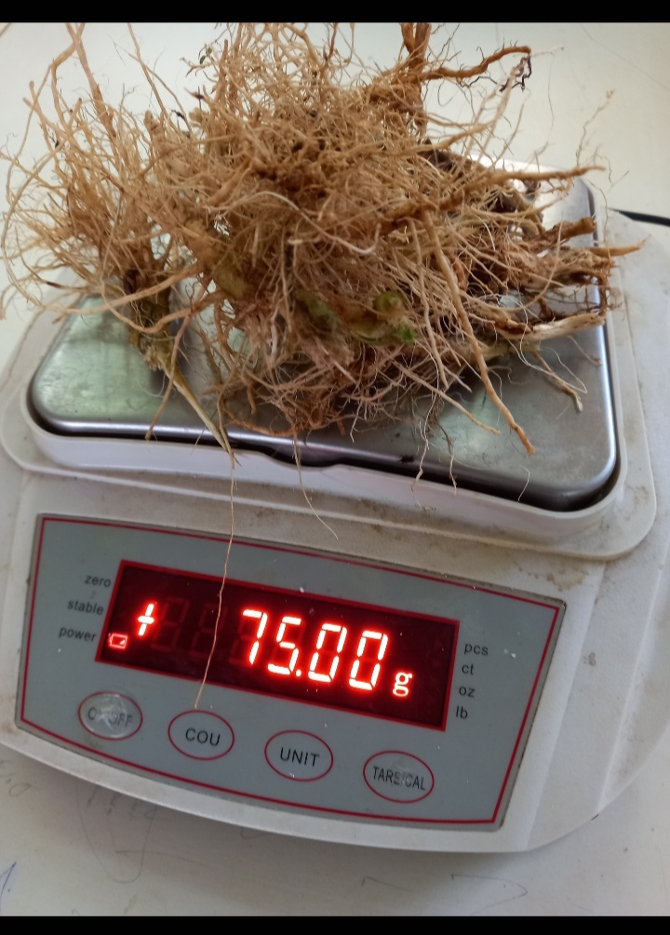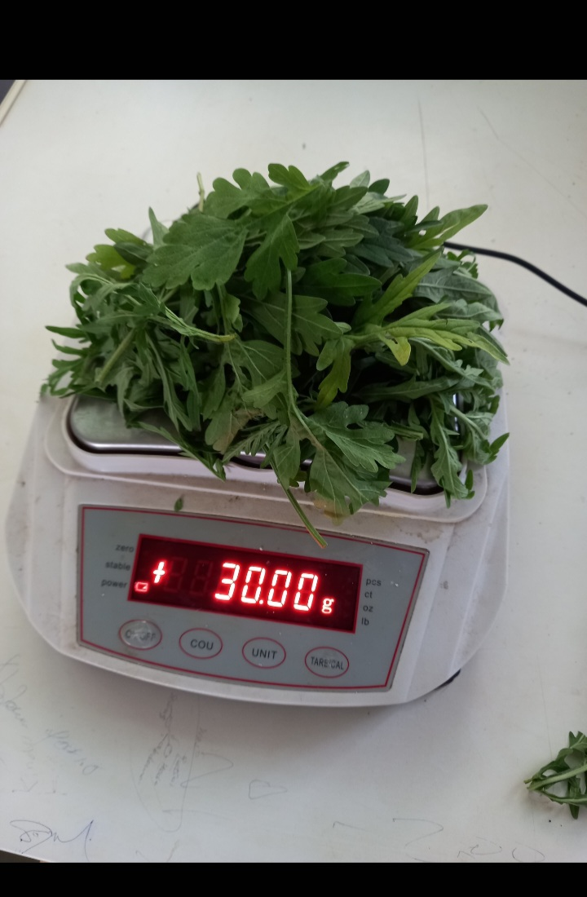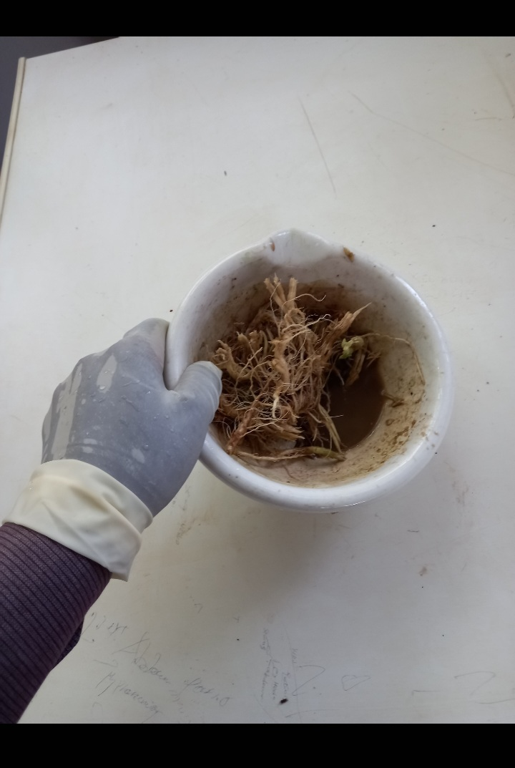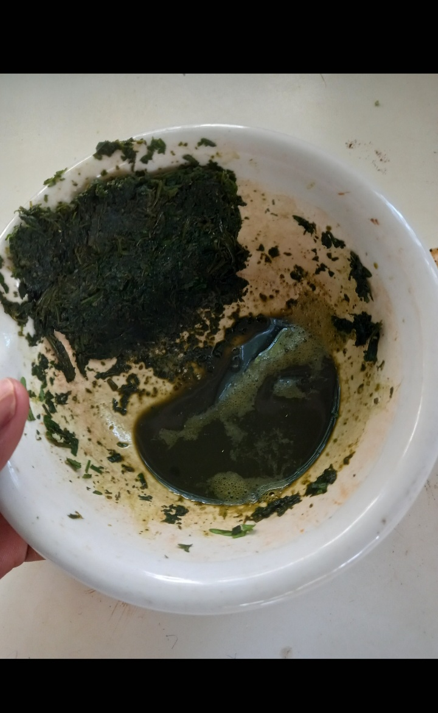

B
A

D
C
A-weighing of root extract in E-balance (error 0.01g) B-weighing of root extract
C. grounding root extract D- grounding leaf extract
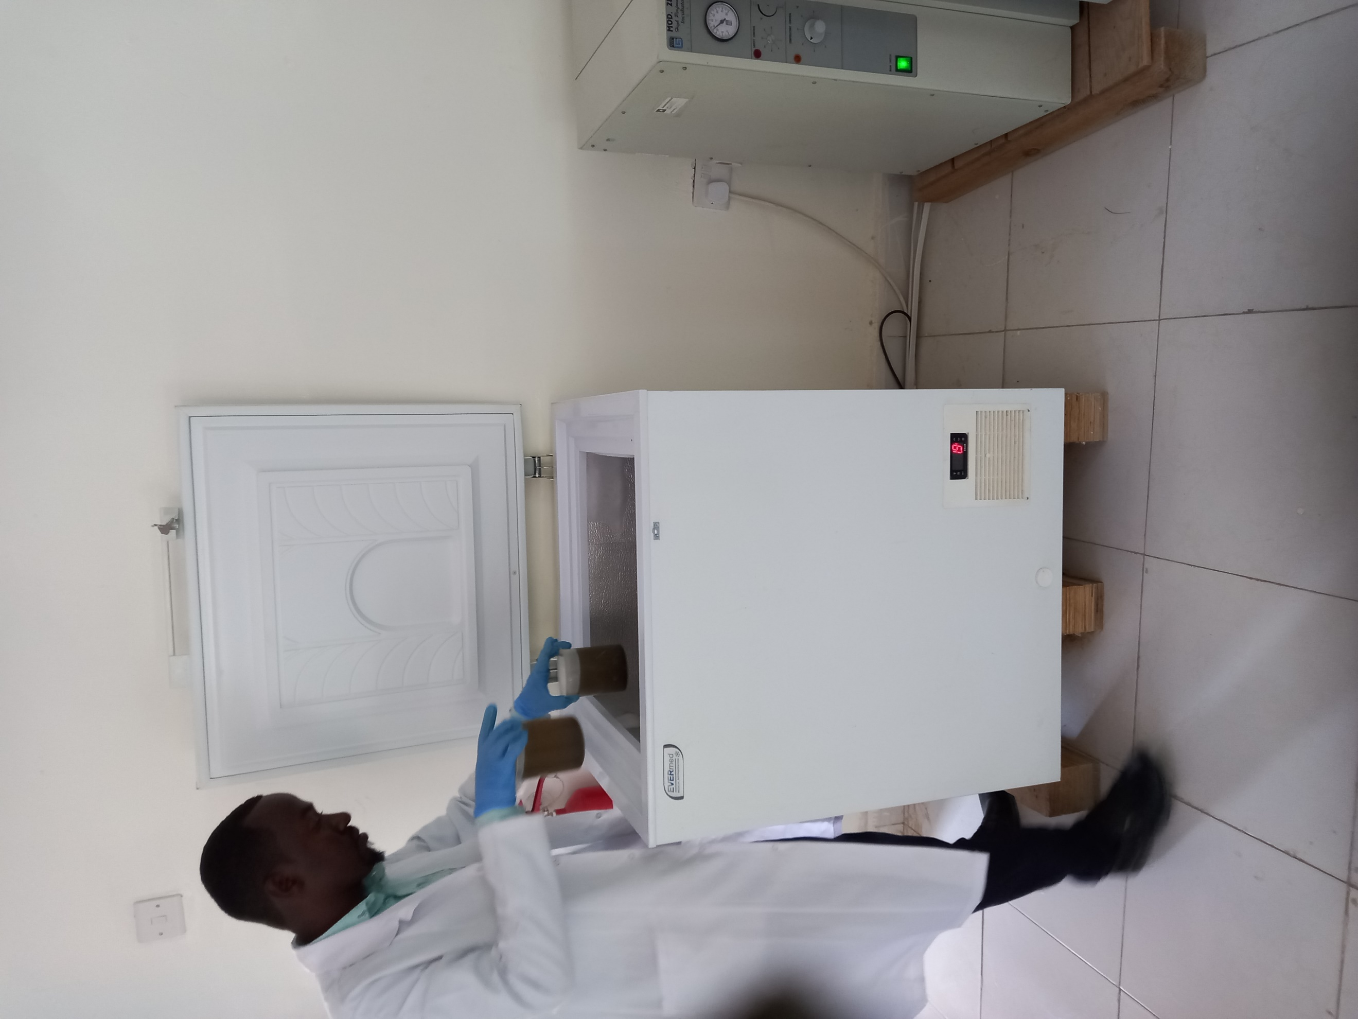

storage of prepared extracts at 15c⁰

Plate 3. Seed viability and health test
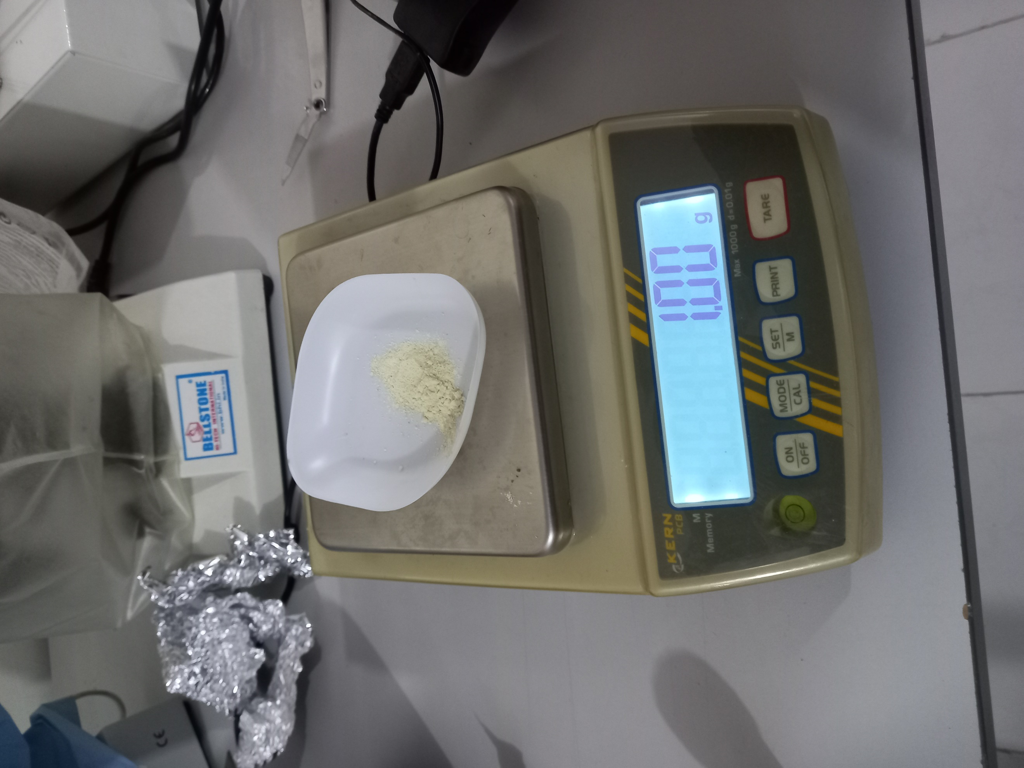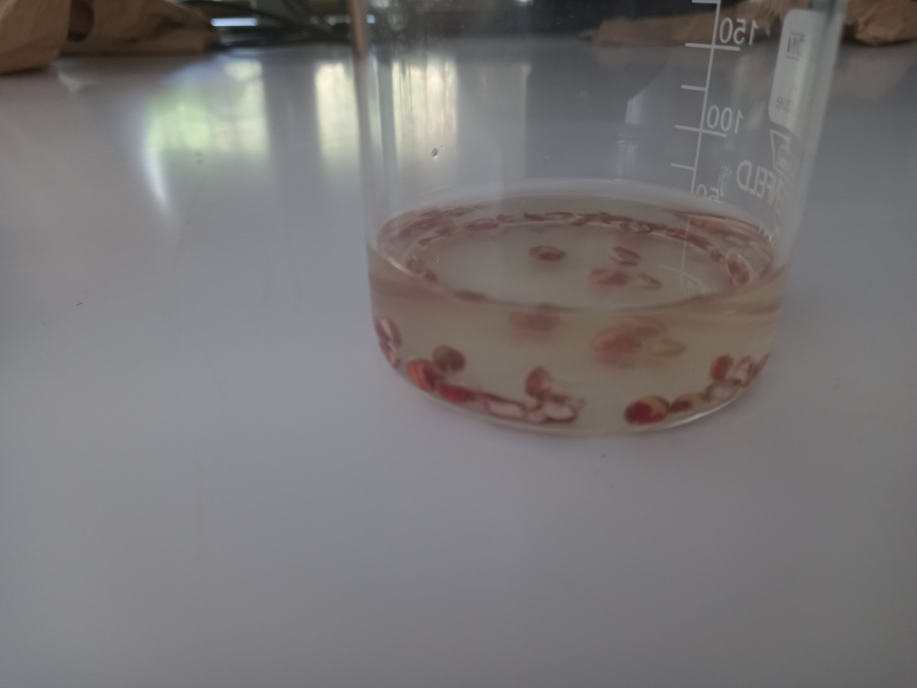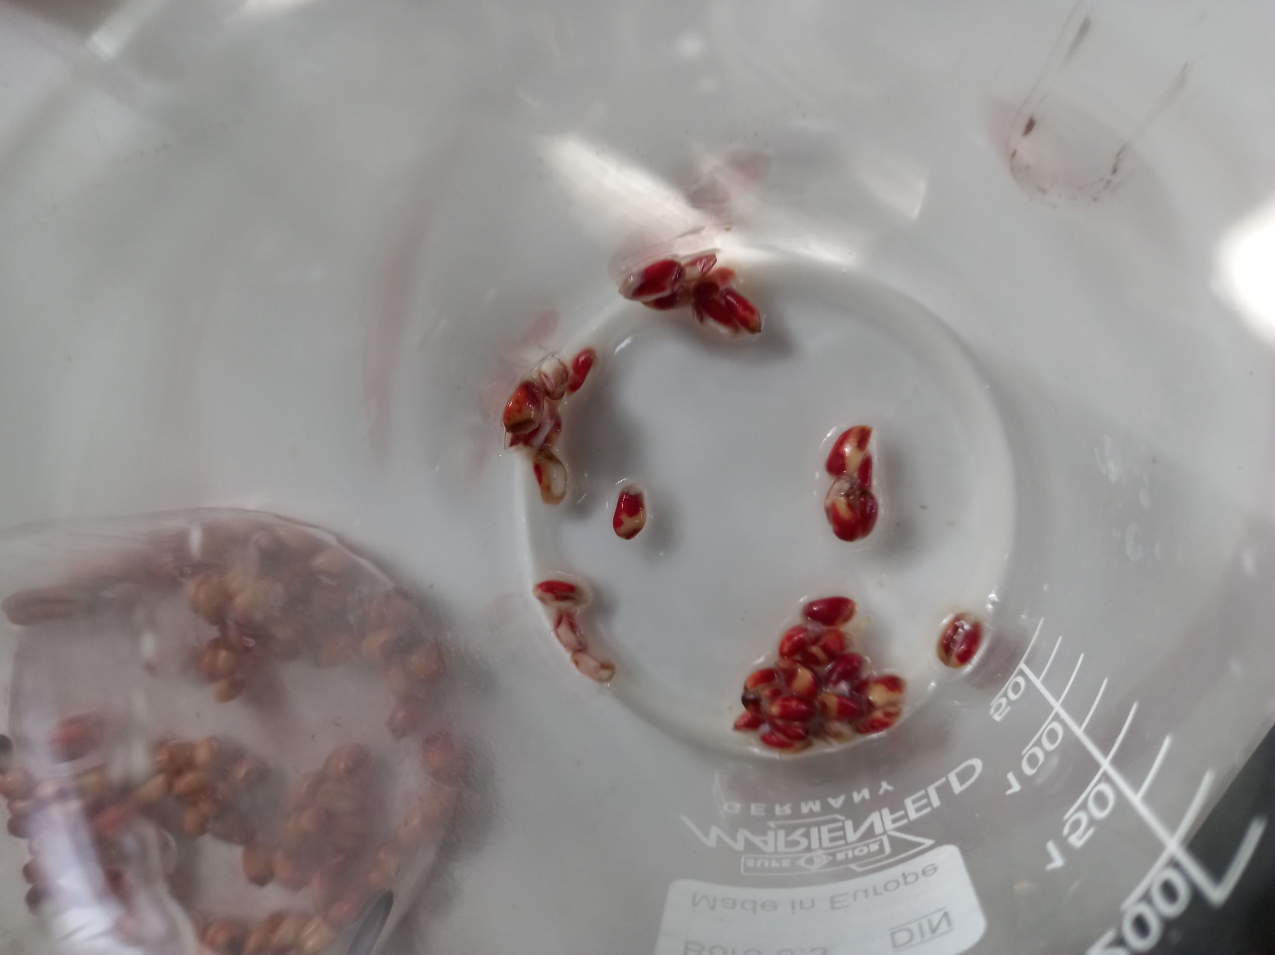

C
B
A

A-1gm of TTZ weighing in E-balance (error 0.01g)
B-wheat seeds in TTZ solution after 24 hrs. C-Stained wheat seeds
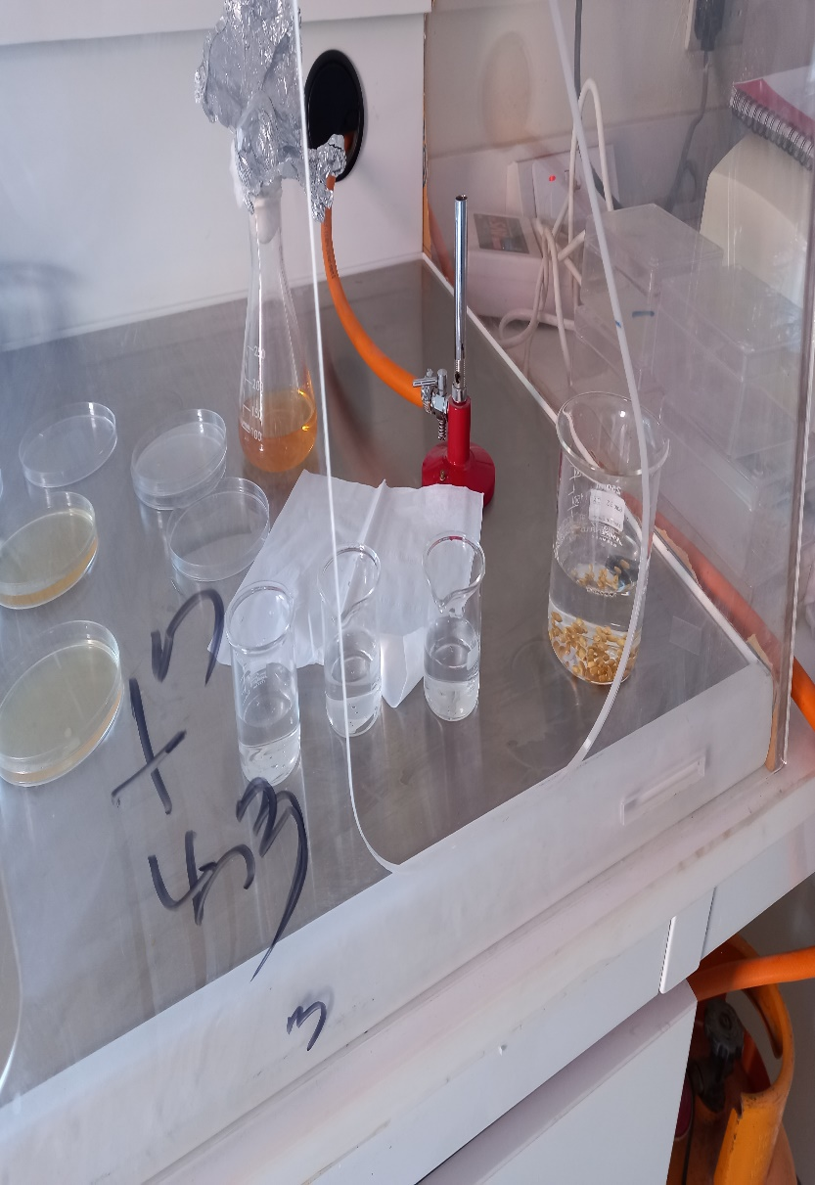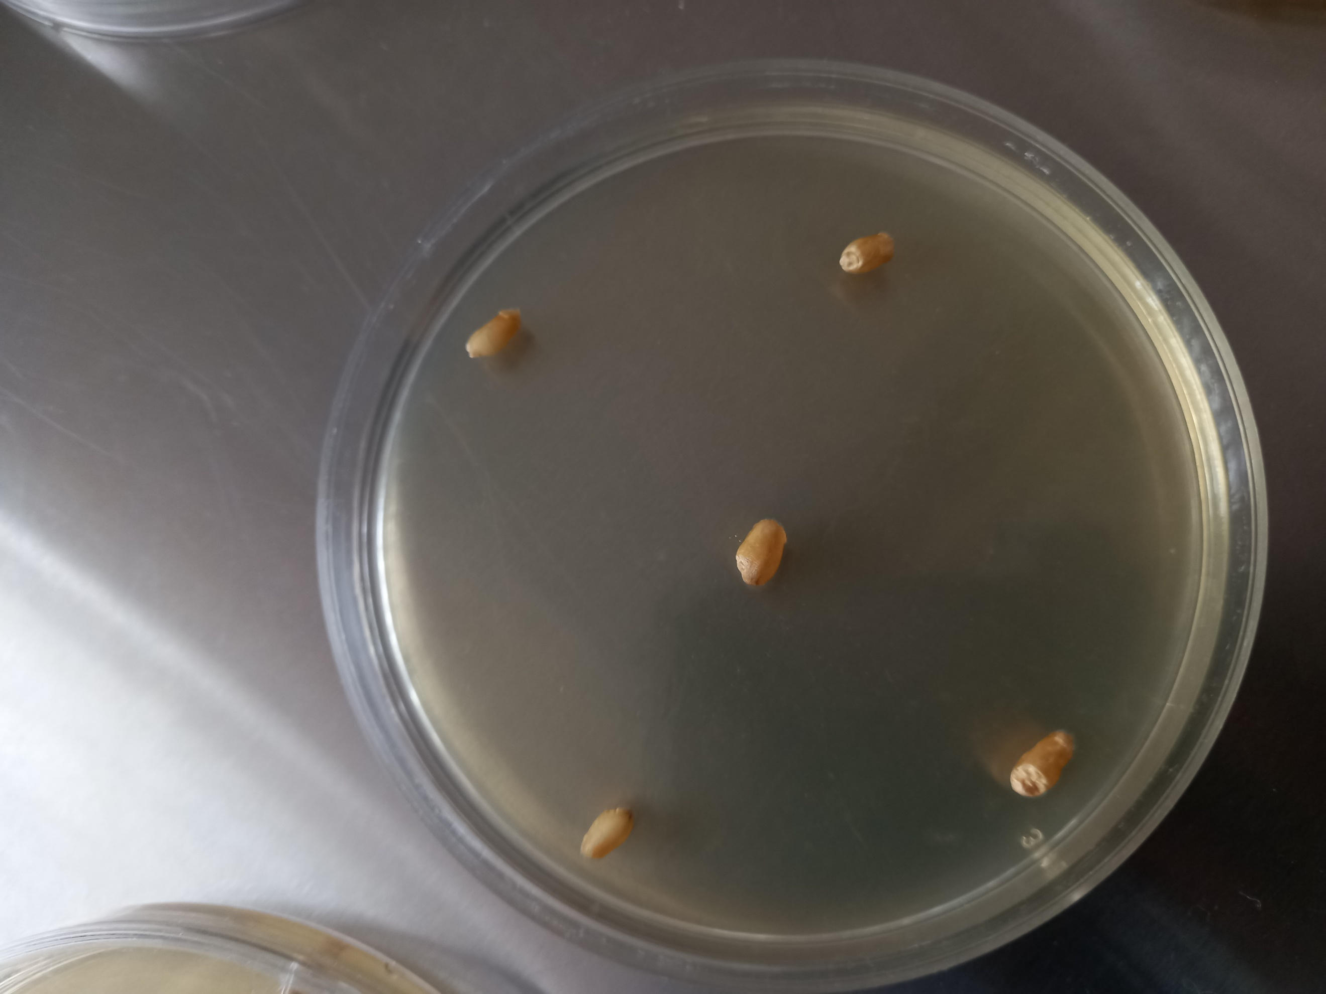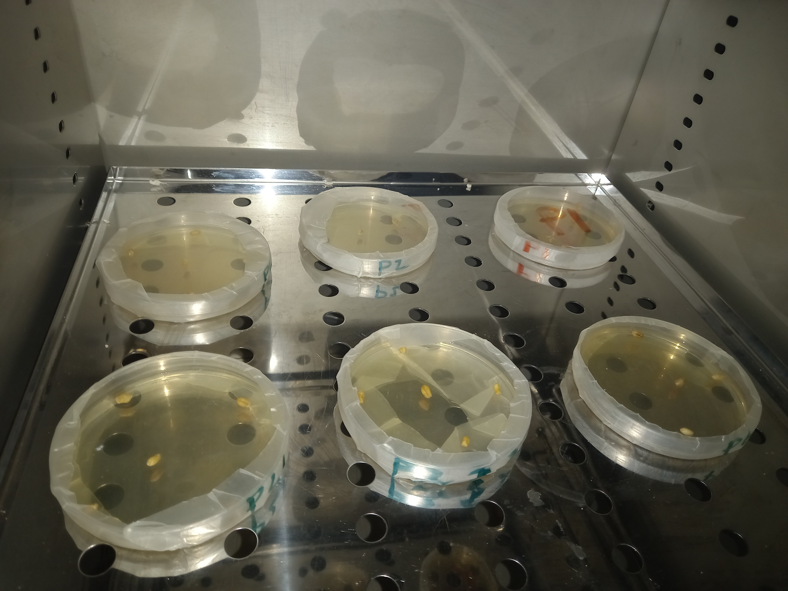

A

C
D

A cooling and wheat seed sterilization under hood C-sterilized seeds placed in PDA D-Filmed petri plates placed inside incubator at 27c⁰

Plate 4. Soil test and lab experiment setting
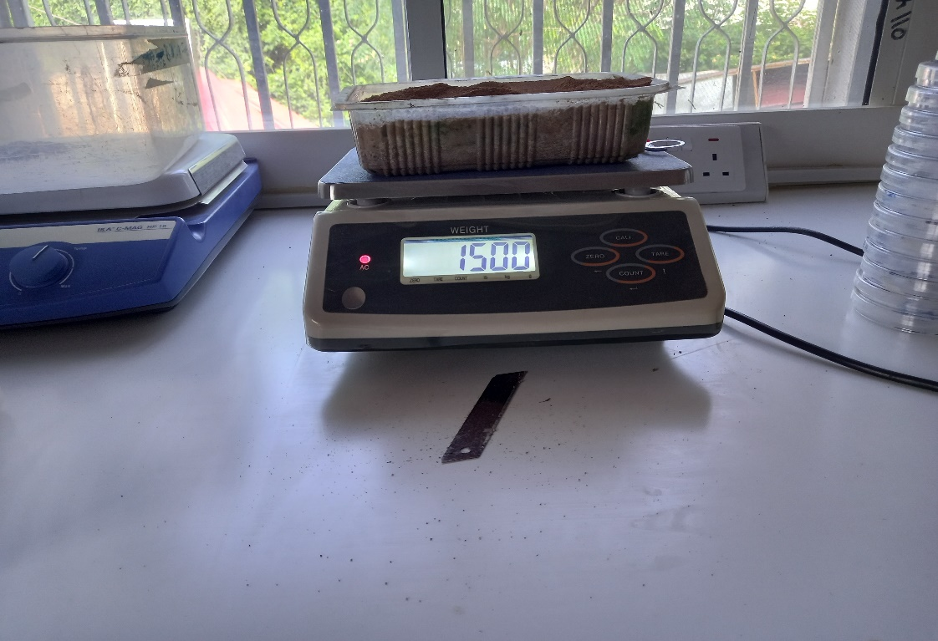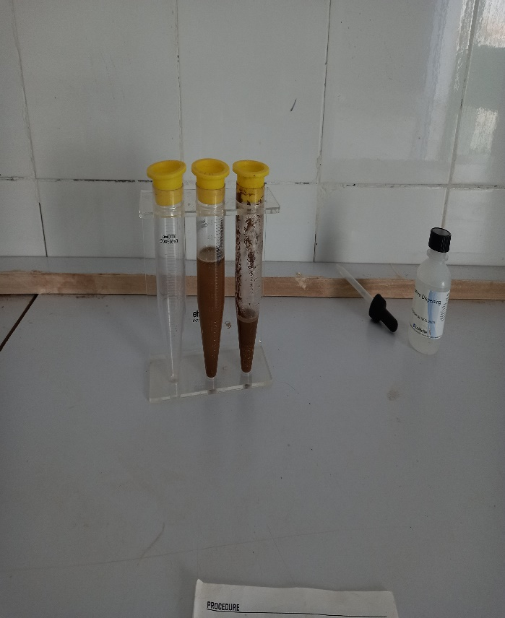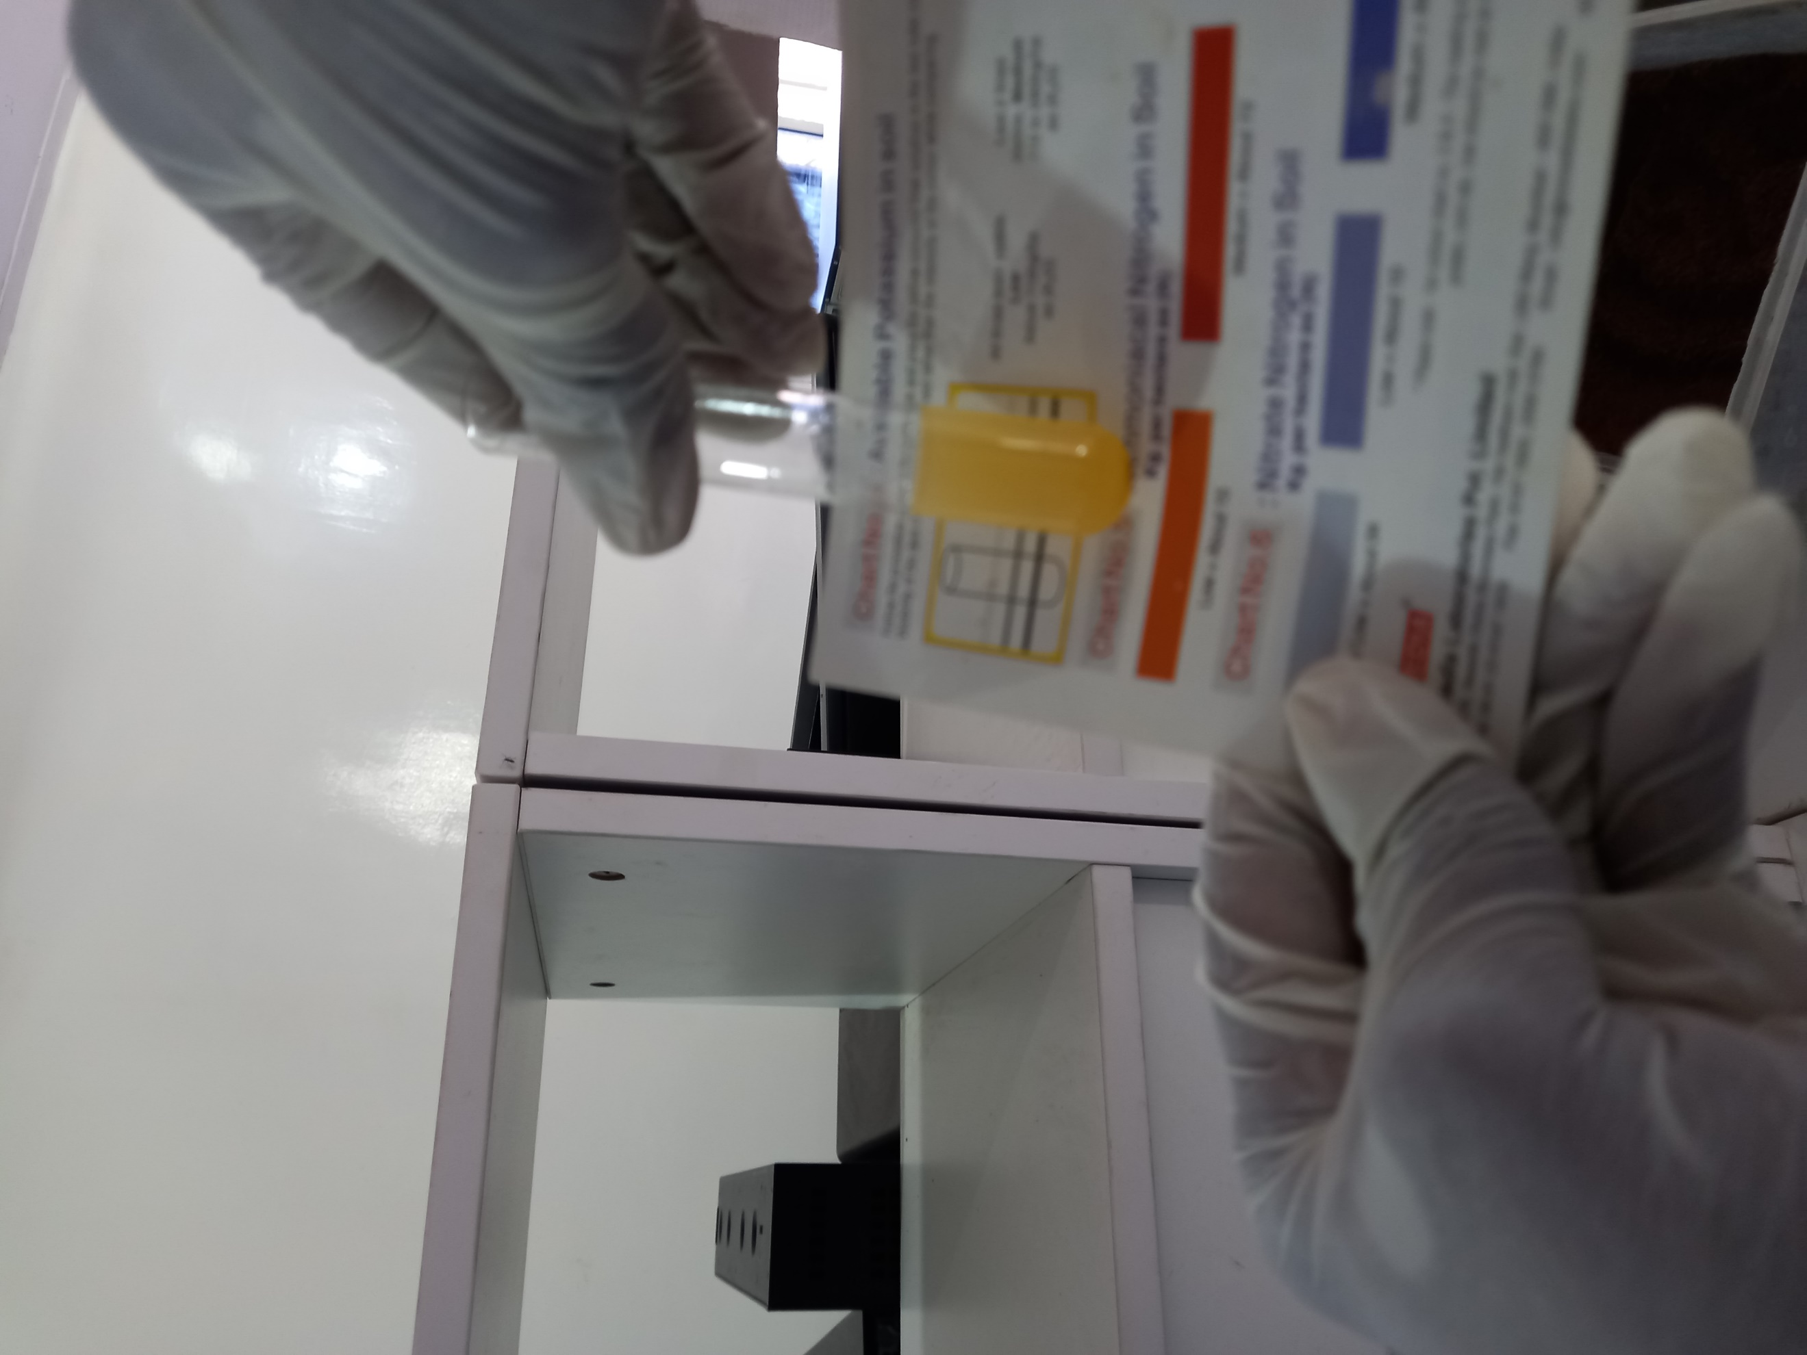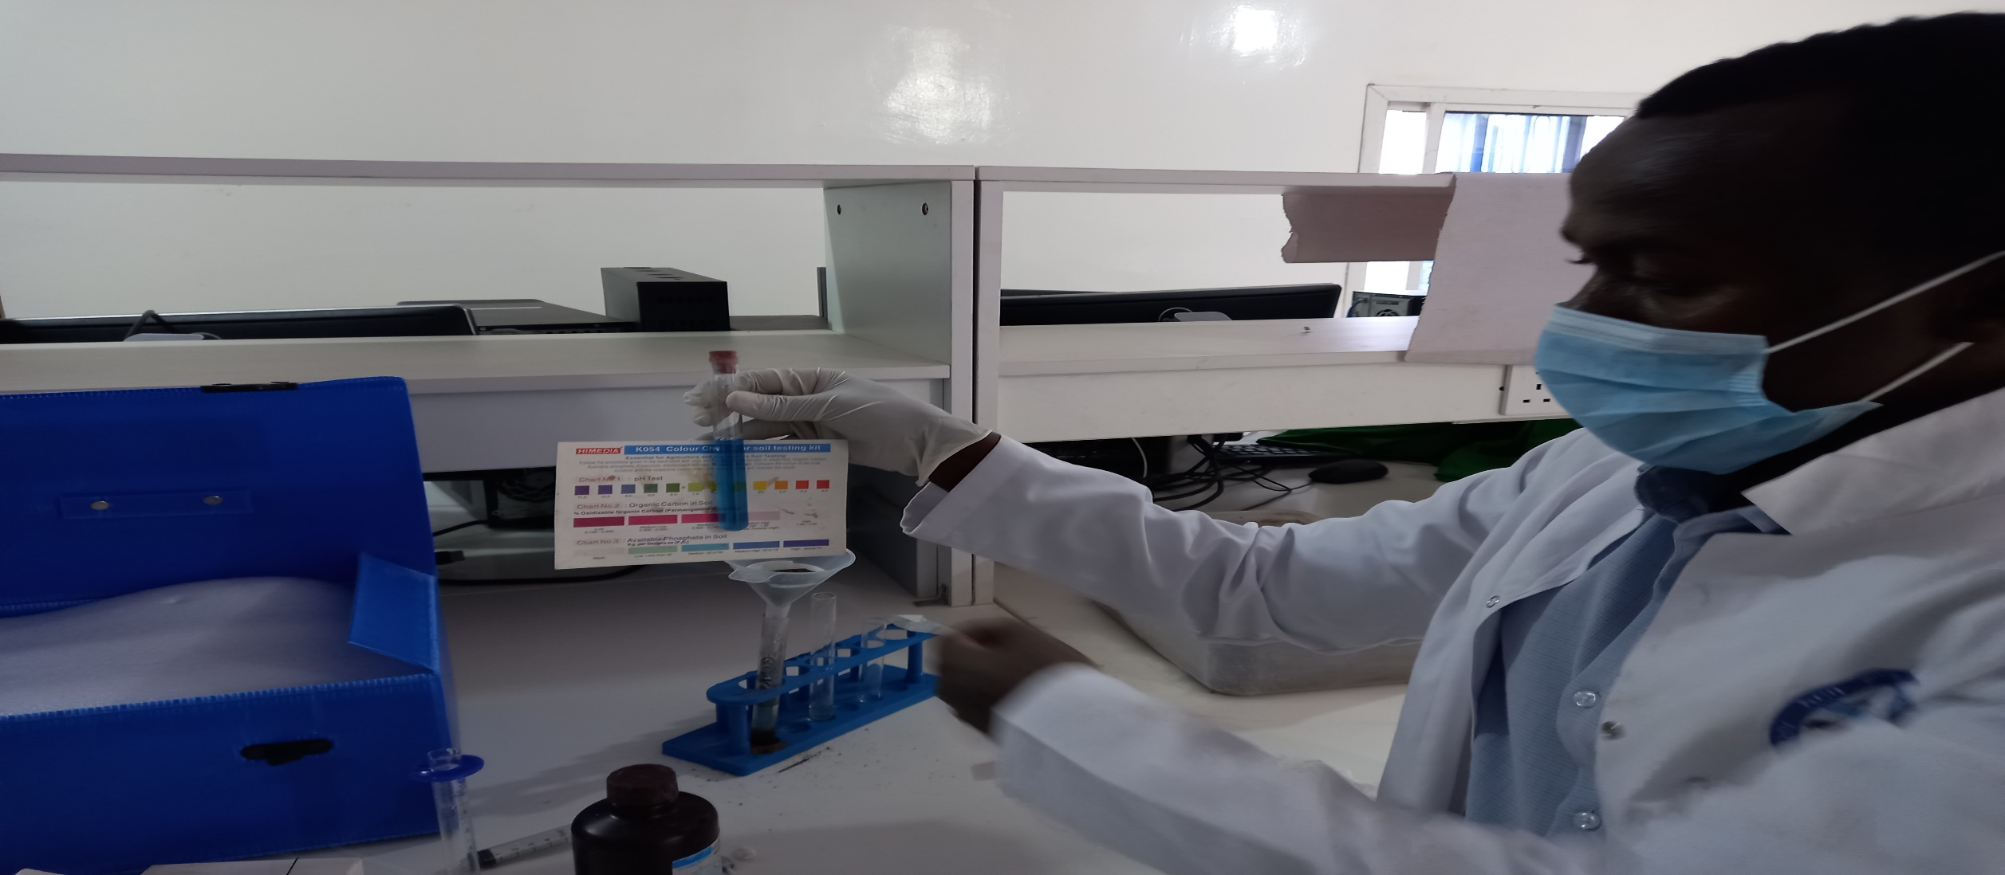

A
B

D
C

A-weighing of collected soil E-balance (error 0.01g) B-soil texture testing
C- Potassium analysis D-Phosphorus analysis
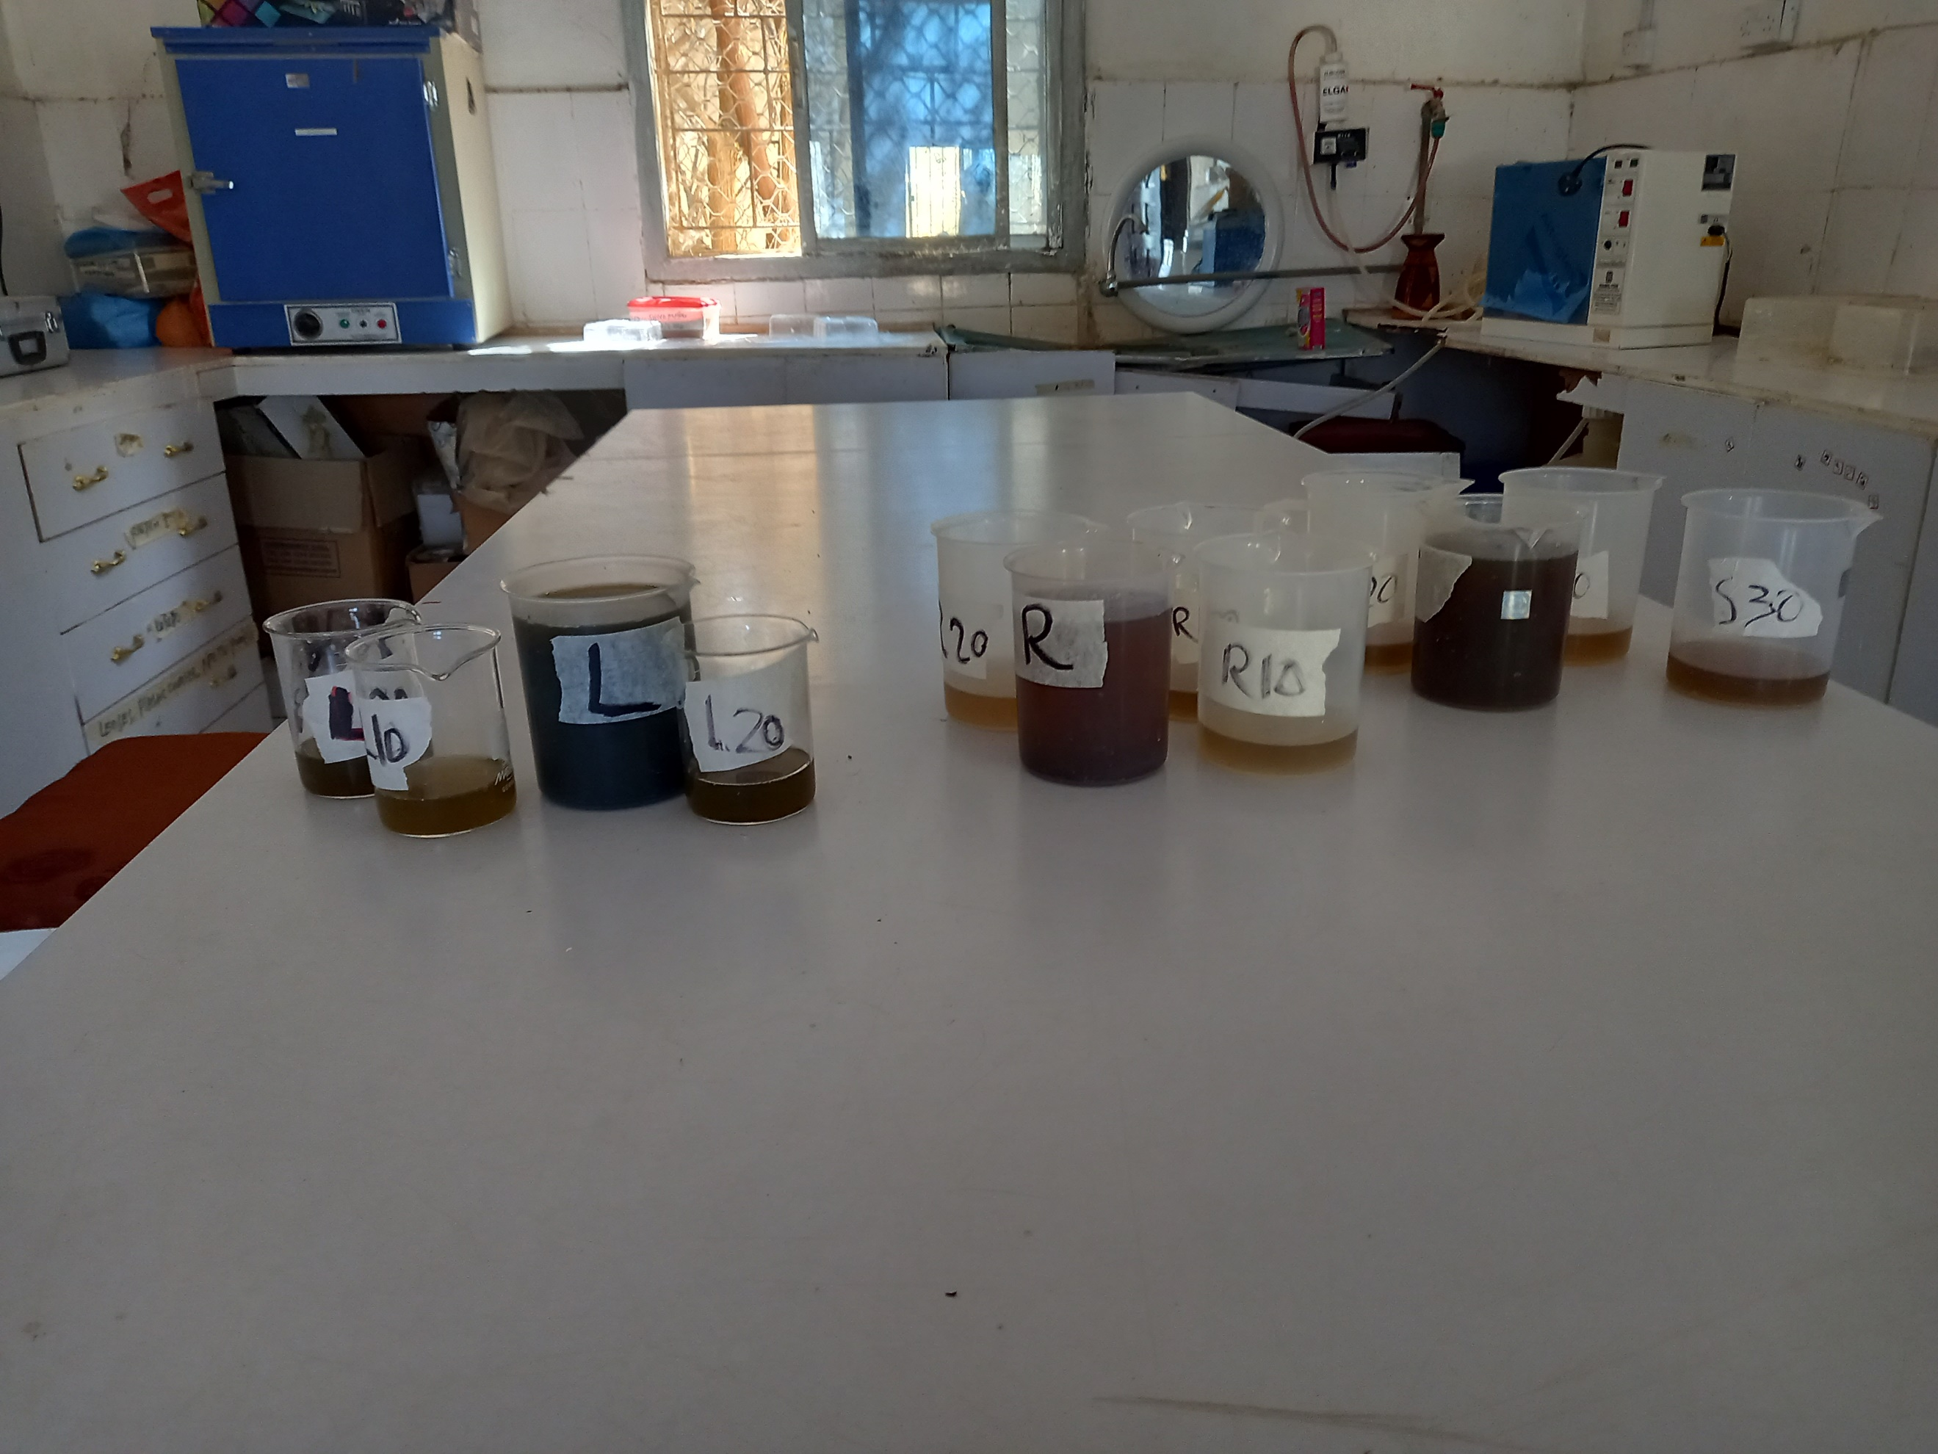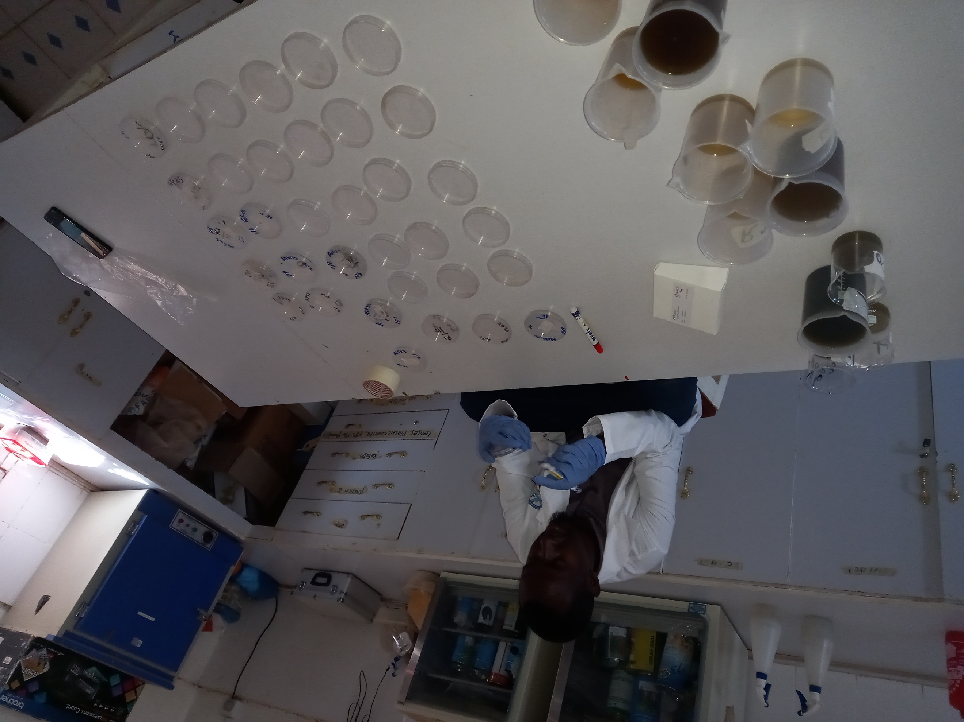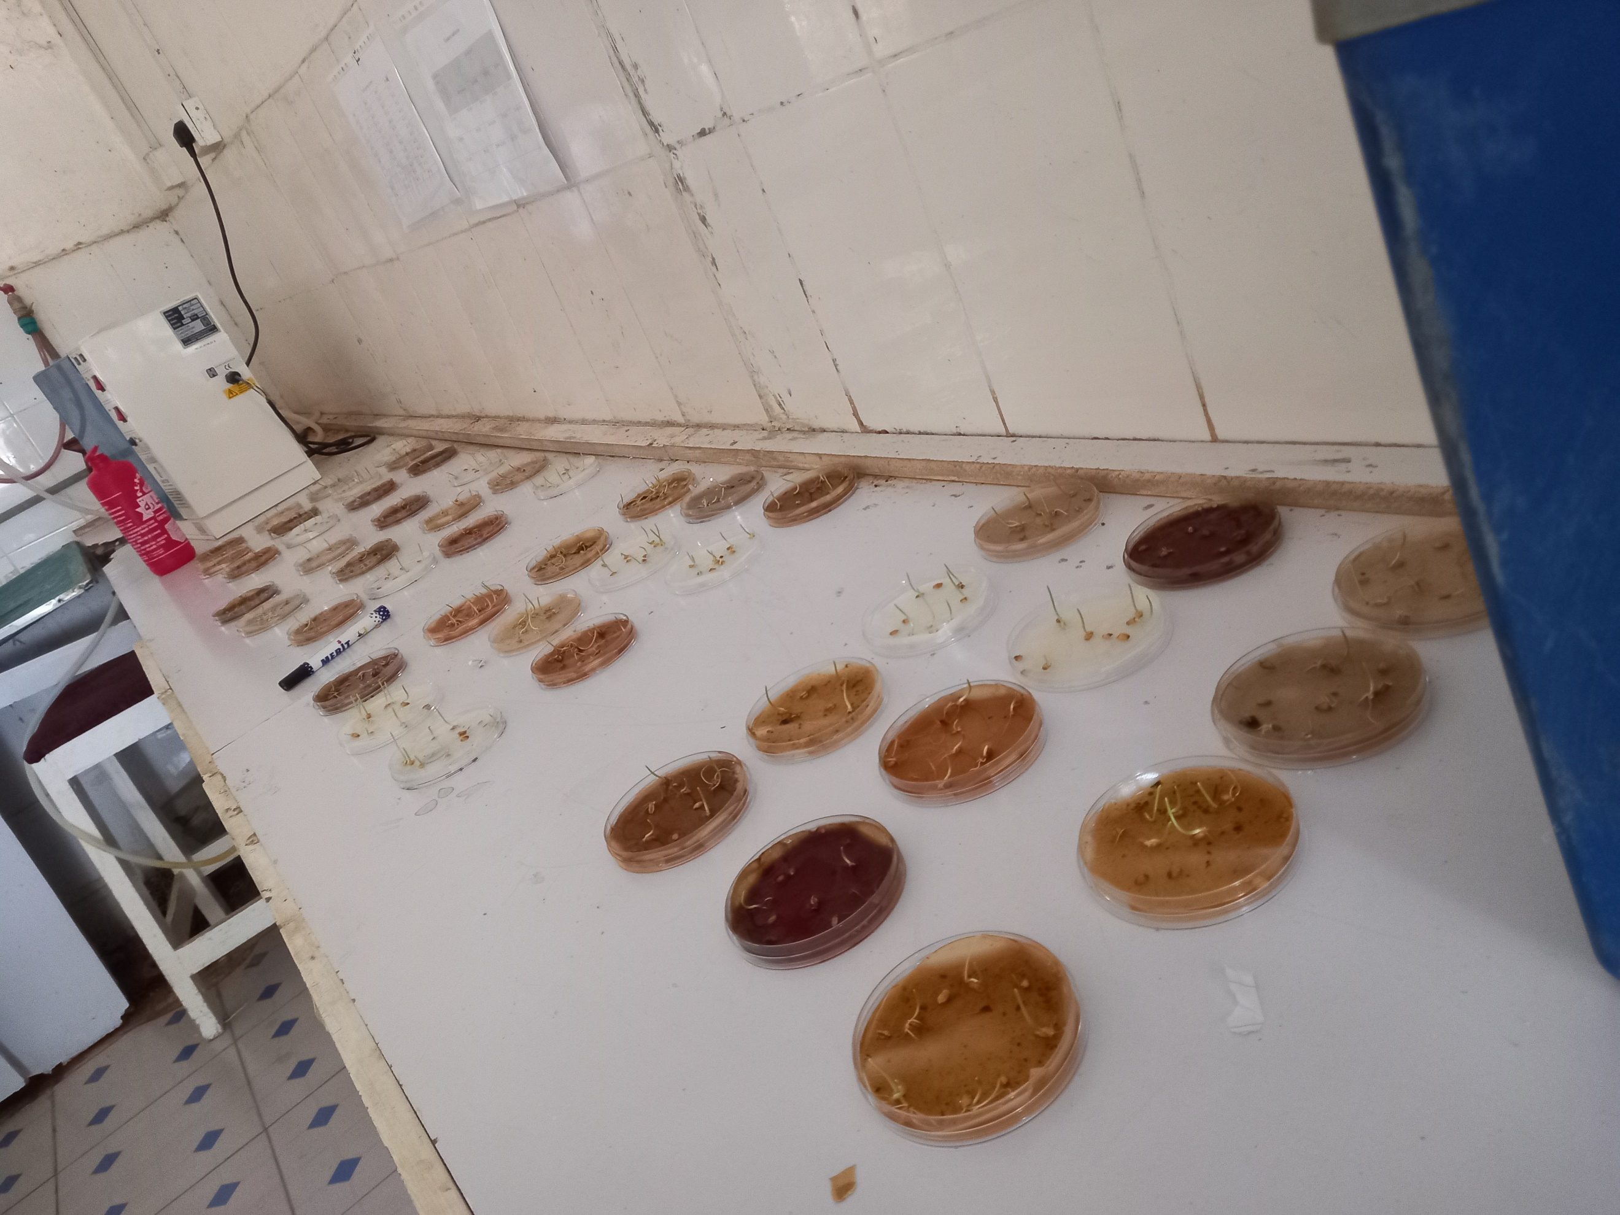

B
A

C

A-extract rate preparation B-Petri plate labeling C- Layout of treated petri plates
Plate 5. Lab experiment husbandry
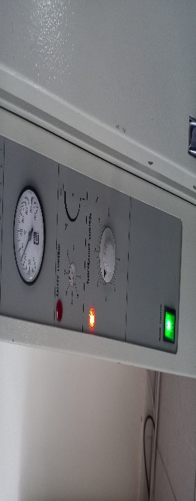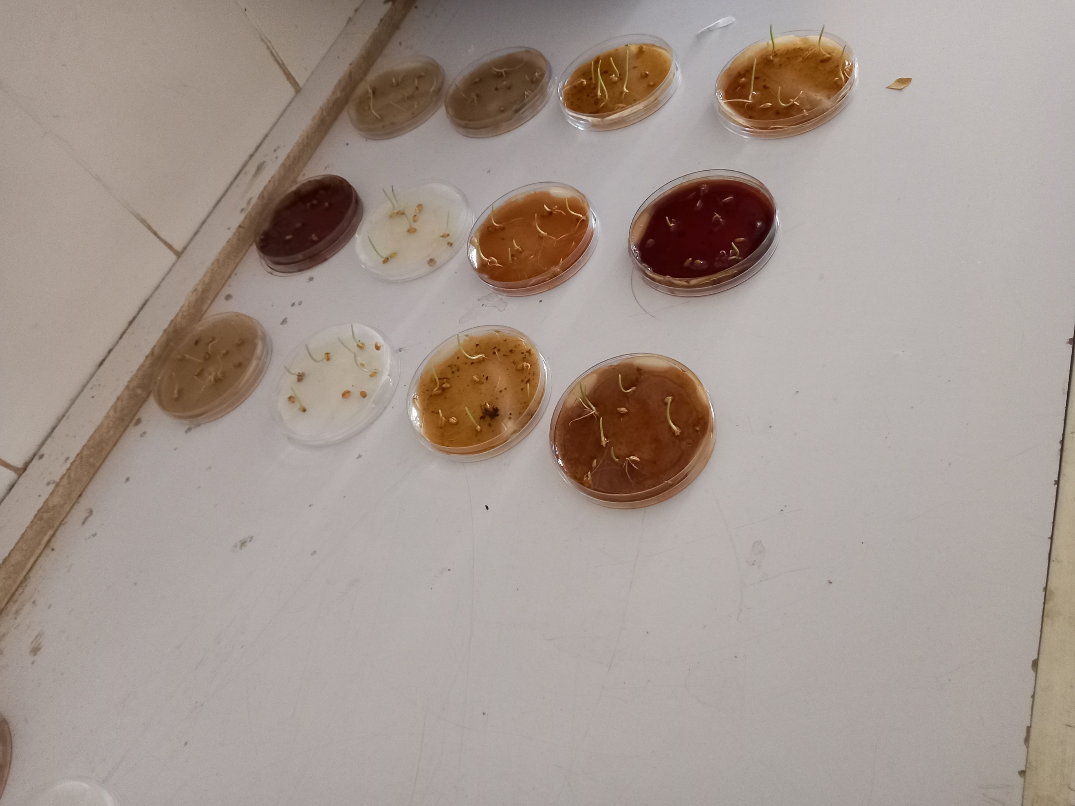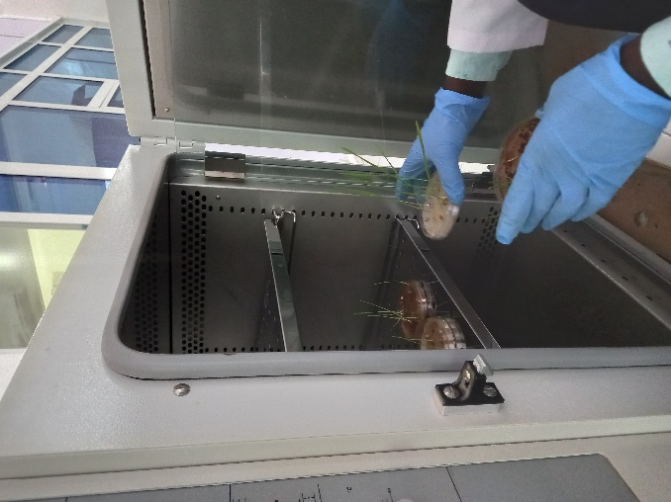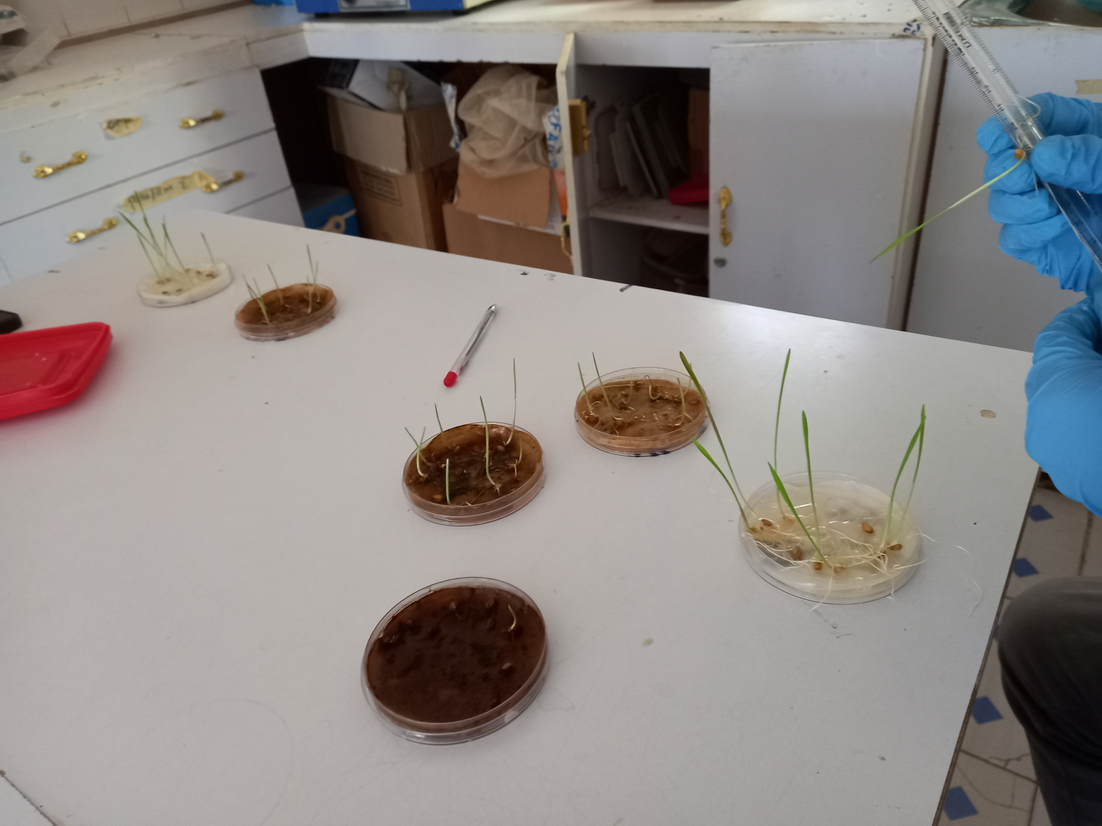

A
B

D
C

A-setting seed incubator temperature (25c⁰) B-emerged seedling after 4th day C-Placing the seedling inside the incubator D-Effect of treatment in seedlings

Plate 6. Pot experiment husbandry
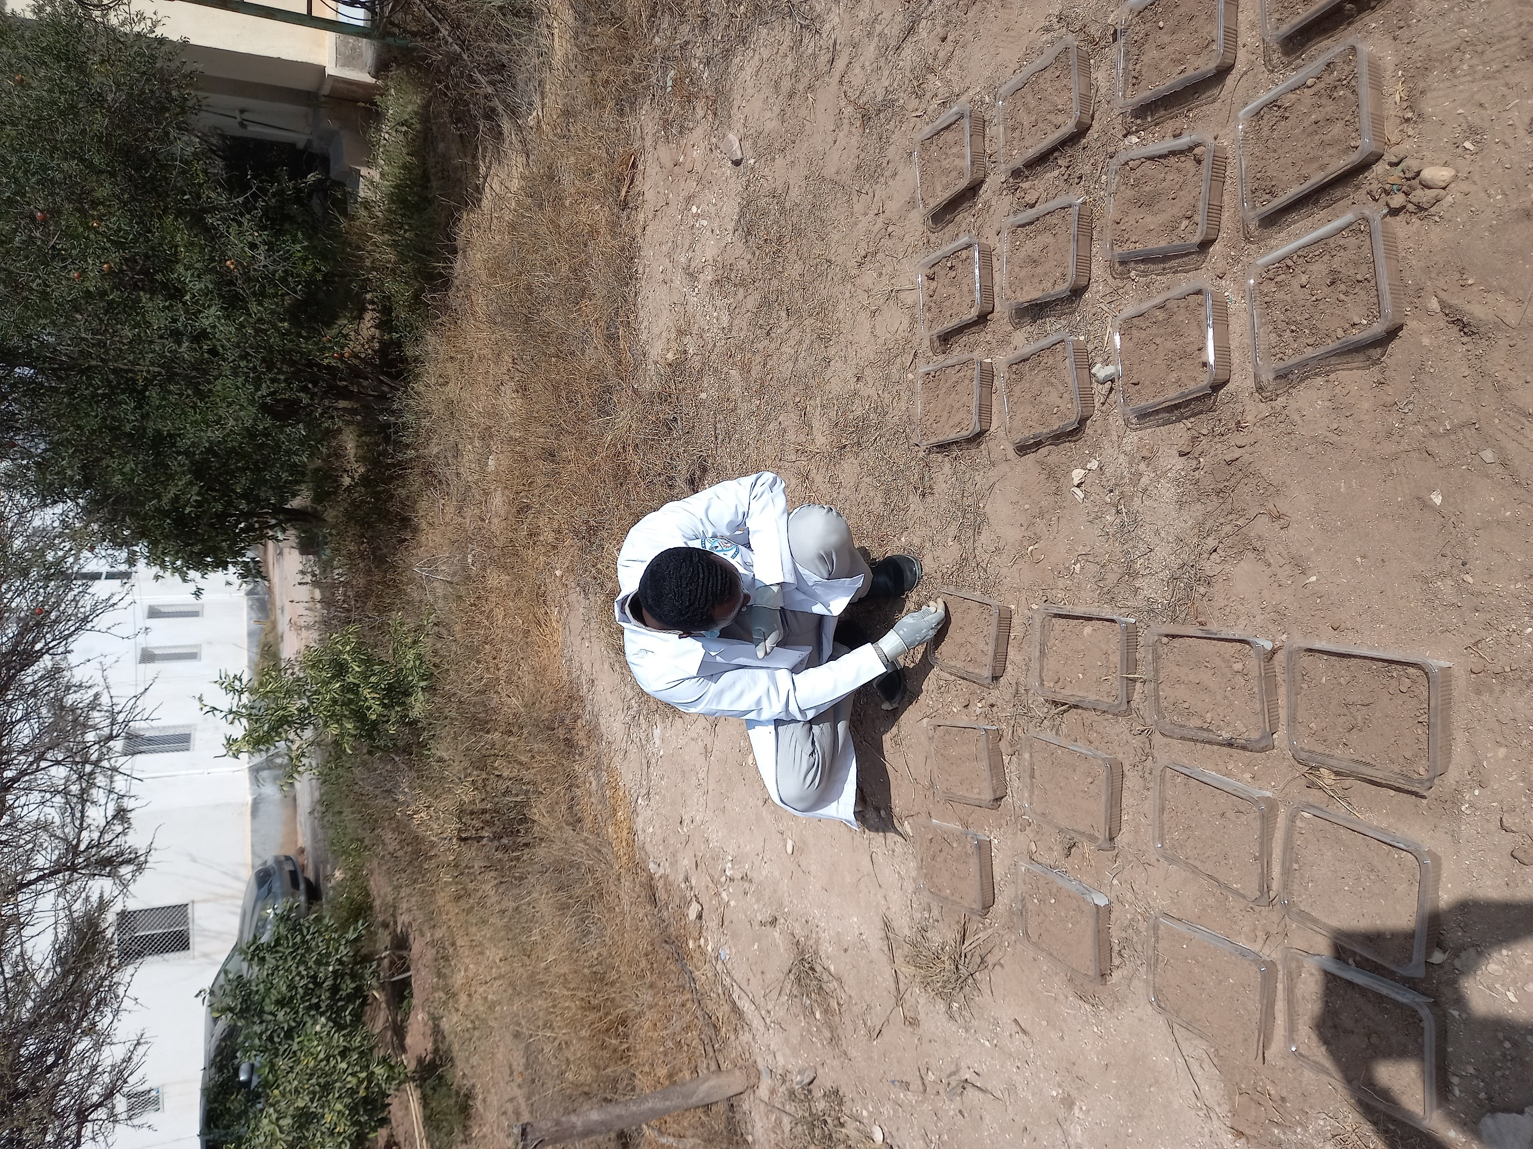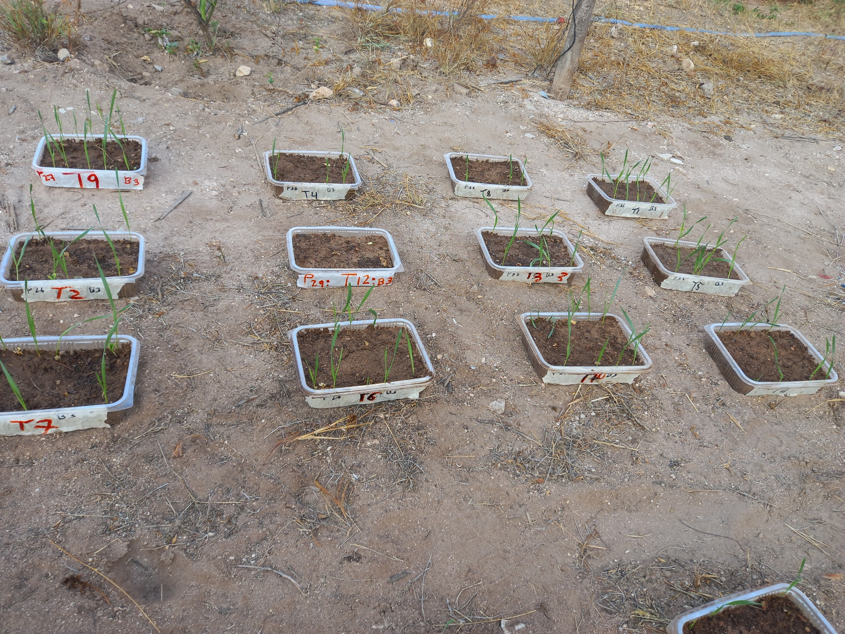

A

B

A-seed sowing in pot trails B-emerged seedlings in pot trials after the 10th day

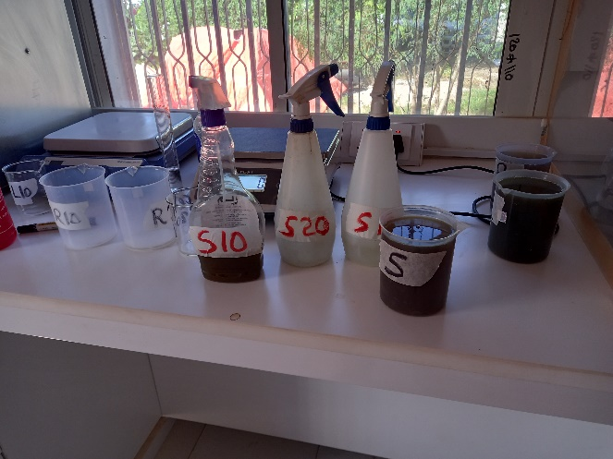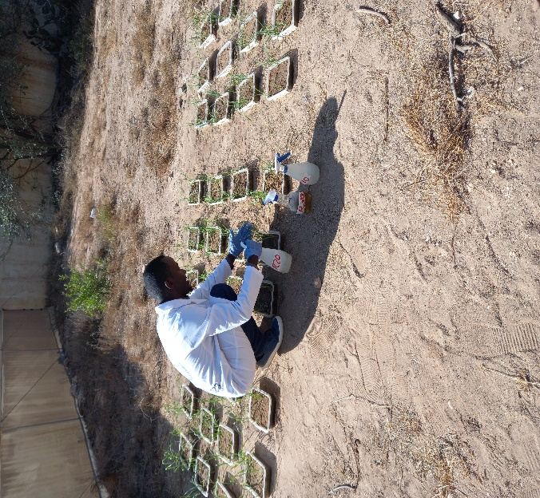

B
A

A-Spray extract preparation B- Spraying the extract in pot seedlings
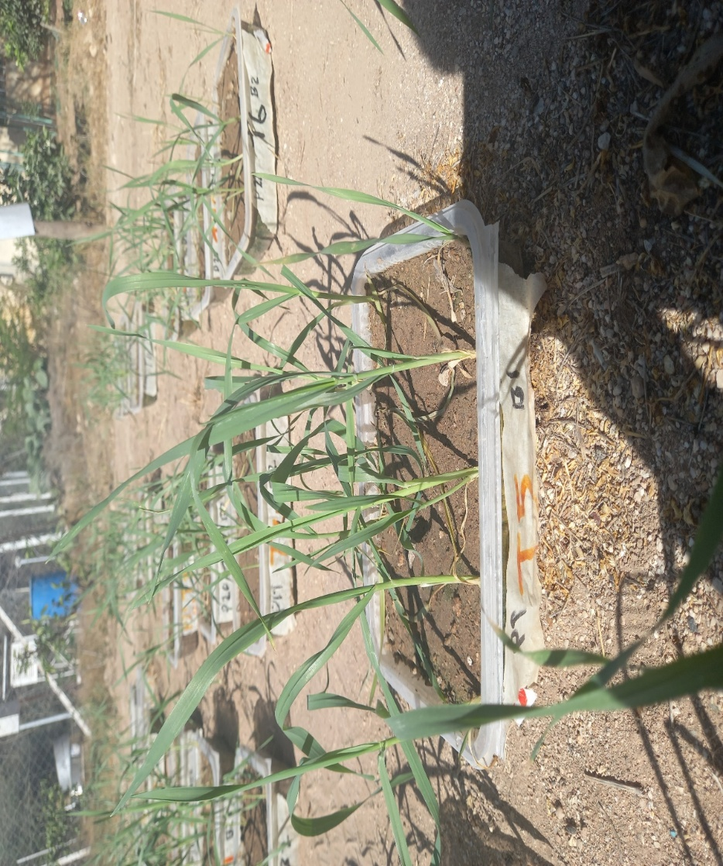
Plate 7. Effect of leaf extract concentrates on pot shoot growth

Control pot seedling

