Nitrogen Doped Graphene Synthesis and Evaluation of Its Electrical Properties

ABSTRACT
In the current research, Nitrogen-doped graphene (NGr), is an emergent nanomaterial for energy applications. Graphene oxide (GO) was synthesized using an improved Hummers method. For nitrogen doping a hydrothermal treatment was carried out with urea an ecofriendly material. The synthesized sample was characterized using Scanning Electron Microscopy (SEM), Fourier Transformation Infrared Spectroscopy (FTIR), UV-Visible Spectroscopy, Raman Spectroscopy, and X-ray Diffraction (XRD). FTIR peaks at 1154cm-1, 1588 cm-1, 3365cm-1 represents the C-N , C=C, N-H stretching vibrations respectively. The results obtained from LCR meter (high Er value of 8000 µS/cm) demonstrate that nitrogen doping effectively enhancing the electrical conductivity and dielectric properties of graphene. The NGr exhibits a significant increase in conductivity with rising temperature and frequency, indicating its potential for use in high-frequency electronic devices, supercapacitors, and fuel cells. This study provides valuable insights into the scalable production and application of nitrogen-doped graphene in next-generation energy and electronic devices.
Key Words: Graphene, Nitrogen doped graphene, electrical conductivity, dielectric constant, LCR meter.

INTRODUCTION
Graphene is considered as a two-dimensional mono-layer of thick sheet sp² hybridized conjugated carbon atom orchestrated in a densely packed system and circumscribed to a hexagonal honeycomb lattice. It was discovered in the year 2004 by scotch tape method. This youngest nanostructure of carbon has received highest amount of accentuate among the scientific clique worldwide due to its notable properties such as the high range mobility of charge carrier under the influence of proliferating room temperature i.e (2.584 × 10⁵cm²·v⁻¹·s⁻¹), high Young’s module (1.054 TPa), extensive specific surface area (2628 m²·g⁻ ¹), high thermal conductivity (~4988 W·m⁻¹·K⁻¹), high optical transmittance (~96.7%) it also exhibit various morphological properties of quantum confinement into nano scale ribbon or (GNRs)[1]. All the above characteristics mentioned thus defined the immense potential of graphene material among different avenues of technology such as including energy transfiguration and repository in lithium ion batteries used in nouvelle period electric vehicles, supercapacitors, biosensors used as emissary for drug delivery systems, electronics related to high imaging system, high-efficiency sea water desalination system, adsorption of hazardous heavy metal from the aquas medium and many more countless other applications.
While graphene has stellar potential, there are still challenges in producing high-quality graphene at scale and integrating it into applicable utilitarian devices as production is expensive ongoing research aims to address these challenges and unlock the full potential of this remarkable material. To synthesize graphene, various methodology is being employed based on the desired quality and quantity of the material. Some common technique includes conversion of graphite flakes to graphite oxide which is a water dispersible oxygen derivative of the former when subjected to exfoliation gives a single layer of graphene oxide (GO)[2]. It is a strategic starting material for large scale preparation of graphene. Deoxygenation of these nanosheets via chemical reduction which is the most versatile method to achieve commercial large scale of the following called as RGO (Reduced Graphene Oxide) in any medium with the use of various reducing reagents which is mentioned in the followed tabular form.

Table 1: A list of different reducing agents used in graphene oxide reduction

Reducing agent for Graphene oxide | Concentration of Graphene oxide in aquas medium (mg/ml) | Temperature Maintained (C0) | Time Taken in the process | Reference used
Glycine | 0.25 | 95⁰C | 20hr-22hr | [3]
Green tea  polyphenol | 1.5 | 80⁰C | 8hr | [4]
Grape juice | 0.6-1.2 | 95⁰C | 3hr | [5]
L-cysteine | 0.5-1.75 | 28⁰C | 14hr | [6]
L-ascorbic acid | 1.1-2.5 | 28⁰C | 6hr-12hr | [7]
Melatonin | 0.1-1.5 | 75⁰C-80⁰C | 3hr-6hr | [8]
Melamine | 0.5-1 | 180⁰C | 6hr | [9]
Manganese  (powder) | 0.5-1 | 35⁰C | Till residue  obtained | [10]
Oxalic acid | 2.5 | 80⁰C-90⁰C | 6hr | [11]
Pyridine |  |  |  | [12]
Pyrrole | 1-1.5 | 150⁰C | 16hr-18hr | [13]
Sodium  hydroxide | 1 | 90⁰C | 1hr | [14]
Benzylamine | 1 | 90⁰C | 2hr | [15]
NaBH4 |  |  |  | [16]
Urea | 0.04-0.8 | 170⁰C-180⁰C | 3hr-12hr-18hr | [17]
Alumina  powder | 1-1.5 | 30⁰C | 30min | [18]
Zinc dust  (micronized) | 2.5-3 | 27⁰C-35⁰C | Till residue | [19]
Vitamin C | 0.1-0.5 | 100⁰C | 4hr | [20]
Hydrazine  Hydrate | 1-1.5 | 113⁰C | 8hr | [21]

The process of reduction can also be achieved via other way such as [22] mechanical exfoliation this methodology involves stripping off graphene layers from graphite using adhesive tape, producing high-quality graphene but in determinate quantities. Chemical

Vapor Deposition (CVD) graphene can be grown on metal substrates like copper or nickel through CVD, allowing the production of high-quality graphene films suitable for electronics.

Liquid Phase Exfoliation this procedure requires, graphite or graphite oxide is exfoliated into a liquid phase to produce graphene in substantial quantities, albeit with more defects compared to other proposed process. Reduction of Graphene Oxide (GO) can be reduced through chemical, thermal, or electrochemical methods to procure reduced graphene oxide (rGO), which has some defects but is more scalable.

Epitaxial Growth can be progressed on silicon carbide (SiC) substrates through epitaxial growth, yielding high-quality graphene but with limitations in scalability. Bottom-Up approaches use pyrolysis of organic precursors is another procedure for synthesizing graphene from the bottom-up.

Citing to the extensive properties exhibited by graphene i.e heightened electrochemical conductivity, Charge mobility and large specific area which can be further enhanced by introduction of a heteroatom into the Sp² hybridized carbon lattice; Nitrogen, Boron, Sulphur are used as dopant thus increasing the chemical functionalization of graphene nanoribbons due to presence of lattice defects in the former structure before deoxygenation of the carbon layer encouraging facile doping of the following heteroatom improving its properties.

The use of Nitrogen as a doping material is widely accepted and topic of interest among many due to the virtue of compatibility shown in their atomic size of carbon (0.67 Å) to nitrogen i.e (0.56 Å) and a more negative electronegativity (χN = 3.07) than Carbon (χC = 2.58) with the presence of five valence electron making it quite useful to get incorporated into carbon basal plane with the formation of valence bonds [23].

Observing the further structure after the insertion of nitrogen heteroatom into graphene lattice, it typically forms three main bonding configurations within the carbon lattice: graphitic nitrogen (quaternary N), pyridinic nitrogen, and pyrrolic nitrogen. Pyridinic nitrogen bonds with two carbon atoms at the edges or defects of graphene, contributing one p electron to the π system. Pyrrolic nitrogen involves nitrogen atoms contributing two p electrons to the π system, similar to pyrrole but not bonding into the five-membered ring.

Quaternary nitrogen refers to nitrogen atoms replacing carbon atoms in the hexagonal ring. Pyridinic and quaternary nitrogen are sp2 hybridized, while pyrrolic nitrogen is sp3 hybridized."
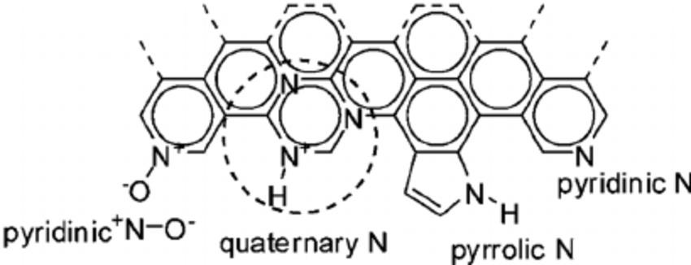

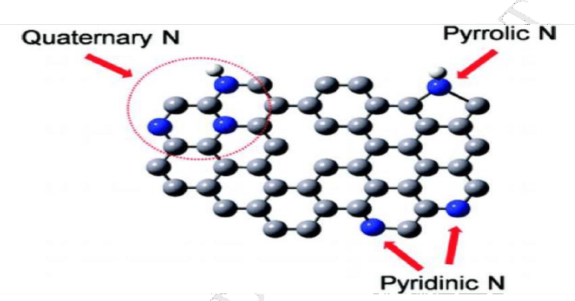

Figure 1(a) & (b): BONDING AFTER DOPING OF NITROGEN IN LATTICE

The bonding configuration of nitrogen atoms in graphene significantly influences its electronic properties and affects graphene in the following way [24] :

Quaternary Nitrogen (Graphitic N) introduces additional electrons into the π system, distorting the electronic structure of graphene. Consequence can lead to alteration in the conductivity and band structure of graphene, affecting its overall electronic properties.

Pyridinic Nitrogen effect on bonds with two atoms of carbon at the edges or defects of graphene, contributing one p electron to the π system, which leads to the configuration that can create localized states within the bandgap, influencing the electronic properties and potentially enhancing catalytic activity. Pyrrolic Nitrogen involves nitrogen atoms gives two p electrons to the system, similar to pyrrole. Thus, configuration can affect the

distribution of charge and interactions within the graphene structure, impacting its behavior. Overall, the presence of different nitrogen bonding configurations in graphene introduces variations in its electronic structure, bandgap, conductivity, and reactivity, making it a versatile material for various applications in electronics, catalysis, and other fields.

The synthesis of nitrogen-doped graphene involves various methods, each with its advantages and limitations. The most common methods include [25] , Reduction-expansion method which involves the decomposition of graphite oxide (GO) and urea, which results in the formation of nitrogen-doped graphene sheets which amount to nitrogen introduced into the structure that can be controlled by varying the initial amount of urea in the precursor suspension.

Aerosol-Plasma (ATP) method uses a plasma torch of atmospheric microwave system to produce graphene samples under argon and nitrogen atmospheres from starting material, the experimental conditions used, can produce samples with higher surface areas. Plasma-assisted synthesis use this methodology in plasma form to synthesize nitrogen-doped graphene.

Chemical Vapor Deposition (CVD) is a procedure that takes the deposition of carbon atoms onto a substrate in the presence of a catalyst and a gas containing nitrogen with controlled high pressure surrounding and requires meticulous tracking.

Hydrothermal method uses a hydrothermal or autoclave i.e lined with teflon process to synthesize nitrogen-doped graphene which we considered and performed in the following project which used, synthesis with controlled nitrogen doping levels.
The future scope of work in nitrogen-doped graphene and its applications is vast and promising, driven by its unique properties and potential in various advanced technologies. Here are some key areas for future research and development such as enhancing the performance of supercapacitors and batteries by improving the energy density, power density, and cycling stability of NGr electrodes, utilizing NGr as a catalyst in fuel cells, particularly for oxygen reduction reactions, to improve efficiency and durability. It can contribute to the development of sustainable energy technologies, reducing reliance on fossil fuels and lowering carbon footprints. Utilizing the unique optical properties of NDG for advanced imaging techniques in medical diagnostics. Creating highly sensitive and selective sensors for detecting gases, biomolecules, and environmental pollutants, utilizing the high surface area and tuneable electronic properties of NDG. The research on producing multi-dimensional or 3-D heterostructure of N-doped graphene are being considered.

MATERIALS AND METHODS

Materials

The materials consisting chemicals of AR grade were received. Extra pure fine flakes of graphite (SIGMA ALDRICH) was used in the synthesis procedure. sulfuric acid (SIGMA ALDRICH AR), also known as H2SO4(98%), potassium permanganate (KMnO4), hydrogen peroxide (H2O2), sodium nitrate (NaNO3), and hydrochloric acid of the grade AR were obtained. A 100 mL volumetric flask containing 35% HCl was filled with distilled water to the needed amount to produce 10% HCl. Urea with the measured quantity of 30 gm, 10 ml of ethanol, epoxy glue was weighed in approximately 6 gm

Instruments

Centrifuge equipment (Eltek TC 450B), PH Meter (Systronic, PH system 362), magnetic stirrer (1ml REMI), Ultra-sonic bath (power heater ultrasonic cleaner, JK scientific class work), and Shakers were the tools used to create graphite oxide. Hydrothermal (30ml) of Ants-Lab, Oven, Hydraulic press (Athena), High temperature furnace (MI-F1000C), LCR meter (IM3536-HIOKI).

Synthesis Of Graphite Oxide

Enhanced Hummers Method
In a 1000 ml volumetric flask graphitic flakes weighed upwards to 2 gm were taken along with a 1gm of NaNO3 (sodium nitrate) with 100 ml of H2SO4 (98%) while being agitated under a magnetic stirrer maintaining a temperature around (0-5)⁰C. At the prescribed temperature the suspension was agitated for four hours before addition of potassium permanganate of 6 grams in weight which was gradually added to the mixture in controlled manner with maintaining the following temperature of 10⁰C. The solution was agitated for 24 hours to till pasty brown consistency was obtained. Then the ice bath was removed and it was stirred at room temperature for two hours followed by addition of 100cc of deionised water and the effervescence was obtained and the solution turned clayish brown followed by addition of 200cc of deionised water to dilute the suspension. Then addition of 10 ml of H2O2 to stop the reaction and oxidise the excess KMnO4 giving a yellow colour at the end. The solution was rinsed with 3 ml of 10% HCl and washed with deionized water multiple times till near neutral PH (6-7) was obtained. The following was filtered and dried at 70⁰C temperature and the dried form of GO was obtained.
Synthesis Of Exfoliated Graphene Oxide (GO:
The obtained GO was weighed upwards to 1.3 grams and was added to 50 ml of distilled water, the aquas colloidal solution was kept in a ultrasonic water bath at 50⁰C for an hour. The following was dried at 70⁰C in oven for a day.
Synthesis Of Nitrogen Doped Graphene:
The exfoliated and dried GO (graphene oxide) was measured and taken along with urea in a weight ratio of (1:60) along with 10 ml of ethanol and 30 ml of distilled water and was stirred at hot plate at 62⁰C till the solution reduced to half. The suspension was then transferred to the crucible of 30 ml Teflon lined autoclave, the screws of the hydrothermal was placed tightly and kept at a temperature of 210⁰C for 18 hours in hot oven. The black residue obtained was collected and weighed.
Pellet Formation
The obtained sample was then converted into pellets using a hydraulic press (athena) and pre prepared epoxy glue as binding agent at 1100 Kg/cm² of pressure the pellet obtained was then coated with oxides of silver both the sides and the thickness and diameter are measured using a screw gauge and vernier caliper respectively. The pellet was kept in a high temperature furnace (MI-F1000C) and using a LCR meter at varying temperature upward to 100⁰C starting from room temperature was measured and the dielectric properties were noted and later inferred.

RESULTS AND DISCUSSION

Visual Observation

The characterization of following GO (graphitic oxide), NGr (Nitrogen doped graphene) were taken into account ocularly. Brown yellow solution was obtained after addition of graphene oxide in water, the following indicates that graphite is converted into GO or graphene oxide. The residue sample obtained after hydrothermal treatment of the GO and urea was black in colour and when dispersed in water yields the same colour.

Characterization
Using a Bruker vertex 70, FTIR was carried out. On a Rigaku Miniflex-600 diffractometer XRD patterns were captured at scanning rate of 0.045⁰ s⁻¹ from 0⁰ to 60⁰. SEM (SU-8230) was taken 80-120 kv the prepared sample morphology was evaluated. Utilizing Raman spectrophotometer (JASCO NRS 3300) we got to know about the defects in the carbon structure in comparison to N-Graphene. UV-Visible spectrometer the different absorbance was compared for two given sample.

Fourier Transform Infrared Spectroscopy (FTIR)

Figure 2 (a), 2 (b) represents the FTIR analysis of the two obtained sample in dried and powdered form yields the result about the different functional groups present in the sample. The data was compared for both and the following observation were made. Since GO (oxides of graphene) contain many oxygen groups multiple peaks were observed in 1000cm⁻¹ to 2000cm⁻¹. The oxygen to carbon bonding in graphitic oxides varies from carbonyl (C=O), hydroxyl –(OH), alcoholic (C-O), etheric (C-O-C) produces vibration signals at 1735cm⁻¹ (stretching), 3650cm⁻¹, 1033cm⁻¹(stretching), and 1574cm⁻¹(bending). The broad strong band 3650cm⁻¹ is obtained due to (-OH) with moisture content. In comparison to NGr the peak of 1735cm⁻¹ was absent indicating the carbonyl group (C=O) complete removal and reduction of the following. Due to reduction as well as insertion of heteroatom to the carbon moiety leads to the peaks obtained at 1154cm-1 which represent the vibration of functional group (C-N); thus, nitrogen heteroatom is being introduced into the carbon lattice. Presence of 1588 cm-1 indicates the (C=C) unsaturation is changed and form aromatic forms. The high intense peak at 3365cm-1 is due to -N-H stretching vibration was deduced.

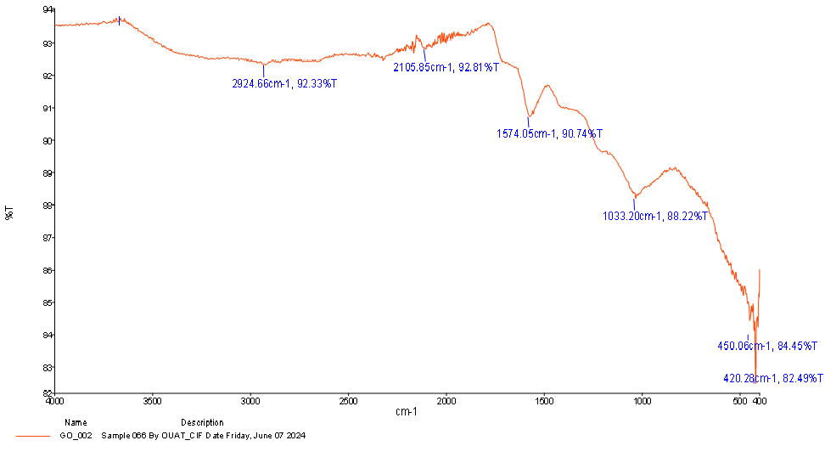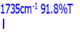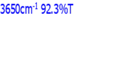
Figure 2: (a) FTIR OF GO
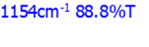
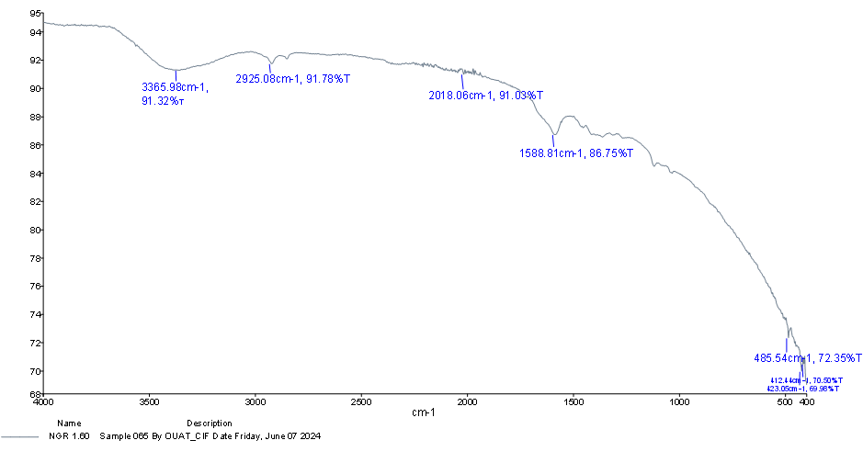

Figure 2: (b) FTIR OF NGR (1:60)

Scanning Electron Microscope (SEM)

The Scanning Electron Microscope was utilized to establish the morphological characterization of the sample. SEM images captured are presented in figure 3(a),(b),(c). In the fig3(a) it can be observed for GO (oxide of graphite) represent several layers stacked in sleek lamellar of the nanocrystal composite and strong bond between sheets. Fig3(b) and (c) represents the SEM image of Nitrogen doped graphene, the primary observation showed the wrinkles or crumbled surface representing π-π interaction i.e introduction of Nitrogen atom in the carbon lattice.

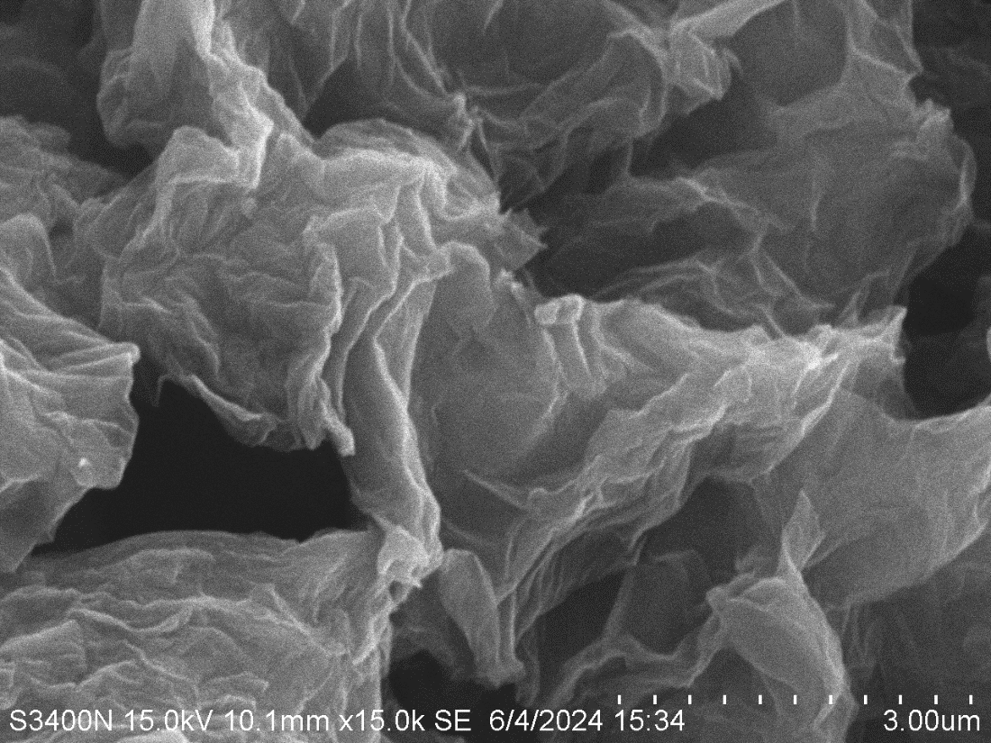

Figure 3:(a)-SEM IMAGE OF GRAPHENE OXIDE

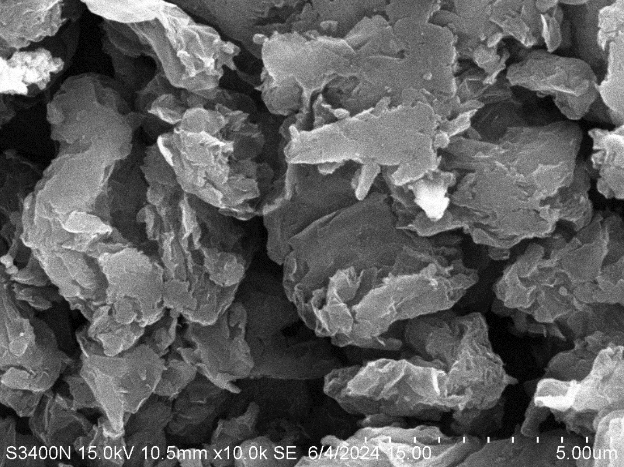

Figure 3: (b)- SEM IMAGE OF N-GRAPHENE
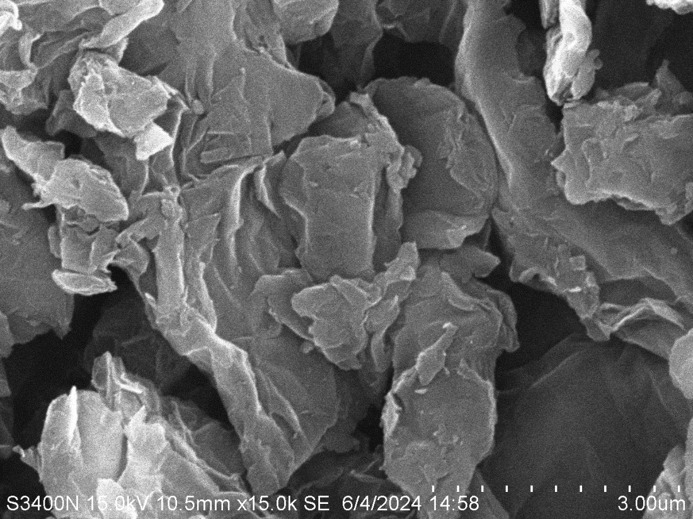
Figure 3:(c)- SEM IMAGE OF N-GRAPHENE

UV Visible Spectroscopy

UV-Vis spectroscopy was employed to characterize the synthesized NG. Figure4 (a) ,(b) shows the UV-Vis spectra of both graphitic oxide and NGr. In the UV-Vis spectrum, GO exhibits two notable absorption peaks at approximately 245 nm and 300 nm. These peaks correspond to the π-π* transition of the C=C bonds within the aromatic ring and the n-π* transition for C=O bonds. Conversely, NGr displayed a shift in the peak position from 300 nm to 287 nm. The shift to a lower wavelength in the UV-Vis spectrum of NGr compared to oxides of graphene suggests an increase in bond strength relative to the precursor. This phenomenon can be attributed to the removal of most oxygen-containing groups and the restoration of C=C conjugation, which results in stronger electron bonding.

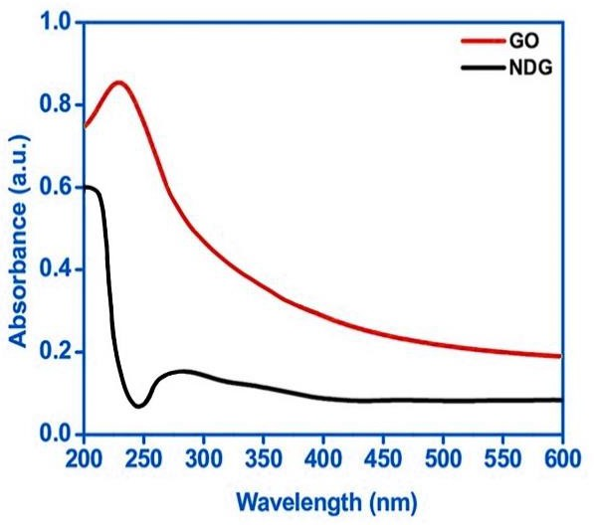
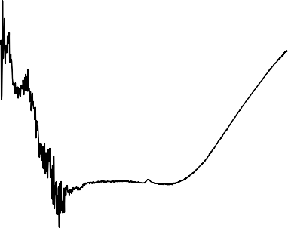
16
Reflectance
15
14
13
Reflectance
12
11
10
9
8
200 400 600 800 1000 1200
Wavelength(nm)

Figure 4: (a), (b) – UV VISBILE ABSORBANCE AND REFLECTANCE OF NGr

Raman Spectroscopy

Raman shift helps to find the degree of deformation in the structure of the following sample. At 1320cm-1 D band was obtained with the highest intensity for N-doped graphene represents the disorder band. A less intense G band was observed at 1550cm-1. The intensity ratio i.e ID/IG ratio for GO (graphene oxide) was found to be 0.78 whereas for Nitrogen doped graphene the value was 1.15 which establish the incorporation of heteroatom of nitrogen in the crystal lattice.

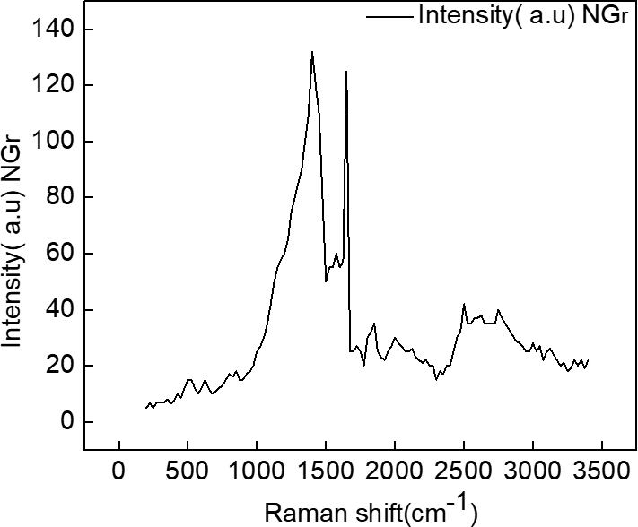

Figure 5: RAMAN SHIFT OF NGr

X-Ray Diffraction Study (XRD):

XRD analysis gives the crystal structure of the sample. The figure (fig-6) displays a broader peak at 23.4⁰ at a plane (002) with d-spacing of 0.36 nm. This can be compared with the GO a sharp peak is obtained at 11.2⁰ at (001) plane where the d-spacing is 0.75 nm, which is missing in NGr that confirms the structure.
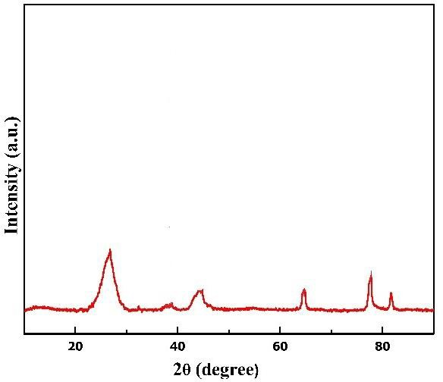

Figure 6: XRD OF NGr

ELECTRICAL PROPERTIES

Log(f) vs Er

The electrical properties were measured by LCR meter under a varying temperature of 100⁰C and variable frequency of 4000 MHz. The dielectric constant (Er) obtained was plotted against frequency. The dielectric constant decreases with increasing frequency indicate the material's varying ability to polarize in response to an alternating electric field. This behavior is typical for dielectric materials, where polarization mechanisms such as dipole orientation cannot keep up with high-frequency electric fields. Consequently, the material's energy storage capability and dielectric losses vary with frequency, impacting its ability for various electrical and electronic applications. Specifically, high Er (8000 µS/cm) at low frequencies makes the material suitable for capacitive energy storage, while low Er at high frequencies favors high-frequency and broadband applications due to reduced dielectric losses and impedance advantageous for efficient signal transmission with minimal attenuation [26,27]
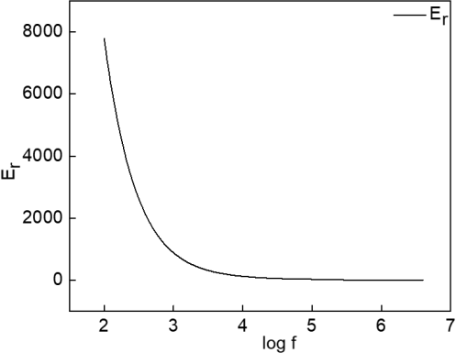

Figure 7: Log(f) vs Er
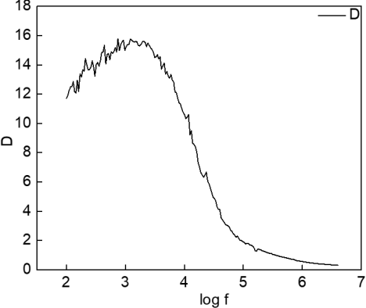

Figure 8: Log(f) vs D

Log(f) vs D

The Log (f) and dielectric loss(D) plot reveals that dielectric loss decreases with increasing frequency. This behavior is typically for many dielectric materials indicating the material is more efficient at higher frequencies due to reduced energy dissipation [28-29] The implications for electrical properties include the need for effective thermal management at low frequencies and the suitability of the material for high-frequency applications due to lower dielectric loss. Thus, the relationship helps in selection and optimizing materials for specific applications based on their dielectric loss characteristics over a range of frequencies such as low frequency AC circuit and capacitor or use in high frequency telecommunication system.
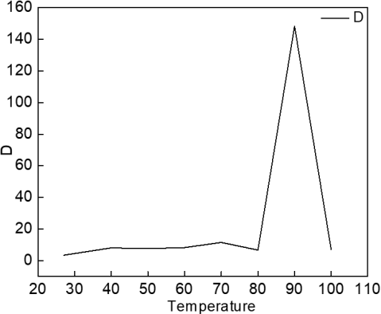

Figure 9: Temperature vs D

Temperature vs D

Fig -9 shows the relationship between temperature and dielectric loss. It represents the dielectric loss increases with temperature, which indicates greater energy dissipation is at higher temperatures [30-31]. It has significant implications on the material performance in different thermal events such as automotive, aerospace, or industrial applications.
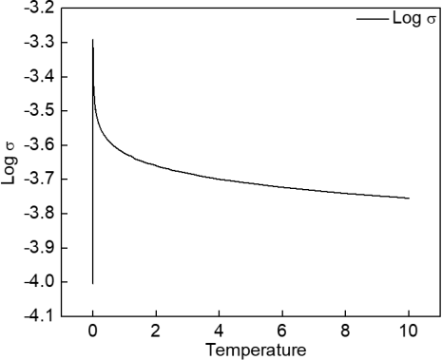

Figure 10: Temperature vs log(σ)

Temperature vs log(σ)

Fig 10 represents the Temperature and Log σ graph of the synthesized sample. The plot suggested that the sample exhibits increased conductivity with rising temperature. This behavior is for semiconductor materials where thermal energy promotes charge carrier movement, enhancing conductivity.
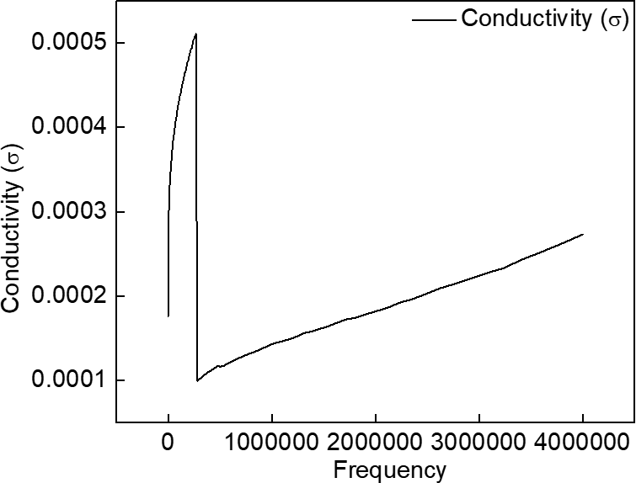

Figure 11: Frequency vs σ

Frequency vs σ

Fig .11 demonstrates the frequency and conductivity graph of the sample. It exhibits increase in conductivity with frequency, suggesting it is well-suited for high-frequency applications. The figure shows the frequency-dependent conductivity, which is a characteristic of materials with dispersive electrical properties.

CONCLUSION
In conclusion the synthesis of GO and NGr via enhanced hummers method and subsequent hydrothermal treatment at achievable temperature near to 200⁰C using urea as economical and environmentally accepted source of chemical. The obtained sample was characterized using various techniques such as SEM, FTIR, UV-VIS, Raman spectra and XRD. The dielectric properties were measured in a varying temperature and the results showed the dielectric constant (Er) decreases with increase in frequency. The curve Log(f) vs D sows that D decrease with increase in frequency, thus at higher frequency the material is more efficient. The curve Temperature vs log(σ) shows that the dielectric loss increases with temperature. The curve Temperature vs log(σ) exhibits conductivity increases with rising temperature. This showed the semiconductor behavior of the materials. The curve Frequency vs σ exhibits increase in conductivity with frequency, suggesting it is well-suited for use in supercapacitors as well as fuel cell battery.

REFERENCES

- Wang, H., Maiyalagan, T., & Wang, X. (2012). Review on recent progress in nitrogen-doped graphene: synthesis, characterization, and its potential applications. AcS catalysis, 2(5), 781-794.
- Yokwana, K., Ntsendwana, B., Nxumalo, E. N., & Mhlanga, S. D. (2023). Recent advances in nitrogen-doped graphene oxide nanomaterials: Synthesis and applications in energy storage, sensor electrochemical applications and water treatment. Journal of Materials Research, 38(13), 3239-3263.
- Zhang, J., Yang, H., Shen, G., Cheng, P., Zhang, J., & Guo, S. (2010). Reduction of graphene oxide via L-ascorbic acid. Chemical communications, 46(7), 1112-1114.
- Xu, H., Ma, L., & Jin, Z. (2018). Nitrogen-doped graphene: Synthesis, characterizations and energy applications. Journal of energy chemistry, 27(1), 146-160.
- Du, M., Sun, J., Chang, J., Yang, F., Shi, L., & Gao, L. (2014). Synthesis of nitrogen-doped reduced graphene oxide directly from nitrogen-doped graphene oxide as a high-performance lithium ion battery anode. Rsc Advances, 4(80), 42412-42417.
- Chen, D., Li, L., & Guo, L. (2011). An environment-friendly preparation of reduced graphene oxide nanosheets via amino acid. Nanotechnology, 22(32), 325601
- Zhang, J., Yang, H., Shen, G., Cheng, P., Zhang, J., & Guo, S. (2010). Reduction of graphene oxide via L-ascorbic acid. Chemical communications, 46(7), 1112-1114.
- Li, C., Wang, X., Liu, Y., Wang, W., Wynn, J., & Gao, J. (2012). Using glucosamine as a reductant to prepare reduced graphene oxide and its nanocomposites with metal nanoparticles. Journal of Nanoparticle Research, 14, 1-11.

- Xue, Y., Chen, H., Qu, J., & Dai, L. (2015). Nitrogen-doped graphene by ball-milling graphite with melamine for energy conversion and storage. 2D Materials, 2(4), 044001.
- Lee, Y. R., Song, M. S., Lee, K. M., Kim, I. Y., & Hwang, S. J. (2011). Synthesis and electrochemical characterization of reduced graphene oxide-manganese oxide nanocomposites. Journal of Electrochemical Science and Technology, 2(1), 1-7.

- Song, P., Zhang, X., Sun, M., Cui, X., & Lin, Y. (2012). Synthesis of graphene nanosheets via oxalic acid-induced chemical reduction of exfoliated graphite oxide. Rsc Advances, 2(3), 1168-1173.
- Ensafi, A. A., Jafari-Asl, M., & Rezaei, B. (2016). Pyridine-functionalized graphene oxide, an efficient metal free electrocatalyst for oxygen reduction reaction. Electrochimica Acta, 194, 95-103.
- Amarnath, C. A., Hong, C. E., Kim, N. H., Ku, B. C., Kuila, T., & Lee, J. H. (2011).
Efficient synthesis of graphene sheets using pyrrole as a reducing agent. Carbon, 49(11), 3497-3502.
- Coros, M., Varodi, C., Pogacean, F., Gal, E., & Pruneanu, S. M. (2020). Nitrogen-doped graphene: The influence of doping level on the charge-transfer resistance and apparent heterogeneous electron transfer rate. Sensors, 20(7), 1815.
- A.K. Geim, Graphene: Status and prospects, Science 324 (2009) 1530-1534.
- Yang, Z. Z., Zheng, Q. B., Qiu, H. X., Jing, L. I., & Yang, J. H. (2015). A simple method for the reduction of graphene oxide by sodium borohydride with CaCl2 as a catalyst. New Carbon Materials, 30(1), 41-47.
- Lei, Z., Lu, L., & Zhao, X. S. (2012). The electrocapacitive properties of graphene oxide reduced by urea. Energy & Environmental Science, 5(4), 6391-6399.
- Z.P. Chen, W.C. Ren, L.B. Gao, B.L. Liu, S.F. Pei, H.M. Cheng, Three-dimensional flexible and conductive interconnected graphene networks grown by chemical vapour deposition, Nat. Mater. 10 (2011) 424-428.
- Fan, Z., Wang, K., Wei, T., Yan, J., Song, L., & Shao, B. (2010). An environmentally friendly and efficient route for the reduction of graphene oxide by aluminum powder. Carbon, 48(5), 1686-1689.
- C. Berger, Z.M. Song, X.B. Li, X.S. Wu, N. Brown, C. Naud, D. Mayou, T.B. Li, J. Hass,
A.N. Marchenkov, E.H. Conrad, P.N. First, W.A. de Heer, Electronic confinement and coherence in patterned epitaxial graphene, Science 312 (2006) 1191-1196.
- Fernández-Merino, M. J., Guardia, L., Paredes, J. I., Villar-Rodil, S., Solís-Fernández, P., Martínez-Alonso, A., & Tascón, J. M. D. (2010). Vitamin C is an ideal substitute for hydrazine in the reduction of graphene oxide suspensions. The Journal of Physical Chemistry C, 114(14), 6426-6432.
- Imamura,G., & Saiki, K. (2011). Synthesis of nitrogen-doped graphene on Pt (111) by chemical vapor deposition. The Journal of Physical Chemistry C, 115(20), 10000-10005.
- Muchlis, M.I.A, Aziz, H., Hujjah., Zurnansyah, D. Zabrian, E.H Sujiono, & Samnur, (2024) , Green synthesis of reduced graphene oxide using Zn powder based on coconut shell waste , AIP Conf. Proc. 2799, 020143. https://doi.org/10.1063/5.0182202.
- Mingyun Guo, Jian Cui, Guangfa Zhang, et al. Efficient production n of few-layer graphene by shear exfoliation of graphite in an aqueous liquid. Authorea. September 24, 2020.
DOI: 10.22541/au.160091453.39301830
- K.S. Novoselov, A.K. Geim, S.V. Morozov, D. Jiang, Y. Zhang, S.V. Dubonos, I.V. Grigorieva, A.A. Firsov, Electric field effect in atomically thin carbon films, Science 306 (2004) 666-669.
- Jauja-Ccana, V.R.; La-Torre-Riveros, L.; Cordova-Huaman, A.; Huayta, G.; Manfredy, L.; Naupa, A.; Isaacs, M.; La Rosa-Toro, A. Review—Rational Design of Nitrogen-doped Graphene as Anode Material for Lithium-ion Batteries. J. Electrochem. Soc. 2023, 170, 040525.
- Arvas, M.B.; Gencten, M.; Sahin, Y. One-step synthesized N-doped graphene-based electrode materials for supercapacitor applications. Ionics 2021, 27, 2241–2256.
- Pham, T.V.; Kim, J.G.; Jung, J.Y.; Kim, J.H.; Cho, H.; Seo, T.H.; Lee, H.; Kim, N.D.; Kim, M.J. High Areal Capacitance of N-Doped Graphene Synthesized by Arc Discharge. Adv. Funct. Mater. 2019, 29, 1905511.
- Quílez-Bermejo, J.; García-Dalí, S.; Daouli, A.; Zitolo, A.; Canevesi, R.L.S.; Emo, M.; Izquierdo, M.T.; Badawi, M.; Celzard, A.; Fierro, V. Advanced Design of Metal Nanoclusters and Single Atoms Embedded in C₁N₁-Derived Carbon Materials for ORR, HER, and OER. Adv. Funct. Mater. 2023, 33, 2300405.
- Li, W.; Yu, C.; Tan, X.; Wang, Z.; Qiu, J. Electric-Field-Triggered Graphene Production: From Fundamental Energy Applications to Perspectives. Accounts Mater. Res. 2022, 3, 175–186.
- Dalal, M.H.; Lee, C.-Y.; Wallace, G.G. Cathodic exfoliation of graphite into graphene nanoplatelets in aqueous solution of alkali metal salts. J. Mater. Sci. 2020, 56, 3612–3622.

