Geospatial Modeling of Forest Canopy Density in Hunsur Taluk, Karnataka, India

Abstract
Forest Canopy Density (FCD) is an important indicator for assessing forest health, biomass distribution, and ecosystem resilience. However, spatially explicit assessments of canopy density in fragmented dry deciduous landscapes remain limited, particularly using integrated multi-index geospatial approaches. This study aims to model forest canopy density in Hunsur Taluk, Mysuru District, Karnataka, India, using multispectral remote sensing data and GIS techniques. Sentinel-2 Level-2A surface reflectance imagery was processed in Google Earth Engine to derive key spectral indices, including the Normalised Difference Vegetation Index (NDVI), Advanced Vegetation Index (AVI), Bareness Index (BI), and Shadow Index (SI). These indices were integrated through a weighted overlay method to generate the final FCD map and classify canopy density into five categories. Land Use/Land Cover analysis revealed that cropland dominates the region (46.60%), followed by scrub forest (18.00%), natural forest (17.21%), and plantations (9.29%). NDVI values ranged from −0.517 to 0.888, while the computed FCD values varied from 7.49 to 80.75, indicating considerable spatial heterogeneity in canopy structure. Low canopy density occupied the largest area (23.23%), whereas very high canopy density accounted for 19.83%, highlighting the presence of dense forest pockets within a predominantly agrarian landscape. The integration of multiple spectral indices improved canopy discrimination and reduced single-index limitations in dry deciduous ecosystems. Overall, the study demonstrates that geospatial FCD modelling provides a reliable and cost-effective framework for forest monitoring and can support sustainable forest management, biodiversity conservation, and environmental planning in semi-arid tropical regions.
Keywords:
Forest Canopy Density (FCD); NDVI; Advanced Vegetation Index (AVI); Remote Sensing; GIS-Based Forest Monitoring

1. Introduction
Forest ecosystems represent one of the most complex and ecologically significant biomes on Earth, contributing substantially to global carbon balance, biodiversity conservation, hydrological regulation, and climate stabilization. Within forest structural attributes, forest canopy density (FCD) is widely recognized as a critical indicator of forest health, productivity, and disturbance dynamics. Canopy density refers to the proportion of ground area covered by the vertical projection of tree crowns and serves as a quantitative measure of vegetation cover and structural integrity. Because canopy cover directly reflects biomass distribution, regeneration status, and ecosystem resilience, it has become a central parameter in forest monitoring and environmental assessment studies. Dense canopy layers regulate light penetration, influence microclimatic conditions, control evapotranspiration, and maintain soil moisture regimes. Variations in canopy density often signal anthropogenic disturbances such as deforestation, selective logging, forest degradation, and fragmentation. Consequently, accurate estimation of canopy density is essential for sustainable forest management, biodiversity conservation, and climate mitigation programs. As emphasized in the comprehensive review by Abdollahnejad et al. (2017), canopy density assessment methods have evolved considerably, moving from conventional ground-based measurements to advanced remote sensing-based approaches that enable large-scale and temporal monitoring. Traditional field-based techniques, including visual crown cover estimation, hemispherical photography, and forest inventory sampling, provide reliable and detailed plot-level information. However, these approaches are labour-intensive and limited in spatial coverage, particularly in tropical and mountainous regions. The integration of satellite remote sensing and Geographic Information Systems (GIS) has therefore revolutionized canopy density estimation by facilitating synoptic, repetitive, and cost-effective observation of forest landscapes.
Comparative evaluations of remote sensing methods indicate that canopy density can be estimated using various spectral indices and classification techniques, though performance varies depending on sensor resolution, forest structure, and environmental conditions (Joshi et al., 2006). Among the different methodologies, the Forest Canopy Density (FCD) model has emerged as a widely adopted and operationally efficient framework. The model integrates multiple spectral indices such as the Advanced Vegetation Index (AVI), Bare Soil Index (BI), and Shadow Index (SI) to enhance discrimination between vegetation and non-vegetation components. Early research on canopy density stratification through biophysical modeling demonstrated that combining vegetation and shadow information significantly improves canopy representation compared to single-index approaches (Nandy et al., 2003). By accounting for both vegetation vigour and shadow effects, the FCD model reduces spectral confusion and provides a more reliable estimation of canopy percentage.
The applicability of the FCD model has been extensively tested across diverse ecological regions. For instance, Deka et al. (2013) implemented the model to monitor tropical deforestation, demonstrating its effectiveness in detecting changes in canopy cover over time. Similarly, studies conducted in protected areas such as Mt. Simpang and Mt. Tilu Nature Reserves in Indonesia highlighted the model’s capability to assess forest fragmentation and canopy thinning. Integration of visual interpretation with FCD modeling has also proven effective in monitoring canopy dynamics in regions such as Central Mexico, reinforcing the model’s adaptability across varying forest types. At watershed and regional scales, the FCD model has been successfully applied using datasets such as LISS-IV and Landsat imagery. Applications in the Sali watershed of West Bengal demonstrated its utility for forest cover stratification and management planning. In peatland ecosystems of Central Kalimantan, Indonesia, the model facilitated identification of degraded areas targeted for revegetation efforts. Similarly, canopy density monitoring in regions such as Gadchiroli District (Maharashtra) and Sathyamangalam Forest (Tamil Nadu) has underscored the importance of geospatial techniques in regional forest assessment and sustainable resource management.
As forest ecosystems face escalating pressures from climate variability, land-use change, and anthropogenic activities, robust canopy density models are indispensable for sustainable forest governance. Therefore, this research is grounded in the objective of critically examining and applying the Forest Canopy Density model to improve forest structural assessment. The study aims to contribute to methodological refinement and enhance the precision of canopy density estimation. The integration of multispectral satellite data, GIS-based analysis, and advanced classification approaches provides a comprehensive framework for understanding canopy dynamics and supporting sustainable forest management strategies.
2. Study area
Hunsur taluk, Mysuru District falls in the survey of India topo sheet Nos. 57D/3, 4, 7, 8 and 11. The taluk is bounded by North latitudes 12° 05′ 00″-12° 26′ 00″ and east longitudes 76° 05′ 00″-76° 32′ 00″, (Fig. 1) covering an area of 897 sq km receives an annual average rainfall of 800 mm. The rainfall is highly variable in its distribution over space and time. The southwestern monsoon contributes more than 60% of the annual rainfall from June to September. During October and December, the northeastern monsoon and depressions either in the Bay of Bengal or the Arabian Sea bring rainfall to the area. The area is covered with hilly terrain and contains red-shallow gravelly soils. Geologically, the Hunsur area is covered by the Archean basement complex of gneisses, younger granites, and rocks (KP and Reddy, 2017). The Hunsur region is predominantly characterized by dry deciduous forests, which form the main type of natural vegetation in the area. In addition to these forests, the region also has extensive energy plantations, established mainly to meet fuelwood and energy needs. Agriculture is another important land use in Hunsur, with tobacco being one of the major crops widely cultivated by farmers.
3. Materials and Methods
3.1 Datasets
Multiple spectra with high spatial resolution satellite images have been used to estimate the forest canopy density status of Hunsur taluk. The satellite images were obtained from the Google Earth Engine (GEE) cloud-computing platform for extracting different indices, such as the NDVI, BI, AVI, LULC and SI. First, significant weight values are assigned for different classes of multiple themes, and an FCD map is prepared. The primary datasets utilized include median composite images of Sentinel-2 Level-2A (surface reflectance) images, which were filtered for the period November 2025--January 2026 to capture the post monsoon vegetation peak. A cloud cover threshold of <10% was applied, and the remaining clouds were masked via the QA60 bitmask band. Sentinel-1 SAR (ground range detected) data for C-band synthetic aperture radar data (Instrument Mode: IW) were integrated to provide structural information, which is less sensitive to atmospheric conditions and aids in differentiating built-up areas from bare soil.

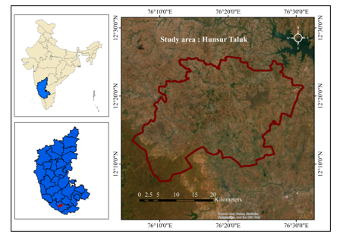
Figure 1 : Study area
3.2 Image Pre-processing
Various Sentinel images have been collected from the Google Earth engine to assess the spatial growth of the forest canopy as well as the different forest attributes of the study area. For sustainable forest resource protection, scientific forest studies have relied mostly on postmonsoon imagery. To calculate the area and improve data extraction, images are further transformed into Universe Transverse Mercator (UTM) projections from geographical coordinate systems. When processing images, the WGS84 datum system is considered.
  - LULC classification
Land use and land cover (LULC) represent significant physical and human-induced characteristics of the Earth’s surface. Land use describes the manner in which humans utilize land resources for different purposes, whereas land cover refers to the natural or physical features that exist on the surface. Over the past few decades, rapid population growth and increasing development activities have caused substantial modifications in LULC patterns. Understanding and monitoring these changes are essential for effective environmental planning and sustainable land management. LULC studies have therefore become an important component of research related to climate change and its influence on forests, disaster risk assessment, forest degradation, the conversion of forestland, and the expansion of settlements in forested regions.
4. Random Forest
RF is a new nonparametric ensemble machine-learning algorithm developed by Breiman (2001). The RF algorithm has been widely applied for solving environmental problems, such as water resource management and natural hazard management. It can handle a variety of data, such as satellite imagery and numerical data (Abdullah et al., 2019). It is an ensemble learning method based on a decision tree that combines massive ensemble regression and classification trees. Recently, several studies have shown satisfactory performance for LULC classification via RF in the field of remote-sensing applications (Camargo et al., 2019; Ma et al.,2017). A large number of trees in this method provide better accuracy in the fields of image classification (Liaw and Wiener, 2002) and land-use modeling. Breiman (2001) stated that using more trees than required trees is an unnecessary and time-consuming process, but it does not hamper the entire model.
3.3 Normalized Difference
The NDVI is essentially a vegetation index that reflects the proper state of an area's vegetation. The range of NDVI values is always between (+1) and (−1). A higher value denotes better vegetation health, whereas a lower value denotes bad vegetation health. Generally, a score of +0.4 indicates healthy plant growth. Rousel (1974) was the first to utilize the normalized difference vegetation index (NDVI) to assess the growth and health of plants in a given area. The NDVI is the most popular and extensively used vegetation index for identifying vegetative areas across a region (Bhandari and Kumar 2012). To determine the NDVI values for a region, the following distinctions between the red and infrared bands were utilized (Gandhi 2015):
NDVI =$\frac{NIR-Red}{NIR +Red}$
3.4 Shadow Index
The canopy shadow index is a vital spectral measure that provides important details on the canopy cover of forests. The SI looks at the overall reflectance from the canopy. Mature or dense forests are indicated by high SI values, whereas open forests or places with very little

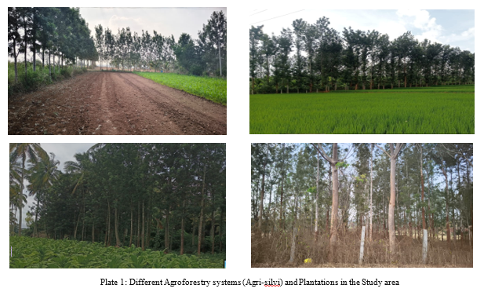

forest cover are indicated by low values. The FCD model is also utilized to determine the real canopy cover, whereas the SI index is employed to calibrate the total reflectance across the forest canopy (Huemmrich 1996).
SI =${[(1 -Red) × (1-Green) × (1-Blue)]}^{\frac{1}{3}}$
3.5 Advanced Vegetation Index
The Advanced Vegetation Index (AVI) is a spectral reflectance indicator used to assess vegetation conditions from multispectral imagery, similar to the normalized difference vegetation index (NDVI). This index uses two spectral bands, red and near-infrared, to evaluate vegetation based on their reflectance characteristics. The AVI is considered more responsive than the NDVI in identifying areas with dense vegetation or high canopy cover. Although the difference between the NDVI and AVI is relatively small, the AVI enhances this variation through the use of a power transformation (Roy et al., 1996). As a result, the AVI is capable of capturing subtle changes in vegetation and provides useful information about foliage activity (Anonymous, 1993).
AVI = ${[(NIR+1(1-Red) × (NIR-Red)]}^{\frac{1}{3}}$
3.6 Soil Bareness Index
The Bareness Index (BI) is a spectral reflectance-based indicator used to evaluate the condition of exposed soil or land surfaces in a particular area. It is widely applied for identifying cropland and other bare surface features. Bare land can generally be grouped into two categories: primary bare land, which shows no evidence of human influence, and secondary bare land, which reflects varying levels of anthropogenic impact (Pal et al., 2018). The index is derived via four spectral bands, namely, blue, red, near-infrared (NIR), and shortwave infrared (SWIR) bands, to determine the extent of surface bareness. The red and SWIR bands mainly indicate the soil mineral composition and surface properties, whereas the blue and NIR bands help represent the presence and conditions of vegetation. The bare soil index (BSI) is calculated via the following equation:
BSI = $\frac{(SWIR+RED) - (NIR+BLUE) }{NIR +(SWIR+RED) +(NIR+BLUE) }$
  - FCD Model
The forest canopy density (FCD) model is an effective approach for estimating the density and condition of forest cover within a given area (Sahana et al., 2015). This model helps in identifying the extent to which forest regions have undergone deforestation or degradation over time. In this study, the FCD map was generated via a weighted overlay analysis (Table 1) performed via the Google Earth Engine. All the previously derived indices were then integrated to produce the final spatial output for the Hunsur taluk.
Table 1: Assigned weights of different classes of thematic layers
Theme | Class | Value Range | Weight
NDVI | Very High | 0.635 – 0.888 | 5
NDVI | High | 0.509 – 0.634 | 4
NDVI | Medium | 0.366 – 0.508 | 3
NDVI | Low | 0.0673 – 0.365 | 2
NDVI | Very Low | -0.517 – 0.0672 | 1
AVI | Very High | 0.4038 – 0.6728 | 5
AVI | High | 0.351 – 0.4037 | 4
AVI | Medium | 0.3009 – 0.3509 | 3
AVI | Low | 0.2112 – 0.3008 | 2
AVI | Very Low | 0.00 – 0.2111 | 1
BI | Very High | -0.58 – -0.195 | 1
BI | High | -0.194 – -0.0876 | 2
BI | Medium | -0.0875 – -0.0147 | 3
BI | Low | 0.0148 – 0.117 | 4
BI | Very Low | 0.118 – 0.663 | 5
SI | Very High | 0.945 – 0.978 | 5
SI | High | 0.926 – 0.944 | 4
SI | Medium | 0.905 – 0.925 | 3
SI | Low | 0.868 – 0.904 | 2
SI | Very Low | 0.192 – 0.867 | 1

Results

4.1 Land use and land cover

The geospatial analysis of land use/land cover (LULC) (Figs. 2 and 3) in Hunsur Taluk indicates a predominantly agrarian landscape with substantial forest and vegetation cover. The total area is 89,722 ha. The proportional distribution of classes reveals marked spatial heterogeneity. Croplands constitute the dominant class, occupying 41,825 ha (46.60%), nearly half of the total geographical area. This statistically confirms the agricultural dependency of the taluk and indicates a strong anthropogenic influence on land transformation. Deciduous forest cover accounts for 15,437 ha (17.21%), whereas scrub forest occupies 16,146 ha (18.00%). The plantation areas cover 8,331 ha (9.29%), reflecting managed forest stands. Fallow land comprises 4,411 ha (4.92%), which represent seasonal agricultural cycles. Water bodies and built-up areas account for 2.10% and 1.88%, respectively, indicating relatively limited urban expansion and stable hydrological features within the study area.

The Random Forest model demonstrated strong predictive performance in the analysis. The obtained value of 0.78 indicates a high level of consistency and reliability in classification, while the overall accuracy of 0.82 (82.49%) reflects the model’s effectiveness in correctly distinguishing between different classes.
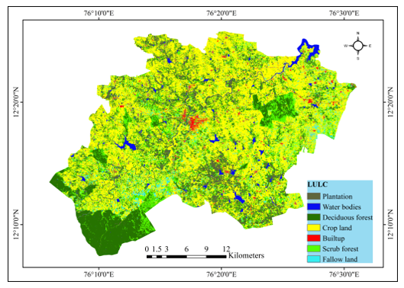
Figure 2: LULC map of study area
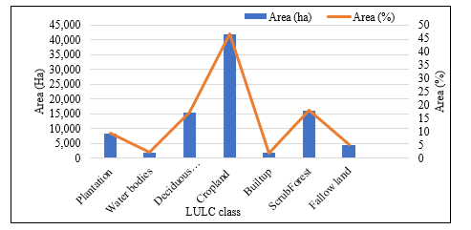
Figure 3: Area and Percentage Distribution of Major Land Use/Land Cover (LULC) Classes in the Study Area
4.2 NDVI
The normalized difference vegetation index (NDVI) is a widely used spectral indicator for assessing vegetation vigor and photosynthetic activity. In the present study, the NDVI values ranged from −0.517--+0.88 (Fig. 4). The derived NDVI layer was classified into five distinct categories on the basis of threshold ranges to represent varying vegetation density conditions. The very low NDVI class (−0.517 to 0.067) corresponds primarily to water bodies, barren surfaces, exposed soil, and built-up areas. The low-NDVI class (0.067 to 0.365) represents sparsely vegetated areas, fallow lands, and degraded scrub patches. The moderate NDVI class (0.366--0.508) is predominantly distributed across mixed agricultural crop lands. The high NDVI class (0.509 to 0.634) is associated with relatively dense vegetation cover, including well-established plantations. These areas demonstrate stronger near-infrared reflectance and active biomass accumulation. The very high NDVI class (0.635 to 0.88) indicates a dense forest canopy and plantations.
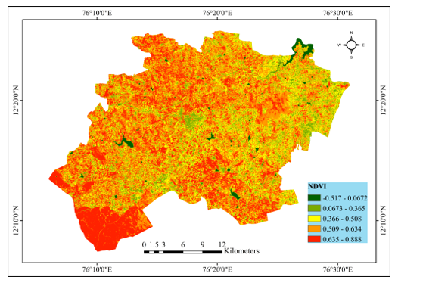
Figure 4: NDVI map of Study area
4.3 Advanced Vegetation Index (AVI)
The AVI is a spectral reflectance-based indicator designed to enhance vegetation density estimation by incorporating nonlinear transformations of near-infrared and red band reflectance. Although conceptually similar to the NDVI, the AVI is more sensitive to variations in high-biomass regions and is particularly effective in distinguishing dense canopy structures. In the present study, the AVI values ranged from 0.00 to 0.672 (Fig. 5). On the basis of threshold classification, the AVI layer was categorized into five distinct classes to represent varying vegetation density conditions. The very low AVI class (0.00–0.211) corresponds primarily to water bodies, built-up areas, exposed soil, and barren surfaces. The low AVI class (0.211–0.30) is distributed across mainly fallow lands, sparsely vegetated agricultural fields, and degraded scrub patches. The moderate AVI class (0.30–0.35) is observed across mixed agricultural landscapes and open forest areas, indicating moderate canopy development and seasonal crop cover. The high AVI class (0.35–0.40) represents relatively dense vegetation, including plantations. The very high AVI class (0.40–0.67) is concentrated within dense forest pockets of the taluk, indicating high biomass and well-developed canopy structures.
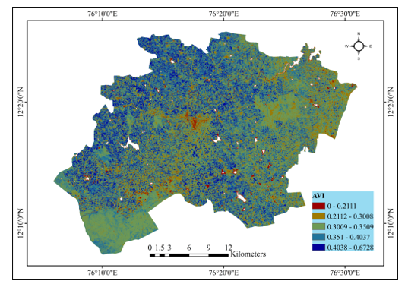
Figure 5: AVI map of study area
4.4 Bareness Index (BI)
BI is a spectral reflectance–based indicator designed to quantify exposed soil surfaces and nonvegetated land features. It is particularly useful in distinguishing barren land, fallow areas, and sparsely vegetated surfaces from dense vegetation cover. In the present study, the BI values ranged from −0.58--+0.663 (Fig. 6). On the basis of threshold segmentation, the BI layer was classified into five categories to discriminate varying degrees of soil exposure and vegetation cover. The very low BI class (−0.58 to −0.195) corresponds primarily to dense forest patches and well-established vegetation zones. The low BI class (−0.194 to −0.087) is associated mainly with moderately vegetated regions, including plantation areas and semidense forest patches. The moderate BI class (−0.087 to −0.014) represents mixed landscapes consisting of scrub vegetation, transitional forest edges, and partially cultivated agricultural land. The high BI class (0.014 to 0.11) is distributed across fallow lands, sparsely vegetated agricultural fields, and degraded scrub regions. The very high BI class (0.118--0.663) is largely confined to exposed surfaces such as barren land, river channels, built-up areas, and dry open fields.
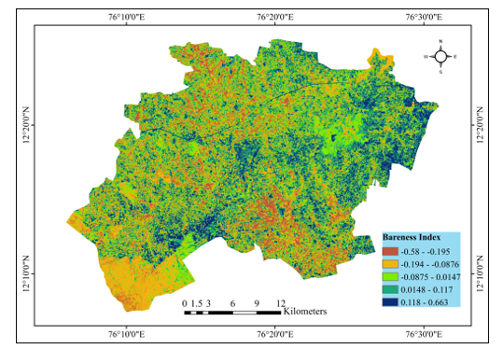
Figure 6: Bareness index map of study area
4.5 Shadow Index (SI)
The SI is a spectral reflectance–based indicator used to quantify canopy shadow intensity, which is directly associated with forest structural complexity and crown closure. Dense and mature forest stands generally present relatively high SI values due to increased shadow effects produced by multilayered canopies, whereas sparse vegetation and exposed surfaces present comparatively low SI values. In the present study, the SI values ranged from 0.192--0.978 (Fig. 7). The derived SI was classified into five categories on the basis of threshold segmentation to represent varying canopy shadow intensities. The very low SI class (0.192–0.867) is associated primarily with water bodies, built-up areas, agricultural fields, and exposed land surfaces. The low SI class (0.868–0.904) corresponds to sparsely vegetated regions, fallow lands, and degraded scrub patches where canopy closure is limited. The moderate SI class (0.905–0.925) represents transitional zones consisting of open forests, mixed plantations, and agricultural–forest interfaces, indicating intermediate canopy density. The high SI class (0.926–0.944) is observed within semi dense forest patches and well-established plantation zones, reflecting substantial canopy layering and increased shadow effects. The very high SI class (0.945–0.978) is concentrated within dense forest pockets of the taluk, particularly in core forest regions where canopy closure is high and structural complexity is well developed.
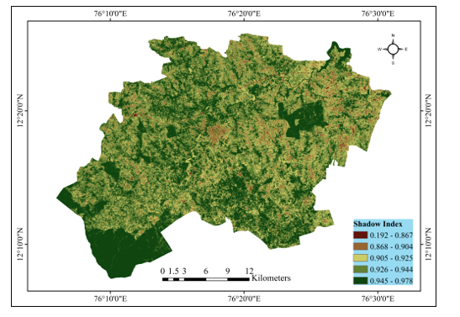
Figure 7: Shadow index map of study area

4.6 Forest canopy density (FCD) model
The Forest Canopy Density (FCD) model (Fig. 8) for Hunsur Taluk was developed through the integration of four spectral indices, namely, the normalized difference vegetation index (NDVI), advanced vegetation index (AVI), bareness index (BI), and shadow index (SI), by considering the LULC of plantations, shrubs and deciduous forests. A weighted overlay analysis approach was employed to synthesize these indices, wherein relative weights were assigned according to their ecological significance and contribution to canopy characterization. This multicriteria integration enhances model robustness and minimizes bias associated with single-index estimation. The computed FCD values range from 7.49 to 80.75, indicating substantial spatial variability in canopy cover across the taluk. On the basis of threshold segmentation, the FCD output was classified into five canopy density classes (Classes I–V), which represented a gradient from very low to very high canopy density.
Table 2: Area and percentage distributions of forest canopy density classes in the study area
Serial No. | Class | Canopy Density Class | Area (ha) | Percentage (%)
1 | Class I | Very Low Canopy Density | 7,744 | 19.40%
2 | Class II | Low Canopy Density | 9,271 | 23.23%
3 | Class III | Moderate Canopy Density | 7,211 | 18.07%
4 | Class IV | High Canopy Density | 7,770 | 19.47%
5 | Class V | Very High Canopy Density | 7,917 | 19.83%
The distributions of the FCD model values indicate that low canopy density accounts for the largest proportion (23.23%), whereas moderate canopy density accounts for the smallest share (18.07%). The relatively balanced distributions among the high (19.47%) and very high (19.83%) canopy classes suggest the presence of substantial dense forest patches within the taluk.
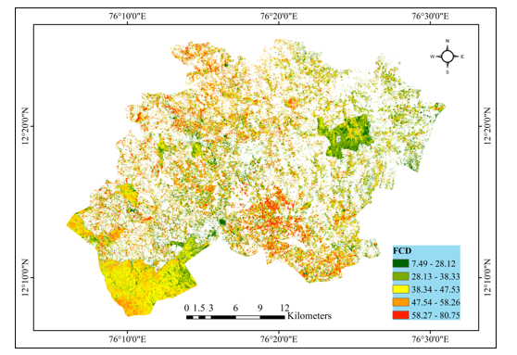
Figure 8 : Forest canopy density map of study area
5. Discussion
5.1 LULC
The geospatial analysis of land use/land cover (LULC) in Hunsur taluk underscores a predominantly agrarian landscape, where cropland dominates 46.60% of the total area, affirming the region's heavy agricultural dependency and anthropogenic transformation of land, which is consistent with findings from IRS-1D LISS-III data analyses that highlight that kharif crops covering 47.98% of groundwater overexploitation exceed 27% (Manjunatha and Basavarajappa, 2021). Together, natural forests (17.21%) and scrub forests (18.00%) constitute more than thirty percent of the area, stabilizing the ecology of denudational hills and buffering erosion, whereas plantations (9.29%) represent managed interventions such as silver oak and teak cultivation, mirroring spatiotemporal trends in nearby Mysuru taluk, where vegetation recovery offsets shrubland decline through afforestation. Fallow land (4.92%) reflects seasonal cycles vulnerable to drought in rainfed zones, with minimal built-up areas (1.88%) and water bodies (2.10%) signaling restrained urbanization and hydrological stability but posing risks to biodiversity from population-driven expansion and soil erosion into streams. These patterns align with broader Karnataka LULC dynamics, urging policies focused on groundwater monitoring and land management to counter agricultural intensification pressures.
5.2 Multi-Index Assessment of Vegetation Structure and Land Surface Conditions in Hunsur Taluk
The integrated analysis of the NDVI, AVI, BI, and SI in Hunsur Taluk demonstrated a clear ecological gradient from nonvegetated and degraded surfaces to structurally complex forest canopy values effectively capture variability in vegetation vigor, with low values corresponding to water bodies, barren lands, and built-up areas, whereas higher values reflect dense plantations and intact forest stands, confirming its reliability as a proxy for photosynthetic activity and biomass health (Nițu et al., 2025; Mehmood et al., 2024). The AVI further refines canopy discrimination by enhancing sensitivity to high-biomass zones through nonlinear NIR–red transformations, enabling improved identification of dense forest pockets compared with the NDVI alone (Medhe and Badhe, 2023). The convergence of high NDVI and AVI classes in denudational hill forests and riparian buffers along streams underscores the ecological resilience of these zones, whereas moderate classes highlight agro-forest mosaics and plantation landscapes subjected to seasonal drought and anthropogenic pressures (Kaliraj et al., 2026).
BI and SI provide complementary structural and surface condition insights, strengthening land cover interpretation. The inverse relationship between the BI and vegetation indices clearly differentiates exposed soils, fallow lands, and degraded scrublands from semidense and dense forest canopies, emphasizing areas vulnerable to erosion and groundwater stress in this predominantly agricultural taluk (Oñate-Valdivieso et al., 2024). High BI zones correspond with low NDVI/AVI classes, particularly in cropland-dominated and built-up regions, indicating potential land degradation risks. Moreover, the SI values effectively capture canopy shadow intensity and crown closure, with high SI values confirming a multilayered forest structure and ecological stability, whereas low SI values indicate sparse vegetation and exposed landscapes. Together, these indices offer a robust framework for stratifying LULC patterns and identifying priority zones for afforestation, scrub restoration, and watershed management to increase hydrological buffering and biodiversity conservation (Kaliraj et al., 2026).
5.3 Forest canopy density (FCD) model
The FCD model for Hunsur taluk integrates the NDVI, AVI, BI, and SI via weighted overlay analysis, assigning ecological weights to prioritize vegetation vigor (NDVI/AVI), soil exposure (BI), and structural shadows (SI) and focusing on plantations, scrubs, and deciduous forests to robustly map canopy gradients and reduce single-index biases (Namasivayam and Ramamoorthy, 2024; Medhe and Badhe 2023). FCD values reveal pronounced variability, with threshold-derived classes delineating very low density (open/agricultural interfaces) to very high density (dense core forests), aligning with the taluk's forest-scrub matrix amid croplands (FSI, 2019). This principal component-based synthesis excels in tropical deciduous

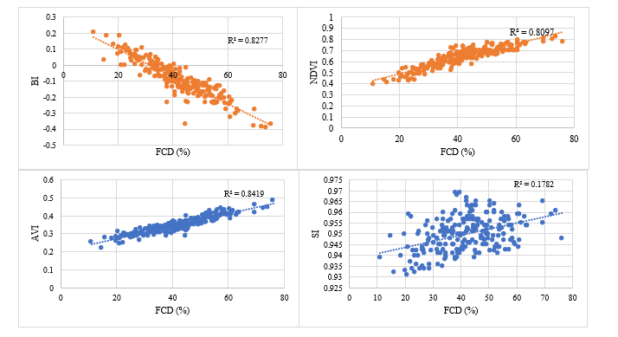

Figure 9: Scatter plots shows the relationship of different spectral indices with FCD values

monitoring, capturing degradation in transitional zones near perennial streams (Namasivayam and Ramamoorthy, 2024).
The integration of FCD outputs with Land Use Land Cover (LULC) mapping clearly indicates an urgent management priority: expanding Trees Outside Forests (TOF) in the Hunsur landscape to address both ecological and livelihood needs. A substantial portion of Hunsur Taluk is under tobacco cultivation, which relies predominantly on fuelwood for curing, thereby generating a very high and spatially concentrated wood demand. At the same time, the taluk’s proximity to Nagarhole National Park, a designated Tiger Reserve, brings strict conservation regulations that restrict removal of timber and fuelwood from protected forest areas to safeguard wildlife habitat. This juxtaposition creates a pronounced socio-ecological tension between the fuelwood requirements of tobacco-based rural livelihoods and the legal as well as ecological imperatives of biodiversity conservation in and around the Tiger Reserve (Mahadevamurthy, 2013).
In this context, strategically promoting TOF on private farmlands, community holdings, and agroforestry systems emerges as a viable, decentralized solution that aligns with national and state-level efforts to scale up TOF for climate and livelihood benefits. Expanding farm forestry and multipurpose tree plantations can ensure a dedicated and sustainable fuelwood supply for tobacco curing, thereby reducing anthropogenic pressure on the protected forest cores of Nagarhole and its buffer. Such interventions simultaneously enhance carbon sequestration and contribute to achieving national tree and forest cover targets by increasing tree cover outside the Recorded Forest Area. Moreover, well-designed agroforestry and woodlot systems improve the economic resilience of tobacco farmers by diversifying farm outputs (timber, poles, fuelwood, and non-timber products) and stabilizing income streams over time (Naveena et al., 2026).
Integrating TOF expansion with existing agricultural systems in Hunsur can also strengthen ecological connectivity between remnant forest fragments and the larger Nagarhole landscape, which is critical for wide-ranging species such as the tiger and other large mammals. By embedding tree resources within agricultural mosaics, the landscape can move toward a more balanced configuration that reconciles conservation priorities with rural livelihood security, effectively operationalizing a “grow-own-fuel” approach tailored to the tobacco sector in this taluk
5.4 Integrated FCD Mapping and Index Correlations in Hunsur Taluk
Correlation and regression analyses confirm robust predictive power, particularly AVI (R²=0.84) and BI (R²=0.82) against FCD percentages, whereas the weaker correlation of SI (R²=0.1782) reflects its niche sensitivity to shadow complexity in sparse canopies; the NDVI has a strong fit (R²=0.80), validating multi-index synergy for tropical deciduous monitoring.
These correlations affirm the efficacy of FCD in semiarid Karnataka watersheds, where high AVI/NDVI alignment signals biomass vigor in plantations amid groundwater overexploitation, yet BI's inverse trend highlights erosion-prone fallows near perennial streams such as Lakshman Theertha (Medhe and Badhe, 2023). SI's modest R² underscores limitations in open forest transitions but enhances structural detail in dense pockets, collectively minimizing single-index biases as per principal component protocols (Rikimaru, 1996).

6. Challenges and limitations
The assessment of forest canopy density (FCD) via remote sensing and geospatial techniques faces several challenges and limitations. One major constraint is the influence of cloud cover, atmospheric disturbances, and seasonal variations, which can affect the accuracy of satellite-derived indices such as the NDVI, AVI, BI, and SI. The spatial resolution of satellite imagery may not adequately capture small-scale canopy gaps or heterogeneous forest patches, leading to generalization errors. The weightage overlay method involves the subjective assignment of weights to thematic layers, which may introduce bias in the final FCD output. Additionally, topographic effects, shadow influences in hilly terrain, and mixed pixel problems reduce classification accuracy. The limited ground truth data for validation and difficulties in accessing dense forest areas further restrict the reliability and precision of the model outputs.

7. Way forward
To overcome these challenges, future research should focus on integrating high-resolution satellite data, LiDAR, and UAV-based observations to improve canopy structure assessment and minimize mixed pixel errors. Advanced machine learning and deep learning algorithms can be employed to reduce subjectivity in weight assignment and enhance classification accuracy. The incorporation of multitemporal datasets will help in understanding seasonal dynamics and long-term forest health trends. Improved atmospheric correction techniques and terrain normalization methods can further refine results in complex landscapes. Strengthening field-based validation through systematic sampling and GPS-based ground truth collection will enhance model reliability. The integration of cloud-based platforms such as the Google Earth Engine can facilitate large-scale and time-efficient FCD monitoring.

8. Conclusion
Remote sensing-based Forest Canopy Density (FCD) modeling offers a robust and efficient framework for assessing forest health, structural complexity, and spatial distribution. While limitations exist regarding spatial resolution and the inherent subjectivity of biophysical indices, the integration of advanced satellite imagery and machine learning significantly enhances the reliability of these models. Consequently, FCD mapping serves as a critical decision-support tool for sustainable forest management, biodiversity conservation, and strategic environmental planning.
Based on the LULC and FCD maps, there is a clear need to expand Trees Outside Forests (TOF) in Hunsur. Extensive tobacco cultivation in the region creates high fuelwood demand for curing, while proximity to Nagarhole National Park restricts forest resource extraction due to conservation regulations. Promoting TOF on private and community lands can provide a sustainable fuelwood supply, reduce pressure on protected forests, strengthen farmers’ livelihoods, and enhance carbon sequestration and ecological stability in the landscape.
Disclaimer (Artificial intelligence)

Author(s) hereby declares that NO generative AI technologies such as Large Language Models (ChatGPT, COPILOT, etc.) and text-to-image generators have been used during the writing or editing of this manuscript.

9. References
Abdollahnejad, A., Panagiotidis, D., & Surový, P. (2017). Forest canopy density assessment using different approaches-review.
Abdullah, A. Y. M., Masrur, A., Adnan, M. S. G., Baky, M. A. A., Hassan, Q. K., & Dewan, A. (2019). Spatio-temporal patterns of land use/land cover change in the heterogeneous coastal region of Bangladesh between 1990 and 2017. Remote Sensing, 11(7), 790.
Anonymous (1993) Rehabilitation of logged-over forests in Asia/Pacific region. Final Report of Sub Project II International Tropical Timber Organisation—Japan Overseas Forestry Consultants Association, pp 1–78.
Bhandari, A. K., Kumar, A., & Singh, G. K. (2012). Feature extraction using Normalized Difference Vegetation Index (NDVI): A case study of Jabalpur city. Procedia technology, 6, 612-621.
Breiman, L. (2001). Random forests. Machine learning, 45(1), 5-32.
Camargo, F. F., Sano, E. E., Almeida, C. M., Mura, J. C., & Almeida, T. (2019). A comparative assessment of machine-learning techniques for land use and land cover classification of the Brazilian tropical savanna using ALOS-2/PALSAR-2 polarimetric images. Remote Sensing, 11(13), 1600.
Deka, J., Tripathi, O. P., & Khan, M. L. (2013). Implementation of forest canopy density model to monitor tropical deforestation. Journal of the indian society of remote sensing, 41(2), 469-475.
Gandhi, G. M., Parthiban, B. S., Thummalu, N., & Christy, A. (2015). Ndvi: Vegetation change detection using remote sensing and gis–A case study of Vellore District. Procedia computer science, 57, 1199-1210.
Huemmrich, K. F. (1996, May). Effects of shadows on vegetation indices. In IGARSS'96. 1996 International Geoscience and Remote Sensing Symposium (Vol. 4, pp. 2372-2374). IEEE.
Joshi, C., De Leeuw, J., Skidmore, A. K., Van Duren, I. C., & Van Oosten, H. (2006). Remotely sensed estimation of forest canopy density: A comparison of the performance of four methods. International Journal of Applied Earth Observation and Geoinformation, 8(2), 84-95.
Kaliraj, S., Joe, R. J., Pitchaimani, V. S., Abishek, S. R., & Karuppannan, S. (2026). GIS-based assessment of land degradation vulnerability and environmental indices as ecological indicators in Western Agro-climatic zone of Tamil Nadu, India. Scientific Reports.
KP, P. R., & Reddy, S. R. RAINFALL TREND ANALYSIS OF A MINI WATERSHED: A CASE STUDY ON DEGRADING LAKES/TANKS.
Liaw, A., & Wiener, M. (2002). Classification and regression by randomForest. R news, 2(3), 18-22.
Ma, L., Li, M., Ma, X., Cheng, L., Du, P., & Liu, Y. (2017). A review of supervised object-based land-cover image classification. ISPRS Journal of Photogrammetry and Remote Sensing, 130, 277-293.
Mahadevamurthy, M. (2013). Assessment of fuel wood requirement for tobacco curing in Periyapatna and Hunsur taluks of Karnataka. Global Journal of Biology, Agriculture & Health Sciences, 2(2), 67–72.
Manjunatha, M. C., & Basavarajappa, H. T. (2021). Geospatial approach in Land Classification Analysis for Hunasuru Taluk of Karnataka State, India. METHODOLOGY, 8(8).
Medhe R. S, Badhe Y. P. Forest Canopy Density Monitoring by Using Geospatial Techniques: A Study of Gadchiroli District, Maharashtra, India. Curr World Environ 2023;18(3).
Mehmood, K., Anees, S. A., Muhammad, S., Hussain, K., Shahzad, F., Liu, Q., ... & Khan, W. R. (2024). Analyzing vegetation health dynamics across seasons and regions through NDVI and climatic variables. Scientific Reports, 14(1), 11775.
Namasivayam, G., & Ramamoorthy, S. (2024). Estimation of forest canopy density through Geospatial Technology—a case study on Sathyamangalam Forest, Erode District, Tamil Nadu. Environmental Monitoring and Assessment, 196(2), 209.
Nandy, S., Joshi, P. K., & Das, K. K. (2003). Forest canopy density stratification using biophysical modeling. Journal of the Indian Society of Remote Sensing, 31(4), 291-297.
Naveena, K. P., Manjunatha, M., Mangala, K. P., Chowti, S. P., & Bommesh, J. C. (2026). Economic appraisal of adoption of the grow-own-fuel initiative in FCV tobacco curing: Empirical evidence from Mysuru and Hassan districts of Karnataka. International Journal of Agriculture Extension and Social Development, 9(1), 259–265.
Nițu, A., Florea, C., Ivanovici, M., & Racoviteanu, A. (2025). NDVI and beyond: Vegetation indices as features for crop recognition and segmentation in hyperspectral data. Sensors, 25(12), 3817.
Oñate-Valdivieso, F., Oñate-Paladines, A., & Díaz, R. (2024). Soil degradation in andean watersheds: a case study using remote sensing. Frontiers in Earth Science, 12, 1325189.
Pal, S. C., Chakrabortty, R., Malik, S., & Das, B. (2018). Application of forest canopy density model for forest cover mapping using LISS-IV satellite data: a case study of Sali watershed, West Bengal. Modeling Earth Systems and Environment, 4(2), 853-865.
Rikimaru, A. (1997). Development of forest canopy density mapping and monitoring model using indices of vegetation, bare soil and shadow. In The 18th Asian Conference on Remote Sensing, Kuala Lumpur, Malaysia E 6.1/6.6 (1997).
Rouse Jr, J. W., Haas, R. H., Schell, J. A., & Deering, D. W. (1974). Paper a 20. In Third Earth Resources Technology Satellite-1 Symposium: The Proceedings of a Symposium Held by Goddard Space Flight Center at Washington, DC on December 10-14, 1973: Prepared at Goddard Space Flight Center (Vol. 351, p. 309).
Roy, P. S., Sharma, K. P., & Jain, A. (1996). Stratification of density in dry deciduous forest using satellite remote sensing digital data an approach based on spectral indices. Journal of biosciences, 21(5), 723-734.
Sahana, M., Sajjad, H., & Ahmed, R. (2015). Assessing spatio-temporal health of forest cover using forest canopy density model and forest fragmentation approach in Sundarban reserve forest, India. Modeling Earth Systems and Environment, 1(4), 49.

