Diversity Assessment of Spider Communities (Arachnida: Araneae) Across Different Habitat Types in Chhattisgarh, India: Implications for Conservation and Bioindicator Potential

Abstract:
Spiders (Order: Araneai) are one of the most diverse and ecologically important arthropods as significant bioindicators of natural environmental health and natural pest checkers in the earth ecosystem. This study provide an in-depth evaluation of spider diversity in three different districts of Chhattisgarh in India - Gariyaband (forest/hilly area), Mahasamund (mixed forest-agriculture) and Raipur (urban/semi-urban) - during a 12-month season (July 2023 to June 2024). Systematic sampling methods such as pitfall traps, sweep netting and visual encounter survey were used to record 5,137 individuals of 57 species of spiders. Alpha diversity indices showed that there was a lot of variation among the districts with Gariyaband having the highest species richness (S=59), Shannon-Wiener diversity (H'=4.057) and total abundance (N=2,082), followed by Mahasamund (S=46, H'=3.806, N=1,672) and Raipur (S=36, H'=3.565, N=1,383). One-way ANOVA revealed a significant difference in the abundance of months between the districts with a high level of significance (F=54.423, p<0.001). Beta diversity analysis based on Bray-Curtis dissimilarity and Jaccard similarity indices revealed that there was moderate community differentiation with the Gariyaband and Mahasamund having the highest similarity (Jaccard Index=0.789). The analysis of seasonal variation showed that the abundance was high during the post-monsoon/winter in all the districts. The results show that habitat heterogeneity and anthropogenic disturbance have a significant effect on the structure of spider communities, which supports the possible use of spiders as valid bioindicators to monitor the ecosystem in Central India.
Keywords: Spider diversity, Chhattisgarh, Alpha diversity, Beta diversity, Bioindicators, Habitat disturbance, Conservation, Seasonal variation

1. Introduction
Spiders (Order: Araneae) are one of the most diverse and ecologically important lineages of terrestrial arthropods and there are about 50,000 described species in the world (World Spider Catalog, 2025). Spiders as generalists predators are also important in controlling the numbers of insects, as well as keeping the ecosystem balanced as a result of having complex food web (Nyffeler and Birkhofer, 2017). They are good bioindicators to measure ecosystem health and are sensitive to environmental change due to their relative sedentary lifestyle and habitat specificity (Sebastian and Peter, 2009; Cardoso et al. 2011).
A great spider fauna is preserved in India, as there are more than 2,000 species of spiders which are recorded in different ecological zones (Singh et al. 2023). The Chhattisgarh state, which is located in Central India, is a distinct biogeographic area with the combination of tropical dry deciduous forests, farmlands and fast-growing cities. Although it is an environmentally important area, the spider diversity and community structure in the area have not been studied comprehensively (Singh and Singh, 2021; Choudhury et al. 2024).
Diversity indices have become a common practice in ecological research in assessing biodiversity. The diversity measures such as species richness, Shannon-Wiener index (H), Simpson diversity index (1-D) and Pielou index of evenness (J) give information about the characteristics of the community in particular habitats (Shannon and Weaver 1949; Simpson, 1949; Pielou, 1966). The analysis of beta diversity to compare the composition of communities across habitats using Bray-Curtis dissimilarity and Jaccard similarity index (Whittaker, 1972; Bray and Curtis, 1957) is the method that allows comparing community composition across habitats.
One significant threat to the biodiversity of the world and its drastic effects on arthropod communities is urbanization and habitat fragmentation (Sharma et al. 2024). The response of spider communities to disturbance of a habitat is of critical use in the formulation of effective conservation and preservation of ecosystem services. The purpose of the study will focus on determining the diversity of spiders in various habitat types in Chhattisgarh, the anthropogenic disturbance and its effect on community structure and the foundation of future monitoring and conservation activities.

1.1 Research Objectives

The main aims of this research were: (1) to report the richness and abundance of spider species in three different habitat types in Chhattisgarh; (2) to measure alpha diversity with the help of various ecological indices; (3) to evaluate the beta diversity and similarity of communities among districts; (4) to examine seasonality in spider abundance; and (5) to determine the potentials of spider species as bioindicators to monitor the ecological state of the environment in Central India.

2. Materials and Methods
2.1 Study Area
The research was carried out in three districts of Chhattisgarh, India that models the different habitat types: (1) Gariyaband District (20.63"N, 82.05"E) - with a dense vegetation cover and hilly topography with minimal anthropogenic disturbance; (2) Mahasamund District (21.10"N, 82.10"E) - with mixed forest- agriculture landscapes with moderate anthropogenic disturbance; and (3) Raipur District (21.2 The area has three seasons namely pre-monsoon (March-May), monsoon (June-September) and post-monsoon/winter (October-February).
2.2 Data Collection
It occurred in 12 months (July 2023- June 2024) using various methods of collection: (1) Pitfall traps - 70% ethanol and detergent-filled plastic containers (8.5 cm diameter, 12 cm depth) operating 72 hours at a time (Gardarin & Valantin-Morison, 2021); (2) Sweep netting - 50 sweeps per sampling location with a standard insect net; (3) Visual encounter surveys - 30 minutes per quad Preservation was done in 70% ethanol and identification done based on standard taxonomic keys (Tikader and Malhotra, 1980; Barrion and Litsinger, 1995; Sebastian and Peter, 2009).
2.3 Statistical Analysis
Alpha diversity was measured as follows: (1) Species Richness (S) - number of species; (2) Shannon-Wiener Diversity Index (H ) = -Sum(pi x lnpi), where pi is proportion of individuals of species i (Shannon and Weaver, 1949); (3) Simpson's Diversity Index (1-D) = 1 -Sum(ni(ni -1)/ N(N-1)) where ni is the number of individuals of species i (Simpson, 1949); (4) Even
Bray-Curtis dissimilarity (abundance-based) and Jaccard similarity index (presence/absence-based) were used to measure beta diversity (Bray and Curtis,1957; Jaccard, 1912). Shared species counts and Jaccard similarity coefficients were used to measure species overlap. The Chao1 estimator was used to test the sampling completeness (Chao, 1984).
One-way ANOVA to test statistical significance between monthly abundance was used to compare bulls among districts, pair-wise t-tests to test statistical significance between bulls within a district, Kruskal-Wallis to test non-parametric analysis and Pearson/Spearman correlation coefficients to test relationship among variables (Morris et al. 2014). All the analyses were done in R statistical software (version 4.3.0) and vegan package to calculate the diversity.

3. Results
3.1 Species Richness and Abundance
The 5,137 individuals of spider species recorded in the three districts in the course of the 12-month study period were of 57 species. Gariyaband District had the greatest level of species richness (S=59) and total abundance (N=2,082) and contributed 40.5% of the total individuals collected. The maximum number of species that were recorded had their individuals in Mahasamund District, 46 species and 1,672 individuals respectively (32.5%) and Raipur District recorded the minimum values, 36 species and 1,383 individuals respectively (26.9%).
SN | District | Species (S) | Abundance (N) | Shannon (H') | Simpson (1-D) | Evenness (J')
1. | Gariyaband | 59 | 2,082 | 4.057 | 0.982 | 0.995
2. | Mahasamund | 46 | 1,672 | 3.806 | 0.977 | 0.994
3. | Raipur | 36 | 1,383 | 3.565 | 0.971 | 0.995
Table 1: Alpha Diversity Indices Across Districts
3.2 Alpha Diversity Analysis
Shannon-Wiener diversity index (H') showed that there was great diversity in the districts with Gariyaband having the highest diversity (H0=4.057), then Mahasamund (H0=3.806) and Raipur (H0=3.565). The diversity index (1-D) of Simpson was between 0.971 and 0.982, which showed a high index of diversity among all the districts. Evenness indices of Pielou (J'>0.99) indicated good balance communities devoid of overcoming species. Gariyaband was the most diverse habitat proven by means of Margalef richness index (7.59) and Menhenick index (1.29).
3.3 Beta Diversity and Community Similarity.
Bray-Curtis dissimilarity analysis depicted moderate differentiation of community among districts. Mahasamund and Raipur topped the dissimilarity with 0.338 and 0.297 respectively and Gariyaband topped the dissimilarity with Mahasamund (0.187). Jaccard similarity index revealed greatest similarity between Gariyaband and Mahasamund community (0.789), implying that they have common habitat features. The overlap analysis of species recorded 45 similar species between Gariyaband and Mahasamund, 35 between Gariyaband and Raipur and 28 between Mahasamund and Raipur and 28 species shared by all three districts.

SN | Comparison | Bray-Curtis | Jaccard Index | Shared Species
1. | Gariyaband vs Mahasamund | 0.187 | 0.789 | 45
2. | Gariyaband vs Raipur | 0.297 | 0.614 | 35
3. | Mahasamund vs Raipur | 0.338 | 0.538 | 28
Table 2: Beta Diversity Metrics Among Districts

3.4 Statistical Analysis
ANOVA revealed the highly significant and significant differences in the monthly abundance by using one way ANOVA (F=54.423, p<0.001). The significance of differences in the pairs (t=6.543, p<0.001), (t=10.250, p<0.001) and (t=4.077, p<0.001) between the districts showed that the differences were statistically significant. The Pearson correlation analysis revealed that Mahasamund and Raipur (r=0.668, p=0.018) and Gariyaband and Raipur (r=0.635, p=0.027) had significant positive correlations, meaning that the Mahasamund and Gariyaband share the same pattern of seasonal abundance.
Figure 1: Comprehensive statistical analysis of spider diversity across districts. (A) Monthly abundance patterns, (B) Species richness comparison, (C) Shannon-Wiener diversity, (D) Seasonal abundance, (E) Bray-Curtis dissimilarity matrix, (F) Jaccard similarity index, (G) Monthly Shannon diversity trends, (H) Rank-abundance curve for Gariyaband, (I) Top 5 species comparison, (J) Species evenness, (K) Diversity indices profile, (L) Total abundance distribution.

3.5 Seasonal Variation
The analysis of seasonal abundance showed that all the districts showed similar trends with the highest abundance recorded during post-monsoon/winter (October-February). Gariyaband had 718 people recorded in post-monsoon/winter, 686 individuals recorded in pre-monsoon and 678 individuals recorded in the monsoon. The same was found in Mahasamund (569, 524, 579 respectively) and Raipur (494, 425, 464 respectively). Shannon diversity index had small seasonal variation, with values of 3.73 to 3.86 among all the districts and seasons.
SN | Season | Gariyaband | Mahasamund | Raipur | Total
1. | Pre-Monsoon | 686 | 524 | 425 | 1,635
2. | Monsoon | 678 | 579 | 464 | 1,721
3. | Post-Monsoon/Winter | 718 | 569 | 494 | 1,781
Table 3: Seasonal Abundance and Diversity Patterns
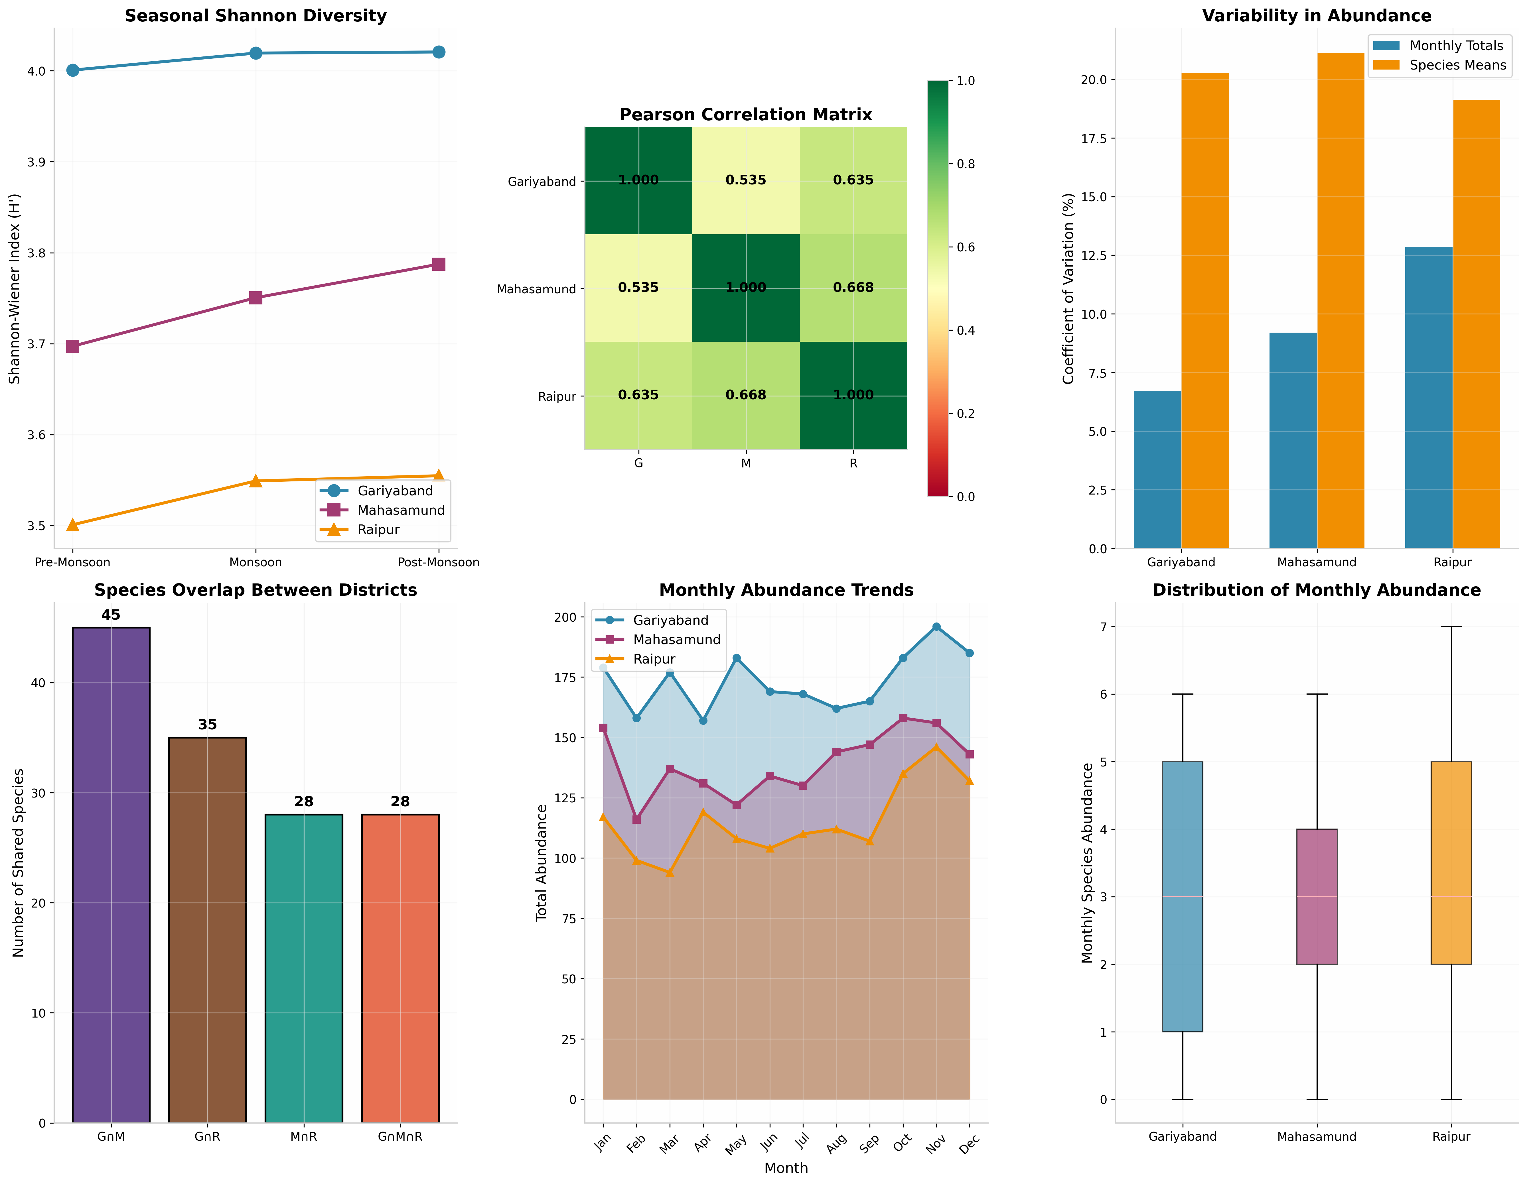
Figure 2: Seasonal analysis of spider diversity patterns. (A) Seasonal Shannon diversity trends across districts, (B) Pearson correlation matrix showing inter-district relationships, (C) Coefficient of variation in abundance, (D) Species overlap between districts, (E) Monthly abundance trends, (F) Distribution of monthly abundance across districts.
3.6 Dominant Species
The top species included Argiope aemula (154 individuals), Plaxippus paykulli (153 individuals) and Hersilia savignyi (131 individuals) and Steatoda nabalis (130 individuals) and Cyrtophora citriola (119 individuals) in all the districts. Gariyaband alone supported five species (Aegiope aetherea, Nephila pilipes, Ostearius melanopygius, Telamonia dimidiata female and male) and this indicates the need of disturbed forest habitats to conserve unique spider species.
3.7 Sampling Completeness
The analysis of Chao1 estimator showed that all three districts had 100% sampling completeness and observed species richness was the same as estimated richness. This reveals that adequate sampling was done to ensure that spider diversity in the study area was well documented.

4. Discussion
This study provides the first comprehensive assessment spider diversity in different habitat types in Chhattisgarh, Central India. The recorded diversity (57 species) and abundance (5,137 individuals) of arachnids indicate the high level of arachnid species in the region, which is in line with what had been reported by the adjacent areas (Kujur and Ekka, 2016; Nichat et al. 2025). The results demonstrate evident trends of diversity fluctuation in relation to habitat type and anthropogenic disturbance which prove using spiders as effective bioindicators of ecosystem monitoring.
4.1 Diversity of Spiders based on Habitat.
The abundance of spider species in Gariyaband District can be explained by the dense forest cover, the diversity of the microhabitat and the low level of human interference (S=59, H'=4.057). Forest ecosystems offer highly stratified vertical structures, a rich pool of prey and constant micro climatic conditions that maintain a variety of spider assemblages (Uetz, 1991; Kapoor, 2008). The five distinct species found in this district such as the giant orb weaver Nephila pilipes are an indication of the conservation importance of untouched forest environments.
Mahasamund District as a mixture of forest-agriculture areas had intermediate diversity (HI=3.806, S=46). Intensive farming activities such as pesticides can reduce biodiversity because agroecosystems can host large numbers of spiders because of the presence of agricultural pest organisms as food, as well as because of adequate moisture and food supply (Sugumaran et al. 2024). Jaccard similarity (0.789) between Gariyaband and Mahasamund is high which indicates high rate of species exchange between forest and agricultural habitats.
The least diversity was found in Raipur District, which is an urban and semi-urban area (H'=3.565, S=36), which is also in line with the results of other studies related to urbanization in India (Sharma et al. 2024). Urbanization causes both a loss of habitat heterogeneity, enhanced environmental stressors and synanthropic species adapted to human modified environments. The high level of correlation between the abundance patterns of Raipur and Mahasamund implies that urban spider communities can be partially maintained due to the immigration of adjacent natural habitats.
4.2 Seasonal Dynamics
The peak abundance is observed in the post-monsoon/winter which is comparable with studies in other tropical areas (Anirudhan and Sudhikumar, 2023; Pandey and Agrawal, 2025). The conditions in the post-monsoon period offer the best temperature, humidity and prey after the reproduction period. The fact that the Shannon diversity does not vary significantly among the seasons shows that abundance varies but not community composition, which is an indication that the spider assemblage is resilient to seasonal environmental change.
4.3 Beta Diversity and Community Structure.
Beta analysis of diversity indicated medium differentiation of communities across districts whereby the Bray-Curtis values of dissimilarity were within the range of 0.187 to 0.338. The Jaccard similarity between Gariyaband and Mahasamund (0.789) was relatively high, which implies a high level of overlap of species since these two areas were likely connected through the environment and shared similarities in their environment. Comparatively, the reduced similarity between the urban (Raipur) and the forest (Gariyaband) habitat (0.614) is indicative of urbanization filtering the community composition.
The decentralized value of the evenness of the high Pielou (>0.99) among all the districts signifies the existence of well-balanced communities that have no dominant species as well, which promotes the stability of the ecosystem and proper distribution of resources among the coexisting species. This pattern of evenness is typical of a mature, undisturbed community and is the opposite of the dominance patterns usually found in the severely disturbed habitats.
4.4 Conservation Implications
The results reveal that forest habitat in Chhattisgarh is important in conserving the spider diversity and related ecosystem services. The five exotic species recorded in Gariyaband are worthy elements of the local flora that can be at risk of being destroyed by erosion. The great reduction of diversity between forest and urban habitat underscores the importance of urban green space planning that includes habitat heterogeneity and connectivity to tolerate spider populations.
Spiders also play an important role in the natural management of pests in the agricultural environment and it is estimated that world populations of spiders eat 400-800 million tons of pests per year (Nyffeler and Birkhofer, 2017). The preservation of spider diversity in agricultural ecosystems can increase the biological control facilities and decrease the use of chemical pesticides to promote sustainable agriculture in the area.
4.5 Bioindicator Potential
Their usefulness in monitoring ecosystems of Central India is supported by the high disparities in the species diversity of spiders across habitat type and the fact that these species are sensitive to environmental disturbance. These regularities that were observed in various diversity measures (richness, Shannon, Simpson, evenness) offer a solid model of measuring the quality of habitats and monitoring the environmental change. The spider sampling protocols should be standardized in future monitoring programs to facilitate long-term monitoring and early recognition of degradation of the ecosystem.

5. Conclusion
This study provides comprehensive baseline data on the diversity of spiders belonging to different types of habitats found in Chhattisgarh, Central India documenting 57 species and 5137 individuals over a period of 12 months. The results have shown high variation in spider community structure which is related to habitat type and anthropogenic disturbance with forest habitats being most diverse and urban environments showing a reduced species richness and abundance.
Key findings are as follows: (1) Gariyaband District recorded the highest diversity of spiders (H'=4.057, S=59) attributed to its dense forest cover and low disturbance; (2) Significant differences in abundance among districts (F=54.423, p<0.001) were observed; (3) The results of Beta diversity analysis showed moderate differentiation of communities with maximum similarity was found between forest and agricultural habitats; (4) The seasonal variation results showed consistent peak abundance in post-monsoon/winter among all districts; (5) High
The study makes spiders highly valued bioindicators for ecosystem monitoring in Central India and emphasizes on the importance of conservation of forest habitat connectivity against the backdrop of ever-increasing urbanization. Future studies should concentrate on long-term monitoring, functional diversity studies and assessment of climate change effects on spider community dynamics in the area.
7. CONFLICT OF INTEREST
The author declares that there is no conflict of interest associated with this study. The research was conducted solely for academic and scientific purposes.
8. SCOPE OF THE STUDY
8.1. Documentation- Baseline Diversity of Spiders in Central India.
The baseline level data of spider diversity in forest, agro-forest and urban environment of Chhattisgarh were documented in the present study and 57 species and 5137 individuals were recorded. This database would be used as a point of reference in future taxonomic, ecological and biodiversity tracking of the region.
8.2. Evaluation of habitat-Centered Community Structure.
The study compares spider assemblages in three different habitat areas namely undisturbed forest (Gariyaband), mixed forest-agriculture (Mahasamund) and urban/semi-urban (Raipur) and enables comparison of ecological evaluation. The results add to the knowledge of how the heterogeneity of habitats and anthropogenic disturbance affect patterns of species richness and abundance and species diversity.
8.3. Implementation of Ecological Diversity Indices and Statistic Tools.
Diversity indices of alpha and beta (Shannon, Simpson, Pielou Evenness, Bray-Curtis, Jaccard) and statistical tests (ANOVA, correlation analysis) are then used in the study, providing a methodological basis to the study of biodiversity and ecology of similar ecosystems in the future.
8.4. Assessment of Seasonal Interaction in Spider Communities.
The study offers information on the variations of spider populations over time by examining the abundance seasonality patterns over 12 months. This provides a window of opportunity to long-term ecological studies and studies that can be conducted on the impact of climate in Central India.
8.5. Conservation and Bioindicator Development Implications.
The study highlights the potential of using spiders as bioindicator of ecosystem health and environmental disturbance. The results can be applied to conservation planning, sustainable agricultural and urban green spaces management strategies within Chhattisgarh and identical biogeographic areas.
Disclaimer (Artificial Intelligence)
The authors declare that generative Artificial Intelligence (AI) tools were used only for limited language editing and grammar improvement during the preparation of the manuscript. All scientific content, data analysis, interpretation of results, and conclusions were developed entirely by the authors. The authors take full responsibility for the accuracy, originality, and integrity of the work presented in this manuscript.
9. References
Anirudhan, S., & Sudhikumar, A. V. (2023). Seasonal variation in the diversity and species richness of spiders in the Indian Thar desert. Research Square. https://doi.org/10.21203/rs.3.rs-3336485/v1
Barrion, A. T., & Litsinger, J. A. (1995). Riceland spiders of South and Southeast Asia. CAB International.
Bray, J. R., & Curtis, J. T. (1957). An ordination of the upland forest communities of southern Wisconsin. Ecological Monographs, 27(4), 325-349. https://doi.org/10.2307/1942268
Cardoso, P., Pekar, S., Jocque, R., & Coddington, J. A. (2011). Global patterns of guild composition and functional diversity of spiders. PLoS ONE, 6(6), e21710. https://doi.org/10.1371/journal.pone.0021710
Chao, A. (1984). Nonparametric estimation of the number of classes in a population. Scandinavian Journal of Statistics, 11(4), 265-270.
Choudhury, S. R., Nirmalkar, M. K., Singh, B. B., & Anand, A. (2024). Spider fauna of Chhattisgarh: An updated checklist of spiders of Chhattisgarh, India with new additions. Serket, 20(3), 311-334.
Gardarin, A., & Valantin-Morison, M. (2021). Which pitfall traps and sampling effort to choose to evaluate cropping system effects on spider and carabid assemblages? Environmental Entomology, 50(1), 256-266. https://doi.org/10.1093/ee/nvaa145
Jaccard, P. (1912). The distribution of the flora in the alpine zone. New Phytologist, 11(2), 37-50. https://doi.org/10.1111/j.1469-8137.1912.tb05611.x
Kapoor, V. (2008). Effects of rainforest fragmentation and shade-coffee plantations on spider communities in the Western Ghats, India. Journal of Insect Conservation, 12(1), 53-68. https://doi.org/10.1007/s10841-007-9076-9
Kujur, R., & Ekka, A. (2016). Exploring the spider fauna of Gomarda Wildlife Sanctuary, Chhattisgarh, India. International Research Journal of Biological Sciences, 5(6), 31-36.
Kumar, P., Dobriyal, M., Kale, A., Pandey, A. K., Tomar, R. S., & Thounaojam, E. (2022). Calculating forest species diversity with information-theory based indices using sentinel-2A sensor's of Mahavir Swami Wildlife Sanctuary. PLoS ONE, 17(5), e0268018. https://doi.org/10.1371/journal.pone.0268018
Morris, E. K., Caruso, T., Buscot, F., Fischer, M., Hancock, C., Maier, T. S., ... & Rillig, M. C. (2014). Choosing and using diversity indices: Insights for ecological applications from the German Biodiversity Exploratories. Ecology and Evolution, 4(18), 3514-3524. https://doi.org/10.1002/ece3.1155
Nichat, A. R., Harris, K. K., Warte, H. K., Dubey, M., Sori, P., & Nayak, J. (2025). Spiders diversity in North East Gariaband forest regions of Chhattisgarh, India. Uttar Pradesh Journal of Zoology, 46(4), 119-127. https://doi.org/10.56557/upjoz/2025/v46i44808
Nyffeler, M., & Birkhofer, K. (2017). An estimated 400-800 million tons of prey are annually killed by the global spider community. The Science of Nature, 104(3-4), 30. https://doi.org/10.1007/s00114-017-1440-1
Pandey, A., & Agrawal, V. M. (2025). Diversity of spiders and seasonal variation surrounding "Madosilli Waterfall" Sarangarh-Bilaigarh District, Chhattisgarh, India. International Journal of Research and Scientific Innovation, 12(10), 2156-2164. https://doi.org/10.51244/IJRSI.2025.1210000191
Pielou, E. C. (1966). The measurement of diversity in different types of biological collections. Journal of Theoretical Biology, 13, 131-144. https://doi.org/10.1016/0022-5193(66)90013-0
Sebastian, P. A., & Peter, A. V. (2009). Spiders of India. Universities Press.
Shannon, C. E., & Weaver, W. (1949). The mathematical theory of communication. University of Illinois Press.
Sharma, A., Deka, B., Bishaya, P., Kumar, R., & Sharma, N. (2024). Impact of urbanisation on the taxonomic and functional diversity of spider assemblages in Guwahati City, Assam, India. Urban Ecosystems, 27(1), 239-249. https://doi.org/10.1007/s11252-023-01445-6
Simpson, E. H. (1949). Measurement of diversity. Nature, 163, 688. https://doi.org/10.1038/163688a0
Singh, B. B., & Singh, R. (2021). Checklist of spider diversity of Chhattisgarh (Araneomorphae: Araneae: Arachnida). Journal of Applied Biosciences, 47(1, 2), 52-56.
Singh, R., Verma, A. K., Singh, B. B., & Singh, G. (2023). Spider fauna of India. Asian Biological Research Foundation & Nature Light Publisher.
Sugumaran, M. P., Natarajan, K., Porkodi, G., Gayathry, G., Jayakumar, J., Kalaichelvi, K., ... & Sindhuja, M. (2024). Spiders as natural pest controllers: Insights into their distribution, diversity and ecological impact in agriculture. Journal of Applied Life Sciences International, 27(5), 1-9. https://doi.org/10.9734/jalsi/2024/v27i5655
Tikader, B. K., & Malhotra, M. S. (1980). Fauna of India: Araneae (Spiders). Zoological Survey of India.
Uetz, G. W. (1991). Habitat structure and spider foraging. In S. S. Bell, E. D. McCoy, & H. R. Mushinsky (Eds.), Habitat structure: The physical arrangement of objects in space (pp. 325-348). Springer. https://doi.org/10.1007/978-94-011-3076-9_16
Whittaker, R. H. (1972). Evolution and measurement of species diversity. Taxon, 21(2/3), 213-251. https://doi.org/10.2307/1218190
World Spider Catalog (2025). World Spider Catalog. Version 26. Natural History Museum Bern. https://doi.org/10.24436/2

Table 4. Final Species Set Used Throughout All Tables
(information based on reliable sources (scientific studies, arachnology databases like iNaturalist/Wikipedia and bite reports)
S.N. | Species | Family | Plates
1 | Hippasa agelenoides | Lycosidae (Wolf spiders) | 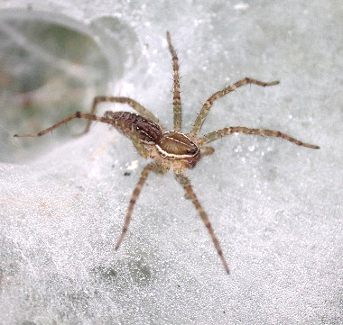
2 | Pholcus phalangioides | Pholcidae (Cellar spiders) | 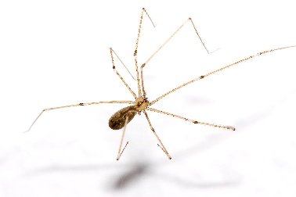
3 | Cyrtophora citriola | Araneidae (Orb-weavers) | 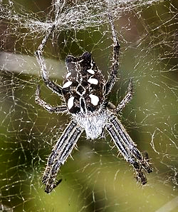
4 | Argiope aemula | Araneidae (Orb-weavers) | 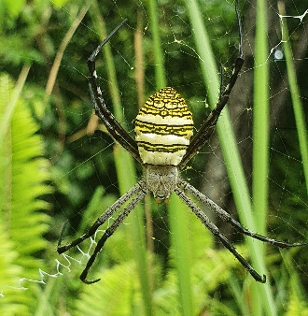
5 | Oxyopes salticus | Oxyopidae (Lynx spiders) | 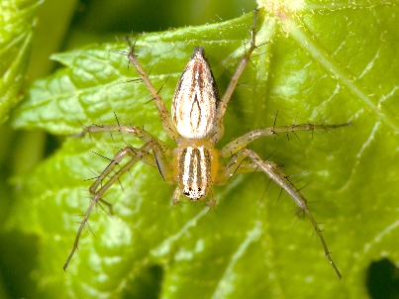
6 | Heteropoda venatoria | Sparassidae | 