Design of an IOT based smart microclimate monitoring and controlling system for naturally ventilated polyhouse cultivation

ABSTRACT
This research addresses the escalating global food demand by developing an automated, IoT-based microclimate monitoring and control system for sustainable greenhouse cultivation. Traditional agricultural practices often suffer from resource inefficiency and high manual labour intensity, which this study mitigates through a precision agriculture framework implemented within a 292 m² naturally ventilated polyhouse at Precision Farming Development Centre, Tavanur. The system architecture integrates a dual-core ESP32 microcontroller as the primary edge processor, utilizing a DHT22 sensor for high-precision temperature and humidity tracking and a BH1750 sensor for ambient light intensity. Data is synchronized via a 4G LTE gateway to the ThingSpeak IoT platform, providing real-time visualization and remote telemetry. Sensor validation demonstrated high fidelity, with R² values ranging from 0.965 to 0.985 and a rapid 2-second response time. Environmental results revealed a rhythmic diurnal oscillation where air temperature ascended from a nocturnal minimum of 21°C to a stabilized midday peak of 32.5°C. This thermal profile was inversely correlated with relative humidity, which reached a zenith of 85.5% before dropping to 79% under maximum solar gain. Light intensity served as the primary thermodynamic driver, peaking at 70,000 lux in September. The automated system effectively managed these fluctuations through closed-loop control of actuators, including exhaust fans, supplemental lighting, and solenoid valves for irrigation. This integrated approach provides a scalable, economically viable solution for optimizing greenhouse microclimates and enhancing the productivity of sensitive crops like cucumbers.
Key words: Internet of Things (IoT), Precision Agriculture, Greenhouse Microclimate Control, ESP32 Microcontroller & Automation
- INTRODUCTION
Agriculture has faced significant challenges over the years due to increasing population pressure, climate change, and limited natural resources. As the world population is projected to reach approximately 9.7 billion by 2050 (United Nations, 2019), the demand for food is expected to rise by nearly 70% (FAO, 2017). To meet this escalating food demand, agricultural practices must evolve to become more efficient and sustainable. According to the Food and Agriculture Organization (FAO), about one-third of food produced globally is wasted, yet nearly 690 million people faced hunger in 2019 (FAO, 2020). With the projected increase in global food demand, innovative agricultural technologies, including IoT, become vital for addressing these challenges. IoT technology can provide streamlined resource management, improve yields, and reduce waste, thus supporting food security in the face of population growth and increasing water scarcity.
Traditional agriculture, characterized by labour-intensive methods and minimal use of technology, often yields lower productivity and could lead to significant resource waste, particularly in water and fertilizers. Traditional agriculture relies heavily on manual labour, local knowledge, and practices passed down through generations. This type of farming typically involves the cultivation of crops using rudimentary tools and techniques, with little reliance on scientific principles or advanced technologies. Although it sustains millions globally, traditional methods often lead to inefficient water usage, inconsistent crop production, and vulnerability to pest infestations and climatic variations. In contrast, precision agriculture uses advanced technologies to monitor and manage field variability in crops to optimize yields. This method leverages GPS, sensors, data analytics, and automated systems to apply resources like water and fertilizers more effectively, thus enhancing productivity and sustainability. Precision agriculture aims to make farming more resource-efficient and environmentally friendly.
Greenhouses are specialized structures that allow for the modification of both the crop growing medium and the environmental conditions to meet the specific requirements of various crops. The successful cultivation of crops in greenhouses can be significantly enhanced through the adoption of new technologies in electronics, particularly automation systems for climate control, irrigation, and fertigation (Kumar et al., 2020). One of the challenges faced by farmers is the low income generated from their produce during the normal growing season, as prices tend to drop. Conversely, agricultural products often command higher prices during the offseason. The growth and yield of plants are influenced by several factors, including the quality of fertilizers, the genetic potential of seeds, pest and disease management, and the optimization of environmental parameters.
Key environmental factors such as temperature, relative humidity, carbon dioxide concentration, light intensity and wind velocity play a crucial role in determining crop yield. Adjustments to these parameters are essential for maximizing production. Each crop has a specific temperature range within which growth and yield are optimized. If temperatures deviate from this optimal range, the movement of minerals, water, and nutrients within the plant particularly in leaves, stems, and roots can be adversely affected, leading to a decline in photosynthesis and overall plant health (Garcia et al., 2023).
Managing the microclimate within a greenhouse has traditionally involved manual monitoring of temperature, humidity, and ventilation. This approach can be labour-intensive and error-prone, leading to suboptimal growing conditions. On the other hand, smart microclimate monitoring employs IoT sensors to continuously track environmental parameters and automatically regulate conditions to optimal levels. This leads to improved crop health and yield while minimizing labour costs and human error. The economic feasibility of implementing IoT technology in polyhouse cultivation is becoming increasingly attractive. Despite initial investment costs in IoT devices and infrastructure, the long-term savings achieved through reduced water and fertilizer consumption, labour costs, and enhanced crop yield justify the expenses. As the cucumber crop is sensitive to environmental conditions, the adoption of IoT-based automation systems could significantly enhance production efficiency while reducing operational risks. In conclusion, as agriculture moves toward a more technologically advanced future, integrating IoT-based systems holds great promise for enhancing productivity, sustainability, and economic viability in greenhouse cultivation (Liu et al. 2020; Bhujel et al., 2020). By exploring its potential impacts on cucumbers and evaluating its scalability in polyhouse systems, this research aims to contribute to the more efficient, sustainable, and economically viable approaches to modern agriculture.
Recent advancements in agricultural monitoring have emphasized the optimization of Wireless Sensor Network (WSN) architectures and data integrity. Sun et al. (2010) demonstrated the practical challenges of scaling these networks in tea plantations, noting that while an ARM-based gateway and CC2420-equipped nodes provided a functional drought monitoring system, Quality of Service (QoS) diminished as the network grew from 5 to 20 nodes, with increased transmission intervals leading to higher packet loss rates. Addressing the reliability of such data, Laktionov et al. (2021) developed an information model for IoT-based greenhouse monitoring that utilized error-rectification algorithms to significantly reduce measurement uncertainty from 0.6% to 0.01%. This focus on hardware flexibility was furthered by Laktionov et al. (2019), who utilized an Arduino Mega 2560 and Ethernet Shield W5100 architecture integrated with a remote ThingSpeak server to create a modular system adaptable to various growth stages. The choice of communication standard remains a pivotal factor in performance; as Erazo-Rodas et al. (2018) observed in Andean greenhouse trials, while mesh topologies like DigiMesh offer robust bit-rate maintenance despite crop height interference, Wi-Fi-based IEEE 802.11 standards often provide superior stability and precision for real-time applications. Collectively, these studies underscore that optimizing precision agriculture requires a strategic balance between node density, protocol selection, and algorithmic data refinement.
The adoption of an IoT-based smart microclimate monitoring and control system has the potential to transform greenhouse farming practices significantly. By offering real-time data and accurate management of environmental conditions, farmers can establish optimal growth environments for their crops, leading to increased yields and enhanced sustainability. Utilizing a network of interconnected sensors, data analytics, and actuation mechanisms, this system equips greenhouse operators with critical insights and precise control over their growing conditions. The incorporation of IoT technology in greenhouse farming is in line with the larger movements toward precision agriculture and sustainable food production. Consequently, this innovative strategy presents substantial opportunities to boost crop yields, promote sustainability, and reshape the future of greenhouse agriculture.
- MATERIALS AND METHODS
2.1 Details of the study area and weather and climate
The field experiment was conducted in a naturally ventilated polyhouse of 292 m2 area in the research plot of the Precision Framing Development Center, KCAET, Tavanur, Kerala. The average maximum temperature of the study area is 35ºC, and the average minimum temperature is 26ºC. Average RH and light intensity are 75% and 40,000 lx, respectively.
2.2 Details of hardware components used
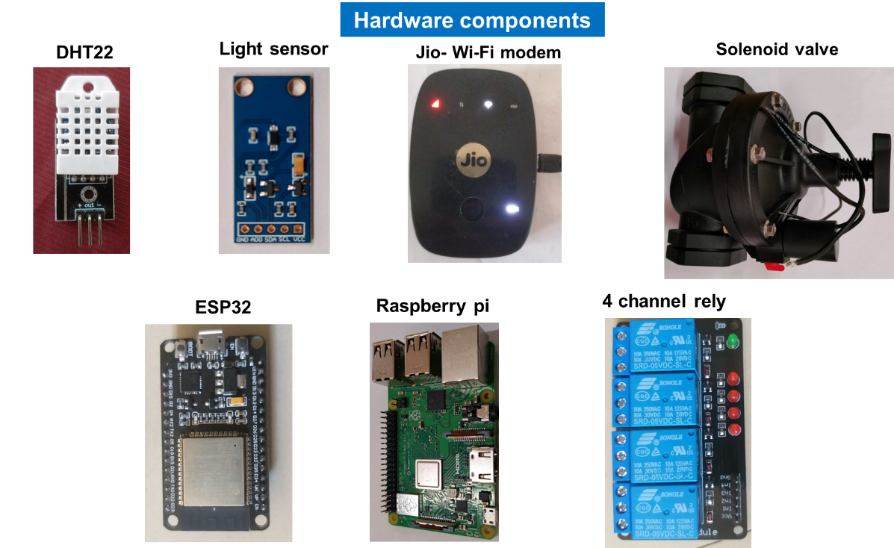
Fig.1. Details of hardware components used
2.2.1 DHT22 Temperature and Humidity Sensor
The DHT22 (AM2302) is a high-precision, digital sensor used for monitoring atmospheric conditions within the greenhouse. Unlike its predecessor (DHT11), it features a capacitive humidity sensor and a thermistor to provide a wider measurement range and higher accuracy. It operates within a temperature range of -40 ºC to +80 ºC (±0.5 ºC accuracy) and a relative humidity range of 0 to 100% (2-5% accuracy). The sensor utilizes a single-bus digital signal output, ensuring stable data transmission over relatively long distances, which is critical for large-scale polyhouse deployments.
2.2.2 BH1750 Ambient Light Sensor
To quantify the solar radiation available for crop photosynthesis, a BH1750 ambient light sensor is integrated. This is a digital Silicon Ratio Pressure (SRP) sensor that communicates via the I²C bus interface. It is capable of measuring wide-range light intensity from 1 to 65535 lx with high resolution. Its built-in 16-bi A/D converter eliminates the need for complex calculations on the microcontroller, providing direct digital output that is minimally affected by infrared radiation or the spectral characteristics of the light source.
2.2.3 JioFi M2S 4G Wireless Hotspot
The communication backbone of the system is the JioFi M2S portable 4G LTE hotspot. This gateway establishes a local Wi-Fi network (IEEE 802.11 b/g/n) to facilitate data exchange between the edge devices and the Blynk IoT cloud. It supports LTE bands 3, and 40, delivering peak download speeds of 15 Mbps and upload speeds of 50 Mbps. Equipped with a 2300 mAh rechargeable battery, it ensures continuous network availability for telemetry and remote control even during temporary power fluctuations in the field.
2.2.4 Solenoid Valve (Diaphragm Type)
Controlled irrigation is executed through an electromagnetic solenoid valve, typically rated for 12V or 24V DC operation. This actuator functions as an electrically controlled gate that manages the flow of water to the drip or fogging lines. When the microcontroller triggers the assigned relay, the solenoid's internal plunger lifts, allowing water to pass through the orifice. The valve is designed to operate under standard irrigation pressures, ensuring a leak-proof seal when de-energized to prevent water wastage.
2.2.5 ESP32 Microcontroller Unit (MCU)
The ESP32 serves as the primary "Edge" processor for sensor data acquisition and local logic execution. It is a powerful system-on-a-chip (SoC) featuring integrated Wi-Fi and dual-mode Bluetooth connectivity. It boasts a dual-core Xtensa® 32-bit LX6 microprocessor, operating at up to 240 MHz. Its extensive GPIO (General Purpose Input/Output) pins, supporting PWM, ADC, and I²C protocols, allow it to interface simultaneously with multiple sensors and relay modules while maintaining a low power consumption profile.
2.2.6 Raspberry Pi Single-Board Computer (SBC)
In this architecture, the Raspberry Pi acts as a high-level controller or local data logger. It features a Broadcom BCM2711 quad-core 64-bit ARM Cortex-A72 processor and multiple USB and HDMI ports. While the ESP32 handles real-time sensor tasks, the Raspberry Pi can run more complex computational tasks, host local databases, or serve as a secondary gateway. Its Linux-based operating system provides a robust environment for managing long-term data storage and advanced analytics for the greenhouse microclimate.
2.2.7 4-Channel Relay Module
To bridge the gap between low-voltage microcontrollers and high-voltage actuators (like solenoid valves and lights), a 4-channel relay module is utilized. Each channel features an opto-isolated electromagnetic relay capable of switching loads up to 10A at 250 V AC or 30V DC. The integrated LED indicators provide visual feedback on the state of each channel (Open/Closed), while the opto-couplers protect the sensitive GPIO pins of the ESP32 from back-EMF and electrical noise generated by the inductive loads of the solenoid valves.
2.3 Calibration of DHT22 Sensor and BH1750 light sensor
Our measurement process involved using a dry bulb and wet bulb hygrometer to assess temperature and relative humidity. We conducted simultaneous readings from both the hygrometer and a sensor to allow for direct comparison. For ambient temperature inside the polyhouse, we utilized the hygrometer's dry bulb temperature. To determine relative humidity, both dry bulb and wet bulb temperatures were recorded and the difference between the dry and wet bulb temperatures and then used psychrometric chart for the determining corresponding relative humidity value. All data points were systematically recorded in an Excel spreadsheet. We then created a scatter diagram, with the DHT22 sensor readings on the x-axis and the hygrometer's dry bulb and wet bulb readings on the y-axis. By adding a linear trendline to this diagram, we obtained a calibration equation, which was subsequently incorporated into the program.
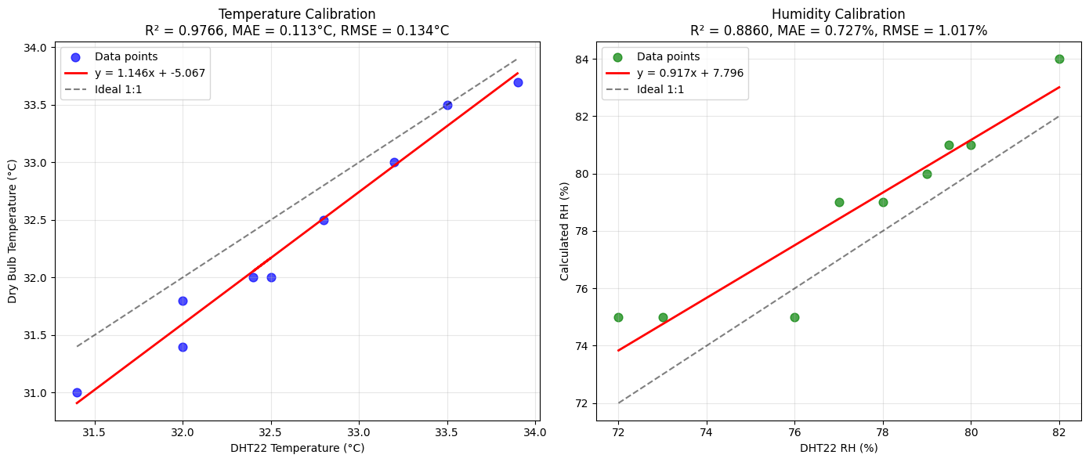
Fig. 2. Calibration graph of DHT22 Sensor and BH1750 light sensor
The procedure for calibration of BH1750 light sensor is same as that of calibration of DHT22 temperature & humidity sensor. The light intensity value obtained from the BH1750 light sensor was compared with the luxmeter reading. Scatter diagram was drawn with BH1750 light sensor reading in x-axis and luxmeter reading in y-axis. Then trendline was added, linear option was chosen and a calibration equation was obtained. The calibration results for the temperature and humidity sensor and the light sensor are illustrated in Fig. 2 and Fig. 3 respectively.
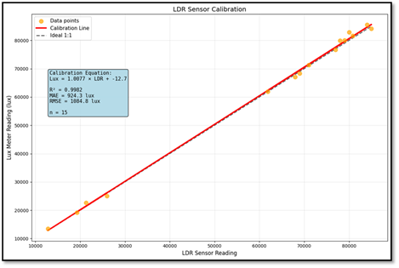
Fig. 3. calibration graph for LDR sensor
2.4 Hardware design
The hardware design centres on an ESP32 microcontroller, a versatile SoC integrated with dual-mode Wi-Fi and Bluetooth, serving as the core processing and communication hub for the sensor network is shown in Fig. 4. To facilitate reliable field deployment, the system is assembled on a perforated prototyping board featuring a series of screw terminal blocks for secure, modular sensor connections, including dedicated inputs for LDR and DHT11/22 sensors. The design incorporates bidirectional logic level converters to ensure voltage compatibility between the 3.3V ESP32 and potential 5V peripheral components, alongside a physical toggle switch to alternate between normal operation and programming modes. This architecture provides a robust interface for multi-channel data acquisition, utilizing labelled terminals for various environmental and functional sensors, which aligns with the modular requirements for scalable agricultural IoT applications.
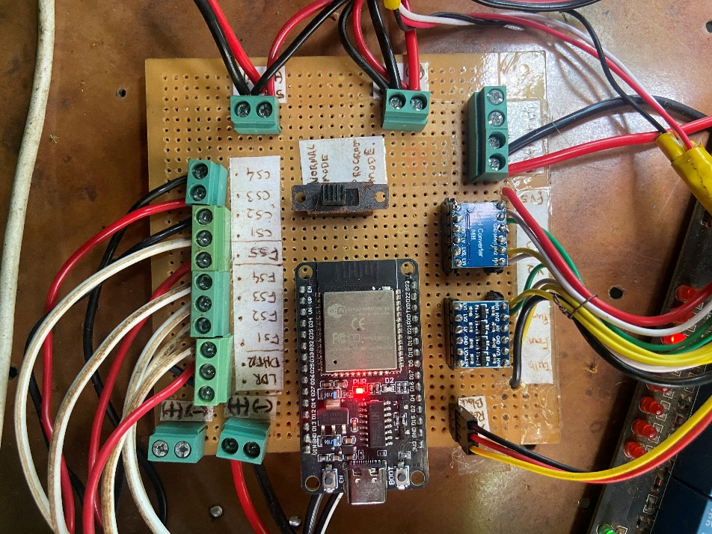
Fig. 4. Integrated IoT control node for automated greenhouse microclimate management.
  - Microclimate control
Microclimate control in a greenhouse is the active management of the local atmospheric conditions primarily temperature, humidity and light intensity to optimize plant growth, health, and crop yield. Unlike open-field agriculture, the enclosed structure of a greenhouse allows for precise, automated manipulation of these factors, creating an artificial, ideal environment. The goal is to maintain specific threshold for the plants being grown. This is achieved by monitoring the environment with sensors and adjusting microclimate using actuators.
2.5.1 Design of microclimate control system
The hardware architecture of the automated microclimate control system is designed for continuous monitoring of environmental parameters and the precise control of actuators to maintain optimal microclimatic conditions.
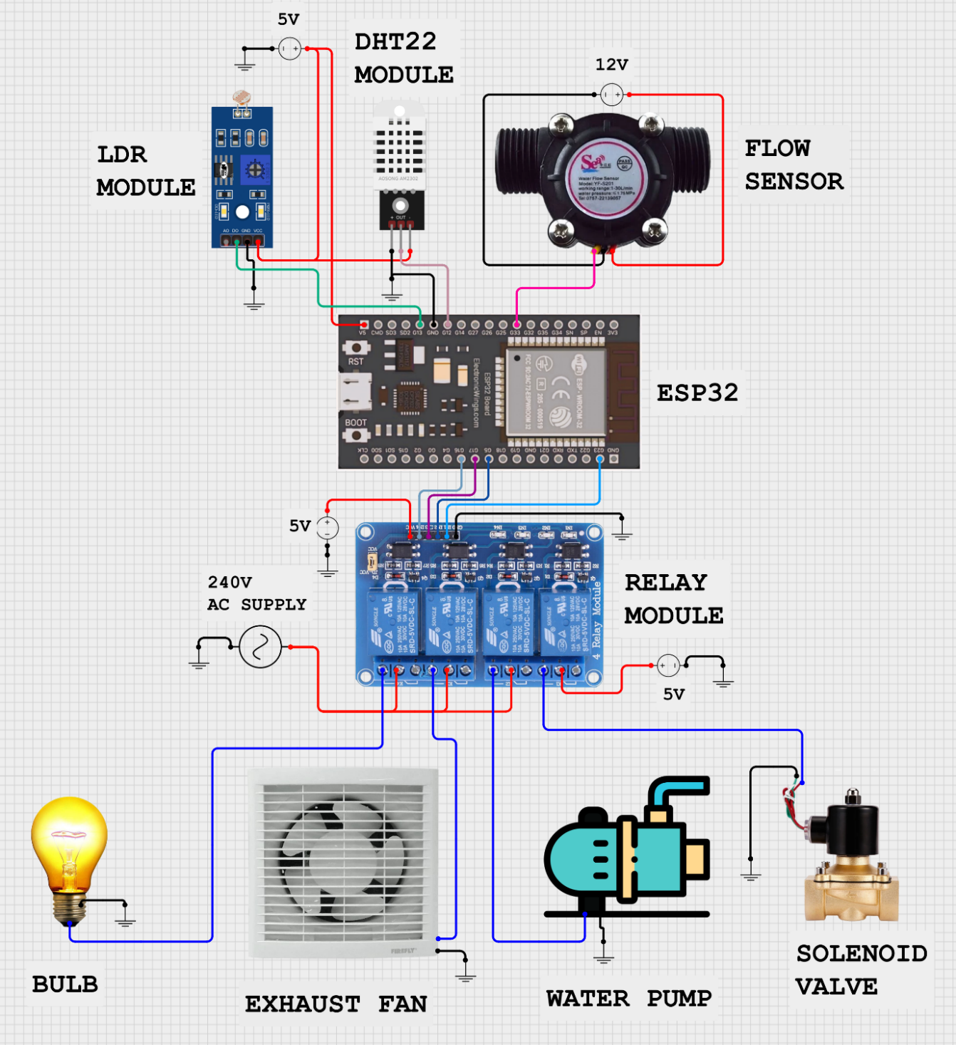
Fig. 5. Schematic diagram of IoT based smart microclimate monitoring and control system
    - System working principle
The microclimate control system operates based on continuous environmental monitoring and adaptive control logic. The LDR module continuously monitors light intensity, and the DHT22 module measures temperature and humidity within the greenhouse. These sensor readings are transmitted to the ESP32. The flow sensor provides data on the amount of water being moved, potentially for cooling mechanisms. The ESP32 processes sensor data against pre-defined optimal microclimate parameters. For example, if light levels fall below a threshold, the ESP32 decides to activate supplemental lighting. If temperature or humidity exceeds desired ranges, the ESP32 determines if the exhaust fan needs to be engaged. Similarly, it assesses water flow for cooling. Based on light conditions, the ESP32 sends a signal to the relay module to switch the "Bulb" ON or OFF. Based on temperature and humidity, the ESP32 activates or deactivates the "Exhaust Fan" via the relay module for ventilation. For water-related control (cooling), the ESP32 triggers the "water pump" and controls the "valve motor" via their respective relay channels to manage water flow as needed. This integrated system enables automatic regulation of key microclimatic parameters, ensuring a favorable environment for crop growth within the greenhouse.
- RESULT AND DISCUSSION
3.1 Sensor System Validation and Performance Metrics
The reliable operation of the automated IoT system hinges on the accuracy and precision of the integrated low-cost sensors, whose performance characteristics are summarized in Table 1 All critical sensors—the DHT22 (Temperature and Humidity), LDR (Light Intensity), demonstrated high fidelity, confirming the system's ability to collect trustworthy real-time data. Crucially, the Coefficient of Determination R² values for all sensors were exceptionally high, ranging from a minimum of 0.965 (LDR) to a maximum of 0.985 (DHT22 Humidity), indicating a near-perfect linear correlation between sensor output and standard reference measurements (Louki and Al-Omran, 2023; Kumar et al., 2014). Furthermore, the achieved Accuracy (RMSE) was minimal 0.36°C for DHT22 Temperature, while the Precision sigma of Error remained tightly controlled ±0.17°C, confirming the suitability of these low-cost components for rigorous scientific application (Gaikwad et al., 2020). The rapid Response Time 2s for climate sensors further validates the system's capability to provide the timely data necessary for the responsive, closed-loop control utilized in the automated treatments, proving that these affordable sensors do not compromise the integrity of the experimental control (Angitha et al., 2024).
Table 1. Performance metrics and statistical validation of low-cost IoT sensors integrated into the automated control system.
Parameter | DHT22 Temperature (°C) | DHT22 Relative Humidity (%) | LDR (Light Intensity)
Range (Measured) | -40 - +80 °C | 0 - 100% | ADC: 0-1025
Accuracy (RMSE) | 0.36°C | 2.38% | ±3
Precision (σ of Error) | ±0.17°C | 0.47 | 1.5
Sensitivity | 0.85 | 0.95 | 0.0063 ADC/Lux
(R²) | R2=0.977 | R2=0.985 | R2=0.965
Resolution | 0.1°C | 1 RH | 0.2Lux
Response Time | 2s | 2s | 2s
3.2 ThingSpeak dashboard
A real-time environmental monitoring dashboard hosted on the ThingSpeak IoT platform, featuring three distinct data visualizations for air temperature, relative humidity, and light intensity over a specific time interval is shown in Fig. 6. The Air Temperature chart (Field 5) displays a consistent upward trend, rising from approximately 25°C to nearly 39°C, which inversely correlates with the Relative Humidity (Field 6) that steadily declines from roughly 85% to 40% over the same period. Meanwhile, the Light Intensity graph (Field 3) shows a progressive increase in lux levels, peaking above 15.0k, though it exhibits significant momentary fluctuations or signal drops around 11:00. Collectively, these graphical representations demonstrate the platform's ability to aggregate and synchronize multi-sensor data, providing a comprehensive temporal analysis of environmental conditions suitable for automated climate tracking or agricultural research.
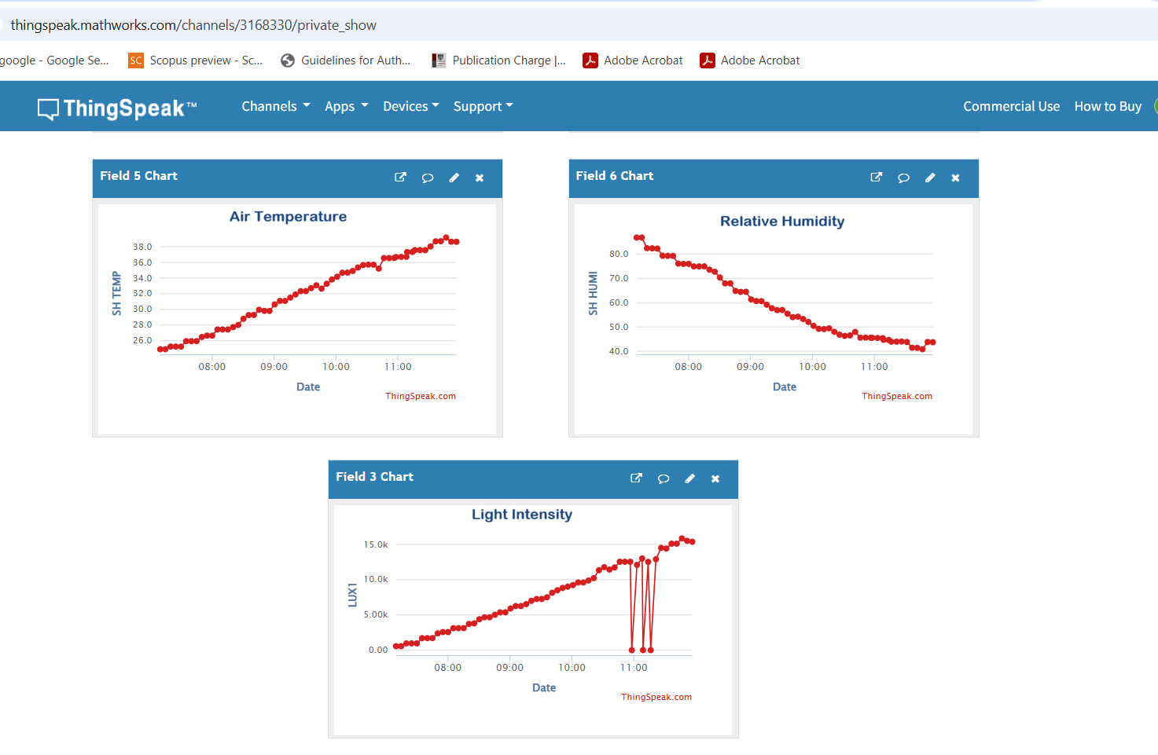
Fig. 6. Cloud-Based Data Acquisition Interface for Microclimate Monitoring
3.3 Monitoring of microclimate
The provided graphical analysis illustrates (Fig. 7) the diurnal variation of key microclimate parameters—temperature, relative humidity, and light intensity—recorded at two-hour intervals over a 24-hour cycle. The Temperature (°C) profile exhibits a characteristic bell-shaped curve, ascending from a minimum of approximately 20°C in the early morning to a sustained peak of roughly 32°C between 12:00 and 16:00, followed by a sharp decline as solar radiation diminishes. Conversely, the Humidity (%) levels demonstrate an inverse relationship with thermal trends, starting at a maximum of 85% and fluctuating downward to a midday low of approximately 79% before recovering in the evening hours. The Light Intensity (Lux) data quantifies the solar influence on these variables, showing a rapid increase after 06:00 to a zenith of nearly 68,000 Lux at noon, which serves as the primary driver for the observed shifts in the greenhouse atmospheric conditions. This synchronized dataset underscores the dynamic interplay between radiation and thermodynamic variables, which is critical for evaluating the performance of climate control and automated irrigation strategies in protected cultivation.
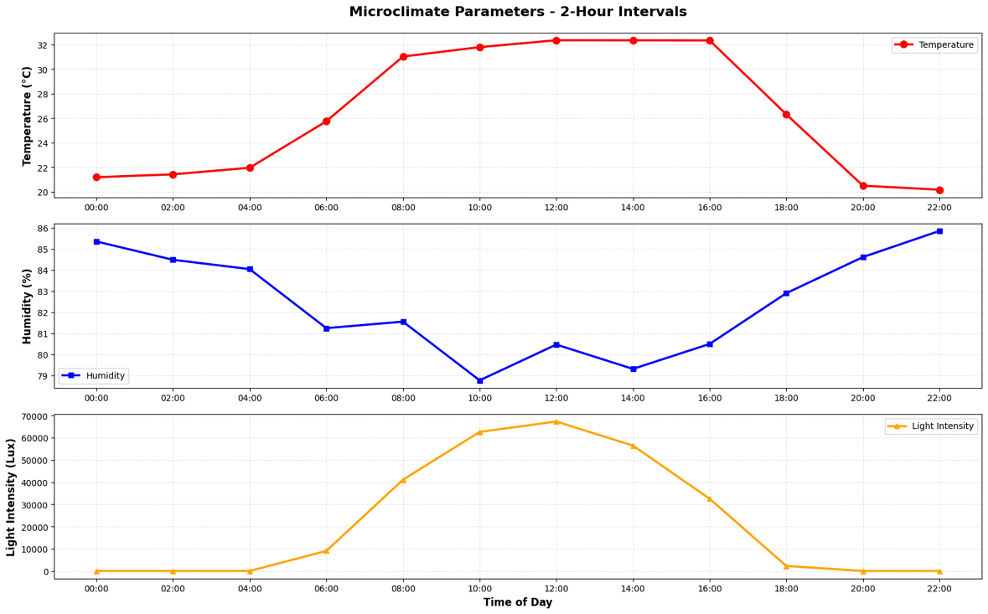
Fig. 7. Diurnal Fluctuations of Greenhouse Microclimate Parameters at Two-Hour Intervals in a day
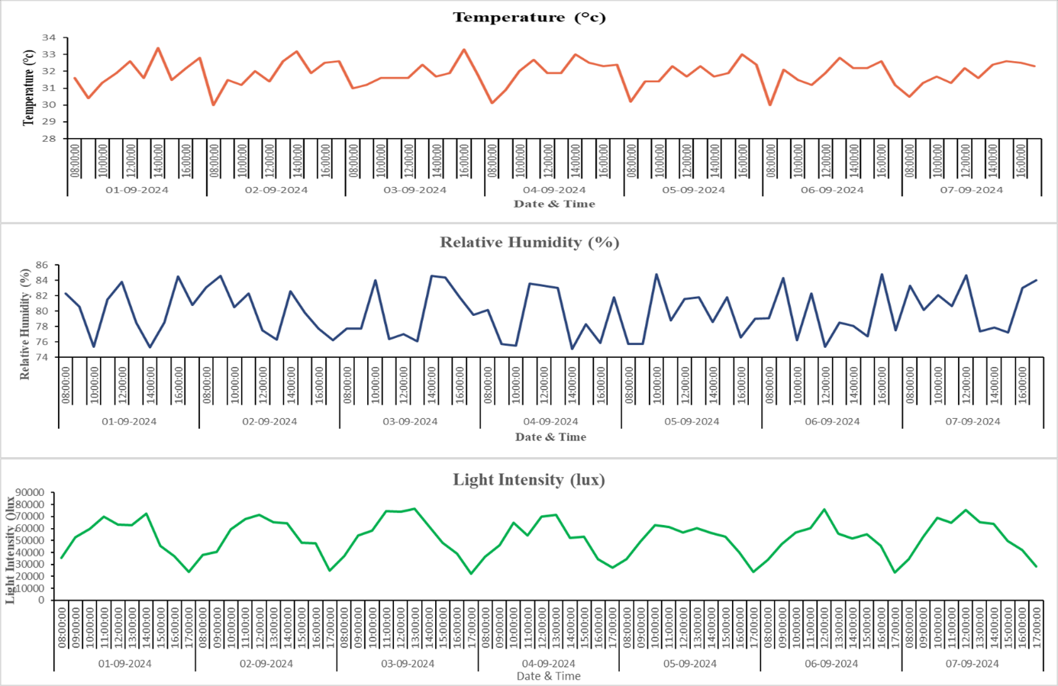
Fig. 8. Diurnal and Multi-Day Temporal Variations of Greenhouse Microclimate Parameters in a week

3.3.1 Air Temperature (°C)
The thermal profile within the protected structure exhibits a rhythmic diurnal oscillation, closely following the solar cycle. Based on the 24-hour analysis, the temperature remains relatively stable and at its minimum (approximately 20–22°C) during the nocturnal and pre-dawn hours before experiencing a rapid ascent following sunrise at 06:00. This warming trend culminates in a sustained plateau of approximately 32°C between 12:00 and 16:00, representing the period of maximum solar thermal gain. The multi-day longitudinal data further corroborates this pattern, revealing consistent daily peaks ranging between 30°C and 34°C from September 1st to September 7th (Fig. 8). These fluctuations highlight the significant influence of external solar radiation on the internal greenhouse environment, necessitating robust climate control strategies to prevent heat stress during peak afternoon hours (Manohar and Igathinathen, 2012).
3.3.2 Relative Humidity (%)
Relative humidity (RH) demonstrates a distinct inverse relationship with ambient temperature, characterized by high saturation levels during cooler periods and significant depletion during the day C. During the early morning hours, RH reaches its zenith at approximately 85–86%, likely due to the cooling of the air and reduced transpiration (Fig. 8). As the temperature rises, the humidity levels drop sharply, reaching a midday minimum of approximately 79% around 10:00 to 14:00. The seven-day observation period shows a highly dynamic environment, with RH frequently fluctuating between 75% and 85%. These variations are critical in a greenhouse context, as sustained high humidity can increase disease pressure, while the midday dips recorded in the data indicate the effective vapor pressure deficit changes that drive crop transpiration and nutrient uptake (Korade et al., 2020).
3.3.3 Light Intensity (Lux)
The light intensity data quantifies the primary driver of the greenhouse microclimate, showcasing a steep bell-shaped curve that defines the available photosynthetically active radiation. Starting from zero during the nocturnal phase, intensity increases exponentially after 06:00, reaching peak values exceeding 65,000 to 75,000 Lux between 11:00 and 13:00. The multi-day graph illustrates slight variations in daily peaks, potentially due to transient cloud cover or seasonal shifts, with maximum values consistently hitting the 60,000–80,000 Lux range (Fig. 8). This high-intensity solar input directly correlates with the observed temperature spikes and humidity drops, confirming that the greenhouse's thermodynamic state is heavily dependent on incident light. For the purposes of this research, these levels provide the necessary energy for crop growth while simultaneously defining the operational requirements for automated shading or cooling systems (Salokhe and Sharma, 2012).
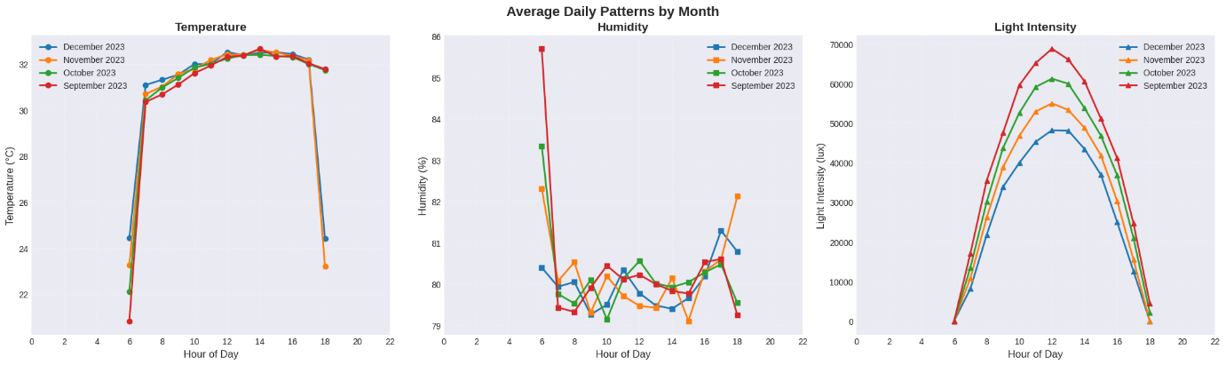
Fig. 9. Comparative Analysis of Diurnal and Monthly Microclimate Trends within the Greenhouse Environment
The integrated microclimate data illustrates fig. 9 the dynamic interplay between thermal, hygrometric, and radiative parameters over multiple temporal scales, from 24-hour diurnal cycles to seasonal monthly variations. Across all periods, the Air Temperature (°C) displays a consistent bell-shaped trajectory, with nocturnal minimums near 21°C ascending to a stabilized afternoon peak of approximately 32.5°C between 12:00 and 16:00. This thermal behaviour is inversely correlated with Relative Humidity (%), which frequently reaches its saturation zenith (above 85%) during pre-dawn hours before experiencing significant midday depressions to roughly 79% as solar gain increases. The Light Intensity (lux) serves as the primary forcing function for these fluctuations, with peak solar radiation values exceeding 70,000 lux during the high-sun hours of September, while December exhibits a notably lower peak around 48,000 lux, reflecting the expected seasonal reduction in available photosynthetically active radiation. Collectively, these results quantify a highly responsive protected environment where automated systems must manage a 10–12°C temperature delta and a 6–10% humidity variance to maintain optimal growth conditions throughout the production cycle.
CONCLUSION
The research successfully implemented an IoT-based smart monitoring and control system within a 292 m² naturally ventilated polyhouse at PFDC, Tavanur, to address the inefficiencies of traditional greenhouse management. The hardware architecture, centered on a dual-core ESP32 microcontroller and a Raspberry Pi, facilitated the seamless integration of DHT22 and BH1750 sensors for high-precision environmental tracking. Validation of these low-cost components yielded exceptional reliability, with R² values reaching up to 0.985 and an RMSE of only 0.36°C for temperature, confirming their suitability for scientific applications. Real-time data synchronization via a 4G LTE gateway to the ThingSpeak and Blynk platforms enabled continuous telemetry and cloud-based visualization of the microclimate.
Analysis of the environmental parameters revealed a strong thermodynamic correlation between incident radiation and atmospheric variables. Light intensity acted as the primary driver, peaking at 70,000 lux in September and dropping to 48,000 lux by December. This radiative forcing resulted in rhythmic diurnal temperature oscillations, ascending from nocturnal minimums of 21°C to midday peaks of 32.5°C, while relative humidity exhibited a consistent inverse relationship, fluctuating between 85.5% and 79%. The automated system effectively managed these shifts using closed-loop control logic to trigger exhaust fans, supplemental lighting, and solenoid valves for irrigation and cooling.
In conclusion, the integration of IoT technology significantly enhances greenhouse productivity by maintaining optimal growth conditions through precise, real-time interventions. This study demonstrates that low-cost, high-fidelity sensor networks can effectively replace error-prone manual monitoring, reducing labour costs and operational risks for sensitive crops like cucumbers. The system's scalability and modular design offer a viable pathway for small-to-medium-scale farmers to adopt precision agriculture, ultimately contributing to global food security and sustainable resource management.
Disclaimer (Artificial intelligence)

Author(s) hereby declare that NO generative AI technologies such as Large Language Models (ChatGPT, COPILOT, etc.) and text-to-image generators have been used during the writing or editing of this manuscript.

REFERENCES
- Angitha, A.K., Joseph, A. & Paul, J. (2024). An IoT-based real-time microclimate monitoring and controlling system for greenhouse. Environmental Engineering & Management Journal (EEMJ), 23(12).
- Bhujel, A., Basak, J.K., Khan, F., Arulmozhi, E., Jaihuni, M., Sihalath, T., Lee, D., Park, J. & Kim, H.T., (2020). Sensor systems for greenhouse microclimate monitoring and control: a review. Journal of Biosystems Engineering, 45(4), 341-361.
- FAO. 2017. The future of food and agriculture – Trends and challenges. Food and Agriculture Organization of the United Nations.
- FAO. 2020. The state of food security and nutrition in the world 2020. Food and Agriculture Organization of the United Nations.
- Gaikwad, A., Kulkarni, A., & Shinde, S. (2020). Development of low-cost IoT-based system for real-time monitoring of agricultural parameters. International Journal of Computer Applications, 174(42), 11-15.
- Garcia, P., Martinez, J., & Lopez, A. (2023). Temperature effects on photosynthesis and crop yield. Plant Physiology Journal, 45(1), 78-89.
- Korade, R. R., Patil, K. P., Bhadane, D. P., Chaudhari, R. C., & Dahiwale, P. K. (2020). IoT-based advanced greenhouse automation system. International Research Journal of Engineering and Technology, 7(3), 2095–2099.
- Kumar, A., Singh, R., & Patel, S. (2020). Advances in greenhouse technology: A review. Journal of Agricultural Science, 12(3), 45-58.
- Kumar, D. S., Reddy, S. P., & Swamy, B. S. (2014). Greenhouse environment monitoring system using digital signal processor. International Journal of Scientific and Research Publications, 4(1), 1-7.
- Laktionov I.S., Vovna O.V., Bashkov Y.O., Zori A.A. & Lebediev V.A. (2019). Improved computer-oriented method for processing of measurement information on greenhouse microclimate, International Journal Bioautomation, 23, 71-86.
- Laktionov I.S., Vovna O.V., Kabanets M.M., Sheina H.O., & Getman I.A. (2021). Information Model of the Computer-Integrated Technology for Wireless Monitoring of the State of Microclimate of Industrial Agricultural Greenhouses, Instrumentation, Mesures, Métrologies, 20, 289-300.
- Louki, K., & Al-Omran, A. M. (2023). Empirical correction equation for ECH2O-5TE sensor to improve soil moisture measurements under hot and saline conditions. Water, 15(3), 543.
- Manohar, S., & Igathinathen, B. (2012). Temperature management in greenhouse crops: A review. International Journal of Engineering Research and Applications, 2(5), 1432-1436.
- Salokhe, S. T., & Sharma, D. K. (2012). Microclimate and solar energy availability in different types of greenhouses. International Journal of Agricultural Engineering, 5(2), 246-253.
- Sun D., Jiang S., Wang W., & Tang J. (2010). WSN Design and Implementation in a Tea Plantation for Drought Monitoring, International Conference on Cyber- Enabled Distributed Computing and Knowledge Discovery, Huangshan, China.
- United Nations. 2019. World Population Prospects: The 2019 Revision. Department of Economic and Social Affairs, Population Division.

