CLINICAL AND RADIOGRAPHIC EVALUATION OF INTRAMEDULLARY INTERLOCKING NAILING AND POSITIVE PROFILE END-THREADED INTRAMEDULLARY PINNING IN CANINE DIAPHYSEAL FRACTURES

Abstract
The present study was undertaken to compare the clinical and radiographic outcomes of diaphyseal long bone fractures in dogs stabilized using positive profile end-threaded intramedullary (IM) pins and interlocking intramedullary nails (ILN). Twelve dogs presented with non–weight-bearing lameness due to diaphyseal fractures of the femur or tibia were randomly divided into two equal groups. Group I fractures were managed by open reduction and retrograde fixation with positive profile end-threaded IM pins, whereas Group II fractures were stabilized by open reduction and normograde application of interlocking intramedullary nails. Postoperative limb function was evaluated on days 7, 15, 30, and 60 using a standardized lameness scoring system, and fracture healing was assessed radiographically at corresponding intervals. Earlier toe-touching and initiation of weight-bearing were observed in Group II as early as the seventh postoperative day. Mean lameness scores were significantly lower (P < 0.05) in the ILN group compared to Group I at all postoperative intervals. By day 60, dogs in Group II showed complete functional recovery with no observable lameness, whereas mild residual stiffness persisted in a few animals of Group I. Radiographic evaluation revealed faster progression of fracture healing in Group II, with earlier periosteal proliferation and complete union characterized by absence of a radiolucent fracture line by day 60. Although Group I also achieved satisfactory union, comparatively greater periosteal callus formation and mild fragment compression were noted. No major complications such as implant failure or non-union were encountered. The findings indicate that interlocking intramedullary nailing provides superior stability and improved functional recovery compared to positive profile end-threaded IM pin fixation in canine diaphyseal fractures.
Keywords: Intramedullary Pinning, canine diaphyseal fractures, Postoperative limb function, Radiographic evaluation, Long bones
Introduction
Long bones are designed to withstand substantial physiologic loads during activities such as walking and running; however, when subjected to excessive compression, tension, shear, bending, or torsion, fractures occur in predictable patterns depending on the magnitude and direction of force (Karen and Spencer, 2012; Piermattei and DeCamp, 2006; Kumar and Gahlot, 2013). The primary objective of fracture management is to achieve stable fixation that allows early ambulation and complete functional recovery (Lidbetter and Glyde, 2000; Karen and Spencer, 2012).
Intramedullary (IM) pinning is commonly employed for long bone fractures in small animals. Nevertheless, unthreaded IM pins alone provide limited resistance to rotational and shearing forces (Kumar and Gahlot, 2013). Modifications such as stack pinning and plate–IM pin combinations have been introduced to improve axial and rotational stability (Lidbetter and Glyde, 2000; Hulse et al., 2000). Positive profile end-threaded pins enhance metaphyseal purchase while leaving a portion of the medullary cavity unoccupied, potentially preserving medullary circulation (Johnson et al., 2005). However, inadequate resistance to compressive forces and partial collapse of fracture fragments have been reported with these implants (Chanana et al., 2018).
Intramedullary interlocking nailing (ILN) offers distinct biomechanical advantages. By locking the nail to the cortices with screws or bolts, ILN improves resistance to torsional, compressive, and shear forces compared to conventional IM pins (Nieves, 2000). As a biological osteosynthesis technique, it minimizes disruption of blood supply at the fracture site and provides rigid, load-bearing fixation until sufficient callus formation occurs (Dueland et al., 1999; Kapler, 2015). Previous reports have indicated improved functional outcomes and smaller callus formation with ILN compared to positive profile end-threaded pins (Kumar et al., 2020).
Fracture stabilization techniques in small animal orthopedics continue to evolve with the aim of optimizing biomechanical strength while preserving biological viability at the fracture site. Successful fracture healing depends not only on mechanical stability but also on maintenance of the biological environment surrounding the fracture. Excessive instability may lead to delayed union or non-union, whereas overly rigid fixation can interfere with normal load sharing and bone remodeling. In canine patients, early restoration of limb function is essential to prevent muscle atrophy, joint stiffness, and complications associated with prolonged disuse. Therefore, comparative clinical evaluation of different fixation methods under practical conditions is essential to determine their relative effectiveness and long-term functional benefits.
Therefore, the present study was undertaken to compare the clinical and radiographic outcomes of diaphyseal long bone fractures in dogs stabilized using positive profile end-threaded intramedullary pins and interlocking intramedullary nails.
Materials and Methods:
Twelve client-owned dogs presented to the surgery ward with a history of non weight bearing lameness and diagnosed with diaphyseal fractures of the femur or tibia were included in the present study. The age of the animals ranged from 6 months to 8 years, and body weights varied between 14 and 37 kg. Both male and female dogs were represented. Fractures included simple transverse and short oblique diaphyseal configurations without severe comminution. A detailed preoperative clinical and radiographic evaluation was performed in all cases to determine the location and configuration of the fracture and to assess fragment alignment and displacement. Standard mediolateral and craniocaudal radiographic views were obtained. The animals were randomly allocated into two equal groups comprising six dogs each.
All dogs were premedicated 30 minutes prior to induction with intramuscular administration of butorphanol (0.2 mg/kg), acepromazine (0.05 mg/kg), and glycopyrrolate (0.01 mg/kg). General anesthesia was induced using intravenous propofol (4 mg/kg to effect) and maintained with isoflurane inhalation anesthesia.
In Group I, fractures were managed by open reduction and internal fixation using positive profile end-threaded intramedullary pins inserted in a retrograde manner. In Group II, fractures were stabilized by open reduction and fixation with an interlocking intramedullary nail inserted normogradely, following standard surgical approaches described by Piermattei (1993). Intraoperatively, fracture reduction was achieved using bone-holding forceps, and implant diameter was selected based on preoperative measurement of the medullary canal, ensuring approximately 60–70% canal occupancy for optimal stability. In Group II, interlocking screws were inserted using a targeting jig to achieve precise bicortical fixation. All surgeries were performed under strict aseptic conditions by the same surgical team to minimize procedural variability. Immediate postoperative radiographs were obtained to confirm satisfactory fracture reduction and implant placement.
Postoperatively, the operated limb was supported with a modified Robert-Jones bandage, which was replaced on alternate days along with routine wound dressing until suture removal. All animals received postoperative antibiotics, analgesics, and supportive therapy as part of standard postoperative care. Activity was restricted for the first two weeks, followed by controlled leash walking. Owners were instructed regarding home care and follow-up compliance.
Clinical evaluation of limb function was performed on postoperative days 7, 15, 30, and 60 using a lameness scoring system described by Cook et al. (1999):
0 – No observable lameness
1 – Intermittent, mild weight-bearing lameness with minimal or no gait alteration
2 – Consistent, mild weight-bearing lameness with slight gait change
3 – Moderate weight-bearing lameness characterized by an obvious gait abnormality and head bobbing
4 – Severe weight-bearing lameness with toe-touching only
5 – Non–weight-bearing lameness

Radiographic evaluation was also conducted at the same intervals to assess implant stability, progression of callus formation, fracture union, and potential complications. Fracture healing was graded on a 0–6 scale based on callus formation and disappearance of the fracture line as described by Hyashi et al. (2008):
0 – Recent fracture without evidence of bone formation
1 – Irregularity at the fracture fragment margins
2 – Initial or mild periosteal proliferation
3 – Exuberant or organized periosteal proliferation
4 – Developing osseous callus with periosteal proliferation
5 – Advanced osseous callus formation with a faint radiolucent fracture line
6 – Marked osseous callus formation with complete disappearance of the radiolucent fracture line

Both clinical and radiographic findings were recorded and compared between groups to evaluate fracture healing and functional recovery.

Results
The surgical approaches adopted in the present investigation provided adequate exposure of the fracture site, facilitating satisfactory reduction and alignment of fracture fragments in all animals. Implant placement was appropriate in both groups, as confirmed radiographically. The duration of surgery was slightly longer in Group II due to interlocking screw placement, although this difference was not clinically significant. Earlier toe-touching of the operated limb was observed in Group II compared to Group I, which may be attributed to the greater rigidity and rotational stability achieved with interlocking nail fixation.
- Clinical Evaluation of Limb Function
Functional recovery was significantly faster in Group II than in Group I. The mean lameness scores differed significantly (P < 0.05) between the groups at various postoperative intervals. Preoperatively, both groups exhibited comparable high lameness scores (4.83 ± 0.17), consistent with non–weight-bearing status. On the seventh postoperative day, Group II showed significantly (p<0.05) lower lameness scores (2.83 ± 0.17) compared to Group I (3.67 ± 0.21). By the fifteenth day, the difference remained significant (p<0.05), with Group II recording a mean score of 1.33 ± 0.21, whereas Group I showed 2.50 ± 0.43.
At 30 days postoperatively, Group II demonstrated significantly lower lameness scores (0.67 ± 0.21) compared to Group I (1.00 ± 0.37), indicating a faster return to near-normal gait. By the sixtieth day, Group II achieved complete functional recovery with a mean score of 0 (no observable lameness), while Group I animals showed minimal residual lameness in a few cases. Dogs in Group II exhibited improved confidence during ambulation and reduced compensatory weight shifting to the contralateral limb. Restoration of muscle mass around the affected limb was observed earlier in Group II, likely due to earlier weight-bearing and improved mechanical stability.
Table-1: Lameness scores (Mean±S.E):
 | Preoperative | Day 7 | Day 15 | Day 30 | Day 60
Group-I | 4.83±0.17^{C} | 3.67±0.21^{BC b} | 2.50±0.43^{B b} | 1.00±0.37^{A} | 0.17±1.17^{A}
Group-II | 4.83±0.17^{D} | 2.83±0.17^{C a} | 1.33±0.21^{B a} | 0.67±0.21^{AB} | 0^{A}

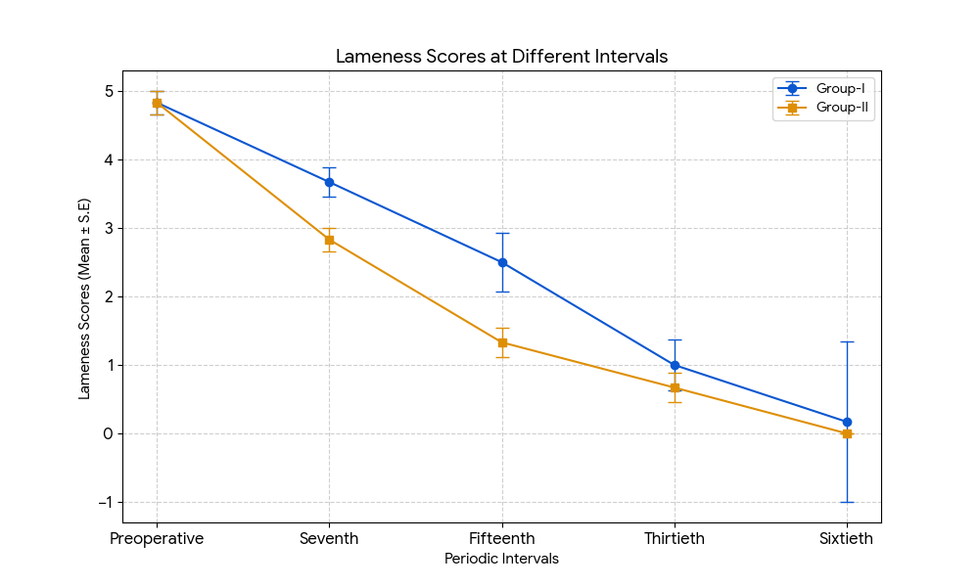
Fig-1: Graph showing lameness scores of both groups during different periodic intervals

- Radiographic Evaluation and Fracture Healing
Fracture healing was assessed using the scoring system described by Hayashi et al. (2008). The progression of bone union indicated comparatively superior stability and faster healing in Group II. Preoperatively, both groups had similar baseline healing scores (0.17 ± 0.17). Minimal bone formation was observed in both groups on the seventh postoperative day (0.33 ± 0.21). However, by the fifteenth day, Group II showed significantly (p<0.05) higher healing scores (2.50 ± 0.22) compared to Group I (1.67 ± 0.21), indicating earlier periosteal proliferation.
At 30 days, Group II reached a mean healing score of 5.33 ± 0.21, whereas Group I showed a score of 4.00 ± 0.37. By the sixtieth day, Group II achieved complete radiographic union with a score of 6.00 ± 0, characterized by abundant callus formation and absence of a radiolucent fracture line. Group I approached complete union (5.67 ± 0.21), although a faint radiolucent gap persisted in a few cases. Sequential radiographs revealed earlier cortical bridging in Group II, often involving at least three cortices by Day 30, whereas comparable bridging in Group I was observed closer to Day 60. Periosteal reaction was comparatively more pronounced in Group I, suggesting secondary bone healing associated with relatively increased interfragmentary motion. In contrast, Group II demonstrated more organized and compact callus formation, consistent with enhanced mechanical stability. Mild compression between fracture fragments was observed in Group I during the early postoperative period. No postoperative complications such as implant failure, non-union, implant migration, screw loosening, or seroma formation were recorded in either group during the study period.

Table-2: Fracture healing scores (Mean±S.E):
 | Preoperative | Day 7 | Day 15 | Day 30 | Day 60
Group-I | 0.17±0.17^{D} | 0.33±0.21^{D} | 1.67±0.21^{C a} | 4.0±0.37^{B a} | 5.67±0.21^{A}
Group-II | 0.17±0.17^{C} | 0.33±0.21^{C} | 2.50±0.22^{B b} | 5.33±0.21^{A b} | 6.00±0^{A}

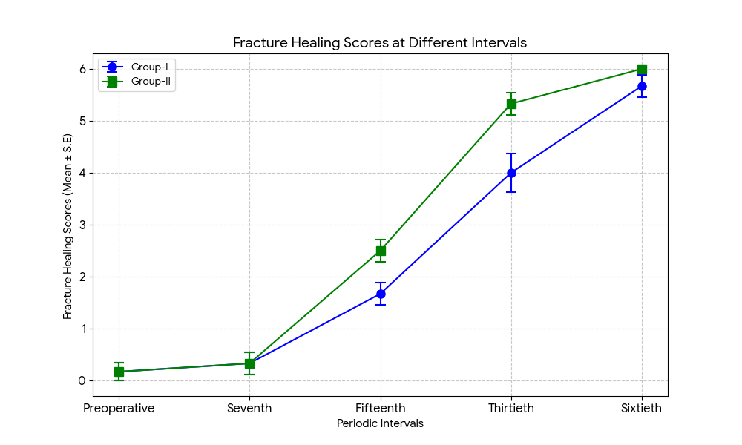
Fig-2: Graph showing fracture healing scores of both groups during different periodic intervals
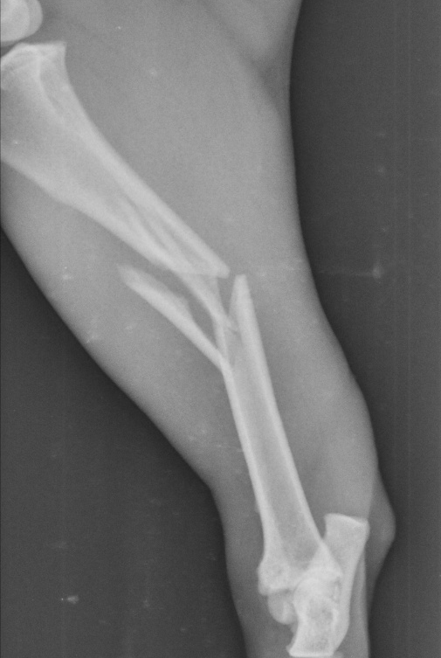 | 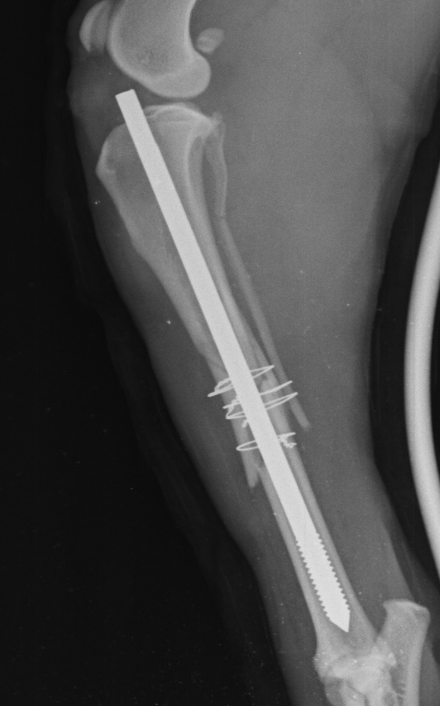 | 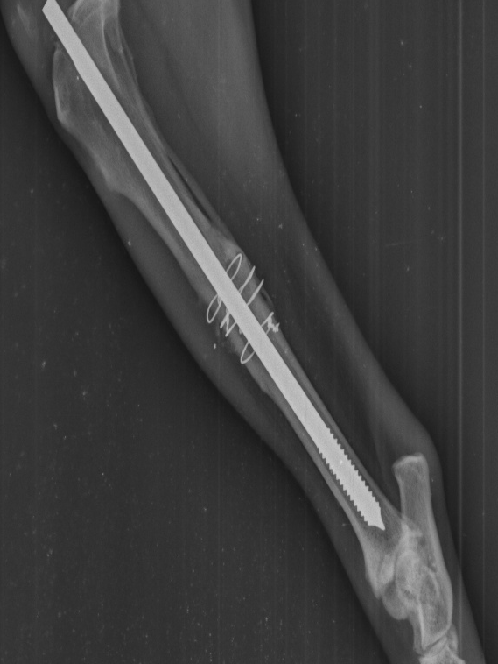
Fig-3: Pre and postoperative radiographs of case-2 of Group-I
A: Preoperative radiograph showing comminuted mid diaphyseal tibia fracture with mild displacement of fragments.
B: Immediate postoperative radiograph showing good reduction of fracture fragments.
C: Radiograph showing complete radiographic healing on 60th postoperative day.
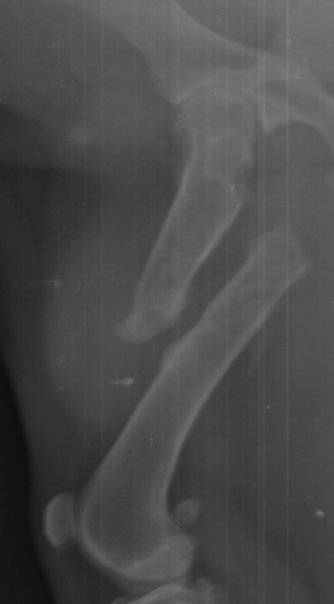 | 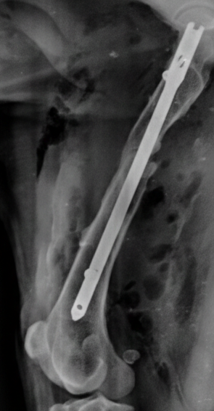 | 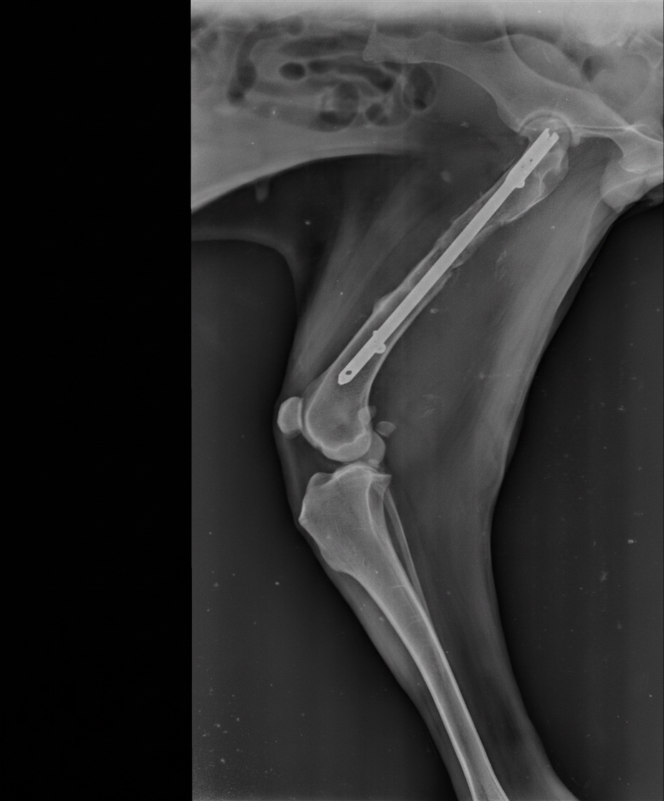
Fig-4: Pre and postoperative radiographs of case-4 of Group-II
A: Preoperative radiograph showing transverse mid diaphyseal femur fracture with displacement of fragments.
B: Immediate postoperative radiograph showing good reduction of fracture fragments.
C: Radiograph showing complete radiographic healing on 60th postoperative day.

Discussion
The present study demonstrated that both fixation techniques provided satisfactory fracture reduction and uneventful healing; however, interlocking intramedullary nailing (ILN) resulted in superior functional and radiographic outcomes compared to positive profile end-threaded intramedullary pins.
The earlier toe-touching and significantly lower lameness scores observed in the ILN group can be attributed to the enhanced mechanical stability of the construct. Unlike conventional IM pins, which primarily resist bending forces but offer limited control against torsion and axial compression (Kumar and Gahlot, 2013), ILN systems lock the proximal and distal cortices to the nail, thereby improving resistance to torsional, compressive, and shear stresses (Nieves, 2000). This rigid fixation enables the implant to function as a load-bearing device until adequate callus formation develops (Kapler, 2015), facilitating early weight-bearing and ambulation. The superior functional outcome observed in this study aligns with previous findings (Kumar et al., 2020). Furthermore, bicortical locking reduces interfragmentary motion and minimizes rotational instability, which are critical determinants of early limb use and pain reduction.
In contrast, mild compression and partial collapse of fracture fragments observed in the positive profile pin group during the early postoperative period may be explained by their relatively lower resistance to compressive forces, as previously reported (Chanana et al., 2018). Although positive profile end-threaded pins provide improved purchase in cancellous bone and reduce the risk of pin migration (Johnson et al., 2005), they may not sufficiently counteract rotational and axial forces in unstable diaphyseal fractures. The greater dependence on frictional stability within the medullary canal may permit subtle micromotion under physiologic loading conditions, thereby influencing early functional recovery.
Radiographically, the ILN group exhibited faster progression toward union with comparatively smaller periosteal callus formation. It is well established that the quantity of callus formed is inversely proportional to the stability at the fracture site (Piermattei and DeCamp, 2006; Nunamaker, 1985). The smaller callus observed in the ILN group indicates greater primary stability and a tendency toward direct or minimally exuberant secondary bone healing. Conversely, the comparatively larger periosteal callus in the positive profile pin group suggests relative micromotion at the fracture site, necessitating additional biological support. Earlier cortical bridging observed in the ILN group further supports the concept of improved biomechanical environment facilitating organized bone remodeling.
The absence of complications such as implant failure or non-union in both groups reflects appropriate case selection, surgical technique, and postoperative management. Nevertheless, the overall findings support the biomechanical advantages of ILN repairs described by Durall et al. (2004) and Dueland et al. (1999), particularly in providing stable fixation while preserving fracture site vascularity. Additionally, earlier restoration of limb function in the ILN group likely contributed to improved muscle mass maintenance and joint mobility, factors that are clinically relevant in enhancing overall patient recovery.
It is important to acknowledge that the present study was conducted on a limited number of clinical cases with a follow-up period of 60 days. Although the findings clearly indicate superior early functional and radiographic outcomes with ILN, larger-scale studies with extended follow-up periods would be valuable to further evaluate long-term implant performance, remodeling patterns, and potential late complications. Objective gait analysis and biomechanical testing could also provide quantitative support to the clinical observations recorded. Despite these limitations, the consistent trend toward earlier union and improved limb use in the ILN group suggests that interlocking intramedullary nailing offers a more stable and predictable method for managing diaphyseal long bone fractures in dogs when compared to positive profile end-threaded intramedullary pins.

Conclusion
In conclusion, although positive profile end-threaded intramedullary pins remain a practical and economical option for long bone fracture repair, interlocking intramedullary nailing offers superior mechanical stability, earlier return to limb function, reduced callus formation, and faster radiographic union. These findings suggest that ILN may be considered a more reliable fixation method for diaphyseal fractures of long bones in dogs, especially in cases where enhanced rotational and axial stability is required.

Ethical Approval
Animal Ethic committee approval has been collected and preserved by the author(s)

Disclaimer (Artificial intelligence)

Author(s) hereby declare that NO generative AI technologies such as Large Language Models (ChatGPT, COPILOT, etc.) and text-to-image generators have been used during the writing or editing of this manuscript.

References
Chanana, M., Kumar, A., Tyagi, S. P., Singla, A. K., Sharma, A., & Farooq, U. B. (2018). End-threaded intramedullary positive profile screw ended self-tapping pin (Admit pin): A cost-effective novel implant for fixing canine long bone fractures. Veterinary World, 11(2), 181–185. https://doi.org/10.14202/vetworld.2018.181-185
Cook, J. L., Tomlinson, J. L., & Reed, A. L. (1999). Fluoroscopically guided closed reduction and internal fixation of fractures of the lateral portion of the humeral condyle: Prospective clinical study of technique and results in ten dogs. Veterinary Surgery, 25, 386–389.
Dueland, R. T., Johnson, K. A., Roe, S. C., Engen, M. H., & Lesser, A. S. (1999). Interlocking nail treatment of diaphyseal long-bone fractures. Journal of the American Veterinary Medical Association, 214, 59–66.
Durall, I., Díaz-Bertrana, M. C., & Puchol, J. L. (2004). Radiographic findings related to interlocking nailing: Windshield–wiper effect and locking screw failure. Veterinary and Comparative Orthopaedics and Traumatology, 16, 217–222.
Hayashi, A. M., Matera, J. M., Sterman, F. A., Muramoto, C., & Cortopassi, S. R. G. (2008). Evaluation of electroacupuncture in bone healing of radius-ulna fracture in dogs. Brazilian Journal of Veterinary and Animal Science, 45, 339–347.
Hulse, D., Ferry, K., Fawcett, A., Gentry, D., Hyman, W., Geller, S., & Slater, M. (2000). Effect of intramedullary pin size on reducing bone plate strain. Veterinary and Comparative Orthopaedics and Traumatology, 13, 185–190.
Johnson, A. L., Houlton, J. E. F., & Vannini, R. (2005). AO principles of fracture management in the dog and cat. AO Publishing.
Kapler, M. (2015). A practitioner’s guide to fracture management. Part 3: Selection of internal fixation technique. Today’s Veterinary Practice, 5(6).
Karen, M. T., & Spencer, A. J. (2012). Veterinary surgery: Small animal. Saunders Elsevier.
Kumar, H., Tyagi, S. P., Kumar, A., Kumar, A., & Singh, S. (2020). Comparative evaluation of intramedullary interlocking nailing and end-threaded pinning (positive profile) for fixation of femoral fractures in dogs. Indian Journal of Animal Sciences, 90(2), 166–170.
Kumar, P., & Gahlot, T. K. (2013). Clinical evaluation of intramedullary pinning and interlocking nailing technique for stabilization of femoral fractures in dogs. Journal of Animal Science Advances, 3(6), 310–313.
Lidbetter, A. D., & Glyde, M. R. (2000). Supracondylar femoral fractures in adult animals. Compendium on Continuing Education for the Practicing Veterinarian, 22, 1041–1054.
Nieves, M. A. (2000). Fracture management using the interlocking nail. In Proceedings of the 30th Annual American College of Veterinary Surgeons Forum (pp. 186–188).
Nunamaker, D. M. (1985). Methods of internal fixation. In C. D. Newton & D. M. Nunamaker (Eds.), Textbook of small animal orthopaedics (pp. 261–286). JB Lippincott Company.
Piermattei, D. L. (1993). The hindlimb. In An atlas of surgical approaches to the bones of the dog and cat (3rd ed., pp. 310–312). W.B. Saunders.
Piermattei, D. L., Flo, G. L., & DeCamp, C. E. (2006). Brinker, Piermattei and Flo’s handbook of small animal orthopaedics and fracture repair (4th ed.). Saunders Elsevier.

