Original Research Article
Trend Analysis and ARIMA Forecasting of Area, Production, and Yield of Major Crops in Andhra Pradesh, India
Abstract
Agriculture plays a vital role in the economy of Andhra Pradesh, contributing significantly to food security, employment generation, and rural livelihoods, with diverse agro-climatic conditions supporting a wide range of crops. However, increasing climatic variability, market fluctuations, and structural changes in cropping patterns necessitate systematic time series analysis to understand production dynamics and generate reliable forecasts for informed agricultural planning. This study conducts a comprehensive time series (TS) analysis and forecasting of major crops in Andhra Pradesh, a key agricultural state in India. Focusing on the core crop groups of cereals, millets, pulses, and oilseeds, the research analyzes long-term historical data on area, production, and yield (1975-2023). The analysis covers cereals, millets, pulses, and oilseeds, which together account for most of the state’s cultivated area and food output. Polynomial regression models are employed to identify structural growth patterns, followed by ARIMA models to generate five-year production forecasts. Stationarity testing and model diagnostics were conducted to ensure robust model specification, and forecast accuracy was evaluated using standard error measures. The results reveal significant heterogeneity in the growth patterns and predictability across crop groups. The results reveal significant heterogeneity in growth dynamics and predictability across crop groups. Rice exhibits a strong non-linear upward trend in production (R² = 0.963), driven largely by sustained yield improvements (R² = 0.972), and demonstrates high forecasting accuracy (MAPE = 6.28%), indicating a stable and predictable production system. Millets display pronounced non-linear fluctuations in cultivated area (R² ≈ 0.97), yet ragi production shows relatively strong forecast reliability (MAPE = 11.16%), despite their predominantly rainfed nature. In contrast, pulses and oilseeds exhibit persistent non-stationarity and higher forecast errors (MAPE ranging from 14–20%), reflecting greater sensitivity to climatic variability and market shocks. The study concludes that agricultural planning in Andhra Pradesh requires crop-specific, evidence-based strategies. The findings advocate for continued investment in productivity-enhancing technologies for stable cereals, targeted support for climate-resilient practices in millets, and robust policy interventions, including improved irrigation, varietal adoption, and market support to mitigate volatility in pulses and oilseeds. The forecasts (2024–2028) provide practical guidance for production planning, procurement decisions, price stabilization, and climate-resilient agricultural policy in the state. The findings emphasize the need for crop-specific, evidence-based interventions, including productivity-enhancing technologies for cereals, climate adaptation support for millets, and improved irrigation, varietal innovation, and market mechanisms for pulses and oilseeds. By combining structural trend analysis with ARIMA forecasting, the study offers an empirically grounded framework for regional crop predictability and strengthens the agricultural forecasting literature.
Keywords: Augmented Dickey–Fuller (ADF) Test, Coefficient of determination, Regression, Stationarity, Trend Analysis.
- INTRODUCTION
Agriculture remains a cornerstone of the Indian economy, ensuring food security, generating employment, and sustaining rural livelihoods. Within this broader context, Andhra Pradesh (AP) occupies a strategically important position due to its diverse agro-climatic zones, expanding irrigation infrastructure, and increasing emphasis on crop diversification. Over the years, the state has experienced substantial changes in cropping patterns, productivity, and market integration, making the analysis of temporal dynamics in agricultural production essential for informed policy formulation, efficient resource allocation, and long-term sustainability.
Cereals, millets, pulses, and oilseeds form the foundation of agricultural production and rural livelihoods in AP. Rice dominate the cropped area and contribute significantly to state and national food grain supplies, while millets such as ragi and bajra, well adapted to semi-arid environments, have gained renewed attention for their climate resilience and nutritional importance. Pulses including bengal gram, greengram, and black gram play a crucial role in ensuring protein security and improving soil fertility through biological nitrogen fixation, whereas oilseeds such as groundnut, castor, and niger support edible oil production, agro-industrial activities, and export earnings. Despite their economic and nutritional significance, the performance of these crops exhibits considerable inter-annual variability driven by rainfall fluctuations, temperature extremes, irrigation access, technological adoption, market conditions, and policy interventions (Bhuyan et al., 2025; Chitikela et al., 2025).
Earlier empirical studies on agricultural production (AP) have documented significant trends and instability. Analyses of paddy cultivation show varying growth and instability in area, production, and yield, influenced by both climatic and agronomic factors (Kumar et al., 2021). Long-term studies of rice production suggest that productivity gains have partially offset area fluctuations, yet instability remains a persistent feature of agricultural output in the state (Sunandini et al., 2020). Time series (TS) forecasting studies have highlighted the effectiveness of statistical models like ARIMA in predicting future trends of key crops, such as groundnut (Ginka et al., 2020). More recent research has employed machine-learning-based time series methods to capture nonlinear dynamics and improve forecasting accuracy for pulse crops, including black gram (Gowri et al., 2025; Srinivas et al., 2025). Forecasts for 2024–2032 indicate continued growth in rice production, emphasizing the need for strategic interventions, including adoption of high-yielding seed varieties, modern cultivation practices and better agricultural infrastructure (Sandeep et al., 2025). The ARIMA (1,0,0) model has been applied to forecast chickpea production in the Bundelkhand region of Uttar Pradesh and Madhya Pradesh (Mayura et al., 2025). Another study analyzed and forecasted finger millet cultivation in Chhattisgarh, India, using historical data from 2001 to 2023. Time series methods, including path analysis and Box-Jenkins ARIMA models, were applied to area, production, and yield. Among 20 models tested, ARIMA (0,1,2), (3,1,1) and (2,0,4) were selected as the best based on accuracy measures and used to forecast finger millet area, production, and yield in Chhattisgarh for 2024–2030 (Chandra et al., 2024). A good account on time series analyis, modeling and forecasting can be found in, to cite few, Box et al. (2015), Hyndman and Athanasopoulos (2021). Chandra and Sahu (2024) have applied Box and Jenkins methodology of ARIMA model fitting to fingermillet crop statistics.
Agricultural TS data on area, production, and yield are inherently complex, often characterized by trends, cycles, structural breaks, and random shocks. Descriptive analysis alone is therefore inadequate to fully capture these dynamics or to generate reliable forecasts. Robust TS modeling and forecasting techniques provide a systematic framework for understanding historical behaviour and anticipating future outcomes, which is critical for agricultural planning, procurement and storage decisions, market stabilization, and risk management in the face of growing climate and market uncertainties.Among TS approaches, the ARIMA model is widely applied for univariate forecasting. The modeling process includes testing for stationarity, identifying model orders through autocorrelation (ACF) and partial autocorrelation (PACF) functions, estimating parameters, and validating residuals. ARIMA models are valued for their simplicity, flexibility, and effectiveness across domains such as finance, energy, and agriculture (Rizvi, 2024).
ARIMA models are particularly effective in capturing linear trends and short-term dynamics in non-seasonal time series, providing robust baseline forecasts when historical data are sufficient (Sharma et al., 2023). Stationarity testing, using methods such as the Augmented Dickey–Fuller (ADF) test, and careful model diagnostics are essential to ensure forecast accuracy. While ARIMA may be less suited for strongly seasonal data, seasonal ARIMA or exponential smoothing methods may perform better, it remains a reliable and interpretable tool for crop-specific forecasting (Gao, 2025).
Despite its relevance, crop-wise TS forecasting in AP remains limited, especially beyond rice. Existing studies often focus on national-level aggregates or short-term trends, neglecting state-specific variability and the heterogeneous behaviour of different crop categories. With AP’s growing agricultural importance, there is a clear need for comprehensive, crop-group-based analyses that capture long-term trends, variability, and future projections.
This study addresses this gap by conducting detailed TS modeling and forecasting of major crops in AP, including cereal (rice), millets (ragi, bajra), pulses (bengal gram, greengram, black gram), and oilseeds (groundnut, castor, niger). Historical data on area, production, and yield are analyzed to identify, estimate, and validate appropriate ARIMA models for each crop. Short- to medium-term forecasts are generated to assess expected production trajectories, variability, and potential risks. The outcomes are intended to provide actionable insights for policymakers, planners, and researchers, supporting crop-specific strategies for food security, diversification, and sustainable agricultural development in AP.
- METHODOLOGY
For this study, annual time series data on the production of bajra, Bengal gram, black gram, castor, green gram, groundnut, niger, ragi, wheat, and rice in India were obtained from the IndiaStat database for the period 1975–2023.
2.1 Time Series Modeling
Time series models describe the behaviour of a variable over time, capturing trends, cycles, and stochastic variations. In this study, parametric models were initially fitted, including:
    - Linear Trend Model
$$Y_{t}=α_{0}+α_{1}t$$
$where, Y_{t}$: Value of the dependent variable at time $t$; $t$: Time index (day, year, month, period); $α_{0}$: Intercept (value of $Y$when $t=0$); $α_{1}$: Linear trend coefficient (average change in $Y$ for a one-unit change in time)
    - Quadratic Trend Model
$$Y_{t}=β_{0}+β_{1}t+β_{2}t^{2}$$
where, $β_{0}$: Intercept term; $β_{1}$; Linear component of the trend; $β_{2}$: Curvature coefficient (determines acceleration or deceleration of growth); $t^{2}$: Squared time variable capturing non-linear behaviour
If $β_{2}>0$, the curve is upward bending; if $β_{2}<0$, it bends downward.
    - Cubic Trend Model
$$Y_{t}=γ_{0}+γ_{1}t+γ_{2}t^{2}+γ_{3}t^{3}$$where, $γ_{0}$: Intercept; $γ_{1}$: Linear trend component; $γ_{2}$: Quadratic curvature component; $γ_{3}$: Cubic coefficient (captures complex turning points or inflection changes); $t^{3}$: Allows the model to capture multiple changes in direction over time.
    - Exponential Model
$$Y_{t}=δ_{0}e^{δ_{1}t}$$
Taking natural logarithms:
$$ln⁡(Y_{t})=ln⁡(δ_{0})+δ_{1}t$$
where, $δ_{0}$: Initial level (value of $Y$when $t=0$); $δ_{1}$: Constant growth rate; $e$: Base of natural logarithm (~2.718); $ln⁡(Y_{t})$: Natural logarithm transformation that linearizes the model.
If $δ_{1}>0$, exponential growth occurs; if $δ_{1}<0$, exponential decay occurs.
    - Logarithmic Model
$$Y_{t}=θ_{0}+θ_{1}ln⁡(t)$$where, $θ_{0}$: Intercept term; $θ_{1}$: Elasticity-type coefficient (change in $Y$for a percentage change in time); $ln⁡(t)$: Natural logarithm of time.
This model shows rapid change initially that slows over time.
    - Growth (Log-Linear) Model
$$ln⁡(Y_{t})=λ_{0}+λ_{1}t$$
where, $λ_{0}$: Log of initial value; $λ_{1}$: Continuous growth rate; $Y_{t}=e^{λ_{0}+λ_{1}t}$: Exponential form of the model.
Model selection was based on maximum R², minimum standard error, and significance of coefficients, with preference for models having fewer parameters in case of ties. Observed and fitted values were also compared graphically.
2.2 ARIMA($p,d,q$) Model
The Auto-Regressive Integrated Moving Average (ARIMA) model of order $(p,d,q)$is expressed as
$$ϕ(B)(1-B)^{d}Y_{t}=θ(B)ε_{t},$$where $Y_{t}$denotes the observed value of the time series at time $t$, $ε_{t}$ is a white noise error term with zero mean, constant variance, and no serial correlation, and $B$ represents the backshift operator such that $BY_{t}=Y_{t-1}$. The parameter $d$indicates the order of differencing required to render the series stationary. The terms $ϕ\left(B\right)$and $θ\left(B\right)$denote the autoregressive and moving average polynomials of orders $p$and $q$ respectively.
The autoregressive component of the model is defined as
$$ϕ(B)=1-ϕ_{1}B-ϕ_{2}B^{2}-⋯-ϕ_{p}B^{p},$$where $ϕ_{i}$($i=1,2,…,p$) are the autoregressive coefficients. These coefficients capture the influence of past values of the series on its current value, thereby reflecting the persistence or memory inherent in the time series.
The moving average component is given by
$$θ\left(B\right)=1-θ_{1}B-θ_{2}B^{2}-⋯-θ_{q}B^{q},$$where $θ_{i}$($i=1,2,…,q$) are the moving average coefficients. These coefficients represent the effect of past error terms or shocks on the current value of the series, thereby capturing the impact of unanticipated innovations.
2.3 Augmented Dickey–Fuller (ADF) Stationarity Test
The ADF test is based on the following regression equation:
$$ΔY_{t}=α+βt+δY_{t-1}+\sum_{i=1}^{k}{λ_{i}}ΔY_{t-i}+e_{t},$$
where $ΔY_{t}=Y_{t}-Y_{t-1}$denotes the first difference of the series, $α$is the intercept term, $βt$represents a deterministic time trend, $δ$ is the coefficient associated with the lagged level of the series, $λ_{i}$are coefficients of lagged differenced terms included to eliminate serial correlation, and $e_{t}$is a white noise error term.
Hypotheses for the ADF test:
- $H_{0}:δ=0$; the series contains a unit root and is non-stationary
- $H_{1}:δ<0$; the series is stationary
2.4 Model Diagnostics and Selection
Residual analysis included visual inspection and the Ljung–Box test (Granville, 2016):
$$Q=n(n+2)\sum_{k=1}^{m}{\frac{{\hat{r}}_{k}^{2}}{n-k}}$$
where, $Q$: Ljung–Box test statistic; $n$: Number of observations; $m$: Number of lags tested; ${\hat{r}}_{k}$: Sample autocorrelation of residuals at lag $k$.
Model performance was evaluated using:
- Root Mean Square Error (RMSE): $RMSE=\sqrt{\frac{1}{n}\sum_{i=1}^{n}{(}Y_{i}-{\hat{Y}}_{i})^{2}}$
- Mean Absolute Error (MAE): $MAE=\frac{1}{n}\sum_{i=1}^{n}{∣}Y_{i}-{\hat{Y}}_{i}∣$
- Mean Absolute Percentage Error (MAPE): $MAPE=\frac{100}{n}\sum_{i=1}^{n}{\left|\frac{Y_{i}-{\hat{Y}}_{i}}{Y_{i}}\right|}$
- Coefficient of Determination (R²): $R^{2}=\frac{\sum_{i=1}^{n}{(}{\hat{Y}}_{i}-\overset{ˉ}{Y})^{2}}{\sum_{i=1}^{n}{(}Y_{i}-\overset{ˉ}{Y})^{2}}$
where, $Y_{i}$: Actual observed value; ${\hat{Y}}_{i}$: Model predicted value
The validated ARIMA models were used to generate forecasts for crop production, providing insights into future trends and variability.
- RESULTS AND DISCUSSION
3.1 Time series modelling and forecasting of Rice
The temporal dynamics of rice was analyzed using regression and TS techniques to capture both long-term structural trends and short-term stochastic variations.
3.1.1 Trend Analysis
The cultivated area under rice exhibited a distinct non-linear pattern over time. Rice area followed a cubic trend, with the model explaining 80.7 per cent of the variation as indicated in Fig. 1 (R² = 0.807) and exhibiting strong statistical significance. All polynomial terms were significant, indicating multiple phases of expansion and contraction. These fluctuations likely reflect shifts in cropping patterns, changes in irrigation access, and evolving market and policy incentives influencing farmers’ land allocation decisions.
Rice production demonstrated a strong non-linear growth trend, driven by both area dynamics and yield improvements. The cubic production model achieved an R² of 0.963, capturing 96.3 per cent of the total variability in rice production. The growth in rice production appears to have been driven by a combination of cultivated area expansion and substantial yield gains over the study period.
Rice yield trends further highlight the evolving productivity dynamics of the crop. Yield followed a pronounced cubic trend with an R² of 0.972, suggesting that productivity improvements have been substantial but non-linear. This pattern reflects phases of rapid technological adoption, such as improved varieties, better input use, and enhanced management practices followed by periods of stabilization. The linear and quadratic terms were statistically significant, while the cubic term was marginally significant, indicating diminishing marginal gains in yield growth in later periods.
3.1.2 Time Series Modeling and Forecasting
Prior to ARIMA modeling, the stationarity of the rice production series was examined using the Augmented Dickey–Fuller (ADF) test. Rice production was found to be non-stationary at level, necessitating first differencing. This non-stationarity reflects long-term structural changes in rice production, including technological progress, expansion of irrigation infrastructure, and sustained policy support, which together have contributed to persistent upward trends in production.
Among the candidate models examined, ARIMA (0,1,1) was identified as the most appropriate specification for rice production.
The ARIMA (0,1,1) model for rice can be expressed as $ΔY_{t}=1829.93+ε_{t}-0.6641 ε_{t-1}$
As discussed in Table 1, the ARIMA (0,1,1) model was fitted to the rice production series to evaluate forecasting performance. Model performance was assessed using RMSE, MAE, and MAPE. The model yielded an RMSE of 5512.16 and an MAE of 4507.62, indicating moderate absolute forecast errors. The MAPE value of 6.28 per cent suggests that, on average, the forecasted rice production deviates from the observed values by about 6.28 per cent. This relatively low percentage error reflects reasonably good forecasting accuracy and confirms the suitability of the ARIMA (0,1,1) model for rice production forecasting under a stable production environment. The forecast for the next five years for the rice production is given in the fig.1.
Table 1: ARIMA model performance of Rice
Crop | Model | RMSE | MAE | MAPE (%)
Rice | (0,1,1) | 5512.16 | 4507.62 | 6.28

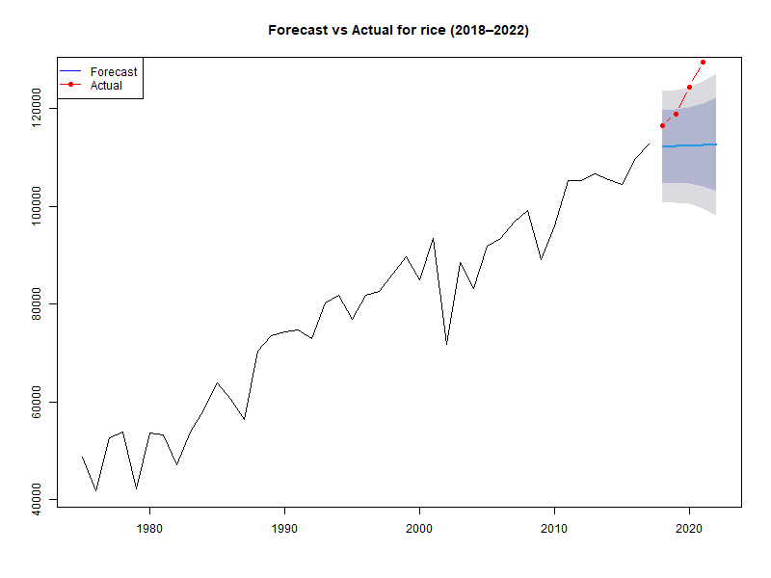
Fig. 1: Actual vs forecasted value of Rice
3.2 Time series modelling and forecasting of Millets production
Millets, represented by ragi (finger millet) and bajra (pearl millet), were analyzed to understand long-term changes in cultivated area, production, and yield using polynomial regression models, complemented by TS techniques to assess production stability and forecasting performance. These crops are predominantly grown in rainfed and marginal environments, making their production dynamics sensitive to climatic variability, market demand, and policy support.
3.2.1 Trend Analysis
The cultivated area under millets exhibited pronounced non-linear dynamics. Both ragi and bajra areas followed cubic trends, with very high explanatory power indicating that nearly 97 per cent of the variation in area was explained by the fitted models as given in the fig.2. The area models found significant with linear and cubic terms statistically significant (p < 0.001), while the quadratic terms were not significant. These results suggest strong non-linear fluctuations in millet area, characterized by alternating phases of expansion and contraction, likely driven by changes in cropping patterns, relative price movements, and competition from major cereals.
Both the millets (Bajra and ragi) production followed cubic trends, although with substantially lower explanatory power. For both ragi and bajra, the production models explained 78.0 and 55.7 per cent of the variation as indicated in the figure 4, with statistically significant F-statistics (p < 0.05). The linear and quadratic terms were significant (p < 0.001), whereas the cubic term was not, indicating that production growth has not been consistently proportional to area changes. The relatively higher RMSE values suggest moderate deviations between observed and predicted production levels, highlighting the role of additional factors such as rainfall variability, soil fertility, and heterogeneity in agronomic practices. This indicates that millet production has been influenced not only by area dynamics but also by irregular yield performance.
Yield trends for both ragi and bajra were also best described by cubic functions. The yield models explained 82.00 and 74.6 per cent of the total variation and were statistically significant (p < 0.05). Linear and quadratic terms were significant, while the cubic term was marginally significant, reflecting non-linear but gradual improvements in productivity over time. The moderate RMSE values indicate reasonably good predictive performance. Yield gains in millets have been uneven, reflecting the predominantly rainfed nature of cultivation and variable adoption of improved varieties and inputs.
Taken together, the regression results indicate that millet cultivation has experienced strong non-linear area changes, moderate production growth constrained by climatic and management factors, and inconsistent yield improvements. Enhancing yield stability through improved varieties, nutrient and water management, and climate-resilient agronomic practices remains critical for sustaining millet production.
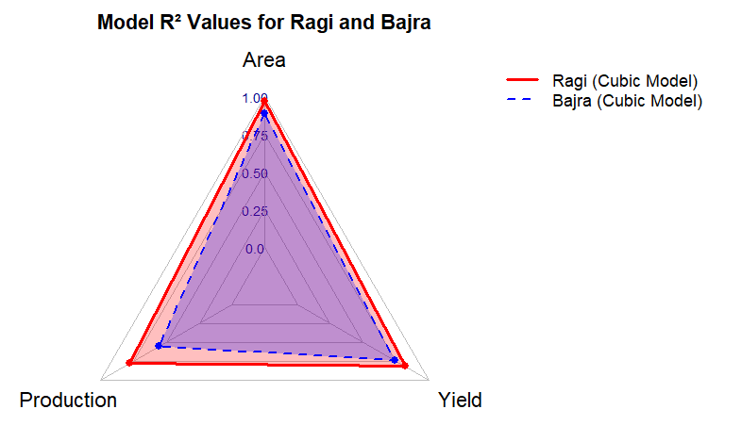
Fig. 2: R² Comparison of millet crops
3.2.2 Time Series Modeling and Forecasting
In the ARIMA modelling exercise, an ARIMA (2,1,1) was selected for ragi based on the lowest AIC (770.7) and BIC (777.74) values. The residual diagnostic (p = 0.9835) confirms that residuals are white noise, and the model captures the serial dependence adequately.
ARIMA (0,1,1) model for Bajra is expressed as $ΔY_{t}=ε_{t}-0.7654 ε_{t-1}$
The model exhibited satisfactory forecasting performance, with moderate RMSE and MAPE values. The Ljung–Box residual diagnostic (p = 0.9835) indicated that the residuals were white noise, confirming the adequacy of the model. As given in the Table 2, moderate MAPE (18.71), an RMSE value of 1701.48 implies that while forecasts are reasonably accurate, some uncertainty remains due to inherent production variability.
Table 2: ARIMA model performance of the Millet crops
Crop | Selected ARIMA Model | RMSE | MAE | MAPE (%)
Ragi | (2,1,1) | 296.06 | 228.70 | 11.16
Bajra | (0,1,1) | 1701.48 | 1241.79 | 18.71

Similarly, ragi production was found to be non-stationary at level (ADF = –4.1024; p = 0.15), which is relatively uncommon for agricultural production series in India. This indicates a mature production system with limited long-term drift. An ARIMA (2,1,1) model provided the best fit, yielding low error measures and a comparatively small MAPE (11.16 %), and an RMSE value of 296.06 indicating high forecasting reliability.
ARIMA (2,1,1) Model of ragi is expressed as: $ΔY_{t}=-22.37-0.3670ΔY_{t-1}-0.3945ΔY_{t-2}+ε_{t}-0.7966ε_{t-1}$
The residual diagnostic (p = 0.964) further confirmed that the model captured the serial dependence structure adequately. The ARIMA model predictions of millets crops for the next five years are given following fig. 3.
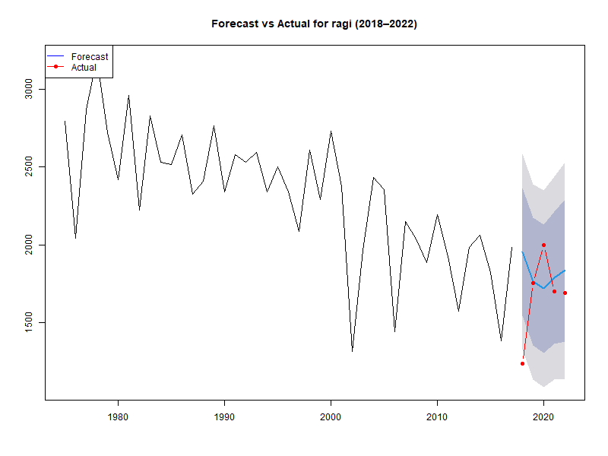 | 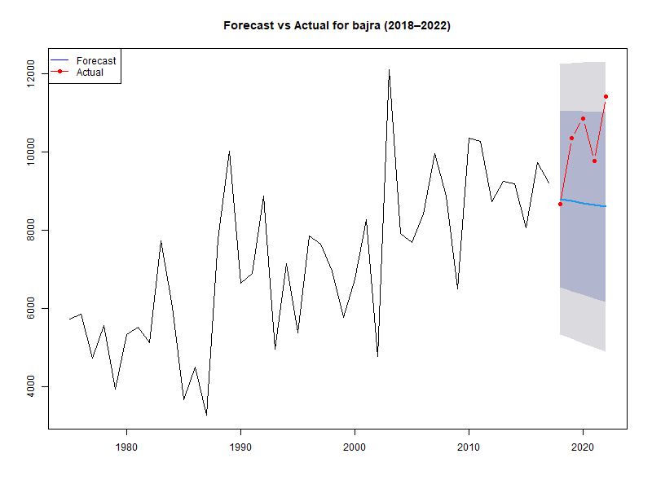
Fig. 3: Actual vs forecasted value of millets
3.3 Time series modelling and forecasting of Pulses
Pulses constitute a critical component of the agricultural system, contributing significantly to protein security, soil fertility through biological nitrogen fixation, and income diversification for farmers. In this study, the temporal behaviour of major pulse crops (Bengal gram (chickpea), Blackgram (urd bean), and Greengram (mung bean)) was examined using regression-based trend analysis and time series modeling to capture long-term structural changes and assess their forecasting potential.
3.3.1 Trend Analysis
The cultivated area, production, and yield of Bengal gram exhibited pronounced non-linear behaviour, best described by cubic regression models. The area under Bengal gram recorded an R² of 0.715, indicating that 71.5 per cent of the variation was explained by the model as given in the fig.4. While the linear and quadratic terms were highly significant, the cubic term was not, suggesting that area changes were largely governed by simpler expansion–contraction dynamics rather than complex fluctuations. In contrast, production showed a much stronger cubic pattern with an R² of 0.873, and all coefficients were statistically significant, indicating pronounced non-linear growth over time. Yield also followed a cubic trend with strong explanatory power (R² = 0.868), where linear and quadratic components were highly significant and the cubic component marginally significant. Moderate RMSE values for area, production, and yield suggests, that the models fitted the observed data reasonably well.
Black gram displayed comparatively distinct dynamics. The area under cultivation followed a cubic trend with an R² of 0.680, with statistically significant linear and cubic terms, indicating both gradual shifts and higher-order non-linear adjustments in area allocation. Production and yield, however, were best captured by power function models, with high explanatory power (R² = 0.799 for production and 0.785 for yield). These results indicate multiplicative growth patterns, highlighting the dominant role of yield enhancement in driving production increases, even when cultivated area fluctuated. The RMSE values reflect strong predictive performance, suggesting that technological improvements, better crop management, and adoption of improved varieties have substantially influenced Black gram productivity.
Green gram also exhibited strong non-linear trends across all three indicators. The cultivated area followed a cubic trend with a high R² of 0.894, and all regression coefficients were highly significant, indicating repeated phases of expansion and contraction over time. Production similarly exhibited a cubic pattern with an R² of 0.885, reflecting close alignment between area changes and yield improvements. Yield followed a cubic trend with a comparatively lower R² of 0.695, suggesting greater sensitivity to external factors such as rainfall variability, pest incidence, and soil fertility differences. The regression results indicate that green gram cultivation has experienced dynamic growth, with strong non-linear expansion in area and production and moderate variability in yield performance.
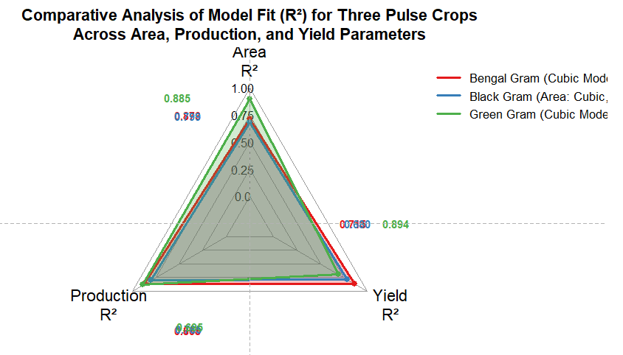
Fig. 4: R² Comparison of millets pulses
3.3.2 Time Series Modeling and Forecasting
The ADF test results indicate that production series for all three pulse crops are non-stationary at level, implying the presence of stochastic trends and long-lasting effects of shocks.
The ADF test statistic for Bengal gram production was –1.6296 with a p-value of 0.72, which exceeds the 5 per cent significance threshold. Hence, the null hypothesis of a unit root cannot be rejected, confirming the presence of non-stationarity in the production series. After first differencing, an ARIMA (0,1,1) model was selected based on minimum information criteria values.
ARIMA (0,1,1) Model for Bengal gram is expressed as $ΔY_{t}=164.24+ε_{t}-0.4780 ε_{t-1}$
The model demonstrated satisfactory forecasting performance, with moderate RMSE and MAPE values as indicated in the Table 3, and residual diagnostics confirmed white-noise behaviour. Despite the non-stationary nature of the series, the relatively low MAPE suggests that the model provides reliable short- to medium-term forecasts.
As indicated in the Table 3, the ARIMA model performance for pulse crops shows varying levels of forecast accuracy. Black gram demonstrates the best predictive performance, with the lowest RMSE (227.64), MAE (138.88), and MAPE (8.67%), indicating relatively small absolute and percentage errors. Bengal gram and Greengram have higher RMSE and MAE values, with MAPE of 14.83% and 15.14% respectively, suggesting moderate forecasting accuracy. The ARIMA models provide acceptable forecasts for all pulses, but predictions for Blackgram are more precise compared to Bengal gram and Greengram.
Table 3: ARIMA model performance of pulse crops
Crop | Selected ARIMA Model | RMSE | MAE | MAPE (%)
Bengal gram | (0,1,1) | 1050.93 | 845.34 | 14.83
Black gram | (3,1,0) | 227.64 | 138.88 | 8.67
Green gram | (1,1,2) | 246.21 | 188.25 | 15.14

Black gram production was also found to be non-stationary (ADF = 0.3676; p = 0.99), reflecting persistent trends and lack of mean reversion. An ARIMA (3,1,0) model was selected, yielding low forecast error measures and a small MAPE, indicating that a simple random walk adequately captures much of the observed variation.
ARIMA (3,1,0) model for black gram is expressed as $ΔY_{t}=38.10+0.0293 ΔY_{t-1}-0.4126 ΔY_{t-2}-0.2463 ΔY_{t-3}+ε_{t}$
However, the presence of a unit root implies that long-term forecasts should be interpreted cautiously, as future trends may shift due to policy or technological changes.
ARIMA (1,1,2) model for green gram is expressed as $ΔY_{t}=0.9571 ΔY_{t-1}+ε_{t}-1.6632 ε_{t-1}+0.8694 ε_{t-2}$
Although the MAPE indicates reasonable predictive performance, relatively higher absolute errors suggest that production forecasts remain sensitive to structural changes and climatic variability. The forecasted model with the actual values is given in the figure below (Fig.5).

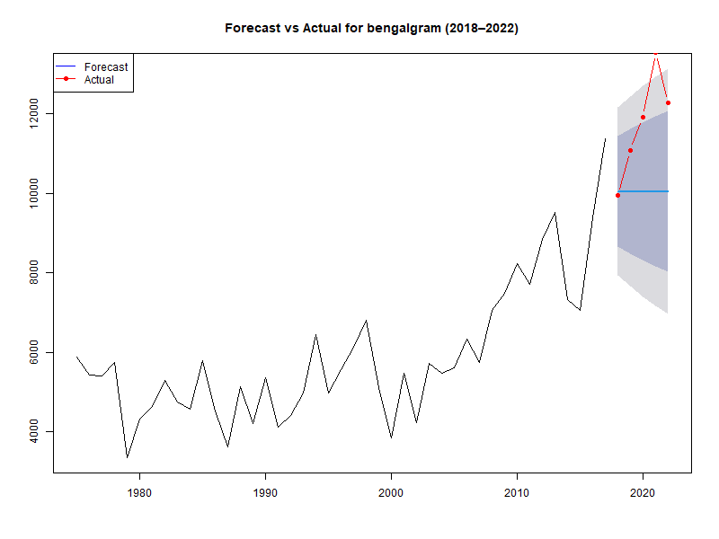 | 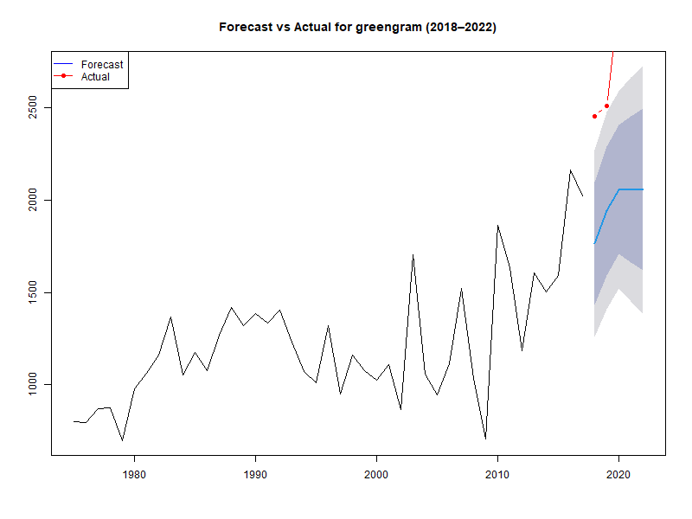
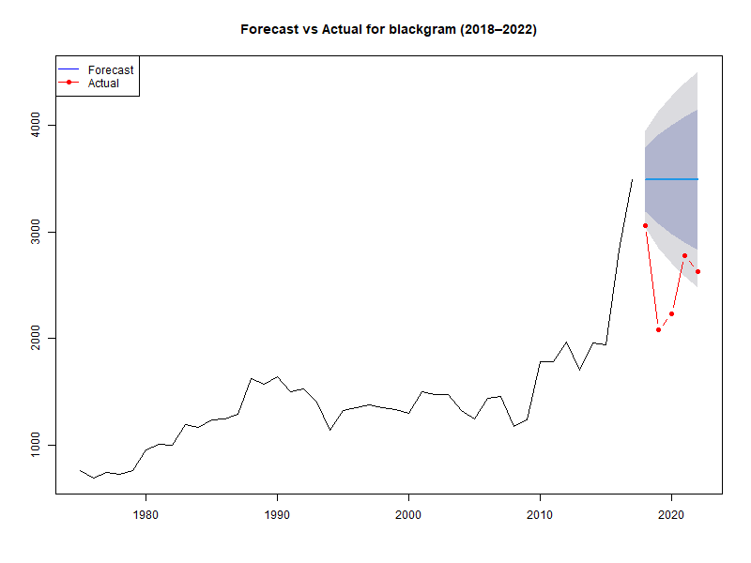

Fig. 5: Actual vs forecasted value of pulses
3.4 Time series modelling and forecasting of Oilseeds
Oilseeds constitute an important component of the agricultural economy, contributing to edible oil availability, industrial raw materials, export earnings, and farm income diversification. In this study, the temporal dynamics of major oilseed crops (Castor, Niger and Groundnut) were examined through regression-based trend analysis and time series modeling to capture structural changes, non-linear growth patterns, and forecasting performance.
3.4.1 Trend Analysis
Castor exhibited strong and sustained growth across area, production, and yield, with different functional forms capturing the underlying dynamics. The cultivated area followed a power function trend, explaining 69.4 per cent of the total variation (R² = 0.694) as given in the fig. 6, with a statistically significant model and highly significant coefficients. This indicates a consistent expansion of castor area over time, likely driven by its rising commercial importance, export demand, and adaptability to semi-arid environments. Production also followed a power function with very high explanatory power (R² = 0.895; F = 445.262, p < 0.05), reflecting strong non-linear growth supported by area expansion, improved agronomic practices, and adoption of superior seed material. Yield, however, followed a quadratic trend with an even higher R² of 0.932, indicating phased productivity improvements characterized by periods of rapid gain followed by stabilization. These results collectively suggest that castor cultivation has benefited significantly from technological progress and management improvements, resulting in a robust and sustained growth trajectory.
Niger cultivation displayed pronounced non-linear behaviour, best captured by cubic regression models. The cultivated area exhibited a very strong cubic trend (R² = 0.964; F = 440.807, p < 0.05), with significant linear, quadratic, and moderately significant cubic components. This indicates sharp fluctuations in area allocation over time, reflecting farmers’ responses to market demand, rainfall variability, and suitability to marginal lands. Production also followed a cubic trend with a high explanatory power (R² = 0.823), where linear and quadratic terms were dominant, suggesting that production closely mirrored area dynamics with limited higher-order fluctuations. Yield exhibited a comparatively weaker cubic trend (R² = 0.489), indicating that less than half of the yield variability was explained by the model. This highlights the strong influence of external factors such as climatic extremes, soil fertility, and pest pressure on yield performance. Overall, Niger production was largely area-driven, with yield contributing inconsistently to output growth.
Groundnut exhibited relatively complex and less predictable behaviour compared to other oilseeds. The cultivated area followed a cubic trend (R² = 0.763), with all coefficients highly significant, reflecting alternating phases of expansion and contraction influenced by crop rotation decisions, market price volatility, and climatic variability. Production, however, was best described by an inverse function with a very low explanatory power (R² = 0.127), despite statistical significance. The high RMSE indicates substantial deviations between observed and predicted values, suggesting that groundnut production is strongly affected by erratic rainfall, pest incidence, and management practices rather than area changes alone. In contrast, yield followed a cubic trend with relatively high explanatory power (R² = 0.804), indicating non-linear yield improvements over time driven by varietal development, nutrient management, and pest control. These findings suggest that while yield gains have contributed positively, overall groundnut production remains highly unstable.
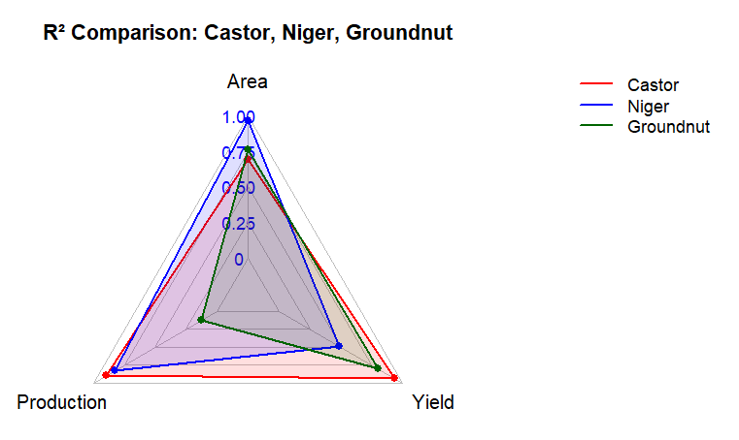
Fig.6: R² comparison of oilseed models
3.4.2 Time Series Modeling and Forecasting
The ADF test results shows that all three oilseed crops exhibited non-stationarity at level, indicating the presence of stochastic trends and persistent shocks.
While the model produced moderate forecasting accuracy, the residual diagnostic (p = 0.029) indicated remaining autocorrelation, suggesting that castor production dynamics may involve structural breaks, external market shocks or seasonal influences not captured by a simple random walk specification. This underscores the need for more flexible or extended modeling approaches for castor. Because of that from among the competing specifications, ARIMA (2,1,2) was selected based on the lowest AIC value (664.84), reduced residual variance and improved forecast accuracy. Diagnostic tests confirmed the absence of residual autocorrelation (Ljung–Box p > 0.05), indicating model adequacy.
The ARIMA (2,1,2) model for castor production is expressed as ΔYₜ = 0.1378 ΔYₜ₋₁ − 0.8050 ΔYₜ₋₂ − 0.3930 $ε_{t-1}$+ 1.0000 $ε_{t-2}$ + $ε_{t}$.
Table 4: ARIMA model comparison of oilseed crops
Crop | Selected ARIMA Model | RMSE | MAE | MAPE (%)
Castor | (2,1,2) | 211.02 | 150.64 | 20.23
Groundnut | (0,1,2) | 1349.80 | 1038.12 | 15.68
Niger | (1,1,2) | 20.24 | 15.92 | 12.58

Groundnut production also exhibited non-stationarity (ADF = –2.0532; p = 0.553), reflecting persistent long-term trends driven by structural changes such as irrigation expansion and input intensification. An ARIMA (0,1,2) model provided the best fit, with satisfactory residual diagnostics (p = 0.854) and acceptable forecasting performance.
The ARIMA model performance for the oilseed crops shows notable differences in forecasting accuracy as given in the Table 4. Niger demonstrates the best predictive performance, with the lowest RMSE (20.24), MAE (15.92), and MAPE (12.58%), indicating highly accurate forecasts. Castor shows moderate accuracy as shown in the table 4. with an RMSE of 211.02, MAE of 150.64 and a relatively high MAPE of 20.23%, suggesting larger percentage errors. Groundnut has the highest RMSE (1349.80) and MAE (1038.12), with a MAPE of 15.68%, indicating substantial absolute forecast errors despite a moderate percentage error. The ARIMA models provide acceptable forecasts for all oilseed crops, with Niger forecasts being the most precise, followed by Groundnut and Castor.
ARIMA (0,1,2) model for groundnut is expressed as $ΔY_{t}=ε_{t}-0.9652 ε_{t-1}+0.3522 ε_{t-2}$
Although the MASE value below unity indicates improvement over naïve forecasts, relatively high absolute errors reflect the large scale and inherent volatility of groundnut production.
Similarly, Niger seed production was found to be non-stationary (ADF = –1.4925; p = 0.774). An ARIMA (1,1,2) model was selected, yielding relatively low error measures and satisfactory residual diagnostics (p = 0.750).
ARIMA (1,1,2) model for Niger is expressed as $ΔY_{t}=0.5377 ΔY_{t-1}+ε_{t}-1.3967 ε_{t-1}+0.8711 ε_{t-2}$The comparatively low MAPE suggests good forecasting accuracy for a minor oilseed crop; however, forecasts of all the oil seed crops as given in the fig.7, remain sensitive to changes in policy incentives and farmers’ crop substitution decisions.
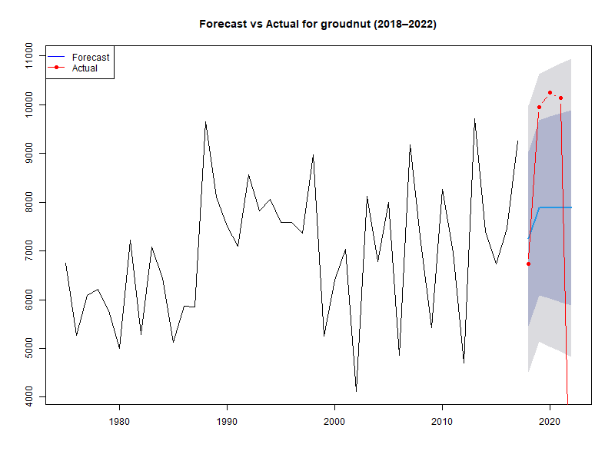 | 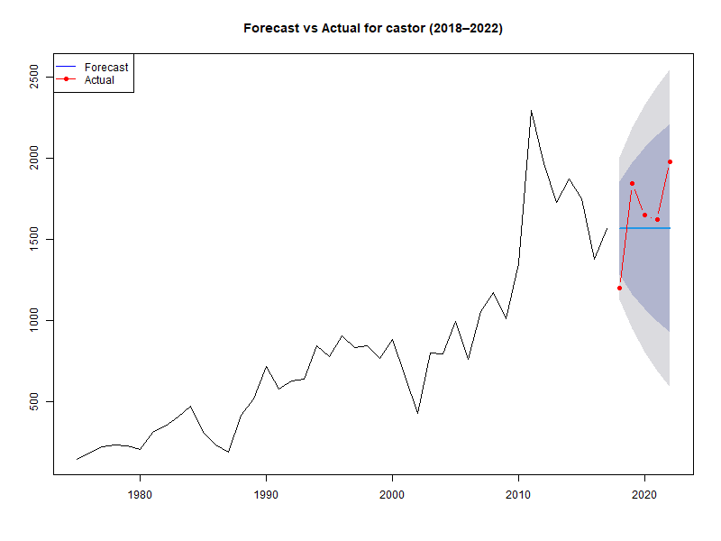
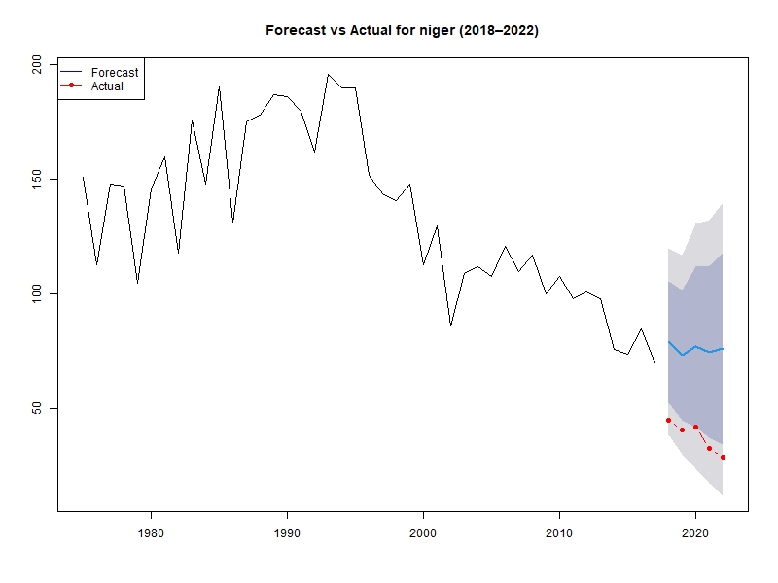
Fig. 7: Actual vs Forecast values of oilseed crops

- CONCLUSION
This study provides a comprehensive assessment of long-term trends and time series dynamics in the area, production, and yield of major crop groups, cereals, millets, pulses, and oilseeds, in India using regression-based trend models and ARIMA forecasting techniques. The results clearly demonstrate that agricultural growth in India is heterogeneous across crop groups, shaped by distinct structural drivers, technological adoption patterns, and levels of exposure to climatic and market risks.
Rice exhibits a stable and predictable growth trajectory in production, driven primarily by sustained yield improvements. This reflects the successful diffusion of high-yielding varieties, expanded irrigation coverage, and improved crop management practices. The strong forecasting performance of ARIMA models for rice underscores the structural stability of the rice production system and supports their use for medium- to long-term production planning. From a policy perspective, these findings highlight the importance of continued investment in productivity-enhancing technologies for rice, particularly water-saving and climate-smart practices, to sustain growth while addressing emerging resource and climate constraints and ensuring long-term food security.
Millets display relatively stable long-run behaviour, with production series exhibiting level stationarity and limited stochastic drift. However, pronounced non-linear fluctuations in cultivated area and yield variability indicate strong dependence on rainfall and agro-climatic conditions. The reliable short- to medium-term forecasts obtained from ARIMA models suggest that millets can play a more predictable role in diversification strategies, provided productivity constraints are addressed. Policy efforts should therefore prioritize the promotion of climate-resilient millet varieties, improved input management, and price and procurement support mechanisms to enhance farmer incentives and strengthen the contribution of millets to nutritional security and climate adaptation strategies.
In contrast, pulse crops are characterized by strong non-linear trends and persistent non-stationarity, implying that production is subject to long-lasting shocks arising from climatic variability, market uncertainties, and uneven technological adoption. While yield improvements have been a key driver of production growth, forecasting accuracy remains constrained due to stochastic trends and structural instability. These results emphasize the need for targeted policy interventions aimed at stabilizing cultivated area, accelerating the adoption of improved varieties and production technologies, and expanding irrigation and risk-mitigation instruments such as crop insurance. Strengthening extension services and ensuring remunerative and stable prices will be critical for enhancing resilience and reducing production volatility in the pulse sector.
Oilseeds similarly exhibit pronounced non-linear and non-stationary behaviour, with considerable heterogeneity across crops. Castor shows robust and sustained growth supported by technological progress and productivity gains, whereas Niger and groundnut display higher instability driven by area fluctuations, climatic sensitivity, and management constraints. Although short-term forecasts are reasonably reliable, long-term projections remain uncertain due to persistent trends and potential structural shifts. Policy measures should therefore focus on sustained investment in research and development, dissemination of climate-resilient and high-yielding varieties, strengthening market linkages, and promoting efficient resource management to improve yield stability and reduce production risk in oilseeds.
The study highlights the need for crop-specific, evidence-based agricultural policies rather than uniform interventions. By combining time series forecasting with structural trend analysis, policymakers can anticipate crop-specific production trends, volatility, and potential risks, enabling targeted support for high-growth crops, incentives for low-growth or declining crops, and stabilization measures for perishable or volatile crops. Such differentiated strategies can enhance productivity, reduce post-harvest losses, stabilize prices through calibrated MSPs and insurance schemes, and improve resilience against climatic and market shocks. Furthermore, aligning policies with crop-specific nutritional and food security goals ensures a diversified, nutrient-rich agricultural output, while guiding investments in research, mechanization, and extension services to maximize long-term productivity, income, and sustainability in Indian agriculture.
Disclaimer (Artificial intelligence)

Author(s) hereby declare that generative AI technologies such as Large Language Models, etc. have been used during the writing or editing of manuscripts. This explanation will include the name, version, model, and source of the generative AI technology and as well as all input prompts provided to the generative AI technology.

Details of the AI usage are given below:

1.ChatGPT used for grammar correction.

References
Box, G.E.P., Jenkins, G.M., Reinsel, G.C. and Ljung, G.M. (2015). Time Series Analysis: Forecasting and Control,5th Edition, by, 2015. John Wiley and Sons Inc., New Jersey, pp. 712. ISBN: 978-1-118-67502-1.
Chandra, R.M., and Sahu, B.P. 2024. “Time Series Modeling and Forecasting of Finger Millet Cultivation Area, Production and Productivity in Chhattisgarh, India: The Box Jenkins Methodology”. Asian Research Journal of Agriculture 17 (4):18-30. https://doi.org/10.9734/arja/2024/v17i4494.
Gao, Y. (2025). A comparative study of ARIMA and ETS models for time series forecasting. Advances in Economics, Management and Political Sciences, 149(1), 196–201. https://doi.org/10.54254/2754-1169/2024.19252
Ginka, A. K., Akhtar, P. M., & Dhanunjaya, S. (2020). Forecasting area, yield and production of groundnut crop in new Andhra Pradesh using R. International Journal of Mathematics Trends and Technology, 66(6), 261–274. https://doi.org/10.14445/22315373/IJMTT-V66I6P526
Gowri, P., Kutty, N., & Pandiyathuray, A. (2025). Prediction of area, production and productivity of black gram in Andhra Pradesh using machine learning methods. International Research Journal of Multidisciplinary Scope, 6(4), 1336–1350. https://doi.org/10.47857/irjms.2025.v06i04.07183
Hyndman, R.J. & Athanasopoulos, G. (2021) Forecasting: principles and practice, 3rd edition, OTexts: Melbourne, Australia.
Kumar, K. R.B., Reddy, M. A., Karunakaran, K. R., & Shafeer, K. B. (2021). Trend and instability index analysis in paddy crop area, productivity and production across districts in Andhra Pradesh, India. Asian Journal of Agricultural Extension, Economics & Sociology, 39(11), 69–78. https://doi.org/10.9734/ajaees/2021/v39i1130727
Maurya, Ankit Kumar, Rahul Kumar Rai, Yash Gautam, Pankaj Kumar Ojha, Gaurav Shukla, and Pushpa. 2025. “Forecasting of Gram Production in Bundelkhand Region: A Time Series Analysis Using ARIMA Model”. Journal of Scientific Research and Reports 31 (9):288-98. https://doi.org/10.9734/jsrr/2025/v31i93492.
Rizvi, M. F. (2024). ARIMA model time series forecasting. International Journal for Research in Applied Science and Engineering Technology. https://doi.org/10.22214/ijraset.2024.62416
Sandeep, Kumari & Sharma, Shilpa & Sharma, Ajit & Lohia, mahima. (2025). Forecasting of Rice Production in India using Linear Time Series Models. 17. 19.
Sharma, C., Jha, P., & Anand, P. (2023). Prediction and time series analysis of wheat, rice and maize yields using ARIMA models (pp. 1055–1061). Proceedings of the IEEE International Conference on Trends in Automation, Communication and Computing Systems. https://doi.org/10.1109/ictacs59847.2023.10389919
Sunandini, G. P., Paul, K. S. R., & Irugu, S. D. (2020). Analysis of trends, growth and instability in rice production in Andhra Pradesh. Current Journal of Applied Science and Technology, 39(42), 40–46. https://doi.org/10.9734/cjast/2020/v39i4231129
Srinivas, R., V., R., Prakash, K. K., Dhandapani, A., & Sreenivasulu, K. N. (2025). Long Term Trends and Current Status of Major Food Grains in Andhra Pradesh, India. Journal of Scientific Research and Reports, 31(12), 720–728. https://doi.org/10.9734/jsrr/2025/v31i123812
Bhuyan, N., Mahanta, S., & Sarma, D. (2025). Forecasting Yield of Major Crops in Assam: A Time Series Approach. Journal of Scientific Research and Reports, 31(6), 932–942. https://doi.org/10.9734/jsrr/2025/v31i63187
Chitikela, G., Rathod, S., & Vijayakumar, S. (2025). Change point-driven interrupted time series and machine learning models for forecasting Indian food grain production. Discover Food, 5(1), 68. https://doi.org/10.1007/s44187-025-00350-5

