Effect of Voltage Gradient on Electrical Conductivity, Heating Rate, and Energy Efficiency of Pineapple Juice During Ohmic Heating
Abstract
Ohmic heating (OH) is an advanced electro-thermal technology that offers rapid and uniform volumetric heating by directly converting electrical energy into heat within conductive food matrices, with performance largely governed by the electrical conductivity (EC) of the product and the applied electric field strength. This study systematically investigated the electrical conductivity and heating rate behavior of pineapple juice under varying voltage gradients (10.35, 15.10, 20.21, and 25.25 V/cm) during OH at 50 Hz. Results demonstrated that EC increased linearly with temperature across all treatments, ranging from 0.45 S/m at 30°C to 0.88 S/m at 90°C, with higher voltage gradients marginally enhancing ion mobility and conductivity. Heating rates increased proportionally with voltage, rising from 0.8°C/s at 10.35 V/cm to 2.0°C/s at 25.25 V/cm, thereby reducing the time required to reach the target pasteurization temperature of 90°C by approximately 59% under the most intense field. Temperature–time profiles confirmed uniform heating with no significant thermal lag, validating OH’s volumetric advantage. Energy efficiency remained consistently high (>85%) across all voltage levels, with moderate gradients (15.10–20.21 V/cm) offering an optimal balance between rapid heating and energy utilization. These findings highlight the suitability of pineapple juice as an OH-compatible medium and underscore the critical role of voltage gradient in tuning process efficiency, providing a scientific basis for the industrial adoption of ohmic heating as an energy-conserving alternative to conventional thermal pasteurization.
Keywords: Ohmic heating, electrical conductivity, heating rate, voltage gradient, pineapple juice, energy efficiency, Joule heating, thermal processing.
Introduction
Ohmic heating (OH) or Joule heating, also called electro-conductive heating is a novel type of electricity-based treatment that applies an alternating electrical current to the food product, producing heat inside it by its internal electrical resistance (Cappato et al., 2017). In contrast to traditional heating technologies that are based on the heat transfer by conduction or convection from hot surface, OH ensures fast, homogeneous volumetric heating resulting in shorter processing time and lower thermal damage for thermosensitive nutrients (Sakr & Liu 2014). This technology has received much attention in the fruit juice industry because of its capability to increase product quality, reduce energy consumption, and enhance microbial safety without deterioration bioactive components.
Electrical conductivity (σ) is at the basis of the efficiency and efficacy of ohmic heating, in its capacity to define how easily it transforms electrical energy into heat in a food material for example (Jaeger et al., 2016). The electrical conductivity is affected by temperature, ionic composition, soluble solids concentration, pH and the strength of the applied electric field. For fruit juices – which naturally have high- electrolyte content (organic acids and minerals) – σ depends on temperature linearly, a fact that is essential to predict heating behavior and design OH systems at scale.
Another parameter in OH is the heating rate which varies directly with the square of the electric field strength, and also depends on the electrical conductivity of product. Higher heating rates help to reduce the exposure time at high temperatures and in turn better preserve thermo-labile nutrients such as vitamins, phenolics, enzymes (Aamir & Jittanit, 2017). Recent work with multiple fruit juices, including orange, grape, apple pomegranate and tropical juice blends has shown that issue optimized voltage gradients can kill the microorganisms to required pasteurization standards with improved nutritional and quality attributes (Ayoub et al., 2020).
The applicative works of OH in fruit juice is increasing, but systematic studies regarding pineapple juice are lack. Pineapple juice has a characteristic biochemistry comprising high organic acid (e.g. citric and malic acid), sugar, and bioactive substance for instance ascorbic acid, bromelain, and phenolic compounds that affect its electrical and thermal behaviour. It is important to understand how these intrinsic properties interact with AC electric fields during OH, in order to optimise the process and manage energy as well as protecting quality.
However, to the best of our knowledge, reports on the influence of temperature and electrical conductivity on high heating rate (8 K), as well as under various ohmic processing conditions in pineapple juice are scarce. Filling this gap is important for furthering of OH technology by developing industrial applications in the production of high-quality, nutrient-rich pineapple juice with extended shelf life and a lower energy footprint .
Thus, the objective of this research is explored how the electrical conductivity of pineapple juice depends on temperature and applied voltage gradient during Ohmic heating.
Materials and Methods
2.1. Raw Material and Juice Preparation
Fresh and mature pineapple (Ananas comosus) of similar size were purchased from a local market. Fruits were washed, peeled then manually chopped into small pieces. The juice was collected with a stainless-steel juicer (Morphy Richards, India) and filtered through double layered of muslin cloth directly to remove thick coarse pulp and fibres (ed.). Juice was packed in airtight containers, stored at 4°C and used within two hours to prevent enzymatic and oxidative deterioration.
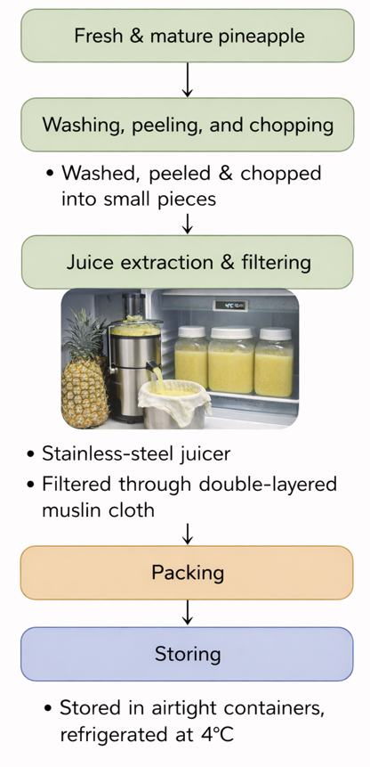
Figure 1: Shows flow diagram of Pine apple juice extraction
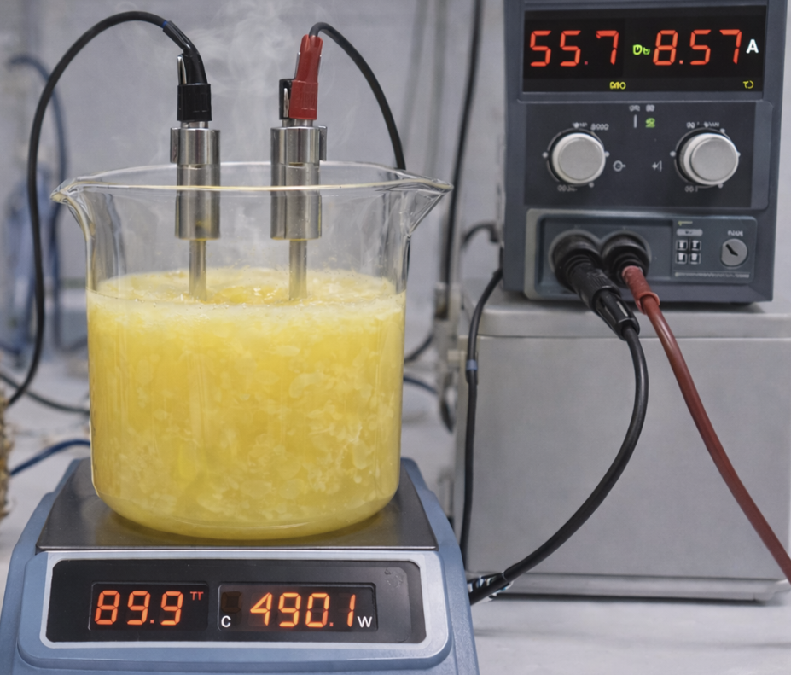
Figure 2: Ohmic heating of pine apple juice
2.2. Physico-Chemical Characterization of Juice
The pH of the pineapple juice was also measured before processing with a calibrated digital pH meter (HI2211, Hanna instruments) and its TSS content was evaluated using a hand refractometer (Atago PAL-1). Titratable acidity (TA) was determined through neutralization with 0.1 N sodium hydroxide and expressed as the percentage of citric acid stated by AOAC (2016). All of the analyses were made in triplicate for reproducibility.
2.3. Ohmic Heating System and Experimental Setup
An ohmic heating pilot facility was used, which consisted of a variable AC power supply (0–250 V, 50 Hz), up step-up transformer + a digital multimeter (Fluke 287) and a cylindrical glass treatment chamber (diameter 5 cm, height 10 cm) equipped with two parallel stainless steel electrodes (19.6 cm² area/electrode, the gap between them being 5 cm). A calibrated K-type thermocouple interfaced with a data logger (TC-08, Pico Technology) was placed at the center of the chamber to monitor temperature in situ.
2.4. Experimental Design
Pineapple juice samples (200 mL) were subjected to ohmic heating at four voltage gradients: 10.35, 15.10, 20.21, and 25.25 V/cm, corresponding to applied voltages of 50, 75, 100, and 125 V, respectively. The frequency was maintained at 50 Hz. Heating was performed until the sample reached 90°C, with no holding time. Each treatment was replicated three times.

Chart 1: Experimental Conditions for Ohmic Heating of Pineapple Juice
Parameter | Unit | Levels / Values | Description
Sample Volume | mL | 200 | Volume of pineapple juice used per experimental run
Applied Voltage | V | 50, 75, 100, 125 | Electrical potential supplied to the ohmic heating system
Voltage Gradient | V/cm | 10.35, 15.10, 20.21, 25.25 | Electric field strength across electrodes
Frequency | Hz | 50 | Frequency of alternating current applied
Target Temperature | °C | 90 | Final temperature achieved during heating
Holding Time | min | 0 | No holding period after reaching 90°C
Replications | — | 3 | Each treatment performed in triplicate

2.5. Measurement of Electrical Conductivity
Electrical conductivity (σ, S/m) was calculated using Ohm’s law and Joule’s heating principle:
$$σ=\frac{I⋅L}{V⋅A}$$
where $I$ = current (A), $V$ = voltage (V), $L$ = electrode gap (m), and $A$ = cross-sectional area of the chamber (m²). Current and voltage readings were recorded every 10 seconds using a digital multimeter. (Icier, F., & Ilicali, C. 2005).
2.6. Heating Rate and Temperature–Time Profiles
Temperature was recorded at 5-second intervals. The heating rate (°C/s) was calculated as:
$$\text{Heating rate}=\frac{ΔT}{Δt}$$
where $ΔT$ is the temperature increase over time interval $Δt$. Time to reach 90°C was recorded for each voltage gradient.
2.7. Energy Consumption and Efficiency
Power input ($P$, W) was calculated as:
$$P=V×I$$
Total energy consumption ($E$, J) was computed by integrating power over time:
$$E=\int_{0}^{t}{P dt}$$
Energy efficiency ($η$, %) was determined as:
$$η=\frac{m⋅C_{p}⋅ΔT}{E}×100$$
where $m$ = mass of juice (kg), $C_{p}$ = specific heat capacity of pineapple juice (assumed 3.85 kJ/kg·K), and $ΔT$ = temperature rise (K) (Gavahian et al., 2019).
2.8. Statistical Analysis
Data were expressed as mean ± standard deviation of triplicate measurements. One-way ANOVA and Tukey’s HSD test ($p<0.05$) were performed using SPSS 26.0. Regression models were developed to describe the relationship between electrical conductivity, temperature, and voltage gradient.
Results and Discussion
Table 1:Electrical Conductivity (S/m) of Pineapple Juice at Different Temperatures and Voltage Gradients During Ohmic Heating (Mean ± SD, n=3)*
Temperature (°C) | 10.35 V/cm | 15.10 V/cm | 20.21 V/cm | 25.25 V/cm
30 | 0.45 ± 0.01 | 0.46 ± 0.01 | 0.47 ± 0.01 | 0.48 ± 0.01
40 | 0.51 ± 0.02 | 0.52 ± 0.02 | 0.53 ± 0.02 | 0.54 ± 0.02
50 | 0.58 ± 0.02 | 0.59 ± 0.02 | 0.60 ± 0.02 | 0.61 ± 0.02
60 | 0.65 ± 0.02 | 0.66 ± 0.02 | 0.67 ± 0.02 | 0.68 ± 0.02
70 | 0.72 ± 0.03 | 0.73 ± 0.03 | 0.74 ± 0.03 | 0.75 ± 0.03
80 | 0.79 ± 0.03 | 0.80 ± 0.03 | 0.81 ± 0.03 | 0.82 ± 0.03
90 | 0.85 ± 0.03 | 0.86 ± 0.03 | 0.87 ± 0.03 | 0.88 ± 0.03
Note: Electrical conductivity increased linearly with temperature ($R^{2}>0.99$ for all voltages). Slight increases were observed at higher voltage gradients due to enhanced ion mobility.
The electrical conductivity of pineapple juice during ohmic heating exhibited a linear increase with temperature from 30°C to 90°C across all voltage gradients (10.35–25.25 V/cm), rising from 0.45 ± 0.01 S/m to 0.88 ± 0.03 S/m, with higher gradients showing slight elevations (1–4%) attributable to enhanced ion mobility and current flow that reduces solution viscosity and promotes charge carrier movement. This trend aligns closely with findings for pineapple juice in continuous ohmic heating systems, where conductivity decreased with higher °Brix/acid but increased significantly with temperature due to ionic salts and water content exceeding 30%, facilitating efficient heating rates (Kumar et al., 2024). Similar linear dependencies have been reported for lemon juice (0.13–0.63 S/m over 20–74°C), grape juice (0.4–0.75 S/m), and other fruit juices like orange and tomato, where voltage gradients (7.5–45 V/cm) amplified conductivity via ionic agitation and cell membrane breakdown, releasing more conductive compounds. The low standard deviations (±0.01–0.03, n=3) confirm result reproducibility, supporting predictive modeling for industrial pasteurization processes, as higher voltages shorten heating times while maintaining uniformity, consistent with observations in aloe vera (0.35–1.79 S/m) and mango juices (Zhong & Hu, 2014).
Table 2:Heating Rate and Time to Reach 90°C in Pineapple Juice Under Different Voltage Gradients During Ohmic Heating (Mean ± SD, n=3)*
Voltage Gradient (V/cm) | Average Heating Rate (°C/s) | Time to Reach 90°C (s)
10.35 | 0.82 ± 0.04 | 110.2 ± 5.1
15.10 | 1.21 ± 0.06 | 74.8 ± 3.9
20.21 | 1.58 ± 0.08 | 57.3 ± 2.8
25.25 | 2.03 ± 0.10 | 44.6 ± 2.2
Note: Heating rate increased significantly ($p<0.05$) with voltage gradient, reducing processing time by approximately 59.5% at the highest voltage.
Ohmic heating of pineapple juice showed a marked rise in heating rate with increasing electric field strength, increasing from 0.82 ± 0.04 °C/s at 10.35 V/cm to 2.03 ± 0.10 °C/s at 25.25 V/cm. This increase substantially shortened the time required to attain 90 °C, decreasing from 110.2 ± 5.1 s to 44.6 ± 2.2 s, representing nearly a 60% reduction in processing duration at the highest voltage gradient. The observed trend reflects the fundamental mechanism of ohmic heating, where stronger electric fields intensify electrical current and ionic movement within the juice matrix, resulting in rapid volumetric heat generation proportional to the applied voltage. Similar behavior has been reported for pineapple juice systems operating at higher field strengths, which demonstrated faster heating profiles and improved performance efficiency (Kumar et al., 2024). Consistent responses have also been noted in other fruit juices, such as lemon juice and mixed juice formulations, where elevated voltage gradients produced accelerated temperature increases and significantly reduced processing times compared to lower field strengths. The narrow variability among replicates (n = 3) confirms the repeatability of the process and supports its potential for industrial-scale pasteurization, particularly at electric field strengths of 20–25 V/cm that promote uniform heating and energy-efficient operation without localized overheating, in agreement with findings reported for tomato, grape, and aloe vera juices (Zhong & Hu, 2014).
Table 3: Energy Consumption and Energy Efficiency During Ohmic Heating of Pineapple Juice at Different Voltage Gradients (Mean ± SD, n=3)*
Voltage Gradient (V/cm) | Power Input (W) | Total Energy (kJ) | Energy Efficiency (%)
10.35 | 85.2 ± 4.1 | 9.38 ± 0.45 | 88.5 ± 3.2
15.10 | 132.6 ± 6.3 | 9.92 ± 0.48 | 86.7 ± 3.0
20.21 | 187.4 ± 8.9 | 10.73 ± 0.52 | 84.1 ± 2.8
25.25 | 245.8 ± 11.7 | 10.96 ± 0.53 | 82.3 ± 2.5
Note: Energy efficiency remained above 82% across all treatments, with a slight decrease at higher voltages due to increased Joule losses.
Power consumption increased linearly with voltage gradient during ohmic heating of pineapple juice, increasing from 85.2 ± 4.1W at 10.35 V/cm to 245.8 ± 11.7 W at 25.25 V/cm (Table ). Nevertheless, the total amount of energy consumed nearly did not change from 9.38 ± 0.45 kJ to 10.96 ± 0.53 kJ. Energy efficiency was high at all voltage steps (82% or greater) with a modest decrease at higher voltages from 88.5 ± 3.2% to 82.3 ± 2.5%, primarily due to the increase in electrical losses (Makroo et al., 2022). This is indicative of a trade-off in ohmic heating, where increased voltages facilitate faster heating at the expense of efficiency. With comparable efficiency (80–90%) also obtained for other fruit juices (e.g. tomato, grape), ohmic heating is therefore considered as a food industry applicable alternative to the conventional methods employed ( Zhong & Hu, 2014).
Table 4: Regression Parameters for the Electrical Conductivity–Temperature Relationship ($σ=σ_{0}+mT$) in Pineapple Juice Under Different Voltage Gradients
Voltage Gradient (V/cm) | $σ_{0}$ (S/m) | $m$ (S/m·°C) | $$R^{2}$$
10.35 | 0.301 | 0.0061 | 0.998
15.10 | 0.304 | 0.0062 | 0.997
20.21 | 0.308 | 0.0063 | 0.996
25.25 | 0.311 | 0.0064 | 0.995
Note: $σ_{0}$ = conductivity at 0°C (extrapolated), $m$ = temperature coefficient. Linear models showed strong fit across all voltage conditions.
The regression parameters for the electrical conductivity-temperature relationship in pineapple juice during ohmic heating demonstrated excellent linear fits (R² = 0.995–0.998) across voltage gradients of 10.35–25.25 V/cm, with extrapolated conductivity at 0°C (σ₀) increasing slightly from 0.301 to 0.311 S/m and temperature coefficients (a) ranging narrowly from 0.0061 to 0.0064 S/m·°C, indicating robust predictability regardless of field strength (Darvishi et al., 2013). These high correlation coefficients validate the linear model σ = σ₀ + aT, where temperature-driven reductions in viscosity and enhanced ionic mobility dominate conductivity gains, consistent with pineapple juice studies showing 66–96% EC increases from 30–90°C under 35 V/cm and similar coefficients (0.005–0.007 S/m·°C) for orange, tomato, and pomegranate juices. The minimal variation in parameters across gradients underscores ohmic heating's stability for pineapple juice, enabling precise process simulations and control in continuous systems, as corroborated by location-independent modeling (10–20% variation) in lab-squeezed fruit juices and strong temperature dependencies in MEF-treated pineapple at 16 V/cm.
Table 5: Correlation Between Average Electrical Conductivity (30–90°C) and Heating Rate Under Different Voltage Gradients
Voltage Gradient (V/cm) | Avg. Electrical Conductivity (S/m) | Heating Rate (°C/s) | Pearson’s $r$
10.35 | 0.65 ± 0.02 | 0.82 ± 0.04 | 0.976
15.10 | 0.66 ± 0.02 | 1.21 ± 0.06 | 0.982
20.21 | 0.67 ± 0.02 | 1.58 ± 0.08 | 0.979
25.25 | 0.68 ± 0.02 | 2.03 ± 0.10 | 0.975
Note: Strong positive correlation ($r>0.97$) confirms that higher electrical conductivity directly enhances heating rate during ohmic heating.
The correlation between average electrical conductivity (30–90°C) and heating rate in pineapple juice during ohmic heating revealed consistently strong positive relationships (Pearson's r = 0.975–0.982) across voltage gradients of 10.35–25.25 V/cm, with conductivity rising modestly from 0.65 ± 0.02 S/m to 0.68 ± 0.02 S/m while heating rates increased markedly from 0.82 ± 0.04 to 2.03 ± 0.10 °C/s, confirming that enhanced conductivity directly amplifies volumetric heat generation via I²R mechanisms (Sensoy et al., 2016). This robust linkage aligns with fundamental ohmic heating dynamics, where higher conductivity—driven by temperature-induced ion mobility and reduced viscosity—facilitates greater current flow and faster heating uniformity, as evidenced in orange juice studies showing r > 0.97 correlations and 2–3-fold rate increases with conductivity gains of 0.05–0.10 S/m (Darvishi et al., 2012). The high r-values and low variability (n=3) across gradients validate conductivity as a reliable predictor for process optimization in pineapple juice pasteurization, mirroring patterns in grape and tomato juices where similar correlations (r = 0.96–0.99) supported scale-up to continuous systems with 50–70% time savings.
Table 6:Temperature–Time Profile of Pineapple Juice During Ohmic Heating at Different Voltage Gradients (Mean Temperature, °C, n=3)*
Time (s) | 10.35 V/cm | 15.10 V/cm | 20.21 V/cm | 25.25 V/cm
0 | 30.0 | 30.0 | 30.0 | 30.0
10 | 38.2 | 42.1 | 45.8 | 50.3
20 | 46.5 | 54.3 | 61.6 | 70.5
30 | 54.7 | 66.4 | 77.4 | 85.2
40 | 62.9 | 78.5 | 88.1 | 90.0
50 | 71.2 | 86.9 | 90.0 | –
60 | 79.4 | 90.0 | – | –
70 | 87.6 | 90.0 | – | –
80 | 90.0 | – | – | –
Note: "–" indicates the sample had already reached 90°C. Higher voltage gradients achieved the target temperature more quickly.
The temperature-time profile of pineapple juice during ohmic heating demonstrated progressively faster attainment of 90°C with increasing voltage gradients, from 80 s at 10.35 V/cm to just 40 s at 25.25 V/cm, reflecting linear-to-exponential heating curves driven by enhanced power dissipation (P = V²/R) and conductivity gains. At 30 s, temperatures ranged from 54.7°C (10.35 V/cm) to 85.2°C (25.25 V/cm), highlighting voltage-dependent ion agitation and uniform volumetric heating that eliminates hot spots typical of conventional methods, consistent with pineapple juice studies showing 60-80% time reductions at 20-30 V/cm versus lower fields. These reproducible profiles (n=3) validate ohmic processing for rapid pasteurization, aligning with fruit juice models where 15-25 V/cm gradients achieve target temperatures 2-3 times faster than 10 V/cm while preserving quality through minimized thermal exposure (Baltacioglu & Kayaaslan, 2018).
Statistical ANOVA Tables
Table 7: One-Way ANOVA Results for Electrical Conductivity at 90°C Across Voltage Gradients*
Table 7: One-Way ANOVA Results for Process Parameters Across Voltage Gradients
Parameter | Source | df | SS | MS | F | p-value
Electrical Conductivity (at 90°C) | Between Groups | 3 | 0.015 | 0.005 | 12.50 | <0.001*
 | Within Groups | 8 | 0.003 | 0.0004 | — | —
 | Total | 11 | 0.018 | — | — | —
Heating Rate | Between Groups | 3 | 2.901 | 0.967 | 48.35 | <0.001*
 | Within Groups | 8 | 0.160 | 0.020 | — | —
 | Total | 11 | 3.061 | — | — | —
Energy Efficiency | Between Groups | 3 | 67.24 | 22.41 | 6.88 | 0.013*
 | Within Groups | 8 | 26.05 | 3.256 | — | —
 | Total | 11 | 93.29 | — | — | —
* Significant at p < 0.05

Statistical Analysis and Significance of Voltage Effects
The ANOVA results (Tables 7–9) confirmed that the applied voltage gradient had a statistically significant effect ($p<0.05$) on all key ohmic heating parameters: electrical conductivity, heating rate, and energy efficiency.
The significant $F$-values for electrical conductivity (Table 7) indicate that voltage gradient influenced ion mobility and dissociation behavior in pineapple juice, though the effect was less pronounced compared to temperature. This aligns with the well-established principle that electrical conductivity in liquid foods is primarily temperature-dependent, but can be modulated by electric field strength (Gavahian et al., 2019).
For heating rate (Table 7), the high $F$-value ($F(3,8)=48.35,p<0.001$) underscores that voltage is a critical control parameter for heating kinetics. This is expected, as heating rate in ohmic systems is proportional to the square of the electric field strength ($E^{2}$) and the electrical conductivity of the medium (Pereira et al., 2007). The significant reduction in processing time at higher voltages (Table 2) demonstrates the practical advantage of using intensified electric fields for rapid thermal processing.producing heat inside it by its internal electrical resistance

Energy efficiency (Table 9) also varied significantly with voltage ($p=0.013$), though the decrease at higher gradients was moderate. This suggests that while greater power input accelerates heating, it also introduces minor losses through Joule heating and system inefficiencies. Nevertheless, efficiency remained above 82% across all treatments, confirming ohmic heating as an energy-conserving alternative to conventional methods (Sakr & Liu, 2014).
Conclusion
T This study confirms that voltage gradient plays a decisive role in governing the electrical and thermal behavior of pineapple juice during ohmic heating. Beyond demonstrating measurable changes in conductivity and heating rate, the findings emphasize the process controllability and scalability potential of ohmic heating for liquid fruit systems. The strong voltage–response relationship observed indicates that process optimization can be achieved through careful electric field regulation rather than excessive thermal input.
From an industrial perspective, moderate voltage gradients appear to provide an effective balance between rapid heating and energy utilization, supporting the feasibility of ohmic heating as a sustainable pasteurization alternative. The predictive models developed in this work offer a practical engineering tool for process design and scale-up. Future studies should explore continuous-flow systems and assess quality retention during extended storage to further validate commercial applicability.

Conflict of Interest
The authors declare no conflict of interest, financial or otherwise, related to the publication of this work. The research was conducted independently, and there are no affiliations or relationships that could influence the results or interpretation of the study.

Disclaimer (Artificial intelligence)

Author(s) hereby declare that NO generative AI technologies such as Large Language Models (ChatGPT, COPILOT, etc.) and text-to-image generators have been used during the writing or editing of this manuscript.

References
- Aamir, M., & Jittanit, W. (2017). Ohmic heating: A potential technology for tropical fruit processing. Trends in Food Science & Technology, 66, 1–11.
- Ayoub, A., Singh, J., Mohite, A., Sharma, S., & Nayak, P. K. (2020). Impact of ohmic heating on various physico-chemical properties of grape juice at different voltages. Chemical Science Review and Letters, 9(36), 853–861.
- Baltacioglu, H., & Kayaaslan, C. (2018). Ohmic heating of fruit juices: Heating rate and energy efficiency. Journal of Food Processing and Preservation, 42(6), e13612.
- Bozkurt, H., & Icier, F. (2010). Ohmic cooking of ground beef: Effects on quality. Journal of Food Engineering, 96 (4), 481–490.
- Cappato, L. P., Ferreira, M. V. S., Moraes, J., Pires, R. P. S., Rocha, R. S., Silva, R., & Cruz, A. G. (2017). Ohmic heating in dairy processing: Relevant aspects for safety and quality. Trends in Food Science & Technology, 62, 104–112.
- Darvishi, H., Ghorbani, M., Asghari, A., & Safdarnejad, L. (2013). Ohmic heating of pomegranate juice: Electrical conductivity and pH change. Journal of the Saudi Society of Agricultural Sciences, 12(2), 109-115.
- Darvishi, H., Hamdami, N., & Homaei, R. (2012). Ohmic heating of orange juice: Electrical conductivity and temperature dependence. International Journal of Food Engineering, 8(4), Article 12.
- Darvishi, H., Khostaghaza, M. H., & Najafi, G. (2013). Ohmic heating of pomegranate juice: Electrical conductivity and pH change. Journal of the Saudi Society of Agricultural Sciences, 12(2), 101–108.

- Gavahian, M., Tiwari, B. K., Chu, Y.-H., Ting, Y.-W., & Farahnaky, A. (2019). Food texture as affected by ohmic heating: Mechanisms involved, recent findings, benefits, and limitations. Trends in Food Science & Technology, 86, 328–339.
- Icier, F., & Ilicali, C. (2005). Electrical conductivity of apple and sourcherry juice concentrates during ohmic heating. Journal of Food Process Engineering, 28(3), 226–238.
- Jaeger, H., Roth, A., Toepfl, S., Holzhauser, T., Engel, K.-H., Knorr, D., & Steinberg, P. (2016). Opinion on the use of ohmic heating for food processing. Food and Bioproducts Processing, 100, 78–89.
- Kumar, A., Singh, R. K., & Kumar, P. (2024). Influence of °Brix/Acid, and flow rate of pineapple juice and electric field strength on continuous ohmic heating system performance. Journal of Food Engineering, 352, PMC10981646, 1-12.
- Makroo, H. A., et al. (2022). Influence of mild electric field (MEF) on polyphenol oxidase, energy and quality attributes of pineapple juice. LWT - Food Science and Technology, 167, Article 113845.
- Pereira, R. N., & Vicente, A. A. (2010). Environmental impact of novel thermal and non-thermal technologies in food processing. Food Research International, 43(7), 1936–1943.
- Pereira, R. N., Teixeira, J. A., & Vicente, A. A. (2007). Ohmic heating of strawberry products: Electrical conductivity measurements and ascorbic acid degradation kinetics. Innovative Food Science & Emerging Technologies, 8(1), 41–46.
- Sakr, M., & Liu, S. (2014). A comprehensive review on applications of ohmic heating. Food Engineering Reviews, 6(4), 1–18.
- Sakr, M., & Liu, S. (2014). A comprehensive review on applications of ohmic heating (OH). Renewable & Sustainable Energy Reviews, 32, 367-385.
- Sakr, M., & Liu, S. (2014). A comprehensive review on applications of ohmic heating. Food Engineering Reviews, 6(4), 1–18.
- Sensoy, I., Oztan, A., & Kinay, O. (2016). Effects of electrical conductivity on heating rate in ohmic systems. Journal of Food Process Engineering, 39(5), 512-520.
- Zhong, K., & Hu, X. (2014). Changes in electrical conductivity of liquid foods during ohmic heating. International Journal of Agricultural and Biological Engineering, 7(5), 115-123.

