Minireview Article

EVALUATION OF RECREATIONAL TOURISM POTENTIAL IN CITIES USING SWOT ANALYSIS: THE CASE OF AKYAKA REGION

ABSTRACT
Recreation tourism activities are peaceful and enjoyable activities that people do in their free time to relax and refresh their minds and bodies. Today, recreational activities are considered an integral part of tourism. Examining Akyaka's recreational tourism potential is an important issue that includes elements such as sociotourism, cultural tourism and sea tourism. The aim of this study is to evaluate the current situation of recreation areas in Akyaka in terms of recreation tourism. For this purpose, field research and observation techniques were preferred. On the basis of photographs and observations of recreation areas, opportunities, threats, strengths and weaknesses were identified. It was determined that Akyaka offers many suitable areas for recreation. However, it turns out that these regions are not sufficiently explored. Based on the research results, practical recommendations are provided to visitors, local governments and local populations to ensure more effective and efficient use of these areas.

Keywords: Recreation, tourism, recreational tourism, SWOT

1.INTRODUCTION
Industrialization, technological developments and changing living conditions have increased people's leisure needs. Recreation and tourism play an important role in the social, cultural and economic structure of modern communities (Akyüz, Kul & Yaşartürk, 2014). Historically, recreational rides and activities were only accessible to a select group. Today, it has become an entertainment activity preferred by a large segment of society (Bell et al., 2007). Factors that negatively affect the quality of life are dense urbanization, population growth, environmental pollution, noise and stress, which have increased the need for individuals to connect with nature. It has also led to the acceptance of recreation only as an important element of individual renewal and social welfare (Jitaru et al., 2012). In current planning methods, recreation and tourism are seen as important areas that contribute to improving the quality of social life, protecting environmental sustainability and supporting economic development (Toy & Yılmaz, 2010).
RECREATION, TOURISM CONCEPTS AND THEIR EVALUATION FROM VARIOUS PERSPECTIVES
Recreation is defined as any activity in which individuals voluntarily participate in their free time beyond their compulsory work and life responsibilities and provides physical, mental and social renewal (Jensen and Guthrie, 2006). Today's fast lifestyle, increasing time and increasing income levels have led to entertainment gaining greater importance in social life (Karaküçük, 2008). These activities are extremely valuable for individual development, social interaction, and the importance of physical and mental health (Hazar, 2003).
Recreational activities have both beneficial and detrimental effects in socio-cultural, environmental and economic fields. While these activities offer various benefits by enhancing cultural interaction, increasing environmental awareness, and providing economic vitality, they can also introduce risks such as overexploitation, environmental degradation, or loss of cultural values (Crawford et al., 1991).
The classification of recreation shows that activities can be examined according to different criteria such as location, time, participant characteristics, objectives and application methods (Mull et al., 1997; Karaküçük, 2008). Recreational activities are evaluated in different categories such as rural and urban, indoor and outdoor, individual and group, active and passive, daily and holiday, national and international, and vary according to the results that the individual expects from the activity (Hazar, 2003; Sevil, 2012). This categorization is essential for comprehending the intricate aspects of recreation and identifying suitable activities during the planning phases.
The concept of tourism includes traveling and staying in places temporarily, enabling individuals to depart from their usual residences (Sağcan, 1986; Sarı and Özüpek, 2011). The basic characteristics of tourism are based on factors such as consumer status, non-profit process, interaction with cultural and natural values and the realization of pleasant travel (Pirselimoğlu Batman, 2013). The concept of sustainable tourism aims to protect natural and cultural values, maintain ecological balance, minimize environmental impacts and manage tourism activities in accordance with the principles of social justice (Bulut, 2006; Keleş, 2003; Erdem, 2007).
Tourism planning is a flexible and adaptable process that takes into account public participation. It incorporates technology, balances the environment and economy, and promotes land use planning with various functions. The terms recreation and tourism are often considered complementary elements in many cases. Both fields use similar resources for reasons such as leisure, seeking experience and volunteer activities and overlap to a large extent (Çetinkaya, 2014; Brey and Lehto, 2007). The similarities between recreation and tourism are expressed in their development under the influence of individual needs, the ability of all ages and socio-cultural groups to make their preferences both individually and in groups, and their differentiation according to changing economic and social conditions (Hazar, 2003). The differences are that recreation usually includes short-term, low-cost activities, while tourism is a long-term travel situation that is mostly organized close to the place of residence, and requires accommodation. While tourism stands out as a strong economic sector, recreation is generally a service provided by the public sector or at low cost (Karaküçük & Akgül, 2016; Sertkaya, 2001).
The natural, economic, social, cultural and spatial factors that determine the tourism and recreation potential are shaped according to the suitability of the region, carrying capacity, environmental values, accessibility, infrastructure status and user demands (Sertkaya, 2001).
Tourism and recreational activities can have impacts such as infrastructure development and increased economic activities, ecosystem damage, loss of cultural identity, pollution, and spatial pressure (Bingöl & Arslan, 2021). Maintaining a balance between conservation and use and applying sustainability principles are fundamental elements in the management of tourism and recreational areas (Kolçu, 1993; Beatley, 1995).
INTEREST STUDIES
Inskeep (1991) highlights the significance of analyzing factors such as the natural surroundings, cultural sites, transportation systems, and visitor traits in the planning of rural tourism. The SWOT analysis highlighted environmental hazards such as urban overcrowding, noise pollution, and the diminishing of natural spaces. It is asserted that cultural and social diversity can be viewed as a valuable opportunity.
Karaküçük (1999) emphasizes that recreation plays a significant role in urban life, and that recreational areas are essential urban components that enhance the physical, social, and cultural framework. When assessing recreation options in urban areas considerations include the availability of natural spaces, transportation accessibility, population density, characteristics of the socio-economic structure and the sufficiency of infrastructure.
Gunn and Var (2002) highlighted the importance of recreational spaces for tourism planning within urban environments. By employing the SWOT analysis they highlighted the importance of assessing the strengths of the city's natural resources, the weaknesses associated with excessive urbanization, the opportunities arising from enhancements in public spaces and the threats created by environmental challenges.
Torkildsen (2005) asserts that conducting a SWOT analysis is essential for overseeing leisure activities within urban areas. The advantages of leisure tourism in urban areas are characterized by convenient access a variety of activity options and well-established infrastructure. Disadvantages are shown as issues related to the environment and insufficient planning.
Christopher Edginton et al. (2008) areas designed for entertainment in urban settings play an important role in drawing in tourists. The research emphasizes the advantages of accessibility, a variety of activities, and the quality of public areas while it also points out shortcomings in maintenance, management, and infrastructure as disadvantages.
Kılıç and Şahin (2009) state that tourism and recreation are two important elements that support each other in cities. Recreation opportunities help to increase the diversity of tourism products. However, overconstruction, loss of space, and disorganized visitor management lead to problems.
2. METHODOLOGY
Akyaka is a coastal residential area located in the Ula district of Muğla province. It is located in the northeast of the Gulf of Gökova, on the south side of the Gökova Plain (Ministry of Environment and Urbanization, 2012). It was formed at the point where the settlement of the Kadın Azmağı and the freshwater source meets the sea and has the characteristics of both a coastal ecosystem and a wetland (DOKA/SEPA, 2015). Akyaka is located approximately 28 kilometers from the center of Muğla and approximately 18 kilometers from the center of Ula district (Ula Municipality, 2020). The fact that Akyaka is located within the Gökova Special Environmental Protection Area indicates that the region requires strong ecological and legal protection (Ministry of Environment and Urbanization, 2023; Muğla Governorship, 2019).
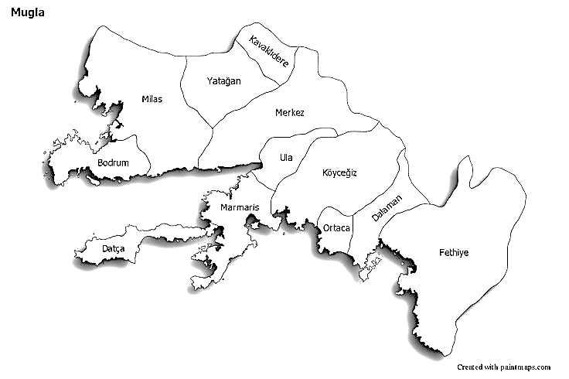
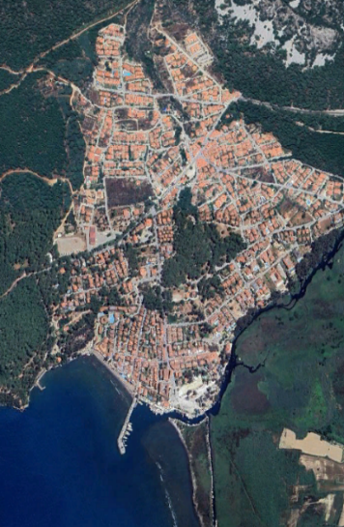
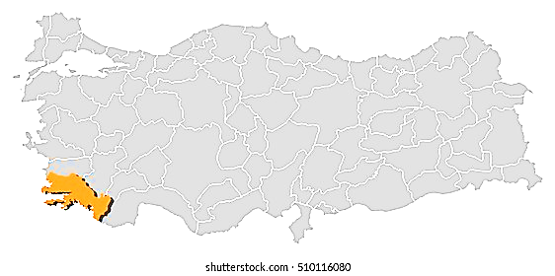

Figure 1. Region location representation.
The research location is situated in the Mediterranean climate zone, experiencing an average yearly precipitation of approximately 900 mm and a temperature range of about 16–17 °C (MGM, 2020). Regional wind patterns along the bay create favorable conditions for wind sports and kitesurfing, particularly on the Akçapınar-Akyaka shoreline (SEPA, 2015). The Akyaka-Gökova area is one of Turkey's most abundant coastal regions regarding biological diversity. This area offers an essential habitat for otters (Lutra lutra), sea turtles (Caretta caretta), numerous waterfowl, and species that move between freshwater and saltwater (DOKA/SEPA, 2015).
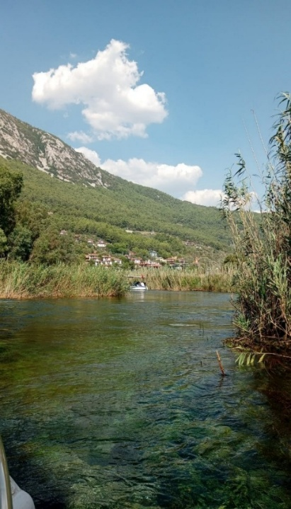
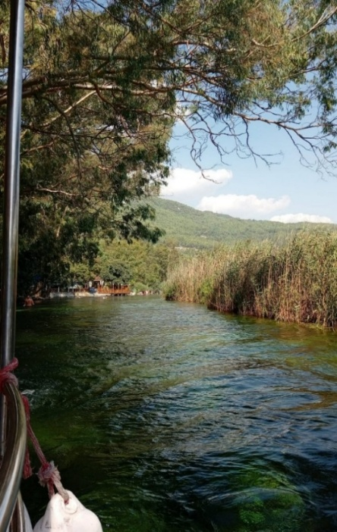

Figure 2. Woman's Desire (Original, 2025)

The Women's River is an area where freshwater meets saltwater, creating a unique ecosystem filled with various aquatic plants, including Nymphaea, Potamogeton, Phragmites, and Typha. This area is found in the natural habitat of the Anatolian sweet mastic tree (Liquidambar orientalis), which faces global threats (Muğla Governorship, 2019).
Akyaka benefits from a favorable position due to its closeness to the D400 highway and Dalaman Airport (Ula Municipality, 2020). The economy of the region is based on tourism, fishing, beekeeping, citrus and olive production (Muğla Governorship, 2019).
Boat tours, canoeing, kitesurfing and coastal walks are frequently organized around the Women's Azmağı; In addition, mineral-rich waters support the development of ecotourism activities (DOKA/SEPA, 2015; Muğla Governorship, 2019). Akyaka and Gökova Basin have a rich cultural structure that reflects the effects of many civilizations. The remains of city walls, rock tombs and defensive structures surrounding the ancient city of Idyma are important archaeological elements in the region.
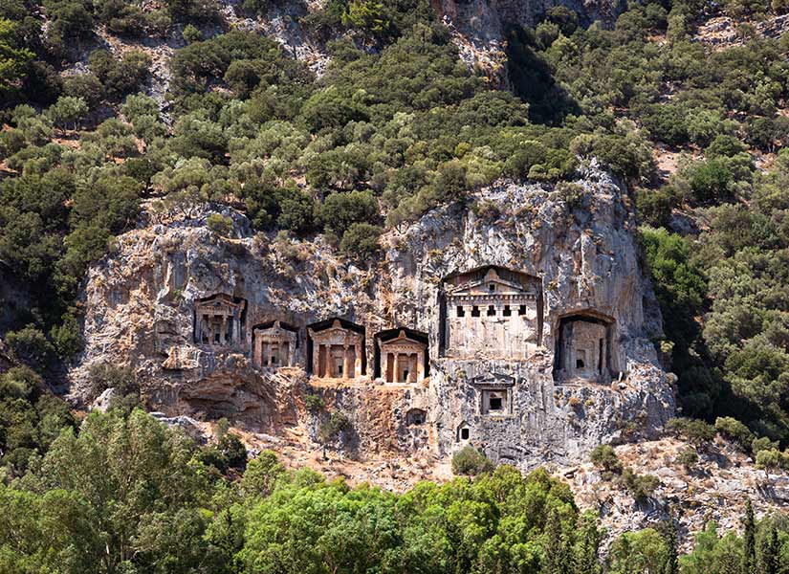
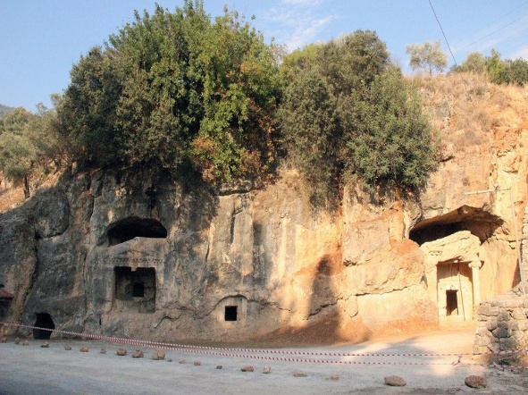

Figure 3. Idyma Ancient City (Original, 2025)
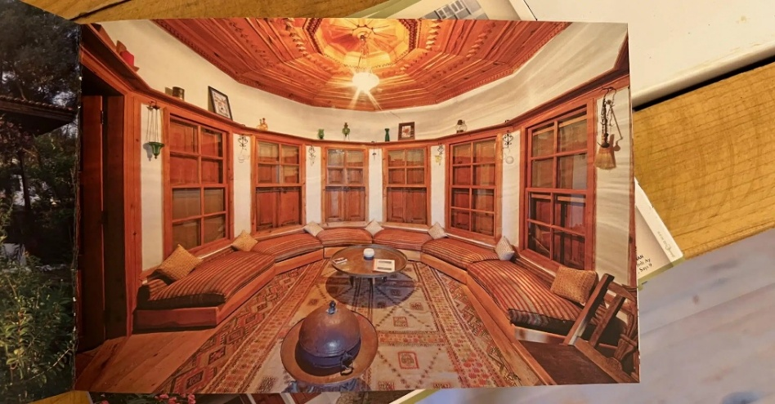
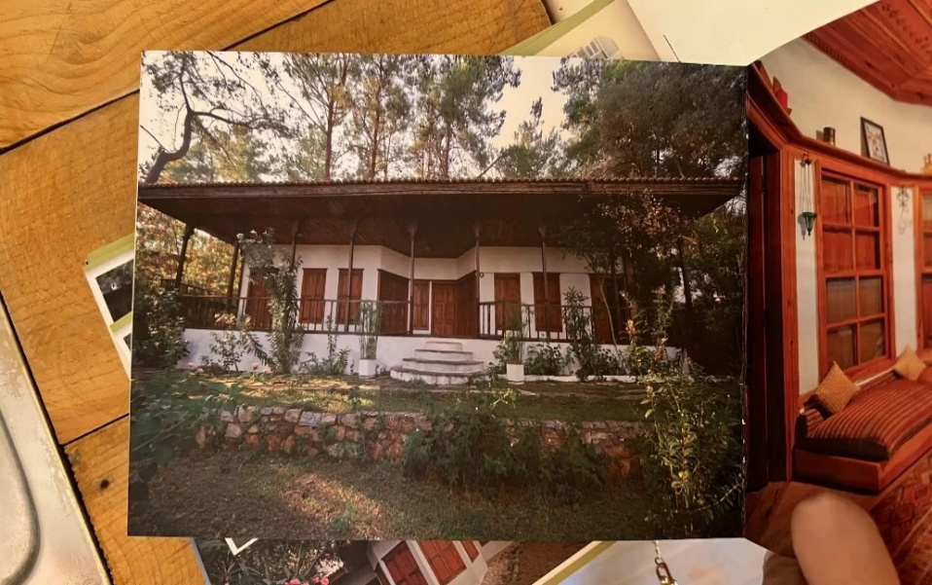
The traditional Muğla house architecture in Akyaka has been sustainably developed with woodwork under the leadership of Nail Çakırhan and features prominent protruding balconies, wide eaves and chimneys unique to Muğla. The old stone aqueducts, historical fountains and irrigation canals around the Azmak Stream are valuable cultural components of the region. The traces of the stone mill in Akçapınar show how traditional agricultural methods have been preserved throughout history (Muğla Governorship, 2019).

Figure 4. Nail Çakırhan's house architecture (URL-1, URL-2)
3. DISCUSSION
The research method is based on the evaluation of the data collected through literature reviews conducted in Akyaka using SWOT analysis. SWOT is a valuable tool for decision-making by identifying strengths, weaknesses, opportunities, and threats in planning processes (Uçar & Doğru, 2005). The current situation of Akyaka in terms of recreational tourism has been examined with the information obtained from scientific sources. In the study, internal (strengths-weaknesses) and external (opportunities-threats) factors were first determined. A future state analysis was developed using SO, WO, ST, and WT relationships. At the end of this analysis, the recommended recreational tourism activities were combined with the SWOT results and guide planning decisions for sustainable tourism were developed. SWOT current situation evaluations made in the context of recreation tourism for Akyaka are presented in the Tables section.
Tables 1 and 2: SWOT analysis

 | STRENGTHS
S1 | Geographical location | - Muğla, Marmaris and Aydın can be reached quickly via the 400 highway  - Proximity to Dalaman Airport will increase the number of international visitors  - Natural bays throughout the bay contribute to maritime transportation.
S2 | Climate | - Summer winds provide the perfect grip for windsurfing.  - The mild winter weather conditions are suitable for bird watching and nature walks.
S3 | Topographic diversity of landscapes | - The impressive panoramic view from Sakar Pass to the bay is among the attractions for visitors.  - The reed beds and swamps surrounding Azmak provide a rich habitat for various species.  - Woodlands and coastal plains are suitable for various types of recreation.
S4 | Richness of flora and fauna | - Sweetgum forests are rare species found in limited areas around the world.  - Migratory birds use reed beds as feeding grounds.
S5 | Cultural and architectural values | - Çakırhan-style woodwork, protruding balconies and Muğla-style chimneys are characteristic features of the region.  - There are stone and wooden structures and old agricultural fields around the village.  - The region has historical water sources, ancient waterways, and cultural environmental elements.
S6 | Water sports and nature tourism | - Azmak offers suitable conditions for canoeing, kitesurfing and paddleboarding.  - The mountainous regions are suitable for hiking and cycling tourism.
 | WEAKNESSES
W1 | Administrative Management | - Inadequate oversight leads to increased repression in some regions.  - There are delays between institutions in the planning stages.  - Usage limits are not always clearly defined.
W2 | Transportation Capacity Problem | - Beaches quickly exceed their capacity.  - Boat traffic in Azmak can negatively affect underwater plants.  - Vehicle traffic and parking space scarcity negatively impact the user experience.
W3 | Infrastructure Deficiencies | - Parking spaces do not meet demand during peak seasons.  - There are no toilets and showers in the recreation areas.  - Guidance and information signs are insufficient.
W4 | Seasonal Factors and Economic Sentiment | - Many businesses cease operations during the winter months, leading to a decline in employment.  - Price increases during the summer months pose financial challenges for local communities.  - Since the economy is based on tourism, it is susceptible to external shocks.
W5 | Coastal and Swamp Sensitivity | - Pedestrian pressure can quickly destroy the dunes.  - Boat movements affect bird breeding grounds.
Table 2
 | OPPORTUNITIES
O1 | Nature-Based Tourism Trends | - There are global funding opportunities for ecotourism projects.  - The City Slow identity promotes slow living tourism.  - Natural laboratory features can be seen on educational and research trips.
O2 | Promotion and Brand Value Potential | - Azmak's clean water increases its visibility in photos and media.  - Gökova's appearance is a symbolic feature in promotional videos.  - The architecture of Nail Çakırhan offers a unique city identity.
O3 | Sports Tourism Development Opportunities | - Kitesurfing competitions can be organized at the international level.  - Walking and cycling routes can be improved.  - Azmak can be considered an area for canoe training.
O4 | Cultural and Rural Tourism Opportunities | - A cultural route can be created with stone mill foundations and historical waterways.  - Rural architecture provides the necessary infrastructure for agricultural tourism.  - Handicrafts and local products can be traded.
O5 | Gastronomy and Local Product Opportunities | - Fish restaurants create a well-known brand value in the food industry.  - Organic honey and olive oil products can be included in the touristic product category.  - Ecological markets become places that attract visitors.

 | THREATS
T1 | Pressures on the Ecosystem and Overexploitation | - Boat engines can cause water pollution.  - Beach crowding can negatively affect the sand structure.  - Noise and light pollution have negative effects on animals.

T2 | Construction Printing | The increase in commercial enterprises threatens coastal integrity.  Sand dunes and reed beds are at risk of mud layers.  The natural landscape can be irreversibly damaged.
T3 | Environmental Pollution and Waste Issues | Boat engines can cause oil and fuel leaks.  Solid waste accumulates in reed deposits and coastal areas.  Noise pollution negatively affects many living things, especially bird species.
T4 | Effects of Climate Change | Increasing drought rates can reduce the water flow of the Azmak River.  Rising temperatures cause stress in aquatic ecosystems.  The risk of fire increases in red pine forests.
T5 | Exceeding Carrying Capacity | The kitesurfing area can become dangerous for safety.  Boat traffic affects underwater vegetation.  Heavy use of the beach negatively affects the coastal ecosystem.

SWOT Analysis for Future Situation Analysis

SWOT analysis provides an opportunity to strategically evaluate both the current and future situation. Using the internal (S–W) and external (O–T) information obtained within the framework of the current situation assessment, four different types of strategies were created for the future of Akyaka: SO, WT, WO and ST strategies (Uçar and Doğru, 2005).
1. SO Strategy (Strengths + Opportunities)
GOAL 1 (SO): The natural (Azmak Creek, Gökova Bay, Sweetgum Forests) and cultural landscape elements of Akyaka should be used effectively in tourism and recreation activities.
GOAL 2 (SO): Tourism services in Akyaka should be diversified. (Alternatives such as canoeing, hiking, bird watching, cultural visits and agricultural tourism).
GOAL 3 (SO): The values of nature, cultural, entertainment and visual resources should be protected in accordance with sustainable principles and transferred to future generations.

2.WT Strategy (Weaknesses + Threats)
GOAL 1 (WT): Social events to be held in Akyaka should be designed in a way that does not harm sensitive areas such as the Azmak River ecosystem and coastal sand dunes.
GOAL 2 (WT): Local communities, business owners, and visitors should be aware of environmental issues, ecosystem conservation, and sustainable sourcing.
GOAL 3 (WT): Recreational activities should be carried out in designated areas with defined carrying capacity, taking into account the balance between conservation and use.

3. External Work Strategy (Weaknesses + Opportunities)
Targets have been set to reduce weaknesses (W) and strengthen existing opportunities (O).
TARGET 1 (WO): The existing conservation of Akyaka should be carefully protected and effective conservation methods should be strengthened.
GOAL 2 (WO): Proposed recreational facilities should be designed to be in harmony with nature, take into account environmental sensitivities and include the necessary infrastructure.

4. ST Strategy (Minimizing Threats by Using Strengths Well)
GOAL 1 (ST): Public awareness should be increased about the value of Akyaka's natural and cultural areas (Women's Azmağı, sweet forests, Muğla houses).
GOAL 2 (ST): More effective management methods, monitoring systems and control mechanisms should be established in protected areas.
GOAL 3 (ST): It is of great importance to strengthen the promotion of the concept of sustainable tourism in order to support Akyaka's ecotourism identity.

Comparison of Current and Future SWOT Analyses

SO-ST: The national border of Akyaka constitutes the main area of uncertainty for both SO and ST. SO schematically combines natural and cultural values with opportunities to create development recommendations in ecotourism, sports tourism and cultural events. ST can use these positive aspects to minimize threats, enhance protection, and ensure sustainable management. SO aims to improve development, while ST aims to provide protection.
WT-WO: Both strategy groups continue to focus on weak points as a starting point. WT is aimed at risk reduction and protection methods aimed at preventing the increase of weaknesses, while WO options aim to increase weaknesses and support their ecological normalization with existing proposals. WT proposes a defense plan, while WO offers a method of development.
FISSAT-THREATS: Opportunities show that Akyaka has a significant development potential in the fields of ecotourism, sports tourism and cultural promotion. Threats emphasize aspects that jeopardize sustainability because of ecosystem demands, building activities, and environmental dangers. Opportunities signify chances for growth, whereas threats highlight vulnerable areas that need safeguarding.
4. CONCLUSION
Akyaka has the ability to become one of Turkey's top destinations for sustainable tourism due to its natural and cultural scenery, diverse plant and animal life, coastal and wetland environments, traditional buildings, and distinct community layouts. These characteristics indicate that the region possesses a delicate ecosystem and necessitates an appropriate management plan for its careful utilization and preservation.The SWOT analysis conducted in this study reveals that Akyaka's strengths, natural beauty, climate, biodiversity, and cultural identity can be transformed into significant opportunities through effective planning methods. On the other hand, factors such as scattered settlements, large number of visitors, environmental pressures and exceeding the carrying capacity negatively affect the natural structure of the region unless the necessary precautions are taken.
5. RECOMMENDATIONS
In order for Akyaka to become a sustainable entertainment tourism center:
- To support passive recreation activities that protect natural and cultural values without depletion (nature walks, bird watching, plant observation, landscape viewing, photography, etc.)
- To increase the number of training activities that increase environmental awareness and develop a culture of conservation between the local community and businesses,
- Determination of usage limits according to the carrying capacity of sensitive ecosystems on the banks of the Azmak River and in the sweet forests,
- Establishing a balance between the preservation and use of traditional structures, cultural environmental elements and traces of rural life that make up the identity of the region,
- To develop proposals such as diversification of tourism activities to contribute to local economic growth.

6. REFERENCES
Akten, M. and Akten, S., 2011, Model approach for determining recreation potential: Gülez method, 1st National Sarıgöl District and Values Symposium, 17–19 February, Sarıgöl.
Akyüz, H.; Kul, M. and Yaşartürk, F., 2014, Forests and the environment in terms of recreation, International Journal of Science Culture and Sport, Special Issue 1, 881–890.
Beatly, T., 1995, Planning and sustainability: elements of a new paradigm, Journal of Planning Education and Research, 9(4), 383–395.
Bell, S.; Tyrväinen, L.; Sievänen, T.; Pröbstl, U. and Simpson, M., 2007, Outdoor recreation and nature tourism: a European perspective, Living Reviews in Landscape Research, 1(2), 1–46.
Bingöl, B., 2011, A study on recreation planning in terms of conservation and use principles in Dilek Peninsula – Büyük Menderes Delta National Park, PhD Thesis, Ankara University Science Institute, Ankara, 245 p.
Brey, E. T. and Lehto, X. Y., 2007, Relationship between diurnal and holiday activities, Annals of Tourism Research, 34(1), 160–180.
Bulut, Z., 2006, Determination of the recreational tourism potential of Kemaliye (Erzincan) district and its surroundings within the scope of alternative tourism, PhD thesis, Atatürk University Institute of Natural and Applied Sciences, Erzurum, 204 p.
Crawford, D. W.; Jackson, E. L. and Godbey, G., 1991, Hierarchical model of leisure constraints, Leisure Sciences, 13(4), 309–320.
Çetinkaya, G., 2014, Evaluation of hiking trails for tourism purposes: The case of Antalya Beydağları, Master's thesis, Akdeniz University Institute of Social Sciences, Antalya.
Ministry of Environment and Urbanization, 2023, Akyaka Environmental Data and Nature Conservation Report. Ankara.
Demircan, S., 1999, Ministry of Forestry and Environmental Policy, Ankara.
DOKA/SEPA, 2015, Gökova Special Environmental Protection Area Management and Planning Document. Ankara.
Erdem, B., 2007, Evaluation of the natural and cultural values of the city of Sivas in terms of landscape architecture and tourism, Master's Thesis, Ankara University Institute of Science, Ankara, 180p.
Gunn, C. A. & Var, T. (2002), Tourism Planning: Fundamentals, Concepts, Situations. 4th edition, Routledge, New York.
Gürbüz, A., 2002, A study on the impact of tourism on the social environment, Technology Journal, (1–2), 49–59.
Hazar, A., 2003, Recreation and Animation (2nd edition), Detay Publications, Ankara.
Inskeep, E. (1991), Tourism Planning: An Integrated and Sustainable Development Approach. Van Nostrand Reinhold, New York.
Jensen, C. R. and Guthrie, S., 2006, Outdoor Recreation in America (6th ed.), Human Kinetics, Champaign, IL.
Jitaru, D.; Sambotin, L.; Khalil, F. I.; Mayer, M. and Tirchi, S., 2012, Recreational rural tourism in Europe, Agricultural Management/Lucrari Stiintifice Seria I, Management Agricol, 14(4).
Karaküçük, S. (1999), Recreation: Leisure Time Evaluation. Gazi Publishing House, Ankara.
Karaküçük, S., 2008, Recreation: Evaluation of Leisure Time, Gazi Publishing House, Ankara.
Karaküçük, S. and Akgül, B. M., 2016, Ecorekreation: Recreation and Environment, Gazi Publishing House, Ankara.
Keleş, A., 2003, Sustainable Tourism Planning in Turkey and Ecological Approach to Yacht Tourism, Master's Thesis, Ankara University Institute of Social Sciences, Ankara, 119 p.
Kılıç, B. & Şahin, S. (2009), Evaluation of the relationship between urban tourism and recreation. Anadolu University Journal of Social Sciences, 9(2), 45–60.
Kızılırmak, İ., 2006, Investigation of the use of local events as tourist attraction centers in Turkey, Journal of Social Sciences, (15), 181–196.
Kolcu, İ. H., 1993, A model for evaluating tourism potential from natural, historical and cultural perspectives: The case of Ayvalık, Master's Thesis, Istanbul Technical University Institute of Science, Istanbul, 269 p.
Muğla Governorship, 2019. Cultural and natural heritage inventory in Muğla Province. Mugla.
Mull, R. F.; Bayless, K. G.; Ross, C. M. and Jamieson, L. M., 1997, Recreational Sports Management (3rd ed.), Human Kinetics, Champaign, IL.
Özdemir, G. & Karakuş, E. (2017), Evaluation of urban open green spaces in terms of recreation and tourism. Journal of Landscape Architecture, 9(1), 35–48.
Sarı, G. and Özüpek, N., 2011, The effect of public relations activities applied in travel agencies on internal promotion: The case of Manavgat, Journal of the Faculty of Commerce and Tourism, (1), 25–45.
Sertkaya, Ş., 2001, A study on the determination and evaluation of the tourism and recreation potential of the coastal region of Bartın Province, PhD Thesis, Ankara University Institute of Science, Ankara, 371 p.
Sevil, T., 2012, Leisure and recreation: concepts and characteristics, S. Kocaekşi (Ed.), Leisure and Recreation Management, Anadolu University Publications, Eskişehir, 2–25.
Torkildsen, G., 2005, Amusement and Recreation Management (5th ed.), Taylor and Francis Group, London and New York.
Toy, S. and Yılmaz, S., 2010, Evaluation of the suitability of climatic conditions for tourism and recreation activities in Artvin province, III. National Black Sea Forestry Congress, 4, 1513–1522.
Türker, G. Ö.; Türker, A. and Güzel, F. Ö., 2014, Evaluation of the recreational potential of Dalyan destination in the context of touristic product diversification, International Journal of Science Culture and Sport, Special Issue 2, 70–86.
URL-1, Nail Çakırhan's house architecture, accessed from https://www.herumutortakarar.com/nail-cakirhan-evi/.
URL-2, Nail Çakırhan's house architecture, accessed from https://www.herumutortakarar.com/nail-cakirhan-evi/.

