Development and Storage Stability Analysis of Fortified RTS Beverage from Mahua (Madhuca indica) Flowers with Ginger and Mint Extract

Abstract
Mahua (Madhuca indica) flowers are rich in natural sugars, minerals, and bioactive compounds, yet remain underutilized in value-added beverage applications. The present study aimed to develop and optimize a non-fermented ready-to-serve (RTS) beverage from mahua flower extract fortified with ginger and mint at varying concentrations (5%, 7.5%, and 12%). Sensory evaluation using a 9-point hedonic scale revealed that 7.5% ginger and 12% mint incorporation resulted in significantly higher overall acceptability scores (7.02 and 7.35, respectively; p ≤ 0.05). The optimized formulations were subjected to storage stability assessment under ambient and refrigerated conditions for three months. Physicochemical parameters including total sugars, pH, and total soluble solids (TSS) were analyzed at monthly intervals. A gradual decline in total sugars, pH, and TSS was observed during storage, with significantly greater deterioration under ambient conditions. Two-way ANOVA indicated significant effects of storage period, storage condition, and their interaction (p ≤ 0.05). Microbial analysis showed earlier contamination in ginger-blended RTS under ambient conditions, whereas mint-blended RTS exhibited extended microbial stability. All samples remained microbiologically safe under refrigerated storage throughout the study period. The results demonstrate that incorporation of mint at 12% enhances sensory quality and shelf-life stability of mahua RTS beverage compared to ginger fortification. Refrigerated storage significantly improved physicochemical retention and microbial safety. The developed mahua-based RTS beverage offers potential for commercial exploitation and value addition of this underutilized forest resource.
Keywords: Mahua flower, RTS beverage, Ginger extract, Mint extract, Storage stability.
INTRODUCTION
The Mahua or Indian butter tree, which is a member of the Sapotaceae family, is botanically known as Madhuca indica . Its Latin name, which combines the words "madhuk" for sweet and "indica" for Indian, comes from the Sanskrit language. This deciduous tree is widely found in portions of Gujarat, Andhra Pradesh, Rajasthan, Tamil Nadu, Jharkhand, Chhattisgarh, Madhya Pradesh, Orissa, and Bihar (Purwar.2025).This evergreen tree, called Mahwain Hindi, produces oblong yellow fruits after white, luscious blossoms. Mahua's qualities vary from sweetness (madhur) to dryness (kashaya). Madhu, meaning honey in English, refers to the sugar-rich blossoms of Mahua, which contain 66-72% of their dry weight (Sarojini, P. (2013)), and it has a number of therapeutic advantages, including laxative and anthelmintic effects. Bark, flower, fruit, and seeds are used in a variety of ways, from treating skin conditions with flower juice to treating nerve diseases with pulp. Its medicinal usefulness is further shown by formulations like madhukasava and therapeutic uses include utilizing the fruit as a laxative or a bark decoction to treat wounds. The phytosterols free sitosterol and b-sitosterol are among its primary chemical components.
The Mahua tree is an important multifunctional species that grows well in mixed deciduous forests in South Asia, including Nepal, India, and Sri Lanka. The tree, which goes by several names depending on the location, is indigenous to arid areas of India and is primarily found in tropical and subtropical woods in the country's north and center. It is an essential economic resource because it can be used for food, medicine, The Mahua tree is a huge species with scaly, gray to dark brown bark, linear-lanceolate leaves grouped close to branch ends, fragrant, densely clustered pale yellow flowers, ovoid yellow berries for fruits, and compressed, shiny seeds for seeds. There are numerous uses for the Mahua plant's seed, bark, flower, fruit, and leaf.
The Mahua tree flowers during the sparsest agricultural season (March-April). It provides income and employment opportunities for society's most vulnerable members. The plant's flowers, including the fleshy corollas, are edible and contain a high concentration of natural sugars, vitamins, and minerals (Sinha et al., 2017). It is used to sweeten several local dishes such as halwa, kheer, puri, and burfi (Patel, 2008).
Mahua tree has several chemical elements such as alkaloids, ethylcinnamate, sesquiterene alcohol, triterpenoids, b-carotene, xanthophylls, amino acids, fatty acids, carbohydrates, proteins, saponins, and tannins (Ramadan et al. 2016). These compounds contribute in different medicinal such as aphrodisiac, astringent, demulcent, and cooling agent. According to Chandra (2001), they can be used as a general tonic to treat helminths, acute and chronic tonsillitis, pharyngitis, and bronchitis. The M. Indica plant contains several phytochemicals that indigenous people employ for therapeutic purposes. Mahua flowers are high in carbohydrates and minerals such as iron, calcium, magnesium, and potassium, making them an important source of energy. The flowers have antioxidant and anti-microbial effects (Sinha et al., 2017). Mahua flowers are open-dried in the sun before storing. Flowers' hygroscopic nature causes them to easily absorb air moisture, leading to spoilage.
Mahua is used in local diets and is known for its high-energy seeds. Its flowers and seeds are used in a variety of ways, which enhances the nutritional landscape (Pinakin et al. 2018). Mahua has produced a wide range of goods, such as barfi, kheer, paratha (Mishra et al. 2019), butter, candy , cupcake, fermented beverages, milk shake (Thangamani et al. 2022), wine/vermouth (Yadav et al. 2012). the causes of the underutilization of Mahua flowers and potential strategies for processing and value-adding to optimize flower use. The flowers have several health advantages and have the potential to be used in place of sugar in a variety of food products.
Materials and Methods
This Chapter deals with the materials, experimental procedures, techniques, and methodologies employed during the present investigation related to the technological, analytical, and statistical aspects.
Raw material details: Mahua flower were collected from the region of Chhattisgarh district of Sarguja for production of ready-to-serve non-fermented beverage and stored in polythene bag at room temperature for future use. Fresh ginger and mint herbs were collected from the local market of Sambalpur Orissa.
Location of experiment: This study was conducted in the Department of Food Science Technology and Nutrition at Sambalpur University Orissa.
Preparation and Manufacture of Mahua flower Fortified RTS beverage: A ready-to-serve, non-alcoholic beverage was prepared from mahua flowers. About 500 g dried mahua flowers were soaked overnight in 1000 ml water containing KMS (100 ppm). The soaked flowers were ground in a mechanical grinder/juicer and then the juice was extracted through two layered muslin cloth. Then total volume was made to 1000 ml with water. In the extracted juice, ginger and mint extract was added @ 5, 7.5 and 12 per cent. The mixture was treated to ultra-sonicator for 30 min. and again filtered through one layered muslin cloth. Organoleptic evaluation of RTS beverage samples was performed by a panel of semi-trained persons on a 9-point Hedonic scale (Amerine et al., 1) for selection of optimum blending combination. The prepared RTS with selected blending combinations was filled in plastic bottles of polyethylene terephthalate (PET) with screw-cap under aseptic conditions and used for study of storage stability.
Result & Discussion:
Physico-Chemical Analysis
Various biochemical parameters such as, total soluble solids (TSS), pH, reducing sugar of RTS beverage of mahua flowers were estimated during the storage period at monthly interval. Reducing sugars in samples were estimated by using dinitrosalicylic acid (DNS) reagent method as described by Miller (7). The total soluble solids in the samples were determined with the help of hand refractometer and expressed in terms of °Brix. The pH of the samples was measured by using hand held pH meter. Microbial load of stored samples was recorded as per the standard methods of microbial examination of food (Ranganna, 10). Standard plate count agar (SPCA) medium was used for total viable bacterial count and Rose Bengal agar medium for fungal count. All experiments were carried out in triplicates. The data recorded were subjected to statistical analysis under completely randomised block design using SPSS-13 O software (Gomez and Gomez, 3).
Physico-chemical properties were recorded for the different levels of blending in mahua flower juice based RTS (Table 1). On the basis of organoleptic evaluation two blends, with Ginger and Mint were selected for storage studies (Table 1). Two conditions, i.e., ambient and refrigerated (0-4°C) were used for storage of RTS bottles.
Table 1. Physico-chemical and organoleptic evaluation of mahua RTS.
Treatment | TSS (°Brix) | pH | Taste | Colour | Flavour | Over all acceptability
Mahua+ginger₅. | 13.45±0.10 | 5.60±0.10 | 6.48±0.11 | 5.78±0.18 | 6.40±0.20 | 6.22±0.10
Mahua+ginger_{7.5}. | 16.63±0.15 | 6.43±0.05 | 7.10±0.10 | 6.46±0.32 | 7.50±0.10 | 7.02±0.05
Mahua+ginger₁₂. | 17.00±0.10 | 5.36±0.05 | 5.34±0.15 | 6.00±0.13 | 5.10±0.10 | 5.48±0.12
Mahua+mint₅ | 11.30±0.15 | 5.33±0.05 | 5.30±0.10 | 5.65.±0.11 | 5.60±0.10 | 5.52±0.02
Mahua+mint_{7.5} | 13.80±0.05 | 5.26±0.05 | 7.15±0.05 | 6.13 ±0.10 | 6.40±0.08 | 6.56±0.06
Mahua+mint₁₂ | 16.46±0.28 | 5.43±0.10 | 7.85±0.15 | 6.40 ±0.05 | 7.80±0.21 | 7.35±0.15
Control | 11.40±0.17 | 5.66±0.05 | 4.50±0.30 | 4.36 ±0.20 | 4.68±0.16 | 4.51±0.10
CD (P = 0.05) | 0.02 | 0.10 | 0.22 | 0.31 | 0.25 | 0.20

Mahua flower RTS beverage fortified with 7.5% ginger extract
The reducing sugars content of mahua RTS blended with Mahua + Ginger 7.5 decreased from 190.05 to 176.39 mg/ml and to 179.38 mg/ml in the RTS beverages stored at ambient and refrigerated conditions, respectively. There was gradual decrease in pH as well as total soluble solids content of the RTS during the storage period in refrigerated conditions as compared to ambient conditions. The pH decreased from 5.30 to 4.50 in case of RTS blended with ginger @ 7.5 per cent after three months of storage at ambient, while it decreased to 5.03 in case of refrigerated conditions. The TSS decreased from 18.50 to 16.46°Brix at ambient and to 17.10°Brix at refrigerated storage of mahua RTS blended with ginger (Table 2).
Table 2. Storage-induced quality alterations in mahua flower RTS beverage fortified with 7.5% Ginger extract
Storage period (month) | Reducing sugars (mg/ml) | pH | TSS (°Brix)
Ambient conditions
0 | 190.05 ± 0.4 | 5.30 ± 0.05 | 18.50 ± 0.10
1 | 187.40 ± 0.27 | 5.16 ± 0.05 | 17.00 ± 0.11
2 | 180.05 ± 0.38 | 5.10 ± 0.05 | 16.60 ± 0.10
3 | 176.39 ± 0.27 | 4.50 ± 0.05 | 16.46 ± 0.05
Refrigerated conditions
0 | 190.05 ± 0.4 | 5.30 ± 0.05 | 18.50 ± 0.10
1 | 187.40 ± 0.40 | 5.25 ± 0.05 | 17.25 ± 0.05
2 | 184.43 ± 0.20 | 5.20 ± 0.15 | 17.15 ± 0.05
3 | 179.38 ± 0.18 | 5.03 ± 0.05 | 17.10 ± 0.05
CD (P = 0.05)
Month | 0.383 (± 0.13) | 0.087 (± 0.03) |  | 0.113 (± 0.04)
Storage condition | 0.242 (±0.08) | 0.055 (±0.02) | 0.071 (± 0.02)
Month x Storage condition | 0.542 (± 0.18) | 0.123 (± 0.04) | 0.160 (± 0.06)

Figure 1. Effect of storage period on reducing sugars (mg/ml) of Mahua RTS beverage under ambient and refrigerated conditions.
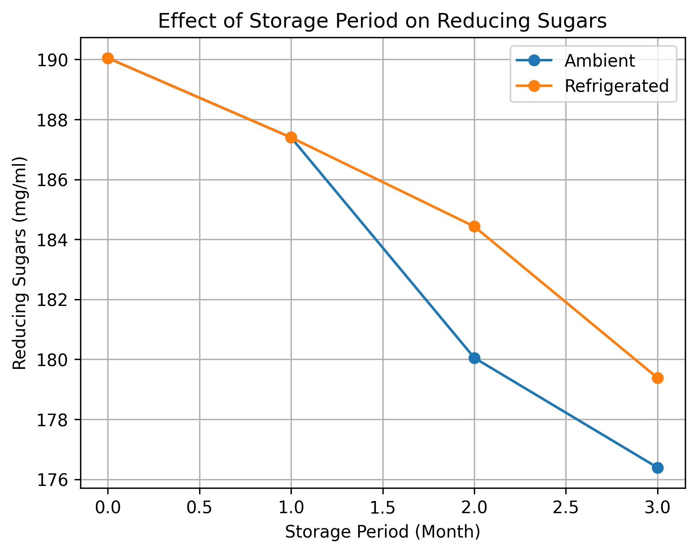
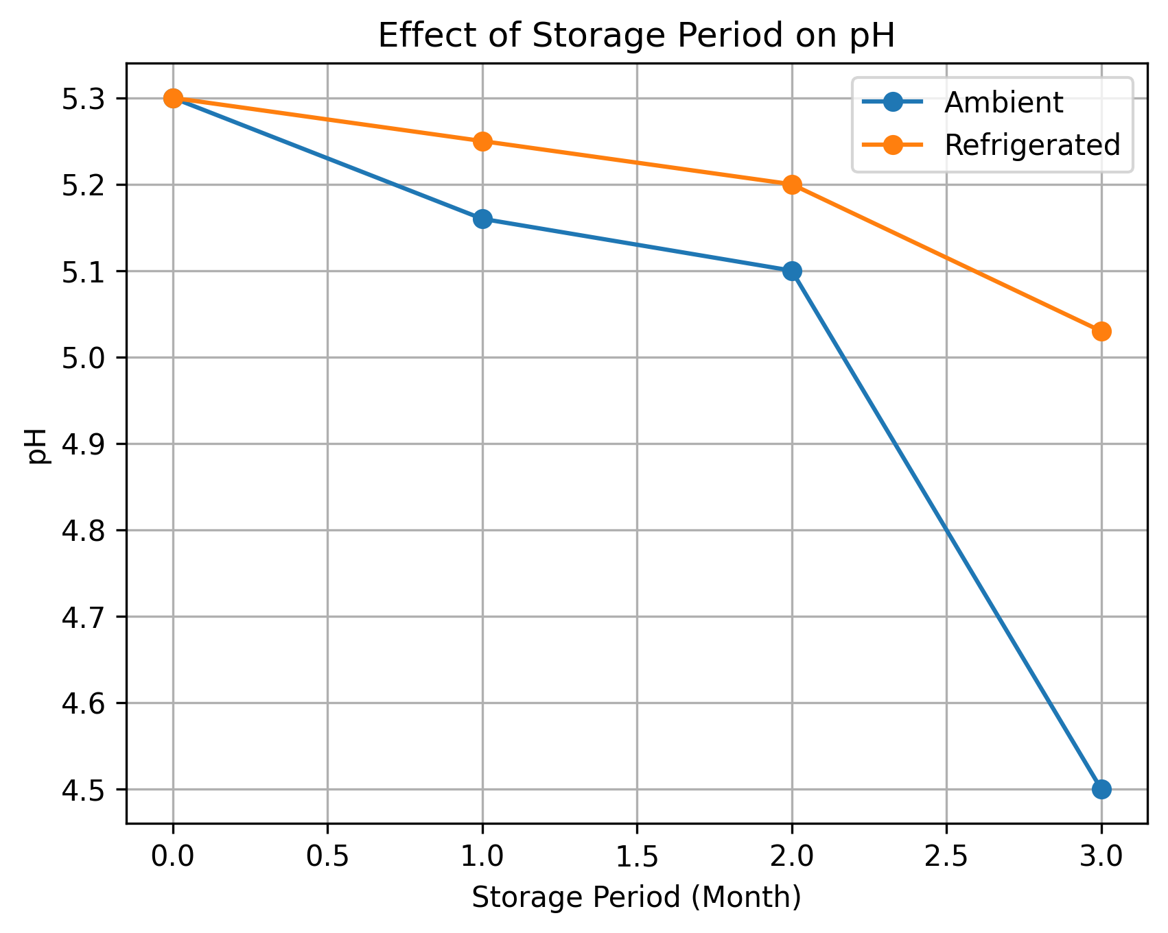
Figure 2. Effect of storage period on pH of Mahua RTS beverage under ambient and refrigerated conditions.
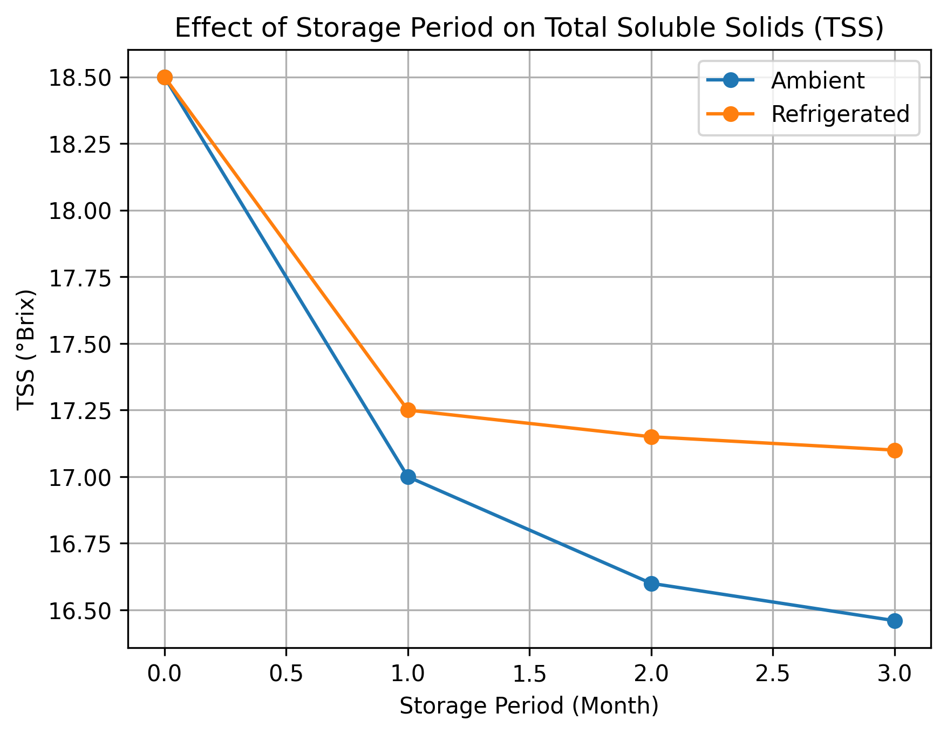
Figure 3. Effect of storage period on total soluble solids (°Brix) of Mahua RTS beverage under ambient and refrigerated conditions.

Mahua flower RTS beverage fortified with 12% Mint extract
The reducing sugars content of mahua RTS blended with Mahua + Mint 12 decreased from 190.05 to 179.39 mg/ml and to 179.20 mg/ml in the RTS beverages stored at ambient and refrigerated conditions, respectively. There was gradual decrease in pH as well as total soluble solids content of the RTS during the storage period in refrigerated conditions as compared to ambient conditions. The pH decreased from 5.30 to 4.80 in case of RTS blended with ginger @ 12 per cent after three months of storage at ambient, while it decreased to 4.40 in case of refrigerated conditions. The TSS decreased from 18.50 to 17.15°Brix at ambient and to 17.30°Brix at refrigerated storage of mahua RTS blended with ginger (Table 3).
Table 3 .Storage-induced quality alterations in mahua flower RTS beverage fortified with 12% Mint extract
Storage period (month) | Reducing sugars(mg/ml) | pH | TSS (°Brix)
Ambient conditions
0 | 190.05 ± 0.4 | 5.30 ± 0.05 | 18.50 ± 0.10
1 | 189.40 ± 0.27 | 5.26 ± 0.05 | 17.70 ± 0.11
2 | 185.05 ± 0.38 | 5.20 ± 0.05 | 17.25 ± 0.10
3 | 179.39 ± 0.27 | 4.80 ± 0.05 | 17.15 ± 0.05
Refrigerated conditions
0 | 190.05 ± 0.4 | 5.30 ± 0.05 | 18.50 ± 0.10
1 | 189.25 ± 0.40 | 5.26 ± 0.05 | 17.60 ± 0.05
2 | 185.40 ± 0.20 | 5.40 ± 0.15 | 17.55 ± 0.05
3 | 179.20 ± 0.18 | 4.40 ± 0.05 | 17.30 ± 0.05
CD (P = 0.05)
Month | 0.365 (± 0.12) | 0.082 (± 0.03) | 0.105 (± 0.03)
Storage condition | 0.230 (± 0.08) | 0.052 (± 0.02) | 0.068 (± 0.02)
Month x Storage condition | 0.516 (± 0.17) | 0.116 (± 0.04) | 0.148 (± 0.05)

Figure 4. Effect of storage period on Reducing sugars (mg/ml) of Mahua RTS beverage under ambient and refrigerated conditions.

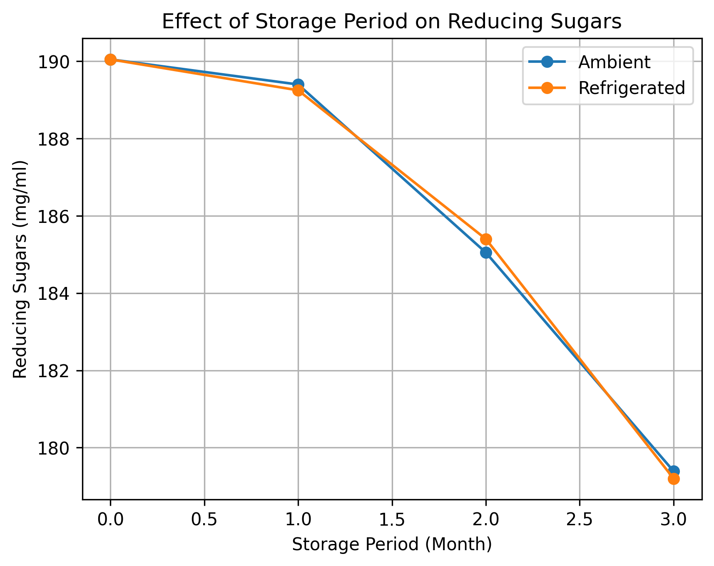
Figure 5. Effect of storage period on pH of Mahua RTS beverage under ambient and refrigerated conditions.

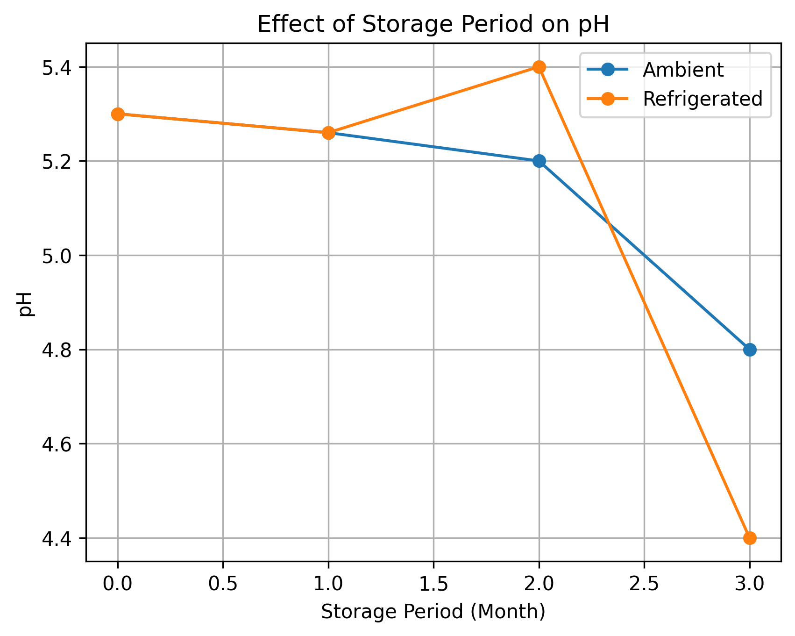
Figure 6. Effect of storage period on total soluble solids (°Brix) of Mahua RTS beverage under ambient and refrigerated conditions.
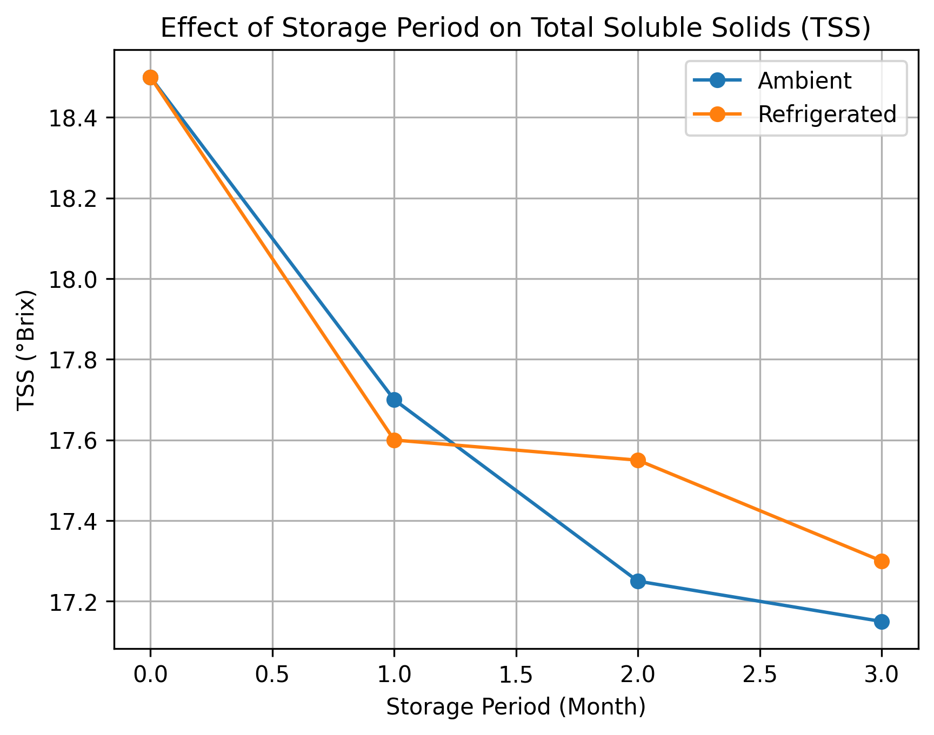
Microbial Analysis:
Microbial load was detected in ginger blended RTS at three month of storage at ambient conditions. Total bacterial count of mahua RTS blended with Ginger 7.5 was found to be log 5.36 cfu / ml and total fungal count was found to be log 4.83 cfu / ml. Samples of RTS blended with Mint12 were free from microbial contamination till three month of storage at ambient condition and total bacterial count was found to be log 5.54 cfu / ml and total fungal count was found to be 4.81 cfu / ml at three month of storage at ambient conditions. However, all the samples were free from microbial contamination till end of storage period at refrigerated condition.
Conclusion:
The biochemical composition of the mahua flower juice extract and the blending material (mint and ginger) utilized in this study may be the cause of this difference in the quality characteristics of the mahua flower juice-based RTS. Based on the findings, it can be observed that the RTS made from mahua flower juice and combined with ginger and mint significantly boosted the beverage's organoleptic acceptability. Compared to ginger, mint required a higher degree of mixing. The shelf-life of Mahua RTS combined with Mint12 was found to be superior to that of blended with Ginger7.5. Mahua RTS had a three-month shelf life when kept in a refrigerator.

COMPETING INTERESTS DISCLAIMER:
Authors have declared that they have no known competing financial interests OR non-financial interests OR personal relationships that could have appeared to influence the work reported in this paper.

Reference:
- Amerine, M. A., Pangborn, R. M., & Roessler, E. B. (1965). Principles of sensory evaluation of food. Academic Press.
- Chand, S., & Mahapatra, S. N. (1983). Production of sugar syrup from mahua (Madhuca latifolia) flowers. Research and Industry, 28, 81–83.
- Gomez, K. A., & Gomez, A. A. (1984). Statistical procedures for agricultural research (2nd ed.). Wiley.
- Hedge, J. E., & Hofreiter, B. T. (1962). Estimation of carbohydrate. In R. L. Whistler & J. N. BeMiller (Eds.), Methods in carbohydrate chemistry (pp. 17–22). Academic Press.
- Jayashree, B., Harishanker, N., & Rukmini, C. (1998). Chemical composition and biological evaluation of mahua flowers. Journal of Oil Technologists’ Association of India, 30, 170–172.
- Miller, G. L. (1972). Use of dinitrosalicylic acid reagent for determination of reducing sugar. Analytical Chemistry, 3, 426–428.
- Mishra, A., & Poonia, A. (2019). Mahua (Madhuca longifolia) flowers: Review on processing and biological properties. Nutrition & Food Science, 49(6), 1153–1163. https://doi.org/ (Add DOI if available)
- Patel, M. (2008). Biochemical investigations of fresh mahua (Madhuca indica) flowers for nutraceuticals [Doctoral dissertation, Institution name].
- Patel, M., & Naik, S. N. (2006). A study on the alternative uses of mahua flowers. In Proceedings of the International Conference on Molecules to Materials (pp. 203–206). SLIET, Longowal.
- Pinakin, D. J., Kumar, V., Kumar, A., Gat, Y., Suri, S., & Sharma, K. (2018). Mahua: A boon for pharmacy and food industry. Current Research in Nutrition and Food Science Journal, 6(2), 371–381.
- Purwar, S., Bisht, V., & Gupta, E. (2025). Mahua (Madhuca indica): The multifunctional tree of tradition and sustenance. In Fasting superfoods: Cultivation, nutrition & market potential (pp. 329–357). Springer Nature Singapore.
- Ramadan, M. F., Mohdaly, A. A. A., Assiri, A. M., Tadros, M., & Niemeyer, B. (2016). Functional characteristics, nutritional value and industrial applications of Madhuca longifolia seeds: An overview. Journal of Food Science and Technology, 53(5), 2149–2157.
- Rangana, S. (1986). Handbook of analysis and quality control for fruit and vegetable products (2nd ed.). Tata McGraw-Hill.
- Shrivastava, R. K., Swarnkar, S. K., & Bhutey, P. G. (1970). Decolorization and deodorization studies on mahua extract. Research and Industry, 15, 114–117.
- Sinha, J., Singh, V., Singh, J., & Rai, A. K. (2017). Phytochemistry, ethnomedical uses and future prospects of mahua (Madhuca longifolia) as a food: A review. Journal of Nutrition & Food Sciences, 7, 573.
- Sunita, M., & Sarojini, P. (2013). Madhuca longifolia (Sapotaceae): A review of its traditional uses and nutritional properties. International Journal of Humanities and Social Science Invention, 2(5), 30–36.
- Thangamani, D., Rajan, S. P., Karunamoorthi, J., & Lalitha, S. (2022). Spiritually significant natural resource of Madhuca longifolia (J. Koenig ex L.) J. F. Macbr.: Conservation and value-added products management. Pharma Innovation Journal, 11, 792–796.
- Yadav, P., Garg, N., & Dwivedi, D. (2012). Preparation and evaluation of mahua (Bassia latifolia) vermouth. International Journal of Food Fermentation Technology, 2(1), 57–61.

