Phytodiversity Documentation and Carbon Stock Assessment of Urban Green Space in Bilaspur

ABSTRACT
Urban green spaces (UGS) are vital "carbon stock" repositories and "lungs of the city" that mitigate urban heat and support psychological well-being. This study assessed plant diversity, biomass accumulation, and carbon storage across three urban parks in Bilaspur, Chhattisgarh: Bilasa Taal Vasundhara Udyan (BTVU), Energy Education (EE) Park, and Smriti Van (SV) Rajkishorenagar. Vegetation was analyzed using 56 quadrats (10×10 m²) per site to determine frequency, density, and Importance Value Index (IVI). A total of 67 plant species belonging to 28 families and 57 genera were documented. The flora was dominated by 56 tree species. EE Park exhibited the highest tree richness with 35 species and a density of 1208.76 stems ha⁻¹. BTVU followed with 30 species and a density of 1164 stems ha⁻¹, while SV Rajkishorenagar recorded 19 trees and a density of 908.31 stems ha⁻¹. However, total tree basal cover followed the opposite order; SV Rajkishorenagar recorded the highest at 105.04 m² ha⁻¹, compared to 71.95 m² ha⁻¹ at BTVU and 48.77 m² ha⁻¹ at EE Park. Diversity indices varied significantly; the Shannon index ($H'$) for tree layers was highest at EE Park at 3.60 and lowest at SV Rajkishorenagar at 2.81. Beta diversity ($βd$) was highest at SV Rajkishorenagar at 3.53, indicating high species turnover. Biomass and carbon stock analysis revealed that trees are the primary contributors. SV Rajkishorenagar recorded the highest average total tree biomass at 1184.18 t ha⁻¹, followed by BTVU at 1015.17 t ha⁻¹ and EE Park at 662.91 t ha⁻¹. Correspondingly, carbon storage was maximum at SV Rajkishorenagar at 497.41 t ha⁻¹, with branches at 226.97 t ha⁻¹ and roots at 133.40 t ha⁻¹ storing the largest shares. BTVU stored 425.62 t ha⁻¹ of carbon, while EE Park stored 277.54 t ha⁻¹. These findings demonstrate that mature urban stands in Bilaspur provide sequestration services comparable to tropical forests, offering critical data for sustainable urban planning and greenhouse gas mitigation.
Keywords: carbon sequestration, biomass, carbon, diversity, climate mitigation.
1. INTRODUCTION
Urban green spaces (UGS) are widely recognized for their ability to support mental health and psychological well-being. These spaces provide a break from urban stressors, reduce anxiety, and foster emotional restoration (Tigga et al., 2025). Urban green spaces (UGS) serve as "carbon stock" repositories and the "lungs of the city." A significant quantity of carbon is sequestered and stored by the plant patches surrounding metropolitan areas (Strohbach and Haase 2012). By restoring ecological flow in urban areas and strengthening sustainable urbanization with stimulated economic growth and improved environment (Frantzeskaki 2019), UGS offer a wide range of ecosystem benefits (Kabisch 2015). Additionally, by applying nature-based solutions, urban vegetation can generate co-benefits (Nesshover et al., 2017).
Urban heat islands, the proliferation of built-in areas, concrete, masonry, and tarmac, as well as the rising frequency of extreme heat events and climate change, are all contributing factors to cities' rapid urbanization, according to (Singh et al., 2020). Increasing urbanization can significantly influence regional carbon dynamics and is a significant contributor to environmental change worldwide (Pataki et al., 2006).
India has experienced extraordinary urbanization and population expansion in recent decades, according to (Singh et al., 2019). India's urban centers expanded from 5161 classified towns and 384 urban agglomerations in 2001 to 7935 classified towns and 475 urban agglomerations in 2011, making it the world's second largest urban system. The country's overall population grew by 17.64% between 2001 and 2011 (Majumdar and Selvan, 2018). According to (Nowak et al., 2013), urban areas in the contiguous United States grew from 2.5% of the country's land area (19.5 million ha) in 1990 to 3.1% (24.0 million ha) in 2000. By 2050, urban land is expected to account for 8.1% of total land area if the 1990s development trends continue. Although the negative consequences of urbanization, urban trees can reduce urban heat and its detrimental effects on energy use, human health, and urban infrastructure (Wang et al., 2019).
The understory plant layer is significant and varied from an ecological, social, and economic perspective. According to earlier reports, understory vegetation serves a variety of diverse purposes, such as preventing soil erosion (Casermeiro et al., 2004), promoting regeneration, offering food and habitat for wildlife, and shielding edible plants from large herbivores (Baraza et al., 2006).
Vegetation in urban environments must be properly managed as a CO2 absorber. These trees in urban areas positively affect climate change but often receive less attention because their ecosystem services are poorly understood or not quantified. An area’s carbon sink is obtained from the production of biomass density and tree species (Dharmawan and Samsoedin 2012; Krisnawati et al., 2021).
Estimating biomass and carbon content in green open spaces still needs to be carried out. It is needed because the potential of biomass plays a very important role in absorbing carbon. Furthermore, green open space reduces CO2 levels through conservation and management (Heriyanto and Subiandono 2012; Onrizal and Kusmana 2009; Subiandono et al., 2013). In the clean development mechanism, developed countries must reduce carbon dioxide (CO2) emissions. In contrast, developing countries, which are generally located in tropical areas, are required to prevent forest destruction to reduce global warming (Astiani et al., 2017; Lugina et al., 2011). This study aims to determine the types of trees planted in the green open space of Bilasa Taal, Vasundhara Udyan, Energy Education Park, Bilaspur, Chhattisgarh and their contribution in storing carbon indicate the ability of plants to absorb CO2. The research results are expected to become recommendations for developing green open spaces in industrial areas, among others, by selecting tree species capable of absorbing greenhouse gas emissions.
Urban Forestry is the art, science, and technology of managing trees and forest resources in and around urban community ecosystems for the physical, sociological, economic, and aesthetic benefits trees provide society (Helms 1998). The world is fast becoming an urban place as nearly two third of the world’s population is expected to live in urban areas by 2025 (Schell and Ulijaszek 1999).
2. MATERIAL AND METHODS
2.1 Study Area
The study site is located in the plains areas of terrain zone of Bilaspur with an elevation of 264 m above the mean sea level. It is located at the Bilaspur city, Chhattisgarh with 22° 4' 43.1112'' N latitude and 82° 9' 8.3808'' E Longitude. The climate of the Bilaspur is tropical wet and dry climate. Overall climate of the area is sub-tropical humid in nature. In general, the maximum temperature is recorded in May whereas lowest temperature in January. The total annual rainfall received was about 580 mm of which about 80 % of the total rainfall was recorded during July to September and relative humidity ranged from about 77 to 82 %. The summer and winter temperature are mild with highest of 42.40C during May and lowest of 11.60C during January. Consequently, the area is warm and humid except a sort spell of winter extending from December to February.
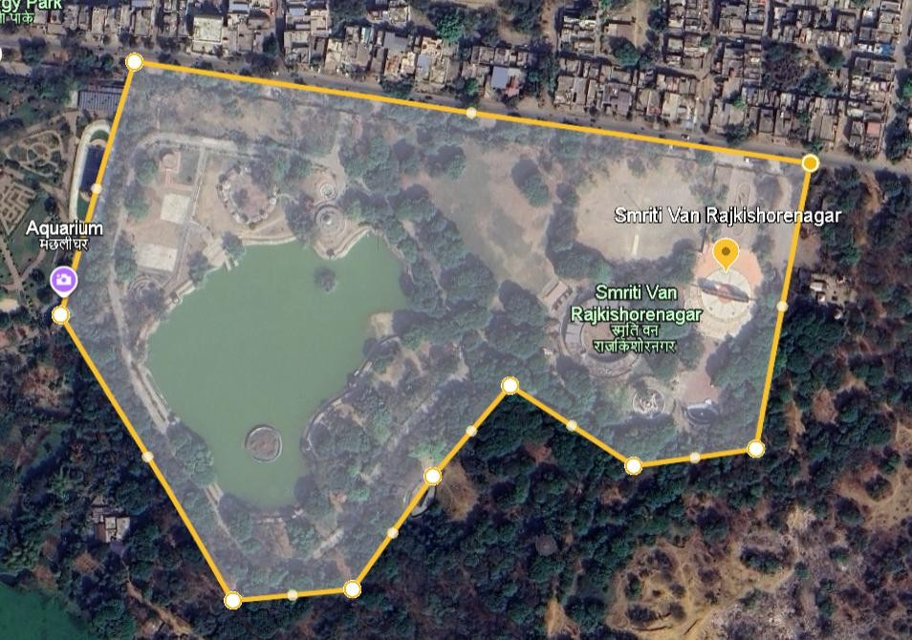
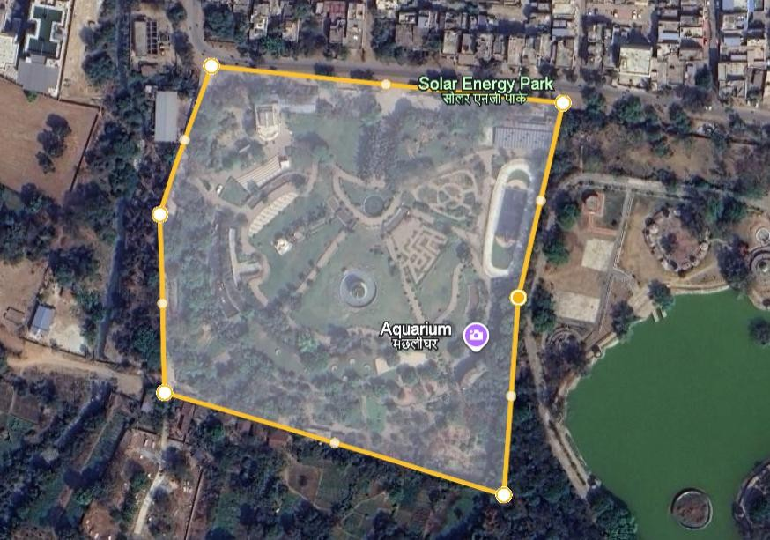
Photo 1. Smriti Van Park (Courtesy Google Map)
Photo 2. Solar Energy Park [Courtesy Google Map]

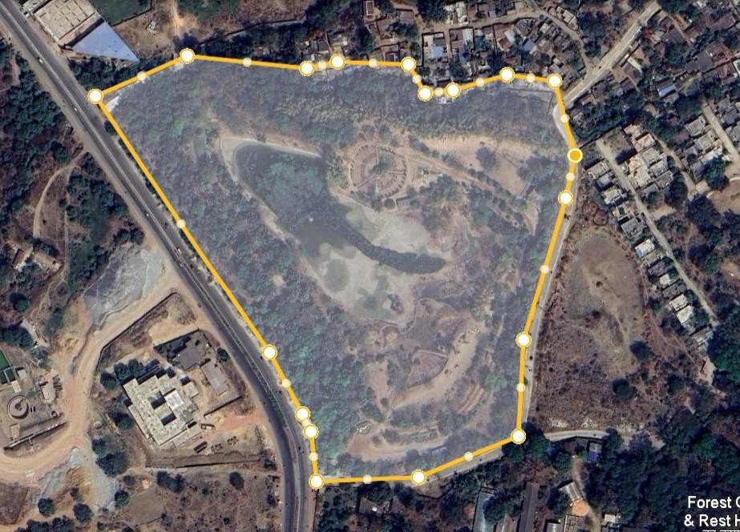
Photo 3. BilasaTaal Vasundhara Udyan [Courtesy Google Map]
2.2 Methods of data collection and analysis
The park vegetation was analyzed using approximately 56 quadrats (each 10×10 m² in size). Girth at breast height (GBH) of trees was measured at 1.37 m on trunk of trees. The vegetation data was quantitatively analyzed for frequency, density and abundance (Curtis and McIntosh, 1950). An importance value was calculated as the sum total of relative frequency, relative density, and relative dominance (Phillips, 1959). Species diversity indices for tree layers were determined, using basal cover values from Shannon-Wiener information function (Shannon and Weaner, 1963). Concentration of dominance was measured by Simpson’s index (Simpson, 1949), species richness following Margalef (Margalef, 1958), equitability following Pielou (Pielou, 1966), and beta diversity following Whittaker (Whittaker, 1972). The phytodiversity documentation of Urban Park was evaluated through Linear and quadrate sampling by selecting three different park, with a total of approximately fifty six linear/quadrates in every site.
2.3 Estimation of biomass and carbon Carbon Stock Estimation
For the measurement of tree biomass, regression equations relating tree circumference to biomass developed by Singh and Mishra (1979) and computation protocols described by Singh and Singh (1991) were used in brief, the mean GBH value for each species for a girth class will be used in the regression equations to get an estimate of biomass (by component) for that girth class. This value then will be multiplied by the density of trees or shrubs in that girth class. The estimate will be averaged across to obtain the mean estimate for the sites. For the estimation of carbon stock and sequestration carbon concentration measured earlier by Singh (2010) was used.
3. Results and Discussion
3.1 Plant Diversity
A total of 67 plant species were documented from the three sites which was represented by 28 families and 57 genera. Tree with 56 species (23 families and 51 genera) dominated the list followed by shrubs with 11 species (7 families and 11 genera). Similar comparable species richness of 84 plant species from green spaces of Nairobi (Nyambane et al., 2016) and 80 plant species from urban parks in Bangaluru, India (Nagendra and Gopal, 2010a) was reported. The present study also demonstrated that among the urban green spaces, parks were the most diverse with higher species richness (Nielsen et al., 2013; Nyambane et al., 2016).
The phytodiversity documentation of Urban Parks showed that Bilasa Taal Vasundhara Udyan recorded a total of 33 species consisting of 30 trees and 3 shrubs, Energy education park 41 species including 35 trees and 6 shrubs. Smriti van Rajkishorenagar accounted for 23 species with 19 trees and 4 shrubs.

Fig. 1. Total numbers of phytodiversity recorded at different Park
Table 1. Diversity parameter on three study sites
Parameter | Bilasa Taal Vasundhara Udyan |  |  |  | Energy Education Park |  |  |  | Smriti Van Rajkishorenagar
 | T | Sa | Sh | Se | T | Sa | Sh | Se | T | Sa | Sh | Se
Species richness (d) | 15.62 | 1.54 | 1.85 | 2.17 | 20.14 | 5.29 | 3.19 | 3.92 | 8.90 | 0.72 | 3.32 | 3.13
Shannon index (H) | 3.37 | 0.08 | 1.22 | 0.08 | 3.60 | 0.13 | 2.65 | 7.94 | 2.81 | 2.96 | 0.24 | 0.12
Concentration of dominance (cd) | 0.19 | 0.35 | 0.39 | 0.25 | 0.14 | 0.16 | 0.35 | 0.16 | 0.25 | 0.85 | 0.28 | 0.22
Species evenness index (EI) | 2.28 | 0.16 | 2.55 | 0.14 | 2.33 | 0.15 | 3.40 | 9.40 | 2.20 | 9.84 | 0.40 | 0.17
Beta diversity (βd) | 2.23 | 22.33 | 22.33 | 16.75 | 1.91 | 8.38 | 11.17 | 9.57 | 3.53 | 33.5 | 16.75 | 13.4
Note: T- tree; Sa- sapling; Sh- shrub; Se-seedling

3.2 Shannon index (H’)
There was inequality in the Shannon index value between sites and within sites for different plant life forms. The Shannon index for tree layers was highest at EE Park (3.60), followed by BTVU (3.37) and SV Rajkishorenagar (2.81). It was 2.96 at the SV Rajkishorenagar, 0.13 at EE park, and 0.08 at BTVU for the sapling layer. However, it was highest 7.94 at EE park, 0.12 at SV rajkishorenagar and 0.08 at BTVU for the seedling layer. The Shannon index value for the shrub layer was highest on EE park (2.65), followed by BTVU (1.22) and SV rajkishorenagar (0.24).
3.3 Simpson’s index (Cd)
The concentration of dominance values for the trees layer was highest at the SV rajkishorenagar (0.25) followed by BTVU (0.19) and EE park (0.14). However, it was highest under SV rajkishorenagar (0.85) for the sapling layer followed by the BTVU and EE park with 0.35 and 0.16 and it was (0.25) at BTVU, (0.22) SV rajkishorenagar and (0.16) at EE park for the seedling layer, respectively. It was highest at the BTVU (0.39) followed by the EE park (0.35) and the SV rajkishorenagar (0.28) for the shrub layer.

3.4 Species richness (d)
The species richness values calculated for tree layers were highest at the EE park (20.14) followed by the BTVU (15.62) and SV rajkishorenagar (8.90). Whereas the value of richness was highest at the EE park with (5.29) for the sapling layer followed by BTVU (1.54) and SV rajkishorenagar (0.72). The Species richness for seedling layer was EE park (3.92), followed by SV rajkishorenagar (3.13) and BTVU (2.17). The shrub layer was highest on SV rajkishorenagar (3.32), followed by EE park (3.19) and BTVU (1.85).
3.5 Species evenness index (EI)
The equitability values for the tree layer were highest at EE park (2.33) followed by the BTVU (2.28) and SV rajkishorenagar (2.20). It was highest at the SV rajkishorenagar (9.84) followed by the BTVU and EE park with 0.16 and 0.15 for the sapling layer. It was (9.40) at the EE park, 0.17 at SV rajkishorenagar and (0.14) at BTVU for the seedling layer. And for the shrub layer was highest at the EE park with 3.40 followed by the BTVU with 2.55 and lowest at the SV rajkishorenagar with 0.40.

3.6 Beta diversity (βd)

The Whittaker style total turnover (T) was lowest at Energy Education Park (T = 1.91), intermediate at Bilasa Taal Vasundhara Udyan (T = 2.23), and highest at Smriti Van Rajkishorenagar (T = 3.53). The subcomponents showed similar contrasts: Sa (interpreted here as a species-turnover component) was 22.33 at Bilasa Taal, 8.38 at Energy Education Park, and 33.50 at Smriti Van; Sh and Se followed the same pattern (Sh: 22.33, 11.17, 16.75; Se: 16.75, 9.57, 13.40 respectively).
Locally, earlier work on Bilaspur has documented spatial variation in tree composition and green space structure across the city (Singh & Tiwari, 2022), supporting the idea that different parks in Bilaspur can host markedly different assemblages depending on planting history, maintenance, and habitat features (Singh & Tiwari, 2022). Species richness of a disturbed site is a sum of species' responses. Some species may survive disturbances while others vanish (Sagar et al. 2003).
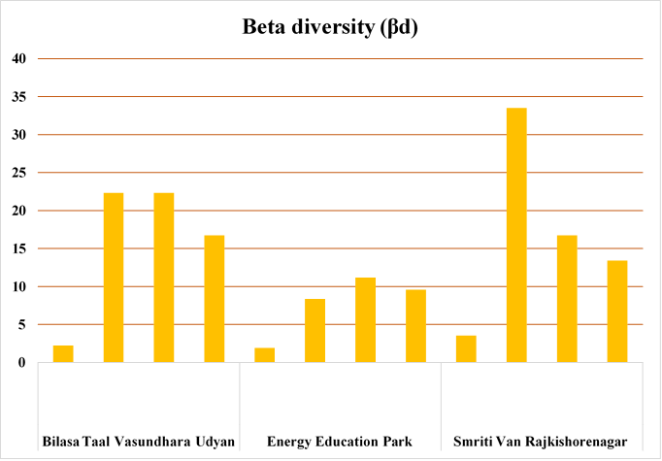
Fig. 2. Beta (β) Diversity (vegetation)
3.7 Vegetation analysis
The parameters for vegetation analysis i.e. frequency, relative frequency, density, relative density, abundance, relative abundance, important value index (IVI). The site-wise details are as follows:
3.7.1 Tree Layer
A total of 67 species belonging to 28 families were identified on all the three sites. Out of 56 identified tree species, 56 tree species belonging to 23 families were found in the park layer. Thirty-five tree species were found as top canopy at highly disturbed park with the highest tree density of 1208.76 stems ha-1, 30 tree species with a density of 1164 stems ha-1 at BTVU park and sixteen species at SV Rajkishore nagar with 908.31 stems ha-1 tree density. Frequency (%), density (stem ha-1), basal area (m2 ha-1), and IVI for tree layer are given in Table 2. Total tree basal cover followed the order; SV Rajkishorenagar (105.04 m2 ha-1) > BTVU (71.95 m2 ha-1) > EE park (48.77 m2 ha-1). Analysis of variance indicated that the basal area at three sites were significantly different (p<0.05). The total density of tree layer also followed the opposite order as for tree basal cover being highest at EE park (1208.76 stem ha- 1), followed by BTVU (1164 stem ha 1) and SV rajkishorenagar (908.31 stem ha-1). The top story of vegetation was dominated by the Roystonea regia on BTVU, by Roystonea regia on EE park and Peltophorum pterocarpum and Dalbergia sissoo on SV rajkishorenagar. A/F ratio (Table 2) indicated that at least disturbed species Alstonia scholaris, Syzgium cumini and Ficus religiosa. Mangifera indica, Bombax ceiba, Butea monosperma was contiguously distributed while at BTVU it was regularly distributed. Most of the species present at EE park were contiguously distributed.
3.7.2 Sapling layer
Total sapling Abundance cover followed the order; EE park (109.5 m2 ha-1) > SV rajkishorenagar (7.5 m2 ha-1) > BTVU (5.33 m2 ha-1). The total sapling density was maximum on SV rajkishorenagar with (4600 stem/ha) and EE park and BTVU density was (2525 stem/ha) and (2775 stem/ha). Analysis of variance indicated that the Abundance and density of sapling layer at three sites were significantly different (p<0.05). A/F ratio (Table 4) indicated that at least disturbed Ficus benghaleensis and Manginfera indica are regularly distributed, Morus, Mangnolia champaca, Alstonia Scholaris are randomly distributed, and Azadirachta indica and Aesculus chinensis are contiguously distributed. Whereas all the species present at EE park were contiguously distributed. Plumeria alba was regularly distributed at SV rajkishorenagar and Mangifera indica was randomly distributed, whereas all other species were contiguously distributed.
3.7.3 Seedling layer
Seedlings of 9 tree species belonging to 6 families were identified in all three sites. Frequency (%), density (stem/ha), and IVI of seeding layer are given in (Table 5). The total seedling density was maximum (42,700 stem ha-1) at EE park and minimum at SV rajkishorenagar (27,100 stem ha-1). Analysis of variance indicated significant difference for seedling density form site to site. A/F ratio indicated the contiguous distribution pattern of seedling of all the species.
3.7.4 Shrub layer
A total of 11 shrub species belonging to 7 families were estimated on all the three sites. Frequency (%), density (stems ha-1), Abundance (m2 ha-1) and IVI for shrub layer in Urban green spaces under study sites are given in Table 5. Total Abundance for shrub layer followed the order: EE park (22.15 m2 ha-1) > SV rajkishorenagar (5.5 m2 ha-1)> BTVU (4.83 m2 ha-1). The density of shrub layer was maximum (1452 stems ha-1) on EE park and minimum (220.11 stems ha-1) on BTVU. Analysis of variance indicated that the Abundance at three sites were significantly different (p<0.05). Based on A/F ratio the distribution pattern for the species present at BTVU was random for Bambusa bambos, bougainvillea buttiana and for Canavalia ansiforms it was regular. For species present at EE park it was regular for Bambusa bambos and bougainvillea buttiana and it was contiguous for Bambusa bambos and Plumeria obtusa. At SV rajkishorenagar the distribution pattern was contiguous for all the species i.e., Cassia tora, cassian opaca, narium oleander, thevetia peruviana.

Table 2. Species structure of the three study sites (Tree layer)

SITE 1 |  |  |  |  |  |  |  |  |  | SITE 2 |  |  |  | SITE 3
S.  No. | Species | F(%) |  | D  (Stems ha⁻¹) | BA  (m² ha⁻1) | IVI | A/F | F(%) | D  (Stems ha⁻¹) | BA  (m² ha⁻¹) | IVI | A/F | F(%) | D  (Stems ha⁻¹) | BA  (m² ha⁻¹) | IVI | A/F
1 | Acacia sensu lato | 5.56 |  | 6 | 0.34 | 2.07 | 0.18
2 | Aegle marmelos | 5.56 |  | 17 | 0.26 | 2.92 | 0.54 | 9.52 | 14 | 0.2 | 3.51 | 0.16
3 | Aesculus chinensis |  |  |  |  |  |  | 19.05 | 90 | 1.07 | 13.49 | 0.25
4 | Albizia julibrissin | 5.56 |  | 6 | 0.27 | 1.98 | 0.18
5 | Alstonia scholaris | 50 |  | 61 | 2.06 | 18.24 | 0.02 | 14.29 | 38 | 1.06 | 8.2 | 0.19
6 | Arecaceae |  |  |  |  |  |  |  |  |  |  |  | 7.69 | 8 | 0.84 | 3.5 | 0.13
7 | Azadirachta indica | 33.33 |  | 61 | 1.77 | 14.46 | 0.05 | 14.29 | 14 | 0.44 | 4.96 | 0.07 | 30.77 | 62 | 3.44 | 17.33 | 0.06
8 | Bauhinia | 5.56 |  | 11 | 0.89 | 3.32 | 0.36
9 | Bombax ceiba | 5.56 |  | 17 | 1.3 | 4.37 | 0.54 | 33.33 | 76 | 6.65 | 26.64 | 0.07 | 15.38 | 38 | 3.44 | 11.11 | 0.16
10 | Bougainvillea spectabilis |  |  |  |  |  |  |  |  |  |  |  | 15.38 | 0.31 | 1.93 | 8.86 | 0.13
11 | Buchanania lanzan | 5.56 |  | 6 | 0.09 | 1.73 | 0.18
12 | Butea monosperma | 16.67 |  | 28 | 0.32 | 6.21 | 0.10 | 4.76 | 5 | 0.05 | 1.46 | 0.21 | 7.69 | 31 | 0.34 | 5.46 | 0.52
13 | Careya arborea | 5.56 |  | 17 | 0.26 | 2.92 | 0.54
14 | Cassia fistula | 16.67 |  | 28 | 1.49 | 7.83 | 0.10 | 19.05 | 71 | 1.37 | 12.54 | 0.20 | 7.69 | 8 | 0.44 | 3.12 | 0.13
15 | Chrysophyllum oliviforme |  |  |  |  |  |  |  |  |  |  |  | 7.69 | 8 | 0.8 | 3.46 | 0.13
16 | Citrus limetta |  |  |  |  |  |  | 4.76 | 5 | 0.08 | 1.52 | 0.21
17 | Cocos nucifera | 11.11 |  | 167 | 8.58 | 28.53 | 1.35
18 | Cordia dichotoma | 5.56 |  | 6 | 0.07 | 1.7 | 0.18
19 | Dalbergia sissoo | 16.67 |  | 22 | 1.5 | 7.37 | 0.08 | 57.14 | 110 | 4.92 | 30.65 | 0.03 | 61.54 | 192 | 12.99 | 47.7  9 | 0.05
20 | Delonix regia | 33.33 |  | 83 | 5.45 | 21.5 | 0.08 | 14.29 | 14 | 0.65 | 5.39 | 0.07 | 7.69 | 0.0008 | 0.25 | 2.94 | 0.13
21 | Elaeocarpus ganitrus |  |  |  |  |  |  | 4.76 | 5 | 0.08 | 1.5 | 0.21
22 | Eucalyptus |  |  |  |  |  |  |  |  |  |  |  | 23.08 | 69 | 5.58 | 18.29 | 0.13
23 | Ficus auriculata |  |  |  |  |  |  | 4.76 | 38 | 0.37 | 4.86 | 1.68
24 | Ficus benghalensis | 16.67 |  | 17 | 1.63 | 7.07 | 0.06 | 14.29 | 43 | 3.57 | 13.73 | 0.21 | 30.77 | 62 | 5.87 | 19.64 | 0.06
25 | Ficus benjamina | 11.11 |  | 33 | 0.34 | 5.59 | 0.27
26 | Ficus racemosa | 5.56 |  | 6 | 0.07 | 1.7 | 0.18
27 | Ficus religiosa | 16.67 |  | 33 | 3.98 | 11.77 | 0.12 | 9.52 | 10 | 0.15 | 3.01 | 0.11 | 38.46 | 54 | 6.55 | 21.36 | 0.04
28 | Gmelina arborea |  |  |  |  |  |  | 19.05 | 29 | 0.44 | 7.1 | 0.08
29 | Hura crepitans |  |  |  |  |  |  | 4.76 | 14 | 1.86 | 5.95 | 0.63
30 | Litchi chinensis |  |  |  |  |  |  | 4.76 | 5 | 0.05 | 1.46 | 0.21
31 | Lonchocarpus | 5.56 |  | 6 | 0.11 | 1.75 | 0.18
32 | Magnolia champaca |  |  |  |  |  |  | 9.52 | 14 | 0.23 | 3.57 | 0.16
33 | Mangifera indica | 22.22 |  | 28 | 3.38 | 11.6 | 0.06 | 9.52 | 19 | 1.44 | 6.44 | 0.21 | 30.77 | 38 | 3 | 14.47 | 0.04
34 | Millettia pinnata | 27.78 |  | 61 | 1.24 | 12.6 | 0.08 | 9.52 | 10 | 0.18 | 3.08 | 0.11
35 | Moringa oleifera |  |  |  |  |  |  | 9.52 | 33 | 0.35 | 5.39 | 0.37
36 | Morus |  |  |  |  |  |  | 28.57 | 100 | 0.82 | 15.69 | 0.12
37 | Murraya koenigii |  |  |  |  |  |  | 4.76 | 14 | 0.15 | 2.45 | 0.63
38 | Neolamarckia cadamba |  |  |  |  |  |  | 23.81 | 52 | 3.67 | 16.65 | 0.09
39 | Nerium oleander |  |  |  |  |  |  |  |  |  |  |  | 7.69 | 15 | 0.15 | 3.66 | 0.26
40 | Nyctanthes arbor-tristis |  |  |  |  |  |  | 4.76 | 5 | 0.07 | 1.5 | 0.21
41 | Peltophorum dubium |  |  |  |  |  |  |  |  |  |  |  | 30.77 | 38 | 2.66 | 14.14 | 0.04
42 | Peltophorum pterocarpum | 22.22 | 44 |  | 3.62 | 13.35 | 0.09 |  |  |  |  |  | 38.46 | 169 | 48.62 | 73.61 | 0.11
43 | Phyllanthus emblica | 11.11 | 28 |  | 0.52 | 5.36 | 0.23 | 23.81 | 95 | 0.88 | 14.46 | 0.17
44 | Pithecellobium dulce |  |  |  |  |  |  | 4.76 | 10 | 0.14 | 2.03 | 0.42
45 | Plumeria alba |  |  |  |  |  |  | 4.76 | 4.76 | 0.1 | 1.95 | 0.42 | 7.69 | 23 | 0.18 | 4.5 | 0.39
46 | Prosopis cineraria |  |  |  |  |  |  |  |  |  |  |  | 30.77 | 85 | 7.84 | 23.95 | 0.09
47 | Prunus dulcis | 11.11 | 11 |  | 0.15 | 3.41 | 0.09 | 4.76 | 10 | 0.15 | 2.05 | 0.42
48 | Psidium guajava | 22.22 | 33 |  | 0.1 | 7.5 | 0.07 | 9.52 | 14 | 0.11 | 3.33 | 0.16
49 | Robinia pseudoacacia | 5.56 | 6 |  | 0.28 | 1.99 | 0.18
50 | Roystonea regia | 27.78 | 211 |  | 28.21 | 63.01 | 0.27 | 28.57 | 114 | 15.33 | 46.61 | 0.14
51 | Santalum album |  |  |  |  |  |  | 4.76 | 5 | 0.05 | 1.46 | 0.21
52 | Saraca asoca |  |  |  |  |  |  | 19.05 | 33 | 0.43 | 7.47 | 0.09
53 | Senna siamea | 22.22 | 44 |  | 2.8 | 12.21 | 0.09
54 | Syzygium cumini | 44.44 | 67 |  | 0.87 | 15.94 | 0.03 | 33.33 | 71 | 1.26 | 15.2 | 0.06
55 | Vachellia nilotica |  |  |  |  |  |  | 9.52 | 24 | 0.4 | 4.7 | 0.26 | 7.69 | 8 | 0.12 | 2.81 | 0.13
56 | TOTAL | 494.49 | 1164 |  | 71.95 | 300 | 6.48 | 495.2 | 1208.76 | 48.77 | 300 | 8.83 | 407.67 | 908.31 | 105.04 | 300 | 2.75
Note: F- Frequency; D - Density; BA - Basal Area; IVI - Importance Value Index; A/F- Abundance to frequency ratio

Table 3. Species structure of the three study sites (Sapling layer)

 |  |  |  | SITE 1 |  |  |  |  | SITE 2 |  |  |  | SITE 3
S.  No. | Species | F(%) | D  (Stems ha⁻¹) | A (m²  ha⁻¹) | IVI | A/F | F(%) | D  (Stems ha⁻¹) | A (m²  ha⁻¹) | IVI | A/F | F(%) | D  (Stems ha⁻¹) | A (m²  ha⁻¹) | IVI | A/F
1 | Aesculus chinensis |  |  |  |  |  | 4.76 | 600 | 100 | 65.98 | 1.05
2 | Alstonia scholaris |  |  |  |  |  | 9.52 | 475 | 2 | 48.23 | 0.21
3 | Azadirachta indica |  |  |  |  |  | 4.76 | 250 | 2 | 31.01 | 0.42
4 | Dalbergia sissoo | 16.67 | 975 | 2.33 | 103.75 | 0.14
5 | Ficus benghalensis | 27.78 | 700 | 1 | 85.42 | 0.04
6 | Limonia acidissima |  |  |  |  |  | 14.26 | 350 | 1 | 44.26 | 0.07
7 | Magnolia champaca |  |  |  |  |  | 4.76 | 125 | 1 | 19.35 | 0.21
8 | Mangifera indica | 22.22 | 1100 | 2 | 110.83 | 0.09 | 9.52 | 250 | 1 | 31.8 | 0.11
9 | Morus |  |  |  |  |  | 4.76 | 125 | 1 | 19.35 | 0.21
10 | Phyllanthus emblica |  |  |  |  |  | 9.52 | 350 | 1.5 | 40.02 | 0.16
11 | Plumeria alba |  |  |  |  |  |  |  |  |  |  | 30.77 | 4225 | 5.5 | 245 | 0.18
12 | Prunus dulcis |  |  |  |  |  |  |  |  |  |  | 7.69 | 375 | 2 | 55 | 0.26
 | TOTAL | 66.67 | 2775 | 5.33 | 300 | 0.27 | 61.86 | 2525 | 109.5 | 300 | 2.43 | 38.46 | 4600 | 7.5 | 300 | 0.44
Note: F- Frequency; D - Density; BA - Basal Area; IVI - Importance Value Index; A/F- Abundance to frequency ratio

Table 4. Species structure of the three study sites (Seedling layer)

 |  |  |  | SITE 1 |  |  |  |  | SITE 2 |  |  |  |  | SITE 3
S.  No. | Species | F(%) | D  (Stems ha⁻¹) | A  (m² ha⁻¹) | IVI | A/F | F(%) | D  (Stems ha⁻¹) | A  (m² ha⁻¹) | IVI | A/F | F(%) | D  (Stems ha⁻¹) | A  (m² ha⁻¹) | IVI | A/F
1 | Aegle marmelos |  |  |  |  |  | 25 | 3800 | 1.5 | 31.04 | 0.06
2 | Butea monosperma | 62.5 | 7500 | 1.2 | 75.35 | 0.02
3 | Dalbergia sissoo |  |  |  |  |  |  |  |  |  |  | 57.14 | 7100 | 1.25 | 73.4 | 0.02
4 | Ficus benghalensis |  |  |  |  |  | 37.5 | 5000 | 1.33 | 37.33 | 0.04 | 42.86 | 5700 | 1.33 | 62.23 | 0.03
5 | Ficus religiosa |  |  |  |  |  | 50 | 6300 | 1.25 | 44.33 | 0.025 | 28.57 | 2900 | 1 | 39.63 | 0.04
6 | Mangifera indica |  |  |  |  |  |  |  |  |  |  | 42.86 | 7100 | 1.67 | 72.44 | 0.04
7 | Millettia pinnata | 37.5 | 8800 | 2.33 | 85.05 | 0.06 | 12.5 | 2500 | 2 | 27.57 | 0.16
8 | Neolamarckia cadamba |  |  |  |  |  | 62.5 | 8800 | 1.4 | 56.25 | 0.02
9 | Phyllanthus emblica | 50 | 6300 | 1.25 | 65.73 | 0.03
10 | Psidium guajava | 50 | 7500 | 1.5 | 73.87 | 0.03
11 | Santalum album |  |  |  |  |  | 37.5 | 7500 | 2 | 48.86 | 0.05
12 | Saraca asoca |  |  |  |  |  | 37.5 | 8800 | 2.33 | 54.62 | 0.06
13 | Vachellia nilotica |  |  |  |  |  |  |  |  |  |  | 28.57 | 4300 | 1.5 | 52.3 | 0.05
 | TOTAL | 200 | 30100 | 6.28 | 300 | 0.14 | 262.5 | 42700 | 11.81 | 300 | 0.42 | 200 | 27100 | 6.75 | 300 | 0.18
Note: F- Frequency; D - Density; BA - Basal Area; IVI - Importance Value Index; A/F- Abundance to frequency ratio

Table 5. Species structure of the three study sites (Shrubs)

SITE 1 |  |  |  |  |  |  |  | SITE 2 |  |  |  |  | SITE 3
S.  No. | Species | F(%) | D (Stems ha⁻¹) | A (m²  ha⁻¹) | IVI | A/F | F(%) | D  (Stems ha⁻¹) | A (m²  ha⁻¹) | IVI | A/F | F(%) | D  (Stems ha⁻¹) | A (m²  ha⁻¹) | IVI | A/F
1 | bambusa bambos | 22.22 | 132 | 1.5 | 131.03 | 0.07 | 14.29 | 800 | 14 | 130.97 | 0.98
2 | bougainvillea buttiana | 16.67 | 88 | 1.33 | 98.42 | 0.08 | 19.05 | 96 | 1.25 | 28.9 | 0.07
3 | canavalia ensiforms | 5.56 | 0.11 | 2 | 70.55 | 0.36
4 | Cassia Tora |  |  |  |  |  |  |  |  |  |  | 7.69 | 60 | 2 | 78.03 | 0.26
5 | Cassian Opaca |  |  |  |  |  |  |  |  |  |  | 15.38 | 60 | 1 | 76.52 | 0.07
6 | cestrum nocturnum |  |  |  |  |  | 19.05 | 116 | 1.5 | 31.33 | 0.08
7 | duranta erecta |  |  |  |  |  | 19.05 | 116 | 1.5 | 31.33 | 0.08
8 | ixora ccinensis |  |  |  |  |  | 23.81 | 132 | 1.4 | 36.36 | 0.06
9 | Narium Oleandar |  |  |  |  |  |  |  |  |  |  | 15.38 | 92 | 1.5 | 98.1 | 0.10
10 | plumeria obtusa |  |  |  |  |  | 19.05 | 192 | 2.5 | 41.11 | 0.13
11 | Thevetia Peruviana |  |  |  |  |  |  |  |  |  |  | 7.69 | 32 | 1 | 47.35 | 0.13
 | TOTAL | 44.45 | 220.11 | 4.83 | 300 | 0.51 | 114.3 | 1452 | 22.15 | 300 | 1.39 | 46.14 | 244 | 5.5 | 300 | 0.55
Note: F- Frequency; D - Density; BA - Basal Area; IVI - Importance Value Index; A/F- Abundance to frequency ratio

3.8 Biomass Accumulation and Carbon Stock of the Study Sites
3.8.1 Biomass Distribution Across Urban Parks of Bilaspur

The analysis of biomass allocation across different vegetation types and sites revealed substantial variations. Trees consistently dominated total biomass across all sites, while shrubs and saplings contributed only marginally. Biomass was unevenly distributed among plant components, with branches and roots storing the greatest proportion, followed by the bole, while leaves contributed the least.
At Bilasa Taal Vasundhara, the average total tree biomass was (1015.17 t ha⁻¹ ±4.92), with branches (408.42 t ha⁻¹ ±2.18) and roots (329.60 t ha⁻¹ ±1.50) accounting for the majority. The bole contributed (253.19 t ha⁻¹ ±1.15), whereas leaves added only (24.03 t ha⁻¹ ±0.10). Shrubs and saplings were minor contributors, with biomass values of (0.20 t ha⁻¹ ±0.00) and (1.72 t ha⁻¹ ±0.12), respectively.
In Energy Education Park, total tree biomass was considerably lower at (662.91 t ha⁻¹ ±4.13). Branches (261.49 t ha⁻¹ ±1.83) and roots (217.86 t ha⁻¹ ±1.26) remained the dominant fractions, followed by the bole (167.35 t ha⁻¹ ±0.97) and leaves (16.22 t ha⁻¹ ±0.09). Shrubs (1.08 t ha⁻¹ ±0.02) and saplings (1.38 t ha⁻¹ ±0.09) contributed slightly higher values than at Bilasa Taal Vasundhara, though still negligible in comparison with tree biomass.
The highest biomass was recorded at Smriti Van, where tree biomass averaged (1184.18 t ha⁻¹ ±9.75). Branches represented the largest component (497.34 t ha⁻¹ ±4.87), followed by roots (373.55 t ha⁻¹ ±2.69), bole (286.78 t ha⁻¹ ±2.06), and leaves (26.51 t ha⁻¹ ±0.17). Shrubs contributed (0.36 t ha⁻¹ ±0.05) and saplings (2.74 t ha⁻¹ ±0.08), both higher than in the other sites. The lower biomass observed in Energy Education Park (662.91 t ha⁻¹ ±4.13) may be attributed to differences in land-use history or management practices. Comparable studies in managed forest parks have also shown reduced biomass due to selective cutting, plantation design, or younger age classes (Kumar et al., 2014).
The tree biomass values recorded in Smriti Van (1184.18 t ha⁻¹ ±9.75) and Bilasa Taal Vasundhara (1015.17 t ha⁻¹ ±4.92) are comparable with tropical forest ranges reported globally. For instance, Brown (1997) documented above-ground biomass values ranging from 100 to 1200 t ha⁻¹ in tropical forests, depending on forest age and density. Similarly, Chavan and Rasal (2010) reported biomass of 652.5 t ha⁻¹ in Indian tropical forests, which is lower than the values obtained in this study, suggesting that Smriti Van and Bilasa Taal Vasundhara may have denser or more mature stands.
3.8.2 Carbon Stocks in Urban Green Spaces of Bilaspur, Chhattisgarh
At Bilasa Taal Vasundhara, the total tree carbon stock averaged (425.62 t ha⁻¹ ±2.08), with branches contributing the most (186.53 t ha⁻¹ ±1.00), followed by roots (117.77 t ha⁻¹ ±0.53), bole (110.14 t ha⁻¹ ±0.50), and leaves (11.21 t ha⁻¹ ±0.05). Shrubs and saplings stored only (0.08 t ha⁻¹ ±0.02) and (0.74 t ha⁻¹ ±0.05), respectively, which is less than 1% of the total.
In Energy Education Park, total tree carbon storage was lower, averaging (277.54 t ha⁻¹ ±1.74). Branches (119.38 t ha⁻¹ ±0.83) and roots (77.82 t ha⁻¹ ±0.45) remained the dominant components, with bole (72.80 t ha⁻¹ ±0.42) and leaves (7.57 t ha⁻¹ ±0.04) contributing less. Shrubs and saplings contained (0.46 t ha⁻¹ ±0.008) and (0.59 t ha⁻¹ ±0.04), respectively.
The highest carbon stock was recorded at Smriti Van, with tree carbon averaging (497.41 t ha⁻¹ ±4.15). The distribution pattern was similar to the other sites, with branches (226.97 t ha⁻¹ ±2.23) and roots (133.40 t ha⁻¹ ±0.96) holding the largest shares, followed by bole (124.68 t ha⁻¹ ±0.90) and leaves (12.37 t ha⁻¹ ±0.08). Shrubs and saplings contributed (0.15 t ha⁻¹ ±0.02) and (1.18 t ha⁻¹ ±0.04), respectively.
The carbon stock values in Smriti Van (497.41 t ha⁻¹) and Bilasa Taal Vasundhara (425.62 t ha⁻¹) are comparable with values reported from tropical forests worldwide. Brown (1997) recorded total carbon stocks ranging between 200–500 t ha⁻¹ in tropical forests, while Pan et al. (2011) estimated that tropical ecosystems account for nearly 55% of the global forest carbon sink.

Table 6. Biomass distribution in three selected urban parks of Bilaspur, Chhattisgarh

Site | Tree | Shrub | Sapling | Total
Bilasa Taal Vasundhara | 1015.2 | 0.2 | 1.72 | 1017.09
Energy Education Park | 662.91 | 1.08 | 1.38 | 665.37
Smriti Van Rajkishorenagar | 1184.2 | 0.36 | 2.74 | 1187.3

Table 7. Carbon Stock of all the three gardens of Bilaspur, Chhattisgarh

Site |  | Type |  | Bole | Branch |  |  | Leaf | Root | Total (t ha-1)
 |  | Tree | Average | 110.14 | 186.53 |  |  | 11.21 | 117.77 | 425.62
 |  |  | SE | ±0.50 | ±1.00 |  |  | ±0.05 | ±0.53 | ±2.08
Bilasa taal  Vasundhara |  | Shrubs | Average | 0.04 | 0.02 |  |  | 0.01 | 0.01 | 0.08
 |  |  | SE | ±0.009 | ±0.005 |  |  | ±0.002 | ±0.003 | ±0.02
 |  | Saplings | Average | 0.37 | 0.21 |  |  | 0.06 | 0.10 | 0.74
 |  |  | SE | ±0.03 | ±0.01 |  |  | ±0.004 | ±0.01 | ±0.05
 |  | Tree | Average | 72.80 | 119.38 |  |  | 7.57 | 77.82 | 277.54
Energy Education Park |  |  | SE | ±0.42 | ±0.83 |  |  | ±0.04 | ±0.45 | ±1.74
 |  | Shrubs | Average | 0.21 | 0.13 |  |  | 0.05 | 0.07 | 0.46
 |  |  | SE | ±0.004 | ±0.002 |  |  | ±0.001 | ±0.001 | ±0.008
 |  | Saplings | Average | 0.30 | 0.16 |  |  | 0.05 | 0.08 | 0.59
 |  |  | SE | ±0.02 |  | ±0.01 | ±0.002 |  | ±0.005 |  | ±0.04
Smriti Van | Tree |  | Average | 124.68 |  | 226.97 | 12.37 |  | 133.40 |  | 497.41
 |  |  | SE | ±0.90 |  | ±2.23 | ±0.08 |  | ±0.96 |  | ±4.15
 | Shrubs |  | Average | 0.07 |  | 0.04 | 0.02 |  | 0.02 |  | 0.15
 |  |  | SE | ±0.01 |  | ±0.006 | ±0.002 |  | ±0.003 |  | ±0.02
 | Saplings |  | Average | 0.59 |  | 0.33 | 0.10 |  | 0.16 |  | 1.18
 |  |  | SE | ±0.02 |  | ±0.01 | ±0.003 |  | ±0.005 |  | ±0.04

REFERENCES
Astiani, D., Mujinaan, M., and Rafistanto, A. 2017. Forest Type Diversity on Carbon Stocks-Cases of Recent Land Cover Condition of Tropical Lowland, Swamp, and Peat Swamp Forest in West Kalimantan, Indonesia. Biodiversitas 18(1): 137-144.
Baraza, E., Zamora R., Hodar JA. 2006. Conditional outcomes plant herbivore interactions: neighbours’ matter. Oikos 113(1):148–156.
Brown, S. 1997. Estimating biomass and biomass change of tropical forests: a primer. FAO Forestry Paper 134.
Casermeiro, MA., Molina, JA., de la Cruz, MT., Hernando, J., Hernando, MI., and Moreno PS. 2004. Influence of scrubs on runoff and sediment loss in soils of Mediterranean climate. Catena 57:91–107.
Chavan, B. L., and Rasal, G. B. 2010. Sequestered standing carbon stock in selective tree species grown in University campus at Aurangabad, Maharashtra, India. International Journal of Engineering Science and Technology, 2(7): 3003– 3007.
Curtis, J.T., McIntosh, R.P., 1950. The interrelations of certain analytic and synthetic phytosociological characters. Ecology 31, 434– 455. https://doi.org/10.2307/1931497.
Dharmawan, I. W.S ., and Samsoedin, I. 2012. Dinamika Potensi Biomassa Karbon pada Landskap Hutan Bekas Tebangan di Hutan Penelitian Malinau. Jurnal Penelitian Sosial dan Ekonomi Kehutanan 9(1): 12-20cc
Frantzeskaki, N. 2019. Seven lessons for planning nature-based solutions in cities. Environ. Sci. Policy, 93:101–111.
Helms, J. A., Ed. 1998. The dictionary of forestry. Society of American Foresters.
Heriyanto, N. M., and Subiandono, E. 2012. Komposisi dan Struktur Tegakan, Biomassa dan Potensi Kandungan Karbon Hutan Mangrove di Taman Nasional Alas Purwo. Jurnal Penelitian Hutan dan Konservasi Alam 9(1): 023-032
Kabisch, N. 2015. Ecosystem service implementation and governance challenges in urban green space planning-The case of Berlin, Germany. Land Use Policy ,42:557–567.
Krisnawati, H., Adinugroho, W. C., Imanuddin, R., Suyoko, S., Weston, C. J., and Volkova, L. 2021. Carbon Balance of Tropical Peat Forests at Different Fire History and Implications for Carbon Emissions. Science of the Total Environment 779: 146365
Kumar, A., Sharma, C. M., Rajwar, G. S., and Gairola, S. 2014. Biomass and carbon storage in different land-use forests of Western Himalaya. Forest Research, 3(1): 1–9.
Lugina, M., Ginoga, K. L., Wibowo, A., Bainnaura, A., and Partiani, T. 2011. Prosedur Operasi Standar SOP untuk Pengukuran Stok Karbon di Kawasan Konservasi. Pusat Penelitian dan Pengembangan Perubahan Iklim dan Kebijakan. Jakarta, Indonesia.
Majumdar, T., and Selvan, T., 2018. Carbon storage in trees of urban and peri-urban forests of Agartala, Tripura. Iaetsd Journal for Advanced Research in Applied Sciences 5:2394-8442.
Margalef, R., 1958. Information theory in ecology. General Systems 3, 36–71.
Nagendra H and Gopal D. 2010a. Street trees in Bangalore: density, diversity, composition and distribution. Urban Forestry and Urban Greening, 9:129-137.
Nesshover, C., Assmuth, T., Irvine, K.N., Rusch, G.M., Waylen, K.A., Delbaere, B., Krauze, K. 2017. The science, policy and practice of nature-based solutions: An interdisciplinary perspective. Sci. Total Environ, 579:1215–1227.
Nielsen, A. B., Van Den Bosch, M., Maruthaveeran, S., & Van Den Bosch, C. K. (2013). Species richness in urban parks and its drivers: A review of empirical evidence. Urban Ecosystems, 17(1), 305–327. https://doi.org/10.1007/s11252-013-0316-1
Nowak, D. J., Greenfield, E. J., Hoehn, R. E., and Lapoint, E. 2013. Carbon storage and sequestration by trees in urban and community areas of the United States. Environmental pollution, 178: 229-236.
Nyambane, D.O., Njoroge, J.B., & Watako, A. (2016). Assessment of tree species distribution and diversity in the major urban green spaces of Nairobi city, Kenya. Journal of Horticulture and Forestry, 8, 12-23.
Onrizal, E. A., and Kusmana, C., 2009. Struktur dan Keanekaragaman Jenis Mangrove Pasca Tsunami di Pulau Nias. Jurnal Berita Biologi, 9(4): 359-364.
Pan, Y., Birdsey, R. A., Fang, J., et al. 2011. A large and persistent carbon sink in the world’s forests. Science, 333(6045): 988–993.
Pataki, D.E., Alig, R.J., Fung, A.S., Golubiewski, N.E., Kennedy, C.A., Mcpherson, E.G., Nowak, D.J., Pouyat, R.V., and Lankao, P.R. 2006. Urban ecosystems and the North American carbon cycle. Global Change Biology, 12:2092-2102.
Phillips, E.A., 1959. Methods of vegetation study. Henry Holt, New York, p 107
Pielou, E.C., 1966. The measurement of diversity in different types of biological collections. Journal of theoretical biology 13, 131–144. https://doi.org/10.1016/0022 5193(66)90013-0.
Sagar, R., Raghubanshi, A. S., and Singh, J. S. 2003. Tree species composition, dispersion and diversity along a disturbance gradient in a dry tropical forest region of India. Forest ecology and Management, 186(1-3): 61-71.
Schell, LM., and Ulijaszek S.J., 1999. Urbanism, Health and Human Biology in Industrialized Countries, Cambridge University Press, Cambridge.
Shannon, C.E., Weaver, W., 1963. The Mathematical Theory of Communication. University of Illinois Press. Urbana, U.S.A. 117 p.
Simpson, E.H., 1949. Measurement of diversity. Nature 163(4148), 688–688.
Singh, A.K., Singh, H., and Singh, J.S. 2020. Green infrastructure of cities: an overview. Proceedings of the Indian National Science Academy.
Singh, H., Singh, A.K., and Singh, J.S. 2019. Contribution of Street Trees to Carbon Sequestration: A Case Study from Varanasi, India. International journal of plant and environment, 5(01):09-15.
Singh, Harshita & Tiwari, S.. (2022). Trees Diversity, Distribution, and Conservation in urban centers: A study of Bilaspur city of Chhattisgarh state, India. JOURNAL OF SCIENTIFIC RESEARCH. 66. 238-248. 10.37398/JSR.2022.660126.
Singh, K.P., Misra, R., 1979. Structure and functioning of natural modified and silvicultural ecosystems in Eastern Uttar Pradesh, 160 pp. Final Technical Report (1975 1978), MAB, Research Project, Banaras Hindu University, India.
Singh, L., 2010. Impact of land use on vegetation and soil carbon, net primary productivity and nutrient budget in tropical dry deciduous forest of Barnawapara Sanctuary. Final Technical Report. MoEF Funded Project., I.G.K.V. Raipur, India.
Singh, L., Singh, J.S., 1991. Species structure, dry matter dynamics and carbon flux of a dry tropical forest in India. Annals of Botany 68(3), 263–273. https://doi. org/10.1093/oxfordjournals.aob.a088252.
Strohbach, M.W., Haase, D. 2012. Above ground carbon storage by urban trees in Leipzig, German: Analysis of patterns in a European city. Landsc. Urban Plan,104:95–104.
Subiandono, E., Bismark, M., and Heriyanto, N. M. 2013. Kemampuan Avicennia marina Forsk. Vierh. dan Rhizophora apiculata Bl. dalam Penyerapan Polutan Logam Berat. Jurnal Penelitian Hutan dan Konservasi Alam, 9(1): 23-32.
Tigga, A., Trivedi, A., Dixit, A., & Sahu, P. (2025). Benefits of Urban Green Spaces for Human Health: A Review. Journal of Geography, Environment and Earth Science International, 29(7), 203–216. https://doi.org/10.9734/jgeesi/2025/v29i7927
Wang, X. H., Wu, Y., Gong, J., Li, B., and Zhao, J. J. 2019. Urban planning design and sustainable development of forest based on heat island effect. Appl. Ecol. Environ. Res. 17: 9121–9129
Whittaker, R.H., 1972. Evolution and measurement of species diversity. Taxon 21(2–3), 213–251. https://doi. org/10.2307/1218190.

